NARRATIVES OF URBAN RESISTANCE: THE COMMUNITY LAND TRUST

UDI ENGELSMAN, MIKE ROWE AND ALAN SOUTHERN
UNIVERSITY OF LIVERPOOL

Abstract
A small part of the self-help housing campaign has been the slow emergence of the Community Land Trust (CLT) movement. CLTs are heterogeneous in terms of their scale and urban/rural contrast and because the motivation behind their inception appear to be so different. We initially outline here the contradiction between housing as the process of activism and housing as a commodity. This is important because we see in the former means by which community organising can be explained, but show the former to be understood in terms of class analysis. We then consider activism through the four phases of direct action suggested by Ward and go on to look specifically at two CLTs, both in major US cities.¹ These two cases, one in Boston and one in New York, offer an insight into why a particular type of community organizing took place. We see a stand against gentrification in the heart of Manhattan, radical action to secure the ownership of land and to prevent displacement in a Lower East Side neighbourhood. In contrast, the second case shows a stand against the violence exerted in the degeneration of a South Boston neighbourhood. Here we see a community conversant with civil rights struggles able to secure the compliance of the local state through their direct action. Narratives of resistance, we suggest, rely on activists and professionals who both share similar aims and develop a symbiotic relationship in resisting the hegemony of private capital and the state.

1. Introduction

Since Engels wrote about the housing question, problems of cost and quality have remained and processes of gentrification in many major cities have intensified. For Engels, housing was a class question and it remains a contested terrain; a verb or a noun, the former describing housing as a process to include the active behaviour of securing housing in a collective sense, while the latter is used to describe housing as a commodity, the basis of home ownership. It is the latter that dominates with housing markets of such importance that they were central to the financial crisis of 2007/08 and the Great Recession that followed. We draw here upon two case studies where the harshness of the market led to struggle against processes of clearance and gentrification in communities in the US cities of New York and Boston. We derive our main points from a small number of interviews that show how land was secured for housing in the form of a Community Land Trust (CLT) and use detail from the dialogue to consider the roles of community activism and of professionals, of resistance and cooperation in struggles over the housing question today. We ask whether, as Ward suggests, incorporation by the state is the inevitable outcome short of revolutionary change.²

2. Ideology and Struggle
Engels’ three pamphlets that constitute what we know as The Housing Question formed part of a debate about the cost and condition of urban housing during a period of rapid industrialisation on the European continent.³ While we might expect the capitalist’s ownership of land and property to be central to Engels’ analysis of housing, he is at pains to emphasise that simply passing ownership to individual workers is not the solution. The relationship between owner and tenant is not inherently exploitative, in that surplus value is not extracted from the tenant. Rather, the exchange is a commodity transaction that “proceeds according to the economic laws which govern the sale of commodities in general and in particular the sale of the commodity, land property”.⁴ Engels remains important to the self help movement precisely because of his observations that transfer of ownership to the worker would simply pass on the burden of maintenance and replacement and in an industrial and urban context, this is not practicable in the way proposed by the Proudhonists, for whom ownership is also associated with other idyllic visions of self-sufficiency and small-scale enterprise. Today however, the ideals that underpin ownership, including stewardship, independence and autonomy, are sometimes elevated to grand political theory of a conservative or radical nature.⁵

We are reminded of Engels’ work precisely because of the relevance today of housing as verb or noun and these two definitions prompt a call for critical reflection in itself. Engels, who saw self help housing as petite bourgeois and not fundamentally addressing the problems that confront the working class, may seem outdated in this regard. Contemporary thinking about common(s) ownership implies “substance, action, plurality and above all, relationality”.⁶ Proudhonist in essence, it suggests housing value rests in the relationship between subjects and objects thereby recognizing housing as an activity and not a product.⁷ However there still exists the notion that self help housing is a technical form of social organization, one pursued within the parameters of bourgeois ideology.⁸ Thus as verb, housing ideology and struggle echo through cooperative and shared ownership movement particularly in the discourse of economic recovery post financial crisis. Our task here is to try and explain housing as a verb, or specifically to understand how the CLT movement can be seen as a basis from which to improve the life of communities and undermine capitalist expansion of housing as a product.

To this we can turn to Ward who recognised how the space for autonomous action and resistance has diminished in North America and Western Europe.⁹ Ward’s work, tracing the resistance of cotters and squatters, is largely historic. He does for example, speak supportively of the interventionist approach of the post war UK government and regarded the twentieth century new town movement (in the UK) as a success as it explicitly provided employment for women, better living conditions for working class families and provision of services, while acknowledging impacts on previous communities in older cities and saw problems of bureaucratic system built housing led by constraints on public finance. Ward saw the potential in new towns for self-help community based initiatives and as means by which resources could be deployed in an efficient way for working class people.¹⁰ Beyond the new town however, Ward is consistent in searching for examples of struggle to wrest control of housing from developers and from urban planners. He poses here questions about what form of catalyst there is for types of community independence, how assets and liabilities can come under the control of the community in much the way that the CLT movement has sought land and buildings, and how these contrast to the powers of global capital.

We remain mindful of Engels and more recently Burgess, although see in Ward a more pragmatic way in which to explore our two case studies, in New York and Boston to show how actors become active and activists of some type. Ward identifies the phases that, he argues, are followed in all direct action on housing issues: first there is initiative, a term used to describe the spark that starts the action; then there is consolidation indicating that how, when the initiative is undertaken, the action grows to the point of becoming a threat to property rights and then reaches a scale whereby the movement cannot be ignored; what follows next is a period of success when the authorities must concede to the activists and to the broader movement what has been won; and fourthly is official action, an important phase whereby the state acts to resolve any issues and may seek to co-opt the radical action, and so provide some form of legitimacy.¹¹ From a radical perspective, then, he describes a practice that leads to adoption and co-option. We may pick up only part of a story here derived from the activist and the professional, but we can see narratives of resistance in what we present. Two marginalized urban communities who each build a CLT confront the contemporary housing question using direct action. There is a radical starting point, we see ideology and struggle in each, set against the particularly harsh dynamics of land use and gentrification and as we conclude, we do not seek to force these categories onto the evidence, but perhaps can tentatively identify a move in each CLT towards reforms in their respective development.

3. Narratives of Resistance
Community Land Trusts (CLTs) have appeared as a means to achieve affordable housing and sustainable neighbourhoods. Their emergence has come from a radical starting point, a history of struggle that enable their advocates to take a stand as an alternative to the profit-driven approach of urban developers. Community organization as protagonist against private capital and the state who combine as antagonist, are features in the struggle to acquire land. Yet the CLT can also appear to be petite bourgeois with home ownership often central to their development and in the UK, linked to access for owner occupation in a number of rural and some urban communities. They appear to be paradoxical with an adherence to self-help, social ownership and individual home ownership in much the way advocated by Proudhon and his contemporary allies.¹² Our cases are focused on a community in the Roxbury area of Boston, specifically in the Dudley Street Triangle, and on Cooper Square located in the Lower East Side of Manhattan. We draw from two in-depth interviews, one with local activist and another with a local professional, to examine narratives of urban resistance. We provide a brief description of each neighbourhood and then we use the four phases implied by Ward of initiative, consolidation, success and official action to explore narratives of resistance as each CLT has become embedded within their specific place.

DSNI, Dudley Street, Boston MA
The Dudley Street neighbourhood is located less than two miles from downtown Boston. It has a multi-cultural population of approximately 23,000, of which 38% are African-American, 29% Latino, 25% Cape Verdean and 7% White.¹³ Its history is one familiar to similar communities across the US in the first half of the twentieth century, as segregated suburbanization became an official Federal policy in the 1930s. In 1968, a National Commission on Urban Problems “deplored the tacit agreement among all groups - lending institutions, fire insurance companies, and the FHA – to redline inner city neighbourhoods denying them credit and insurance”.¹⁴ Anyone who could afford to left the area and, through the 1960s and 1970s, Latinos and Cape Verdean immigrants began to arrive. The loss of industry also had a devastating effect on the wider Roxbury neighbourhood, which included Dudley Street. Income levels in the area were well below median income and by 1989, only 38% of families earned the federally defined self-sufficiency income of $37,591.¹⁵ At the end of the twentieth century owner occupancy was low at 27% and while the unemployment rate stood at 14% it was generally regarded that many more were economically inactive but not showing on official figures. Thus the community experienced the dual affect of deindustrialization and public sector disinvestment to produce low income levels and lack of opportunity.

This decade saw the neighbourhood reach boiling point. Burglaries were common, with some homes being broken into continuously. Residents spoke of landlords committing atrocities, particularly the gruesome act of setting houses on fire, in some cases while the tenants were still inside to claim insurance money. The neighbourhood became the dumping ground of the city, including reports of toxic waste: “The violators came and went without fear of the law, blighting the neighbourhood with toxic chemicals, auto carcasses, old refrigerators, rotten meat, and other refuse. Adding insult to injury, Dudley became an illegal dumping ground for debris from housing and other construction around Boston”.¹⁶

Cooper Square, Lower East Side Manhattan, New York City
It is the geography of Cooper Square that provides an important context to the development of the CLT. In this ‘real estate capital of the world’ the Lower East Side is sandwiched between Wall Street and midtown Manhattan, thereby overflowing with so-called development potential. On an early research visit we were informed that Cooper Square is “highly convenient for rich people but inconveniently occupied by poor people”.¹⁷ This area has an industrial history, one associated with working class activism (the headquarters of the IWW sit adjacent to the Cooper Square Committee offices for example) in a city known for its community resistance to matters associated with housing.

One of the organisers explained that even with a long tale of immigrant workers arriving into the neighbourhood, it has never fitted the sociological model of a ‘melting pot’ and is a place where communities, and people in those communities, pursue their religion and politics as they remain relevant to their culture. The Cooper Square Committee was formed in 1959 beginning the modern narrative of resistance to the plans then advocated by urban planner, Robert Moses. Moses had proposed to bulldoze an eleven-block area of the Lower East Side displacing 2400 mainly low-income tenants. The land would then be passed on to (ironically) a union-backed developer to build almost 3000 units of middle-income housing.¹⁸ It was only some years later, after the election of a sympathetic Mayor, David Dinkins who as the city’s first African-American mayor was keen to raise the political argument for community control over vacant land, that a catalyst for the formation of Cooper Square CLT was provided.

Figure 1 Cooper Square and the ‘Real Estate Capital of the World’
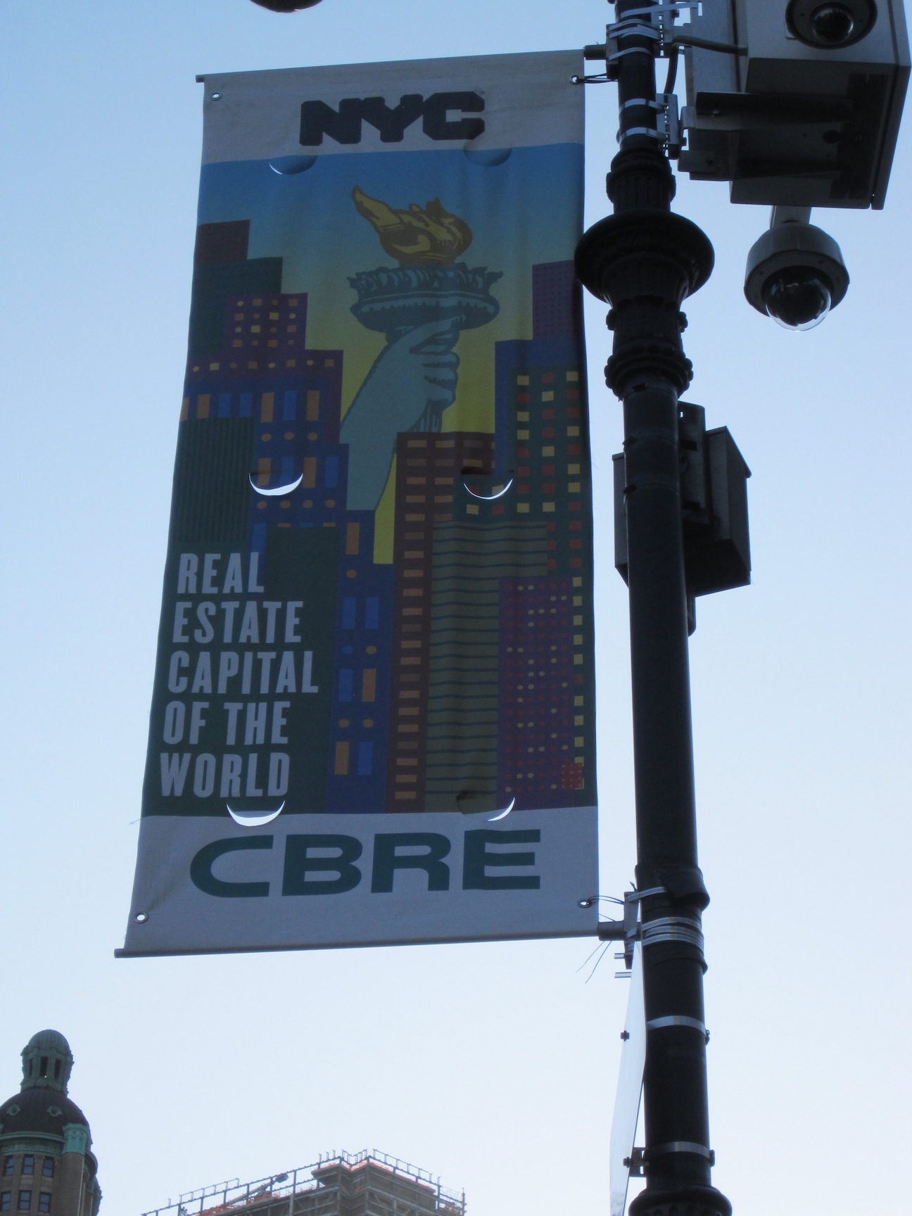

3.1 Initiative

Cooper Square
In Cooper Square, the trigger was provided by the threat of slum clearance by more deliberate planning:

“He [Robert Moses] came to the Lower East Side. He looked at these tenements. They were a hundred years old. Then they were 80 years old but they were all ‘law tenements’ with toilets in the hall for eight people. Just a toilet. No sink, no room. A toilet for eight people. Five stories high, no elevators, no cross ventilation, poor. They jammed the immigrants into old law tenements and the City. And Robert Moses saw these tenements. And he walked from Cooper Square to Wall Street and it took him 20 minutes. So he thought ‘oh my God, we can tear down these rat traps, we can build more expensive housing, fill it with people who can walk to Wall Street.’ He picked the wrong neighbourhood.”¹⁹

In this initiative period we can identify the levelling gaze, the regularising of cities to serve simple rational plans.²⁰ We might also see the instincts of the community organiser to agitate and call for resistance:

“The city never made plans for the people they are throwing out, only for the people who would come in who would be people of more income... Now, we have a book. It’s called The Alternate Plan for Cooper Square and there’s one guiding principle and this... we helped Walter [Thabit] do the best thing he ever did in his life which is The Alternate Plan for Cooper Square. It’s used all over the world. People really know it all over the world. He was a great professional and a perfectionist. That’s why he was so broke. And the guiding principle was urban renewal. The people who live in urban renewal areas must be the benefits… the beneficiaries and not the victim of the plan”.²¹

The alternate plan for Cooper Square was based on a number of guiding principles. It considered land use planning and use of major road artery’s, residential and commercial use of buildings in Cooper Square, community facilities and how to support the homeless, standards of housing and housing for the elderly and for local artists, and provided a means to achieve future renewal through a plan for Cooper Square that was different to what was being presented by city authorities.²² This would translate into a commitment to provide housing at rents that local tenants could afford, minimising offsite relocation of residents during construction, supporting local businesses and retaining a visually and socially satisfying aesthetic. The alternate plan suggested building 1440 new housing units, 620 of which were to be public housing, 300 moderate income rentals, 520 middle income cooperatives, 48 units for artists and 160 furnished room units.²³

Dudley Street
In Dudley Street, the deaths of young children in one house fire were, all too literally, the spark. The years of disinterest and disinvestment meant residents were suspicious of the municipality and sought means by which to organise. DSNI was established in 1984 as a merger and coalition of churches, community, non-profit and charitable organisations.²⁴ Speaking in December 2008, Luis Cruz, a one-time president of the CLT Dudley Neighbors Inc. created by DSNI and an early activist, said that when they started the organisers had some clear aims:

“We would start to clean up our community first… also, when we started it, the idea was to produce housing, at an affordable rate, to make sure that people in our community would not be displaced and that we were in fact insulated from gentrification”²⁵

While the form of clearance that threatened Dudley Street was both more violent and less planned, the response was expressed in similar terms:

“Our motto from the beginning has been development without displacement and, at the same time, we’ve been looking to generate economic opportunities in housing opportunities... We wanted to do it in a way that the residents here benefited and that the people who really fought to make Dudley nicer more vital, vibrant neighbourhood are not then displaced by new families coming in.”²⁶

But the path to consolidation was very different.

3.2 Consolidation

Dudley Street
At the time DSNI was set up, and because there were few incentives to invest, there were around 1300 vacant lots, accounting for more than 20% of the neighbourhood. Around a third of these were owned by Federal, State and City authorities. The remainder were generally in private hands and in tax arrears.²⁷ It became apparent that this complex pattern of land ownership meant the municipality would have to become enablers in the process, despite the community’s original distrust. Steven Coyle, the then director of the Boston Redevelopment Authority (BRA), suggested that DSNI apply for 121A status, which would grant it eminent domain powers (that is the equivalent of the right to repossession and disposal of land) over the land at the heart of the neighbourhood. Mayor Flynn was supportive of the plan, but there was opposition to the granting of these powers to community groups, an unprecedented step, from within the BRA. Two board members ended up leaving the board over the issue and it seems it was difficult to convince people in Dudley Street that consolidation of the DSNI initiative was not threatening.²⁸ It was interesting therefore, that locals were fearful of a collective group making decisions on securing land, through the award of eminent domain status.

Cooper Square
For Cooper Square, the consolidation period was its most challenging. They had to fight for many years to avoid being ‘snuffed out’:

“It took us 54 fucking years... 54 years! So, if you are not in it for the long haul and you are dealing with the City, quit if you are not ready to devote yourself to winning.”²⁹

When Moses unveiled his plan in 1959, the community organiser recalls the alternative that they put forward:

“we presented our plan which said the plan has to be for the benefit of the people who live there. The planners in the City said ‘this is outrageous. We can’t benefit the people that live there we will never get anything built’”³⁰

These very different experiences of consolidation undermine the simple framework that Ward presents. What we see here is the way in which the localised experiences of consolidation are faced and sensed in very different ways. In one case we see the enthusiasm for being part of an activist cohort, part of political activism, while in the other we get the feel for the struggle to consolidate activism. In some respect the issue of time may be influential as one activist may reflect romantically on a period of struggle, while professionals may consider in a pragmatic way the need to maintain activists in the present tense. They may also reflect and affect the nature and character to subsequent developments as we consider below.

3.3 Success

Dudley Street
Once the power of eminent domain was granted in 1988, DSNI needed funding to implement the first stage of its plan for the area. The significance of this success was that DSNI were the first community-based organisation to be awarded eminent domain status in the US, something that previously remained in the control of local agencies. The Ford Foundation, HUD, Massachusetts’ Department of Environmental Management and the City of Boston have all offered financial and other support to the project.³¹ Tulloss suggests this was because of the timing. In 1983, Mayor Flynn defeated Mel King on a populist platform. Both mayors, after years of disinvestment, spoke of a focus on the needs of neighbourhoods and not just the central business districts. As DSNI emerged, it was able to demonstrate it represented the community and spoke on behalf of people in Dudley Street and developed a political strategy that was palatable. This enabled the organisation to move beyond its initial formation period. DSNI’s early achievements, especially receiving the important eminent domain powers, helped it establish a reputation as influential and trustworthy, which made it easier to gain the respect of local residents, professionals and political stakeholders. Once DSNI began developing its first affordable homes, completed in 1994 and consisting of 36 units of affordable homeownership, it had established itself as a respectable and competent community organisation.

Cooper Square
In Cooper Square, the timing could not have been less fortuitous. Robert Moses’ plan was only defeated after a prolonged battle that lasted from 1959 to 1971. In 1971, “we got the green light from the city that they would accept our plan which was The Alternate Plan. So, when they gave us the green light, that’s when things fell apart because the Feds had no more money. We had to go back to the drawing board”.³² It would take Cooper Square until 1984 to complete their first housing project, named after Thelma Burdick, the first Cooper Square chairperson.

Figure 2 The Cooper Square neighbourhood under gentrification pressures:
view from inside a CLT apartment

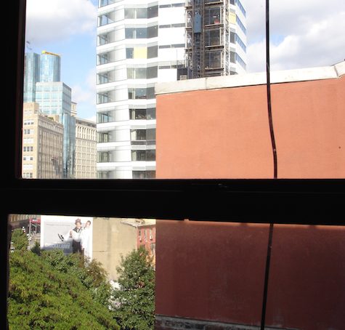

3.4 Official Action

Dudley Street
In Dudley Street and since 1988, over 400 homes have been built and over 500 refurbished, all belonging to the community land trust and affordable in perpetuity. Dudley Neighbors Inc. (DNI) is the name of the community land trust that holds ownership of the land itself and it is a subsidiary of DSNI. The Director of DNI explains that the CLT is a ‘gatekeeper’ of development projects within Dudley St. neighbourhood:

“Where a project will come in and if it doesn’t fit certain of our development principles we will say well this doesn’t fit or that doesn’t fit so whether that has to do with affordable housing, whether that has to do with all the way down to bedroom sizes”.³³

Whilst the CLT does focus on housing, it is also used to promote other opportunities:

“… to work with our residents and committees to look for economic development strategies especially around work force around jobs and around you know anything that can be done to boost the local economy, still in a way that is benefitting the local residents and so were are involved in everything from coalitions to promote local food production and greenhouse and community farms”.³⁴

DSNI’s status as an established stakeholder has been challenged on occasion by other local stakeholders. On the few occasions where CLT properties were foreclosed, the banks claimed that they could sell the property on the open market. DNI responded by threatening to raise the ground lease from $49 a month to $649 a month.

“Because of the foreclosure we can knock off all the deed restriction that the city has and that we can say if you do that if you don’t keep the restriction on, instead of the 49 dollars we were charging the homeowners we will charge you 649 dollars a month. So you can sell that unit for whatever you think you can but just tack on that amount, and the bank says ‘your crazy, we can’t do that’ and we say ‘alright then the other alternative is keep the restrictions on let us help market the unit to another family who hits the income limits you get your mortgage’”.³⁵

Figure 3 Growing your own activists, Dudley Street
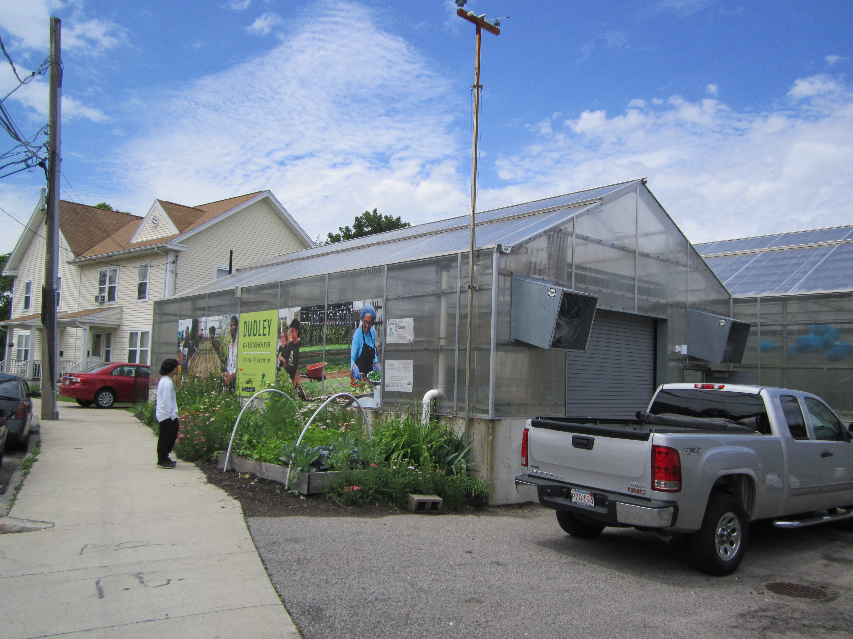

As a result of DSNI’s initial successes they have become an entrenched and permanent part of the political process in the Dudley Street neighbourhood. This is confirmed with a meeting with a local councillor in Dunkin Donuts in nearby Blue Hill Avenue, part of the symbolic boundary of the Dudley Triangle, where the message is one of value creation by DSNI and how their intervention has led to neighbourhood stabilization and not least according to the politician, has provided a foundation that has overcome disenfranchisement and exclusion.³⁶
Cooper Square
The formality of Cooper Square CLT can be traced back to the 1961 Alternate Plan and two principles in particular can be highlighted: the separation of the ownership of land and ownership of buildings. The reason behind this was because of the belief that “gentrification takes an insidious form” and that affordable housing can be subject to tenants themselves selling on to those from a higher economic class.³⁷ So, established in 1991, the CLT took ownership of the land holding 19 buildings that at the time had over 300 units of family rented housing, plus 23 commercial units. Importantly, these units were leased to and managed by the Cooper Square Mutual Housing Association (CSMHA), also established in 1991. This model of land and property separation was designed to inculcate in tenants the philosophy of cooperative ownership, with tenants becoming members who purchase a share worth $250, with rights to resale of properties restricted.

The New York City (local) authority required CSMHA to secure two-thirds of residents vote for a move to cooperative ownership. While in one sense this form of arm twisting was an illustration of authority, the vote was secured with 82% in favour, demonstrating the political campaign behind the formality of ownership structure. On the ground, every building has a ‘Building Captain’ and a ‘Building Co-Captain’. While these meet on a regular basis as kernels in the reproduction of the ownership principles, the ageing demography of tenants, whereby around 40% are over 55 years of age, has an affect. One result is the difficulty in getting tenants to think beyond the problems they face immediately and beyond the building they occupy. For one activist, the CSMHA provides the means by which the CLT can be institutionalized, and to demonstrate beyond Cooper Square how the need for securing land and the need for community organizing become part of the same struggle.³⁸ Land is acquired through struggle, and this struggle becomes the forerunner to securing levels of public investment into a structure such as a CLT.

Figure 4 Illustrating officialdom, Cooper Square

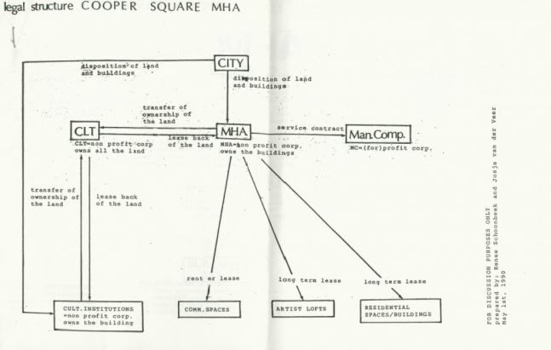

4. Resistance, activists and professionals
The strategies of activism and organizing used to secure resources for communities are consistent in our cases and maybe beyond. Today the Cooper Square Committee continue to agitate for political reform, such as for tenant safety and fund raising, while in Dudley Street there remains a focus on community leadership.³⁹ There are however, questions concerning the formalized way in which activism is brought under legitimate processes. The four phases of practice are useful in this respect and the evidence we put forward is interesting not least because our cases sit as they do in the world’s wealthiest nation.⁴⁰ Each phase of initiative, consolidation, success and official action are deployed in our two cases as reactions to the political economy, to the forces of neoliberalism and the structures of inequality that are experienced by community members.

4.1 Acts of resistance

While Scott talks of acts of resistance and the weapons the peasants of South-East Asia deployed, nearby to the centre of the neoliberal financial powerhouse of Wall Street and Midtown Manhattan, the local activist explains the strategies used in the fight for ownership of land.⁴¹

“Well if we said if we were going to have a picket line and we were going to have a lot of people at the picket line and we are each going to have a leaflet and we make it very colourful and we get the press, next month we can’t say we are going to have a picket line because we did that already. They could say we covered that, so we said this time we are going to sleep in in the City office. We are going to sleep in at a City office so they said what do you mean you are going to sleep in? We mean we are going to lay on the ground then we are going to go to sleep. We are not going to leave, so they called the cops and it happened to be a Director who was very afraid that it would be in a paper that we arrested all these people with their children and their diapers and stuff. So we upped the ante we always added something.”⁴²

Add to this the way in which it became clear that the narrative of resistance was discursive and gendered. Discursive in the sense that whenever possible, efforts were made to exploit the local New York City media channels and newspapers, and then through creating new imagery when victories in the long running battle were secured.

“And the one of the things that we always did was any little victory we celebrated like crazy, little ones or big ones we celebrated because it gave us the energy to reach for the next win and the next prize so it was worth the struggle.”⁴³

And gendered because the role of women in the struggles in Lower East Side and housing in general in New York was well known.

“All housing movements are led by women... because they are in charge of the home, they are in charge of the children they are in charge of the roof they might not be earning the money although more and more women are working but home is a woman’s responsibility throughout history housing movements have been run by women but there was something about Cooper Square like the fact that we wrote our own songs that it was a different kind of it was a very exciting struggle it was not boring.”⁴⁴

These acts of resistance bring those concerned to the attention of the authorities, outlining for instance how they were under scrutiny by the FBI and family members subject to forms of blacklisting. Undertaken as they were, within the framework of legal protest, the need is to recognise whether they can be managed in ways other than being deemed illegitimate.

4.2 Professionals and proletariat
There are themes that emerge from the interview data we present here that are consistent with Ward’s four ideal categories of direct action. We find, on the one hand, narratives that illustrate the initiative, that can reveal a social consciousness and identify with a wider struggle against the market or against racial segregation. While on the other, we find professionals describing the ways in which they have used the levers of funding and power to mobilise resources around the central issue of housing. And we find in each of these a demonstration of housing as process enabled by the reciprocal relationship between the sometimes radical activist and professional community worker. We may exaggerate this point slightly to show how it is expressed in very different terms.

In our New York instance professionals are rarely welcomed and not often spoken of warmly as other comrades, although the distinction is not always explicit:

“...so I became an organiser one of the first people who came to the first meeting was Walter Thabit who is a rare community planner because he only works for communities and not for the city and not for corporations.”⁴⁵

More normally, they (the professionals) are regarded as necessary:

“I just got the name of my lawyer… that told us about the land trust, so he came to us with this idea, I mean if we didn’t have him we wouldn’t know there was a Community Land Trust. If we didn’t have Walter we didn’t know that we could plan for people and not for the corporations. So you need the professionals but they can’t tell you how to do it, you have to tell them.”⁴⁶

In this there is an assumption that the term ‘professional’ marks out some types of involvement and not others.

We once had a picket line. We took a key and we dipped it in epoxy and we put it in the door of the City office and broke off the key so when they came to work and we were outside picketing and when they came to work they couldn’t get in... It wasn’t Cooper Square ‘cause City moved the office because we were doing too much damage to their office they moved it to Stuyvesant Street which was five blocks away. So we are outside picketing and they are trying to get in and they call the cops and we had a lawyer, a local lawyer, and he talked with the cops and he said if you plead guilty I can get you off, and we said what do you mean guilty, we are not guilty, they are guilty. They are destroying us how can you say we are guilty? He said do you want to get out, no we want to win so we said go away we will get a different lawyer. He said, ‘look I want to be your lawyer you do great work’, you want to be our lawyer, tell them we are innocent, tell them the City is at fault. If the door is locked don’t blame us we have no idea how the door is locked. Go find out who locked the door but we are here to demand our rights as citizens. You do that or go away. So he did that, he won the case but we never let them tell us what to do.”⁴⁷

In this way we see the activist keeping an eye on the professional, a level of activism that draws on the skills of a profession, that itself can be a struggle. In the Cooper Square story those such as Thelma Burdick and Walter Thabit proved to be an exception, although the majority proved the rule:

“We didn’t let Walter tell us what to do. So you need an accountant you need your lawyer, you need a planner that does your bidding and if they don’t do you’re bidding tell them goodbye.”⁴⁸

In contrast, for the professional, their role can almost be seen as one of translation:

“So we are a gatekeeper we had come up 1987/1988 with a large community process that ended up coming up with an alternative development plan to what the City had put out and then we’ve kept refining that vision over the years, and so we do act as a gatekeeper where a project will come in and if it doesn’t fit certain of our development principles we will say well this doesn’t fit or that doesn’t fit, so whether that has to do with affordable housing whether that has to do with all the way down to bedroom sizes.⁴⁹

Figure 5 The cluttered desk of an activist or overworked professional?

Here we see brokerage in action; the translation for the authorities, from the community and also for those who are charged with the rebuilding process:

“We recently worked with a developer who was proposing some housing and the smallest bedrooms were really small and one of the principals of DSNI in the community come up with is that there are families in this community who want to have children, who want to have the opportunity to have a desk in their room or have some opportunity to do homework not just big enough to stick a bed there and that’s it. And so he agreed to increase the bedroom size in order to fit a desk. Those are the kinds of things, gets down to the granule details of trying to promote a certain development, type of development in the neighbourhood and not just cramming in as many units as you can and not having them be high quality.”⁵⁰

We find a language of advocacy, this more than a professional buy in to the principles of the CLT and of the activism behind it:

“Yes so my role here is both maintaining the Community Land Trust and looking for other opportunities to promote the Land Trust model both within the neighbourhood and in other neighbourhoods in other areas of the city and beyond and then also to work with our residents and committees to look for economic development strategies especially around work force around jobs and around you know anything that can be done to boost the local economy still in a way that is benefitting the local residents”⁵¹

And then this advocacy moves on to articulate an authority and potential from intra-dependency of initiatives within the community:

“... and so we’re involved in everything from coalitions to promote local food production, and greenhouse and community farms and an art place initiative, where we are looking at the creative economy and how to create an arts kind of culture district using the Strand Theatre, which is an early 1900s theatre that has been restored but still really doesn’t do programming that is really reflective of the community. We promote opportunities for employment whether it is in concessions or promotions or in the theatre etc. so we are looking at, from arts to food to health care to food services to child care you know every opportunity we can.”⁵²

Then reflecting on the contradiction thrown up in the relationship between professional and community organisation, the substance and action, the plurality and the relationality that McDermott made reference to.⁵³

“But we also find the language of dependence, of doing for: “A lot of it falls on me, we do have community organisers and partners so a lot of the DSNI’s role is that we are not providing job training or work force development training but we are partnering with other groups to do and we hold them accountable and say you help design the programme.”⁵⁴

Thus we can begin to draw out the difference between activism and the organizing work of professionals as a narrative of resistance. We see levels of activism and organizing that are complementary and remain central to any likelihood of social consciousness being shifted in some way. Yet they are different. For instance, one seems to engage in struggle through pragmatism, fighting as it were for the very basic of needs, in this case housing. This contrasts to the element of choice that might be, but not always, deployed by the other. We are not suggesting a clear distinction between the two but a symbiotic relationship between proletariat and professional where one might remain in a romanticised and sometimes defeatist role without the deployment of expertise from the other.

5. Conclusion
Should this be the theory to match the practice it would remiss to suggest one pulls in a radical manner and the other tends towards reformism. We have seen in our two cases a path from resistance, activism and organizing towards securing public investment and creating the conditions for housing. And while we have not discussed it in detail here due to constraints on space, we also see in the two cases some desire for home ownership, not least because of the way housing in the US has taken a particular form embedded in the psyche of people.⁵⁵ Indeed, the tension between those who argue that housing is a process, illustrated by activism and struggle and those who see housing as a product, not necessarily a class issue but rather a commodity transaction and subsumed in the patterns of capitalism seen amongst the wider spatial distribution has not been resolved in our review of Dudley Street and Cooper Square. Suffice to say at this point that individual home ownership and collective ownership appear at odds, but are evident in the work of the CLT.

In both of our cases we see how resistance as part of the housing verb, raises some central dilemmas. In seeking to control the use of housing, radical movements inevitably become engaged in debates about ownership, about property and about land. We have described the case of Dudley Street and Cooper Square by travelling through Ward’s four phases of action. From the point of view of Engels, regardless of the radical credentials of these activists, the concerns they raise and actions they pursue must inherently be petite bourgeois in character. It is perhaps inevitable then that those radicals enter into alliances with community professionals who are able to mobilise the resources needed to defend the terrain. On appearance this alliance may well be an uneasy and uncomfortable one, as we have illustrated but it may also represent aspects of praxis, of theory building, of raising class consciousness and practice. These are aspects to which we have devoted little time here, but would be worthy of greater reflection. However, what we might point to, not entirely irrespective of the theory and practice dynamic, is that we have seen a catalyst for some form of community independence and the CLT by securing both assets and liabilities under their control, and in this respect both communities have stood resistant and in contrast to the powers of the market. In the sense of narratives of resistance, the communities in both Dudley Street and Cooper Square share a common heritage in resisting the hegemony of private capital and the state.

Notes
1. Colin Ward, Anarchy in Action, (London: Freedom Press, 2001).
2. Ibid.
3. Friedrich Engels, The Housing Question, (London: Martin Lawrence, 1935).
4. Ibid. 25.
5. For the former see for instance, Hilaire Belloc, The Servile State, (Indianapolis: Liberty Classics, 1977); An Essay on the Restoration of Property, (Norfolk, VA: IHS Press, 2009). For the latter see Colin Ward, Housing: An Anarchist Approach, (London: Freedom Press, 1983); Social Policy: An Anarchist Approach, (London: Freedom Press, 2000).
6. Mary McDermott, “Introduction,” Community Development Journal, 49(S1), (2014): i2.
7. Although this is drawn more recently from John Turner “Housing in Three Dimensions: Terms of Reference for the Housing Question Redefined,” World Development, 6(9/10) (1978).
8. Rod Burgess, “Petty Commodity Housing or Dweller Control? A Critique of John Turner’s Views on Housing Policy,” World Development, 6(9/10) (1978).
9. We should note, as Ward did, that the situation in the global south is very different, see Ward, Anarchy and Ward, Social Policy.
10. Ward, Housing.
11. Ward, Anarchy, 89-90.
12. For this see Turner, Housing, and also Edward Goetz and Mara Sidney, “Revenge of the Property Owners: Community Development and the Politics of Property,” Journal of Urban Affairs, 16(4) (1996); Michael Stone, “Social Ownership”, in A Right to Housing Foundations for a New Social Agenda, Eds. Rachel Bratt, Michael Stone and Chester Hartmann (Philadelphia, PA: Temple University Press, 2006); Stuart Hodkinson, “The Return of the Housing Question,” ephemera, 12(4) (2012).
13. DSNI, DSNI December 2009 Integrated report, internal publication, (Dudley Street Neighborhood Initiative, Boston, 2010).
14. Peter Medoff, and Holly Skalr, Streets of Hope: The Fall and Rise of an Urban Neighborhood, (Boston: South End Press, 1994): 15.
15. Dudley Neighborhood Profile, Dudley Neighborhood Profile, available at: http://www.dsni.org/community-profile. Accessed October 2015, (2003).
16. Medoff and Sklar, Streets, 2.
17. This quote is taken from a discussion with a CLT professional in October 2007. A number of interviews and group discussions were held as part of this research and are used in this article.
18. Tom Angotti, New York for Sale: Community Planning Confronts Global Real Estate, (Cambridge Massachusetts: MIT Press, 2008).
19. Interview with a community organiser, Cooper Sq. June 2013.
20. James Scott, Weapons of the Weak: Everyday Forms of Resistance, New Haven: Yale University Press, 1985).
21. Community organiser, Cooper Square, June 2013.
22. This according to the Cooper Square Community Development Committee and Businessmens Association “An alternate plan for Cooper Square” (9 Second Avenue, New York, 1961); see also Walter Thabit, Cooper Square Committee Chronology, New York: Planning Network, March 2005).
23. CSCDCBA, An alternate.
24. Janice Tulloss, “Transforming Urban Regimes – A Grassroots Approach to Comprehensive Community Development: The Dudley Street Neighborhood Initiative” available http://comm-org.wisc.edu/papers98/tulloss.htm. Accessed October 2015 (1996).
25. This quotation is from a speech given during a research visit in December 2008 and reported in Udi Engelsman, Symbolic Violence and Community Participation: Contrasting Cases of Communities in Inner Urban Areas and their Involvement in Regeneration, (Unpublished PhD thesis: University of Liverpool, 2014): 139.
26. Interview with community professional, Dudley Street, June 2013.
27. Tulloss, “Transforming”; Stephen Plumer and David Nesbitt, “The Dudley Street Neighborhood Initiative Revitalization Plan: A Comprehensive Community Controlled Strategy,” (Boston: DAC International, 1987).
28. Medoff and Sklar, Streets.
29. Community organiser, Cooper Sq. June 2013.
30. Ibid.
31. Tulloss, “Transforming.”
32. Community organiser, Cooper Sq. June 2013.
33. Community professional, Dudley, June 2013.
34. Ibid.
35. Ibid.
36. Interview with local Boston City Councillor, June 2013.
37. Interview with Cooper Square CLT and housing professional, March 2013.
38. Ibid.
39. Space does not allow us to provide a thorough update on the two CLTs. However, social media can provide an update on Cooper Square and Dudley Street activists. See https://www.facebook.com/coopersquarecommittee and http://www.dsni.org.
40. As suggested by Ward, Anarchy and Ward, Housing.
41. Scott, Weapons.
42. Community organiser, Cooper Sq. June 2013.
43. Ibid.
44. Ibid.
45. Ibid.
46. Ibid.
47. Ibid.
48. Ibid.
49. Community professional, Dudley, June 2013.
50. Ibid.
51. Ibid.
52. Ibid.
53. McDermott, “Introduction.”
54. Community professional, Dudley, June 2013.
55. Stone, “Social Ownership”; See also Michael Stone, “Housing and the Financial Crisis: Causes, Consequences, Cures”, Housing Finance International, (September 2009).

Bibliography

Angotti, Tom. New York for Sale: Community Planning Confronts Global Real Estate. Cambridge Massachusetts: MIT Press, 2009.
Belloc, Hilaire. The Servile State, 2nd edition. Indianapolis: Liberty Classics, 1977.
Belloc, Hilaire. An Essay on the Restoration of Property, 2nd edition. Norfolk, VA: IHS Press, 2009.
Burgess, Rod. (1978) “Petty Commodity Housing or Dweller Control? A Critique of John Turner’s Views on Housing Policy”, World Development, 6(9/10), 1105-1133.
Cooper Square Community Development Committee and Businessmens Association. An Alternate Plan for Cooper Square. 9 Second Avenue, New York, 1961.
DSNI. DSNI December 2009 Integrated Report. Internal publication, Dudley Street Neighborhood Initiative, Boston, 2010.
Dudley Neighborhood Profile. Dudley Neighborhood Profile, available at: http://www.dsni.org/community-profile. Accessed October 2015, 2003.
Engels, Friedrich. The Housing Question, London: Martin Lawrence, 1935.
Engelsman, Udi. Symbolic Violence and Community Participation: Contrasting Cases of Communities in Inner Urban Areas and their Involvement in Regeneration. Unpublished PhD thesis: University of Liverpool, 2014.
Goetz, Edward G. and Sidney, Mara. “Revenge of the Property Owners: Community Development and the Politics of Property”, Journal of Urban Affairs, 16(4), 319-334, 1996.
Hodkinson, Stewart. “The Return of the Housing Question”, ephemera, 12(4), 423-444, 2012.
McDermott, Mary. “Introduction”, Community Development Journal, 49(S1), pp.i1–i11, 2012.
Medoff, Peter. and Skalr, Holly. Streets of Hope: The Fall and Rise of an Urban Neighborhood, Boston: South End Press, 1994.
Plumer, Stephen. and Nesbitt, David. The Dudley Street Neighborhood Initiative Revitalization Plan: A Comprehensive Community Controlled Strategy, Boston: DAC International, 1987.
Scott, James. Weapons of the Weak: Everyday Forms of Resistance, New Haven: Yale University Press, 1985.
Stone, Michael E. Social Ownership, in Rachel G. Bratt, Michael E. Stone and Chester Hartmann (eds.), A Right to Housing Foundations for a New Social Agenda, Philadelphia, PA: Temple University Press, 2006, 240-260.
Stone, Michael E. “Housing and the Financial Crisis: Causes, Consequences, Cures”, Housing Finance International, September, 2009, 34-39.
Thabit, Walter. Cooper Square Committee Chronology, A listing of Cooper Square Events and Activities – Including Victories and Defeats - From March 1959 Through March 2005, New York: Planning Network, 2005.
Tulloss, J.K. Transforming Urban Regimes – A Grassroots Approach to Comprehensive Community Development: The Dudley Street Neighborhood Initiative, available http://comm-org.wisc.edu/papers98/tulloss.htm. Accessed October 2015, 1996.
Turner, John F.C. “Housing in Three Dimensions: Terms of Reference for the Housing Question Redefined”, World Development, 6(9/10), 1978, 1135-1145.
Ward, Colin. Housing: An Anarchist Approach, London: Freedom Press, 1983.
Ward, Colin. Social Policy: An Anarchist Approach, London: Freedom Press, 2000.
Ward, Colin. Anarchy in Action, London: Freedom Press, 2001.

