GPS tracking reveals rafting behaviour of Northern Gannets (Morus bassanus): Implications for foraging ecology and conservation

Matt I. D. Carter^{1,2}*, Samantha L. Cox¹, Kylie L. Scales^{3,4}, Anthony W. J. Bicknell⁵, Matthew D. Nicholson², Kelly Atkins², Greg Morgan⁶, Lisa Morgan⁶, W. James Grecian⁷, Samantha C. Patrick⁸, Stephen C. Votier⁵
¹Marine Biology and Ecology Research Centre, University of Plymouth, Drake Circus, Plymouth, PL4 8AA, UK
²College of Life and Environmental Science, University of Exeter, Penryn Campus, Cornwall, TR10 9EZ, UK
³Institute of Marine Sciences, University of California, Santa Cruz, CA 95064, USA
⁴NOAA: National Oceanic & Atmospheric Administration, Southwest Fisheries Science Center, Monterey, CA 93940, USA
⁵Environment and Sustainability Institute, University of Exeter, Penryn Campus, Cornwall, TR10 9EZ, UK
⁶'RSPB Ramsey Island, St Davids, Pembrokeshire, SA62 6PY, UK
⁷Institute of Biodiversity, Animal health & Comparative medicine, College of medical, veterinary & Life Sciences, University of Glasgow, Glasgow, G12 8QQ, UK
⁸Department of Earth, Ocean & Ecological Sciences, University of Liverpool, L69 3GP, UK

SHORT TITLE
Northern Gannet rafting behaviour

KEY WORDS
Habitat Use ⋅ Seabirds ⋅ Social Information ⋅ Special Protection Area ⋅ Celtic Sea
SUMMARY
- Capsule: Three quarters of tracked Northern Gannets (Morus bassanus) at Grassholm Island gathered in rafts around the colony, concentrated within a recently designated Special Protection Area (SPA) extension, but rafting was not correlated with foraging effort.
- Aims: To investigate the incidence, distribution and foraging implications of Northern Gannet rafting behaviour in waters adjacent to a large colony.
- Methods: Using bird-borne GPS we reconstructed at-sea behaviour and used a speed filter to identify rafting behaviour within 10 km of the colony. We mapped the spatial distribution of rafting events from 160 breeding individuals over 5 years, and investigated the relationship between foraging effort (trip duration and total distance travelled) and the presence/absence of rafting.
- Results: On average, 74% of tracked birds engaged in rafting. Of the 381 foraging trips analysed, rafting was recorded on 237 (62%). Birds were more likely to raft on outbound journeys (224 trips, 59%), than inbound (38 trips, 10%), however presence/absence of rafting did not correlate significantly with foraging trip length. The majority of rafting was concentrated in a 2-km radius around the colony within a recently designated seaward SPA extension. Birds show low repeatability in rafting, although there was lower variation within than among individuals.
- Conclusion: Our results suggest that rafting around the island is common among breeding gannets on Grassholm. A recent seaward SPA extension encapsulates the core distribution of rafting behaviour at this site. Rafting did not appear to be directly correlated with foraging behaviour. Given the dearth of literature on rafting and the wealth of GPS tracking data for seabirds, we suggest that similar research be conducted elsewhere to further elucidate the ecological significance of this behaviour and advise conservation management.
INTRODUCTION
Much applied and theoretical seabird research has focussed on the behaviour of birds attending breeding colonies (Bayer, 1982; Clode, 1993; Chaurand & Weimerskirch, 1994; Danchin & Wagner, 1997), and more recently miniaturised bio-logging devices have enabled the study of fine-scale distribution and behaviour while birds search for food at sea or visit wintering grounds (Weimerskirch, 2007; Burger & Shaffer, 2008; Wakefield et al., 2009, 2013). However, relatively few studies have investigated how seabirds use waters adjacent to the colony, despite observations suggesting that many populations use such areas frequently (Burger, 1997; McSorley et al., 2003).

Rafting appears to be important around seabird colonies for a number of reasons. Firstly, birds congregate on the water to engage in preening and bathing (Burger, 1997; McSorley et al., 2003). These behaviours may be especially important for colonial seabirds because incubation and brooding periods can last weeks (Coulson, 2002) and high population density may lead to extensive plumage fouling from guano. Secondly, rafts may also provide an important source of social information. This information may be significant for locating a mate (Daniels et al., 1994), for making decisions about where to recruit (Halley et al., 1995), or may be related to foraging behaviour (Weimerskirch et al., 2010; Racine et al., 2012; Votier et al., 2013; Machovsky-Capuska et al., 2014; Thiebault et al., 2014; Evans et al., 2015). For example, Weimerskirch et al., (2010) discovered that Guanay Cormorants (Phalacrocorax bougainvillii) use ‘compass rafts’ around the colony to signal the bearing of food patches to departing conspecifics and Machovsky-Capuska et al., (2014) found evidence to support this hypothesis in Australasian Gannets (Morus serrator). With this in mind, investigating rafting at seabird colonies may yield further important discoveries for the study of seabird habitat use and foraging ecology, and may also have implications for conservation.

The present study utilises a large, fine-scale GPS tracking dataset of the at-sea movements and behaviour of Northern Gannets (Morus bassanus, hereinafter ‘gannet’) to study rafting behaviour in waters around a very large breeding colony at Grassholm, Wales. We employ a speed filter to identify rafting and use this to (1) examine the incidence of rafting behaviour for 389 foraging trips from 160 birds across 5 years and test for differences between the sexes, (2) test the consistency (repeatability) of the rafting behaviour of individual birds, (3) map the spatial distribution of rafting events within a 10-km radius of the colony to check the effectiveness of a recent seaward extension of the Grassholm Special Protection Area (SPA) at encompassing areas important for rafting, and (4) test the hypothesis that rafting is correlated with foraging effort. Finally, we provide future directions for the role of rafting in seabird research and conservation.

MATERIALS & METHODS
Study colony and bird sampling
Field work was conducted on Grassholm Island, Wales, UK (51° 43'N, 5° 28'W; Fig. 1) during June and July in 2006 and, 2010-13. Approximately 40,000 pairs of gannets breed on the island from April to October alongside several thousand immature and sub-adult non-breeding birds. The island has been an SPA under EU law since 1986, and in October 2014 the Welsh Government approved a 2-km marine extension to account for aggregations of birds using adjacent waters. Although daytime boat-based surveys of gannet activity in this area have been conducted by the Joint Nature Conservation Committee (JNCC) (McSorley et al., 2003), no formal assessment of this behaviour had previously been published in the peer-reviewed literature.

Chick-rearing gannets were caught using a brass noose or metal crook at the end of a carbon-fibre pole under license from Natural Resources Wales (NRW) and the British Trust for Ornithology (BTO). For sexing based on sex-linked genes, a blood sample (approx. 0.2 ml) was extracted from the tarsal vein under license from the UK Home Office and birds sexed using standard techniques (AvianBiotech.com). Birds were caught on changeover (the point where brooding duties are switched) to minimise time that chicks were left unattended and to ensure that foraging trips began directly after release. Individuals were selected opportunistically within the periphery of the colony and fitted with a GPS logger and, for a sub-sample in 2010-2013, a time-depth recorder (TDR; see below). Birds were recaptured within 4-10 days to recover archival tags. Handling time was kept to a maximum of 15 minutes. All birds flew off strongly after release and showed no signs of immediate adverse effects.

Instrumentation
All birds (n=203; Table 1) were fitted with GPS loggers, secured to the base of the tail or back feathers using Tesa® tape. In 2006, ~65 g loggers from Earth & Ocean Technologies were used, but during 2010-11 the lighter (~30 g) i-gotU GT-600 loggers from MobileAction Technology were deployed, both programmed to obtain a fix every two minutes. During 2012-13 the further lighter (~20 g) i-gotU GT-120 GPS loggers were used and set to obtain a fix every minute. TDRs (G5; Cefas Technology Limited; 5.7 g; n=43) and LAT 1810 (Lotek Wireless Inc.; 10.5 g; n=26) devices were deployed, in combination with GPS loggers, on the underside of the central tail feathers during July 2010-13. The G5 TDR logged pressure and temperature every 0.1 seconds (10 Hz) during dives, and LOTEK LAT1810 TDR continuously at 1 second intervals (1 Hz).

Data screening
GPS tracking data were manually edited to focus on individual foraging tracks, removing fixes obtained while birds were stationary on the nest. Location fixes were interpolated using a cubic spline to a constant time interval of 60 seconds (Tremblay et al., 2006), to avoid bias caused by mixed device duty cycles (see Appendix I). In some instances, the GPS logger battery expired before the completion of a foraging trip. For the purposes of this study, only complete trips from sexed birds were included (n=389 foraging trips from 160 individuals; Table 1). Total trip duration and distance were calculated for each foraging trip. To filter out GPS fixes of birds on the colony and to account for inherent positional error in GPS transmissions, a minimum convex polygon was mapped around the island and data intersecting this area were excluded (Fig. 1 inset map).

Identifying rafting
Rafting was defined as >1 consecutive GPS fixes below a speed threshold of 10 km h⁻¹. The speed threshold was based upon visual inspection of a density plot of gannet travel speed during foraging trips (Fig. 2) and is consistent with studies of flight speeds in the closely related Cape Gannet (Morus capensis; Grémillet et al., 2004). Circling behaviour may produce artificially low groundspeed estimates, consequently, only sequences of GPS fixes were counted as rafting events, removing single low-speed fixes. To test the sensitivity of the screening regime, the analysis was repeated with >2 consecutive fixes (see Appendix II). The resulting tracks, classified as rafting, show a directional pattern of close successive fixes, consistent with contemporaneous tidal movement or wind vectors, indicating that the behaviour captured is indeed most likely to represent birds resting on the water (Fig. 3). Amélineau et al., (2014) have shown that gannet movements <10 km h⁻¹ may be related to foraging, and so to check that slow movements of birds in this area were not caused by foraging we analysed gannet dive data from 69 individuals on 117 foraging trips in July 2010-13 (for management of dive data see Appendix III). Distance from the colony was calculated for each dive (n=2937) and plotted in a histogram (Fig. 4c). 0.51% (n=15) of recorded dives were within 10 km of the colony, confirming that slow-moving birds in this area are unlikely to be foraging (Fig 4b).

Rafting study area
To investigate rafting behaviour on waters around the colony, we focussed on an area with a 10-km radius from the centre of the island (51° 43' 51"N, 5° 28' 47"W; Fig. 1). This radius was selected for two reasons. Firstly, while some birds may rest on the water outside this area, we are specifically interested in rafting behaviour close to the colony. Secondly, casual field observations and an initial qualitative assessment of tracking data indicate that rafting tends to be concentrated in this area. Moreover, rafting appears to be found in a more dispersed manner away from the colony, making it difficult to differentiate from foraging and potentially concomitant during this behaviour (see Appendix IV).

Data analysis
GPS data were analysed per foraging track and rafting was separated into outbound or inbound (pre/post foraging). Trips where birds left the colony to overnight on the water within 10 km of the island (n=8) were included in incidence and spatial distribution analyses but excluded from analyses relating to foraging effort as they were unlikely to represent foraging trips.

- Incidence
We investigated the incidence of rafting using χ² contingency tables. First, we compared the number of birds that rafted for each sampling year. Second, we determined whether the total number of rafting birds was significantly different from those birds that did not raft. This analysis was conducted for all birds combined and then compared between the sexes. Third, we tested whether the number of outbound journeys that featured rafting events was significantly different to that of inbound journeys. To investigate diel patterns in rafting, we compared the time of day of foraging trip departures and of rafting events.

It is possible that birds may engage in extra bathing in response to handling for tag application, which could be incorrectly interpreted as rafting. We therefore tested this by comparing the frequency of birds that rafted outbound on the first foraging trip (i.e. immediately after handling) with the frequency of birds that rafted during a second foraging trip (i.e. several days after handling). Of the 160 birds included in the study, 150 recorded complete trips immediately after handling, and 66 of these recorded a second trip.
- Spatial distribution
A kernel density estimate (KDE) of the rafting fixes was created using a cell size of 10 m and a smoothing parameter (h) of 645 m in ArcMap™ 10.1. This produced a satisfactory bandwidth that would account for any positional error in GPS fixes, whilst other algorithms such as least squares cross validation (LSCV) were found to over-estimate range. 95% kernel cores were mapped for males and females separately to show the distribution of rafts for each sex. 25% contours were mapped for all rafting fixes. These were favoured over 50% contours for core habitat use to reduce the risk of a prolonged rafting event from one bird being counted as core habitat use at population level. We also calculated the number of rafting fixes located within the 2-km seaward SPA extension.

We calculated the distance from the centre of the colony for each rafting fix of males and females, and compared them in a two sample t-test to investigate differences in mean rafting range of males and females. Lastly we used contingency tables to determine whether there were any sex-specific or inter-annual differences in the use of the SPA.

- Repeatability
To determine whether there were any consistent inter-individual differences in presence/absence of rafting behaviour, we calculated repeatability (r) using the R package 'rptR' (Nakagawa & Schielzeth, 2010). This approach tests the null hypothesis that between-individual variance equals within-individual variance in a binomial model. Only birds with repeat foraging trips were included in the analysis (n=74 individuals, 303 trips).

- Rafting and foraging effort
Trip duration and total distance were used as metrics of foraging effort. These variables were found to be collinear (Spearman’s Rank Correlation, r=0.92, n=381, p<0.001) and so were modelled separately to avoid the risk of a type II error (Zuur et al., 2010). In all models, sex and its two-way interaction was included as an explanatory covariate, and individual was included as a random effect to account for pseudoreplication. To test the hypothesis that rafting upon leaving the colony (hereinafter ‘outbound’) drives differences in (1) trip duration and (2) total distance, we used Linear Mixed-Effects Models (LMMs). Response variables were log-transformed to better approximate a normal distribution. To test the hypothesis that differences in (1) trip duration and (2) total distance drive rafting upon return to the colony (hereinafter ‘inbound’), we used Generalized Linear Mixed-Effects Model (GLMM) logistic regressions. GLMMs with ‘binomial’ error structure were required due to the binary response variable (presence/absence of rafting). All analyses were undertaken using R 3.0.2 (R Core Team, 2015) using the package 'lme4' (Bates et al., 2014).

RESULTS
Incidence
The number of tracked gannets that engaged in rafting was significantly higher than those that did not (74%; Table 2; χ²₁=23.04, p<0.001). There was no significant difference in the probability of rafting between males (73%) and females (64%) (Table 2; χ²₁=0.591, p=0.442). The incidence of rafting varied significantly among years (Table 2; χ²₄=11.205, p=0.024) – the lowest number of rafting birds was in 2013 (60%) and the highest in 2010 (100%). Gannets were significantly more likely to raft outbound (59% of foraging trips, n=224) than inbound (10% of foraging trips, n=38) (Table 3; χ²₁=34.797, p<0.001). 14% of birds (n=21) rafted both outbound and inbound on the same foraging trip (7% of foraging trips, n=25). Overall, rafting was detected on 62% of foraging trips (n=237).

There was a clear diel pattern to foraging trip departures (χ²₂₃=229.879, p<0.001), with 97% between 06:00 and 21:00 (Fig. 5). Rafting events on foraging trips (n=273) followed a similar diel pattern (χ²₂₃=199, p<0.001) with 97% initiated between 06:00 and 21:00 (Fig. 5). Earliest rafting initiated was at 02:50 inbound from a foraging trip, whilst the latest was at 23:34 also on an inbound trip. Mean raft initiation was at 12:21 ± 241 mins. There was no significant difference in rafting probability for birds on outbound trips immediately following handling (58%) compared with those birds on trip 2 with no handling (52%) (χ²₁=0.327, p=0.567).

Spatial distribution
Utilization distribution of rafting in the 10-km radius study area is indicated in Fig. 6. Although mean rafting range was 3.8 ± 3 km, maximum extent of core habitat use (25% kernel cores) at the population level was 2 km from the centre of the colony (Fig. 6). In sex-specific analysis, mean rafting range for females (2.1 ± 1.9 km) was significantly smaller than for males (4.4 ± 3.1 km; two sample t-test, t_{3,443}=30.663, p<0.001).

The extended SPA boundary (17 km²) accounts for 5.4% of the total study area (314 km²). Of all rafting GPS fixes in the study area (n=4556), 46% were found to be within the extended SPA boundary (Table 2). 91% of all rafting birds used this area. There was no significant difference in the use of this area by rafting males (89%) compared with rafting females (92%; Table 2; χ²₁=0.05, p=0.824), and no significant inter-annual variation in the proportion of rafting birds that used the area (Table 2; χ²₄=4.44, p=0.35).
Repeatability
Individual birds showed low repeatability in the incidence of rafting behaviour, although there was statistically lower variation within than among individuals (r=0.105 ± 0.05, p=0.001). Both sexes showed low repeatability; males (r=0.156 ± 0.08, p=0.001) and females (r=0.034 ± 0.05, p=0.021), however males were significantly more repeatable than females (χ²₁=7.834, p=0.005).

Rafting and foraging effort
Mean foraging trip distance was 407.9 ± 275.4 km and mean trip duration was 1333 ± 1020.5 mins (Table 3). Rafting outbound was not significantly correlated with foraging trip distance (Table 4; Fig. 7a; χ²₁=0.464, p=0.496), with no significant sex effect (Table 4; χ²₁=2.032, p=0.154), and no significant interaction between rafting and sex (Table 4; χ²₁=1.02, p=0.31). Rafting outbound was not significantly correlated with trip duration (Table 4; Fig. 7b; χ²₁=0.62, p=0.431). There was no significant sex effect (Table 4; χ²₁=2.347, p=0.126), and there was no significant interaction between sex and rafting (Table 4; χ²₁=0.612, p=0.434).

Propensity to raft inbound was not significantly correlated with foraging trip duration (Table 4; Fig. 8a; χ²₁=0.064, p=0.801), with no significant sex effect (Table 4; χ²₁=0.606, p=0.437), and no significant interaction between trip duration and sex (Table 4; χ²₁=1.932, p=0.165). Propensity to raft inbound was not significantly correlated with foraging trip distance (Table 4; Fig. 8b; χ²₁=0.584, p=0.445), with no significant sex effect (Table 4; χ²₁=0.573, p=0.449), and no significant interaction between trip distance and sex (Table 4; χ²₁=1.754, p=0.185).

DISCUSSION
Observations of seabird habitat use at colonies often describe aggregations of rafting birds on adjacent waters (Burger, 1997; Weimerskirch et al., 2010; Racine et al., 2012). This study supports these observations, showing that a high proportion (74% of tracked birds over 5 years) of studied gannets raft within 10 km of Grassholm, and that rafting is likely to occur on over half (62%) of foraging trips undertaken by breeding birds. Spatial analysis shows that, within the 10-km radius study site, rafting was concentrated within a 2-km radius of the island (Fig. 6). Despite gannets showing sexual segregation of foraging habitat (Stauss et al., 2012; Cleasby et al., 2015), sex appears to have little influence on the spatial distribution of rafting; females recorded a smaller rafting range than males, however, ranges overlapped and there was no significant sex difference in rafting propensity.

The waters immediately to the west of the island were found to be of particular importance for rafting (Fig. 6). This is likely to be because the majority of breeding gannets as well as large numbers of non-breeders are generally located here and this is the primary direction of departure (Votier et al., 2011). Our analysis of gannet dive data has shown that foraging is not likely to occur in waters adjacent to the colony (Fig. 4), and therefore rafting in this area is not concomitant with foraging and must have some other ecological significance.

Drivers of variation
Rafting behaviour has been poorly documented in most seabirds but recent studies have shown that it may influence the foraging decisions of certain species; e.g. signalling the flight bearing of food patches to conspecifics (Weimerskirch et al., 2010; Machovsky-Capuska et al., 2014). Northern Gannets, however, appear to rely on personal memory to find prey, showing high repeatability in foraging locations and departure angles (Pettex et al., 2010, 2012; Patrick et al., 2014; Waggitt et al., 2014). Nevertheless, evidence is also emerging that gannets use colonies as social information centres (Grémillet et al., 2004; Votier et al., 2013; Wakefield et al., 2013; Thiebault et al., 2014) implying that the interplay between personal and social information use remains poorly understood. A recent analysis of sub-colony variation in foraging behaviour suggests that information transfer does not occur on the colony itself (Waggitt et al., 2014). Our analysis suggests that rafting is unlikely to be related to these social information processes; we found that rafting outbound on foraging trips did not drive variation in trip duration or total distance, although 85% of rafting events were initiated on outbound journeys. Similarly, variation in trip duration and total distance did not affect the propensity of birds to raft inbound. Therefore the preference of birds to raft outbound could be motivated by a need to preen and clean soiled feathers after sitting on the nest; plumage maintenance is likely to be essential to a bird’s ability to fly and forage effectively (e.g. for waterproofing), and to obtain a mate (e.g. appearing fit). Investigating the potential relationship between the duration of nest attendance and propensity to raft outbound could help to elucidate this in future studies.

Gannets show consistent individual differences in foraging behaviour (Votier et al., 2010; Patrick et al., 2014, 2015; Wakefield et al., 2015). Although gannets showed low repeatability in rafting, the variance in this behaviour was significantly lower within than between individuals. Moreover, while males were more repeatable than females, we do not understand the reasons for this difference. The temporal distribution of rafting events follows the temporal patterns expressed in foraging departures, and there was a strong diel pattern to both (Fig. 6). This is largely attributed to the majority of rafting events occurring on outbound journeys. There is a bias towards our capture of birds during daylight hours, although gannets are thought to be inactive at night (Garthe et al., 2003). We found significant inter-annual variation in the incidence of rafting (Table 2). This suggests that variation in the propensity of birds to raft could be driven by environmental factors at the colony, or changes to prey distribution and abundance which may affect time budgets. Moreover, weather conditions may affect a bird’s necessity to clean its plumage, affecting rafting propensity upon leaving the nest. Further investigation of wind, temperature and tidal conditions at the colony and across foraging zones is required to explore this.

SPA extension
Seabirds face multiple threats both at sea and on land (Furness, 2003; Votier et al., 2005; Croxall et al., 2012). European Union (EU), member states are required to designate the 'most suitable territories in number and size’ for rare, vulnerable and migratory species as SPAs under the European Commission's Directive on the Conservation of Wild Birds (2009/147/EC). Although the majority of SPAs protect terrestrial habitat, the directive also obliges member states to identify and protect important areas for aggregations of birds at sea. Marine extensions to existing SPAs are implemented in the UK to fulfil this requirement (McSorley et al., 2003). Wilson et al. (2009) demonstrated that quantifying rafting activity around colonies is effective in advising the implementation of such extensions to SPA boundaries. Furthermore, given that rafting may be important for social processes and ultimately population health, the argument for extending SPAs to encompass this behaviour is growing. Grassholm SPA is a key nesting site for gannets, holding at least 12.5% of the North Atlantic breeding population (Stroud et al., 2001). Previously, the Grassholm SPA covered the land to the mean low water mark, however, a 2-km seaward extension to account for behaviour such as preening, bathing and displaying was recently approved. Here we have shown that this area is used by 91% of rafting birds, and, although only representing 5.4% of the 10-km radius study area, it encompasses 46% of all recorded rafting activity. We therefore conclude that the SPA extension is effective in encompassing rafting activity. Qualitative assessment of the data suggests that rafting events are likely to be initiated in this area, with some birds then drifting away from the colony with tidal flow.

Future directions
The few studies of seabird rafting around the colony have employed either radio telemetry (Wilson et al., 2009) or observational data (Weimerskirch et al., 2010; Machovsky-Capuska et al., 2014) to describe this behaviour. While these methods have improved our understanding of rafting, they have a number of limitations. They are not only constrained by the requirement of an observer at the colony but are associated with large errors and restricted ranges. Conversely, biologging can reveal animal movement patterns with few spatiotemporal limitations and a high degree of precision, including speed estimations (Hooker et al., 2007). Our study demonstrates that GPS loggers (as well as TDRs) are an effective tool for identifying and quantifying rafting behaviour. Given the wealth of biologging data for seabirds (Ropert-Coudert et al., 2009), we suggest that similar studies would likely improve our understanding of habitat use around the colony. This information could be used to refine predictive models of seabird distribution and better advise the boundaries of future SPA extensions (Grecian et al., 2012). In order to further refine data screening, we propose a number of considerations. Firstly, combining GPS tracking data with immersion data from TDRs or geolocation sensors with saltwater switches could improve information on rafting. For example, TDR data filtered to periods when the wet/dry sensor is activated, but the pressure sensor does not indicate diving, could be combined with speed estimation to remove doubt of any flight being mistaken as rafting. Secondly, this study is limited by the temporal resolution of the data resulting from device duty cycles of >1 minute. Uncertainties in bird behaviour could be elucidated by employing a finer scale resolution of one fix per second for example. Moreover, observational data may offer greater insight into the function of rafting by quantifying behaviour such as preening and bathing. Furthermore, including tidal movements in the analysis would allow an evaluation of the accuracy of the screening method. Quantifying tidal flow in the study area, and its variability, would help to determine a more accurate speed threshold for birds resting on the water. Given that little is known about rafting in most seabird species, combining biologging data with environmental data will no doubt help to elucidate the ecological significance of this behaviour, and will likely have positive outcomes for ecology and conservation.
ACKNOWLEDGEMENTS
We would like to thank the Royal Society for the Protection of Birds for permission to work on Grassholm. Device deployment and blood sampling was conducted with permission from the Countryside Council for Wales. Thanks to Tim & Beth Brooke from VentureJet for providing safe transportation of field workers and gear to and from the island. Thanks to Professor Stuart Bearhop (University of Exeter) for his contribution to the project. Thanks to Nils Piechaud for help with coding in R.
REFERENCES
Amélineau, F., Péron, C., Lescroël, A., Authier, M., Provost, P. & Grémillet, D. 2014. Windscape and tortuosity shape the flight costs of northern gannets. J. Exp. Biol. 217: 876–85.
Bates, D., Mächler, M., Bolker, B. & Walker, S. 2014. Fitting linear mixed-effects models using lme4. J. Stat. Softw.
Bayer, R. 1982. How important are bird colonies as information centers? Auk 99: 31–40.
Burger, A. 1997. Arrival and departure behavior of Common Murres at colonies: evidence for an information halo? Colon. Waterbirds 20: 55–65.
Burger, A.E. & Shaffer, S.A. 2008. Perspectives in Ornithology: Application of tracking and data-logging technology in research and conservation of seabirds. Auk 125: 253–264.
Chaurand, T. & Weimerskirch, H. 1994. Regular alternation of short and long foraging trips in the blue petrel Halobaena caerulea: a previously undescribed strategy of food provisioning in a pelagic seabird. J. Anim. Ecol. 63: 275–282.
Cleasby, I.R., Wakefield, E.D., Bodey, T.W., Davies, R.D., Patrick, S.C., Newton, J., et al. 2015. Sexual segregation in a wide-ranging marine predator is a consequence of habitat selection. Mar. Ecol. Prog. Ser. 518: 1–12.
Clode, D. 1993. Colonially breeding seabirds: Predators or prey? Trends Ecol. Evol. 8: 336–338.
Coulson, J.C. 2002. Colonial Breeding in Seabirds. In: Biology of Marine Birds (E. A. Schreiber & J. Burger, eds), pp. 87–113. CRC Press, Boca Raton, FL.
Croxall, J.P., Butchart, S.H.M., Lascelles, B., Stattersfield, A.J., Sullivan, B., Symes, A., et al. 2012. Seabird conservation status, threats and priority actions: a global assessment. Bird Conserv. Int. 22: 1–34.
Danchin, E. & Wagner, R.H. 1997. The evolution of coloniality: the emergence of new perspectives. Trends Ecol. Evol. 12: 342–347.
Daniels, D., Heath, J. & Stevenage, S. 1994. Courtship behaviour in offshore Kittiwake Rissa tridactyla flocks prior to the breeding season. Seabird 16: 12–21.
EC. 2009. Directive 2009/147/EC of the European parliament and of the Council of 30 November 2009 on the conservation of wild birds. Off. J. Eur. Union L20: 7–25.
Evans, J., Votier, S.C. & Dall, S.R.X. 2015. Information use in colonial living. Biol. Rev. (in press).
Furness, R. 2003. Impacts of fisheries on seabird communities. Sci. Mar. 67: 33–45.
Garthe, S., Benvenuti, S. & Montevecchi, W.A. 2003. Temporal patterns of foraging activities of northern gannets, Morus bassanus, in the northwest Atlantic Ocean. Can. J. Zool. 461: 453–461.
Grecian, W.J., Witt, M.J., Attrill, M.J., Bearhop, S., Godley, B.J., Grémillet, D., et al. 2012. A novel projection technique to identify important at-sea areas for seabird conservation: An example using Northern gannets breeding in the North East Atlantic. Biol. Conserv. 156: 43–52. Elsevier Ltd.
Grémillet, D., Dell’Omo, G., Ryan, P.G., Peters, G., Ropert-Coudert, Y. & Weeks, S.J. 2004. Offshore diplomacy or how seabirds mitigate intra-specific competition: a case study based on GPS tracking of Cape gannets from neighbouring colonies. Mar. Ecol. Prog. Ser. 268: 265–279.
Halley, D.J., Harris, M.P. & Wanless, S. 1995. Colony attendance patterns and recruitment in immature Common Murres (Uria aalge). Auk 112: 947–957.
Hooker, S.K., Biuw, M., McConnell, B.J., Miller, P.J.O. & Sparling, C.E. 2007. Bio-logging science: Logging and relaying physical and biological data using animal-attached tags. Deep Sea Res. Part II Top. Stud. Oceanogr. 54: 177–182.
Machovsky-Capuska, G.E., Hauber, M.E., Libby, E., Amiot, C. & Raubenheimer, D. 2014. The contribution of private and public information in foraging by Australasian gannets. Anim. Cogn. 17: 849–858.
McSorley, C.A., Dean, B.J., Webb, A. & Reid, J.B. 2003. Seabird use of waters adjacent to colonies: Implications for seaward extensions to existing breeding seabird colony Special Protection Areas. JNCC Report 329. Peterborough, UK.
Nakagawa, S. & Schielzeth, H. 2010. Repeatability for Gaussian and non-Gaussian data: a practical guide for biologists. Biol. Rev. Camb. Philos. Soc. 85: 935–56.
Patrick, S.C., Bearhop, S., Bodey, T.W., Grecian, W.J., Hamer, K.C., Lee, J., et al. 2015. Individual seabirds show consistent foraging strategies in response to predictable fisheries discards. J. Avian Biol. 46.
Patrick, S.C., Bearhop, S., Grémillet, D., Lescroël, A., Grecian, W.J., Bodey, T.W., et al. 2014. Individual differences in searching behaviour and spatial foraging consistency in a central place marine predator. Oikos 123: 33–40.
Pettex, E., Bonadonna, F., Enstipp, M.R., Siorat, F. & Grémillet, D. 2010. Northern gannets anticipate the spatio-temporal occurrence of their prey. J. Exp. Biol. 213: 2365–2371.
Pettex, E., Lorentsen, S.H., Grémillet, D., Gimenez, O., Barrett, R.T., Pons, J.B., et al. 2012. Multi-scale foraging variability in Northern gannet (Morus bassanus) fuels potential foraging plasticity. Mar. Biol. 159: 2743–2756.
R Core Team. 2015. R: A language and environment for statistical computing. R Foundation for Statistical Computing, Vienna, Austria.
Racine, F., Giraldeau, L.A., Patenaude-Monette, M. & Giroux, J.F. 2012. Evidence of social information on food location in a ring-billed gull colony, but the birds do not use it. Anim. Behav. 84: 175–182.
Ropert-Coudert, Y., Beaulieu, M., Hanuise, N. & Kato, a. 2009. Diving into the world of biologging. Endanger. Species Res. 10: 21–27.
Stauss, C., Bearhop, S., Bodey, T.W., Garthe, S., Gunn, C., Grecian, W., et al. 2012. Sex-specific foraging behaviour in northern gannets Morus bassanus: incidence and implications. Mar. Ecol. Prog. Ser. 457: 151–162.
Stroud, D.A., Chambers, S., Cook, S., Buxton, N., Fraser, B., Clement, P., et al. 2001. The UK SPA network: its scope and content. Volume 2: Species Accounts. JNCC. Peterborough, UK.
Thiebault, A., Mullers, R., Pistorius, P., Meza-Torres, M.A., Dubroca, L., Green, D., et al. 2014. From colony to first patch: Processes of prey searching and social information in Cape Gannets. Auk 131: 595–609.
Tremblay, Y., Shaffer, S.A., Fowler, S.L., Kuhn, C.E., McDonald, B.I., Weise, M.J., et al. 2006. Interpolation of animal tracking data in a fluid environment. J. Exp. Biol. 209: 128–140.
Votier, S.C., Bearhop, S., Witt, M.J., Inger, R., Thompson, D. & Newton, J. 2010. Individual responses of seabirds to commercial fisheries revealed using GPS tracking, stable isotopes and vessel monitoring systems. J. Appl. Ecol. 47: 487–497.
Votier, S.C., Bicknell, A., Cox, S.L., Scales, K.L. & Patrick, S.C. 2013. A bird’s eye view of discard reforms: bird-borne cameras reveal seabird/fishery interactions. PLoS One 8: e57376.
Votier, S.C., Grecian, W.J., Patrick, S. & Newton, J. 2011. Inter-colony movements, at-sea behaviour and foraging in an immature seabird: results from GPS-PPT tracking, radio-tracking and stable isotope analysis. Mar. Biol. 158: 355–362.
Votier, S.C., Hatchwell, B.J., Beckerman, A., McCleery, R.H., Hunter, F.M., Pellatt, J., et al. 2005. Oil pollution and climate have wide-scale impacts on seabird demographics. Ecol. Lett. 8: 1157–1164.
Waggitt, J.J., Briffa, M., Grecian, W.J., Newton, J., Patrick, S.C., Stauss, C., et al. 2014. Testing for sub-colony variation in seabird foraging behaviour: ecological and methodological consequences for understanding colonial living. Mar. Ecol. Prog. Ser. 498: 275–285.
Wakefield, E.D., Bodey, T.W., Bearhop, S., Blackburn, J., Colhoun, K., Davies, R., et al. 2013. Space partitioning without territoriality in gannets. Science (80-. ). 341: 68–70.
Wakefield, E.D., Cleasby, I.R., Bearhop, S., Bodey, T.W., Davies, R., Miller, P.I., et al. 2015. Long-term individual foraging site fidelity - why some gannets don’t change their spots. Ecol. Monogr. (in press).
Wakefield, E.D., Phillips, R.A. & Matthiopoulos, J. 2009. Quantifying habitat use and preferences of pelagic seabirds using individual movement data: A review. Mar. Ecol. Prog. Ser. 391: 165–182.
Weimerskirch, H. 2007. Are seabirds foraging for unpredictable resources? Deep Sea Res. Part II Top. Stud. Oceanogr. 54: 211–223.
Weimerskirch, H., Bertrand, S., Silva, J., Marques, J.C. & Goya, E. 2010. Use of social information in seabirds: compass rafts indicate the heading of food patches. PLoS One 5: e9928.
Wilson, L.J., McSorley, C.A., Gray, C.M., Dean, B.J., Dunn, T.E., Webb, A., et al. 2009. Radio-telemetry as a tool to define protected areas for seabirds in the marine environment. Biol. Conserv. 142: 1808–1817.
Zuur, A.F., Ieno, E.N. & Elphick, C.S. 2010. A protocol for data exploration to avoid common statistical problems. Methods Ecol. Evol. 1: 3–14.

FIGURES
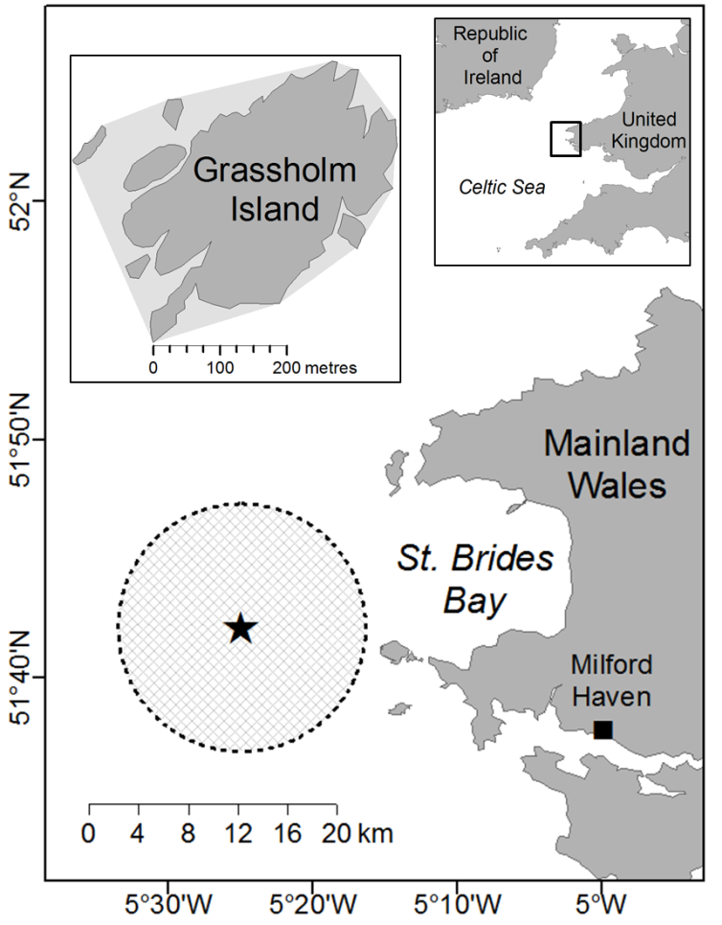
Fig. 1. Star indicates location of the study colony, Grassholm Island (51° 43'N, 5° 28'W), home to approximately 40,000 breeding pairs of Northern Gannets. Dashed line indicates the 10 km radius study limit (see “Rafting study area”). Inset map of the island indicates the minimum convex polygon (light grey area) defined around the colony to exclude GPS fixes of birds on the nest and to account for inherent positional error in GPS transmissions of birds on the island.

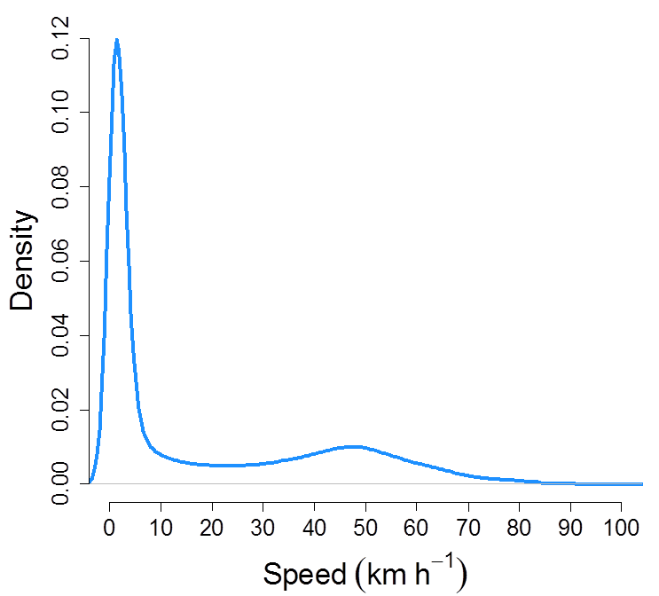

Fig. 2. Kernel density estimate of speed (km h⁻¹) for Northern Gannets. Data taken from all GPS fixes (n=511,572) during all complete tracks (n=389) and filtered to eliminate fixes of birds when stationary on nest. Kernel smoothing parameter (h) = 1.46.
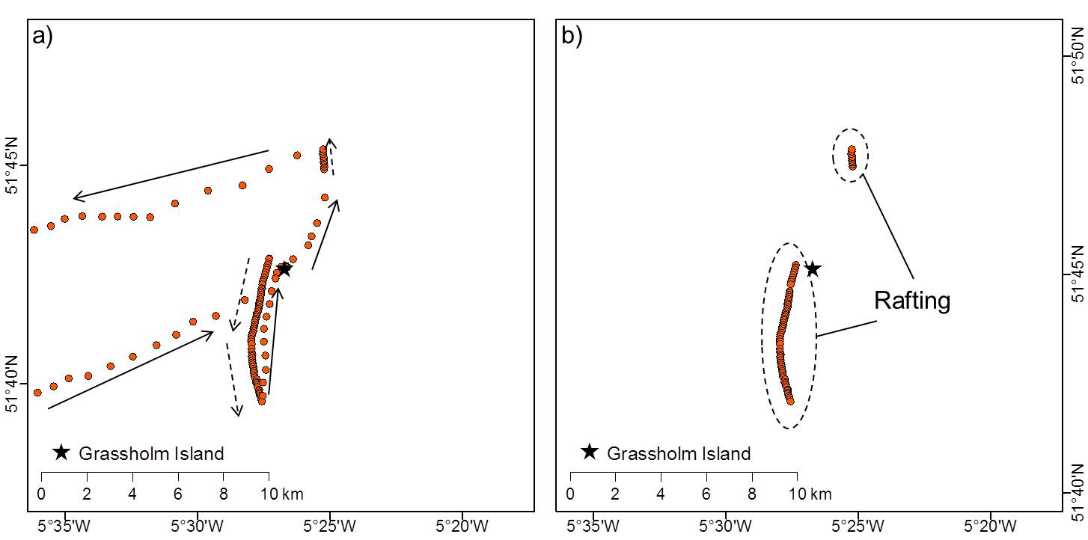
Fig. 3. GPS fixes for one gannet track (a) unfiltered and (b) filtered indicating that rafting events are qualitatively identifiable by directional patterns of close successive fixes. Arrows indicate direction of movement. Dashed arrows indicate movement <10 km h⁻¹.
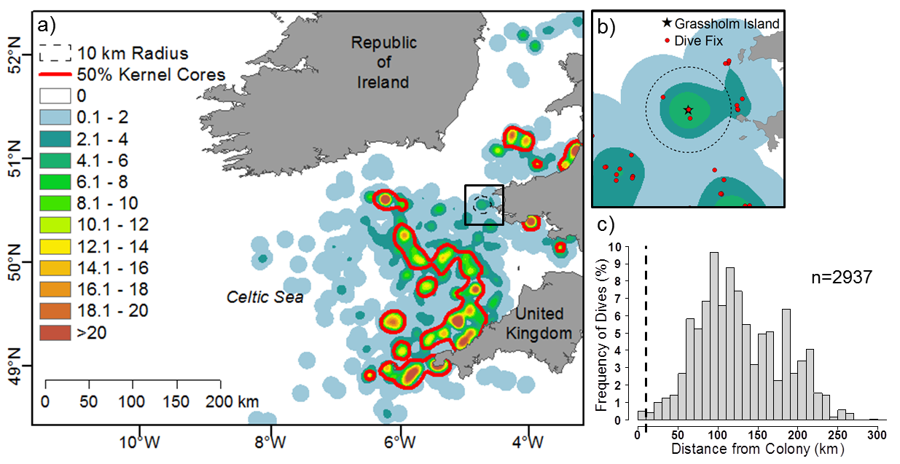
Fig. 4. (a) Kernel density estimate of dive fixes (n=2937) from 69 individuals on 117 foraging trips. Kernel smoothing parameter (h) = 10 km, cell size = 200 m. 50% kernel cores show core foraging areas. Colour palette indicates number of dive fixes per unit area. (b) Inset map shows close-up of the 10 km radius study area. (c) Percentage frequency histogram shows distance from colony of dive fixes with dashed line indicating 10 km radius. Slow moving birds within the study area are not likely to be foraging due to low density of dives.

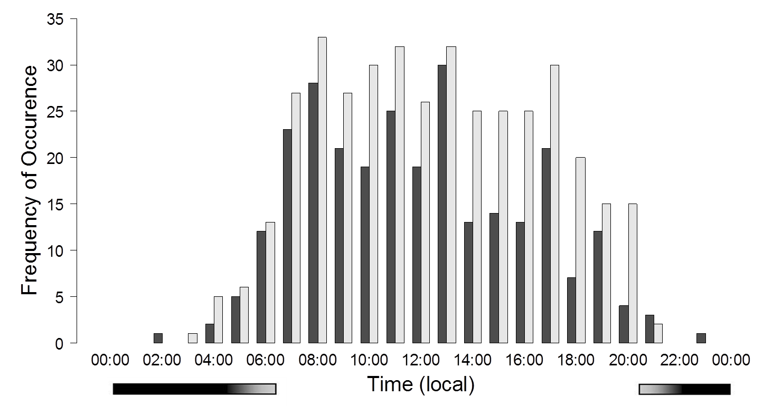

Fig. 5. Frequency distribution of time rafting events (n=262, dark bars) initiated, and departure times for foraging trips (n=389, light bars). Time shown in Greenwich Mean Time (GMT). Gradient bars on the x axis indicate hours of twilight and darkness.
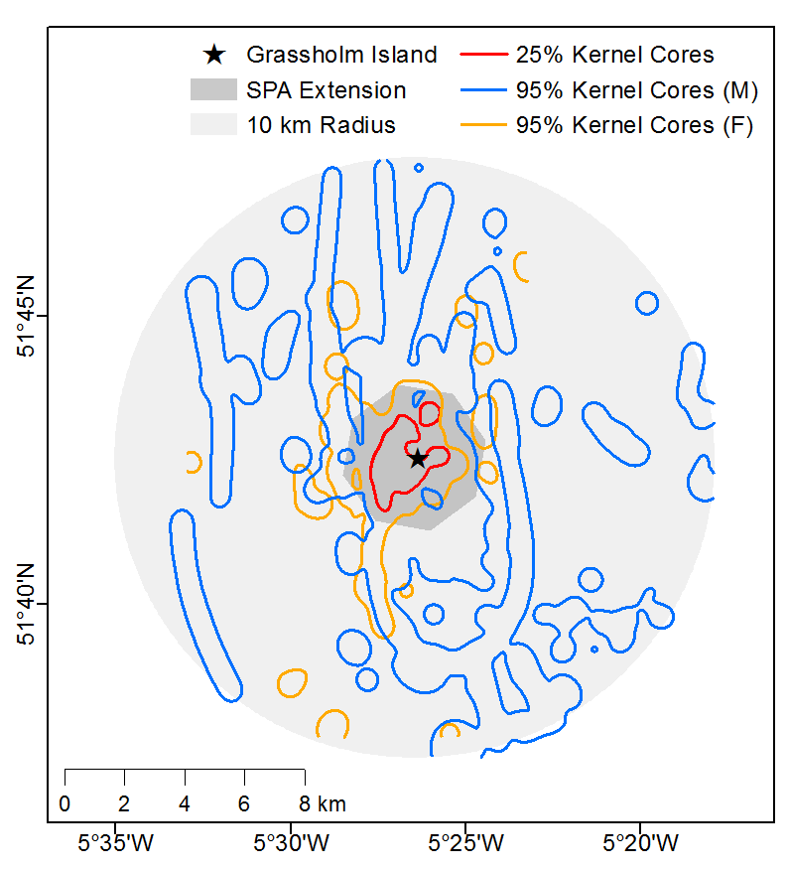
Fig. 6. Kernel density estimate of gannet rafting behaviour in a 10 km radius around the colony. 95% kernel cores represent majority of rafting within the study area for males (blue) and females (gold), 25% kernel cores represent core rafting areas for whole sampled population. Kernel smoothing parameter (h) = 645 m, cell size = 10 m. Dark grey polygon denotes recent 2 km radius seaward extension to SPA.

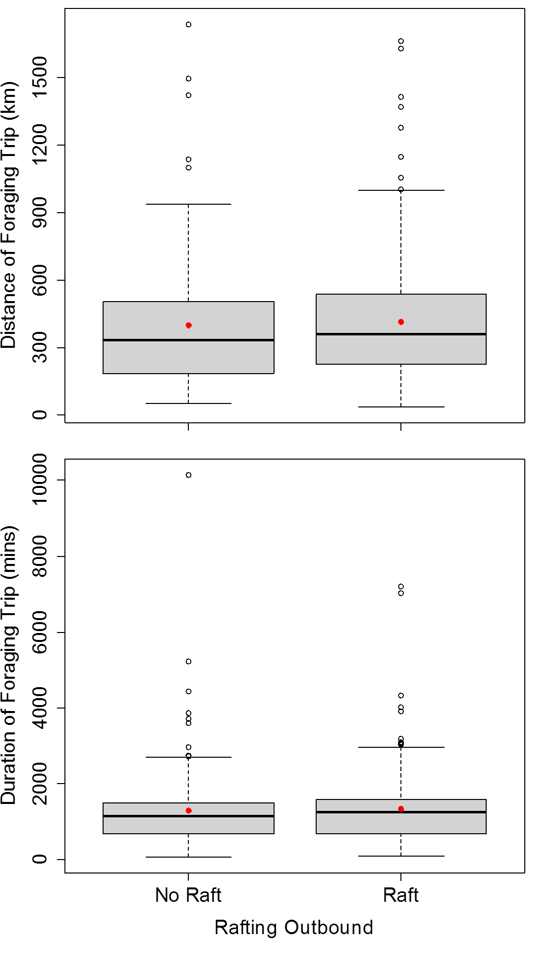
Fig. 7. Boxplots showing effect of presence/absence of outbound rafting on foraging trip (a) total distance (km) and (b) total duration (min). Thick black lines are median values, red dots are mean values, boxes show interquartile ranges, dotted lines show minimum and maximum values. Empty circles are outliers.

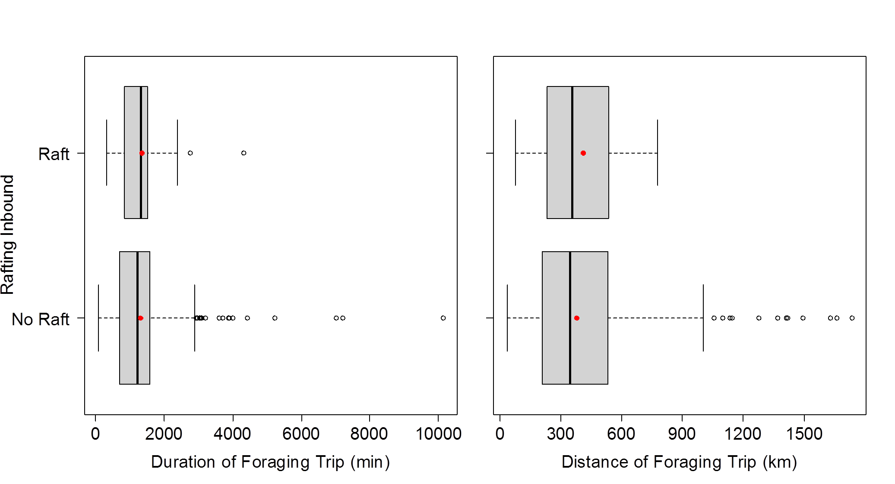
Fig. 8. Boxplots showing effect of foraging trip (a) total duration (min) and (b) total distance (km) on presence/absence of rafting inbound. Thick black lines are median values, red dots are mean values, boxes show interquartile ranges, dotted lines show minimum and maximum values. Empty circles are outliers.
TABLES
Table 1. Sample sizes of GPS tracked birds per year and the associated foraging trips included in this study. Only complete tracks from sexed birds were included for analysis here.
*Some foraging trips (n=8) were later found to be over-night rafting events with no foraging activity. These were included in spatial and incidence analysis of rafting but excluded from analysis of rafting and foraging effort.
 | No. individuals tagged |  |  |  |  | No. individuals included |  |  |  | No. foraging trips included
 | Total | Male | Female | Sex Unknown |  | Total | Male | Female |  | Total | Male | Female
2006 | 26 | 15 | 11 | 0 |  | 22 | 13 | 9 |  | 28 | 17 | 11
2010 | 26 | 14 | 4 | 8 |  | 18 | 14 | 4 |  | 65 | 47 | 18
2011 | 54 | 22 | 15 | 17 |  | 34 | 19 | 15 |  | 173 | 89 | 84
2012 | 43 | 20 | 21 | 2 |  | 41 | 20 | 21 |  | 49 | 28 | 21
2013 | 54 | 20 | 30 | 4 |  | 45 | 19 | 26 |  | 74 | 30 | 44
Total | 203 | 91 | 81 | 31 |  | 160 | 85 | 75 |  | 389* | 211 | 178

Table 2. Incidence of rafting. Number of rafting birds and rafting GPS fixes within 10 km study area per year. Number of rafting birds and rafting GPS fixes recorded in SPA extension boundary and percentage of 10 km radius values. SPA boundary accounts for 17 km², 5.4% of total study area (314 km²).
 | Rafting within 10 km radius  (% of studied birds) |  |  |  |  | Rafting within SPA boundary  (% of 10 km radius values)
 | Total birds | Males | Females | No. GPS fixes |  | Total birds | Males | Females | No. GPS fixes
2006 | 17  (77%) | 11  (85%) | 6  (67%) | 1068 |  | 16  (94%) | 10  (91%) | 6  (100%) | 504  (47%)
2010 | 18  (100%) | 14  (100%) | 4  (100%) | 638 |  | 18  (100%) | 14  (100%) | 4  (100%) | 371  (58%)
2011 | 28  (82%) | 15  (79%) | 13  (87%) | 1280 |  | 28  (100%) | 15  (100%) | 13  (100%) | 570  (45%)
2012 | 29  (71%) | 13  (65%) | 16  (76%) | 756 |  | 24  (83%) | 11  (85%) | 13  (81%) | 348  (46%)
2013 | 27  (60%) | 13  (68%) | 14  (54%) | 814 |  | 21  (78%) | 9  (69%) | 12  (86%) | 285  (35%)
Total | 118  (74%) | 66  (73%) | 52  (64%) | 4556 |  | 107  (91%) | 59  (89%) | 48  (92%) | 2078  (46%)

Table 3. Foraging trip parameters of male and female gannets. Distance and duration values are shown as means ± SD. n=381 foraging trips.
 | Males | Females | Total
Foraging trip distance (km) | 389 ± 257.1 | 425.2 ± 296.1 | 407.9 ± 275.4
Foraging trip duration (min) | 1233.4 ± 808 | 1449.3 ± 1214.6 | 1333 ± 1020.5
No. trips w/ rafting outbound (% of foraging trips) | 116 (57%) | 108 (61%) | 224 (59%)
No. trips w/ rafting inbound (% of foraging trips) | 28 (14%) | 10 (6%) | 38 (10%)

Table 4. Model outputs for analysis of rafting and foraging effort. For all analyses sex was included as fixed effect and individual was a random effect.

 |  |  |  |  |  | Main effect |  |  | Sex effect |  |  | Interaction dep. variable * sex
Figure | Model | Response variable | Dependent variable | Error structure | df | χ² | p |  | χ² | p |  | χ² | p
7a | LMM | Foraging trip distance | Pres./abs. rafting outbound | - | 1 | 0.464 | 0.496 |  | 2.032 | 0.154 |  | 1.02 | 0.31
7b | LMM | Foraging trip duration | Pres./abs. rafting outbound | - | 1 | 0.62 | 0.431 |  | 2.347 | 0.126 |  | 0.612 | 0.434
8a | GLMM | Pres./abs. rafting inbound | Foraging trip duration | "Binomial" | 1 | 0.064 | 0.801 |  | 0.606 | 0.437 |  | 1.932 | 0.165
8b | GLMM | Pres./abs. rafting inbound | Foraging trip distance | "Binomial" | 1 | 0.584 | 0.445 |  | 0.573 | 0.449 |  | 1.754 | 0.185

APPENDIX I
Interpolation of location fixes
GPS loggers recorded gannet locations at differing duty cycles. For this reason, it was necessary to interpolate location fixes to a constant one minute interval to avoid processing data at varying resolutions under the same regime. This process was conducted using a cubic spline interpolation in MATLAB. Fig. A1 shows some examples of the output from this procedure.
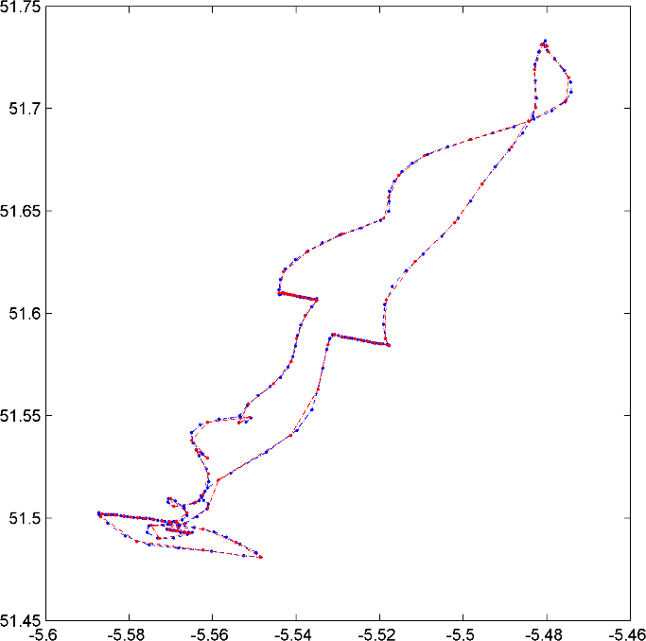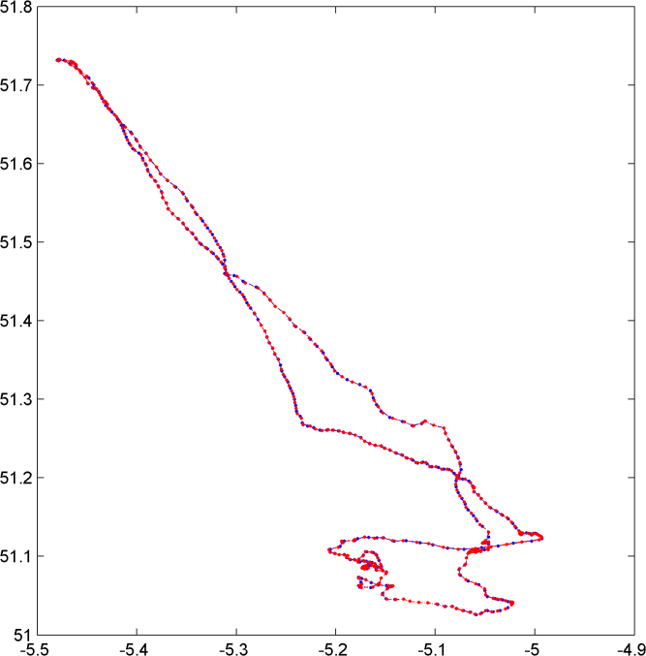
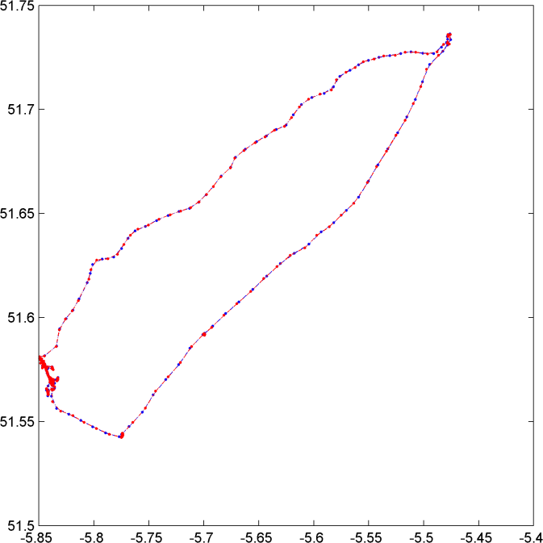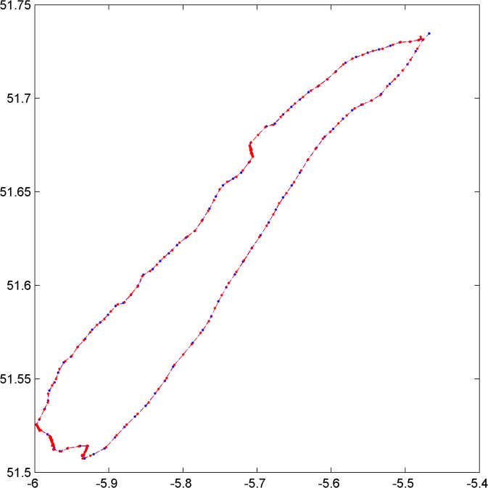
Fig. A1. Re-interpolation of GPS fixes for gannet foraging tracks. Red dots are original GPS fixes, blue dots are fixes re-interpolated to one minute intervals.

APPENDIX II
Sensitivity of methods
Data were screened to sequences of >1 consecutive GPS fixes to avoid counting low speed estimates generated by circling as rafting. To evaluate the sensitivity of this screening regime, we repeated the analysis with sequences >2 fixes. Comparing plotted fixes (Fig. A2a) and kernel density estimates (KDEs) (Fig. A2b) of both methods indicates that there is very little difference in the representation of the spatial distribution of rafting. The second method reports moderately less intensity of habitat use around the colony; 44% of fixes (n=1942) were recorded within the proposed SPA boundary; a negative difference of 2%. In the second analysis, however, 106 birds (66%) recorded rafting behaviour compared to 118 (74%) from the original analysis, although this difference is not significant (χ²₁=0.457, p=0.499). This indicates that 12 birds included in the primary analysis recorded low-speed events of around 2 minutes. Although the second method recorded a lower incidence of rafting in the population, it is unlikely that this difference could be attributed to circling behaviour. Casual field observations of gannets circling at the colony suggest that this behaviour would be absorbed by data screening as they generally circle over the land.
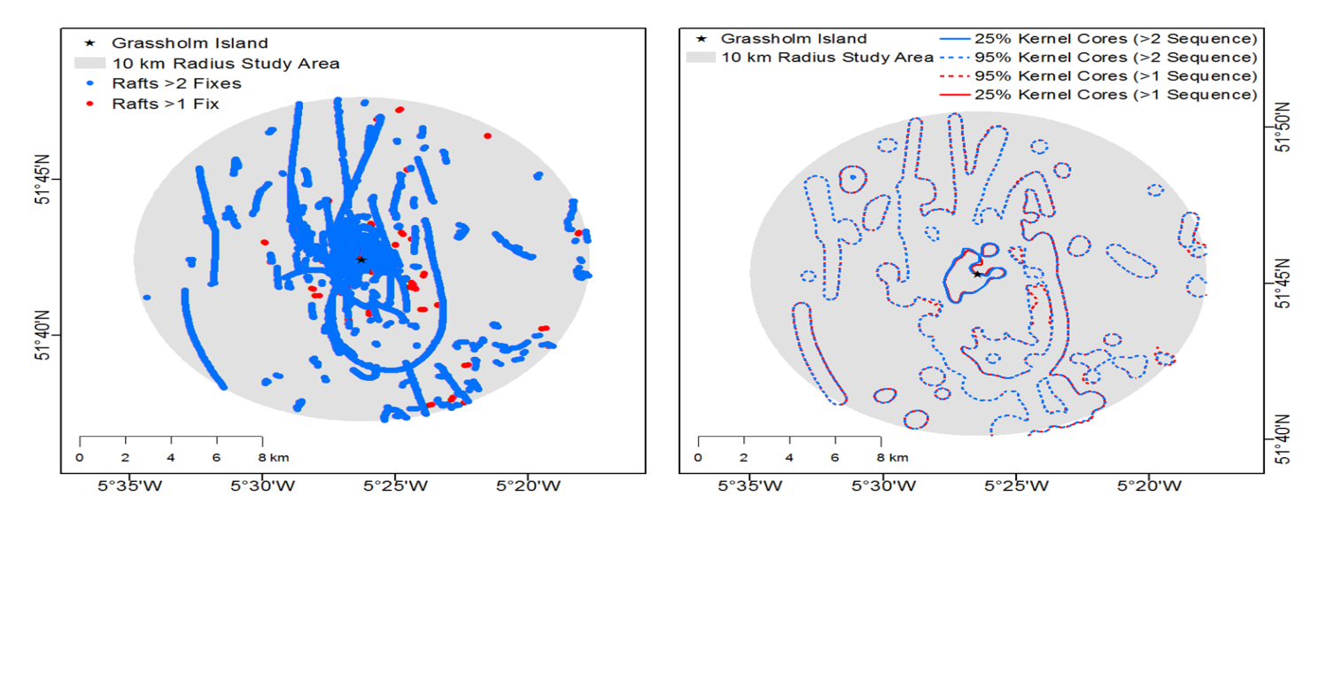
Fig. A2. (a) Plot of all rafting fixes in sequence >2 (blue) overlaid on fixes in sequence >1 (red). Visible red dots show rafting events that would be excluded with this method. (b) 95% isopleths show rafting distribution for >2 sequence analysis (blue) overlaid on >1 sequence (red). Kernel smoothing parameter (h) = 645 m, cell size = 10 m. The isopleths show little variation in the way that the spatial distribution of rafting is represented.
APPENDIX III
Management of dive data
Dives, defined as periods when the pressure sensor of the TDR indicated activity at >1.5m depth, were matched to the closest GPS fix in time. Any dives occurring after the end of civil dusk (the point at which the centre of the sun is 6° below the local horizon) (n=<10) were deemed to be erroneous and were excluded from analysis, as gannets are known to be diurnal predators (Garthe et al., 2003). A kernel density estimate (KDE) of dive fixes was mapped using a smoothing parameter (h) of 10 km and a cell size of 200 m (Fig. 4b). This smoothing parameter was selected in accordance with a previously documented mean scale of area restricted search (ARS) behaviour for this species (9.1 ± 1.9 km; Hamer et al., 2009). 50% kernel cores were calculated to show core foraging range.

APPENDIX IV
Extent of rafting
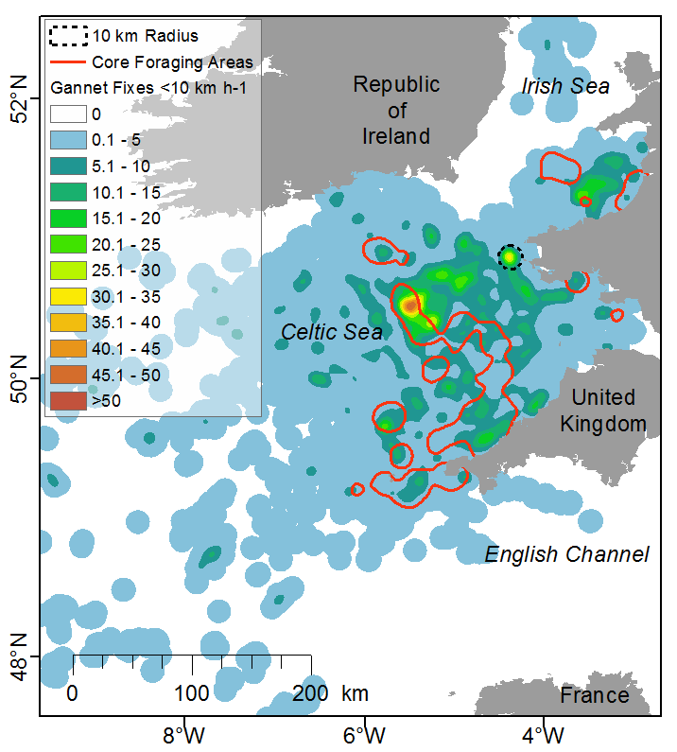
Fig. A3. Kernel density estimate of GPS location fixes of birds travelling <10 km h⁻¹ together with core foraging areas (red lines) calculated from 50% kernel cores of gannet dives (see Fig. 4b). Kernel smoothing parameter (h) = 10 km, cell size = 200 m. Colour palette indicates number of GPS fixes per unit area. This map shows that, although rafting is clustered around the colony, it appears to occur also on a wider scale. Rafting away from the colony may coincide with foraging.

REFERENCES
Garthe, S., Benvenuti, S. & Montevecchi, W.A. 2003. Temporal patterns of foraging activities of northern gannets, Morus bassanus, in the northwest Atlantic Ocean. Can. J. Zool. 461: 453–461.
Hamer, K.C., Humphreys, E.M., Magalhães, M.C., Garthe, S., Hennicke, J., Peters, G., et al. 2009. Fine-scale foraging behaviour of a medium-ranging marine predator. J. Anim. Ecol. 78: 880–889.

