Title: HPI reactivity does not reflect changes in personality among trout introduced to bold or shy social groups

Short Title: Effect of social interaction on trout coping style

Jack S. Thomsonª, Phillip C. Watts^{b}, Tom G. Pottinger^{c} & Lynne U. Sneddon^{d}

ª School of Environmental Sciences, University of Liverpool, Liverpool, L69 3GP, UK
^{b} Department of Ecology, University of Oulu, FI-90014, Finland
^{c} Centre for Ecology and Hydrology, Lancaster Environment Centre, Bailrigg, Lancaster, LA1 4AP, UK
^{c} School of Life Sciences, University of Liverpool, Liverpool, L69 7ZB, UK

Author and address for correspondence:
Jack S. Thomson
School of Environmental Sciences
Nicholson Building
Brownlow Street
University of Liverpool
L69 3GP

jsthomson.ecol@gmail.com
0151 794 3594

Summary
Physiological stress responses often correlate with personalities (e.g. boldness). However, this relationship can become decoupled, although the mechanisms underlying changes in this relationship are poorly understood. Here we quantify (1) how an individual’s boldness (response to novel objects) in rainbow trout, Oncorhynchus mykiss, changes in response to interactions with a population of either bold or shy conspecifics and we (2) measured associated post-stress cortisol levels. Initially-bold trout became shyer regardless of group composition, whereas shy trout remained shy demonstrating that bold individuals are more plastic. Stress-induced plasma cortisol reflected the original personality of fish but not the personality induced by the treatment, irrespective of population personality. Change in boldness of bold trout may indicate preference towards initially subordinate behaviour when joining a new population. However, here we provide further evidence that behavioural and physiological parameters of coping styles may become uncoupled whereby behavioural changes are not correlated with stress responsiveness.

Keywords: coping style; boldness; behavioural plasticity; Oncorhynchus mykiss; cortisol; group influence

- Introduction

Variation in personality – consistent between-individual differences in behaviour (Adriaenssens & Johnsson, 2012) – has clear fitness consequences and is, therefore, evolutionarily important. However, the fitness benefits of behavioural traits depend on the environmental and social context (Sih & Watters, 2005), and the extent to which individuals can modulate their personality to match new challenges thus has important evolutionary implications. While between-individual differences in behaviour generally are consistent through time (Sih et al., 2004), personalities may change dependent upon environmental context (Dingemanse et al., 2010). One key personality axis is boldness, the propensity for taking risks in novel situations (Sneddon, 2003; van Oers et al., 2005). Boldness typically correlates with behaviours such as aggression, activity and exploration (Lima & Dill, 1990; Sneddon et al., 2003; Bell, 2005; van Oers et al., 2005; Adriaenssens & Johnsson, 2012). Interactions with exogenous stimuli often lead to shifts in boldness (Cockrem, 2007; Frost et al., 2007); the extent of behavioural change may, however, be limited by the costs of information gathering and integration, usually in the form of detecting environmental cues and enacting any relevant physiological adjustments associated with such change (DeWitt et al., 1998).

Personality has been linked with the magnitude of an individual’s physiological response to stress (e.g. Koolhaas et al., 1999) such that individuals can be described according to coping style. Proactive animals respond to stress with relatively low hypothalamo-pituitary-adrenal/interrenal (HPA/I) axis activity and tend to exhibit bold behaviour, while reactive individuals are characterised by a higher HPA/I response, inactivity and shyness. Additionally, proactive and reactive animals have different capacities for behavioural change, with proactive animals more likely to form routines and having more rigid personalities than the more behaviourally labile reactive animals (Koolhaas et al., 1999; Cockrem, 2007; Ruiz-Gomez et al., 2011). These individual differences are heritable and likely provide populations with the requisite behavioural variation to cope with a variety of environmental pressures (Ruiz-Gomez et al., 2011). However, recent data suggests that proactive and reactive profiles are not rigid per se. For instance, though boldness is often strongly linked with HPA/I reactivity, the relationship could be context-dependent or decoupled under particular environments (e.g. Vaz-Serrano et al., 2011). Likewise, incidents of high stress have also been observed to induce behavioural change in trout without a shift in underlying physiological parameters (Ruiz-Gomez et al., 2008) . Recent work has explored whether underlying physiology drives behavioural differences (Koolhaas et al., 2010), whether behaviour instead drives physiological differences through encouraging exposure to particular stress-inducing challenges (Carere et al., 2010), or indeed whether such relationships are linked through underlying factors such as a common pathway or pleiotropic effects (Carere et al., 2010). Currently, none of these relationships appears to be particularly strongly supported over any other.

Although personality of an individual strongly defines their responses to stimuli, a common question, particularly among social animals, is how much of any behavioural response can be attributed to an individual’s personality compared to the influence of other group members (Magnhagen & Bunnefeld, 2009). The contribution of individual and social factors may depend on context: in some instances, individuals of a particular personality may take a particular role (e.g. initiative and leadership by bold individuals; LeBlond & Reebs, 2006; Harcourt et al., 2009; Favati et al., 2014); alternatively, the group’s actions may be influenced by the average behaviour of the group (Sih & Watters, 2005). However, individual fish may be expected to adapt their behaviour to conform to their group behavioural profile to minimise the potential increase in risk (associated with behaving differently to the rest of the group) whilst simultaneously maximising the benefits of working together and sharing information, particularly to more quickly acclimate to a new environment with unknown risks and resource availability (Krause & Ruxton, 2002; Magnhagen, 2012; Castanheira et al., 2016). Thus the expectation is that there may be a shift in some behaviours as individuals join a group. However, how socially-induced changes in personality are reflected in underlying physiological mechanisms appear to be little explored.

Thus, the aims of this study were (1) to determine whether boldness in rainbow trout Oncorhynchus mykiss is influenced by the behavioural composition of a social group, and whether such behavioural change was linked to the personality of the fish itself; and (2) to determine whether post-stress cortisol profiles reflect any such behavioural change. The relationship between personality and stress responsiveness has been well-explored in rainbow trout (Øverli et al., 2005; Thomson et al., 2011) and O. mykiss therefore provides a robust model for investigating animal personality and the influence of personality on how individuals respond to social and environmental stimuli.

2. Material and methods

2.1 General animal husbandry

Rainbow trout, Oncorhynchus mykiss (approx. 7.5-12.5 cm total length) were obtained from a commercial supplier and housed in stock tanks (2 x 2 x 0.5 m) at approximately 170 fish per tank (not all of which were used in this project). Trout were maintained on a semi-recirculating system on a 14:10 h light:dark cycle at 13±1°C, and fed 1% body weight per day on commercial trout feed (Skretting, UK). Half of the tank had an opaque cover for shelter. For experimental procedures, fish were caught at random and transferred to individual glass aquaria (90 x 50 x 45 cm; termed the home aquaria) which were screened from visual disturbance (Figure 1). All home aquaria were supplied with filtered freshwater and maintained at 10 ± 1°C with constant aeration and 1% body weight of food per day at the same time each day. Fish to be used as a focal individual were anaesthetised, weighed and tagged one day after transferal to the home aquarium (Section 2.4). Otherwise, fish were allowed to acclimatize for at least one week before being evaluated for boldness (Section 2.2) to ensure that behavioural responses to stimuli are not been impaired by the stress associated with moving (Beitinger, 1990). Fish that did not resume feeding within two weeks of moving were excluded from the experiment.

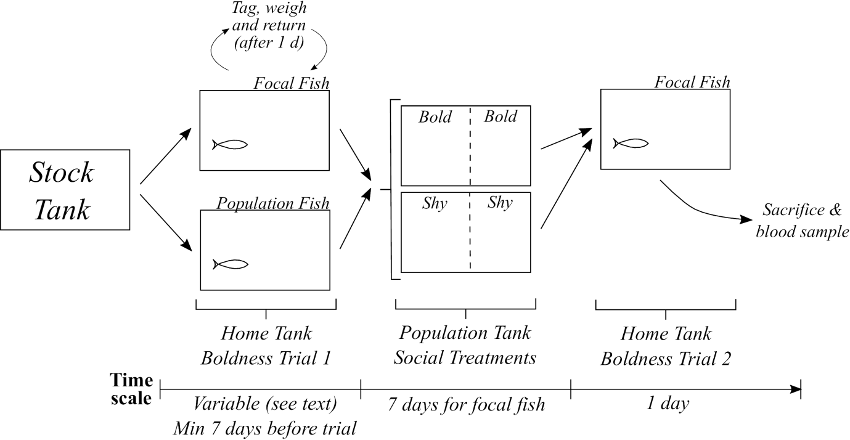

Figure 1: Schematic of the experimental procedure, indicating the experimental set-up and the time-scale of experiments. Dotted lines indicate dividers within the Population Tanks which housed two fish populations simultaneously (see Section 2.3 for details).

2.2 Individual boldness trial I

Boldness was assessed using standard novel object tests used to distinguish bold and shy behaviour in rainbow trout (Frost et al., 2007; Thomson et al., 2011), and which correlate with other measures of boldness, e.g. latency to emerge into a novel arena (Brown et al., 2007; Adriaenssens & Johnsson, 2012), latency to taste novel prey (Frost et al., 2007), and the degree of active / passive) behaviour (Thomson et al., 2011). A low-light video camera was positioned in front of the home aquarium that was lined with rulers to quantify the position of any fish and object. After 10 min, to allow fish to recover from any disturbance of setting up the equipment, a novel object was placed into the centre of the aquarium and the behaviour of the fish was recorded for 10 min (see also Section 2.7). Boldness was scored according to three factors: latency to approach to within 5 cm of a novel object (approach latency), duration of time that individuals were passive (passive duration), and the frequency with which an individual initiated passive behaviour (passive frequency). Passive behaviour included the subject resting at the base of the tank, pivoting on its own axis, and drifting across the tank, but excluded active swimming for more than one body length. Including measures of passive behaviour provides further justification of our selection criterion for identifying bold and shy fish.

Concordant with previous studies (Frost et al., 2007; Thomson et al., 2011; Thomson et al., 2012), the main measure of boldness was latency to approach the novel object; fish that approached the novel object within 180 s were considered bold (n=13) and those that did not approach the object within 300 s as shy (n=21), as trout that do not approach an object within 600s are unlikely to approach it ever (Frost et al., 2007). No fish had an approach latency between 180-300 s in the first trial. Trout classified as bold or shy exhibit clear differences in personality (e.g. Thomson et al., 2011; Thomson et al., 2012), with such measures of behaviour consistent over time in constant conditions (Thomson et al., 2011) . After this test for boldness, fish were moved into population tanks (Figure 1) either as a member of the population (Section 2.3) or as a focal fish (Section 2.4).

2.3 Population tanks

Separate social populations of either nine bold or nine shy trout were set up in opaquely-sided tanks (~149x92x37 cm) that were otherwise identical to the stock tanks. Populations consisted of entirely bold or shy groups to maximise the impact of social cues on focal individuals and to limit potential conflicting cues that may arise from mixed groups. A total of four populations (two bold and two shy; Figure 1) were established in two aquaria, with populations within the same aquarium separated by a divider to prevent direct interactions. As populations within the same tank shared the same flow-through of water, the same behavioural types, both the social population and the focal individual, were maintained in the same aquarium to ameliorate transfer of chemical cues associated with specific behaviours among populations during the experiments. Populations were established over a one-month period, with the same fish utilized throughout the experiment to reduce variation in the population composition between focal fish, and to minimize the total numbers of animals used in accordance with Home Office guidelines.

2.4 Focal fish

The day after the transfer from stock tanks to home aquaria, focal trout (n=34, 35.64±3.09 g) were netted, anaesthetized (benzocaine: Sigma-Aldrich Co., UK) at 0.033 g l⁻¹) and tagged using yellow visible implant elastomer (VIE, Northwest Marine Technology Inc.) behind the eye. Tagging with VIE has no effect on fish behaviour or growth (Olsen & Vøllestad, 2001). Each fish was weighed (to 0.01 g), returned to its home aquarium and allowed to acclimate for one week or until resumption of feeding. Focal fish were then given the novel object test (Section 2.2) to assess boldness before being placed into one of the population tanks. Only one focal fish was placed into each population at a time.

2.5 Social treatment

Focal fish spent 1 week in the population tank (Figure 1), during which time the group was exposed (in random order) to three cues, each on a single occasion: (1) novel object exposure - a novel object was placed centrally into the tank and left for 15 min before being retrieved with a net (see also 2.8 Novel Objects); (2) simulated predator attack – food pellets were presented to the population and when one fish attempted to feed, a predator threat was simulated using a model heron (Ardea cinerea) head that was thrust towards the group of fish twice in succession (Jönsson et al., 1996; Johnsson et al., 2001); (3) Net chase - the population was chased with a hand-net (15x10 cm) for 2 min, with the net moved around the tank to ensure that each fish was chased; net-chasing is thought to simulate chasing by a predator (Brown et al., 2007). These cues were intended to encourage a population response to an environmental challenge, thereby reinforcing interactions within the population to facilitate possible transmission of boldness-related behaviour between the focal fish and other trout within their populations.

During husbandry procedures two bold focal fish in a bold population were observed to be chased by the population animals; this would be expected, since rainbow trout form dominance hierarchies through agonistic interactions (Pottinger & Carrick, 2001; Gilmour et al., 2005), and bold animals are more aggressive and tend to become dominant (Sih et al., 2004; Huntingford & Adams, 2005). Animals that experienced excessive chasing and which exhibited signs of stress were removed from the experiment within 24 hours; there was no evidence that this biased our sample, since our data is fully representative for bold and shy fish, with no systematic removal of fish that responded during a certain time period (Section 3.1). To minimise the impact upon focal fish, the sample size for the bold focal fish in bold population treatment group was capped at n=5. Aggressive interactions were not quantified as part of the experiment. No chasing behaviour was observed among the shy population, nor of shy focal fish held within the bold population, and thus sample sizes were not capped for these treatments.

2.6 Individual boldness trial II

After one week, the focal fish was identified by its VIE tag, retrieved and replaced in its home aquarium. After a 24 hour recovery period, focal fish were re-tested for boldness (Section 2.7): a 24 hour period was considered sufficient time to allow the fish to recover from the immediate stress of handling, but not enough time to re-habituate to solitary conditions. Physiological habituation to stimuli takes upwards of 7 days in trout (Moreira et al., 2004) whilst behavioural conditioning also takes more than 2 or 3 days to achieve (Sneddon, 2003). Trout are routinely tested for boldness immediately after movement between tanks or locations as part of novel- or open-field tests (e.g. Schjolden et al., 2005), suggesting that relocation does not appreciably alter behaviour. Therefore the second measure of boldness was considered to accurately reflect the animal’s behaviour after co-habitation with the population, and extending the recovery period would have a detrimental impact on our estimate of the influence of social exposure to behaviour.

2.7 Novel objects

Each focal fish was exposed to three novel objects throughout the study.
- Boldness trial I (section 2.2): Orange rubber stopper (7.1 x 4.9 cm)
- Social Treatment (section 2.5): Lego DuploTM construct with shapes and colours altered between every trial and each used just once throughout the study (objects constructed from a combination of 4-8 blocks, either 2x2 or 2x4; mean ± SE volume of objects=137.7 ± 9.1cm³; colours of bricks were red, blue and black)
- Boldness trial II (section 2.6): Weighted blue box (7.5 x 5.3 x 3.8cm)
Use of three objects prevented individuals from habituating to one object, although this procedure was precautionary as it is unlikely that fish will habituate unless an object is presented regularly and repeatedly (Sneddon et al., 2003); here, an object was presented at a maximum rate of once per week.

2.8 Stress physiology measurements

On the same day as the final behavioural trial focal fish were exposed to an emersion stressor by being netted and lifted from the water for 60 s to induce an acute physiological stress response (Pickering & Pottinger, 1989). Focal fish were then returned to the home aquaria for 15 min (to allow a cortisol response to the stressor to develop), after which time the fish was netted and euthanized by concussion. This procedure was completed at the same time each day for every focal fish to ensure that hormonal levels were not compromised by diel fluctuations (Pickering & Pottinger, 1983). Immediately after euthanasia, fish were weighed and a blood sample was taken from the caudal vessels into a 2 ml heparinised syringe. The blood was centrifuged at 3,500 RPM for 5 min at 4ºC, and the supernatant plasma aspirated and frozen at -20ºC until analysis. Cortisol concentrations were determined using a validated radioimmunoassay procedure (Pottinger & Carrick, 2001) with sample order randomised and the assays conducted blind. Overall, 34 focal fish were tested (in bold populations: 5 bold and 11 shy; in shy populations: 8 bold and 10 shy). Given the size of the fish and the possible effect of blood removal on blood volume and associated tissue damage it was considered too much of a risk to the well-being and survival of the fish to collect blood for cortisol measurements before the Social Treatment.

2.9 Statistical Analyses
All analyses were completed in R (v. 3.2.3; R Core Team, 2015) and in all cases p values were compared to α=0.05.

Mann-Whitney tests were used to compare the passive duration (s) and passive frequency between ostensibly bold and shy trout in the first trial, and thus demonstrate that approach latency alone (Section 2.2) could be used to discriminate between discrete bold and shy personalities. Post-stress plasma cortisol concentration (ng ml⁻¹) was analysed using ANOVA with focal boldness, group boldness, and their interaction as fixed factors. Analysis of specific growth rate is detailed in Supplementary Material.

Change in passive behaviour and passive frequency across the two trials were analysed using a mixed-model approach (Zuur et al., 2009). For passive duration a linear mixed effects model (lmer) was used whereas passive frequency was modelled using a generalized linear mixed effects model (glmer) approach assuming a Poisson distribution (using the package lme4, v. 1.1-12; Bates et al., 2015). In each case, individuals were considered as a random effect (with random intercepts), and focal personality, group personality and trial number as fixed effects. Initially, full models were constructed using all main effects and their full interactions. Models were reduced with step-wise removal of non-significant terms and comparisons of BIC (using the nlme package; Pinheiro et al., 2016) until a minimum adequate model (MAM) was developed (Table 1); p values for individual terms in the final models were then obtained through a Likelihood Ratio Test procedure, comparing the model with the term to the MAM under a Chi-squared distribution. Assumptions of normality and heteroscedasticity were checked by plotting the residuals.

Approach latency was subject to strong floor- and ceiling-effects and analysis using the above method resulted in an error structure which indicated the data did not meet the assumptions of these models. Modelling using the above approach was therefore inappropriate for these data. Instead, a binomial logit regression model was used to determine whether there was any effect of either the original personality of the focal fish or the population personality, or their interaction, on whether individuals changed their boldness. A change in boldness was considered to be a change in approach latency that crossed the selection criterion boundary e.g. a change of approach latency from 10s to 150s was not considered a change in boldness, since both fall within the definition of ‘bold’, but a change from 10s to 200s was considered a change since the upper limit for bold behaviour was 180s. As per previous models, a model reduction approach was taken, removing non-significant terms in the model and comparing BIC between models (using the nlme package; Pinheiro et al., 2016) to generate a MAM (Table 1).

Table 1: Full and Minimum Adequate Models (MAM) and BIC for each behavioural response variable used in analyses. Parameters are abbreviated as pop (boldness of the population into which the focal fish was placed: bold or shy), foc (boldness of the focal fish: bold or shy) and trial (behavioural trial before or after the focal fish spent one week with the population fish), along with an error term indicating repeated measurements on individual fish (id).
 | Model Parameters | BIC
Passive Duration (s)
Linear Mixed Effects Model (lmer)
Full | pop × foc × trial +(1|id) | 856.97
MAM | foc × trial + (1|id) | 810.11
Passive Frequency
Generalized Linear Mixed Effects Model (glmer)
Full | pop × foc × trial + (1|id) | 524.14
MAM | pop + foc + trial + (pop × trial) + (foc × trial) + (1|id) | 518.16
Change in boldness
Binary Logistic model (glm)
Full | pop × foc | 41.00
MAM | pop + foc | 39.55

3. Results

  - Initial Behaviour and Justification of Selection Criterion

The Results from this study are comprised from a total of n=70 fish, involved either within the populations (n=36) or as focal fish (n=34). Personality descriptors of focal fish were defined by approach latency, with a priori definitions of bold fish approaching to within 5cm of the novel object within 180s and shy fish approaching after 300s or not at all. Here fish exhibited a similar distribution: in the first trial, bold focal fish approached the object very quickly (mean ± SE approach latency for bold fish=42.1 ± 12.5s) whereas most (18 of 21) shy fish did not approach the object at all (Figure 2a). No fish exhibited an approach latency between 180 – 300s. Fish selected for boldness on this criterion also exhibited differences in activity levels: bold fish were initially less passive than shy fish (W=72, p=0.023; Figure 2b). Likewise, bold fish more frequently switched between passive and active behaviour than shy fish (W=198.5, p=0.029; Figure 2c). These data therefore justify the selection criterion and binning of fish into bold or shy categories.

3.2 Physiology

Irrespective of the behavioural type of the population that focal fish were placed into (F_{1,30}=0.08, p=0.78), bold trout consistently had significantly lower post-stress plasma cortisol concentrations than shy trout (mean ± SE =36.18±5.93 ng ml⁻¹ for bold and 89.82±11.40 ng ml⁻¹ for shy; F_{1,30}=7.92, p=0.009; Figure 2). The interaction of personality and population was not significant (F_{1,30}=0.05, p=0.83). Specific growth rate did not differ between any treatment groups; see Supplementary Material for further information.

3.3 Behavioural Change

Passive duration differed between trials dependent on the personality of the focal fish (χ²₁=6.60, p=0.010). Bold fish in the initial trial were, on average, the least passive; however, after the trial bold focal fish were at least as passive as shy fish, which did not appear to change in this behaviour across the two trials (Figure 2b). Frequency of passive behaviour also differed between trials, with the change in frequency dependent on both the personality of the group (χ²₁=18.03, p<0.0005) and of the focal individual (χ²₁=5.72, p=0.0168), but there was no significant interaction between all three parameters. Initially bold focal fish switched between active and passive behaviours most frequently; both bold and shy focal fish
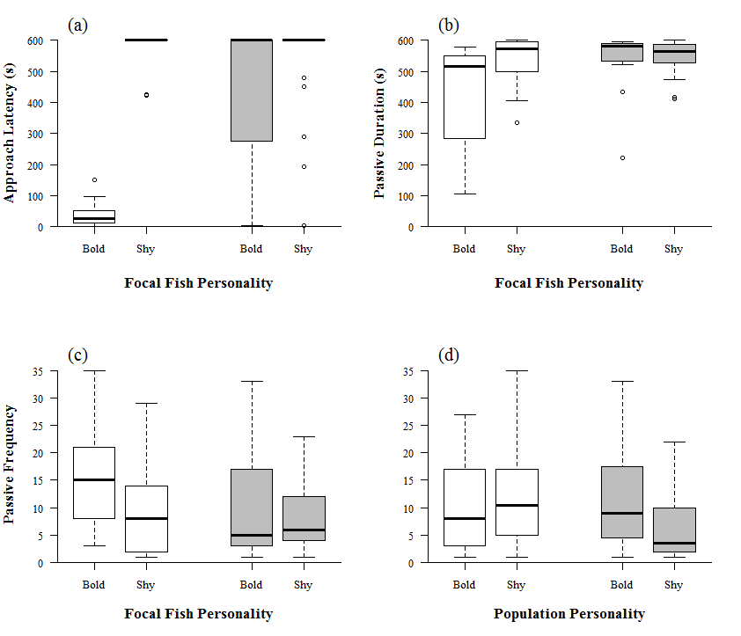

Figure 2: Behaviour of rainbow trout, Oncorhynchus mykiss, before (white boxes) and after (grey boxes) a week spent with a population of either bold or shy trout (where boldness was measured as latency to approach within 5cm of a novel object, and where bold fish approached in <180s and shy fish approached in >300s or not at all). Figures indicate different measures of behaviour: (a) latency to approach to within 5cm of a novel object (s) for bold and shy focal fish; (b) duration of passive behaviour (s) of bold and shy focal fish; and frequency of changing between passive and active behaviour (see text for details) between (c) bold and shy focal fish and (d) comparisons of all focal fish compared between populations. For all boxes: line=median, box=interquartile range, whiskers indicate extent of data <1.5×IQR, dots=outliers (greater than 1.5×IQR outside the box).
reduced the frequency of switching behaviours in the second trial (Figure 2c). However, in the second trial fish which had spent time in a bold population tended to switch behaviour more frequently than those which had spent time in the shy population (Figure 2d).

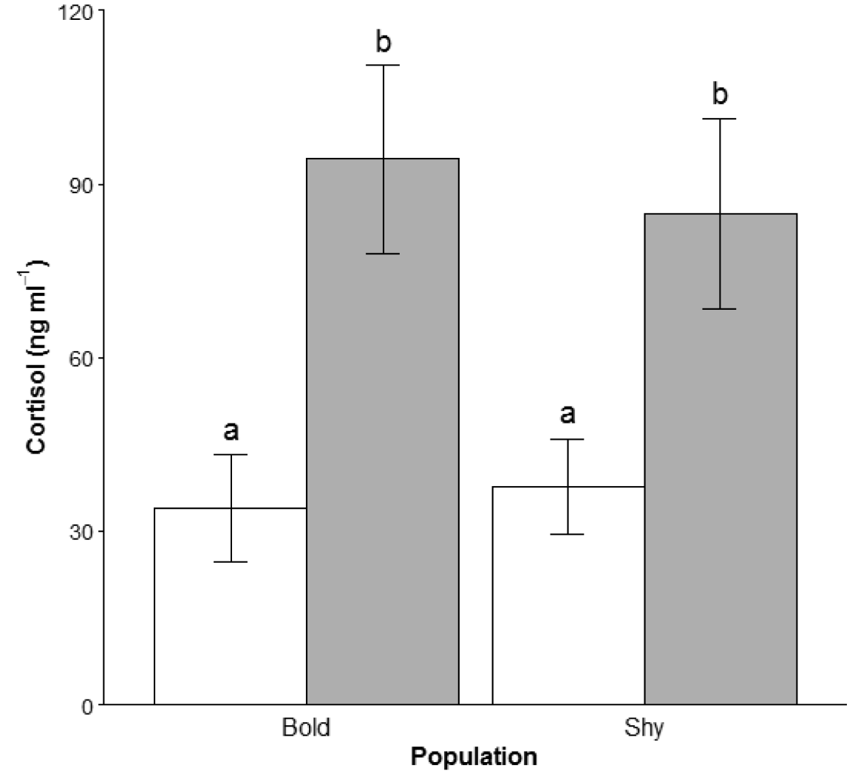
Figure 3: Mean (±SE) plasma cortisol concentrations in bold (white) and shy (grey) rainbow trout, Oncorhynchus mykiss, 15 min after an emersion stress. Individual trout were placed into a group of either nine bold (Bold Population) or nine shy conspecifics (Shy Population) for one week before sampling. Groups which do not share a common lower case letter were significantly different (p<0.05). n=5,8 for bold trout and n=11,10 for shy trout in a bold and shy population respectively.

Initially-bold fish were more likely to change their boldness than shy fish (z₂=-3.08, p=0.002; Figure 2a): 77% of initially bold fish changed their behaviour towards either an intermediate or shy type, whereas only 14% of initially shy focal fish changed behaviour. There was, however, no effect of the personality of the population in determining whether focal fish changed boldness (z₂=-1.36, p=0.175).

Discussion

Plasticity of behaviour and coping style allows individuals flexibility to deal with rapid changes in environment. Here, we show that trout tended towards a shy behavioural strategy after time spent with a population of conspecifics, regardless of their original personality or that of the population with which they cohabited. Of significant interest, however, was that stress physiology reflected the original personality type of the focal fish rather than the personality after removal from the population: initially-bold fish exhibited lower plasma cortisol concentrations than initially-shy trout regardless of any behavioural change.

4.1 Physiology

Post-stress cortisol profiles differed between initially bold or shy focal fish, regardless of any change in behavioural profile. The link between HPI reactivity and boldness is well-established (Koolhaas et al., 1999; Øverli et al., 2005) yet studies are beginning to highlight occasions where this link is disrupted, either through behavioural inconsistency or a combined behavioural and physiological inconsistency over time under certain conditions (e.g. Ruiz-Gomez et al., 2008; Vaz-Serrano et al., 2011; Boulton et al., 2015). We took only one blood sample, and thus could only detect stress-induced cortisol secretion at the end of the experiment rather than quantify temporal changes (an issue that may have been resolved by using larger fish); however, our data imply that whilst boldness may change under social conditions in rainbow trout, the underlying physiological components reflect an innate behavioural type (i.e. bold or shy). Thus whilst coping styles may provide an excellent model of the relationship between personality traits and underlying physiological mechanisms, particularly among rats and mice (Koolhaas et al., 1999), emerging evidence indicates that this association may be lost during development (Vaz-Serrano et al., 2011), periods of stress (Ruiz-Gomez et al., 2008; Boulton et al., 2015), or because the relationship is only evident under certain contexts (Øverli et al., 2007; Castanheira et al., 2016).

Recent studies have focused on the mechanisms underlying differences in stress physiology and personality. For instance, Carere et al. (2010) highlight three proximal explanations for the relationship between stress physiology and personality: (1) stress physiology determines behaviour, (2) additional factors underlie both physiology or behaviour, or (3) behaviour determines physiology. However, a correlation between between stress physiology and personality (potentially due to pleiotropy) may be more likely than a direct cause-effect relationship (Carere et al., 2010). Indeed, greater plasticity in personality than physiology (e.g. Ruiz-Gomez et al., 2008) may indicate one or more additional, unmeasured, factor(s), to explain the decoupling between behaviour and physiology. However, what should also be considered are the broad suite of hormones, proteins and pathway interactions which exert some control over the HPI axis (and thus cortisol secretion) and the roles that they might also have in the control of behaviour. For instance, corticotropin releasing factor initiates the HPI axis by binding to receptors in the pituitary, but is also implicated in control of appetite (Bernier & Craig, 2005), aggression (Backström et al., 2011) and locomotor activity (Clements et al., 2002). Also, serotonin influences agonistic interactions (LePage et al., 2005) but has roles in regulation of adrenocorticotropic hormone and cortisol secretion and is likely regulated itself by corticosteroids (Dinan, 1996; Kreke & Dietrich, 2008). Such direct interactions between elements of the HPI axis and behaviour are numerous, and suggest that if behaviour can change whilst HPI reactivity remains static further underlying mechanisms mediating the relationship are likely to be present and require further study. Importantly, these data have potential implications for how individuals cope with stress whilst simultaneously interacting, often competitively, with an established group of conspecifics.

4.2 Behavioural flexibility

Trout adjusted levels of neophobia and activity a suite of behaviours when placed into a population of conspecifics. However, the change was largely independent of the population-level behaviour and, instead, was associated with the original personality of the focal fish: the implication is that bold and shy trout may react to a population differently. Furthermore, this would suggest that behavioural change under these conditions is not driven by a requirement for social cohesiveness: behavioural homogeneity within a group increases information sharing, for instance, and may limit opportunities for predators to single out potential prey in an extension of the oddity effect (which usually applies to how different individuals look compared to their group rather than how they behave; Krause & Ruxton, 2002). Thus other factors may contribute to observed behavioural changes, though further studies should investigate how behaviour changes over various time scales within, and after removal from, the population.

Particularly among animals which form dominance hierarchies (Winberg & LePage, 1998; Sneddon et al., 2005) entry into a group may provide a distinct challenge for a newcomer, as the hierarchy must be resettled, often through agonistic interactions (e.g. trout; Barnard & Burk, 1979), and where the new member may be the focus of aggression (Johnsson, 1997; Höjesjö et al., 1998). Effects of prior residency (e.g. Deverill et al., 1999) and experience within the group naturally provide a competitive advantage for group members over new entrants, even moreso than the experience of winning a contest (Kim & Zuk, 2000). Furthermore, group members encountering a new individual may only need to resolve this single contest whereas the new member will likely be required to resolve contests against all the members of the group which, coupled with transport between tanks, will be extremely stressful, particularly if the focal fish is inherently aggressive. Thus new members may need to utilise, or be coerced into utilising, a subordinate or shy strategy (Huntingford, 1976; Sundström et al., 2004; Bell, 2005) to accommodate themselves within the group (Øverli et al., 2004). Indeed, dominant individuals tend to exert a behavioural influence rather than allow group behaviour to be defined by consensus (Sih & Watters, 2005; Magnhagen & Bunnefeld, 2009).

An alternative explanation for differences in behavioural change between bold and shy focal fish may derive from known differences in cognitive ability between fish, where bold/proactive individuals tend to have greater learning ability than and shy/reactive fish (Sneddon et al., 2003; Moreira et al., 2004). Such differences in learning ability also manifest within social contexts (Magnhagen & Staffan, 2003). Thus, if shy fish take longer to learn than bold fish, then any change in behaviour may not have occurred within the timespan of this experiment. Furthermore, the duration such changes last after removal from the group may also differ; bold animals retain responses to a conditioned stimulus for longer (Moreira et al., 2004), and this may impact on how these fish respond in the future both in a social context but, potentially, to unrelated environmental stimuli.

Behavioural change (in bold focal fish) or lack of change (in shy fish) was not ubiquitous. Some bold fish (approximately 20-25%) remained bold, possibly because these fish were particularly aggressive or large relative to the population into which they were placed and thus able to compete successfully under difficult conditions. Unfortunately, no direct measurements of the behaviour of focal fish within the population tank were made, only observations of behaviour during regular husbandry procedures, nor were measurements of the size of population fish recorded. Shy fish can become bolder after watching other fish or winning competitive interactions (Frost et al., 2007). Whether individuals changed in behaviour may depend upon the degree with which they observed or directly interacted with other fish in the group. We did not measure behaviour or behavioural change within the population itself and thus the mechanisms of any behavioural change within this study are difficult to explain, but are an important consideration for future studies. Furthermore, addressing whether the population exhibited the expected bold or shy personalities as a group for the duration of the experiment should be measured. We chose to use the same populations throughout to reduce the number of fish used in the experiment for ethical reasons and to ensure each focal individual had the same experience rather than each individual being presented with a different group which may have confounded our results; however, this is certainly a factor of interest.

4.4 Conclusions and implications

Our data support emerging evidence that the relationship between stress physiology and personality, as accepted through coping style theory, can become decoupled. Whilst the change in behaviour observed, principally in bold focal fish becoming shyer, has implications for our understanding of how fish may integrate into social groups, that stress responses were linked to individuals’ initial personality may indicate alternative and unexplored factors link physiology and behaviour and mediate the personality change within this particular context. Furthermore, these data may also help us improve the social environment and integration for fish held in captivity, particularly in compliance with regulations on use of animals in scientific research to ensure social animals are housed appropriately.

Acknowledgments
JT was supported by a NERC CASE PhD studentship [NE/F008120/1] supervised by LS, PW and TGP. LS, PW and TGP are grateful for a research grant from the Leverhulme Trust. We are grateful to Helen Evans, Lisa Olohan and Gregor Govan for technical assistance; and also to Jon Banks and Scott Weiss for the development of custom-built cameras and behavioural analysis software, respectively. We would also like to thank two anonymous reviewers for their feedback on the manuscript, and to the editor, Mark Briffa, for advice on statistical procedures.

References

Adriaenssens, B. & Johnsson, J. I. (2012). Natural selection, plasticity and the emergence of a behavioural syndrome in the wild. — Ecology Letters 16, 47-55.
Backström, T., Schjolden, J., Øverli, Ø., Thörnqvist, P.-O. & Winberg, S. (2011). Stress effects on AVT and CRF systems in two strains of rainbow trout (Oncorhynchus mykiss) divergent in stress responsiveness. — Hormones and Behavior 59, 180-186.
Barnard, C. J. & Burk, T. (1979). Dominance hierarchies and the evolution of "individual recognition". — Journal of Theoretical Biology 81, 65-73.
Bates, D., Maechler, M., Bolker, B. & Walker, S. (2015). Fitting Linear Mixed-Effects Models Using lme4. — Journal of Statistical Software 67, 1-48.
Beitinger, T. L. (1990). Behavioral reactions for the assessment of stress in fishes. — Journal of Great Lakes Research 16, 495-528.
Bell, A. M. (2005). Behavioural differences between individuals and two populations of stickleback (Gasterosteus aculeatus). — Journal of Evolutionary Biology 18, 464-473.
Bernier, N. J. & Craig, P. M. (2005). CRF-related peptides contribute to stress response and regulation of appetite in hypoxic rainbow trout. — American Journal of Physiology: Regulatory, Integrative and Comparative Physiology 289, R982-R990.
Boulton, K., Couto, E., Grimmer, A. J., Earley, R. L., Canario, A. V. M., Wilson, A. J. & Walling, C. A. (2015). How integrated are behavioral and endocrine stress response traits? A repeated measures approach to testing the stress-coping style model. — Ecology and Evolution 5, 618-633.
Brown, C., Burgess, F. & Braithwaite, V. A. (2007). Heritable and experiential effects on boldness in a tropical poeciliid. — Behavioural Ecology & Sociobiology 62, 237-243.
Carere, C., Caramaschi, D. & Fawcett, T. W. (2010). Covariation between personalities and individual differences in coping with stress: Converging evidence and hypotheses. — Current Zoology 56, 728-740.
Castanheira, M. F., Cerqueira, M., Millot, S., Gonçalves, R. A., Oliveira, C. C. V., Conceição, L. E. C. & Martins, C. I. M. (2016). Are personality traits consistent in fish? - The influence of social context. — Applied Animal Behaviour Science 178, 96-101.
Clements, S., Schreck, C. B., Larsen, D. A. & Dickhoff, W. W. (2002). Central administration of corticotropin-releasing hormone stimulates locomotor activity in juvenile chinook salmon. — General and Comparative Endocrinology 125, 319-327.
Cockrem, J. F. (2007). Stress, corticosterone responses and avian personalities. — Journal of Ornithology 148, S169-S178.
Deverill, J. I., Adams, C. E. & Bean, C. W. (1999). Prior residence, aggression and territory acquisition in hatchery-reared and wild brown trout. — Journal of Fish Biology 55, 868-875.
DeWitt, T. J., Sih, A. & Wilson, D. S. (1998). Costs and limits of phenotypic plasticity. — Trends in Ecology and Evolution 13, 77-81.
Dinan, T. G. (1996). Serotonin and the regulation of hypothalamic-pituitary-adrenal axis function. — Life Sciences 58, 1683-1694.
Dingemanse, N. J., Kazem, A. J. N., Réale, D. & Wright, J. (2010). Behavioural reaction norms: where animal personality meets individual plasticity. — Trends in Ecology and Evolution 25, 81-89.
Favati, A., Leimar, O., Radesäter, T. & Løvlie, H. (2014). Social status and personality: stability in social state can promote consistency of behavioural responses. — Proceedings of the Royal Society B 281, 20132531.
Frost, A. J., Winrow-Giffen, A., Ashley, P. J. & Sneddon, L. U. (2007). Plasticity in animal personality traits: does prior experience alter the degree of boldness? — Proceedings of the Royal Society B 274, 333-339.
Gilmour, K. M., DiBattista, J. D. & Thomas, J. B. (2005). Physiological causes and consequences of social status in salmonid fish. — Integrative and Comparative Biology 45, 263-273.
Harcourt, J. L., Sweetman, G., Johnstone, R. A. & Manica, A. (2009). Personality counts: the effect of boldness on shoal choice in three-spined sticklebacks. — Animal Behaviour 77, 1501-1505.
Höjesjö, J., Johnsson, J. I., Petersson, E. & Järvi, T. (1998). The importance of being familiar: individual recognition and social behavior in sea trout (Salmo trutta). — Behavioral Ecology 9, 445-451.
Huntingford, F. & Adams, C. (2005). Behavioural syndromes in farmed fish: implications for production and welfare. — Behaviour 142, 1207-1221.
Huntingford, F. A. (1976). The relationship between anti-predator behaviour and aggression among conspecifics in the three-spined stickleback, Gasterosteus aculeatus. — Animal Behaviour 24, 245-260.
Johnsson, J. I. (1997). Individual recognition affects aggression and dominance relations in rainbow trout, Oncorhynchus mykiss. — Ethology 103, 267-282.
Johnsson, J. I., Sernland, E. & Blixt, M. (2001). Sex-specific aggression and antipredator behaviour in young brown trout. — Ethology 107, 587-599.
Jönsson, E., Johnsson, J. r. I. & Björnsson, B. T. (1996). Growth hormone increases predation exposure of rainbow trout. — Proceedings of the Royal Society B 263, 647-651.
Kim, T. & Zuk, M. (2000). The effects of age and previous experience on social rank in female red junglefowl, Gallus gallus spadiceus. — Animal Behaviour 60, 239-244.
Koolhaas, J. M., de Boer, S. F., Coppens, C. M. & Buwalda, B. (2010). Neuroendocrinology of coping styles: Towards understanding the biology of individual variation. — Frontiers in Neuroendocrinology 31, 307-321.
Koolhaas, J. M., Korte, S. M., De Boer, S. F., Van der Vegt, B. J., Van Reenen, C. G., Hopster, H., De Jong, I. C., Ruis, M. A. W. & Blokhuis, H. J. (1999). Coping styles in animals: Current status in behavior and stress-physiology. — Neuroscience and Biobehavioral Reviews 23, 925-935.
Krause, J. & Ruxton, G. D. (2002). Living in Groups. — Oxford University Press, Oxford.
Kreke, N. & Dietrich, D. R. (2008). Physiological endpoints for potential SSRI interactions in fish. — Critical Reviews in Toxicology 37, 215-247.
LeBlond, C. & Reebs, S. G. (2006). Individual leadership and boldness in shoals of golden shiners (Notemigonus crysoleucas). — Behaviour 143, 1263-1280.
LePage, O., Larson, E. T., Mayer, I. & Winberg, S. (2005). Serotonin, but not melatonin, plays a role in shaping dominant-subordinate relationships and aggression in rainbow trout. — Hormones and Behavior 48, 233-242.
Lima, S. L. & Dill, L. M. (1990). Behavioral decisions made under the risk of predation: a review and prospectus. — Canadian Journal of Zoology 68, 619-640.
Magnhagen, C. (2012). Personalities in a crowd: What shapes the behaviour of Eurasian perch and other shoaling fishes? — Current Zoology 58, 35-44.
Magnhagen, C. & Bunnefeld, N. (2009). Express your personality or go along with the group: what determines the behaviour of shoaling perch? — Proceedings of the Royal Society B 276, 3369-3374.
Magnhagen, C. & Staffan, F. (2003). Social learning in young-of-the-year perch encountering a novel food type. — Journal of Fish Biology 63, 824-829.
Moreira, P. S. A., Pulman, K. G. T. & Pottinger, T. G. (2004). Extinction of a conditioned response in rainbow trout selected for high or low responsiveness to stress. — Hormones and Behavior 46, 450-457.
Olsen, E. M. & Vøllestad, L. A. (2001). An evaluation of visible implant elastomer for marking age-0 brown trout. — North American Journal of Fisheries Management 21, 967-970.
Øverli, Ø., Korzan, W. J., Larson, E. T., Winberg, S., LePage, O., Pottinger, T. G., Renner, K. J. & Summers, C. H. (2004). Behavioral and neuroendocrine correlates of displaced aggression in trout. — Hormones and Behavior 45, 324-329.
Øverli, Ø., Sørensen, C., Pulman, K. G. T., Pottinger, T. G., Korzan, W., Summers, C. H. & Nilsson, G. E. (2007). Evolutionary background for stress-coping styles: relationships between physiological, behavioral, and cognitive traits in non-mammalian vertebrates. — Neuroscience and Biobehavioral Reviews 31, 396-412.
Øverli, Ø., Winberg, S. & Pottinger, T. G. (2005). Behavioral and neuroendocrine correlates of selection for stress responsiveness in rainbow trout - a review. — Integrative and Comparative Biology 45, 463-474.
Pickering, A. D. & Pottinger, T. G. (1983). Seasonal and diel changes in plasma cortisol levels of the brown trout, Salmo trutta L. — General and Comparative Endocrinology 49, 232-239.
—. (1989). Stress responses and disease resistance in salmonid fish - effects of chronic elevation of plasma-cortisol. — Fish Physiology and Biochemistry 7, 253-258.
Pinheiro, J., Bates, D., DebRoy, S., Sarkar, D. & Team, R. C. (2016). Linear and Nonlinear Mixed Effects Models. — In.
Pottinger, T. G. & Carrick, T. R. (2001). Stress responsiveness affects dominant-subordinate relationships in rainbow trout. — Hormones and Behavior 40, 419-427.
Ruiz-Gomez, M. d. L., Huntingford, F. A., Øverli, Ø., Thornqvist, P.-O. & Höglund, E. (2011). Response to environmental change in rainbow trout selected for divergent stress coping styles. — Physiology & Behavior 102, 317-322.
Ruiz-Gomez, M. d. L., Kittilsen, S., Höglund, E., Huntingford, F. A., Sørensen, C., Pottinger, T. G., Bakken, M., Winberg, S., Korzan, W. J. & Øverli, Ø. (2008). Behavioral plasticity in rainbow trout (Oncorhynchus mykiss) with divergent coping styles: when doves become hawks. — Hormones and Behavior 54, 534-538.
Schjolden, J., Backström, T., Pulman, K. G. T., Pottinger, T. G. & Winberg, S. (2005). Divergence in behavioural responses to stress in two strains of rainbow trout (Oncorhynchus mykiss) with contrasting stress responsiveness. — Hormones and Behavior 48, 537-544.
Sih, A., Bell, A. & Johnson, J. C. (2004). Behavioral syndromes: an ecological and evolutionary overview. — Trends in Ecology and Evolution 19, 372-378.
Sih, A. & Watters, J. V. (2005). The mix matters: behavioural types and group dynamics in water striders. — Behaviour 142, 1417-1431.
Sneddon, L. U. (2003). The bold and the shy: individual differences in rainbow trout. — Journal of Fish Biology 62, 971-975.
Sneddon, L. U., Braithwaite, V. A. & Gentle, M. J. (2003). Novel object test: examining nociception and fear in the rainbow trout. — Journal of Pain 4, 431-440.
Sneddon, L. U., Margareto, J. & Cossins, A. R. (2005). The use of transcriptomics to address questions in behaviour: Production of a suppression subtractive hybridisation library from dominance hierarchies of rainbow trout. — Physiological and Biochemical Zoology 75, 695-705.
Sundström, L. F., Petersson, E., Höjesjö, J., Johnsson, J. I. & Järvi, T. (2004). Hatchery selection promotes boldness in newly hatched brown trout (Salmo trutta): implications for dominance. — Behavioral Ecology 15, 192-198.
Thomson, J. S., Watts, P. C., Pottinger, T. G. & Sneddon, L. U. (2011). Physiological and genetic correlates of boldness: Characterising the mechanisms of behavioural variation in rainbow trout, Oncorhynchus mykiss. — Hormones and Behavior 59, 67-74.
—. (2012). Plasticity of boldness in rainbow trout, Oncorhynchus mykiss: do hunger and predation influence risk-taking behaviour? — Hormones and Behavior 61, 750-757.
van Oers, K., Klunder, M. & Drent, P. J. (2005). Context dependence of personalities: Risk-taking behavior in a social and a nonsocial situation. — Behavioral Ecology 16, 716-723.
Vaz-Serrano, J., Ruiz-Gomez, M. d. L., Gjøen, H.-M., Skov, P. V., Huntingford, F. A., Øverli, Ø. & Höglund, E. (2011). Consistent boldness behaviour in early emerging fry of domesticated Atlantic salmon (Salmo salar): Decoupling of behavioural and physiological traits of the proactive stress coping style. — Physiology & Behavior 103, 359-364.
Winberg, S. & LePage, O. (1998). Elevation of brain 5-HT activity, POMC expression, and plasma cortisol in socially subordinate rainbow trout. — American Journal of Physiology: Regulatory, Integrative and Comparative Physiology 274, 645-654.
Zuur, A. F., Ieno, E. N., Walker, N. J., Saveliev, A. A. & Smith, G. M. (2009). Mixed Effects Models and Extensions in Ecology with R. — Springer, New York.

Supplementary Material
Analysis of Specific Growth Rate
Specific growth rate (%) was analysed using ANOVA with focal boldness, group boldness, and their interaction as fixed factors. Specific growth rate was calculated as G=100 × [log(w_{f}) – log(w_{i})] × (t⁻¹) where w_{f}=final weight (g), w_{i}=initial weight (g) and t=time as days in study (Höjesjö et al., 1999). t varied per fish due to only limited space being available in population tanks, with mean t=20.3 (SE ± 1.2) days for the entire experiment.

Most focal individuals lost a small amount of weight throughout the test period (mean weight change ± SE =-0.89±0.31 g), with only initially shy trout placed into a shy population showing a mean positive growth rate (Figure 4). However, growth rate between trials was not significantly different either between initially bold and shy rainbow trout (F_{1,29}=0.56, p=0.46) or between the population into which fish were placed (F_{1,29}=2.06, p=0.16). Growth rate was not influenced by the interaction of initial personality and population (F_{1,29}=0.05, p=0.54).

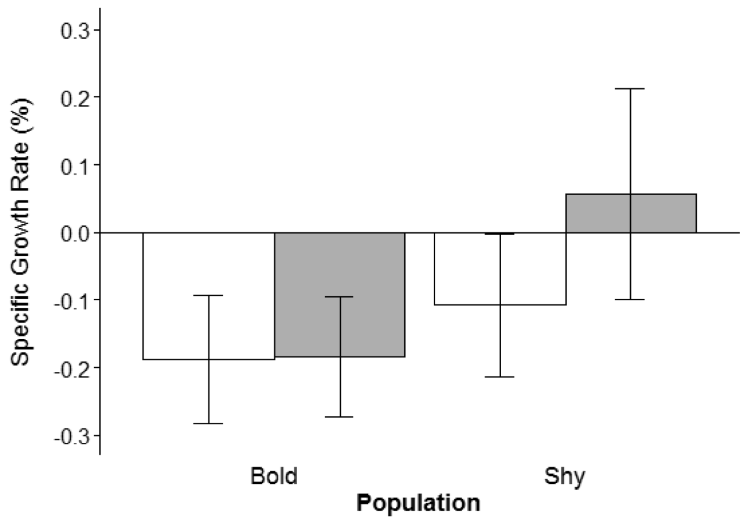
Figure S1: Mean (±SE) specific growth rate (G) of bold (white) and shy (grey) rainbow trout,
Oncorhynchus mykiss, placed for one week into a population of nine bold or shy trout. n=5,8 for bold trout and n=10,10 for shy trout in a bold and shy population respectively.

