Nonlinear dynamics of straight fluid-conveying pipes with general boundary conditions and additional springs and masses

T. Zhang 1,2,[1], H. Ouyang 2, Y.O. Zhang 1, B.L. Lv 2,3

*1. School of Naval Architecture and Ocean Engineering, Huazhong University of Science & Technology, Wuhan 430074, China*

*2. School of Engineering, University of Liverpool, The Quadrangle, Liverpool L69 3GH, UK*

*3. College of Power and Energy Engineering, Harbin Engineering University, Harbin, 150001, P. R. China*

**Abstract**

In this paper, nonlinear equations of three-dimensional motion are established for straight fluid-conveying pipes with general boundary conditions. Firstly ten springs at the two ends of the pipes are used to represent the general boundary conditions, and the displacements are expressed as the superposition of a Fourier cosine series and four supplementary functions to satisfy the boundary conditions. Then in the Lagrangian framework, three coupled equations of motion in compact matrix form are derived by using the extended Hamilton’s principle, and the effect of the extra linear springs and lumped masses at arbitrary positions along the pipe are also considered in these equations. The natural frequencies of pipes with several different boundary conditions are computed by the linearized dynamic equations in order to validate the method through comparisons with results from other reliable sources. Nonlinear dynamic behaviour of the pipes with different boundary conditions is analysed by solving the nonlinear equations using the Runge-Kutta scheme at last. It is found that the method presented in the paper could conveniently and effectively solve the nonlinear vibration problem of fluid-conveying pipes with general boundary conditions and additional springs and masses.

Keywords: Nonlinear, Dynamics, Fluid-conveying pipes, General boundary conditions, Stability

## 1. Introduction

Fluid-conveying pipes are one of the most common and important structures widely used in engineering and the dynamics of these pipes has been a popular research topic. A significant amount of research has been carried out on dynamics of fluid-conveying pipes. From the literature in the past 50 years, various numerical or approximate analytical methods have been applied to pipe dynamics [1-4]. The research into dynamics of straight pipes can be roughly divided into two categories according to the dynamic characteristics of the pipes: those with rigid boundaries so that the non-conservative flow-induced force has no effect on the system stability and those with non-rigid boundaries so that the non-conservative flow-induced force has a strong influence on the system stability.

A pipe whose translations at both ends are fully constrained is a conservative system if dissipative damping is ignored, and its equations of motion are typically described in the Lagrangian framework and derived from Hamilton’s principle or Newton’s laws of motion. The equations can be discretized and solved by many methods. The modal superposition method [5-7] and the Galerkin method [8-10] are conveniently used for pipelines modelled as beams. There are other similar approaches such as Differential Quadrature Method (DQM) [11, 12], Differential Transformation Method (DTM) [13, 14] and Finite Difference Method (FDM) [15]. A pipe can even be taken as a cylindrical shell [16]. The finite element method (FEM) is more suitable for complex pipe systems [17, 18]. Moreover, the interaction between pipes and fluids can be studied in more details by the FEM, or by the Spectral Element Method (SEM) [19, 20]. In addition, the wave approach [21] and the transfer matrix method (TMM) [22, 23] are also well-suited to analysis of periodic or multi-span pipelines. It seems that most of the afore-mentioned papers are more concerned with linear dynamics of pipes and the influence on the structure of fluids than with the nonlinear dynamic behaviour of pipes [24].

Being an inherently non-conservative system, the dynamic behaviour of a cantilever fluid-conveying pipe is more interesting and complicated than a simply-supported or clamped pipe (either of which is a conservative system when damping is absent), especially at very high fluid velocity. The motion of the pipe exhibits complex bifurcations and even chaos usually associated with strong nonlinearities [25-30]. It should be noted that Païdoussis and his co-workers set up a set of nonlinear equations of motion in the Eulerian framework for large deflection. Only the lateral motion of the pipe as a function of the curvilinear coordinate along the centreline of the pipe needs to be studied because the longitudinal displacement can be expressed by the lateral displacement with the inextensibility condition [3, 26, 27]. Vertical cantilever pipes with spring supports and concentrated masses in 2D vibration [31-33] and 3D vibration [34-38] were studied, and these works revealed that the vibration involved bifurcation and was really complex for non-conservative pipe systems. On the other hand, it is also very important to get convergent and accurate results at lowest possible cost [39]. In contrast with the Eulerian approach mentioned above, a novel extended Lagrange version of the non-linear equations for cantilever pipes was also presented [40] and the numerical results agreed with the results of [2]. Moreover, it is worth noting that a three-dimensional, geometrically exact theory for flexible fluid-conveying tubes with variable cross sections was derived in [41]. The dynamic change of the cross section showed significant effects on both the linear and nonlinear solutions.

In this paper, new 3-dimensional nonlinear equations of motion are derived from the extended Hamilton’s principle for a fluid-conveying pipe with general boundary conditions. In contrast with other published works, the displacements in the three perpendicular directions are expressed as special Fourier series [42], which is also called improved Fourier series method in some papers [43, 44]. One major advantage of the method is that all kinds of boundary conditions can be covered by suitable springs at both ends of the pipe. The unknown coefficients of the special Fourier series can be viewed as generalized coordinates of displacements. Another advantage is that energy variation is with respect to each generalized coordinates but not directly to displacements. Then by means of the extended Hamilton’s principle [1, 3], the equations of motion with square and cubic nonlinear stiffness terms can be conveniently obtained for the fluid-conveying pipe. Moreover, linear springs and lumped masses at arbitrary positions along the pipe can also be included in the dynamic system in order to widen the practical application of this method. Its validity and accuracy are confirmed by results of simulated numerical examples compared with the results from the published literature, and the linear and nonlinear dynamic behaviour is analysed in several cases with different boundary conditions at last.

## 2. Problem formulation

To simplify the analysis, a uniform Euler-Bernoulli beam is used to model a typical slender fluid-conveying pipe. Some devices and elastic supports on the pipe are included as lumped masses and linear springs, as shown in Fig. 1. A Cartesian coordinate system is also defined.

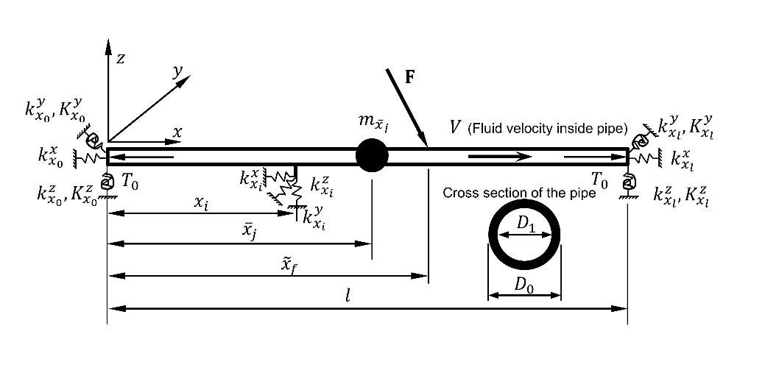

Fig. 1 Schematics of a pipe conveying fluid with multiple elastic supports and lumped masses.

To represent general boundary conditions at both ends of the pipe, there are respectively five springs (two rotational springs about the *y* and *z* axes and three linear springs in three perpendicular directions) [42]. In addition, there are  elastic supports modelled as linear grounded springs and devices modelled as lumped masses along the pipe, with the location of the *i*-th set of springs , and  marked by  and the location of the *j*-th lumped mass  marked by , where the superscripts indicate the directions of the springs. Taking into account the springs at the two ends of the pipe, and  and  added into the sequence , then the stiffness of linear springs at the two ends are denoted by , , , ,  and . Similarly the stiffness values of the rotational springs are denoted as , ,  and . There is always fluid flow inside the pipe at a constant velocity , and a balanced tensile force  is applied at both ends (tension is positive and compression is negative).

## 3. Equations of Motion

For a three-dimensional Euler-Bernoulli beam, respectively the longitudinal, transverse and vertical displacements of a point on the pipe in the three directions are given by:

|  |  |
| --- | --- |
|  | (1) |

where ,  and are the coordinates of a point of the pipe in the Lagrangian coordinate system, and ,  and  are the longitudinal, transverse and vertical displacements of the neutral axis of the pipe, respectively.

Using a nonlinear strain-displacement relation and neglecting the shear strain, the normal strain of a point in the pipe can be expressed as:

|  |  |
| --- | --- |
|  | (2) |

Adding the longitudinal normal strain caused by the axial force  acting at the ends of the pipe, the *x*-direction normal strain becomes:

|  |  |
| --- | --- |
|  | (3) |

where the primes denote the differentiation with respect to the longitudinal coordinate , and  denotes the cross-sectional area of the pipe, and  is the Young's modulus of the pipe’s material.

Only considering the longitudinal normal strain in this study, the strain energy of the pipe is:

|  |  |
| --- | --- |
|  | (4) |

Substituting Eq. (3) into Eq. (4), and considering that the longitudinal displacement of the pipe is a one-order lower quantity than the transverse and vertical displacements, the following equation is obtained:

|  |  |
| --- | --- |
|  | (5) |

where, and  is the second moment of .  represents terms in the fifth order of magnitude or above and thus are subsequently ignored.

The displacement vector of an arbitrary point  on the centre line of the pipe can be written as:

|  |  |
| --- | --- |
|  | (6) |

where, andare the threeorthogonal basis vectors in the Cartesian coordinate system, respectively.

The velocity vector  of the same centre point is:

|  |  |
| --- | --- |
|  | (7) |

in which, the overhead dot represents differentiation with respect to time as usual.

The kinetic energy  of the pipe can be represented by:

|  |  |
| --- | --- |
|  | (8) |

where  is the mass per unit length of the pipe. It is assumed that the fluid velocity is uniform over the entire cross-section of the pipe.

Because of the deformation of the pipe, the relative velocity vector  of the fluid at the centre point in the pipe cross section is given by [1]

|  |  |
| --- | --- |
|  | (9) |

Taking the motion of the structure into account, the absolute fluid velocity vector  at the same point in the Cartesian coordinate system can also be written as follows:

|  |  |
| --- | --- |
|  | (10) |

When the rotary inertia effect and the secondary flow effect are neglected, the kinetic energy  of the fluid inside the pipe can be described as:

|  |  |
| --- | --- |
|  | (11) |

where  is the mass per unit length of the fluid.

Considering the elastic supports at the two ends of the pipe and  intermediate linear springs, the total potential energy of all springs may be expressed as:

|  |  |
| --- | --- |
|  | (12) |

Similarly, for the  lumped masses on the pipe, the total kinetic energy of them can be written as:

|  |  |
| --- | --- |
|  | (13) |

Suppose an external concentrated force vector  acts at  on the pipe. Then the virtual work done by all external forces may be expressed as:

|  |  |
| --- | --- |
|  | (14) |

where ,  and  are the components of force  projected onto the *x*, *y* and *z* axes, respectively;  is the variational operator.

For the above pipe, implementation of the Hamilton’s principle leads to equation below:

|  |  |
| --- | --- |
|  | (15) |

where the last term of Eq. (15) on the left-hand side is the variations of the virtual momentum at the two ends. This term becomes zero when both ends of the pipe are constrained.

 is the outward normal vector at the two ends of the pipe whose expression is respectively:

|  |  |
| --- | --- |
|  | (16) |

The improved Fourier series method [43] is used to transform the equations of motion in the physical coordinates into those in the generalised coordinates and is described below.

The three displacements can be expanded as:

|  |  |
| --- | --- |
|  | (17) |

where , , , ,  and  are vector functions.

In order to simplify the equations, the following dimensionless quantities are introduced:

, , , , , , ,

, , , , , ,

|  |  |
| --- | --- |
| , , , , ,  , | (18) |

Following the improved Fourier series method, these vector functions described above now become:

|  |  |
| --- | --- |
|  | (19) |

where the elements of vectors ,  and are functions of only dimensionless time . Functions  are defined by:

|  |  |
| --- | --- |
|  | (20) |

Actually vector functions ,  and inthe Fourier series are all truncated to a finite number of terms  in this study, and vectors , and can be considered sets of generalised coordinates of the three displacements.

Substituting Eqs. (5), (8), (11), (12), (13) and (17) into Eq. (15), a procedure of variational operations with respect to all these generalised coordinates is executed, and then the following equations governing the motion of the fluid-conveying pipe are obtained:

|  |  |
| --- | --- |
| , | (21.a) |
| , | (21.b) |
| , | (21.c) |

in which,  and are symmetric matrices, and areasymmetrical matrices and they are related to the nonlinear terms in Appendix A. ,  and  are mass matrices, and the dimension is  for  and , and is  for ; ,andare vectors due to the external load. In addition,

|  |  |
| --- | --- |
|  | (22) |

These mass matrices are all symmetrical, and their elements are given in Appendix A. For the axial motion, mass matrix  is formed from the first columns and the first rows of matrix ; ,andaredamping matrices, each of which consists of two parts if the Rayleigh damping is ignored. One part is an anti-symmetrical matrix  caused by the Coriolis force of the fluid inside the pipe, whereas the other part is a symmetrical matrix  caused by the non-conservative force at both ends of the pipe. These damping matrices can be written as follows:

|  |  |
| --- | --- |
|  | (23) |

The elements in matrices  and are given in Appendix B, and  is also a part of , in the same way as is obtained from . If viscosity of the fluid is considered, a linear damping matrix should beadded into the right-hand side of Eq. (23) due to internal energy dissipation of the pipe as a result of the friction between the pipe and the fluid:

|  |  |
| --- | --- |
|  | (24) |

where  and  are Rayleigh damping constants, and  is the stiffness matrix of the pipe itself introduced below.

,  and  arestiffness matrices in the three perpendicular directions respectively, and they can be expressed as sums of several matrices:

|  |  |
| --- | --- |
|  | (25) |

 isa symmetrical matrix. Matrix on the right-hand side of Eq. (25)is due to the centrifugal force caused by the fluid flow and the force acting at both ends of the pipe. Matrix is due to the elastic supports at both ends of the pipe. Matrix  is an asymmetrical matrix caused by the non-conservative force at both ends of the pipe with elastic supports and the last matrix on the right-hand side of the three expressions is caused by the elastic supports along the pipe.

## 4. Natural frequencies of fluid-conveying pipes

For modal analysis of the pipe, it is necessary to obtain the linearized equations of motion in the neighbourhood of equilibrium positions. In this situation when the external force is neglected, the linear equations of motion are given by:

|  |  |
| --- | --- |
|  | (26) |

Actually the above equations which are independent of each other are the free vibration equations of three displacements of the fluid-conveying pipe respectively, and the natural frequencies of the system are solved numerically first. The three equations in Eq. (26) are in the same form, so only the solution process of the vertical displacement is addressed here as an example. By means of an equation reduction technique [45], the free vibration equation of the vertical displacement can be rewritten in the form:

|  |  |
| --- | --- |
|  | (27) |
| , , |  |

The complex eigenvalue  of Eq. (27) satisfy:

|  |  |
| --- | --- |
|  | (28) |

Eq. (27) can be expressed in several different forms, but with the form above matrix  is still symmetrical and this important feature is essential in overcoming the potential ill-posedness of the algorithm used in this paper. Solving the eigenvalue problem of Eq. (27),  pairs of eigenvalues (also called poles)  are obtained, where ‘-’ denotes the complex conjugate. It is known that the imaginary part of the pole is the natural frequency  while the real part is about the stability of the system.

It should be pointed out that Eq. (28) would be a serious ill-conditioned equation with the increase of  (for example, ). For low frequencies, the value of  has a very small effect on the accuracy of the eigenvalues; but for higher frequencies, the effect becomes greater, and very high frequencies may be quite wrong. In the present paper, an improved algorithm is proposed for dealing with the ill-conditioned eigenvalue problem and its details are given in Appendix B.

All the relevant equations are derived for general elastic boundary conditions. It is very easy to simulate all kinds of classical boundary conditions by setting the spring constants at the two ends to appropriate values. Table 1 lists values of the spring constants for four ideal boundary conditions of the pipe.

Table 1 The spring constants to represent the ideal boundary conditions

|  |  |  |  |  |  |  |  |  |  |  |
| --- | --- | --- | --- | --- | --- | --- | --- | --- | --- | --- |
| Boundary conditions |  |  |  |  |  |  |  |  |  |  |
| Cantilever |  |  |  |  |  | 0 | 0 | 0 | 0 | 0 |
| Pinned-pinned |  |  |  | 0 | 0 |  |  |  | 0 | 0 |
| Pinned-clamped |  |  |  | 0 | 0 |  |  |  |  |  |
| Clamped-clamped |  |  |  |  |  |  |  |  |  |  |

In order to explore the convergence and efficiency of this method, the natural frequencies of the pipe without fluids are computed and compared with those reported in [46], as in Table 2.

Table 2 The natural frequencies of the pipe as  increases 

|  |  |  |  |  |  |  |  |
| --- | --- | --- | --- | --- | --- | --- | --- |
|  |  |  |  |  |  |  |  |
| Clamped-clamped | 1 | 903.9174 | 1822.8926 | 3547.5664 | 22.4134 | 61.9520 | 250792.8 |
| 3 | 893.1090 | 1786.9814 | 2762.0153 | 22.3739 | 61.6729 | 123.2994 |
| 5 | 893.0321 | 1786.1600 | 2682.1302 | 22.3733 | 61.6728 | 120.9061 |
| 10 | 893.0164 | 1786.0423 | 2679.0977 | 22.3733 | 61.6729 | 120.9038 |
| 50 | 893.0137 | 1786.0322 | 2679.0407 | 22.3732 | 61.6727 | 120.9042 |
| 100 | 893.0137 | 1786.0322 | 2679.0407 | 22.3730 | 61.6729 | 120.9040 |
| Exact a |  | 893.0084 | 1786.0168 | 2679.0253 | 22.3733 | 61.6728 | 120.9034 |

a results from Blevins (1976).

It is seen that the results of this paper are close to the exact solutions presented by Blevins [46] with increasing value of  and for the first several frequencies, only a few terms of the Fourier series could lead to an accurate solution. Table 3 compares the first four natural frequencies of the fluid-conveying pipe with various stiffness values of both rotational and translational constraints, in which the Fourier series is truncated to . By changing the stiffness of both the rotational and linear springs, the boundary conditions can turn from the pinned-pinned case to the clamped-clamped case. The classical pinned-pinned and clamped-pinned cases show good agreement with [47]. The natural frequencies of the pinned-free pipe with various stiffness of the linear springs are shown in Table 4. Different cases with changing the stiffness of the linear springs at the pinned end are computed, and the pinned-free pipe (, , ) finally turns into a cantilever pipe. In Table 5, the natural frequencies of the pipe with various stiffness values of the linear springs at both ends are listed. The pipe is assumed with  and , and then the stiffness of the linear springs at both ends are changed at the same time.

Table 3 The natural frequencies of the fluid-conveying pipe with various stiffness of both the rotational and linear springs (, , , )

|  |  |  |  |  |  |  |  |
| --- | --- | --- | --- | --- | --- | --- | --- |
|  |  |  |  |  |  |  |  |
|  | 0.01 | 0 | 0 | 0.1726 | 15.4195 | 49.9653 | 104.2479 |
|  | 1 | 0 | 0 | 1.7156 | 15.5487 | 50.0050 | 104.2669 |
|  | 100 | 0 | 0 | 8.9320 | 26.5041 | 54.5712 | 106.3011 |
| Pinned-pinned | 1010 | 0 | 0 | 9.8696 | 39.4784 | 88.8265 | 157.9136 |
| Exacta | 1010 | 0 | 0 | 9.8696 | 39.4784 | 88.8264 | 157.9137 |
|  | 1010 | 10 | 0 | 13.4296 | 44.7216 | 95.0931 | 164.8569 |
|  | 1010 | 100 | 0 | 15.1258 | 49.0452 | 102.3850 | 175.1760 |
| Clamped-pinned | 1010 | 1010 | 0 | 15.4182 | 49.9649 | 104.2477 | 178.2695 |
| Exacta | 1010 | 1010 | 0 | 15.4182 | 49.9649 | 104.2477 | 178.2697 |
|  | 1010 | 1010 | 10 | 19.6273 | 55.5005 | 110.7090 | 185.3459 |
|  | 1010 | 1010 | 100 | 21.9518 | 60.5461 | 118.7590 | 196.4160 |
| Clamped-clamped | 1010 | 1010 | 1010 | 22.3733 | 61.6728 | 120.9035 | 199.8592 |

a results from Thomson (1988)

Table 4 The natural frequencies of the pinned-free fluid-conveying pipe with various stiffness of the linear springs at the pinned end (, , , , , )

|  |  |  |  |  |  |
| --- | --- | --- | --- | --- | --- |
|  |  |  |  |  |  |
|  | 0.01 | 0.1734 | 15.4277 | 49.9749 | 104.2577 |
|  | 1 | 1.5572 | 16.2501 | 50.8958 | 105.1983 |
|  | 100 | 3.4477 | 21.6200 | 60.5700 | 118.7574 |
| Cantilever | 1010 | 3.5159 | 22.0345 | 61.6979 | 120.9020 |
| Exact | 1010 | 3.5160 | 22.0345 | 61.6972 | 120.9019 |

Table 5. The natural frequencies of the pipe with various stiffness of the linear springs at both ends (, , , , )

|  |  |  |  |  |  |
| --- | --- | --- | --- | --- | --- |
|  |  |  |  |  |  |
| 0.01 | 0.01 | 1.4026 | 2.4940 | 22.5900 | 61.7777 |
| 1 | 1 | 1.4058 | 4.9877 | 25.6353 | 62.2332 |
| 100 | 100 | 1.4121 | 9.8859 | 38.7783 | 87.1790 |
| 1010 | 1010 | 1.4123 | 10.0701 | 39.5291 | 88.8490 |

Another verification for the accuracy of the method is provided by the example of a pinned-pinned pipe with various dimensionless fluid velocities. As seen in Table 6, the computed natural frequencies approach the exact values closely. When , the first eigenvalue becomes zero, and this means that the pipe becomes unstable. For the pipes with multiple supports , it is obvious that the solutions are also exactly consistent with the FEM and TMM results [22] as shown in Table 7. Good agreement also can be found between the presented results and those reported in [14] as shown in Table 8.

Table 6 The natural frequencies of the pined-pined pipe with various fluid velocities

|  |  |  |  |  |  |
| --- | --- | --- | --- | --- | --- |
|  | |  | | | |
|  |  |  |  |
| 0.5 | Presented method | 9.7347 | 39.3620 | 88.7146 | 157.7973 |
| Exact a | 9.7438 | 39.3532 | 88.7014 | 157.7886 |
| Error(%) | **-0.09** | **0.02** | **0.01** | **0.01** |
| 1.0 | Presented | 9.3207 | 39.0108 | 88.3806 | 157.4726 |
| Exact a | 9.3563 | 38.9752 | 88.3250 | 157.4129 |
| Error(%) | **-0.38** | **0.09** | **0.06** | **0.04** |
| 2.0 | Presented | 7.4903 | 37.5847 | 87.0333 | 156.1603 |
| Exact a | 7.6112 | 37.4250 | 86.8034 | 155.9008 |
| Error(%) | **-1.58** | **0.43** | **0.26** | **0.17** |
| 3.0 | Presented | 2.8159 | 35.1114 | 84.7543 | 153.9655 |
| Exact a | 2.9296 | 34.6877 | 84.2062 | 153.3477 |
| Error(%) | **-3.88** | **1.25** | **0.65** | **0.40** |
| $$π$$ | Presented | 0.0000 | 34.6684 | 84.3545 | 153.5802 |
| Exact a | 0 | 34.1893 | 83.7463 | 152.8992 |
| Error(%) | **----** | **1.40** | **0.73** | **0.45** |

a results from Blevins (1976).

Table 7 The natural frequencies of the pined-pined pipe with six middle supports

|  |  |  |  |  |  |  |
| --- | --- | --- | --- | --- | --- | --- |
|  | |  | | | | |
|  |  |  |  |  |
| 0 | Presented | 113.6072 | 321.8330 | 637.3554 | 986.9637 | 1042.8165 |
| TMM a | 113.6057 | 321.8237 | 637.1004 | 986.0757 | 1041.9966 |
| FEM a | 113.6314 | 321.8364 | 637.3842 | 987.0748 | 1042.8857 |
| 3.00 | | 110.1645 | 318.4551 | 633.7701 | 982.5034 | 1037.9208 |
| 6.00 | | 99.5001 | 308.2218 | 622.9415 | 969.0158 | 1023.6765 |
| 12.00 | | 47.7057 | 265.3897 | 578.4943 | 913.2545 | 964.6553 |
| 13.65 | | 0.0000 | 247.4455 | 560.4837 | 890.5315 | 940.8224 |

a results from Wu (2001).

Table 8 Critical velocities of different pipe types

|  |  |  |  |
| --- | --- | --- | --- |
| Pipe Type | Critical Velocities | | |
| Ni | Païdoussis | Present |
| Pinned-pinned Pipe (1st mode) | 3.1416 | π | 3.14 |
| Pinned-pinned Pipe (1st and 2nd combined) | 6.3941 | 6.38 | 6.40 |
| Clamped-clamped Pipe (1st mode) | 6.2832 | 2π | 6.28 |
| Clamped-clamped Pipe (1st and 2nd combined) | 9.2946 | 9.3 | 9.29 |
| Cantilevered Pipe (3rd mode) | 9.3224 | 9.3 | 9.33 |
| Clamped-spring-mass (1st mode) | - | - | 5.59 |

## 5. Stability of the fluid-conveying pipes

The dynamic behaviour of the fluid-conveying pipe is very complicated with various boundary conditions, and sometimes the stable region and unstable region may intertwine with increasing fluid velocity. The minimum velocity at which the pipe loses stability is of most concern usually. A dimensionless critical velocity  is defined as:

|  |  |
| --- | --- |
|  | (29) |

where **d and **c are the critical velocity for divergence and flutter instability respectively.

Numerical methods such as the bisection method can be used to determine the minimum unstable velocity form the curves of the eigenvalues versus fluid velocities. For these three kinds of ideal boundary conditions (Pinned-Pinned, Clamped-Clamped and Clamped-Pinned), one can see the pipes are a gyroscopic system, and therefore the critical velocity is independent of  shown by black solid lines in Fig. 2.

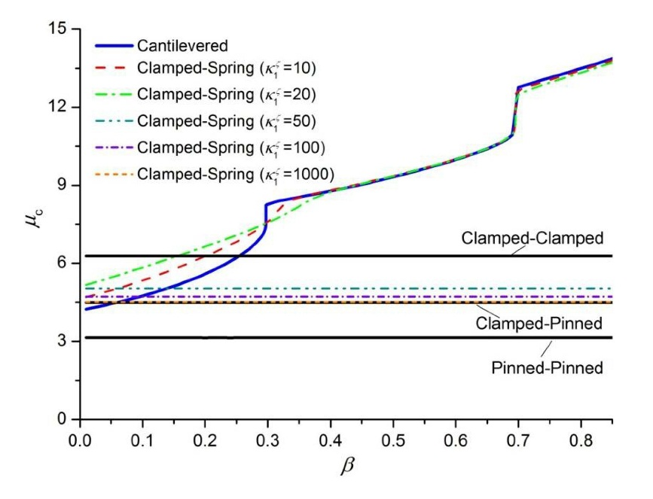

Fig. 2 The critical instability velocity  as a function of  with various boundary conditions.

The pipe always loses stability by divergence at first for fully or partly constrained boundaries. However, for a cantilever pipe, flutter instability may occur first, and the dimensionless critical velocity increases with the increase of . Moreover, the curve can be roughly divided into three segments, and in these different regions instability of the cantilever pipe appears with different modes. If a linear spring is added at the free end of the pipe, the stiffness of the spring would have a great influence on the stability of the pipe. When the dimensionless stiffness coefficient  is relatively large (for example, ), the critical velocity is independent of ; but when  is relatively small, it increases the critical velocity of pipe when . Fig. 3 shows the critical velocity of the cantilever pipe with a lumped mass and a linear spring at the free end. It is obvious that the critical velocity decreases with the increase of the lamped mass when .

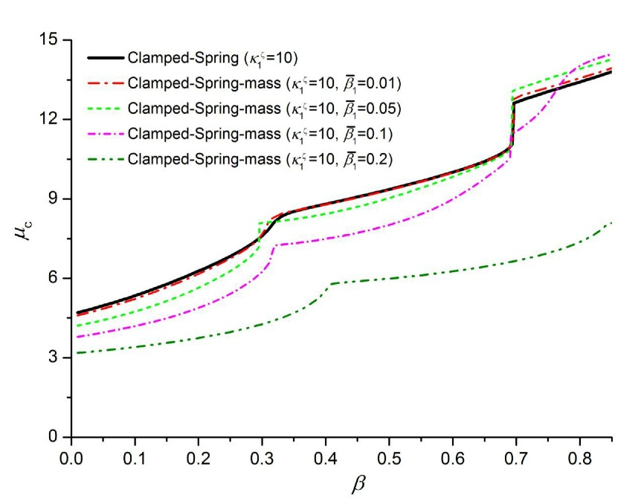

Fig. 3 The critical velocity  as a function of  for different lumped mass .

For a pinned-pinned pipe supported by two rotational springs of an identical stiffness value at the two ends, the critical velocity curves versus stiffness coefficient  are demonstrated in Fig. 4. When , the critical velocity  is nearly equal to that of the clamped-clamped pipe. In addition, the effects of the axial force  are also shown in Fig. 4. It is evident that the axial compressive force reduces the critical velocity.

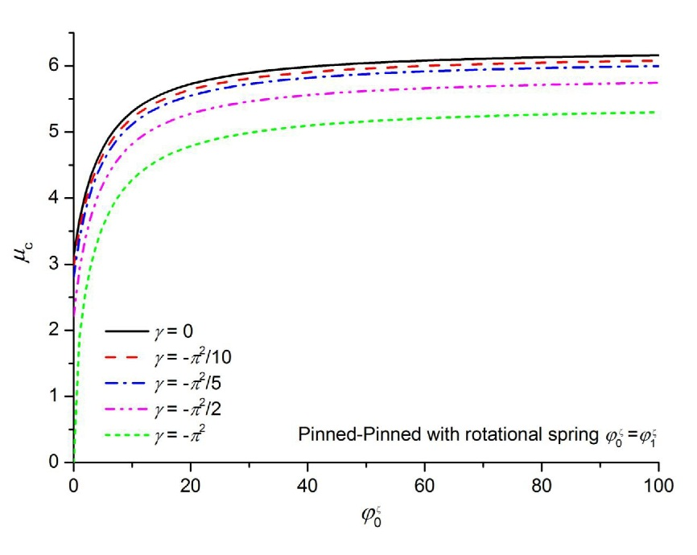

Fig. 4 The critical velocity  versus the rotational spring stiffness at two ends of the pipe.

## 6. Nonlinear dynamic responses

When  is large, it will be costly and very difficult to get convergent results if one solves the original set of time-dependent Eq. (21) directly. Therefor a transformation method will be used to overcome this drawback of the equations.

For the pipe with zero fluid velocity, one can get the -th vibration mode , and from Eq. (26), and then a modal transformation may be introduced as follows:

|  |  |
| --- | --- |
|  | (30.a) |
|  | (30.b) |
|  | (30.c) |

By substituting Eq. (30) into Eq. (21), and left-multiplying it by ,andrespectively, then the new reduced equations of motion may be expressed as:

|  |  |
| --- | --- |
|  | (31.a) |
|  | (31.b) | |
|  | (31.c) | |

For the multi-degree-of-freedom dynamic system with square and cubic stiffness nonlinearities, although there are many different numerical methods which can be employed to obtain very accurate numerical solutions [28], a fourth-order auto-adaptive step-size Runge-Kutta scheme is applied to deal with the time-dependent system more conveniently to demonstrate the effectiveness of this method. In order to reduce the cost of computation and maintain appropriate accuracy of results,  is generally taken as 5 and , .

As an example, the nonlinear dynamic responses of a clamped-clamped fluid-conveying pipe without viscous damping are investigated firstly with an external harmonic force at the middle of the pipe only acting in the vertical direction , and the initial conditions employed here are that displacement and velocity of the pipe are zero. The external harmonic force is very small and is introduced to tease out the stability behaviour from the dynamic response. This idea was also used for this purpose in [6].

In order to verify the nonlinear model, the vertical dynamic responses obtained respectively from the nonlinear and linear equations are compared in Fig. 5. When the fluid velocity is lower than the critical velocity , the pipe remains stable under the small disturbances of the external load. It can be seen that the results of nonlinear and linear models completely agree in the subcritical range. If the fluid velocity is greater than , the results of the linear model exhibit divergence or flutter instability; however a convergent solution is possible from the nonlinear model. Fig. 5 also demonstrates that even with a small perturbation the vibration amplitude of the pipe will suddenly increase by a large amount as long as  and the displacement will vibrate around a new equilibrium point (which is not the initial static equilibrium point).

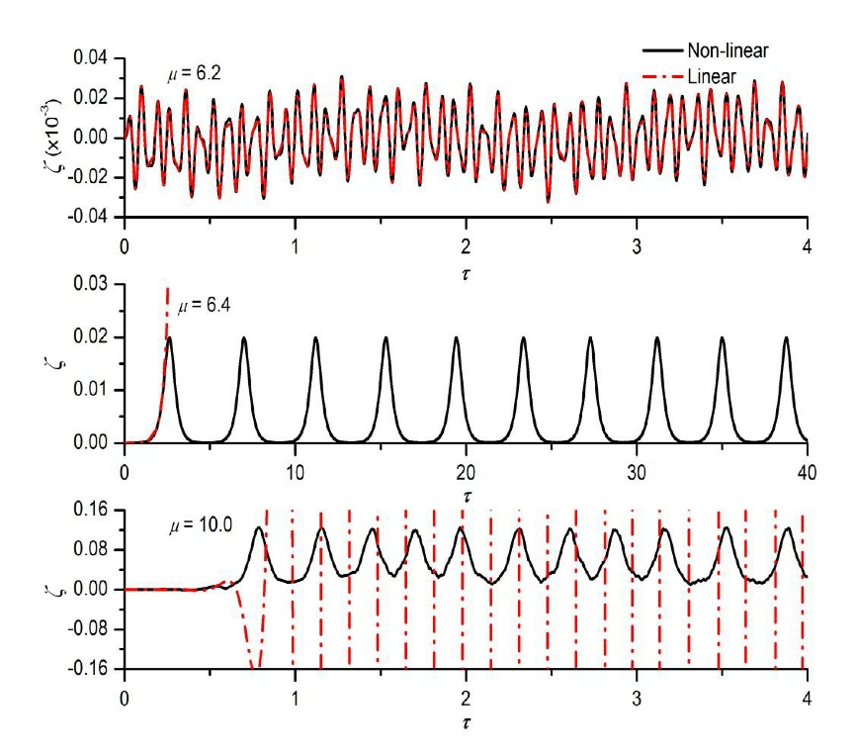

Fig. 5 Dynamic responses of the vertical displacement at the middle of a clamped-clamped pipe from the nonlinear and linear models. (=0.5, =2.0e3, =0.001, =24)

Proportional viscous damping may have a great influence on the dynamic responses of the fluid-conveying pipe when its translations at boundaries are fully constrained. The dynamic response of a clamped-clamped pipe with different amounts of proportional viscous damping is computed and the vertical displacement at the middle of the pipe is shown in Fig. 6. There are two different unstable phenomena (divergence and flutter) in the whole range of the fluid velocity (up to 14), and therefore results at two typical unstable fluid velocities ( and ) are compared to find out the effect of the viscous damping.

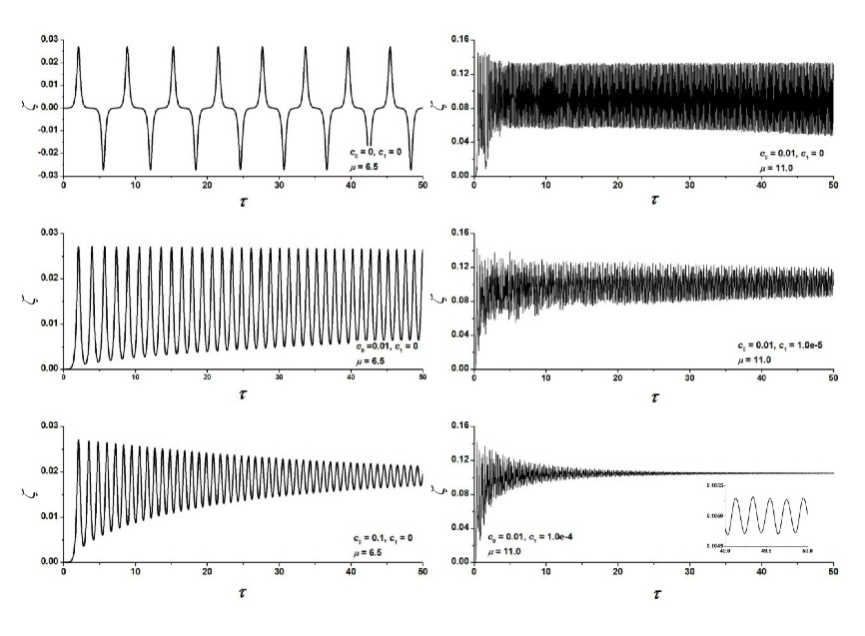

Fig. 6 Dynamic responses of the vertical displacement at various levels of proportional damping. (=0.5, =2.0e3)

In the divergence region predicted by the linear stability analysis, the vibrations of the pipe end up in the form of regular periodic motion with low frequencies when nonlinearity is included, and the pipe may jump between two symmetrical equilibrium positions if the viscous damping is zero. For the flutter instability predicted by the linear model, the pipe oscillates violently at higher frequencies than in the divergence region. Moreover, with the increase in viscous damping, the oscillating amplitude of the pipe reduces evidently. In these two cases, if time is long enough, the proportional damping would make the motion of pipe decay completely.

For the linear model without any viscous damping causing energy loss, the displacement of the pipe grows continuously because of the appearance of resonance when the frequency of external harmonic force is equal to the fundamental natural frequency of the dynamic system. However, the displacement does not grow with time in the nonlinear model as seen from Fig. 7. Furthermore the responses of the point at the middle of the pipe with three different boundary conditions are also shown in Fig. 7, and for each boundary condition the frequency of external harmonic forces is equal to the first natural frequency of the fluid-conveying pipe respectively.

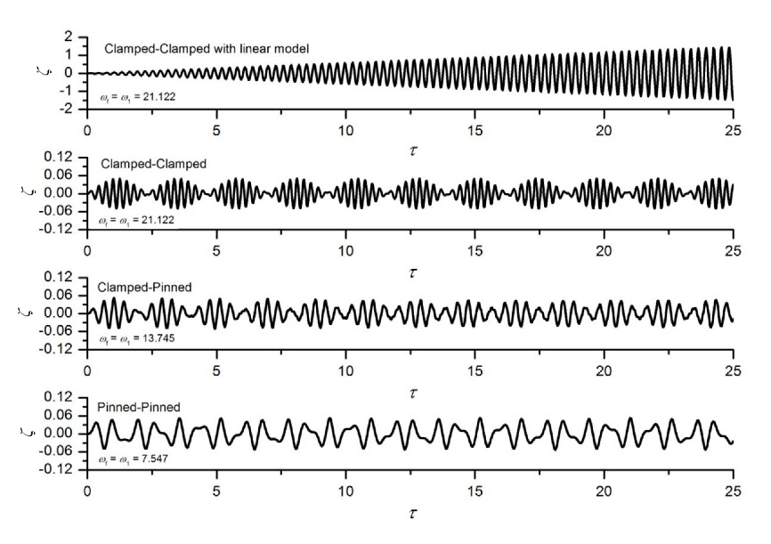

Fig. 7 The resonance of the pipe with different boundary conditions. (=2.0, =0.2, =2.0e3)

The nonlinear dynamics of the cantilever pipe is more complex and interesting . A bifurcation diagram may be useful to illustrate the overall dynamics of the system. Therefore the results of a cantilever pipe as a typical case are shown in Fig. 8. The system is stable at low fluid velocity (), and then a Hopf bifurcation occurs at  and the pipe would lose stability. The range of fluid velocity that leads to distinct dynamic behaviour can probably be divided into three regions based on the nature of the dynamic response. The time histories and the phase portraits of the tip displacement are also given in Fig. 9 at three flow velocities for the three different regions of distinct dynamic behaviour respectively. In the region of , the dynamic response is a periodic oscillation at greater amplitude than that of the response at lower fluid velocities. The pipe appears to experience quasi-periodic oscillations with several frequencies when , and the pipe may undergo chaotic motion when . Moreover, asymmetrical oscillations in the *y* and *z* directions occur at a fluid velocity , and the symmetry is regained shortly after a small increase in fluid velocity ().

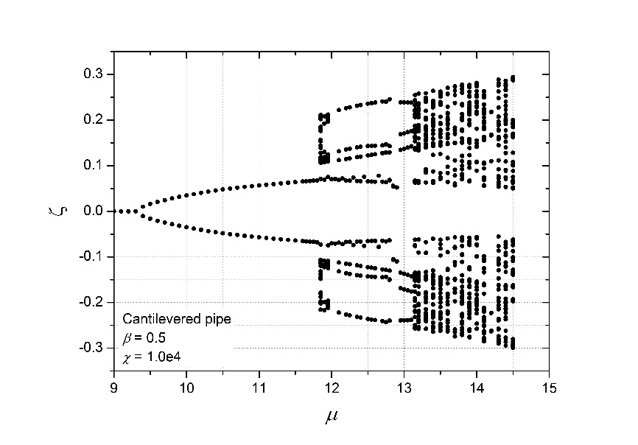

Fig. 8 The bifurcation diagram for a cantilevered pipe.

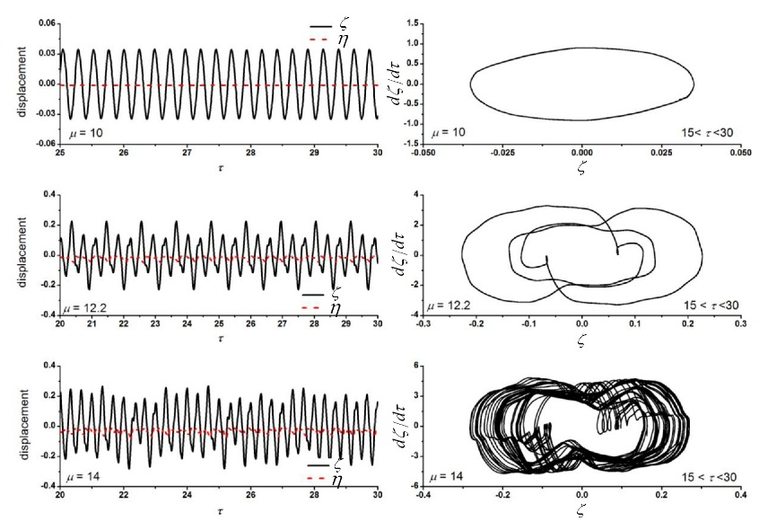

Fig. 9 The time histories and the phase portraits of tip displacement.

In addition, the longitudinal displacement at the free tip is also illustrated in the figure, and it is clear that its amplitude increase with the fluid velocity, and wherefore the aforementioned assumption that the longitudinal displacement is a second-order small quantity in comparison with the other two displacements may not be valid for larger values of fluid velocity. In that case those quantities including (or ) should not be ignored in the strain energy given by Eq. (8). However, it is convenient to derive the new nonlinear equations of motion by the presented method if these quantities are included.

A case of a cantilever pipe with two linear springs and a lumped mass added at the end of the pipe is studied further to validate the approach in this paper at last. The bifurcation diagram of the tip displacement at the free end of the pipe is shown in Fig. 10, and Hopf bifurcations are seen to develop at about  for the transverse displacement, which is slightly greater than the unstable velocity () obtained by the linear analysis as shown in Table 8. However, Hopf bifurcation of the vertical displacement takes place at a smaller fluid velocity  in spite of a larger stiffness of the spring than the transverse spring. In the region of , the pipe oscillates symmetrically in a quasi-periodic form and vibration in the transverse direction diverges at a higher rate than that in the vertical direction. Moreover chaotic oscillation occurs when , but quasi-periodic motion can be observed at  within the chaos-dominated region.

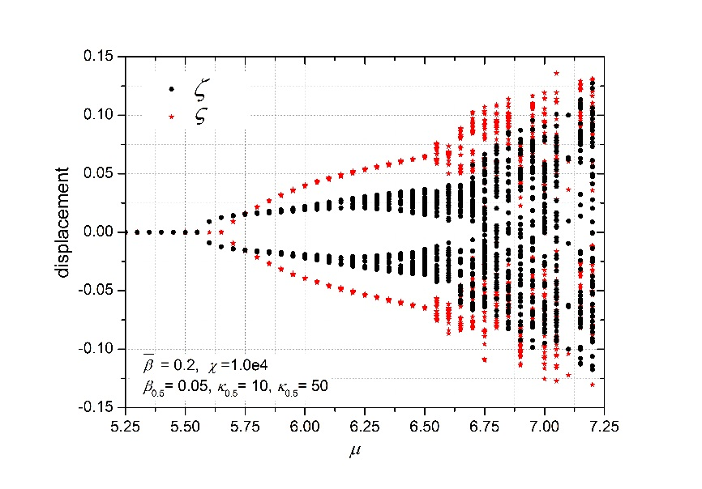

Fig. 10 Bifurcation diagram for a cantilever pipe with tow linear springs and a lumped mass added at the middle of the pipe.

Furthermore, at three typical flow velocities, the tip displacement projected onto theplane and its power spectrum density (PSD) are presented in Fig. 11. The periodic motion is evident for both the transverse and vertical displacements at , and the first dimensionless frequencies of the motions (separately denoted with  and ) are different according to the PSD (the first dimensionless frequency of the vertical motion is larger than that of the transverse motion) because of the larger stiffness of the vertical spring. For the chaotic oscillations (observed from the graph of the projected tip displacement) at , there are not significant peaks in the PSD curve. It is very interesting to see that periodic motions are regained abruptly at , and in this case, the first frequency of the vertical motion is half of that of the transverse motion. Moreover, the spacing between the adjacent PSD peaks is the same for the two motions. Chaotic oscillations would re-emerge immediately with a small increase in fluid velocity.

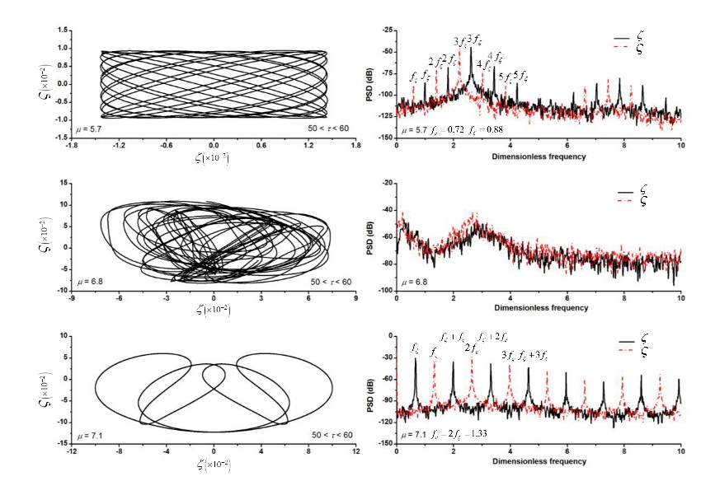

Fig. 11 Tip displacement projected onto yz-plane and PSD diagrams of the tip displacement at different flow velocities.

The nonlinear dynamical behaviour of fluid-conveying pipes is very interesting and complex, especially when extra springs and lumped masses are added. Pipe vibration due to unsteady internal flow can also be studied by the presented method, if these flow characteristics are taken into account in the kinetic energy when nonlinear equations of motion are derived. This will be one future research topic.

## 7. Conclusions

A new set of equations of motion are derived for the linear and nonlinear vibrations of straight fluid-conveying pipes in this paper. The mathematical expressions of these equations are considerably simple and can easily be programmed. The biggest advantage of the equations is their convenience in dealing with pipes with general boundary conditions. An analytical expression for the pipe vibration in the form of a special Fourier cosine series and four supplementary functions is given.

The comparison of several models in the linear stability analysis serves to demonstrate that the results of the equations are very accurate even with small numbers of truncated terms in the special Fourier series*,* and the eigenvalue analysis of the pipe is able to determine various unstable regions for the fluid velocity. For the pipe with translations at boundaries fully constrained, the non-dimensional unstable velocity is constant at various fluid mass ratio  (mass of the fluid over the mass of the fluid plus the mass of the pipe) and divergence instability would first take place generally. However, the unstable velocity would increase with larger  for other boundary conditions and flutter instability may occur first (before divergence) in these cases.

When becoming unstable, the dynamics of the pipe whose translations are fully constrained at both ends could typically evolve into a new equilibrium position after a small perturbation, while the nonlinear oscillations of the pipe are normally asymmetric about the initial equilibrium position. Moreover, viscous damping would significantly affect the pipe vibration. For pipes with translations at boundaries allowed at one end, unlike pipes whose translations at boundaries are fully constrained, both unstable symmetrical and asymmetrical oscillations could occur when subjected to an external disturbance. With the increase in the fluid velocity, the nonlinear vibration would gradually evolve into three different forms: periodic motion, quasi-periodic motion and chaotic motion; and the magnitude of oscillations would increase too. In addition, the longitudinal displacement can no longer be taken as a lower order quantity than the other displacements when the fluid velocity is quite large.

## Acknowledgements

This study was supported by the National Defence Fund of Huazhong University of Science and Technology (No. 01-18-140019). A large part of this work was carried out at the School of Engineering, University of Liverpool during the year-long visit of the first and fourth authors.

## References

[1] S.S. Chen, Flow-induce vibration of circular cylindrical structure, Hemisphere Publishing Corporation, New York, 1987.

[2] M.P. Païdoussis, G.X. Li, Pipes conveying fluid: a model dynamical problem, J. Fluid. Struct. 7 (1993) 137-204.

[3] M.P. Païdoussis, Fluid-Structure Interactions: Slender Structures and Axial Flow, vol.1. Academic Press, London, UK, 1998.

[4] M.P. Païdoussis, Fluid-structure Interactions: Slender Structures and Axial Flow, vol. 2. Elsevier Academic Press, London, UK, 2004.

[5] U. Lee, C.H. Pak, S.C. Hong, The dynamics of a piping system with internal unsteady flow, J. Sound Vib. 180 (1995) 297-311.

[6] S.I. Lee, J. Chung, New non-linear modelling for vibration analysis of a straight pipe conveying fluid, J. Sound Vib. 254 (2002) 313-325.

[7] D. Meng, H. Guo, S. Xu, Non-linear dynamic model of a fluid-conveying pipe undergoing overall motions, Appl. Math. Model. 35 (2011) 781-796.

[8] J.D. Jin, Z.Y. Song, Parametric resonances of supported pipes conveying pulsating fluid, J. Fluid. Struct. 20 (2005) 763-783.

[9] L. Wang, A further study on the non-linear dynamics of simply supported pipes conveying pulsating fluid, Int. J. Non-Linear Mech. 44 (2009) 115-121.

[10] Y. Modarres-Sadeghi, M.P. Païdoussis, Nonlinear dynamics of extensible fluid-conveying pipes, supported at both ends, J. Fluid. Struct. 25 (2009) 535-543.

[11] Q. Qian, L. Wang, Q. Ni, Instability of simply supported pipes conveying fluid under thermal loads, Mech. Res. Commun. 36 (2009) 413-417.

[12] L. Wang, Q. Ni, In-plane vibration analyses of curved pipes conveying fluid using the generalized differential quadrature rule, Comput. Struct. 86 (2008) 133-139.

[13] C.K. Chen, S.S. Chen, Application of the differential transformation method to a non-linear conservative system, Appl. Math. Comput. 154 (2004) 431-441.

[14] Q. Ni, Z.L. Zhang, L. Wang, Application of the differential transformation method to vibration analysis of pipes conveying fluid, Appl. Math. Comput. 217 (2011) 7028-7038.

[15] D.G. Gorman, J.M. Reese, Y.L. Zhang, Vibration of a flexible pipe conveying viscous pulsating fluid flow, J. Sound Vib. 230 (2000) 379-392.

[16] Y.L. Zhang, D.G. Gorman, J.M. Reese, A finite element method for modelling the vibration of initially tensioned thin-walled orthotropic cylindrical tubes conveying fluid, J. Sound Vib. 245 (2001) 93-112.

[17] A. Pramila, On the gyroscopic terms appearing when the vibration of fluid conveying pipe is analyzed using the FEM, J. Sound Vib. 105 (1986) 515-516.

[18] L.G. Olson, D. Jamison, Application of a general purpose finite element method to elastic pipes conveying fluid, J. Fluid. Struct. 11 (1997) 207-222.

[19] U. Lee, H. Oh, The spectral element model for pipelines conveying internal steady flow, Eng. Struct. 25 (2003) 1045-1055.

[20] U. Lee, J. Park, Spectral element modelling and analysis of a pipeline conveying internal unsteady fluid, J. Fluid. Struct. 22 (2006) 273-292.

[21] G.H. Koo, Y.S. Park, Vibration reduction by using periodic supports in a piping system, J. Sound Vib. 210 (1998) 53-68.

[22] J.S. Wu, P.Y. Shih, The dynamic analysis of a multi-span fluid-conveying pipe subjected to external load, J. Sound Vib. 239 (2001) 201-215.

[23] H.L. Dai, L. Wang, Q. Qian, J. Gan, Vibration analysis of three-dimensional pipes conveying fluid with consideration of steady combined force by transfer matrix method, Appl. Math. Comput. 219 (2012) 2453-2464.

[24] M. Nikolić, M. Rajković, Bifurcations in nonlinear models of fluid-conveying pipes supported at both ends, J. Fluid. Struct. 22 (2006) 173-195.

[25] M.P. Païdoussis, G.X. Li, F.C. Moon, Chaotic oscillations of the autonomous system of a constrained pipe conveying fluid, J. Sound Vib. 135 (1989) 1-19.

[26] M.P. Païdoussis, C. Semler, Nonlinear and chaotic oscillations of a constrained cantilevered pipe conveying fluid: a full nonlinear analysis, Nonlinear Dyn. 4 (1993) 655-670.

[27] C. Semler, G.X. Li, M.P. Païdoussis, The nonlinear equations of motion of pipes conveying fluid, J. Fluid. Struct. 10 (1994) 787-825.

[28] C. Semler, M.P. Païdoussis, Nonlinear analysis of the parametric resonances of a planar fluid-conveying cantilevered pipe, J. Fluid. Struct. 10 (1996) 787-825.

[29] A. Sarkar, M.P. Païdoussis, A cantilever conveying fluid: coherent modes versus beam modes, Int. J. Non-Linear Mech. 39 (2004) 467-481.

[30] M.P. Païdoussis, A. Sarkar, C. Semler, A horizontal fluid-conveying cantilever: spatial coherent structures, beam modes and jumps in stability diagram, J. Sound Vib. 280 (2005) 141-157.

[31] M.P. Païdoussis, C. Semler, Nonlinear dynamics of a fluid-conveying cantilevered pipe with an intermediate spring support, J. Fluid. Struct. 7 (1993) 269-298.

[32] M.P. Païdoussis, C. Semler, Non-linear dynamics of a fluid-conveying cantilevered pipe with a small mass attached at the free end, J. Non-Linear Mech. 33 (1998) 15-32.

[33] M.H. Ghayesh, M.P. Païdoussis, M. Amabili, Nonlinear dynamics of cantilevered extensible pipes conveying fluid, J. Sound Vib. 332 (2013) 6405-6418.

[34] M. Wadham-Gagnon, M.P. Païdoussis, C. Semler, Dynamics of cantilevered pipes conveying fluid. Part 1: Nonlinear equations of three-dimensional motion, J. Fluid. Struct. 23 (2007) 545-567.

[35] M.P. Païdoussis, C. Semler, M. Wadham-Gagnon, S. Saaid, Dynamics of cantilevered pipes conveying fluid. Part 2: Dynamics of the system with intermediate spring support, J. Fluid. Struct. 23 (2007) 569-587.

[36] Y. Modarres-Sadeghi, C. Semler, M. Wadham-Gagnon, M.P. Païdoussis, Dynamics of cantilevered pipes conveying fluid. Part 3:Three-dimensional dynamics in the presence of an end-mass, J. Fluid. Struct. 23 (2007) 589-603.

[37] M.H. Ghayesh, M.P. Païdoussis, Three-dimensional dynamics of a cantilevered pipe conveying fluid, additionally supported by an intermediate spring array, J. Non-Linear Mech. 45 (2010) 507-524.

[38] M.H. Ghayesh, M.P. Païdoussis, Y. Modarres-Sadeghi, Three-dimensional dynamics of a fluid-conveying cantilevered pipe fitted with an additional spring-support and an end-mass, J. Sound Vib. 330 (2011) 2869-2899.

[39] C. Semler, W.C. Gentleman, M.P. Païdoussis, Numerical solution of second order implicit non-linear ordinary differential equations, J. Sound Vib. 195 (1996) 553-574.

[40] S. Michael, G. Johannes, I. Hans, An alternative approach for the analysis of nonlinear vibrations of pipes conveying fluid, J. Sound Vib. 310 (2008) 493-511.

[41] F. Gay-Balmaz and V. Putkaradze, On flexible tubes conveying fluid: geometric nonlinear theory, stability and dynamics, J. Non. Sci. 25 (2015) 889-936.

[42] W.L. Li, Free vibration of beams with general boundary conditions, J. Sound Vib. 237 (2000) 709-725.

[43] J.T. Du, W.L. Li, Z.G. Liu, T.J. Yang, G.Y. Jin, Free vibration of two elastically coupled rectangular plates with uniform elastic boundary restraints, J. Sound Vib. 330 (2011) 788-804.

[44] J.T. Du, W.L. Li, H.A. Xu, A.G. Liu, Vibro-acoustic analysis of a rectangular cavity bounded by a flexible panel with elastically restrained edges, J. Acoust. Soc. Am. 131 (2012) 2799-2810.

[45] D.J. Ewins, Modal testing theory, practice and application, Research Studies Press Ltd, London, 2000.

[46] R.D. Blevins, Formulas for natural frequency and model shape, New York, Van Nostrand Reinhold, 1976.

[47] W.T. Thomson, Theory of vibration with applications. Unwin Hyman Ltd., London, 1988.

[48] G. Fix, R. Heiberger, An algorithm for the ill-conditioned generalized eigenvalue problem, SIAM J. Numer. Anal. 9 (1972) 78-88.

[49] J.H. Wilkinson, The algebraic eigenvalue problem, Oxford University Press, Oxford, 1965.

## Appendix A:

Since the special Fourier series expressions of the displacements are composed of two distinct parts, all square system matrices for linear terms in Eq. (21) can be decomposed into four parts below, in order to concisely express them.

; ; ; ;

;;;;;

where superscript T denotes the matrix transpose operation, and the dimension of all the partitioned matrices with subscript aa is . Moreover, the dimension of all the partitioned matrices with subscript cc is . Then the elements of these partitioned matrices are given by:

,;

 , ;

, ;  , ;

,;  , ;

,;  , ;

 , ;

 , ;

 , ;  , ;

 ,  ;  , ;

 ,  ;  ,  ;

 , ;

where  and .

**;****;****;****;** **;****;**

**;****;**

**;**

For the intermediate masses and springs:

;;;;

,;

 , ;

,;,;

,  ;

,;

, ;

,;

, ;

,;,;

, ;

where ; ;; and  is the dimensionless location of the *j*-th lumped mass and  is the dimensionless location of the *i*-th elastic spring.

For the matrices of the nonlinear terms, to simplify the expressions of the matrix elements, a function vector  is introduced as follows:

|  |  |
| --- | --- |
|  | (A.1) |

The matrices of the non-linear terms can then be expressed as:

, ,

, ,

, ,

## Appendix B:

For the ill-conditioned eigenvalue problem of Eq. (27), considering the asymmetry of matrix  and referring to [48]**,** a modified algorithm is given as follows:

(1) The symmetrical matrix  (its dimension is , which is equal to  for the vertical and transverse vibration, but is equal to  for the longitudinal vibration) may become adiagonal matrix  with the orthogonal transformation .

|  |  |
| --- | --- |
| , | (B.1) |

where  is a diagonal matrix with descending elements:

|  |  |
| --- | --- |
| , | (B.2) |

The consequence of the ill-condition of matrix  (its condition number would be greater than  when ) is that the values of some  will be very small compared with other diagonal elements. Therefore  can be partitioned as:

|  |  |
| --- | --- |
|  | (B.3) |

where the  diagonal matrix  has been chosen such that:

|  |  |
| --- | --- |
| , | (B.4) |

where  is a small positive parameter which can be set as  or even smaller when. It is obvious that . Operator  denotes the -norm.

(2) For the asymmetrical matrix , a new matrix  with the orthogonal transformation  also can be partitioned into the form:

|  |  |
| --- | --- |
|  | (B.5) |

And applying the congruent transformation associated with:

|  |  |
| --- | --- |
|  | (B.6) |
|  | (B.7) |
|  | (B.8) |

It can be observed that:

|  |  |
| --- | --- |
| , , and rank()=. | (B.9) |

(3) Using the orthogonal-triangular decomposition of by Householder transform [49],then a  matrix  would be obtained:

|  |  |
| --- | --- |
| , | (B.10) |

where  is a full-rank () triangular matrix.

Applying the transformation associated with:

|  |  |
| --- | --- |
|  | (B.11) |
|  | (B.12) |
|  | (B.13) |

where matrix  should be a non-singular matrix for the models in this study, and.

(4) Finally the computation of eigenvalues of Eq. (27) is transformed into computation of the new equation , with  and , which leads to:

|  |  |
| --- | --- |
|  | (B.14) |

where  is a part of an eigenvector of Eq. (B.14). Solving the eigenvalue of Eq. (B.14) results in only  complex eigenvalues which may be called the -stable approximate eigenvalues of Eq. (27), and the eigenvectors of Eq. (27) take the following form:

|  |  |
| --- | --- |
| ; where: | (B.15) |

1. Corresponding author. Present address: School of Engineering, University of Liverpool, The Quadrangle, Liverpool L69 3GH, UK. Tel.:+86 13995559242;

   E-mail address: [zhangt7666@mail.hust.edu.cn](mailto:zhangt7666@mail.hust.edu.cn) (T. Zhang); h.ouyang@liverpool.ac.uk (H. Ouyang); zhangyo1989@gmail.com (Y.O. Zhang)