**Cytotoxicity evaluation using cryopreserved primary human hepatocytes in various culture formats**

Lysiane Richerta,h,*, Audrey Bazea, Céline Parmentiera, Helga Geretsb, Rowena Sison-Youngc, Martina Doraud, Cerys Lovatte, Andreas Czichd, Christopher Goldringc, Kevin Parkc, Satu Juhilaf, Alison J. Fosterg and Dominic Williamsg.

aKaLy-Cell, 20A rue du Général Leclerc, 67115 Plobsheim, France. l.richert@kaly-cell.com, a.baze@kaly-cell.com, c.parmentier@kaly-cell.com.

bUCB BioPharma SPRL, Non-Clinical Development, Chemin du Foriest, 1420 Braine-l'Alleud, Belgium. helga.gerets@ucb.com.

cMRC Centre for Drug Safety Science, Department of Molecular and Clinical Pharmacology, Sherrington Building, Ashton Street, University of Liverpool, Liverpool L69 3GE, UK. Rowena.Sison-Young@liverpool.ac.uk,C.E.P.Goldring@liverpool.ac.uk., uk.park@liverpool.ac.uk

dSanofi-Aventis Deutschland GmbH, R&D DSAR Preclinical Safety, Industriepark Hoechst, D-65926 Frankfurt. Martina.Dorau@sanofi.com, Andreas.Czich@sanofi.com

eGlaxoSmithKline, Safety Assessment, Stevenage, Hertfordshire, UK. cerys.a.lovatt@gsk.com.

fOrion Corporation, R&D, In Vitro Biology, Orionintie 1A, P.O.Box 65, FI-02101 Espoo, Finland. satu.juhila@orionpharma.com.

gTranslational Safety, Drug Safety & Metabolism, AstraZeneca, Cambridge Science Park, Cambridge, UK. Alison.Foster2@astrazeneca.com, Dominic.P.Williams@astrazeneca.com.

hUniversité de Franche-Comté, EA 4267 Besançon, France.

**Funding:** This work was supported by funding from the MIP-DILI project, a European Community grant under the Innovative Medicines Initiative (IMI) Programme (Grant Agreement number 115336).

**\*Corresponding author**:

Lysiane Richert, Ph.D.

KaLy-Cell

20A, rue de Général Leclerc,

67115 Plobsheim

France

Phone: +33 88108830

l.richert@kaly-cell.com

**List of abbreviations**: DILI, Drug-induced liver injury; NPC, non-parenchymal cells; 2D-sw, 2D sandwich; SM, safety margin; MT, microtissue; TC, training compound.

**Abstract**

Sixteen training compounds selected in the IMI MIP-DILI consortium, 12 drug-induced liver injury (DILI) positive compounds and 4 non-DILI compounds, were assessed in cryopreserved primary human hepatocytes. The non-DILI-compounds were correctly identified 2 hours following a single exposure to pooled human hepatocytes (n = 13 donors) in suspension and 14-days following repeat dose exposure (3 treatments) to an established 3D-microtissue co-culture (3D-MT co-culture, n = 1 donor) consisting of human hepatocytes co-cultured with non-parenchymal cells (NPC). In contrast, only 5/12 DILI-compounds were correctly identified 2 hours following a single exposure to pooled human hepatocytes in suspension. Exposure of the 2D-sandwich culture human hepatocyte monocultures (2D-sw) for 3 days resulted in the correct identification of 11/12 DILI-positive compounds, whereas exposure of the human 3D-MT co-cultures for 14 days resulted in identification of only 9/12 DILI-compounds; in addition to ximelagatran (not identified by either culture system, Sison et al., 2016), the 3D-MT co-cultures failed to detect amiodarone and bosentan. The sensitivity of the 2D human hepatocytes co-cultured with NPC to ximelagatran was increased in the presence of lipopolysaccharide (LPS), but only at high concentrations, therefore preventing its classification as a DILI positive compound. In conclusion (1) despite suspension human hepatocytes having the greatest metabolic capacity in the short term, they are the least predictive of clinical DILI across the MIP-DILI test compounds, (2) longer exposure periods than 72h of human hepatocytes do not allow to increase DILI-prediction rate, (3) co-cultures of human hepatocytes with NPC, in the presence of LPS during the 72h exposure period allow the assessment of innate immune system involvement of a given drug.

**Keywords:** cryopreserved human hepatocytes; monoculture and co-culture; DILI, *in vitro* models; short term and long term exposure.

1. **Introduction**

Drug-induced-liver injury (DILI) continues to pose significant problems in drug development despite extensive screening during early development, suggesting that currently used *in vitro* models are not appropriate for effective screening or data not used effectively. Within the Innovative Medicines Initiative (IMI)-funded consortium ‘Mechanism-based Integrated Systems for the Prediction of Drug-Induced Liver Injury’ (MIP-DILI) an assessment of various cell types has been undertaken to determine the usefulness of simple 2D cell models, in the absence of prior human exposure data, for determining the hepatotoxic potential of a series of selected training compounds (Sison-Young et al., 2016). Eight of the 9 training compounds (TC) incubated with either fresh or cryopreserved primary human hepatocytes for 3 days in 2D-sandwich (2D-sw) monoculture were correctly identified, only when nominal *in vitro* concentrations were adjusted for *in vivo* exposure levels. Moreover, human hepatocytes exposed for 1 day or 3 days to TCs in 2D-sw monoculture, could not completely distinguish between established drugs with respect to their propensity to cause DILI in man. In particular, ximelagatran was not identified as a drug presenting a risk of inducing DILI in man, and entacapone was classified as a false-positive. However, assigning sensitivity and specificity of assays across such a small compound set is not useful.

Human hepatocytes undergo significant and irreversible modification in their transcriptomic profile at attachment to culture matrix (Richert et al., 2006), with down-regulation of phase I and II enzymes. Transporter mRNA levels are not affected by plating to the same extent as phase I and II enzymes. Instead down-regulation is moderate and, for some transporters, levels are even stable or up-regulated as also observed by others (Jigorel et al., 2005). Phase I metabolism rates are also significantly reduced following plating (Blanchard et al., 2004; Smith et al., 2012), whereas phase II metabolism rates are less reduced (Alexandre et al., 2002; den Braver-Sewradji et al., 2016). This has been partly attributed to the regeneration of co-factors in culture, suggesting a shift of phase I/phase II ratio towards phase II in cultured hepatocyes. Human hepatocytes in suspension, either freshly isolated or after cryopreservation, present a transcriptomic profile similar to liver *in vivo* (Richert et al., 2006), and their use in suspension has become a widely accepted model for prediction of *in vivo* metabolism (Jouin et al., 2006; Floby et al., 2009), drug-drug interactions through cytochrome P450 inhibition (Mao et al., 2012; Desbans et al., 2014) and have been used for assessment of drug and metabolite toxicity (Elaut et al., 2006). Although a major draw-back of the use of hepatocytes in suspension is their short life span*, i.e.* up to several hours, limiting the contact time of TCs with cells, pools of cryopreserved primary human hepatocytes used in suspension have been recently described as useful for the screening of hepatotoxicants (Mennecozzi et al., 2015). The first aim of the present study was thus to compare the cytotoxicity profiles obtained with human hepatocytes in suspension exposed for 2 hours to the mean data (partly from Sison-Young et al. (in press)) obtained with 2D-sw monocultures exposed at day 2 after plating for 24 hours. In order to do so, a pool of cryopreserved human hepatocytes was maintained in suspension under continuous shaking that has been shown to allow high viability and increase the metabolic performance of the cells (Simon et al., 2009).

The second aim of the present study was to compare the cytotoxicity profiles in established cultures of human hepatocytes exposed for longer periods of time (up to 14 days) to the mean data (partly from Sison-Young et al., 2016) obtained in 2D-sw mono cultures exposed for 72 hours from day 2 after plating. Indeed, in recent years, hepatocyte culture systems allowing culture (and exposure) times up to several weeks have been developed, such as modified 2D-sw monocultures (Parmentier et al., 2013) as well as 2D co-cultures (Khetani et al., 2013) and 3D-monocultures and co-cultures (Darnell et al., 2012; Messner et al., 2013).

In the present study, cryopreserved plateable human hepatocytes were used since only minimal differences are reported in the phenotype between fresh and cryopreserved primary human hepatocytes (Darnell et al., 2012; Smith et al. 2012), and in their direct response to toxicants (Sison-Young et al., 2016).

Sixteen TCs chosen by the consortium were tested. From their highest concentration without a clear cytotoxic effect, defined as inducing no more than 20 % cell death (Bordessa et al., 2014), and their Cmax *in vivo*, a safety margin (SM) was calculated. An SM < 10 was set as identification of a DILI risk (Mueller et al., 2015). Finally, the effect of an inflammation stimulus on the cytotoxicity of specific TCs was evaluated.

# Material and methods

## Pooled cryopreserved human hepatocyte suspensions

The pool of cryopreserved primary human hepatocytes P0203T (n = 13 donors) was provided by KaLy-Cell (Plobsheim, France). The pooled hepatocytes were thawed in a water-bath (1 - 2 minutes) and diluted in 50 mL KLC-Thawing Medium (KLC-TM; proprietary formulation); centrifuged 170 x *g*; 20 minutes; room temperature, washed (KLC-Washing Medium (KLC-WM; proprietary formulation)); 100 x *g*; 5 minutes; room temperature and re-suspended in KLC-Suspension Medium (KLC-SuM; proprietary formulation). Cell number and viability were determined by the trypan blue exclusion method. After dilution to a concentration of 2 x 106 viable cells/mL in medium, the hepatocyte suspension was distributed into eight 96-well plates (50 µl/well). The plates were pre-incubated for approximately 15 min under shaking (900 rpm) in a humidified chamber at 37°C with 5% CO2.

## Cryopreserved human hepatocyte cultures

### 2D-sw monoculture

Cryopreserved primary human hepatocytes (list of donors in table 1) provided by KaLy-Cell (Plobsheim, France) were thawed (1 - 2 minutes in water bath) and diluted in 50 mL KLC-Thawing Medium (KLC-TM; proprietary formulation); centrifuged 170 x *g*; 20 min; room temperature, washed with KLC-Washing Medium (KLC-WM; proprietary formulation); 100 x *g*; 5 min; room temperature and re-suspended in KLC-Seeding Medium (KLC-SM; proprietary formulation). Cell number and viability were determined by the trypan blue exclusion method. The cells were plated at a seeding density of 0.07 x 106 viable cells/well of a KaLy-Cell home-coated type I rat tail collagen (10 µg/well) 96-well plate. The cells were allowed to attach for 4 – 6 hours (in a humidified chamber at 37°C with 5% CO2) after which the cells were overlaid with 0.25 mg/mL matrigel in KLC-SM for a sandwich like configuration culture (2D-sw) and left to incubate overnight (in a humidified chamber at 37°C with 5% CO2). Cells were used for analysis if the attachment efficiency was greater than 80%. Serum-free KLC-Maintenance Medium (KLC-MM) was used for compound treatment.

### 2D co-culture

Cryopreserved primary human hepatocytes (donors JNB and 1307) obtained from Bioreclamation IVT (Baltimore, US) and Hepregen (Medford, MA) respectively, and cryopreserved 3T3 J2 mouse fibroblasts obtained from Howard Green at Harvard University (US) were used in the manufacturing of the human micropatterned co-culture platform (HepatoPac®, Hepregen Corporation). The HepatoPac cultures were prepared at Hepregen according to their own protocol (Khetani et al., 2013). In brief, cryopreserved hepatocyte vials were thawed at 37°C for 90 - 120 seconds followed by dilution with 50 mL of pre-warmed hepatocyte culture medium (HCM) (Hepregen Corporation, Medford, MA). The cell suspension was spun at 100 x *g* for 10 minutes. The supernatant was discarded, cells were re-suspended in HCM and viability was assessed using trypan blue exclusion (typically 80 – 95%). Liver-derived non-parenchymal cells (NPC), as judged by their size (~10 µm in diameter) and morphology (non-polygonal) were consistently found to be less than 1 % in these preparations. To create micropatterned co-cultures (MPCCs) in 96-well plates, a hepatocyte pattern was first produced by seeding hepatocytes on rat-tail collagen (BD Biosciences, Franklin Lakes, NJ) type I-patterned substrates that mediate selective cell adhesion. The cells were washed with medium 4 - 6 hours later to remove unattached cells, and incubated in HCM, leaving ~ 5 x 103 attached hepatocytes on 13 collagen-coated islands within each well for 96-well plates. 3T3-J2 murine embryonic fibroblasts were seeded 12 – 18 hours later to create co-cultures. The cultures were placed in a humidified incubator at 37oC. Culture medium was replaced every 2 days (~ 65 µL/well) for 7 days.

Cryopreserved human hepatocytes (donor S1195T) and mixed cryopreserved liver NPC provided by KaLy-Cell (Plobsheim, France) were also used for co-culturing. NPC were thawed (60 - 90 seconds), transferred into a 50 mL centrifuge tube containing HBSS + 10% FBS and centrifuged at 900 x *g;* 7 minutes. NPC were re-suspended in KLC-Seeding Medium (KLC-SM; proprietary formulation) and viability and cell number were determined by Trypan blue exclusion. Thawed cryopreserved human hepatocytes were co-cultured with NPC at a ratio of 2:1 (46 000 hepatocytes/ 23 000 NPC). NPC were allowed to attach for 1 hour before the addition of human hepatocytes in KLC-SM. After overnight attachment, medium was switched to KLC-Seeding Medium (KLC-SM; proprietary formulation) containing 2 % FBS.

### 3D monoculture and co-culture

Cryopreserved plateable human hepatocytes (donor N1309VT) provided by KaLy-Cell or donor IZT, purchased from Bioreclamation-IVT) were cultured or co-cultured with mixed cryopreserved liver NPC or with Kupffer cells from Bioreclamation-IVT by InSphero for 3D-microtissue (MT) formation. The hepatocytes were seeded (1 x 103 viable cells/drop) alone or together with NPC (100 cells/drop) in re-aggregation medium. Following re-aggregation, they were transferred into GravityTRAPTM plates in human liver maintenance medium (hLiMM, InSphero AG) and the medium was subsequently renewed using hLiMM, 70 µL/well until maturation in 96-well plates (Messner et. al. 2013). After stable 3D-MT formation, the cells were treated with TCs in hLiMM.

## Dosing

Sixteen (16) TCs were chosen by the consortium according to their known implications in DILI in humans: buspirone, entacapone, metformin and pioglitazone as DILI-negative while acetaminophen, amiodarone, bosentan, diclofenac, nefazodone, perhexiline, tolcapone, troglitazone, ximelgatran, chlorpromazine, fialuridine and trovafloxacin as DILI-positive (Kleiner et al., 1997; Shaw et al., 2010; Gandhi et al., 2013 and Sison-Young et al., 2016).

All stock solutions, except for metformin, and for some experiments acetaminophen, were prepared as 200-fold stocks in DMSO (Sigma-Aldrich, Saint-Quentin Fallavier, France). Stock aliquots were stored at -20 °C and only thawed once. Acetaminophen stock solutions were prepared as 200-fold stocks in media. Suspended hepatocytes (50 µL) were dosed in technical triplicates in serum-free medium with 50 µL of 2-fold concentrated TCs. During the incubation period of 2 hours, the plates were shaken at 163 g in a humidified chamber at 37°C with 5% CO2 which has been shown to increase the metabolic performance of the cells (Simon et al. 2009). Cultured hepatocytes were dosed in serum-free medium in technical triplicates with a final concentration of 0.5 % DMSO. Controls were cells treated with 0.5 % DMSO in dosing medium, in the absence of TCs. Dosing regimen of cells in the various culture formats is given in Table 1.

|  |  |  |  |  |  |  |  |  |  |
| --- | --- | --- | --- | --- | --- | --- | --- | --- | --- |
| **Donor** | **Sex of Donor** | **Age of Donor (years)** | **Race** | **Pathology** | **Medication** | **Culture Format** | **Test compounds** | **Treatment conditions** | **End-points** |
| P0203T | 4♀ & 9 ♂ | 40 to 82 | - | - | - | **Suspension** | 16 training compounds (see list below)* | 2h under stirring | resazurin |
| S1356T | ♀ | 59 | Caucasian | Liver metastasis from carcinoid right lung | No | **2D-sw a** | FIA, TVX | Daily from D1 to D3 | D2 & D4: resazurin and ATP |
| S1359T | ♀ | 78 | Caucasian | Liver metastasis from Grawitz tumor | No |
| S1373T | ♀ | 69 | Caucasian | Liver metastases from sigmoid adenocarcinoma | Paracetamol |
| B0403VT | ♀ | 47 | Caucasian | Non-transplantable liver | Rocephine, Flagyl | CPZ, DCF |
| HHC300307 | ♂ | 72 | Caucasian | MHCCR | Unknown |
| N1309VT | ♂ | 75 | Caucasian | Colorectal cancer | Tenordate | **2D-sw a** | APAP, CPZ, DCF, TGZ | Daily from D1 to D3 | D2 & D4: resazurin and ATP |
| **3D-MT (In Sphero) a** | APAP, CPZ; TGZ, TVX | Daily from D7** to D9 | D10: ATP |
| IZT | ♀ | 44 | Caucasian | HTN, type 2 diabetes, obstructive pulmonary disease, possible renal carcinoma | Unknown | **Spheroid (InSphero) co-culture c** | 16 training compounds (see list below)* | D6**, D11 and D15 | D20:ATP |
| **Spheroid (InSphero) co-culture b** | APAP, CPZ, DCF, TGZ | D6**,D12,D16,D19 | D21:ATP |
| S1195T | ♀ | 62 | Caucasian | liver metastasis after pancreatic cancer | No | **2D-swa and 2D-sw co-culturec** | APAP, TVX, XIM | Daily from D1 to D3 | D4: resazurin |
| JNB | ♀ | 19 | Caucasian | Lupus | Unknown | **2D-co-culture (Hepregen)d** | ENT, TOL | D8** and D10 | D13:ATP |
| 1307 | ♂ | 31 | Unknown | Anoxia, 2nd to heroin overdose | Unknown | D8**, D10, D13 and D15 | D17: ATP |

♀: Female; ♂: Male; MHCCR: liver metastasis from colorectal cancer; HTN: hypertension

* acetaminophen (APAP), amiodarone (AMIO), bosentan (BOS), buspirone (BUS), chlorpromazine (CPZ), diclofenac (DCF), entacapone (ENT), fialuridine (FIA), metformin (MET), nefazodone (NEF), perhexiline (PER), pioglitazone (PIO), tolcapone (TOL), troglitazone (TGZ), trovafloxacin (TVX), ximelagatran (XIM)

** stable 2D or 3D-MT co-cultures formed

a monocultures, b co-cultures with kupffer cells, c co-cultures with mixed non-parenchymal cells, d co-cultures with mouse 3T3 cells

**Table 1**: Donor characteristics of cryopreserved human hepatocyte lots used in this study, culture formats, TCs, treatment conditions and end-points.

### Resazurin assay

After incubation with TCs, cell viability was determined using a 4.5 mM stock solution of resazurin (Sigma-Aldrich, Saint-Quentin Fallavier, France) prepared in phosphate buffer. This stock solution was added to the cells at 10 % of the cell culture volume to give a final concentration of 450 μM resazurin. The cells were incubated for 30 min (suspensions) or 1 hour (monolayers) in a humidified chamber at 37°C with 5% CO2. The supernatant (after a 5 min centrifugation step at 350 g of suspended hepatocytes) or medium samples were transferred into black, flat-bottom 96-well plates. Reduction of the resazurin dye results in the highly fluorescent product, resorufin which is measured at 530 – 560 nm excitation wavelength and 590 nm emission wavelength.

### ATP assay

After incubation with TCs, the cells cultured in 2D-format were washed twice with PBS and fresh PBS and CellTiter-Glo® solution (Promega, Madison, WI, USA) in equal volumes were added. The cells were placed in a plate shaker for 2 minutes to induce lysis and left to incubate (10 minutes; room temperature). The supernatant samples were transferred into opaque flat-bottomed 96-well plates (Greiner-Bio-One, Frickenhausen, Germany) and the luminescence measured.

After incubation with TCs, the medium from cells cultured in 3D-MT was removed and 40 μl of a 1:1 diluted CellTiter-Glo® 3D Cell Viability reagent (Promega Madison, WI, USA) (with culture medium) was added to GravityTRAP plates with a Viaflo96-system. The reagent in the wells was pipetted up and down and transferred into a white-half area assay plate and incubated for 20 minutes at RT on a shaker in the dark. Subsequently, luminescence was measured. Internal ATP standards were measured for calculation of ATP/3D-MT.

## Data analysis

Cell viability was determined as the percentage of the fluorescent resorufin after incubation with resazurin in the treated cells compared with vehicle control or the percentage of ATP detected in the treated cells compared with vehicle control. For a given TC, the highest concentration without a clear cytotoxic effect, defined as inducing no more than 20 % cell death or ATP depletion was determined graphically. Eighty % viability is indeed generally considered as a cut-off for a cytotoxic effect (Bordessa et al., 2014). From the highest concentration without a clear cytotoxic effect and its Cmax *in vivo*, a safety margin (SM) was calculated for each TC. An SM < 10 was set as identification of a DILI risk (Mueller et al., 2015).

In order to calculate hepatocyte- only responses for ATP in micropatterned co-cultures (HepatoPac), cellular ATP levels were also determined in stromal-only cultures (i.e. murine 3T3 fibroblasts). ATP signals in stromal-only control cultures were subtracted from those of HepatoPacTM co-cultures to obtain hepatocyte-specific effects.

# Results and Discussion

## Viability profiles in Suspended Pooled Human Hepatocytes

Figure 1 shows the viability profiles obtained with the pool of cryopreserved human hepatocytes (P0203T n = 13 donors) exposed for 2 hours to the 16 TCs compared to the mean viability profiles obtained with plated cryopreserved human hepatocyte preparations in 2D-sw monoculture (n = 3 - 5 donors) exposed for 24 hours.

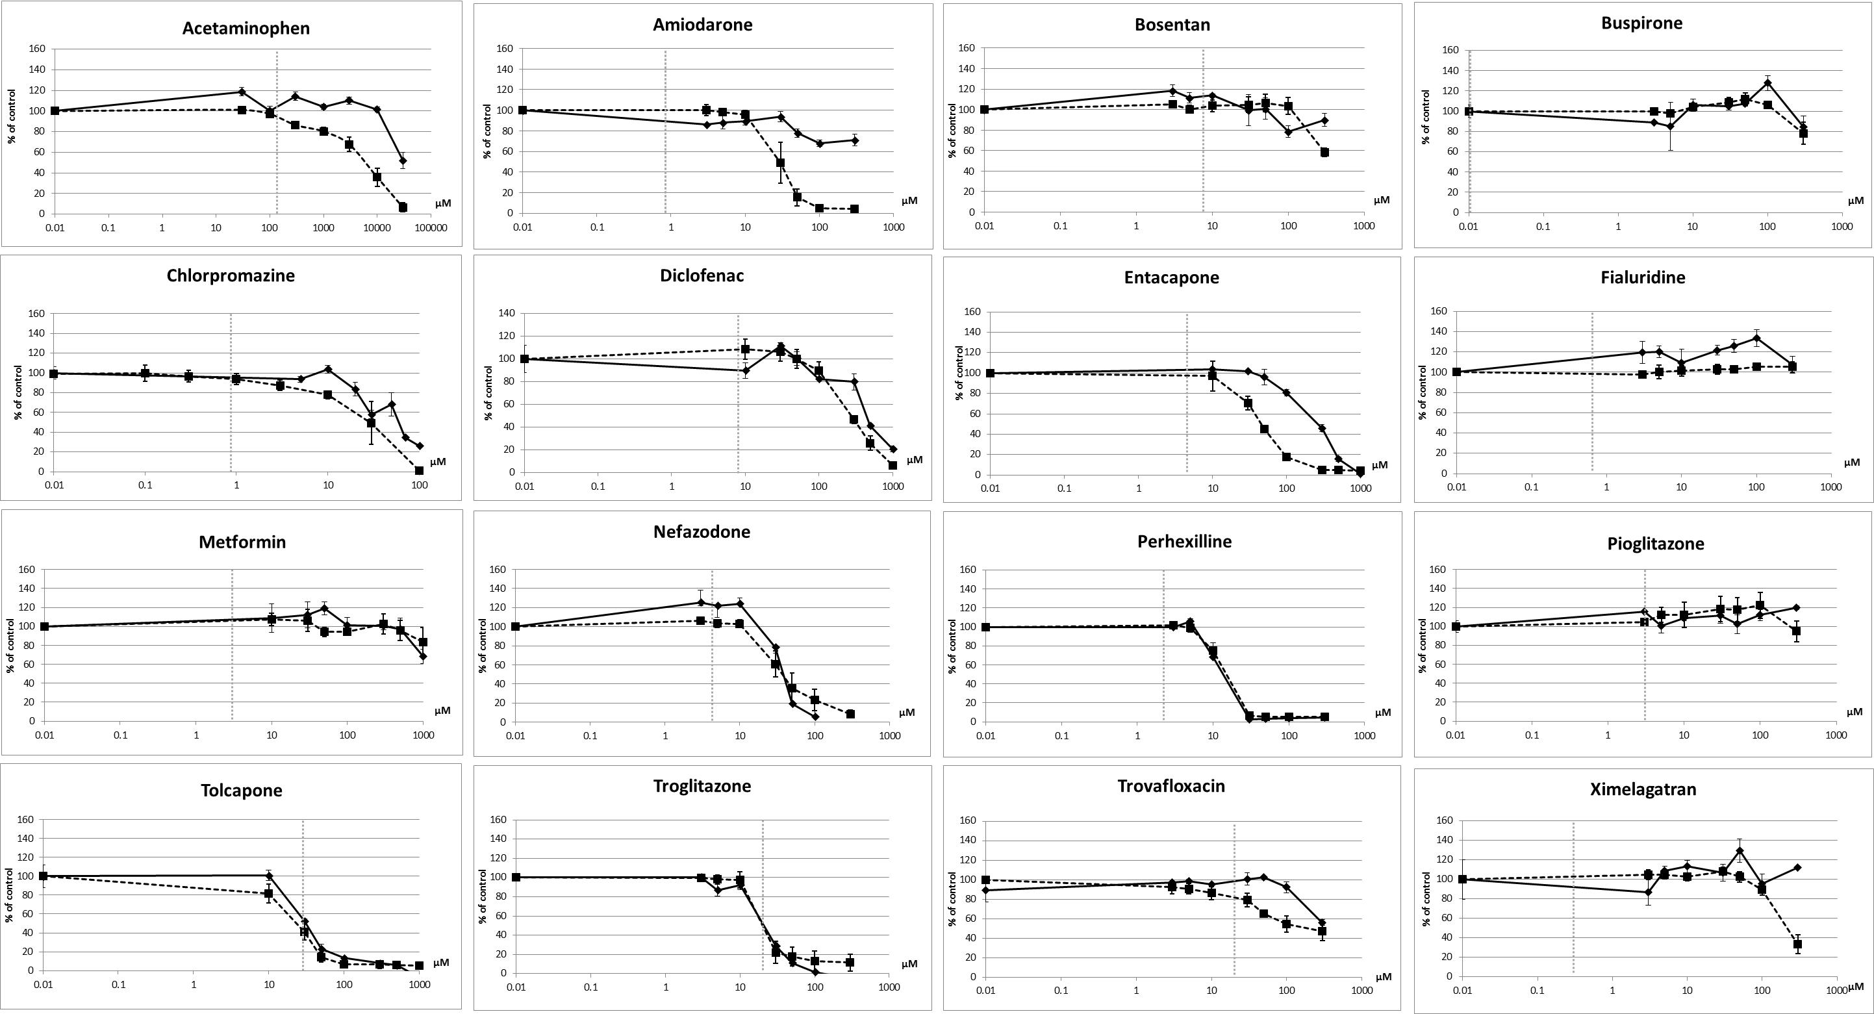

**Figure 1:** Cell viability profiles of 16 TCs in a pool (P0203T, n = 13 donors) of suspended human hepatocytes after 2 hours of exposure (black solid line) and in human hepatocytes (mean of 3 to 5 donors) in 2D-sw monocultures exposed at day 2 after plating for 24 hours (dotted line). For treatment protocol details see Table I. Total Cmax is represented by the vertical grey line. 2D-sw monoculture data except for chlorpromazine, fialuridine and trovafloxacin are from Sison-Young et al., 2016 .

Viability profiles obtained with 11/16 TCs after a single 2 hour exposure of a pool of cryopreserved human hepatocytes in suspension were comparable to the mean viability profile of cryopreserved human hepatocytes in 2D-sw monoculture after a single 24h exposure, *i.e*. for bosentan, buspirone, chlorpromazine, diclofenac, fialuridine, metformin, nefazodone, perhexiline, pioglitazone, tolcapone and troglitazone. Suspended hepatocytes were less sensitive to 5/16 TCs, *i.e*. acetaminophen, amiodarone, entacapone, trovafloxacin, and ximelagatran.

Based on the highest concentration without a clear cytotoxic effect (set at less than 20% loss of cell viability), an SM was calculated and reported in Table 2.

# 3.2 Viability *versus* ATP profiles in Human Hepatocytes in 2D-sw monoculture

The viability (resazurin) and ATP profiles were equivalent for chlorpromazine and trovafloxacin in human hepatocytes in 2D-sw monoculture configuration (n = 3) exposed for up to 3 days (data not shown) as reported for the 13 TCs previously tested (Sison-Young et al., in press). In contrast, fialuridine was found to be non-cytotoxic in the resazurin assay up to 300 µM, both after 1 day and 3 days of exposure, depleted ATP in a concentration-dependent manner above 3 µM, after 3 days of exposure, with a 60 % ATP depletion being observed at 300 µM (Figure 2c). This observation is in accordance with the mitochondrial toxicity-related mechanism of hepatotoxicity in humans reported for this drug (Kleiner et al., 1997). Consequently, the SM after 3 days of exposure was calculated based on ATP depletion (see Table 2).

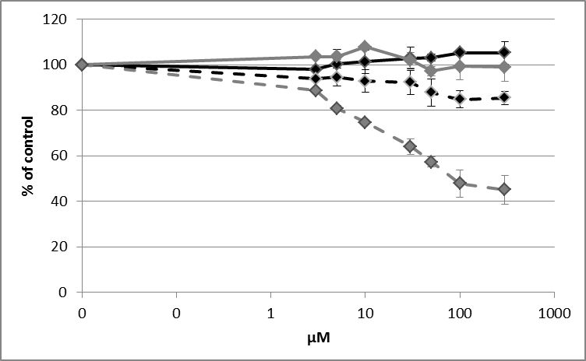

**Figure 2:** cell viability (in black) and ATP content (in grey) profiles of fialuridine in human hepatocytes (n = 3 donors) in 2D-sw monocultures exposed for 1 day (solid lines) and 3 days (dashed lines). Total Cmax is represented by the vertical grey line.

## Cytotoxicity profiles in established 3D-co-cultures

The 16 TCs were also evaluated in 3D-MT co-cultures consisting of cryopreserved human hepatocytes (n = 1 donor) co-cultured with mixed cryopreserved liver non parenchymal cells (NPC) and submitted to 3 repeat-treatments over 14 days as outlined in Table 1. The results obtained on ATP content are shown in Figure 3, and compared to the mean ATP content observed in plated cryopreserved human hepatocytes (n = 3 – 5 donors) daily treated for 3 days in 2D-sw monocultures.



(a): precipitation in hLiMM culture medium

**Figure 3:** Profiles of ATP content in 3D-MT co-cultures consisting of human hepatocytes (n = 1 donor) co-cultured either with NPC and exposed to the 16 TCs over a 14-day culture period (3 treatments, black) or with Kupffer cells and exposed to acetaminophen, chlorpromazine, diclofenac or troglitazone over a 14-day culture period (4 treatments, grey). As a comparison, profiles of mean ATP content of human hepatocyte 2D-sw monocultures (n = 3 - 5) daily exposed for 3 days (dotted line) are also shown. Total Cmax is represented by the vertical grey line. For treatment protocol details see Table 1. 2D-sw monoculture data except for chlorpromazine, fialuridine and trovafloxacin are from Sison-Young et al., 2016.

Also shown in this figure is the ATP content in 3D-MT co-cultures consisting of cryopreserved human hepatocyte co-cultured with Kupffer cells and exposed to acetaminophen, chlorpromazine, diclofenac or troglitazone, according to the treatment regimen outlined in Table 1, *i.e.* four repeat-treatments over 14 days in 3D-MT. The profiles of ATP depletion were similar in the two types of 3D-MT co-cultures (with Kupffer cells or NPC) and two types of treatment regimen (3 or 4 over 14 days).

Seven/16 TCs *i.e.* acetaminophen, buspirone, diclofenac, metformin, perhexiline, troglitazone and ximelagatran displayed a similar ATP depletion profile in 3D-MT co-cultures compared to the mean 2D-sw monocultures, and 7/16 TCs, *i.e.* amiodarone, bosentan, chlorpromazine, entacapone, nefazodone, tolcapone and trovafloxacin showed ATP depletion at higher concentrations in 3D-MT co-cultures compared to the mean 2D–sw monocultures. It should however be noted that the latter precipitated in hLiMM culture medium above 250 µM. Two/16 TCs, *i.e.* fialuridine and pioglitazone depleted ATP in 3D-MT-co-cultures at lower concentrations than in the mean 2D-sw monocultures, with pioglitazone precipitating in hLiMM culture medium from 15.6 µM.

Based on the highest concentration having no adverse effect on ATP content, an SM was calculated and reported in Table 2.

|  |  |  |  |  |  |  |  |  |  |  |
| --- | --- | --- | --- | --- | --- | --- | --- | --- | --- | --- |
| **Compounds** | **Cmax (µM)** |  | **Pool Susp 2h** | | **Spheroid co-cult D14** | |  | **2Dsw-/24h** | **2Dsw- daily/ 72h** | |
|  |  |  | **IC20resazurin** | **SMresasurin** | **IC20ATP** | **SMATP** |  | **SMresasurin** | **SMresazurin** | **SMATP** |
| Acetaminophen | 139 |  | 10000 | 72 | 300 | **2** |  | **7** | **2** | **2** |
| Amiodarone | 0.81 |  | 30 | 37 | 25 | 31 |  | 12 | **4** | **4** |
| Bosentan | 7.39 |  | >300 | >41 | 100 | 14 |  | 14 | **7** | **1** |
| *Buspirone | 0.01 |  | >300 | >30000 | 100 | 10000 |  | 10000 | 10000 | 10000 |
| Chlorpromazine | 0.84 |  | 20 | 24 | 5 | **6** |  | **4** | **1** | **1** |
| Diclofenac | 7.99 |  | 300 | 38 | 30 | **4** |  | 13 | **1** | **1** |
| *Entacapone | 4.34 |  | 100 | 23 | 100 | 23 |  | **2** | **2** | **2** |
| Fialuridine | 0.64 |  | >300 | >469 | <4 | **<6** |  | >469 | >469 | **8** |
| *Metformin | 7.75 |  | 500 | 65 | 250 | 32 |  | >39 | 13 | 13 |
| Nefazodone | 4.26 |  | 30 | **7** | 30 | **7** |  | **2** | **1** | **1** |
| Perhexiline | 2.16 |  | 5 | **2** | 2 | **1** |  | **2** | **<1** | **<1** |
| *Pioglitazone | 2.95 |  | >300 | >102 | 30 | 10 |  | >102 | >102 | 34 |
| Tolcapone | 27.8 |  | 10 | **0.4** | 20 | **0.7** |  | **0.4** | **<0.4** | **0.1** |
| Troglitazone | 6.39 |  | 10 | **2** | 5 | **1** |  | **2** | **0.5** | **0.5** |
| Trovafloxacin | 19.7 |  | 100 | **5** | 100 | **5** |  | **1** | **0.5** | **1.5** |
| Ximelagatran | 0.30 |  | >300 | >1000 | 25 | 83 |  | 333 | 167 | 333 |

**Table 2:** Cmax, IC20 (highest concentration inducing less than 20% cell viability loss) and calculated SM (IC20/Cmax) values. The grey area indicates correct *in vivo* data prediction. The values in bold indicate an SM of < 10. * correspond to non-DILI TCs.

Only 5/12 DILI-compounds were correctly identified after a single exposure for 2 hours of pooled human hepatocytes in suspension and 7/12 DILI-compounds after a single exposure for 24 hours of 2D-sw human hepatocyte monocultures (mean of 3 to 5 donors). The 3D-MT co-culture of human hepatocytes with NPC (1 donor) identified 9/12 DILI-compounds based on the ATP depletion profiles after a 14-day exposure period (3 treatments). In addition to ximelagatran, also not identified in 2D-sw human hepatocyte monocultures (mean of 3 to 5 donors) based on the ATP depletion profiles, bosentan and amiodarone were not correctly identified as DILI-compounds in the 3D-MT co-culture of human hepatocytes with NPCs.

The two well-known hepatotoxic compounds amiodarone and bosentan were correctly evaluated as DILI positive in human hepatocytes cultured in the micropatterned 2D co-culture format treated twice over five days (n = 1, SM = 6, data not shown). The variable SMs could be at least in part related to inter-donor variability in sensitivity to these compounds. Indeed, the SM for amiodarone ranged between 4 and 37 in the 4-5 human 2D-sw monocultures exposed for 3 days (data not shown). This is in accordance with our recent finding of a certain degree of inter-donor variability in the metabolic clearances of amiodarone (Pomponio et al., 2015), most probably related to either a difference in drug metabolizing Phase I and/or Phase II enzyme and/or transporter activities. Similarly, the SM of bosentan varied between 0.7 and 14 in the 4-5 human 2D-sw monocultures exposed for 3 days (data not shown). The mechanisms of hepatotoxicity of bosentan are at least partly related to its inhibitory effect of the Bile Salt Export Pump (BSEP) (Ho et al., 2010), and to CYP2C9-dependent formation of a cytotoxic metabolite (Matsunaga et al., 2016). Differences in the expression and function of the BSEP and CYP2C9 proteins could explain the inter-donor variability, regardless of the culture and treatment format used.

Inter-donor variability was also observed in the response of human 2D-sw monocultures exposed for 1 day or 3 days to acetaminophen, chlorpromazine, diclofenac, perhexiline and trovafloxacin (data not shown), however an SM of < 10 in all tested culture and treatment formats was observed, leading to their unequivocal classification as strongly cytotoxic compounds.

Entacapone was chosen, like buspirone, metformin and pioglitazone as a negative control, *i.e.* non-hepatotoxic to humans based on available literature information. Table 2 shows that buspirone, metformin and pioglitazone presented indeed an SM of ≥ 10 in human hepatocytes in all tested culture and treatment conditions.

Entacapone presented an SM > 20 in the pool of suspended human hepatocytes as well as in the 3D-MT co-culture exposed for 14 days (three treatments), while the SM was only 2 based on both mean cell viability loss and ATP depletion of human hepatocytes in 2D-sw monocultures, when treated for 1 day or 3 days (Sison-Young et al., 2016). Entacapone and its hepatotoxic counterpart, tolcapone, were also assessed using human hepatocytes in a micropatterned 2D co-culture format (human hepatocyte-mouse fibroblast co-culture) exposed for five or nine days (twice or four treatments). Tolcapone was clearly cytotoxic from 25 µM, in the range of its Cmax, as also observed in all other culture and treatment formats, entacapone displayed clear cytotoxicity only for concentrations higher than 50 µM to human hepatocytes in the micropatterned 2D co-culture format (Figure 4)

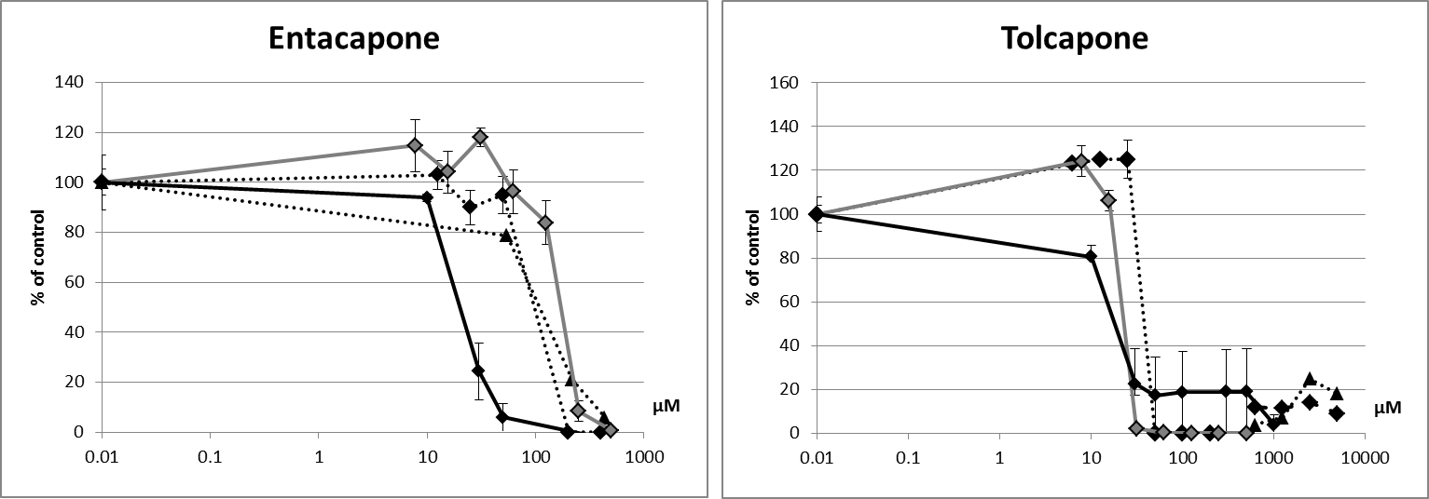

**Figure 4:** ATP depletion profile of entacapone and tolcapone in human hepatocyte cultures, 2D-sw monocultures (3-day treatment, solid line), 2D co-culture with mouse 3T3 cells (5-day (▲) or 9-day (⬥) treatment, dotted lines) or 3D-MT co-culture with NPC (14-day treatment, grey line). For treatment protocol details see Table 1.

No inter-donor variability was seen in the IC20 with the 4 human hepatocyte 2D-sw monocultures exposed for 3 days to entacapone (data not shown) confirming that further studies are needed to understand the high sensitivity to entacapone of 2D-sw monocultures *versus* established long-term hepatocyte 2D- and 3D co-cultures.

## Influence of 2D and 3D Culture Format and Treatment Regimen

Particularly striking was the observation that the sensitivity of human hepatocytes in 2D-sw monocultures exposed for 3 consecutive days to trovafloxacin, which was on average 3-fold higher than 3D-MT co-culture exposed for 14 days (Table 2). We postulated if culture format and treatment regimen could affect the outcome of the ATP-depletion profile. A comparative experiment was performed using the same human cryopreserved hepatocyte preparation in monoculture in a 2D-sw and 3D-MT format and exposed daily to trovafloxacin for 4 days. Figure 5 shows that the sensitivity of this human hepatocyte preparation to trovafloxacin was equivalent in both culture formats, with ATP depletion occurring from concentrations over 10 µM. No precipitation of trovafloxacin in either of the two treatment media (hLiMM and serum-free KLC-Maintenance Medium) was observed. The sensitivity of the cells in the two culture formats to acetaminophen, chlorpromazine and troglitazone was also equivalent. Interestingly, comparing the data form Figure 3 and Figure 5 shows that the cytotoxicity profile following a treatment regimen over 3 days to 3D-MT or 2Dsw monocultures are equivalent to those following a 14-day treatment regimen of 3D-MT co-cultures (Kupffer-cells or NPC).

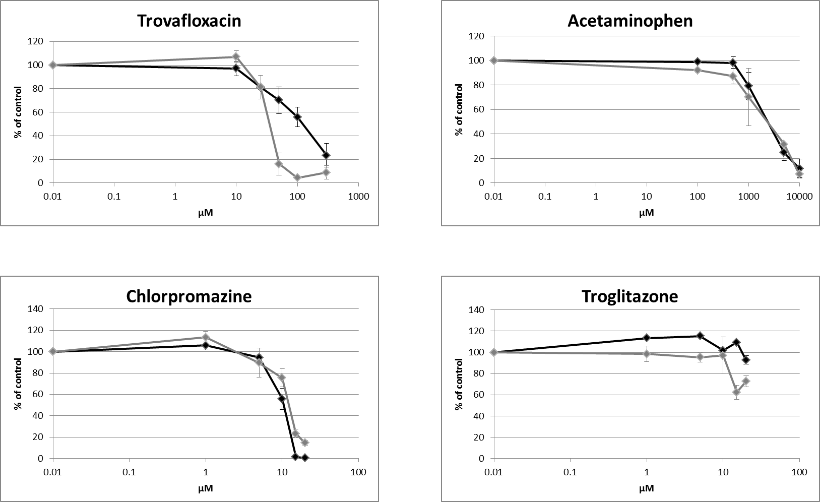

**Figure 5:** profiles of ATP content in human hepatocyte monocultures (n = 1) daily exposed for 4 days to acetaminophen, chlorpromazine, troglitazone or trovafloxacin (2D-sw, black; 3D-MT, grey).

## Co-culture and Inflammation

When 2D human hepatocyte preparations were co-cultured with NPC in the presence of lipopolysaccharide (LPS), which is known to mimic the *in vivo* stimulation of NPC by the immune system (Shaw et al., 2009), their sensitivity to trovafloxacin (5 µM and 10 µM) was increased (Figure 6) in accordance with reported involvements of the immune system in its mechanism of hepatotoxicity of trovafloxacin (Liguori et al., 2010; Messner et al., 2013), while, as expected their sensitivity to acetaminophen (100 µM and 300 µM) was not modified.

Ximelagatran which induces hepatic injury in long-term clinical trials was not depicted in the present study as potentially hepatotoxic in all culture systems and treatment protocols, as also previously reported (Keisu and Andersson, 2010). In the presence of lipopolysaccharide, ATP values were slightly (10 %) decreased in 2D human hepatocyte-NPC co-cultures following ximelagatran treatments at 25 µM (Figure 6). At lower concentrations of ximelagatran, an accentuation of ATP depletion was not observed, suggesting that the innate immune cells play a minor role in the ximelagatran mechanism of hepatotoxicity.

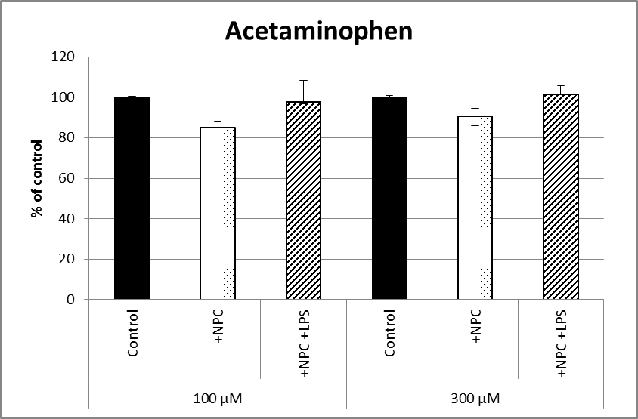 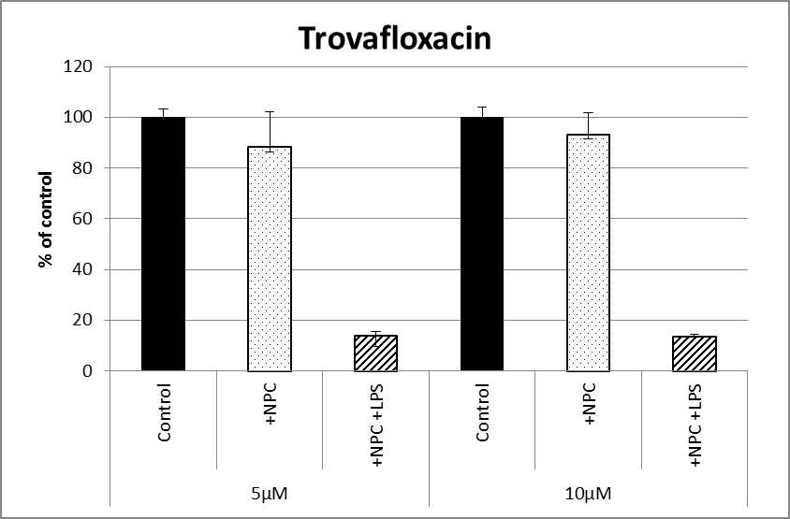

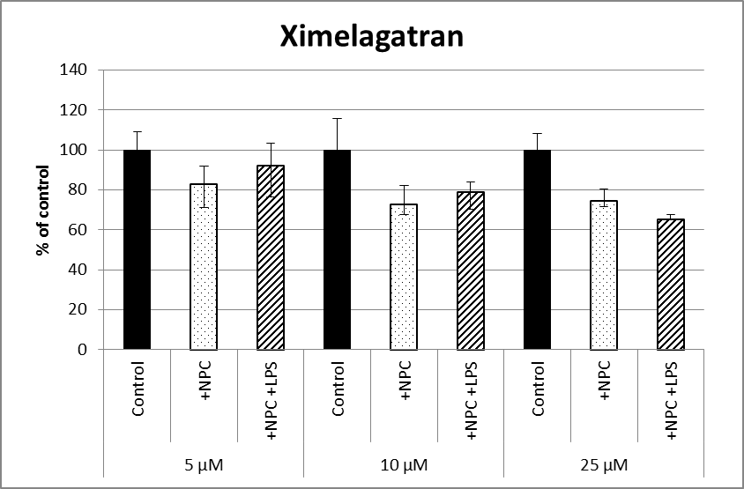

**Figure 6:** Cell viability profiles of acetaminophen 100 and 300 µM, trovafloxacin 5 and 10 µM and ximelagatran 5, 10 and 25 µM on cell viability profiles of human hepatocytes (n = 1) in 2D- monoculture and 2D co-culture with NPC exposed daily over 48 hours in the presence or absence of LPS (0.01 mg/mL). Results are expressed as % of viability of human hepatocytes in 2D monoculture exposed to these concentrations in the presence of LPS (controls).

In summary, non-DILI-compounds were all (4/4) correctly identified after a single exposure for 2 hours of pooled human hepatocytes in suspension and after a 14-day exposure (3 treatments) of a 3D-MT co-culture (1 donor). In contrast, only about half of the DILI-compounds were correctly identified after a single exposure of 2 hours (pools of human hepatocytes in suspension). The 3D-MT co-culture (1 donor), in addition to ximelagaran (also not identified in human hepatocytes in 2D-sw monocultures after a three-day exposure, Sison et al., 2016) additionally failed to detect amiodarone and bosentan. This could in part be due to inter -donor variability in the sensitivity to amiodarone and bosentan, highlighting the importance of assessing various human hepatocyte preparations. The presence of LPS in 2D human hepatocyte-NPC co-cultures increased their sensitivity to ximelagatran, but only at high concentrations, which did not allow classification of it as a DILI compound.

The overall choice of a predictive DILI model depends upon a number of factors, particularly depending on which stage of the drug development pipeline the model will be deployed. At early stages, cost, throughput, turnaround time, sensitivity and specificity are important. At later stages, mechanistic recapitulation (e.g. BSEP inhibition, mitotoxicity and toxic metabolite formation) and understanding donor variability becomes more important when nominating a candidate molecule for GLP studies. As such, a one-model-fits-all approach is unlikely to be feasibile during drug discovery, due consideration is needed as to the most appropriate time of deployment of each model between lead investigation and candidate drug investment decision. Take home messages from this research are that (1) despite suspension human hepatocytes having the greatest metabolic capacity in the short term, they are the least predictive of clinical DILI across the MIP-DILI test compounds, (2) longer exposure periods than 72h of human hepatocytes do not allow to increase DILI-prediction rate, (3) co-cultures of human hepatocytes with NPCs, in the presence of LPS during the 72h exposure period allow the assessment of innate immune system involvement of a given drug.

**Acknowledgments**

We thank M. Untrau (KaLy-Cell) for technical assistance, Simon Messner and Johannes Haugstetter (InSphero) for the delivery of high-quality liver microtissue and for the support with scientific expertise, and Okey Ukairo for the work conducted at Hepregen.

# References

Alexandre E, Viollon-Abadie C, David P, Gandillet A, Coassolo P, Heyd B, Mantion G, Wolf P, Bachellier P, Jaeck D, Richert L. (2002). Cryopreservation of adult human hepatocytes obtained from resected liver biopsies. Cryobiology 44:103-113.

Blanchard N, Richert L, Notter B, Delobel F, David P, Coassolo P, and Lavé T (2004) Impact of serum on clearance predictions obtained from suspensions and primary cultures of rat hepatocytes. *Eur J Pharm Sci* 23:189–99.

Bordessa A, Colin-Cassin C, Grillier-Vuissoz I, Kuntz S, Mazerbourg S, Husson G, Vo M, Flament S, Martin H, Chapleur Y, Boisbrun (2014). Optimisation of troglitazone derivatives as potent anti-proliferative agents : towards more active and less toxic agents.. *Eur J Med Chem* 83:129–140.

# Darnell M, [Ulvestad M](http://www.ncbi.nlm.nih.gov/pubmed/?term=Ulvestad%20M%5BAuthor%5D&cauthor=true&cauthor_uid=22776955), Ellis E, [Weidolf L](http://www.ncbi.nlm.nih.gov/pubmed/?term=Weidolf%20L%5BAuthor%5D&cauthor=true&cauthor_uid=22776955), and [Andersson TB](http://www.ncbi.nlm.nih.gov/pubmed/?term=Andersson%20TB%5BAuthor%5D&cauthor=true&cauthor_uid=22776955). (2012) In vitro evaluation of major in vivo drug metabolic pathways using primary human hepatocytes and HepaRG cells in suspension and a dynamic three-dimensional bioreactor system. *J Pharmacol Exp Ther.* 343:134-44.

den Braver-Sewradj SP, den Braver MW, Vermeulen NPE, Commandeur JNM, Richert L, Vos JC. Combination of four substrates for assessment of variability between donor and culture conditions for cytochrome P450, UDP- glucuronosyltransferase and sulfotransferase activity in cryopreserved primary human hepatocytes (submitted).

Desbans, C., Hilgendorf, C., Lutz, M., Bachellier, P., Zacharias, T., Weber, J.C., Dolgos, H., Richert, L., Ungell, A.L., (2014). Prediction of fraction metabolized via cyp3a in humans utilizing cryopreserved human hepatocytes from a set of 12 single donors. Xenobiotica: The Fate of Foreign Compounds in Biological Systems 44, 17–27.

Elaut G, Papeleu P, Vinken M, Henkens T, Snykers S, Vanhaecke T, and Rogiers V (2006) Hepatocytes in suspension. *Methods Mol Biol* 320:255–63.

# [Gandhi A](http://www.ncbi.nlm.nih.gov/pubmed/?term=Gandhi%20A%5BAuthor%5D&cauthor=true&cauthor_uid=23238562), [Guo T](http://www.ncbi.nlm.nih.gov/pubmed/?term=Guo%20T%5BAuthor%5D&cauthor=true&cauthor_uid=23238562), [Shah P](http://www.ncbi.nlm.nih.gov/pubmed/?term=Shah%20P%5BAuthor%5D&cauthor=true&cauthor_uid=23238562), [Moorthy B](http://www.ncbi.nlm.nih.gov/pubmed/?term=Moorthy%20B%5BAuthor%5D&cauthor=true&cauthor_uid=23238562), and [Ghose R](http://www.ncbi.nlm.nih.gov/pubmed/?term=Ghose%20R%5BAuthor%5D&cauthor=true&cauthor_uid=23238562) (2013). Chlorpromazine-induced hepatotoxicity during inflammation is mediated by TIRAP-dependent signaling pathway in mice.[*Toxicol Appl Pharmacol.*](http://www.ncbi.nlm.nih.gov/pubmed/23238562) 266:430-8.

# [Ho RH](http://www.ncbi.nlm.nih.gov/pubmed/?term=Ho%20RH%5BAuthor%5D&cauthor=true&cauthor_uid=20010382), [Leake BF](http://www.ncbi.nlm.nih.gov/pubmed/?term=Leake%20BF%5BAuthor%5D&cauthor=true&cauthor_uid=20010382), [Kilkenny DM](http://www.ncbi.nlm.nih.gov/pubmed/?term=Kilkenny%20DM%5BAuthor%5D&cauthor=true&cauthor_uid=20010382), [Meyer Zu Schwabedissen HE](http://www.ncbi.nlm.nih.gov/pubmed/?term=Meyer%20Zu%20Schwabedissen%20HE%5BAuthor%5D&cauthor=true&cauthor_uid=20010382), [Glaeser H](http://www.ncbi.nlm.nih.gov/pubmed/?term=Glaeser%20H%5BAuthor%5D&cauthor=true&cauthor_uid=20010382), [Kroetz DL](http://www.ncbi.nlm.nih.gov/pubmed/?term=Kroetz%20DL%5BAuthor%5D&cauthor=true&cauthor_uid=20010382), and [Kim RB](http://www.ncbi.nlm.nih.gov/pubmed/?term=Kim%20RB%5BAuthor%5D&cauthor=true&cauthor_uid=20010382). (2010) Polymorphic variants in the human bile salt export pump (BSEP; ABCB11): functional characterization and interindividual variability. [*Pharmacogenet Genomics*](http://www.ncbi.nlm.nih.gov/pubmed/20010382) 20:45-57.

Jigorel E, Le Vee M, Boursier-Neyret C, Bertrand M, and Fardel O (2005) Functional expression of sinusoidal drug transporters in primary human and rat hepatocytes. *Drug Metab Dispos* 33:1418–22.

Jouin D, Blanchard N, Alexandre E, Delobel F, David-Pierson P, Lavé T, Jaeck D, Richert L, Coassolo P. (2006). Cryopreserved human hepatocytes in suspension are a convenient high throughput tool for the prediction of metabolic clearance. Eur. J. Pharm. Biopharm. 63:347-355.

[Keisu M](http://www.ncbi.nlm.nih.gov/pubmed/?term=Keisu%20M%5BAuthor%5D&cauthor=true&cauthor_uid=20020269), and [Andersson TB](http://www.ncbi.nlm.nih.gov/pubmed/?term=Andersson%20TB%5BAuthor%5D&cauthor=true&cauthor_uid=20020269). (2010) Drug-induced liver injury in humans: the case of ximelagatran. [*Handb Exp Pharmacol.*](http://www.ncbi.nlm.nih.gov/pubmed/20020269) 196:407-18.

[Khetani SR](http://www.ncbi.nlm.nih.gov/pubmed/?term=Khetani%20SR%5BAuthor%5D&cauthor=true&cauthor_uid=23152190), [Kanchagar C](http://www.ncbi.nlm.nih.gov/pubmed/?term=Kanchagar%20C%5BAuthor%5D&cauthor=true&cauthor_uid=23152190), [Ukairo O](http://www.ncbi.nlm.nih.gov/pubmed/?term=Ukairo%20O%5BAuthor%5D&cauthor=true&cauthor_uid=23152190), [Krzyzewski S](http://www.ncbi.nlm.nih.gov/pubmed/?term=Krzyzewski%20S%5BAuthor%5D&cauthor=true&cauthor_uid=23152190), [Moore A](http://www.ncbi.nlm.nih.gov/pubmed/?term=Moore%20A%5BAuthor%5D&cauthor=true&cauthor_uid=23152190), [Shi J](http://www.ncbi.nlm.nih.gov/pubmed/?term=Shi%20J%5BAuthor%5D&cauthor=true&cauthor_uid=23152190), [Aoyama S](http://www.ncbi.nlm.nih.gov/pubmed/?term=Aoyama%20S%5BAuthor%5D&cauthor=true&cauthor_uid=23152190), [Aleo M](http://www.ncbi.nlm.nih.gov/pubmed/?term=Aleo%20M%5BAuthor%5D&cauthor=true&cauthor_uid=23152190), and [Will Y](http://www.ncbi.nlm.nih.gov/pubmed/?term=Will%20Y%5BAuthor%5D&cauthor=true&cauthor_uid=23152190). (2013). Use of micropatterned co-cultures to detect compounds that cause drug-induced liver injury in humans. [*Toxicol Sci.*](http://www.ncbi.nlm.nih.gov/pubmed/23152190) 132:107-17.

Kleiner DE, Gaffey MJ, Sallie R, Tsokos M, Nichols L, McKenzie R, Straus SE, Hoofnagle JH. (1997). Histopathologic changes associated with fialuridine hepatotoxicity. *Mod. Pathol.* 10: 192–199.

Liguori MJ, Ditewig AC, Maddox JF, Luyendyk JP, Lehman-McKeeman LD, Nelson DM, Bhaskaran VM, Waring JF, Ganey PE, Roth RA, and Blomme EA. (2010) [Comparison of TNFα to lipopolysaccharide as an inflammagen to characterize the idiosyncratic hepatotoxicity potential of drugs: Trovafloxacin as an example.](http://www.ncbi.nlm.nih.gov/pubmed/21151465) *Int J Mol Sci.*11:4697-714.

Mao J, Mohutsky M, Harrelson J, Wrighton S, and Hall S. (2012). Predictions of CYP-Mediated Drug-Drug Interactions Using Cryopreserved Human Hepatocytes: Comparison of Plasma and Protein-Free Media Incubation Conditions. *Drug Metab. Dispos*. 40:706-16.

Matsunaga J, N, Kaneko N, Staub AY, Nakanishi T, Nunoya K, Imawaka H, Tamai I (2016). Analysis of the Metabolic Pathway of Bosentan and of the Cytotoxicity of Bosentan Metabolites Predicti. *Drug Metab. Dispos*. 44:66-27.

Mennecozzi M, Landesmann B, Palosaari T, Harris G, Whelan M. (2015) Sex Differences in Liver Toxicity—Do Female and Male Human Primary Hepatocytes React Differently to Toxicants In Vitro?. PLoS ONE 10: e0122786.

# [Messner S](http://www.ncbi.nlm.nih.gov/pubmed/?term=Messner%20S%5BAuthor%5D&cauthor=true&cauthor_uid=23143619), [Agarkova I](http://www.ncbi.nlm.nih.gov/pubmed/?term=Agarkova%20I%5BAuthor%5D&cauthor=true&cauthor_uid=23143619), [Moritz W](http://www.ncbi.nlm.nih.gov/pubmed/?term=Moritz%20W%5BAuthor%5D&cauthor=true&cauthor_uid=23143619), and [Kelm JM](http://www.ncbi.nlm.nih.gov/pubmed/?term=Kelm%20JM%5BAuthor%5D&cauthor=true&cauthor_uid=23143619). (2013) Multi-cell type human liver microtissues for hepatotoxicity testing. [*Arch Toxicol.*](http://www.ncbi.nlm.nih.gov/pubmed/23143619)87:209-13.

Mueller SO, Guillouzo A,Hewitt PG, and Richert L. (2015) Overview on liver cell models and their use in pharmaceutical drug toxicity testing *Toxicology In Vitro* 14: 172-186, 2015.

Parmentier, C., Truisi, G.L., Moenks, K., Stanzel, S., Lukas, A., Kopp-Schneider, A., Alexandre, E., Hewitt, P.G., Mueller, S.O., Richert, L., 2013. Transcriptomic hepatotoxicity signature of chlorpromazine after short- and long-term exposure in primary human sandwich cultures. Drug Metab. Dispos.: Biol. Fate Chem. 41, 1835–1842.

Pomponio G, Savary C, Parmentier C, Bois F, Guillouzo A, Romanelli L, Richert L, Di Consiglio E, Testai E. (2015). In vitro kinetics of amiodarone and its major metabolite in two human-derived cell models after acute and repeated exposure. *Toxicology In Vitro* 14: 252-255.

Richert L, Liguori MJ, Abadie C, Heyd B, Mantion G, Halkic N, and Waring JF (2006) Gene expression in human hepatocytes in suspension after isolation is similar to the liver of origin, is not affected by hepatocyte cold storage and cryopreservation, but is strongly changed after hepatocyte plating. *Drug Metab Dispos* 34:870–9.

Shaw PJ, Ditewig AC, Waring JF, Liguori MJ, Blomme EA, Ganey PE, and Roth RA (2009). [Coexposure of mice to trovafloxacin and lipopolysaccharide, a model of idiosyncratic hepatotoxicity, results in a unique gene expression profile and interferon gamma-dependent liver injury.](http://www.ncbi.nlm.nih.gov/pubmed/18930950) *Toxicol Sci.* 107:270-80.

Shaw PJ, Ganey PE, and Roth RA (2010). Idiosyncratic Drug-Induced Liver Injury and the Role of Inflammatory Stress with an Emphasis on an Animal Model of Trovafloxacin Hepatotoxicity. Toxicol Sci. 118:7-18.

Simon S, Blanchard N, Alexandre E, Hewitt NJ, Bachellier P, Heyd B, Coassolo P, Schuler F, and Richert L (2009). The comparison of fresh and cryopreserved human hepatocytes for the prediction of metabolic clearance in humans, an update. The Medicon Valley – Hepatocyte User Forum (MV-HUF).

Sison-YoungR, LauschkeVM, JohannE, AlexandreE, AntherieuS, AertsH, GeretsH, LabbeG, SchofieldC, StahlS, LovattC, HolderJ, RichertL, KitteringhamN, JonesR, ElmasryM, WeaverR, HewittP, Ingelman-SundbergM, GoldringC, and ParkK (2016) A multi-center assessment of the use of primary human hepatocytes, HepG2, HepaRG and Upcyte cells, with basic measures of cell health, as single cell models of acute hepatotoxicity (in press).

Smith CM, Nolan CK, Edwards MA, Hatfield JB, Stewart TW, Ferguson SS, Lecluyse EL, and Sahi J (2012) A comprehensive evaluation of metabolic activity and intrinsic clearance in suspensions and monolayer cultures of cryopreserved primary human hepatocytes. *J Pharm Sci* 101:3989–4002.

~~.~~