**Supporting Information**

**1,3-Dipolar Cycloaddition of Nitrones to Gold(III)-bound Isocyanides**

**Tatyana B. Anisimova,a Mikhail A. Kinzhalov,b Maxim L. Kuznetsov,a**

**M. Fátima C. Guedes da Silva**,**a Andrey A. Zolotarev,b Vadim Yu. Kukushkin,b Armando J. L. Pombeiro**,\***a and Konstantin V. Luzyanin\***b,c

*a*Centro de Química Estrutural, Instituto Supérior Técnico, Universidade de Lisboa,

Av. Rovisco Pais, 1049-001 Lisbon, Portugal, e-mail: pombeiro@tecnico.ulisboa.pt

*b*Saint Petersburg State University, Universitetskaya Nab., 7/9, 199034 Saint Petersburg, Russian Federation

*c*Department of Chemistry, University of Liverpool, Crown Street, Liverpool L69 7ZD, United Kingdom, e-mail: konstantin.luzyanin@liverpool.ac.uk

**Contents**

Detailed characterization of complexes **8**‒**17**

1H and 13C{1H} NMR spectra for **8**–**17**

X-ray diffraction data

Theoretical calculation data

**Detailed characterization of complexes 8‒17**

*Characterization of* ***8*** *and* ***11****–****17***. Complex **8** was characterized by elemental analyses (C, H, N), ESI‒-MS, IR, 1D (1H, 13C{H}) and 2D (1H,1H-COSY, 1H,13C-HSQC, 1H,13C-HMBC) NMR spectroscopic techniques, and by single-crystal X-ray diffraction.

Satisfactory elemental analyses were accomplished for **8**. In the ESI–-MS spectrum, the set of signals of the fragmentary ions [M – H]– and [M – HCl – H]– with specific isotopic distribution was detected; the latter ion gives the most intensive set of signals in the spectrum. In the IR spectrum of **8**, one strong band corresponding to *ν*(Ccarbene=N) was detected at 1637 cm–1, while no band in the interval 2208–2245 cm–1 from *ν*(C≡N) stretches in starting [AuCl3(CNR1)] was observed. The value of the *ν*(Ccarbene=N) vibrations is higher than those observed for *ν*(Ccarbene=N) stretches for the known gold(I) aminooxycarbene complexes [NCAu{C(OCHR1C*a*HR2)N*b*H(C*a*−N*b*)}] (1560 cm–1, R1 = Me, R2 = H or R1 = H, R2 = Ph),1 but agrees with the corresponding value detected for a palladium(II) aminooxycarbene complex (1642 cm–1).2

1H and 13C{1H} NMR spectra of **8** and **11**–**17** are provided on **Figures S1**–**S17**. In the 1H NMR spectrum of **8**, the CH2 groups of the pyrroline ring emerged as three multiplets with intensities of 1*H*, 1*H*, and 2*H* in the ranges 2.51−2.39, 2.23−2.15, and 2.05−1.89 ppm, respectively, whereas the CH proton was detected as a doublet of doublets at 5.57 ppm (3*J*HH 7.2 and 2.3 Hz). In the spectrum of the starting dipole **4**, the signals of the CH2 groups appeared as a doublet of triplets (3*J*HH 7.3 and 2.3 Hz) and a triplet (3*J*HH 7.3 Hz) at 2.61 and 2.15 ppm, correspondingly, and the CH proton resonated as a broadened triplet at 6.90 ppm. In the 13C{1H} NMR spectrum of **8**, the carbene carbon resonance emerged as a singlet at 172.0 ppm. Resonance of the NCH carbon of the pyrroline ring appeared as a singlet at 83.6 ppm (ca. 135 ppm for the NCH carbon of starting **4**). To our knowledge, no data on 13C{1H} NMR spectra of gold-(cyclic aminooxycarbene) complexes have been previously reported.

Compounds **11**‒**17** were characterized by 1D (1H, 13C{H}) and 2D (1H,13C-HSQC) NMR at −50 ºC (for **11**, **12**, **14**‒**17**) or at −15 ºC (for **13** in order to increase its solubility), and by single-crystal X-ray diffraction (for **13**•CH2Cl2).

1H and 13C{1H} NMR spectra of **11**–**17** are provided on **Figures S4**–**S17**. In the 1H NMR spectra of **11**‒**13**, the characteristic signal of the CH group proton was detected as a sharp singlet in the 5.86–5.52 ppm range. These resonances are slightly shifted to lower field than the corresponding signals of the cyclic carbene complexes [PdCl2{C(ONR2C*c*H(*p*-Tol))=N*d*R1}(C≡NR1)(C*c*–N*d*)] (R2 = Me, CH2Ph, R1 = Cy, Xyl, Bu*t*)2 generated *via* 1,3-dipolar cycloaddition of **5** or *p*-TolCH=N+(CH2Ph)O– to Pd-coordinated isocyanides (5.6−5.3 ppm) and are comparable to the value obtained for **8** (5.57 ppm). Signals of the NMe groups (3.41−3.01 ppm) appeared in a higher field compared to the corresponding signal of dipole **5** (3.74 ppm at −50 ºC) and resonances observed for the abovementioned palladium complexes [PdCl2{C(ONR2C*c*H(*p*-Tol))=N*d*R1}(C≡NR1)(C*c*–N*d*)] (4.00−3.75 ppm).2 In the spectra of **11**, **14**, and **16**, characteristic 1H signals of the CH group of the cyclohexyl ring appeared as triplets at 4.42 ppm (3*J*HH 12.2 Hz, **11**) or at 3.32 ppm (3*J*HH 10.7 Hz, **16**) or a broaded multiplet in the range 3.46−3.10 ppm (**14**). Addition of the nitrones to the coordinated isocyanides is accompanied by a pronounced *δ* 13C shift to a lower field. Thus, in **11**–**17**, the Ccarbene=N 13C resonances were found in the range 176.0−169.7 ppm, *i*.*e*. shifted by *ca*. 60 ppm to the lower field in comparison with the starting (isocyanide)AuIII complexes (*e*.*g*. 111.8 ppm for C≡N in **1**). These values for the Ccarbene=N 13C signals are comparable to those observed for **7** (172.0 ppm) and are slightly shifted to lower field compared to the peaks exhibited by [PdCl2{C(ONR2C*c*H(*p*-Tol))=N*d*R1}(C≡NR1)(C*c*–N*d*)] (157–159 ppm).2 In the 13C NMR spectra of **14**‒**17**, the characteristic signal of the tertiary C carbon was detected as a sharp singlet in the range 98.1–95.6 ppm.

*Characterization of* ***9*** *and* ***10***. Complexes **9** and **10** were characterized by ESI‒-MS, IR, 1D (1H, 13C{H}) and 2D (1H,1H-COSY, 1H,13C-HSQC, 1H,13C-HMBC) NMR and by single-crystal X-ray diffraction (for **9**).

Compound **9** gave satisfactory results of CNH elemental analyses, while for **10** those were not undertaken due to its fast decomposition even in the dark under N2. Although the full characterization of **10** could not be performed, comparison of ESI‒-MS, IR and 1D (1H, 13C{H}) NMR data of **8**−**10** allows the assumption that **10** has a gold(III)-metallacycle structure similar to **9** rather than the carbene structure similar to **8**. The ESI−-MS spectrum of **9** displayed signals that were attributed to the [M + Cl]− and [M − H]− ions. We also detected the signal of the corresponding fragmentary ion [M + Cl – NCCH2CH2CMe2]−, which probably corresponds to one of the products of decomposition of the starting low-stable complex. In the ESI−-MS spectrum of **9**, only one signal from the [M − H]− ion was found. In each of the IR spectra of **9** or **10**, two bands corresponding to *ν*(C=O) and *ν*(C=N) stretching vibrations appeared at 1771 and 1607 or at 1764 and 1606 cm–1 for **9** and **10**, respectively. In the IR spectrum of the most related and structurally characterized complex [(Ph3P)Au{C(=O)NHMe}],3 two bands at 1478 and 1433 cm–1 were detected. The low energy of these vibrations was due to the presence of a hydrogen bonding of the N−H group, which is not possible for **8**. In the similar gold(I) complex [(Ph3P)AuC(=O)Ph]4 and gold(III) complex [(Ph3P)AuMe2{C(=O)OMe}],5 the *ν*(C=O) band appeared at 1606 and 1660 cm–1, correspondingly, and no hydrogen bonding was detected. Data on the related Au-(imine) complexes are rare and usually the *ν*(C=N) bands are either not observed6,7 or appear in the 1515−1640 cm–1 range.8,9 Comparison of the data reported for gold complexes shows that the mean value indicated for *ν*(C=N) is lower than for *ν*(C=O). Thus, one can assume that in the IR spectra of **9** and **10**, the high frequency bands correspond to *ν*(C=O), whereas the other two bands are due to *ν*(C=N).

1H and 13C{1H} NMR spectra of **9** and **10** are provided on **Figures S18**–**S22**. In the 1H NMR spectra of **9** and **10**, the resonances of the CH2 groups of the pyrroline ring were found as two triplets at 3.06 and 2.31 ppm (**9**) or at 2.59 and 2.31 ppm (**10**) indicating that these groups form A2X2 patterns without any other protons involved in spin-spin interactions, while in the spectrum of **9** an ABMNX pattern was observed. In the 1H NMR spectrum of **9**, the CH proton of the cyclohexyl ring was detected as a broad multiplet in the range 3.59–3.48 ppm, which is ca. 0.1 ppm higher than for the starting gold(III) complex [AuCl3(CNCy)] (4.38−4.30 ppm). In the 1H NMR spectrum of **10**, the characteristic signal of the Me group from the xylyl fragment emerged as a singlet at 2.21 ppm, which is 0.36 ppm upfield of that for the starting complex [AuCl3(CNXyl)] (2.57 ppm). In the 13C{1H} NMR spectra of **9** and **10**, the carbonyl carbon resonances emerged as singlets at 155.1 and 156.2 ppm, correspondingly. These values are lower than that for the corresponding gold(III) complex [(Ph3P)AuMe2{C(=O)OMe}] (210.7 ppm)5 and higher than that observed for the related gold(I) compound [(Ph3P)AuC(=O)Ph] (128.8 ppm).4 The carbon of the C=N group was detected at 174.1 and 173.6 ppm for **9** and **10**, respectively, and these values are comparable to the values observed for the related Au-(imine) complexes (e.g. 179.9 ppm for the complex [AuCl2(dmamp)], where dmamp = 2-(*N*,*N*-dimethylaminomethyl)phenyl).9 In the 13C{1H} NMR spectrum of **9**, the CH carbon of the cyclohexyl group appeared at 61.3 ppm as a singlet.

**NMR spectra of complexes 8–17**

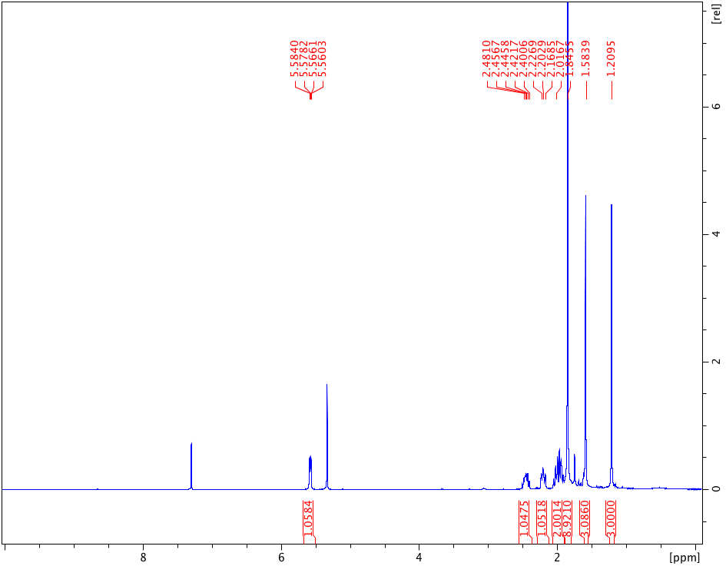

**Figure S1**. 1H NMR spectrum of complex **8** in CDCl3. Residual signal of CH2Cl2 used for recrystallization of complex and H2O (1.79 ppm) are present.

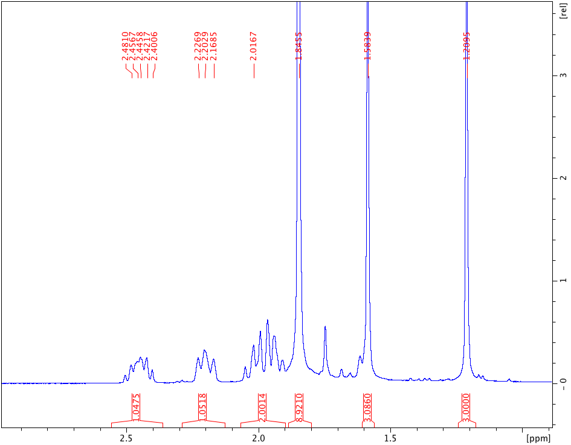

**Figure S2**. 1H NMR spectrum of complex **8** in CDCl3 (expansion of the aliphatic region).

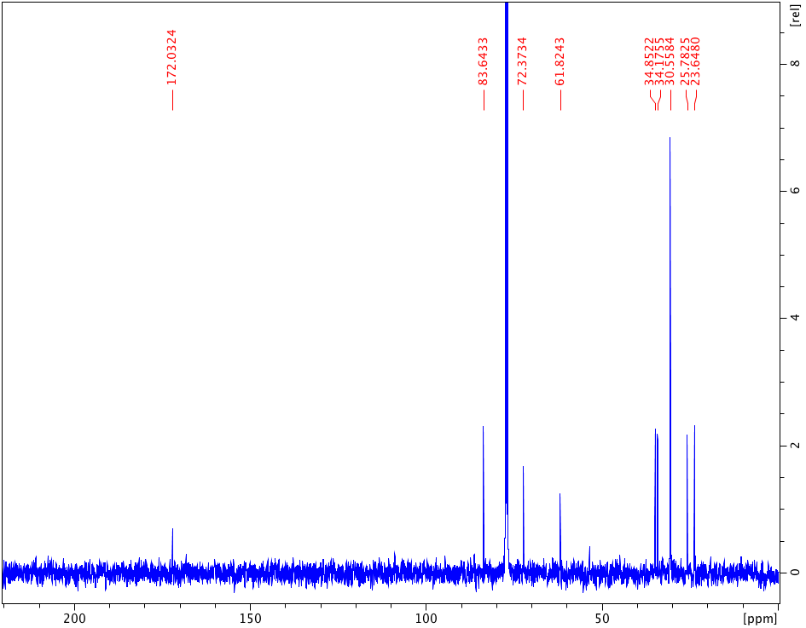

**Figure S3**. 13C{1H} NMR spectrum spectrum of complex **8** in CDCl3. Residual signal of CH2Cl2 used for recrystallization of complex (53.5 ppm) is present.

Spectra of complexes **11**–**17** were obtained *in situ* from the reaction mixtures. For reaction of *aldonitrone* **5** with **1**−**3** or ketonitrone **6** with **2** or **3** or ketonitrone **7** with **2**, nearly quantitative conversion of starting materials into corresponding products **11**–**16** was achieved. It is evidenced by the full disappearance of signals of starting **1**–**3** and emergence of the corresponding signals due to the products. In 1H spectrum of each reaction mixture, a valid integration of 1H signals was obtained matching the proposed formulation of **11**–**16**. For **17**, the conversion even after prolonged time was of ca. 80% as evidenced by the presence of the signals from starting isocyanide complex. Owing the fact that reactions in the NMR tube were undertaken in a small-scale, traces corresponding nitrone (or protonated nitrone) present in small excess were also detected in some spectra.

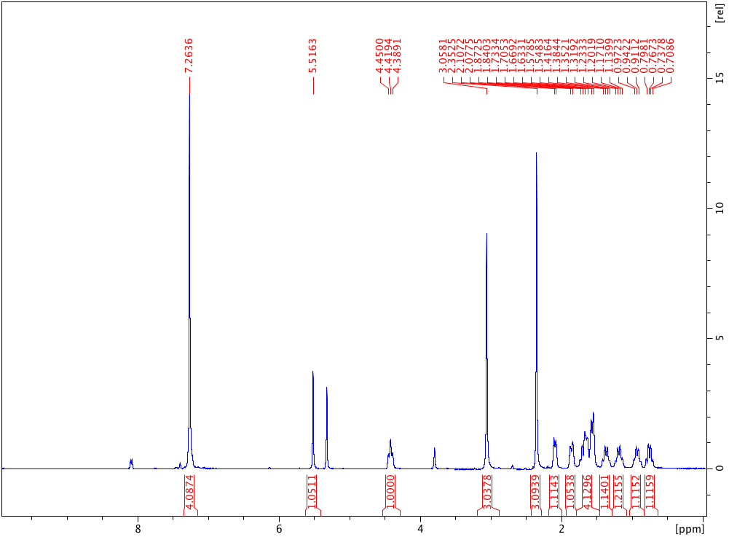

**Figure S4**. 1H NMR spectrum of complex **11** in CH2Cl2.

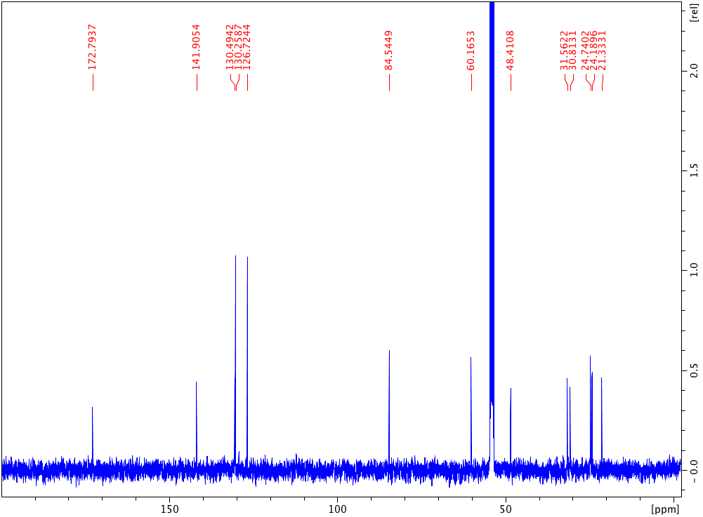

**Figure S5**. 13C{1H} NMR spectrum of complex **11** in CD2Cl2.

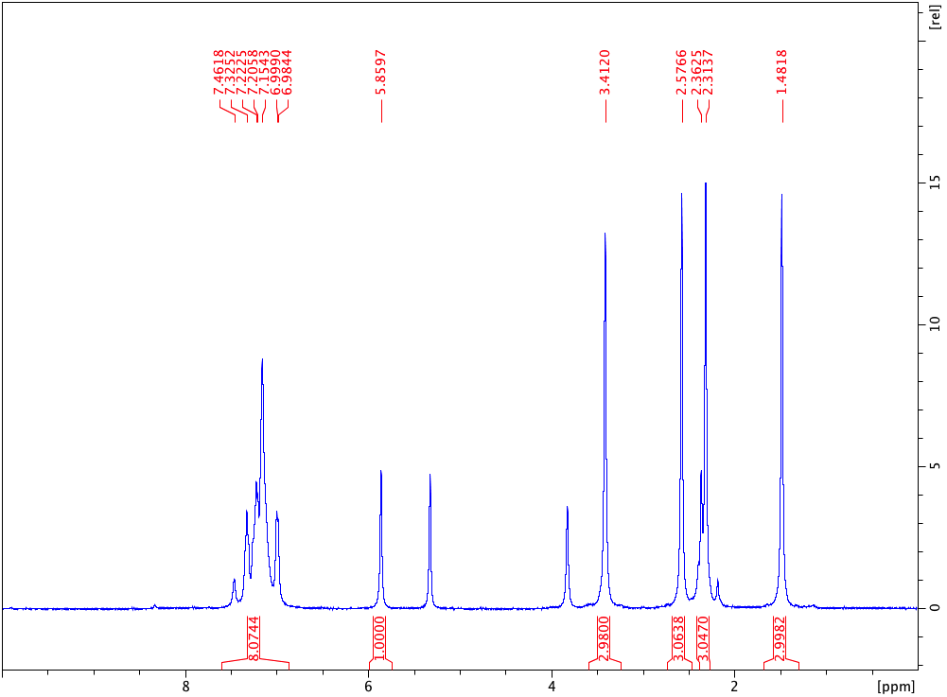

**Figure S6**. 1H NMR spectrum of complex **12** in CH2Cl2.

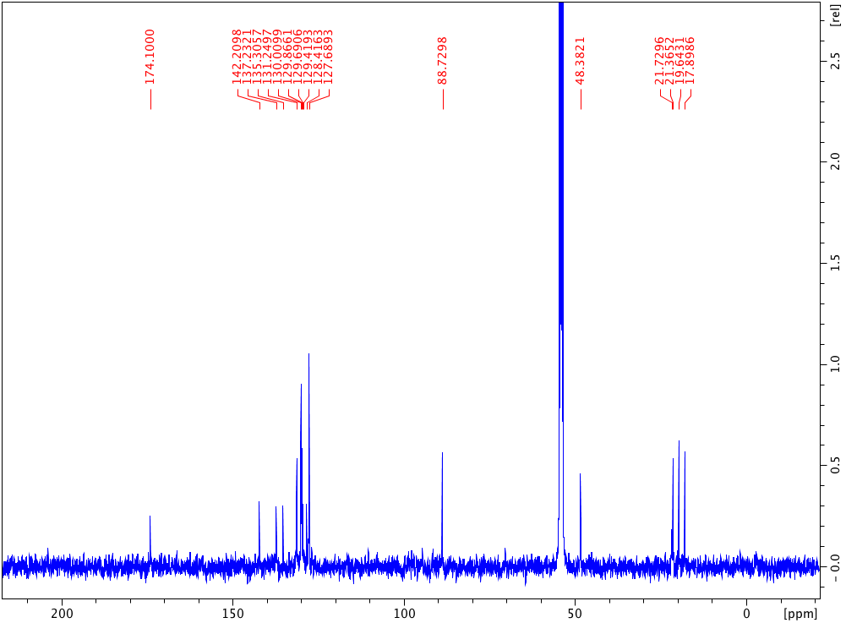

**Figure S7**. 13C{1H} NMR spectrum of complex **12** in CD2Cl2.

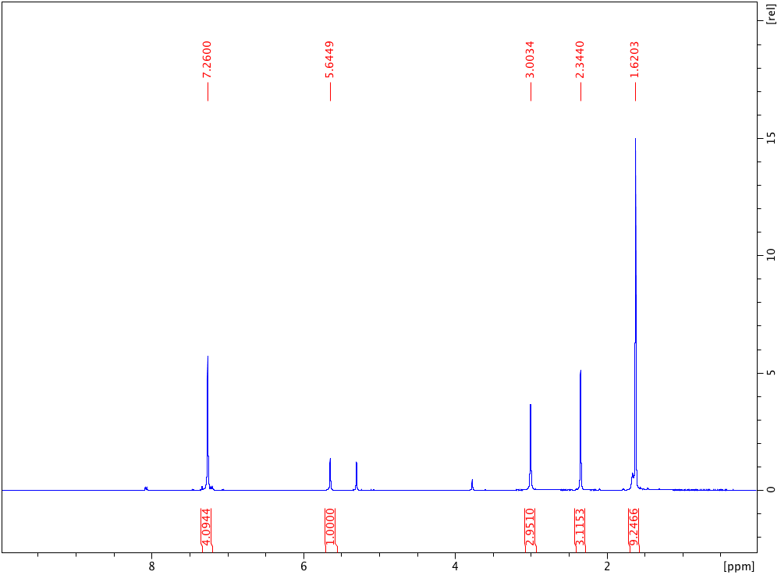

**Figure S8**. 1H NMR spectrum of complex **13** in CH2Cl2.

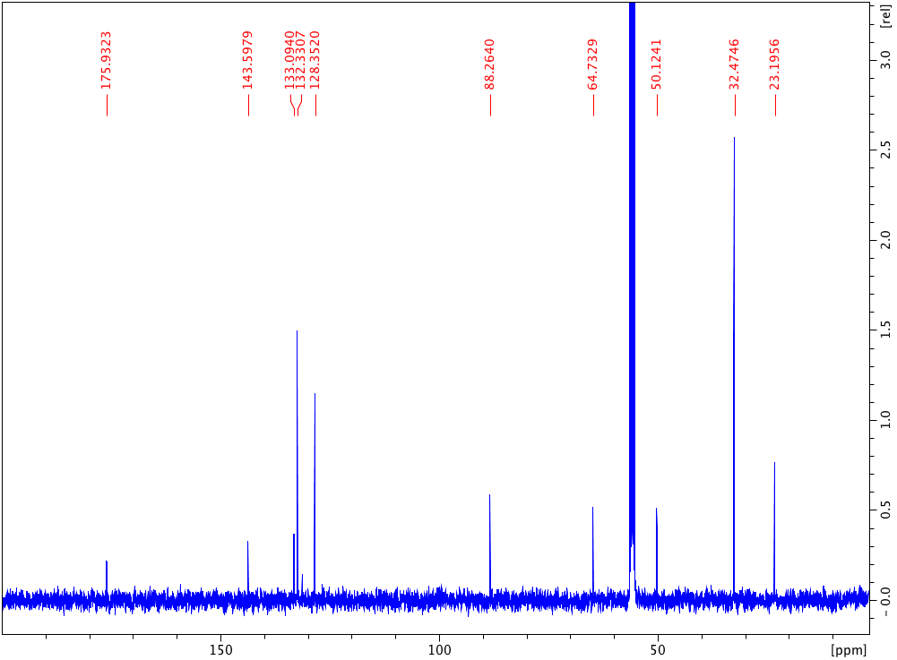

**Figure S9**. 13C{1H} NMR spectrum of complex **13** in CD2Cl2.

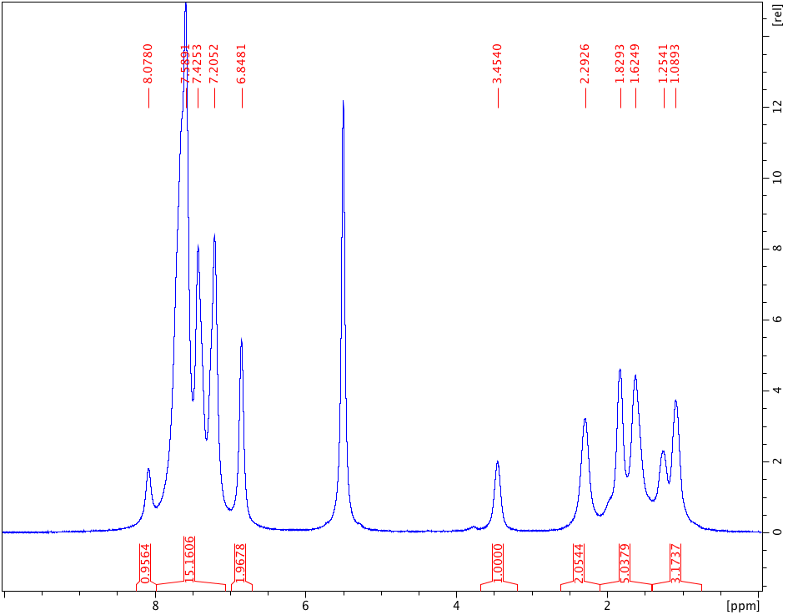

**Figure S10**. 1H NMR spectrum of complex **14** in CH2Cl2.

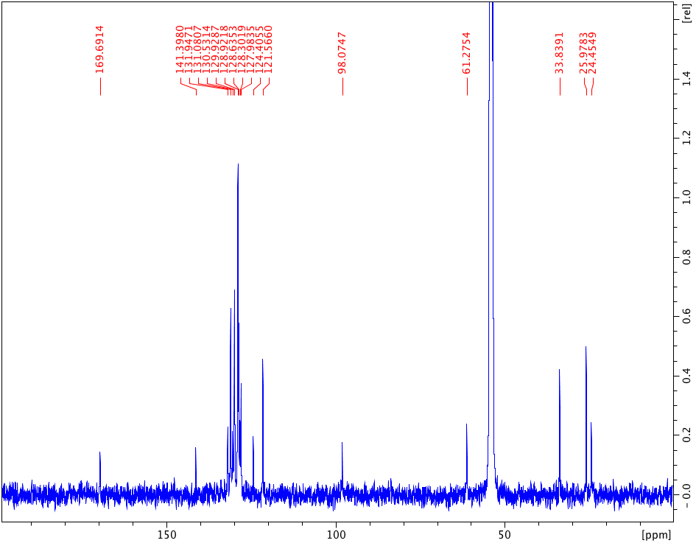

**Figure S11**. 13C{1H} NMR spectrum of complex **14** in CD2Cl2.

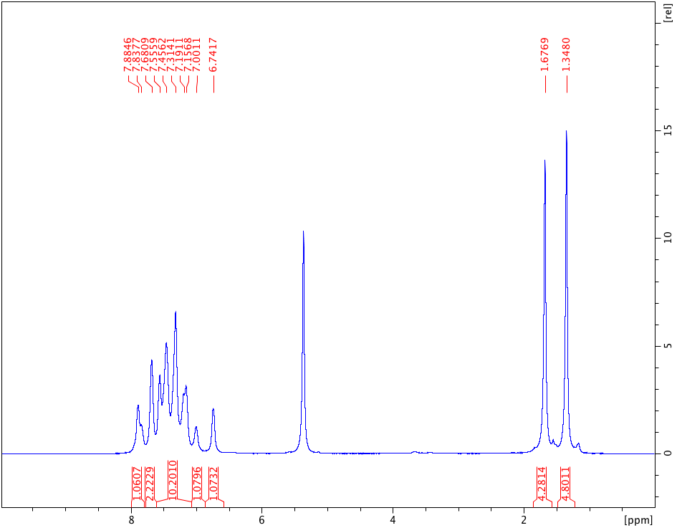

**Figure S12**. 1H NMR spectrum of complex **15** in CH2Cl2.

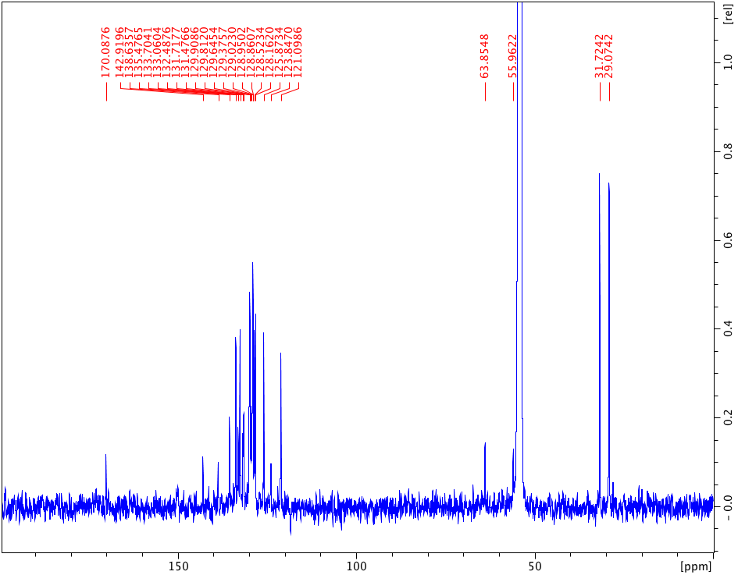

**Figure S13**. 13C{1H} NMR spectrum of complex **15** in CD2Cl2.

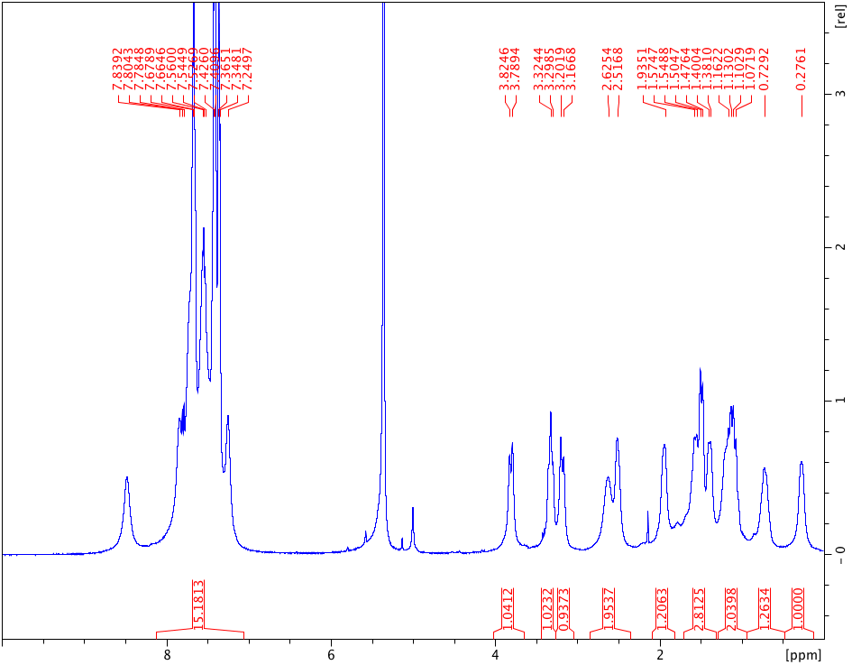

**Figure S14**. 1H NMR spectrum of complex **16** in CH2Cl2.

Low-field resonance at ca. 8.2 ppm corresponds to unresolved aromatic region of a starting nitrone **7** that is present in small excess (less than 10%).

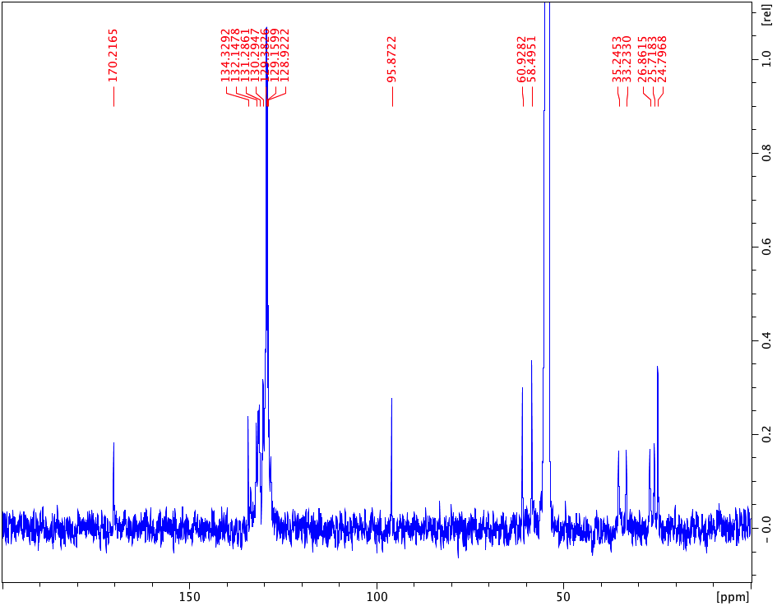

**Figure S15**. 13C{1H} NMR spectrum of complex **16** in CD2Cl2.

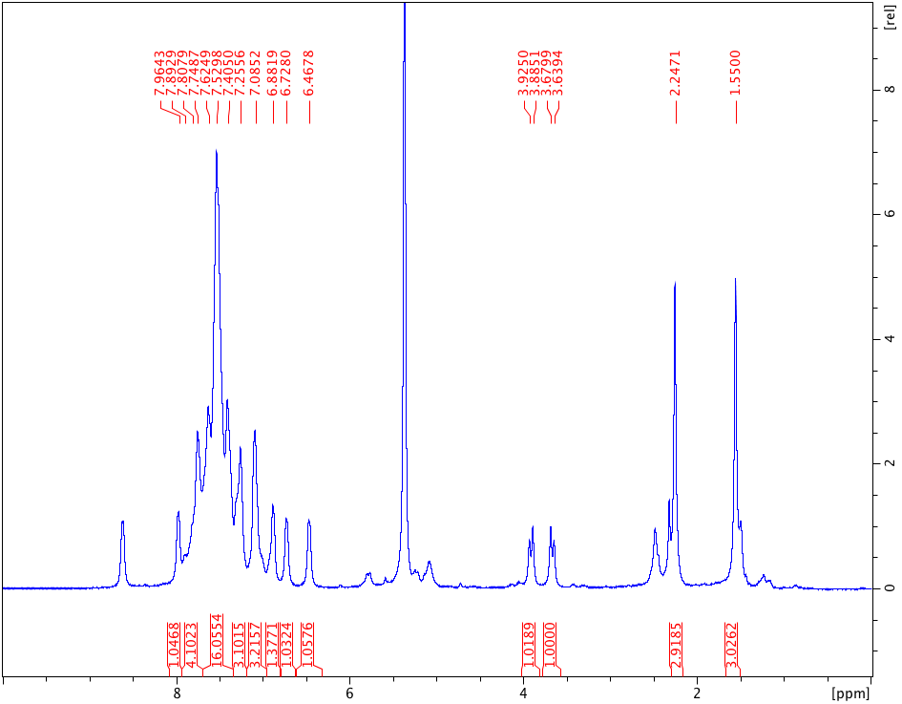

**Figure S16**. 1H NMR spectrum of complex **17** in CH2Cl2.

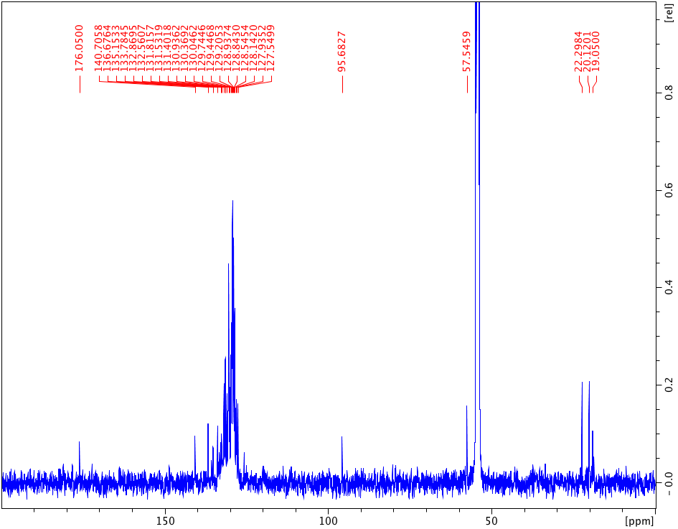

**Figure S17**. 13C{1H} NMR spectrum of complex **17** in CD2Cl2.

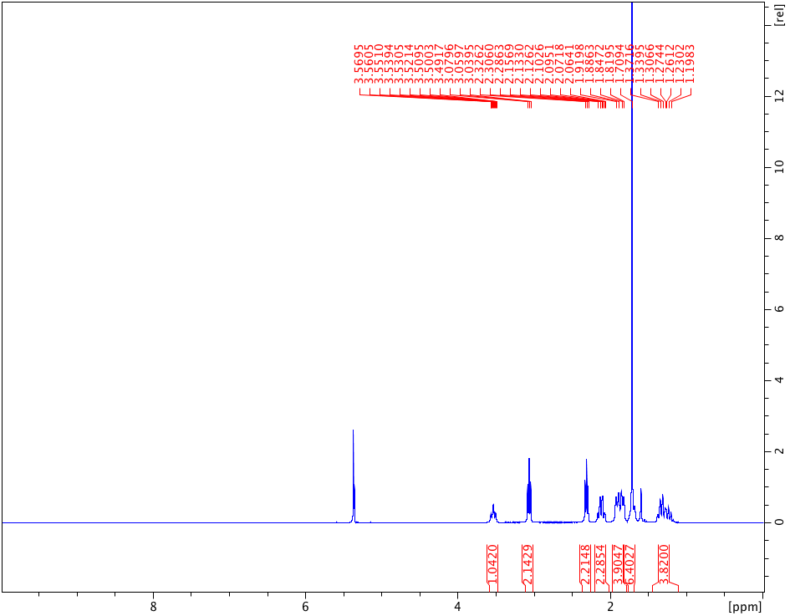

**Figure S18**. 1H NMR spectrum of complex **9** in CH2Cl2.

Residual signal of H2O (1.79 ppm) is present.

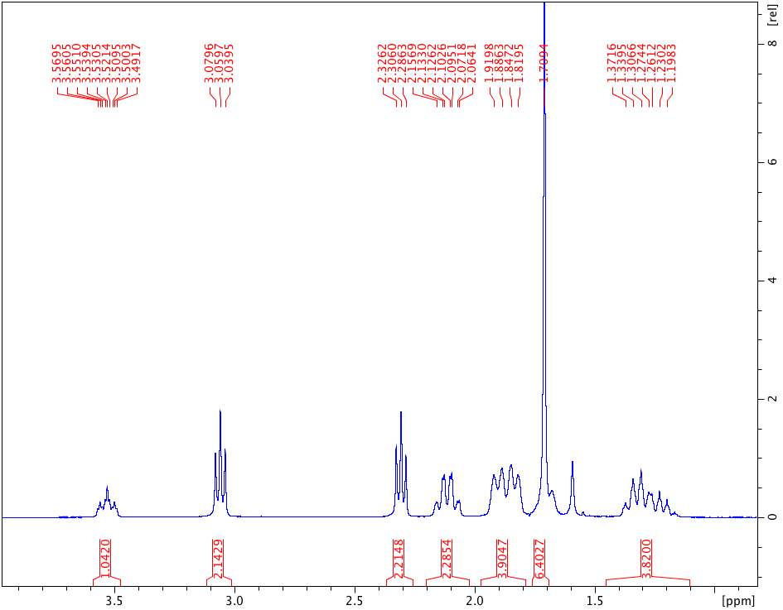

**Figure S19**. 1H NMR spectrum of complex **9** in CD2Cl2 (expansion of the aliphatic region).

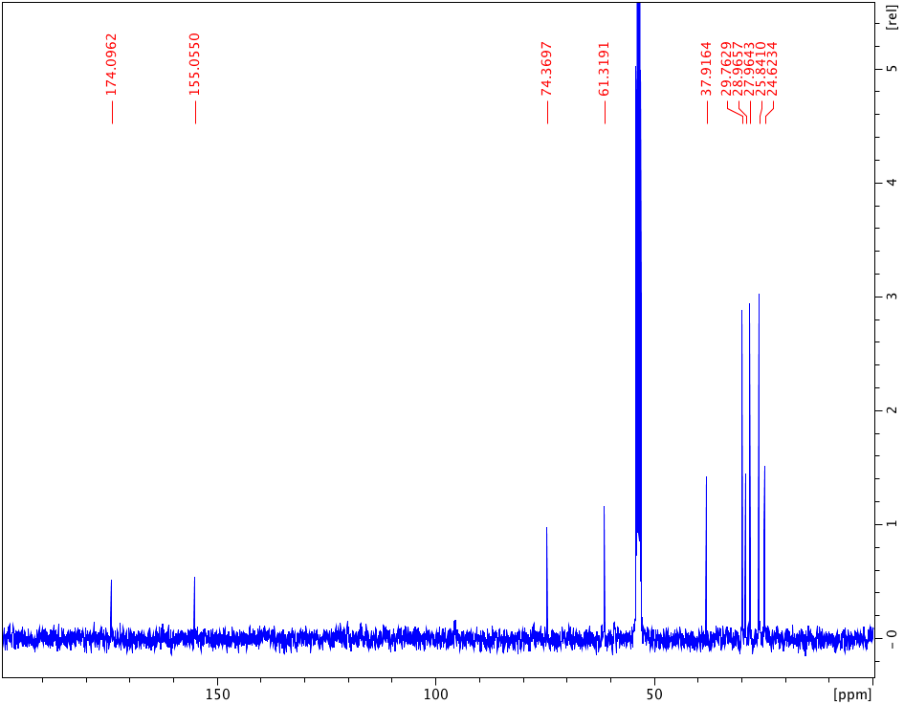

**Figure S20**. 13C{1H} NMR spectrum of complex **9** in CD2Cl2.

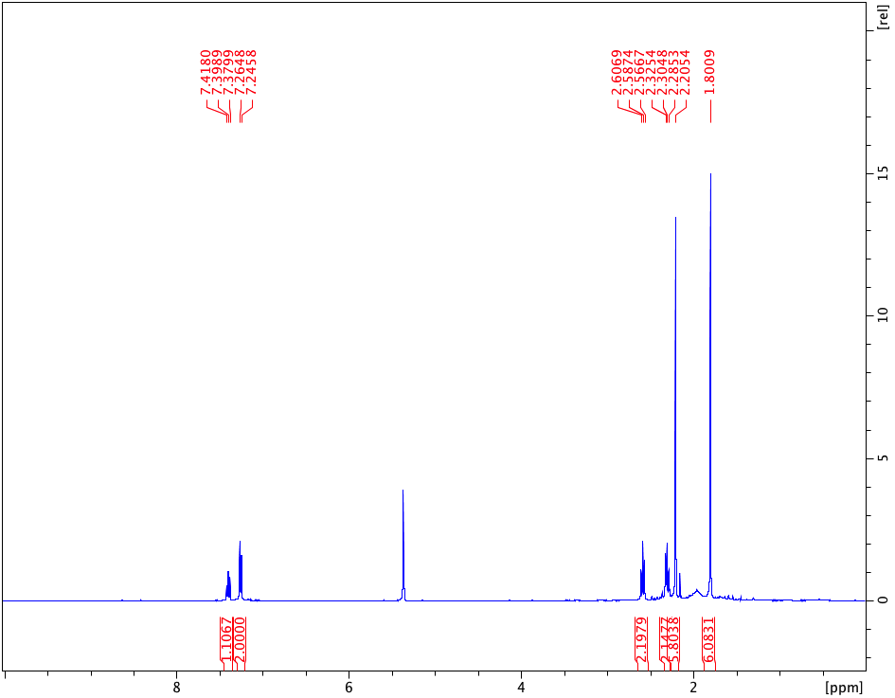

**Figure S21**. 1H NMR spectrum of complex **10** in CD2Cl2.

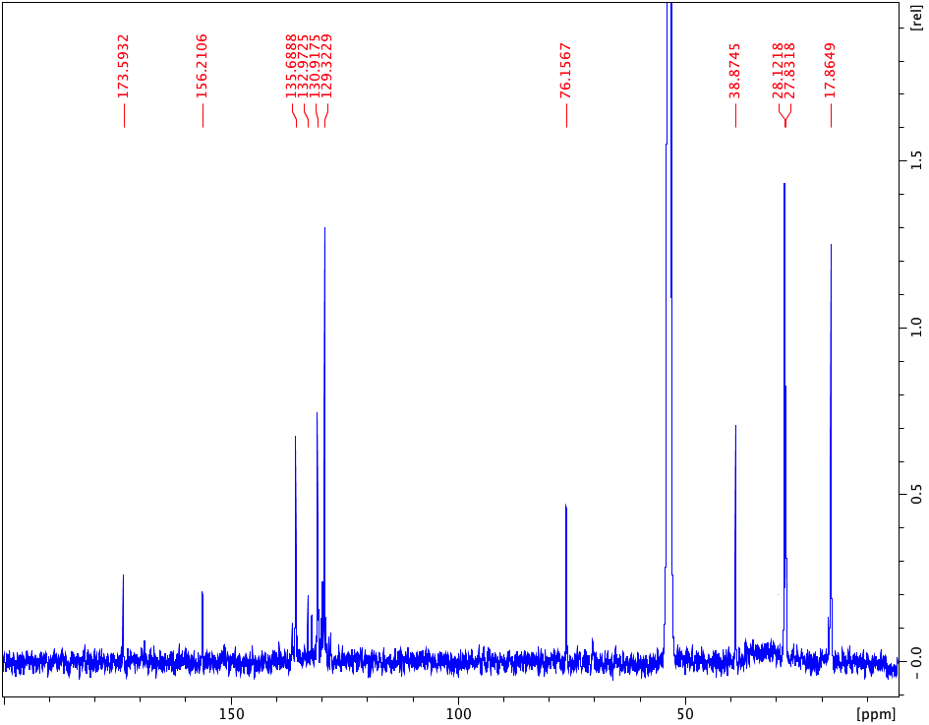

**Figure S22**. 13C{1H} NMR spectrum of complex **10** in CD2Cl2.

**X-ray diffraction data**

**Table S1**. Crystal Data and Structure Refinement Details for **8**, **13**•CH2Cl2 and **9**.

|  |  |  |  |
| --- | --- | --- | --- |
|  | **8** | **13**•CH2Cl2 | **9** |
| Empirical formula | C11H20AuCl3N2O | C15H22AuCl5N2O | C13H21AuCl2N2O |
| Formula weight | 499.61 | 620.56 | 489.18 |
| Crystal system | Monoclinic | Triclinic | Monoclinic |
| Space group | *P*21/*c* | *P*-1 | *P*21/*c* |
| *a* (Å) | 8.5106(13) | 7.5167(4) | 12.6932(8) |
| *b* (Å) | 17.114(2) | 9.4910(3) | 9.4828(8) |
| *c* (Å) | 12.1496(17) | 15.2776(8) | 16.5854(7) |
| *α* (deg) | 90 | 101.664(4) | 90 |
| *β* (deg) | 94.468(5) | 98.710(4) | 98.846(5) |
| *γ* (deg) | 90 | 95.481(4) | 90 |
| *V* (Å3) | 1764.2(4) | 1046.11(9) | 1972.6(2) |
| Z | 4 | 2 | 4 |
| No. rfls. | 46337 | 9326 | 9842 |
| Rfls Unique | 8395 | 4715 | 3883 |
| *ρ*calc (g/сm3) | 1.881 | 1.970 | 1.647 |
| *μ*(Mo K*α*) (mm–1) | 8.784 | 7.676 | 7.724 |
| Rint | 0.1010 | 0.0442 | 0.0448 |
| Final R1a, wR2b  (*I* ≥ 2σ) | 0.0400, 0.0756 | 0.0337, 0.0758 | 0.0466, 0.1329 |
| GOF | 0.968 | 1.009 | 0.970 |

*a**R*1 = Σ||*F*o| – |*F*c||/Σ|*F*o|. *b**wR*2 = [Σ[*w*(*F*o2 – *F*c2)2]/ Σ[*w*(*F*o2)2]]1/2

**Table S2**. Selected bond lengths (Å) and angles (°) for **8** and **13**.

|  |  |  |
| --- | --- | --- |
|  | **8** | **13**•CH2Cl2 |
| Au1‒Cl1 | 2.3098(11) | 2.3056(12) |
| Au1‒Cl2 | 2.2826(12) | 2.2846(12) |
| Au1‒Cl3 | 2.2793(12) | 2.2842(12) |
| Au1‒C1 | 1.999(4) | 2.015(5) |
| C1‒N1 | 1.292(5) | 1.288(6) |
| C1‒O1 | 1.307(4) | 1.313(6) |
| O1‒N2 | 1.519(4) | 1.509(5) |
| C1‒Au1‒Cl1 | 178.39(11) | 178.68(14) |
| C1‒Au1‒Cl2 | 88.13(12) | 87.17(14) |
| C1‒Au1‒Cl3 | 87.61(12) | 88.78(13) |
| Cl1‒Au1‒Cl2 | 92.00(4) | 91.93(4) |
| Cl1‒Au1‒Cl3 | 92.22(4) | 92.12(4) |
| Au1‒C1‒N1 | 132.8(3) | 132.4(4) |
| C1‒N1‒C3 | 130.3(3) | 130.0(4) |
| C3‒N1‒C2 | 121.2(3) | 122.4(4) |
| C1‒N1‒C2 | 108.2(3) | 107.5(4) |
| N1‒C2‒N2 | 101.9(3) | 102.9(4) |
| C2‒N2‒O1 | 100.7(2) | 102.4(3) |
| O1‒C1‒N1 | 114.6(3) | 115.5(4) |
| Au1‒C1‒O1 | 112.5(2) | 112.0(3) |

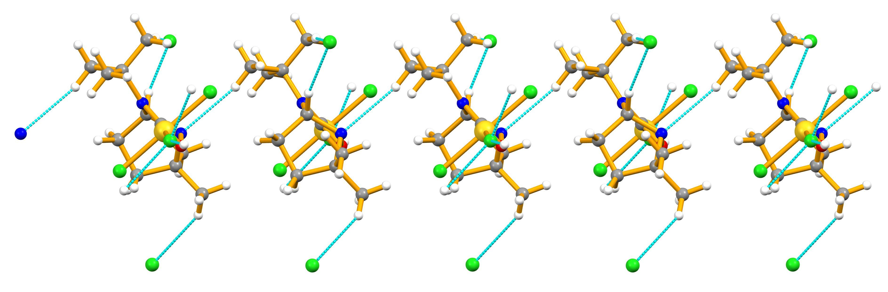

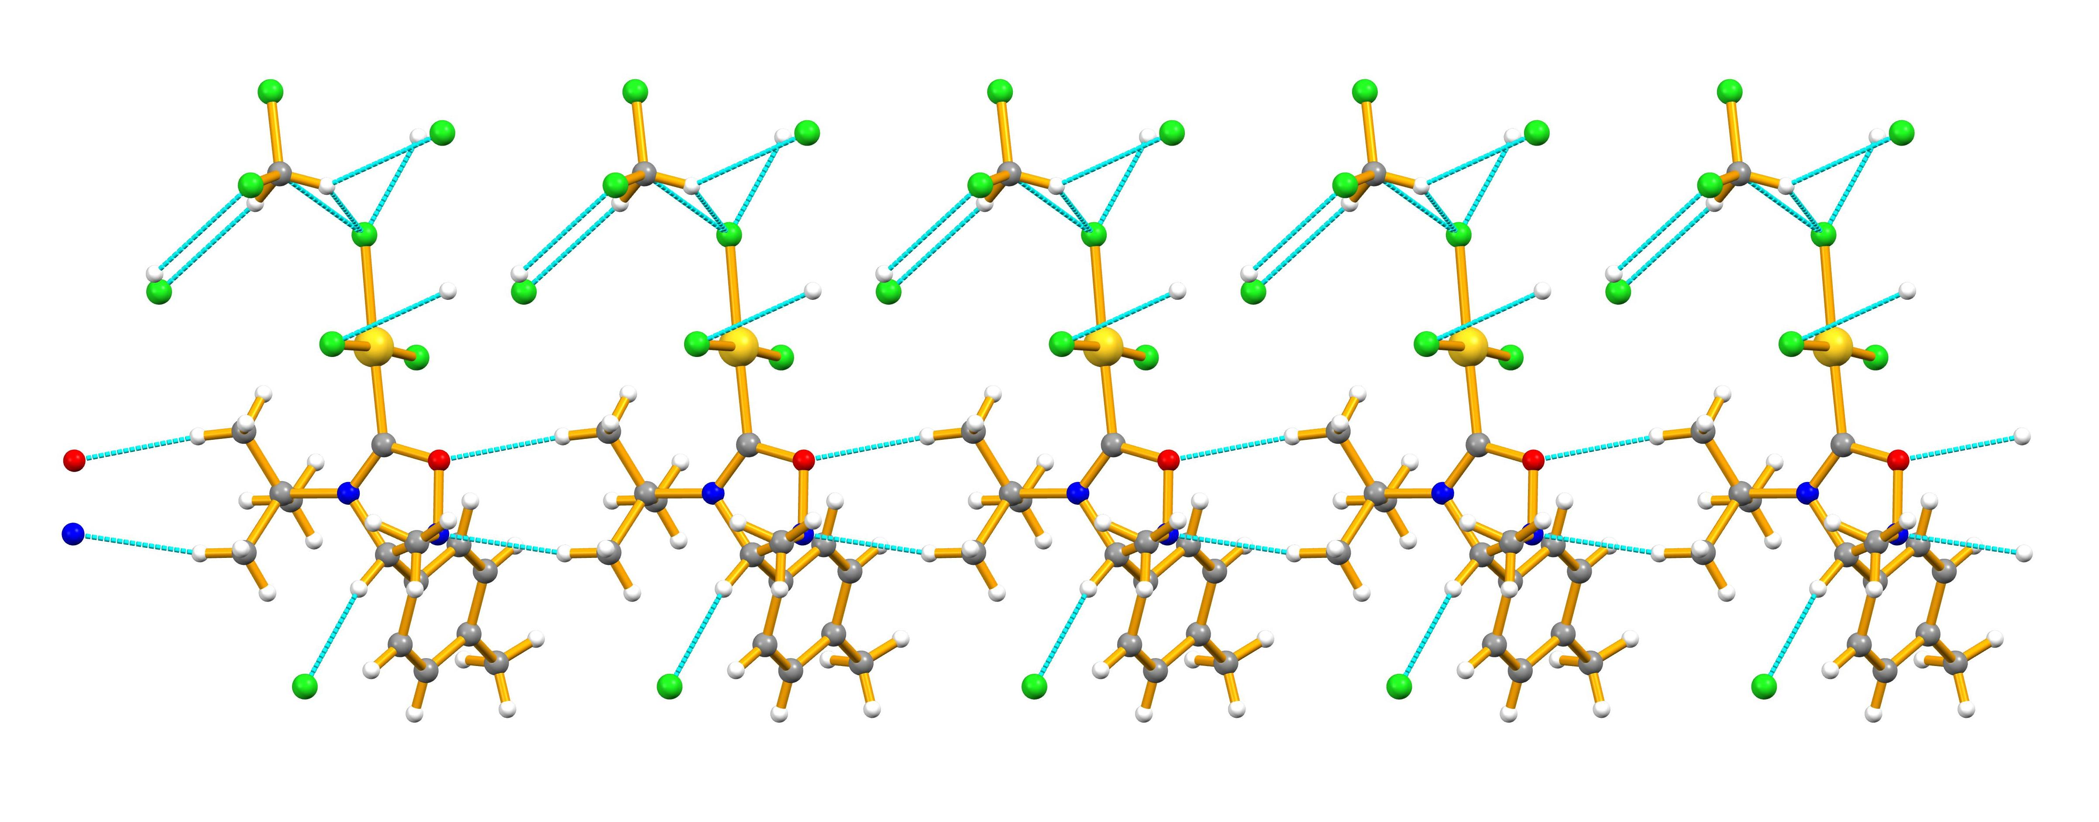

**Figure S23**. Intermolecular interactions in **8** (top) and **13** (bottom) viewed down the crystallographic *b* and *c* axis, respectively. The CH⋅⋅⋅N (in **8**), and CH⋅⋅⋅N and CH⋅⋅⋅O (in **13**) lead to 1D chains which further expand to a 3D networks by means of CH⋅⋅⋅Cl contacts.

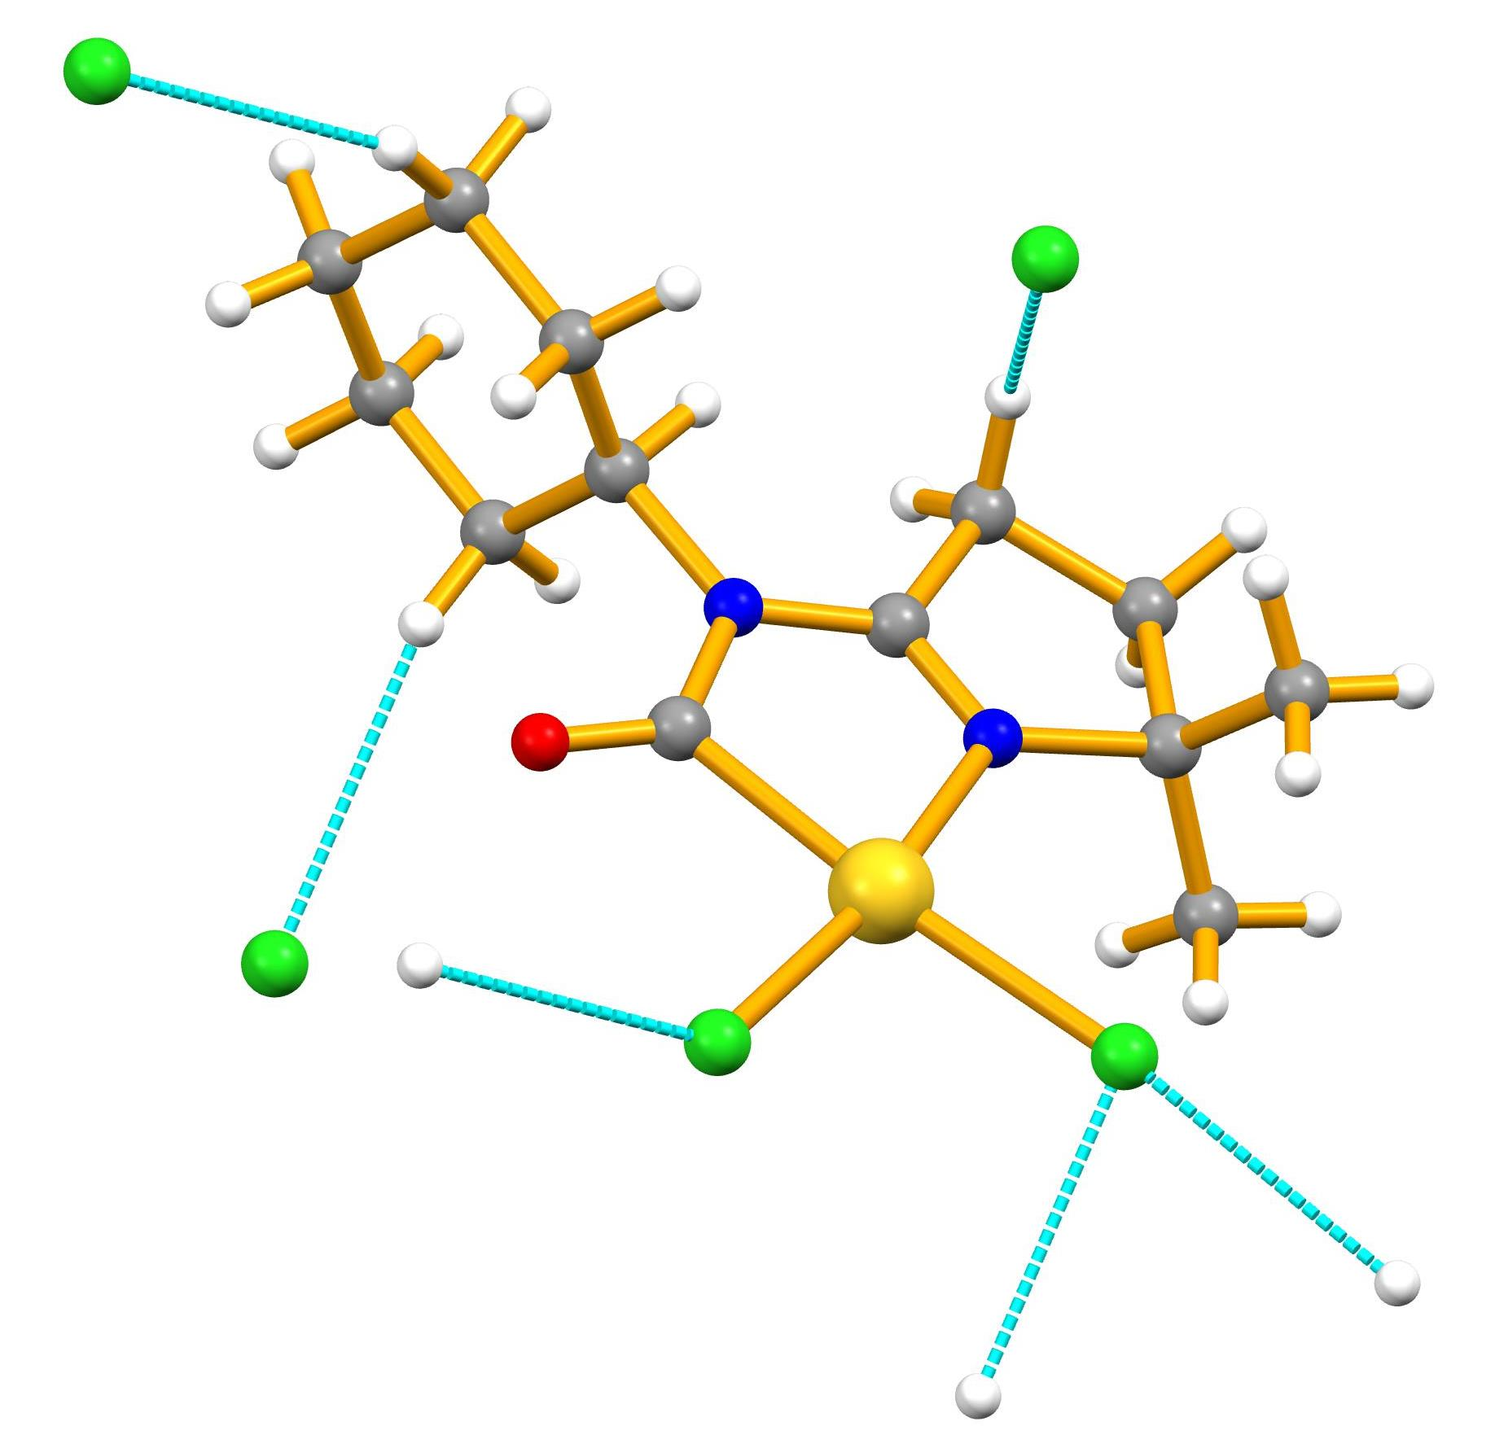

**Figure S24**. Intermolecular interactions in **9**

**Theoretical calculation data**

**Computational Details**

The full geometry optimization of all structures and transition states has been carried out at the DFT/HF hybrid level of theory using Becke’s three-parameter hybrid exchange functional in combination with the gradient-corrected correlation functional of Lee, Yang and Parr (B3LYP)10,11 with the help of the Gaussian-03 program package.12 No symmetry operations have been applied. The geometry optimization was carried out using a quasi-relativistic Stuttgart pseudopotential describing 60 core electrons and the appropriate contracted basis set for the gold atom13 and the 6-31+G(d,p) basis set for other atoms. Then, single-point calculations were performed on the basis of the equilibrium geometries found using the 6-311+G(d,p) basis set for non-metal atoms. As was shown by us previously14-18this approach is sufficiently accurate for the description of CAs to the C≡N bond and of the N–O bond cleavage providing results close to those obtained by such methods as MP2, MP4, CCSD(T), CBS-Q and G3B3.

The Hessian matrix was calculated analytically for the optimized structures in order to prove the location of correct minima (no imaginary frequencies) or saddle points (only one imaginary frequency) and to estimate the thermodynamic parameters, the latter being calculated at 25 °C. The nature of transition states was investigated by the analysis of vectors associated with the imaginary frequency.

Total energies corrected for solvent effects (Es) were estimated at the single-point calculations on the basis of gas-phase geometries at the CPCM-B3LYP/6-311+G(d,p)//gas-B3LYP/6-31+G(d,p) level of theory using the polarizable continuum model in the CPCM version19,20 with CH2Cl2 as solvent. The UAKS model was applied for the molecular cavity. The entropic term in CH2Cl2 solution (Ss) was calculated according to the procedure described by Wertz21 and Cooper and Ziegler22 using equations (1)–(4), while enthalpies and Gibbs free energies in solution (Hs and Gs) were estimated using appropriate equations (5) and (6). The activation energies of deprotonation of **2A** and **3A** by **4** were calculated relative to the molecular complexes of **2A**/**3A** with **4** (**2A•••4** and **3A•••4**).

ΔS1 = R ln Vsm,liq/Vm,gas (1)

ΔS2 = R ln V°m/Vsm,liq (2)



(3)

Ss = Sg + ΔSsol = Sg + [ΔS1 + α(Sg + ΔS1) + ΔS2] =

Sg + [(–11.80 cal/mol·K) – 0.21(Sg – 11.80 cal/mol·K) + 5.45 cal/mol·K] (4)

where Sg = gas-phase entropy of solute, ΔSsol = solvation entropy, S°,sliq, S°,sgas, and Vsm,liq = standard entropies and molar volume of the solvent in liquid or gas phases (174.5 and 270.3 J/mol•K and 64.15 mL/mol, respectively, for CH2Cl2), Vm,gas = molar volume of the ideal gas at 25 °C (24450 mL/mol), V°m = molar volume of the solution corresponding to the standard conditions (1000 mL/mol).

Hs = Es(6-311+G(d,p)) – Eg(6-311+G(d,p)) + Hg(6-31+G(d,p)) (5), and Gs = Hs – TSs (6)

where Es, Eg and Hg are the total energies in solution and in gas phase and gas-phase enthalpy calculated at the corresponding level.

**Mechanistic considerations on formation of 9 and 10**

Following the hypothesis that the formation of the metallacyclic products **9** and **10** occurs via unstable cycloaddition intermediates of the **8** type (**1A** and **2A**, **Scheme S1**), two possible general pathways may be considered a priori for the decomposition of these carbene cycloadducts. The first one includes initial N–O bond cleavage in **1A** and **2A** followed by the deprotonation of the endocylic CH group along with the elimination of the Cl– ligand, rotation of the formed deprotonated ligand around the C–N bond and cyclization (**Scheme S1**, pathway A). A second pathway starts from the deprotonation of the endocyclic CH group (a 1,3-dipole molecule may serve as an appropriate base in the absence of a basic additive) and subsequent N–O bond cleavage while the further steps are the same (**Scheme S1**, pathway B).

Theoretical calculations at the DFT level of theory were performed to determine the most plausible pathway of the decomposition of **2A** and **3A**. Despite an extensive search of the potential energy surface, we were unable to locate a transition state (TS) for the initial N–O bond cleavage in accord with pathway A. All attempts led either to starting cycloadducts **2A** and **3A** or to very energetic TSs for a side reaction of the formation of a three membered cyclic structure. The potential energy scan toward the N–O bond cleavage in **3A** with all other internal coordinates being relaxed demonstrated a monotonous increase of the system’s energy at least until the NO distance of 2.8 Å. These results suggest that pathway A is not feasible.

An attempt of the geometry optimization of complexes **2B** and **3B** – which are the first intermediates of pathway B – was then undertaken. The starting geometries were obtained by elimination of the proton from the endocyclic CH group in the equilibrium structures of **2A** and **3A**. However, surprisingly, the N–O bond was spontaneously broken in the deprotonated complexes as a result of the optimization to give directly complexes **2C** and **3C** (**Scheme S1**, pathway C). Thus, calculations clearly indicate that deprotonation of the cyclic carbene complexes promotes their decomposition and following transformation into products of the **9** and **10** type.



**Scheme S1**. Pathways of the transformation of cycloaddition carbene complexes into metallacyclic species calculated at the B3LYP/6-311+G(d,p)//6-31+G(d,p) level of theory (Gibbs free energies in solution are indicated in kcal/mol).

The crucial factor determining pathway C is the acidity of the endocyclic CH group in **1A**–**3A**. Firstly, the gas phase acidity (deprotonation energy) of this group was estimated as the difference of the gas phase total energies of **3C**/**2C/1C** and **3A**/**2A**/**1C**. The C–H group was found to be less acidic in **3A = 8** (R’ = Bu*t*) than in both **2A** (R’ = Cy) and **1A** (R’ = Xyl) by 3.8 and 8.2 kcal/mol, respectively. Secondly, the deprotonation energy in CH2Cl2 solution was calculated as a difference of Gibbs free energies in solution of **3C**/**2C/1C** and **3A**/**2A/1C**. Solvation decreases the relative deprotonation energies of **1A**/**2A** and **3A**, however, both **1A** and **2A** remain clearly more acidic than **3A** by 8.0 and 1.7 kcal/mol, respectively. Thirdly, transition states for the deprotonation of **1A**, **2A** and **3A** to **1C**, **2C** and **3C** were found with the dipole molecule **4** taken as a base. The calculated activation Gibbs free energies of deprotonation in CH2Cl2 solution are 11.9, 17.5 and 20.9 kcal/mol for **1A**, **2A** and **3A**, respectively, demonstrating that the xylyl and cyclohexyl carbene complexes are more acidic compared to the *tert*-butyl one also from the kinetic viewpoint by 9.0 and 3.4 kcal/mol, respectively. Note that the difference of the activation barriers of 3.4 kcal/mol corresponds to the ratio of the reaction rate coefficients of 310. The lower acidity of the *tert*-butyl derivative may be accounted for by the strong electron donor character of the Bu*t* group. These results are in agreement with experimental isolation of **9** (R’ = Cy) and **10** (R’ = Xyl), while cycloadduct **8** (R’ = Bu*t*) was found to be relatively stable under synthetic conditions.

Besides the dipole molecule, water always present in the reaction mixture as moisture or any other species with a basic center may play the role of a proton abstractor in this reaction. Theoretical calculations revealed that the efficiency of **4** and H2O as a base in this process is nearly similar. Calculated activation energy of the deprotonation of **3A** by water is 21.2 kcal/mol *vs.* 20.9 kcal/mol when **4** is taken as a base.

In further experiments, addition of either 1 equiv or 0.1 equiv of a base (triethylamine or triethanolamine) to a solution of **8** in CH2Cl2 at −74 °C led to the immediate formation of a bright yellow solution which was warmed to RT and analyzed by 1H NMR and ESI+/−-MS revealing the presence of a broad mixture of yet unidentified species. On the contrary, addition of 1 equiv of dipole **4** to a solution of **8** in CH2Cl2 at −74 °C did not trigger any reaction. Upon gradual heating of the resulting solution to RT, its color gradually changed from pale greenish to bright yellow followed by precipitation of a colorless solid (IR 2972 w, 1769 s, 1579 s, 1407 s). The solution was separated from the solid, whose analysis by 1H and 13C{1H} NMR23-26 and ESI+/−-MS revealed the presence of protonated **4**. Analysis of the precipitate with the help of 1H and 13C{1H} NMR (in DMSO-*d*6) and ESI+/−-MS indicated the presence of a mixture of at least three yet unidentified species, while signals of **8** were not found. Owing a high oxidative power of gold(III), an easy oxidation of the organic ligand by this metal center is quite anticipated. The addition of a base (triethylamine, triethanolamine, or excess of **4**) conceivably accelerates this side redox reaction, which becomes more efficient than the expected formation of the metallacyclic complex and leads to a mixture of the oxidation products.

**Theoretical study of pathway based on oxygen transfer**

Besides the mechanism proposed and discussed in the main text, another possibility of the formation of metallacycles **9** and **10** can be considered. This pathway includes the oxygen transfer from nitrone to the isocyanide ligand (this process was previously experimentally observed2 and theoretically studied14 for the Pd-bound isocyanides complexes) to give metal-coordinated imine and isocyanate (**Scheme S2**). The N atom of the formed isocyanate then can attack either protonated or deprotonated C atom of imine to give the metallacyclic product. However, calculations indicate that there are no minima for several key intermediates of this mechanism. All attempts to optimize these structures led to initial imino complex and isocyanate or to a highly energetic complex **I** (**Chart S1**) which clearly does not belong to the reaction path towards **9** and **10** or to the energetically unfavorable cleavage of the CN bond of the isocyanate fragment.



**Scheme S2.** Alternative pathways of the formation of metallacyclic complexes **9** and **10**.

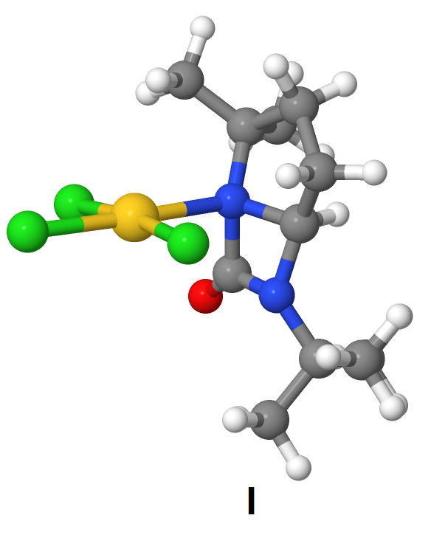

**Chart S1.**

**Table S3.** Cartesian atomic coordinates (in Å) of the calculated equilibrium structures.

**2a**

C -2.717893 -0.306024 0.087279

C -0.450903 0.008197 0.210123

H 0.293313 -0.335001 -0.512901

C 0.139065 0.276884 1.620954

H -0.095203 -0.537385 2.311738

H 1.228755 0.352120 1.558060

C -0.500355 1.614922 2.033453

H 0.129735 2.186349 2.720502

H -1.464654 1.446562 2.524612

C -0.717862 2.354755 0.692047

C 0.598676 2.941246 0.143405

H 1.387744 2.189080 0.044508

H 0.961310 3.717721 0.824089

H 0.432746 3.386656 -0.840791

C -1.788078 3.446215 0.745314

H -2.726257 3.076454 1.162449

H -1.984172 3.848414 -0.253019

H -1.428556 4.263269 1.378440

N -1.580721 -0.948182 0.220284

N -1.082701 1.264960 -0.280094

O -2.550053 0.974122 -0.118940

Cl -6.891886 -1.603257 0.414666

Cl -4.548819 -0.313759 2.506167

Cl -4.602776 -1.473852 -2.072687

Au -4.657714 -0.923790 0.220453

H -2.693289 -5.371823 -0.465467

C -1.700250 -5.308861 -0.000460

C -1.828350 -4.631781 1.373109

C -0.756062 -4.525098 -0.925209

H -1.342154 -6.338078 0.117845

C -2.276118 -3.165735 1.240840

C -1.179746 -3.051767 -1.055581

C -1.297767 -2.404876 0.336938

H 0.268750 -4.577024 -0.528593

H -0.727155 -4.982250 -1.920541

H -0.455210 -2.499661 -1.666917

H -2.149060 -2.975201 -1.561296

H -0.312611 -2.439546 0.819426

H -3.281190 -3.144167 0.805320

H -2.343213 -2.682598 2.220887

H -2.547271 -5.169721 2.000271

H -0.862167 -4.675594 1.897437

**3a** = **8**

C -0.659451 0.942102 -0.693381

C 1.567287 0.993384 -0.214438

H 2.402874 0.457533 -0.665527

C 0.393671 -1.341456 -0.185981

C -0.988223 -1.926765 0.134044

H -1.679227 -1.843258 -0.706760

H -1.432837 -1.460526 1.016865

H -0.859681 -2.993358 0.340814

C 0.912781 -1.899142 -1.525618

H 1.910429 -1.518312 -1.768142

H 0.230684 -1.638463 -2.339069

H 0.980278 -2.989635 -1.463676

C 1.354328 -1.696937 0.963119

H 2.364913 -1.307632 0.810149

H 1.433220 -2.785651 1.019385

H 0.978847 -1.337789 1.925240

C 1.871827 1.508128 1.225958

H 1.262429 0.992000 1.969295

H 2.921749 1.319812 1.469902

C 1.557915 3.017126 1.164342

H 2.220856 3.608818 1.801656

H 0.528743 3.206459 1.485034

C 1.714772 3.382648 -0.330803

C 3.198211 3.525333 -0.728500

H 3.799218 2.658117 -0.436532

H 3.620643 4.403233 -0.230487

H 3.292197 3.657291 -1.809549

C 0.939374 4.628759 -0.760949

H -0.115458 4.562903 -0.488489

H 1.011592 4.777638 -1.842433

H 1.368578 5.504687 -0.264800

N 0.338282 0.164389 -0.326116

N 1.237707 2.164865 -1.060863

O -0.267372 2.154809 -0.990346

Cl -5.005055 0.426617 -0.951668

Cl -2.779507 1.345609 1.447927

Cl -2.384475 0.009273 -3.067480

Au -2.679146 0.676203 -0.820320

**2c**

C -0.734208 -0.147132 0.263684

C 1.137031 1.374042 0.152964

C 0.337954 2.582347 0.627253

H -0.653614 2.637584 0.184016

H 0.198026 2.499069 1.712824

C 1.262796 3.737968 0.211148

H 1.308337 4.540737 0.954468

H 0.908777 4.178971 -0.728087

C 2.646021 3.056346 -0.014446

C 3.554120 3.203058 1.222387

H 3.040163 2.859930 2.126860

H 3.845715 4.250614 1.367941

H 4.461307 2.601707 1.101503

C 3.368805 3.587938 -1.259384

H 2.754527 3.436407 -2.153256

H 4.318364 3.062398 -1.407748

H 3.577024 4.660414 -1.159267

N 0.650915 0.054737 0.249035

N 2.348319 1.621476 -0.199562

O -1.523249 0.641671 -0.209487

Cl -2.736028 -3.449648 2.604259

Cl -1.120861 -0.402003 3.249281

Cl -1.949083 -2.869961 -0.745650

Au -1.579723 -1.723971 1.310002

H 1.950890 -4.384989 -0.142630

C 2.836978 -3.735442 -0.141625

C 2.896032 -2.971965 1.191349

C 2.755426 -2.768618 -1.333973

H 3.712189 -4.391315 -0.243722

C 1.700141 -2.014971 1.345503

C 1.580844 -1.784515 -1.192161

C 1.662252 -1.044948 0.154070

H 3.697155 -2.202954 -1.404422

H 2.655966 -3.329336 -2.272277

H 1.604354 -1.048884 -2.005122

H 0.630460 -2.323949 -1.267120

H 2.606403 -0.497363 0.162205

H 0.784919 -2.614238 1.399307

H 1.763917 -1.453863 2.283298

H 2.910009 -3.675228 2.033094

H 3.835294 -2.399710 1.242099

**3c**

C -1.605063 0.839664 -0.101986

C 0.598195 1.580820 0.077059

C 0.327351 -0.871229 -0.533965

C -0.542100 -2.068412 -0.110213

H -1.456261 -2.155064 -0.699221

H -0.803083 -2.028715 0.949959

H 0.038998 -2.979750 -0.290802

C 0.511010 -0.873409 -2.063929

H 1.167729 -0.057283 -2.372991

H -0.457009 -0.760706 -2.560180

H 0.952291 -1.827033 -2.379910

C 1.688788 -1.042362 0.174882

H 2.417595 -0.294393 -0.137893

H 2.090237 -2.028767 -0.077351

H 1.567576 -0.996789 1.262984

C 0.570226 2.377322 1.372989

H -0.439892 2.621042 1.700689

H 1.034005 1.765389 2.159609

C 1.424451 3.591517 0.982691

H 2.059555 3.959522 1.795349

H 0.773905 4.414558 0.666816

C 2.255217 3.078966 -0.236361

C 3.651379 2.589841 0.192365

H 3.583848 1.874407 1.019368

H 4.270130 3.433525 0.521068

H 4.156350 2.094933 -0.644014

C 2.384554 4.131824 -1.344164

H 1.395344 4.432467 -1.703364

H 2.947794 3.732482 -2.194437

H 2.904184 5.022017 -0.968726

N -0.270717 0.455467 -0.099867

N 1.492375 1.922024 -0.767175

O -1.919856 2.016677 -0.088195

Cl -5.254190 -1.783325 0.245220

Cl -2.814499 -0.425563 2.388227

Cl -3.339153 -0.396419 -2.356443

Au -3.213098 -0.452119 0.029096

TS **2a** to **2c**

C -0.524029 0.817656 -0.202515

C 1.481001 0.975017 0.996347

C 1.480332 1.781031 2.320995

H 0.524549 1.704165 2.842560

H 2.257562 1.407667 2.996646

C 1.775972 3.212314 1.827084

H 2.424677 3.774137 2.505482

H 0.841627 3.771605 1.719054

C 2.419070 3.012447 0.426466

C 3.964117 2.921034 0.507752

H 4.278321 2.209696 1.278231

H 4.371369 3.904090 0.763412

H 4.381004 2.612510 -0.455310

C 2.028481 4.100280 -0.587503

H 0.944106 4.143455 -0.702919

H 2.470204 3.896657 -1.567391

H 2.392076 5.071126 -0.233665

N 0.309649 0.169343 0.677682

N 1.920181 1.712007 -0.056299

O -0.157932 1.825530 -0.797503

Cl -4.668302 -0.432199 -1.238851

Cl -3.234202 1.783982 0.934970

Cl -1.514258 -1.246722 -2.270789

Au -2.454713 0.209238 -0.653210

C 5.373843 -0.421414 0.251004

C 6.252962 -0.586227 -0.941686

H 6.779865 0.339936 -1.193180

H 7.026855 -1.336521 -0.727191

C 5.259996 -1.041447 -2.040705

H 5.685447 -1.804722 -2.695668

H 4.981587 -0.186123 -2.662827

C 4.005292 -1.571472 -1.301042

C 4.033171 -3.089531 -1.073897

H 4.992443 -3.420480 -0.661564

H 3.875368 -3.597068 -2.029864

H 3.236360 -3.390847 -0.389835

C 2.697306 -1.114287 -1.941967

H 2.620036 -0.024564 -1.968961

H 1.824018 -1.504011 -1.417781

H 2.663547 -1.492471 -2.968518

N 4.192647 -0.917601 0.068351

H 5.633340 -0.001876 1.215847

O 3.255078 -0.988587 0.990348

H 2.415878 0.082861 0.968987

H -2.311195 -3.369707 2.244646

C -1.387567 -3.283696 2.832891

C -1.351177 -1.907965 3.514792

C -0.176277 -3.474769 1.907908

H -1.417986 -4.080653 3.585734

C -1.249766 -0.772585 2.481893

C -0.048274 -2.333802 0.882697

C -0.006729 -0.973629 1.597311

H 0.740039 -3.521743 2.515674

H -0.248627 -4.431628 1.377581

H 0.863435 -2.462513 0.292431

H -0.887975 -2.361580 0.182549

H 0.859844 -0.992911 2.267935

H -2.154164 -0.771151 1.867718

H -1.216343 0.202627 2.977719

H -2.248534 -1.759185 4.125860

H -0.492327 -1.862111 4.201696

TS **3a** to **3c**

C -0.591904 0.468630 -0.186740

C 1.402699 1.277696 0.707227

C -0.064160 -0.232983 2.263260

C -1.500693 0.075777 2.724950

H -2.253216 -0.493337 2.176563

H -1.742779 1.136327 2.628440

H -1.589865 -0.209225 3.778104

C 0.149829 -1.753944 2.169323

H 1.204783 -1.983819 1.998437

H -0.448005 -2.194427 1.369357

H -0.149679 -2.217599 3.115302

C 0.882883 0.334094 3.341087

H 1.938839 0.195282 3.104041

H 0.689726 -0.218417 4.264666

H 0.692041 1.388752 3.549618

C 1.367602 2.686614 1.354519

H 0.422951 2.870441 1.869482

H 2.172747 2.792960 2.089250

C 1.563200 3.613239 0.139210

H 2.159338 4.501616 0.368147

H 0.591389 3.948712 -0.235574

C 2.236320 2.705905 -0.922711

C 3.780588 2.755824 -0.819812

H 4.117530 2.591251 0.208824

H 4.131656 3.742101 -1.138500

H 4.232646 2.002453 -1.471493

C 1.816018 3.027830 -2.365185

H 0.732020 2.966362 -2.472589

H 2.271065 2.325480 -3.070205

H 2.145237 4.040946 -2.620273

N 0.247309 0.399838 0.905558

N 1.797093 1.332526 -0.591214

O -0.235592 1.014966 -1.228954

Cl -4.760275 -1.024659 -0.648046

Cl -3.280489 1.921579 0.251804

Cl -1.634592 -2.344966 -0.996964

Au -2.535387 -0.250815 -0.340058

C 5.277956 -0.248765 0.164410

C 6.019332 -0.942984 -0.926853

H 6.429443 -0.236871 -1.656204

H 6.876143 -1.484298 -0.501821

C 4.945489 -1.885065 -1.525483

H 5.354790 -2.856480 -1.810604

H 4.512967 -1.428656 -2.420255

C 3.847057 -2.034101 -0.442830

C 4.062411 -3.249862 0.470251

H 5.092398 -3.304614 0.838953

H 3.849479 -4.161959 -0.094621

H 3.386338 -3.213313 1.327747

C 2.434285 -1.995525 -1.017036

H 2.240599 -1.060315 -1.546473

H 1.675007 -2.113553 -0.244062

H 2.323847 -2.827671 -1.719342

N 4.130044 -0.792714 0.406211

H 5.614095 0.583968 0.770469

O 3.319962 -0.430977 1.385049

H 2.433528 0.485302 1.035518

TS **3a** to **3c** (B = H2O)

C -0.314053 -0.713255 -0.822470

C 1.176888 0.062757 0.794651

C -0.068189 -2.188931 1.303188

C -1.592414 -2.376374 1.408070

H -2.026832 -2.813837 0.508414

H -2.106826 -1.433189 1.606236

H -1.797529 -3.066472 2.232302

C 0.594299 -3.478146 0.786607

H 1.683980 -3.404692 0.818867

H 0.287857 -3.708108 -0.234409

H 0.293035 -4.313151 1.427850

C 0.452732 -1.894839 2.724492

H 1.531143 -1.728231 2.755548

H 0.248282 -2.777855 3.335593

H -0.063278 -1.051761 3.189267

C 0.692450 1.104097 1.832613

H -0.365994 0.967907 2.065565

H 1.251796 1.006249 2.768130

C 0.971057 2.447510 1.124162

H 1.364927 3.211323 1.800422

H 0.050266 2.837987 0.680482

C 1.974742 2.093891 -0.005965

C 3.449205 2.240276 0.449296

H 3.635636 1.727683 1.398042

H 3.675112 3.302523 0.583030

H 4.129046 1.836441 -0.306696

C 1.755283 2.892910 -1.299659

H 0.737461 2.756296 -1.669560

H 2.452224 2.573461 -2.080081

H 1.923755 3.955995 -1.098087

N 0.283240 -1.022217 0.377526

N 1.751511 0.663753 -0.278754

O 0.018461 0.288996 -1.459809

Cl -3.201890 -3.108113 -3.204331

Cl -3.426733 -0.529271 -0.994120

Cl 0.185014 -3.011691 -2.814922

Au -1.687457 -1.852214 -1.883380

O 3.319959 -1.488383 1.023095

H 2.300872 -0.603314 1.070607

H 4.201456 -1.122200 1.266443

H 3.316025 -1.689948 0.033890

O 5.808556 -0.548743 1.761986

H 6.266996 -1.069372 2.434854

H 6.464304 -0.349091 1.080475

O 3.032729 -1.592059 -1.589217

H 2.590399 -0.720175 -1.573879

H 2.384189 -2.188831 -2.007813

**References for Supporting Information**

(1) Beck, W.; Weigand, W.; Nagel, U.; Schaal, M. *Angew. Chem. Int Ed.* **1984**, *23*, 377–378.

(2) Luzyanin, K. V.; Tskhovrebov, A. G.; da Silva, M.; Haukka, M.; Pombeiro, A. J. L.; Kukushkin, V. Y. *Chem.-Eur. J.* **2009**, *15*, 5969–5978.

(3) Balch, A. L.; Olmstead, M. M.; Vickery, J. C. *Inorg. Chem.* **1999**, *38*, 3494–3499.

(4) Raubenheimer, H. G.; Esterhuysen, M. W.; Esterhuysen, C. *Inorg. Chim. Acta* **2005**, *358*, 4217–4228.

(5) Komiya, S.; Sone, T.; Ozaki, S.; Ishikawa, M.; Kasuga, N. *J. Organomet. Chem.* **1992**, *428*, 303–313.

(6) Bardaji, M.; Laguna, A.; Perez, M. R.; Jones, P. G. *Organometallics* **2002**, *21*, 1877–1881.

(7) Notash, B.; Amani, V.; Safari, N.; Ostad, S. N.; Abedi, A.; Dehnavi, M. Z. *Dalton Trans.* **2013**, 6852–6858.

(8) Cinellu, M. A.; Maiore, L.; Minghetti, G.; Cocco, F.; Stoccoro, S.; Zucca, A.; Manassero, M.; Manassero, C. *Organometallics* **2009**, *28*, 7015–7024.

(9) Bonnardel, P. A.; Parish, R. V.; Pritchard, R. G. *J. Chem. Soc.-Dalton Trans.* **1996**, 3185–3193.

(10) Becke, A. D. *J. Chem. Phys.* **1993**, *98*, 5648–5652.

(11) Lee, C.; Yang, W.; Parr, R. G. *Phys. Rev.* **1988**, *B37*, 785–789.

(12) Frisch, M. J.; Trucks, G. W.; Schlegel, H. B.; Scuseria, G. E.; Robb, M. A.; Cheeseman, J. R.; Jr., J. A. M.; Vreven, T.; Kudin, K. N.; Burant, J. C.; Millam, J. M.; Iyengar, S. S.; Tomasi, J.; Barone, V.; Mennucci, B.; Cossi, M.; Scalmani, G.; Rega, N.; Petersson, G. A.; Nakatsuji, N.; Hada, M.; Ehara, M.; Toyota, K.; Fukuda, R.; Hasegawa, J.; Ishida, M.; Nakajima, T.; Honda, Y.; Kitao, O.; Nakai, H.; Klene, M.; Li, X.; Knox, J. E.; Hratchian, H. P.; Cross, J. B.; Adamo, C.; Jaramillo, J.; Gomperts, R.; Stratmann, R. E.; Yazyev, O.; Austin, A. J.; Cammi, R.; Pomelli, C.; Ochterski, J. W.; Ayala, P. Y.; Morokuma, K.; Voth, G. A.; Salvador, P.; Dannenberg, J. J.; Zakrzewski, V. G.; Dapprich, S.; Daniels, A. D.; Strain, M. C.; Farkas, O.; Malick, D. K.; Rabuck, A. D.; Raghavachari, K.; Foresman, J. B.; Ortiz, J. V.; Cui, Q.; Baboul, A. G.; Clifford, S.; Cioslowski, J.; Stefanov, B. B.; Liu, G.; Liashenko, A.; Piskorz, P.; Komaromi, I.; Martin, R. L.; Fox, D. J.; Keith, T.; Al-Laham, V.; Peng, C. Y.; Nanayakkara, A.; Challacombe, M.; Gill, P. M. W.; Johnson, B.; Chen, W.; Wong, M. W.; Gonzalez, C.; Pople, J. A., Gaussian 03, revision C.02, Gaussian, Inc., Wallingford CT, 2004.

(13) Andrae, D.; Haeussermann, U.; Dolg, M.; Stoll, H.; Preuss, H. *Theor. Chim. Acta* **1990**, *77*, 123–141.

(14) Menezes, F. M. C.; Kuznetsov, M. L.; Pombeiro, A. J. L. *Organometallics* **2009**, *28*, 6593–6602.

(15) Kuznetsov, M. L.; Kukushkin, V. Y.; Dement’ev, A. I.; Pombeiro, A. J. L. *J. Phys. Chem.* **2003**, *107*, 6108–6120.

(16) Kuznetsov, M. L.; Kukushkin, V. Y. *J. Org. Chem.* **2006**, *71*, 582–592.

(17) Kuznetsov, M. L.; Kukushkin, V. Y.; Pombeiro, A. J. L. *J. Org. Chem.* **2010**, *75*, 1474–1490.

(18) Novikov, A. S.; Kuznetsov, M. L.; Pombeiro, A. J. L. *Chem.-Eur. J.* **2013**, *19*, 2874–2888.

(19) Tomasi, J.; Persico, M. *Chem. Rev.* **1997**, *94*, 2027–2094.

(20) Barone, V.; Cossi, M. *J. Phys. Chem.* **1998**, *102*, 1995–2001.

(21) Wertz, G. H. *J. Am. Chem. Soc.* **1980**, *102*, 5316–5322.

(22) Cooper, J.; Ziegler, T. *Inorg. Chem.* **2002**, *41*, 6614–6622.

(23) House, H. O.; Manning, D. T.; Melillo, D. G.; Lee, L. F.; Haynes, O. R.; Wilkes, B. E. *J. Org. Chem.* **1975**, *41*, 855–863.

(24) Turner, M. J.; Luckenbach, L. A.; Turner, E. L. *Synth. Commun.* **1986**, *16*, 1377–1385.

(25) R. A. Burgett; X. Bao; Villamena, F. A. *J. Phys. Chem.* **2008**, *112*, 2447–2455.

(26) Potapenko, D. I.; Bagryanskaya, E. G.; Reznikov, V. V.; Clanton, T. L.; Khramtsov, V. V. *Magn. Res. Chem.* **2003**, *41*, 603–608.