**Design and synthesis of irreversible analogues of bardoxolone methyl for the identification of pharmacologically-relevant targets and interaction sites**

Michael H.L. Wong12#,Holly K. Bryan2#, Ian M. Copple2#, Rosalind E. Jenkins2, Pak Him Chiu2, Jaclyn Bibby1, Neil G. Berry1, Neil R. Kitteringham2, Christopher E. Goldring2, Paul M. O’Neill1*, B. Kevin Park2.

1. Department of Chemistry, University of Liverpool, L69 7ZD, UK.

2. MRC Centre for Drug Safety Science, Department of Molecular and Clinical Pharmacology, University of Liverpool, L69 3GE, UK.

# These authors contributed equally

* To whom correspondence should be addressed

**Abstract**

Semi-synthetic triterpenoids such as bardoxolone methyl (methyl-2-cyano 3,12-dioxooleano-1,9-dien-28-oate; CDDO-Me) (**4**) are potent inducers of anti-oxidant and anti-inflammatory signalling pathways, including those regulated by the transcription factor Nrf2. However, the reversible nature of the interaction between triterpenoids and thiols has hindered attempts to identify pharmacologically relevant targets and characterise the sites of interaction. Here, we report a shortened synthesis and SAR profiling of **4**, enabling the design of analogues that react irreversibly with model thiols, as well as the model protein glutathione S-transferase P1, in vitro. We show that one of these analogues, CDDO-Epoxide (**13**), is comparable to **4** in terms of cytotoxicity and potency towards Nrf2 in rat hepatoma cells, and stably modifies specific cysteine residues (namely Cys-257, -273, -288, -434, -489 and -613) within Keap1, the major repressor of Nrf2, both in vitro and in living cells. Supported by molecular modelling, these data demonstrate the value of **13** for identifying site(s) of interaction with pharmacologically-relevant targets, and informing the continuing development of triterpenoids as novel drug candidates.

**Introduction**

Aberrant inflammation and oxidative stress are involved in a number of pathologies, including cancer, neurodegeneration and cardiovascular disease. As a result, there is increasing interest in the development of compounds that antagonise inflammation and oxidative stress as novel therapeutics.

One class of compound that has shown promise for the inhibition of inflammatory and oxidative cascades are triterpenoids related to the natural product oleanolic acid (**1**).1 Whilst oleanolic acid exhibits only weak anti-inflammatory and anti-oxidant activity, a substantial medicinal chemistry effort by Sporn and colleagues has resulted in its functionalization and discovery of 2-cyano-3,12-dioxooleana-1,9(11)-dien-28-oic acid (CDDO) (**2**), 2-cyano-3,12-dioxooleana-1,9-dien-28-imidazolide (CDDO-Im) (**3**) and methyl 2-cyano-3,12-dioxooleana-1,9(11)-dien-28-oate (CDDO-Me) (**4**), also known as bardoxolone methyl), which are highly potent inducers of anti-oxidant enzymes and inhibitors of inducible nitric oxide synthase (iNOS) 2, 3 3-8 (Figure 1). Of these compounds, **4** has undergone clinical trials for the treatment of solid tumours, lymphomas and chronic kidney disease (CKD)9, 10. However, a phase III trial in late-stage CKD patients was recently halted due to cardiovascular adverse events thought to be related to endothelin-mediated increases in blood pressure.11, 12 Recently, two new phase II trials of **4** (in CKD - NCT02316821, and pulmonary arterial hypertension - NCT02036970) were initiated with stricter exclusion criteria for patients with a history of cardiovascular disease.



Figure 1 - Chemical structures of triterpenoids.

One of the primary pharmacological targets of **4** is the transcription factor Nrf2, which regulates the expression of a battery of cytoprotective genes that encode anti-inflammatory and anti-oxidant proteins, as wells as xenobiotic metabolising enzymes, drug transporters and stress response mediators.13 The activity of Nrf2 is largely regulated by the redox-sensitive protein Keap1, which is endowed with multiple cysteine residues that are both critical for its ability to repress Nrf2 14-16 and can be chemically modified by electrophilic Nrf2-inducing agents.17-20 Indeed, the current consensus is that chemical/oxidative modification of one or more Keap1 cysteines acts as the molecular trigger for activation of Nrf2 signalling,21 although the detailed biochemical facets that determine the potency of an Nrf2 inducer have yet to be fully defined.22

Previous SAR studies have identified the α,β unsaturated ketones in the A and C rings of **4** and related triterpenoids as important pharmacophores for the induction of cytoprotective signalling pathways.23 However, it is possible that the ability of such moieties to undergo reversible Michael-type thiol addition23 has hindered the direct identification of pharmacological targets in living cells. For example, a small number of studies have provided primarily indirect evidence that triterpenoids can interact with Keap1, which is known to be chemically modified by many other Nrf2 inducers.24 Amongst these studies, Dinkova-Kostova et al. demonstrated that the UV spectrum of a double cyano-functionalised triterpenoid is altered in the presence of recombinant Keap1 protein, in a manner that is identical to the alteration seen in the presence of dithiothreitol 4. Moreover, is has been shown that the same triterpenoid can inhibit in-cell adduction of Keap1 by radiolabelled dexamethasone 21-mesyate 4 or a biotinylated sulfoxythiocarbamate analogue of sulforaphane 25. Very recently, Cleasby et al. reported the crystal structure of the 132 amino acid BTB domain of human Keap1 (which contains 3 of the 27 cysteines present in the full length protein) adducted at Cys-151 by **2**, the carboxylic acid derivative of **4**, 26 although there is conflicting evidence surrounding the functional requirement of Cys-151 of Keap1 for triterpenoid activation of Nrf2 signalling in cells 27-29. To our knowledge, there is no direct evidence that triterpenoids can interact with Keap1 in living cells. Indeed, when a biotin-conjugated analogue of **3** was used to affinity-purify targets from human HEK293 cells, Keap1 was not identified amongst the list of putative targets that included AMP-dependent protein kinase (AMPK), mammalian target of rapamycin (mTOR) and phosphatase and tensin homolog (PTEN) 30. Therefore, the ability of triterpenoids to interact with Keap1 in cells is unclear. A detailed understanding of the nature of the interaction between triterpenoids and their target proteins is vital to inform the continuing design and development of this compound class as novel therapeutics. 22 Encouraged by the recent elegant use of chemical tuning strategies to circumvent the ability of isothiocynates 25, cyanoacrylamides and pyrrolopyrimidines 31 to undergo reversible Michael-type thiol addition, and thus reveal their biological targets, we have chemically modified **4** to generate analogues that are capable of forming stable and detectable thiol adducts in vitro. We describe the use of one of these analogues to reveal sites of interaction of this potent Nrf2 inducer with Keap1 in vitro and in cells.

**Results and Discussion**

**Alternative synthesis of 4.** We adapted a previously described ten-step synthesis of **4** from commercially available **1** 3, 5-8 to enable production of the former in eight steps (full details provided in supplementary material). Step 3 of the new synthetic route involved the use of *meta*-chloroperoxybenzoic acid (mCPBA) to convert **5** into **7** (Scheme 1). The intermediate epoxide **6** was only observed during subsequent scale up of this step. During purification by flash column chromatography, the epoxide was no longer observed. One explanation is that the acidic nature of the silica used for chromatographic purification could have caused the epoxide to ring open to form a highly stabilised tertiary carbocation, which produces the desired ketone (**7**) upon loss of a proton (Scheme 2). The addition of the nitrile group was achieved with one step, as opposed to the two steps described by Sporn32, by treating **9** with LDA and *p*-TsCN to obtain the desired product **10**.



Scheme 1 – Overall synthesis of 4 from 1, with details of improved synthesis. Several steps have been described previously 3, 5-8. Reagents and conditions:(a) mCPBA, DCM, 0 °C to rt, overnight, silica gel chromatography; (b) HBr 48 % (0.38 equiv), Br2 [1.0 M in ACN] (1.08 equiv), MeCN, 35 °C, 16 hr; (c) Br2 [1.0 M in ACN] (1.08 equiv) over 5 mins, 1 hour; (d) LDA, THF, N2, -78 °C to rt, 20 mins, *p*-TsCN, -78 °C to rt; (e) DDQ, PhH.



**Scheme 2** – **Rearrangement of the epoxide intermediate 6 to the target ketone 7.**

**SAR studies.** The pharmacological activity of **4** was confirmed by exposing H4IIE-ARE8L rat hepatoma cells 33 to the compound for 1 or 24 h, resulting in stabilisation of Nrf2 protein (Figure 2A) or activation of an Nrf2-sensitive luciferase reporter transgene (Figure 2B), respectively, at low nanomolar concentrations. The latter measure was used to assess the pharmacological activity of synthetic intermediates of **4**, in order to verify critical pharmacophores. **4** possesses α,β unsaturated ketones in both A and C rings, and an electron-withdrawing cyano group in the C-2 position within the A ring. In contrast, oleanolic acid and compound **7**, which lack these moieties, were inactive across the range of concentrations tested (Figure 2B and Table 1). Compounds **8** and **9**, which contain an α,β unsaturated ketone only in the C ring, exhibited relatively modest activity as inducers of the Nrf2 reporter (Figure 2B and Table 1). The introduction of a cyano group in the A ring resulted in a substantial increase in potency towards Nrf2, with compound **10** found to augment reporter activity in the low nanomolar range (Figure 2B and Table 1).However, compound **10** was still 18-fold less potent than **4** as an inducer of Nrf2.

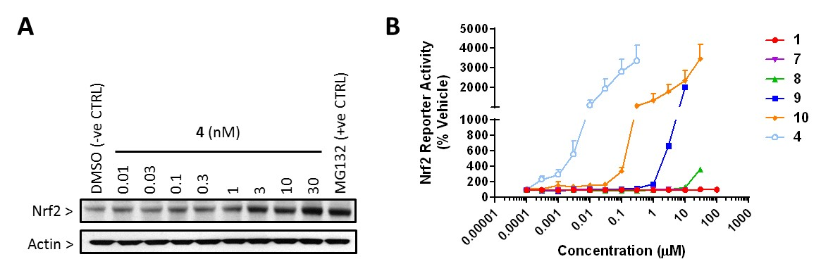

Figure 2 – Pharmacological activity of 4 and synthetic intermediates as inducers of Nrf2. (A) Accumulation of Nrf2 protein in H4IIE-ARE8L cells following 1 h exposure to the indicated concentrations of 4. DMSO (0.5 %) and the proteasome inhibitor N-(benzyloxycarbonyl)leucinyl-leucinyl-leucinal (MG132; 10 μM) were used as negative and positive controls, respectively. Blots are representative of n=3 independent experiments. (B) Relative potencies of 4 and synthetic intermediates as inducers Nrf2 reporter transgene activation, in H4IIE-ARE8L cells. Cells were exposed to the indicated concentrations of the compounds for 24 h. Luciferase activity is expressed relative to the vehicle control. Data represent mean + S.D., n=4.

|  |  |
| --- | --- |
| Compound | CD (µM) |
| 1 | N.D. |
| 7 | N.D. |
| 8 | 17.6 ± 3.6 |
| 9 | 1.2 ± 0.2 |
| 10 | 0.009 ± 0.006 |
| 4 | 0.0005 ± 0.0004 |

Table 1 – Relative potencies of 4 and synthetic intermediates as inducers of Nrf2. The data presented in Figure 2B were used to determine the concentration of each compound that provoked a 2-fold increase in ARE8L reporter transgene activity (CD). N.D., not determined. Data represent mean + S.D., n=4.

**Reversible thiol addition of 4.** The α,β unsaturated ketones located in the A and C rings of **4** can potentially react with thiols via reversible 1,4-conjugate addition. To examine this, we reacted the compound with the model thiol β-mercaptoethanol (β-ME) or N-acetyl cysteine (NAC), and used proton NMR coupled with temperature variation to monitor thiol addition. For both β-ME and NAC, the vinylic proton on the A ring of **4** was lost as the thiol concentration was increased (Figure 3A-B), indicative of a 1,4-conjugate addition. Moreover, the vinylic proton on the C ring was shifted upfield giving a singlet at 5.85 ppm (β-ME, Figure 3A) or 5.81 ppm (NAC, Figure 3B). In both cases, molecular modelling revealed that the close proximity of the thiol sulphur results in shielding of the vinylic proton on the C ring of **4**, accounting for the observed upfield shifts (Figure S1). Consistent with previous experiments employing dithiothreitol as the model thiol 23, the vinylic proton on the A ring of **4** reappeared when the reactions containing β-ME and NAC were heated to 50 °C, and disappeared upon return to room temperature (Figure 3A-B). These data demonstrate that the α,β unsaturated ketone in the A ring of **4** undergoes facile and reversible reaction with thiols. Given that **10**, which lacks a double bond in the A ring, is not capable of 1,4-conjugate addition to thiols, yet exhibits relatively high potency towards Nrf2 in H4IIE-ARE cells (Table 1), we tested the ability of the compound to react with β-ME by proton NMR. There was no evidence for 1,4-conjugate addition of **10** to β-ME via the A or C rings (Figure S2), even in the presence of the base triethylamine (TEA). Although we cannot exclude the possibility that **10** undergoes 1,2-conjugate addition to thiols, these observations suggest that non-covalent interactions play an important role in determining the potency of **4** and related triterpenoids as inducers of Nrf2 signalling.

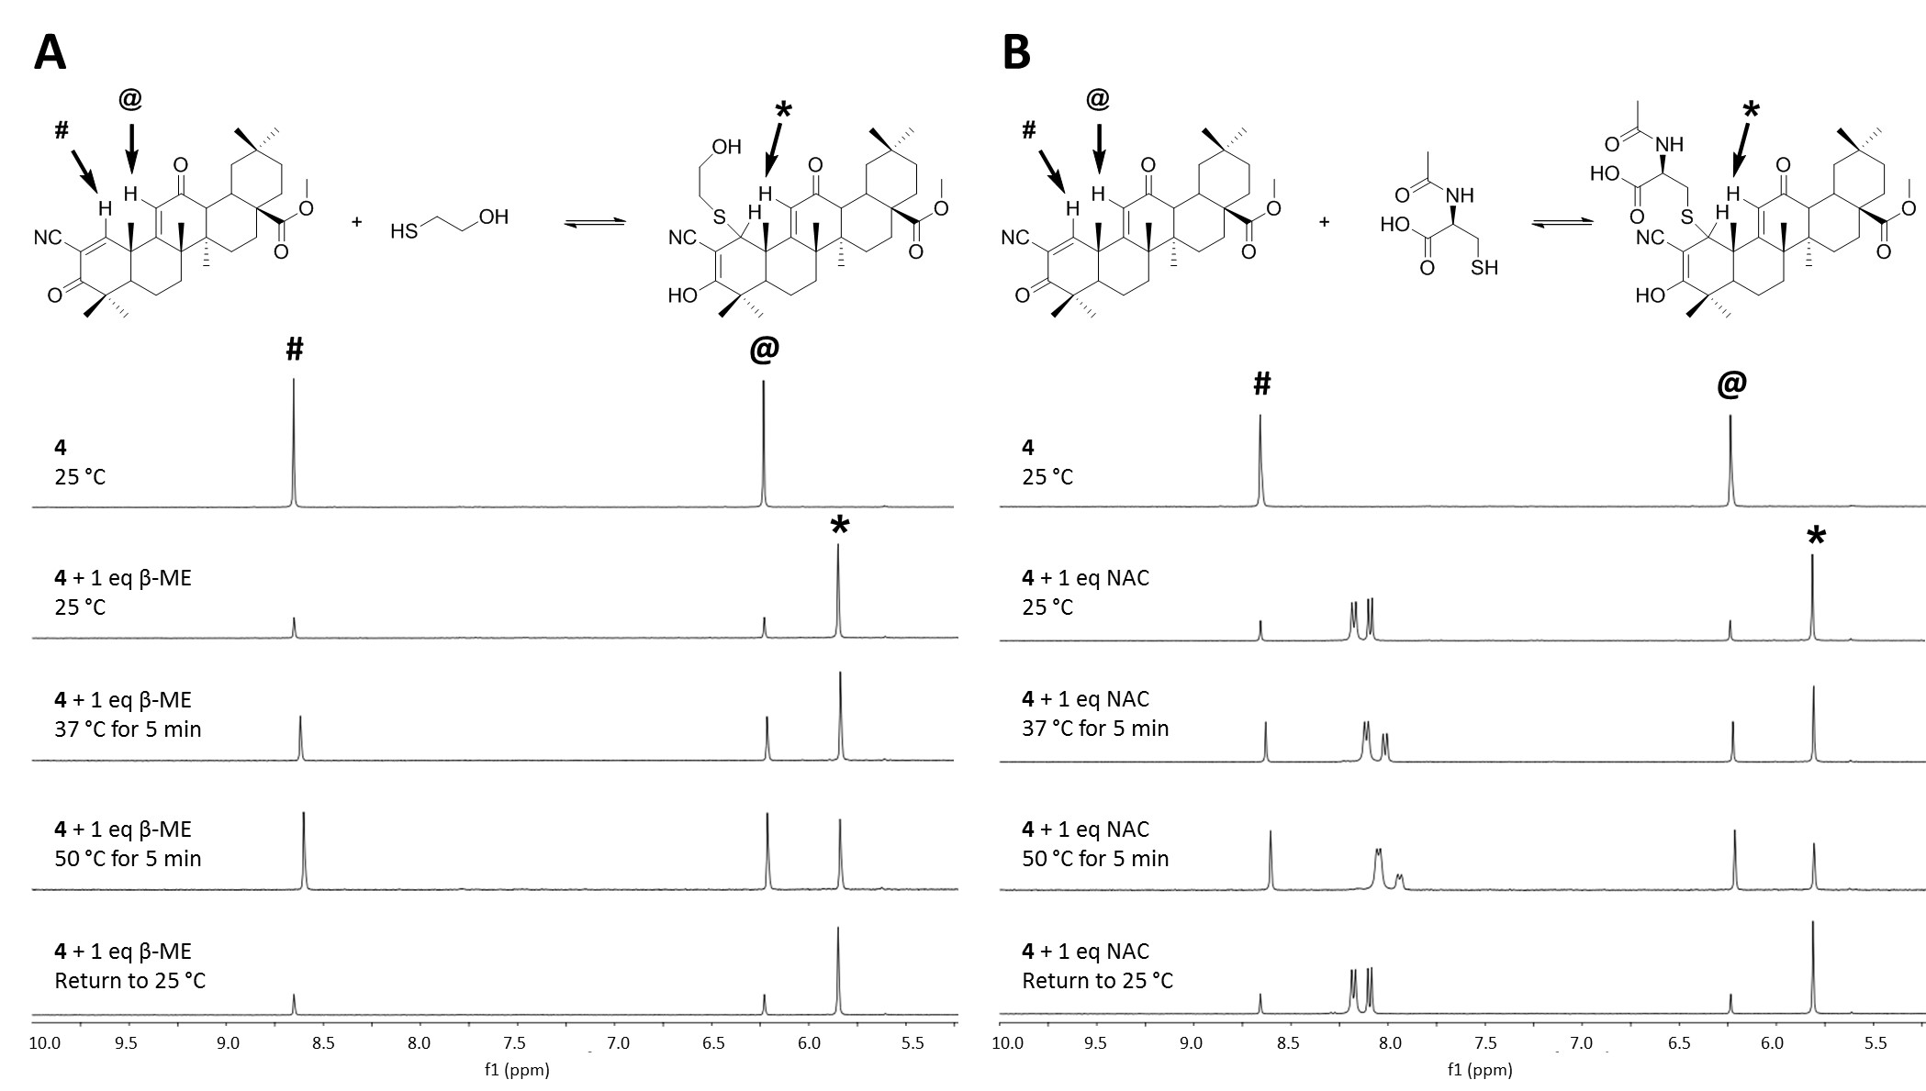

Figure 3 – Reversible thiol addition of 4. 1H NMR evidence for reaction between 4 and (A) β-mercaptoethanol (β-ME) or (B) N-acetylcysteine (NAC) at 25 °C. The data demonstrate reversal of the reactions upon increase in temperature to 50 °C, and recurrence of the reactions upon return to 25 °C. Whilst the proton signals from the A-ring (#) and C-ring (@) enones of 4 decrease upon reaction with β-ME, the signal from the C-ring enone shifts to yield a compensatory vinylic signal (*). Data are representative of n=3 independent experiments.

**Chemical synthesis of irreversible analogues of 4.** Whilst a biotinylated analogue of **3**, the imidazole derivative of **4**,has previously been used to identify selected protein targets in mammalian cells,30 there is a notable lack of direct evidence for an interaction of **4** with one of its purported principal targets, Keap1. The cyano group of **4** is highly electron withdrawing, rendering the α,β unsaturated ketone in the A ring more susceptible to nucleophilic attack, and can effectively stabilise a negative charge, facilitating reversible thiol addition. Whilst the relatively high potency of **10** towards Nrf2, and inability of the compound to undergo 1,4-conjugate addition to thiols, indicates that non-covalent interactions are vital for the pharmacological efficacy of triterpenoids, it is likely that the reversible nature of the interaction between **4** and its subcellular targets has also hindered the identification of pharmacologically relevant targets, including Keap1. In order to overcome this barrier, and enable the isolation and characterisation of stable protein adducts that may inform the development of novel triterpenoids and other Nrf2 inducers, we synthesised analogues of **4** that we rationalised would be capable of interacting with thiols in an irreversible, covalent manner (Scheme 3). The first analogue, methyl 3,12-dioxooleana-1,9(11)-dien-28-oate (DDO-Me, **11**), was synthesised from intermediate **9** using phenylselenyl chloride followed by oxidation with hydrogen peroxide, to give **11** in 57 % yield. In an alternative approach, the double bond in the A-ring was oxidised to an epoxide moiety. The angles of the bonds within the three membered ring (60 ° compared with 109.5 ° for standard tetrahedral geometry) render this functional group highly strained 34, 35, and we hypothesised that this ring would open during nucleophilic attack, generating an alkoxide that is protonated to yield a stable alcohol. Incorporation of the epoxide moiety was attempted on **11** and **4** to produce methyl 3,12-dioxo-1,2-epoxyolean-9(11)-en-28-oate (DDO-Epoxide, **12**)and 2β-cyano-3,12-dioxo-1,2-epoxyolean-9(11)-en-28-oate (CDDO-Epoxide, **13**). The synthesis of **12** required the use of **11**, hydrogen peroxide and a base, giving **12** in 49 % yield. The use of iodosobenzene in anhydrous dichloromethane yielded **13** from **4** in 75 % yield. The synthesis of **13** has been described by others,36 although detailed evidence for the assignment of the epoxide stereochemistry was not provided. To address this knowledge gap, we used NMR nuclear Overhauser effect (nOe) analysis. The C-25 methyl protons (1.15 ppm and 1.20 ppm respectively) and C-1 protons (4.24 ppm and 5.14 ppm respectively) were identified for both **12** and **13**. The C-25 methyl protons were irradiated and a nOe signal was observed for the C-1 and C-11 protons (Figure 4, blue spectra). Such an effect would not be expected if the epoxides of **12** and **13** were configured in the beta orientation, particularly as the C-1 proton would be anti to the C-25 methyl proton. These data demonstrate that the epoxides of **12** and **13** are in the alpha configuration.



Scheme 3 – Synthesis of 11, 12 and 13. Reagents and conditions:(a) PhSeCl, Ethyl Acetate, r.t., 2.5 hrs; (b) 30 % H2O2, THF, H2O; (c) 30 % H2O2, MeOH, 10 % NaOH, r.t.; (d) PhIO, DCM, N2, 12 hr.

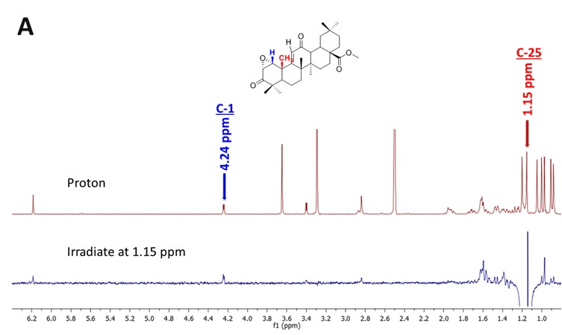

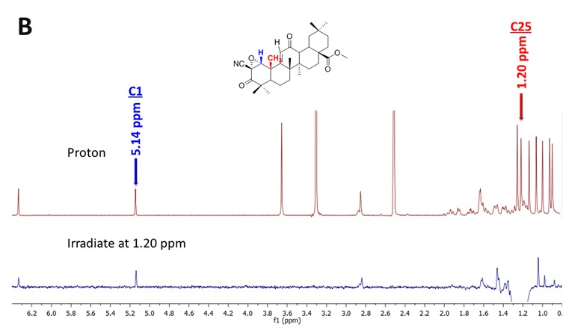

Figure 4 – Stereochemical characterisation of 12 and 13. Irradiation of C-25 of (A) 12 or (B) 13 demonstrates that C-1 has the beta configuration (blue spectra). Such an effect would not be expected if the epoxide functions of 12 and 13 were configured in the beta orientation, since the C-1 proton would be in the alpha configuration and anti to the C-25 methyl proton.

**Pharmacological activity of irreversible analogues of 4 as inducers of Nrf2.** Although the synthesis of **12** has been reported previously,36 its pharmacological activity as an inducer of Nrf2 has not been examined, to our knowledge. Therefore, we exposed H4IIE-ARE8L cells to **11**, **12** or **13** for 24 hours, and measured the effect on Nrf2 luciferase reporter transgene activity. Whilst **11** and **12** both provoked concentration-dependent increases in Nrf2 reporter transgene activity, they were 3-4 orders of magnitude less potent than **4** (Figure 5A and Table 2), indicating that the cyano group is an important driver of pharmacological activity. In keeping with this notion, and consistent with the recent observation of Nakagami et al.,37 **13** was found to be almost equipotent to **4** as an inducer of Nrf2 (Figure 5A and Table 2). This relatively small difference in potency towards Nrf2 was mirrored by the small difference in cytotoxicty for **4** and **13** (Figure 5B and Table 2). Therefore, **13** was used for subsequent chemical and biological investigations.

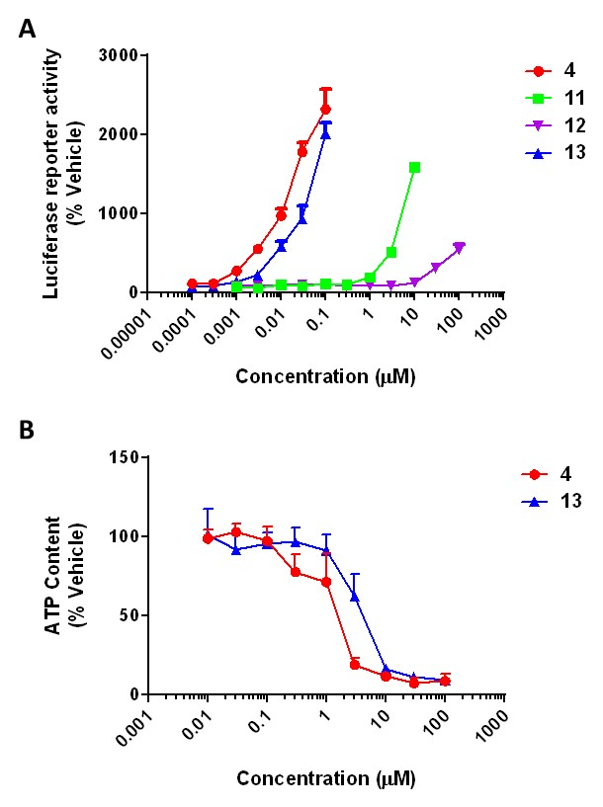

Figure 5 – Pharmacological activity and cytotoxicity of irreversible analogues of 4. H4IIE-ARE8L cells were exposed to the indicated concentrations of the compounds for 24 h and (A) Nrf2 reporter transgene activation or (B) ATP content were determined. Luciferase activity and ATP content are expressed relative to the vehicle control. Data represent mean + S.D., n=4.

|  |  |  |  |
| --- | --- | --- | --- |
| Compound | Structure | CD (µM) | IC50 (µM) |
| 4 |  | 0.0005 ± 0.0004 | 1.4 ± 0.6 |
| 11 |  | 0.9 ± 0.1 | N.D. |
| 12 |  | 15.4 ± 0.6 | N.D. |
| 13 |  | 0.002 ± 0.0002 | 4.3 ± 1.6 |

Table 2 – Pharmacological activity and cytotoxicity of irreversible analogues of 4. The data presented in Figure 5 were used to determine the concentration of each compound that (A) provoked a 2-fold increase in ARE8L reporter transgene activity (CD) and (B) provoked a 50 % decrease in cellular ATP content (IC50). N.D., not determined. Data represent mean + S.D., n=4.

**Irreversible thiol addition of 13.** Using proton NMR coupled with temperature variation, we confirmed that **13** reacted within β-ME, albeit only in the presence of TEA (Figure 6). The loss of the signal at 5.15 ppm (representing the proton located on the epoxide) confirmed that the reaction reached completion. Importantly, the thiol adduct formed by **13** was found to be insensitive to temperature elevation (Figure 6), indicating its stability.

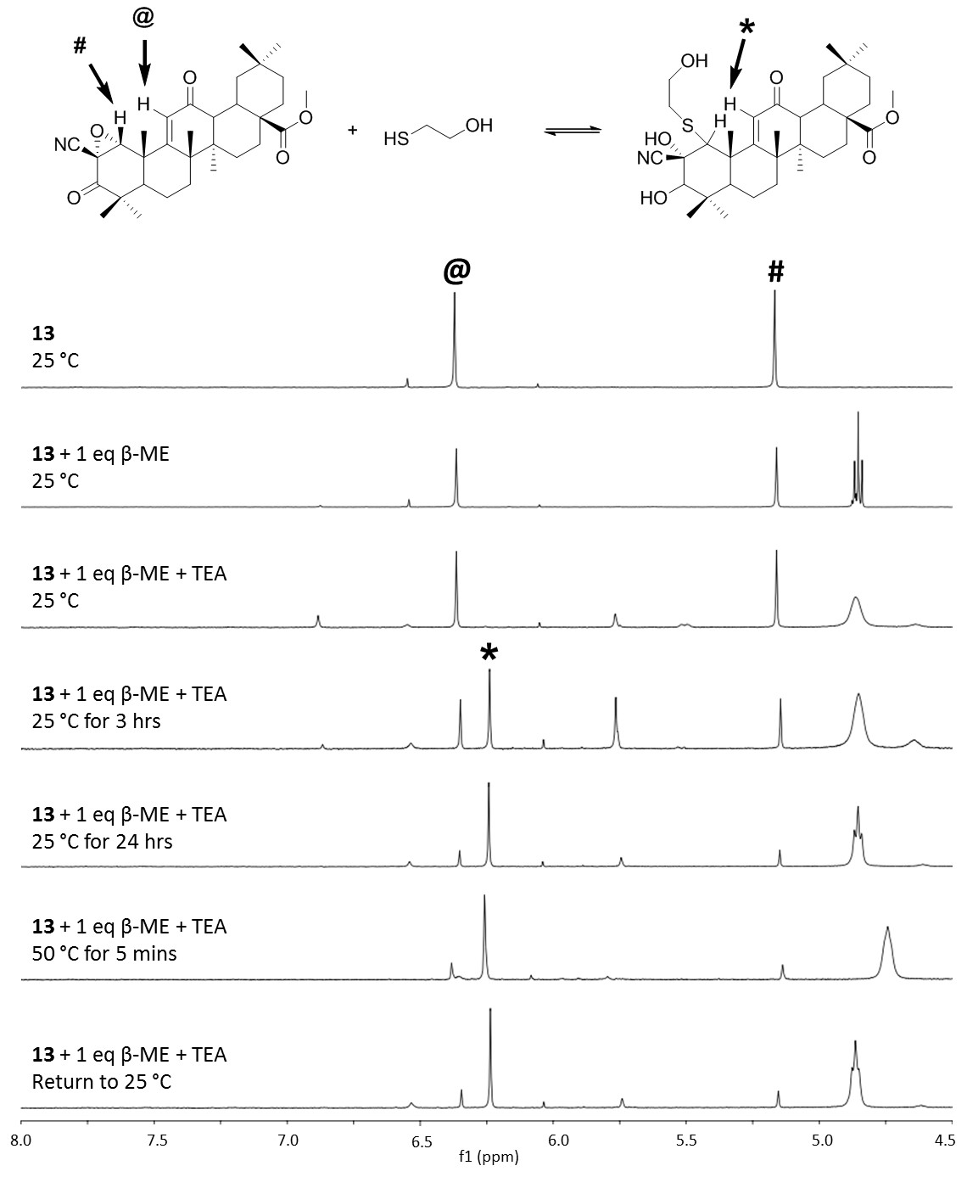

Figure 6 – Irreversible thiol addition of 13. 1H NMR evidence for reaction between 13 and β-ME at 25 °C, in the presence of TEA. The data demonstrate the stability of the reaction product upon increase in temperature to 50 °C. Whilst the proton signals from the A-ring (#) and C-ring (@) enones of 13 decrease upon reaction with β-ME, the signal from the C-ring enone shifts to yield a compensatory vinylic signal (*). Data are representative of n=3 independent experiments.

Based on these observations, we sought to determine if **13** could be used to directly identify a protein target, and characterise the specific site(s) of interaction, using LC-MS/MS. We reacted **13** with the model protein glutathione S-transferase P1 (GSTP1), which we have used previously to characterise chemically reactive drug metabolites 38, and found that the compound covalently modified the highly-reactive Cys-47 of GSTP1 in vitro (Figure 7A). Importantly, we also found that **4** could covalently modify this residue (Figure 7B), and consistent with this, pre-incubation of GSTP1 with increasing molar excesses of **4** inhibited modification of Cys-47 by **13** (Figure 7C), indicating that both compounds are capable of interacting with the same cysteine residue within a protein.

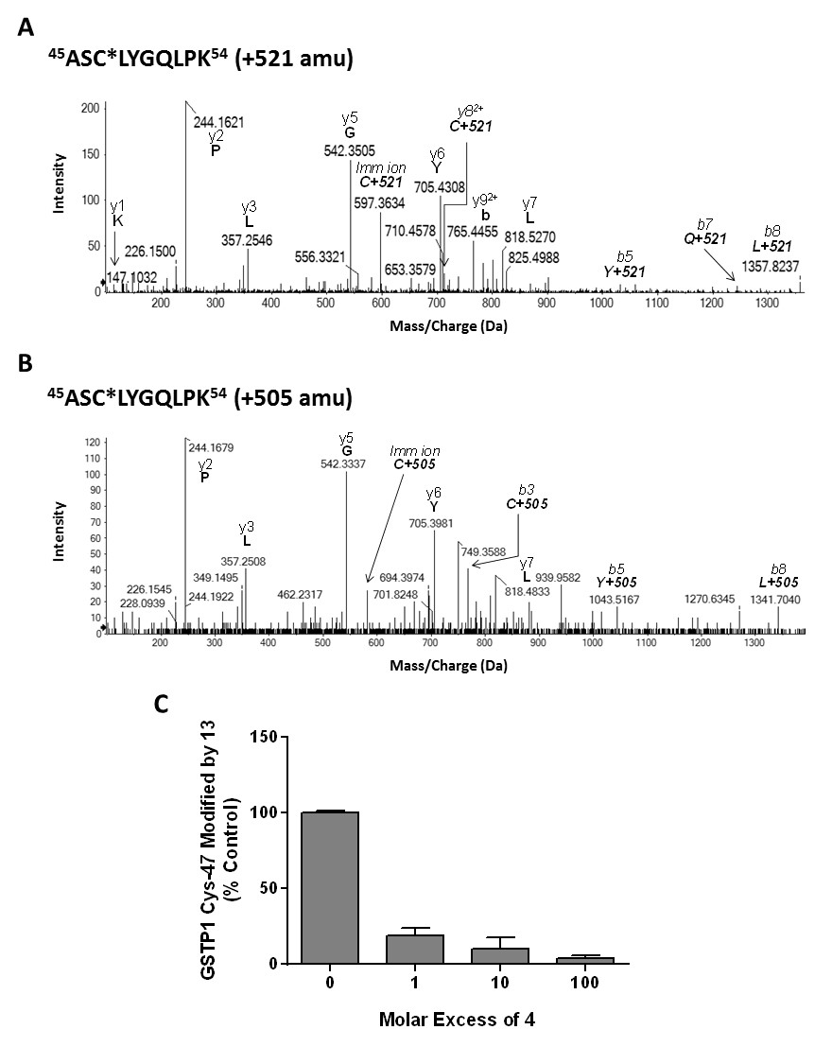

Figure 7 – Modification of GSTP1 by 4 and 13. (A-B) LC-MS/MS evidence for the modification of Cys-47 of GSTP1 following in vitro exposure to (A) 100:1 molar ratio of 13 for 24 h, or (B) 10:1 molar ratio of 4 for 1 h. Characteristic mass shifts of +521 (13) and +505 (4) amu were detected on the indicated peptide y/b ions. (C) Concentration-dependent inhibition by 4 of the modification of Cys-47 of GSTP1 by 13. GSTP1 was pre-incubated with the indicated molar excesses of 4 for 1 h, before exposure to 13 (1:1 molar ratio) for a further 24 h. Data represent mean + SD, n=3.

**Identification of sites of interaction between 13 and Keap1.** In spite of our observation that both **4** and epoxide **12** can modify GSTP1, we were unable to identify the site(s) of **4** modification following incubation of the compound with recombinant Keap1, most likely due to the complexity of the Keap1 protein relative to GSTP1, and the chemical lability of the adduct(s). However, due to its capacity to react irreversibly with thiols, we were able to show that **13** chemically modifies Cys-257, -273, -288, -434, -489 and -613 of Keap1 in a concentration-dependent manner (Figure 8A-C and S3), with Cys-257 found to be the most readily detected adduct in vitro. We next examined the biological relevance of our in vitro experiments in a cellular context, by expressing Keap1-V5 in HEK293T cells. Following exposure of the cells to epoxide **13** for 1 h, and in keeping with the experiments performed with recombinant Keap1 protein in vitro, LC-MS/MS analysis revealed the selective modification of Cys-257, -288 and -489 (and to a lesser degree Cys-273 and -434) of Keap1-V5 (Figure 8A). Talalay and colleagues have previously shown that a double cyano-functionalised triterpenoid can inhibit adduction of Keap1 by radiolabelled dexamethasone 21-mesyate 4 or a sulfoxythiocarbamate analogue of sulforaphane 25. The latter compounds have both been shown to covalently modify Keap1 at Cys-273, -288 and -613, whilst dexamethasone 21-mesyate also targets Cys-257 18, 25. Importantly, these residues were found here to be directly modified by **13** (Figure 8A). Recently, Cleasby et al. reported the crystal structure of the 132 amino acid BTB domain of human Keap1 adducted at Cys-151 by **2** 26. There was no evidence in our study for the direct modification of Cys-151 of Keap1 by **13**. Saito and colleagues have also recently shown that whilst mutation of Keap1 Cys-151 lowers the ability of **3** to activate Nrf2 signalling in cells, combined mutation of this cysteine with Cys-273 and Cys-288 completely abrogates the induction of Nrf2 by this compound 39, indicating that multiple cysteines in Keap1 are required for sensing **3** and related Nrf2 inducers.

To further examine the nature of the chemical interaction between **13** and Keap1, we generated an in silico model of the protein based on the reported crystal structures of the BTB 26 and DGR 40 domains of Keap1, with the remainder of the protein model based on homology with the crystal structure of KLHL11, as recently described 41. Consistent with previous reports 20, it was apparent that the cysteine targets of **13** in Keap1 were adjacent to basic amino acids (Figure 8D-E and S4) which are known to reduce the pKa, and thus enhance reactivity towards electrophiles, of neighbouring cysteine thiols 42. Taken together, these data demonstrate that **13** modifies specific cysteine residues in Keap1.

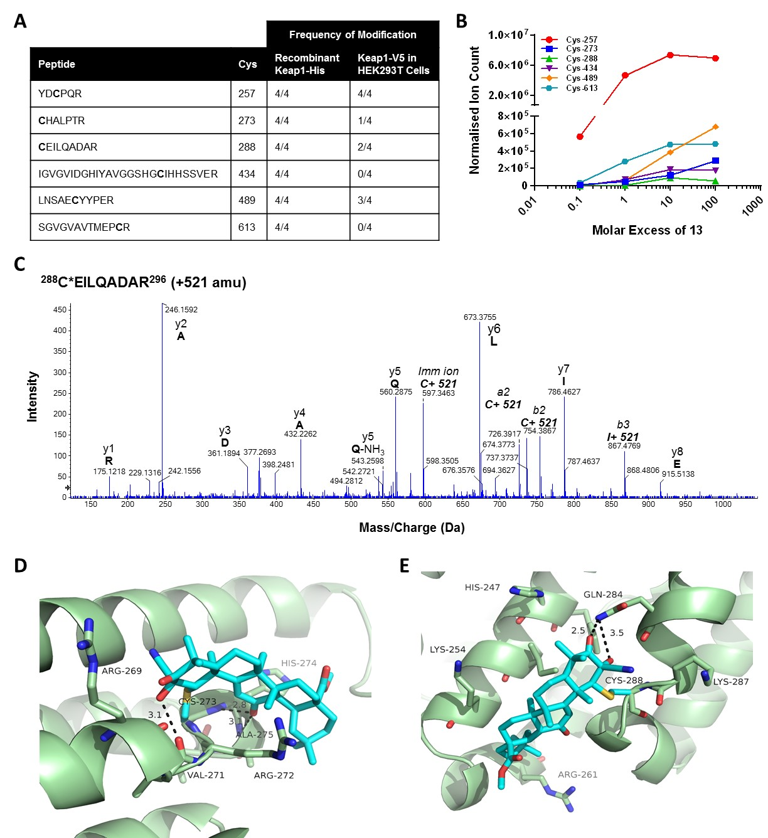

Figure 8 – Modification of Keap1 cysteines by 13. (A) Frequencies of modification of the indicated cysteines, from n=4 independent experiments, following in exposure of (A) recombinant Keap1 protein to a 100:1 molar excess of 13 for 24 h, or (B) Keap1-V5 -expressing HEK293T cells to 100 µM 13 for 1 h, as determined by LC-MS/MS. (B) Concentration-dependent modification of the indicated Keap1 cysteines by 13. The data are representative of n=3 independent experiments. (C) Representative mass spectrum depicting modification of Cys-288 of Keap1 following in vitro exposure to 13, with a characteristic mass shift of 521 amu detected on the indicated peptide y and b ions. (D-E) Homology models of Keap1 Cys-273 (D) and Cys-288 (E) covalently modified by 13 (light blue). H bonding interactions (indicated by dotted black lines) are shown with (D) the backbone atoms of Val-271, Ala-275 and Cys-273 and (E) the side chain of Gln-284. Additional mass spectra and models are provided as supplementary material.

**Conclusion**

We have synthesised a novel epoxide-functionalised analogue (**13**) of bardoxolone methyl (CDDO-Me; **4**) that can be used as a chemical tool to identify the site(s) of interaction with pharmacologically relevant targets. Indeed, we have used **13** to provide direct evidence for the modification of specific cysteine residues in Keap1 by a potent triterpenoid inducer of Nrf2. Whilst the functional importance of these modifications in transducing the signal for Nrf2 activation will require further elucidation, a detailed understanding of the chemical facets that underlie the potency of triterpenoids as modulators of Nrf2 and other signalling pathways is critical to their continuing development as novel drug candidates. Further functionalization of **13** (for example, with biotin or alkene moieties) could enable affinity-based capture of protein targets from cells, and reveal novel targets and/or pharmacological mechanism(s) of action of this compound class.

**Experimental Section**

**General Methods for Chemistry.** Reactions that were air and moisture sensitive were performed under a nitrogen atmosphere with oven-dried glassware. Chemical and anhydrous solvents were obtained from commercial sources, or dried and distilled prior to use. Chromatographic purification of products was accomplished by flash column chromatography, unless otherwise indicated. All compounds tested are ≥ 95 % pure, as determined by elemental analysis (%C, %H, %N) and/or analytical HPLC/LCMS.

**Preparation of 2-cyano-3,12-dioxooleana-1,9(11)-dien-28-oic acid (2)****8****,** **43****. 4** (1.26 g, 2.49 mmol) was dissolved in anhydrous DMF (20 mL). Lithium iodide was added to the reaction that was refluxed overnight. The reaction mixture was cooled and water (50 mL) was added. 5% HCl was then added to the solution which was washed with ethyl acetate (3 x 50 mL). The combined organic layers were washed with water (3 x 50mL), brine (3 x 50 mL) and dried over magnesium sulfate. The solution was filtered and the solvent was removed under vacuum. The crude product was purified by flash chromatography using 5% ethyl acetate in hexane to give the title compound **2** (538.5 mg, 44%); Rf = 0.08, 1:1 ethyl acetate in hexane; mp = lit43 283-288°C found 296-298°C; 1H NMR (400 MHz, CDCl3) δ 8.07 (s, 1H), 6.01 (s, 1H), 3.08 – 2.95 (m, 2H), 2.00 – 1.87 (m, 2H), 1.83 – 1.68 (m, 6H), 1.62 – 1.51 (m, 3H), 1.49 (s, 3H), 1.35 (s, 3H), 1.32 – 1.19 (m, 4H), 1.26 (s, 3H), 1.17 (s, 3H), 1.03 (s, 3H), 1.00 (s, 3H), 0.91 (s, 3H); 13C NMR (100 MHz, CDCl3) δ 198.9, 196.7, 183.9, 168.7, 165.9, 124.1, 114.6, 114.5, 49.8, 47.7, 47.1, 45.8, 45.1, 42.6, 42.2, 35.7, 34.4, 33.3, 33.0, 31.7, 31.4, 30.7, 28.0, 27.0, 26.7, 24.7, 23.1, 22.5, 21.7 and 18.3; IR νmax (neat)/cm-1 2944, 1723, 1688 and 1663; HRMS (ESI) calculated for C31H41NO4 [M+Na]+ 514.2933 found 514.2916.

**Preparation of methyl 2-cyano-3,12-dioxooleana-1,9(11)-dien-28-oate (4)****8****,** **44****. 10** (2.6 g, 5.13 mmol) was dissolved in anhydrous benzene. 2,3-Dichloro-5,6-dicyanobenzoquinone (2.0 g, 8.82 mmol) was added to the solution of **10** which was refluxed for 30 minutes. The solution was cooled and the insoluble matter was filtered. Benzene was removed *in vacuo* and the crude product was recrystallised from methanol and water to obtain the title compound **4** (2.25 g, 87%) as a white solid product; Rf = 0.3, 30% ethyl acetate in hexane; mp = lit44 228°C found 228-230°C; 1H NMR (400 MHz, CDCl3) δ 8.05 (s, 1H), 5.97 (s, 1H), 3.70 (s, 3H), 3.04 (dt, *J* = 13.6, 3.7 Hz, 1H), 2.94 (d, *J* = 4.7 Hz, 1H), 1.96 – 1.63 (m, 9H), 1.60 – 1.50 (m, 3H), 1.49 (s, 3H), 1.33 (s, 3H), 1.30 – 1.20 (m, 3H), 1.26 (s, 3H), 1.17 (s, 3H), 1.01 (s, 3H), 1.00 (s, 3H) and 0.90 (s, 3H); 13C NMR (100 MHz, CDCl3) δ 199.0, 196.7, 178.3, 168.5, 165.9, 124.1, 114.7, 114.5, 52.0, 49.8, 47.8, 47.3, 45.8, 45.1, 42.6, 42.2, 35.8, 34.5, 33.3, 32.8, 31.7, 31.6, 30.7, 28.1, 27.1, 26.7, 24.7, 23.2, 22.7, 21.7, 21.7 and 18.3; IR νmax (neat)/cm-1 2947 (CH), 2868 (COCH3) 2234 (CN), 1720 (CO), 1688 (C=C) and 1663 (C=C); HRMS (ESI) calculated for C32H­43NO4 [M+Na]+ 528.3090 found 528.3101.

**Preparation of 3β-acetyloleanolic acid methyl ester (5)****45****.** 3β-acetoxy-olean-12-en-28-oic acid (6.47 g, 12.97 mmol) was dissolved in acetone (100 mL). Potassium carbonate (7.17 g, 51.89 mmol) and iodomethane (3.23 mL, 51.89 mmol) were added to the reaction and the mixture was left to stir at room temperature for 24 hours. The reaction mixture was concentrated *in vacuo* and the residue was dissolved in dichloromethane. The organic layer was washed with water, brine and dried over magnesium sulfate. The solution was concentrated *in vacuo* to give crude product that was purified by flash chromatography using 5% ethyl acetate in hexane gave the title compound (**5**) (6.48 g, 97%) as a white powder; Rf = 0.8, 20% ethyl acetate in hexane; mp = lit45 219-221°C found 218-219°C; 1H NMR (400 MHz, CDCl3) δ 5.28 (t, *J* = 3.6 Hz, 1H), 4.49 (dd, *J* = 8.9, 7.1 Hz, 1H), 3.62 (s, 3H), 2.86 (dd, *J* = 13.8, 4.2 Hz, 1H), 2.05 (s, 3H), 2.02 – 1.83 (m, 3H), 1.74 – 1.25 (m, 15H), 1.22 – 1.15 (m, 2H), 1.12 (s, 3H), 1.10 – 0.99 (m, 2H), 0.93 (s, 3H), 0.92 (s, 3H), 0.90 (s, 3H), 0.86 (s, 3H), 0.85 (s, 3H) and 0.72 (s, 3H); 13C NMR (100 MHz, CDCl3) δ 178.4, 171.2, 143.9, 122.4, 81.0, 55.4, 51.7, 47.7, 46.8, 46.0, 41.7, 41.4, 39.4, 38.2, 37.8, 37.0, 34.0, 33.2, 32.7, 32.5, 30.8, 28.2, 27.8, 26.0, 23.8, 23.6, 23.5, 23.2, 21.5, 18.3, 17.0, 16.8 and 15.5; IR νmax (neat)/cm-1 2937 (CH), 2862 (COCH3) and 1726 (C=O); HRMS (ESI) calculated for C33H­52O4 [M+Na]+ 535.3763 found 535.3758; Microanalysis calculated for C33H52O4 requires C 77.30 %, H 10.22 % found C 77.39 %, H 10.16 %.

**Preparation of methyl 3β-acetoxy-12,13-epoxyoleanolate (6).** The minor impurity **6** was obtained during the synthesis of methy-3β-acetoxy-12-oxo-olean-28-oate (**7**) starting with **5** (6.48 g, 12.64 mmol), where the crude product was purified by flash chromatography using 5% ethyl acetate in hexane to give **6** (153 mg, 2%) as a white compound; Rf = 0.46, 20% ethyl acetate in hexane; 1H NMR (400 MHz, CDCl3) δ 4.47 (dd, *J* = 10.5, 5.9 Hz, 1H), 3.68 (s, 3H), 3.16 (s, 1H), 2.04 (s, 3H), 2.06 – 1.91 (m, 2H), 1.85 – 1.55 (m, 11H), 1.49 – 1.13 (m, 10H), 1.11 (s, 3H), 0.94 (s, 3H), 0.93 (s, 3H), 0.84 (s, 3H), 0.82 (s, 3H), 0.81 (s, 3H) and 0.80 (s, 3H); 13C NMR (100 MHz, CDCl3) δ 178.5, 171.1, 80.8, 67.4, 63.8, 55.3, 51.9, 47.9, 43.9, 41.0, 40.4, 39.3, 38.5, 38.1, 37.8, 36.7, 34.2, 33.3, 32.7, 30.5, 29.4, 28.3, 23.9, 23.7, 23.5, 22.8, 22.8, 21.4, 20.0, 18.0, 17.1, and 16.7; IR νmax (neat)/cm-1 2949 (CH), 2862 (COCH3) and 1730 (C=O); HRMS (ESI) calculated for C33H52O5 [M+Na]+ 551.3712 found 551.3727.

**Preparation of methy-3β-acetoxy-12-oxo-olean-28-oate (7)****46****.** **5** (3.85 g, 7.51 mmol) was dissolved in dry dichloromethane (50 mL) and cooled to 0°C. Pre-purified *meta*-chloroperoxybenzoic acid (1.55 g, 9.01 mmol) (see section 2.4.2.1) was added to this reaction that was left to stir for 12 hours at room temperature. The mixture was washed with sodium hydrogen carbonate solution and dichloromethane. The organic layer was washed with water, brine, dried over magnesium sulfate and filtered. The filtrate was concentrated *in vacuo* to obtain the crude product. The crude product was purified by flash chromatography using 5% ethyl acetate in hexane to give the title compound **7** (3.93 g, 99%) as a white powder; Rf = 0.56, 20% ethyl acetate in hexane; mp = lit47 189-191°C found 187-189°C; 1H NMR (400 MHz, CDCl3) δ 4.47 (dd, *J* = 11.1, 5.0 Hz, 1H), 3.68 (s, 3H), 2.79 (dt, *J* = 13.5, 3.4 Hz, 1H), 2.60 (d, *J* = 4.3 Hz, 1H), 2.28 – 2.07 (m, 2H), 2.05 (s, 3H), 1.97 – 1.73 (m, 3H), 1.69 – 1.14 (m, 15H), 1.13 – 0.99 (m, 2H), 0.98 (s, 3H), 0.96 (s, 3H), 0.94 (s, 3H), 0.90 (s, 3H), 0.87 (s, 3H), 0.87 (s, 2H) and 0.86 (s, 3H); 13C NMR (100 MHz, CDCl3) δ 211.9, 178.5, 171.1, 80.5, 55.3, 52.0, 49.7, 47.5, 41.9, 41.3, 38.6, 37.9, 37.7, 36.9, 36.3, 34.6, 33.5, 33.1, 32.1, 31.8, 30.8, 28.0, 27.6, 23.5, 23.3, 22.8, 21.4, 20.7, 18.3, 16.6, 16.2 and 15.4; IR νmax (neat)/cm-1 2927 (CH), 2858 (COCH3) and 1724 (C=O); HRMS (ESI) calculated for C33H­52O5 [M+Na]+ 551.3712 found 551.3711.

**Preparation of methyl 3β-acetoxy-12-oxoolean-9(11)-en-28-oate (8)****48****,** **49****.** Ketone **7** (12.31 g, 23.28 mmol) was dissolved in acetonitrile (100 mL). 48% Hydrobromic acid (1.0 mL, 8.85 mmol) was then added to the reaction. The reaction mixture was heated to 35°C and 1.0 M of bromine in acetonitrile (25.14 mL, 25.14 mmol) was added to the reaction which was left to stir at 35°C for 18 hours. A further 1.0 M of bromine in acetonitrile (25.14 mL, 25.14 mmol) was added dropwise to the reaction mixture and left to stir for a further 1 hour at 35°C. The reaction mixture was cooled to room temperature and was diluted with ethyl acetate. The solution was worked up with water and sodium bicarbonate. The organic layer was then washed with saturated sodium sulfite in water, brine and dried over magnesium sulfate. The solution was filtered and dried *in vacuo* to give the crude product. The crude product was re-crystallised using methanol and water to obtain title compound **8** (12.11 g, 99%) as a white solid; Rf = 0.33, 20% ethyl acetate in hexane; mp = lit49 208-209 found 207-208°C; 1H NMR (400 MHz, CDCl3) δ 5.74 (s, 1H), 4.48 (dd, *J* = 11.7, 4.7 Hz, 1H), 3.68 (s, 3H), 3.02 (dt, *J* = 13.6, 3.6 Hz, 1H), 2.84 (d, *J* = 4.7 Hz, 1H), 2.06 (s, 3H), 1.99 – 1.56 (m, 12H), 1.55 – 1.11 (m, 7H), 1.24 (s, 3H), 1.21 (s, 3H), 1.00 (s, 3H), 0.99 (s, 3H), 0.91 (s, 3H), 0.90 (s, 3H) and 0.90 (s, 3H); 13C NMR (100 MHz, CDCl3) δ 200.6, 178.4, 178.0, 171.0, 123.0, 79.8, 51.9, 50.4, 49.5, 47.4, 45.3, 41.7, 39.9, 38.3, 36.2, 35.9, 34.6, 33.4, 33.0, 32.9, 31.6, 30.7, 28.1, 28.1, 24.0, 24.0, 23.8, 23.2, 22.7, 21.8, 21.4, 17.9 and 16.8; IR νmax (neat)/cm-1 2946 (CH), 2862 (COCH3), 1734 (C=O), 1720 (C=O) and 1663 (C=C); HRMS (ESI) calculated for C33H­50O5 [M+Na]+ 549.3556 found 549.3561; Microanalysis Calculated for C33H50O5 requires C 75.25%, H 9.57% found C 75.15%, H 9.50%

**Preparation of methyl 3,12-dioxoolean-9(11)-en-28-oate (9)****8****.** Preparation of Jones reagent: 2.5 g of CrO3 was dissolved in 2.5 mL of conc. H2SO4. The mixture was cooled to 0°C and 75 mL of cold water was added dropwise to obtain a maroon coloured solution. Methyl 3β-hydroxy-12-oxoolean-9(11)-en-28-oate (2.6 g, 5.36 mmol) was dissolved in acetone (50 mL). The reaction mixture was cooled to 0°C and the Jones reagent was added dropwise to the reaction until a colour change from green to light orange/brown colour was observed. The mixture was allowed to stir at room temperature for 10 minutes. The acetone was then removed by *vacuo* and worked up in dichloromethane:diethyl ether (1:2, 3 x 50 mL) and water. The combined organic layers were washed with water, brine, dried over magnesium sulfate and filtered. The solvent was removed *in vacuo* to give the title compound **9** (2.57 g, 99%) as a white solid product; Rf = 0.22, 20% ethyl acetate in hexane; mp = 102-105°C; 1H NMR (400 MHz, CDCl3) δ 5.79 (s, 1H), 3.69 (s, 3H), 3.03 (dt, *J* = 13.6, 3.5 Hz, 1H), 2.89 (d, *J* = 4.7 Hz, 1H), 2.65 (ddd, *J* = 15.8, 11.0, 7.2 Hz, 1H), 2.48 (ddd, *J* = 15.8, 7.0, 3.8 Hz, 1H), 2.21 (ddd, *J* = 13.3, 7.3, 3.9 Hz, 1H), 1.95 – 1.56 (m, 10H), 1.54 – 1.43 (m, 3H), 1.31 (s, 3H), 1.28 (s, 3H), 1.26 – 1.15 (m, 3H), 1.13 (s, 3H), 1.09 (s, 3H), 1.01 (s, 3H), 1.00 (s, 3H) and 0.89 (s, 3H); 13C NMR (100 MHz, CDCl3) δ 216.0, 200.2, 178.4, 176.7, 124.2, 52.0, 51.1, 49.7, 47.7, 47.4, 45.5, 41.9, 39.6, 37.2, 36.0, 34.6, 34.3, 33.4, 33.0, 32.1, 31.7, 30.8, 28.3, 26.4, 23.9, 23.7, 23.2, 22.9, 21.8, 21.6 and 19.3; IR νmax (neat)/cm-1 2945 (CH), 2870 (COCH3), 1720 (C=O), 1709 (C=O) and 1659 (C=C); HRMS (ESI) calculated for C31H­46O4 [M+Na]+ 505.3294 found 505.3282.

**Preparation of methyl 2-cyano-3,12-dioxoolean-9(11)-en-28-oate (10)****8****,** **32****. 9** (0.2 g, 414 µmol) was dissolved in dry tetrahydrofuran. The solution was cooled to -78°C, flushed with nitrogen and nitrogen balloon attached. Lithium di*iso*propylamide (66.58 mg, 0.31 mL, 621 µmmol, 2.0 M in heptanes/THF/ethyl benzene) was added dropwise to the reaction and left to stir at room temperature for 20 minutes. *p*-toluenesulfonyl cyanide (150 mg, 828 µmol) was dissolved in dry tetrahydrofuran in a dry flask. The flask was cooled to -78°C and the solution containing **9** was transferred dropwise to the flask. The reaction was allowed to stir for 5 minutes and quenched with ammonia solution. The solution was acidified with 5% hydrogen chloride solution and extracted with ethyl acetate (3 x 50 mL). Combined organic layers were washed with water brine and dried over magnesium sulfate. Solvent was removed *in vacuo* and purified by flash chromatography using 5% ethyl acetate in hexane to give the title compound **10** (185 mg, 88%) as a white powder; Rf = 0.3, 30% ethyl acetate in hexane.1H NMR (400 MHz, CDCl3) δ 5.80 – 5.70 (m, 1H), 3.69 (s, 3H), 3.08 – 2.98 (m, 1H), 2.95 – 2.86 (m, 1H), 2.43 (d, *J* = 15.3 Hz, 1H), 2.25 (d, *J* = 15.3 Hz, 1H), 1.94 – 1.55 (m, 12H), 1.53 – 1.37 (m, 4H), 1.25 (s, 3H), 1.22 (s, 3H), 1.20 (s, 3H), 1.12 (s, 3H), 1.00 (s, 6H) and 0.90 (s, 3H); 13C NMR (100 MHz, CDCl3) δ 200.0, 178.4, 175.1, 124.5, 52.0, 49.7, 48.5, 47.4, 45.5, 42.3, 41.9, 39.6, 38.7, 38.6, 38.1, 37.5, 36.0, 34.6, 33.4, 33.0, 32.9, 31.6, 31.3, 30.8, 28.3, 28.0, 24.1, 23.2, 23.1, 21.7, 20.0 and 18.9; IR νmax (neat)/cm-1 2949 (CH), 2869 (COCH3), 2207 (CN), 1722 (C=O) and 1659 (C=C); HRMS (ESI) calculated for C32H45NO4 [M+Na]+ 530.3246 found 530.3233.

**Preparation of methyl 3,12-dioxooleana-1,9(11)-dien-28-oate (11)****8****. 9** (200 mg, 414 µmol) was dissolved in ethyl acetate (25 mL). Phenylselenyl chloride (87 mg, 456 µmol) was added to the reaction which was left to stir at room temperature for 2.5 hours. 5 mL of water was added to the reaction and the water was removed *via* a separating funnel.Subsequently, THF (15 mL) was added to the organic layer along with hydrogen peroxide (30%, 0.33 mL). The reaction was left to stir for a further hour at room temperature. The reaction was washed with water (3 x 50 mL), brine (50 mL) and dried over magnesium sulfate. The solvent was removed *in vacuo* and purified by flash chromatography using 2% ethyl acetate in hexane to give the title compound **11** (114.5 mg, 57%) as a white powder; Rf = 0.19, 20% ethyl acetate in hexane; mp = 182-183°C; 1H NMR (400 MHz, CDCl3) δ 7.33 (d, *J* = 10.5 Hz, 1H), 6.00 (s, 1H), 5.92 (d, *J* = 10.5 Hz, 1H), 3.70 (s, 3H), 3.04 (dt, *J* = 13.4, 3.5 Hz, 1H), 2.92 (d, *J* = 4.7 Hz, 1H), 2.02 – 1.64 (m, 10H), 1.62 – 1.44 (m, 5H), 1.42 (s, 3H), 1.31 (s, 3H), 1.19 (s, 3H), 1.12 (s, 3H), 1.01 (s, 3H), 1.00 (s, 3H) and 0.89 (s, 3H); 13C NMR (100 MHz, CDCl3) δ 203.6, 199.7, 178.4, 171.6, 154.9, 126.0, 123.8, 52.0, 49.8, 48.5, 47.4, 45.8, 44.8, 42.2, 41.9, 36.0, 34.6, 33.4, 33.0, 32.2, 31.7, 30.8, 28.2, 27.3, 27.0, 24.7, 23.2, 22.8, 21.8, 21.7 and 18.5; IR νmax (neat)/cm-1 2945 (CH), 2861 (COCH3), 1716 (CO), 1673(C=C) and 1654 (C=C); HRMS (ESI) calculated for C31H­44O4 [M+Na]+ 503.3137 found 503.3138.

**Preparation of methyl 3,12-dioxo-1,2-epoxyolean-9(11)-en-28-oate (12)****36****. 11** (200 mg, 416 µmol) was dissolved in methanol (5 mL). Hydrogen peroxide (30%, 200 µL, 2.0 mmol) and sodium hydroxide (10% w/v) were added successively and monitored using TLC analysis. The reaction was completed in 4 hours. Ethyl acetate (100 mL) was added to the reaction mixture that was washed with water, sodium thiosulfate solution (5% w/v, 100 mL) and dried over magnesium sulfate. The solution was concentrated to give a crude product in which purification by flash chromatography using 20% ethyl acetate in hexane to give the title compound **12** (101.2 mg, 49%) as a white powder; mp = 116-118°C; 1H NMR (400 MHz, CDCl3) δ 6.12 (s, 1H), 3.92 (d, J = 4.5 Hz, 1H), 3.70 (s, 3H), 3.44 (d, J = 4.5 Hz, 1H), 3.05 (dt, J = 7.3, 3.9 Hz, 1H), 2.93 (d, J = 4.5 Hz, 1H), 2.13 – 2.06 (m, 1H), 1.98 – 1.79 (m, 2H), 1.77 – 1.40 (m, 9H), 1.40 – 1.27 (m, 3H), 1.26 (s, 3H), 1.20 (s, 3H), 1.14 (s, 3H), 1.10 (s, 3H), 1.05 (s, 3H), 1.00 (s, 3H) and 0.90 (s, 3H); 13C NMR (100 MHz, CDCl3) δ 211.2, 199.6, 178.4, 171.2, 124.5, 62.6, 56.6, 52.0, 49.8, 47.4, 45.7, 44.8, 42.4, 42.0, 41.1, 35.9, 34.6, 33.4, 32.9, 31.8, 31.6, 30.8, 28.3, 28.0, 23.9, 23.2, 23.0, 22.8, 21.8, 21.2 and 18.5; IR νmax (neat)/cm-1 2946 (CH), 2870 (COCH3), 1721 (CO), 1704 (C=C) and 1661 (C=C); HRMS (ESI) calculated for C31H­44O5 [M+Na]+ 519.3086 found 519.3086.

**Preparation of methyl 2β-cyano-3,12-dioxo-1,2-epoxyolean-9(11)-en-28-oate (13)****36****,** **50****.** Preparation of iodosylbenzene50: Sodium hydroxide (1.88 M, 532 mL) was added dropwise to (diacetoxyiodo)benzene (1.19 g, 4.09 mmol) at room temperature. The yellow mixture was stirred for three hours at room temperature and filtered under vacuum. The filtrate was washed with water until the washings were neutral. The yellow solid was dried and stored at room temperature until required. **4** (50.0 mg, 98.9 µmol) was dissolved in chloroform (50 mL), Iodosylbenzene (89.2 mg, 405.4 mmol) was added to the reaction which was left to stir for 12 hours. The reaction mixture was washed with water (50 mL), brine and dried over magnesium sulfate. The solution was concentrated to give crude product in which purification by flash chromatography using 30% ethyl acetate in hexane gave the title compound **13** (38.8 mg, 75%) as a white powder; Rf = 0.21, 20% ethyl acetate in hexane; mp = 142-143°C; 1H NMR (400 MHz, CDCl3) δ 6.08 (s, 1H), 4.35 (s, 1H), 3.70 (s, 3H), 3.04 (dt, *J* = 6.7, 3.7 Hz, 1H), 2.94 (d, *J* = 4.6 Hz, 1H), 2.02 – 1.79 (m, 3H), 1.77 – 1.44 (m, 10H), 1.39 – 1.28 (m, 2H), 1.27 (s, 6H), 1.19 (s, 3H), 1.12 (s, 3H), 1.08 (s, 3H), 1.00 (s, 3H) and 0.90 (s, 3H); 13C NMR (100 MHz, CDCl3) δ 202.5, 198.9, 178.3, 168.7, 125.0, 113.7, 69.2, 53.3, 52.0, 49.8, 47.3, 45.7, 45.2, 42.6, 42.1, 41.0, 35.9, 34.6, 33.4, 32.9, 31.6, 31.5, 30.8, 28.3, 28.1, 24.0, 23.2, 22.9, 22.8, 21.7, 21.5 and 18.4; IR νmax (neat)/cm-1 2947 (CH), 2870 (COCH3), 1715 (CO), 1663 (C=C), 1242, 906 and 810; HRMS (ESI) calculated for C32H­43NO5 [M+Na]+ 544.3039 found 544.3047.

**Preparation of 3β-acetoxy-olean-12-en-28-oic acid** **5****,** **46****.** Under an atmosphere of nitrogen, oleanolic acid (**1**) (4 g, 8.76 mmol) was dissolved in dichloromethane (100 mL). Triethylamine (2.44 mL, 17.52 mmol), acetic anhydride (2.07 mL, 21.9 mmol) and 4-(dimethylamino)pyridine (10.7 mg, 87.6 µmol) were added to the reaction and the mixture was left to stir at room temperature for 12 hours. 2 M hydrochloric acid solution was added to the reaction and the mixture was washed with dichloromethane (3 x 100 mL). The combined organic layers were washed with water, brine and dried over magnesium sulfate. The solution was concentrated *in vacuo* to give crude product in which was purified by by flash chromatography using 20% ethyl acetate in hexane gave the title compound (4.13 g, 95%) as a white powder; Rf = 0.4, 20% ethyl acetate in hexane; mp = lit51 254.2-257.8°C found 255-257°C; 1H NMR (400 MHz, CDCl3) δ 5.27 (t, *J* = 3.3 Hz, 1H), 4.59 – 4.39 (m, 1H), 2.82 (dd, *J* = 13.4, 3.7 Hz, 1H), 2.05 (s, 3H), 2.03 – 1.85 (m, 3H), 1.82 – 1.16 (m, 18H), 1.12 (s, 3H), 1.10 – 1.02 (m, 2H), 0.94 (s, 3H), 0.93 (s, 3H), 0.90 (s, 3H), 0.86 (s, 3H), 0.85 (s, 3H) and 0.74 (s, 3H); 13C NMR (100 MHz, CDCl3) δ 184.6, 171.2, 143.7, 122.7, 81.1, 55.4, 47.7, 46.7, 45.9, 41.6, 41.0, 39.4, 38.2, 37.8, 37.1, 33.9, 33.2, 32.6, 32.6, 30.8, 28.2, 27.8, 26.0, 23.7, 23.6, 23.5, 23.0, 21.5, 18.3, 17.3, 16.8 and 15.5; IR νmax (neat)/cm-1 3178 (OH), 2943 (CH), 1726 (C=O) and 1680 (C=C); HRMS (ESI) calculated for C32H­50O4 [M+Na]+ 521.3607 found 521.3618.

**Preparation of methyl 3β-hydroxy-12-oxoolean-9(11)-en-28-oate****49****.** Acetyl **8** (1.7 g, 3.23 mmol) was dissolved in methanol (50 mL). Potassium hydroxide (5 g, 90.33 mmol) was added to the reaction mixture and refluxed for 1 hour. The reaction mixture was allowed to cool to room temperature and 6.0 M hydrochloric acid was used for the work up and extracted three times in dichloromethane: diethyl ether (1:2, 3 x 50 mL). The combined organic layers were washed with water, brine and dried over magnesium sulfate. The solution was filtered and the solvent was removed under reduced pressure to give the title compound **8** (1.55 g, 99%) as a white solid; Rf = 0.11, 20% ethyl acetate in hexane; mp = lit49 233°C found 232-233°C; 1H NMR (400 MHz, CDCl3) δ 5.75 (s, 1H), 3.68 (s, 3H), 3.22 (dd, *J* = 11.6, 4.6 Hz, 1H), 3.02 (dt, *J* = 13.7, 3.6 Hz, 1H), 2.84 (d, *J* = 4.7 Hz, 1H), 2.00 – 1.56 (m, 14H), 1.53 – 1.25 (m, 6H), 1.24 (s, 3H), 1.18 (s, 3H), 1.03 (s, 3H), 1.00 (s, 3H), 0.99 – 0.97 (m, 2H), 0.89 (s, 4H) and 0.83 (s, 3H); 13C NMR (100 MHz, CDCl3) δ 200.8, 178.5, 178.5, 122.9, 78.1, 52.0, 50.3, 49.6, 47.4, 45.4, 41.8, 40.1, 39.4, 36.5, 35.9, 34.6, 33.4, 33.0, 32.9, 31.6, 30.8, 28.2, 27.6, 24.0, 23.8, 23.2, 22.8, 21.9, 18.1 and 15.7; IR νmax (neat)/cm-1 3299 (OH), 2943 (CH), 2867 (COCH3), 1721 (C=O) and 1658 (C=C); HRMS (ESI) calculated for C31H­48O4 [M+Na]+ 507.3450 found 507.3445.

**Cell culture.** H4IIE-ARE8L cells, stably expressing a luciferase reporter regulated by an eight-times repeated antioxidant response element (ARE), were a kind gift of Prof. Alex Odermatt (Universität Basel, Switzerland). The generation of H4IIE-ARE8L cells has been described previously 33. H4IIE-ARE8L and HEK293T cells were maintained at 37 °C in a 5 % CO2 atmosphere in Dulbecco’s modified Eagle’s medium supplemented with 584 mg/L L-glutamine, 10 % fetal bovine serum (Life Technologies). The media for H4IIE-ARE8L cells was further supplemented with 1 mM HEPES and 1X non-essential amino acids, whilst the media for HEK293T cells was further supplemented with 100 U/mL penicillin and 100 μg/mL streptomycin. Compounds were dissolved in DMSO, with the concentration of the solvent in the media controlled to 0.5 %.

# Western blotting. Protein levels in whole-cell lysates were determined essentially as described 52, with Nrf2 (ab62352) and β-actin (Nqo1; ab6276) antibodies from Abcam.

**Nrf2 reporter assay.** Following exposure of H4IIE-ARE8L cells to the indicated compounds for 24 h, the cells were washed in PBS and then incubated for 5 min with PBS supplemented with 150 µg/mL D-luciferin (Promega). Luminescence was quantified on a Varioskan Flash Multimode Reader (Thermo Scientific) and normalised to the reporter activity detected in vehicle-exposed cells.

**Thiol reactivity studies.** **4** or **13** (10 mg) were dissolved in 0.75 mL of DMSO-d6 containing 0.05 % trimethylsilane (TMS), and combined with the indicated molar equivalents of β-mercapthoethanol (β-ME) at 25 °C. For reactions with **13**, 1 molar equivalent of triethylamine (TEA) was also added. NMR signals were recorded, immediately for reactions containing **4**, or at the indicated times for reactions containing **13**, on a Bruker DPX 400 MHz (1H, 400 MHz). Chemical shifts were described in parts per million (ppm), downfield from the internal standard (TMS). To demonstrate thermal lability, reactions containing **4** or **13** were heated to 37 or 50 °C prior to measurement of NMR signals. Subsequently, reactions containing **4** were cooled to 25 °C, and NMR signals were recorded.

**Nuclear Overhauser effect (nOe) analysis. 12** or **13** (5 mg) were dissolved in 0.75 mL of DMSO-d6. All nOe experiments were performed on an Bruker Avance 500 MHz NMR. The protons located on C-1 and C-25 were identified, and the latter was irradiated to generate an nOe spectrum.

**ATP assay.** Following exposure of H4IIE-ARE8L cells to the indicated compounds for 24 h, cellular ATP content was quantified using the CellTiter-Glo Luminescent Cell Viability Assay (Promega), and normalised to the ATP content in vehicle-exposed cells.

**Recombinant protein expression.** Polyhistidine-tagged human glutathione S-transferase P1 and mouse Keap1 were expressed in E. coli essentially as described 18, 38. Recombinant proteins were purified from bacterial lysates using HIS-Select nickel affinity gel. The on-bead protein content was determined using a bicinchoninic acid assay.

**GSTP1 and Keap1 modification studies.** Purified recombinant human GSTP1-His or mouse Keap1-His were incubated on-bead with the indicated molar excess of **13** and/or **4** for up to 24 h at pH 8.4 and 37 °C, then free cysteines were capped with 55 mM iodoacetamide (IAA) for 15 min. For competition experiments, GSTP1-His was incubated with the indicated molar excess of **4** for 1 h prior to exposure to **13** (1:1 molar ratio) for a further 24 h, during which **4** remained in the incubation buffer. In-cell Keap1 modifications were determined via ectopic expression of mouse Keap1-V5 in HEK293T cells, essentially as described 17. Cells were exposed to 100 µM **13** for 1 h. Keap1-V5 was immunopurified from cell lysates, and free cysteines were capped with IAA. GSTP-His, Keap1-His or Keap1-V5 were digested with 400 ng trypsin overnight at 37 °C prior to LC-MS/MS analysis.

**LC-MS/MS.** Tryptic peptides were desalted for reverse phase chromatography using ZipTips (Millipore). Samples were delivered into a Triple TOF 5600 mass spectrometer (AB Sciex) by automated in-line reverse phase liquid chromatography, using an Eksigent NanoUltra cHiPLC System mounted with microfluidic trap and analytical column (15 cm × 75 μm) packed with ChromXP C18-CL 3μm. A NanoSpray III source was fitted with a 10 μm inner diameter PicoTip emitter (New Objective). Samples were loaded in 0.1 % formic acid (FA) onto the trap, which was then washed with 2 % acetonitrile (ACN)/0.1 % FA for 10 min at 2 µL/min before switching in-line with the analytical column. A gradient of 2-50 % ACN, 0.1 % FA over 90 min was applied to the column at a flow rate of 300 nL/min. Spectra were acquired automatically in positive ion mode using information-dependent acquisition powered by Analyst TF 1.5.1. software, using mass ranges of 400-1600 atomic mass units (amu) in MS and 100-1400 amu in MS/MS. Up to 25 MS/MS spectra were acquired per cycle (approx. 10 Hz) using a threshold of 100 counts per sec, with dynamic exclusion for 12 sec and rolling collision energy. The instrument was automatically calibrated after every fifth sample using a beta-galactosidase digest. Protein sequence coverage was determined using ProteinPilot software v4.0 using the ParagonTM algorithm 53 and the most recent version of the SwissProt database. Carboxyamidomethyl (+57.0 amu) was selected as a variable modification. Peptides modified by **4** or **13** were identified using PeakView software to extract parent ions of the appropriate peptide plus compound m/z (extracted ion count, XIC), and the area under the curve of each XIC peak was used to assess the relative quantification of individual modified peptides across samples. For samples in the same experiment, the XIC was normalised to the total ion count (TIC) of the first sample in that experiment. Modified peptides were verified by manual inspection of the MS/MS spectra.

**Keap1 modelling.** The mouse Keap1 protein sequence was aligned against that of Kelch-like family member 11 (KLHL11; PDB: 4AP2) 41 using ClustalW and was used, alongside crystal structures of the Broad complex, Tramtrack and Bric-a-Brac (BTB; PDB: 4CXI) 26 and double glycine repeat (DGR; PDB: 2DYH) 40 domains of Keap1, to generate models using Modeller 9.11 54. GOLD 5.2 (CCDC Software; 55) was used to dock **13** within the pocket surrounding a given cysteine, with the binding site defined as 10 Å around the cysteine Cα. A generic algorithm with ChemPLP 56 as the fitness function was used to generate 50 binding modes per ligand. Default settings were retained for the “ligand flexibility”, “fitness and search options” and “GA settings”, however the “allow early termination” setting in the “fitness and search option” was turned off to retain all ligand conformations. Protons were added, and crystallographic water molecules were removed. For covalent docking to cysteines, the corresponding side chain was removed from the protein and the ligand modified to contain the side chain to allow flexibility. The site of covalent attachment was at the cysteine Cα.

**Supporting Information**

Additional NMR, LC-MS/MS and modelling data are provided as Supporting Information.

**Corresponding Author**

Paul M O’Neill

Phone: 00-44-151-794-3553

Fax: 00-44-151-794-3588

E-mail: [p.m.oneill01@liv.ac.uk](mailto:p.m.oneill01@liv.ac.uk)

**Acknowledgments**

This work was supported by the Medical Research Council, as part of the Centre for Drug Safety Science [grant number G0700654].

**Abbreviations**

ACN, acetonitrile; amu, atomic mass units; ARE, antioxidant response element; BTB, broad complex, Tramtrack and Bric-a-Brac; CD, concentration provoking a 2-fold increase in ARE8L reporter transgene activity; CKD, chronic kidney disease; DGR, double glycine repeat; FA, formic acid; GSTP1, glutathione S-transferase P1; IAA, iodoacetamide; IC50, concentration provoking a 50 % decrease in cellular ATP content; Keap1, Kelch like ECH-associated protein 1; KLHL11, Kelch-like family member 11; β-ME, β-mercaptoethanol; NAC, N-acetyl cysteine; Nrf2, nuclear factor erythroid factor 2 related factor 2; *p*-TsCN, p-toluenesulfonyl cyanide; TEA, triethylamine; XIC, extracted ion count.

**References**

1. Liby, K. T.; Sporn, M. B. Synthetic oleanane triterpenoids: multifunctional drugs with a broad range of applications for prevention and treatment of chronic disease. *Pharmacol. Rev.* **2012,** *64*, 972-1003.

2. Honda, T.; Honda, Y.; Favaloro, F. G.; Gribble, G. W.; Suh, N.; Place, A. E.; Rendi, M. H.; Sporn, M. B. A novel dicyanotriterpenoid, 2-cyano-3,12-dioxooleana-1,9(11)-dien-28-onitrile, active at picomolar concentrations for inhibition of nitric oxide production. *Bioorg. Med. Chem. Lett.* **2002,** *12*, 1027-1030.

3. Honda, T.; Rounds, B. V.; Gribble, G. W.; Suh, N.; Wang, Y.; Sporn, M. B. Design and synthesis of 2-cyano-3,12-dioxoolean-1,9-dien-28-oic acid, a novel and highly active inhibitor of nitric oxide production in mouse macrophages. *Bioorg. Med. Chem. Lett.* **1998,** *8*, 2711-2714.

4. Dinkova-Kostova, A. T.; Liby, K. T.; Stephenson, K. K.; Holtzclaw, W. D.; Gao, X.; Suh, N.; Williams, C.; Risingsong, R.; Honda, T.; Gribble, G. W.; Sporn, M. B.; Talalay, P. Extremely potent triterpenoid inducers of the phase 2 response: correlations of protection against oxidant and inflammatory stress. *Proc. Natl. Acad. Sci. U. S. A.* **2005,** *102*, 4584-4589.

5. Honda, T.; Finlay, H. J.; Gribble, G. W.; Suh, N.; Sporn, M. B. New enone derivatives of oleanolic acid and ursolic acid as inhibitors of nitric oxide production in mouse macrophages. *Bioorg. Med. Chem. Lett.* **1997,** *7*, 1623-1628.

6. Honda, T.; Gribble, G. W.; Suh, N.; Finlay, H. J.; Rounds, B. V.; Bore, L.; Favaloro, F. G.; Wang, Y.; Sporn, M. B. Novel Synthetic Oleanane and Ursane Triterpenoids with Various Enone Functionalities in Ring A as Inhibitors of Nitric Oxide Production in Mouse Macrophages. *J. Med. Chem.* **2000,** *43*, 1866-1877.

7. Honda, T.; Rounds, B. V.; Bore, L.; Favaloro, F. G., Jr.; Gribble, G. W.; Suh, N.; Wang, Y.; Spor, M. B. Novel synthetic oleanane triterpenoids: a series of highly active inhibitors of nitric oxide production in mouse macrophages. *Bioorg. Med. Chem. Lett.* **1999,** *9*, 3429-3434.

8. Honda, T.; Rounds, B. V.; Bore, L.; Finlay, H. J.; Favaloro, F. G.; Suh, N.; Wang, Y.; Sporn, M. B.; Gribble, G. W. Synthetic Oleanane and Ursane Triterpenoids with Modified Rings A and C:  A Series of Highly Active Inhibitors of Nitric Oxide Production in Mouse Macrophages. *J. Med. Chem.* **2000,** *43*, 4233-4246.

9. Hong, D. S.; Kurzrock, R.; Supko, J. G.; He, X.; Naing, A.; Wheler, J.; Lawrence, D.; Eder, J. P.; Meyer, C. J.; Ferguson, D. A.; Mier, J.; Konopleva, M.; Konoplev, S.; Andreeff, M.; Kufe, D.; Lazarus, H.; Shapiro, G. I.; Dezube, B. J. A phase I first-in-human trial of bardoxolone methyl in patients with advanced solid tumors and lymphomas. *Clin. Cancer Res.* **2012,** *18*, 3396-3406.

10. Pergola, P. E.; Raskin, P.; Toto, R. D.; Meyer, C. J.; Huff, J. W.; Grossman, E. B.; Krauth, M.; Ruiz, S.; Audhya, P.; Christ-Schmidt, H.; Wittes, J.; Warnock, D. G.; Investigators, B. S. Bardoxolone methyl and kidney function in CKD with type 2 diabetes. *N. Engl. J. Med.* **2011,** *365*, 327-336.

11. Chin, M. P.; Reisman, S. A.; Bakris, G. L.; O'Grady, M.; Linde, P. G.; McCullough, P. A.; Packham, D.; Vaziri, N. D.; Ward, K. W.; Warnock, D. G.; Meyer, C. J. Mechanisms contributing to adverse cardiovascular events in patients with type 2 diabetes mellitus and stage 4 chronic kidney disease treated with bardoxolone methyl. *Am. J. Nephrol.* **2014,** *39*, 499-508.

12. de Zeeuw, D.; Akizawa, T.; Audhya, P.; Bakris, G. L.; Chin, M.; Christ-Schmidt, H.; Goldsberry, A.; Houser, M.; Krauth, M.; Lambers Heerspink, H. J.; McMurray, J. J.; Meyer, C. J.; Parving, H. H.; Remuzzi, G.; Toto, R. D.; Vaziri, N. D.; Wanner, C.; Wittes, J.; Wrolstad, D.; Chertow, G. M.; Investigators, B. T. Bardoxolone methyl in type 2 diabetes and stage 4 chronic kidney disease. *N. Engl. J. Med.* **2013,** *369*, 2492-2503.

13. Bryan, H. K.; Olayanju, A.; Goldring, C. E.; Park, B. K. The Nrf2 cell defence pathway: Keap1-dependent and -independent mechanisms of regulation. *Biochem. Pharmacol.* **2013,** *85*, 705-717.

14. Wakabayashi, N.; Dinkova-Kostova, A. T.; Holtzclaw, W. D.; Kang, M. I.; Kobayashi, A.; Yamamoto, M.; Kensler, T. W.; Talalay, P. Protection against electrophile and oxidant stress by induction of the phase 2 response: fate of cysteines of the Keap1 sensor modified by inducers. *Proc. Natl. Acad. Sci. U. S. A.* **2004,** *101*, 2040-2045.

15. Yamamoto, T.; Suzuki, T.; Kobayashi, A.; Wakabayashi, J.; Maher, J.; Motohashi, H.; Yamamoto, M. Physiological significance of reactive cysteine residues of Keap1 in determining Nrf2 activity. *Mol. Cell. Biol.* **2008,** *28*, 2758-2770.

16. Zhang, D. D.; Hannink, M. Distinct cysteine residues in Keap1 are required for Keap1-dependent ubiquitination of Nrf2 and for stabilization of Nrf2 by chemopreventive agents and oxidative stress. *Mol. Cell. Biol.* **2003,** *23*, 8137-8151.

17. Copple, I. M.; Goldring, C. E.; Jenkins, R. E.; Chia, A. J.; Randle, L. E.; Hayes, J. D.; Kitteringham, N. R.; Park, B. K. The hepatotoxic metabolite of acetaminophen directly activates the Keap1-Nrf2 cell defense system. *Hepatology* **2008,** *48*, 1292-1301.

18. Dinkova-Kostova, A. T.; Holtzclaw, W. D.; Cole, R. N.; Itoh, K.; Wakabayashi, N.; Katoh, Y.; Yamamoto, M.; Talalay, P. Direct evidence that sulfhydryl groups of Keap1 are the sensors regulating induction of phase 2 enzymes that protect against carcinogens and oxidants. *Proc. Natl. Acad. Sci. U. S. A.* **2002,** *99*, 11908-11913.

19. Hong, F.; Sekhar, K. R.; Freeman, M. L.; Liebler, D. C. Specific patterns of electrophile adduction trigger Keap1 ubiquitination and Nrf2 activation. *J. Biol. Chem.* **2005,** *280*, 31768-31775.

20. McMahon, M.; Lamont, D. J.; Beattie, K. A.; Hayes, J. D. Keap1 perceives stress via three sensors for the endogenous signaling molecules nitric oxide, zinc, and alkenals. *Proc. Natl. Acad. Sci. U. S. A.* **2010,** *107*, 18838-18843.

21. Tong, K. I.; Kobayashi, A.; Katsuoka, F.; Yamamoto, M. Two-site substrate recognition model for the Keap1-Nrf2 system: a hinge and latch mechanism. *Biol. Chem.* **2006,** *387*, 1311-1320.

22. Wilson, A. J.; Kerns, J. K.; Callahan, J. F.; Moody, C. J. Keap calm, and carry on covalently. *J. Med. Chem.* **2013,** *56*, 7463-7476.

23. Couch, R. D.; Browning, R. G.; Honda, T.; Gribble, G. W.; Wright, D. L.; Sporn, M. B.; Anderson, A. C. Studies on the reactivity of CDDO, a promising new chemopreventive and chemotherapeutic agent: implications for a molecular mechanism of action. *Bioorg. Med. Chem. Lett.* **2005,** *15*, 2215-2219.

24. Sekhar, K. R.; Rachakonda, G.; Freeman, M. L. Cysteine-based regulation of the CUL3 adaptor protein Keap1. *Toxicol. Appl. Pharmacol.* **2010,** *244*, 21-26.

25. Ahn, Y. H.; Hwang, Y.; Liu, H.; Wang, X. J.; Zhang, Y.; Stephenson, K. K.; Boronina, T. N.; Cole, R. N.; Dinkova-Kostova, A. T.; Talalay, P.; Cole, P. A. Electrophilic tuning of the chemoprotective natural product sulforaphane. *Proc. Natl. Acad. Sci. U. S. A.* **2010,** *107*, 9590-9595.

26. Cleasby, A.; Yon, J.; Day, P. J.; Richardson, C.; Tickle, I. J.; Williams, P. A.; Callahan, J. F.; Carr, R.; Concha, N.; Kerns, J. K.; Qi, H.; Sweitzer, T.; Ward, P.; Davies, T. G. Structure of the BTB domain of Keap1 and its interaction with the triterpenoid antagonist CDDO. *PLoS One* **2014,** *9*, e98896.

27. Takaya, K.; Suzuki, T.; Motohashi, H.; Onodera, K.; Satomi, S.; Kensler, T. W.; Yamamoto, M. Validation of the multiple sensor mechanism of the Keap1-Nrf2 system. *Free Radic. Biol. Med.* **2012,** *53*, 817-827.

28. Ichikawa, T.; Li, J.; Meyer, C. J.; Janicki, J. S.; Hannink, M.; Cui, T. Dihydro-CDDO-trifluoroethyl amide (dh404), a novel Nrf2 activator, suppresses oxidative stress in cardiomyocytes. *PLoS One* **2009,** *4*, e8391.

29. Eggler, A. L.; Small, E.; Hannink, M.; Mesecar, A. D. Cul3-mediated Nrf2 ubiquitination and antioxidant response element (ARE) activation are dependent on the partial molar volume at position 151 of Keap1. *Biochem. J.* **2009,** *422*, 171-180.

30. Yore, M. M.; Kettenbach, A. N.; Sporn, M. B.; Gerber, S. A.; Liby, K. T. Proteomic analysis shows synthetic oleanane triterpenoid binds to mTOR. *PLoS One* **2011,** *6*, e22862.

31. Serafimova, I. M.; Pufall, M. A.; Krishnan, S.; Duda, K.; Cohen, M. S.; Maglathlin, R. L.; McFarland, J. M.; Miller, R. M.; Frodin, M.; Taunton, J. Reversible targeting of noncatalytic cysteines with chemically tuned electrophiles. *Nat. Chem. Biol.* **2012,** *8*, 471-476.

32. Honda, T.; Favaloro, F. G., Jr.; Janosik, T.; Honda, Y.; Suh, N.; Sporn, M. B.; Gribble, G. W. Efficient synthesis of (-)- and (+)-tricyclic compounds with enone functionalities in rings A and C. A novel class of orally active anti-inflammatory and cancer chemopreventive agents. *Org. Biomol. Chem.* **2003,** *1*, 4384-4391.

33. Kratschmar, D. V.; Calabrese, D.; Walsh, J.; Lister, A.; Birk, J.; Appenzeller-Herzog, C.; Moulin, P.; Goldring, C. E.; Odermatt, A. Suppression of the Nrf2-dependent antioxidant response by glucocorticoids and 11beta-HSD1-mediated glucocorticoid activation in hepatic cells. *PLoS One* **2012,** *7*, e36774.

34. Nguyen, T.; Nioi, P.; Pickett, C. B. The Nrf2-antioxidant response element signaling pathway and its activation by oxidative stress. *J. Biol. Chem.* **2009,** *284*, 13291-13295.

35. Reisman, S. A.; Aleksunes, L. M.; Klaassen, C. D. Oleanolic acid activates Nrf2 and protects from acetaminophen hepatotoxicity via Nrf2-dependent and Nrf2-independent processes. *Biochem. Pharmacol.* **2009,** *77*, 1273-1282.

36. Anderson, E.; Bender, C. F.; Jiang, X.; Liu, X.; Sun, H.; Visnick, M. A-Ring epoxidized triterpenoid-based anti-inflammation modulators and methods of use thereof. WO 2013/188818 A1, 2013.

37. Nakagami, Y.; Masuda, K.; Hatano, E.; Inoue, T.; Matsuyama, T.; Iizuka, M.; Ono, Y.; Ohnuki, T.; Murakami, Y.; Iwasaki, M.; Yoshida, K.; Kasuya, Y.; Komoriya, S. Novel Nrf2 activators from microbial transformation products inhibit blood-retinal barrier permeability in rabbits. *Br. J. Pharmacol.* **2015,** *172*, 1237-1249.

38. Jenkins, R. E.; Kitteringham, N. R.; Goldring, C. E.; Dowdall, S. M.; Hamlett, J.; Lane, C. S.; Boerma, J. S.; Vermeulen, N. P.; Park, B. K. Glutathione-S-transferase pi as a model protein for the characterisation of chemically reactive metabolites. *Proteomics* **2008,** *8*, 301-315.

39. Saito, R.; Suzuki, T.; Hiramoto, K.; Asami, S.; Naganuma, E.; Suda, H.; Iso, T.; Yamamoto, H.; Morita, M.; Baird, L.; Furusawa, Y.; Negishi, T.; Ichinose, M.; Yamamoto, M. Characterizations of Three Major Cysteine Sensors of Keap1 in Stress Response. *Mol. Cell. Biol.* **2015,** *36*, 271-284.

40. Lo, S. C.; Li, X.; Henzl, M. T.; Beamer, L. J.; Hannink, M. Structure of the Keap1:Nrf2 interface provides mechanistic insight into Nrf2 signaling. *EMBO J.* **2006,** *25*, 3605-3617.

41. Canning, P.; Cooper, C. D.; Krojer, T.; Murray, J. W.; Pike, A. C.; Chaikuad, A.; Keates, T.; Thangaratnarajah, C.; Hojzan, V.; Ayinampudi, V.; Marsden, B. D.; Gileadi, O.; Knapp, S.; von Delft, F.; Bullock, A. N. Structural basis for Cul3 protein assembly with the BTB-Kelch family of E3 ubiquitin ligases. *J. Biol. Chem.* **2013,** *288*, 7803-7814.

42. Snyder, G. H.; Cennerazzo, M. J.; Karalis, A. J.; Field, D. Electrostatic influence of local cysteine environments on disulfide exchange kinetics. *Biochemistry* **1981,** *20*, 6509-6519.

43. Inc., T. R. C. Bardoxolone. <http://www.trc-canada.com/detail.php?CatNum=B118660&CAS=%20218600-44-3&Chemical_Name=Bardoxolone&Mol_Formula=C31H41O4&Synonym=CDDO;%20RTA%20401;%202-Cyano-3,12-dioxooleana-1,9(11)-dien-28-oic%20Acid> (January 2014).

44. Walling, J.; Parent, S. D.; Jonaitis, D. T.; Kral, R. M. Novel forms of cddo methyl ester. WO 2009/023232 A1, 2009.

45. Niesen, A.; Barthel, A.; Kluge, R.; Kowitzsch, A.; Strohl, D.; Schwarz, S.; Csuk, R. Antitumoractive endoperoxides from triterpenes. *Arch. Pharm.* **2009,** *342*, 569-576.

46. Zhu, Y. M.; Shen, J. K.; Wang, H. K.; Cosentino, L. M.; Lee, K. H. Synthesis and anti-HIV activity of oleanolic acid derivatives. *Bioorg. Med. Chem. Lett.* **2001,** *11*, 3115-3118.

47. Siewert, B.; Wiemann, J.; Kowitsch, A.; Csuk, R. The chemical and biological potential of C ring modified triterpenoids. *Eur. J. Med. Chem.* **2014,** *72*, 84-101.

48. Jiang, X.; Greiner, J.; Maravetz, L. L.; Szucs, S. S.; Visnick, M. Antioxidant inflammation modulators: novel derivatives of oleanolic acid. WO 2009/146216 A3, 2010.

49. McKean, L. C.; Manson, W.; Spring, F. S. 84. Triterpene resinols and related acids. Part XXV. Ketoisooleanolic acid and isooleanolic acid. *J. Chem. Soc.* **1952**, 432-437.

50. McQuaid, K. M.; Pettus, T. R. Chemoselective Epoxidation of Electron Deficient Enones with Iodosylbenzene. *Synlett* **2004,** *13*, 2403-2405.

51. Leal, A. S.; Wang, R.; Salvador, J. A.; Jing, Y. Synthesis of novel heterocyclic oleanolic acid derivatives with improved antiproliferative activity in solid tumor cells. *Org. Biomol. Chem.* **2013,** *11*, 1726-1738.

52. Copple, I. M.; Lister, A.; Obeng, A. D.; Kitteringham, N. R.; Jenkins, R. E.; Layfield, R.; Foster, B. J.; Goldring, C. E.; Park, B. K. Physical and functional interaction of sequestosome 1 with Keap1 regulates the Keap1-Nrf2 cell defense pathway. *J. Biol. Chem.* **2010,** *285*, 16782-16788.

53. Shilov, I. V.; Seymour, S. L.; Patel, A. A.; Loboda, A.; Tang, W. H.; Keating, S. P.; Hunter, C. L.; Nuwaysir, L. M.; Schaeffer, D. A. The Paragon Algorithm, a next generation search engine that uses sequence temperature values and feature probabilities to identify peptides from tandem mass spectra. *Mol. Cell. Proteomics* **2007,** *6*, 1638-1655.

54. Sali, A.; Blundell, T. L. Comparative protein modelling by satisfaction of spatial restraints. *J. Mol. Biol.* **1993,** *234*, 779-815.

55. Jones, G.; Willett, P.; Glen, R. C.; Leach, A. R.; Taylor, R. Development and validation of a genetic algorithm for flexible docking. *J. Mol. Biol.* **1997,** *267*, 727-748.

56. Korb, O.; Stutzle, T.; Exner, T. E. Empirical scoring functions for advanced protein-ligand docking with PLANTS. *J. Chem. Inf. Model.* **2009,** *49*, 84-96.

**TOC Graphic**

