Title: Anatomical site markers (ASMs): Evaluation of their use among Maltese radiographers.

Authors:

Ms Stephanie Attard (BSc)
Radiographer
Department of Health
Malta
Tel: 00356-79949401
E-mail: stephanie.attard.11@um.edu.mt

Mr Jose G Couto (MSc)
Assistant Lecturer
Department of Radiography
Faculty of Health Sciences
University of Malta
Tel: 00356-23401846
E-mail: jose.g.couto@um.edu.mt

Dr Stuart MacKay (PhD)
Senior Lecturer
School of Health Sciences
University of Liverpool
UK
Tel: ++44(0)1517945805
E-mail: s.mackay@liverpool.ac.uk

Dr Francis Zarb (PhD)
Lecturer
Department of Radiography
Faculty of Health Sciences
University of Malta
Malta.
Tel: 00356-23401833
E-mail: francis.zarb@um.edu.mt

Word Count: 3154

Author final version. NB there may be some differences to the final Journal approved version.

Abstract

Purpose: To evaluate the perception and 5 year application of anatomical side markers (ASMs) by radiographers in Malta.

Methods and materials: There were two phases to the methods. Phase 1 involved a longitudinal retrospective observation of a stratified sample of radiographs over 5 years, using a self-designed data record sheet to record features of the placement of ASMs. Phase 2 consisted of cross-sectional prospective self-designed questionnaire evaluating the radiographers’ perception on the use of ASMs in professional practice.

Results: In phase 1, radiographs (n=500) were selected from 234,105 taken over the 5-year period (error: +/-4.38%; 95% confidence level). Four hundred and thirty radiographs (86%) had evidence of markers, of which 110 (25.6%) had a pre-exposure marker and 320 (74.4%) had a post-processed marker. The remaining 14% had no evidence of any markers. Two hundred and eighty two (56.4%) of the radiographs had ASMs placed according to recommended guidelines by Ballinger, Frank and Merrill. In phase 2, the majority of radiographers (84.6%) prefer using post-processing markers, with 15.4% preferring pre-exposure markers. While, 76.6% of radiographers found applying pre-exposure markers time consuming. Sixty percent (60.5%) of radiographers gave correct answers on use of markers as recommended in the guidelines.

Conclusion: Radiographer preference in using post-processing markers was evident, while, the use of pre-exposure markers was seen to be influenced by time of examination, projection executed, and patient positioning. Radiographer awareness and continuous training is recommended.

Keywords: anatomical side markers, X-ray marker, lead markers, image quality labeling, best practice

Introduction
Anatomical side markers (ASM’s) are radiopaque markers used in radiography containing the letters ‘R’ and ‘L’ to indicate the side of anatomy imaged on radiographs¹. ASM’s can be added on the receptor prior to X-ray emission using either pre-exposure ASM’s², or else inserted afterwards using post-processing ASM’s³.
Incorrect use of pre-exposure ASMs is classified, as one of the most common sources of error in radiography^{4, 5}. Improperly-marked radiographs result in confusion, wasted time and effort. It can also lead to unnecessary radiation dose to patients due to repeats in exposure⁶. Omission of ASMs is seen as such a risk that radiologists may refuse to report the radiograph⁷. Post-processing ASMs may be inserted in digital radiography, or hand-written with a permanent marker in the case of film radiography³. However, post-exposure ASMs should not be an acceptable substitute for pre-exposure ASMs and the use of pre-exposure ASMs is considered ‘best practice’⁸ as they form part of the original image. Placing post-processing ASMs on radiographs may increase potential mismarking resulting in serious implications, thus, after exposure, a double check should be made to confirm that the placement of post-exposure ASM corresponds to the anatomical side imaged⁹ and in turn matches with the referring clinician’s request¹⁰. Medico-legal issues associated with non-use or misuse of pre-exposure ASMs may arise and radiographers and other health care professionals have been held responsible and disciplined due to such errors^{11, 12}.
Specific guidelines exist which should be followed by all radiographers when using ASMs^{6, 13-16}. Ballinger, Frank and Merrill¹ provide such guidelines (Table 1) on how ASMs are to be placed during planar X-ray imaging and are found in their textbook which is recommended to radiographers locally during their under-graduate studies. Thus these guidelines were followed in this study.

Table 1: Guidelines for the use of Anatomical Side Markers (ASMs) in Radiography¹
1. | For AP and PA projections that include the right and left sides of the body, a ‘R’ pre-exposure ASM is used.
2. | For lateral projections of the head and trunk, the side closest to the image receptor should always be marked with a pre-exposure ASM placed anterior to the anatomy.
3. | For oblique projections that include both the right and left sides of the body, the side nearest the image receptor is marked with a pre-exposure ASM.
4. | For limb projections, the appropriate ‘R’ or ‘L’ pre-exposure ASM should be used.
5. | For limb projections that are done with two images on one image receptor, only one of the projections needs to be marked with a pre-exposure ASM.
6. | For limb projections where both the right and left sides are imaged side-by-side on one image receptor, both the ‘R’ and ‘L’ pre-exposure ASM must be used to clearly identify the two-sides.
7. | For AP/PA or oblique chest projections, the pre-exposure ASM is placed on the upper outer corner so that the thoracic anatomy is not obscured.
8. | For decubitus positions of the chest and abdomen, the ‘R’ or ‘L’ pre-exposure ASM should always be placed on the side up and away from the anatomy of interest.
9. | No matter which projection is performed, and no matter what position the patient is in, if a ‘R’ pre-exposure ASM is used it must be placed on the “right” side of anatomy. If a ‘L’ pre-exposure ASM is used is must be placed on the “left” side of anatomy.

Whilst use of pre-exposure ASMs has many benefits and is the method of choice, a disadvantage to using such markers is the possibility of being a source for cross-contamination when using the same marker for multiple studies, as hospital environments are a potential reservoir of infection¹⁷. However this can be alleviated by following proper infection-control measures including routine cleaning^{18.}
Pre-exposure ASMs are ideally placed within the collimated area, to ensure their presence on the radiograph⁸. However, it may not always be possible to place a pre-exposure ASM within the primary beam without obscuring anatomy. Therefore collimation may be compromised to include pre-exposure ASMs¹⁹. However, researchers have demonstrated that placement of pre-exposure ASM in the primary beam did not offer any superiority to pre-exposure ASMs placed in the secondary beam as these were still clear and aesthetically similar to those in the primary beam²⁰.
Ever since the advent of digital radiography, marking radiographs with ASMs after exposure has been made easier. Nonetheless, it is still strongly recommended that pre-exposure ASMs be used the same way they were used in conventional film systems²¹. If a pre-exposure ASM has not been placed, it may not be possible to accurately determine the orientation of the radiograph since it is not uncommon for a radiograph to be flipped or rotated during post-processing without the radiographers’ knowledge¹¹.
Therefore, the aim of this study was to evaluate the application of ASMs in accordance to the guidelines stipulated above, and determine the radiographers’ perception on the use of such markers in a hospital in Malta.
Methodology
Institutional ethical approval (UREC reference Number: 165/2014) was obtained prior to undertaking any data collection. The study involved two non-experimental phases.
Phase 1 was longitudinal and retrospective gathering quantitative data, involving the evaluation of ASM use, from archived radiographs (n=500), performed over the last 5 years (2010-2014 inclusive) collected from the Picture Archiving and Communication System (PACS) in a public general hospital in Malta. Evaluation was conducted following the guidelines provided by Ballinger and Frank referred to in the introduction. Stratified random sampling was used to ensure representation of radiographs from all five consecutive years. Cluster sampling was then applied to each year separately, selecting all kinds of radiographs randomly from 1 particular week from each year²². The margin of error was calculated showing that a sample of 500 selected from a population of 234,105 radiographs guarantees a maximum margin of error of +/- 4.38%, assuming a 95% confidence level²³. A data record sheet was used to record the required parameters which included the year and time of the examination; the type of examination performed; the type of projection performed; patient position; and evidence of ASM on the image. Analysis of data recorded in this phase was performed using Pearson’s correlation and the chi-square test to produce cross tabulations²⁴ using the ‘IBM Statistical Package of Social Sciences Statistics 20’ (IBM SPSS Statistics 20).
Phase 2 involved a cross-sectional, prospective data collection of both quantitative and qualitative data. In phase 2 all radiographers (n=35) working day and/or night shifts in planar X-ray imaging in the same public general hospital, were invited to participate in the study. The sample included both male and female radiographers with work experience varying from 1 to 30 years and education level ranging from a diploma up to a master’s degree in radiography. A self-designed questionnaire divided into 3 sections was distributed containing both closed and open-ended questions. The sections were related to: 1) Radiographer’s perception of the use of ASM’s in clinical practice; 2) Education/training resources and 3) Knowledge of stipulated guidelines of ASM use by Ballinger and Frank. The questionnaire response rate was of 74.3% (n=26). Descriptive statistics were used in the analysis and presentation of the findings in this phase.
Results
On comparison, both phases demonstrated similar outcomes to the use and knowledge of ASMs by radiographers.
Phase 1:
Presence of ASMs on radiographs
The presence of ASMs on radiographs was noted in only 86% (n=430/500) of the sample, with these having post-processing ASMs 74.4% (n=320/430) of the time. Out of the 430 radiographs having ASMs, 282 (65.6%) of the radiographs had their ASMs placed according to guidelines. No pre-exposure ASMs were seen to be obscuring essential anatomy and no post-processing ASMs were seen to be added on radiographs to compensate for incorrect pre-exposure ASM placement. Three radiographs (0.6%) showed pre-exposure ASMs placed outside the collimation area but within the secondary radiation; while 1 radiograph (0.2%) had a pre-exposure ASM partially included within the primary beam, cut off by collimation.
Time of acquisition of radiographs and ASM use
More radiographs were acquired during the day time (7.30am-7.30pm) than during the night time (7.30pm-7.30am) as demonstrated in Figure 1. The use of pre-exposure ASMs was significantly (p<0.05) more evident on radiographs taken during the day (28.7%, n=98/342) to radiographs performed during the night (18.4%, n= 29/158). ASMs were shown to be more in accordance to the guidelines on radiographs taken during the day (72.8%, n=249/342), when compared to radiographs taken during the night (67.7%, n=107/158) however, this difference was not significant.

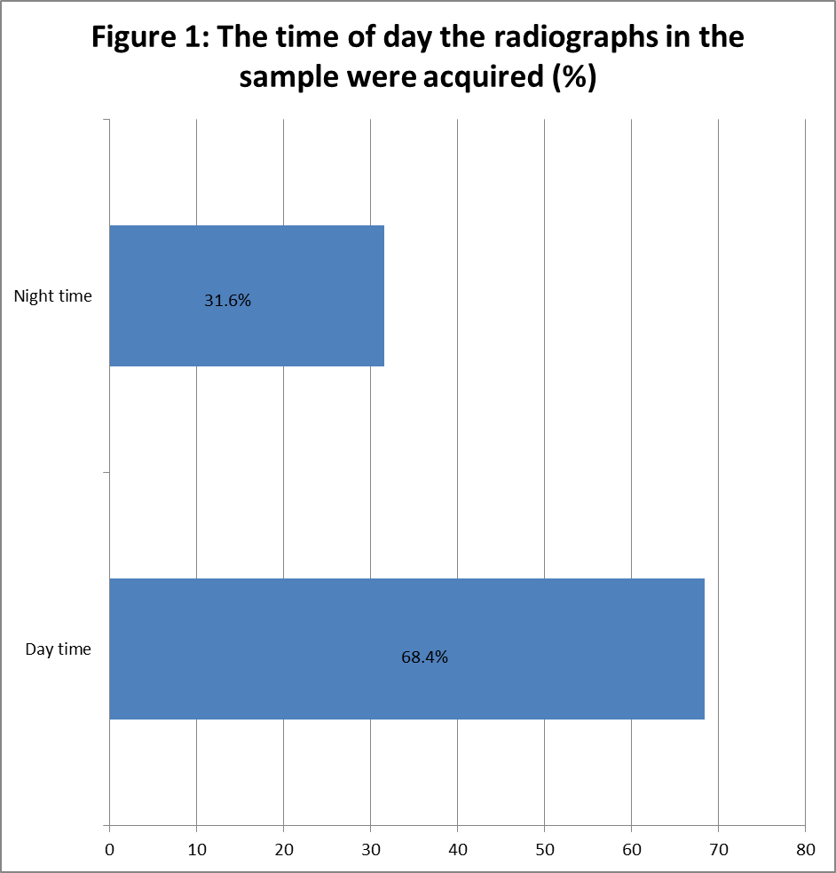
ASM use and type of anatomy examined
Figure 2 shows how ASMs (pre & post exposure) were present on radiographs according to the type of anatomy examined. The presence of pre-exposure ASMs was significantly (p<0.05) more evident in radiographs demonstrating unilateral anatomy (47.4%, n=107/226) e.g. one limb, when compared to radiographs of bilateral anatomy such as the chest, pelvis and abdomen (28.8%, n=61/212) and radiographs demonstrating both sides of unilateral anatomy e.g. the right and left limbs (12.9%, n=8/62). Placement of ASMs was noted to be within guidelines mostly in radiographs showing unilateral anatomy (97.3%, n=220/226), while only 54.7% (n=116/212) of bilateral anatomy radiographs and 24.2% (n=15/62) of radiographs showing both sides of unilateral anatomy had ASMs placed according to the guidelines.
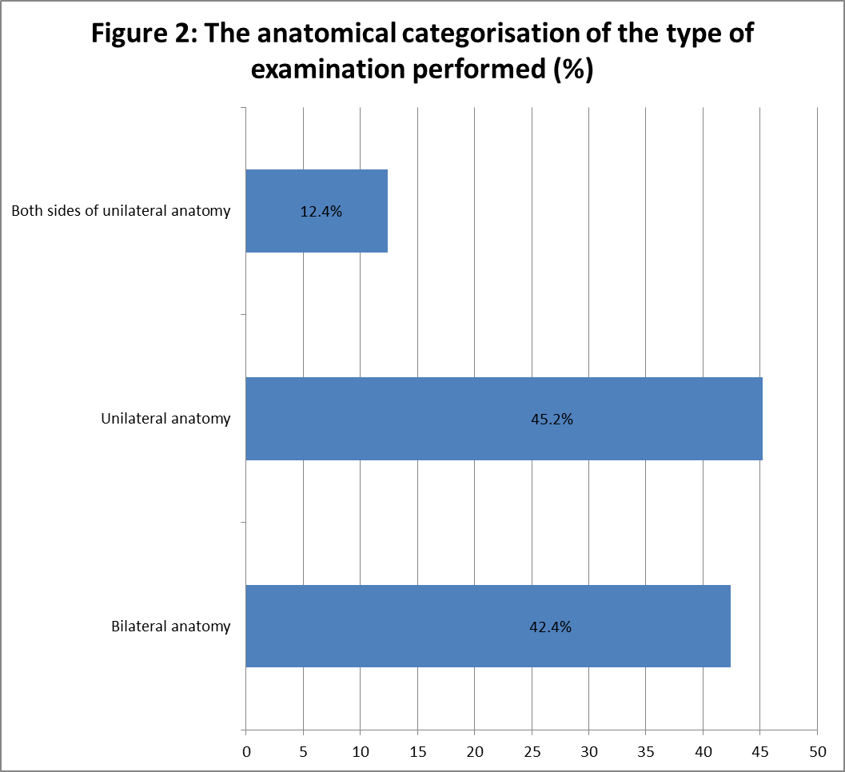

ASM use and type of projection
The use of ASMs (pre & post exposure) depending on the type of projection is demonstrated in Figure 3. Pre-exposure ASMs were placed most frequently in the AP (96.1%, n=173/180), PA (94.8%, n=111/117) and oblique (95%, n=19/20) projections, while lateral (68.1%, n=92/135) and uncommon projections (e.g. AP oblique frog view of the hip, Swimmer’s view of the cervical spine and the patella skyline view) (70.5%, n=31/44) showed significantly (p<0.05) lower use of pre-exposure ASMs on radiographs. The lateral, oblique and special projections showing the presence of an ASM had a significant high (p<0.05) percentage of ASM placed in accordance to guidelines. A significantly high (p<0.05) percentage of radiographs in the posterior/anterior and anterior/posterior projections had an ASM placed not according to the guidelines.
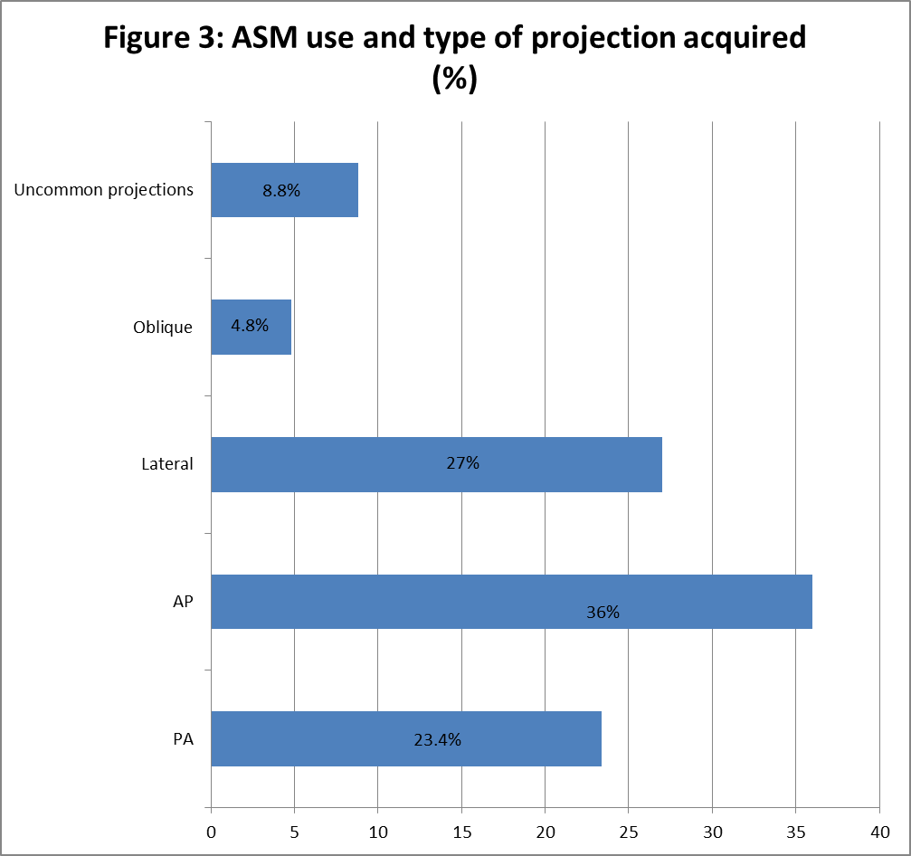

Patient positioning and ASM use
ASM (pre & post exposure) use in accordance with patient positioning is presented in Figure 4. A significantly high percentage (p<0.05) of pre-exposure ASMs were seen in most patient positions. However in the lateral decubitus position, no pre-exposure ASMs were evident on all the radiographs evaluated but post-processing ASMs were used instead and all were positioned according to guidelines. There is a weak insignificant correlation between patient positioning (r = 0.134; p>0.05) and the use of ASMs placed according to guidelines.
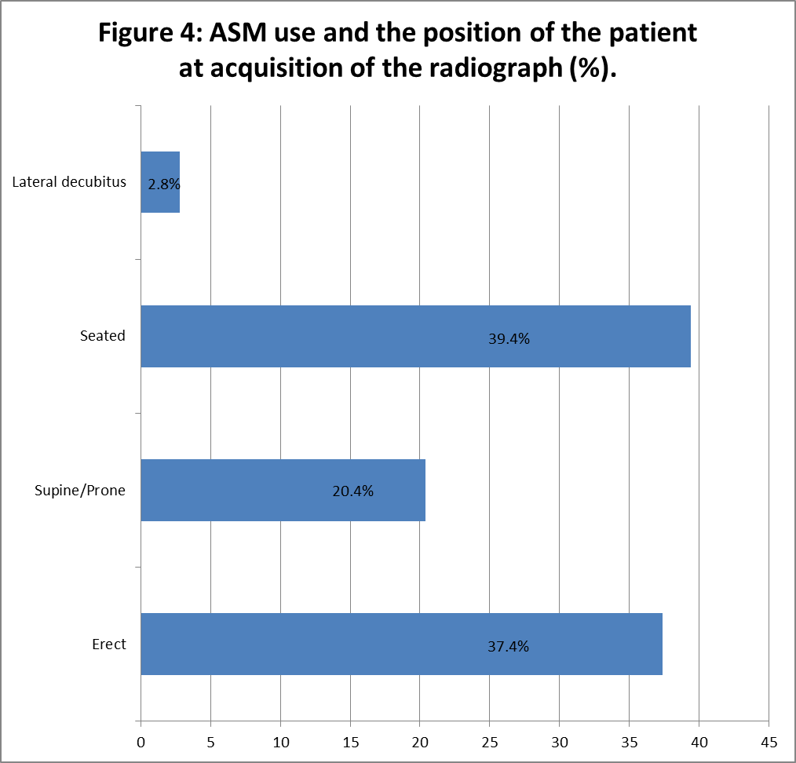

Phase 2:
Questionnaire Section1: Radiographer’s perception of the use of ASM’s in clinical practice.
The majority of radiographers (80.8%, n=21/26) prefer using post-processing ASMs. Reasons were due to lack of time, large work-load, risk of obscuring essential anatomy and due to the influence of other radiographers. Additionally, the majority of respondents (65.4%, n=17/26) stated ‘not having their own personal pre-exposure ASMs in hand’ and all respondents (100%) stated that ‘no pre-exposure ASMs were available in the X-ray rooms’.
Radiographers (19.2%, n=5/26) who prefer using pre-exposure ASMs stated that ‘pre-exposure ASMs made the radiograph more professional and that no excuse is acceptable to allow the addition of post-processing ASMs’. Two respondents (7.8%) also stated that ‘using pre-exposure ASMs made them legally covered’ where legal and liability issues may arise due to potential mismarking.
Most radiographers (57.7%, n=15/26) find difficulties in placing pre-exposure ASMs while only 15.4% (n=4/26) stated that ‘they never find any difficulties in placing pre-exposure ASMs’. A total of 76.9% (n=20/26) of the respondents find placement of pre-exposure ASMs time consuming.
Questionnaire Section 2: Education/training resources
The majority of respondents ‘acquired knowledge about the use of ASMs during their radiography education and training program’ while others obtained such information from other radiographers and during their work experience (Figure 5).
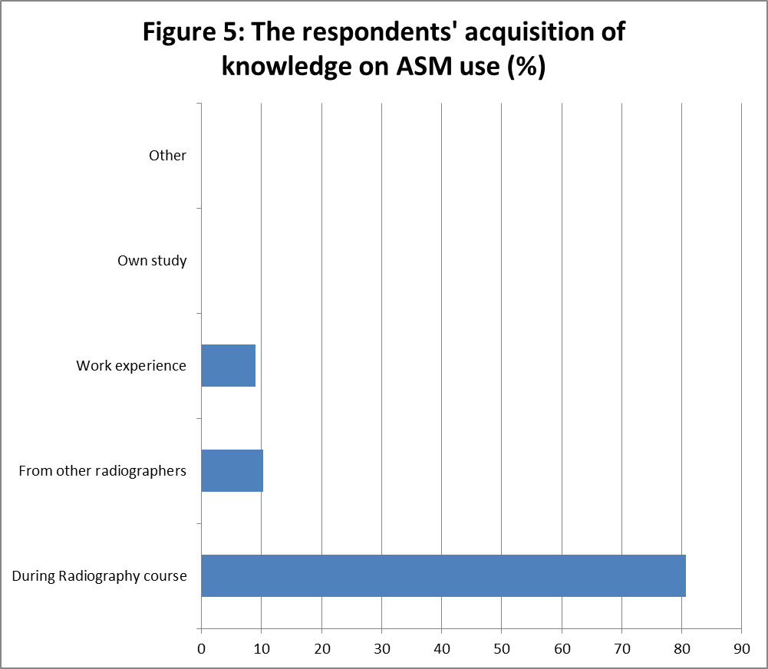

Questionnaire Section 3: Knowledge of stipulated guidelines of ASM use by Ballinger and Frank
Knowledge on ASM use ranged from ‘just sufficient’ to ‘excellent’, and ‘good’ being the most common answer (Figure 6). The majority of respondents (73.1%, n=19/26) agreed that ‘Best Practice’ is when pre-exposure ASMs are used during planar X-ray imaging.

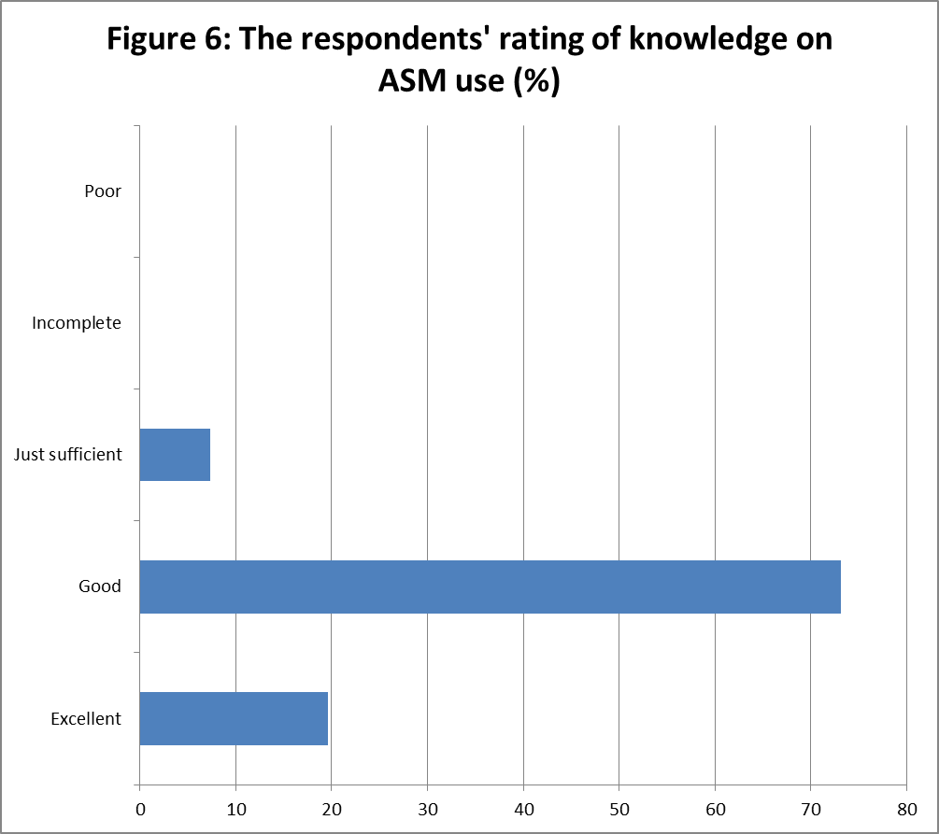
All radiographers (100%) agreed that the placement of pre-exposure ASMs should be within collimation and 65.4% (n=17/26) of the respondents stated that ‘placement of pre-exposure ASM out of collimation is incorrect’. Having the radiograph with the pre-exposure ASM partially cut off due to collimation was considered still correct by 76.9% (n=20/26) of the respondents. Most radiographers (88.5%, n=23/26) agreed that limiting the beam collimation is more important over having pre-exposure ASMs included within the primary beam.
The mean percentage score of replies from the questionnaire which were in line with the stipulated guidelines was calculated to find out the radiographers’ knowledge about these guidelines with the resultant score estimated to be 60.5%.
Discussion
Most radiographers participating in the study agree that use of pre-exposure ASMs is considered as ‘best practice’ and knew how to place such markers. Yet, results from this study show how use of post-exposure ASMs is dominant over the use of pre-exposure ASMs (74.4% vs 25.6%) and that only 56.4% (n=282/500) of the sample showed correct placement of markers. It was not the scope of this study to probe into the reasons why the majority of Maltese radiographers prefer using post-exposure ASMs, however, no excuses are valid to justify this practice. The finding of this study are in line with findings by Platt and Strudwick¹¹, where presence of pre-exposure ASMs in the primary beam was seen in 32% and 23% of radiographs analysed during pre- and post-Computed Radiography (pre/postCR) installation. The remaining 66% and 77% of the radiographs showed presence of post-processing ASMs as in this local study. However, this does not agree with the findings of Titley and Cosson’s study¹⁹, as the distinction between the use of both types of ASMs was narrower, where presence of pre-exposure ASMs (59.8%) was more than post-processed ASMs (40.2%).
The absence of ASM on radiographs is a concern (14%, n=70/500) in this study. When comparing to other studies, the number is less than in Titley’s and Cosson’s study¹⁹ (40.8%) but greater than in Platt and Strudwick’s study¹¹ (1% in pre-CR installment, while none in post-CR installment). Omission of pre-exposure ASMs may be a result of incorrect practices within the workplace¹¹, where colleagues learn from each other. Additionally, radiography students participating in radiography examinations as part of their training, increase the time necessary for each examination due to less experience and more time to engage in each imaging technique. Thus radiographers may feel pressured by time constraints and simple procedural requirements, such as placement of pre-exposure ASMs, may be neglected¹¹. Also, distressed patients and pediatrics, who may be uncooperative, may result in pre-exposure ASMs being moved or become hidden. However, every possible effort should be made to correctly include a pre-exposure ASMs⁸.In the local scenario it is the radiologists’ prerogative as to whether or not to accept radiographs for interpretation without any type of ASM because of legal implications. Most of the time, however such radiographs are still interpreted and a diagnostic report still issued.
Despite the lack of use of pre-exposure ASMs on radiographs in the local study, the collimation of most radiographs having no pre-exposure ASMs was still quite broad, where a pre-exposure ASM could have easily been added without changing the collimation.
Titley and Cosson’s study¹⁹ showed 0.6% of the radiographs having superimposition of pre-exposure ASMs over essential anatomy. In this local study no pre-exposure ASMs were seen to be obscuring essential anatomy. Although it is acknowledged that this might have been due to the limitations of the sample even though this was randomly acquired. Platt and Strudwick’s and Titley and Cosson’s studies^{11,19} showed evidence of incorrect pre-exposure ASM placement which were corrected for by adding post-processing ASMs. However in contrast, no post-processing ASMs were seen to be added on radiographs to compensate for similar mistakes in the local study. However in the local hospital system, one can simply “crop out” the incorrectly placed pre-exposure ASM before archiving the image on PACS thus preventing this error from being demonstrated. Pre-processed images are not available on PACS for evaluation.
The use of pre-exposure ASMs was more evident on radiographs taken during the day to radiographs performed during the night. This contradicts Platt and Strudwick’s¹¹ claim that less evidence of pre-exposure ASMs is seen during the day shift. These authors suggest that this can be due to the pressure of time available for imaging. This also differs from Titley and Cosson’s¹⁹ findings who noticed no difference in use of pre-exposure ASMs in their study with regards to time of acquisition. However the majority of the radiographers in the local study claimed it time consuming to place pre-exposure ASMs which may be the reason for radiographers feeling more time pressured during the night shift.
Platt and Strudwick¹¹ claim that placement of pre-exposure ASMs is influenced by ‘communities of practice’. This local study shows how there may be an influence on the culture and practice of other radiographers as seen when evaluating radiographs according to examination performed, projection executed and patient positions. Different from Titley and Cosson’s study¹⁹ where pre-exposure ASMs use was higher on radiographs of bilateral anatomy, compared to radiographs demonstrating unilateral anatomy, it was evident in the local study that placement of ASMs was mostly noticed in radiographs showing unilateral anatomy and least in radiographs showing bilateral anatomy.
The use of ASMs was least shown in special views, in accordance with Titley and Cosson’s¹⁹ findings, showing that pre-exposure ASMs were more likely to be placed in routine projections rather than in uncommon projections. The reason behind this result is unknown from the study as the right and left side of anatomy do not change when performing uncommon techniques. In Titley and Cosson’s study¹⁹ the use of pre-exposure ASMs was mostly seen when patients were imaged in the supine position. However the opposite was found in this local study as the use of pre-exposure ASMs was seen less in supine or prone positions when compared to other patient positions. The lateral decubitus position had the least incidence of pre-exposure ASM use.
Limitations
Being a retrospective study, the radiographs evaluated were acquired from PACS. However this system only stores radiographs depending on what was archived to the system by the radiographer. Thus there is a possibility that not all radiographs taken for the examinations are present on PACS, leading to lack of data that might have demonstrated the misuse of ASM in radiography. In future it is suggested to conduct the same study prospectively so that the researcher has access to both pre- and post-processed radiographs.
Radiographers undertaking the evaluation test as part of the questionnaire, might have discussed the answers between themselves or looked up the answers from other sources, thus data collected might not reflect the participants’ true level of knowledge. If this was the case, the benefit from this is that radiographers became more aware on the importance of pre-exposure ASM and how to incorporate them during radiography.
This was one study in one hospital on the island of Malta and the findings cannot be generalized to other departments. However it has added to the body of knowledge in this area and it is suggested that further studies are to be undertaken in more than one hospital site to develop this further.
Conclusion
Use of pre-exposure ASMs during planar X-ray imaging is of utmost importance in radiography however this was not demonstrated in this local study as the use of post-processing ASMs predominated. More awareness and education should be undertaken for radiographers on the importance of using pre-exposure ASMs and the presence of guidelines that should be followed in practice. Departmental pre-exposure ASMs and protocols on how to use pre-exposure ASM should be made available to radiographers in every X-ray room and quality assurance in ASM usage should be conducted routinely to provide a basis for in-service training of radiographers on the use of pre-exposure ASMs. An information leaflet developed during the course of this study regarding the use of pre-exposure ASMs was distributed in the local radiology department (Appendix A).
References
- Ballinger P, Frank E, Merrill V. Merrill's atlas of radiographic positions and radiologic procedures. 13th ed. St. Louis, Mo.: Mosby; 2013.
- Long B, Frank E, Ehrlich R. Radiography essentials for limited practice. Oxford: Saunders; 2013.
- Herrmann T, Fauber T, Gill J et al. Best Practices In Digital Radiography. 1st ed. Albuquerque: American Society of Radiologic Technologists; 2012. Available at: http://www.asrt.org/docs/whitepapers/asrt12_bstpracdigradwhp_final.pdf. Accessed November 21, 2014.
- Health and Care Professions Council. Standards Of Proficiency: Radiographers. 1st ed. London: Health and Care Professions Council; 2013. Available at: http://www.hpc-uk.org/assets/documents/10000dbdstandards_of_proficiency_radiographers.pdf. Accessed October 13, 2014.
- Aakre K, Johnson C. Plain-Radiographic Image Labeling: A Process to Improve Clinical Outcomes. Journal of the American College of Radiology. 2006;3(12):949-953. doi:10.1016/j.jacr.2006.07.005.
- Fabian C. Knowing right from left on X-rays: A way to minimize errors of laterality. Applied Radiology. 2005; 34(7):19-24.
- Finnbogason T, Bremmer S, Ringertz H. Side markings of the neonatal chest X-ray: two legal cases of pneumothorax side mix up. Eur Radiol. 2001;12(4):938-941. doi:10.1007/s003300101067.
- The Royal College of Radiologists, The Society and College of Radiographers. Imaging For Non-Accidental Injuries (NAI): Use Of Anatomical Markers. 1st ed. London: SCoR; 2011. Available at: https://www.rcr.ac.uk/imaging-non-accidental-injury-nai-use-anatomical-markers. Accessed October 8, 2014.
- McQuillen-Martensen K. Exercises In Radiographic Critique. Philadelphia: Saunders; 1996.
- Sloane C, Whitley A. Clark's Pocket Handbook For Radiographers. London: Hodder Arnold; 2010.
- Platt J, Strudwick R. The application of anatomical side markers during abdominal and IVU examinations: An investigation of practice prior to and post-installation of computed radiography (CR).Radiography. 2009;15(4):292-299. doi:10.1016/j.radi.2008.11.006.
- Parelli R. Medicolegal Issues For Diagnostic Imaging Professionals. Boca Raton: CRC Press/Taylor & Francis Group; 2009.
- Ball J, Price T, Chesney D. Chesneys' Radiographic Imaging. Oxford: Blackwell Science; 1995.
- Bontrager K, Lampignano J. Textbook Of Radiographic Positioning And Related Anatomy. 8th ed. St. Louis, Mo.: Mosby; 2013.
- Easton S. An Introduction To Radiography. Edinburgh: Churchill Livingstone/Elsevier; 2009.
- The Society of Radiographers. Radiographer suspended after failure to prove competency.Synergy News. 2007.
- Rhomberg P, Fritsche T, Sader H, Jones R. Antimicrobial susceptibility pattern comparisons among intensive care unit and general ward Gram-negative isolates from the Meropenem Yearly Susceptibility Test Information Collection Program (USA). Diagnostic Microbiology and Infectious Disease. 2006;56(1):57-62. doi:10.1016/j.diagmicrobio.2005.12.009.
- Tugwell J, Maddison A. Radiographic Markers - A reservoir for bacteria? .Radiography.2011;17(2):115-120.
doi: 10.1016/j.radi.2010.10.005
- Titley A, Cosson P. Radiographer use of anatomical side markers and the latent conditions affecting their use in practice. Radiography. 2014;20(1):42-47. doi:10.1016/j.radi.2013.10.004.
- Adejoh T, Onwuzu S, Nkubli F, Ikegwuonu N. Radiation Field Preference for Radiographic Anatomical Markers by Radiographers in a University Teaching Hospital in Nigeria. Open Journal of Radiology. 2014;04(03):275-278. doi:10.4236/ojrad.2014.43036.
- Carter C, Vealé B. Digital Radiography And PACS. St. Louis, Mo.: Mosby Elsevier; 2008.
- Fox N, Hunn A, Mathers N. Sampling And Sample Size Calculation. 2nd ed. Sheffield: The NIHR RDS EM / YH; 2009.
- Ramachandran K, Tsokos C. Mathematical Statistics With Applications. Amsterdam: Academic Press; 2009.
- Heavey E. Statistics For Nursing. Sudbury, MA: Jones & Bartlett Learning; 2011.

