NPR Paper Format—Microsoft Word
Proton emission – recent results and future prospects*
R.D. Page¹ , D.T. Joss¹

(1. Department of Physics, Oliver Lodge Laboratory, University of Liverpool, Liverpool L69 7ZE, United Kingdom )

Abstract: Considerable progress has been made in the study of proton-emitting nuclei since the first observation of direct proton emission nearly half a century ago. This has led to improvements in our understanding of this rare decay process and provided invaluable nuclear structure data far from the valley of beta stability. This paper reviews the implications of some recent results for exotic iridium, rhenium and tantalum isotopes and considers prospects for future experimental studies of proton-emitting nuclei located at and above the N=82 neutron shell closure.

Key words: proton emission, alpha decay, reduced proton-decay width.

CLC Number: (optional, please provide it if you know) Document code: A

1 Introduction
Although proton emission is the radioactive decay mode that is expected to determine the limit of observable proton-rich nuclei for most elements, one feature of proton emitters with N ≥ 84 is that most of the proton-emitting states also have a competing α-decay branch [1]. A typical example is ¹⁶⁶Ir, in which proton and α-particle emission have been observed from both the ground state and a low-lying isomeric state [2]. Measurements of the proton-decay energies, half-lives, and branching ratios indicate that the protons are emitted from πd_{3/2} and πh_{11/2} orbitals, respectively. As in other odd-odd nuclei in this region, in both states the odd proton is assumed to be coupled to a neutron in a νf_{7/2} orbital. The unhindered α decays from these states populate corresponding levels in ¹⁶²Re which also undergo both proton and α-particle emission. An analogous situation is observed for odd-A proton emitters in this region with the odd protons in the isomeric states occupying the πh_{11/2} orbital, but in the low-spin ground states the protons occupy the πs_{1/2} orbital.
The competition between proton and α-particle emission has several important consequences. Two obvious repercussions for proton-decay studies are that the number of counts in proton-decay peaks is reduced as a result of the competition and the branching ratio for the α decay has to be taken into account when determining the reduced proton-decay half-life for comparison with theoretical predictions. However, the presence of α-particle emission in this region does increase the sensitivity of decay studies to weak proton-decay branches when using the standard technique of implanting fusion-evaporation residues into a double-sided silicon strip detector and reconstructing the histories of decay chains observed within each detector pixel. This increase in sensitivity occurs both in cases where the daughter nucleus following proton emission undergoes α decay and those in which an α-decaying state populates a level in the daughter nucleus that has a proton-decay branch. Another benefit of the prevalence of α-particle emission in this region is that proton separation energies for many, less exotic nuclei can be deduced from measurements of proton-decay Q values and the Q values of competing α-decay branches, together with the α-decay Q values of members of the α-decay chain populated by the observed proton decay [3].
An important quantity deduced from proton-decay experiments is the reduced proton-decay width. An early analysis of the systematics of reduced proton-decay widths was performed in 1997 by Davids et al. [2], who compared the measured values for proton emitters from Tm to Tl with spectroscopic factors predicted using simple spherical shell model arguments. This original sample comprised data for 15 proton-emitting states and although the uncertainties on many of the measurements were large, the results did appear to follow the expected trend, decreasing with increasing atomic number. However, for proton emission from πd_{3/2} orbitals, the measured values appeared to be systematically lower than predicted. As well as the discovery of more cases of proton emission in this region since that analysis, more precise measurements have been performed in many cases and competing decay branches have been identified and quantified. In some instances the improved data have been the result of dedicated proton-decay spectroscopy experiments, but others have arisen as a by-product of in-beam experiments with relatively long beam times and/or the combination of data sets from separate experiments. This expanded and improved set of measurements, obtained using the GREAT spectrometer [4] at the focal plane of the gas-filled separator RITU [5] at the Jyväskylä University Accelerator Laboratory (JYFL), provides an opportunity for a more detailed analysis of reduced proton-decay widths to be performed.

2 Recent Results
The first proton emitter above the N=82 shell closure to be discovered was ¹⁶⁰Re [6] and this has been a focus of several recent experimental studies [7, 8, 9, 10]. In the original discovery, 24 proton-decay events were isolated, which was sufficient to establish that the protons were emitted from the πd_{3/2} orbital. However, the more recent study of Darby et al. was performed with a sample that was 2 orders of magnitude larger, which resulted in significantly improved half-life and branching ratio measurements [8]. Better statistics were also obtained for the α-decay branch of this state, for which only a few events were previously observed. This α-decay branch populates the corresponding state in ¹⁵⁶Ta, which was known to undergo proton emission [6, 11, 12]. The clean selection of this state through correlations with ¹⁶⁰Re α decays allowed the β-decay branch of this state to be identified indirectly through the α decays of the ground state of the granddaughter nuclide ¹⁵⁶Hf [10]. Comparison of the yields of the two decay branches revealed the proton-decay branching ratio for the πd_{3/2} ground state of ¹⁵⁶Ta to be 71 ± 3 %, which represents an important correction factor when deducing its reduced proton-decay width [8].
Despite the significant increase in the production yield of ¹⁶⁰Re, Darby et al. found no evidence for proton or α-particle emission from its low-lying πh_{11/2} state, which was expected from Q-value systematics to lie at an excitation energy of 185 ± 21 keV [3]. However, they did observe 2 low-energy mutually coincident γ rays emitted in the decay of a 2.8 μs isomer in ¹⁶⁰Re [7]. This was interpreted as a γ-decay path from the πh_{11/2} isomer to the πd_{3/2} ground state. The subsequent in-beam γ-ray spectroscopy study of ¹⁶⁰Re by Sapple et al. identified the strongest γ-ray transitions and these fitted in well with the systematics of πh_{11/2}⊗νh_{9/2} states in the N=85 isotone chain [9]. It was also found that the prompt γ-ray cascade populated the γ-decaying isomer, supporting the interpretation proposed by Darby et al. [7].
One question raised with the ¹⁶⁰Re isomer’s γ-ray cascade was that the combined γ-ray energy was lower than the expected excitation energy of the isomer. In addition, it was difficult to reconcile the deduced γ-ray multipolarities with the expected spin difference between the πh_{11/2} isomer and the πd_{3/2} ground state. One way to establish the πh_{11/2} isomer’s excitation energy would be to search for an α-decay branch from the πh_{11/2} isomer in ¹⁶⁴Ir [10]. Proton emission from this state with a half-life of ~75 μs had previously been observed in two independent studies. The estimated Q value for the α decay of this state suggested that a branching ratio of a few % could be expected [3], which would have been below the sensitivity limits of the previous experiments. Drummond et al. performed a dedicated decay-spectroscopy experiment to study ¹⁶⁴Ir in greater detail. The order of magnitude increase in statistics yielded a more precise half-life of 70 ± 10 μs for the πh_{11/2} isomer [10]. A weak α-decay branch was also identified and from the measured decay energy, an excitation energy of the πh_{11/2} isomer in ¹⁶⁰Re was deduced to be 166 ± 14 keV. This excitation energy is compatible with the value expected from Q-value systematics [3] and confirms that at least one other, unobserved electromagnetic transition must be involved in the decay of the πh_{11/2} isomer in ¹⁶⁰Re to its ground state. The low energy of any such transitions would lead to them having high internal conversion coefficients and possibly also significant lifetimes, depending on their multipolarity. These effects could explain why they were not observed in the study of Darby et al. [7].

3 Discussion
The increased number of known proton-decay branches and measurements with improved precision allows a more detailed analysis of the reduced proton-decay widths to be performed for proton emitters at and above the N=82 neutron shell closure. Figure 1 shows the reduced proton-decay widths for proton emission from πs_{1/2}, πd_{3/2} and πh_{11/2} orbitals as a function of mass number for tantalum, rhenium, iridium and gold proton emitters. The experimental data are compared with values calculated using Wentzel–Kramers–Brillouin (WKB) approximation and the global optical model of Becchetti and Greenlees [15], either with spectroscopic factors expected from the low-seniority shell-model calculation proposed by Davids et al. [2] (dashed lines) or with spectroscopic factors calculated in the BCS theory using the proton pairing strength from [16] and proton single-particle energies from [17] (dotted lines).
The bottom panel in Figure 1 shows the reduced proton-decay width data for πh_{11/2} orbitals. The values for the gold isotopes are slightly lower than predicted from the shell-model arguments, but the agreement is worse for the BCS calculations. The values for ^{164,165}Ir are also lower than the BCS theory predictions, but are compatible with the shell-model values. The remaining values are all consistent both sets of calculated values, although the error bars in some cases are rather large.
The measured reduced proton-decay widths for proton emission from πd_{3/2} orbitals shown in the middle panel of Figure 1 are in clear disagreement with the values expected from the shell-model calculations. This discrepancy had been identified earlier and prompted calculations that take into account particle-vibration coupling, which provided better agreement with the measurements for ¹⁶⁰Re [18] and for ¹⁶⁰Re and ¹⁶⁶Ir [19]. It would be of interest to extend these calculations to ¹⁵⁶Ta and ¹⁷⁰Au to see whether they also provide better agreement for those cases.
The experimental data shown in the top panel of Figure 1 for proton emission from the πs_{1/2} orbital in ¹⁶¹Re and ¹⁶⁷Ir are also lower than would be expected from the shell-model spectroscopic factors. The uncertainties in the measured values for ¹⁵⁷Ta and ¹⁷¹Au are too large to allow conclusions to be drawn about any discrepancy, but the values for all four proton emitters are consistent with the BCS calculations.
One concern with the spectroscopic factors expected from the low-seniority shell-model calculations is that the underlying assumption of degenerate πs_{1/2}, πd_{3/2} and πh_{11/2} orbitals may be an oversimplification [20]. It can be seen that the measured reduced proton-decay widths for the πs_{1/2} and πd_{3/2} orbitals agree well with the spectroscopic factors calculated using the BCS theory. However, concerns have been raised regarding the validity of the Becchetti-Greenlees potential when applied to proton-decay calculations [21], so one should be cautious in drawing any firm conclusions as this apparent agreement may be fortuitous. Given the recent progress in measuring reduced proton-decay widths, it would be useful to compare the improved and expanded data set with calculations using more sophisticated theoretical models than those used in the present paper.

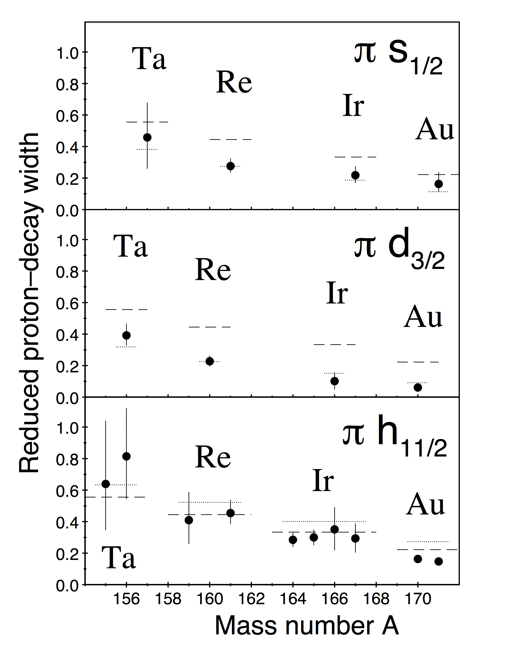
Figure 1 Systematics of reduced proton-decay widths plotted as a function of proton-emitter mass number. The dashed lines denote spectroscopic factors calculated using a low seniority shell-model approach, while the dotted lines indicate values calculated using BCS theory (see text for details). The top, middle and bottom panels are for πs_{1/2}, πd_{3/2} and πh_{11/2} orbitals, respectively.

4 Future Prospects
Although recently published experimental data have resulted in more precise reduced proton-decay widths in several cases, there is still scope for improvements in others. For example, a higher-precision measurement of the reduced proton-decay width of the ground state of ¹⁵⁷Ta appears to be entirely feasible using a recoil mass separator and determining the relative yields of its proton- and α-decay branches. Such a measurement would establish whether, like ¹⁶¹Re and ¹⁶⁷Ir, its reduced proton-decay width is compatible with the BCS prediction shown in Figure 1. The decay widths for proton emission from πh_{11/2} orbitals in ^{155,156}Ta and ¹⁵⁹Re are also comparatively large. A recent experiment at Jyväskylä has produced an order of magnitude increase in yield for ¹⁵⁵Ta and ¹⁵⁹Re compared with the previous studies [23, 24] and the data are under analysis at the time of writing. This new measurement for ¹⁵⁵Ta₈₂ is potentially of significance as a benchmark for proton-decay calculations, because it is the only known proton emitter with a closed neutron shell and is therefore expected to be spherical.
Obtaining an improved measurement for the πh_{11/2} isomer in ¹⁵⁶Ta is more problematic, since there is no significant α-decay branch from the corresponding state in ¹⁶⁰Re with which to correlate the ¹⁵⁶Ta decays [8]. Furthermore, the main uncertainty comes from the proton-decay branching ratio measurement and the competing decay mode is β-particle emission and not α decay. An alternative approach could be to produce the ¹⁵⁶Ta nuclei in projectile fragmentation reactions and implant them into a stack of silicon strip detectors. The ¹⁵⁶Ta nuclei could then be identified uniquely in terms of their mass number and atomic number from time of flight and energy loss measurements in the standard way [25]. The fraction of the ¹⁵⁶Ta nuclei that are in the πd_{3/2} ground state can be determined from yield of its characteristic proton decays [8], allowing the number of ¹⁵⁶Ta nuclei in the πh_{11/2} isomeric state to be deduced. Using this knowledge together with the yield of its proton decays, a more precise branching ratio and hence reduced proton-decay width could be determined.
There are further new cases of proton radioactivity that potentially remain to be discovered in this region [3]. Most are expected to be very short lived, so fast digital readout electronics could be essential. In several cases, the daughter nuclides are not expected to undergo α decay, so identification using the standard approach with a recoil separator following fusion-evaporation reactions will be difficult. These cases might also be better studied through fragmentation reactions. Even though the higher energies of implanted ions make measuring the proton-decay signals within microseconds challenging, this is now technically feasible [26].
For even shorter-lived proton-emitting states, in-flight proton-decay measurements are an interesting possibility for the future. Such measurements have already been performed, e.g., for two-proton emission from ¹⁹Mg [27] and proton emission from ⁶⁹Br [28], and there is no reason why similar experiments could not be successful for nuclei in this heavier mass region too. In contrast, the recent study of the α-particle and γ-ray decays of a high-spin multi-particle isomer in ¹⁵⁸Ta that has enhanced stability against proton emission raises the possibility of isomeric states with comparatively long half-lives existing beyond the expected boundaries of the nuclear landscape [29]. On this basis, it appears as if there are good prospects for further progress in experimental studies and discoveries of proton-emitting nuclei in this region.
References:
[1] Blank B, Borge M J G, Prog Part Nucl Phys 2008, 60:403.
[2] Davids C N, Woods P J, Batchelder J C, et al. Phys Rev C 1997, 55:2255.
[3] Page R D, Phys Rev C 2011, 83:014305
[4] Page R D, Andreyev A N, Appelbe D E, et al. Nucl Instrum Methods Phys Res B 2003, 204:634.
[5] Leino M, Nucl Instrum Methods Phys Res B 1997, 126:320.
[6] Page R D, Woods P J, Cunningham R A, et al. Phys Rev Lett 1992, 68:1992.
[7] Darby I G, Page R D, Joss D T, et al. Phys Lett B 2011, 695:78.
[8] Darby I G, Page R D, Joss D T, et al. Phys Rev C 2011, 83:064320.
[9] Sapple P J, Page R D, Joss D T, et al. Phys Rev C 2011, 84:054303.
[10] Drummond M C, O’Donnell D, Page R D, et al. Phys Rev C 2014, 89:064309.
[11] Livingston K, Woods P J, Davinson T, et al. Phys Rev C 1993, 48:2151
[12] Page R D, Woods P J, Cunningham R A, et al. Phys Rev C 1996, 53:660.
[13] Kettunen H, Greenlees P T, Helariutta K, et al. Acta Phys Polonica 2001, 32:989.
[14] Mahmud H, Davids C N, Woods P J, et al. Eur Phys Journal A 2001, 15:85.
[15] Becchetti F D, Greenlees G W, Phys Rev 1969, 182:1190.
[16] Dudek J, Majhofer A, Skalski J, J Phys G 1980, 6:447.
[17] Brown B A, Stone N J, Stone J R, et al. Phys Rev C 2005, 71:044317.
[18] Hagino K, Phys Rev C 2001, 64:041304.
[19] Davids C N, Esbensen H, Phys Rev C 2001, 64:034317.
[20] Åberg S, Semmes P B, Nazarewicz W, Phys Rev C 1997, 56 :1762.
[21] Ferreira L S, Maglione E, Fernandes D E P, Phys Rev C 2002, 65:024323.
[22] Irvine R J, Davids C N, Woods P J, et al. Phys Rev C 1997, 55:1621.
[23] Joss D T, Darby I G, Page R D, et al. Phys Lett B 2006, 641:34.
[24] Page R D, Bianco L, Darby I G, et al. Phys Rev C 2007, 75:061302.
[25] Lorusso G, Nishimura S, Xu Z Y, et al. Phys Rev Lett 2015, 114:192501.
[26] Braga D, Coleman-Smith P J, Davinson T, et al. IEEE Nucl Sci Symp Conf Rec 2009, 1-5:1924.
[27] Mukha I, Sümmerer K, Acosta L, et al. Phys Rev Lett 2007, 99:182501.
[28] Rogers A M, Famiano M A, Lynch W G, et al. Phys Rev Lett 2011, 106:252503.
[29] Carroll R, Page R D, Joss D T, et al. Phys Rev Lett 2014, 112:092501.

* * Received date:： yyyy-mm-dd; Revised date：yyyy-mm-dd Foundation item:：This work has been supported by the United Kingdom Science and Technology Facilities Council. Biography: Name(Year of Birth―), male/female(Nationality), Place of birth, Degree/Title, Research field; E-mail address. Corresponding author: Name, E-mail address. The item can be neglected if the corresponding author is the first author of the paper.

