Global risk model for vector-borne transmission of Zika virus reveals the role of El Niño 2015
Caminade C^{a,b}, J. Turnerª, S. Metelmann^{b,c}, J.C. Hesson^{a,d}, M. Blagrove^{a,b}, T. Solomon^{b,e}, A.P. Morse^{b,c}, M. Baylis^{a,b}

ªDepartment of Epidemiology and Population Health, Institute of Infection and Global Health, University of Liverpool, Liverpool, UK;
^{b}Health Protection Research Unit in Emerging and Zoonotic Infections, University of Liverpool, Liverpool, UK;
^{c}Department of Geography and Planning, School of Environmental Sciences, University of Liverpool, UK;
^{d}Department of Medical Biochemistry and Microbiology, Zoonosis Science Center, Uppsala University, Sweden;
^{e}Department of Clinical Infection, Microbiology and Immunology, Institute of Infection and Global Health, University of Liverpool, UK

Corresponding author details
Cyril Caminade
Institute of Infection and Global Health,
The Farr Institute@HeRC,
Water house building, block F2, University of Liverpool,
Liverpool L69 3BL,
United Kingdom
Tel: + 44 151 794 8322
Emails: Cyril.Caminade@liverpool.ac.uk cyril.caminade00@gmail.com

Classification
- Biological Sciences/Environmental Sciences
- Social Sciences/Sustainability Science

Abstract

Zika, a mosquito-borne viral disease that emerged in South America in 2015, has been declared a Public Health Emergency of International Concern by the World Health Organisation in February 2016. We developed a climate-driven R₀ mathematical model for the transmission risk of Zika virus (ZIKV) that explicitly includes two key mosquito vector species Aedes aegypti and Aedes albopictus. The model was parameterized and calibrated using the most up to date information from the available literature. It was then driven by observed gridded temperature and rainfall datasets for the period 1950-2015. We find that the transmission risk in South America in 2015 was the highest since 1950. This maximum is related to favouring temperature conditions which caused the simulated biting rates to be largest, mosquito mortality rates and extrinsic incubation periods to be smallest in 2015. This followed the suspected introduction of ZIKV in Brazil in 2013. The ZIKV outbreak in Latin America has very likely been fuelled by the 2015-2016 El Niño climate phenomenon affecting the region. The highest transmission risk globally is in South America and tropical countries where Ae. aegypti is abundant. Transmission risk is strongly seasonal in temperate regions where Ae. albopictus is present, with significant risk of ZIKV transmission in the south-eastern states of the USA, southern China and to a lesser extent over southern Europe during the boreal summer season.
Keywords
Zika virus, R₀ model, El Niño, Latin America, Ae. albopictus, Ae. aegypti

Significance statement

This study is the first study quantifying the impact of climate variability on Zika virus transmission by two mosquito vectors with distinct characteristics: Ae. aegypti and Ae. albopictus. Observed climate data was used to dynamically drive two vectors - one host R₀ epidemiological model. Our modelling results indicate that temperature conditions, related to the 2015 El Niño climate phenomenon, were exceptionally conducive for mosquito-borne transmission of ZIKV over South America. The virus is believed to have entered the continent earlier in 2013. This implicates that such a large ZIKV outbreak occurred not solely because of the introduction of ZIKV in a naive population but because the climatic conditions were optimal for mosquito-borne transmission of ZIKV over South America in 2015.

\body

Introduction

Zika virus (ZIKV) is an emerging mosquito-borne virus that infects and causes disease in humans. Approximately eighty percent of infections are asymptomatic; the twenty percent of clinically-affected people mostly experience mild symptoms such as fever, arthralgia and rash [1]. A small proportion is believed, however, to develop a paralytic auto-immune disease called Guillain-Barré syndrome [2, 3]. There is also evidence that the infection of women during a critical part of pregnancy can lead to the development of microcephaly in the unborn child [4, 5]. The recent discovery of ZIKV in South America, and a surge in the number of reports of Guillain-Barré syndrome and microcephaly cases in the region led the World Health Organisation to announce a Public Health Eme rgency of International Concern on 1st February 2016.
ZIKV was first isolated in Uganda from monkeys in 1947 and Aedes africanus mosquitoes in 1948 [6]. Several other mosquito species (mostly of the genus Aedes) have been implicated as ZIKV vectors. Globally, the most important is the Yellow Fever mosquito, Ae. aegypti [7], which is widespread in tropical regions of the world. A second vector is the Asian tiger mosquito, Ae. albopictus [8], one of the world’s most invasive mosquito species. It occurs in both tropical and temperate regions, often together with Ae. aegypti, but also extending further north into temperate countries. Other Aedes species may be locally important, such as Ae. hensilli which is considered to have been the primary vector in the Zika outbreak in French Polynesia in 2007 [1, 9].
The risk of spread of an infectious disease can be described by its basic reproduction ratio (R₀), defined as the average number of secondary infections arising from a typical primary infection in an otherwise fully-susceptible population. R₀ has an important threshold value: a value above 1 indicates that the pathogen could spread if it were introduced, resulting in a minor or major outbreak depending on the size of R₀; while a value below 1 indicates that pathogen transmission would be insufficient to produce a major outbreak. Mathematical formulations of R₀ exist for several vector-borne diseases (VBD) including those with one host and one vector (such as malaria [10]) or two hosts and one vector (such as zoonotic sleeping sickness [11] and African horse sickness [12]). Relatively little attention has been paid to developing mathematical formulations of R₀ where there are two vector species and either one or multiple host species [13]. Consideration of two vector species in the R₀ formulation is essential where two vectors have different epidemiological parameters. It also allows for the estimation of R₀ where the two species co-occur and primary infections in one species can lead to secondary infections in the second.
Ae. aegypti and Ae. albopictus appear to have different susceptibilities to ZIKV [7, 14-16], feeding rates and feeding preferences [17, 18]. Ae. aegypti feeds more often, and almost exclusively, on humans and is, therefore, an extremely efficient transmitter of human viruses. Ae. albopictus feeds less frequently and on a broader range of hosts and is therefore less likely to both acquire and transmit a human virus. Given equal mosquito and human densities, regions with Ae. aegypti are therefore theoretically expected to have a higher R₀ for ZIKV than regions with Ae. albopictus; but, as Ae. albopictus extends beyond the range of Ae. aegypti into more temperate regions, it is essential that both are included in global models of ZIKV transmission risk.
The risk of transmission of a mosquito-borne virus, and hence its R₀, is also highly sensitive to climate [19]. Temperature and rainfall influence the abundance and seasonality of mosquitoes. Further, temperature has a major effect on the capacity of a population of mosquitoes to transmit virus. This is influenced by the mean number of blood meals in a typical mosquito’s remaining lifespan after the point at which it becomes infectious [20]; which is determined by the combined effects of the feeding frequency (estimated by biting rates) and longevity of the mosquitoes (estimated from mortality rates), and the time required for development of virus inside a mosquito (the extrinsic incubation period or EIP). All three of these variables are highly sensitive to environmental temperature conditions.
Here we develop the first global R₀ model for ZIKV that explicitly includes two vector species and one host; and which considers the influence of climate dynamically. First, we extend a recently-developed two vector mathematical framework for an animal VBD [13] to ZIKV. Second, we parameterise the model using recently published estimates of the global distribution of Ae. aegypti and Ae. albopictus, as well as the temperature-sensitive virus transmission variables described above. Lastly, we drive the model using global, observation-based historical climate data to derive global, seasonal estimates of the R₀ of ZIKV that describe transmission risk by one, the other and both vectors where they co-occur.
Our model considers risk of transmission by vectors only. There is strong evidence that ZIKV can also be transmitted sexually [21]. Although the number of confirmed cases to date is very small, relative to the number of cases believed to have been caused by mosquito bites, it does allow the spread of ZIKV in regions where mosquito vectors are absent. If the risk of sexual transmission remains small, however, our model indicates where and when the greatest risks of vector transmission occur; where vector control measures may be most usefully implemented; and when and where health professionals should communicate potential ZIKV threat to infected travellers returning from ZIKV endemic countries.

Results
Our R₀ model output (Fig 1A and 1B) captures well the observed, largely tropical distribution of ZIKV transmission (Fig 1C). Since the 1950s, ZIKV transmission or seropositivity has been reported in several African countries, Pakistan, India, south eastern Asia, parts of Oceania [22] and it recently spread in 2015 and 2016 to Latin American countries, Florida, Thailand and the Philippines (Fig 1C) where, importantly, large R₀ values are simulated. It has been speculated that the epidemiologically naïve population of people in South America may account for the size of the outbreak there. While this is very likely true, our model also finds the average R₀ of ZIKV to be greater in South America than any other region of the world. Other areas with high values of R₀ are some African countries (Côte d’Ivoire, Central African Republic, Nigeria, Kenya, Tanzania, Uganda) and Asian countries (India, Vietnam, the Philippines, Singapore, parts of Malaysia and Indonesia, Thailand), where ZIKV circulation was also previously reported [7, 8, 22-29]. The model finds south and south-east Asia to be suitable for ZIKV transmission. ZIKV was first identified in Asia nearly fifty years ago [28], but there have not been significant outbreaks recorded. The model appears to under-predict for Egypt as it does not find Egypt to be suitable for ZIKV transmission although seropositive people have been reported there. Nevertheless, the prevalence in Egypt is believed to be very low [30].
The R₀ model output is further validated against other published estimates of R₀ for Rio de Janeiro, Brazil and for Colombia as a whole (Fig 2). The minimum, 25th, 50th, 75th percentiles and maximum R₀ values simulated for Rio de Janeiro (0, 3.4, 3.9, 4.3 and 5 respectively) are very similar to estimates by [31] (0, 3.2, 3.8, 4 and 4.6 respectively). The simulated R₀ values for Colombia range between 0 and 6.9, with a median value of 4.1. These values are also in good agreement with preliminary R₀ estimates for ZIKV in Colombia (3, 3.9 and 6.6) [32]. The climate data are unfortunately too spatially coarse to obtain R₀ estimates for small islands in Oceania, where Zika outbreaks were also reported in the last decade. Furthermore, if one assumes that ZIKV transmission might occur where dengue virus transmission was reported, due to the similarity of both viruses and their mosquito vectors, the ZIKV Ro model captures about 96% of dengue occurrence points as reported by [33] (Fig S1 and table S1).
Next we investigated the effect of seasonal change in climate on the risk of ZIKV transmission. Our R₀ model shows that boreal summer temperature conditions lead to increased R₀ values over temperate regions where both vectors (or only Ae. albopictus) are present (Fig S2). Thus, the model outputs suggest that the environmental conditions might be suitable for ZIKV transmission to occur over a wider geographical range than has currently been observed (Fig 1A), particularly when considering the seasonal peak in R₀ (Fig 1B). Over the South American continent, R₀ values are large all year round, and peak during the boreal winter and spring (Fig S3). In Africa, the largest R₀ values are simulated over southern Africa during boreal winter and over the Sahelian region during boreal summer and fall (Fig S4), which correspond to the peak of the rainy season over these regions. Over Asia, R₀ values are relatively large all year round in Oceania, while a clear peak in R₀ is shown during boreal summer and fall over India, Vietnam, Laos and Cambodia (Fig S5). During boreal summer, a large increase in R₀ is simulated over the south-eastern states of the USA (Fig S6), and smaller increases are simulated over southern Europe (Fig S7) and southern China (Fig S5). The large R₀ summer values over the south-eastern states of the USA are due to both very conducive temperature conditions and to the spatial overlap of Ae. albopictus and Ae. aegypti (Fig S8). Therefore, our model indicates that there is a large potential risk of ZIKV transmission in south-eastern USA, and to a lesser extent over southern China and southern Europe in boreal summer. This signal mainly relates to the presence of the highly invasive Ae. albopictus in temperate regions (Fig S8), and to higher biting rates (Fig S9), lower EIPs (Fig S10) and lower mortality rates (Fig S11) during the warm season.
The modelling framework also allows investigation of the respective contributions of Ae. aegypti and Ae. albopictus in the total R₀ burden (Fig S12). Given the selected parameter settings, which are based on the published literature, Ae. aegypti is responsible for >90% of ZIKV transmission risk in the tropics while Ae. albopictus appears to make a smaller contribution (less than 10%). Ae. albopictus is, however, the main vector responsible for ZIKV transmission risk in temperate areas such as northern USA and southern Europe (Fig S12).
VBDs are not just affected by seasonal variations in climate; extreme climatic anomalies can also favour epidemics. One of the strongest El Niño events ever recorded occurred in 2015-2016, and there have been concerns about its possible impact on vector borne disease burden [34] and agricultural production worldwide. El Niño events are characterized by the movement of warmer than average sea surface temperatures across the central Pacific basin, and are associated with warmer temperature conditions over the Tropics and rainfall anomalies that vary greatly by region and season. To investigate the impact of El Niño on potential ZIKV transmission risk at global scale, we derived the R₀ relative anomaly for 2015 (Fig 3A). Large positive anomalies in R₀ are simulated over the Tropics, meaning that climate conditions were particularly conducive for ZIKV transmission in 2015 relative to the long-term average. This can be seen over South America (especially Colombia and Brazil) but also in Africa (with the largest anomaly shown over Angola), southern India, south East Asia and Oceania. While intense ZIKV transmission was only reported over Central and South America in 2015, the virus is believed to have entered the region in 2013 [35]. Standardized model anomalies calculated for the South American continent further reveal that 2015 was the year with the highest R₀ value (exceeding two standard deviations) over the whole sixty-seven year time period (Fig 3B). This R₀ maximum is mainly related to simulated maximum biting rates, minimum extrinsic incubation periods and mortality rates in 2015 (Fig S13 and S14). A large positive anomaly is also shown for the 1997-1998 El Niño, before ZIKV was introduced to the South American continent. Therefore, our model indicates that the 2015 El Niño event, superimposed on the long term global warming trend, has played an important amplification effect through its impacts on mosquito vector and their overall ability to transmit virus.

Discussion
The model provided interesting insights into the spatiotemporal distribution of potential disease transmission risk; permitted the relative contributions of the two main disease vectors to be quantified; and implicates the current El Niño in playing an important amplification role. Importantly, we demonstrate that warm temperature conditions associated with the current El Niño climate phenomenon, superimposed on the warming trend, were exceptionally conducive for mosquito borne transmission of ZIKV in 2015 over the South American continent. The conducive temperature conditions in 2015 over South America can be related to the superposition of climate change, decadal and year to year variability [36]. Similarly, R₀ modelling work for the risk of bluetongue, an animal VBD that emerged in northern Europe in 2006, highlighted that temperature conditions in northern Europe in that particular year were also exceptionally conducive for disease transmission [37]. Other notable impacts of El Niño 2015-2016 are historical droughts impacting food security in Ethiopia and southern Africa, and forest fires in California, Canada, Malaysia and Indonesia. The number of dengue cases in India in 2015 was the largest recorded [38]. Interestingly, our model finds one of the largest 2015 R₀ anomalies for ZIKV in Africa to be centred on Angola. Although ZIKV has not been recently reported, Angola is currently experiencing a large outbreak of Yellow Fever, transmitted by Ae. aegypti, and we speculate, therefore, that this outbreak might also have been favoured by El Niño conditions. This raises further concerns about the impact of large El Niño events on vector-borne disease risk in a future warmer, more connected world with increasing levels of drug and insecticide resistance. Flaviviruses in general should have a promising future [39].
Our results corroborate that Ae. aegypti, likely due to its anthropophilic behaviour and its aggressiveness is a larger threat than Ae. albopictus for ZIKV transmission worldwide. However, the threat posed by Ae. albopictus is not negligible, especially during the warm season in temperate regions; and the overlap of both vector species produces the largest R₀ values. Similarly, in Europe in recent years Ae. albopictus was responsible for a small number of autochthonous cases of chikungunya and dengue in Italy, southern France and Croatia while Ae. aegypti was responsible for more than two thousand cases of dengue on the island of Madeira in 2012 [40, 41]. Consequently, there is a need to focus disease preparedness measures or vector control interventions primarily in regions infested by Ae. aegypti or where both vectors co-occur.
The simulated spatial distribution of ZIKV is similar to other published estimates which utilized environmental covariates and boosted regression tree method to estimate environmental suitability for ZIKV at global scale [42], or employed a one host –one vector R₀ modelling approach to derive attack rates for Latin America [43]. Our model framework further allowed exploring spatial and temporal changes in potential disease risk. We showed the potential of ZIKV transmission during boreal summer over the south-eastern states of the USA as previously considered by others [44]. Autochthonous transmission of ZIKV was observed in Florida in summer 2016. Only a few cases were reported so far, however, as there is large proportion (80%) of asymptomatic infections with ZIKV, more people might be infected without showing any clinical signs.
There are several caveats in our modelling framework that need to be mentioned. Firstly, we did not consider sexual transmission of ZIKV, as it likely plays a very minor role in the overall amount of transmission. Secondly, we only considered the risk posed by Ae. aegypti and Ae. albopictus, believed to be the main competent vectors of ZIKV (and certain other arboviruses, such as dengue and chikungunya viruses). However, other Aedes species can transmit ZIKV locally (such as Ae. hensilli in Pacific islands; and Ae. africanus in parts of Africa). There is also a debate about the capacity of the geographically widespread Culex quinquefasciatus vector to transmit ZIKV [45-47]. However, most recent studies are showing poor or no competence of this species to transmit ZIKV. Our model might, therefore, underestimate R₀ in some localities where vectors other than Ae. aegypti or Ae. albopictus are present. Our mathematical framework can be readily extended to include additional vectors, but limitations arise from the lack of detailed distribution and epidemiological data for these species. There is an urgent need for further studies on vectors of ZIKV and their distribution, abundance and transmission parameters. Thirdly, estimates of vector to host ratios for Ae. aegypti and Ae. albopictus were approximated from probability of occurrences as they were limited by the large spatial and temporal differences in published field studies. Further estimates of mosquito densities in different demographic and geographic settings, preferably with standardised methods [48], will be highly useful to improve and upscale mechanistic spatiotemporal risk models. ZIKV extrinsic incubation periods were approximated by dengue virus estimates in our study, as they were similar in high temperature settings [7]. Better estimates of the dependency of the EIP of ZIKV to temperature, especially in the lower and higher temperature tail of the distribution, will be highly valuable for further model refinement.
Our R₀ model presents the risk of transmission given the introduction of virus in a fully susceptibility population. It does not address the potential of the pathogen and the vectors to spread via tourism and trade; nor the risk of transmission in populations that have already been exposed to ZIKV. Recent modelling work suggest that the ZIKV epidemic in Latin America should be over in 3 years maximum and that acquired herd immunity will likely cause a delay of more than a decade until large epidemics re-emerge [49]. India, China, Indonesia, the Philippines and Thailand have been estimated at risk of mosquito-borne ZIKV infection due to the large volume of travellers arriving from affected areas in Latin America [50]. Furthermore, socio-economic factors (such as health service per capita, urbanisation, vulnerability indices) should be included in assessments of the full impact of Zika in future studies. Our model uses recently published studies by the medical, biological and entomological communities; it benefits from statistical [51] and mathematical [13] modelling techniques; and from recent environmental datasets produced by the National Oceanic and Atmospheric Administration [52, 53]. This underlines the importance of taking multidisciplinary approaches to address and anticipate the health and food security challenges to come.

Materials and Methods
R₀ Model design
To calculate R₀ for ZIKV transmission, we adapted the two hosts – two vectors expression derived in [13]. This expression is suitable for pathogens including bluetongue virus, which have two main hosts and two main vectors with different feeding preferences. In the case of ZIKV, there is one main host (i.e. humans) capable of transmitting the virus. So, we prevented the second ‘host’ from contracting and transmitting the infection. However, as Ae. aegypti and Ae. albopictus feed to different extents on humans, we retained the measures of feeding preference. In addition, as infection with ZIKV is not associated with mortality, the standard pathogen-induced mortality rate (d) was set to zero. The resulting expression is:
$$R_{0}=\sqrt{\tilde{R_{11}}+\tilde{R_{22}}} (1)$$
where
$$\tilde{R_{11}}= \left(\frac{b_{1}β_{1}a_{1}^{2}}{μ_{1}}\right)\left(\frac{ν_{1}}{ν_{1}+μ_{1}}\right)\left(\frac{ϕ_{1}^{2}m_{1}}{r}\right)$$
$$\tilde{R_{22}}= \left(\frac{b_{2}β_{2}a_{2}^{2}}{μ_{2}}\right)\left(\frac{ν_{2}}{ν_{2}+μ_{2}}\right)\left(\frac{ϕ_{2}^{2}m_{2}}{r}\right)$$
R_{ij} is the average number of infectious vectors of type i produced by an infectious vector of type j; 1 stands for Ae. aegypti and 2 for Ae. albopictus. As a result of the second ‘host’ being non-infectious, the between-species terms R₁₂ and R₂₁ are eliminated from R₀ (further details are given in Supplementary Information). In fact, this expression for R₀ is true for any number of ‘hosts’, providing that only one of them is a true host (i.e. capable of transmitting the infection). Biting rates (“a”), mortality rates (“μ”) and extrinsic incubation periods (“eip=1/ν”) for both vector species are the only parameters dynamically relying on temperature data. These dependencies to temperature were calculated based on published evidence from the literature (see table 1 and Fig S15). Vector preferences (“ɸ”), transmission probabilities (from vector to host “b” and host to vector “β”) and ZIKV recovery rate (r) were assumed to be constant and they were derived from recently published estimates for ZIKV, or dengue virus, if they were not available (table 1).
Vector to host ratios (m₁ and m₂) were derived from published probability of occurrence (prob₁ and prob₂) at global scale [51]. Given the large differences in mosquito density estimates published in the literature for different regions and seasons [48], these probabilities of occurrences [0-1] have been arbitrary linearly re-scaled to range between 0 and a maximum estimate of vector to host ratio following [37]. This maximum was estimated as an order of magnitude (Fig S16) using maximum ZIKV R₀ value to calibrate it. A maximum R₀ value of 6.6 was reported by [32] for Colombia during the outbreak. This maximum R₀ value is reached when the vector to host ratio value reaches about one thousand in the model, between 30 and 37°C (Fig S16C). This constraint is on the maximum solely; however the model reproduces well the distribution of R₀ values with respect to other published estimates (Fig 2). Lower values for m are generally reported by entomologists (10 is a commonly reported value [48]). However, this depends on the selected field method to estimate m. Values of 52 Aedes mosquitoes/person/hour have been reported in Macao using human baits; 1.8 mosquitoes/hour using CDC traps and 110 mosquitoes/hour using aspirators [54]. As both Aedes species are active from dawn to dusk e.g. over 12 hours maximum (with a peak of activity in the early morning and late afternoon) this is equivalent to 624, 21.6 and 1320 mosquitoes/day, thus including the selected maximum if we assume that a trap is a potential host. Biting rate estimates for Ae. aegypti of about 150 bites per person per day were reported for Thailand over a 7 months period [55]. In Macao, biting rates were reported to range between 94 and 314 bites per person per day [54]. Our estimates of (m x a) range between 100 to 250 bites per person per day for Ae. aegypti and between 25 and 125 for Ae. albopictus if we assume m=1000 (Fig S17)
The percentages of R₀ attributed to Ae. aegypti (R₁₁/R₀²) and Ae. albopictus (R₂₂/R₀²) were derived from equation (1) which can be rewritten such as: 1=100%=R₁₁/R₀²+R₂₂/R₀². An explicit mathematical derivation of the R₀ model is provided in the SI appendix; parameter setting details and the publication references employed to estimate them are shown and discussed in table 1.
R₀ Model integration and driving datasets
The Zika R₀ model is dynamic, meaning that some epidemiological parameters are both varying in space and time from 1948 to 2015. The model runs on a monthly time step. To incorporate rainfall seasonality effects we employed a criterion, derived for malaria in Africa within the Mapping Malaria Risk in Africa (MARA) project framework, e.g. “80 mm per month for at least five months for stable transmission” [56]. If the criterion was not met we assumed R₀=0 for a particular location and month. All spatially-varying parameters were interpolated to the temperature data grid.
For temperature, we utilized gridded data which combines station data from the Global Historical Climatology Network version 2 with the Climate Anomaly Monitoring System [52]. This monthly temperature dataset is available at 0.5° x 0.5° degree square resolution at global scale for the period 1948-2015. For rainfall, we employed the Global Precipitation Climatology Centre (GPCC) global rainfall data available at similar spatial and time resolution for the same time period [53].
R₀ Model validation
Countries with active transmission of ZIKV (Fig 1C) were obtained from the Centers for Disease Control and Prevention (CDC) at [http://www.cdc.gov/zika/geo/active-countries.html] and the European Center for Disease Prevention and control at [http://ecdc.europa.eu/en/healthtopics/zika_virus_infection/zika-outbreak/pages/zika-countries-with-transmission.aspx]. Historical circulation of ZIKV at country scale (including seroprevalence estimates) was derived from [22, 57]. Baseline R₀ estimates for Rio de Janeiro (Fig 2A) were mathematically derived from reported cases provided by the Brazilian Notifiable Information System [31]. R₀ estimates for Colombia (Fig 2B) were mathematically derived from reported cases provided by the Instituto Nacional de Salud de Bogotá [32].

Supplementary Information
Further details about the model design, the model validation and additional analysis are provided in the SI appendix.

Acknowledgements
The research was funded by the National Institute for Health Research Health Protection Research Unit (NIHR HPRU) in Emerging and Zoonotic Infections at the University of Liverpool in partnership with Public Health England (PHE) and Liverpool School of Tropical Medicine (LSTM). CC acknowledges support by The Farr Institute for Health Informatics Research (MRC grant: MR/M0501633/1). The views expressed are those of the author(s) and not necessarily those of the NHS, the NIHR, the Department of Health or Public Health England.

References
1. Duffy, M.R., et al., Zika virus outbreak on Yap Island, Federated States of Micronesia. N Engl J Med, 2009. 360(24): p. 2536-43.
2. Musso, D., E.J. Nilles, and V.M. Cao-Lormeau, Rapid spread of emerging Zika virus in the Pacific area. Clinical Microbiology and Infection, 2014. 20(10): p. O595-O596.
3. Hazin, A.N., et al., Computed Tomographic Findings in Microcephaly Associated with Zika Virus. N Engl J Med, 2016.
4. Mlakar, J., et al., Zika Virus Associated with Microcephaly. N Engl J Med, 2016. 374(10): p. 951-8.
5. de Paula Freitas, B., et al., Ocular Findings in Infants With Microcephaly Associated With Presumed Zika Virus Congenital Infection in Salvador, Brazil. JAMA Ophthalmol, 2016.
6. Dick, G.W.A., S.F. Kitchen, and A.J. Haddow, Zika Virus (I). Isolations and serological specificity. Transactions of the Royal Society of Tropical Medicine and Hygiene, 1952. 46(5): p. 509-520.
7. Li, M.I., et al., Oral Susceptibility of Singapore Aedes (Stegomyia) aegypti (Linnaeus) to Zika Virus. PLoS Neglected Tropical Diseases, 2012. 6(8): p. e1792.
8. Grard, G., et al., Zika Virus in Gabon (Central Africa) – 2007: A New Threat from Aedes albopictus? PLoS Neglected Tropical Diseases, 2014. 8(2): p. e2681.
9. Ledermann, J.P., et al., Aedes hensilli as a Potential Vector of Chikungunya and Zika Viruses. PLoS Neglected Tropical Diseases, 2014. 8(10): p. e3188.
10. Aron, J.L. and R.M. May, The population dynamics of malaria, in The Population Dynamics of Infectious Diseases: Theory and Applications, R.M. Anderson, Editor 1982, Springer US: Boston, MA. p. 139-179.
11. Rogers, D.J., A general model for the African trypanosomiases. Parasitology, 1988. 97 ( Pt 1): p. 193-212.
12. Lord, C.C., et al., Simulation studies of African horse sickness and Culicoides imicola (Diptera:Ceratopogonidae). J Med Entomol, 1996. 33(3): p. 328-38.
13. Turner, J., R.G. Bowers, and M. Baylis, Two-host, two-vector basic reproduction ratio (R(0)) for bluetongue. PLoS One, 2013. 8(1): p. e53128.
14. Wong, P.-S.J., et al., Aedes (Stegomyia) albopictus (Skuse): A Potential Vector of Zika Virus in Singapore. PLoS Neglected Tropical Diseases, 2013. 7(8): p. e2348.
15. Chouin-Carneiro, T., et al., Differential Susceptibilities of <italic>Aedes aegypti</italic> and <italic>Aedes albopictus</italic> from the Americas to Zika Virus. PLoS Negl Trop Dis, 2016. 10(3): p. e0004543.
16. Diagne, C.T., et al., Potential of selected Senegalese Aedes spp. mosquitoes (Diptera: Culicidae) to transmit Zika virus. BMC Infectious Diseases, 2015. 15: p. 492.
17. Ponlawat, A. and L.C. Harrington, Blood feeding patterns of Aedes aegypti and Aedes albopictus in Thailand. J Med Entomol, 2005. 42(5): p. 844-9.
18. Farjana, T. and N. Tuno, Multiple Blood Feeding and Host-Seeking Behavior in Aedes aegypti and Aedes albopictus (Diptera: Culicidae). Journal of Medical Entomology, 2013. 50(4): p. 838-846.
19. Rogers, D.J. and S.E. Randolph, Climate change and vector-borne diseases. Adv Parasitol, 2006. 62: p. 345-81.
20. Smith, D.L., et al., Ross, macdonald, and a theory for the dynamics and control of mosquito-transmitted pathogens. PLoS Pathog, 2012. 8(4): p. e1002588.
21. Foy, B.D., et al., Probable Non–Vector-borne Transmission of Zika Virus, Colorado, USA. Emerging Infectious Diseases, 2011. 17(5): p. 880-882.
22. Hayes, E.B., Zika Virus Outside Africa. Emerging Infectious Diseases, 2009. 15(9): p. 1347-1350.
23. Berthet, N., et al., Molecular characterization of three zika flaviviruses obtained from sylvatic mosquitoes in the Central African Republic. Vector-Borne and Zoonotic Diseases, 2014. 14(12): p. 862-865.
24. Kokernot, R.H., et al., Survey for antibodies against arthropod-borne viruses in the sera of indigenous residents of Angola. Trans R Soc Trop Med Hyg, 1965. 59(5): p. 563-70.
25. Geser, A., B.E. Henderson, and S. Christensen, A multipurpose serological survey in Kenya. 2. Results of arbovirus serological tests. Bull World Health Organ, 1970. 43(4): p. 539-52.
26. Henderson, B.E., G.B. Kirya, and L.E. Hewitt, Serological survey for arboviruses in Uganda, 1967-69. Bull World Health Organ, 1970. 42(5): p. 797-805.
27. Pond, W.L., Arthropod-Borne Virus Antibodies in Sera from Residents of South-East Asia. Trans R Soc Trop Med Hyg, 1963. 57: p. 364-71.
28. Marchette, N.J., R. Garcia, and A. Rudnick, Isolation of Zika virus from Aedes aegypti mosquitoes in Malaysia. Am J Trop Med Hyg, 1969. 18(3): p. 411-5.
29. Olson, J.G., et al., Zika virus, a cause of fever in Central Java, Indonesia. Transactions of the Royal Society of Tropical Medicine and Hygiene, 1981. 75(3): p. 389-393.
30. Smithburn, K.C., et al., Immunity to Certain Arthropod-Borne Viruses among Indigenous Residents of Egypt. American Journal of Tropical Medicine and Hygiene, 1954. 3(1): p. 9-18.
31. Bastos, L., et al., Zika in Rio de Janeiro: Assessment of basic reproductive number and its comparison with dengue. bioRxiv, 2016.
32. Nishiura, H., et al., Preliminary estimation of the basic reproduction number of Zika virus infection during Colombia epidemic, 2015-2016. Travel Med Infect Dis, 2016. 14(3): p. 274-6.
33. Bhatt, S., et al., The global distribution and burden of dengue. Nature, 2013. 496.
34. Paz, S. and J.C. Semenza, El Nino and climate change--contributing factors in the dispersal of Zika virus in the Americas? Lancet, 2016. 387(10020): p. 745.
35. Faria, N.R., et al., Zika virus in the Americas: Early epidemiological and genetic findings. Science, 2016.
36. Muñoz, Á.G., et al., Analyzing climate variations at multiple timescales can guide Zika virus response measures. GigaScience, 2016. 5(1): p. 1-6.
37. Guis, H., et al., Modelling the effects of past and future climate on the risk of bluetongue emergence in Europe. J R Soc Interface, 2012. 9(67): p. 339-50.
38. NVBDCP, Dengue Cases and Deaths in India since 2010, G.o. India, Editor 2016: http://nvbdcp.gov.in/den-cd.html.
39. Gould, E.A. and T. Solomon, Pathogenic flaviviruses. Lancet, 2008. 371(9611): p. 500-9.
40. Medlock, J.M., et al., A review of the invasive mosquitoes in Europe: ecology, public health risks, and control options. Vector Borne Zoonotic Dis, 2012. 12(6): p. 435-47.
41. Lourenco, J. and M. Recker, The 2012 Madeira dengue outbreak: epidemiological determinants and future epidemic potential. PLoS Negl Trop Dis, 2014. 8(8): p. e3083.
42. Messina, J.P., et al., Mapping global environmental suitability for Zika virus. Elife, 2016. 5.
43. Alex Perkins, T., et al., Model-based projections of Zika virus infections in childbearing women in the Americas. Nat Microbiol, 2016. 1(9): p. 16126.
44. Monaghan, A.J., et al., On the Seasonal Occurrence and Abundance of the Zika Virus Vector Mosquito Aedes Aegypti in the Contiguous United States. PLoS Curr, 2016. 8.
45. Guo, X.X., et al., Culex pipiens quinquefasciatus: a potential vector to transmit Zika virus. Emerg Microbes Infect, 2016. 5(9): p. e102.
46. Fernandes, R.S., et al., Culex quinquefasciatus from Rio de Janeiro Is Not Competent to Transmit the Local Zika Virus. PLoS Negl Trop Dis, 2016. 10(9): p. e0004993.
47. Huang, Y.J., et al., Culex Species Mosquitoes and Zika Virus. Vector Borne Zoonotic Dis, 2016. 16(10): p. 673-6.
48. Scott, T.W. and A.C. Morrison, Aedes aegypti density and the risk of dengue-virus transmission. Ecological Aspects for Application of Genetically Modified Mosquitoes, 2003. 2: p. 187-206.
49. Ferguson, N.M., et al., EPIDEMIOLOGY. Countering the Zika epidemic in Latin America. Science, 2016. 353(6297): p. 353-4.
50. Bogoch, II, et al., Potential for Zika virus introduction and transmission in resource-limited countries in Africa and the Asia-Pacific region: a modelling study. Lancet Infect Dis, 2016.
51. Kraemer, M.U.G., et al., The global distribution of the arbovirus vectors Aedes aegypti and Ae. albopictus. eLife, 2015. 4: p. e08347.
52. Fan, Y. and H. van den Dool, A global monthly land surface air temperature analysis for 1948-present. Journal of Geophysical Research-Atmospheres, 2008. 113(D1).
53. Schneider, U., et al., GPCC's new land surface precipitation climatology based on quality-controlled in situ data and its role in quantifying the global water cycle. Theoretical and Applied Climatology, 2014. 115(1-2): p. 15-40.
54. Almeida, A.P.G., et al., Bioecology and Vectorial Capacity of Aedes albopictus (Diptera: Culicidae) in Macao, China, in Relation to Dengue Virus Transmission. Journal of Medical Entomology, 2005. 42(3): p. 419-428.
55. Tawatsin, A. and U. Thavara, Dengue Haemorrhagic Fever in Thailand: Current Incidence and Vector Management, in Vector Biology, Ecology and Control, P.W. Atkinson, Editor 2010, Springer Netherlands: Dordrecht. p. 113-125.
56. Craig, M.H., R.W. Snow, and D. le Sueur, A climate-based distribution model of malaria transmission in sub-Saharan Africa. Parasitology Today, 1999. 15(3): p. 105-111.
57. Kindhauser M.K., A.T., Frank V., Santhana R.S. & Dye C., Zika: the origin and spread of a mosquito-borne virus. Bull World Health Organ, 2016.
58. Liu-Helmersson, J., et al., Vectorial Capacity of Aedes aegypti: Effects of Temperature and Implications for Global Dengue Epidemic Potential. PLoS ONE, 2014. 9(3): p. e89783.
59. Scott, T.W., et al., Longitudinal Studies of Aedes aegypti (Diptera: Culicidae) in Thailand and Puerto Rico: Blood Feeding Frequency. Journal of Medical Entomology, 2000. 37(1): p. 89-101.
60. Scott, T.W., et al., Blood-feeding patterns of Aedes aegypti (Diptera: Culicidae) collected in a rural Thai village. J Med Entomol, 1993. 30(5): p. 922-7.
61. Sivan, A., et al., Host-feeding pattern of Aedes aegypti and Aedes albopictus (Diptera: Culicidae) in heterogeneous landscapes of South Andaman, Andaman and Nicobar Islands, India. Parasitol Res, 2015. 114(9): p. 3539-46.
62. Kamgang, B., et al., Notes on the blood-feeding behavior of Aedes albopictus (Diptera: Culicidae) in Cameroon. Parasit Vectors, 2012. 5: p. 57.
63. Richards, S.L., et al., Host-Feeding Patterns of Aedes albopictus (Diptera: Culicidae) in Relation to Availability of Human and Domestic Animals in Suburban Landscapes of Central North Carolina. Journal of Medical Entomology, 2006. 43: p. 543-551.
64. Faraji, A., et al., Comparative host feeding patterns of the Asian tiger mosquito, Aedes albopictus, in urban and suburban Northeastern USA and implications for disease transmission. PLoS Negl Trop Dis, 2014. 8(8): p. e3037.
65. Delatte, H., et al., Blood-feeding behavior of Aedes albopictus, a vector of Chikungunya on La Reunion. Vector Borne Zoonotic Dis, 2010. 10(3): p. 249-58.
66. Andraud, M., et al., Dynamic Epidemiological Models for Dengue Transmission: A Systematic Review of Structural Approaches. PLoS ONE, 2012. 7(11): p. e49085.
67. Brady, O.J., et al., Modelling adult Aedes aegypti and Aedes albopictus survival at different temperatures in laboratory and field settings. Parasites & Vectors, 2013. 6: p. 351-351.
68. Mclean, D.M., et al., Vector Capability of Aedes-Aegypti Mosquitos for California Encephalitis and Dengue Viruses at Various Temperatures. Canadian Journal of Microbiology, 1974. 20(2): p. 255-&.
69. Musso, D., et al., Detection of Zika virus in saliva. Journal of Clinical Virology, 2015. 68: p. 53-55.

Figure captions
Figure 1. Observed and simulated ZIKV distribution. A) Mean annual R₀ (calculated over the period 1980-2015), B) Annual R₀ peak which represents the largest monthly value over the whole time period (1980-2015). C) Past and recent (2015-2016) countries with reported ZIKV circulation.
Figure 2. Comparison of simulated R₀ with other published estimates. Box and whisker plot of simulated R₀ (red) versus other published estimates (blue box and whisker and black dots for single point estimates) for Rio de Janeiro [31] and Colombia [32]. The box and whisker depicts the minimum, 25th, 50th, 75th percentiles and maximum across the ensemble of values. Simulated distributions are based on closest grid point for Rio de Janeiro and all country values for Colombia, over the 1950-2015 period.

Figure 3. ZIKV transmission risk anomalies. A) Annual R₀ 2015 anomaly (%) with respect to the 1950-2015 period. B) Standardized R₀ anomalies with respect to the 1950-2015 period. The indices have been calculated for the South American continent, see A) for the spatial domain definition. The solid line and the coloured bars respectively depict raw and linearly de-trended anomalies.

Figure 1.
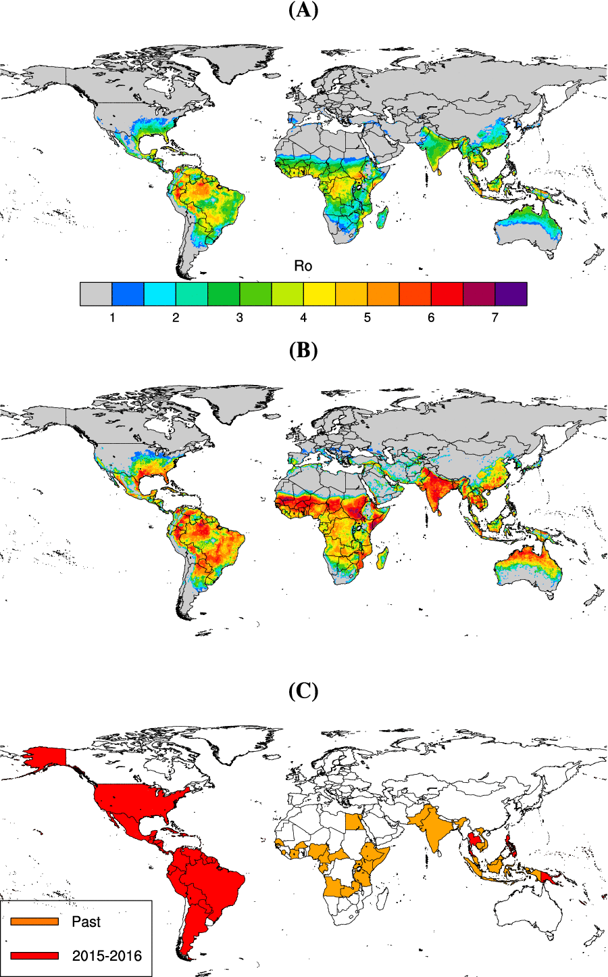

Figure 2.
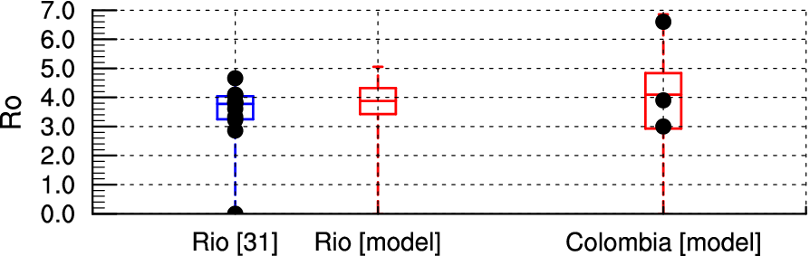

Figure 3.
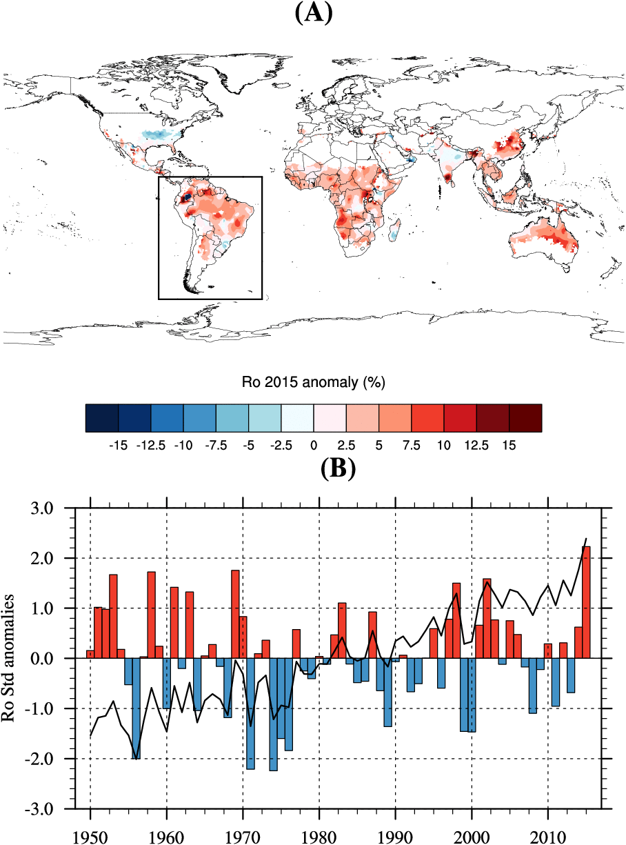

Table 1.
R₀ model parameter settings – an index of 1 denotes Ae. aegypti, an index of 2 denotes Ae. albopictus. *denotes parameters which are dynamically simulated in space and time over the whole time period. T stands for temperature.

Symbol | Description | Constant/Formula | Comments | Ref
*a₁  *a₂ | Biting rates (per day) | a₁=0.0043T + 0.0943  a₂=0.5 x a₁ | The linear dependency to temperature was based on estimates for Ae. aegypti in Thailand. Biting rates for Ae. albopictus were halved based on observed feeding interval data [18]. | [58, 59]
ɸ₁  ɸ₂ | Vector preferences (0-1) | ɸ₁=1 [0.88 – 1]  ɸ₂=0.5 [0.24 – 1] | Most studies show that Ae. aegypti mainly feeds on humans. Ae. albopictus can feed on other wild hosts (cats, dogs, swine…) and large differences are shown for feeding preference between urban and rural settings for this species. | [17, 54, 60-65]
b₁  b₂ | Transmission probability - vector to host (0-1) | b₁=0.5 [0.1-0.75]  b₂=0.5 [0.1-0.75] | Based on dengue parameters -estimates from a mathematical review study. | [66]
β₁  β ₂ | Transmission probability - host to vector (0-1) | β₁=0.1  β₂=0.033 | Recent laboratory experiment studies generally show low transmission efficiency (in saliva) for various vector / ZIKV strain combinations (South America and Africa). Estimates by [15] were used in the final model version. | [14-16]
*μ₁  *μ₂ | Mortality rates (0-1 per day) | μ₁=1/(1.22+exp(-3.05+0.72T))+0.196 if T < 22°C  μ₁=1/(1.14+exp(5.14-1.3T))+0.192 if T ≥ 22°C  μ₂=1/(1.1+exp(-4.04+0.576T))+0.12 if T < 15°C  μ₂=0.000339T²-0.0189T+0.336 if 15°C ≤ T < 26.3°C  μ₂=1/(1.065+exp(32.2-0.92T))+0.0747 if T ≥ 26.3°C | Mortality rates were derived for both mosquito vectors from published estimates based on both laboratory and field data. | [67]
*eip₁  *eip₂ | Extrinsic Incubation Periods - EIP (days) | eip₁=1/ν₁=4+exp(5.15-0.123T)  eip₂=1/ν₂=1.03(4+exp(5.15-0.123T)) | EIP for dengue were used as estimates for ZIKV were only available at single temperature. 50% (100%) of Ae. aegypti mosquitoes were infected by ZIKV after 5 days (10 days) at 29°C [7]. An EIP longer than 7 days was reported by [15] at similar temperature. Model estimates for dengue suggests eip1≈ 8 - 9 days at 29°C. The 1.03 multiplying factor for Ae. albopictus was derived from [67]. | [68]
m1  m2 | Vector to host ratios | m1=1000*prob1  m2=1000*prob2 | m was derived as the product of a constant with probability of occurences published at global scale for both mosquito vectors. See Materials and Methods for further details. | [51]
r | Recovery rate (per day) | r=1/7 |  | [69]

