Eye-Tracking Glasses
The Tobii Glasses 1 Eye Tracker (Tobii Technology AB, 2014) is similar in appearance to regular glasses, but incorporates an infrared (IR) camera in its frame that records gaze coordinates of the participant's right eye (sampling rate: 30 Hz), and a scene camera (resolution: 640*480; recording angle: 56° Horizontal - 40° Vertical) that records the participant’s visual field, after being calibrated through a 9-point grid (Figure S1).
Fixation Definition
Fixations, defined as pauses of the eye movement on a specific area of the visual field, lasting a minimum of 100 milliseconds, were identified from the raw eye tracker data, using the ClearView Fixation Filter (Velocity Threshold (i.e., the maximum pixel-distance between two consecutive data points): 25 pixels/sample; Duration Threshold (i.e., the minimum fixation duration): 100 ms).
Areas of Interest
Using the Tobii Studio Eye tracking software (version 3.2.1.188), dynamic (i.e. tracking the infant’s movement) areas of interest (AOIs) were hand-drawn over the footage recorded by the scene camera, to assess the length in seconds (duration), and the number (count) of ﬁxations within an AOI.
General Areas of Interest
The first AOI included the whole frame captured by the glasses, and was activated only when the infant was visible within the frame. The second AOI overlapped with the first, but included only the infant's head. Subtraction of the latter values from the former provided a measure of gaze to the infant's body . The third AOI included the whole frame, and was activated only when the infant was not included in the frame (i.e., the mother was looking away from the infant).
Facial Area of Interest
The first AOI included the entirety of the infant's face, as for the previous analysis. Overlapping this AOI, two smaller ones were drawn: the first was over the infant's mouth (from the bottom of the nose to the chin), and the second over their eyes (including eyebrows). The border of the AOI for the eyes was half the interocular distance away from either eye (Figure S2 in Supplementary Materials). Subtracting the values of these last two AOIs from those for the "Face" provided a measure of maternal visual attention to the remaining areas of the infant's face.
Eye-Tracking Data Precision
Two-level random intercept generalised mixed models were used to compare groups with regard to data reduction percentages, precision percentages, and duration of analysed eye-tracking footage, using a binomial distribution for the first, binary, variable (subject retained vs. subject excluded), and a Gaussian distribution for the latter two, continuous, variables.
The reduction in the number of recordings used for analysis, due to the adopted eye-tracking precision threshold, did not differ by group, with 13.01%, and 8.80% of recording removed from analyses for General AOIs, and Facial AOIs, respectively.
In the final dataset, the two groups did not differ in the precision percentage for General AOIs (M(sd): Index=76.48(11.96), Comparison=80.41(12.57); X²(1)= 1.361, p=.243), but the Index group showed a trend towards lower precision percentages compared to the Comparison group in relation to Facial AOIs (M(sd): Index=84.37(13.03), Comparison=88.96(10.54); X²(1)= 3.154, p=.076).
Because of the generally higher percentages found in the Comparison group, to control for the reliability of the eye-tracking data, all following models retained the main effect of the precision percentage, regardless of its impact on the fit of the model.
References
Tobii Technology AB. (2014). Tobii Studio Version 3.3.0 User Manual. Danderyd (Sweden): Tobii Technology AB.

 |  |  | Index | Comparison | P
Mothers | Age (M±sd) |  | 32.97±5.16 | 34.05±3.13 | n.sª
 | Education (%) | Graduate\Postgraduate | 30.00 | 61.90 | n.s^{b}
 | Marital Status (%) | Married | 40.00 | 90.48 | 0.006^{b}
 | Ethnicity (%) | White | 100.00 | 90.48 | n.s^{b}
Infants | Gestation Wks (M±sd) |  | 38.90±2.28 | 40.42±2.26 | n.sª
 | Weight at Birth (M±sd) |  | 3011.56±422.92 | 3646.02±711.52 | 0.015ª
 | Gender (%) | Male | 20.00 | 61.90 | 0.054^{b}
 | Birth Order (%) | First Child | 60.00 | 38.10 | n.s^{b}
 | Feeding (%) | Breast | 20.00 | 71.43 | 0.005^{b}
 |  | Formula | 60.00 | 9.52
 |  | Mixed | 20.00 | 19.05
 | Cleft Type (%) | Cleft Lip | 30.00
 |  | Cleft Lip and Palate | 70.00
 | Cleft Side (%) | Unilateral | 90.00
 |  | Bilateral | 10.00
Table S1: Main Demographic Characteristics. ª: Student’s t test; ^{b}: Fisher’s Exact Test.

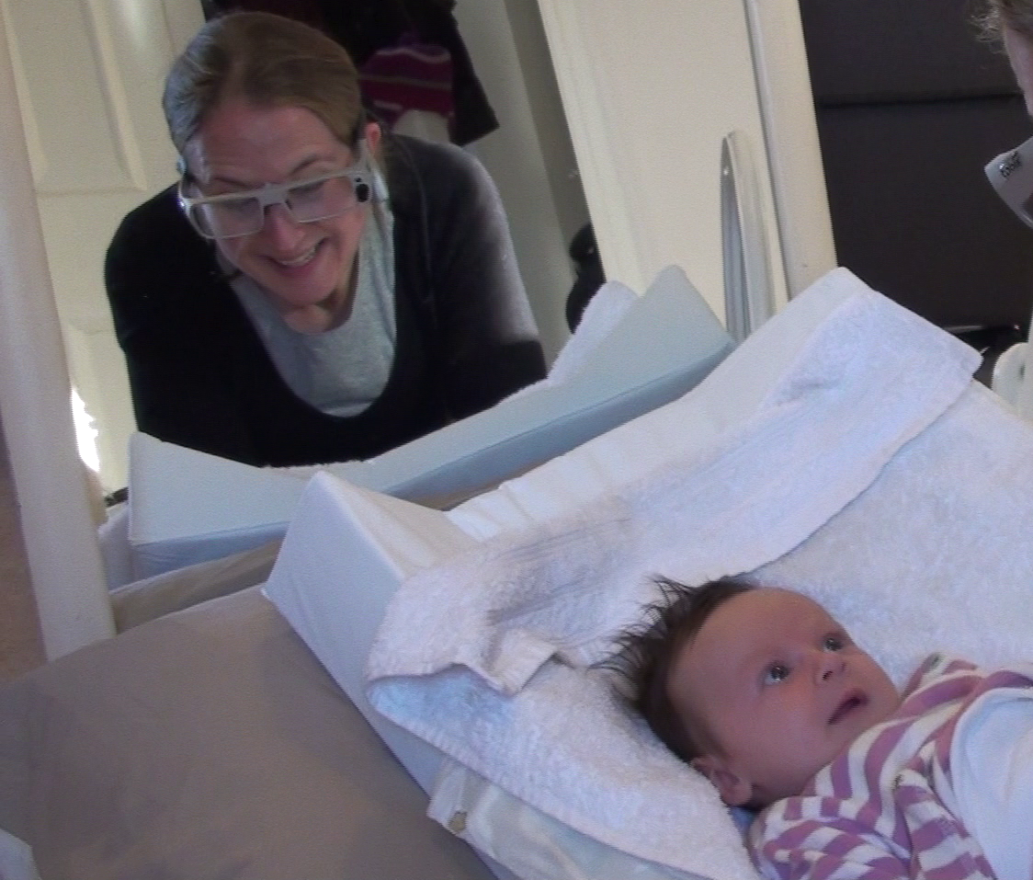
Figure S1. Mother-Infant Interaction, with Eye-Tracking Glasses (mother visible in a mirror).

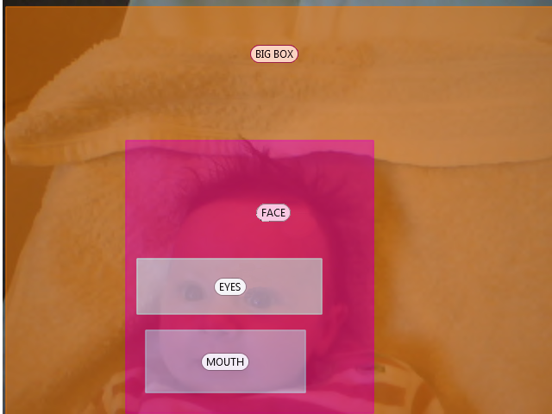
Figure S2. Facial Areas of Interest (AOIs).

