What paint can tell us: a fractal analysis of neurological changes in seven artists

Abstract
The notion that artistic capability increases with dementia is both novel and largely unsupported by available literature. Recent research has suggested an emergence of artistic capabilities to be a by-product of involuntary behaviour seen with dementia, as opposed to a progression in original thinking (de Souza, et al., 2010). A far more complementary explanation comes from Hannemann (2006), who suggests that art offers an outlet for dementia patients to refine and sharpen their cognitive abilities. As dementia severely impedes linguistic skills, non-verbal therapeutic methods such as painting can permit dementia patients to express themselves in a way not possible verbally. In addition, it is argued that painting allows for a degree of socialisation, thus elevating negative feeling such as isolation and a lack of direction. Fractal analysis has been used to determine the authenticity of major works of art. Taylor et al., (1999) found that through a fractal analysis of Jackson Pollock’s paintings it was possible to distinguish authentic works from a large collection of fakes, demonstrating that when artists paint they instil within their work their own pattern of unique fractal behaviour. Can age-indexed variations in the fractal dimension of the works of artists anticipate specific cognitive deteriorations? To answer this question we analysed age-related variations in the fractal dimension of a large corpus of digital images of work created by seven artists who experienced both normal ageing and neurodegenerative disorders (n=2092). The results of our analysis showed that patterns of change in the fractal dimension of the paintings differentiated artists who suffered neurological deterioration from those of normal aging controls.

Introduction
The study of linguistic changes as an early indicator of cognitive deterioration has an established history. The classic Nun Study (Snowdon, Kemper, Mortimer, Greiner, Wekstein, D. R., & Markesbery, 1996) examined the linguistic capabilities of 93 nuns from a convent in Wisconsin, USA (ages at time of study ranged from 75 to 95 years). Lexical analysis determined that low scores in idea density and grammatical capability in the autobiographical works written in early life strongly correlated with low scores for cognitive ability in later life. Neuropathological examinations of 14 of the nuns presented post mortem diagnosis of Alzheimer’s disease (AD), a condition not reported in sisters who scored highly for idea density in early life. Similarly, Butterwort reports that the speeches of Ronald Reagan showed language deterioration akin to the onset of AD (Butterworth, 1984 reported in Forbes-McKay & Venneri, 2005). Reagan displayed significant decline within five linguistic categories. For example, he did not display any confusion errors in 1980, though they were present in the 1984 debate. Butterworth conclusions were that Reagan’s linguistic decline since 1980 was an indicator of the initial signs of AD, a conclusion confirmed 10 years later, when Reagan received his official diagnosis of AD. Computational linguistic analysis has demonstrated that is it possible to detect early signs of AD in the late works of the novelist and philosopher Iris Murdoch (Leslie, 2004). In contrast to other Murdoch novels, her work was shown to have fewer numbers of unique word types relative to the word count (Garrard, Maloney, Hodges, & Patterson, 2004).
Artists manifest visual, motor, auditory and cognitive neuropsychological deficits in strikingly eloquent ways (Chatterjee, 2004). Artists often remain motivated, productive and expressive and, despite deficits in visual processing skills and motor capabilities, their personal style, depth, balance and quality of stroke are frequently well preserved (Van Buren et al., 2013). Mell, Howard, & Miller, (2003) describe the case study of a painter with frontotemporal dementia. Though her ability to organise class lessons or grade homework declined, her paintings became freer, more intricate and original. The painter Danae Chambers, diagnosed with AD with anterior lobe damage, continued to paint with enduring creativity for 10 years before the quality of her art began to suffer (Fornazzi, 2005). With a Mini-Mental State Examination score of 8, Chambers was able to create form and precision in her paintings, and retained the ability to correct errors. Eventually Chambers’ attention to detail deteriorated, her figures lacked proportion and she applied heavy dark colours to her work. Fornazzi reasons that, whilst Chambers was experiencing a decline in attention, working memory, and episodic memory, visuo-constructive capabilities were probably preserved.
Espinel (1997) reports similar trends in the work of Willem De Kooning who continued to paint even after he developed Alzheimer’s disease. It is widely agreed among art historians that, although De Kooning’s work was simpler in nature and restricted to primary shades, his post AD work reflected a new coherent, intense style, demonstrating the artist’s ability to discern visually pleasing abstract forms, shapes and colours (Figs 1a & b).

Please insert Figures 1a and 1b about here
In their review of 14 case studies Gretton and Ffytche, (2014), identify some broad generalisations in artistic change across the different dementias. AD presents prominent changes in the spatial aspects, colour and contrast. For example, the artist Lester Potts was a saw miller until diagnosed with AD. Potts went on to become an acclaimed watercolour artist, and we can see the progression of the disease through his works (Figs 2 a,b,c). Potts early works are full of detail, colour and contrast (2a). As the disease progressed Potts focused less on colour, rather he would draw shapes repeatedly (2b). Towards the end of his life we see him loose interest, preferring to draw simple grey images with repeating patterns that capture aspects of his previous life as a saw miller (Fig 2c).

Please insert Figures 2a,b,c about here
A similar pattern can be observed in the work of the magazine illustrator Carolus Horn (1921-1992). Horn annually visited Venice to paint. Figures 3a and 3b (Bridge of Sighs) show the changes in his paintings as the disease progressed. Fine detail became replaced with heavier lines and colour primary colours became preferred, with images becoming progressively two-dimensional and towards the end (3c) with realism lost and a single colour, child-like image created (Maurer & Prvulovic 2005; Bogousslavsky & Boller, 2005).
Insert Figures 3a,b,c,d about here
Lewy Body Dementia (LBD) is characterised by a different pattern of artistic change with works containing simple, bizarre content. For example, as William Utermohlen’s (1933-2007) AD advanced, his paintings are described as becoming oversimplified with a distinct lack of a relationship between proportion and perspective (Fig 4). These simple, abstract and often unusual creations have been compared to the Alison in Wonderland illustrator, Mervyn Peak (Fig 5 a & b). Peaks’ condition is ascribed by different writers to AD, Parkinson disease, or postencephalitic Parkinsonism, however Shalas (2003), following a detailed review produces substantial evidence in support of a probable diagnosis of LBD.
Insert Figure 4 about here
Insert Figure 5a & 5b here

Some systematic changes in artistic style are also reported for those suffering from Parkinson’s disease, particularly reduced precision and a stronger engagement with kinaesthetic movements. For example, Johanne Vermette felt that her PD increased her creativity, but that her work became less precise (Pinker, 2002). Chatterjee, Hamilton, & Amorapanth, (2006) describe a graphic designer with impaired distal movements becoming fluid and more controlled when he applied winding proximal movements of larger amplitude. Walker, Warwick, & Cercy (2006) reports on the painting skills of an artist with PD who produced excessive amounts of pastels under dopamine agonists, which had a strong sense of colour and kinaesthesia. The relationship between dopamine drugs and increased artistic output has also been reported in art-naïve PD patients (Inzelberg, 2013), however it is important to differentiate between increased artistic output and true creativity. Such drugs provoke new behavioural responses such as social inhibition, but artistic output is not the same as creativity. Creativity requires emotional expression, technical ability and an appreciation of evocative impact, planning, fluency and mental flexibility (de Souza et al., 2014).
Gretton and Ffytche (2014) argue that there has been a significant underrepresentation of art-dementia studies. There are a number of potential biases in the literature, particularly around the measure of changes in an artist’s work (Van Buren et al., 2013). Detailed biographical information is often preferred because attributing changes in an artist’s work as an indicator of the onset of a disease is problematic because the symptoms may predate clinical diagnosis by several years. That being said, studies that capture deficits in higher functions and faculties are particularly useful in understanding deficits distributed across brain regions. Focusing on artists, spotlights the ways in which specific cognitive deficits might enhance or diminish a given aspect of their work. The authors go on to demonstrate that certain neurological conditions do in fact present a pattern of artistic change, which could function as a useful classificatory scheme for neuro-degenerative decline. The authors argue that more longitudinal designs are needed, and here we attempt to answer this recommendation by reporting on a series of case study analyses of the works of painters who, in the later stages of life, were diagnosed with a neuro-degenerative disorder. Such historical analyses do not provide a microscope on the artistic patterns of different types of dementias, in the style of Gretton & Fftche, because the specifics of the artists’ disorders examined here, are unconfirmed by autopsy. However, a review of the dementia literature would suggest that two of the artist, James Brooks and Willem De Kooning, were possibly suffering from Lewy Body Dementia. This is a small-sample study covering two different neuropsychological conditions, PD and AD. The results of which are contrasted with artists who aged naturally.

Fractal dimension as a predictor of neurodegeneration
Chaterjee, Widick, Sternschein, Smith & Bromberger, (2010) identified the lack of quantitative measures of art as a critical obstacle to the reliable measurement of change in the work of artists with cognitive impairments. The authors developed the Assessment of Art Attributes (AAA), a measurement system based on formal perceptual qualities (balance, colour, depth, and complexity) and content representational attributes (emotion, abstraction, symbolism). Whilst the AAA system’s formalization of predetermined categories for measurement is an important step towards reliable artistic measurement, accurate assessment using this method requires at least some degree of artistic knowledge or training. Here we apply fractal analysis as an objective measure of structural change in artworks over an artist’s lifetime.
Fractals (Fig 6a&b) are mathematical characterisations of self-repeating patterns often described as the fingerprints of nature (Taylor & Micolich, 1999). They can be found in natural phenomena such as clouds, snowflakes, trees, rivers, and mountains (Gouyet, 1996; Mandelbrot, 1977). Viewing fractal patterns can elicit high alpha waves in areas associated with attention visual spatial processing (Hagerhall et al., 2008) and are associated with judgements of beauty in art, particularly when pictures are representative of something in the natural environment (Forsythe et al., 2011) and they have been found to be a valid measure of universal and individual preference (Street, Forsythe, Reilly, Taylor, Hemly, 2016).
Figure 6 here
Artists are known to operate within a particular range of fractal dimension. Taylor et al., (2006) examined film footage of Jackson Pollock at work and concluded that Pollock was generating paintings with a high fractal dimension (FD). That Pollock was able to fine-tune the structure of his paintings, gradually increasing their fractal content over a 10-year period. Pollock’s fractal ‘signature’ could be contrasted with recently discovered Pollock paintings, enabling a determination of authenticity. Here we examine the usefulness of fractal analysis in detecting the onset of neuo-degenerative deterioration. We analysed 2092 images from seven artists: Salvador Dali and Norval Morrisseau, who were diagnosed with PD; James Brooks and Willem De Kooning, who developed AD; and Marc Chagall, Pablo Picasso and Claude Monet, who showed no evidence of neurodegenerative diseases. Our working hypothesis is that heterogeneity in FD could indicate the onset and development of neurological changes.
Methodology

Case Studies

Salvador Dalĺ (PD)
Salvador Dalĺ, 1904 – 1989, is famed for his idiosyncratic and iconic contributions to the Surrealist movement. Dalĺ’s right hand trembled severely towards the end of his career. The causes of the tremor are disputed although it seems to be generally considered that the disease was typical idiopathic PD or drug-induced Parkinsonism. During the last 10 years of his life Dalĺ also suffered from arteriosclerosis (a hardening of medium and large arteries) and by late 1980 Dalĺ’s right hand was shaking severely. At this point he attended a PD specialist who determined that Dalĺ was more likely suffering from Parkinsonism caused by the cocktail of drugs being administered by his wife Gala. Gala died in June 1982 but Dalĺ continued to maintain his public image, ignoring the effects of the drugs and signing blank canvases for other artists to create a Dalĺ impersonation. The last work attributed to him was painted in 1983.

Norval Morrisseau (PD, stroke and periodic alcoholism)
Norval Morrisseau (1932-2007) took inspiration from Midewiwin scrolls, spiritual material that was passed orally from generation to generation in some Native American Tribes. He painted x-ray like images, probably drawn in the first instance in pencil, often depicting animal bones and skin at the same time. Many of the images were outlined with heavy black lines, and they were frequently filled with bright, sometimes neon colouring and were often painted with his finger-tips. Morrisseau became ill during the 1990s; first with a stroke and then at the age of 65 he was diagnosed with PD. It is estimated that prior to diagnosis, Morrisseau may have created up to 10,000 paintings. Although his output decreased post-diagnosis, he continued to paint. Insofar as possible, we have worked closely with Norval Morrisseau Unlimited to include in our analyses only the authenticated works of Morrisseau.

Willem De Kooning (AD)
Art historians note a distinct difference between De Kooning’s (1904-1997) late style and previous works (Garrels, 1997). De Kooning’s earlier works had included abstract figures of women multi-coloured prints and canvases caked in oils (Espinel, 1997). Post-1970 saw De Kooning’s attentions focused on creating ribbon like abstractions (Figs 1a & b). He lost interest in shape and form, becoming more interested in colour. Paint was manipulated to appear hazy and faded at times, and he focused largely on using only primary colours. It has been suggested that this behaviour was ‘symptomatic of neurological disorder’ (Garrels, 1997). Sahlas (2003) goes further and draws parallels between the style expressed by De Kooning and patients with LBD. De Kooning received an official diagnosis of AD in 1989, though reports of observable symptoms were recorded in 1983.

James Brooks (AD)
James Brooks, 1906-1992, was a renowned abstract expressionist painter, known primarily for pioneering abstract American art (Fig 7a & b). Brooks enjoyed a diverse and rich artistic career, deriving influence from his peers, his own life experiences, various art classes and art schools. As a consequence, his artistic style often changed, beginning with social realist art, developing into a cubist style before paving the way to more abstract expressionist pieces. Brooks was diagnosed with AD in 1985 and his production slowed to a virtual standstill. In 1992, he died in East Hampton, New York aged 85. Again we do not know the type of dementia Brooks presented with however we can see systematic changes in his artworks (Fig 8 a & b) that fit with the LBD profile identified by Gretton and Ffytche (2014).
Figures 7 a & b here

Marc Chagall (Normal Aging)
From what we know of Chagall, 1887-1985, he lived a relatively healthy and long life and died at the age of 98 of a heart attack. Often creating striking images using only two or three colours, Chagall manipulated the texture of his work through altering his media, favouring gouache, watercolour or oil paints. In addition to paint, Chagall created some 24 lithographs, employing woodcuts and etching techniques in the creation of his prints.

Claude Monet (Normal Aging)
Monet (1840-1926) was the founder of French Impressionism, known for his consistent and prolific landscape painting. Monet rejected traditional landscapes painting, applying bright colours in dashes and swirls, often painting the same scene many times so that he could capture changes light or the passing seasons. Monet died at the age of 86 from lung cancer, he was known to have significant problems with his sight from 1911. In 1923 he underwent surgery for cataracts and he continued painting until his death (Gordon & Forge, 1989). Figure 8 shows a subsection of Monet’s work with the paint laid down with omnidirectional brush strokes to the point that it is commonly impossible to tell how the surface was created. As described by Elkins (2000) getting real directionless is immensely difficult and artists have to work against their own anatomy to create this kind of effect.

Pablo Picasso (Normal Aging)
Picasso (1881-1973) is included in this study as an example of an artist who regularly changed his artistic style and died through the normal aging process. Early paintings were classical scenes of photographic quality but by 1900 he favoured a soft focus pastel effect, referred to as his ‘blue period’. In 1904 “the rose period” saw Picasso soften his palette with depictions of graceful harlequins and acrobats. 1907 saw the creation of Picasso’s first cubist piece. However, by 1909, having explored analytical cubism to its limits, Picasso shifted to collage cubism. In doing so, he varied his medium, utilizing cut out sections of material to form an image and adding lines to complete the piece. Picasso’s 1917 ‘portrait of Olga in armchair’ shows a shift in style once again, from cubism to neo-classicism. During the 1950s Picasso began to alter his technique once again. Favouring simplified creations, he opted to leave parts of the canvas untouched. Picasso continued to work rapidly and frequently in his final years, which made for a large quantity of similar paintings. The paintings at this stage have a rough, sketchy quality to them.

Images
One of the challenges with this piece of research is that the most popular or acclaimed paintings are also the most widely reproduced and therefore the most accessible. Paintings that were perhaps considered by the artists or collectors to be of an inferior quality are not so easily accessed. The provenance of paintings can also be a significant challenge. With this in mind, all available paintings were sourced from reputable Internet sites such as online art galleries, the online art auction house Christies, The National Gallery of Ireland and private collections (for example Norval Morrisseau Unlimited). Statistical analysis and empirical research favour equality during the research procedure, this is to ensure the results are as fair and as reliable as possible. The infrequent number of paintings created per annum meant that exact equality would be impossible. For prolific painters such as Dali, this was less of an issue. However, for other artists both the sporadic availability of paintings and the fact that artists do not neatly produce an equal number of paintings per year proved more of a challenge. To overcome this challenge, Linear Effects Mixed Modelling and Productivity Analysis were applied in our analysis. In total 2092 digital images were individually analysed. This sample represents all the available images that we were able to access: Dalí, n=322; Morrisseau, n=325; Brooks, n=139; De Kooning, n=199; Chagall, n= 298; Monet, n=497; Picasso, n=312.

Digital images

Fractal analysis has been used by way of determining the fractal qualities of digital images of natural scenes (Pentland, 1984; Keller, Crownover, & Chen, 2009), and Taylor et al., (2006) were able to analyse quality photographs of the works of Jackson Pollock. Taylor stipulated that, although the photograph could not reflect the experience of viewing a painting in a gallery, it would contain the relevant data needed for fractal analysis. His research demonstrates that a photograph of a natural scene or painting retains the information necessary for fractal analysis.

Fractal Dimension
Fractal dimension is a measure of how completely a pattern fills a space. There are various methods for measuring it and all are based on a power law that generates scale-invariant properties (Taylor & Sprott, 2008).
The formula
$D=\frac{\left(\frac{L2}{L1}\right)}{\left(\frac{S1}{S2}\right)}$
defines the dimension, D, as any real number between 1 and 2. L1, L2 are the measured lengths of the curves (in units) and S1, S2 are the sizes of the units (i.e., the scales) used in the measurements.
The fractal dimension of the images analysed in this study were calculated using the public domain image-processing program ImageJ (Rasband, 2013). To prepare the images for analysis they were converted to black and white using the binary threshold algorithm within ImageJ. This transformation enables an analysis of the images’ fundamental geometric features. This is a manual transformation, as it requires a human observer to make a judgement regarding what part of the image is the foreground or background.
To calculate D, the box-counting method was used. The box-counting dimension is widely used because it can measure images that are not self-similar and most naturally occurring curves and surfaces are not entirely self-similar. The calculation involves breaking an image into smaller box-shaped pieces (Mandelbrot, 1984; Mandelbrot & Blumen, 1989). To do so, an image must be mapped onto a grid. The x-axis of the grid is S, where S=1/(width of the grid). For example, if the grid is 240 blocks high and 120 blocks wide, then S=1/120. The number of blocks that the image touches as well as any empty blocks are then counted (N(S)). The grid is re-sized to a finer magnification and the process repeated. Different magnifications can then be compared. In this case the numbers of squares (N) are counted as the magnification is reduced and consequentially the size of the squares (L). Fractal patterns are determined by N(L) through a power law relationship N(L) ~ L^{-D}, where D lies between 1 and 2 - generates the scale invariance. The values are often plotted on a graph where the x-axis is log(S) and the y-axis is log (N(s)). D can then be derived from the slope of the resulting curve.
In order to obtain a standard measure of fractal dimension using the box-counting method it was necessary, for purposes of comparability, that the same definition be applied to the whole image set. The box counts were initially set at: 2, 4, 8, 16, 32, 64, 128, 256, 512, 1024. We manually backtracked from a box count of 1024 to 720 because beyond this level there were no statistical differences in D to the fourth decimal place. The box sizes for all images were then set between 1 and 720. ImageJ binary threshold conversion was used for all images. Each image was also visually inspected to ensure that the algorithm correctly distinguished foreground from background in calculating D. For further reading on Fractal Analysis see Brown & Liebovitch, (2010) and Street et al., (2016).

Statistics

Linear Mixed Modelling (LMM) was used to analyse the FD of the seven artists’ work. This form of analysis incorporates fixed and random effect terms in one linear model (Baayen, Davidson, & Bates, 2008) and also allows for a combination of categorical “treatment” variables and continuous covariates. For further reading on linear mixed effects modelling see Galecki & Burzykowski (2013). Here the dependent variable is the fractal dimension (FD) of the paintings produced by the artists in the sample. This is measured over the lifetime of the artist. The two main independent variables are age and health (i.e. whether or not the artist ultimately succumbed to a neurodegenerative disorder). The two independent, fixed (as opposed to random) variables in the model are age, which is used both as a linear and quadratic, and health, which is coded as a set of contrasts between the healthy controls and those who ended up developing either AD or PD. Note that we control for the natural variability between artists’ styles by quantifying a painting’s fractal dimension with respect to the artist’s own overall average FD.
Once a mixed-effects model has been fitted to the data, the set of estimated parameters include coefficients for fixed effects in addition to the standard deviations and correlations for the random effects (Baayen et al., 2008). Mixed-effects modelling affords the opportunity to observe whether there are differences in the dependent variables as a function of specific random effects. In this case, the chosen random effect is the individual artist. Mixed-effects modeling allows us to ask the question whether specific artists showed different rates of change in their paintings’ FD over time.

Results
Fig 9 compares the age variation in FD of paintings by the control group with those by artists who developed either AD or PD. The lines represent the best fit of a second-order polynomial and the grey bands represent the standard error. In the case of artists who ultimately developed AD, a negative linear trend as a function of age can be clearly seen, whereas the slope is positive for the control group. In contrast, there is a distinct curvilinear trend apparent in the case of those artists who developed PD.
Figure 9 here
Table 1 here
Note that age represents the age covariate centred about the mean and that age² is the same term squared (Table 1). Centring makes the model estimates easier to interpret in terms of changes to FD as a function of age. There are two contrasts of central interest: control vs. AD and control vs. PD. The interactions between the covariates and contrasts are given in the last few rows of the model. For example, age x ctrl-AD represents the interaction of the linear age term with the control vs. AD contrast.
The results indicate that there is a significant positive overall linear trend in FD as a function of age (t=3.994; p<0.001). Interestingly, the overall difference in FD between the control group and the two groups suffering from neurological disorders is not significant. However, the interaction between the contrasts and the linear and, to a lesser extent, the quadratic terms for age are significant, which is in line with what we would expect from the patterns apparent in Figure 9. There is a highly significant interaction between age and the ctrl-AD contrast (t=-4.563; p <0.001). The AD artists show a decline of about 0.003 in average fractal dimension per year. In the case of the artists who developed PD, there is also a linear decline (t=-1.809; p =0.07) and a quadratic pattern in the form of an inverted-U shape (t=-1.878; p=0.06), both of which are just short of statistical significance. We also carried out a post-hoc power analysis of the age x ctrl-AD interaction. Using effect sizes derived from the mixed-effects model, we carried out 1000 model fittings involving simulated data (Gelman & Hill, 2007). The significant age x ctrl-AD interaction was replicated in all of the simulations. Therefore, notwithstanding the small sample of individual artists, the linear decline in fractal dimension as a function of age for the AD artists can be considered a robust effect. To give some idea of overall fit, an R² analogue, Ω² (Xu, 2003), suitable for mixed-effects models was calculated for the linear model with and without the addition of a quadratic age term. This gave an Ω² value of 0.021 for the model without the quadratic term, and a slightly larger 0.024 with its addition.

Productivity analysis
The output of each artist was included as an independent measure (Fig 10). Productivity, on its own did not improve the predictions of the Fractal Dimension of the artist’s work, however it did interact significantly with one of the degenerative conditions (t=2.03, p<0.05). In contrast to controls, where artists with PD had periods of output above their annual average, their output was of a higher fractal dimension.
Figure 10 here

Discussion
We have analysed some 2092 images from seven artists across their lifetime with a view to determining meaningful changes in the fractal dimension of art across the lifetime of artists who suffered from Parkinson’s and Alzheimer’s disease. In contrast to the control artists reported here who did not suffer neurodegeneration, there are some overall differences between PD and AD artists. Artists with neurodegenerative conditions present more heterogeneity in the fractal dimension of their paintings. Artists who age normally, even those like Picasso who regularly varied their personal style, tended to stay within a much smaller range of fractal dimension. If we consider these results in light of findings from linguistic analysis, authors may change the style of the “story” from inner lives, to philosophy to romance, but the style of prose or syntactic structure will often be consistent with that authors “voice”. In much the same way, painters will work within a different style or genre, but the fractal dimension in which they operate will remain comparable. These results are supported by previous findings by Taylor et al., (2006) in their fractal examination of the work of Jackson Pollock. Pollock operated within a specific fractal dimension, a measure so finely tuned that it has been applied as a test for fraudulent paintings.
The work of artists with AD (De Kooning & Brooks) shows a steady decline in FD from about age 40. In contrast to the controls, the art of the AD group presents greater variance in FD across time. PD artists present a marginally significant inverted-U shaped pattern. Moreover, as their output increased, so did the fractal dimension of their work. This increased output of a higher FD continues until their late 50s before declining. The artists concerned, Dali and Morrisseau, both started painting at a much lower fractal range than other artists in this sample, gradually increasing the fractal dimension of their paintings to the level of fractal dimension where the other artists in this sample commenced their career. PD is a late middle-age disorder with onset typically around 60 years of age so it is difficult to draw the conclusion that an earlier propensity to create simpler images is a feature of PD. Both artists concerned could be broadly described as painting in a representational style, with aspects that are recognisable in some way. The increase in fractal dimension over lifetime may simply reflect increasing personal skill in managing detail within their paintings. Or it could also be a side effect of dopamine agents, which are known to provoke new behavioural responses and to increase artistic output (Inzelber, 2013)
This is a small sample study covering different neuropsychological conditions that can only support tentative conclusions. Identifying changes in someone's behaviour that can predict clinical diagnoses years later is challenging. Often a promising method does not replicate in subsequent studies (Bissel, 2013) and the small sample size here is undoubtedly a weakness of this study. However, these findings are of importance for two reasons. Our data adds to that already gathered to determine the provenance of paintings by artists such as Jackson Pollock (Taylor et al., 2006). We build on this research by providing an increased range of fractal data for artists across their lifetime output. Researchers can now evaluate the authenticity of paintings, taking into consideration neurological damage that could place a painting outside the artist’s normal FD range for a specific period in time. Secondly, this study demonstrates that it could be possible to identify changes in the structure of a painting, years before diagnosis of a neurological disorder. In much the way that linguists have been able to determine changes in the diaries from the Nun Study, the writings of authors and the speeches of politicians, fractal analysis can determine the changes that take place within the pattern of brush strokes of a painting.
Accessibility to the work of all of the artists in this study has been an issue. Accessible paintings tend to be well known and are often widely reproduced for public consumption, but are not necessarily representative of all works produced by the artist. Some paintings are inaccessible to researchers and the general public and are likely to remain so. We have been assisted by museum curators and have been able to secure access to some works held in private collections. Nonetheless, it should be kept in mind that the elements of an artist’s oeuvre, while not random, are to some degree contingent. Creative individuals express themselves in many ways and at many different levels. Available works exist because the artist has permitted them to do so. Artists such as Vincent Van Gogh, Paul Cézanne and Francis Bacon would radically alter, mutilate and even destroy their paintings. Those paintings that do exist are examples that reflect not only the thematic and aesthetic concerns of the artist, but also the artist’s attitude towards their creation. If the work exists then one can infer that the artist found the composition to be exceptional in some way. As such the examination of the life of an artist through the structural examination of their paintings is not a candid journal of expression across time. Something that is of course no truer for painters than it is for writers and other artists. With these caveats in mind we offer a unique window onto the pattern of structural changes over time in the work of seven artists.

References
Baayen, R. H., Davidson, D. J., & Bates, D. M. (2008). Mixed effects modelling with crossed random effects for subjects and items. Journal of Memory and Language, 59, 4, 390-412.
Bissel, M. (2013). Reproducablity: The risks of the replication drive, Nature, 503, 333-334, doi:10.1038/503333a
Bogousslavsky J, Boller F (eds): Neurological Disorders in Famous Artists. Front Neurol Neurosci. Basel, Karger, 2005, vol 19, pp 101-111

Brown, C., & Liebovitch, L. (2010) Fractal Analysis, Sage Publications, Inc, USA.
Chaterjee, A., Widick, P., Sternschein, R., Smith, W.B, & Bromberger, B. (2010). The assessment of art attributes, Empirical studies of the arts, Vol. 28(2) 207-222.
Chatterjee, A. (2004). Prospects for a cognitive neuroscience of visual aesthetics. Bulletin of Psychology and the Arts, 4, 55–60
Chatterjee, A., Hamilton, R. H., & Amorapanth, P. X. (2006). Art produced by a patient with Parkinson’s disease. [Case Reports]. Behavioural Neurology, 17, 105–108.
de Souza, L. C., Volle, E., Bertoux, M., Czernecki, V., Funkiewiez, A., Allali, G., (2010). Poor creativity in frontotemporal dementia, a window into the neural bases of the creative mind. Neuropsychologia 48, 3733–3742. doi: 10.1016/j.neuropsychologia.2010.09.010
de Souza, L.C., Cerqueira G, H., Teixeira, A, L., Caramelli, P., Levy, R, Dubois, B; Voile, E. (2014). Frontal lobe neurology and the creative mind. Frontiers In Psychology, Frontiers in Psychology. Vol. 5, p1-73. 74p. DOI: 10.3389/fpsyg.2014.00761.
Elkins, J. (2000). What painting is. New York: Routledge.

Espinel, C. H. (2007). Memory and the creation of art: The syndrome, as in de Kooning, of 'creating in the midst of dementia'--An 'ArtScience' study of creation, its 'brain methods' and results. In J. Bogousslavsky, M. G. Hennerici, J. Bogousslavsky, M. G. Hennerici (Eds.), Neurological disorders in famous artists - Part 2 (pp. 150-168). Basel, Switzerland: Karger. doi:10.1159/000102877

Forbes-Mckay. K. E.. Venneri. A. (2005). Detecting subtle spontaneous language decline in early Alzheimer's disease with a picture description task. Neurological Sciences. 26. 4. 243–254.
Fornazzari L, R. (2005) Preserved painting creativity in an artist with Alzheimer's disease. Eur J Neurol 12: 419–424.
Forsythe, A., Nadal, M., Sheehy, N., Cela-Conde, C., & Sawey, M. (2011). Predicting beauty: Fractal dimension and visual complexity in art. British Journal Of Psychology, 10249-70.
Galecki, A., & Burzykowski, T. (2013). Linear mixed effects models using R: A step-by-step approach, Springer, UK.
Garrard, P., Maloney, L., Hodges, J., & Patterson, H. (2004). The Effects of very early Alzheimer’s Disease on the characteristics of writing by a renowned author. Brain, vol 128, 250-260.
Garrels, G. (1997). Willem De Kooning: the late paintings, the 1980s. USA: Walker art centre.
Gelman, A. & Hill, J. (2007). Data Analysis Using Regression and Multilevel/Hierarchical Models, Cambridge, UK.
Gouyet, J.F. (1996). Physics and Fractal Structures, New York, Springer-Verlag.
Gordon, R. & Forge, A. (1989) Monet, Penobscot Books, USA.
Gretton, C., & Ffytche, D. H. (2014). Art and the brain: a view from dementia. International Journal of Geriatric Psychiatry, 29(2), 111-126
Hagerhall C. M., Laike T., Taylor R. P., Küller M., Küller R., Martin T. P., (2008) Investigations of human EEG response to viewing fractal patterns, Perception 37(10) 1488 –1494.
Hannemann, B. (2006). Creativity with dementia patients - Can creativity and art stimulate dementia patients positively?. Gerontology, 52(1), 59-65.
Inzelberg, R. (2013). The awakening of artistic creativity and Parkinson’s disease. Behav. Neurosci. 127, 256–261. doi: 10.1037/a0031052
Keller, J.M. Crownover, R. M., and Chen, R.Y. (2009). Characteristics of natural scenes related to the fractal dimension, IEEE Trans. PAMI, 9, 621-627
Leslie, M. (2004). Novelist’s final work reveals signs of Alzheimer’s disease. Science Ageing Knowl. Environment, Vol 51 p 113.
Mandelbrot, B.B. (1984). The Fractal Geometry of Nature, W H Freeman & Co, USA.
Mandelbrot, B. B., & Blumen, A. (1989). Fractal Geometry: What is it, and what does it do? Royal society of London: Mathematical and Physical Sciences. Vol. 423 (1864) 3-16.
Mell J,C., Howard S,M., & Miller, B,L. (2003). Art and the brain: the influence of frontotemporal dementia on an accomplished artist, Neurology, 60, 1707–1710.
Maurer, K., & Prvulovic, D. (2005). Carolus Horn-When the images in the brain decay. Evidence of backward-development of visual and cognitive functions in alzheimer’s disease, In. Bogousslavsky J, Boller F (eds): Neurological Disorders in Famous Artists. Front Neurol Neurosci. Basel, Karger, 2005, vol 19, pp 101–111.
Pentland, A. P. (1984). Fractal based descriptions of natural scenes, IEEE Trans Pattern Anal Mach Intell. 1 Jun, 6(6), 661-74.
Pinker, S. (2002). Art movements. Canadian Medical Association Journal, 166, 224.
Rasband, W. (2013). ImageJ. https://imagej.nih.gov/ij/index.html
Sahlas, D, J. (2003) Dementia with Lewy Bodies and the neurobehavioural decline of Mervyn Peake, Arch Neurology, 60, 889-892.
Snowdon, D. A., Kemper, S. J., Mortimer, J. A., Greiner, L. H., Wekstein, D. R., & Markesbery, W. R. (1996). Linguistic ability in early life and cognitive function and Alzheimer’s disease in late life; Findings from the Nun Study. JAMA. Vol 275 (7) pp 528-532.
Street N., Forsythe, A.M., Reilly, R., Taylor, R., Helmy, M.S. (2016). A Complex Story: Universal Preference vs. Individual Differences Shaping Aesthetic Response to Fractals Patterns, Frontiers in Human Neuroscience, doi: 10.3389/fnhum.2016.00213
Taylor, R.P., Micolich, A.P., Jonas, D. (1999). Fractal analysis of Pollock’s drip paintings, Nature, 399, 422.
Taylor. R. P., Guzman, R., Martin, T. P., Hall, G. D. R., Micolich, A. P., Jonas, D., Scannell, B. C., Fairbanks, M. S., & Marlow, C. A. (2006). Authenticating Pollok paintings using fractal geometry. Pattern recognition letters. Vol. 28 (2007) 695-702.
Taylor R. P., Sprott J. C. (2008). Biophilic fractals and the visual journey of organic screen-savers. Nonlinear Dynamics Psychol. Life Sci. 12, 117–129
Van Buren, B., Bromberger, B., Potts, D., Miller, B & Chatterjee, A (2013). Changes in Painting Styles of Two Artists with Alzheimer’s Disease, Psychology of Aesthetics, Creativity, and the Arts, 2013, Vol. 7, No. 1, 89–94
Walker, R. H., Warwick, R., & Cercy, S. P. (2006). Augmentation of artistic productivity in Parkinson’s disease. [Case Reports Letter]. Movement Disorders, 21, 285–286. doi:10.1002/mds.20758
Xu, R. (2003). Measuring explained variation in linear mixed effects models. Statistics in Medicine, 22, 3527-3541.

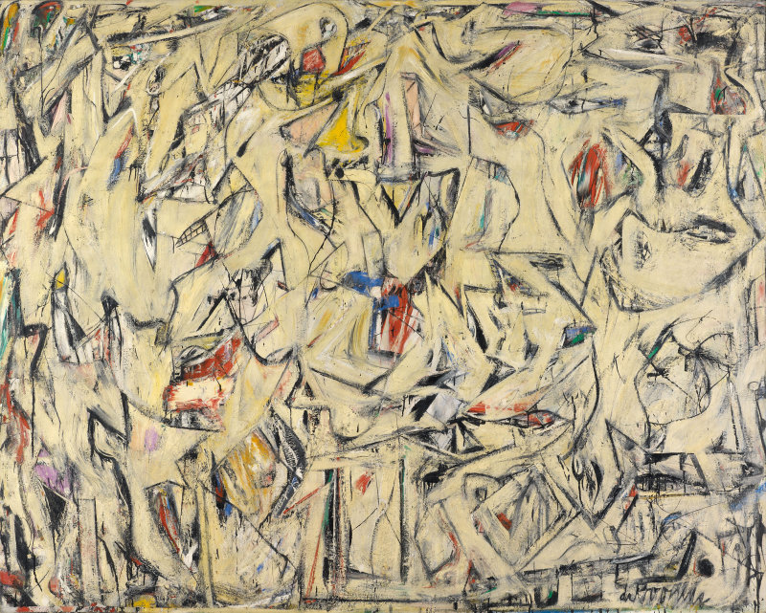

Fig 1a Excavation, 1950 by Willem de Kooning 1950 © The Willem de Kooning Foundation / Artists Rights Society (ARS), New York and DACS, London

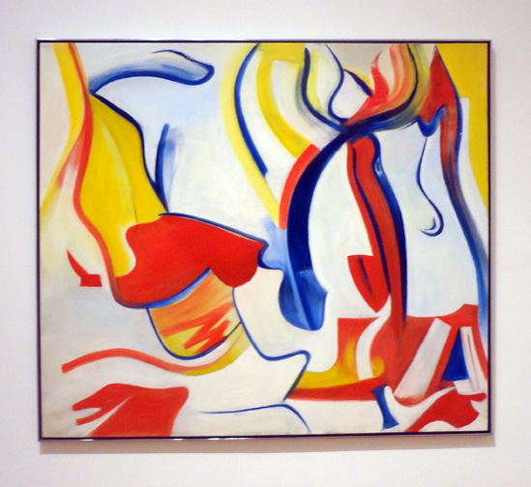

Fig 1b: Rider Untitled VII, by Willem de Kooning, 1985, The Museum of Modern Art, New York, © The Willem de Kooning Foundation / Artists Rights Society (ARS), New York and DACS, London

Lester Potts Fig 2a Sunset reprinted with permission from Daniel Potts.
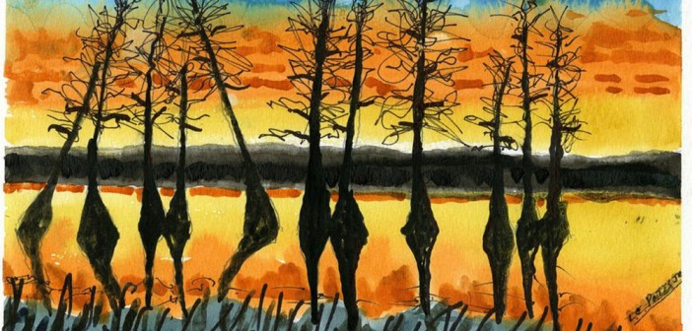 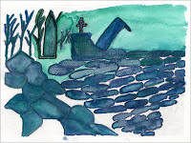2b Blue Green Collage
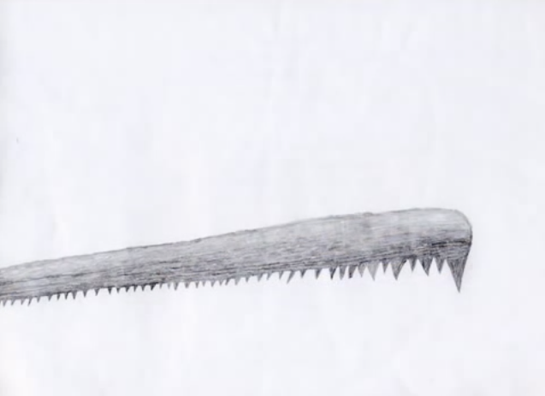 Fig 2c The Cross Cut Saw

Figures 3 Carolus Horn, a (1981) & b (1987): The Bridge of Sighs. Permissions Springer
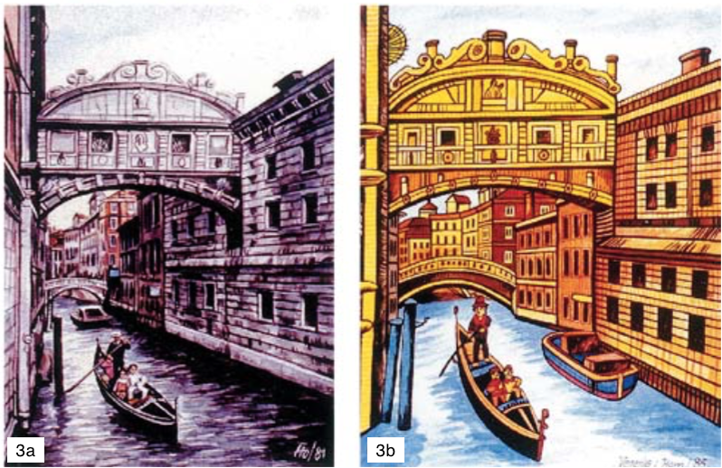
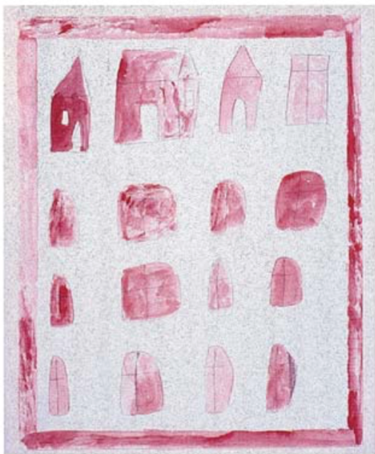
Figures 3c: Carolus Horn; final stages. Permissions Springer

Fig 4: William Utermohlen, Self Portraits printed with permission of Mrs P Utermohlen ©
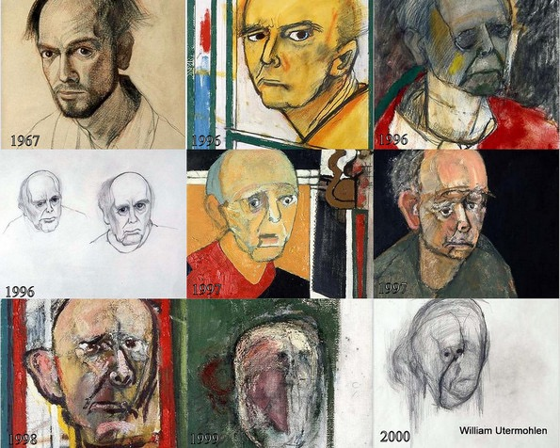

Figure 5a: Mervyn Peak: The Hatter and the March Hare (c) The British Library Board, Add MS 88931/7/1/5, folio 9
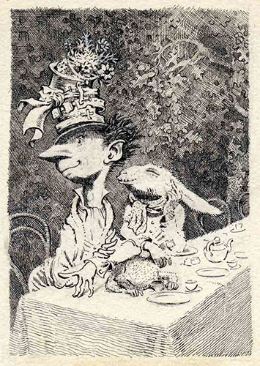

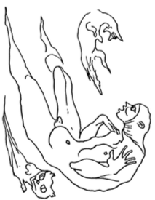
Figure 5b: with Dunce Cap by Mervyn Peake reprinted by permission of Peters Fraser & Dunlop (www.petersfraserdunlop.com) on behalf of the Estate of Mervyn Peake.

Fig 6: Mathematical (a) and natural fractals (b) Authors own.
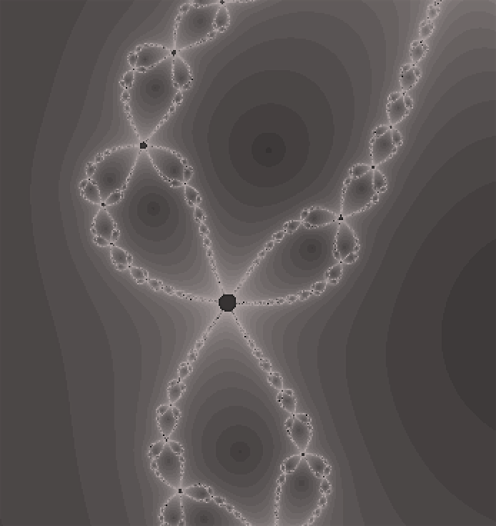
6a

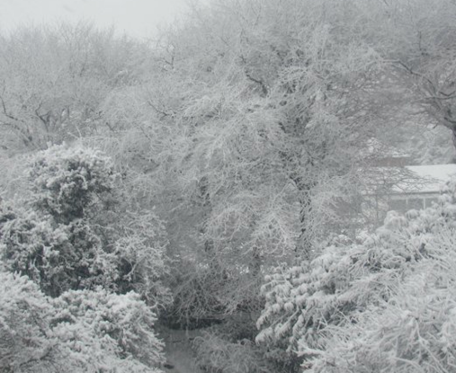

6b

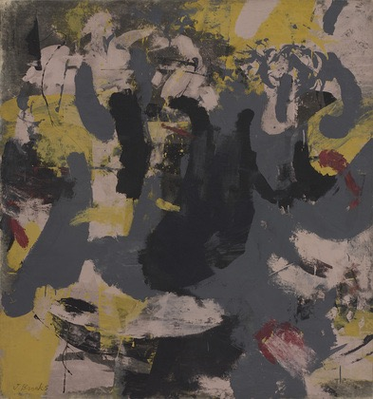

Fig 7a: Qualm, James Brooks, 1950. © 2016 James and Charlotte Brooks Foundation, Inc.
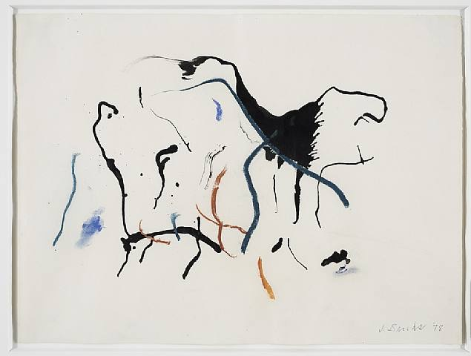

Figure 7b: Ink and Pastel on Paper (1978), singed lower right, J Brooks, 1978. © 2016 James and Charlotte Brooks Foundation, Inc., Courtesy of Van Doren Waxter, New York

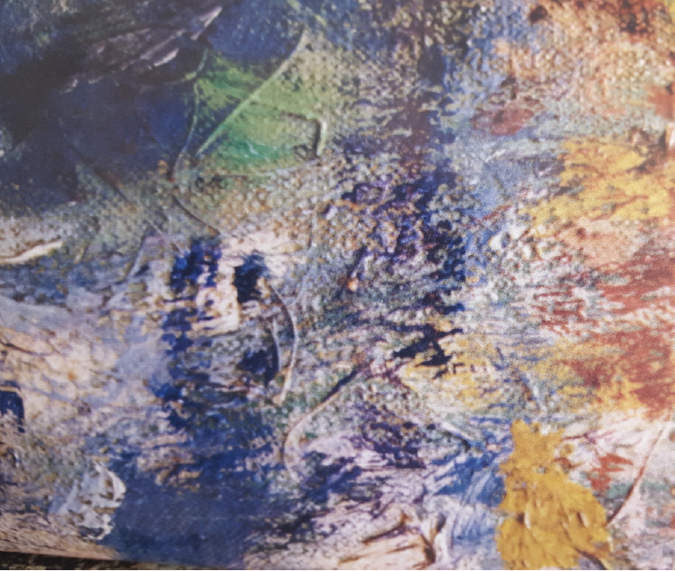
Figure 8: Sub section of Artist’s Garden at Vetheuil (1880), National Gallery of Art, Washington (From Elkins, 2000).

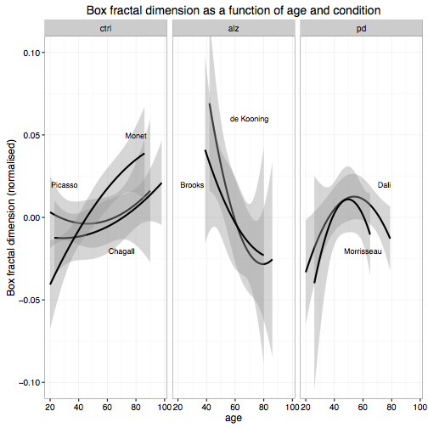
Fig. 9: Fractal dimension of work as a function of artist age and neurodegenerative disorder

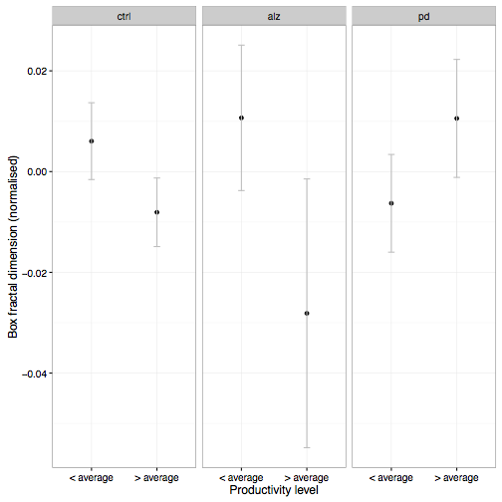
Fig 10: Fractal dimension of paintings as a function of condition and whether they were produced in a period of above or below average productivity as measured by the average yearly output of the artist. Note the reversal of the pattern for the PD condition.

Table 1: A linear mixed-effects model to predict fractal dimension as a function of age and health condition of the artist. Significance probabilities are calculated using Satterthwaite’s (1946) method for approximating degrees of freedom.
Term | Estimate | SE | t | p
(intercept) | 1.903e-03 | 4.239e-03 | 0.449 | 0.6534
age | 5.358e-04 | 1.342e-04 | 3.994 | < 0.001
age² | -1.317e-06 | 6.869e-06 | -0.192 | 0.8479
ctrl-AD | 9.296e-03 | 7.908e-03 | 1.175 | 0.2400
ctrl-PD | 7.680e-03 | 7.807e-03 | 0.984 | 0.3254
age x ctrl-AD | -3.045E-03 | 6.674e-04 | -4.563 | < 0.001
age x ctrl-PD | -5.915e-04 | 3.269e-04 | -1.809 | 0.0706
age² x ctrl-AD | 4.043e-05 | 3.579e-05 | 1.130 | 0.2588
age² x ctrl-PD | -3.571e-05 | 1.901e-05 | -1.878 | 0.0605

