Where Physics meets Chemistry: Thin Film Deposition from Reactive Plasmas
Running Title: The relationship between plasma physics and plasma chemistry

Andrew Michelmore^{1,2}, Jason D. Whittle¹, James W. Bradley³ and Robert D. Short^{2,4}
1. School of Engineering, University of South Australia, Mawson Lakes Campus, Mawson Lakes, Australia, SA, 5095
2. Future Industries Institute, University of South Australia, Mawson Lakes Campus, Mawson Lakes, Australia, SA, 5095
3. Department of Electrical Engineering and Electronics, University of Liverpool, Brownlow Hill, Liverpool, L69 3GJ, United Kingdom
4 Material Science Institute, Lancaster University, Lancaster, LA 1 4YN, United Kingdom
Corresponding authors:
r.d.short1@lancaster.ac.uk
andrew.michelmore@unisa.edu.au

Abstract
Functionalising surfaces using polymeric thin films is an industrially important field. One technique for achieving nanoscale, controlled surface functionalization is plasma deposition. Plasma deposition has advantages over other surface engineering processes, including that it is solvent free, substrate and geometry independent, and the surface properties of the film can be designed by judicious choice of precursor and plasma conditions. Despite the utility of this method, the mechanisms of plasma polymer growth are generally unknown, and are usually described by chemical (i.e. radical) pathways. In this review, we aim to show that plasma physics drives the chemistry of the plasma phase, and surface – plasma interactions. For example, we show that ionic species can react in the plasma to form larger ions, and also arrive at surfaces with energies greater than 1000 kJ mol⁻¹ (>10 eV) and thus facilitate surface reactions that have not been taken into account previously. Thus, improving thin film deposition processes requires an understanding of both physical and chemical processes in plasma.

Keywords: Thin films, plasma physics, plasma chemistry, functionalization, polymer

- Introduction
Of the techniques available for engineering bespoke surfaces, plasma polymerization is one of the most versatile surface technologies (already supporting Food and Drug Administration and European Medicines Agency approved therapies and devices) [1,2]. This low cost, versatile and highly reproducible (electrically excited) gas coating technology affords provision of coatings of precise chemistry, thickness and physical properties and is readily integrated into manufacturing processes [3]. In this context it has a +20 year track record and wide industry acceptance that other (newer) technologies have yet to achieve.
Plasma polymerization (also known as glow discharge polymerization) is a method whereby a plasma source generates a gas discharge providing the energy to activate a liquid/gas monomer. These reactive fragmented monomers then initiate polymerisation. These polymers adhere to a wide range of substrates and are able to coat complex geometries [4]. Through careful selection of monomers and plasma conditions, specific surface chemical functionality can be attained [5,6]
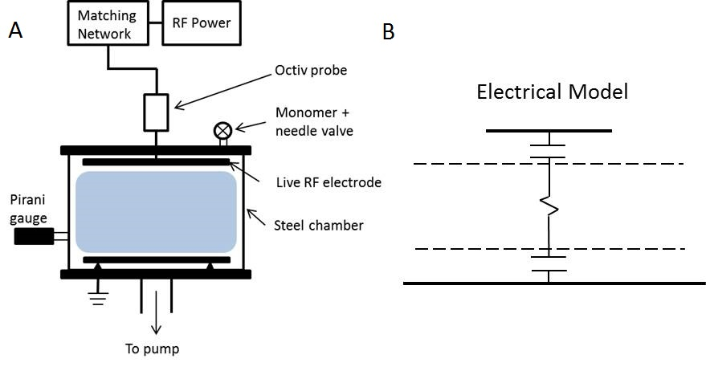
Figure 1. (a) A schematic of an RF plasma polymerisation reactor, and (b) a simplified electrical model showing the sheath regions and the bulk plasma. Adapted with permission from ref [7]

The basic requirements for plasma deposition are a vacuum chamber, typically capable of pressures less than 0.1Pa, a method of introducing an organic vapour, and a means of providing electrical power to the gas phase (see Figure 1). Electrical power may be coupled to the gas phase via an internal electrode as shown above, or an external electrode typically wound around the vacuum chamber. For many plasma processes, RF power at 13.56 MHz is used although DC or microwave sources may also be used. A matching network is also required to match the impedance of the generator to that of the plasma once ignited. It should be noted that the heating of the generator, matching network, cables and electrical power being dissipated to air outside the chamber are all sources of loss of power; the coupling efficiency can vary between 5% and 90% depending on the geometry and processing conditions [8].

Polymers formed by this process were known since the 1870’s but they were given little scientific attention as they were thought to be undesirable by-products of electrical discharge [3]. The plasmas discussed here are those formed within low pressure, low temperature reactors with volatile organic compounds. These types of plasmas have been utilised since the 1960’s for a range of applications.

In the mid 1980s Richard Ward at Durham University established for a range of carboxylic acid compounds that under the conditions of low plasma power that high retention of the carboxylic acid could be achieved as measured by X-ray photoelectron spectroscopy [9]. This work was quickly followed up by a number of groups over the late 1980s and 1990s, and plasma polymerization conditions were established that allow formation of ultrathin films with specific chemistries and thicknesses, by use of very low power inputs [e.g. 10,11].
The advantages of these plasma functionalised surfaces can be summarised as follows:
• A wide range of materials and geometries can be coated [4] and broadly speaking the coating is, in terms of chemistry and physical properties, substrate independent [12].
The technology offers a high degree of control over surface chemistry. It can be used to provide coatings of predominantly a single functional chemistry or a mixture [13].
• Control over functional group density can be attained [5,6].
• Control over surface stability/solubility. Plasma surfaces can be stabilised with a high degree of crosslinking or optimised for a higher solubility [14,15].
• Stable for long periods under ambient conditions [16]. This is important in the context of any defined product; it should not change over time.[17]
- Sterilisable by certified methods (irradiation and ethylene oxide) without significant changes to the coating [18].
• The process and variables are becoming increasingly better understood [e.g. 19-25] and this improves reliability, and provides industry confidence in applying the technology in a manufacturing context
In the past three years, recent applications of plasma polymerized platforms include:
- Utilising the chemical and electrical structure of plasma-polymerized pyrrole (ppPY) as a bioactive platform for DNA immobilization and cell adhesion and as platforms on which to assemble biosensors [26] and as long-range surface plasmon resonance sensors [27]
- The application to modify polymer electrolyte membranes for uses in polymer electrolyte membrane fuel cells [28] and plasma graft-polymerization for the synthesis of highly stable hydroxide exchange membranes [29]
- Novel dielectric thin film coatings [30]
- Plasma polymerized fluoropolymers to enhance corrosion resistance and haemocompatibility of biomedical NiTi alloys [31]
- To improve the hydrophobicity of natural materials [32]
- Providing amine rich surfaces for chemical coupling reactions, for example amines are used to couple gallic acid. GA was bound to an amine-group-rich plasma-polymerized allylamine (PPAam) coating to provide surfaces for Endothelial Cells and Smooth Muscle Cells selectivity [33]
- The functionalization of multi-walled CNTs to improve their dispersion in polymer matrices [34]
- The surface modification of advanced (aramid) polymer fibres [35] and advanced polymer membranes [36] and for new surfaces to control crystal growth [37]
- And, finally, adapted plasma techniques have been used to grow first microspheres on surfaces and then microporous surfaces [38] or improved biomaterials [39].

During the 1960s and 1970s, several researchers investigated the fundamental processes which led to deposition for various hydrocarbon precursors. The species which form the deposit were identified as being ions, radicals and neutrals although no consensus was reached regarding the exact mechanisms [40,41]. With the realisation that useful functionalised surfaces could be fabricated using this technique, new products and applications were largely developed by trial and error rather than through a thorough understanding of the physical and chemical processes. While this approach was successful in the short term, more recently a desire to deposit ultra-thin films (<10nm) on complex geometries such as scaffolds and micro-pores has necessitated the fundamentals of deposition be revisited [42]. In this review, we aim to describe the chemical and physical processes which occur during deposition from plasma, and how an understanding of both is necessary to intelligently design plasma deposition processes.

- A complex business: Defining plasmas

In the first instance, we need to understand how plasma is ignited and define what it is made of. Defining plasma adequately for processing applications is difficult. We have found that in many texts on plasma, and in our own experience, that determining the species in plasma is a complex task. This is true even for the simplest plasmas.
The problem is that cold or non-thermal noble gas plasmas, such as Argon, consist of gas atoms, electrons and ions which are not in thermodynamic equilibrium and must be defined by their density, energy distribution and electrical potential separately, and this turns out to be a lot to measure. When including reactive precursors into the gas phase, the complexity of the plasma increases greatly as many extra physical and chemical processes come into play; fragmentation of the precursor results in formation of a variety of radicals smaller than the precursor, while charging processes result in a wide variety of species which range between very small (from a single proton) and very large (protonated oligomers). Thus, we find that reactive plasmas must be defined in terms of electron density and energy distribution, neutral, radical and ion molecule mass distribution and energy distribution, and electrical potentials. The first step in being able to define plasma though is by understanding the processes which lead to plasma ignition, maintenance, and importantly, the reactions which lead to species of differing mass, chemical functionality and chemical reactivity.
An important thermodynamic parameter for all species in plasma is their kinetic energy. This is typically measured by their temperature which varies greatly for non-thermal depositing plasmas as will be discussed later. Precursor gas molecules enter the chamber at approximately ambient temperature (298 K) while electrons can reach temperatures of greater than 100,000 K; molecular ions in the bulk of the plasma remain at approximately ambient temperature, but as they approach surfaces can heat up to >200,000 K [43,44]. A more convenient way to define temperature is the kinetic energy each particle has. An electron volt (eV) is defined as the energy a single free electron gains when losing a volt of electrical potential, or 1.6 x 10⁻¹⁹ J. Electron volts can then be converted to Kelvin using Boltzmann’s constant.
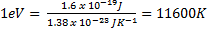 (1)
Using electron volts not only describes each particles temperature, but also defines how much electrical potential energy the particle can overcome.

  - Heating electrons
In plasmas, it is first the electrons we should always focus on. Free electrons are created in gases by radiation and other random processes [45].
(2)
Where X is any atomic species, and hν represents radiation. But to create a stable plasma phase these electrons must be heated. Electrons are heated in plasmas by two mechanisms: Ohmic heating though collisions with neutral atoms/molecules in the bulk plasma, or Stochastic (collision-less) heating via momentum transfer due to the oscillating electric fields at the boundaries of the plasma (the electric fields near surfaces in the plasma are discussed later). The maximum energy (E_{max}) that can be transferred between an electron and a neutral molecule during an elastic collision is given by:
(3)
where m is the atomic mass. As m_{e} << m_{neutral}, this term reduces to 4m_{e} / m_{neutral}. The result is that even for an electron and a neutral molecule colliding in opposite directions, only about 0.01% of the neutral molecules energy is transferred to the electron. For cold plasma, collisions between electrons and neutral molecules result in only a small increase in electron velocity, and thus Ohmic heating is only a minor contributor to electron temperature. Stochastic heating provides the electrons with the majority of their energy in cold plasma. The electron energy distribution function (EEDF) is an important parameter in defining the plasma as the electrical power provided to the gas is coupled with free electrons; having acquired kinetic energy, the electrons then distribute this energy through collisions with other species in the gas, which can lead to ionization and the formation of plasma. For a stable plasma phase to be ignited and maintained, it is critical that the electrons gain enough energy to break bonds, producing radicals, ions and more electrons. Electrons with 3-5eV are capable of causing dissociation collisions, while electrons with greater than ~10eV may cause ionization. A typical plot of an EEDF is given in Figure 2 assuming a Maxwellian distribution. The average electron temperature in technological plasmas is usually 2-5eV [44], and it can be seen that at 3eV only a small proportion of electrons have sufficient energy to cause ionization.
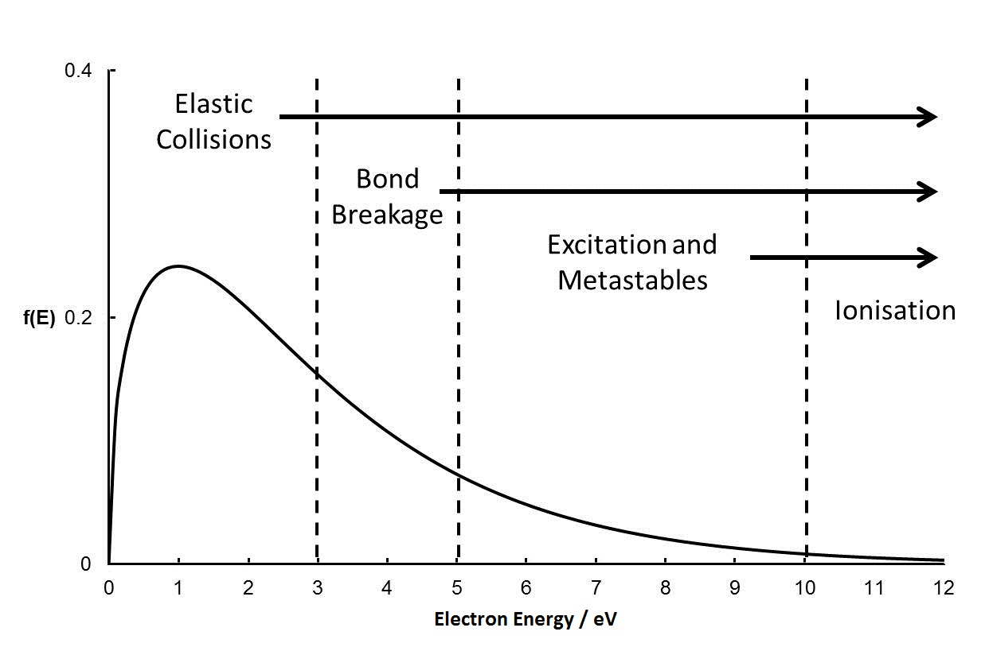
Figure 2. Maxwellian electron energy distribution function with average electron temperature of 3eV, and the types of collisions that each energy can cause.

With neutral gas molecules and electrons with a distribution of energies in the plasma phase, a number of collision processes are possible depending on the energy of the colliding species (Figure 2). Low energy collisions result in elastic scattering, with minimal energy being transferred between the molecule and the electron. These collisions do not result in any reactive species being created. For the molecules in plasmas to become reactive and capable of depositing on surfaces, inelastic collisions must take place to activate the molecules.

Key Points:
1 eV = 11,600 K

For cold plasmas, electrons are heated by electric fields in the plasma, and are defined by an electron energy distribution function. Typically, the average electron temperature is between 2 – 10 eV depending on the operating conditions (for example, electron temperature decreases with increasing pressure).

Electrons distribute energy throughout the plasma through collisions with neutral molecules.

  - Plasma Chemistry
Throughout this review, we will show that the physics of the plasma drives the chemistry, and provides plasma species and surfaces in contact with the plasma with chemical energy which facilitate deposition. In the previous section, we discussed how electrons are heated in plasmas. Here, we discuss how reactive species are created in the plasma phase by hot electron impacts.

Radicals
The energy required to homolytically cleave bonds in organic molecules is typically in the range of 3-5eV [46]. Therefore electrons with kinetic energies greater than 3eV are capable of causing bond scission upon collision with valence electrons in neutral molecules, resulting in the formation of two radical species. For a simple diatomic molecule X₂, this follows Equation 4.
(4)
where X• represents a free radical. In depositing plasmas, these collisions result in large molecules being fragmented into smaller species which are then reactive due to the presence of radical sites. These species can then combine with other molecules either through radical – radical termination, or radical propagation if the other molecule has a double bond. Radicals do not gain energy from the applied RF power as they are neutral and remain at ambient temperature.
Fragmentation of the precursor is a critical parameter for depositing plasmas, particularly where the goal is to functionalise the surface with a specific chemical group. For example, surfaces rich in ether groups can afford the surface with non-fouling properties [21,47]. The degree to which the surface exhibits non-fouling properties is directly related to the ether content [48]. It has been convincingly shown that using low power triethylene glycol monoallyl ether plasma results in high retention of ether groups [10]. Increasing the RF power increases the fragmentation of the precursor in the plasma and ether functionality being lost resulting in surfaces with poor non-fouling properties.
Radical species are highly reactive and the building blocks of conventional polymerization [49]; they are also relatively abundant in the plasma phase. Agarwal et al. for example measured the radical density of oxygen plasmas at around 10¹⁹ radicals m⁻³ using absorbance of white light [50]. Since the early 1970s, it was assumed that due to their role in conventional polymerization and relative abundance in the plasma compared to other species that radicals contributed the majority of the mass to plasma polymer films. It is certainly true that plasma radicals can be a significant source of mass depositing from reactive plasmas, but recent measurements indicate that other species may contribute mass too.

Excited States, Metastables and VUV
More energetic collisions between electrons and neutral species can result in kinetic energy being absorbed by core level electrons of the neutral molecule, rather than the valence electrons which form covalent bonds. In this case, the core level electron is excited to a higher energy orbit, as shown in Equation 5
(5)
where X₂* represents an excited molecule. Excited molecules only exist for a short time before the electron falls back to its’ initial (ground) state in one, or a series of transition steps. Each transition step results in emission of a photon,
(6)
where X₂’ represents a lower level excited state, and h₀ a photon with energy equal to the difference between the two states. The glow of the plasma is due to some of these photons being in the visible region of the electromagnetic spectrum, however a wide range of energetic photons are possible including vacuum ultraviolet (VUV). VUV radiation may also dissociate or ionize molecules if the photons are of sufficient energy.

Ions
Positive ions can be created in plasma by energetic collisions between molecules and electrons above approximately 10eV. The result is ionization of the molecule and release of a free electron as shown in equation 7a.
(7a)

These collisions also maintain the plasma as they create electrons, which can then gain energy from the electric fields and cause further ionization reactions. In cases where the atom X has high electronegativity, the electron may attach to the atom instead forming a negative ion (Eq. 7b) [51]. Note that this collision consumes free electrons and so does not help maintain the plasma. As discussed later, these negative ions also do not arrive at surfaces in contact with the plasma and so do not usually contribute mass to plasma polymers.
(7b)

It has also been shown that ionization of neutral gas molecules may result from collisions between neutral molecules and H₃O⁺ ions. H₃O⁺ is due to the ever present water adsorbed on the walls of the chamber. In this case, a hydrogen ion is transferred from the H₃O⁺ to the neutral molecule, R.
(8)
Thus, the plasma consists of an equal number of ions and electrons, and overall charge neutrality is maintained. While ions are charged, they are massive compared to electrons. Consequently ions do not react to electric fields and accelerate as electrons do, and remain approximately at ambient temperature with the neutral species. As we shall discuss later, while the electrons thermodynamically drive the reactions in the plasma phase, ions are responsible for activating surfaces in contact with the plasma and enabling deposition.

Relative densities
Table 1. Units typically used in measuring plasma pressure, and conversions.
Pa | mbar | mTorr
1 | 1 x 10⁻² | 7.5

The relative density of each species is important, as it affects which of the main chemical deposition pathways dominates. As we show later, this can have a dramatic effect on the performance of the thin film. The pressure used for depositing plasmas varies considerably, but is generally in the range of between 1-100Pa [52] (Table 1 gives conversion constants for other commonly used units of pressure). If we take 10Pa as being a representative value, the density of neutral precursor molecules is ~ 2.5 x 10²¹ / m³.
An important parameter is the plasma density, which is the density of electrons in the plasma phase, n_{e}. For electropositive plasmas, the electron density is equal to the ion density, and therefore the plasma density is also equal to the ion density. The plasma density and the temperature of each species are influenced by factors including the plasma reactor geometry, the operating pressure and efficiency of power coupling. Typically for technological plasma systems used for plasma deposition, the plasma density is in the range of 10¹⁴-10¹⁶ ions m⁻³. Compared to the total density of species mentioned above, ions are relatively rare in the plasma with approximately 10⁴ – 10⁶ gas molecules for each ion. For comparison, based on the work of Agarwal et al, there is approximately 1 radical for every 200 gas molecules [50].
Due to this disparity in relative abundance, the role of ions in plasma polymer deposition has until recently been ignored for RF plasmas, despite the fact that ions have been known to contribute to DC plasma deposition for sometime [e.g. 53]. If the flux of particles to surfaces was solely governed by gas kinetic theory, the flux of radicals would be approximately 100-10,000 times higher than the flux of ions. As discussed below, observation of some plasma physics suggests that ions may be more important in depositing plasmas than previously thought.

Key points:
Electron impacts with different energies create different plasma species.

~3-5eV yields radicals, ~5-8eV yields metastables and VUV radiation, >10eV yields ions.

In technological plasma bulk typically ~10⁵ neutrals : 500 radicals : 1 ion

  - Chemical reactions in the plasma phase
The preceding discussion largely defines the physics of collisions in the plasma phase. Once the plasma has been ignited and the species described above created, collisions between these species may cause chemical reactions. We now must consider the likely reactions that may take place within the plasma.

In the bulk of the plasma, where the species are at close to ambient temperature, we can consider five general 2-body collisions. In order of decreasing cross sectional area they are:

(9a)
(9b)
(9c)
(9d)
(9e)
where •R is a radical species, N is a neutral species (ground state or excited) and I is an ionic species .

3-body collisions are also possible, where the involvement of the third body allows for the dissipation of excess energy [54]. Three body collisions in the gas phase are highly unlikely at low pressure, and so the walls of the plasma chamber often act as the third body.

Neutrals are by far the most abundant species in the plasma, typically accounting for > 99% of the particles. Next most abundant are radicals, and therefore the total collisional cross-section for •R+N is large. The reaction between •R+N results in a larger radical, •RN. If the neutral N contains a carbon-carbon double bond there is the possibility of radical propagation. However, care is required as for example allylic compounds will not readily propagate in this fashion.

Radical – radical collisions are less likely than radical – neutral collisions, but may still have a relatively high cross-section. For •R+R• reactions, the result will either be a di-radical or the radical sites combine to form a neutral. Both reactions are thermodynamically favourable, and for example, the •R+N rate constant for acetylene plasmas has been calculated to be 4 x 10⁻¹¹ cm³ s⁻¹ [55].

As ions typically account for less than 1 in 10,000 of the particles in “cold” low pressure plasmas, reactions involving ions in the plasma phase have often been ignored. However, due to the relative density of neutral species, the total cross sectional area for I + N collisions is actually quite high and the reaction can have a high rate constant; for example, O’Toole et al. have measured rate constant for allyl alcohol M-H⁺ + M at 2.1 x 10⁻⁹ cm³ s⁻¹, where M is the precursor [56]. Reactions I+N and I+R• result in larger ionic species, and plasma phase analysis demonstrates these large ions can be present in high numbers. I+I results in charge neutralization if the ions are of opposite charge. For this case the rate constant is very high due to electrostatic attraction. This has been observed in acetylene plasmas by Stoykov et al. who measured the ion-ion recombination rate constant at 1 x 10⁻⁷ cm³ s⁻¹ [57].

Key points:
Collisions between plasma species can result in larger species being formed in the plasma phase.

  - Plasma phase mass spectrum analysis (experimental results)

Since the 1990s, instrumentation has become available to measure the mass spectrum of charged and neutral species in the plasma phase. Particles in the plasma phase are allowed to enter the instrument via an orifice, typically 100μm in diameter. For measuring neutrals, the particles are ionised using a high energy electron beam; for ionic particles this stage is not required. The charged particles can then be separated due to their energy and mass : charge ratio by applying an electric field, usually a quadrupole mass analyser, before being measured by a detector.
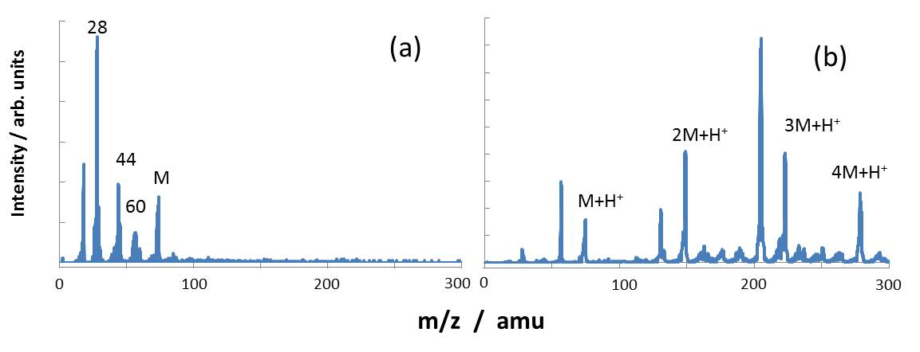
Figure 3. Plasma phase mass spectra of propionic acid at 1Pa and 2W (a) neutral phase and (b) positive ions. Reproduced from ref [15] with permission from The Royal Society of Chemistry

Figure 3 shows the neutral and ionic plasma phase mass spectra of propionic acid [15]. The base peak for the neutral spectrum is the precursor at 74 m/z, with fragment peaks observed at 60, 44 and 28 m/z. No peaks are observed with masses greater than the precursor, indicating that no neutral clusters or oligomers are formed in the plasma. In contrast, the mass spectrum of the ions shows several peaks with masses greater than the precursor. The base peak in the ions is the protonated precursor at 75 m/z, with peaks corresponding to protonated dimers, trimers and even tetramers. In some cases, species up to 7M+H⁺ have been observed [58]. Peaks between these species can be ascribed to pronated clusters after loss of hydrogen atoms, methyl groups or water.
These results are typical for many precursors, with oligomeric species only being observed in the ions, not the neutrals. The exact nature of these protonated dimers and trimers is not known at present; they may be ion clusters which form around a proton, or true oligomers. To date, one of the few exceptions has been methyl isobutyrate which showed a small neutral dimer peak [59]. This shows that while collisions in the plasma may occur relatively frequently between neutral species, the reaction kinetics must be much slower than reactions which include ions.

Key Points:
The relative densities in the plasma phase are Neutral precursors >> Radicals >> Ions

Radicals are formed by fragmentation reactions, and are thus generally smaller than the precursor. Ion fragments may also form, but may also form due to protonation of the precursor. Ions can also react to form oligomeric species which are larger than the precursor.

- Plasma – surface interactions
3.1 Sheath physics
We can safely assume that in the bulk of the plasma only electrons can gain significant kinetic energy (from the oscillating electric fields). (This is true for MHz and only deviates a bit for KHz electrical fields). A consequence is that when considering the plasma phase the neutral and ionic species gain chemical energy in the form of radical sites and charges, but remain at ambient temperature. . It is important to understand that this assumption breaks down as soon as we introduce a surface. In the presence of surfaces (which are of course always present in deposition) ions can acquire energy from electric fields that develop at surfaces and this kinetic energy can drive surface thermodynamics. This is an important feature of plasma deposition that has been completely overlooked in some of the major theses on plasma polymers. For not only do surfaces provide energy to incoming ions, but their presence even changes fluxes by 1 -2 orders of magnitude [44,54].

Plasma phase – surface potentials
Let us consider the bulk plasma and insert an imaginary plane (see Fig 4). The fluxes, J, of all species in the plasma phase through the imaginary plane from one side can be given by:
(10a)
(10b)
(10c)
(10d)
where the thermal velocity of particle x, v_{x}, is given by
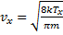 (10e)
and T_{x} is the absolute temperature. As the imaginary plane has no physical properties, these equations hold true for all species. We only have to consider the electrons are at much higher temperature than the other species, so v_{e} >> v_{i} ≈ v_{neutrals}, to a first approximation. If we now consider a real surface, the total particle flux (electrons, ions and neutrals) will only be from one side (the right handside as drawn). Overall the flux of negatively and positively charged species, which are predominately electrons and positive ions respectively has to be equal (this is not the case in highly electronegative gases, where there may be an appreciable negative ion flux.)
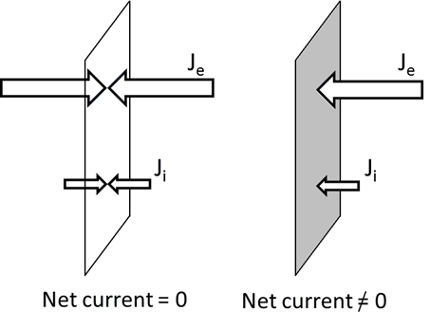
Figure 4. The net flux of charged particles through an imaginary plane (left) is zero, while the net flux to a solid surface is not due to the higher mobility of electrons (right) Reproduced from ref [42] with permission from The Royal Society of Chemistry.

So, quasineutrality is conserved and n_{i} = n_{e}; however the electron velocity (v_{e}) is greater than the ion velocity (v_{i}) as electrons are both hotter and lighter. A consequence of this fact is that the moment we put a surface in the plasma, the electron flux to this surface is much higher than that of ions. Thus, the surface develops a net negative potential, or viewed from the opposite perspective, the plasma develops a positive potential relative to this surface. If the surface were at ground the plasma potential is known as V_{p}. And whilst it is of course, not possible to “suddenly” place a surface in the bulk of plasma, the effect we have just described will occur on all walls containing the plasma, or on any substrate placed in the plasma (before it is ignited). Substrates will be likely to be electrically floating in the plasma (not grounded) and therefore the imbalance of opposite charges will develop a floating potential, V_{f}.

Now, as we have alluded to the total positive and negative particle fluxes must become equal. Therefore as a negative potential develops on the surface, the surface will then begin to repel low energy electrons (J_{e} decreases), and attract positive ions (J_{i} increases). Equilibrium is very quickly established where an equal balance between the positive and negative fluxes is achieved.

The potential difference between the plasma and the wall at equilibrium is known as the sheath voltage, V_{p}-V_{f}, and will be described later but is typically of the order of 10-30V for plasmas depositing functionalised surfaces. This potential will accelerate positively charged to the surface, providing kinetic energy that can do work on arrival at the surface.

The existence of the potential V_{p}-V_{f} has further ramifications that we must now discuss. The first is that there are two regions which must be addressed; a region close to the surface and a region slightly further from the surface but before the bulk plasma, which have distinct properties. These are known as the sheath and pre-sheath respectively.

The Sheath
The sheath region arises when the surface has developed a negative potential relative to the plasma. Electrons are repelled by the negative potential and so their density is reduced compared to the bulk plasma, creating a net positive space charge near the surface (a region depleted of electrons). This region close to the surface is known as the sheath [44]. The sheath has the effect that only relatively few electrons have sufficient energy to overcome the negative potential and reach the surface as shown (in 2d) in Fig 5. As we move across the sheath (perpendicular away from the surface) the density of this net positive charge decreases and eventually, the net charge becomes zero as the electron and ion densities are equal. This point marks the outer edge of the sheath. The Boltzmann equation gives the electron distribution with respect to the distance from the wall, x,
(11)
Poisson’s equation (12) can be used in electrostatics to determine the variation of potential in regions of space charge.
(12)
where φ is the potential, ρ is the density, and ε₀ is the permittivity of a vacuum. Combining this with the Boltzmann distribution gives:
(13)
Where V₀ is the voltage at the wall, and
(14)

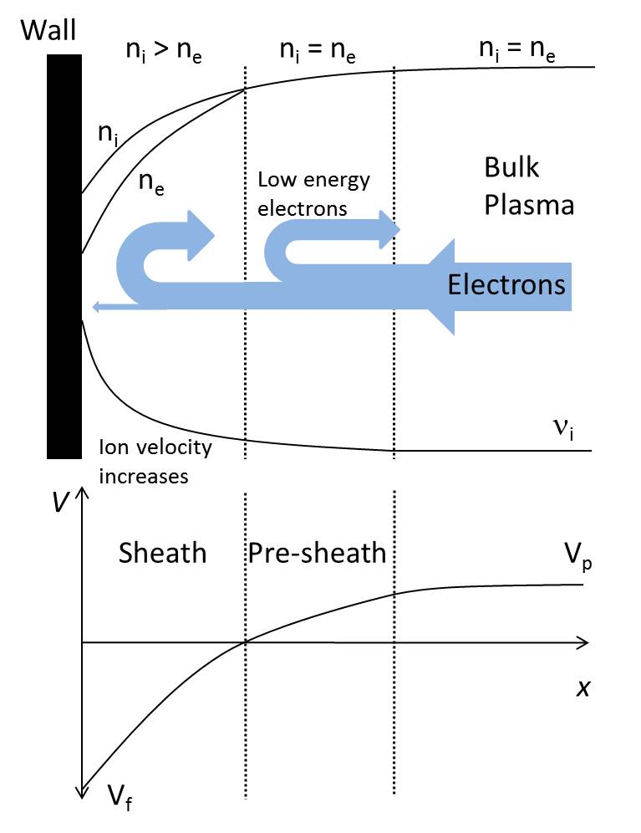Figure 5. A schematic of the sheath and pre-sheath regions showing electrons being repelled from the wall which has acquired a negative potential. Reproduced from ref [42] with permission from The Royal Society of Chemistry.

Where λ_{D} is known as the Debye length. This is shown in Figure 5, where we can see the space charge develop as we move from the bulk of the plasma towards the surface – on the same line imagined earlier but moving the other way, we can see low energy electrons repelled from the surface and positive ions accelerate as they reach the surface. The potential changes as shown in Fig 5b and The Debye length, λ_{D}, detable1termines the length scale of the sheath. The sheath typically extends approximately 100-500μm from the surface and positive ions which enter the sheath accelerate towards the surface due to the negative potential and can only escape the sheath if they collide with other atoms.

Pre-sheath
If the discussion regarding the sheath seems fairly straightforward, there is, however, a complication that arises at the edge of the sheath that has profound consequences for the ion flux arriving at the surface. As ions approach the negatively charged surface, they convert electrical potential energy into kinetic energy. For ion energy conservation:
(15)
As the positive ions accelerate, their density decreases. In the same region, electrons are repelled from the surface and also decrease in density. Now importantly, for the sheath to remain stable, the electron density must always be less than the ion density at all points inside the sheath. Furthermore, by definition the ion and electron densities must be equal at the sheath edge. Given these boundary conditions, David Bohm [60] was the first to identify that the ions must enter the sheath with a speed greater than (kT_{e}/m)^{1/2} (see Chapman [54] for a more mathematical treatment). This speed is known as the Bohm velocity (or occasionally as the acoustic velocity). The electric field (which is < kT) extends out beyond the edge of the sheath (where n_{i}= n_{e}) and there exists a pre-sheath region between the sheath and the bulk plasma. Most importantly for “cold” plasmas, the “Bohm Sheath Criterion” results in an increase in the flux of ions to the surface above the thermal flux (Eq. 10a). If we consider the ions from the bulk enter the pre-sheath with just ambient thermal energy, Bohm showed that the ion flux at the sheath edge is:
(16)
Note that in Eq. 16, the ion flux is proportional to the square root of the electron temperature, T_{e}, and not T_{i} as in Eq.10a. This fact is almost always overlooked in texts describing plasma polymer deposition. It is so important that we repeat that the ion flux to the surface is determined by the electron temperature, not the bulk ion temperature. This is because the flux of ions to the surface must be balanced by an equal flux of electrons. As electrons are repelled from the negatively charged surface, the electron flux to the surface is dependent on the proportion of electrons which can overcome the sheath potential, and hence both ion and electron fluxes depend on T_{e}.
Consequently, for typical values of n_{i} (10¹⁴ - 10¹⁶ ions m⁻³) and T_{e} (~3 eV), typical ion fluxes are in the range of 1-6 x 10¹⁸ ions m⁻² s⁻¹. Calculating the ratio of the ion flux to a surface in Eq. 16, to the thermal flux of ions (Eq. 10a), we get:
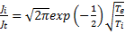 (17)
For most plasma processes used for polymerisation, T_{e} ~30,000K and T_{i} ~ 300K, and so the flux of ions to a surface is enhanced by a factor of ~15 times, simply due to the electric fields created by the plasma around surfaces.

Sheath Potential

While the sheath surrounding surfaces increases the flux of ions to the surface, it also has another important function. The electric field which develops across the sheath also accelerates ions increasing their kinetic energy. Recall that in the bulk of the plasma the ions are not affected by the oscillating electric fields and can only gain little energy through collisions with energetic species, and so remain at approximately ambient temperature (~0.026eV). However the voltage drop across the sheath is generally in the range of 10-30V which provides the ions with enough thermodynamic energy to cause a range of reactions at the surface. The implications of this are discussed below, but for now we can derive the sheath voltage.

If we consider the presheath, the ions accelerate from their normal thermal velocity to the Bohm velocity due a potential difference. Therefore we can determine the presheath potential as
(18)
With regard to the sheath region, we can write the ion and electron fluxes to the surface which must be equal to maintain equilibrium. The ion flux was previously given in Eq. 16
(19)
Where ΔV_{sheath} is the potential difference across the sheath. The exponential term represents the fraction of electrons with enough energy to overcome the potential difference and reach the surface (assuming a Maxwell-Boltzmann distribution). As n_{i} = n_{e} we can solve for V_{sheath}, which yields
(20)
Therefore, the potential difference between the plasma bulk and the wall is the addition of the presheath and sheath potentials.
(21)
It must be noted this is for a DC sheath only.

RF Sheaths
A further complication exists for RF plasmas due to self-biasing [61]. When discussing the charging of a surface placed in contact with the plasma, we noted that the higher mobility of electrons resulted in a higher flux of electrons to the surface than ions when the plasma is ignited. After some time, the potentials developed decreased electron flux and increased ion flux such that equilibrium was established.

However for RF plasmas, the sheath potential is time-dependent. If we consider the case of a RF voltage being imposed on the DC sheath we discussed above (figure 6), electrons will flow to the surface faster during the positive phase of the RF. During the negative phase of the RF, ions will flow faster but will not increase at the same rate as the electrons due to their lower mobility. Therefore a time-averaged RF imposed negative voltage develops on the surface, called the self-bias, V_{sb}. Again, the self-bias voltage is established to maintain an equal flux of electrons and ions, but now the fluxes are time-averaged. The DC sheath voltage derived above then needs to have this voltage added as in Equation 22.
(22)
Where I₀ is a modified Bessel function. For large values of V_{RF}, this equation simplifies to V_{p}-V_{sb} = V_{RF}. Thus, the sheath voltage, and therefore the maximum ion energy, can be highly dependent on the RF.

Key points:
The plasma phase gains a positive potential relative to surfaces due to electrons diffusing out of the plasma faster than ions.

The region close to the surface is depleted of electrons due to the negative charge of the surface. This region is known as the Sheath. Ions pass through the sheath to the surface and gain kinetic energy.

To conserve the Sheath as a region of positive space charge, ions must pass through a pre-sheath region and enter the sheath at the Bohm velocity. This increases the ion flux to the surface above the thermal flux.

  - Collisional vs collision-less
    - Plasma density vs pressure
As discussed above, electrons are heated by electric fields in the plasma. At low pressure, the mean free path of electrons will be large and thus electrons can gain significant energy from the electric fields between collisions. As discussed above, some of these electrons will be at higher temperatures and upon collisions with neutral molecules will be able to ionize them and sustain the plasma. At low pressure this results in electrons in the plasma bulk being able to sustain the plasma, and a homogeneous plasma is formed. This is known as α mode.

As the pressure is increased, the mean free path of the electrons decreases, which reduces the amount of energy the electrons gain between collisions. This results in the average electron temperature decreasing, and thus the fraction of electrons with enough energy to cause ionization decreases. While the frequency of electron – molecule collisions may increase, the frequency of ionization events decreases and the plasma density decreases in the bulk of the plasma. If the pressure is increased too much, the plasma will not be able to be sustained. However, increasing the pressure also increases the frequency of electron-molecule collisions in the sheath (from essentially zero at very low pressure). Therefore, ionization collisions may occur within the sheath, giving rise to secondary electrons which are liberated into a strong electric field in the sheath [44]. These secondary electrons are then accelerated out of the sheath and may acquire a large amount of energy (>50eV). These fast electrons can then ionize neutral molecule close to the sheath. Thus, while the bulk of the plasma decreases in density as the pressure increases, the plasma density near surfaces increases, resulting in a heterogeneous plasma. This is known as γ mode plasma. Under these conditions the Bohm Criterion is not valid, however experimentally the ion flux to the surface can still be measured using ion flux probes. It should be noted that predicting the transition from α to γ mode is not trivial. In general, increasing the pressure and/or power pushes the plasma towards γ mode, but in order to observe this transition experimentally, current - voltage measurements at the electrode should be used.

    - Ion flux to surfaces versus pressure
If we consider again plasma at very low pressure, the mean free path of the electrons is high and therefore they gain significant energy between collisions from the RF fields. Therefore the average electron temperature is high and collisions above the ionisation threshold are likely and the plasma density is high. The ion flux to surfaces under such conditions is then given by the Bohm criterion which is proportional to electron temperature and ion density.

Increasing the pressure decreases the electron mean free path which decreases the electron temperature and thus the plasma density. Therefore in α mode plasma, increasing the pressure decreases the ion flux.

Upon crossing the pressure threshold into γ mode plasma though, the plasma becomes heterogeneous. Ionisation now occurs in the sheath, and in the near sheath regions. This increases the ion flux to surfaces as shown in Table 2. However, collisions in the sheath result in the ion energy being lower.

Pressure (mbar) | Ion flux (10¹⁸ ions/m²s)
0.005 | 0.122
0.008 | 0.114
0.01 | 0.110
0.05 | 0.438
0.06 | 0.525
0.26 | 1.605

Table 2. Ion flux to surfaces from 15W ethanol plasma as a function of pressure. Reproduced with permission from ref [25]

Key points:
At low pressure plasmas are homogeneous, and decreasing pressure at constant input power increases the plasma density.

At high pressure, collisions in the sheath result in plasma density being non-homogeneous, with increased plasma density close to surfaces.

3.3 Energy flux to surface
Ions (kinetic + ionization)

As the plasma transitions from α to γ mode, collisions in the sheath increase resulting in the ions losing energy before reaching the surface. This is shown in Figure 6 where at a pressure of 0.01 mbar the ion energy distribution shows a single peak centred at around 14eV. Increasing the pressure slightly to 0.05 mbar results in the same peak at 14eV, but importantly a smaller peak at around 3eV is evident due to ion-neutral collisions in the sheath. Increasing the pressure further results in higher collision frequency and the average ion energy decreases even further.

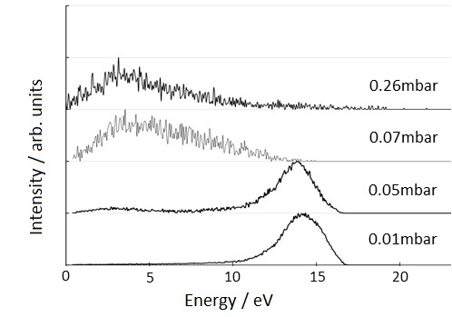
Figure 6. Ion energy of ethanol plasma as a function of pressure at constant power of 15W. Reproduced with permission from ref [25]

But what effect does this have on the total energy being delivered to the surface? Recall that while the average ion energy decreases with pressure, the ion flux increases in the collisional regime. The total kinetic energy being delivered per second to the surface is therefore
(23)
However, each ion arriving at the surface also results in an ion-recombination event, which can liberate ~5eV [56]. Therefore the total energy flux is given by:
(24)
When all contributions are taken into account, the total energy flux to the surface, at constant power, increases with pressure. Importantly for depositing plasmas though, this energy is distributed over many atoms, both on the surface and in the ion itself. As a result the ion is “soft landed” under the low power conditions which are often used when functionalising a surface. This means the degree of etching and rearrangement of atoms on the surface is often quite low. At higher power, etching and ion bombardment may become an issue [62].

Photons
As evident by the glow discharge, the plasma creates photons which can dissipate their energy on the surface. Visible light and VUV are the most common in plasma, but it is the VUV component which is higher in energy and therefore more likely to cause chemical changes to the surface. Titus et al measured the flux of VUV energy under Argon plasma and under the low power commonly used in depositing plasmas, the flux was of the order of ~10¹⁴-10¹⁵ photons cm⁻² s⁻¹ [63]. This is very low in comparison to studies where photons have been used to initiate deposition directly onto surfaces; in one such study the photon flux used was 10¹⁷ cm⁻² s⁻¹ [64]. Further, Barton et al measured the energy flux of ions and photons to a polystyrene surface in an Argon discharge [65]. The ion energy flux was greater than the photon energy flux for pressures below 25mTorr (~3.3 Pa), while the photon energy flux was greater above 25mTorr. However it was noted that some of the emitted photons had energies below the bond strength of the substrate, and that the VUV absorption coefficient for polymers is low, meaning the depth of penetration of the radiation is typically an order of magnitude higher than the ion-stopping distance. This means that much of the photon energy is either not capable of modifying the surface chemistry, or that the modification is likely to occur over a relatively thick slab of the substrate, rather than concentrated at the surface as is the case for ions. Therefore, while the contribution of energy from photons to the surface should not be ignored, under low pressure low power conditions typically used in depositing plasmas the contribution is probably quite low.

Electrons

Most of the electrons which enter the sheath do not have enough energy to overcome the sheath potential, and are ejected. For a Maxwellian distribution with an average electron temperature of 3eV, approximately 1 in 10⁷ electrons have energies above 15eV. Remember that the net current to the surface at equilibrium is zero, so the electron flux is equal to the ion flux, which is of the order of 10¹⁸ - 10¹⁹ m⁻² s⁻¹. The energy with which they arrive at the surface is their temperature in the plasma bulk minus the sheath potential, however they can still provide energy. Electron bombardment has been used to polymerize organic compounds on surfaces, but the electron energy required is usually greater than 100eV [66]. Therefore, in all likelihood electrons probably do not substantially contribute to energy flux at the surface.

The total energy flux to surfaces can cause a range of phenomena. Ion bombardment and ion-recombination, or high energy photons can cause bond scission on the surface resulting in the formation of surface radicals. In the case of depositing plasmas, these radicals are generally located on the top atomic layer, however for plasma immersion ion implantation much higher energies (up to 20keV) are used and the radicals can be located up to 50nm below the surface layer.
If the density of these radicals is high enough, they can recombine randomly with neighbouring radical sites, causing cross-linking of the deposit. This may also result in some rearrangement of heteroatoms (for example, neighbouring carbonyl and hydroxyl groups can combine to form a carboxylate or ester), or elimination of hydrogen [67]. Importantly, energy flux to the surface via ions, photons and electrons can activate the surface which provides a thermodynamic driving force for deposition.

Key points:
Ions provide the surface with the majority of the energy from the plasma due to high energy ion impacts. Each ion impact also releases energy due to ionisation events.

Photons and electrons may also provide the surface with some energy, although orders of magnitude lower than the ions.

The flux of energy activates the surface by causing bond scission, and can also cause cross-linking reactions to occur. This facilitates deposition via grafting as discussed in the next section.

- Mechanisms of deposition
So what does this mean for the surface? We have shown above that the plasma phase consists of a wide variety of species, with different masses, energies and reactivities. Which of these species contribute mass to the deposit? The answer is all of them, however this has not always been so clear. In 1979, Shen and Bell correctly identified that the density of ions in the plasma was approximately 10⁴ – 10⁶ times lower than the density of neutral species [68]. Thus, they concluded that while ion flux could in principle contribute mass to the surface, their contribution could be discounted due to low abundance. They then described possible mechanisms for deposition relating to radical chemistry. This ignored the work of Bohm three decades earlier. Around this time, Yasuda developed the rapid step-growth polymerisation theory to explain deposition from plasma [3]. In this theory, radical species in the plasma phase react with each other and surface radicals to form the deposit. Therefore, from the early 1980s plasma deposition was thought to be dominated by radical chemistry. This is largely because the mechanisms to explain plasma deposition were developed by chemists, and the mechanisms of “traditional” radical polymerisation had already been established and understood. The very nature of reactive plasmas dictates that chemical pathways be examined, and several important contributions have been made describing chemical reactions of the plasma phase [69]. More recently, an appreciation of the physics of plasmas has enabled greater understanding of how ions play a major role in the deposition process, and indeed can contribute substantial mass themselves. For example, Milella et al described ions as activating the substrate via high energy collisions, which then enabled radical and neutral species to deposit [70]. Hegemann et al built on this and introduced an energy density term, described as the energy being delivered to the surface per depositing atom [71]. More recently, Thiry et al described how plasma diagnostic tools have enabled deeper understanding of the chemistry of the plasma phase and the physics of surface interactions [72]. This has led to the roles of each species being re-evaluated, and the developments described now allow real time measurement and control of plasma processes which had not been possible previously. Here, we analyse the contribution of each class of species separately and show how both kinetic energy (physics) and chemical energy play a role in deposition.

4.1 Radical – radical (chemical energy)
Surface radicals created by ion bombardment can react with plasma phase radicals resulting in termination. Thus, radical – radical reactions utilise chemical energy gained by species in the plasma phase and at the surface. Note that multiple physical interactions must occur to provide the surface and plasma species chemical energy to enable deposition. (neutral/electron collision forming radical, neutral/electron collision forming ion, ion/surface collision). These reactions terminate reactive sites, and thus for further deposition to occur the surface must be activated again by ion bombardment.
As discussed above, the radical density in the plasma phase is relatively high, and the surface density of radical sites has been measured by electron spin resonance in the order of 10¹⁴ cm⁻², and increases with power [73]. Due to their relative abundance, the thermal flux of radicals to the surface is relatively high. Thus, since the 1970s deposition from reactive plasmas was thought to be dominated by radical – radical termination reactions. However recent measurements on methyl radicals depositing on surfaces show that the sticking probability is very low at ~ 3 x 10⁻⁵ [74]. This is because for a termination reaction to occur, the radical species must not only collide with a surface radical site, but must also be in the correct orientation to present the radical centre. In the case of methyl radicals, this was ~50%. As the molecular weight of the radical species becomes larger, steric effects become more important and the sticking probability decreases further [75]. While some of the precursors used in depositing plasmas are low molecular weight, such as acetylene and ammonia, others can be quite large, for example heptylamine.

  - Radical propagation (chemical energy)
Another mechanism for plasma species to covalently bind to surface radical sites is via radical propagation. This requires that the plasma species have a carbon-carbon double bond which can transfer an electron to the surface radical site, creating a chemical bond with the surface and leaving another radical site, similar to traditional radical polymerisation. Note that deposition via this mechanism requires only the surface be activated by the plasma, as species in the gas phase utilise chemical energy inherent in the structure of the precursor. This can have a major impact on the deposition rate. For example, propionic acid and acrylic acid are commonly used precursors which differ in that propionic acid is saturated, while acrylic acid contains a double bond. The deposition rate of propionic acid is approximately 5 times lower than acrylic acid at low power due to the ability of acrylic acid to deposit via this mechanism [76]. As the power increases, increased fragmentation of the precursor results in loss of the double bond functionality and radical propagation becomes less important. This mechanism also helps to retain chemical functionality, as it allows intact precursor molecules to deposit, rather than requiring they be fragmented pre-deposition.
The effectiveness of double bonds in increasing deposition rate varies due to the precursor structure. For example, allylic compounds contain double bonds which have resonant structures. Such precursors deposit similar to saturated precursors. 1,7 - Octadiene in contrast contains two terminal double bonds and thus deposits extremely fast.

  - Ion deposition (kinetic energy)
Direct deposition of ions was discounted as a mechanism of depositing mass on the surface in plasma due to low abundance in the 1970s [68]. As discussed above, there are approximately 10⁵ neutrals and around 500 radicals for each ion in the plasma. It was thought that ions then provided the surface with energy enabling subsequent grafting by neutrals. Plasma was thought to be “ion-assisted” deposition, but the mass contribution of ions was discounted. Hyperthermal ion deposition though has shown that the sticking probability of ions is much higher than neutrals and radicals. In the regimes typically encountered in depositing plasmas, the sticking probability increases with ion energy. For hexamethyl disiloxane plasmas, the dominant ion is the protonated precursor minus a methyl group. Brookes at al selected these ions from a plasma based on their mass and energy and deposited them on a surface [77]. At low ion energies of 15eV the sticking probability for this ion was ~20% which increased to ~50% at 100eV. This is because ions arrive at the surface at elevated temperature, >10eV, and can therefore utilise their kinetic energy to drive deposition. It has been shown for some saturated and allylic precursors that ions can contribute approximately 50% of the mass to deposit [20,78]. Thermodynamically, direct ion deposition relies on an electron / neutral ionization collision, and the sheath potential to drive deposition.

4.4 Sticking probabilities
In many cases, it has been assumed that the sticking probability of ions is 1 [79]. Recent studies on the deposition rate of hyperthermal ions though show that a more realistic value of the sticking probability is in the region of 20-50%, depending on the ion energy [77]. As noted by Jacobs though, ions with energies greater than ~15eV can etch and deposit on the surface simultaneously, and so the measured sticking probability is in reality a net value [62].
Of the species present in “cold” plasma, ions are unique as they arrive at the surface with significant kinetic energy, usually greater than 10eV. This opens a range of surface reactions to ions which can be driven by kinetic energy, including deposition, bond scission, surface radical formation and etching. Neutral species arrive at the surface near ambient temperature and must rely on chemical energy to drive reactions. For radicals, this means that the radical must arrive close to an existing surface radical, which depends on the surface radical density. The surface radical density in turn is strongly dependent on the applied power, and the chemistry of the plasma [73]. Thus, while the radical flux to the surface may be quite high, the probability of sticking may vary depending on the nature of the plasma and the radical species. For example, von Keudell et al showed that the sticking probability of CH₃ radicals is very low at ~3 x 10⁻⁵[74], but for C₂H radicals is very high at 0.92 [80]. It was also shown that a CH₃ radical colliding with a surface radical results in a sticking probability of only ~50%. This is for a small CH₃ radical with a single radical centre; as the radical species becomes larger, steric and collision orientation effects become important and the sticking probability may become even lower, while for species with multiple radical centres it may increase. We can expect a similar type of analysis for neutral species which contain a double bond colliding with a surface radical.
Thus, while the density of neutrals in the plasma phase may be much higher than that of ions, this may not lead to higher neutral deposition rates. Ions can have higher average molecular weight due to oligomerisation and higher sticking probabilities due to their higher average energy, resulting in higher deposition rates than would be expected from their relative density in the plasma. Therefore, both neutrals and ions should be considered as contributing mass to the deposit.

4.5 Sputtering (kinetic energy)
As the ion energy increases, ion bombardment not only causes surface radical formation but can etch the surface [62]. Under this regime, the net deposition rate then becomes a competition between deposition and sputtering. Sputtering not only causes decreased net deposition rate, but may also decrease retention of chemical functionality as groups which are deposited on the surface are then bombarded with high energy ions which cause homolytic scission (radical formation) and cross-linking.

Key points:
Ions can deposit on surfaces via kinetic energy. Kinetic energy from ions can also create surface radicals due to bond scission, and sputter material already deposited on the surface.

Radicals and neutrals from the plasma phase rely on chemical energy (radical centres or double bonds) to graft to the surface via surface radicals

Surface processes are driven by energy delivery, which may be due to ion energy flux, photons or other energetic species.

- Implications for plasma polymer thin films
5.1 Functional group retention
In many applications, the deposit must retain some chemical functionality present in the precursor [81]. For example, surfaces functionalised with carboxylic acids, amines and ether groups are often sought. In some cases, the exact nature of these groups is unknown; for example, carboxylic acid or primary amine groups may be cross-linked to esters or secondary amines but such conformational changes are not routinely detected by surface analysis. More recently, much more complex structures have been retained in plasma deposits capable of initiating atomic transfer radical polymerisation [82]; in this case the functionality of the surface is critically linked to the retention of the complex α-bromoisobutyrate group, and cannot be simply correlated with bromine content.

General rules have been established for retaining functionality. By lowering the power / precursor molecule, simple functional groups can be retained with high efficiency such as shown in Figure 7 for acrylic acid.
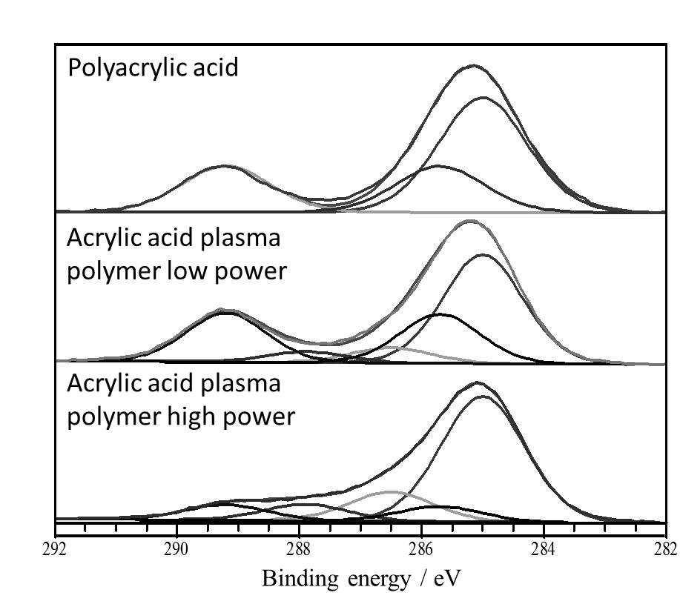
Figure 7. Retention of carboxylic acid groups in acrylic acid plasma polymers, showing high retention of the carboxylic acid peak at 289eV when the plasma power is kept low. Reproduced from ref [42] with permission from The Royal Society of Chemistry.

The question that remains is which species help retain chemical functionality? Plasma phase analysis reveals that neutrals and radical species are fragmented due to electron impacts. Some of these species will still retain the desired groups, but others lose their functionality. Ions can also be fragmented in the plasma, but also form protonated precursor and oligomeric species. If these ions have high energy (>20eV) upon impact they can cause atomic rearrangements and thus cause functional group loss, but under lower power processes ions can be “soft landed” and will not damage the surface. Intact precursor molecules obviously retain their functionality, and if they contain double bonds can significantly contribute to the deposit with good functional group retention. It has recently been shown for hexamethyl disiloxane plasmas that the chemistry of the plasma polymer is dependent on energetic considerations in both the plasma phase and at the surface [83].
The overall retention of functionality is then dependent on the relative mass contributions of each mechanism. This is demonstrated by the comparison of propionic acid and acrylic acid. Not only does acrylic acid deposit much faster due to the possibility of radical propagation reactions, but functional retention is greater than propionic acid under the same conditions.

5.2 Solubility
While maximising functional group retention is often desirable, in many cases this increases the solubility of the deposit, particularly for deposits which gain a charge when placed in contact with water [84]. Primary amines for example act as centres for water molecules to hydrogen bond, and thus decrease the stability of aminated thin films. Fabricating functionalised surfaces then can be a trade-off between maximising surface functional density and stability of the surface in water.
In cases where maximum surface functionalization is desirable, the stability of the deposit can be optimised with recourse to the mechanisms of deposition. Precursors which favour deposition involving radicals are more likely to deposit in linear chains which are then relatively soluble. This is the case for ethylenediamine, which has been shown to have a delicate structure which is readily fragmented in the plasma phase into smaller radical species [24]. Due to the abnormally high abundance of radicals, the deposition is biased towards radical termination reactions. In contrast, the structure of allylamine is quite stable in the plasma phase and the deposition is dominated by ionic deposition [22,24]. In the context of film stability, an important parameter is the energy density during deposition. The energy being provided to the surface, E_{surf}, is given by Eq. 25.
(25)
The energy density, E_{density}, during deposition is then given by the delivered energy divided by the deposition rate, R.
(26)
The energy density is then related to the amount of energy being provided per atom. As the energy density increases, the likelihood of cross-linking increases, which acts to stabilise the film. It is well known that functional groups such as amines and carboxylic acids decrease in solubility when they are coupled to larger hydrocarbon chains. Increasing the cross-linking density offers a means of stabilising films while maximising the functional group density.

5.3 Mechanical properties
In a similar way, the mechanical properties of the film can be tuned. In designing surfaces for cell attachment, the elastic modulus of the surface plays a key role in cell attachment and signalling [85]. Radicals and neutrals which arrive at the surface do so at ambient temperature and bind to the surface using chemical energy. They therefore have opportunity to find the most thermodynamically favourable orientation as they deposit. Ions in contrast, arrive at greatly elevated temperatures, and are more likely to deposit in the orientation in which they arrive. This results in ionic deposition being more random in nature with more cross-linking and low density due to void spaces forming, while neutral deposition allows time for voids to be filled before subsequent deposition [15]. Controlling the ion energy allows for the hardness of the deposit to be tailored [86,87]. It should be noted that while the mechanical properties of diamond-like carbon films has been studied previously, this is one of the least investigated aspects of functionalised plasma deposition to date.

- Conclusion
In plasma, electrical power is coupled with free electrons which gain kinetic energy and distribute this energy to atoms/molecules in the gas phase via high energy collisions. This activates the gas species by creating radicals and ions; however this alone is not enough to thermodynamically drive deposition on surfaces. An understanding of the physics of plasma shows that while ions remain at ambient temperature in the bulk of the plasma, they gain significant energy when colliding with surfaces which activates the surface and drives deposition. Therefore, plasma phase interactions are driven by electrons (electron density and electron temperature), while surface interactions are driven by the delivery of energy to the substrate which enables further reactions to occur at the surface (for example ion – substrate collisions or VUV photon flux).
For many researchers and industrial scientists, plasma polymerisation is seen as a black box; inputs of gas flowrate and electrical power are correlated to the resulting surface chemistry without necessarily understanding the physical and chemical processes which produce the thin film. This causes many issues when laboratory processes are scaled-up, or indeed when a process is transferred to another laboratory, as the processes cannot simply be scaled with physical dimensions. Understanding the underlying physics of plasma will enable surface chemists to better tailor processes for a specific outcome, and help identify the critical parameters for scaling processes.
Measuring plasma parameters, such as plasma density, ion energy, electron temperature etc, is not routinely done for depositing plasmas, but in principle should allow process transfer, and also allow process control in real-time. Recent improvements in instrumentation to measure these parameters will aid our ability to utilise plasma polymerisation.

- References
- Chatelier R C, Dai L, Griesser H J, Li S, Zientek P, Lohmann D, Chabrecek P. US Patent, 6623747, 2003-09-23
- Moustafa, M, Simpson C, Glover M, Dawson R A, Tesfaye S, Creagh F M, Haddow D, Short R, Heller S, MacNeil S. A new autologous keratinocyte dressing treatment for non-healing diabetic neuropathic foot ulcers. Diabetic Medicine, 2004, 21(7): 786–789
- Yasuda H. Plasma polymerization. New York: Academic Press, 1985.
- Kettle A, Beck A J, O'Toole L, Jones F, Short R. Plasma polymerisation for molecular engineering of carbon-fibre surfaces for optimised composites. Composites Science and Technology, 1997, 57(8):1023-1032.
- Lopattananon N, Kettle A, Tripathi D, Beck A J, Duval E, France R M, Short R D, Jones F R. Interface molecular engineering of carbon-fiber composites. Composites Part A: Applied Science and Manufacturing, 1999, 30(1):49-57.
- Beck A J, Jones F R, Short R D. Plasma copolymerization as a route to the fabrication of new surfaces with controlled amounts of specific chemical functionality. Polymer, 1996, 37(24):5537-5539.
- Michelmore A, Whittle J D, Short R D, Boswell R W, Charles C. An Experimental and Analytical Study of an Asymmetric Capacitively Coupled Plasma Used for Plasma Polymerization. Plasma Processes and Polymers, 2014, 11(9): 833–841
- Suzuki K, Nakamura K, Ohkubo H, Sugai H. Power transfer efficiency and mode jump in an inductive RF discharge. Plasma Sources Science and Technology, 1998, 7(1): 13–20.
- Ward R J, Molecular Engineering of Surfaces by Plasma Copolymerization and Enhanced Cell Attachment and Spreading. Dissertation for the Doctoral Degree. University of Durham, UK, 1989
- Beyer D, Knoll W, Ringsdorf H, Wang J-H, Timmons R B, Sluka P. Reduced protein adsorption on plastics via direct plasma deposition of triethylene glycol monoallyl ether. Journal of Biomedical Materials Research Part A, 1997, 36(2): 181-189
- Padron-Wells G, Estrada-Raygoza I C, Thamban, P L S, Nelson C T, Chung C-W, Overzet L J, Goeckner M J. Understanding the Synthesis of Ethylene Glycol Pulsed Plasma Discharges. Plasma Processes and Polymers, 2013, 10(2): 119−135.
- Chen R T, Muir B W, Thomsen L, Tadich A, Cowie B C C, Such G K, Postma A, McLean K M, Caruso F. New Insights into the SubstratePlasma Polymer Interface. Journal of Physical Chemistry B, 2011, 115(20): 6495-6502
- Daw R, O'Leary T, Kelly J, Short R D, Cambray-Deakin M, Devlin A J, Brook I M, Scutt A, Kothari S. Molecular engineering of surfaces by plasma copolymerization and enhanced cell attachment and spreading. Plasmas and Polymers, 1999, 4(2-3): 113-132
- Daw R, Candan S, Beck A, Devlin A, Brook I, MacNeil S, Dawson D A, Short R D. Plasma copolymer surfaces of acrylic acid/1, 7 octadiene: surface characterisation and the attachment of ROS 17/2.8 osteoblast-like cells. Biomaterials, 1998, 19(19):1717-1725.
- Michelmore A, Steele D A, Robinson D E, Whittle J D, Short R D. The link between mechanisms of deposition and the physico-chemical properties of plasma polymer films. Soft Matter, 2013, 9(26): 6167-6175
- Whittle J D, Short R D, Douglas C, Davies J. Differences in the aging of allyl alcohol, acrylic acid, allylamine, and octa-1, 7-diene plasma polymers as studied by X-ray photoelectron spectroscopy. Chemistry of Materials, 2000, 12(9):2664-2671.
- Gengenbach T R, Chatelier R C, Griesser H J. Characterization of the ageing of plasma-deposited polymer films: Global analysis of x-ray photoelectron spectroscopy data. Surface and Interface Analysis, 1996, 24(4): 271−281.
- Haddow D B, Steele D, Short R D, Dawson R A, Macneil S. Plasma‐polymerized surfaces for culture of human keratinocytes and transfer of cells to an in vitro wound‐bed model. Journal of Biomedical Materials Research Part A, 2003, 64A(1): 80-87
- Padron-Wells G, Jarvis B C, Jindal A K, Goeckner M J. Understanding the Synthesis of DEGVE Pulsed Plasmas for Application to Ultra Thin Biocompatible Interfaces. Colloids and Surfaces B, 2009, 68(2): 163-170
- Michelmore A, Bryant P M, Steele D A, Vasilev K, Bradley J W, Short R D. Role of Positive Ions in Determining the Deposition Rate and Film Chemistry of Continuous Wave Hexamethyl Disiloxane Plasmas. Langmuir, 2011, 27(19): 11943-11950
- Michelmore A, Gross-Kosche P, Al-Bataineh S A, Whittle J D, Short R D. On the Effect of Monomer Chemistry on Growth Mechanisms of Nonfouling PEG-like Plasma Polymers. Langmuir, 2013, 29(8): 2595-2601
- Choukourov A, Biederman H, Slavinska D, Hanley L, Grinevich A, Boldryeva, H, Mackova A. Mechanistic Studies of Plasma Polymerization of Allylamine. Journal of Physical Chemistry B 2005, 109(48): 23086-23091
- Michelmore A, Charles C, Boswell R W, Short R D, Whittle J D. Defining Plasma Polymerization: New Insight Into What We Should Be Measuring. ACS Applied Materials and Interfaces, 2013, 5(12): 5387−5391
- Daunton C, Smith L E, Whittle J D, Short R D, Steele D A, Michelmore A. Plasma Parameter Aspects in the Fabrication of Stable Amine Functionalized Plasma Polymer Films. Plasma Processes and Polymers, 2015, 12(8): 817–826
- Saboohi S, Jasieniak M, Coad B R, Griesser H J, Short R D, Michelmore A. Comparison of Plasma Polymerization under Collisional and Collision-Less Pressure Regimes, Journal of Physical Chemistry B, 2015, 119(49): 15359−15369
- Zhang Z H, Liu S L, Shi Y, Dou J, Fang S M. DNA Detection and Cell Adhesion on Plasma-Polymerized Pyrrole. Biopolymers, 2014, 101(5): 496–503
- Wang L, Liu X-J, Hao J, Chu L-Q. Long-range surface plasmon resonance sensors fabricated with plasma polymerized fluorocarbon thin films. Sensors and Actuators B, 2015, 215: 368-372
- Jiang Z, Jiang Z-J. Plasma techniques for the fabrication of polymer electrolyte membranes for fuel cells. Journal of Membrane Science, 2014, 456: 85-106
- Hua J, Zhanga C, Jiangb L, Fanga S, Zhanga X, Wanga X, Menga Y. Plasma graft-polymerization for synthesis of highly stable hydroxide exchange membrane. Journal of Power Sources, 2014, 248: 831-838
- Zhao X Y, Wang M Z, Ji JQ, Wang T H, Yang F, Du, J M. Structural Analysis and Dielectric Property of Novel Conjugated Polycyanurates. Polymer Engineering and Science, 2014, 54(4): 812-817
- Li P H, Li L M, Wang W H, Jin W H, Liu X M, Yeung K W K, Chu P K. Enhanced corrosion resistance and hemocompatibility of biomedical NiTi alloy by atmospheric-pressure plasma polymerized fluorine-rich coating. Applied Surface Science, 2014, 297: 109-115
- Feng Y E, Liao X P, Wang Y N, Shi B. Improvement in Leather Surface Hydrophobicity Through Low-Pressure Cold Plasma Polymerization. Journal of the American Leather Chemistry Association, 2014, 109(3): 89-95
- Yang Z L, Xiong K Q, Qi P K, Yang Y, Tu Q F, Wang, J, Huang N. Gallic Acid Tailoring Surface Functionalities of Plasma-Polymerized Allylamine-Coated 316L SS to Selectively Direct Vascular Endothelial and Smooth Muscle Cell Fate for Enhanced Endothelialization. ACS Applied Materials and Interfaces, 2014, 6(4): 2647-2656
- Li J W, Wu Z X, Huang C J, Liu H M, Huang R J, Li LF. Mechanical properties of cyanate ester/epoxy nanocomposites modified with plasma functionalized MWCNTs. Composites Science and Technology, 2014, 90: 166-173
- Sun Y Y, Liang Q, Chi H J, Zhang Y J, Shi Y, Fang D N, Li F X. The Application of Gas Plasma Technologies in Surface Modification of Aramid Fiber. Fibers and Polymers, 2014, 15(1):1-7
- Tian M, Yin Y, Yang C, Zhao B, Song J, Liu J, Li X-M, He T. CF₄ plasma modified highly interconnective porous polysulfone membranes for direct contact membrane distillation (DCMD). Desalination, 2015, 369: 105-114
- Ma G-Q, Liu Y. Surface modification of polypropylene by ethylene plasma and its induced β-form in polypropylene. Chinese Journal of Polymer Science, 2015, 33(5): 669-673
- Wan S J, Wang L, Xu X J, Zhao C H, Liu X D. Controllable surface morphology and properties via mist polymerization on a plasma-treated polymethyl methacrylate surface. Soft Matter, 2014, 10(6): 903-910
- Zhang Z G, Zhang T Z, Li J S, Ji Z L, Zhou H M, Zhou X F, Gu, N. Preparation of poly(L-lactic acid)-modified polypropylene mesh and its antiadhesion in experimental abdominal wall defect repair. Journal of Biomedical Materials Research Part B, 2014, 102(1): 12-21
- Denaro A R, Owens P A, Crawshaw A. Glow Discharge Polymerization − Styrene. European Polymer Journal, 1968, 4(1): 93-106
- Westwood A R. Glow Discharge Polymerization − Rates and Mechanisms of Polymer Formation. European Polymer Journal, 1971, 7(4): 363-375
- Michelmore A, Steele D A, Whittle J D, Bradley J W, Short R D. Nanoscale deposition of chemically functionalised films via plasma polymerisation. RSC Advances, 2013, 3(33): 13540–13557
- Chabert P, Braithwaite N. Physics of Radio-Frequency Plasmas. Cambridge: Academic Press, 2011
- Lieberman M A, Lichtenberg A J. Principles of Plasma Discharges and Materials Processing. Chichester: John Wiley and Sons, 1994.
- Hulburt E O. Atmospheric Ionization by Cosmic Radiation, Physical Review, 1931, 37(1): 1-8
- Blanksby S J, Ellison G B. Bond Dissociation Energies of Organic Molecules. Accounts of Chemical Research, 2003, 36(4): 255-263
- Johnston E E, Beyers J D, Ratner B D. Plasma Deposition and Surface Characterization of Oligoglyme, Dioxane, and Crown Ether Nonfouling Films. Langmuir, 2005, 21(3): 870-881
- Menzies D J, Cowie B, Fong C, Forsythe J S, Gengenbach T R, McLean K M, Puskar L, Textor M, Thomsen L, Tobin M, Muir B W. One-Step Method for Generating PEG-Like Plasma Polymer Gradients: Chemical Characterization and Analysis of Protein Interactions. Langmuir, 2010, 26(17): 13987-13994
- Flory P J, Principles of polymer chemistry. New York: Cornell University Press, 1953.
- Agarwal S, Quax G W W, van de Senden M C M, Maroudas D, Aydil E S. Journal of Vacuum Science and Technology Part A, 2004, 22:(1) 71-81.
- Booth J-P, Corr C S, Curley G A, Jolly J, Guillon J, Földes T. Fluorine negative ion density measurement in a dual frequency capacitive plasma etch reactor by cavity ring-down spectroscopy. Applied Physics Letters, 2006, 88(15): 151502
- Whittle J D, Short R D, Steele D A, Bradley J W, Bryant P M, Jan F, Biederman H, Serov A A, Choukurov A, Hook A L, Ciridon W A, Ceccone G, Hegemann D, Korner E, Michelmore A. Variability in plasma polymerization processes – An international round-robin study. Plasma Processes and Polymers, 2013, 10(9): 767−778.
- Williams T, Hayes M W. Polymerization in a glow discharge. Nature, 1966, 209: 769−773.
- Chapman B, Glow Discharge Processes. Chichester: John Wiley and Sons, 1980.
- Doyle J R, Chemical kinetics in low pressure acetylene radio frequency glow discharges. Journal of Applied Physics, 1997, 82(10): 4763-4771
- O’Toole L, Mayhew C A, Short R D. On the plasma polymerisation of allyl alcohol: an investigation of ion–molecule reactions using a selected ion flow tube. Journal of the Chemical Society, Faraday Transactions, 1997, 93(10): 1961-1964
- Stoykov S, Eggs C, Kortshagen U. Plasma chemistry and growth of nanosized particles in a C₂H₂ RF discharge. Journal of Physics D: Applied Physics, 2001, 34(14): 2160
- Oh J-S, Bradley J W. Heavy Ion Formation in Plasma Jet Polymerization of Heptylamine at Atmospheric Pressure. Plasma Processes and Polymers, 2013, 10(10): 839-842
- O'Toole L, Short R D, Ameen A P, Jones F R. Mass Spectrometry of and Deposition-rate Measurements from Radiofrequency-induced Plasmas of Methyl Isobutyrate, Methyl Methacrylate and n-Butyl methacrylate. Journal of the Chemical Society, Faraday Transactions, 1995, 91(9): 1363-1370
- Bohm D. Minimum ionic kinetic energy for a stable sheath. In: Guthrie A, Wakerling R K, editors. The Characteristics of Electrical Discharges in Magnetic Fields. London: McGraw Hill, 1949, 77–86.
- Vender D, Boswell R W. Numerical Modeling of Low-Pressure RF Plasma. IEEE Transactions on Plasma Science,1990, 18(4): 725-732
- Jacobs D C, Reactive collisions of hyperthermal energy molecular ions with solid surfaces. Annual Review of Physical Chemistry, 2002, 53: 379–407.
- Titus M J, Nest D, Graves D B. Absolute vacuum ultraviolet flux in inductively coupled plasmas and chemical modifications of 193 nm photoresist. Applied Physics Letters, 2009, 94(17): 171501.
- Truica-Marasescu F, Wertheimer M R, Vacuum-Ultraviolet Photopolymerisation of Amine-Rich Thin Films. Macromolecular. Chemistry and Physics, 2008, 209(10): 1043-1049.
- Barton D, Bradley J W, Gibson K J, Steele D A, Short R D. An in situ comparison between VUV photon and ion energy fluxes to polymer surfaces immersed in an RF plasma. Journal of Physical Chemistry B, 2000, 104(30): 7150-7153
- Haller I, White P. Polymerization Of Butadiene Gas On Surfaces Under Low Energy Electron Bombardment. Journal of Physical Chemistry, 1963, 67(9): 1784-1788
- Peter S, Graupner K, Grambole D, Richter F. Comparative experimental analysis of the a-C:H deposition processes using CH₄ and C₂H₂ as precursors. Journal of Applied Physics, 2007, 102(5): 053304.
- Shen M, Bell A T. A review of recent advances in plasma polymerization. In: Shen M, Plasma Polymerization. ACS Symposium Series. Washington, DC: American Chemical Society, 1979, 1–33.
- Friedrich J, Plasma Processes and Polymers, Mechanisms of Plasma Polymerization – Reviewed from a Chemical Point of View. 2011, 8(9): 783-802
- Milella A, Palumbo F, Favia P, Cicala G, d’Agostino R. Continuous and Modulated Deposition of Fluorocarbon Films from c-C₄F₈ Plasmas. Plasma Processes and Polymers, 2004, 1(2): 164-170
- Hegemann D, Hanselmann B, Blanchard N, Amberg M. Plasma-Substrate Interaction during Plasma Deposition on Polymers. Contributions to Plasma Physics, 2014, 54(2): 162-169
- Thiry D, Konstantinidis S, Cornil J, Snyders R. Plasma diagnostics for the low-pressure plasma polymerization process: A critical review. Thin Solid Films 2016, 606: 19-44
- Ershov S, Khelifa F, Lemaur V, Cornil J, Cossement D, Habibi Y, Dubois P, Snyders R. Free Radical Generation and Concentration in a Plasma Polymer: The Effect of Aromaticity. ACS Applied Materials and Interfaces, 2014, 6(15): 12395−12405
- Von Keudell A, Schwartz-Selinger T, Meier M, Jacob W. Direct identification of the synergism between methyl radicals and atomic hydrogen during growth of amorphous hydrogenated carbon films. Applied Physics Letters, 2000, 76(6): 676–678.
- McNaught A D, Wilkinson A. IUPAC Compendium of Chemical Terminology, 2nd Edn. Oxford: Blackwell Scientific Publications, 1997.
- O'Toole L, Beck A J, Ameen A P, Jones F R, Short R D. Radiofrequency-induced Plasma Polymerisation of Propenoic Acid and Propanoic Acid. Journal of the Chemical Society, Faraday Transactions, 1995, 91(21): 3907-3912
- Brookes P N, Fraser S, Short R D, Hanley L, Fuoco E, Roberts A, Hutton S J. The effect of ion energy on the chemistry of air-aged polymer films grown from the hyperthermal polyatomic ion Si₂OMe⁺₅. Electron Spectroscopy and Related Phenomena, 2001, 121(1-3):281–297.
- Beck A J, Candan S, Short R D, Goodyear A, Braithwaite N StJ. The Role of Ions in the Plasma Polymerization of Allylamine. Journal of Physical Chemistry B, 2001, 105(24): 5730-5736
- Michelmore A, Whittle J D, Short R D. The importance of ions in low pressure PECVD plasmas. Frontiers in Physics, 2015, 3: 3
- Von Keudell A. Surface processes during thin-film growth. Plasma Sources Science and Technology, 2000, 9(4): 455–467.
- Khelifa F, Ershov S, Habibi Y, Snyders R, Dubois P. Free-Radical-Induced Grafting from Plasma Polymer Surfaces. Chemical Reviews, 2016, 116(6): 3975–4005
- Coad B R, Styan K E, Meagher L. One Step ATRP Initiator Immobilization on Surfaces Leading to Gradient-Grafted Polymer Brushes. ACS Applied Materials and Interfaces, 2014, 6(10): 7782−7789.
- Blanchard N E, Hanselmann B, Drosten J, Heunberger M, Hegemann D. Densification and Hydration of HMDSO Plasma Polymers. Plasma Processes and Polymers, 2015, 12(1): 32-41
- Ryssy J, Prioste-Amaral E, Assuncao D F N, Rogers N, Kirby G T S, Smith L E, Michelmore A. Chemical and physical processes in the retention of functional groups in plasma polymers studied by plasma phase mass spectroscopy. Physical Chemistry Chemical Physics, 2016, 18(6): 4496--4504
- Hopp I, Michelmore A, Smith L E, Robinson D E, Bachhuka A, Mierczynska A, Vasilev K. The influence of substrate stiffness gradients on primary human dermal fibroblasts. Biomaterials, 2013, 34(21): 5070-5077
- Memming R, Tolle H J, Wierenga P E. Properties Of Polymeric Layers Of Hydrogenated Amorphous Carbon Produced By A Plasma-Activated Chemical Vapour Deposition Process II: Tribological And Mechanical Properties. Thin Solid Films, 1986, 143(1): 31-41
- Pappas D L, Hopwood J. Deposition of diamondlike carbon using a planar radio frequency induction plasma. Journal of Vacuum Science and Technology Part A, 1994, 12(4):1576-1582

