Technical comment on Boersma et al. (2016) Temperature driven changes in the diet preference of omnivorous copepods: no more meat when it’s hot? Ecology Letters, 19, 45-53.

Monika Winder^{1*}, Alfred Burian¹, Michael R Landry², David JS Montagnes³, Jens M Nielsen¹

¹Department of Ecology, Environment, and Plant Sciences, Stockholm University, 10691 Stockholm, Sweden
²Integrative Oceanography Division, Scripps Institution of Oceanography, La Jolla, CA 92093-0218, USA
³Institute of Integrative Biology, University of Liverpool, Liverpool L69 7ZB UK

AUTHORSHIP
MW wrote the first draft of the manuscript, and all authors contributed substantially to revisions. JMN and AB provided the figures.

*Correspondence: monika.winder@su.se
Abstract
A recent study concluded that omnivorous plankton will shift from predatory to herbivorous feeding with climate warming, as consumers require increased carbon:phosphorous in their food. Although this is an appealing hypothesis, we suggest the conclusion is unfounded, based on the data presented, which seem in places questionable and poorly interpreted.

COMMENT
Identifying major shifts in trophic interactions is central for understanding how natural and anthropogenic pressures affect food web structure and function. To this end, Boersma et al. (Boersma et al. 2016) concluded that marine planktonic omnivores should shift from predatory to herbivorous feeding with climate warming. The authors argue that the metabolic requirements for carbon (C) and phosphorus (P) have different temperature dependencies, with consumers preferring food of a higher C:P ratio (i.e. autotrophs) at higher temperature. Although their conclusion derives from an admirable combination of field and experimental approaches, we suggest there are unacceptable limitations in their methodologies and data interpretation. Specifically, we have misgivings regarding their application of (i) stable isotope (SI) ratios in field studies and (ii) the results of their laboratory experiments, which contradict previous findings and the first principle of metabolic theory.

While SI is a widely used method, the need for careful and critical application has been repeatedly emphasized (Boecklen et al. 2011; Middelburg 2014); here we raise some relevant concerns. Assuming a constant trophic fractionation factor, Boersma et al. (2016) used the measured differences between nitrogen (N) SI ratios of seston and the copepod Temora longicornis to infer a decrease in the copepod’s trophic position (TP), from carnivore to herbivore, with seasonally increasing temperature. However, issues associated with their application of isotopes are evident, as ~50% of TPs assigned to the copepod are below the level for a pure herbivore (TP=2). For a strict heterotroph, these are clearly unrealistic values that likely arise from uncertainties in (i) the trophic fractionation factor (i.e. isotopic enrichment from diet to consumer) and (ii) the variable qualities of seston components comprising the trophic baseline. Trophic enrichment also depends on sources of variation, such as temperature, food quantity and quality (Adams & Sterner 2000), and age or size classes of consumers (Matthews & Mazumder 2008), which vary strongly over seasons. While Boersma et al. (2016) acknowledge the influence of temperature, they incorrectly state that Power et al. (Power et al. 2003) found a positive relationship between temperature and ¹⁵N trophic enrichment, which would steepen the slope of their regression relationship between temperature and SI-derived TP, further supporting their conclusions. In reality, however, the Power et al. (2003) relationship for N is negative (-0.16‰ °C⁻¹), which if applied removes much of this proposed trend (see Fig. 1c in Boersma et al. 2016). In addition, Gutiérrez-Rodríguez et al. (2014) demonstrated that the trophic steps between algal prey and protistan consumers are isotopically invisible. Thus, any seasonal shift in copepod diet, from large phytoplankton→ copepods (colder months) to small phytoplankton→heterotrophic protists→copepods (warmer months), would not have been measured by this isotopic approach.

The use of a mixed seston sample comprising phytoplankton, heterotrophs, and detritus for isotopic baseline estimation is another major uncertainty for assessing zooplankton TPs, as each component can have a distinct SI and vary seasonally in relative contribution to seston. For example, isotopic differences among phytoplankton taxa indicate that the variation of δ¹⁵N could be up to 10 ‰, an equivalent of 3 TPs (Vuorio et al. (Vuorio et al. 2006). We illustrate with a simple model how differences among phytoplankton taxa can explain TP variations of the magnitude observed in the Boersma et al. (2016) field data (Fig. 1). Here, a change in seston community composition from diatoms to cyanobacteria shifts the isotope value of the seston. This then shifts the calculated TP of the consumer from carnivory (TP = 3) to herbivory (TP = 2), even though the zooplankter is feeding only on diatoms. Similarly, a shift in copepod feeding selectivity among algae with different isotope compositions can explain changes in SI-based TP estimates, even if the seston composition remains constant (Fig. 1). Furthermore, seasonal variance in isotope composition within each component of the heterogenous seston induce uncertainty in the baseline estimate used to calculate TP (Matthews & Mazumder 2007). The isotope values of seston and T. longicornis measured within a day by Boersma et al. (2016) show high isotopic variation, which, by averaging, is not considered in their TP-analysis. Consequently, the amount of variation in copepod TP due to diet and other sources cannot be distinguished. All of these scenarios are likely to contribute significantly to uncertainties in SI-derived TP estimates for copepods, providing multiple alternate hypotheses to explain the trends observed by Boersma et al. (2016). A more detailed critical Review including suggestions to address issues related to the isotope approach is warranted in future.

Boersma et al. (2016) also performed a three-trophic-level grazing experiment to support their claim of increased herbivory with warming. However, their data (i) contrast with findings of species-specific temperature effects for the same algae and heterotrophic dinoflagellate used in their experiments (Fig. 2); (ii) contradict the first principles of metabolic theory (Brown et al. 2004) with a negative relationship between net change in algal abundance (reflecting growth rate, as stated by the authors) and temperature; (iii) show a lack of temperature effect on microzooplankton growth rate (again reflected by relative changes in abundance); and (iv) present a negative influence of temperature on specific ingestion rates of both microzooplankton and copepods when fed with replete algae. Although inhibition may occur at high temperatures (Fig. 2), these pronounced and inexplicable trends raise further concerns regarding the authors’ experimental procedures and subsequent conclusions.

We agree that Boersma et al. (2016) raise an important ecological question, and we support the conceptual approach that was taken linking shifts in food acquisition to changes in digestibility of particles and consumer physiological requirements. However, due to substantive methodological limitations and questionable interpretations, we strongly argue that their hypothesis is unsupported by the data presented and requires more rigorous testing.

REFERENCES
1. Adams, T.S. & Sterner, R.W. (2000). The effect of dietary nitrogen content on trophic level. Limnology and Oceanography, 45, 601–607.
2. Boecklen, W.J., Yarnes, C.T., Cook, B.A. & James, A.C. (2011). On the use of stable isotopes in trophic ecology. Annual Review of Ecology, Evolution, and Systematics, 42, 411–440.
3. Boersma, M., Mathew, K.A., Niehoff, B., Schoo, K.L., Franco-Santos, R.M. & Meunier, C.L. (2016). Temperature driven changes in the diet preference of omnivorous copepods: no more meat when it's hot? Ecology Letters, 19, 45–53.
4. Brown, J.H., Gillooly, J.F., Allen, A.P., Savage, V.M. & West, G.B. (2004). Toward a metabolic theory of ecology. Ecology, 85, 1771–1789.
5. Gutiérrez-Rodríθez, A., Décima, M., Popp, B.N. & Landry, M.R. (2014). Isotopic invisibility of protozoan trophic steps in marine food webs. Limnology and Oceanography, 59, 1590–1598.
6. Kimmance, S.A., Atkinson, D. & Montagnes, D. (2006). Do temperature-food interactions matter? Responses of production and its components in the model heterotrophic flagellate Oxyrrhis marina. Aquatic Microbial Ecology, 42, 63–73.
7. Matthews, B. & Mazumder, A. (2007). Distinguishing trophic variation from seasonal and size-based isotopic (δ 15N) variation of zooplankton. Canadian Journal of Fisheries and Aquatic Sciences, 64, 74–83.
8. Matthews, B. & Mazumder, A. (2008). Detecting trophic-level variation in consumer assemblages. Freshwater Biology, 53, 1942–1953.
9. Middelburg, J.J. (2014). Stable isotopes dissect aquatic food webs from the top to the bottom. Biogeosciences, 11, 2357–2371.
10. Montagnes, D.J.S. & Franklin, D.J. (2001). Effect of temperature on diatom volume, growth rate, and carbon and nitrogen content: Reconsidering some paradigms. Limnology and Oceanography, 46, 2008–2018.
11. Power, M., Guiguer, K.R.A. & Barton, D.R. (2003). Effects of temperature on isotopic enrichment in Daphnia magna: implications for aquatic food-web studies. Rapid Communications in Mass Spectrometry, 17, 1619–1625.
12. Post DM (2002) Using stable isotopes to estimate trophic position: models, methods, and assumptions. Ecology, 83, 703-718.
13. Vuorio, K., Meili, M. & Sarvala, J. (2006). Taxon-specific variation in the stable isotopic signatures (δ¹³C and δ¹⁵N) of lake phytoplankton. Freshwater Biology, 51, 807–822.
14. Yang, Z., Lowe, C.D., Crowther, W., Fenton, A., Watts, P.C. & Montagnes, D.J.S. (2012). Strain-specific functional and numerical responses are required to evaluate impacts on predator–prey dynamics, 7, 405–416.

Figure legends:
Fig. 1. Calculation of zooplankton consumer trophic position (TP) with varying seston composition and shift in copepod feeding selectivity using a conceptual stable isotope model. Model outcomes illustrate two scenarios: i) Zooplankton consumer feeding only on diatoms during a shift in seston community composition from 0% to 100% diatom (grey dashed line Seston A), and ii) copepod feeding selectivity changing from 100% cyanobacteria to 100% diatom diet in the case of a seston comprising of equal proportions of both algae (grey solid line Seston B). Both scenarios are followed by a shift in consumer TP (zooplankton (A, B), blue line and top panel). The lower panel shows δ¹⁵N values of diatoms (yellow line) and cyanobacteria (green line) with values of 0 and 3.4‰, respectively, and a zooplankton consumer (red dashed line Zooplankton A) feeding solely on diatoms and thus a constant δ¹⁵N value of 6.8‰ (assuming enrichment of 3.4‰ per trophic step after Post (2002)) and a zooplankton consumer switching its dietary resource from purely cyanobacteria to strictly diatoms (red solid line Zooplankton B). In this example, the difference between diatoms and cyanobacteria is only about 1/3 of the natural variability reported for various phytoplankton taxa (Vuorio et al. 2006).

Fig. 2. Thermal responses of the algae Rhodomonas salina and heterotrophic dinoflagellage Oxyrrhis marina growth rate, i.e. the taxa used by Boersma et al. (2016). Growth rates typically increase with temperature up to the optimal temperature. In contrast, Boersma et al. (2016) reported a negative relationship between R. salina growth and temperature (red dotted line, calculation based on the abundance-temperature regression provided by Boersma et al. 2016 in Fig. 2a and the conversion of abundances to growth rates using start algae abundance) and no significant cell abundance-temperature relationship for O. marina (Fig. 2b in Boersma et al. 2016). Data for R. salina are from (Montagnes & Franklin 2001) and for O. marina from (Kimmance et al. 2006). A study investigating strain differences in Oxyrrhis spp. yielded similar temperature-growth rate relationships
(Yang et al. 2012). O. marina growth rates were measured at comparable food concentrations to those used by Boersma et al. (2016).

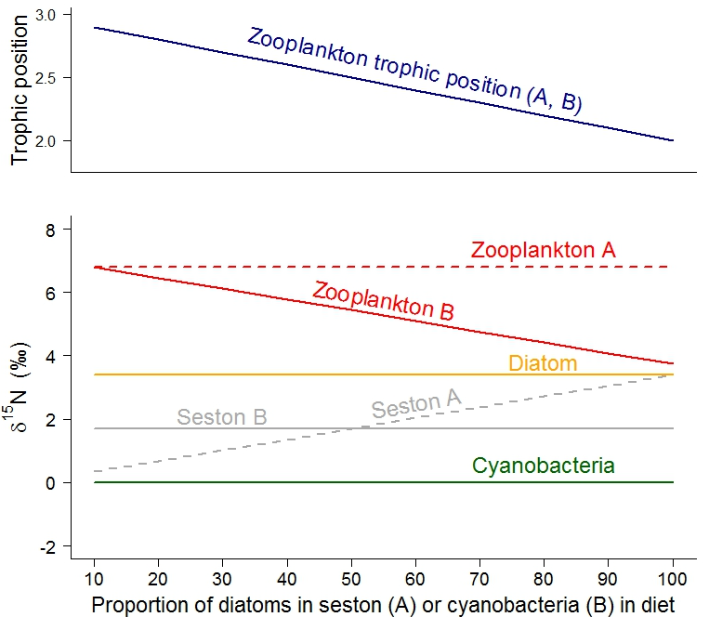

Fig. 1

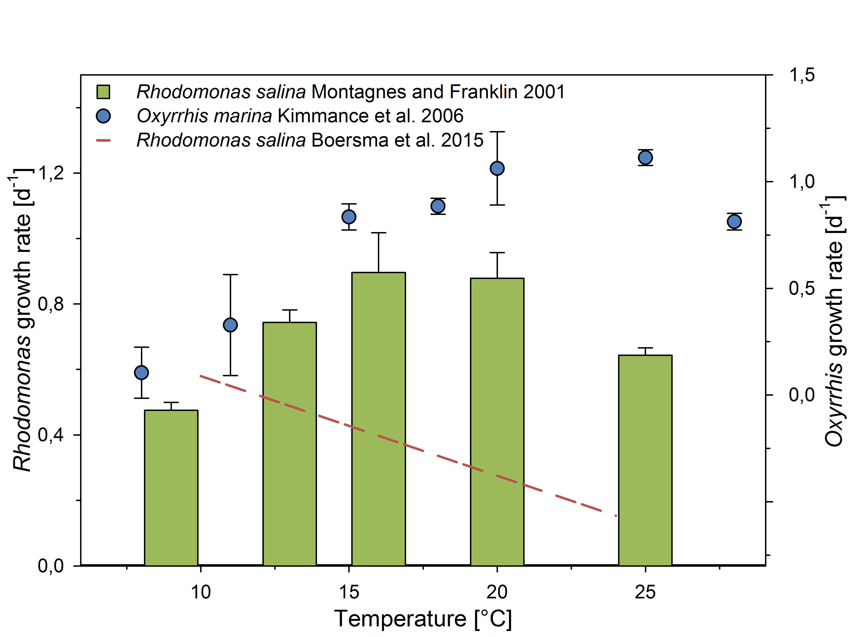
Fig. 2

