AgBiI₄ as a Lead-Free Solar Absorber with Potential Application in Photovoltaics
Harry C. Sansom,¹ George F. S. Whitehead,¹ Matthew S. Dyer,¹ Marco Zanella,¹ Troy D. Manning,¹ Michael J. Pitcher,¹ Thomas J. Whittles,^{2,3} Vinod R. Dhanak,^{2,3} Jonathan Alaria,² John B. Claridge¹ and Matthew J. Rosseinsky¹
¹Department of Chemistry, University of Liverpool, Crown Street, Liverpool L69 7ZD, UK
²Department of Physics, University of Liverpool, Oxford Street, Liverpool L69 7ZE, UK
³The Stephenson Institute for Renewable Energy, University of Liverpool, Liverpool L69 3BX, UK

ABSTRACT
AgBiI₄ powder, crystals and polycrystalline films were synthesized by sealed tube solid state reactions, chemical vapor transport (CVT) and solution processing, respectively, and their structural, optical and electronic properties are reported. The structure of AgBiI₄ is based unambiguously upon a cubic close packed iodide sub-lattice, but it presents an unusual crystallographic problem: we show that the reported structure, a cubic defect-spinel, cannot be distinguished from a metrically cubic layered structure analogous to CdCl₂ using either powder or single crystal X-ray crystallography. In addition, we demonstrate the existence a non-cubic CdCl₂-type polymorph by isolation of non-twinned single crystals. The indirect optical band gap of AgBiI₄ is measured to be 1.63(1) eV, comparable to the indirect band gap of 1.69(1) eV measured for BiI₃ and smaller than that reported for other bismuth halides, suggesting that structures with a close-packed iodide sub-lattice may give narrower band gaps than those with perovskite structures. Band edge states closely resemble those of BiI₃, however the p-type nature of AgBiI₄ with low carrier concentration is more similar to MAPbI₃ than the n-type BiI₃. AgBiI₄ shows good stability toward the AM1.5 solar spectrum when kept in a sealed environment, and is thermally stable below 90 °C.

1. INTRODUCTION
Lead halide based perovskites and perovskite-related semiconductors, particularly methylammonium lead iodide (MAPbI₃), are of great interest due to their remarkable performance in photovoltaic devices. This stems from their possession of a suitable band gap as set by the Shockley-Queisser limit,¹ high absorption coefficients suitable for thin film technology,² good carrier mobilities³⁻⁵ and low recombination rates.^{4, 6, 7} Furthermore, films can be cast from solution⁸ or vapor deposited⁹ and contain inexpensive, earth-abundant elements. The main issues associated with these materials are low stability against thermal and photo-induced degradation (e.g. MAPbI₃ is sensitive to light and heat,^{10, 11} moisture¹² and oxygen¹²), and the potential environmental impact associated with scale up of new lead-based technologies, a concern which is shared with other families of functional materials such as ferroelectrics¹³. Studies exploring the chemical diversity of this class of materials have investigated substituting the methylammonium cation with other organic cations,¹⁴⁻¹⁷ the Pb(II) cation with Sn(II)^{14, 18, 19} or Ge(II), ^{20, 21} and replacing or mixing the halides between Cl, Br and I. ²²⁻²⁵ Attempts to substitute Pb(II) with Sn(II) or Ge(II) have produced compounds that oxidize rapidly to Sn(IV)¹⁴ and Ge(IV)²⁰ in air and more recently the similar chemistries of Pb(II) and Bi(III), which are isoelectronic 6s² cations, has led to interest in developing Bi(III) halide based semiconductors for this purpose. Research has concentrated on producing direct analogues of the hybrid lead perovskites, with 3D networks of bismuth halide octahedra expected to produce narrower band gaps.²⁶ Several ternary and quaternary Bi-based compounds based on a perovskite-type halide sub-lattice have been investigated as potential solar absorbers, including (CH₃NH₃)BiI₄, ²⁷ (NH₄)₃Bi₂I₉, ²⁸ A₃Bi₂I₉ (A = K, Rb, Cs),²⁹ Cs₂AgBiX₆ (X = Cl, Br)³⁰ and (CH₃NH₃)₂KBiCl₆²⁶, but all have been found to exhibit band gaps that are too wide to be used in single junction solar cells (1.90-3.04 eV). In contrast, BiI₃,^{31, 32} whose structure is based on a hexagonal close-packed iodide sub-lattice, has a smaller band gap of 1.69(1) eV,³³ similar to that reported for AgBi₂I₇,³⁴ which is thought to be close packed³⁵. This indicates that selection of a suitable iodide packing array may be an important step in the development of bismuth based halide solar absorbers.
Several Bi-rich compounds based on a close-packed iodide sub-lattice have been reported in the AgI-BiI₃ (Ag_{1-3x}Bi_{1+x}I₄) phase field³⁶. The earliest study of Ag_{1-3x}Bi_{1+x}I₄ isolated the bismuth-rich composition Ag_{0.58}Bi_{1.14}I₄ (x = 0.14), which was reported to crystallize in a cubic unit cell.³⁷ Subsequent reports suggested that this cubic phase is stable across a range of stoichiometries, as it is observed independently for AgBiI₄^{36, 38} (x = 0) and for the compositions Ag_{0.73}Bi_{1.09}I₄ - Ag_{0.58}Bi_{1.14}I₄³⁹ (x = 0.09 - 0.14) using different synthetic routes. The structure of the cubic phase was solved using crystals of AgBiI₄ grown by a solvothermal method,³⁶ and is reported as a cubic close-packed iodide lattice where edge-sharing octahedra are occupied by either an Ag⁺ or Bi³⁺ cation, giving rise to an extended 3D network. It can be considered as a spinel type structure with all of the tetrahedral sites vacant (Figure 2b). Here we use three different routes to synthesize AgBiI₄ as powder, single crystals and solution-deposited films, and evaluate its use as a lead-free solar absorber by detailed characterization of its structure, composition, and electronic and optical properties.

2. EXPERIMENTAL SECTION

2.1 Synthesis procedures
Commercial BiI₃ powder (Alfa Aesar, 99.999 %) was used for the preliminary syntheses (compositional screening) of Ag_{1-3x}Bi_{1+x}I₄, but was found to contain BiOCl as a crystalline impurity and was not used thereafter. The BiI₃ powder used for the synthesis of high quality AgBiI₄ samples (powders, crystals and films) was synthesized directly from the elements: 0.43 mmol Bi powder (Alfa Aesar, 99.999 %, kept in a He-filled dry box) and 0.75 mmol I₂ powder (Sigma-Aldrich, 99.8 %), corresponding to a 16 mol% excess, were combined in a borosilicate tube of length 150 mm, inner diameter of 7 mm and wall thickness of 2 mm and sealed at a pressure of 10⁻⁴ mbar by using a liquid nitrogen bath to prevent the sublimation of I₂. The tube was placed vertically inside a furnace with enclosed heating elements and heated to 427 °C to a melt overnight with slow heating and cooling rates of 1 °C min⁻¹ due to the high vapor pressure of elemental I₂. The resulting BiI₃ powder was found to be phase pure by PXRD and the composition was measured as Bi_{0.98(3)}I_{3.00(3)} by scanning electron microscopy energy-dispersive X-ray spectroscopy (SEM EDX). The AgI starting material (Alfa Aesar, 99.999%) was found to be pure by PXRD with the composition Ag_{1.00(2)}I_{1.00(2)} as measured by SEM EDX, and used throughout the study.
All powder samples were synthesized in sealed 200 mm long quartz tubes, with 1 mm thick walls and a 6 mm internal diameter. The tubes were vacuum sealed at 10⁻⁴ mbar, placed vertically inside a furnace with enclosed heating elements and the temperature was ramped at 5 °C min⁻¹ to 610 °C, held for 1 day and then cooled at a rate of 5 °C min⁻¹ to 350 °C and held for a further 5 days. The tubes were then quickly taken out of the furnace and the bottom half (containing the powder) was quenched to room temperature in a water bath to suppress the formation of BiI₃ and Ag₂BiI₅, which form when the reaction is cooled slowly (see Figure S1).
AgBiI₄ single crystals were grown by chemical vapor transport (CVT). CVT growth was carried out by placing BiI₃ (0.33 mmol) and AgI (0.25 mmol) in a 150 mm long quartz tube, with 1 mm thick walls and a 6 mm internal diameter, which was then vacuum sealed at 10⁻⁴ mbar. The tube was placed horizontally in the middle of a horizontal two-zone tube furnace between temperatures 363 °C and 350 °C for two weeks, with a temperature gradient of 0.8 °C cm⁻¹, the powder being at the hot end. Black octahedral-faceted crystals of dimensions approximately 0.5 mm × 0.5 mm × 0.5 mm and black elongated plate crystals of faces approximately 0.1 mm × 0.5 mm suitable for single crystal X-ray diffraction studies were isolated.
Optimized films were deposited on 15 mm x 15 mm glass substrates, which had been prepared by the following protocol: they were cleaned with soap, sonicated in acetone for 10 minutes, methanol for 5 minutes, rinsed with DI water, dried under a nitrogen gas flow, sonicated in isopropanol for 10 minutes and finally dried again under a nitrogen gas flow. BiI₃ (0.117 mmol) and AgI (0.058 mmol) were dissolved in 4 cm³ DMSO by heating and sonicating at 50 °C for 30 minutes. The solution was then dropped onto a glass substrate until full coverage was achieved. The deposited solution was dried by placing the glass slide in an oven and heating to 200 °C at a rate of 3.4 °C min⁻¹. Once at 200 °C, the oven was switched off, allowing the films to cool back to room temperature.

2.2 Characterization methods
2.2.1 Structural. Initial compositional screening, light sensitivity and solution casting experiments made use of powder X-ray diffraction (PXRD) data measured on a Panalytical X’Pert Pro diffractometer using Co Kα₁ radiation (λ = 1.7890 Å) in Bragg-Brentano geometry and an X’Celerator detector. Phase identification was carried out using the X’Pert HighScore Plus (Version 2.2a)⁴⁰ with the PDF-2-ICDD database. PXRD data of AgBiI₄ in capillaries used for photostability assessment were measured on a Bruker D8 Advance diffractometer using monochromated Mo Kα₁ radiation (λ = 0.7093 Å).
PXRD patterns used for detailed structural analysis were collected using the MAC detectors on the I11 beam line at the synchrotron at Diamond Light Source (RAL, Oxfordshire, UK) with a wavelength of λ = 0.825898 Å at room temperature. Samples were mixed with 80 vol% amorphous boron to reduce absorption effects, and contained within 0.3 mm diameter borosilicate capillaries. For stability measurements the sample was measured every 10 °C on heating from 60-350 °C, using a position sensitive detector for rapid data collection. Topas Academic (Version 5)⁴¹ was used to perform Le Bail fittings and Rietveld refinements of the data. VESTA⁴² was used for graphical representation of the structures.
Single crystal X-ray diffraction (SCXRD) data were collected at 100 K on a Rigaku MicroMax™-007 HF diffractometer with a molybdenum rotating anode microfocus source and a Saturn 724+ detector using Rigaku Crystal Clear v2.0. Unit-cell indexation, data integration and reduction were performed using Rigaku CrysAlisPro v171.38.43.⁴³ The structure was solved and refined using SHELX-2013,⁴⁴ implemented through Olex2.⁴⁵
2.2.2 Compositional Analysis. SEM EDX was used to measure the composition as a direct elemental analysis technique. Measurements were carried out using a Hitachi S-4800 SEM and an Oxford Instruments model 7200 EDS X-Ray detector with the quantification carried out using the microanalysis suite of the Inca Suite software (Version 4.15). Measurements on powders consisted of taking the spectra of 9 different areas. Measurements on crystals consisted of taking the spectra at 3 different areas on each crystal however crystals used for structural analysis were subject to 6 measurements each. Powders of AgI and BiI₃ were used as EDX standards (see Figure S2). All powders and crystals were sputtered with 15 nm Au to limit charging effects. Errors on reported average compositions correspond to the 1σ standard deviation of the measured distribution.
2.2.3 Optical and Electronic Properties. UV-Visible spectra were taken on a Shimadzu UV-2600 instrument with an integrating sphere in both reflection and transmission mode to measure the absorbance, diffuse reflectance and transmittance. The measurements on the powder sample consisted of a small amount of powder pressed between two glass slides and was exposed to light between wavelengths 600-1400 nm. The Kubelka-Munk function F(R) was obtained from the diffuse reflectance measurements R using the equation F(R) = (1 – R)² /2R. Tauc plots were then plotted using (hνF(R))^{1/n} vs. hν where n = ½ and 2 for direct and indirect band gaps respectively. The absorption coefficients of the films deposited on glass slides were calculated using $\text{α} \text{=} \text{-ln(}\text{T}\text{/(1-}\text{R}\text{))/}\text{d}$ where $\text{α}$ is the absorption coefficient (cm⁻¹), T is the transmission, R is the reflection, and d is the average film thickness (cm). The thickness of each film was measured using a WYKO NT1100 Optical Profiling System. A strip of the film was wiped off the glass substrate to produce a step profile, which was measured in 16 areas for each film. The mean of these step heights is reported as the film thickness with errors corresponding to the standard deviation.
2.2.4 X-ray Photoelectron Spectroscopy Measurements. XPS measurements were conducted on powders of BiI₃ and AgBiI₄ using a SPECS monochromatic Al Kα (1486.6 eV) X-ray source and a PSP MCD5 analyzer. Further details, including spectrometer calibration can be found elsewhere.⁴⁶ Use of 54.7° atomic scaling factors (ASFs)⁴⁷ applied to the Ag 3d_{5/2}, Bi 4f_{7/2} and I 3d_{5/2} peak areas gave approximate surface compositions Bi_{1.0}I_{2.9} and Ag_{0.2}Bi_{1.0}I_{3.1}. Charge neutralization at the surface was achieved by means of a low energy electron flood gun and subsequent correction of the binding energy scale to the adventitious C 1s peak (284.8 eV).
2.2.5 Resistivity and Thermopower. Seebeck coefficient and resistivity were measured in a Quantum Design PPMS Dynacool system using the thermal transport and electrical transport options respectively. The Seebeck coefficient was measured on a cold pressed pellet in a two probe configuration using disc shaped copper leads attached with conductive epoxy. The resistivity was measured on a bar shaped sample in a two probe configuration with gold wires attached using silver paint, achieving ohmic contacts.
2.2.6 Photo stability. Two experiments were performed to measure the stability of the material towards the solar spectrum: the first under ambient conditions in an open system, and the second under controlled atmospheres in sealed vessels. For both experiments, a Solar Light Model 16S-300-002 Solar Simulator was used which has a spectral output that complies with air mass 1.5 (AM1.5) per the ASTM standard definition. The combination of neutral density filters and lamp-to-sample distance allowed for the tuning of the intensity of the incident light to 1000 W m⁻² as measured by a Solar Light Pyranometer PMA2144 and datalogging radiometer PMA2100. For measurements under an ambient atmosphere, AgBiI₄ powder was sprinkled on to a glass slide. Sample temperatures were monitored using a T-type thermocouple and were found to stay below 35 °C. Second, for measurements in sealed atmospheres, AgBiI₄ was loaded into thin-walled (0.01 mm wall thickness) borosilicate capillaries under ambient air, dry synthetic air and helium, and these were sealed with a gas-oxygen torch. The capillaries were then placed in the solar simulator and subjected to the full solar spectrum at an intensity of 1000 W m⁻².

2.3 Computational Details.

Density functional theory calculations were performed with a plane-wave basis under periodic boundary conditions using VASP.⁴⁸ A plane-wave cutoff energy of 400 eV was used throughout, and core-electrons were treated using the projector augmented wave method.⁴⁹ Structural optimization was performed using the optB96b-vdW functional⁵⁰ without the inclusion of spin-orbit coupling until atomic forces were less than 0.001 eV Å⁻¹. This was found to reproduce the experimental cell parameters of BiI₃ to within 1%⁵¹ (Figure S3). Electronic structure calculations (band structure and density of states, DOS) were then performed using the PBE⁵² functional with spin-orbit coupling included. The inclusion of spin-orbit coupling has been found to be necessary for the correct description of BiI₃³³.
Structural models of AgBiI₄ were constructed in rhombohedral cells with initial lattice parameters of a = b = c = 14.93 Å, and α = β = γ = 33.56˚, containing 8 metal cations and 16 iodide anions. This cell was chosen such that both the proposed spinel and CdCl₂ structures could be modelled in the same cell. With each structure, the symmetrically unique configurations of four Ag⁺ and four Bi³⁺ ions were constructed, resulting in nine configurations in the spinel structure and six in the CdCl₂ structure. The cell and atomic positions of every configuration was then relaxed and the electronic structure calculated using a 7×7×7 k-point grid. Of all sixteen calculations, one of the two lowest energy configurations had the defect-spinel structure, and one the CdCl₂ structure, the defect-spinel structure being more stable by only 18 meV per AgBiI₄ formula unit (using optB86b-vdW energies, Table S1). The crystal and electronic band structures of these two lowest energy configurations are shown in Figures S4 and S5.

3. RESULTS
3.1 Synthesis and Composition
An initial compositional screening of the Ag_{1-3x}Bi_{1+x}I₄ system was performed by reacting AgI and BiI₃ following the powder synthesis procedure described in section 2.1, with a range of nominal compositions corresponding to 0 ≤ x ≤ 0.19, which covers the range of reported compositions resulting in compounds with the defect-spinel structure (x = 0³⁶, 0.09³⁷– 0.14³⁹). It was necessary to quench the tubes from 350 °C to room temperature to prevent the formation of BiI₃ and Ag₂BiI₅ impurities. For all starting compositions, this route resulted in a bulk powder phase at the bottom of the tube, and a small quantity of fragile flat dendritic crystals, with widths and lengths varying between 50 μm and 300 μm, at the top of the tube. These crystals were found to be silver-poor AgBi₂I₇ (measured by SEM EDX), and their yield increased with decreasing AgI:BiI₃ ratio. The powder retrieved from reactions with nominal compositions of x = 0.05 and 0.07 appear phase pure by PXRD, with the exception of the BiOCl impurity present in the purchased BiI₃ (Figure S6).
Pure BiI₃ synthesized directly from Bi and I₂ was used with the same synthetic procedure and a nominal composition of x = 0.07 to synthesize the phase pure powders used for the remainder of this study. SEM EDX measurements show the resulting powder has an average composition of Ag_{0.97(8)}Bi_{1.06(5)}I_{4.00(10)}, within error of AgBiI₄ (Figure 1), which we will use in the rest of the paper. The composition is slightly Bi and I deficient compared to the starting mixture which is consistent with the small silver-poor crystals forming at the top of the tube. The spread in the composition of the AgBiI₄ powder observed by SEM EDX is larger than that of the standards AgI and BiI₃ (Figure S2), showing a degree of inhomogeneity that is comparable to a previous report on this system.³⁹ Efforts to homogenize the sample by a second firing at 350 °C for 5 days and quenching to room temperature further increased the spread of the composition along the charge balance line (Figure S7). This powder synthesis was found to be reproducible with subsequent reactions producing the same average compositions and spreads (Figure S8).
Single crystals were grown by CVT, resulting in two sets of black crystals with different habits; octahedral-faceted crystals and elongated plate crystals (Figure S9). SEM EDX measured compositions of four octahedral-faceted crystals and four plate crystals are shown in Figure 1b, and Table S2. An octahedral-faceted crystal of composition Ag_{1.16(6)}Bi_{0.93(6)}I_{4.00(5)} and a plate-like crystal of composition Ag_{1.06(5)}Bi_{0.97(5)}I_{4.00(5)}, both within 3σ of AgBiI₄, were used for determination of the crystal structure by SCXRD.
Solution processing of Ag_{1-3x}Bi_{1+x}I₄ was carried out by the method described in section 2.1. This procedure resulted in polycrystalline films with PXRD patterns consistent that of AgBiI₄ powder (Figure S10), with a set of low-intensity peaks corresponding to a BiI₃ impurity. The extremely intense (00l), l = 4n peaks indicate that the polycrystalline films are textured. Two optimised films were used for measurements. A Le Bail fit to laboratory PXRD data give a cubic lattice parameter for films 1 and 2 of a = 12.2104(3) Å and 12.2135(6) Å respectively, which are consistent with that obtained from bulk powder samples (a = 12.21446(4) Å, see Table S6). The composition of the films 1 and 2 was measured by SEM EDX as Ag_{0.79(10)}Bi_{0.90(9)}I_{4.00(10)} and Ag_{0.72(13)}Bi_{1.06(6)}I_{4.00(10)} respectively (Figure 1b). SEM micrographs of the polycrystalline films are shown in Figure S11. Measurements gave a mean thickness of 221(97) nm for film 1 and 343(116) nm for film 2 with a representative film profile shown in Figure S12.
3.2 Structure
The plate-like crystal (Section 3.1) was found by SCXRD at 100 K to be a single untwinned crystal of AgBiI₄. The data were indexed to a rhombohedral unit cell with lattice parameters a = 4.3187(1) Å and c = 20.6004(8) Å, with the space group R$\overline{\text{3}}$m (Table S3). Examination of the lattice parameter ratio c/2a shows that the rhombohedral cell cannot be indexed to an equivalent cubic cell (c/2a = 2.3850(1), instead of c/2a = √6 = 2.4495 for a metrically cubic cell); it is therefore distinct from the previously reported cubic structure,³⁶ and would be distinguishable by PXRD, as shown by the simulated powder pattern in Figure S13. The structure was solved by direct methods and was found to belong to the layered CdCl₂ structure type:⁵³ statistically disordered Ag⁺ and Bi³⁺ ions occupy every other <111> layer of octahedral interstices in the close packed iodide sub-lattice, forming the ordered rock-salt structure with layers of edge-sharing Ag⁺/Bi³⁺ octahedra (Figure 2a). Rhombohedral distortion by contraction along the cubic [111] iodide sub-lattice causes a decrease in I-I distances in layers unoccupied by cations and increases closest Bi-Bi distances compared to the previously reported³⁶ cubic structure.
The previously reported cubic structure also consists of a face-centred cubic iodide sub-lattice but with differing occupation of the octahedral interstices, such that edge-sharing octahedra are occupied by statistically disordered Ag⁺ and Bi³⁺ cations giving rise to an extended 3D network with a defect-spinel structure where tetrahedral sites are entirely vacant (Figure 2b). The cell of the cubic defect-spinel structure in its trigonal setting has the same length along the c axis as the CdCl₂ structure, but is doubled in the a and b directions (Figure 3), and has thus four times the volume of the CdCl₂ cell.
The SCXRD data of the octahedral-faceted crystal (section 3.1) could be indexed according to two different solutions. Initially, the data were reduced in a cubic cell and the structure was solved in the Fd$\overline{\text{3}}$m space group. This produced the defect-spinel structure previously published³⁶ with a = 12.1075(1) Å (Table S4). On closer inspection of the data for the octahedral-faceted crystal, the indexed reflections in an Ewald sphere projection show systematic absences throughout the crystal lattice (Figure 4). If the cubic unit cell is correct, these absences must be coincidental based on the structure factor. Alternatively, the SCXRD data can be indexed to four twinned metrically cubic trigonal cells with cell dimensions corresponding to the CdCl₂ structure, where the c axis (001) of each trigonal cell points along the body diagonal of the cubic defect-spinel cell. Fitting the reflections using the twinned trigonal cells removes the zero-intensity cubic reflections highlighted in Figure 4 by reducing the size of the unit cell. The structure was reduced and solved in the R$\overline{\text{3}}$m CdCl₂ structure and refined against the outputted combined twin reflection listing, with all four twins giving an equal fractional volume contribution (Table S5). The resulting cells have metrically cubic trigonal cells with a = 4.2816(4) Å and c = 20.975(3) Å (c/2a = 2.4494(4)). SCXRD is thus unable to determine whether the octahedral-faceted crystal has the defect-spinel structure or a twinned CdCl₂ structure. SCXRD weighted R parameters for the defect-spinel (wR₂ 0.0377) and twinned CdCl₂ (wR₂ 0.0898) models show that both are valid solutions and neither model may be disregarded on this basis (the difference in values is due to the deconvolution of the overlapped reflections for each rhombohedral cell in the twinned refinement and that the twinned refinement is fitted against 7 times the number of data points). We note that these models could in principle be distinguished by performing electron diffraction on a single domain, however these samples were found to be too unstable in an electron beam to achieve this.
Analysis of PXRD data of AgBiI₄ powder samples also cannot distinguish the two models. As for SCXRD data, Figure 2 shows a series of symmetry allowed reflections for the cubic defect-spinel model which do not correspond to observed Bragg intensity; these reflections are not allowed in the rhombohedral CdCl₂ model. Rietveld refinements of the two candidate models, shown in Figure 2 and Table S6, produce equivalent fits to the data (χ² = 1.229 for the cubic defect-spinel model, versus 1.227 for the CdCl₂ model) and equivalent refined cell parameters: the refined rhombohedral model is metrically cubic with a = 4.31844(1) Å, c = 21.15553(8) Å and c/2a = 2.44944(1), and no peak broadening due to a rhombohedral distortion is resolved.
To test whether the distinct defect-spinel and CdCl₂ models could be distinguished from a statistical combination of the two, a new cell was constructed which accommodates both cation ordering motifs by using equivalent cell settings (the trigonal setting of the cubic defect-spinel model and the trigonal setting of the CdCl₂ cell with doubled a, b parameters) (Figure S14). A series of Rietveld refinements was then carried out at fixed spinel:CdCl₂ ratios, as defined by the occupancies of their characteristic octahedral sites in the close packed iodide sub-lattice. These refinements show a monotonic increase in χ² up to a maximum at the 50:50 ratio (Figure S15), showing clearly that the structure must adopt either the defect-spinel structure, or the CdCl₂ structure, but is not a statistical mixture of the two.
Density functional theory (DFT) calculations were performed to investigate the physical plausibility of the two candidate models. For both defect-spinel and CdCl₂ models, the disorder of the Ag⁺ and Bi³⁺ cations was accounted for by computing energies for all possible Ag/Bi distributions within a supercell. No significant separation was found between the calculated energies of the defect-spinel and CdCl₂ models, suggesting that the two models are expected to have a similar level of stability (Table S1): neither one of the structures can be disregarded on computational grounds.
In summary, it is shown unambiguously by SCXRD that AgBiI₄ can crystallize in a layered CdCl₂-type structure which is metrically rhombohedral. The existence of a second polymorph is also demonstrated, but its structure is more enigmatic: it must either be a metrically cubic equivalent of the layered CdCl₂-type rhombohedral structure, or the cubic defect-spinel structure which has been reported previously.³⁶

3.3 Optical and electronic properties
UV-Visible spectroscopy measurements of powder and thin-film samples show that AgBiI₄ absorbs visible and near infrared light (Figure 5a), with a band gap suitable for single junction solar cells. Tauc plots using diffuse reflectance data give indirect band gaps of 1.63(1) eV for powder samples of AgBiI₄, and 1.75(1) eV and 1.73(1) eV for the polycrystalline films 1 and 2 (Figure 5b). Tauc plots for direct band gaps, which lie in the range 1.73(1) – 1.80(1) eV, are shown in Figure S16. Similar measurements for BiI₃ powder gave an indirect band gap of 1.69(1) eV, consistent with previous reports.³¹⁻³³ A small red shift in the optical absorbance is observed for AgBiI₄ when compared with BiI₃. Indirect band gaps are calculated in similar materials such as CdI₂ (2.9 eV)⁵⁴ and AgBi₂I₇³⁵. Absorption coefficients for films 1 and 2 were found to lie in the range 10⁵-10⁶ cm⁻¹ at energies greater than the band gap (see Figure 5c), which is comparable to typical Pb-based perovskite systems⁵⁵, and implying that similar film thicknesses would be required in a AgBiI₄-based device.
XPS results (Figure 6a) and DOS calculations carried out for the lowest energy CdCl₂ and defect-spinel structures (Figures 6b, c) suggest that the states at the top of the valence band, and bottom of the conduction band closely resemble those of BiI₃ (Figure S3). The top of the valence band is dominated by I 5p states, and the bottom of the conduction band by a mixture of Bi 6p and I 5p states. As the main contribution of the Ag 4d states is to the bottom of the valence band and the Ag states are absent from the conduction band, we have used a combination of the PBE functional⁴⁸ and spin-orbit coupling to study the states around the band gap. This method reproduces the electronic structure of BiI₃⁴⁹ well, but performs less well when describing more localized Ag d states (the computed band gap of AgI of 1.13 eV with this approach is much narrower than the experimental band gap of 2.85 eV⁵⁶). As a result, both structural models have calculated band gaps which are underestimates of the experimental values for (CdCl₂-type AgBiI₄: 0.51 eV, defect-spinel AgBiI₄: 0.81 eV), though we expect this to have little effect on the nature and dispersion of the states close to the valence and conduction band edges.⁵⁷ Using a similar method, Xiao and co-workers computed a band gap of 1.04 eV for AgBiI₄ in the defect-spinel structure, which increased to 1.70 eV when using a hybrid functional³⁵.
Hole and electron effective masses for both the defect-spinel and CdCl₂-type models were calculated by fitting the curvature of the bands along high symmetry directions (Figures S4 and S5). The defect-spinel model showed little difference in either direction, with hole effective masses of 1.0 m_{e} and 0.9 m_{e} and electron effective masses of 0.6 m_{e} and 0.8 m_{e} along the Γ–Z and Γ–L directions respectively. In contrast, for the CdCl₂-type model the effective masses of holes (1.3 m_{e}) and electrons (1.8 m_{e}) are much higher along the Γ–Z direction than along the Γ–L direction where the hole and electron effective mass is 0.4 m_{e}. This is expected since the Γ–Z direction represents transport normal to the Ag⁺ and Bi³⁺ filled planes in the structure. The same effect is seen for hole transport within BiI₃, where we compute an effective mass of 1.5 m_{e} along Γ–Z and 0.9 m_{e} along Γ–L, though surprisingly not for electrons where the effective mass is lower (1.0 m_{e}) along Γ–Z than along Γ–L (1.2 m_{e}).
At 300 K, bulk AgBiI₄ has a large positive Seebeck coefficient and resistivity of 500 µV/K and 1 MΩ·cm respectively (Figure 7), comparable to that of MAPbI₃ (820 µV/K and 38 MΩ·cm),^{58, 59} which suggests a small hole majority carrier concentration and shows that AgBiI₄ behaves as a p-type band semiconductor with low dopant concentration. This is in comparison to BiI₃ which has been characterized as an n-type semiconductor.⁶⁰ Resistivity presents Arrhenius behaviour between 190-300 K, giving an impurity level with an activation energy of 0.4 eV similar to those found in BiI₃ (0.43 eV)⁶¹ and MAPbI₃ (0.48 eV)⁵⁸. The measured thermal conductivity of 0.6 W/K·m is also comparable to that of MAPbI₃ (0.3-0.5 W/K·m).⁵⁸
3.4 Stability
Stability towards light and heat in ambient conditions is a major factor in the technical viability of a solar absorbing material under working conditions in a solar cell. A series of PXRD patterns collected in-situ on heating from 60-350 °C show that the first indication of structural decomposition of AgBiI₄ occurs at 90 °C where Ag₂BiI₅ appears as a minority phase as a shoulder to the main phase [111]_{c}/[003]_{r} peak, and this remains the sole minority phase until a major irreversible decomposition process occurs above 290 °C (Figure S17). No structural phase transitions (i.e. changes to the structure of AgBiI₄ itself) are observed in this temperature range, as shown by the linear expansion of the unit cell up to 100 °C (Figure S18). This compares favourably to the thermal stability of Pb hybrid perovskites, e.g. the organic component of MAPbI₃, CH₃NH₃⁺, decomposes into HI and CH₃NH₂ at 85 °C even in inert atmospheres,⁶² whilst at lower temperatures (45-55 °C) this compound undergoes a tetragonal to cubic phase transition which may affect long term device performance.
The photostability of AgBiI₄ was investigated under ambient conditions (with a sample sprinkled on a glass slide in an open atmosphere) and under controlled gas-tight conditions (in thin-walled borosilicate capillaries sealed under air or inert gas), using a solar simulator as described in section 2.2.6. AgBiI₄ was found to decompose partially to form crystalline AgI under ambient atmospheric conditions after 144 minutes exposure at 1000 W m⁻² and showed a similar decomposition when a 500 nm band-pass filter was used, however it did not decompose under these conditions when a 600 nm band-pass filter was used (Figure S19), implying stability to longer wavelengths. The sealed samples were found to be considerably more stable, with no apparent decomposition after 180 minutes exposure to the full solar spectrum at 1000 W m⁻², whilst exposure for an extended period of 150 hours produced less extensive decomposition than that observed in the open system (Figure S20). A control sample, kept in the dark under ambient conditions was found to be stable for at least 6 weeks (Figure S21). These results imply that, whilst wavelengths of 600-761 nm (approximately 21% of the AM1.5 solar spectrum) would be accessible to the photovoltaic process without causing structural decomposition of AgBiI₄ regardless of atmospheric conditions, the sealed environment of a photovoltaic cell is likely to afford stability over the full solar spectrum for extended periods.

4. DISCUSSION
The results presented in section 3.2 show that bulk powders, polycrystalline films and octahedral-faceted crystals of AgBiI₄ cannot be assigned unambiguously to either the cubic defect-spinel structure or rhombohedral (metrically cubic) CdCl₂-type structure, but must be one of them and not a statistical combination of the two. However, the SCXRD of an un-twinned plate-like crystal associates a metrically rhombohedral cell with the CdCl₂ structure type, with no ambiguity. The two structures both have face-centred cubic iodide sub-lattices, and can be described as different vacancy ordered derivatives of the rock-salt structure with half of the cation sites vacant. Both orderings can be treated as frozen modes associated with the L (½,½,½) point in the Brillouin zone of Fm$\overline{\text{3}}$m and indeed both are products of the L₂⁻ irreducible representation. These distortions can be more explicitly labelled, in the format “Irreducible Representation(order parameter direction in representation space) Sub group (basis) (origin shift)” as L₂⁻(a,0,0,0) R$\overline{\text{3}}$m(½,-½,0),(0, ½,-½),(2,2,2) (0,0,½) and L₂⁻(a,a,-a,a) Fd$\overline{\text{3}}$m(2,0,0),(0,2,0),(0,0,2) (0, ½,0) for CdCl₂-type and defect-spinel respectively.^{63, 64} The difficulty in distinguishing these two models derives from the homometry⁶⁵ of the cubic structure and the twinned rhombohedral structure: in the absence of a detectable rhombohedral strain they possess identical pair distribution functions and thus powder diffraction patterns. Essentially, they are related as alternative cation decorations of an expanded face-centred cubic iodide sub-lattice. It can be shown that the bond lengths and angles are the same for the two structures (Tables S7, S8) with the first coordination spheres of Bi/Ag (octahedral coordination) and I (trigonal coordination) shown in Figure S22. It should be noted that this sort of ambiguity is common in modulated structures where only first order satellites are observed;⁶⁶ in this case the choice of the L point as the modulation vector precludes observation of higher order satellites. The defect-spinel and CdCl₂ structures of AgBiI₄ are computed to have similar energies, suggesting that it may be possible to access the different structures by chemical substitution. We note that the silver rich compound Ag₂BiI₅ has unambiguously been shown to have the CdCl₂ structure,³⁹ and that CuBiI₄ is reported to have a defect-spinel structure.⁶⁷
The structure of BiI₃ consists of a hexagonal close-packed iodide sub-lattice, in which layers of edge-sharing octahedra occupied by 2/3 Bi³⁺ cations and 1/3 vacancies alternate with entirely vacant layers (Figure 3a).⁵¹ Taking into account the unoccupied layers, 1/3 of the octahedral sites in the structure are filled. The inclusion of silver in AgBiI₄ increases the coverage of octahedral sites to 1/2 and changes the close-packing of the iodide sub-lattice from hexagonal to cubic. (Figures 3b,c).
Apart from BiI₃, other recently reported bismuth halide semiconductors have wider band gaps not suitable for single junction devices which have led to them being suggested as useful for tandem devices (Table 1). The structures of all of the compounds with band gaps above 1.9 eV are perovskite-like, with large cations replacing 1/4 of the iodide anions within a close packed lattice (Figure 8, Table 1), whereas AgBiI₄ and BiI₃ with indirect band gaps of 1.63(1) and 1.69(1) eV respectively, both have fully occupied close-packed iodide sub-lattices. The indirect band gap of 1.63(1) eV for AgBiI₄ is to date the most suitable band gap for a bismuth halide solar absorber in single junction solar cells, but is still wider than the ideal 1.1–1.5 eV range suggested by the Shockley-Queisser limit¹, suggesting that further reduction of the optical gap in bismuth halides is desirable. This study suggests that materials with uninterrupted close-packed halide sub-lattices are more promising candidates for bismuth halides with band gaps in the 1.1–1.5 eV range, than those based on the perovskite structure of MAPbI₃ and related lead halides.
The electronic properties of AgBiI₄ are more similar to MAPbI₃ than to BiI₃, in spite of the closer structural similarity with the latter. Previous reports of the resistivity of BiI₃ at room temperature give values of 100-1000 MΩ·cm^{60, 68} with n-type charge carriers, whereas AgBiI₄ has an increased conductivity of 2-3 orders of magnitude with a small number of p-type charge carriers, as does MAPbI₃.⁵⁹

5. CONCLUSION
The lead-free semiconductor AgBiI₄ has been synthesized and characterized. SCXRD of a plate crystal shows that the CdCl₂ structure is accessible and for the octahedral-faceted crystals and powder samples another polymorph exists that adopts either a metrically cubic CdCl₂ structure or a cubic defect-spinel structure, but not a statistical mixture of both. The iodide sub-lattice is cubically close packed in AgBiI₄ in comparison to the hexagonally close packed sub-lattice of BiI₃. We suggest that retaining a close packed iodide sub-lattice is the best way to keep the band gap narrow because other bismuth halide compounds reported have significantly wider band gaps, and all have cations replacing 1/4 of the anions within the anion sub-lattice. Although the band edge states closely resemble those of BiI₃, the p-type nature of AgBiI₄ with low carrier concentrations is more similar to the hybrid perovskites than the n-type BiI₃. These properties suggest that for bismuth halide based semiconductors other structure types, rather than perovskite, may better mimic the properties of the hybrid lead-based systems. AgBiI₄ is accessible via different synthesis routes: solid state sealed tube reactions, chemical vapor transport growth and solution processing. The thermal stability of AgBiI₄ up to 90 °C is above photovoltaic operating temperatures, but light sensitivity intrinsic to the lead and bismuth halides remains a key factor that must be addressed in order to secure the technical viability of these materials in the next generation of solar cells. AgBiI₄ shows structural stability to red light corresponding to energies above the band gap that should be accessible to the photovoltaic process, and its enhanced photo-stability in sealed, controlled atmospheres improves its potential for device application.

6. SUPPORTING INFORMATION
Additional data and Figures can be found in the SI. This material is available free of charge via the Internet at http://pubs.acs.org. The authors declare no competing financial interest.

7. ACKNOWLEDGMENTS
We thank EPSRC for support under EP/N004884 and for a Ph.D studentship for Harry Sansom. We thank the STFC for access to beam time at Diamond Light Source and ISIS Spallation Source, Dr. C. Murray, Dr. A. Baker and Prof. C. Tang for assistance at I11, and Dr. D. Fortes and Dr. K. Knight for assistance at HRPD. We also thank Max Birkett, Dr. Laurie Phillips, Dr. Tim Veal and Dr. Alex Cowan at the Stephenson Institute for Renewable Energy (SIRE), University of Liverpool, UK, for helpful discussion and use of equipment. Matthew Rosseinsky is a Royal Society Research Professor.
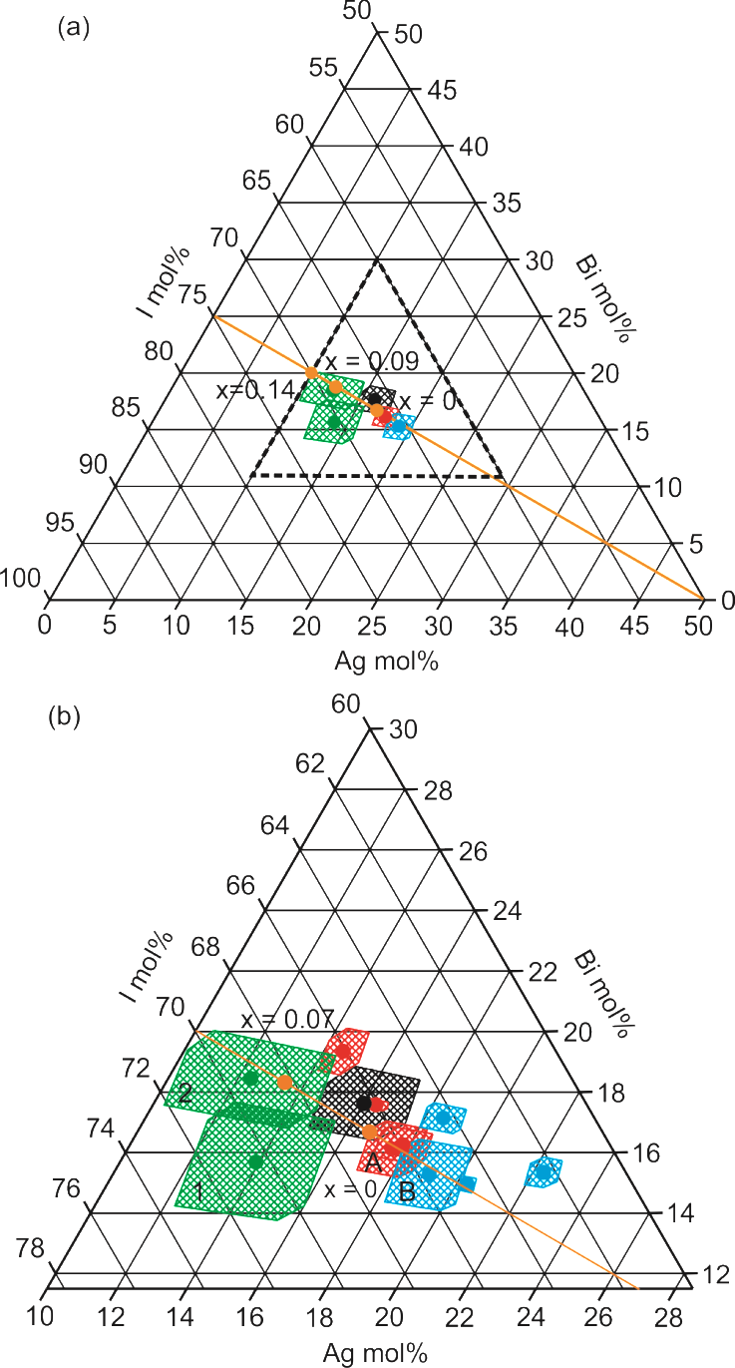
Figure 1. (a) A quarter of the Bi-Ag-I phase diagram of SEM EDX compositional measurements of Ag_{1-3x}Bi_{1+x}I₄ sealed tube synthesized powder (black), polycrystalline film (green), plate crystal with CdCl₂ structure (red) and octahedral-faceted crystal (blue) on the Ag_{1-3x}Bi_{1+x}I₄ charge balance line with previously reported compositions (orange). (b) Dashed zone enlarged around the AgBiI₄ x = 0 point showing additional octahedral-faceted (blue) and plate (red) crystal measurements. Also shown is the nominal x = 0.07 composition used for sealed tube synthesis (orange). Circles represent average compositions and hashed areas represent the 1σ statistical spread. Areas labelled A and B are the plate and octahedral-faceted crystals used for the structural study (Section 3.2). Areas labelled 1 and 2 correspond to the polycrystalline films used for absorption coefficient measurements (Section 3.3).

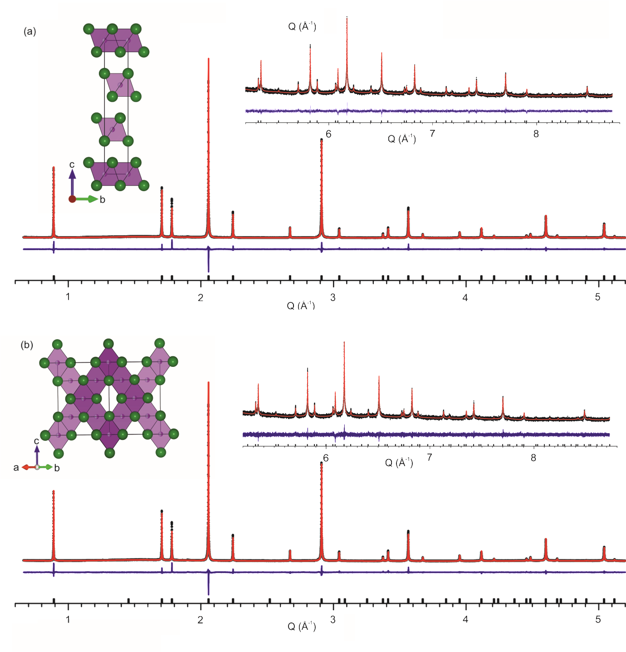
Figure 2. PXRD and Rietveld refinements of AgBiI₄ synchrotron data for (a) CdCl₂ -type and (b) defect-spinel structures, with the structures inset. Tick marks in (b) show the absence of expected Bragg intensity due to the increased cell size of the cubic cell.

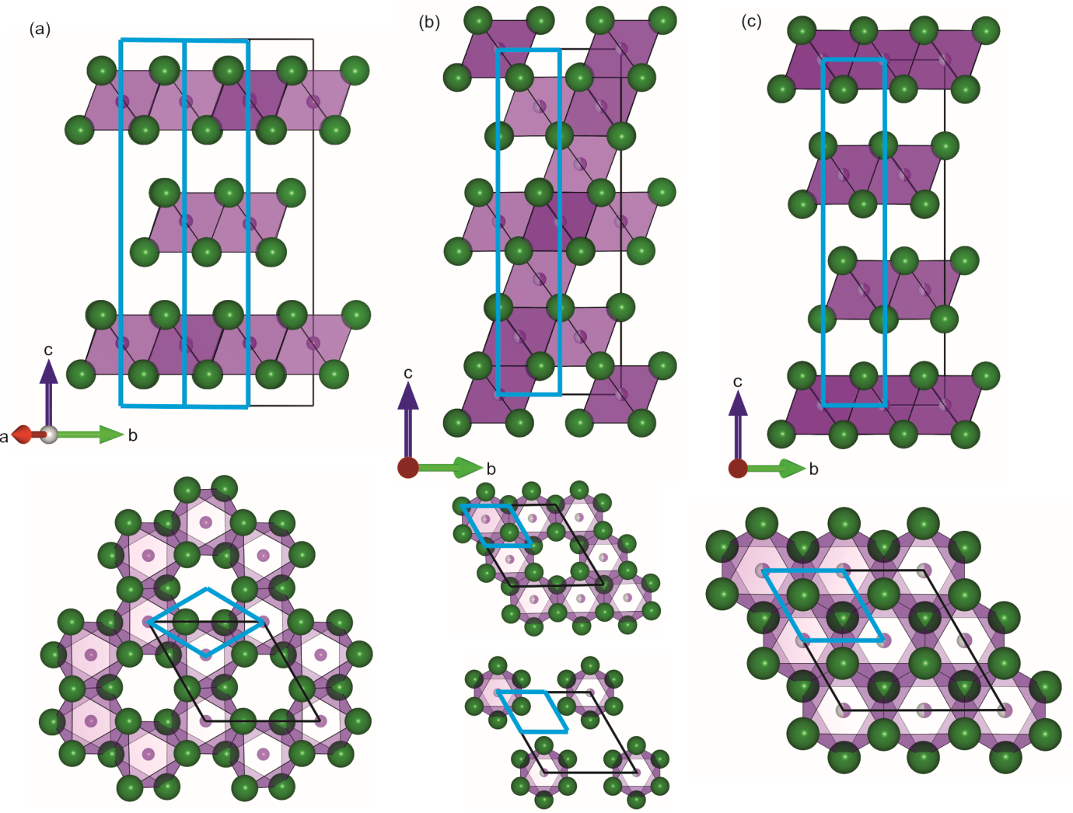
Figure 3. (a) The reported crystal structure of BiI₃,⁵¹ showing its layered structure in which layers of edge-sharing octahedra are occupied by 2/3 Bi³⁺ cations and 1/3 vacancies and alternate with entirely vacant layers. The iodide packing is hexagonally close-packed (ABA).(b) The cubic defect-spinel structure of AgBiI₄ is shown in its trigonal setting, for comparison to BiI₃ and the CdCl₂ structure. The interstitial octahedral sites are occupied by mixed silver and bismuth in alternating layers of 3/4 and 1/4 occupancy. (c) CdCl₂-type structure of AgBiI₄ with doubled a and b directions showing layered structure with alternating fully occupied and entirely vacant layers. In both (b) and (c) the iodide packing is cubic close-packed (ABC). The dimensions of a CdCl₂ single cell are shown in blue in all panels to show the relationship between the different unit cells.

Figure 2. PXRD and Rietveld refinements of AgBiI₄ synchrotron data for (a) defect-spinel and (b) lamellar structures, with the structures inset.

Figure 4. Reconstructed SCXRD pattern from the <01$\overline{\text{1}}$> plane of the Fd$\overline{\text{3}}$m cubic cell. Indexing this pattern to the cubic Fd$\overline{\text{3}}$m cell reveals several allowed Bragg peaks with zero intensity (e.g. the expected [220] reflection is indicated by a green circle and arrow). Alternatively, the pattern can be indexed to two rhombohedral R$\overline{\text{3}}$m twins (red and blue circles), with the [001] axis of the rhombohedral cell aligned along the [111] axis of the cubic cell. Uncircled peaks arise from the rock salt sub-lattice and are common to all twins. This solution has no zero-intensity allowed Bragg peaks. Note that, whilst two rhombohedral R$\overline{\text{3}}$m twins are required to fit this particular region of reciprocal space, by extension four rhombohedral R$\overline{\text{3}}$m twins are required to fit the full data set.

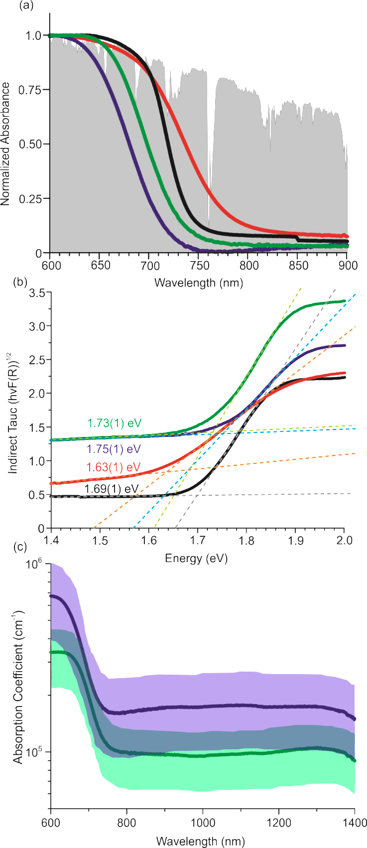
Figure 5. (a) UV-Visible spectroscopy optical absorbance data for sealed tube synthesized powder (red), polycrystalline film 1 (blue) and 2 (green) and BiI₃ powder (black) plotted against AM1.5 solar spectrum (grey)⁶⁹. (b) Tauc plot for indirect band gaps calculated using the Kubelka-Munk function F(R) obtained via diffuse reflectance measurements for the sealed tube synthesized powder (red), polycrystalline film 1 (blue) and film 2 (green) and BiI₃ powder (black). (c) The absorption coefficient of film 1(blue) and 2 (green). The shaded areas in (c) indicate the error limits, derived from the standard deviations of the measured film thicknesses.

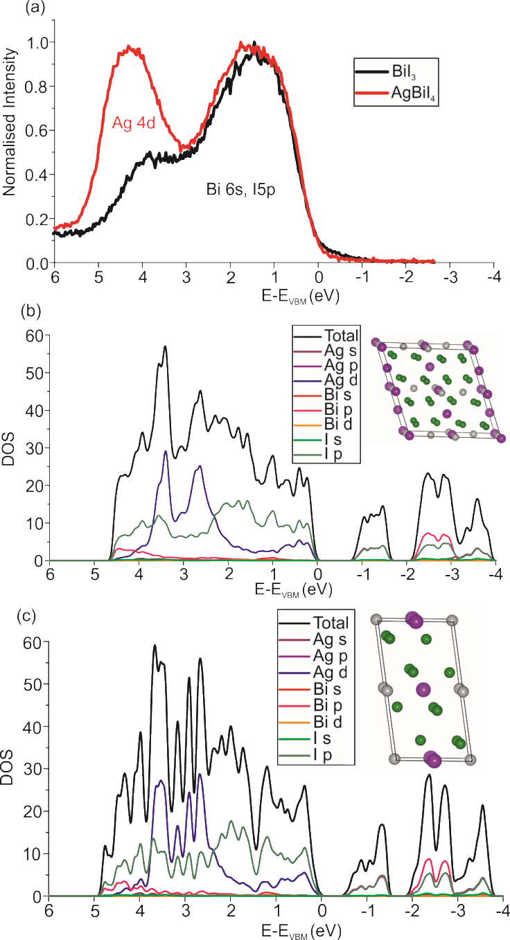
Figure 6. (a) XPS spectra of the valence band of pellets of AgBiI₄ (red) and BiI₃ (black) showing the main Ag 4d contribution is to the bottom of the valence band. DOS calculations for the lowest energy defect-spinel and CdCl₂ structures are shown in (b) and (c), respectively.

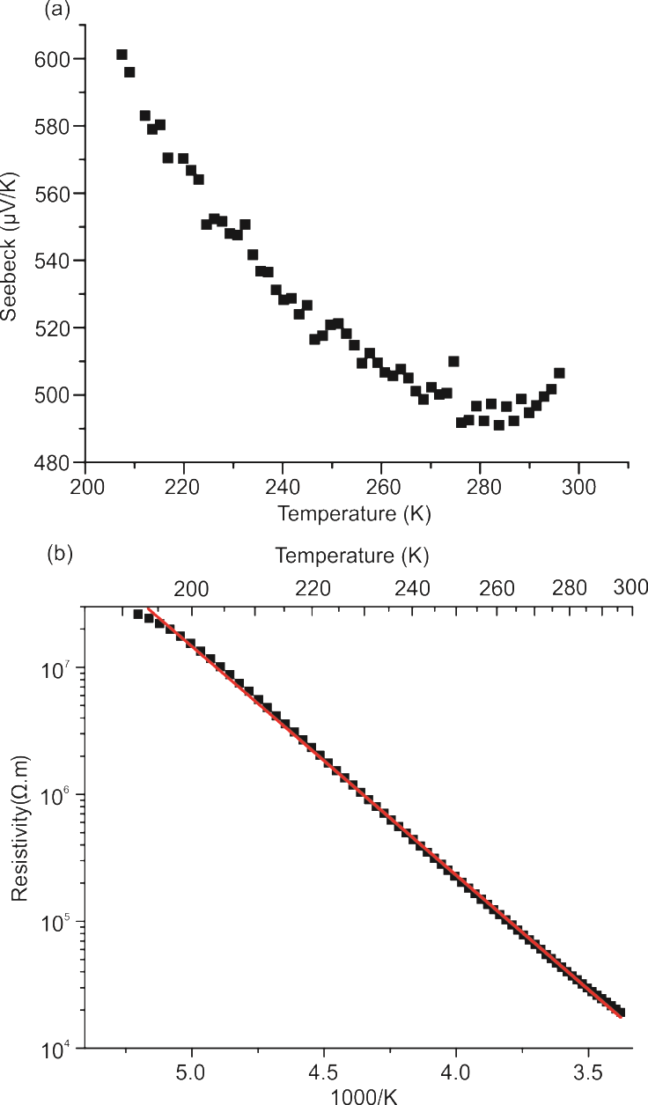
Figure 7. (a) Seebeck coefficient measured from 210-300 K on bulk AgBiI₄ (b) Resistivity of bulk AgBiI₄ measured from 190-300 K.

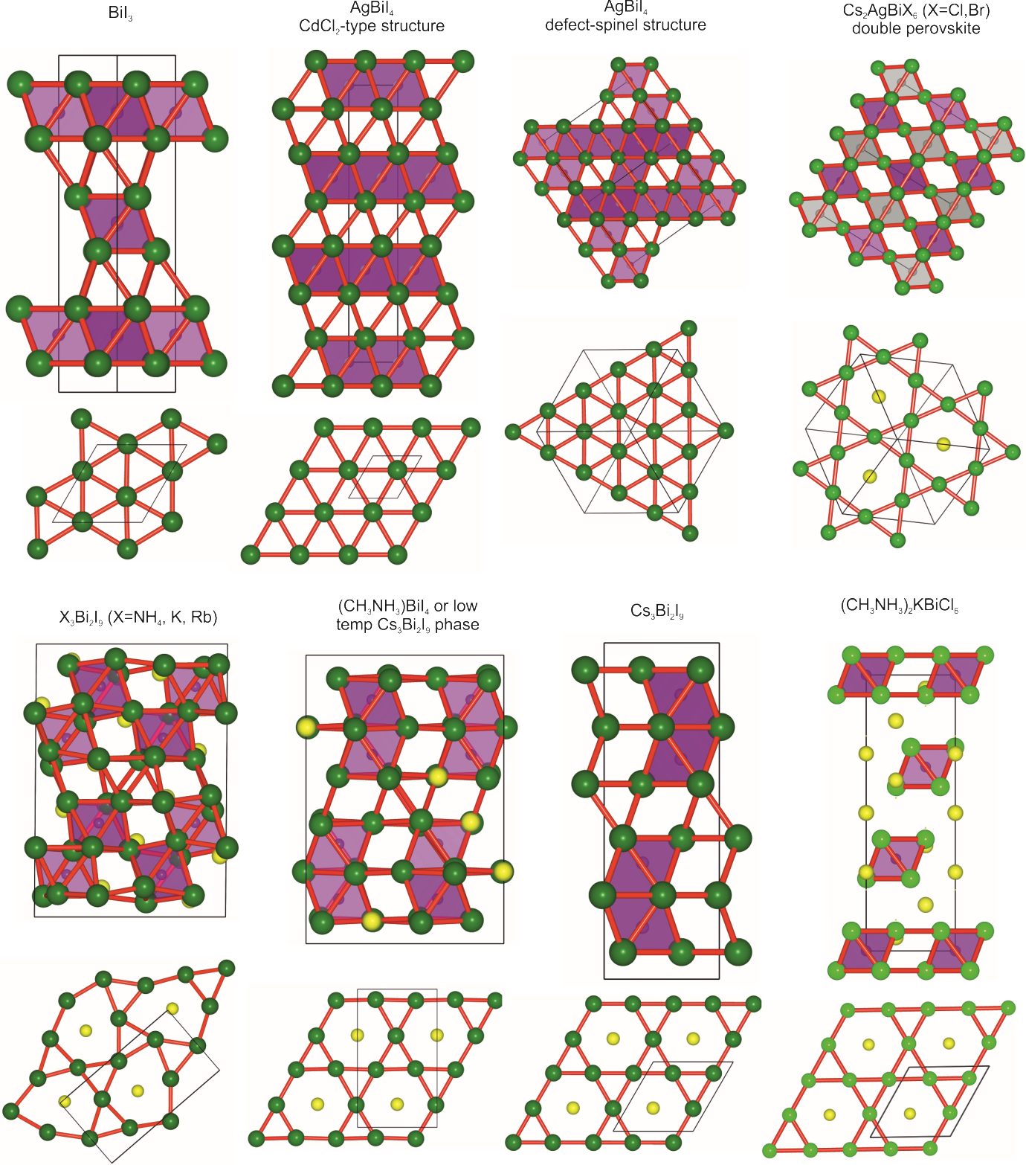
Figure 8. The halide (green) connectivity (red) is shown for AgBiI₄ and the bismuth halide semiconductors with previously reported optical gaps. Bismuth is shown in purple and cations in yellow. BiI₃ shows uninterrupted hexagonal close packed iodide sub-lattice and both the CdCl₂ and defect-spinel structures of AgBiI₄ show uninterrupted cubic close packed iodide sub-lattices. In the double perovskites Cs₂AgBiX₆ (X = Br, Cl) 1/4 of the anions in the close packed iodide sub-lattice are replaced by large Cs⁺ cations, in the perovskite-type structure. The same level of cation substitution is observed in hexagonal iodide layers within (CH₃NH₃)BiI₄, (NH₄)₃Bi₂I₉, A₃Bi₂I₉ (A = K, Rb, Cs) and (CH₃NH₃)₂KBiCl₆. All compounds with structures where cations replace I⁻ anions within the hexagonal layers have optical gaps above 1.9 eV,^{26-30, 32} where those with pure iodide layers have optical gaps of 1.6–1.8 eV.

Compound | Indirect Tauc (eV) | Direct Tauc  (eV) | Calculated type | Iodide sub-lattice
BiI₃ | 1.67(9)³³  1.69(1)* | 1.76³³  1.77(1)* | Indirect^{33,*} | CP
AgBiI₄* | 1.63(1) | 1.73(1) |  | CP
AgBi₂I₇³⁴ | 1.66 | 1.87 | Indirect | CP
(CH₃NH₃)BiI₄²⁷ | 2.04 | 2.63 | Direct | P
(NH₄)₃Bi₂I₉²⁸ | 2.04 |  | Direct | P
(CH₃NH₃)₂KBiCl₆²⁶ | 3.04 | 3.37 | Indirect | P
K₃Bi₂I₉²⁹ |  | 2.10 | Direct | P
Rb₃Bi₂I₉²⁹ |  | 2.10 | Direct | P
Cs₃Bi₂I₉²⁹ | 1.90 |  | Indirect | P
Cs₂AgBiCl₆³⁰ | 2.77 |  | Indirect | P
Cs₂AgBiBr₆³⁰ | 2.190 |  | Indirect | P
*Results obtained from this work

Table 1. Reported band gap values obtained from indirect and direct Tauc plots, DFT-calculated band gap transition types and the iodide sub-lattice type of reported bismuth halides. The most suitable, i.e. smallest, band gaps for single junction photovoltaics are for AgBiI₄ and then BiI₃ which have uninterrupted CCP and HCP iodide sub-lattices respectively. Perovskite-type iodide sub-lattices, which have 1/4 of anion sites replaced by cations, exhibit larger band gaps above 1.90 eV. Abbreviations CP and P stand for close packed and perovskite-type packing, respectively.

References
(1) Shockley, W.; Queisser, H. J. Detailed Balance Limit of Efficiency of p‐n Junction Solar Cells. J. Appl. Phys. 1961, 32, 510-519.
(2) Yakunin, S.; Sytnyk, M.; Kriegner, D.; Shrestha, S.; Richter, M.; Matt, G. J.; Azimi, H.; Brabec, C. J.; Stangl, J.; Kovalenko, M. V.; Heiss, W. Detection of X-ray Photons by Solution-Processed Lead Halide Perovskites. Nat Photon 2015, 9, 444-449.
(3) Wehrenfennig, C.; Eperon, G. E.; Johnston, M. B.; Snaith, H. J.; Herz, L. M. High Charge Carrier Mobilities and Lifetimes in Organolead Trihalide Perovskites. Adv. Mater. (Weinheim, Ger.) 2014, 26, 1584-1589.
(4) Ponseca, C. S.; Savenije, T. J.; Abdellah, M.; Zheng, K.; Yartsev, A.; Pascher, T.; Harlang, T.; Chabera, P.; Pullerits, T.; Stepanov, A.; Wolf, J.-P.; Sundström, V. Organometal Halide Perovskite Solar Cell Materials Rationalized: Ultrafast Charge Generation, High and Microsecond-Long Balanced Mobilities, and Slow Recombination. J. Am. Chem. Soc. 2014, 136, 5189-5192.
(5) Brenner, T. M.; Egger, D. A.; Kronik, L.; Hodes, G.; Cahen, D. Hybrid Organic—Inorganic Perovskites: Low-Cost Semiconductors with Intriguing Charge-Transport Properties. Nature Reviews Materials 2016, 1, 15007.
(6) Xing, G.; Mathews, N.; Sun, S.; Lim, S. S.; Lam, Y. M.; Grätzel, M.; Mhaisalkar, S.; Sum, T. C. Long-Range Balanced Electron- and Hole-Transport Lengths in Organic-Inorganic CH₃NH₃PbI₃. Science 2013, 342, 344-347.
(7) Stranks, S. D.; Eperon, G. E.; Grancini, G.; Menelaou, C.; Alcocer, M. J. P.; Leijtens, T.; Herz, L. M.; Petrozza, A.; Snaith, H. J. Electron-Hole Diffusion Lengths Exceeding 1 Micrometer in an Organometal Trihalide Perovskite Absorber. Science 2013, 342, 341-344.
(8) Sharenko, A.; Toney, M. F. Relationships between Lead Halide Perovskite Thin-Film Fabrication, Morphology, and Performance in Solar Cells. J. Am. Chem. Soc. 2016, 138, 463-470.
(9) Liu, M.; Johnston, M. B.; Snaith, H. J. Efficient Planar Heterojunction Perovskite Solar Cells by Vapour Deposition. Nature 2013, 501, 395-398.
(10) Habisreutinger, S. N.; Leijtens, T.; Eperon, G. E.; Stranks, S. D.; Nicholas, R. J.; Snaith, H. J. Carbon Nanotube/Polymer Composites as a Highly Stable Hole Collection Layer in Perovskite Solar Cells. Nano Lett. 2014, 14, 5561-5568.
(11) Bag, M.; Renna, L. A.; Adhikari, R. Y.; Karak, S.; Liu, F.; Lahti, P. M.; Russell, T. P.; Tuominen, M. T.; Venkataraman, D. Kinetics of Ion Transport in Perovskite Active Layers and Its Implications for Active Layer Stability. J. Am. Chem. Soc. 2015, 137, 13130-13137.
(12) Aristidou, N.; Sanchez-Molina, I.; Chotchuangchutchaval, T.; Brown, M.; Martinez, L.; Rath, T.; Haque, S. A. The Role of Oxygen in the Degradation of Methylammonium Lead Trihalide Perovskite Photoactive Layers. Angew. Chem. Int. Ed. (English) 2015, 54, 8208-8212.
(13) Panda, P. K. Review: Environmental Friendly Lead-Free Piezoelectric Materials. J. Mater. Sci. 2009, 44, 5049-5062.
(14) Stoumpos, C. C.; Malliakas, C. D.; Kanatzidis, M. G. Semiconducting Tin and Lead Iodide Perovskites with Organic Cations: Phase Transitions, High Mobilities, and Near-Infrared Photoluminescent Properties. Inorg. Chem. 2013, 52, 9019-9038.
(15) Koh, T. M.; Fu, K.; Fang, Y.; Chen, S.; Sum, T. C.; Mathews, N.; Mhaisalkar, S. G.; Boix, P. P.; Baikie, T. Formamidinium-Containing Metal-Halide: An Alternative Material for Near-IR Absorption Perovskite Solar Cells. J. Phys. Chem. C 2014, 118, 16458-16462.
(16) Eperon, G. E.; Stranks, S. D.; Menelaou, C.; Johnston, M. B.; Herz, L. M.; Snaith, H. J. Formamidinium Lead Trihalide: a Broadly Tunable Perovskite for Efficient Planar Heterojunction Solar Cells. Energy Environ. Sci. 2014, 7, 982-988.
(17) Kulbak, M.; Cahen, D.; Hodes, G. How Important Is the Organic Part of Lead Halide Perovskite Photovoltaic Cells? Efficient CsPbBr₃ Cells. J. Phys. Chem. Lett. 2015, 6, 2452-2456.
(18) Noel, N. K.; Stranks, S. D.; Abate, A.; Wehrenfennig, C.; Guarnera, S.; Haghighirad, A.-A.; Sadhanala, A.; Eperon, G. E.; Pathak, S. K.; Johnston, M. B.; Petrozza, A.; Herz, L. M.; Snaith, H. J. Lead-Free Organic-Inorganic Tin Halide Perovskites for Photovoltaic Applications. Energy Environ. Sci. 2014, 7, 3061-3068.
(19) Baikie, T.; Fang, Y.; Kadro, J. M.; Schreyer, M.; Wei, F.; Mhaisalkar, S. G.; Graetzel, M.; White, T. J. Synthesis and Crystal Chemistry of the Hybrid Perovskite (CH₃NH₃)PbI₃ for Solid-State Sensitised Solar Cell Applications. J. Mater. Chem. A 2013, 1, 5628-5641.
(20) Stoumpos, C. C.; Frazer, L.; Clark, D. J.; Kim, Y. S.; Rhim, S. H.; Freeman, A. J.; Ketterson, J. B.; Jang, J. I.; Kanatzidis, M. G. Hybrid Germanium Iodide Perovskite Semiconductors: Active Lone Pairs, Structural Distortions, Direct and Indirect Energy Gaps, and Strong Nonlinear Optical Properties. J. Am. Chem. Soc. 2015, 137, 6804-6819.
(21) Clark, S. J.; Donaldson, J. D.; Harvey, J. A. Evidence for the Direct Population of Solid-State Bands by Non-Bonding Electron Pairs in Compounds of the Type CsMX₃(M= Ge, Sn, Pb; X = Cl, Br, I). J. Mater. Chem. 1995, 5, 1813-1818.
(22) Aharon, S.; Cohen, B. E.; Etgar, L. Hybrid Lead Halide Iodide and Lead Halide Bromide in Efficient Hole Conductor Free Perovskite Solar Cell. J. Phys. Chem. C 2014, 118, 17160-17165.
(23) Noh, J. H.; Im, S. H.; Heo, J. H.; Mandal, T. N.; Seok, S. I. Chemical Management for Colorful, Efficient, and Stable Inorganic–Organic Hybrid Nanostructured Solar Cells. Nano Lett. 2013, 13, 1764-1769.
(24) Kitazawa, N.; Watanabe, Y.; Nakamura, Y. Optical Properties of CH₃NH₃PbX₃ (X = Halogen) and their Mixed-Halide Crystals. J. Mater. Sci. 37, 3585-3587.
(25) Protesescu, L.; Yakunin, S.; Bodnarchuk, M. I.; Krieg, F.; Caputo, R.; Hendon, C. H.; Yang, R. X.; Walsh, A.; Kovalenko, M. V. Nanocrystals of Cesium Lead Halide Perovskites (CsPbX₃, X = Cl, Br, and I): Novel Optoelectronic Materials Showing Bright Emission with Wide Color Gamut. Nano Lett. 2015, 15, 3692-3696.
(26) Wei, F.; Deng, Z.; Sun, S.; Xie, F.; Kieslich, G.; Evans, D. M.; Carpenter, M. A.; Bristowe, P. D.; Cheetham, A. K. The Synthesis, Structure and Electronic Properties of a Lead-Free Hybrid Inorganic-Organic Double Perovskite (MA)₂KBiCl₆ (MA = Methylammonium). Mater. Horiz. 2016, 3, 328-332.
(27) Hoye, R. L. Z.; Brandt, R. E.; Osherov, A.; Stevanović, V.; Stranks, S. D.; Wilson, M. W. B.; Kim, H.; Akey, A. J.; Perkins, J. D.; Kurchin, R. C.; Poindexter, J. R.; Wang, E. N.; Bawendi, M. G.; Bulović, V.; Buonassisi, T. Methylammonium Bismuth Iodide as a Lead-Free, Stable Hybrid Organic–Inorganic Solar Absorber. Chem. Eur. J. 2016, 22, 2605-2610.
(28) Sun, S.; Tominaka, S.; Lee, J.-H.; Xie, F.; Bristowe, P. D.; Cheetham, A. K. Synthesis, Crystal Structure, and Properties of a Perovskite-Related Bismuth Phase, (NH₄)₃Bi₂I₉. APL Mater. 2016, 4, 031101.
(29) Lehner, A. J.; Fabini, D. H.; Evans, H. A.; Hébert, C.-A.; Smock, S. R.; Hu, J.; Wang, H.; Zwanziger, J. W.; Chabinyc, M. L.; Seshadri, R. Crystal and Electronic Structures of Complex Bismuth Iodides A₃Bi₂I₉ (A = K, Rb, Cs) Related to Perovskite: Aiding the Rational Design of Photovoltaics. Chem. Mater. 2015, 27, 7137-7148.
(30) McClure, E. T.; Ball, M. R.; Windl, W.; Woodward, P. M. Cs₂AgBiX₆ (X = Br, Cl): New Visible Light Absorbing, Lead-Free Halide Perovskite Semiconductors. Chem. Mater. 2016, 28, 1348-1354.
(31) Lehner, A. J.; Wang, H.; Fabini, D. H.; Liman, C. D.; Hébert, C.-A.; Perry, E. E.; Wang, M.; Bazan, G. C.; Chabinyc, M. L.; Seshadri, R. Electronic Structure and Photovoltaic Application of BiI₃. Appl. Phys. Lett. 2015, 107, 131109.
(32) Brandt, R. E.; Kurchin, R. C.; Hoye, R. L. Z.; Poindexter, J. R.; Wilson, M. W. B.; Sulekar, S.; Lenahan, F.; Yen, P. X. T.; Stevanović, V.; Nino, J. C.; Bawendi, M. G.; Buonassisi, T. Investigation of Bismuth Triiodide (BiI₃) for Photovoltaic Applications. J. Phys. Chem. Lett. 2015, 6, 4297-4302.
(33) Podraza, N. J.; Qiu, W.; Hinojosa, B. B.; Xu, H.; Motyka, M. A.; Phillpot, S. R.; Baciak, J. E.; Trolier-McKinstry, S.; Nino, J. C. Band Gap and Structure of Single Crystal BiI₃: Resolving Discrepancies in Literature. J. Appl. Phys. 2013, 114, 033110.
(34) Kim, Y.; Yang, Z.; Jain, A.; Voznyy, O.; Kim, G.-H.; Liu, M.; Quan, L. N.; García de Arquer, F. P.; Comin, R.; Fan, J. Z.; Sargent, E. H. Pure Cubic-Phase Hybrid Iodobismuthates AgBi₂I₇ for Thin-Film Photovoltaics. Angew. Chem. Int. Ed. 2016, 55, 9586-9590.
(35) Xiao, Z.; Meng, W.; Mitzi, D. B.; Yan, Y. Crystal Structure of AgBi₂I₇ Thin Films. J. Phys. Chem. Lett. 2016, 7, 3903-3907.
(36) Oldag, T.; Aussieker, T.; Keller, H.-L.; Preitschaft, C.; Pfitzner, A. Solvothermale Synthese und Bestimmung der Kristallstrukturen von AgBiI₄ und Ag₃BiI₆. Z. Anorg. Allg. Chem. 2005, 631, 677-682.
(37) Fourcroy, P. H.; Palazzi, M.; Rivet, J.; Flahaut, J.; Céolin, R. Etude du Systeme AgIBiI₃. Mater. Res. Bull. 1979, 14, 325-328.
(38) Dzeranova, K. B.; Kaloev, N. I.; Bukhalova, G. A. The BiI₃ - AgI System. Russ. J. Inorg. Chem. 1985, 30, 1700 - 1701.
(39) Mashadieva, L. F.; Aliev, Z. S.; Shevelkov, A. V.; Babanly, M. B. Experimental Investigation of the Ag–Bi–I Ternary System and Thermodynamic Properties of the Ternary Phases. J. Alloys Compd. 2013, 551, 512-520.
(40) Degen, T.; Sadki, M.; Bron, E.; König, U.; Nénert, G. The HighScore Suite. Powder Diffr. 2014, 29, S13-S18.
(41) TOPAS v5; AXS, B., Karlsruhe, Germany, 2011.
(42) Momma, K.; Izumi, F. VESTA: a Three-Dimensional Visualization System for Electronic and Structural Analysis. J. Appl. Crystallogr. 2008, 41, 653-658.
(43) CrysAlisPro v171.38.48; Ltd., A. T., Yarton, Oxfordshire, UK, 2013.
(44) Sheldrick, G. A Short History of SHELX. Acta Cryst. A 2008, 64, 112-122.
(45) Dolomanov, O. V.; Bourhis, L. J.; Gildea, R. J.; Howard, J. A. K.; Puschmann, H. OLEX2: a Complete Structure Solution, Refinement and Analysis Program. J. Appl. Crystallogr. 2009, 42, 339-341.
(46) Whittles, T. J.; Burton, L. A.; Skelton, J. M.; Walsh, A.; Veal, T. D.; Dhanak, V. R. Band Alignments, Valence Bands, and Core Levels in the Tin Sulfides SnS, SnS₂, and Sn₂S₃: Experiment and Theory. Chem. Mater. 2016, 28, 3718-3726.
(47) Moulder, J. F.; Stickle, W. F.; Sobol, P. E.; Bomben, K. D.; Chastain, J.; King, R. C. Handbook of X-ray Photoelectron Spectroscopy; Physical Electronics, Inc: Eden Prairie, Minnesota, 1995.
(48) Kresse, G.; Furthmüller, J. Efficient Iterative Schemes for Ab Initio Total-Energy Calculations using a Plane-Wave Basis Set. Phys. Rev. B 1996, 54, 11169-11186.
(49) Kresse, G.; Joubert, D. From Ultrasoft Pseudopotentials to the Projector Augmented-Wave Method. Phys. Rev. B 1999, 59, 1758-1775.
(50) Klimeš, J.; Bowler, D. R.; Michaelides, A. Van der Waals Density Functionals Applied to Solids. Phys. Rev. B 2011, 83, 195131.
(51) Trotter, J.; Zobel, T. The Crystal Structure of Sbl₃ and Bil₃. Z. Kristallogr. 1966, 123, 67.
(52) Perdew, J. P.; Burke, K.; Ernzerhof, M. Generalized Gradient Approximation Made Simple. Phys. Rev. Lett. 1996, 77, 3865-3868.
(53) Pauling, L.; Hoard, J. XXXVII. The Crystal Structure of Cadmium Chloride. Z. Krystallogr. 1930, 74, 546-551.
(54) Bordas, J.; Robertson, J.; Jakobsson, A. Ultraviolet Properties and Band Structure of SnS₂, SnSe₂, CdI₂, PbI₂, BiI₃ and BiOI Crystals. J. Phys. C 1978, 11, 2607.
(55) Leguy, A. M. A.; Azarhoosh, P.; Alonso, M. I.; Campoy-Quiles, M.; Weber, O. J.; Yao, J.; Bryant, D.; Weller, M. T.; Nelson, J.; Walsh, A.; van Schilfgaarde, M.; Barnes, P. R. F. Experimental and Theoretical Optical Properties of Methylammonium Lead Halide Perovskites. Nanoscale 2016, 8, 6317-6327.
(56) Sankapal, B.; Baviskar, P.; Salunkhe, D. Synthesis and Characterization of AgI Thin Films at Low Temperature. J. Alloys Compd. 2010, 506, 268-270.
(57) Godby, R. W.; Schlüter, M.; Sham, L. J. Self-Energy Operators and Exchange-Correlation Potentials in Semiconductors. Phys. Rev. B 1988, 37, 10159-10175.
(58) Pisoni, A.; Jaćimović, J.; Barišić, O. S.; Spina, M.; Gaál, R.; Forró, L.; Horváth, E. Ultra-Low Thermal Conductivity in Organic–Inorganic Hybrid Perovskite CH₃NH₃PbI₃. J. Phys. Chem. Lett. 2014, 5, 2488-2492.
(59) Mettan, X.; Pisoni, R.; Matus, P.; Pisoni, A.; Jaćimović, J.; Náfrádi, B.; Spina, M.; Pavuna, D.; Forró, L.; Horváth, E. Tuning of the Thermoelectric Figure of Merit of CH₃NH₃MI₃ (M=Pb,Sn) Photovoltaic Perovskites. J. Phys. Chem. C 2015, 119, 11506-11510.
(60) Han, H.; Hong, M.; Gokhale, S. S.; Sinnott, S. B.; Jordan, K.; Baciak, J. E.; Nino, J. C. Defect Engineering of BiI₃ Single Crystals: Enhanced Electrical and Radiation Performance for Room Temperature Gamma-Ray Detection. J. Phys. Chem. C 2014, 118, 3244-3250.
(61) Devidas, T. R.; Shekar, N. V. C.; Sundar, C. S.; Chithaiah, P.; Sorb, Y. A.; Bhadram, V. S.; Chandrabhas, N.; Pal, K.; Waghmare, U. V.; Rao, C. N. R. Pressure-Induced Structural Changes and Insulator-Metal Transition in Layered Bismuth Triiodide, BiI₃ : a Combined Experimental and Theoretical Study. J. Phys.: Condens. Matter 2014, 26, 275502.
(62) Castro-Hermosa, S.; Yadav, S. K.; Vesce, L.; Guidobaldi, A.; Reale, A.; Carlo, A. D.; Brown, T. M. Stability Issues Pertaining Large Area Perovskite and Dye-Sensitized Solar Cells and Modules. J. Phys. D Appl. Phys. 2017, 50, 033001.
(63) Campbell, B. J.; Stokes, H. T.; Tanner, D. E.; Hatch, D. M. ISODISPLACE: a Web-Based Tool for Exploring Structural Distortions. J. Appl. Crystallogr. 2006, 39, 607-614.
(64) Perez-Mato, J. M.; Orobengoa, D.; Aroyo, M. I. Mode Crystallography of Distorted Structures. Acta Crystallogr. Sect. A 2010, 66, 558-590.
(65) Patterson, A. L. Homometric Structures. Nature 1939, 143, 939-940.
(66) van Smaalen, S.; Lam, E. J.; Lüdecke, J. Structure of the Charge-Density Wave in(TaSe₄)₂I. J. Phys.: Condens. Matter 2001, 13, 9923-9936.
(67) Fourcroy, P. H.; Carre, D.; Thevet, F.; Rivet, J. Structure du Tetraiodure de Cuivre(I) et de Bismuth(III), CuBiI₄. Acta Crystallogr. Sect. C 1991, 47, 2023-2025.
(68) Lintereur, A. T.; Qiu, W.; Nino, J. C.; Baciak, J. Characterization of Bismuth Tri-Iodide Single Crystals for Wide Band-Gap Semiconductor Radiation Detectors. Nucl. Instr. Meth. Phys. Res 2011, 652, 166-169.
(69) Standard Tables for Reference Solar Spectral Irradiances: Direct Normal and Hemispherical on 37°C; Tilted Surface, ASTM International, Pennsylvania, US, 2012.

Table of contents figure:
