**Absolute quantification of uric acid in human urine using surface enhanced Raman scattering with the standard addition method**

Chloe Westleya, Yun Xua, Baskaran Thilaganathanb, Andrew J. Carnellc, Nicholas J. Turnera, Royston Goodacrea*

a School of Chemistry, Manchester Institute of Biotechnology, University of Manchester, 131 Princess Street, Manchester, M1 7DN, UK.

bSt George’s, University of London & St George’s University Hospitals NHS Foundation Trust Clinical Sciences Research Centre, London, SW17 0RE

cDepartment of Chemistry, University of Liverpool, Liverpool, L69 7ZD

**ABSTRACT**

High levels of uric acid in urine and serum can be indicative of hypertension, and the pregnancy related condition, preeclampsia. We have developed a simple, cost-effective, portable surface enhanced Raman scattering (SERS) approach for the routine analysis of uric acid at clinically relevant levels in urine patient samples. This approach, combined with standard addition method (SAM), allows for the absolute quantification of uric acid directly in a complex matrix such as that from human urine. Results are highly comparable and in very good agreement with HPLC results, with an average <9% difference in predictions between the two analytical approaches across all samples analysed, with SERS demonstrating a 60-fold reduction in acquisition time compared with HPLC. For the first time, clinical pre-preeclampsia patient samples have been used for quantitative uric acid detection using a simple, rapid colloidal SERS approach without the need for complex data analysis.

**INTRODUCTION**

Preeclampsia is a hypertension disorder that can occur in pregnant women and is a primary cause for maternal morbidity and mortality worldwide, mainly in developing countries, with 2-5% of pregnancies affected.1-3 The cause of preeclampsia remains unknown and even predicting which women are susceptible/have an increased risk of developing the condition is problematic.4,5 Moreover, when preeclampsia appears in the second or third trimester, there are no treatments available other than premature delivery of the baby,6 and those babies born are at an increased risk of developing hypertension, heart disease and diabetes1,7,8. Currently, diagnosis of preeclampsia is a challenge as there is no specific biomarker(s) for the condition, that provide definitive diagnostics, and clinicians therefore rely on non-specific signs of the disease9; commonly associated symptoms include raised blood pressure and elevated protein levels (proteinuria) in the urine and so blood tests and urine protein measurement tests are often performed.10

Uric acid has been identified as an important biomarker for various diseases such as cardiovascular diseases, gout, renal diseases and can be indicative of preeclampsia.11-15 Uric acid is the end product of the metabolic breakdown of purine nucleotides and in normal circumstances, concentrations range from 3.5-7.0 mg/dL in the blood and from 16-100 mg/dL per 24 h in urine.16 Moreover, elevated uric acid levels (referred to as hyperuricemia) in urine and serum have been associated with preeclampsia, with levels greater than 0.4 mM indicating severe preeclampsia.17

Colorimetric enzymatic assays, liquid chromatography and capillary electrophoresis methodologies have been reported for uric acid detection; however, these have associated disadvantages such as: tests are often only applicable to late-stage preeclampsia, involve time consuming assay based tests, expensive enzymes, sophisticated instrumentation and equipment and often lack sensitivity. Therefore, there is a great need for a rapid, inexpensive, routine, diagnostic test to aid early uric acid detection, thus allowing hyperuricemia conditions to be properly monitored and managed to prevent further health implications.18,19

Surface enhanced Raman scattering (SERS) has increasingly been employed for use in quantification of biologically relevant molecules20-24. SERS is the dramatic enhancement of Raman signals when an analyte is in close proximity/adsorbed onto a nanoscale rough metallic surface, with typical enhancements of 104-106 observed. It is an attractive approach for disease diagnosis as it yields characteristic, molecular information, is label-free, has the ability to be performed in aqueous environments whist demonstrating high sensitivity and low limits of detection (down to fM level and single molecule detection).25-28

Raman spectroscopy also offers several advantages including its ease-of-use along with portability29 leading to the ability to develop point-of-care analysis systems for on-site Point-and-Shoot analyses.30 Recently, there have been several Raman spectroscopy based approaches, mostly utilising electrochemical surface enhanced Raman (E-SERS), to measure uric acid detection. However, these studies have demonstrated problems in establishing reliable, quantitative detection of uric acid at clinically relevant concentrations31, have employed complex set-ups involving Lab on a chip (LoC) based systems32,33 as well as having to rely on complex data analysis34. In all cases, the studies were not performed in real-life situations, i.e. biological fluids, but instead were performed in either urine simulant, synthetic urine or water.35

In this paper, we present an optimised SERS approach for uric acid detection in human urine from clinical pre-preeclamptic patients (urine samples collected between 11-14 weeks gestation) using a portable, easy-to-use Raman instrument. As uric acid is already present in urine, our approach involves using the well-known standard addition method (SAM), as well as HPLC analysis for additional benchmarking (see **supporting information Figure S1**). In SAM, a series of samples are analysed involving spiking in known amounts of uric acid in increasing concentrations whereby the subsequent calibration curve is used to determine the unknown concentration of uric acid in the original (undiluted) sample. We have performed this approach on 21 clinical samples, of which, 11 were performed in triplicate analysis to establish reproducibility, affording direct quantification of the target analyte within the sample thus accounting for the complex sample matrix. To the best of our knowledge, this simple colloidal uric acid detection approach in clinical patient samples is the first study of its kind.

**EXPERIMENTAL**

Full experimental details are provided in the **supporting information** ‘Supplementary Methods’ section.

**Materials.** All chemical reagents were of analytical grade and used with no additional purification unless otherwise stated.

**Human urine samples** were kindly donated by Prof B. Thilaganathan from St George’s, University of London & St George’s University Hospitals NHS Foundation Trust Clinical Sciences Research Centre. Written informed consent was obtained from each study participant and the study conformed to the principles set out in the WMA Declaration of Helsinki and the NIH Belmont report. The study was approved by Wandsworth Local Research Ethics Committee. Clinical pre-preeclamptic patients (urine samples collected between 11-14 weeks gestation).

**Processing of Urine.** For optimisation of uric acid detection in urine, we used a pooled urine stock from 58 different patients (QC *n*=58). For each urine sample, a protein crash method was performed using methanol (at RT). 150 μL urine was aliquoted in Eppendorf tubes. 600 μL methanol was added to this, and centrifuged for 15 min at 13,500 ×*g*. 400 μL was removed from the supernatant into a new Eppendorf tube and concentrated for ~ 4 h using an Eppendorf Vacufuge Concentrator 5301 (Eppendorf, UK). Once all methanol had been removed, the sample was re-suspended in 150 μL water and vortexed for 5 s.

**Sample Selection.** All urine samples from the 58 patients were processed as described above. For the QC sample used in optimising various parameters for SERS detection, all 58 urine samples were pooled.21 of these 58 urine samples were randomly selected to cover the entire uric acid concentration range to remove any measurement redundancy. Triplicate analyses were then performed on 11 of these 21 samples to establish reproducibility.

**Sample preparation.** 3.5×10-4 M uric acid stock solution was prepared in 1M potassium phosphate buffer solution at pH 7.6. Samples for individual analyses were then prepared as follows: For SERS samples, 200 µL of hydroxylamine reduced Ag colloid (HRSC), 75 µL potassium phosphate buffer at pH 7.6 and 125 µL urine was added to a glass vial. The silver colloid was prepared according to the method of Leopold and Lendl.36 For HPLC samples, the same procedure was followed except water was added instead of colloid. For SAM sample preparation the concentration of uric acid spiked into each urine sample was 0, 8.5, 16.7, 24.4, 31.8, 38.9, 45.7 and 55.3 µM. All dilution factors were taken into account when predicting final uric acid concentrations. Moreover, sample pre-treatment, dilution of urine and the use of standard addition method minimised interference from other components present in urine, thus enabling absolute quantification of urine.

**Raman Instrumentation.** A DeltaNu Advantage 200A portable Raman spectrometer (DeltaNu, Laramie, WY, USA) was used for collection of spectra using a HeNe 633 nm laser with ∼3 mW on the sample.

**RESULTS AND DISCUSSION**

**SERS optimisation**

We have previously established optimised conditions for uric acid SERS detection within an enzymatic system by varying certain parameters such as colloid type, pH, concentration, time aggregation and aggregating agent.8 However, uric acid detection in a more complex matrix, such as urine which is a molecular milieu of small molecules, organic acids and ions as well as proteins, required a slightly different set of conditions. Optimised conditions were established using a pooled QC urine sample (from all 58 patient samples), and as before hydroxylamine-reduced silver colloid was the optimum SERS substrate to use, with a potassium phosphate buffer at pH 7.6, without the need for an additional aggregating agent (due to the presence of the buffer). The aggregation time (i.e. the time required to generate an optimum, reproducible response) was slightly modified, with optimum uric acid detection achieved after 3.5 min (± 1 min) aggregation (see **Figure 1** and **supporting information Figures S2 and S3). Table 1** shows the tentative SERS band assignments for uric acid (see **supporting information Figure S4** for normal Raman spectra of uric acid (solid) which aided in band assignment).8,13,35

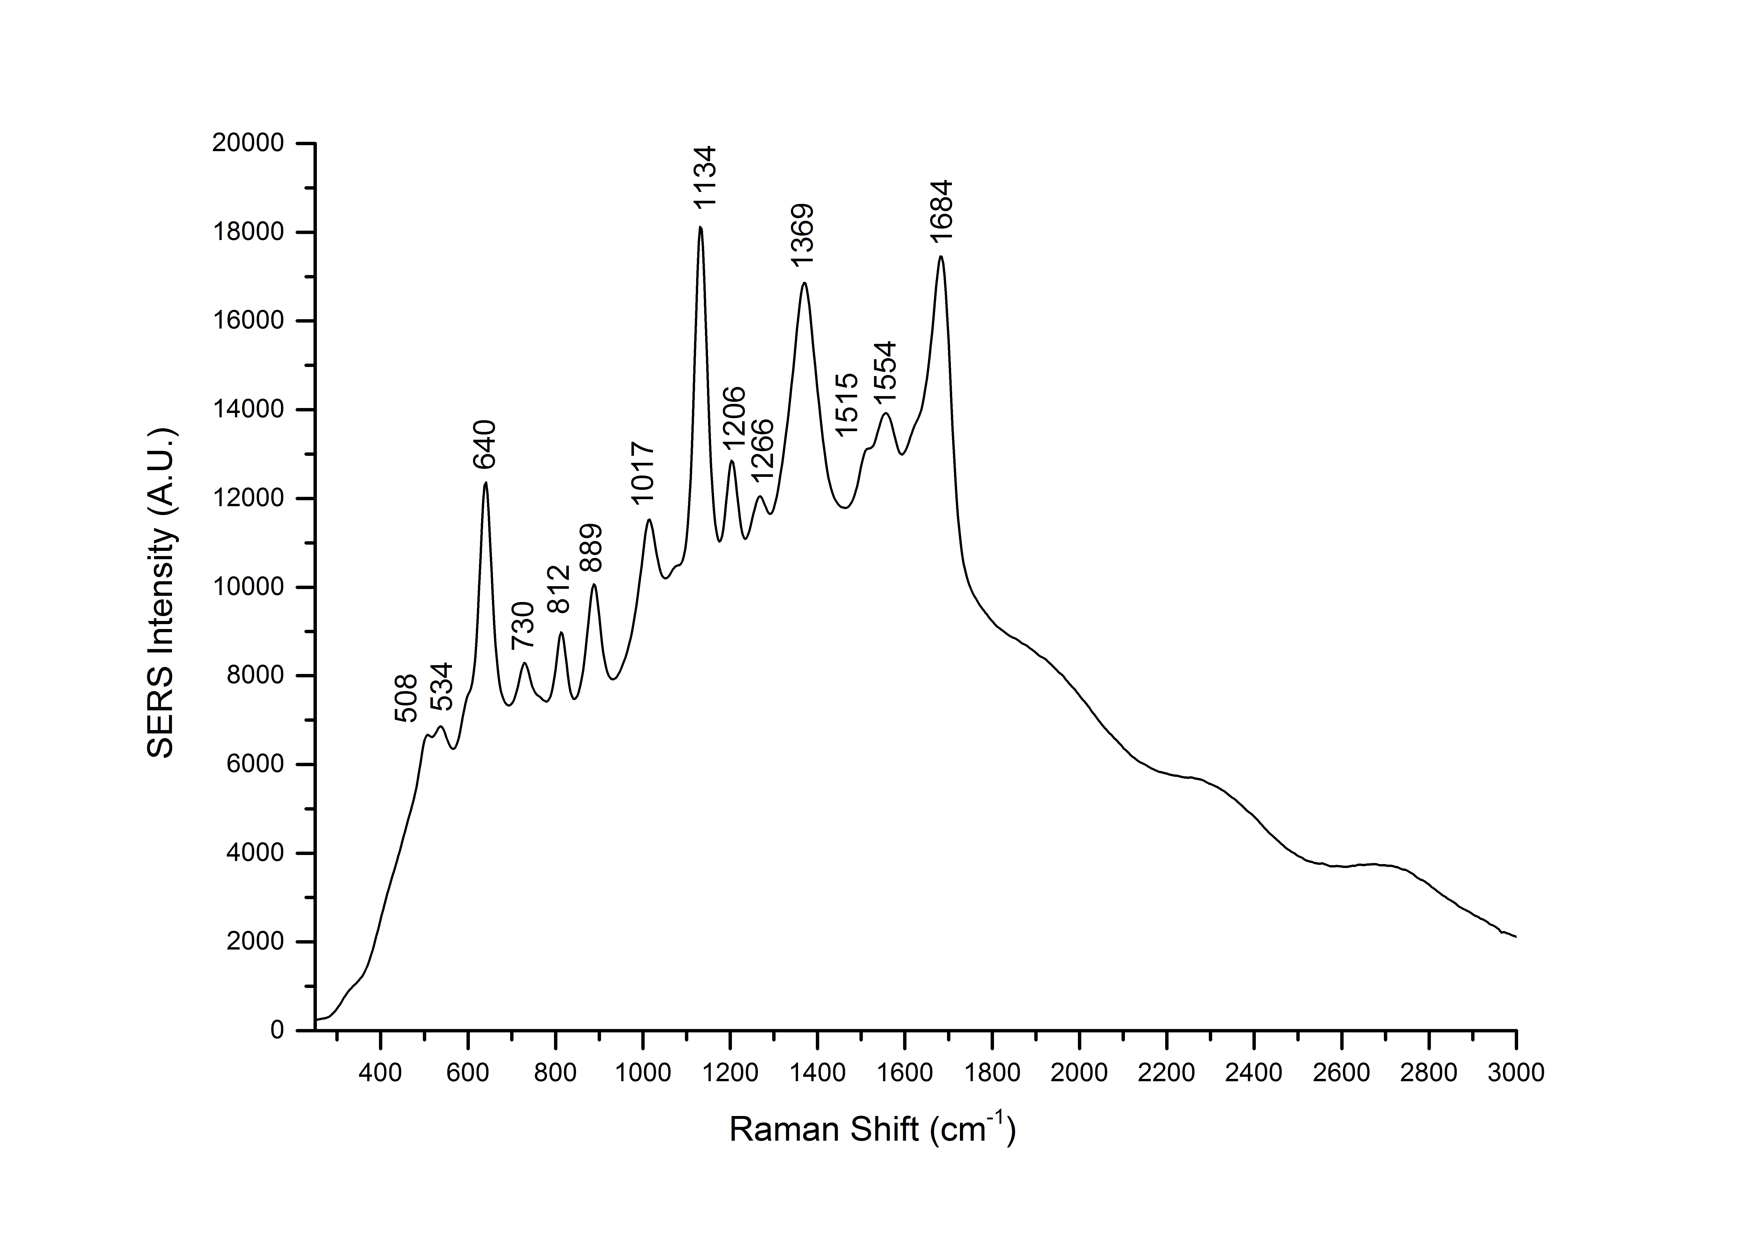

**Figure 1** Annotated mean averaged SERS spectra (*n* = 5) of uric acid. SERS spectra were obtained for 20 s, at 25 µM (dissolved in water) using 200 μL of hydroxylamine reduced silver colloid, potassium phosphate buffer at pH 7.6; measurements were made 3 min after aggregation.

**Table 1:** Band assignments for normal Raman (solid) and tentative SERS (25 µM solution) band assignments for the Uric Acid

|  |  |  |
| --- | --- | --- |
| Raman Shift (cm-1) | **SERS Peak (cm-1)** | **Tentative band assignment[****8****,** **13****,** **35****]** |
| 380 | - | - |
| - | 508 (vwsh) | C-N-C ring vibrations |
| - | 534 (vw) |  |
| 626 (w) | 640 (s) | Skeletal ring deformation |
| 705 (w) | 730 (w) | N-H bending |
| 783 (m) | 812 (m) | Ring vibration |
| 884 (w) | 889 (m) | N-H bending |
| 998 (s) | 1017 (w) | Ring vibrations |
| 1033 (vs) | - | - |
| 1122 (s) | 1134 (vs) | C-N |
| 1233 (s) | 1206 (m) | N-C-C stretching and bending |
| 1289 (s) | 1266 (w) | - |
| 1355 (w) | 1369 (s) | C-O |
| - | 1515 (vwsh) | Asymmetric deformation NH3 |
| 1406 (vs) | - | - |
| 1499 (s) | - | - |
| 1596 (m) | 1554 (m) | C-N |
| 1679 (vs) | 1684 (s) | - |

ν –stretching, b-bending, R-ring; trigd-trigonal deformation, s-strong, vs-very strong, m-medium,

w-weak, vw-very weak

A concern for the analysis in human urine was the effect the pH of individual samples would have on the SERS spectrum as well as any potential difference in how the target analyte would interact with the silver surface. After dilution, the pH of the urine samples varied considerably from 4.45 – 9.3, meaning uric acid would be in different ionisation states and consequently interact with the surface differently, generating sub-optimal SERS spectra, ultimately not representing the actual concentration in the sample. To overcome this and to ensure the urine sample had an overall pH that coincided with optimal uric acid detection, the sample environment was carefully modified. A potassium phosphate buffer at pH 7.6 was added to the colloid and urine, as well as the uric acid spiked in to the sample for the standard addition measurements. Therefore, after all constituents were added (i.e. urine, buffer, spiked uric acid and colloid), the overall sample pH for all patients varied from pH 7.2 – 8.

This meant that in all analyses uric acid was predominantly in its negative 1 ionisation state and would have the same affinity for the colloidal surface thus affording more reproducible and optimal SERS uric acid detection for all samples (see **supporting information Figure S3**). Moreover, the presence of additional buffer (i.e. 75 µL used) in the sample make up) was necessary for samples where low uric acid (or none, as in the blank) was spiked in.

**Standard addition method (SAM) approach**

Previously for quantifying uric acid within a mixture (in terms of monitoring biotransformation(s) involving three analytes) we used various chemometric approaches such as partial least squares regression (PLSR) and multivariate curve resolution-alternating least squares (MCR-ALS).8 However, these data analysis methods are not suitable for quantifying analytes in complex matrices where the sample matrix actually contributes to the analytical signal (i.e., when uric acid is already present in urine). Standard addition method (SAM) works by spiking in known amounts of standard, in this case uric acid, and plotting peak area (of a characteristic peak,*viz*. 1134 cm-1) against the concentration of the standard spiked in, thus yielding a straight line (*y* = *mx* + *b*; where *m* and *b* are the slope of the line and *y*‑intercept, respectively). From there, the concentration of the analyte can be determined from the point at which the extrapolated line crosses the concentration axis (*x*) at zero signal (i.e. where *y* = 0 and thus *x* = -*b*/*m* such that the concentration = *b*/*m*).37,38

A prerequisite in order to use SAM is a linear relationship between the concentration and the SERS signal of uric acid. From performing a concentration profile (see **supporting information Figure S2a**), the linear concentration range was determined to be between 1 – 100 µM). Therefore, for some samples, dilution of the initial urine sample was performed to ensure that on spiking in a known amount of standard, this linear concentration range was retained. Notably, in cases of saturation, comparably lower SERS signals are observed for higher analyte concentrations, as seen beyond 100 µM, and a non-linear relationship is observed. We also had to consider the effect of the concentration-dependence on the orientation of the target molecule on the colloidal surface. We noticed that below 5 µM, although still part of the linear relationship, the SERS spectrum of uric acid changed slightly, in terms of intensity and broadness of certain peaks, indicating the orientation of the analyte molecule on the surface was probably different. Therefore, for this reason, 5 - 100 µM was determined to be the optimum total concentration range of uric acid in the urine sample, taking into account spiking of standard and dilution factors.

**Sample selection and SAM Analysis**

Rather than measure all samples, 21 samples from the 58 human urine samples were randomly selected for comparative SERS and HPLC SAM analysis – we ensured that the samples selected covered the entire uric acid concentration range. The characteristic peak for uric acid used in the analysis was at 1134 cm-1, corresponding to the C-N vibration. **Table 2** shows a summary of the results from each analytical approach along with the associated percentage differences. As an example, for sample 18, HPLC results predicted a uric acid concentration of 172 µM, compared to 186 µM predicted from SERS, a difference of 7.5%. Overall, for all samples analysed, the percentage difference between the two analytical approaches ranged from 0.8% (sample 20) to 19.1% (sample 40), with the average percentage difference being 8.4 %. This is very encouraging considering the uric acid concentration range was extensive (starting from around 65 µM to 670 µM) meaning this approach could be extended to target other uric acid related diseases (i.e. those related to *low* concentration of uric acid (hypouricemia) as well as elevated uric acid levels (hyperuricemia) such as in preeclampsia).

**Table 2:** Summary of results for all samples analysed: HPLC (µM), SERS (µM) and the associated percentage differences between the two analytical approaches

|  |  |  |  |  |  |  |  |
| --- | --- | --- | --- | --- | --- | --- | --- |
| **Sample** | **HPLC (μM)** | **SERS (μM)** | **Difference** | **Sample** | **HPLC (μM)** | **SERS (μM)** | **Difference** |
| **QC (*n*=58)** | 190.3 | 181.1 | 4.8% | **26** | 215.0 | 182.9 | 14.9% |
| **1** | 274.9 | 266.6 | 3.1% | **31** | 548.5 | 601.6 | 8.8% |
| **4** | 112.9 | 111.8 | 1.0% | **36** | 206.9 | 187.7 | 10.2% |
| **5** | 119.4 | 135.1 | 11.6% | **40** | 219.2 | 184.0 | 19.1% |
| **9** | 64.5 | 73.2 | 11.9% | **41** | 309.8 | 294.2 | 5.3% |
| **12** | 91.5 | 88.4 | 3.4% | **44** | 196.6 | 188.7 | 4.0% |
| **14** | 70.1 | 73.1 | 4.1% | **47** | 183.0 | 157.5 | 16.2% |
| **16** | 511.2 | 561.6 | 9.9% | **49** | 679.4 | 665.5 | 2.1% |
| **18** | 172.0 | 186.0 | 7.5% | **52** | 249.5 | 233.8 | 6.7% |
| **20** | 151.9 | 153.1 | 0.8% | **53** | 126.3 | 117.4 | 7.1% |
| **22** | 234.6 | 199.3 | 15.0% | **55** | 345.8 | 301.6 | 12.8% |

NB Dilution factors taken into account. See ‘Preparation of urine for HPLC and SERS analysis’ in Supporting Information.

We next wanted to address the reproducibility of this SERS approach. Eleven of the 21 samples were randomly selected for triplicate HPLC and SERS analysis. For the latter, this meant using a different colloidal batch for each replicate performed (see **supporting information Figure S5).** In general, batch-to-batch variation and reproducibility of SERS enhancements is a key discussion point within the Raman community.39-42 Groups report noticeable discrepancies in results due to variations in colloidal batches, colloid concentrations and nanoparticle aggregation – all of which can result in inconsistent enhancements. However, we have demonstrated using these optimised set of conditions for uric acid detection in urine that we can produce consistent, reliable results that are in good agreement and comparable to HPLC results, the ‘gold standard’ in this case and used for benchmarking **(see Table 3).**

As an example, sample 20 was subjected to triplicate analysis (see **supporting information Figure S6**). The average percentage difference between the HPLC and SERS results was just over 1.5% across the three replicates. The standard deviation (SD) for SERS results was 4.1 (compared to 3.3 for HPLC) and the relative standard deviations (RSD) were 2.1 and 2.7% for HPLC and SERS respectively. These results are excellent in terms of accuracy (difference between HPLC and SERS), precision (SD for these repeat measurements) and overall reproducibility. To emphasise this further, the average percentage difference for triplicate analysis between the two analytical approaches was 7.2%, with the average SD and RSD for SERS being 12.8 and 6.7% and for HPLC, 6.3 and 3.3% respectively.

**Table 3:** Summary of results for samples involving triplicate analysis including associated percentage differences between the two analytical approaches, standard deviations (SD) and relative standard deviations (RSD)

|  |  |  |  |  |  |  |  |
| --- | --- | --- | --- | --- | --- | --- | --- |
| **Sample** | **HPLC (µM)** | **SD (±)** | **RSD (±)** | **SERS (µM)** | **SD (±)** | **RSD (±)** | **Difference** |
| **1** | 274.9 | 13.6 | 5.0% | 266.6 | 17.4 | 6.5% | 3.1% |
| **4** | 112.9 | 3.8 | 3.4% | 111.8 | 9.6 | 8.6% | 1.0% |
| **5** | 119.4 | 1.5 | 1.3% | 135.1 | 11.1 | 8.3% | 11.6% |
| **12** | 91.5 | 6.0 | 6.5% | 88.4 | 9.2 | 10.5% | 3.4% |
| **20** | 152.3 | 3.2 | 2.1% | 153.1 | 4.1 | 2.7% | 1.5% |
| **36** | 206.9 | 5.0 | 2.4% | 187.7 | 8.4 | 4.5% | 10.2% |
| **40** | 219.2 | 1.6 | 0.7% | 184.0 | 12.5 | 6.8% | 19.1% |
| **41** | 309.8 | 10.8 | 3.5% | 294.2 | 16.8 | 5.7% | 5.3% |
| **47** | 183.0 | 6.1 | 3.3% | 157.5 | 13.4 | 8.5% | 16.2% |
| **49** | 679.4 | 9.4 | 4.2% | 665.5 | 16.5 | 2.5% | 2.1% |
| **52** | 249.5 | 8.5 | 3.4% | 233.8 | 22.1 | 9.4% | 6.7% |
| **Control\*** | 51.0 | 0.7 | 1.4% | 53.9 | 4.6 | 8.5% | 7.8% |

*Control is to establish overall errors associated with each technique. 50 µM (i.e. known concentration) was spiked into blank

The average difference between the two analytical approaches was 7.2%. The average SD and RSD for SERS was 12.8 and 6.7% and for HPLC, 6.3 and 3.3% respectively.

To confirm further how excellent the agreement of data are between the two analytical approaches, **Figure 2a)** shows a HPLC *versus* SERS plot for all 21 analyses, reflecting a very good linear trend with an *R2* of 0.9792. In addition, **Figure 2b)** is a plot of percentage difference (from HPLC – SERS predictions) against HPLC predicted concentration for all samples analysed. The ‘randomness’ of the plot (i.e. both positive and negative differences) indicates that there is no systematic bias in the analysis. Notably, there are less samples analysed at high uric acid levels, and ideally we would want an even spread of samples across the entire uric acid concentration range to demonstrate fully how applicable this SERS approach is. However, these samples are real, clinical pre-preeclampsia samples and hence this is reflected by the uric acid concentrations observed.

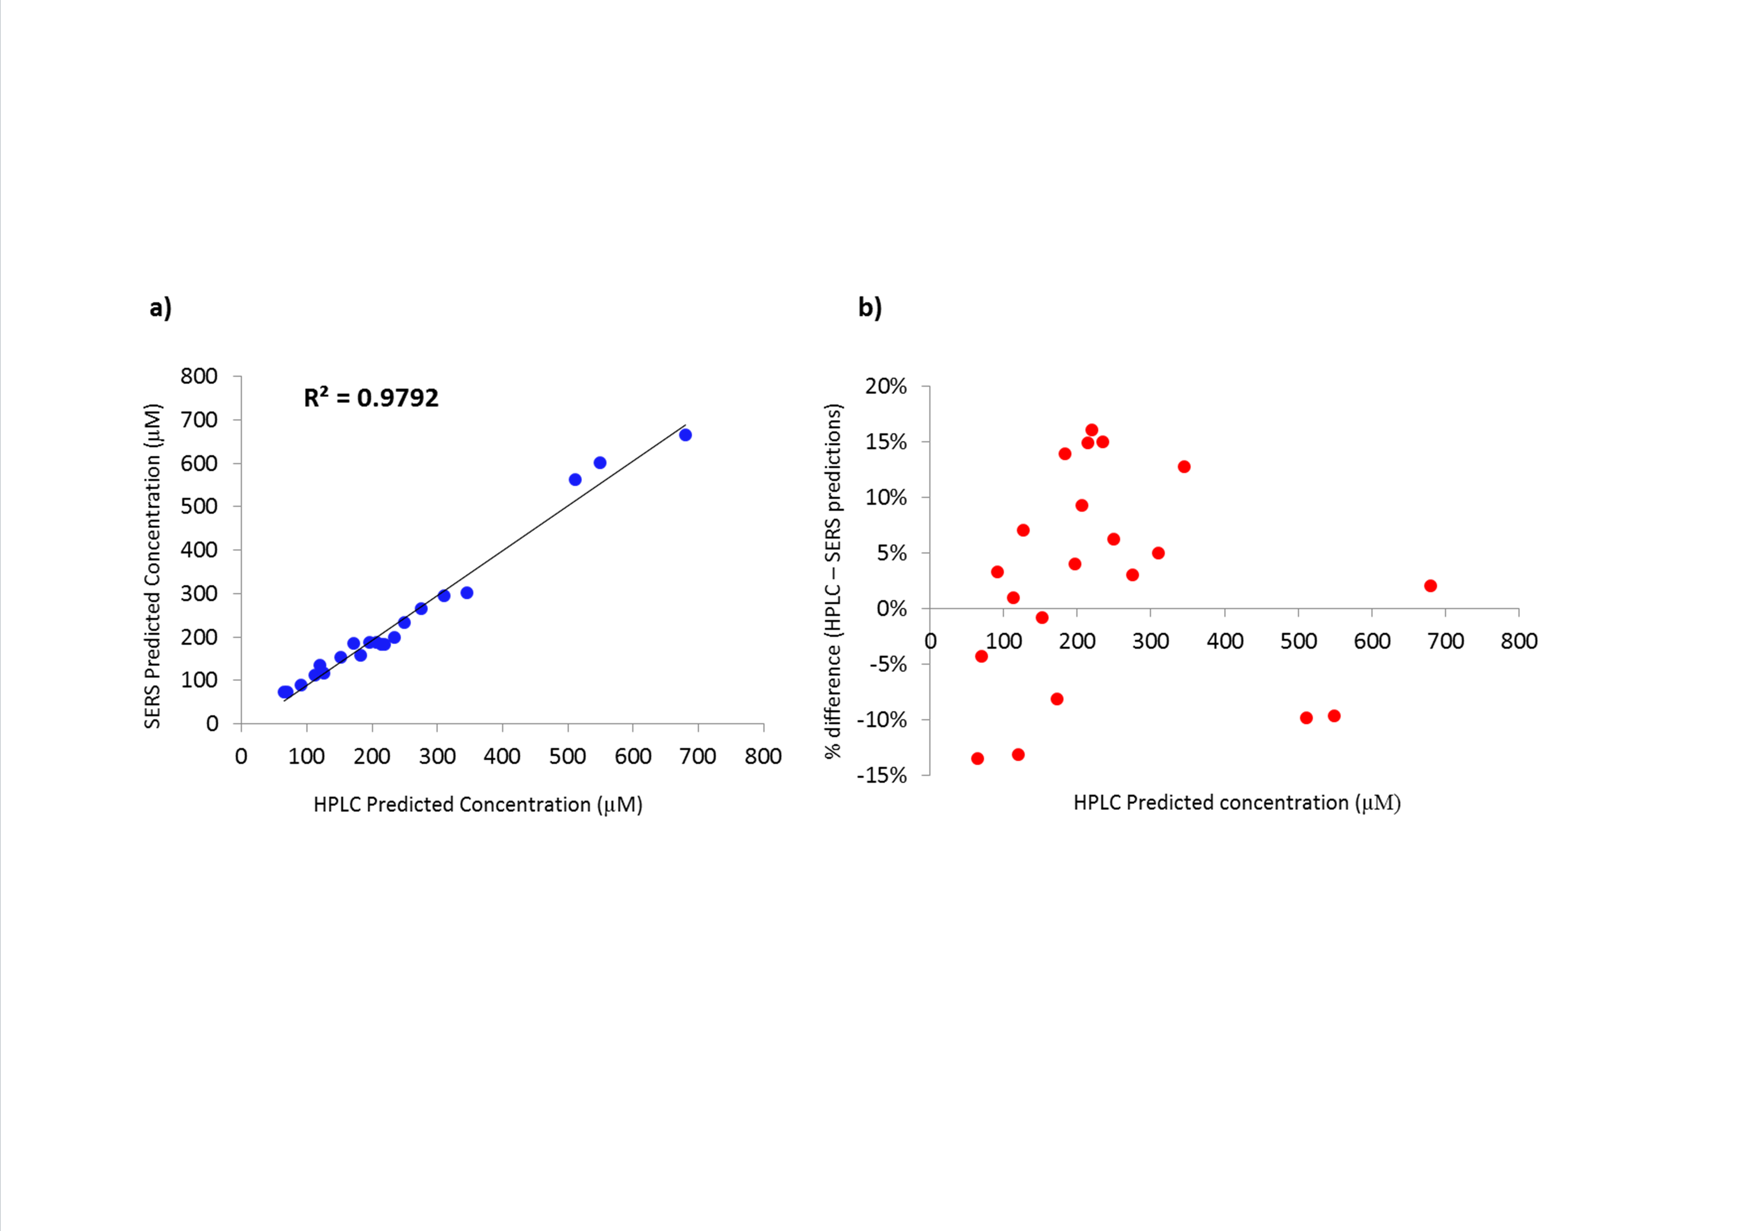

**Figure 2 a)** A plot of predictions from HPLC *vs.* SERS for all samples (including replicates) with an *R2* of 0.9792 indicating results are in very good agreement. **b)** A plot of percentage difference (from HPLC – SERS predictions) against HPLC predicted concentration for all samples analysed, indicating that there is no systematic bias in the analysis.

Noticeably, SERS results have slightly higher SD and RSD throughout the samples analysed. However, the reduction in acquisition times for SERS analysis, compared to lengthy HPLC, largely compensates and outweighs this. In total, SAM HPLC takes 140 min (7 samples × 20 min HPLC trace) for uric acid prediction for each sample. Comparatively, SAM SERS analysis takes 140 s (7 samples × 20 s SERS acquisition), a 60-fold reduction and yet results are in very good agreement and highly comparable. There is only on average 8.4% difference for all samples analysed. There was on average 7.2% difference for the triplicate analysis indicating that the precision and accuracy were similar. Moreover, if one considers the actual associated error with each analytical approach (see **Table 2**) - for HPLC there are associated SD and RSD of 0.7 and 1.4% and for SERS 4.6 and 8.5% respectively - there is overlap and leeway in the results between the two analytical approaches, making this SERS approach a highly attractive alternative that could be used in clinical settings. Finally on this point, the cost of the analysis is comparable, as HPLC apparatus include instrument costs and consumables, which are equivalent to low-cost portable and indeed hand-held Raman spectrometers plus cost of colloid and reagents.

**CONCLUSION**

There is a real urgent unmet need for early diagnosis of preeclampsia in pregnant women. We have demonstrated a SERS based approach to measure uric acid in pre-preeclamptic urine samples which yields absolute quantitation. In combination with the well-known SAM approach, uric acid concentrations have been predicted in urine samples from 21 different patients, and benchmarked against HPLC. It is highly notable that there is a 60-fold reduction in acquisition time when employing this SERS-based approach, and yet the average difference between the two analytical approaches is less than 9%. Furthermore, we have demonstrated excellent reproducibility, with 11 of these samples performed in triplicate analysis using different colloidal batches (for each replicate) highlighting its use for applications in rapid, routine detection of uric acid. We believe this new SERS-SAM analytical approach could easily be translated into an on-site, diagnostic tool for early diagnosis of preeclampsia and indeed other disease where quantification of uric acid is needed.

**Supporting information**. Contains full experimental details of all **Supplementary Methods**, including: **Reagents and Materials**, **Methods**, **Instrumentation**, as well as **Data Processing**. A pictorial representation of the overall process described in this paper (**Figure S1**), optimisation of the SERS process developed (**Figure S2**), and pH profiling of uric acid to check for ionisation and the effect this has on SERS (**Figure S3**). Also included is an annotated mean average Raman spectra of uric acid (**Figure S4**), as well as UV absorbance of five different hydroxylamine-reduced silver colloids showing excellent reproducibility of synthesis (**Figure S5**), and a comparison of the SERS method developed with HPLC from the same patient sample (**Figure S6**).

**ACKNOWLEDGEMENTS**

CW is grateful to BBSRC for a PhD studentship. We are very grateful to Professor Ray K Iles for helping source human urine samples and St George’s, University of London & St George’s University Hospitals NHS Foundation Trust Clinical Sciences Research Centre. YX thanks the Cancer Research UK for funding (including an Experimental Cancer Medicine Centre award). AJC would like to acknowledge BBSRC for funding (BB/M028631/1). NJT and RG are also indebted to BBSRC and GSK for financial funding (grant BB/K00199X/1). NJT thanks the Royal Society for a Wolfson Research Merit Award.

**REFERENCES**

(1) Kenny, L. C.; Broadhurst, D.; Brown, M.; Dunn, W. B.; Redman, C. W.; Kell, D. B.; Baker, P. N. *Reprod. Sci.* **2008**, *15*, 591-597.

(2) Goldenberg, R. L.; McClure, E. M.; Macguire, E. R.; Kamath, B. D.; Jobe, A. H. *Int. J. Gynaecol. Obstet.* **2011**, *113*, 91-95.

(3) Conde-Agudelo, A.; Belizan, J. M.; Lammers, C. *Am. J. Obstet. Gynecol.* **2005**, *192*, 342-349.

(4) Carty, D. M.; Delles, C.; Dominiczak, A. F. *Trends Cardiovasc. Med.* **2008**, *18*, 186-194.

(5) Johnson, J. A. *Ann. Med.* **2012**, *44*, S17-S22.

(6) Redman, C. W.; Sargent, I. L. *Science* **2005**, *308*, 1592-1594.

(7) Barker, D. J.; Gluckman, P. D.; Godfrey, K. M.; Harding, J. E.; Owens, J. A.; Robinson, J. S. *Lancet* **1993**, *341*, 938-941.

(8) Westley, C.; Xu, Y.; Carnell, A. J.; Turner, N. J.; Goodacre, R. *Anal. Chem.* **2016**, *88*, 5898-5903.

(9) Kar, M. *J. Clin. Diagn. Res.* **2014**, *8*, BE01-BE04.

(10) Roberts, J. M.; Cooper, D. W. *Lancet* **2001**, *357*, 53-56.

(11) Bainbridge, S. A.; Roberts, J. M. *Placenta* **2008**, *29*, S67-S72.

(12) Feig , D. I.; Kang , D.-H.; Johnson , R. J. *N. Engl. J. Med.* **2008**, *359*, 1811-1821.

(13) Kodati, V. R.; Tu, A. T.; Turumin, J. L. *Appl. Spectrosc.* **1990**, *44*, 1134-1136.

(14) Puig, J.; Martínez, M.; Mora, M.; Fraile, J.; Montoya, F.; Torres, R. *Nucleosides, Nucleotides Nucleic Acids* **2008**, *27*, 620-623.

(15) Roberts, J. M.; Gammill, H. S. *Hypertension* **2005**, *46*, 1243-1249.

(16) Feig, D. I.; Mazzali, M.; Kang, D. H.; Nakagawa, T.; Price, K.; Kannelis, J.; Johnson, R. J. *J. Am. Soc. Nephrol.* **2006**, *17*, S69-73.

(17) Buhimschi, C. S.; Norwitz, E. R.; Funai, E.; Richman, S.; Guller, S.; Lockwood, C. J.; Buhimschi, I. A. *Am. J. Obstet. Gynecol.* **2005**, *192*, 734-741.

(18) Mikat, B.; Gellhaus, A.; Wagner, N.; Birdir, C.; Kimmig, R.; Köninger, A. *ISRN Obstet. Gynecol.* **2012**, *2012*.

(19) Rasanen, J.; Quinn, M. J.; Laurie, A.; Bean, E.; Roberts Jr, C. T.; Nagalla, S. R.; Gravett, M. G. *Am. J. Obstet. Gynecol.* **2015**, *212*, 82.e81-82.e89.

(20) Ma, K.; Yuen, J. M.; Shah, N. C.; Walsh, J. T.; Glucksberg, M. R.; Van Duyne, R. P. *Anal. Chem.* **2011**, *83*, 9146-9152.

(21) Zhang, D.; Haputhanthri, R.; Ansar, S. M.; Vangala, K.; De Silva, H. I.; Sygula, A.; Saebo, S.; Pittman, C. U. *Anal. Bioanal. Chem.* **2010**, *398*, 3193-3201.

(22) Alharbi, O.; Xu, Y.; Goodacre, R. *Anal. Bioanal. Chem.* **2015**, *407*, 8253-8261.

(23) Cialla, D.; Pollok, S.; Steinbrücker, C.; Weber, K.; Popp, J. *Nanophotonics* **2014**, *3*, 383-411.

(24) Sorensen, K. M.; Westley, C.; Goodacre, R.; Engelsen, S. B. *Anal. Bioanal. Chem.* **2015**, *407*, 7787-7795.

(25) Haes, A. J.; Haynes, C. L.; McFarland, A. D.; Schatz, G. C.; Van Duyne, R. P.; Zou, S. *MRS Bull.* **2005**, *30*, 368-375.

(26) Smith, W. E. *Chem. Soc. Revs.* **2008**, *37*, 955-964.

(27) Kneipp, K.; Wang, Y.; Kneipp, H.; Perelman, L. T.; Itzkan, I.; Dasari, R. R.; Feld, M. S. *Phys. Rev. Lett.* **1997**, *78*, 1667.

(28) Yang, S.; Dai, X.; Stogin, B. B.; Wong, T.-S. *Proc. Natl. Acad. Sci. U. S. A.* **2016**, *113*, 268-273.

(29) Cowcher, D. P.; Xu, Y.; Goodacre, R. *Anal. Chem.* **2013**, *85*, 3297-3302.

(30) Ellis, D. I.; Muhamadali, H.; Haughey, S. A.; Elliott, C. T.; Goodacre, R. *Anal. Methods* **2015**, *7*, 9401-9414.

(31) Pucetaite, M.; Velicka, M.; Pilipavicius, J.; Beganskiene, A.; Ceponkus, J.; Sablinskas, V. *J. Raman Spectrosc.* **2016**, *47*, 681-686.

(32) Kammer, E.; Olschewski, K.; Stockel, S.; Rosch, P.; Weber, K.; Cialla-May, D.; Bocklitz, T.; Popp, J. *Anal. Bioanal. Chem.* **2015**, *407*, 8925-8929.

(33) Zhao, L.; Blackburn, J.; Brosseau, C. L. *Anal. Chem.* **2015**, *87*, 441-447.

(34) Villa, J. E. L.; Poppi, R. J. *Analyst* **2016**, *141*, 1966-1972.

(35) Goodall, B. L.; Robinson, A. M.; Brosseau, C. L. *Phys. Chem. Chem. Phys.* **2013**, *15*, 1382-1388.

(36) Leopold, N.; Lendl, B. *J. Phys. Chem. B* **2003**, *107*, 5723-5727.

(37) Bruce, G. R.; Gill, P. S. *J. Chem. Educ.* **1999**, *76*, 805.

(38) Stark, T.; Wollmann, N.; Losch, S.; Hofmann, T. *Anal. Chem.* **2011**, *83*, 3398-3405.

(39) Larmour, I. A.; Faulds, K.; Graham, D. *J. Raman Spectrosc.* **2012**, *43*, 202-206.

(40) Yaffe, N. R.; Blanch, E. W. *Vib. Spectrosc.* **2008**, *48*, 196-201.

(41) Hobro, A. J.; Jabeen, S.; Chowdhry, B. Z.; Blanch, E. W. *J. Phys. Chem. C* **2010**, *114*, 7314-7323.

(42) Fisk, H.; Westley, C.; Turner, N. J.; Goodacre, R. *J. Raman Spectrosc.* **2016**, *47*, 59-66.

TOC Graphic

