Portable mass spectrometry for the direct analysis and quantification of volatile halogenated hydrocarbons in the gas phase
Stamatios Giannoukos,ª Mariya Juno Antony Joseph,ª Stephen Taylor^{a, b,} *

ªDepartment of Electrical Engineering and Electronics, University of Liverpool, Brownlow Hill, Liverpool, L69 3GJ, United Kingdom
^{b} Q-Technologies Ltd, 100 Childwall Road, Liverpool, L15 6UX, United Kingdom

Short Title: Detection of volatile organohalogen compounds using MIMS.
*Corresponding author: e-mail: S.Taylor@liv.ac.uk

ABSTRACT
Field chemical analysis (FCA) of volatile halogenated hydrocarbons is a highly debated topic of widespread interest due to the significant negative impact of these compounds on public health, on ecosystems and in the environment (e.g. destruction of the stratospheric ozone). This article reports, for the first time, the use of a unique, lightweight (11 kg), man-portable membrane inlet mass spectrometer (MIMS) in the qualitative determination (for both detection and screening) and quantitative analysis of organohalogen chemical analytes in the gaseous phase. Representative compounds examined include: a) volatile organochlorine compounds (e.g. trichloromethane, 1,2-dichloroethane, 1,1,1-trichloroethane, 1,1,1,2-tetrachloroethane), b) volatile organobromine and chlorobromocarbon compounds (e.g. bromomethane, dibromomethane, chlorobromomethane, bromodichloromethane), and c) volatile chlorofluorocarbon and organoiodine compounds (e.g. chlorodifluoromethane, trichlorofluoromethane, 1,1,2-trichloro-1,2,2-trifluoroethane, methyl iodide). Gas phase experiments were undertaken at concentration levels from low ppb to low ppm. The results obtained exhibited excellent linearity within the concentration range examined, high sensitivity (limit of detection < 10 ppb), good repeatability (relative standard deviation, RSD < 5 %) and membrane response times in real time (analysis within few seconds). Chemical investigations of mixture effects are also presented. Our method was successfully validated in laboratory based experiments within a test chamber.

Keywords: field chemical analysis, portable MIMS, organohalogen compounds, ambient air analysis, air pollution, environment.

- INTRODUCTION
Air pollution with volatile organic compounds (VOCs) is considered to be a topic of widespread scientific, political and general interest due to the hazardous and toxic effects of these compounds on living organisms and ecosystems.¹⁻³ A subclass of VOCs with high environmental interest is the volatile halogenated hydrocarbons which have been extensively used for a range of industrial, agricultural, commercial and household applications since the beginning of the 20th century.⁴ Volatile halogenated hydrocarbons bring together properties which can lead to adverse and possible irreversible impact for animal and human health including, but not limited to: thyroid disruption, immunotoxicity, hepatic and kidney disorders, neurological malfunctions and cancer formation.^{5, 6} Ineffective emission management policies during their use and inadequate disposal strategies or technologies have contributed to the growth of this environmental problem. Quantification of these compounds in the atmosphere, in water or soil, whether produced from natural or manmade processes, is still limited. Environmental agencies do not have robust, quantitative prediction models of the current and future worldwide organohalogen concentration distribution.
Human or animal exposure to volatile organohalogen compounds (VOHCs) can occur through inhalation (breathing of contaminated indoor or outdoor air), via ingestion (food or water) or dermal contact (e.g. bathroom or shower water, in the domestic and/or workplace environment).⁷⁻¹² If the organohalogen compounds enter into the bloodstream, they may spread to key body organs such as kidney, liver etc. and break down into by-products or metabolites.¹³ Such breakdown products may leave the human body after some days, if they are in low quantities. However, they may attack healthy human cells causing serious problems if they are present in high amounts). In the atmosphere, organohalogen compounds undergo slow degradation, with estimated half-lives ranging from some months to some years.¹³⁻¹⁵ Some atmospheric organohalogens (e.g. chlorofluorocarbons) may diffuse slowly into the stratosphere and participate (at different levels) in chemical reactions that generate chlorine radicals which eventually contribute to the destruction of the ozone layer.
Common analytical methodologies for the determination of volatile halogenated hydrocarbons in environmental gas samples utilise laboratory based gas chromatography (GC) hybrid techniques. For the target volatile organohalogen compounds considered in this study (Table 1), the following analytical techniques have been extensively used: GC coupled with mass spectrometry (GC-MS), with an electron capture detector (GC-ECD), GC with a photoionisation detector (GC-PID) and coupled with a flame ionization detector (GC-FID).¹³⁻²¹ In some cases, high-performance liquid chromatography (HPLC) coupled with an ultraviolet (UV) detector has also been deployed.¹³ GC or liquid chromatography (LC) coupled to tandem MS (GC-MS/MS or LC-MS/MS) has also been utilised.²² Plasma-assisted reaction chemical ionisation (PARCI) MS has been tested and positively evaluated for the elementary analysis of organobromines.²³ Gas sampling procedures include direct sample collection in cryogenically cooled traps, the use of sorbent tubes filled with absorptive materials, the use of canisters or needle trap devices packed with silica and nanotubes.²⁴ Solid phase microextraction (SPME) has also been shown to be useful in the chemical analysis of such compounds.^{13, 25} Conventional laboratory analytical methodologies although they possess numerous advantages, are nevertheless time consuming, complicated and demanding techniques. They have multiple stages from sample collection and preparation to sample analysis and the data acquisition. The necessity for portable instrumentation with in-situ analytical capabilities and with minimal sample preparation requirements is growing rapidly in order to enhance situational awareness at the point of analysis.²⁶
Recent advances in the miniaturisation of MS, resulting in small footprint instruments with high analytical performance metrics, have led to the development of instruments which can be deployed during field applications.²⁷⁻³⁶ Numerous laboratories across the world are dedicated in the progression of field chemical analysis (FCA), by developing, optimising and using state-of-the-art MS systems, novel sample introduction methodologies and ionisation techniques (both in vacuum and in atmospheric pressure), analysers or filters and improved detection algorithms. In comparison to bulky laboratory based MS systems (stand-alone or combined with other analytical devices), portable MIMS offers direct on-site qualitative and quantitative chemical analysis with real-time (within a few seconds) monitoring capabilities.³⁷⁻⁴⁷ Portable MIMS may be either man-portable as a backpack system, or within a waterproof hand carrying case or vehicle mounted.
The underlying MIMS operating principle is the pervaporative separation of sample molecules through porous or non-porous membrane materials. ^{37, 38} The molecules introduced into the MS vacuum chamber travel to the ion source where they are fragmentated and ionised. The generated ions are separated according to their m/z ratio by the mass analyser and finally detected by the detector. The physical and chemical properties of the sample molecules are critical for the choice of the right membrane interface and this can affect the mass analysis. MIMS characteristics include the following: high sensitivity (ppt/ppb limits of detection - LODs), compound selectivity, fast analysis (within few seconds), repeatability, reliability, robustness and user friendliness.^{37, 38} Generally, MIMS systems have low maintenance costs, since the membrane interface can be employed in continuous analytical processes without requiring frequent replacement. The above properties allow portable MIMS to be an ideal choice for environmental monitoring purposes, especially when crucial decisions need to be taken at the point of analysis.
In this article (which follows other published work⁴⁸), we demonstrate, for the first time, the use of a novel portable MIMS system for the online detection and monitoring of VOHCs in the gaseous phase in the concentration range from low ppb to low ppm. The experimental work is described in four main subcategories as follows: a) volatile organochlorine compounds, b) volatile organobromine and chlorobromocarbon compounds, c) volatile chlorofluorocarbon and organoiodine compounds and d) mixture of VOHCs. The overall weight of the MIMS system used in this work is 11 kg (7 kg lighter than our previous version). The weight reduction is due to the replacement of the vacuum system with a lighter one; whilst maintaining the same vacuum pumping characteristics. The new system, could be integrated within a backpack and carried by an operator during field investigations or could even be integrated in a manned or unmanned ground vehicle (UGV) to give an improved standoff distance e.g. for sensing hazardous analytes.

- EXPERIMENTAL SECTION

  - Concept.
The concept behind this work is the early detection and on-line monitoring of volatile organohalogen pollutants during in-situ operations using portable MS. The compounds for this study, and their characteristic properties (e.g. vapour pressure, log K_{ow}, etc.) are presented in Table 1. Table 2 presents common uses of these compounds and possible effects upon human health. Trihalomethanes¹ (THMs) such as trichloromethane, bromodichloromethane, chlorodifluoromethane and chlorofluorocarbon¹ (CFC) compounds such as chlorodifluomethane, trichlorofluoromethane and 1,1,2-trichloro-1,2,2-trifluoroethane are also included in the list. THMs are mainly produced as by-products during the chlorination of the water and are considered to be carcinogens. CFCs are environmental pollutants that contribute to ozone depletion, enhancing the greenhouse effect and are therefore controlled by the Montreal Protocol.⁴⁹ However, exposure registries for most of the examined compounds in various scenarios or media (atmosphere, water, soil, etc.) are not currently fully established by International Organisations and there are numerous ongoing research studies working towards this direction. Data regarding safe exposure limits in humans are insufficient and require detailed investigation. Thus, the necessity for continuous monitoring of VOHCs in the air using portable molecular sensors is emerging.

Table 1. Summary of the volatile organohalogen compounds used in the MIMS experiments.^{13-15, 50}
Compound | CAS Number | Molecular weight | Vapour pressure (kPa) at 25ºC | log octanol/water partition coefficient (log K_{ow}) | Odour threshold (ppm)
Trichloromethane | 67-66-3 | 119.378 | 26.2645 | 1.97 | 3.30
1,2-Dichloroethane | 107-06-2 | 98.959 | 10.5191 | 1.48 | 3
1,1,1-Trichloroethane | 71-55-6 | 133.404 | 16.5319 | 2.49 | 100
1,1,1,2-Tetrachloroethane | 630-20-6 | 167.849 | 1.5998 | 2.93 | 1.5
Bromomethane | 74-83-9 | 94.939 | 215.9822 | 1.19 | 0.08
Dibromomethane | 74-95-3 | 173.835 | 5.9195 | 1.70 | N/A
Chlorobromomethane | 74-97-5 | 129.384 | 18.9317 | 1.41 | 2.1
Dichlorobromomethane | 75-27-4 | 163.829 | 6.6661 (20ºC) | 2.00 | 1.6
Chlorodifluoromethane | 75-45-6 | 86.468 | 966.5873 | 1.08 | N/A
Trichlorofluoromethane | 75-69-4 | 137.368 | 107.0578 | 2.53 | 0.028
1,1,2-Trichloro-1,2,2-trifluoroethane | 76-13-1 | 187.376 | 48.3960 | 3.16 | 45
Methyl iodide | 74-88-4 | 141.939 | 53.9955 | 1.51 | N/A

Table 2. Summary of common uses and potential health effects of the volatile organohalogen compounds tested in this work.^{13, 14, 51}
Compound | Main uses | Possible health effects
Trichloromethane | - Laboratory and industrial solvent  - Intermediate product in pesticides synthesis  - Metal degreasing solvent  - Production of wood strains and varnishes | - Cancer formation  - Affects the nervous system  - Liver and kidneys disorder
1,2-Dichloroethane | - Solvent in electronics industry, paint and coating industry  - Production of vinyl chloride | - Cancer formation  - Nervous system disorders  - Liver and kidneys disorder
1,1,1-Trichloroethane | Prior to the Montreal Protocol, it was used as:  - Cleaner for photographic films  - Insecticidal fumigant  - Aerosol propellant  - Solvent in electronics industry | - Dizziness and headache  - Respiratory problems  - Hepatic effects  - Nervous system disorder
1,1,1,2-Tetrachloroethane | - Intermediate product in the synthesis of other chemicals e.g. trichloroethylene, etc.  - Solvent | - Inhalation problems  - Carcinogen  - Toxic
Bromomethane | - Pesticide, insecticide, nematocide  - Intermediate product in the synthesis of other chemicals | - Inhalation problems  - Neurological effects
Dibromomethane | - Solvent for fats, waxes, resins, etc.  - Ingredient of fire extinguishing fluids | - Nervous system depressant  - Liver and kidney disorders  - Blood anomalies
Chlorobromomethane | - Intermediate in the manufacturing process of pesticides and other chemicals  - Fire extinguisher | - Skin and eye irritation  - Central nervous system disorders  - Blood damage
Dichlorobromomethane | - Reagent and solvent in organic chemistry  - Fats and waxes separation solvent | - Liver and kidney disorders  - Brain effects e.g. incoordination, etc.  - Cancer formation
Chlorodifluoromethane | Phased out in developed countries, but in use in developing countries  - Propellant and refrigerant  - Pesticide | - Toxic  - Irregular heart beats  - Inhalation difficulties  - Nervous system problems
Trichlorofluoromethane | - Refrigerant  - Consumer products e.g. hair sprays or deodorants  - Insecticide | - Irregular heart beating  - Dizziness  - Lung problems
1,1,2-Trichloro-1,2,2-trifluoroethane | - Dry cleaning agent  - Polymer manufacturing industries  - Electronics industry  - Chemical intermediate | - Affect central nervous system  - Respiratory disorders
Methyl iodide | - Manufacturing of pesticides and nematocides  - Fumigant  - Industrial processes | - Nervous system disorder  - Skin, lung and kidneys disorders  - Pulmonary edema

  - Reagents.
Certified analytical standard stock solutions of trichloromethane (200 μg/mL in methanol), 1,2-dichloroethane (200 μg/mL in methanol), 1,1,1-trichloroethane (200 μg/mL in methanol), 1,1,1,2-tetrachloroethane (5000 μg/mL in methanol), dibromomethane (2000 μg/mL in methanol); chlorobromomethane (200 μg/mL in methanol), bromodichloromethane (200 μg/mL in methanol), trichlorofluoromethane (200 μg/mL in methanol), 1,1,2-trichloro-1,2,2-trifluoroethane (2000 μg/mL in methanol), and methyl iodide (2000μg/ mL in methanol:H₂O (80:20)) were purchased from Sigma Aldrich Co. LLC., U.K. Bromomethane (200 μg/mL in methanol) and chlorodifluoromethane (1000 μg/mL in methanol) were purchased from Fisher Scientific UK Ltd. (Loughborough). All reagents were provided in the liquid phase and stored in the fridge at 4ºC until their use.

2.3 Experimental Setup.
In this study, experiments were carried out using a portable membrane inlet mass spectrometer (MIMS) provided by Q-Technologies Ltd., Liverpool, UK.⁵² The MIMS system has been described in detail previously elsewhere.⁴⁸ However, for clarity purposes and due to some technical changes/improvements of the apparatus, a brief summary follows. Liverpool MIMS system is a compact and lightweight (11 kg) molecular sensor that consists of four main components: a) a sampling probe, b) a triple filter quadrupole mass spectrometer, c) the vacuum system and d) a laptop computer. The inlet sampling probe utilises a very thin flat silicon membrane that allows selective permeation of generally low molecular weight non-polar molecules from the ambient environment into the vacuum chamber. The suction flow rate applied onto the membrane material from the vacuum side is controlled manually using a Swagelok metering valve. The triple filter quadrupole mass spectrometer (QMS) consists of an enclosed electron impact (EI) ion source, the mass analyser (with a pre, main and post filter) and the detector. The EI ion source has a twin Thoriated Iridium filament assembly at 1.6 mA electron emission current. The applied electron energy is 65 eV and the filament current is 1.8 A. The ion focus voltage is set at -110 V. The mass analyser consists of a 125 mm main filter with a 25 mm small quadrupole filter at either end. Electrodes are made from stainless steel and have diameter of 6.3 mm. At the pre and post filter, only RF is applied. In comparison with a single quadrupole mass analyser, the use of a triple filter mass analyser offers enhanced sensitivity and improved resolution. The MIMS system has a mass range of m/z 1-200 with a better than 1 amu resolution over the entire mass range. The sensitivity of the quadrupole analyzer is 1 × 10⁻⁴ A/mbar. The RF frequency is 2 MHz and the RF amplitude 1600 V whereas the DC/RF ratio is set to 8.6. The scanning speed can be varied and is typically between 10 and 15 amu/sec. The detection of ions is performed by a Channeltron type electron multiplier. Data were recorded on a laptop computer and analysed using the NIST 11 mass spectral library as reference database for spectral peaks of each compound. The system vacuum was achieved and maintained in stable low pressure values during experiments using the Agilent Mini-TASK AG 81 pumping system. Agilent Mini-TASK AG 81 consists of the Agilent Turbo-V 81-M turbopump and a dry diaphragm forepump. Total base pressure of the system with the sample inlet valve fully closed was 1× 10⁻⁷ Torr. Operating pressure during mass analysis with the membrane sampling probe attached and the sample inlet valve fully open was varying between 2.0 × 10⁻⁶ Torr and 2.0 × 10⁻⁵ Torr depending on the concentration, the nature and physical and chemical properties of the under examination gas standard. During data acquisition, 10 acquisition points were recorded per unit mass. On average, 10 scans throughout the mass region m/z 40-200 were recorded per sample concentration. High concentration atmospheric molecules (such as N₂ or O₂) were not scanned to reduce the risk of detector degradation. In total 60 scans per compound and per experimental replication were recorded. The experiments were replicated three times to allow us to perform statistical analysis of the results obtained and also to investigate the reproducibility of our technique.

  - Sample Preparation.
Gas calibration standards were prepared using the static dilution bottles gas standard generation technique.^{37, 38, 48, 53, 54} Liquid stock solutions of individual halogenated hydrocarbons were bought at standard concentrations. Calculated quantities of every single reference liquid solution corresponding to a standard gas phase concentration were injected with a high precision micropippete (purchased from Mettler-Toledo Ltd., Leicester, UK) in 1.2 L and 2.8 L narrow-neck glass flasks (Sigma Aldrich Co. LLC., U.K.). The glass flasks were filled with atmospheric air, covered with a lid and several layers of parafilm M wrapping film (obtained from Sigma Aldrich Co. LLC., U.K.), and left in a warm place (30ºC) for 4 hours to ensure complete evaporation of the molecules in the liquid phase. Prior to the start of the experiments, the glass flasks were carefully purged with odour-free soap and deionised water (ReAgent Chemical Services Ltd, Cheshire, UK). Overnight heating at 60ºC ensured complete evaporation of any remaining water droplets. Ten additional purging cycles using zero grade nitrogen (purchased from BOC UK Ltd.) at flow rate 2 L/min per cycle (using a G-series thermal mass flow controller with flow rate range 0.5 – 10 L/min bought from MKS Instruments), followed the above step as a second purification stage of the flasks. Gas standards of the targeted compounds were prepared at the following concentrations: blank, 100 ppb, 250 ppb, 500 ppb, 750 ppb and 1 ppm. Blank samples containing only atmospheric air were also prepared and tested in order to determine the base level as well as to investigate possible chemical contamination of the flasks. Mass spectrometric testing for every compound was done from the lowest concentration to the highest. Due to the toxicity and potential hazards of the examined compounds, all the required health and safety precautionary measures were obtained during sample preparation and mass analysis. Further details are given elsewhere ⁴⁸.

  - Sample Introduction.
Sample introduction was achieved using a membrane inlet sampling probe connected to the vacuum chamber in a close distance from the EI source of the system. The membrane was made from polydimethylsiloxane (PDMS) and was provided by Technical Products, Inc. of Georgia, USA. The thickness of the PDMS membrane sheet was 0.12 mm whereas the sampling area was 33.2 mm². The membrane was continuously kept at ambient temperature throughout our experiments. No analyte enrichment procedures were used.

- RESULTS AND DISCUSSION
The experiments undertaken were classified into four subcategories according to the halogen atoms linked with the carbon atoms of every organic chemical. Therefore, organic compounds containing at least one molecularly bonded atom of chlorine are described in section 3.1, compounds linked with one or more bromine or both chlorine and bromine atom are presented in section 3.2 and compounds with covalently bonded atoms of both chlorine and fluorine as well as iodine are summarised in section 3.3. Finally, the section 3.4 presents data obtained from a mixture of orghanohalogen compounds (one from each group 3.1 - 3.3).

  - Organochlorine Compound Experiments.
This experimental section investigates the mass spectrometric detection and quantitative analysis of volatile organochlorine compounds in the gas phase using our portable MIMS system. Representative mass spectra for four characteristic organochlorine compounds corresponding to 250 ppb are presented in Figure 1. Characteristic mass fragments for every single compound are clearly shown (Figure 1). Experimental mass spectra match with the reference mass spectra obtained from NIST 11 mass spectral library.
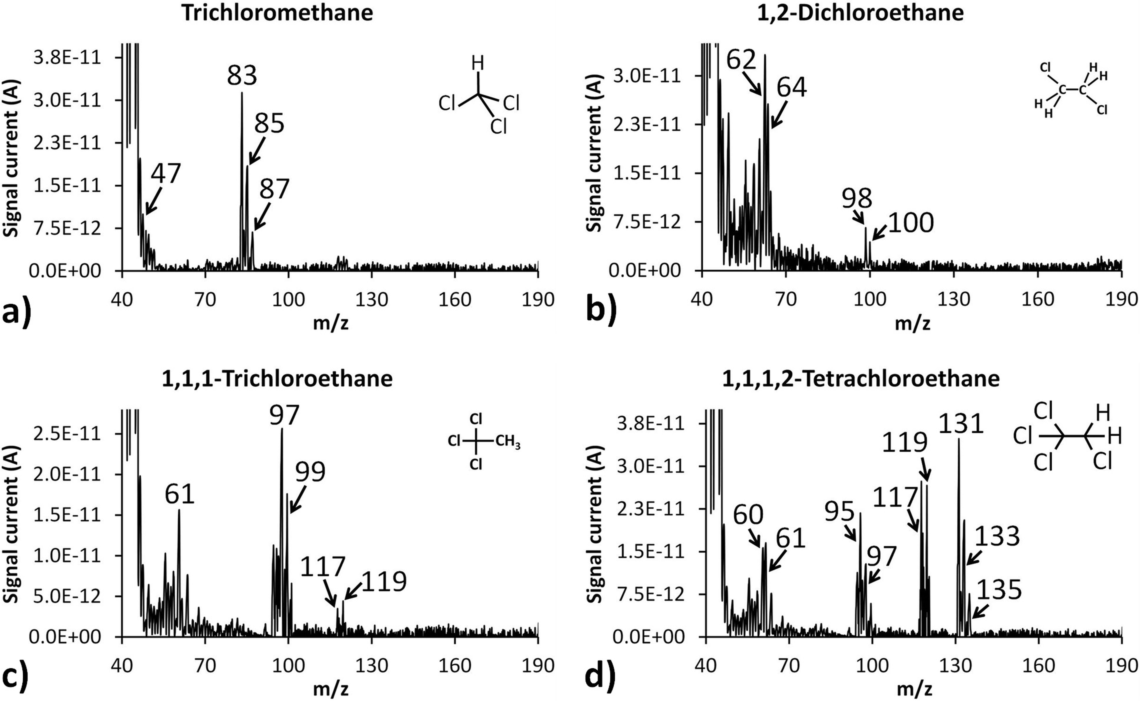
Figure 1. Representative experimental mass spectra at 250 ppb for a) trichloromethane, b) 1,2-dichloroethane, c) 1,1,1-trichloroethane and d) 1,1,1,2-tetrachloroethane obtained with our MIMS system.

In order to test the system response at different concentration levels and to generate calibration plots and concentration prediction models, gas phase standard samples were prepared having the following concentrations: blank, 100 ppb, 250 ppb, 500 ppb, 750 ppb and 1000 ppb. Samples were analysed and mass spectra were recorded. Signal current values corresponding to the most relatively abundant (100%) mass fragment of every compound at the maximum intensity were used to produce calibration curves and to calculate R² values. For the organochlorine compounds tested in the concentration range from 100 ppb to 1 ppm, our MIMS system exhibited excellent linearity with R² values ranging from 0.9969 to 0.9997 (Figure 2). The calibration curves for a) trichloromethane, b) 1,2-dichloroethane, c) 1,1,1-trichloroethane and d) 1,1,1,2-tetrachloroethane are described by the following equations: a) y = 1E-13x - 6E-13, b) y = 1E-13x + 2E-12, c) y = 1E-13x - 6E-13 and d) y = 8E-14x + 6E-14 respectively, where y is the signal current and x is the concentration of the gaseous standards.
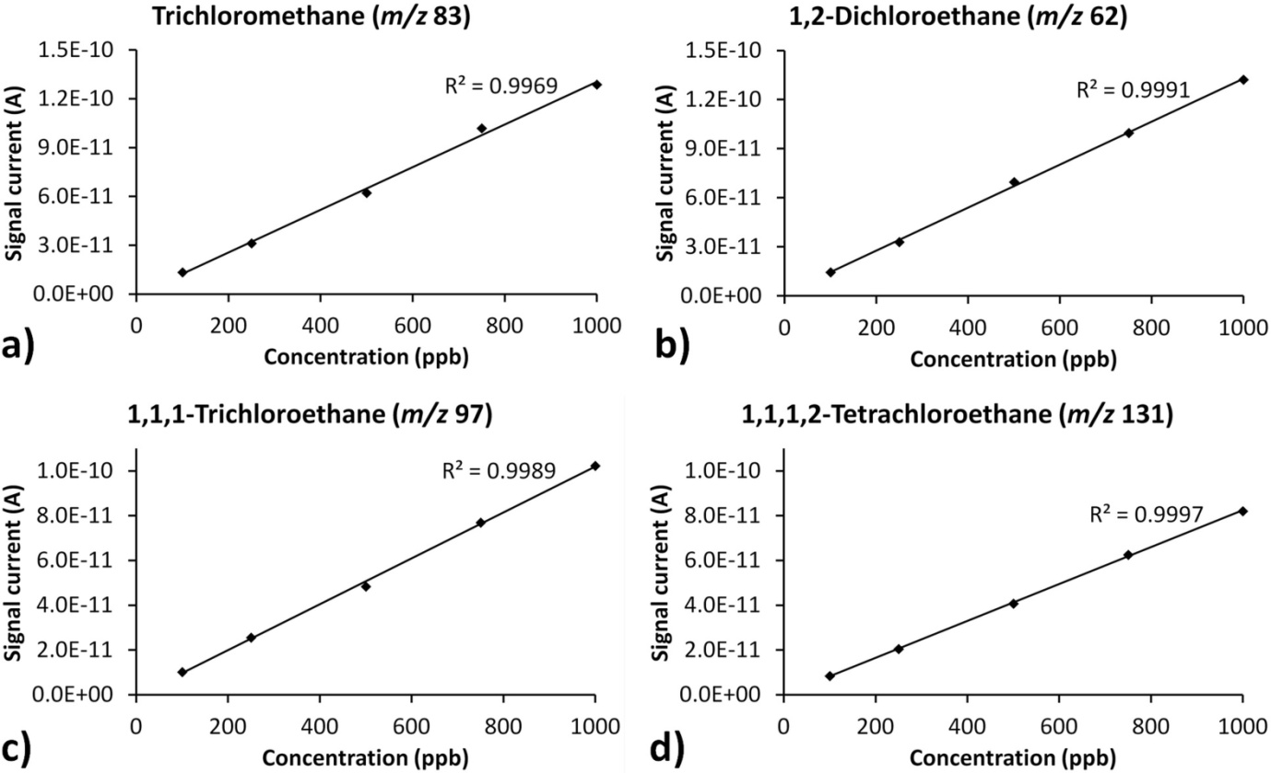
Figure 2. Calibration curves for a) trichloromethane (m/z 83), b) 1,2-dichloroethane (m/z 62), c) 1,1,1-trichloroethane (m/z 97) and d) 1,1,1,2-tetrachloroethane (m/z 131) obtained from the MIMS system.

  - Organobromine and Chlorobromocarbon Compound Experiments
This experimental series investigates the mass spectrometric detection and on-line monitoring of volatile organobromine and chlorobromocarbon compounds in the gaseous phase using our MIMS system. Representative mass spectra for four characteristic compounds corresponding to 250 ppb are presented in Figure 3. Experimental mass spectra were compared with the reference ones from NIST and showed very good agreement. The MIMS response was tested with gas samples at various concentration levels in the ppb region, and the output signal current values were plotted. The R² values for this group of compounds were in the range from 0.9988 to 0.9996 (Figure 4). The calibration curves for a) bromomethane, b) dibromomethane, c) chlorobromomethane and d) bromodichloromethane are described by the following equations: a) y = 2E-14x - 3E-15, b) y = 3E-14x + 2E-13, c) y = 8E-14x + 1E-12 and d) y = 7E-14x - 4E-13 respectively, where y is the signal current and x is the concentration of the gaseous standards.

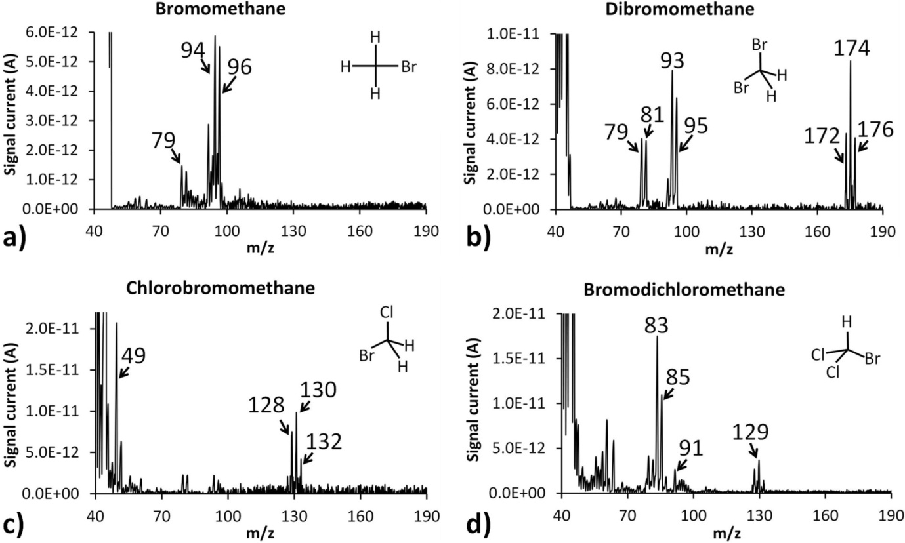
Figure 3. Representative experimental mass spectra at 250 ppb for a) bromomethane, b) dibromomethane, c) chlorobromomethane and d) bromodichloromethane obtained with the MIMS system.

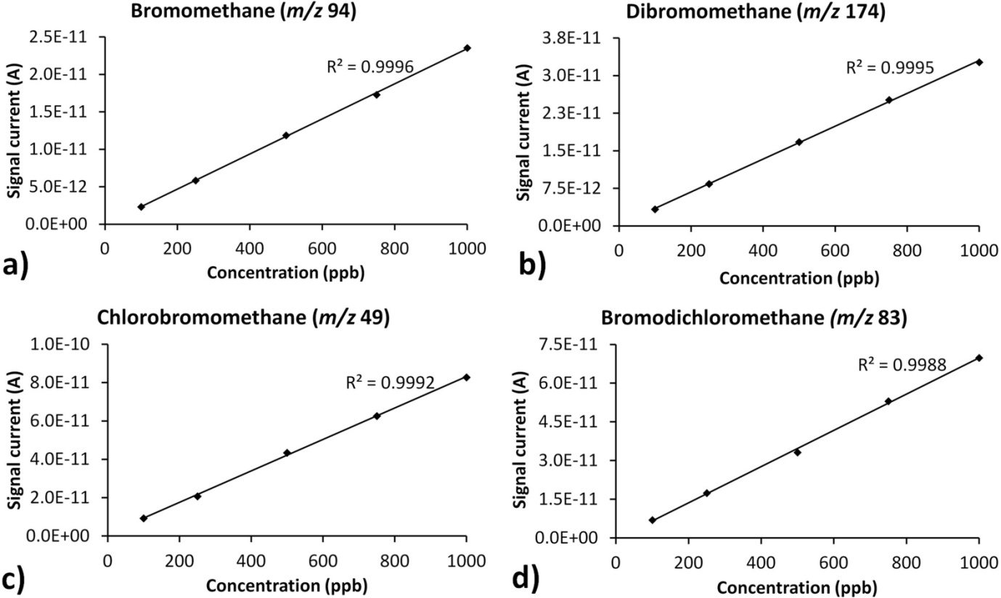
Figure 4. Calibration curves for a) bromomethane (m/z 94), b) dibromomethane (m/z 174), c) chlorobromomethane (m/z 49) and d) bromodichloromethane (m/z 83) obtained from the MIMS system.

  - Chlorofluorocarbon and Organoiodine Compound Experiments
This experimental series targets the mass spectrometric analysis and on-line screening of volatile chlorofluorocarbon and organoiodine compounds in the gaseous phase using the MIMS system. Representative mass spectra for a) chlorodifluoromethane, b) trichlorofluoromethane, c) 1,1,2-trichloro-1,2,2-trifluoroethane and d) methyl iodide corresponding to 250 ppb are presented in Figure 5. Experimental mass spectra correspond precisely to the reference mass spectra from NIST library. However, the only deviation observed was with the experimentally obtained mass fragments m/z 67 and m/z 69 of chlorodifluoromethane which have about two times more abundant signal intensities compared to the reference peaks from the NIST spectrum. MIMS screening capabilities were examined with gas samples at various concentration levels in the ppb region and the output signal current values were plotted. The R² values for this group of compounds were in the range from 0.9988 to 0.9991 (Figure 6). The calibration curves for a) chlorodifluomethane, b) trichlorofluoromethane, c) 1,1,2-trichloro-1,2,2-trifluoroethane and d) methyl iodide are described by the following equations: a) y = 1E-14x - 1E-14, b) y = 2E-13x + 4E-13, c) y = 1E-14x - 3E-14 and d) y = 2E-13x + 2E-12 respectively, where y is the signal current and x is the concentration of the gaseous standards.

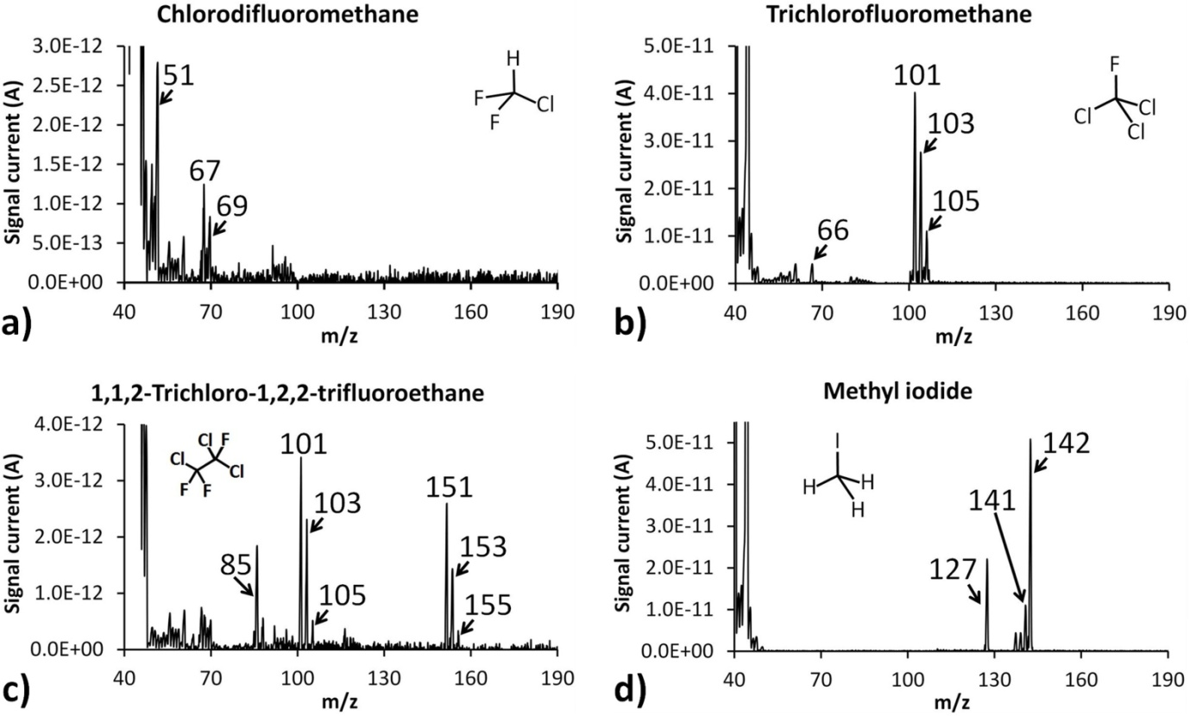
Figure 5. Representative experimental mass spectra at 250 ppb for a) chlorodifluoromethane, b) trichlorofluoromethane, c) 1,1,2-trichloro-1,2,2-trifluoroethane and d) methyl iodide obtained with the MIMS system.

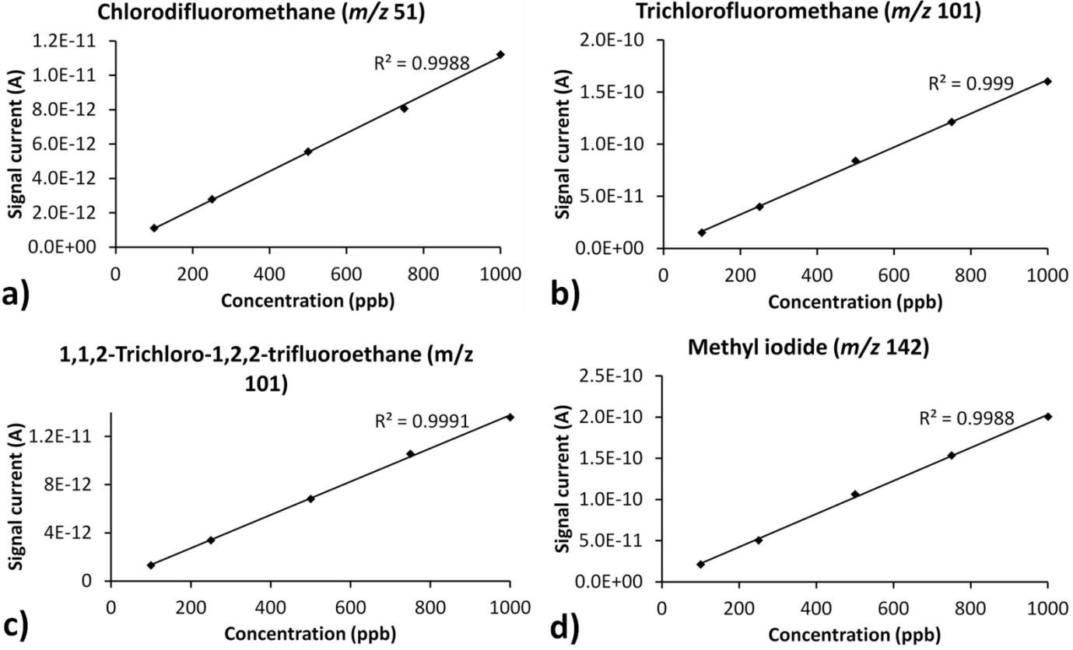
Figure 6. Calibration curves for a) chlorodifluomethane (m/z 51), b) trichlorofluoromethane (m/z 101), c) 1,1,2-trichloro-1,2,2-trifluoroethane (m/z 101) and d) methyl iodide (m/z 142) obtained from the MIMS system.

  - Multi-compound Detection Experiment.
This experimental series investigates the MIMS system response when sampling complex mixtures. The aim of this test was the mass spectrometric differentiation of characteristic mass fragments from a mixture containing three organohalogen compounds. Gas standards of trichloromethane, chlorobromomethane and trichlorofluoromethane corresponding to 100 ppb each were prepared in 1.2 L glass flasks. As described in the sample preparation section the flasks were covered with a lid and several layers of parafilm M and left in a warm place for 4 hours to reach thermodynamic equilibrium. Three 6.35 mm Swagelok PFA flexible tubes with total length 15 cm each were imported into the flasks via small holes made on their lids. The other end sides of the PFA tubes were connected to a stainless steel built-in-house cylindrical mixing chamber. Sampling was achieved by connecting our system membrane inlet sampling probe directly with the output end of the mixing chamber.

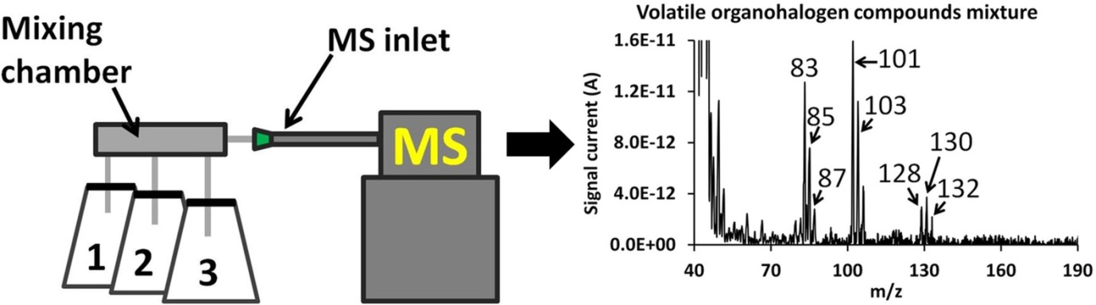
Figure 7. Schematic presentation of the experimental setup that was used to monitor a three organohalogen compound gaseous mixture. Flask 1, 2, 3 correspond to trichloromethane, chlorobromomethane and trichlorofluoromethane respectively at 100 ppb each. Experimental mass peaks for trichloromethane (m/z 83, 85, 87), chlorobromomethane (m/z 128, 130, 132) and trichlorofluoromethane (m/z 101, 103, 105) are shown.

  - Evaluation of the method.
Our MIMS system performance was evaluated by addressing the following analytical criteria: a) membrane response times (rise and fall), b) linear dynamic range within the examined concentration area (essential for quantitative research in complex and unknown concentration raw sample mixtures), c) sensitivity (LODs), d) repeatability, e) response in mixture effects. Alongside with our system technical characteristics (small dimensions and overall weight), the above criteria are important for on-site qualitative investigations and on-line quantitative measurements/monitoring of organic pollutants and hazardous or toxic organic chemicals.
For the organohalogen compounds tested, membrane mean rise time was 24.8 sec, whereas the average fall time was 45.25 sec. Rise time corresponds to the time that is needed for the peaks signal intensity to reach 90% of their maximum value. Fall response time is the time that is required from the membrane and subsequently from the system to purge and the signal intensities of the monitored mass fragments to return back to the base/noise level.⁴⁸ From previous experiments with other chemical substances, it was found that detection times can be improved if the membrane probe is heated.^{38, 48} Linear regression coefficient values (R²) were obtained from the calibration plots and are in the range from 0.9969 to 0.9997 for the examined concentration area (100 ppb – 1000 ppb). This shows that our MIMS system is analytically stable and can be used as a reliable monitoring molecular sensor and a concentration prediction tool for compounds of interest in complex samples.
Detection limits were determined from the resulting calibration curves were found to be in the low ppb concentration area (< 10 ppb) as shown in Table 3. LOD estimates were based on signal current values obtained from the 100 ppb samples. They were calculated based on experimentally obtained signal current values of the most abundant mass fragment of every individual compound and counted to be three times above the base (noise) line/level. The LOD could be further improved by heating the membrane inlet sampling probe and by applying special signal extraction algorithms to the recorded mass spectra.^{38, 48} MIMS measurements during the three replicates were reproducible, leading to repeatable signal current values with relative standard deviation calculated to be 4.96 %. Moreover, MIMS response during the analysis of a mixture of three organohalogen compounds was also examined resulting into clear detection and distinction among its individual components.

Table 3. Summary of the PDMS membrane response times (rise and fall), R² values and limits of detection (LOD) for the examined organohalogen compounds.
Compound name | Characteristic mass peaks (m/z) | Rise time (sec) | Fall time (sec) | R² | LOD (ppb)
Trichloromethane (m/z 83) | 47, 83, 85, 87 | 22 | 46 | 0.9969 | 2.17
1,2-Dichloroethane (m/z 62) | 62, 64, 98, 100 | 20 | 43 | 0.9991 | 2.07
1,1,1-Trichloroethane (m/z 97) | 61, 97, 99, 117, 119 | 23 | 45 | 0.9989 | 2.72
1,1,1,2-Tetrachloroethane (m/z 131) | 60, 61, 95, 97, 117, 119, 131, 133, 135 | 24 | 46 | 0.9997 | 3.56
Bromomethane (m/z 94) | 79, 94, 96 | 20 | 34 | 0.9996 | 8.54
Dibromomethane (m/z 174) | 79, 81, 93, 95, 172, 174, 176 | 16 | 32 | 0.9995 | 8.92
Chlorobromomethane (m/z 49) | 49, 128, 130, 132 | 22 | 38 | 0.9992 | 3.21
Bromodichloromethane (m/z 83) | 83, 85, 91, 129 | 25 | 43 | 0.9988 | 4.28
Chlorodifluoromethane (m/z 51) | 51, 67, 69 | 26 | 50 | 0.9988 | 2.14
Trichlorofluoromethane (m/z 101) | 66, 101, 103, 105 | 32 | 52 | 0.9990 | 1.96
1,1,2-Trichloro-1,2,2-trifluoroethane (m/z 101) | 85, 101, 103, 105, 151, 153, 155 | 36 | 56 | 0.9991 | 2.23
Methyl iodide (m/z 142) | 127, 141, 142 | 32 | 58 | 0.9988 | 1.41

  - Validation of the method.
Our methodology was validated on laboratory scale experiments by using a simulation test chamber. A heavy duty single wall cardboard box with dimensions 305 mm x 229 mm x 229 mm was used to simulate a domestic or a workplace environment. Gas standards of dibromomethane and trichlorofluoromethane corresponding to 10 ppm each were prepared in 1.2 L glass flasks and placed into the test chamber. The glass flasks uncovered and the generated within them standard gases spread and diluted into the enclosed cardboard box air. A small hole (15 mm) in the middle of one of the side walls of the test chamber and at a distance of 300 mm from the two glass flasks was used as a sampling point. The MS membrane inlet probe was inserted in the middle of the sampling point and was continuously monitoring the confined air.
Two scenarios were tested: a) no air flow applied to the top of the flasks and b) medium intesnsity (1 L/ min) of air flow was applied prior to the glass flasks and towards the MS inlet with the use of a mechanical fan to assist the tranfer of the sample molecules to the inlet of the MS. Sample gas plumes travelled with different speeds to the MS system for chemical analysis. Figure 8 shows schematically the described setup and a representative mass spectrum for scenario b) obtained with our MIMS system. Mixture sample detection times for the two examined scenarios (a and b) were 168 sec and 57 sec respectively. The detected concentrations (calculated from the associated calibration plots) for dibromomethane and trichlorofluoromethane correspond to 47.6 ppb and 31.4 ppb.
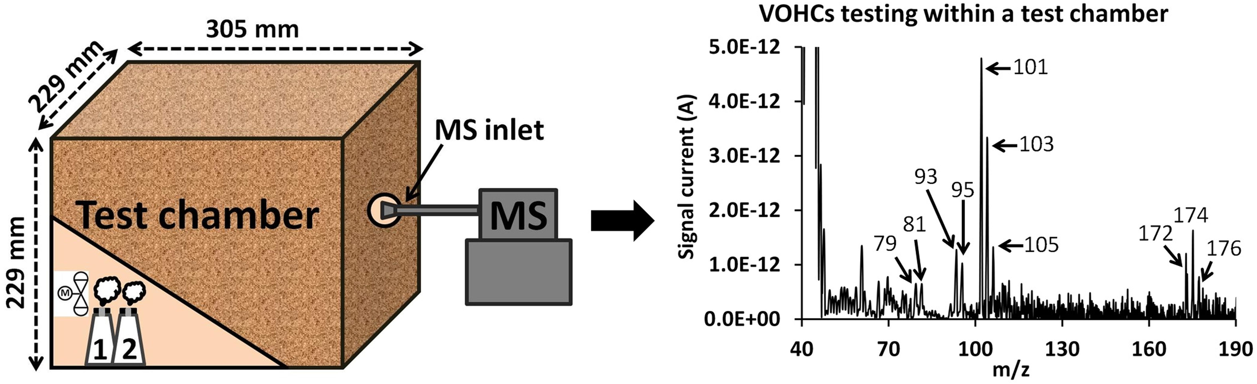
Figure 8. Schematic presentation of the experimental setup that was used for the validation of our methodology. Flask 1 and 2 correspond to dibromomethane and trichlorofluoromethane respectively. Experimental mass peaks for dibromomethane (m/z 79, 81, 93, 95, 172, 174, 176) and trichlorofluoromethane (m/z 101, 103, 105) are shown.

- CONCLUSIONS
In this study, we demonstrate, for the first time, the use of a lightweight portable membrane inlet mass spectrometer for the qualitative and quantitative analysis (both detection and screening) of volatile organohalogen compounds in the gaseous phase for environmental air quality monitoring purposes. In our experiments the following sub-groups of halocarbons were tested: a) volatile organochlorine compounds, b) volatile organobromine and chlorobromocarbon compounds, and c) volatile chlorofluorocarbon and organoiodine compounds. During measurements, we investigated the accuracy of our methodology by addressing essential analytical criteria such as response times, detection limits, repeatability and response in complex situations. Our system demonstrated detection times of seconds, and the calculated detection limits are in the low ppb concentration area. The technique shows repeatable responses with a calculated relative standard deviation of 4.96 %. Experiments with multi-component mixtures showed ease of detection and determination of targeted mass peaks characteristic for the compounds under examination. The described technique was successfully validated in laboratory based experiments.
Future work will include field validation of our methodology. The target is to increase the mass range (e.g. to 500 amu) of our mass analyser in order to expand the ability to detect heavier molecules. Further weight reduction of the overall system is possible, alongside with enhancement of the sensitivity and detection times by testing different membrane materials and also by heating our sampling probe. Investigation of environmental pollutants will continue by testing other potential hazardous and toxic chemicals in the gas phase as well as in water and soil using MIMS and hybrid MS techniques such as GC-MS. Future target is to develop autonomous mini-MS systems integrated on robotic unmanned aerial and ground mobile platforms alongside other types of sensors for air quality monitoring purposes and other applications (e.g. security).

ACKNOWLEDGEMENT
The authors gratefully acknowledge Dr Boris Brkić, Dr. Neil France and Mr. Barry Smith from Q-Technologies Ltd., UK, and Dr. Tom Hogan from Pathway Systems Ltd., UK for their technical and moral assistance. Particular thanks are due to Q-Technologies Ltd., UK for the financial support of this work.

REFERENCES
- World Health Organization, http://www.who.int/en/.
- U.S. Environmental Protection Agency, http://www.epa.gov/.
- European Parliament, http://www.europarl.europa.eu/portal/en.
- P. R. S. Kodavanti, K. Senthil Kumar, B. G. Loganathan, Inter. Encyclop. of Public Health,2008, 686-693.
- M. Salkinoja-Salonen, J. Uotila, J. Jokela, M. Laine, E. Saski, Environ. Health Perspect., 1995, 103, 63-69.
- P. Poursafa, E. Ataei, R. Kelishadi, J. Res. Med. Sci., 2015, 20, 613-618.
- Y. Zhou, L. Asplund, G. Yin, I. Athanassiadis, U. Wideqvist, A. Bignert, Y. Qiu, Z. Zhu, J. Zhao, A. Bergman, Sci. of the Total Environ.,2016, 554, 320-328.
- W. Ben Ameur, Y. El Megdiche, E. Eljarrat, S. Ben Hassine, B. Badreddine, T. Souad, H. Bechir, D. Barcelo, M. R. Driss, Ecotoxicol. Environ. Saf., 2013, 88, 55-64.
- K. Kakimoto, H. Nagayoshi, Y. Konishi, K. Kajimura, T. Ohura, K. Hayakawa, A. Toriba, Chemosphere, 2014, 111, 40-46.
- J. Kowalska, T. Gierczak, Indoor Built Environ., 2013, 22, 920-931.
- H. Sun, Y. Qi, D. Zhang, Qing X. Li, J. Wang, Environ. Pollut., 2016, 209, 177-185.
- H. Hellar-Kihampa, K. De Wael, E. Lugwisha, G. Malarvannan, A. Covaci, R. Van Grieken, Sci. Total Environ., 2013, 447, 186-197.
- U.S. Department of Health and Human Services, Agency for Toxic Substances and Disease Registry, http://www.atsdr.cdc.gov/.
- U.S. Department of Labor, Occupational Safety & Health Administration, https://www.osha.gov/.
- CDC, The National Institute for Occupational Safety and Health (NIOSH), http://www.cdc.gov/niosh/, Method 1003.
- L. Zoccolillo, L. Amendola, S. Insogna and E. Pastorine, J. Chromatogr. A, 2010, 1217, 3890-3895.
- L. A. Wallace, E. D. Pellizzari, T. D. Hartwell, H. Zelon, C. Sparacino, R. Perritt and R. Whitmore, J. Occup. Med., 1986, 28, 603-608.
- V. B. Stein, R. S. Narang, L. Wilson and K. M. Aldous, J. Anal. Toxicol., 1986, 20, 145-150.
- R. Kroneld, Bull. Environ. Contam. Toxicol., 1989, 42, 868-872.
- D. E. Harsch, D. R. Cronn and W. R. Slater, J. Air Pollut. Control Assoc., 1979, 29, 975-976.
- S. R. Rissato, M. S. Galhiane, A. G. de Souza, B. M. Apon, J. Braz. Chem. Soc., 2005, 16, 1038-1047.
- D. Lankova, A. Svarcova, K. Kalachova, O. Lacina, J. Pulkrabova, J. Hajslova, Anal. Chim. Acta, 2015, 854, 61-69.
- H. P. Wang, N. H. Lin, K. Kahen, H. Badiei, K. Jorabchi, J. Am. Soc. Mass Spectrom., 2014, 25, 692-695.
- M. Heidari, A. Bahrami, A. R. Ghiasvand, F. G. Shahna, A. R. Soltanian, Anal. Chim. Acta, 2013, 785, 67-74.
- M. Chai, C. L. Arthur, J. Pawliszyn, R. P. Belardi and K. F. Pratt, Analyst, 1993, 118, 1501-1505.
- S. Giannoukos, B. Brkic, S. Taylor, S.; A. Marshall, G. F. Verbeck, Chem. Rev., 2016, 116, 8146-8172.
- Z. Ouyang, R. J. Noll and R. G. Cooks, Anal. Chem., 2009, 81, 2421-2425.
- C. -H. Chen, T.-C. Chen, X. Zhou, R. Kline-Schoder, P. Sorensen, R. G. Cooks and Z. Ouyang, J. Am, Soc. Mass Spectrom., 2014, 26, 240-247.
- S. Taylor and V. M. Bierbaum, J. Am, Soc. Mass Spectrom., 2008, 19, 1375-1376.
- J. N. Smith, A. Keil, J. Likens, R. J. Noll and R. G. Cooks, Analyst, 2010, 135, 994-1003.
- C. C. Mulligan, D. R. Justes, R. J. Noll, N. L. Sanders, B. C. Laughlin and R. G. Cooks, Analyst, 2006, 131, 556-567.
- G. Huang, L. Gao, J. Duncan, J. D. Harper, N. L. Sanders, Z. Ouyang, R. G. Cooks, J. Am, Soc. Mass Spectrom., 2010, 21, 132-135.
- C. -H. Chen, Z. Lin, R. Tian, R. Shi, R. G. Cooks and Z. Ouyang, Anal. Chem., 2015, 87, 8867-8873.
- J. A. Contreras, J. A. Murray, S. E. Tolley, J. L. Oliphant, H. D. Tolley, S. A. Lammert, E. D. Lee, D. W. Later and M. L. Lee, J. Am, Soc. Mass Spectrom., 2008, 19, 1425-1434.
- G. S. Groenewold, J. R. Scott, E. D. Lee and S. A. Lammert, Anal. Methods, 2013, 5, 2227-2236.
- S. Herndon, J. T. Jayne, M. S. Zahniser, D. R. Worsnop, B. Knighton, E. Alwine, B. K. Lamb, M. Zavala, D. D. Nelson, J. B. McManus, J. H. Shorter, M. R. Canagaratna, T. B. Onasch and C. E. Kolb, Faraday Discuss., 2005, 130, 327-339.
- S. Giannoukos, B. Brkić, S. Taylor and N. France, Anal. Chem., 2014, 86, 1106-1114.
- S. Giannoukos, B. Brkić, S. Taylor and N. France, J. Am. Soc. Mass Spectrom., 2015, 26, 231-239.
- R. C. Johnson, R. G. Cooks, T. M. Allen, M. E. Cisper and P. H. Hemberger, Mass Spectrom. Rev., 2000, 19, 1-37.
- E. Boscaini, M. L. Alexander, P. Prazeller and T. D. Mark, Int. J. Mass Spectrom., 2004, 239, 179-186.
- A. J. Thompson, A. S. Creba, R. M. Ferguson, E. T. Krogh and C. G. Gill, Rap. Comm. Mass Spec., 2006, 13, 2000-2008.
- L. S. Riter, B. C. Laughlin, E. Nikolaev and R. G. Cooks, Rap. Comm. Mass Spec., 2002, 16, 2370-2373.
- R. A. Ketola, T. Kotiaho, M. E. Cisper and T. M. Allen, J. Mass Spectrom., 2002, 37, 457-476.
- I. Cotte-Rodrıguez, E. Handberg, R. J. Noll, D. P. A. Kilgour and R. G. Cooks, Analyst, 2005, 130, 679-686.
- L. S. Riter, Z. Takáts and R. G. Cooks, Analyst, 2001, 126, 1980-1984.
- P. Bocchini, R. Pozzi, C. Andalo and G. C. Galleti, Rap. Commun. Mass Spec., 1999, 13, 2049-2053.
- T. Kotiaho, S. Gylling, A. Lunding and F. R. Lauritsen, J. Agric. Food Chem., 1995, 43, 928-930.
- S. Giannoukos, B. Brkic, S. Taylor, Anal. Methods, 2016, 8, 6607-6615.
- Ozone Secretariat, http://ozone.unep.org/.
- PubChem, https://pubchem.ncbi.nlm.nih.gov/.
- U.S National Library of Medicine, Toxicology Data Network, http://toxnet.nlm.nih.gov/index.html.
- Q-Technologies Ltd., Liverpool, UK, http://q-technologies.co.uk/.
- W. H. McClennen, C. L. Vaughn, P. A. Cole, S. N. Sheya, D. J. Wager, T. J. Mott, J. P. Dworzanski, N. S. Arnold and H. L. C. Meuzelaar, Field Anal. Chem. Technol., 1996, 1, 109−116.
- A. Naganowska-Nowak, P. Konieczka, A. Przyjazny and J. Namiesnik, Crit. Rev. Anal. Chem., 2005, 35, 31-55.

GRAPHICAL ABSTRACT


