A practical approach to dealing with contagious ovine digital dermatitis (CODD) on farms.

Joe Angell*†, Dai Grove-White*‡, Jennifer Duncan*‡

*Department of Epidemiology and Population Health, Institute of Infection and Global Health, The University of Liverpool, Leahurst Campus, Neston, Wirral, CH64 7TE.
‡School of Veterinary Science, The University of Liverpool, Leahurst Campus, Neston, Wirral, CH64 7TE.

†Corresponding author: jwa@liv.ac.uk 0151 794 6050

Details of each author’s current appointment:
J.W. Angell Tenure Track Fellow in Veterinary Infectious Diseases at the University of Liverpool
D.H. Grove-White Head of Division and Senior Lecturer in Livestock Health and Welfare at the University of Liverpool
J.S. Duncan Senior Lecturer in Livestock Health and Welfare at the University of Liverpool

Abstract
Contagious ovine digital dermatitis (CODD) is a cause of severe welfare compromise in affected sheep and can cause major problems on some farms. The specific aetiology is still unknown but Treponema spp. are considered as the most likely infectious agents necessary for disease.
Recent evidence has shown strong links between footrot and CODD and a holistic approach to treatment and control is likely to be necessary in order to achieve control on affected farms. Together with this, strict biosecurity practices are required including the examination of all feet of all new entrants to a flock with the aim of preventing the introduction of CODD to unaffected flocks.

Key words
Sheep; contagious ovine digital dermatitis; lameness; treatment; control

Introduction
Until recently contagious ovine digital dermatitis (CODD) has been poorly researched and consequently has been difficult to manage on affected farms. It causes a severe lameness in sheep (Figure 1) and it can be difficult to recognize as distinct from footrot and therefore can result in a severe welfare problem for affected individuals and flocks. Estimates vary, but it is currently considered to affect approximately 50% of farms in the UK (Kaler and Green, 2008; Angell et al., 2014; Dickins et al., 2016) and as yet, to the authors’ knowledge there have been no confirmed reports of cases outside the UK or Ireland. The impact on individual farms varies enormously, but on average prevalence would typically be low at approximately 2.0% (Angell et al., 2014; Dickins et al., 2016), although some farmers report an extremely high prevalence of disease e.g. 50% (Wassink et al., 2003b; Angell et al., 2014; Angell et al., 2015c). Treatment and control on affected farms can be problematic and the aim of this article is to provide a practical approach to dealing with clinical cases of CODD and to controlling or preventing disease on farms.

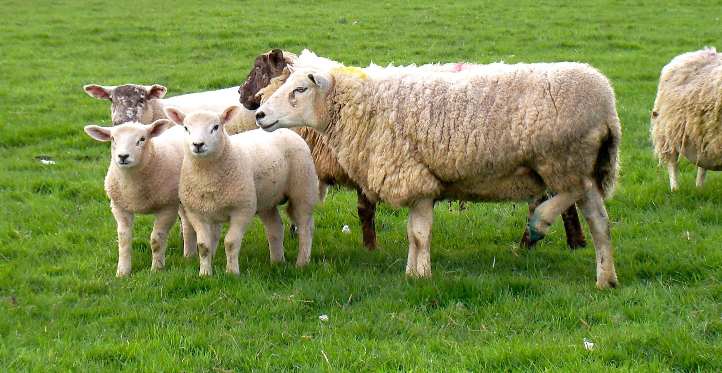
Figure 1: A sheep severely lame with CODD

Aetiology
The aetiology of CODD is still debated, however current research would suggest that the same Treponema spp. as those that cause bovine digital dermatitis (BDD) are the infectious cause, but as to whether they are a primary or secondary pathogen remains unclear (Duncan et al., 2014; Sullivan et al., 2015a). For example, Dichelobacter nodosus – the causative agent of footrot - has been detected in many clinical cases, and has also been shown to be a risk factor for the development of CODD (Moore et al., 2005; Duncan et al., 2012; Angell et al., 2015c; Sullivan et al., 2015a).

Differential diagnosis of foot lesions in sheep
- Footrot
- Interdigital dermatitis (also known as scald, strip etc.)
- Foot abscess
- Toe granuloma
- Strawberry footrot
- Joint infections

Diagnosis
The diagnosis of CODD on a farm or in individual sheep is typically based on clinical signs, but this can be difficult and the authors find it helpful to look at a number of clinical cases together in order to make a diagnosis. Cases can be easily confused with the differentials listed above and mis-diagnosis has been reported to be common amongst farmers and in some cases veterinary surgeons as well (Kaler and Green, 2008; Winter et al., 2015).

Clinical cases typically present initially as an erosive/ulcerative lesion at the dorsal coronary band with or without hair loss, which then may progress leading to under-running of the hoof wall dorsally and abaxially, often leading to the complete sloughing of the hoof capsule (Figure 2) (Angell et al., 2015a). Unfortunately the detection of Treponema spp. in suspect cases is not yet commercially available, and can currently only be carried out in specialist research institutions. Some infected feet can have features of both CODD and footrot and both diseases can occur concurrently.

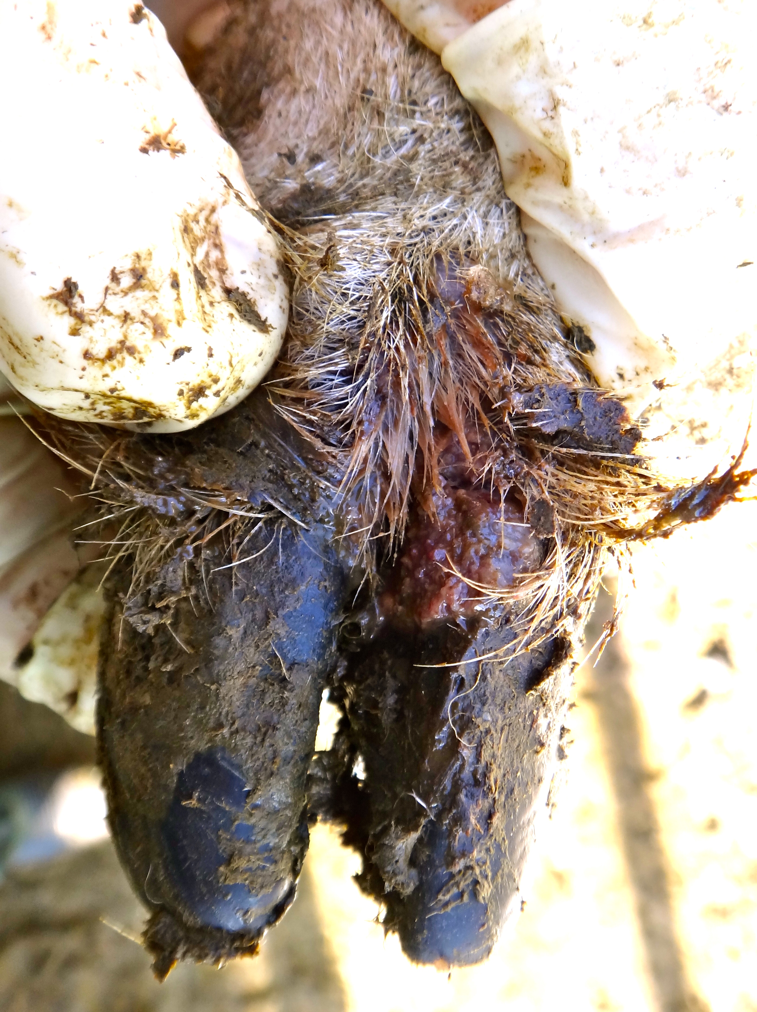
Figure 2a: An early CODD lesion located at the coronary band.

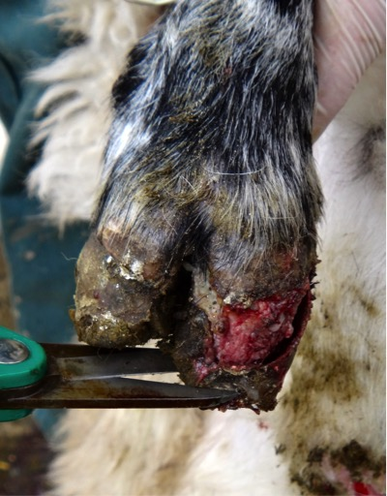
Figure 2b: The CODD lesions can quickly progress leading to under-running of the hoof horn capsule.

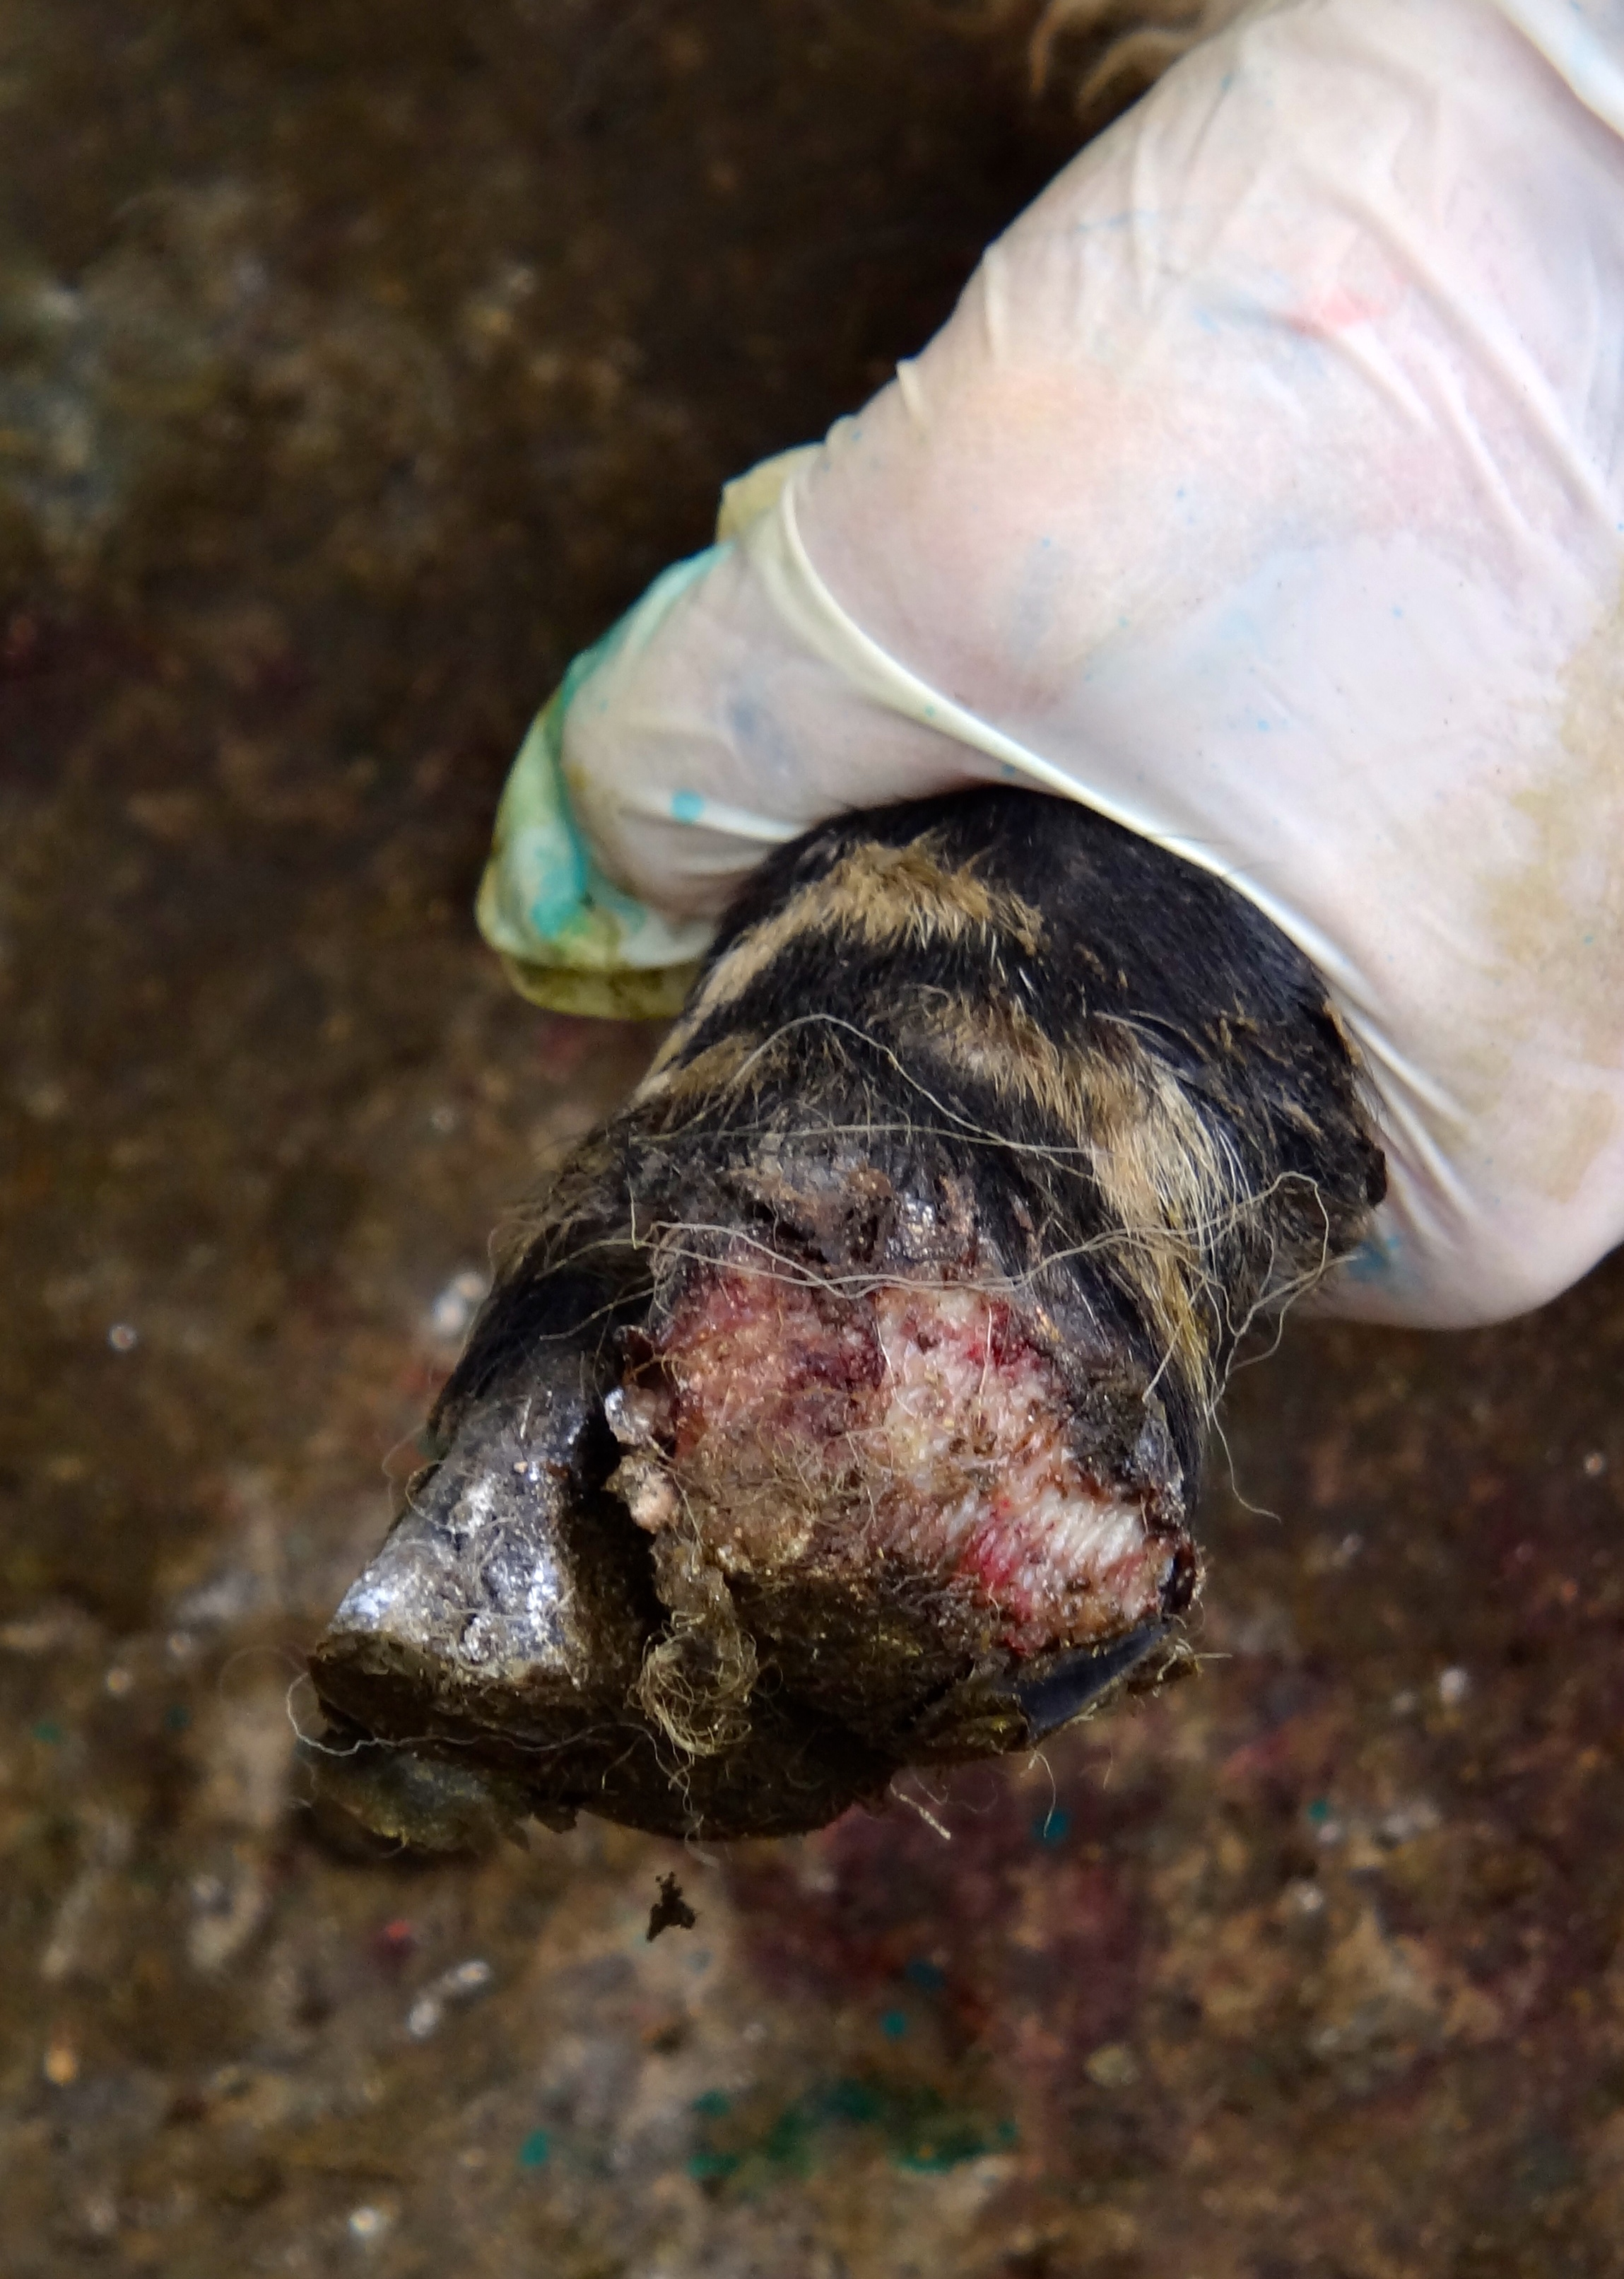
Figure 2c: The under-running can lead to eventual sloughing of the hoof horn capsule

Prevention
As there are still many farms without CODD, it is important that farmers are vigilant particularly with regards to on-farm biosecurity. When asked, the majority of farmers reported that CODD had arrived on their farm through purchasing an undiagnosed infected individual – usually a ram (Angell et al., 2014). Many cases of CODD – particularly the small early lesions at the level of the coronary band may not result in lameness (Angell et al., 2015a) and as such it is recommended that farmers adopt strict quarantine measures for new stock on arrival that include turning over and inspecting every foot of every new sheep on the premises (Figure 3). This process allows identification of small early lesions that are not yet causing lameness. Quarantining also allows any subclinical lesions to become apparent prior to mixing with the rest of the flock.
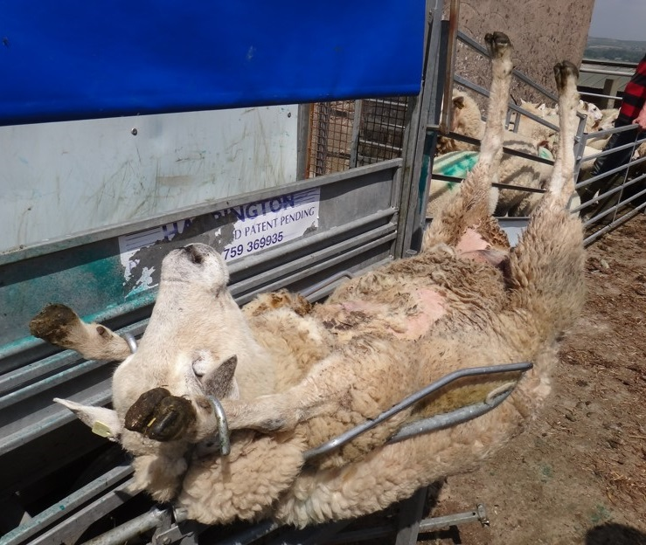
Figure 3: Turning over and manually inspecting all the feet of all new entrants can help identify early lesions that are not yet causing lameness.

It has also been shown recently that CODD and BDD associated Treponema spp. may also survive on hoof trimming equipment, and BDD associated Treponema spp. may also be detected in slurry (Klitgaard et al., 2014; Sullivan et al., 2014). Whilst this evidence is currently limited, it would appear prudent to adopt good cleaning and disinfection practices of any hoof trimming equipment between feet, but also the cleaning and disinfection of for example visiting sheep shearing trailers, sheep scanning trailers and other equipment between farms. These appliances may often not be cleaned between farms and could represent a significant biosecurity risk for CODD, as well as many other contagious diseases.

Treatment
To date there are only a handful of robust treatment studies of CODD cases, and as such it is not possible to be too prescriptive. Recent in vitro work identified penicillins and macrolides as being the most efficacious under laboratory conditions to killing CODD associated Treponema spp. (Angell et al., 2015b). However, to the authors knowledge as yet there are only three published studies examining different treatment/elimination protocols (Duncan et al., 2011; Duncan et al., 2012; Angell et al., 2016) (Table 1). One other anecdotal report indicates the successful treatment of clinical cases with tilmicosin injection (Watson, 1999). When using a long acting amoxicillin injection, it is advisable to re-examine the treated sheep towards the end of the duration of activity of the product in order to establish whether a second injection is necessary.
Study intervention | Recovery rate | New infection rate | Reference
Foot bathing in 1% chlortetracycline for 15 minutes three consecutive days | 52.7% (feet) | 2.5% (feet) | (Duncan et al., 2011)
Foot bathing in 1% chlortetracycline for 15 minutes three consecutive days, together with intramuscular injection of 15mg/kg long acting amoxicillin trihydrate (Bimoxyl LA; Bimeda) | 77.5% (feet) | 1.0% (feet) | (Duncan et al., 2011)
Intramuscular injection of 15mg/kg long acting amoxicillin trihydrate (Betamox LA; Norbrook) | 70.97% (sheep) | 26.36% (sheep) | (Duncan et al., 2012)

Table 1: Summary of the CODD recovery rates and new infection rates in two studies examining different treatment methods of individually affected sheep.

A recent study examined the success of eliminating all clinical signs of CODD from affected farms for one year (Angell et al., 2016). The approach consisted of randomly allocating flocks to either an intervention group (n=13 flocks) or a control group (n=11 flocks). In the intervention group, tilmicosin injection, at a dose of 10mg/kg, was given to whole flocks of sheep, together with the repeated treatment two weeks later of affected cases with a second dose of tilmicosin. In addition, all the clinically affected sheep were isolated for one month, and any new entrants to the flock during the year were also treated. The success in eliminating CODD from these flocks was compared to those flocks that carried on with their current practices (the control group). The results from this study, showed that after one year there was no significant difference in the clinical elimination of CODD (and also footrot) between those flocks that used the tilmicosin intervention and those that carried on with their current practices.

In that study the administration (off license) of two doses of tilmicosin at a 14 day interval at a dose rate of 10mg/kg was very effective at treating individual sheep with CODD. However whole flock treatment with a macrolide as described cannot be recommended for the elimination of CODD (or footrot) in UK flocks, in light of their status as critically important antimicrobials (WHO, 2011).

Control on affected farms
In several studies footrot has been identified as strongly associated with CODD and together with this the use of a multivalent footrot vaccine (Footvax; MSD) has been demonstrated to have an effect on reducing the incidence rate for CODD (Duncan et al., 2011; Duncan et al., 2012; Angell et al., 2015c). Furthermore, some of the seasonal and pasture based risk factors for CODD are similar to those for footrot. For example CODD and footrot may both spread more rapidly at housing or in sheep on pasture that may lead to foot trauma (Wassink et al., 2003a; Angell et al., 2014; Angell et al., 2015c). Consequently, given the well-researched and effective treatment and control strategies for footrot, these should be implemented as soon as possible if not already.

Given the contagious nature of CODD, the prompt isolation and treatment with an appropriate antibiotic of infected individuals, will work to reduce prevalence and spread to uninfected individuals. The use of a ‘lame field’ or ‘lame pen’ can aid with this and enable the farmer to monitor and retreat sheep as necessary. Cleaning and disinfection of handling pens after use, should also help reduce spread between infected and uninfected groups, although there is no robust data for this yet.

Furthermore, given the similarity between the Treponema spp. that are considered a necessary cause of BDD and CODD (and indeed DD syndromes now reported in wild elk and goats (Clegg et al., 2015; Sullivan et al., 2015b)), reducing co-grazing between these species has been considered as a control factor. However, as yet there is very little epidemiological or experimental evidence to suggest that there is any interspecies transmission and as such this is a question that cannot be answered with current data. Consequently, given some of the significant advantages of co-grazing - particularly cattle and sheep in the UK, individual on farm risk/benefit judgments will need to be made on a case by case basis.

Conclusions
Contagious ovine digital dermatitis can cause severe welfare problems for individual sheep and flocks, and is currently under recognised. Vigilance and good biosecurity protocols are needed to avoid introducing it to an uninfected farm. Treatment of individuals can be successful using systemic antibiosis with an appropriate product e.g. amoxicillin injection or tilmicosin injection, although control on farms requires a multifaceted approach including the control of footrot, isolation of clinical cases and good biosecurity practices.

Key Points
- CODD is a severe cause of infectious foot disease in sheep.
- It is now widespread in the UK and can cause severe welfare compromise.
- Strict farm biosecurity is necessary to keep disease out and to help prevent spread.
- Footrot and CODD are strongly associated.
- A holistic approach to lameness control is necessary to target footrot and CODD together.
- Whole-flock administration of tilmicosin cannot be recommended for the elimination of CODD or footrot from flocks.

References
Angell, J.W., Blundell, R., Grove-White, D.H., Duncan, J.S., 2015a. Clinical and radiographic features of contagious ovine digital dermatitis and a novel lesion grading system. Veterinary Record 176, 544-552.
Angell, J.W., Clegg, S.R., Sullivan, L.E., Duncan, J.S., Grove-White, D.H., Carter, S.D., Evans, N.J., 2015b. In vitro susceptibility of contagious ovine digital dermatitis associated Treponema spp. isolates to antimicrobial agents in the UK. Veterinary Dermatology 26, 484-e115.
Angell, J.W., Duncan, J.S., Carter, S.D., Grove-White, D.H., 2014. Farmer reported prevalence and factors associated with contagious ovine digital dermatitis in Wales: A questionnaire of 511 sheep farmers. Preventive veterinary medicine 113, 132-138.
Angell, J.W., Grove-White, D.H., Duncan, J.S., 2015c. Sheep and farm level factors associated with contagious ovine digital dermatitis: a longitudinal repeated cross-sectional study of sheep on six farms. Preventive veterinary medicine 122, 107-120.
Angell, J.W., Grove-White, D.H., Williams, H.J., Duncan, J.S., 2016. Whole-flock, metaphylactic tilmicosin failed to eliminate contagious ovine digital dermatitis and footrot in sheep: a cluster randomised trial. Veterinary Record 179, 308.
Clegg, S.R., Mansfield, K.G., Newbrook, K., Sullivan, L.E., Blowey, R.W., Carter, S.D., Evans, N.J., 2015. Isolation of digital dermatitis treponemes from hoof lesions in Wild North American Elk (Cervus elaphus) in Washington State, USA. Journal of clinical microbiology 53, 88-94.
Dickins, A., Clark, C.C., Kaler, J., Ferguson, E., O'Kane, H., Green, L.E., 2016. Factors associated with the presence and prevalence of contagious ovine digital dermatitis: A 2013 study of 1136 random English sheep flocks. Preventive veterinary medicine 130, 86-93.
Duncan, J.S., Angell, J.W., Carter, S.D., Evans, N.J., Sullivan, L.E., Grove-White, D.H., 2014. Contagious ovine digital dermatitis: An emerging disease. The Veterinary Journal 201, 265-268.
Duncan, J.S., Grove-White, D., Moks, E., Carroll, D., Oultram, J.W., Phythian, C.J., Williams, H.W., 2012. Impact of footrot vaccination and antibiotic therapy on footrot and contagious ovine digital dermatitis. Veterinary Record 170, 462.
Duncan, J.S., Grove-White, D., Oultram, J.W., Phythian, C.J., Dijk, J.V., Carter, S.D., Cripps, P.J., Williams, H.J., 2011. Effects of parenteral amoxicillin on recovery rates and new infection rates for contagious ovine digital dermatitis in sheep. Veterinary Record 169, 606.
Kaler, J., Green, L.E., 2008. Naming and recognition of six foot lesions of sheep using written and pictorial information: a study of 809 English sheep farmers. Preventive veterinary medicine 83, 52-64.
Klitgaard, K., Nielsen, M.W., Ingerslev, H.C., Boye, M., Jensen, T.K., 2014. Discovery of bovine digital dermatitis-associated Treponema spp. in the dairy herd environment by a targeted deep-sequencing approach. Applied Environmental Microbiology 80, 4427-4432.
Moore, L.J., Woodward, M.J., Grogono-Thomas, R., 2005. The occurrence of treponemes in contagious ovine digital dermatitis and the characterisation of associated Dichelobacter nodosus. Veterinary microbiology 111, 199-209.
Sullivan, L.E., Blowey, R.W., Carter, S.D., Duncan, J.S., Grove-White, D.H., Page, P., Iveson, T., Angell, J.W., Evans, N.J., 2014. Presence of digital dermatitis treponemes on cattle and sheep hoof trimming equipment. Veterinary Record 175, 201.
Sullivan, L.E., Clegg, S.R., Angell, J.W., Newbrook, K., Blowey, R.W., Carter, S.D., Bell, J., Duncan, J.S., Grove-White, D.H., Murray, R.D., Evans, N.J., 2015a. The high association of bovine digital dermatitis Treponema spp. with contagious ovine digital dermatitis lesions and the presence of Fusobacterium necrophorum and Dichelobacter nodosus. Journal of clinical microbiology 53, 1628-1638.
Sullivan, L.E., Evans, N.J., Clegg, S.R., Carter, S.D., Horsfield, J.E., Grove-White, D., Duncan, J.S., 2015b. Digital dermatitis treponemes associated with a severe foot disease in dairy goats. Veterinary Record 176, 283.
Wassink, G.J., Grogono-Thomas, R., Moore, L.J., Green, L.E., 2003a. Risk factors associated with the prevalence of footrot in sheep from 1999 to 2000. Veterinary Record 152, 351-358.
Wassink, G.J., Moore, L.J., Grogono-Thomas, R., Green, L.E., 2003b. Exploratory findings on the prevalence of contagious ovine digital dermatitis in sheep in England and Wales during 1999 to 2000. Veterinary Record 152, 504-506.
Watson, C.L., 1999. Severe foot lesions in sheep. Veterinary Record, Letters 145, 711.
WHO, 2011. Critically Important Antimicrobials for Human Medicine. World Health Organization, Geneva, Switzerland, 1-38.
Winter, J.R., Kaler, J., Fergusson, E., Kilbride, A.L., Green, L.E., 2015. Changes in prevalence of, and risk factors for, lameness in random samples of English sheep flocks: 2004-2013. Preventive veterinary medicine.

