Electrical properties and interfacial studies of Hf_{x}Ti_{1−x}O₂ high permittivity gate insulators deposited on germanium substrates
Qifeng Lu¹, Yifei Mu¹, Joseph W. Roberts², Mohammed Althobaiti³, Vinod R. Dhanak³, Jingjin Wu¹, Chun Zhao⁴, Ce Zhou Zhao^{1,5,} *, Qian Zhang⁶, Li Yang⁶, Ivona Z. Mitrovic¹, Stephen Taylor¹ and Paul R. Chalker²
¹ Department of Electrical Engineering and Electronics, University of Liverpool, Liverpool L69 3GJ, UK; E-Mails: qifeng@liverpool.ac.uk (Q.L.); Y.Mu@student.liverpool.ac.uk (Y.M.); jingjin.wu@liverpool.ac.uk (J.W); ivona@liverpool.ac.uk (I.Z.M.); s.taylor@liverpool.ac.uk (S.T.);
² Center for Materials and Structures, School of Engineering, University of Liverpool, Liverpool L69 3GH, UK; E-Mails: eg0u5124@liverpool.ac.uk (R.W.J); pchalker@liverpool.ac.uk (P.R.C.)
³ Department of Physics, University of Liverpool, Liverpool L69 7ZE, UK; E-mail: M.Althobaiti@liverpool.ac.uk (M.A); vin@liverpool.ac.uk (V.R.D);
⁴ Nano and Advanced Materials Institute, Hong Kong University of Science and Technology, Kowloon 999077, Hong Kong, China; E-Mail: garyzhao@ust.hk (C.Z);
⁵ Department of Electrical and Electronic Engineering, Xi’an Jiaotong-Liverpool University Suzhou 215123, China; E-Mail: cezhou.zhao@xjtlu.edu.cn (C.Z.Z.);
⁶ Department of Chemistry, Xi’an Jiaotong-Liverpool University Suzhou 215123, China; E-Mail: li.yang@xjtlu.edu.cn (L.Y.); Qian.Zhang@xjtlu.edu.cn (Q.Z.)
* Author to whom correspondence should be addressed; E-Mail: cezhou.zhao@xjtlu.edu.cn;
Tel.: +86-512-8816-1408.
Academic Editor:
Received: / Accepted: / Published:

Abstract: In this research, the hafnium titanate oxide thin films, Ti_{x}Hf_{1-x}O₂, with a titanium content of x = 0, 0.25, 0.9 and 1 were deposited on germanium substrates by atomic layer deposition (ALD) at 300 °C. The approximate deposition rates of 0.2 Å and 0.17 Å per cycle were obtained for titanium oxide and hafnium oxide, respectively. X-ray Photoelectron Spectroscopy (XPS) indicates formation of GeO_{x} and germanate at the interface. X-ray diffraction (XRD) indicates that all the thin films remain as amorphous for this deposition condition. The surface roughness was analyzed using atomic force microscope (AFM) for each sample. The electrical characterization shows very low hysteresis between ramp up and ramp down of the Capacitance-Voltage (CV) curves indicative of low trap densities. A relatively large leakage current is observed and the lowest leakage current among the four samples is about 1 mA/cm² at a bias of 0.5 V for Ti_{0.9}Hf_{0.1}O₂ sample. The large leakage current is partially attributed to the deterioration of the interface between Ge and Ti_{x}Hf_{1-x}O₂ caused by the oxidation source from HfO₂. Consideration of the energy band diagrams for the different materials systems also provide a possible explanation for the observed leakage current behavior.
Keywords: Ge substrate; titanium-doped hafnium oxide; XPS; XRD; AFM

1. Introduction
Recently, germanium has emerged as a promising candidate for channel materials for high-speed metal-oxide-semiconductor (MOS) devices mainly due to germanium’s high carrier mobility (approximately ×2 for electrons and ×4 for holes compared with those of silicon) [1-5]. However, due to the lack of stable native oxide of germanium, it was difficult to fabricate a Ge Metal-Oxide-Semiconductor Field Effect Transistor (MOSFET) and a variety of dielectric materials were attempted. Among the various candidates, hafnium-based gate stacks, such as HfO₂, HfON and LaHfO_{x}, have proved to be possible solutions to Ge MOS devices and transistors with relative good reliability and high performance have been achieved [6-9]. However, the reported dielectric constants of hafnium-based gate stacks varied from 11.5 to 21, which limited the further scaling into sub-nanometer regime [10, 11]. In order to overcome this problem, a number of trials were carried out to further increase the permittivity of dielectrics. One approach was to add a smaller amount of rare earth materials to the oxides to stabilize the crystal phase with higher relative dielectric constant, such as lanthanum doped zirconium oxide [12, 13]. Similar trials were performed on the hafnium oxide deposited on silicon substrates, although the increase of the dielectric constant was not significant [14, 15]. Another possible solution was to mix hafnium oxide with other higher permittivity dielectric materials, such as titanium oxide (with k ~ 50-80). The high dielectric constant of the titanium oxide originates from the soft phonons of titanium and an increase of the overall dielectric constant of gate oxides after mixing HfO₂ and TiO₂ was achieved [16, 17]. Although, the addition of TiO₂ improved the dielectric constant of an HfO₂-based material, the small energy band gap of TiO₂, which would result in a large leakage current, remained an issue to be considered [17]. Thus, the influence of different amount of the titanium oxide on the property of the HfO₂-based material is of great interest. In addition, the deterioration of the interface due to the oxidation source borne by the high-k materials was observed and the effective passivation of the germanium surface is still an open question [3]. In order to minimize deterioration of interface and suppress the growth of unstable native oxide of germanium, a number of methods have been conceived to passivate the germanium surface, such as NH₃ and sulfur treatment [19, 20], or inserting an interfacial layer, such as aluminum oxide [21], between the high-k thin film and germanium substrate.
In this work, a 0.3 nm Al₂O₃ interfacial layer was deposited on the germanium substrate by atomic layer deposition (ALD) to passivate the surface. Then, the thin films with different content of the TiO₂ in HfO₂ were deposited by ALD afterwards. The effect of TiO₂ content in hafnium oxide was explored in terms of physical and electrical properties. Furthermore, the interface quality and chemical structure between the oxides and substrate were investigated. The results of the measurements and the performance of TiO₂-HfO₂ thin films deposited on Ge substrate are presented and discussed in this paper.

2. Results and Discussion
XPS was used to characterize the quality of the interface and thin films in the stacks. Firstly, the XPS was performed on the 5 nm and 10 nm HfO₂ thin films to find out the chemical structure of the HfO₂ samples in depth direction. XPS is a surface sensitive technique so the interface was probed by using a 5 nm nominal thickness film on the germanium substrate. As shown in Figure 1 (a) and (b), the Hf 4f line shape is typically composed of 4f_{5/2} and 4f_{7/2} spin orbit doublet [22]. With respect to the Hf 4f_{7/2} peak positions, there is a clear difference between the two thin films with different thickness. The sample with thickness of 10 nm has the lower binding energy (BE) peak at the position of 16.5 eV, which is tentatively assigned to stoichiometric HfO₂. For the sample with thickness of 5 nm, the binding energy of the peak is centered at 17.3 eV, a difference of 0.8 eV with respect to the 10 nm one. This shift is indicative of the greater interaction between the HfO₂ and Ge and suggests stoichiometric and chemical changes at the interface. This is in accord with previous research, which has reported that the binding energy of Hf 4f_{7/2} peak in HfSi_{x}O_{y} was 1 eV higher than that from HfO₂ with the binding energy in the range of 16.5–17 eV [23, 24]. Similar results have also been found for the Ge MOS device, which stated that there existed about 0.5 eV shift of binding energy for Hf 4f_{7/2} peak from HfGeO_{x} compared with that from HfO₂ [25, 26]. We can thus tentatively assign the shift in the Hf 4f binding energy to the formation of a germinate, HfGeO_{x}. In contrast, the XPS results in Figure 2 (a) and (b) for TiO₂ samples in this experiment show that the Ti 3p_{3/2} peaks for the 5 nm and 10 nm thickness samples are centered at the same position with binding energy of 36.9 eV, suggesting that no chemical structure change occurs for the TiO₂ samples in depth direction. Based upon the above analysis, it is inferred that HfO₂ will react with the Ge atoms at the interface without an effective passivation of the substrate. Formation of HfGeO_{x} at the interface deteriorates the interface and possibly increases the leakage current in the stack [26].
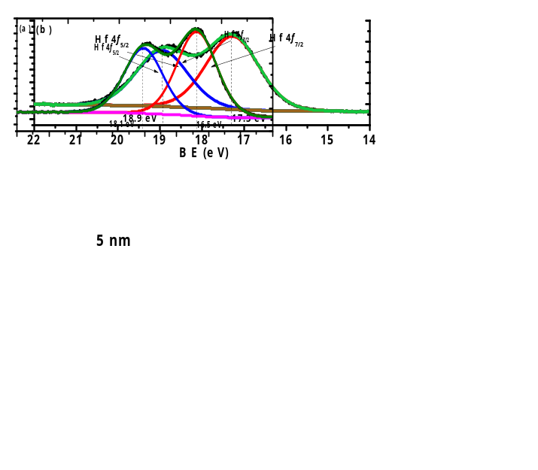
Figure 1. The XPS line shape for HfO₂ thin films with the thickness of (a) 10 nm and (b) 5 nm. The sample with thickness of 10 nm has the lower bonded peak at the position of 16.5 eV for Hf 4f_{7/2} spectra. For the sample with thickness of 5 nm, the bonded peak for Hf 4f_{7/2} spectra is centered at 17.3 eV, with a difference of 0.8 eV with reference to 10 nm one. This shift is probably due to reaction of HfO₂ with germanium for the 5 nm HfO₂ sample.
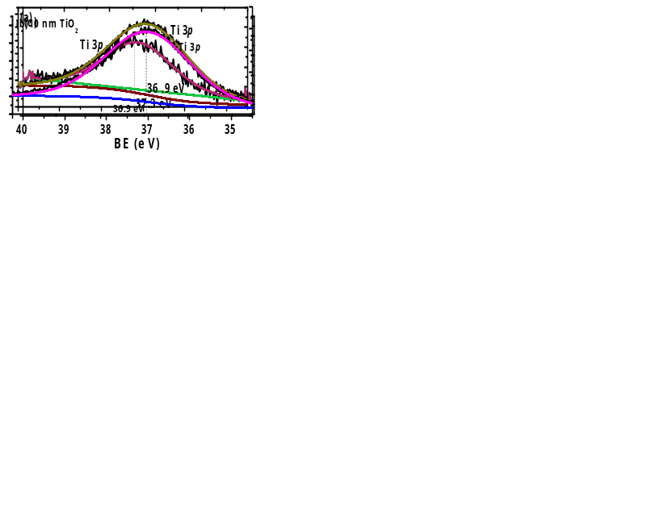
Figure 2. The Ti 3p spectra from (a) 5 nm TiO₂, (b) 10 nm TiO₂ and (c) 5 nm Ti_{0.9}Hf_{0.1}O₂ thin films. The 5 nm and 10 nm thickness TiO₂ samples share the same Ti 3p_{3/2} binding energy centered at the 36.9 eV. A small difference, 0.4 eV, is observed in binding energy of Ti 3p spectra between TiO₂ at 36.9 eV and Ti_{0.9}Hf_{0.1}O₂ samples at 37.3 eV.
Figure 2(c) compares the Ti 3p spectrum from the Ti_{0.9}Hf_{0.1}O₂ sample with the Ti 3p from a pure TiO₂ film on germanium while figure 3 shows the Hf 4f_{7/2} spectra from the same 5 nm thick Ti_{0.9}Hf_{0.1}O₂ sample and compares it to Hf 4f_{7/2} from a pure HfO₂ film. It is clear that the Hf 4f_{7/2} binding energy from Ti_{0.9}Hf_{0.1}O₂, 17 eV, has a smaller difference compared with that from pure HfO₂ at 17.3 eV (Ti_{0.25}Hf_{0.75}O₂ has the same Hf 4f _{7/2} binding energy as Ti_{0.9}Hf_{0.1}O₂, 17 eV, not shown here). In addition, Figure 2 (a) and (c) show that there is also a difference of 0.4 eV in binding energy of Ti 3p spectra between TiO₂ (36.9 eV) and Ti_{0.9}Hf_{0.1}O₂ (37.3 eV). For the Ti_{0.25}Hf_{0.75}O₂ sample, the Ti 3p spectrum was found shifted to higher binding energy by about 0.2 eV while Hf 4f shifted to lower binding energy by about 0.3 eV. The shift of the Hf 4f _{7/2} peak in the Ti_{x}Hf_{1-x}O₂ samples to lower binding energy and Ti 3p to higher binding energy suggests electron transfer from HfO₂ to TiO₂ takes place as a result of chemical mixing between TiO₂ and HfO₂.

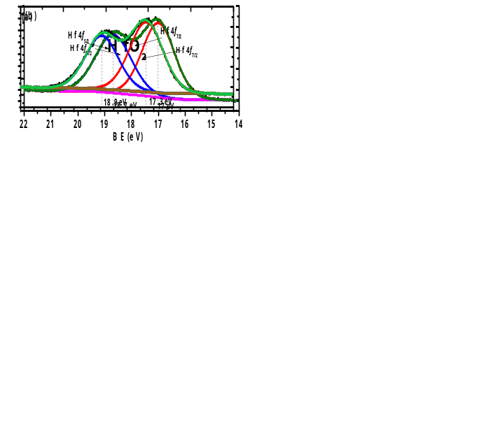
Figure 3. The Hf 4f spectra from 5 nm thick films of (a) HfO₂ and (b) Ti_{0.9}Hf_{0.1}O₂ on Ge. The Hf 4f_{7/2} binding energy from Ti_{0.9}Hf_{0.1}O₂ is 17 eV with a smaller shift compared with that from HfO₂ with 17.3 eV.
In addition, from the analysis of Ge 3d spectra from the four samples with thickness of 5 nm, shown in Figure 4, more information about the Ge surface can be deduced. The corresponding O 1s spectra from the four samples are shown in figure 5. The peaks corresponding to Ge from elemental Ge and GeO_{x} are labelled in the figures. The presence of Ge⁺², Ge⁺³ and Ge⁺⁴ is due to oxidation of the germanium substrate at the interfacial region as well as possible germinate formation. Table 1 shows the compositions extracted from the line fits, relative to the bulk substrate Ge⁰ peak, of the various components at the interface for the four samples. It is clear that the oxidation is much less in the samples with TiO₂ (Figure 4 (a)) compared with the other samples, while oxidation of the substrate in the case of HfO₂ is much greater (Figure 4 (d)). The fitting of the spectra shows an absence of Ge⁺⁴ in the TiO₂ sample, while an incremental increase of the GeO_{x} intensity, especially Ge⁺⁴, is observed with increasing HfO₂ content. This suggests that increasing the amount of HfO₂ in the dielectric films provide more oxidation source to the interface [27]. This has also been observed by other research, which stated that Ge atoms were oxidized by the oxygen atoms provided by the HfO₂ layer [3]. Furthermore, the Hf 4f_{7/2} binding energy difference for the HfO₂ samples with different thickness, shown in Figure 1 (a) and (b) and discussed above, also supports this finding. Therefore, it is inferred that the HfO₂ is a factor in the oxidation and deteriorating effect on the interface. With regard to the significant binding energy shift of the Ge 3d spectra from the samples, it is partially attributed to the presence of a mixture of oxides of GeO_{x} (where x<2) and GeO₂ at the interfacial region. The GeO_{x}, referred to as suboxides in the following discussion, consists of a structure with less than four oxygen atoms attached to one Ge. GeO is known to exhibit a signal at binding energy lower than that of GeO₂ [28]. In this experiment, the concentration of GeO₂ and the x value differ from each other for the four samples. For Ge⁴⁺, it is absent for the pure TiO₂ layer on germanium and is minimum for the Ti_{0.9}Hf_{0.1}O₂, while it is maximum for the pure HfO₂ layer. Therefore, this behavior results in the intensity of the spectral component due to GeO₂ to increase with a concomitant decrease in intensity of the peak of GeO_{x} for oxygen rich samples and this intensity variation leads to a shift of the overall peak [28, 29]. A similar phenomenon of Ge 3d spectra shift was also observed by Caymax in the interface study of HfO₂ gate dielectric deposited on Ge [30]. In addition, the formation of HfGeO_{x} due to the reaction between HfO₂ and Ge is also a possibility in contributing to the shift of the Ge 3d spectra [31, 32].
Table 1. Compositions extracted from the line fits shown in Figure 4, relative to the bulk substrate Ge⁰ peak for the four samples.
 | Ge⁺² | Ge ⁺³ | Ge ⁺⁴
TiO₂ on Ge | 0.06 | 0.12 | -
Ti_{0.9} Hf _{0.1} O₂ | 0.06 | 0.24 | 0.14
Ti_{0.25} Hf_{0.75} O₂ | 0.17 | 0.24 | 0.41
HfO₂ on Ge | 0.13 | 0.45 | 0.75
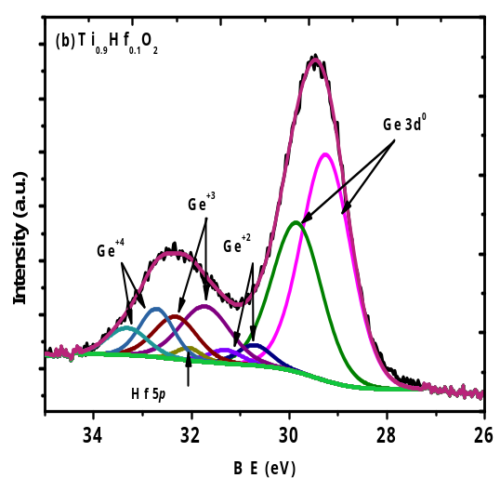
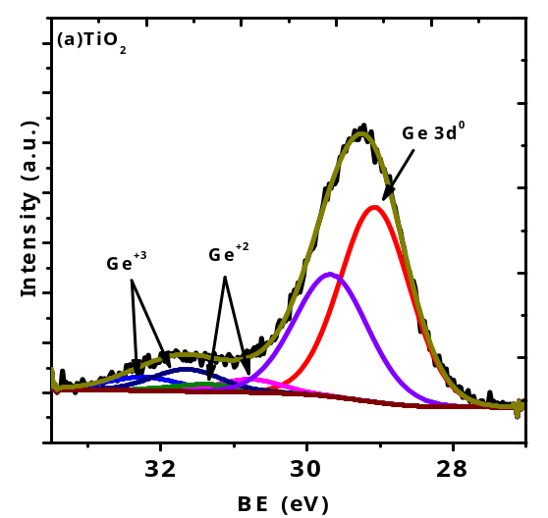
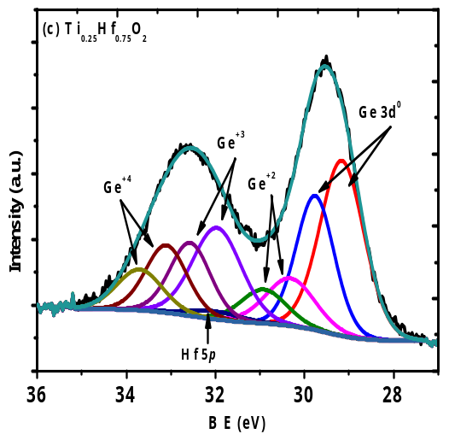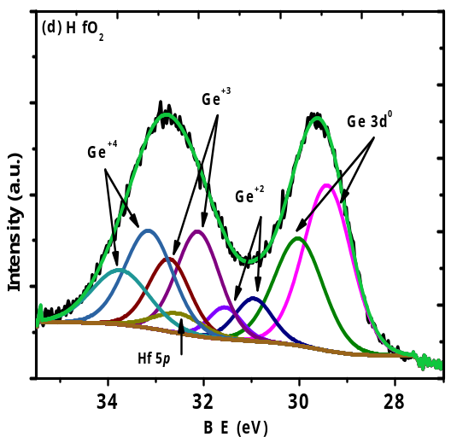
Figure 4. Ge 3d spectra from 5 nm thin films of (a) TiO₂ (b) Ti_{0.9}Hf_{0.1}O₂ (c) Ti_{0.25}Hf_{0.75}O₂ and (d) HfO₂ samples. The presence of Ge⁺², Ge⁺³ and Ge⁺⁴ is due to the Ge oxidation at the interfacial region. There is an increment of GeO_{x} peak intensity, especially for Ge⁺⁴ peaks, with the increase of the HfO₂ concentration.
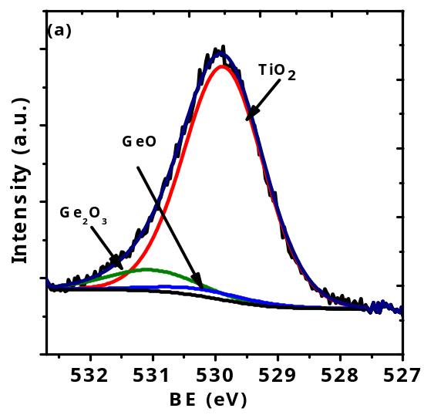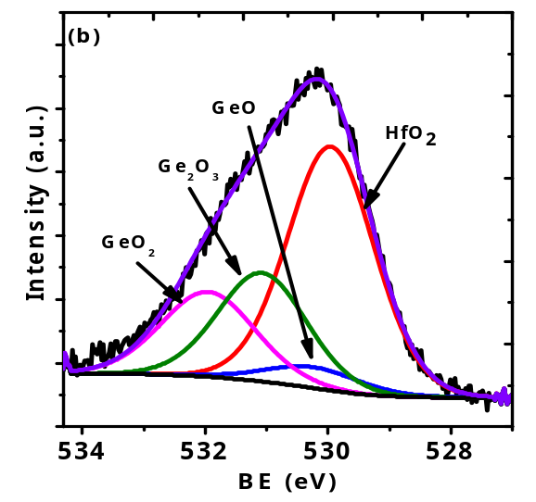
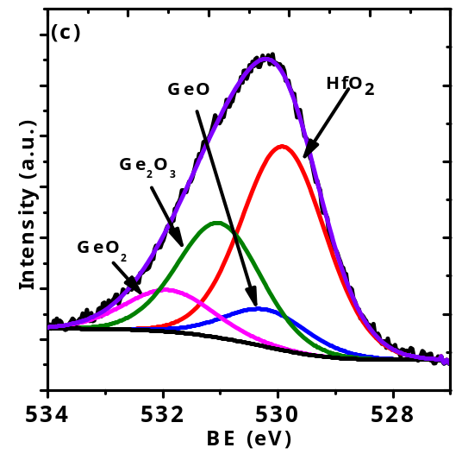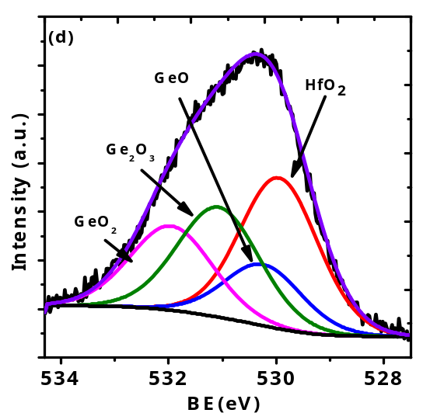
Figure 5. O 1s spectra from 5 nm films of (a) TiO₂ (b) Ti_{0.9}Hf_{0.1}O₂ (c) Ti_{0.25}Hf_{0.75}O₂ and (d) HfO_{2.}
AFM was used to examine the surface roughness of the samples and the results for a scan area of 100 nm ×100 nm are presented in Figure 6. The surface roughness of the samples is quantitatively determined by the root-mean-squared roughness (R_{rms}), defined as
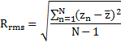 | (1)
where z_{n} is the measured height, is the average height of the sample and N is the number of measurements.
As can be seen, all the samples exhibit good surface morphology with a roughness R_{rms} of 0.325 nm, 0.431 nm, 0.425 nm and 0.202 nm for TiO₂, Ti_{0.9}Hf_{0.1}O₂, Ti_{0.25}Hf_{0.75}O₂ and HfO₂ respectively. The roughness of the thin films less than 0.5 nm demonstrates a nearly atomically smooth surface [33].
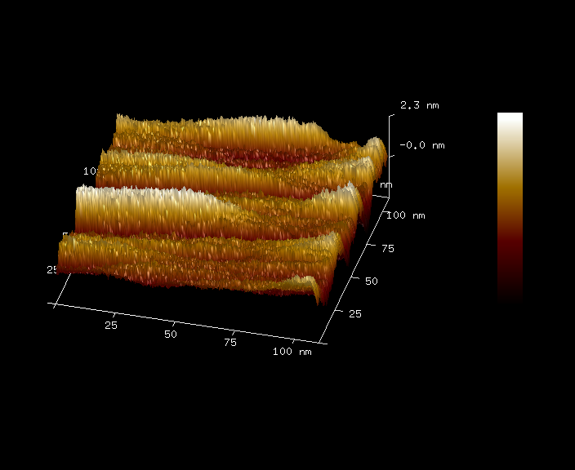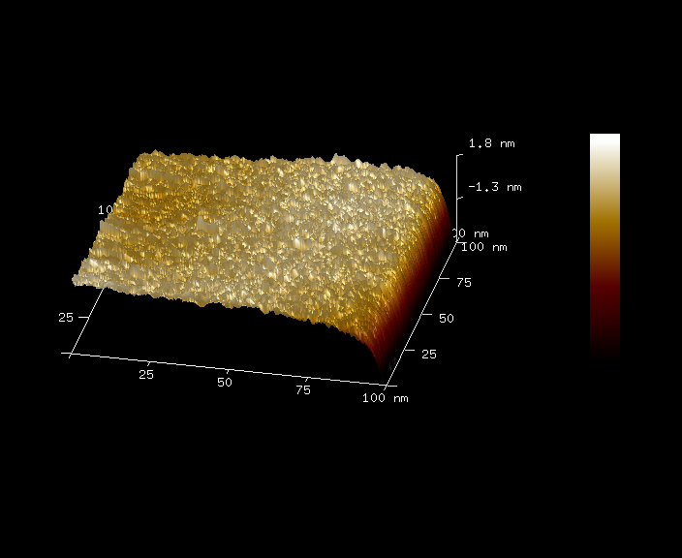
(b)
(a)
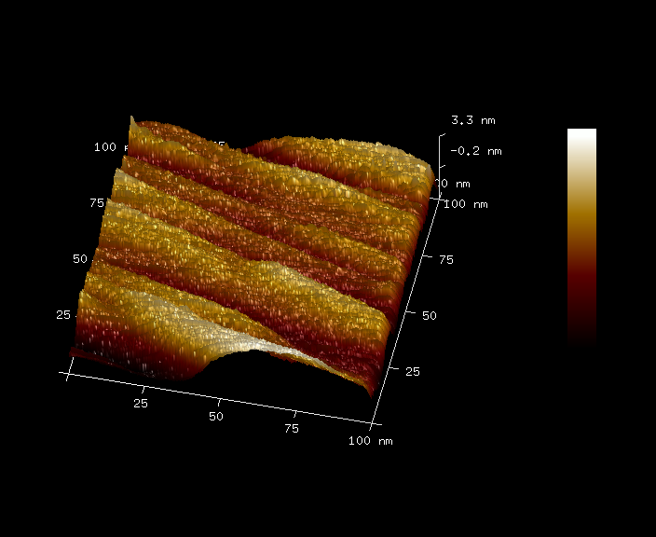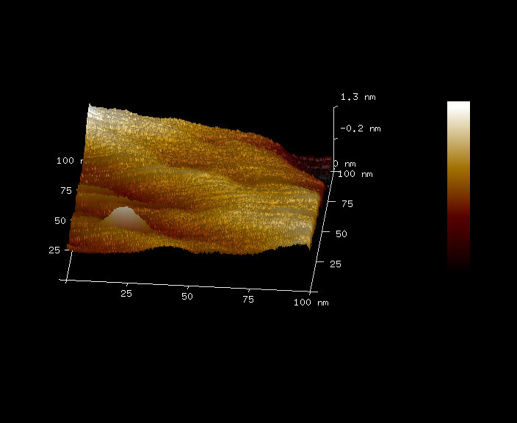
(c)
(d)
Figure 6. AFM images of the samples (a) TiO₂, (b) Ti_{0.9}Hf_{0.1}O₂, (c) Ti_{0.25}Hf_{0.75}O₂ and (d) HfO₂. The roughness (R_{rms}) for each sample is 0.325 nm, 0.431 nm, 0.425 nm and 0.202 nm.
Figure 7 shows the XRD patterns for the four samples with different composition of TiO₂ and HfO₂. The measurement was performed on the samples with a nominal thickness of 10 nm (The actual thickness was in the range 8 to 11 nm determined by ellipsometer). For all the samples, no noticeable diffraction peaks are observed excepted for the one coming from the substrate centered at around 31.5 degree. According to the result of XRD patterns only, it seems that all the thin films remained as amorphous under these deposition conditions. However, due to the small thickness of the thin films, around 10 nm, the sensitivity of XRD is probably not sufficient to detect a limited amount of crystalline phase if present in the thin films, as has been previously pointed out [34, 35]. It is possible that TEM (or SEAD) could further prove the exact morphology of the thin films.
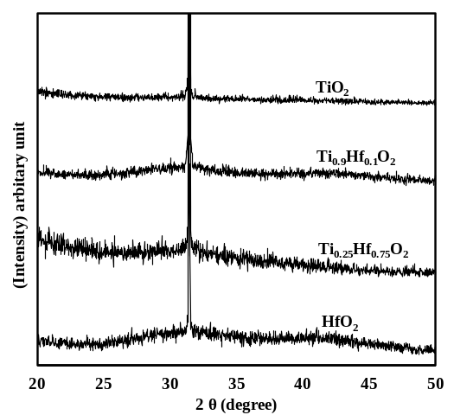
Figure 7. XRD patterns for the 10 nm HfO₂, Ti_{0.25}Hf_{0.75}O₂, Ti_{0.9}Hf_{0.1}O₂ and TiO₂ thin films deposited on germanium substrate. No noticeable diffraction peaks are observed excepted for the one from the substrate.
The Capacitance-Voltage (CV) curves were obtained by sweeping the gate voltage from -1 V to 0.5V in both directions (ramp up and ramp down) at the frequency of 1 MHz using Agilent 4284A LCR meter. Due to an unacceptable distortion of the CV characteristics caused by a large leakage current for the TiO₂ sample, reported below, only the CV curves extracted from HfO₂, Ti_{0.25}Hf_{0.75}O₂ and Ti_{0.9}Hf_{0.1}O₂ samples are presented in Figure 8. The high frequency CV measurements on the three as-grown thin films show that the samples have low trap densities because there is almost no hysteresis between ramp up and ramp down of the CV curves. Due to the dielectric relaxation, probably caused by parasitic effect, lossy interfacial layer and surface roughness of the samples, the obvious frequency dispersion of the samples is observed. Therefore, the vertical change of CV characteristics is not discussed in this paper [36-38]. Regarding the CV characteristics of the Ti_{0.25}Hf_{0.75}O₂ sample, it is noted that saturation in the accumulation region is not obtained, regardless of the bias voltage level. This behavior is attributed to the large leakage current for this sample, which is possibly partially related to the deterioration of the interface as discussed above in the section for XPS analysis. Further comments regarding the leakage current are made in the following section.
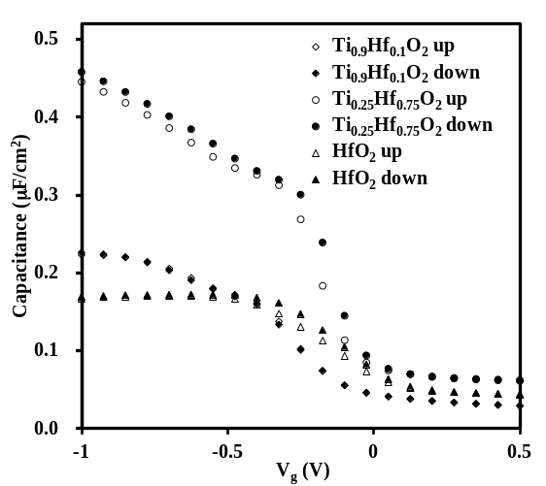
Figure 8. CV characteristics for the three samples of Ti_{0.9}Hf_{0.1}O₂, Ti_{0.25}Hf_{0.75}O₂ and HfO₂. The gate voltage was swept from -1 V to 0.5 V at the frequency of 1 MHz and no horizontal shift is observed. For the CV characteristics of Ti_{0.25}Hf_{0.75}O₂ sample, saturation in the accumulation region is not obtained regardless of the bias voltage level, which is attributed to the large leakage current observed in this sample.
Figure 9 illustrates the relationship between gate leakage current density (J_{g}) and bias voltage (V_{g}) of the samples. The maximum current limit on our instrument was set at 2 mA. From observation of Figure 9, it is apparent that the titanium oxide has the highest leakage current level followed by hafnium oxide and Ti_{0.25}Hf_{0.75}O₂ thin films, both with similar leakage current levels. The Ti_{0.9}Hf_{0.1}O₂ sample has the lowest leakage current, with less than 1 mA/cm² at the bias voltage of 0.5 V. The large leakage current for the TiO₂ sample is attributed to the small band gap of TiO₂ as shown in Figure 10 (a) and discussed further below. For the Ti_{0.9}Hf_{0.1}O₂, Ti_{0.25}Hf_{0.75}O₂ and HfO₂ samples with larger band gap, it is clear that the leakage current increases with increasing amount of HfO₂. Previous research has also reported that a large leakage current was caused by the formation of HfGeO_{x} at the interface between HfO₂ and Ge, and the leakage current was reduced if a germanium nitride barrier layer was first introduced, preventing the formation of HfGeO_{x} [3]. High leakage current behavior, therefore, is probably due to the deterioration of the interfacial layer caused by the interaction of HfO₂ and Ge, which is consistent with the results shown in Figure 4. Thus, the increase of leakage current clearly correlates with the hafnium oxide rich samples. For the TiO₂ doped samples, the TiO₂ would react with HfO₂ to form HfTiO_{x}, consuming the HfO₂ which would otherwise have reacted with the Ge at the interface. It is also possible that other mechanisms may also exist to suppress the leakage current as has been observed for titanium doped tantalum oxide. Titanium doping was found to suppress the oxygen vacancies in tantalum oxide capacitors, which resulted in a significant reduction in leakage current [39]. For HfO₂ capacitors, there are also a considerable number of oxygen vacancies [40-43], which are possibly suppressed when titanium is doped in the HfO₂.
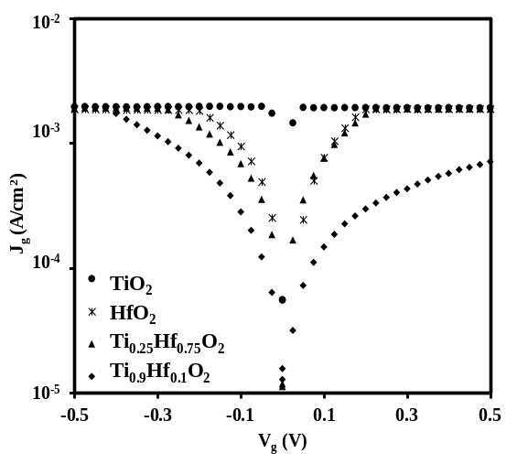
Figure 9. Gate leakage current density (J_{g}) versus gate voltage (V_{g}) for samples of HfO₂, Ti_{0.25}Hf_{0.75}O₂, Ti_{0.9}Hf_{0.1}O₂ and TiO₂. The titanium oxide occupies the highest leakage current level followed by hafnium oxide and Ti_{0.25}Hf_{0.75}O₂ thin films with similar leakage current levels. The Ti_{0.9}Hf_{0.1}O₂ sample has the lowest leakage current.
Although, the titanium incorporation seems to suppress the leakage current, the leakage current is still relatively large. The energy band diagram [18, 19] in Figure 10 attempts to provide a possible explanation in conjunction with the XPS results discussed above. From the energy band diagram in Figure 10 (a), titanium oxide has a relative small band gap (3.2 eV) and the conduction band minimum is at 4.21 eV, while the band gap and conduction band minimum for germanium are 0.66 eV and at 4.13 eV, respectively. The thin aluminum oxide with the thickness of about 0.3 nm is used to passivate the germanium surface and it has almost no contribution to suppressing the leakage current. If a voltage was applied at the gate on the TiO₂/Al₂O₃ stack, dramatic leakage current should be induced from considering the energy band diagram in Figure 10 (a). For the energy band diagram of hafnium oxide shown in Figure 10 (b), the band gap is wider and the conduction band minimum is higher than that of TiO₂. Thus, the HfO₂ sample has a higher potential barrier across the oxide. Therefore, the leakage current of HfO₂ is 5 times smaller than that of TiO₂ regardless of the deterioration of the interface caused by the oxidation of the substrate. When TiO₂ is doped in HfO₂, the reaction of TiO₂ and HfO₂ should adjust the energy band diagram as shown in Figure 10 (c) and the leakage current should be between that of TiO₂ and HfO₂ from the point view of energy band diagram. However, as mentioned above, HfO₂ is considered to be an oxidation source and contribute to the interface deterioration, which enhances the leakage current for the HfO₂ rich samples. Fortunately, the formation of HfTiO_{x} in TiO₂ doped HfO₂ reduces the reaction between HfO₂ and germanium and suppresses the deterioration of interface, which results in the significant reduction of leakage current. Therefore, in our case, the Ti_{0.25}Hf_{0.75}O₂ dielectric sample has almost the same leakage current as HfO₂ sample while the Ti_{0.9}Hf_{0.1}O₂ sample with much less HfO₂ has the smallest leakage current among them.
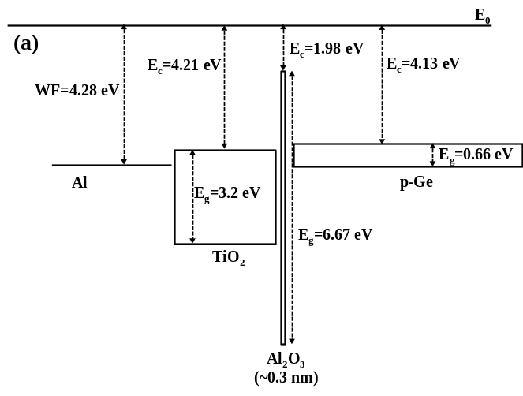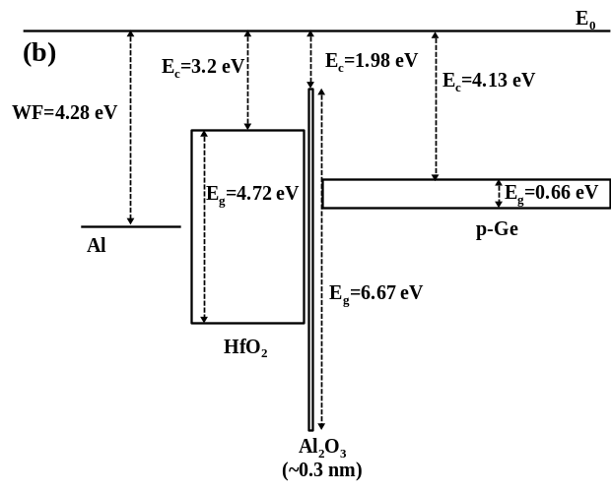
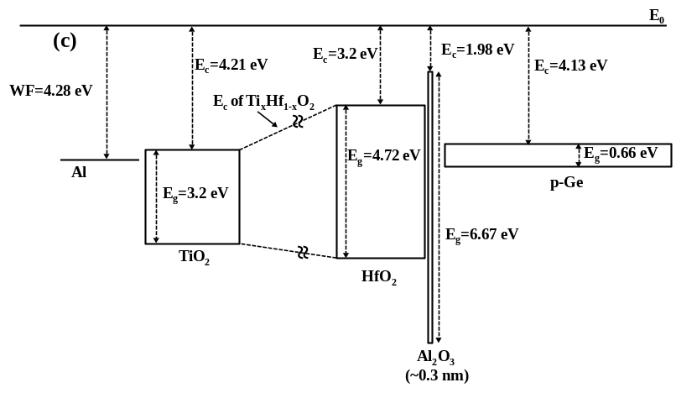
Figure 10．Energy band diagrams for (a) titanium oxide, (b) hafnium oxide and (c) titanium doped hafnium oxide. The work function of Al is represented by WF. Titanium oxide has relative small band gap (3.2 eV) and the conduction band minimum is 4.21 eV below the vacuum level. Modest voltages applied to the gate can result in large leakage currents. Incorporation of hafnium oxide results in a significantly wider band gap and lower conduction band minimum compared to that of TiO₂. Therefore, the resulting leakage current of HfO₂ is 5 times lower than that of TiO₂ for the same applied gate voltage regardless of the interfacial deterioration, as shown in Figure 9.

3. Experimental Section
Before mixing HfO₂ with TiO₂ to form Ti_{x}Hf_{1-x}O₂, the ALD growth rates of TiO₂ and HfO₂ were tested individually. Titanium isopropoxide and methoxymethyl hafnium were used as the ALD precursors and heated to 40 °C and 100 °C, respectively. Deionized water was used as oxygen source and argon was employed as carrier gas in all the experiments. All the deposition was performed at the substrate temperature of 300 °C. The sequence for ALD deposition was precursor pulse/purge/water pulse/purge. For both precursors, the precursor pulse duration of 3 seconds was followed by a purge time of 6 seconds. Water pulse time of 0.01 second was followed by 3 seconds purge time. The thickness of thin films with different ALD cycles was measured by ellipsometer. The relationship between the film thickness and corresponding ALD cycles is shown in Figure 11. From the slopes of the fitting straight line, it was found that the deposition rates for TiO₂ and HfO₂ were approximately 0.203 Å/cycle and 0.166 Å/cycle, respectively. Based on these growth rates, the cycle ratio of the titanium oxide to the hafnium oxide was evaluated to obtain the required dielectric oxides, with the ratio of TiO₂ to HfO₂ being 1:3 and 9:1 (Ti_{0.25}Hf_{0.75}O₂ and Ti_{0.9}Hf_{0.1}O₂), respectively, in terms of thickness. For example, for Ti_{0.25}Hf_{0.75}O₂, two TiO₂ cycles (0.4 Å) were followed by seven HfO₂ cycles (1.2 Å). The content of TiO₂ is equal to 0.4 Å /(0.4 Å +1.2 Å) = 25%. According to the cycle ratio and deposition rates, the total cycles for each oxide were designed to produce the required thickness of the thin films. The p-type germanium wafers were used as the substrate of ALD Ti_{x}Hf_{1-x}O₂ thin films. The Ge wafer was cleaned ultrasonically in acetone followed by O₂ plasma treatment. The germanium oxide on the surface was removed by cyclically rinsing between deionized water (DI water) and diluted 2% HF. The clean wafers were transferred to the ALD chamber (Oxford Instruments OpALTM, UK) immediately to deposit an Al₂O₃ passivation layer (~0.3 nm) by ALD using trimethylaluminum (TMA) as precursor. The TiO₂, Ti_{0.9}Hf_{0.1}O₂, Ti_{0.25}Hf_{0.75}O₂ and HfO₂ thin films were then deposited on the Al₂O₃ passivated germanium substrates, respectively. XPS measurements were carried out in a UHV system consisting of Al Kα X-ray (1486.6 eV) source and a PSP Vacuum systems 5-channel HSA electron energy analyser. The C_{1s} peak in the spectra at 284.6 eV, due to impurity carbon in the samples, was used to calibrate any charging effects during measurements. The experimental XPS spectra were fitted using a Gaussian-Lorentzian line shape doublet to account for the spin-orbit splitting, using the CASAXPS fitting package. Grazing Incident X-ray diffraction (GIXRD) was carried out using Bruker diffractometer (Bruker, Germany) with Cu Kα radiation source (40 kV, 40 mA), spanning a 2θ range from 20° to 50° at a scan rate of 1°/second for all measurements. Surface morphology and roughness of the thin films were analyzed using atomic force microscope (AFM) (Bruker, Germany). The thickness of each thin film was measured by an ELLIP-SR-1 ellipsometer with the incident angle of 65°and wavelength from 300 nm to 900 nm with a step of 20 nm. The electrode contacts with a diameter of 0.3 mm and thickness of 350 nm were deposited by E-beam evaporation (TEMD-600, China). The back surfaces of the samples were deposited with aluminum to form ohmic contact. Aglient 4284A precision LCR meter and Keithley 487 picoammeter were employed to investigate the electrical properties of the samples. All the electrical measurements were performed in the dark at room temperature with a Faraday Cage surrounding the prober station.
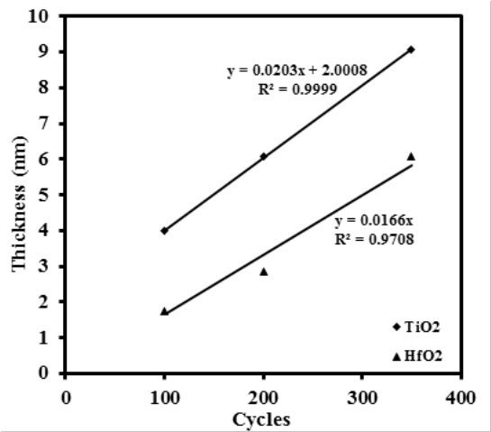
Figure 11. The thin film thickness versus ALD cycles for titanium oxide and hafnium oxide, respectively. The slopes of the two fitting straight lines (y=0.0203x+2.0008 and y=0.0166x) represent the corresponding deposition rates and R² is the coefficient of determination. The deposition rates for TiO₂ and HfO₂ are approximately 0.203 Å/cycle and 0.166 Å/cycle, respectively.

4. Conclusions
Hafnium titanate oxide thin films, Ti_{x}Hf_{1-x}O₂, with a titanium content of x = 0, 0.25, 0.9 and 1 were deposited on alumina passivated germanium substrates. XPS was used to analyze the interface quality and chemical structure. It shows that the HfO₂ deteriorates the interface quality, leading to an enhanced leakage current. The surface roughness was analyzed by atomic force microscope and all the samples exhibit relatively good surface morphology with the roughness RMS of 0.202 nm, 0.425 nm, 0.431 nm and 0.325 nm for HfO₂, Ti_{0.25}Hf_{0.75}O₂, Ti_{0.9}Hf_{0.1}O₂ and TiO₂, respectively. XRD analysis shows that all the samples are amorphous under these deposition conditions. From electrical characterization, it is found that there is almost no hysteresis between ramp up and ramp down of the CV curves, suggesting low trap densities. A relatively large leakage current is observed, with the lowest leakage current of about 1 mA/cm² at the bias of 0.5 V for Ti_{0.9}Hf_{0.1}O₂. The large leakage current is attributed to the deterioration of the interface caused by the oxidation source borne by HfO₂ and the small band gap of the dielectric materials.

Acknowledgments
This research was funded in part from the National Natural and Science Foundation of China under the grant no. 11375146, the Suzhou Science and Technology Bureau of China under the grant SYG201223, and the Jiangsu Provincial Science and Technology Program under the grant BK2012636.

Author Contributions
Qifeng Lu extracted the data and drafted the manuscript. Joseph W. Roberts, Qifeng Lu and Yifei Mu prepared the samples. Jingjin Wu and Qian Zhang performed the XRD and AFM. Vinod Dhanak and Mohammed Althobaiti performed XPS. Ce Zhou Zhao monitored and led the whole research project. Ivona Z. Mitrovic, Steve Taylor, Chun Zhao, Li Yang and Paul R. Chalker participated in the discussions. All of the authors read and approved the final manuscript.

Conflicts of Interest
The authors declare no conflict of interest.

References
- Caymax M, Eneman G, Bellenger F, Merckling C, Delabie A, Wang G, Loo R, Simoen E, Mitard J, De Jaeger B. Germanium for Advanced CMOS anno 2009: A SWOT Analysis. International Electron Devices Meeting, Baltimore, MD, U.S. Dec 7-9 2009; 428-431.
- Saraswat K, Chui C O, Krishnamohan T, Kim D, Nayfeh A, Pethe A. High Performance Germanium MOSFETs. Mat. Sci. Eng. B-Solid 2006, 135, 242–249.
- Kamata Y. High-k/Ge MOSFETs for future nanoelectronics. Materials today 2008, 11, 1-2.
- Shang H, Okorn-Schmidt H, Chan K K, Copel M, Ott J A, Kozlowski P M, Steen S E, Cordes S A, Wong H-S P, Jones E C , Haensch W E. High mobility p-channel germanium MOSFETs with a thin Ge oxynitride gate dielectric. International Electron Devices Meeting, San Francisco, CA, U.S. Dec 8-11 2002; 441-444.
- Goley, P S, Hudait, M K, Germanium Based Field-Effect Transistors: Challenges and Opportunities. Materials 2014, 7, 2301-2339.
- Wu D, Lindgren A-C, Persson S, Sjoblom G, Haartman MV, Seger J, Hellstrom P E, Olsson J, Blom H O, Zhang S L. A Novel Strained Si_{0.7}Ge_{0.3} Surface-channel pMOSFET with an ALD TiN/Al₂O₃/HfAlO_{x}/Al₂O₃ Gate Stack. IEEE Electr. Device. L. 2003, 24, 171.
- Houssa M, Jaeger B D, Delabie A, Elshocht S V, Afanas’ev V V, Autran J L, Stesmans A, Meuris M, Heyns M M. Electrical Characteristics of Ge/GeO_{x}(N)/HfO₂ Gate Stacks. J. Non-Cryst. Solids 2005, 351, 1902.
- Zhao, Y. Design of Higher-k and More Stable Rare Earth Oxides as Gate Dielectrics for Advanced CMOS Devices. Materials 2012, 5, 1413-1438.
- Wu N, Zhang Q C, Zhu C X, Chan D S H, Li M F, Balasubramanian N, Chin A, Kwong D L. Alternative Surface Passivation on Germanium for Metal-Oxide Semiconductor Applications with High-k Gate Dielectric. Appl. Phys. Lett. 2004, 85, 4127.
- Chen J J-H, Bojarczuk N A, Shang Jr. H, Copel M, Hannon J B, Karasinski J, Preisler E, Banerjee S K, Guha S. Ultrathin Al₂O₃ and HfO₂ Gate Dielectrics on Surface-Nitrided Ge. IEEE T. Electron Dev. 2004, 51, 9.
- Li X F, Liu X J, Zhang W Q, Fu Y Y, Li A D, Li H, Wu D. Comparison of the Interfacial and Electrical Properties of HfAlO Films on Ge with S and GeO₂ Passivation. Appl. Phys. Lett. 2011, 98, 162903
- Zhao C Z, Taylor S, Werner M, Chalker P R, Murray R T, Gaskell J M, Jones A C. Dielectric Relaxation of Lanthanum Doped Zirconium Oxide. Appl. Phys. Lett. 2009, 105, 044102.
- Lu Q, Zhao C, Mu Y, Zhao C Z, Taylor S, Chalker P R. Hysteresis in Lanthanide Zirconium Oxides Observed Using a Pulse CV Technique and including the Effect of High Temperature Annealing. Materials 2015, 8, 4829-4842.
- Huang L Y, Li A D, Zhang W Q, Li H, Xia Y D, Wu D. Fabrication and Characterization of La-doped HfO₂ Gate Dielectrics by Metal-Organic Chemical Vapor Deposition. Appl. Surf. Sci. 2010, 256, 2496-2499.
- Wang T, Ekerdt J G. Atomic Layer Deposition of Lanthanum Stabilized Amorphous Hafnium Oxide Thin Films. Chem. Mater. 2009, 21, 3096-3101.
- Chen F, Bin X, Hella C, Shi X, Gladfelter W L, Campbell S A. A Study of Mixtures of HfO₂ and TiO₂ as High-k Gate Dielectrics. Microelectron Eng. 2004, 72, 263.
- Werner M, Peter P J, Hindley S, Romani S, Mather S, Chalker P R, Williams P A, Van D B, Jakob A. Atomic layer deposition of Ti-HfO₂ dielectrics. Appl. Phys. Lett. 2013, 31, 01A102.
- Xu Y, Schoonen M A A. The Absolute Energy Positions of Conduction and Valence Bands of Selected Semiconducting Minerals. Am. Mineral. 2000, 85, 543–556.
- Van Elshocht S, Brijs B, Caymax M, Conard T, Chiarella T, De Gendt S, De Jaeger B, Kubicek S, Meuris M, Onsia B, Richard O, Teerlinck I, Van Steenbergen J, Zhao C, and Heyns M. Deposition Of HfO₂ on Germanium and the Impact of Surface Pretreatments. Appl. Phys. Lett. 2004, 85, 3824.
- Xie R and Zhu C. Effects of Sulfur Passivation on Germanium MOS Capacitors with HfON Gate Dielectric. IEEE Electr. Device. L. 2007, 28, 976-979.
- Kato R, Kyogoku S, Sakashita M, Kondo H, Zaima S. Effects of Atomic Layer Deposition-Al₂O₃ Interface Layers on Interfacial Properties of Ge Metal Oxide Semiconductor Capacitors. Jpn. J. Appl. Phys. 2009, 48, 05DA04.
- Sahin D, Yildiz I, Gencer A I, Aygun G, Turan R. Evolution of SiO₂/Ge/HfO₂(Ge) Multilayer Structure During High Temperature Annealing. Thin Solid Films 2010, 518, 2365-2369.
- Cho M H, Roh Y S, Whang C N, Jeong K, Nahm S W, Ko D H, Lee J H, Lee N I Fujihara K. Thermal Stability and Structural Characteristics of HfO₂ Films on Si(100) Grown By Atomic-Layer Deposition. Appl. Phys. Lett. 2002, 81, 472-474.
- Opila R L, Wilk G D, Alam M A, Van Dover R B, Busch B W. Photoemission Study of Zr- and Hf-Silicates for Use as High-Kappa Oxides: Role of Second Nearest Neighbors and Interface Charge. Appl. Phys. Lett. 2002, 81, 1788-1790.
- Elshocht S V, Caymax M, Conard T, De Gendt S, Hoflijk I, Houssa M, De Jaeger B, Van Steenbergen J, Heyns M, Meuris M. Effect of Hafnium Germanate Formation on the Interface of HfO₂/Germanium Metal Oxide Semiconductor Devices. Appl. Phys. Lett. 2006, 88, 141904.
- Xie Q, Deng S, Schaekers M, Lin D, Caymax M, Delabie A, Qu X, Jiang Y, Deduytsche D, Detavernier C. Germanium Surface Passivation and Atomic Layer Deposition of High-k Dielectrics—A Tutorial Review on Ge-Based MOS Capacitors. Semicond. Sci. Tech. 2012, 27, 074012.
- Curreem K K S, Lee P F, Wong K S, Dai J Y, Zhou M J, Wang J, Li Q. Comparison of Interfacial and Electrical Characteristics of HfO₂ and HfAlO High-k Dielectrics on Compressively Strained Si_{1−x}Ge_{x}. Appl. Phys. Lett. 2006, 88, 182905.
- Prabhakaran K, Maeda F, Watanabe Y, Ogino T. Distinctly Different Thermal Decomposition Pathways of Ultrathin Oxide Layer on Ge And Si Surfaces. Appl. Phys. Lett. 2000, 76, 2244-2246.
- Schmeisser D, Schnell R D, Bogen A, Himpsel F J, Rieger D, Landgren G, Morar J F. Surface Oxidation States of Germanium. Surf. Sci. 1986, 172, 455-465.
- Caymax M, Van Elshocht S, Houssa M, Delabie A, Conard T, Meuris M, Heyns M M, Dimoulas A, Spiga S, Fanciulli M, Seo J W, Goncharova L V. HfO₂ as Gate Dielectric on Ge: Interfaces and Deposition Techniques. Mat. Sci. Eng. B-Solid. 2006, 135, 256-260.
- Kita K, Takahashi T, Nomura H, Suzuki S, Nishimura T, Toriumi A. Control of High-k/Germanium Interface Properties Through Selection of High-k Materials and Suppression Of GeO Volatilization. Appl. Surf. Sci. 2008, 254, 6100-6105.
- Van Elshocht S, Caymax M, Conard T, De Gendt S, Hoflijk I, Houssa M, Jaeger D, Van Steenbergen J. Heyns M, Meuris M. Effect of Hafnium Germanate Formation on the Interface of HfO₂/Germanium Metal Oxide Semiconductor Devices. Appl. Phys. Lett. 2006, 88, 1904.
- Li M, Zhang Z, Campbell S A, Li H J, Peterson J J. Hafnium Titanate as a High Permittivity Gate Insulator: Electrical and Physical Characteristics and Thermodynamic Stability. J. Appl. Phys. 2007, 101, 044509.
- Delabie A, Puurunen R L, Brijs B, Caymax M, Conard T, Onsia B, Richard O, Vandervorst W, Zhao C, Heyns M M, Meuris M, Viitanen M M, Brougersma H H, De Ridder M, Goncharova L V, Garfunkel E, Gustafsson T, Tsai W. Atomic Layer Deposition of Hafnium Oxide on Germanium Substrates. J. Appl. Phys. 2005, 97, 64104-64104.
- Ardalan P, Pickett E R, Harris J S, Marshall A F, Bent S F. Formation of an Oxide-Free Ge/TiO₂ Interface by Atomic Layer Deposition on Brominated Ge. Appl. Phys. Lett. 2008, 92, 2902.
- Tao J, Zhao C Z, Zhao C, Taechakumput P, Werner M, Taylor S, Chalker P R. Extrinsic and Intrinsic Frequency Dispersion of High-k Materials in Capacitance-Voltage Measurements. Materials 2012, 5, 1005-1032.
- Lee B, Moon T, Kim T, Choi D, Park B. Dielectric Relaxation of Atomic-Layer-Deposited HfO₂ Thin Films from 1 kHz to 5 GHz. Appl. Phys. Lett. 2005. 87, 012901.
- Zhao C, Zhao C Z, Werner M, Taylor S, Chalker P. Dielectric Relaxation of High-k Oxides. Nanoscale Res. Lett. 2013, 8, 1-12.
- Lau W S, Tan T S, Babu P, Sandler N P. Mechanism of Leakage Current Reduction of Tantalum Oxide Capacitors by Titanium Doping. Appl. Phys. Lett. 2007, 90, 112903.
- Chen, Y Y. Electrical Characteristics of the Uniaxial-Strained nMOSFET with a Fluorinated HfO₂/SiON Gate Stack. Materials 2014, 7, 2370-2381.
- Ji M, Wang L, Du J. Preparation and Characterization of Gd₂O₃-doped HfO₂ High-k Gate Dielectric Thin Films by RF Sputtering. Journal of Physics: Conference Series 2009, 152, 012005.
- Guha S, Narayanan V. Oxygen Vacancies in High Dielectric Constant Oxide-Semiconductor Films. Phys. Rev. Lett. 2007, 98, 196101.
- Miyata N, Study of Direct-Contact HfO₂/Si Interfaces. Materials 2012, 5, 512-527.

© 2015 by the authors; licensee MDPI, Basel, Switzerland. This article is an open access article distributed under the terms and conditions of the Creative Commons Attribution license (http://creativecommons.org/licenses/by/3.0/).

