"This is the peer reviewed version of the following article: [FULL CITE], which has been published in final form at http://onlinelibrary.wiley.com/doi/10.1002/bjs.10524. This article may be used for non-commercial purposes in accordance with Wiley Terms and Conditions for Self-Archiving."

Long-term follow-up of fenestrated endovascular repair for juxta-renal aortic aneurysm

I N Roy MRCSª, A M Millen MRCSª, S M Jones MD FRCS ª, S R Vallabhaneni MD FRCS ª, J R H Scurr MD FRCS ª, R G McWilliams FRCS FRCR^{b}, J A Brennan MD FRCS ª, R K Fisher MD FRCS ª.
ª Liverpool Vascular and Endovascular Service (LiVES) and ^{b} Interventional Radiology, Royal Liverpool University Hospital, Prescot Street, Liverpool, L7 8XP, UK.
Correspondence:
Mr Iain N Roy
Royal Liverpool University Hospital,
Prescot Street,
Liverpool, L7 8XP.
UK.
Tel: +44 151 706 2000
Fax: +44 151 706 5827
Email: iain.roy@liverpool.ac.uk

Word count: 2881
ABSTRACT
Objective: Fenestrated endovascular aneurysm repair (FEVAR) is an established treatment for juxta-renal aortic aneurysms. The aim of this study was to review long term results and assess the importance of changing stent-graft design on outcomes.
Methods: A retrospective review of all patients who underwent FEVAR within a single unit over 12 years period (February 2003 – December 2015) was conducted. Kaplan-Meier analysis of survival and freedom from target vessel loss, aneurysm expansion, graft-related endoleak, and secondary intervention were performed. Comparison between outcomes of less complex grafts (<3 fenestrations) and more complex grafts (3 and 4 fenestration) was undertaken.
Results: Some 173 patients underwent FEVAR, 90% male, median age 76 years (IQR 70-80). Median aneurysm diameter was 63mm (IQR 59-71) and the median follow up was 34 months (IQR 16-50). Adjusted primary technical operative success was 95%. In-hospital mortality was 5.2%, and there was no known aneurysm related death in follow-up.
Overall survival was 60% (104), median 7.1 years (95% CI 5.2 - 8.1).
There was a trend towards increasing number of fenestrations in the graft design over time. In-hospital mortality was higher in 3 and 4 fenestration compared to <3 fenestration, 7.8% vs 2.4% (p=0.06) .Graft-related endoleaks were also higher following 3 and 4 fenestration stent-grafts, 12 vs 6 (p=0.001).
Conclusions: Fenestrated endovascular repair for juxta-renal aneurysm is associated with few aneurysm related deaths in the long-term. Significant numbers of secondary intervention are required but the majority of these can be performed endovascularly.
Keywords: fenestrated, endovascular, aneurysm

INTRODUCTION
The treatment of a juxta-renal aortic aneurysm by fenestrated endovascular aneurysm repair (FEVAR) was first reported in 1999.¹ FEVAR has become the commonest treatment for juxta-renal aneurysms with 263 cases reported in the UK, in 2015.² The UK wide British Society for Endovascular Therapy: Global Collaborators on Advanced Stent-Graft Techniques for Aneurysm Repair (BSET GLOBALSTAR) registry has established the safety and efficacy through reporting short and medium term outcomes of initial cases during 2003-9.³ Reports of long term outcomes are sparse⁴ and as such long-term durability remains uncertain.
FEVAR stent-graft design has changed over the last decade, with a trend towards a more proximal seal zone, necessitating more fenestrations or scallops to maintain visceral perfusion. While this may allow the treatment of more complex aneurysms it is perceived by the authors that it is also being applied to juxta-renal aneurysms that were previously treated by less complex grafts.
BSET GLOBALSTAR recorded an increased inpatient mortality rate of 9.4% for stent-grafts that incorporated the celiac trunk compared to 2.8% for those that did not. As such the widely reported short and medium term outcomes of early case series may not reflect the outcomes of stent grafts used in modern practice.
The aim of this study was to assess the overall long term outcomes following FEVAR for the treatment of juxta-renal aortic aneurysms in a single centre and to observe the effect of changing stent-graft design .
METHODS
Data of all patients undergoing a FEVAR for juxta-renal aortic aneurysm from February 2003 – December 2015 in Liverpool Vascular & Endovascular Service were included in the analysis. Patients who underwent an endovascular repair involving branched components or fenestrations with a proximal thoracic extension with another stent-graft component were excluded, as they were deemed to represent thoraco-abdominal aneurysm repairs. Analysis of our institutions data provided patient demographics, aneurysm characteristics, operative details and post-operative surveillance data. Confirmation of mortality data were obtained from national NHS institutional information. Cause of death data was obtained from patient’s general practitioners or death certificates obtained.
.
A target vessel was defined according to previous published reports on FEVAR, as “a vessel potentially covered by the stent-graft fabric if not for a deliberate mechanism of preservation, when the stent-graft is deployed as intended.” A fenestration was defined as a “deliberate defect either circular or elliptical”and a scallop was defined as a “U-shaped gap in the proximal fabric of the graft”.⁵
Two sub-groups were created, divided by the median number of fenestrations in implanted stent-grafts. This created a group of grafts with 0,1and2 (<3) fenestrations and a group with 3 or 4 fenestrations. This clinically relates to patients who would normally undergo stenting of a mesenteric vessel (3 or 4 fenestration group) or not (0,1and2 fenestration group).
The primary endpoints was overall survival. Secondary endpoints were freedom from target vessel loss, aneurysm growth, graft-related endoleak (type I or III) and secondary intervention. Definitions for success, complications and other events associated with endovascular repair were in accordance with accepted reporting standards. ^{6, 7}
Renal Function
Pre-operative renal function was calculated as creatinine clearance, calculated using the Cockcroft-Gault formula, all calculations were based upon ideal body weight calculated from the patient’s sex and pre-operative height.
Follow up Protocol
A standardised post FEVAR surveillance protocol was developed in our institution including plain abdominal radiographs (AXR) prior to discharge, one month Duplex ultrasound examination (DUS) and a single arterial phase computed tomography angiography scan (CTA), with a clinical review 6 weeks post-operatively. Six month and then annual AXR, DUS and CTA were undertaken. If complications or potential problems were identified patients were discussed at a multi-disciplinary team (MDT) meeting. Further imaging in the form of triple phase CTA or contrast enhanced ultrasound (CEUS) were performed if deemed appropriate and secondary intervention was undertaken if clinically indicated. Loss of a target vessel was defined as complete occlusion of the target vessel main stem.
Primary outcome was calculated using robust national data, as such patients were censored only at the point of data collection. If the patient was known to be alive and still on the surveillance programme their last point of follow up was taken as the last point of data collection for secondary interventions. If the patient was followed up elsewhere and hence not in the local programme then their last point of imaging was taken as the last follow up time point for secondary outcomes. All planned secondary interventions were undertaken within our institution; unplanned interventions were detected on the next imaging or recorded if correspondence was received. This arrangement was limited to our early experience as all patients now attend our institution for follow-up imaging.
Statistics
Continuous data are presented as median with inter quartile range in parentheses. Overall survival, target vessel loss, graft-related endoleak, and secondary intervention were all subject to Kaplan-Meier analysis and log-rank comparison using R Studio version 0.99 (RStudio, Boston, USA). Median follow up length was determined using the reverse Kaplan-Meier technique. All other statistics were analysed using SPSS version 22 (IBM, Armonk, NY, USA).
RESULTS
During the 12 year study period some 209 patients underwent a branched and/or fenestrated procedure within our institution of which 174 were eligible for inclusion in this analysis. In one patient the device could not be introduced passed a stenotic aortic bifurcation and the procedure was abandoned. The patient remains alive 34 months after the failed operation. That patient has been excluded from the analysis and the remaining 173 patients are presented below.
Patient Variables
Pre-operative continuous variables for the cohort are: age(years) 76(70-79), aneurysm diameter(mm) 63(59-71), BMI 27.3(25.0-30.0), systolic BP (mmHg) 135(122-146), haemoglobin (g/L) 138 (127-147), creatine clearance 55 (43-65), left ventricular ejection fraction (%) 60 (51-64) and FEV₁ (L/1st Second) 201 (1.6-2.6).. Pre-operative nominal variables are summarised in Table I.
Stent-graft Configuration
All patients were treated with fenestrated stent-graft produced by a single manufacturer. (Cook Medical, Bloomington, Indiana, USA). The stent-graft configuration was recorded in all patients (Table II). The most common stent-graft and target vessel configuration was a scallop for the superior mesenteric artery (SMA) and a fenestration for each of the renal arteries (35%). Over the duration of the study there was a trend towards an increasing number of target vessels (Figure 1). Comparison of 2004 & 2015 shows significant difference in the number of target vessels (median 3 vs 4, Z-score=4.64, p<0.01, Mann-Whitney U Test). Aneurysm and stent-graft D1 (neck) diameter do not display any trend over time and are presented as surrogate markers of aneurysm morphology, Supplementary Material.
Operative Data
In 173 patients the fenestrated device was introduced successfully. 2 (0.35%) target vessels were lost intra-operatively, in separate patients, both were renal arteries. There were 35 patients with a graft-related endoleak (type I or III) on completion of the procedure. Primary technical success was 79% (137 patients). 29 of the 35 (83%) of graft-related endoleaks identified on completion angiography had resolved without intervention at the 1 month surveillance imaging. This gives an adjusted primary technical success of 95% (165 patients).
The median operation time differed was significantly shorter for stent-grafts implanted with 0, 1 and 2 fenestrations(285 minutes (95% CI 240 - 330) and those with 3 and 4 fenestrations (360 minutes 95% CI300 - 485) ( p<0.001). Some 31 unplanned intra-operative manoeuvres were required to ensure adequate aneurysm treatment in 29 patients (Table III).
Target Vessels
There were a total of 572 target vessels. Of these, 126 (22%) were preserved with a scallop and 446 (78%) with a fenestration. It was routine practice to place a stent all fenestrations however this was not possible in 4 instances.
Of the 126 vessels preserved with a scallop 10 (8%) required a stent (9 renal arteries and 1 SMA). In total 448 vessels were stented. The stent type was known in 419 cases. Bare metal stents were used in 80 target vessels (Palmaz Genesis, Cordis, USA= 53; Others=27). Covered stents were used in 339 target vessels (Advanta, Atrium Medical, USA= 325; Other = 14).
Perioperative Mortality and Complications
A total of 9 (5.2%) patients died during their primary hospital admission. . The cause of death was embolic ischaemia of abdominal viscera (n=3); myocardial infarction (n=2); multi-organ failure (n=2); retroperitoneal bleed from a target vessel (n=1) and aspiration pneumonia (n=1). Of those who died from abdominal viscera ischaemia, one patient had 4 fenestrations and the remaining 2 patients had 3 fenestrations and a scallop for coeliac axis.
Mortality rates according to the complexity of stent-graft were similar. 2 of 83 (2.4%) patients with fewer than 3 fenestrations died as inpatients, while 7 of 90 (7.8%) patients with 3 or 4 fenestrations died (p=0.06).
In the post-operative period 47 patients (27%) had 53 primary complications which prolonged their inpatient stay (Table IV). Both patients that had transient paraplegia underwent implantation of 4 fenestration stent-grafts and had patent lumbar arteries excluded by the stent-graft. One had planned operative occlusion of a single internal iliac artery. Both had spinal drains inserted upon discovery of their symptoms and made subsequent recoveries. 11 patients required a surgical intervention. These are distinct from the 5 patients who had secondary interventions to maintain FEVAR efficacy before discharge, reported in secondary interventions.
Median length of stay was 7 days (5-11) n=167, and did not change significantly between stent-graft complexity subgroups (p=0.48).
Renal Function
Post operatively 3 (2%) patients required temporary dialysis, no-one needed new permanent dialysis (Table 2). 47 (28%) of 169 patients, with available data, suffered from acute kidney injury (>1.5 fold increase in serum creatinine). No patients required new permanent dialysis in recorded follow-up.
Follow-up
Overall median survival was 7.1 years (95% CI 5.2 - 8.1). 69 patients died during follow-up (Figure 2). There were no reported aneurysm related deaths. Freedom from loss of any target vessel and secondary intervention was 90.1% (95% CI 82.9-97.9) and 62.8% (95% CI 51.7-76.3%) respectively at 5 years. 10 year results for each outcome are presented in supplementary material.
Across all recorded follow-up, freedom from graft-related endoleak rates were higher in patients who received 3 or 4 fenestration grafts, 12 (13%) vs 6 (7%) (long-rank p<0.001), FIGURE 3. Secondary interventions 20 (22%) vs 14 (17%) (long-rank p=0.53) FIGURE 4, aneurysm growth 18 (20%) vs 19 (23%) (long-rank p=0.16) Supplementary FIGURE, and target vessel loss 6 (7%) vs 5 (6%) (long-rank p=0.42) supplementary FIGURE showed no significant difference between subgroups. Survival was similar between more (3/4 fenestrations) and less (<3 fenestrations) complex stent-graft groups (Supp Figure).
34 (14%) of patients required a secondary intervention during the analysed follow-up. The first secondary intervention was endovascular in 30 (88%) of cases, with 4 (12%) requiring open surgery. Most interventions were on target vessel stents, 19 (56%), or limbs, 8 (24%), and were indicated by endoleaks or stenosis. 6 patients required more than one secondary intervention, which resulted in a total endovascular rate of 82% for all secondary interventions.
DISCUSSION
FEVAR has been shown to be an effective and safe method for treating aneurysms not suitable for standard endovascular repair, in the short to medium term. These observations were confirmed in the present cohort. The inpatient mortality of 5.2% in this series is higher than the GLOBALSTAR rate of 4.1%.(4) Meta-analyses have reported a pooled mortality rate of 2%(8) and 2.5%(9) within 30-days which are lower than in our cohort, where the 30-day mortality was 3.4%. One possible explanation for this are a higher proportion of 3 / 4 fenestration devices.
One of the significant difficulties associate with reporting of outcomes of patients with aortic aneurysms are the lack of standard reporting criteria. No clear guidance exists to define juxta-renal aneurysm. A number of terms exist in every day clinical practice including juxta-renal, para-renal and supra-renal aneurysm. It would help greatly to compare the outcomes of different interventions if these were consistently defined. The present series demonstrated a trend to higher inpatient mortality for more complex stent-grafts (3and4 fenestrations) and this may simply be a reflection of the more complex aortic morphology. Over time there has been an increasing use of more complex stent-grafts 3 or 4 fenestrations) in our centre and anecdotally among other centres to deal with juxta-renal aneurysms. The advantage of using more complex stent-grafts is that the sealing zone is generally pushed higher in the aorta, thus offering a potentially more durable proximal seal in relatively healthy aorta. This increased durability remains to be proven. More complex stent-grafts may come at a cost of increasing operating time and rates of graft related endoleaks due to the higher number of fenestrations. The rates of aneurysm expansion, secondary interventions and all-cause mortality between stent-graft of varying complexity may simply be due to relatively small numbers of patients.
The primary technical success rate in this series was relatively low (79%) on completion angiography, compared with other contemporary series (96.8%).⁸ The authors do not routinely balloon mould through the fenestrated segment in order to preserve target vessel stent alignment. The majority (83%) of these endoleaks had resolved without intervention at the one month surveillance imaging. An “adjusted primary technical” success of 95% (165 patients) is more representative of data presented in other cohorts and may represent different reporting practises intra-operatively. Heparinisation during intra-operative imaging and conformation of the stent-graft may account for this discrepancy.,⁹
Freedom from target vessel loss was 90.1% at 5 years in this series. The attrition rate of target vessels is therefore surprisingly low even in the long term, and none of the target vessels that occluded resulted in serious clinical consequences for any patient. This is within the context of a robust surveillance programme which identifies and can act upon threats to target vessel patency. These results are in line with another long term study with median follow up of 67 months⁴ confirming that target vessel loss does not appear to be a significant problem with fenestrated technology.
The current data appears to confirm benefit of fenestrated EVAR technology for patients undergoing juxta-renal aneurysm repair in the long term. There were no aneurysm related deaths in longer-term follow-up and the overall survival was encouraging for a population of patients with aortic aneurysm. There were a significant number of complications that were identified during post-operative surveillance, however, it would seem that interventions to deal with these were effective. Secondary interventions performed after discharge were, in the main, endovascular procedures (82%). The frequency (37.2% over 5 years) of secondary intervention confirms the necessity of continued stent-graft surveillance.

CONFLICT OF INTEREST STATEMENT
I N Roy, A M Millen, S M Jones and J R H Scurr – No Disclosures
S R Vallabhaneni
Is the Chief Investigator of the GLOBALSTAR registry under the auspices of the British Society of Endovascular Therapy and is the Principle Applicant of Unrestricted research grants from Cook Medical. He also received conference travel grants from Cook Medical, Medtronic Inc and Gore Medical.
R G McWilliams
Is a consultant to Cook Medical and has received a research grant from Endologix
J A Brennan
Is a paid proctor for Cook Medical
R K Fisher
Has received research and educational grants from Endologix

TABLES
Table I: Nominal pre-operative variables for patients undergoing FEVAR in a single UK Centre
Variable | Number | Groups - Percentage
Sex | 173 | Male - 90.2% |  |  |  |  | Female – 9.8%
Diabetic | 173 | Diabetic – 15.6% |  |  |  |  | Not Diabetic- 84.4%
IHD | 173 | Known IHD – 53% |  |  |  |  | No Known IHD – 47%
Hypertension | 173 | Known Hypertension – 64% |  |  |  |  | No Known Hypertension – 36%
Smoking Status | 173 | Smoker – 18% |  |  | Ex-Smoker – 64% |  |  |  | Non-Smoker – 18%
Previous Aortic Surgery (FEVAR to treat complication) | 103 | Previous Aortic Surgery – 9% |  |  |  |  | No Previous aortic surgery – 91%
ASA Grade | 168 | ASA 1 – 2% |  | ASA 2 – 29% |  |  | ASA 3 – 67% |  |  | ASA 4 – 2%
Pre-op ECG | 161 | Normal – 48% |  |  | AF – 7% |  |  |  | Other Abnormality – 46%
CKD Stage | 169 | Stage I – 2% | Stage II – 39% |  |  | Stage III – 50% |  | Stage IV – 9% |  |  | Dialysis – 1%

TABLE II: FEVAR stent graft configuration in a single UK Centre
Number Target Vessels  (% of Patients) | Number of Patients | Celiac Axis | SMA | Right Renal Artery | Left Renal Artery
4 (45%) | 30 | Fenestration | Fenestration | Fenestration | Fenestration
 | 47 | Scallop | Fenestration | Fenestration | Fenestration
3 (46%) | 11 |  | Fenestration | Fenestration | Fenestration
 | 62 |  | Scallop | Fenestration | Fenestration
 | 4 | Fenestration | Fenestration | Fenestration to RRA or LRA renal
 | 3 | Scallop | Fenestration | Fenestration to RRA or LRA renal
 | 1 |  | Scallop | Scallop | Fenestration
2 (4%) | 1 a | Fenestration | Fenestration
 | 1 |  | Fenestration | Fenestration
 | 1 |  | Scallop | Fenestration
 | 1 |  |  | Fenestration | Fenestration
 | 2 |  |  | Fenestration | Scallop
1 (5%) | 9 |  |  | Scallop to RRA or LRA renal
a - Patient with end-stage renal failure on dialysis.
LRA = Left renal artery, RRA = Right renal artery.
Table III: Unplanned intra-operative Manoeuvres
Intra Operative Manoeuvre | Reason | Number of patients
Extra Target Vessel Stent | Mal deployment / Endoleak | 5
 | Target Vessel Dissection | 2
 | Target Vessel Perforation | 2
 | Unknown | 2
Unplanned upper limb access | Failure to cannulate TV | 2
Limb Extension/Wallstent | Kink / flow limitation | 7
 | Type Ib Endoleak | 3
 | Iliac Rupture | 2
 | Insufficient limb overlap | 1
Unplanned Fem-fem Bypass | Insufficient Limb flow | 2
Unplanned Ileo-Fem Bypass | Iliac Rupture | 1

TABLE IV: Inpatient complications prolonging inpatient stay and surgical interventions
System | Complication | Numberof Patients | Surgical Interventions
Cardiac | Acute Coronary Syndrome | 8
 | Cardiac Failure | 4
 | Symptomatic Arrhythmia | 4
Respiratory | Pneumonia | 8
 | Acute Respiratory Distress Syndrome | 1
Neurological | Acute Delirium | 3
 | Transient paraplegia | 2 | Spinal Drainage
Urinary | AKI | 7 | 3 – Temporary Dialysis
 | Acute Retention | 2
 | UTI | 2
 | Renal Hypertension from ischemia | 1
Gastro Intestinal | GI Bleed | 1 | Upper GI Endoscopy
 | GI Ischemia | 4 | 1 – Gastrectomy and Splenectomy*  1 – Left Hemi Colectomy¥  1 – Hartmanns Procedure*  1 – Acute SMA stent angioplasty¥
 | Prolonged Ileus | 2
Access Complications | Groin Bleeding | 3 | Surgical Exploration
 | Bypass Graft Occlusion | 1 | Re-do Ileo-Fem graft.
* Died from complication
¥ Stent-graft contained 4 fenestrations

FIGURES
FIGURE 1: Percentage of stent-grafts with each number of target vessels by calendar year
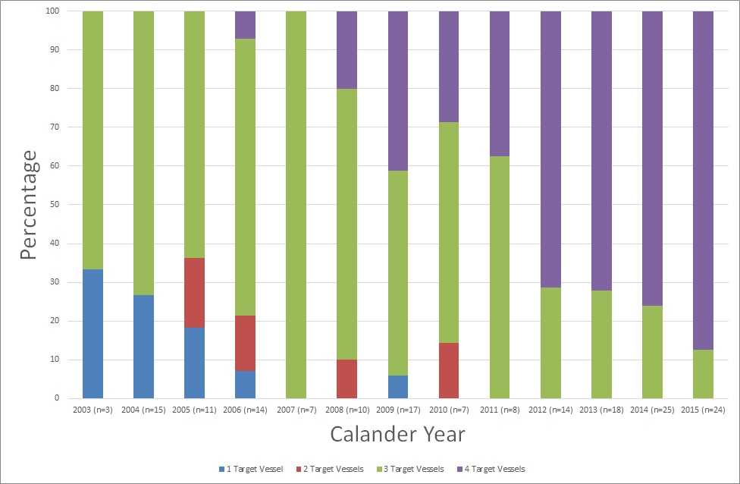

FIGURE 2: Freedom from mortality (all cause) following FEVAR - with 95% confidence intervals
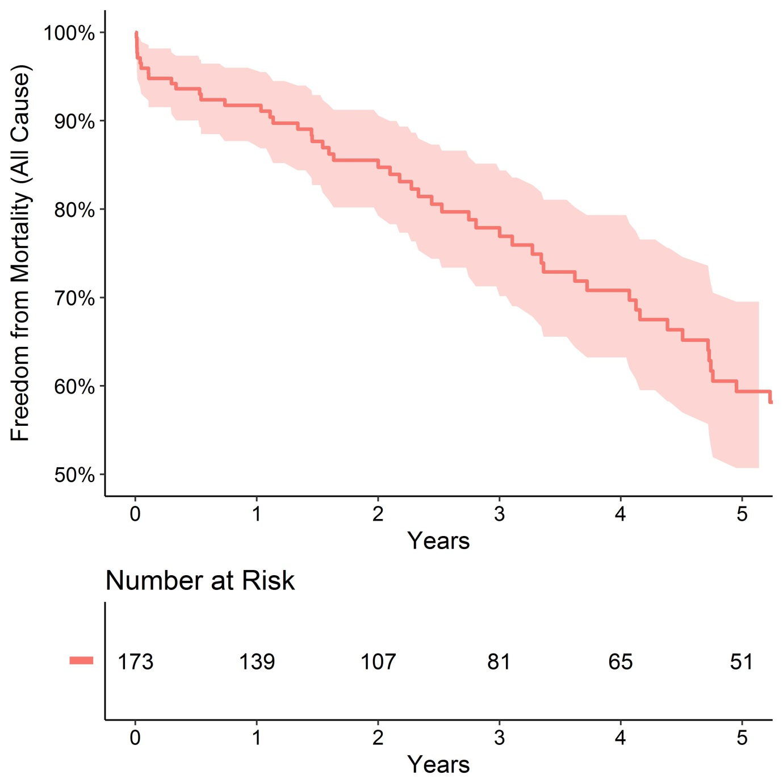

FIGURE 3: Subgroup Freedom from Type I/III Endoleak following FEVAR in a single UK Centre
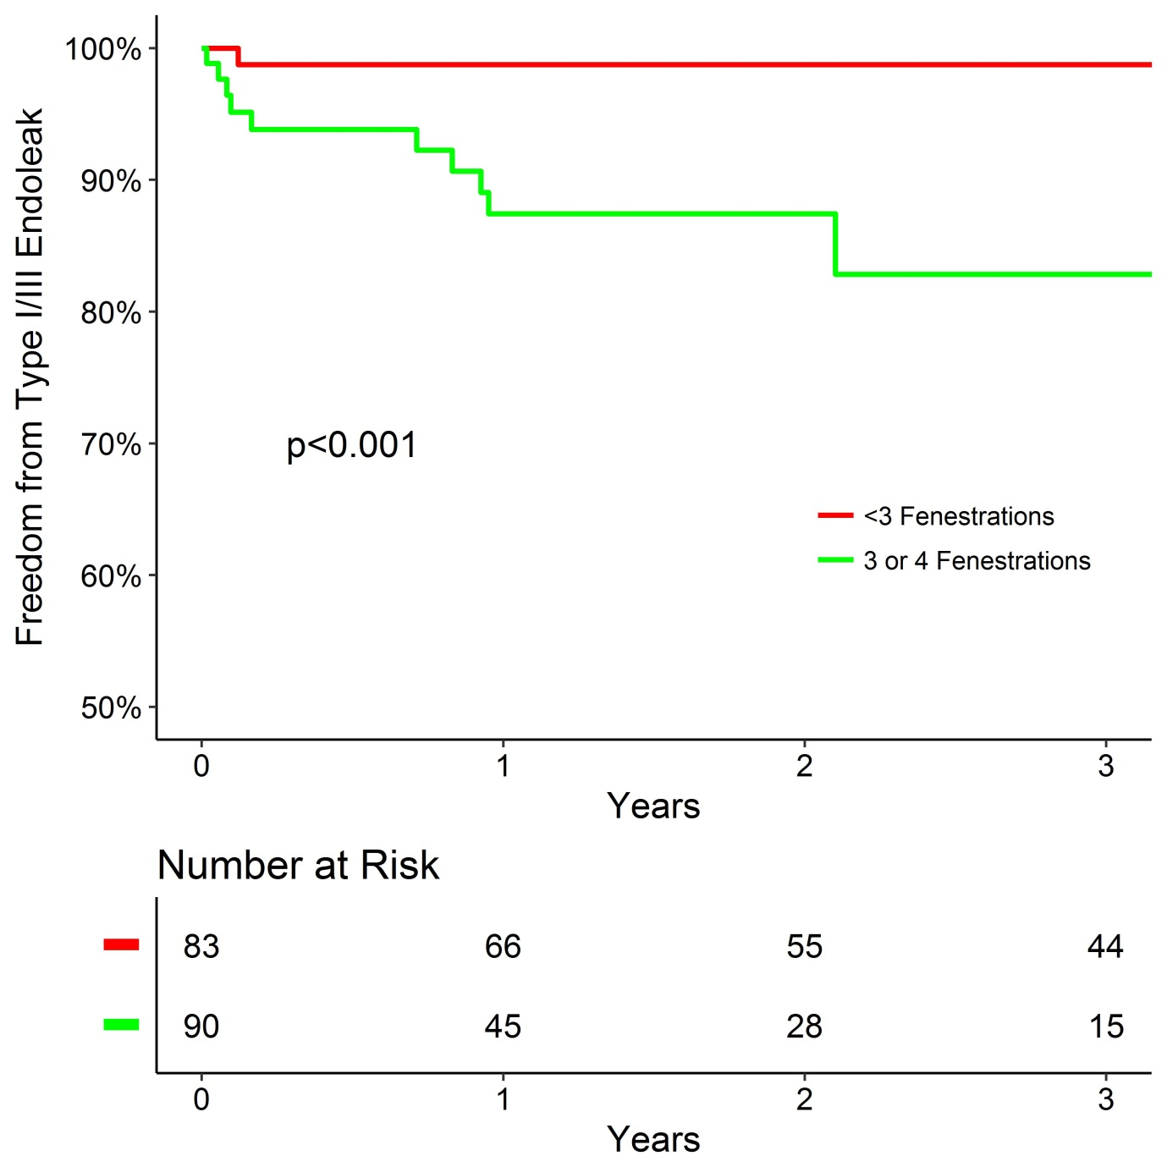

FIGURE 4: Subgroup Freedom from Secondary Intervention following FEVAR in a single UK Centre
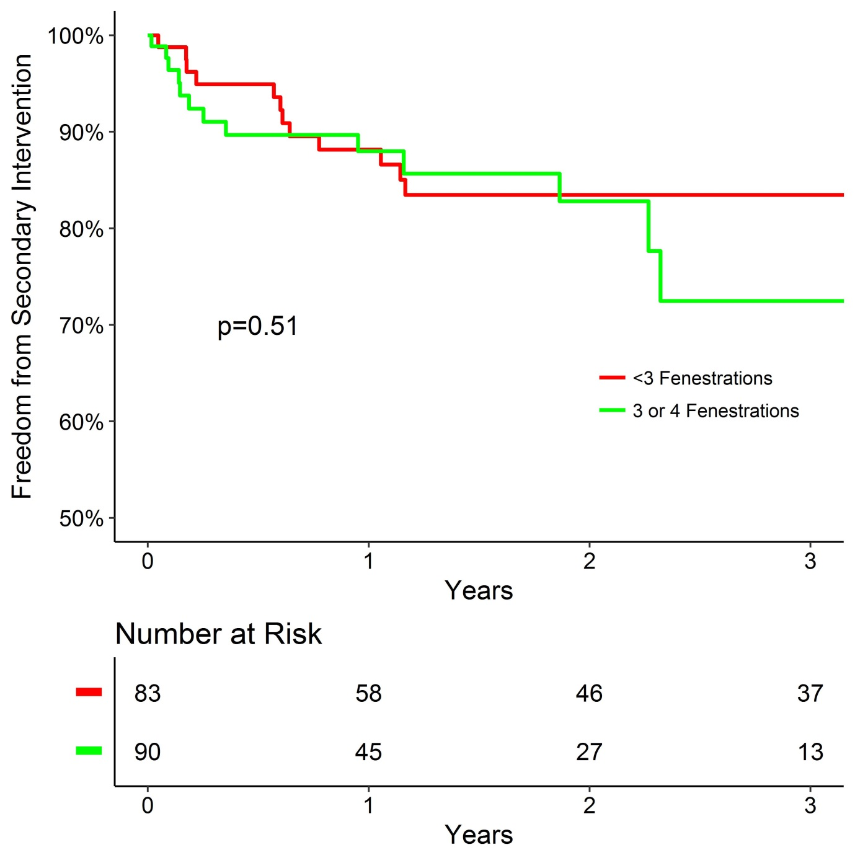

REFERENCES
1. Browne TF, Hartley D, Purchas S, Rosenberg M, Van Schie G and Lawrence-Brown M. A Fenestrated Covered Suprarenal Aortic Stent. European Journal of Vascular and Endovascular Surgery. 18:445-449.
2. Waton S JA, Heikkila K, Cromwell D, Loftus I. . National Vascular Registry: 2015 Annual report. 2015;November 2015.
3. Collaborators G. Early Results of Fenestrated Endovascular Repair of Juxtarenal Aortic Aneurysms in the United Kingdom. Circulation. 2012;125:2707.
4. Kristmundsson T, Sonesson B, Dias N, Törnqvist P, Malina M and Resch T. Outcomes of fenestrated endovascular repair of juxtarenal aortic aneurysm. Journal of Vascular Surgery. 59:115-120.
5. Scurr JR and McWilliams RG. Fenestrated aortic stent grafts. Semin Intervent Radiol. 2007;24:211-20.
6. Chaikof EL, Blankensteijn JD, Harris PL, White GH, Zarins CK, Bernhard VM, Matsumura JS, May J, Veith FJ, Fillinger MF, Rutherford RB, Kent KC and Ad Hoc Committee for Standardized Reporting Practices in Vascular Surgery of The Society for Vascular Surgery/American Association for Vascular S. Reporting standards for endovascular aortic aneurysm repair. J Vasc Surg. 2002;35:1048-60.
7. Boyle JR, Thompson MM, Vallabhaneni SR, Bell RE, Brennan JA, Browne TF, Cheshire NJ, Hinchliffe RJ, Jenkins MP, Loftus IM, Macdonald S, McCarthy MJ, McWilliams RG, Morgan RA, Oshin OA, Pemberton RM, Pillay WR and Sayers RD. Pragmatic minimum reporting standards for endovascular abdominal aortic aneurysm repair. J Endovasc Ther. 2011;18:263-71.
8. Verhoeven EL, Katsargyris A, Oikonomou K, Kouvelos G, Renner H and Ritter W. Fenestrated Endovascular Aortic Aneurysm Repair as a First Line Treatment Option to Treat Short Necked, Juxtarenal, and Suprarenal Aneurysms. Eur J Vasc Endovasc Surg. 2016;51:775-81.
9. Millen AM, Osman K, Antoniou GA, McWilliams RG, Brennan JA and Fisher RK. Outcomes of persistent intraoperative type Ia endoleak after standard endovascular aneurysm repair. J Vasc Surg. 2015;61:1185-91.

Supplementary Material
Supplementary Figure 1: Aneurysm Diameter (mm) by Calendar Year
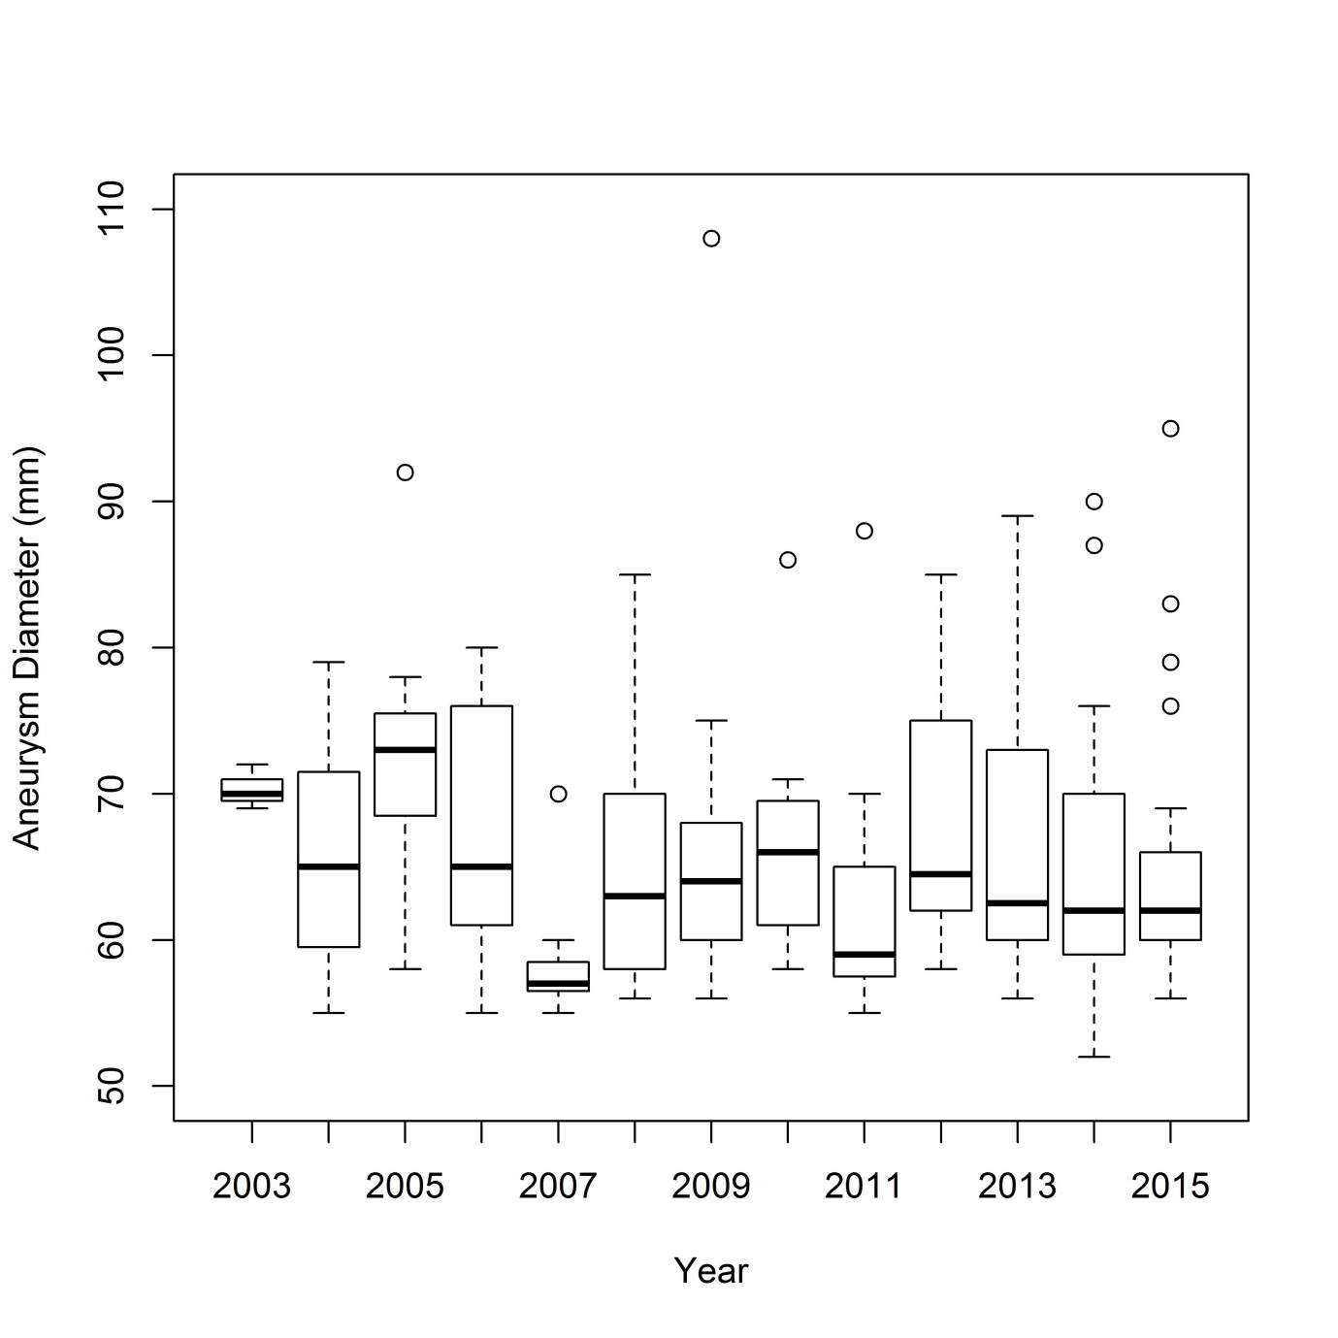

Supplementary Figure 2: Stent-graft D1 Diameter (Neck Diameter) by Calendar Year
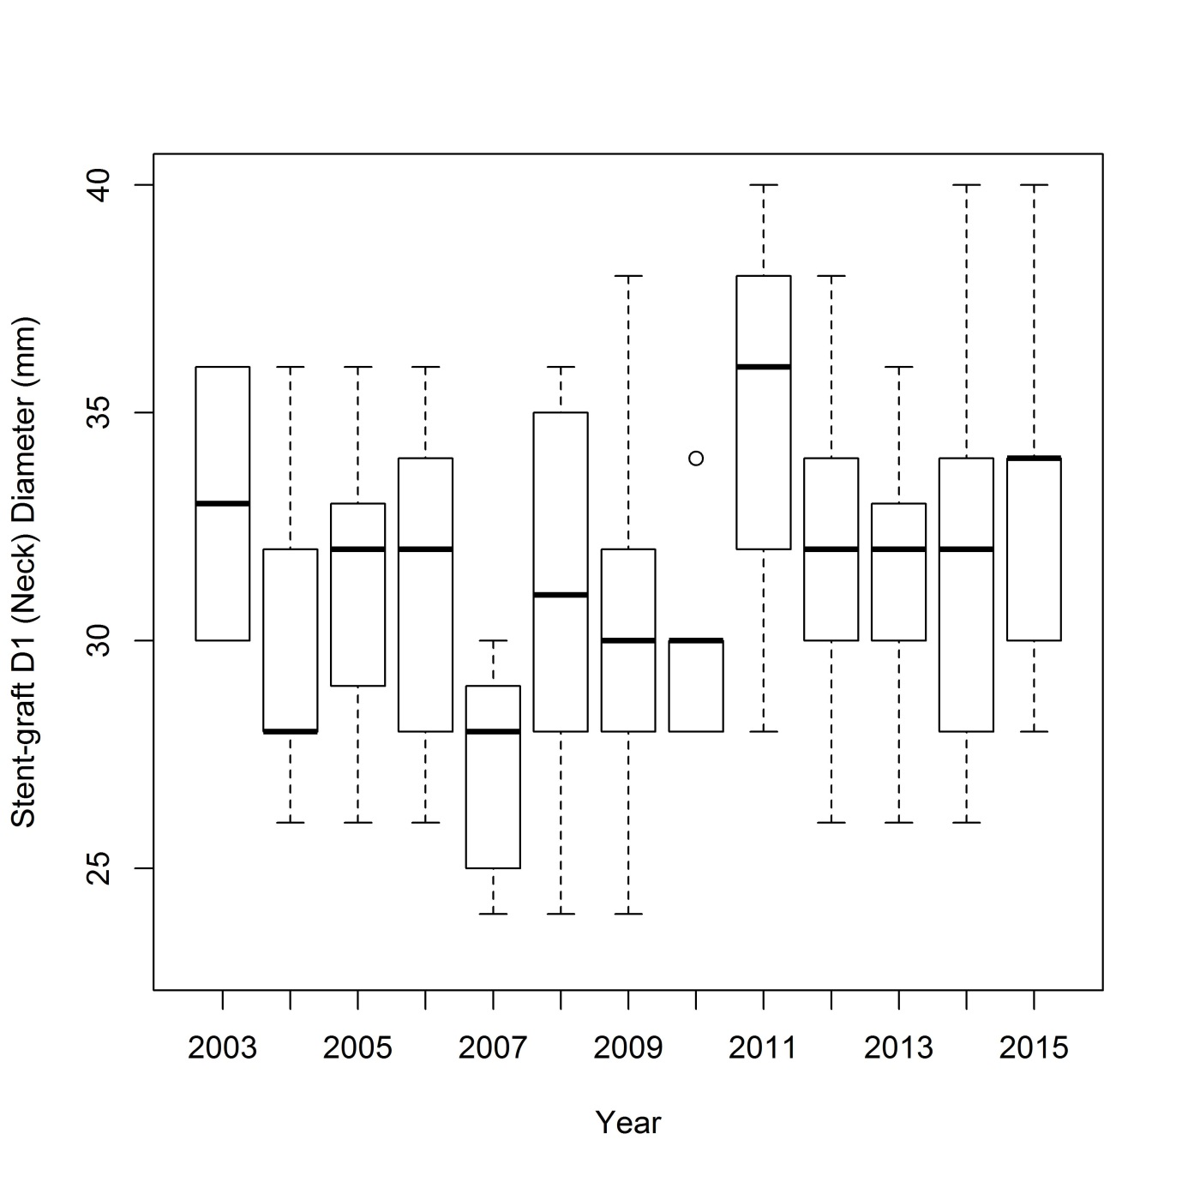

Supplementary Figure 3: Freedom from mortality (all cause) following FEVAR - with 95% confidence intervals
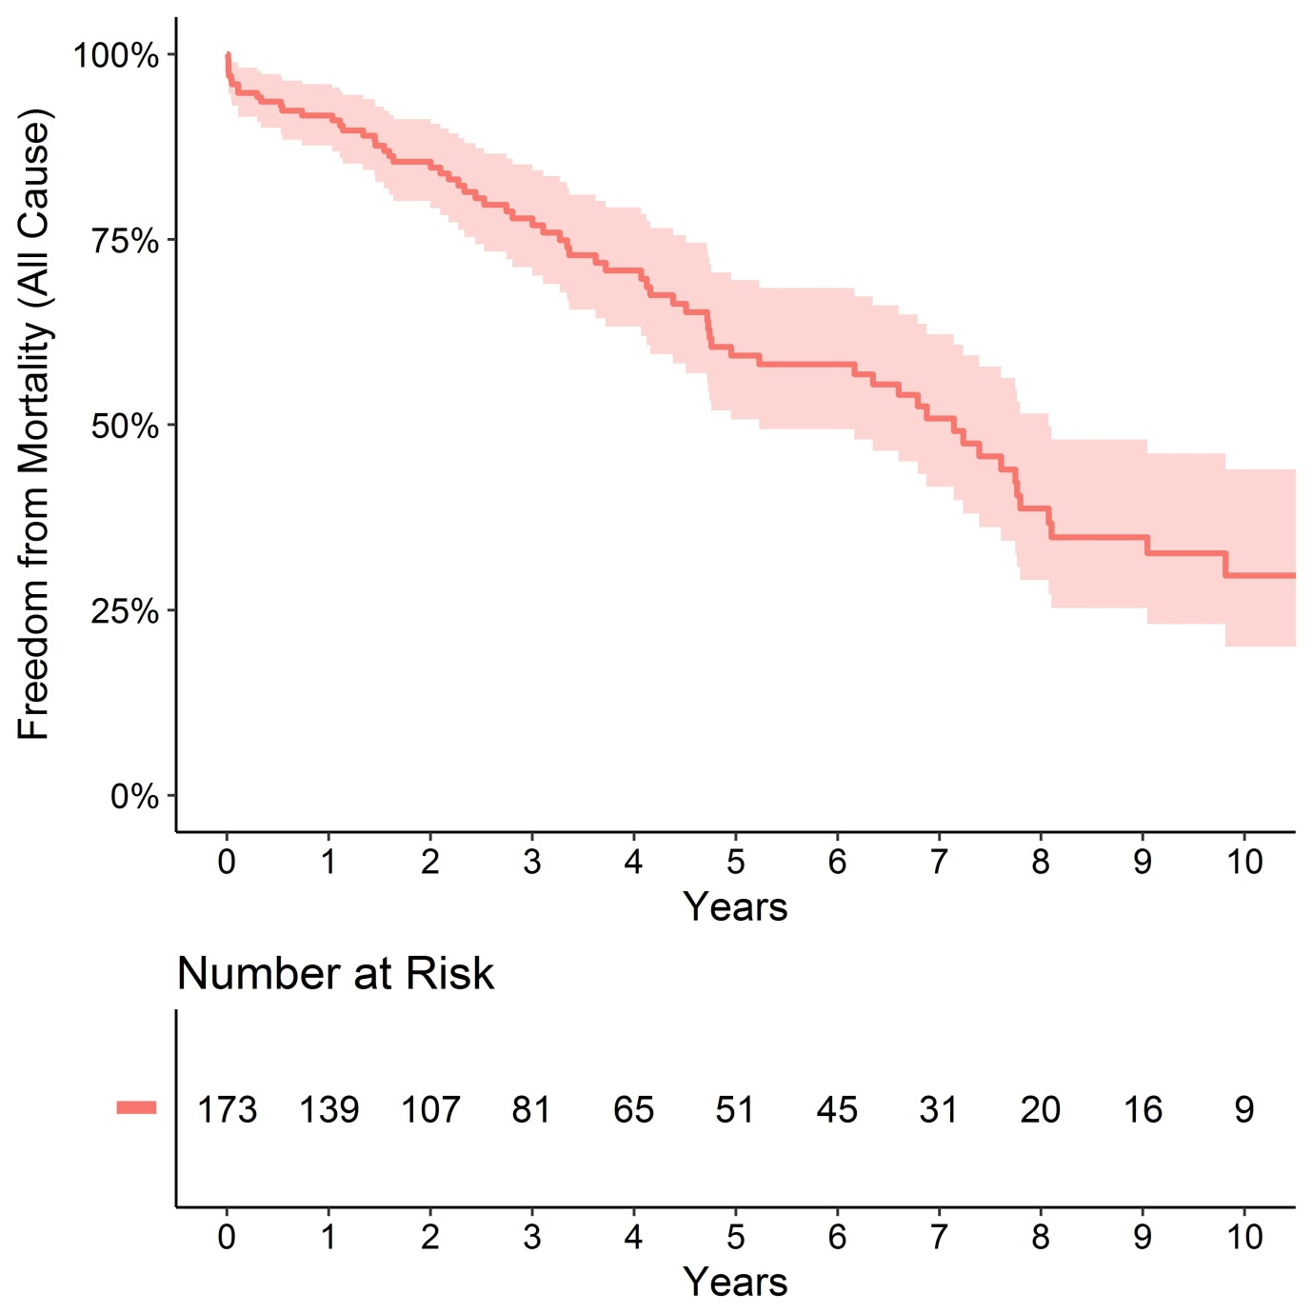

Supplementary Figure 4: Freedom from graft related endoleak following FEVAR - with 95% confidence intervals
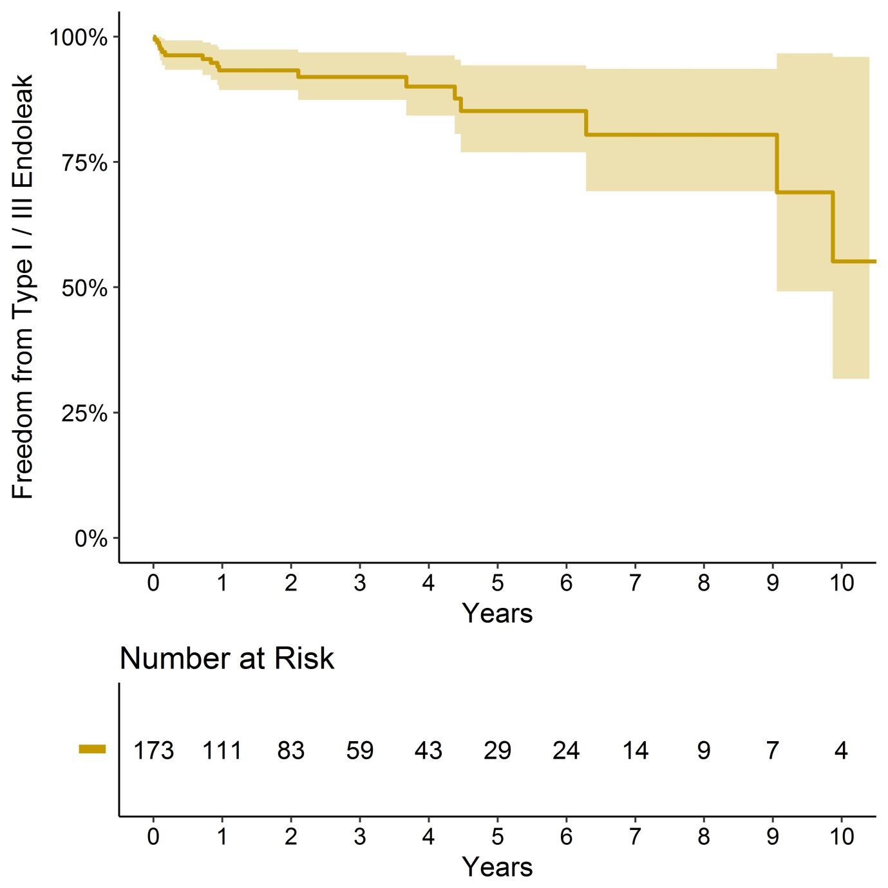

Supplementary Figure 5: Freedom from AAA growth (>5mm) following FEVAR - with 95% confidence intervals
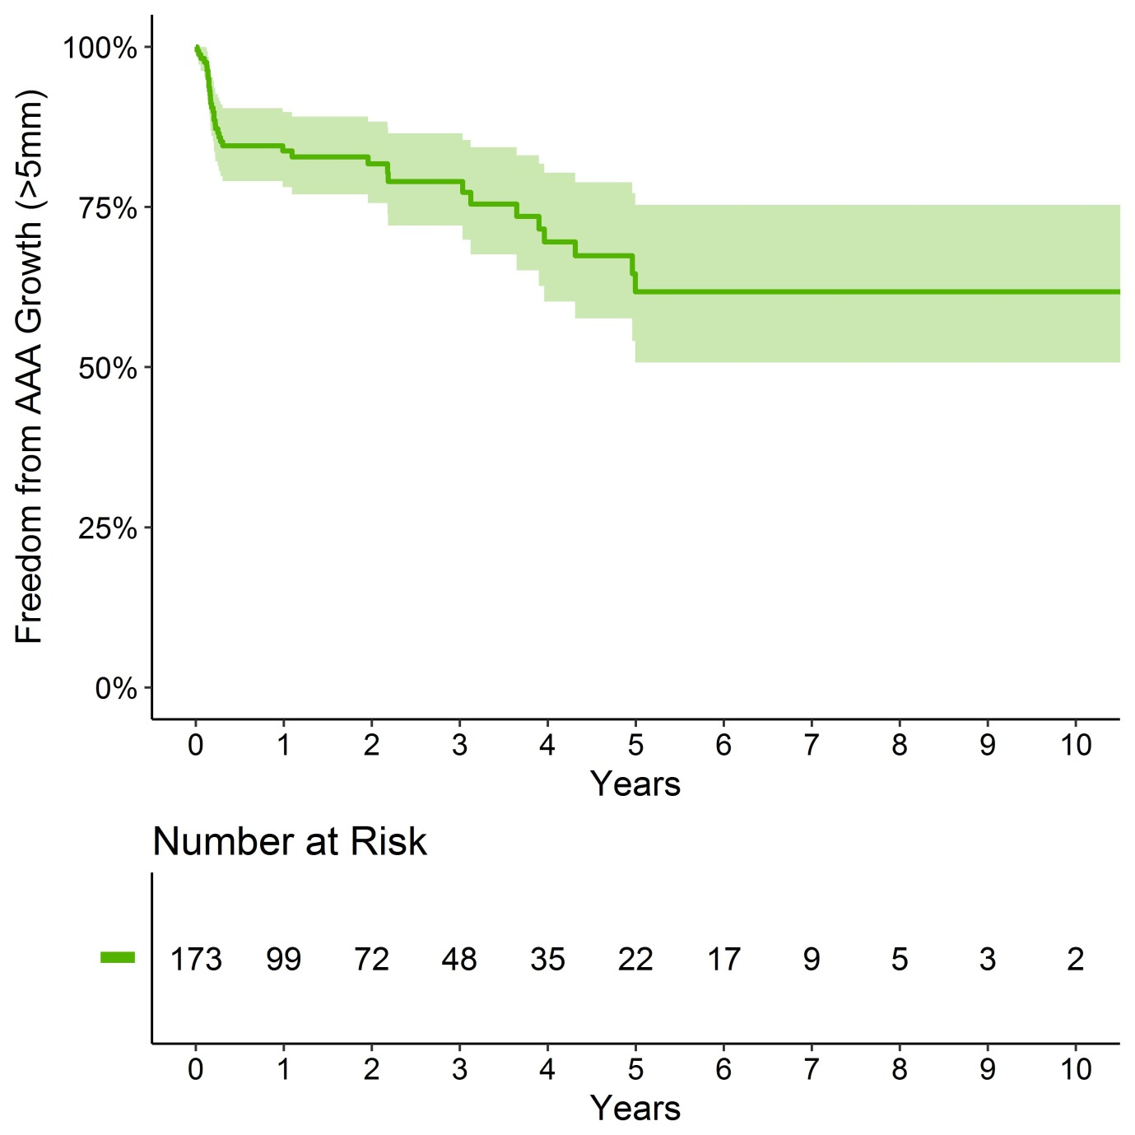

Supplementary Figure 6: Freedom from secondary intervention following FEVAR - with 95% confidence intervals
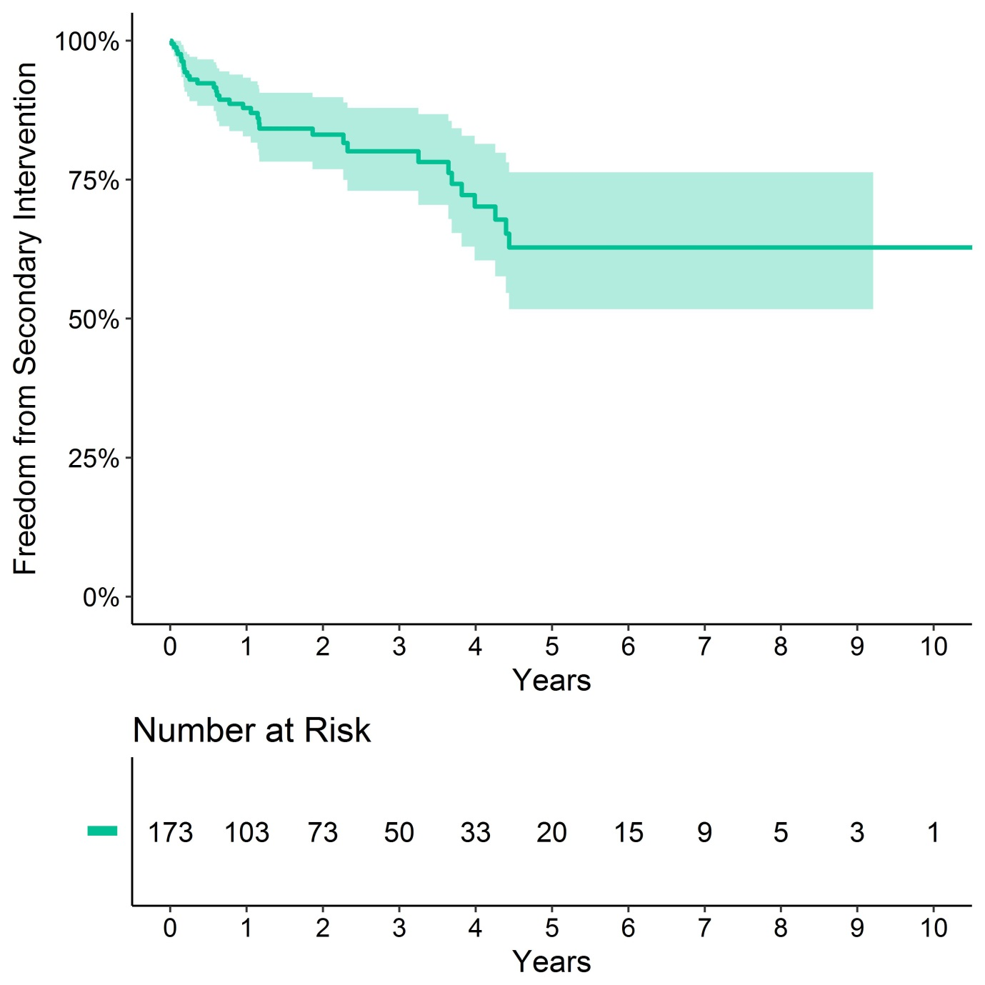

Supplementary Figure 7: Freedom from loss of any target vessel following FEVAR - with 95% confidence intervals
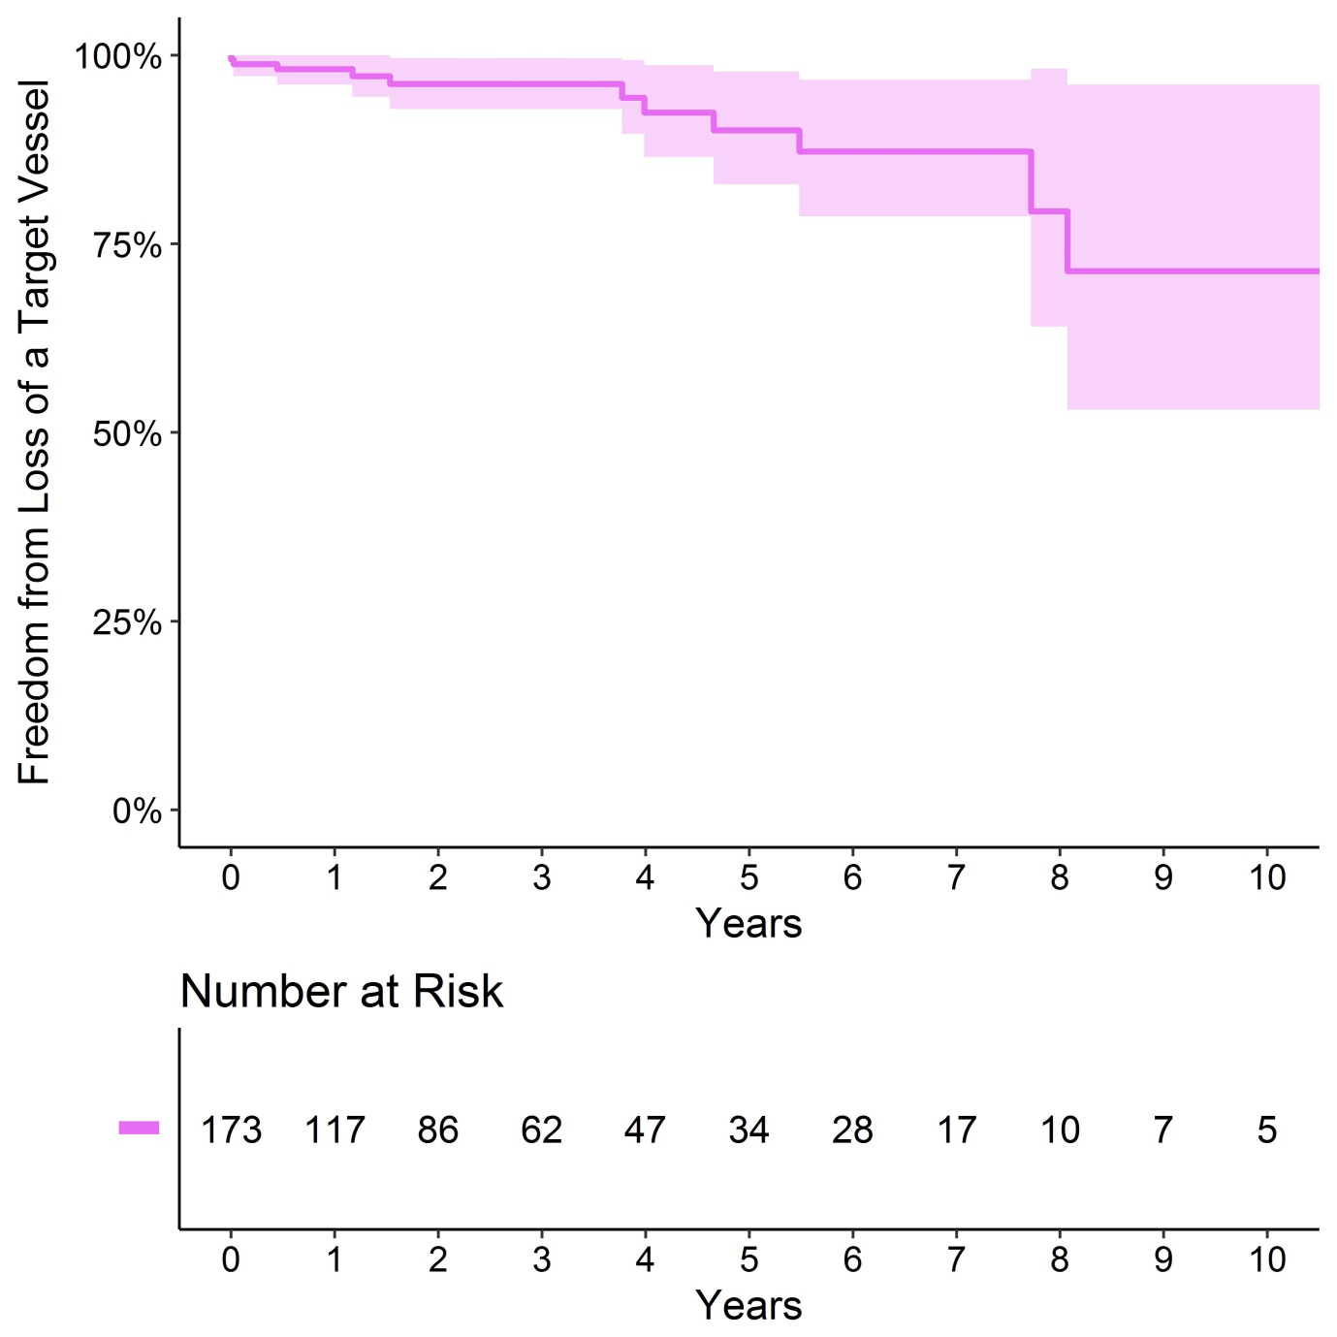

Supplementary Figure 8: Subgroup Freedom from mortality (all cause) following FEVAR in a single UK Centre
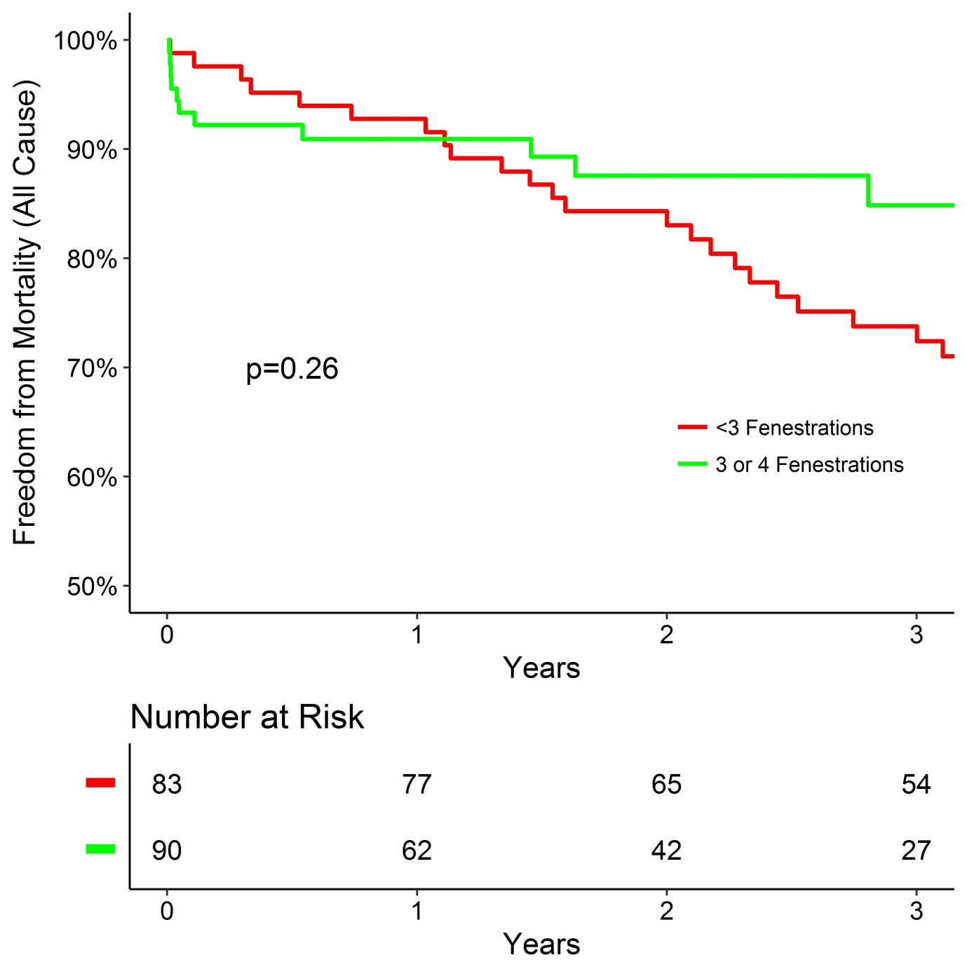

Supplementary Figure 9: Subgroup Freedom from AAA growth >5mm following FEVAR in a single UK Centre
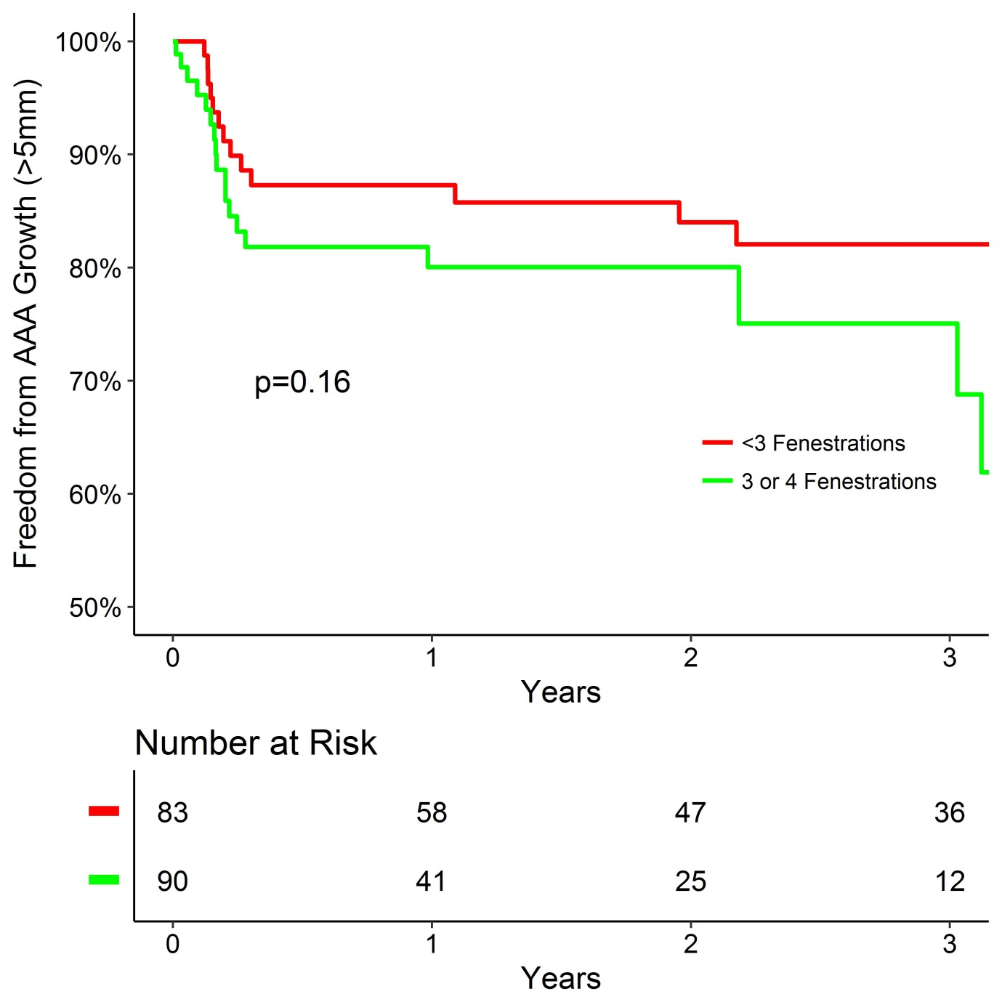

Supplementary Figure 10: Subgroup Freedom from Secondary Intervention following FEVAR in a single UK Centre
