The use of QLF-D (Quantitative Light Induced Fluorescence-Digital) as an oral hygiene evaluation tool to assess plaque accumulation and enamel demineralisation in Orthodontics.

ABSTRACT
Objective: To assess the use of the Quantitative Light-induced Fluorescence-Digital (QLF-D) as an oral hygiene evaluation tool during orthodontics

Materials and Methods: In this prospective, randomised clinical trial, 33 patients undergoing fixed orthodontic appliance treatment were randomly allocated to receiving oral hygiene reinforcement (OHR) at four consecutive appointments using White light (WL) or Quantitative Light-induced Fluorescence (QLF) images, taken with the QLF-D device, as visual aids. Oral hygiene (OH) was recorded assessing the QLF images for demineralisation, by fluorescence loss (ΔF) and plaque coverage (ΔR30). A debriefing questionnaire ascertained the patient perspectives.

Results: There were no significant differences in demineralisation (P=0.56) or plaque accumulation (P=0.82) between the WL and QLF groups from T0 to T4. There was no significant reduction in demineralisation, ΔF, in the WL or the QLF group from T0-T4 (P>0.05), however there was a significant reduction in the ΔR30 plaque scores (P<0.05). All of the participants found being shown the images helpful, with 100% of the QLF group reflecting it would be useful to have OHR for the full duration of treatment compared with 81% of the WL group (OR 2.3; P<0.05).

Conclusion: QLF-D can be used to detect and monitor demineralisation and plaque during orthodontics. OHR at consecutive appointments using WL or QLF images as visual aids is effective in reducing plaque coverage. In terms of clinical benefits, QLF and WL images are of similar effectiveness, however patients preferred the QLF images.

INTRODUCTION
In fixed orthodontics, the brackets and archwires are significant plaque stagnation sites and conventional OH is more difficult. This can lead to demineralisation which may present within 4 weeks of appliance placement.¹ Assessing a patient’s standard of OH at each visit is part of the routine clinical assessment and regular OHR should be given as required. Direct visual assessment is the most commonly used method of assessing plaque with ordinal indices, such as Silness and Loe (1962)², enabling quantification. Similarly, demineralisation is usually assessed by direct vision, which can be criticised as the level of mineral loss sustained before a white mark becomes visible can be advanced.³

A QLF-D device (Inspektor Research Systems BV, Amsterdam, The Netherlands), combines an SLR camera with light sources and filters to produce QLF and WL images (Figure 1). The QLF technique is based on the ability of enamel to autofluoresce when illuminated by visible light.⁴ During demineralisation, minerals are replaced by water resulting in a reduced fluorescence radiance (Figure 2) compared with sound enamel.⁵ QLF has been demonstrated to be a reproducible⁶ and valid technique⁷ with image analysis providing a measure of the mean percentage fluorescence loss of the lesion, ΔF, based on the amount of mineral loss sustained. In vitro^{3,6-7} and in vivo studies^{5,8-9} have demonstrated QLF is an appropriate technique for longitudinal monitoring of demineralisation. Additionally, autofluorescence of bacterial porphyrins enables plaque detection (Figure 3) with a quantitative score, ΔR30, produced relating to the number of pixels covered with red fluorescence. Pretty et al. (2005) demonstrated QLF was a reliable tool for assessing plaque accumulation in vivo.¹⁰

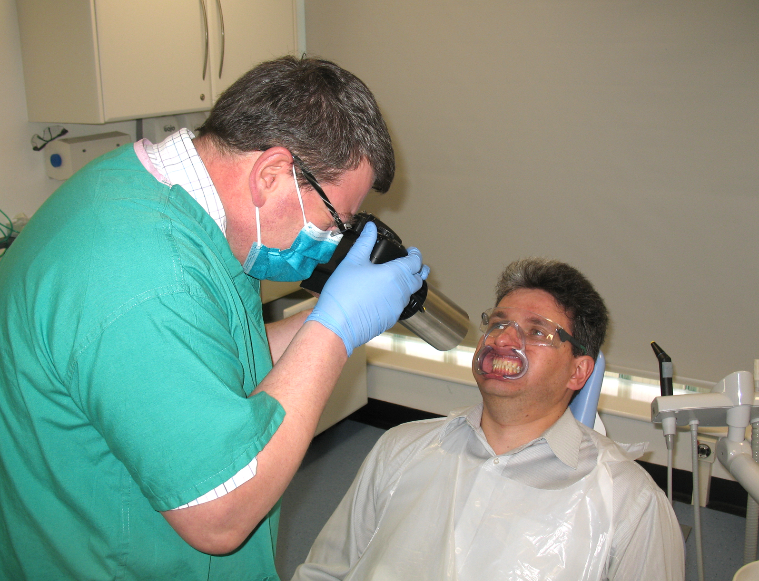

Figure 1: The QLF-D device in use
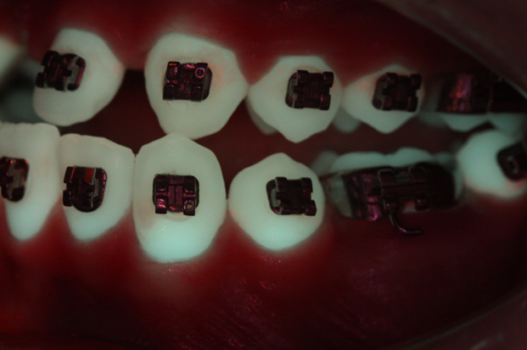
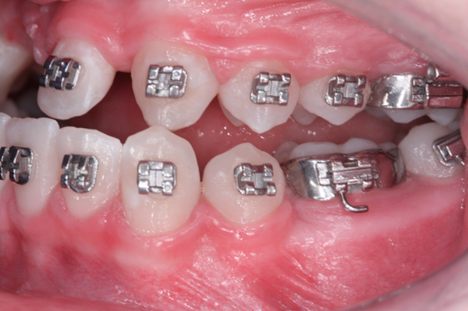

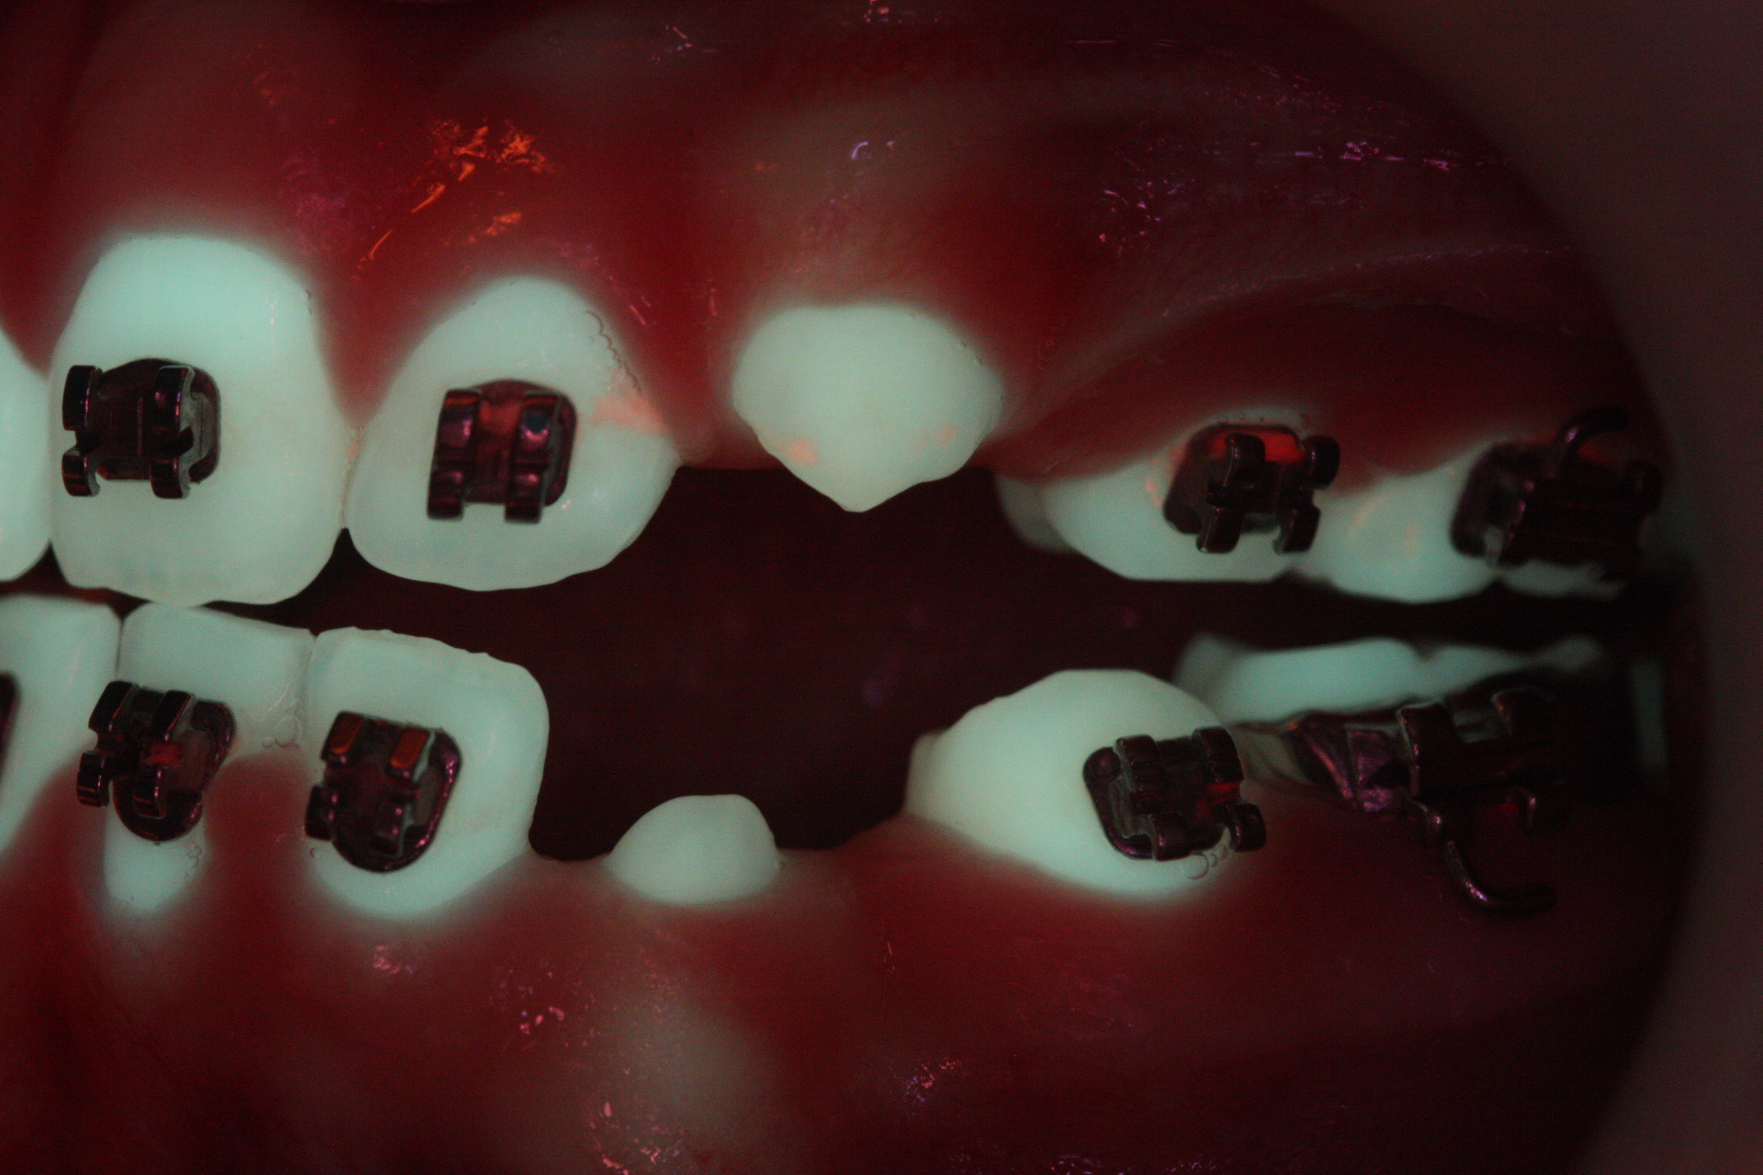
Figure 2: Demineralisation assessment of WL and QLF images
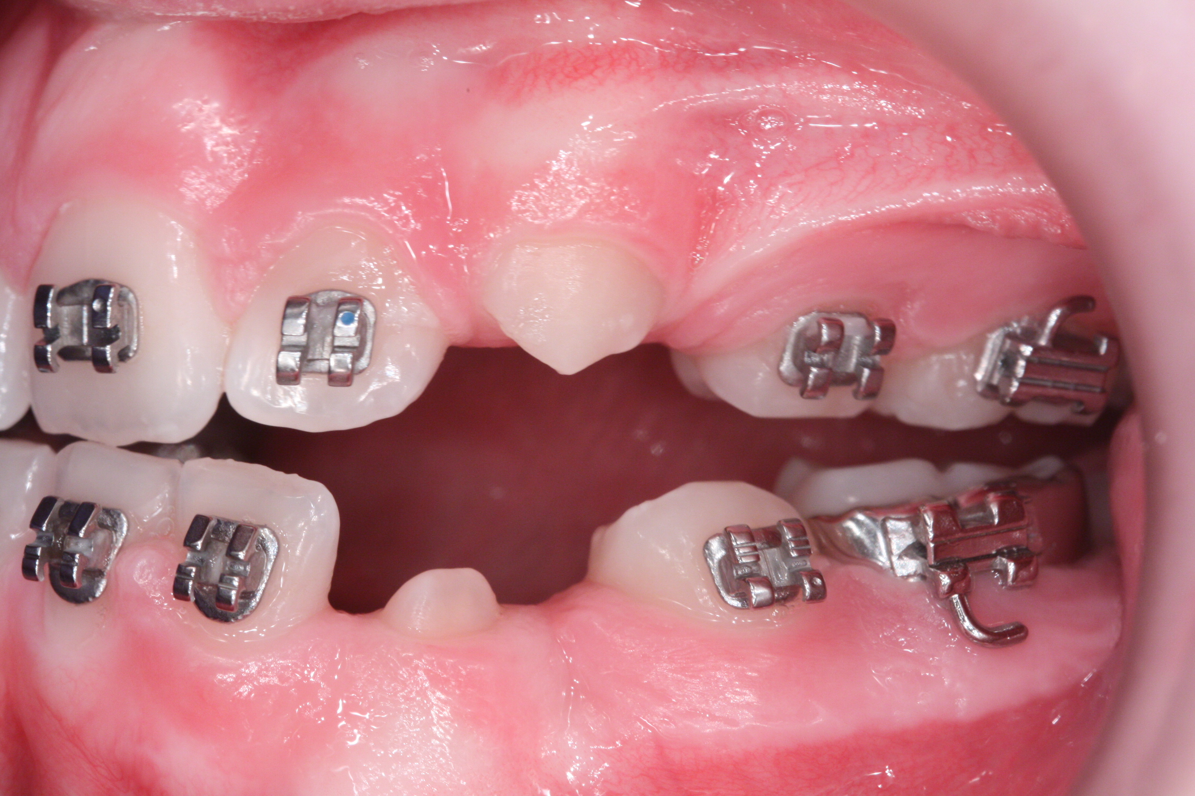
Figure 3: Plaque assessment of WL and QLF images

MATERIALS AND METHODS
The study was a prospective randomised clinical trial with two parallel groups. The setting was the Orthodontic Department, Royal Liverpool University Dental Hospital, Liverpool, United Kingdom. Ethical approval was obtained from the North West Research Ethics Committee- Liverpool Central (REC reference: 13/NW/0005) and the project was registered with the Royal Liverpool and Broadgreen University Hospital Trust Research and Development Department (REF: 4415). The intervention was OHR provided using WL images or the QLF images as visual aids.

There were no previous studies available on which to base a sample size calculation. The study was subsequently conducted as a pilot study and a formal sample size calculation was not carried out. A sample size of 30 was chosen as this would allow estimation of parameters for a sample size calculation to be conducted in future definitive studies.¹¹

Consecutive patients attending Liverpool University Dental Hospital for orthodontic treatment conducted by the same clinician (CCM) were asked to participate. The following inclusion criteria were applied:
- All subjects in good health
- At least 11 years of age
- Undergoing upper and lower fixed appliance treatment

The following exclusion criteria were applied:
- Significant disabilities that may affect manual dexterity and OH practice
- Patients who have had antibiotics in the last two months
- The presence of full coverage restorations
- The presence of visually cavitated lesions

At the baseline assessment (T0), the archwires were removed and the QLF-D device was used to take frontal and buccal images of the maxillary and mandibular dentition when the patient was occluding edge to edge. If required, a prophylaxis was conducted to remove plaque deposits present and the photographs were repeated to allow an assessment of demineralisation. The QLF images were assessed at least a week later for the presence of demineralisation. If there was at least 1 area of demineralisation present, the individual was classed as high risk (HR). If no areas of demineralisation were present, the individual was classed as low risk (LR).

The randomisation process, which was stratified by demineralisation risk, was conducted by an independent statistician. A random number sequence was produced by a computer generated programme. Allocation concealment was with consecutively numbered, sealed opaque envelopes. At the subsequent routine appointment (T1), the next envelope was opened and allocation was made into one of the two parallel groups. All of the patients were treated by one operator (CCM). The first patient enrolled in March 2013 and the last patient completed the study in November 2013.

The standard of OH was reassessed at four consecutive routine appointments (T1-T4), at approximately 6 week intervals. Images were taken and the subjects were given OHR, focussing on the areas of poorer plaque control or where demineralisation was present, using the WL or the QLF images as visual aids. On completion of the study, the participants were given a debriefing questionnaire, which focused on their perception of being shown the images.

Image Analysis
The QLF images were analysed by one clinician (CCM) at least one week later. This interval was based on previous studies, which had employed a similar timeframe between repeated measurements.¹²⁻¹³ A measurement of plaque accumulation on each tooth was graded as ΔR30. For areas of demineralisation, an outline was drawn around each lesion with borders on sound enamel and the mean fluorescence loss (ΔF) was recorded.

Statistical analysis
The data was analysed using SPSS Version 20.0 software. The primary outcome variables were the percentage change in demineralisation (ΔF) and plaque accumulation (ΔR30) from T0-T4. As the outcome was measured at tooth level, but the randomisation was at participant level, multilevel linear regression was used for the analysis to control for the clustering of teeth within participants.

RESULTS
A total of 33 patients were recruited. Figure 4 highlights the flow of patients through the trial. The patients were randomly allocated to the WL or QLF groups stratified on the presence of demineralisation at T0. This resulted in 16 being allocated to the WL group and 17 to the QLF group.

Assessed for eligibility (N=33)
Excluded (n=0)
Randomised and stratified (n=33)
High Risk (n=17) Low risk (n=16)

Allocated to QLF Light group (n=17)
(High risk n=10, low risk=7)
Received intervention (n=17)
Did not receive allocated intervention (n=0)
Allocated to White Light group (n=16)
(High risk n=7, low risk n=9)
Received intervention (n=16)
Did not receive allocated intervention (n=0)

Lost to follow-up (n=0)
Discontinued intervention (n=0)
Lost to follow-up (n=0)
Discontinued intervention (n=0)

Analysed (n=16)
Analysed (n=17)

Figure 4: Flow of participants through the study

Baseline data
There were 21 females and 12 males recruited into the study (Table 1). The median age of the sample was 14.6 years (minimum 11.0yrs; maximum 37.4yrs). There were no differences between the groups at baseline for gender (P=0.90, chi-squared test) and age (P=0.42, Mann-Whitney U-test). The overall mean number of teeth assessed per participant was 18 (SD 3.1) with no differences between two groups (P=0.43, t-test).

 | WL group | QLF group | All
Participants | n=16 | n=17 | N=33
Age (yrs)
Median (IQR) | 14.5 (2) | 15.7 (4.9) | 14.6 (3.5)
Gender
Female | 10 | 11 | 21
Male | 6 | 6 | 12

Table 1: Baseline characteristics of the participants

Demineralisation
The mean percentage change in ΔF from T0-T4 was -21.8% and -13.3% in the QLF and WL groups respectively (Table 2) with wide 95% confidence intervals (P>0.05). The test of the fixed effect of the intervention showed no difference between the QLF and WL groups (P=0.56).

 | White light group | QLF group
Mean | -13.3% | -21.8%
95% Confidence Interval | 10.8% to -37.4% | 1.8% to -45.4%
SE | 10.6 | 9.1

Table 2: Adjusted mean percentage change in ΔF from T0-T4

The outcome measure percentage change in ΔF, could only be used to assess the high risk individuals as those stratified as low risk had no detectable demineralisation at baseline. To account for this an analysis was undertaken at a participant level to include all individuals. Assessing the total number of lesions present (Figure 5), in the HR group, four participants had less lesions and seven participants had a greater number. In the LR group, one participant developed a lesion and the remaining 15 individuals did not develop any lesions. There was a significant difference between the HR and LR groups (P=0.001, chi-square test), which confirmed the need for the randomisation process to have been stratified on the baseline demineralisation risk. Overall, there was no difference in change of lesions present between all of the QLF and WL participants (P=0.39, chi-square test). Additionally, the subgroup analysis by stratification showed no differences (HR-QLF v HR-WL, P=0.84; LR-QLF v LR-WL, P=0.44, chi-square test).

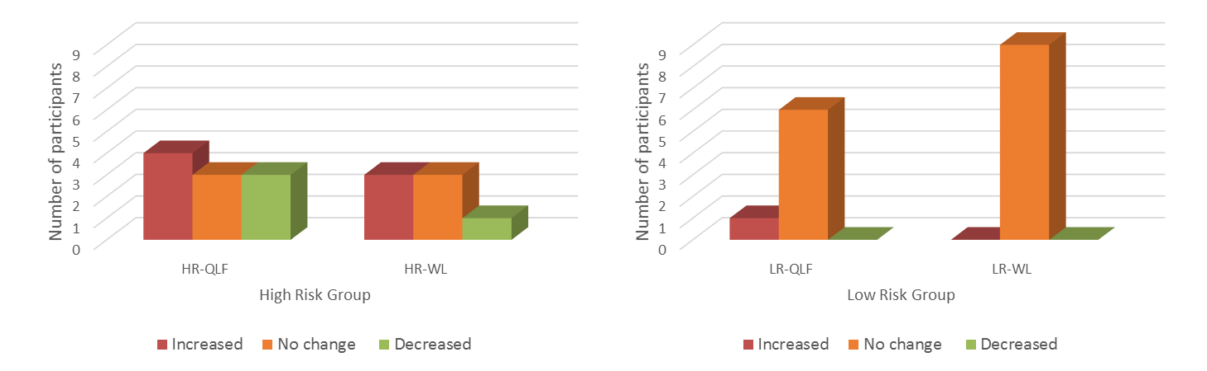

Figure 5: Participant level change in the number of demineralisation lesions from T0 to T4.

Plaque accumulation
The mean percentage change in ΔR30 was -51.0 and -47.3 in the QLF and WL groups respectively (Table 3). The confidence intervals indicate that the mean reductions noted were significantly lower in both groups at T4 than at T0 (P<0.05). The type 3 test of the fixed effect of the intervention indicated there was no difference between the groups (P=0.82).

 | White light group | QLF group
Mean | -47.3% | -51.0%
95% Confidence Interval | -24.3% to -70.3% | -28.3% to -73.8%
SE | 11.2 | 11.1

Table 3: Adjusted mean percentage change in ΔR30

Patient Perspective
The debriefing questionnaire (Table 4) demonstrated the patients were very positive about being shown the images. All of the participants found being shown the images helpful (100%). Interestingly, significantly more participants allocated to the QLF group thought it would be useful to be given the OHR for the whole duration of treatment with an OR of 2.3 (95% CI: 1.5-3.5, P<0.05).

 | WL group | QLF group
Number of participants | 16 | 17
Reported having problems with the photographs | 0% | 0%
Reported the photographs were helpful | 100% | 100%
Reported tooth-brushing improved | 100% | 100%
Reported able to see food accumulation | 100% | 100%
Reported able to see tooth damage | 100% | 100%
Reported it would be useful to be shown images for the whole duration of treatment | 81% | 100%

Table 4: Patient perspectives of OHR

DISCUSSION
This study assessed the QLF-D device as an OH evaluation tool. There was no improvement in demineralisation in both the WL and QLF groups. Additionally, there was no difference between the WL and QLF groups in change in ΔF at a tooth level or in the number of lesions present at a participant level. It is possible that demineralisation present at T0 may have been irreversible with limited potential for improvement, leading to any intervention having minimal effect. Mattousch et al. (2007) conducted a prospective longitudinal study using QLF-D on 51 patients who had completed fixed orthodontic treatment.¹⁴ The median ΔF of lesions at debond was 8.5. Overall, 39% of lesions showed an improvement in the two year period assessed. There was a significant improvement in ΔF within the first 6 months, however no further improvement was achieved after this. This suggests that lesions with median ΔF 8.5 have a potential for improvement, particularly immediately following debond. In this study, the baseline median ΔF was 8.7, indicating similar findings may have been accomplishable. However, as the participants were undergoing active treatment, there is an increased risk of developing new lesions rather than see any improvements. Julien et al., (2013) assessed pre and post-treatment digital images and found 23.4% of 885 patients developed at least 1 lesion during fixed orthodontic treatment.¹⁵ Thus, the likelihood of gaining improvements in ΔF, as seen in the debond study¹⁴ is limited. Hence, it is important to draw attention to the 21 individuals who did not develop any additional lesions throughout the study. One can speculate that the intervention, which resulted in a statistically significant improvement in plaque levels in both groups, facilitated the prevention of further lesions developing.

Another factor which may have led to the lack of any significant changes being noted in demineralisation, may be that the study was relatively short. An RCT by Eppright et al. (2013), involving the use of a weekly text message being sent to the parents of patients undergoing orthodontic treatment and a control group who did not receive such a text reminder, found no difference in the prevalence of demineralisation between the groups.¹⁶ The authors advised that to accurately assess the development of demineralisation with an intervention, longitudinal monitoring should be undertaken for greater than 6 months. In this study, the participants were assessed over 5 visits (T0-T4), held at 6-8 week intervals. The mean overall length of involvement in the study was 5.4 months (SD 0.5) which may have been insufficient to assess significant differences in the development of new lesions between the treatment arms.

Studies on OHR during orthodontics tend to focus on measures of periodontal health, such as bleeding on probing and plaque indices. A systematic review¹⁷ found oral health promotion during fixed orthodontic treatment led to short term improvements in plaque control and/or gingival health in 4 of the 6 studies. In this study there was statistically significant reduction in ΔR30 from T0-T4 in both groups, highlighting the benefit of the OHR intervention. However, there were no differences noted between the groups. Marini et al. (2014) noted similar findings assessing sixty patients undergoing fixed orthodontic treatment who were randomly allocated to receiving repeated OH instruction and motivational reinforcement at six four-weekly visits or at a single visit.¹⁸ There was a significant reduction in plaque with repeated episodes of OHR, highlighting the importance of active reminder systems.

Many oral health promotion techniques have been proposed during orthodontics, including the use of patients using disclosing agents,¹⁹ the provision of feedback report cards,²⁰ counselling sessions,²¹ reward systems²⁰ and weekly text message reminders.¹⁶ However, the participants’ perspectives of such interventions are infrequently gained. In this study, the participants in both groups expressed positive responses to the OHR technique. A significantly greater number of participants in the QLF group felt it would be useful to have the OHR for the full duration of treatment, suggesting that these images may be considered more useful. Patients often have difficulty localising plaque deposits. The WL images are essentially a direct visual assessment, equivalent to assessing one’s self looking in the mirror, thus if patients struggle to detect the plaque by direct vision, it is understandable how the QLF images, where plaque is demonstrated as bright red areas, may be advantageous.

A potential confounding factor was the variation in OH practice as some of the individuals routinely brushed their teeth in the waiting room prior to the appointment. However, by not standardising this, the study allowed an assessment of every-day OH control. Additionally, the OH products that were used at home were not controlled, which is in contrast to the RCT by Peng et al. (2014), where participants were supplied with toothbrushes and toothpaste for standardisation purposes.²²

An additional limitation was that it was not possible to blind the treating clinician, who provided the OHR and undertook the image analysis. The images were anonymised, however, there is a risk of recall bias. Thus, an appropriate time interval was employed between the images being taken and analysed. There is also a risk of measurement bias as the assessor has to subjectively demarcate the lesion or tooth for QLF analysis. However, strict analytical instructions were abided by and previous studies have demonstrated high levels of intra and inter-examiner agreement.¹²
CONCLUSIONS
- QLF images were equally as effective as WL images as OHR visual aids.
- There was no improvement in demineralisation in either group. However, as the assessment period was during active fixed appliance treatment, the risk of developing demineralisation was ongoing and thus the ability to gain significant improvements may have been limited.
- There was a reduction in plaque coverage in both groups, highlighting the benefit of the regular OHR using the images. Photographic records are frequently taken to monitor the occlusion, it would be beneficial for these to be used to provide personalised OHR.
- More QLF participants felt it would be useful to have OHR for the full duration of treatment. Thus, from a patient perspective, the QLF images may be a more useful aid. It may be advantageous for a QLF-D device to be used instead of a conventional camera, as WL photographs can still be taken, with the additional benefit gained of having access to QLF images.

REFERENCES
- Ogaard B, ten Bosch JJ. Regression of white spot enamel lesions. A new optical method for quantitative longitudinal evaluation in vivo. Am J Orthod Dentofac Orthop 1994; 106(3): 238-242.
- Silness P, Loe H. Periodontal disease in pregnancy. Acta Odontol Scand 1962; 22: 121-135.
- Pretty IA, Pender N, Edgar WM, Higham SM. The in vitro detection of early enamel de- and re-mineralization adjacent to bonded orthodontic cleats using quantitative light-induced fluorescence. Eur J Orthod 2003; 25: 217-223.
- de Josselin de Jong EF, Sundstrom F, Westerling H, Tranaeus S, ten Bosch JJ. A new method for in vivo quantification of changes in initial enamel caries with laser fluorescence. Caries Res 1995; 29: 2-7.
- Al-Khateeb S, Forsberg CM, de Josselin de Jong E, Angmar-Mansson B. A longitudinal laser fluorescence study of white spot lesions in orthodontic patients. Am J Orthod Dentofacial Orthop 1998; 113: 595-602.
- Benson PE, Pender N, Higham SM. Quantifying enamel demineralization from teeth with orthodontic brackets- a comparison of two methods. Part 1: repeatability and agreement. Eur J Orthod 2003a; 25: 149-158.
- Benson PE, Pender N, Higham SM. Quantifying enamel demineralization from teeth with orthodontic brackets- a comparison of two methods. Part 2: validity. Eur J Orthod 2003b; 25: 159-165.
- Van der Veen MH, Mattousch T, Boersma JG. Longitudinal development of caries lesions after orthodontic treatment evaluated by quantitative light-induced fluorescence. Am J Orthod Dentofacial Orthop 2007; 131: 223-228.
- Al Maaitah EF, Adeyemi AA, Higham SM, Pender N, Harrison JE. Factors affecting demineralization during orthodontic treatment: A post-hoc analysis of RCT recruits. Am J Orthod Dentofacial Orthop 2011; 139: 181-191.
- Pretty IA, Edgar WM, Smith PW, Higham SM. Quantification of dental plaque in the research environment. J Dentistry 2005; 33: 193-207.
- Browne RH. On the use of a pilot sample for sample size determination. Statistics in Medicine 1995; 14: 1933-1940.
- Pretty IA, Hall AF, Smith PW, Edgar WM, Higham SM. The intra- and inter- examiner reliability of quantitative light-induced fluorescence (QLF) analyses. Br Dent J 2002; 193: 105-109.
- Huang GJ, Roloff-Chiang B, Mills BE, Shalchi S, Spiekerman C, Korpak AM, Starrett JL, Greenlee GM, Drangsholt RJ, Matunas JC 2013.Effectiveness of MI Paste Plus and PreviDent fluoride varnish for treatment of white spot lesions: A randomized controlled trial. Am J Orthod Dentofacial Orthop 143(1): 31-41.
- Mattousch TJH, van der Veen MH, Zentner A. Caries lesions after orthodontic treatment followed by quantitative light-induced fluorescence: a 2-year follow-up. Eur J Orthod 2007; 29: 294-298.
- Julien KC, Buschang PH, Campbell PM. Prevalence of white spot lesion formation during orthodontic treatment. Angle Orthod 2013; 83 (4): 641-647.
- Eppright M, Shroff B, Best AM, Barcoma E, Lindauer SJ. Influence of active reminders on oral hygiene compliance in orthodontic patients. Angle Orthod 2014; 84(2): 208-213.
- Gray D and McIntyre G. Does oral health promotion influence the oral hygiene and gingival health of patients undergoing fixed appliance orthodontic treatment? A systemic literature review. J Orthod 2008; 35: 262-269.
- Marini I, Bortolotti F, Parenti SI, Gatto MR, Bonetti GA 2014. Combined effects of repeated oral hygiene motivation and type of toothbrush on orthodontic patients: A blind randomized clinical trial. Angle Orthod 2014; 84(5): 896-901.
- Boyd RL. Longitudinal evaluation of a system for self-monitoring plaque control effectiveness in orthodontic patients. J Clinical Periodontology 1983: 10: 380-388.
- Richter DD, Nanda RS, Sinha PK, Smith DW. Effect of behaviour modification on patient compliance in orthodontics. Angle Orthod 1998; 68 (2):123-132.
- Lalic M, Aleksic E, Gajic M, Milic J, Malesevic D. Does oral health counselling effectively improve oral hygiene of orthodontic patients. Eur J Paediatr Dent 2012; 13 (3); 181-186.
- Peng Y, Wu R, Qu W, Wu W, Chen J, Fang J, Chen Y, Farella M, Mei L. Effect of visual method vs plaque disclosure in enhancing oral hygiene in adolescents and young adults: a single-blind randomized controlled trial. Am J Orthod Dentofacial Orthop 2014; 145 (3): 280-286.

