Received 00th January 20xx,
- Department of Chemistry, University of Liverpool, Crown Street, Liverpool L69 7ZD, UK. E-mail: srannard@liv.ac.uk.
^{b}KTH Royal Institute of Technology, School of Chemical Engineering, Department of
Fibre and Polymer Technology, Teknikringen 56-58, SE-100 44 Stockholm, Sweden†
Electronic Supplementary Information (ESI) available: Materials, experimental
procedures and characterization data with assignments. See DOI: 10.1039/ x0xx00000x
Accepted 00th January 20xx
DOI: 10.1039/x0xx00000x
www.rsc.org/
Model studies of the sequential and simultaneous statistical modification of dendritic functional groups and their implications within complex polymer architecture synthesis.
Faye Y. Hern,ª Sam E. R. Auty,ª Oliver C. J. Andrén,^{b} Michael Malkoch^{b} and Steve P. Rannardª
Post-synthesis modification of polymers is a synthetically appealing approach to generate a range of samples from a single, well-characterised starting material. When partial or mixed-functionalisation is sought, an inevitable statistical distribution of modification outcomes will lead to considerable variation of chemical structures within the final sample. Here we have comprehensively investigated the post-synthesis sequential/partial and simultaneous mixed modification of xanthate-functional ideal dendrons and used this data to consider the implications for the more complex linear-dendritic hybrids and hyperbranched-polydendron analogues. Although ¹H NMR confirmed the potential to direct the reactions, it was clear from MALDI-TOF studies that very little of the actual targeted structures were generated in the statistical reactions.
Introduction
Multivalent interactions within solution and at interfaces have been of considerable interest for many years, as they are known to govern and control biological events such as the binding of small molecules and proteins;¹ the processes involved in viral infections² and the recognition of xenobiotics by the immune system.³ Many such natural systems take advantage of the simultaneous binding of multiple ligands and receptors with differing chemistry rather than relying on a single chemistry to undertake multiple tasks.⁴ Enhanced binding through multiple interactions has been utilised in the design of a range of biologically-functional synthetic materials. For example, the dendritic microbicide VivaGelTM was designed to utilise terminal functionality derived from 1-(carboxymethoxy)-naphthalene-3,6-disulfonates to target high strength binding to gp-120 proteins situated at the surface of the human immunodeficiency virus as an infection prophylaxis strategy.⁵
The pendant functionality of linear polymers has also been shown to exhibit considerable non-linear binding to surfaces with increasing surface functional group density, despite the flexibility of the backbone and the random coiling of chains in solution.⁶ Dendrimers, possessing a globular shape in solution, and presenting a high density of surface functionality, are well suited to providing spatially-defined and controllable surface chemistry. The size and shape of nanomaterials is also known to impact their fate in vivo; affecting accumulation, residence time and biodistribution.^{7,8} Opsonisation and subsequent recognition of nanomaterials by macrophages has been shown to correlate strongly with size and surface functionality,⁹ whilst biodistribution and pharmacokinetics may be tuned by carefully controlling dendrimer size or synthesising dendritic hybrid materials.^{10,11} There are several strategies that have been employed to generate varying functionality within dendritic polymers including the coupling of different dendrons to form asymmetric structures with differing peripheral chemistry,^{12,13} the formation of ‘Janus’ structures with segmented chemistry around¹⁴ a core,¹⁵ complete peripheral functionalisation with single chemistries to generate total surface-variation¹⁶ and statistical surface functionalisation.¹⁷ Statistical modification of pre-synthesised multifunctional materials is a simple and effective process, but is known to generate a distribution of outcomes as it is difficult to control non-specific and unwanted side reactions, such as degradation of bulk material or undesirable oxidation reactions.¹⁸
To the best of our knowledge, the detailed analysis of the outcomes of statistical modification of dendritic materials, and the implication for heterogeneity within hybrid materials, has not been reported. Dendrimers and linear-dendritic hybrids with surface xanthate functionality have been recently reported and have been shown to undergo facile one-pot deprotection/thiol-acrylate Michael addition reactions;^{19.20} these materials present themselves as ideal candidates for model studies of statistical functional group modification. Here, we have studied the different outcomes of sequential and simultaneous statistical functionalisation strategies to introduce two chemically diverse functional groups to the periphery of model dendrons of different generation, Figure 1. The two strategies have also been evaluated in the statistical introduction of two functional groups to complex polymer architectures with dendritic subunits, that are not so readily analysed in detail, and the implications of the insights derived from the model studies are discussed.

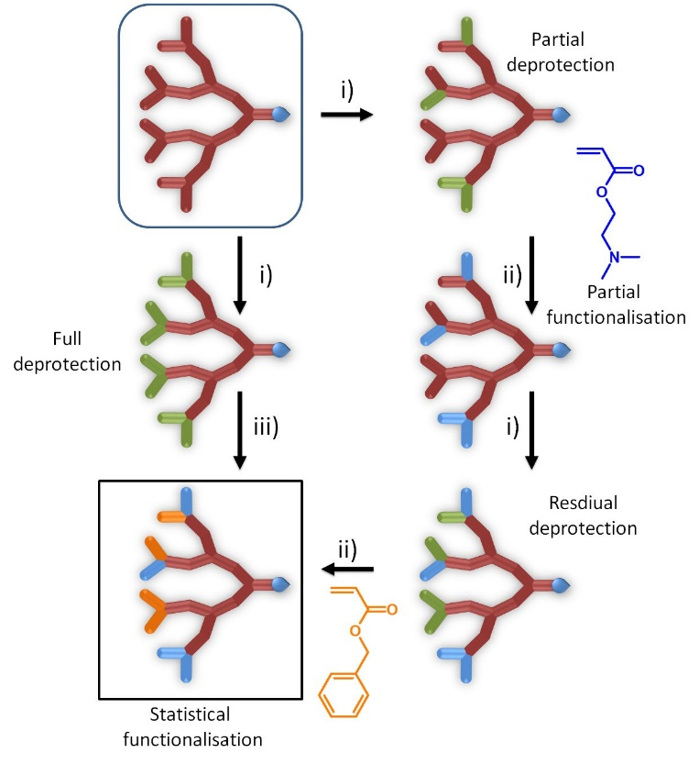
Figure 1. Two strategies for statistical dual-functionalisation of xanthate-functional dendrons: i) deprotection step to form thiol functionality, ii) reaction with single acrylate monomer, iii) reaction with mixed acrylate feedstock.
Results and Discussion
Synthesis of G₁-G₃ xanthate-functional dendrons and atom transfer radical polymerisation (ATRP) initiators
Xanthate functional dendrons (Figure 2) from generation 1 to generation 3 (G₁-G₃) were prepared using literature procedures.^{19,20} In summary, potassium ethyl xanthogenate was reacted with bromoacetic acid, in acetone at ambient temperature, to form a xanthate functional carboxylic acid. This was either reacted directly with G₁ and G₂ hydroxyl functional dendrons, synthesised from bismethylol propionic acid (see Electronic Supporting Information (ESI) Scheme S1), or self-condensed to produce a symmetrical anhydride that was utilised in reactions with G₃ hydroxyl-functional dendrons. In each case, the focal point chemistry was protected with p-toluene sulfonyl ethanol (TSe), yielding dendrons 1-3 (Figure 2; ESI Figures S1-31). Removal of the TSe focal point protecting group generated the acid functional dendrons which were each reacted with 2-hydroxyethyl 2-bromoisobutyrate, synthesised by the reaction of α-bromoisobutyryl bromide with excess ethylene glycol, to form the corresponding ATRP initiators 4-5 (Figure 2; ESI Figures S32-43).
Model studies of sequential and simultaneous xanthate-mediated thiol-mixed acrylate Michael additions using G₁-G₃ xanthate-functional dendrons 1-3.
The focal point protected G₁-G₃ dendrons, 1-3, were used as model materials to compare the outcomes of controlled sequential deprotection/thiol-acrylate Michael additions with those from a single stage simultaneous deprotection/thiol-mixed acrylate Michael addition strategy (Figure 1). We have previously shown that xanthate-functional dendrons may be completely deprotected to yield thiol functional groups using n-butylamine over reaction times as short as 1.5 hours prior to single acrylate addition.¹⁹ The model studies here aimed to determine the potential for either sequential or simultaneous deprotection/functionalisation approaches to more accurately dictate the distribution of functional groups after Michael addition of varying ratios of benzyl acrylate (BzA) and 2-(dimethylamino)ethyl acrylate (DMAEA). These acrylates were selected as they allow ready quantitative spectroscopic analysis and provide suitable mass differences to allow spectrometric assignment of products with varying substitution.
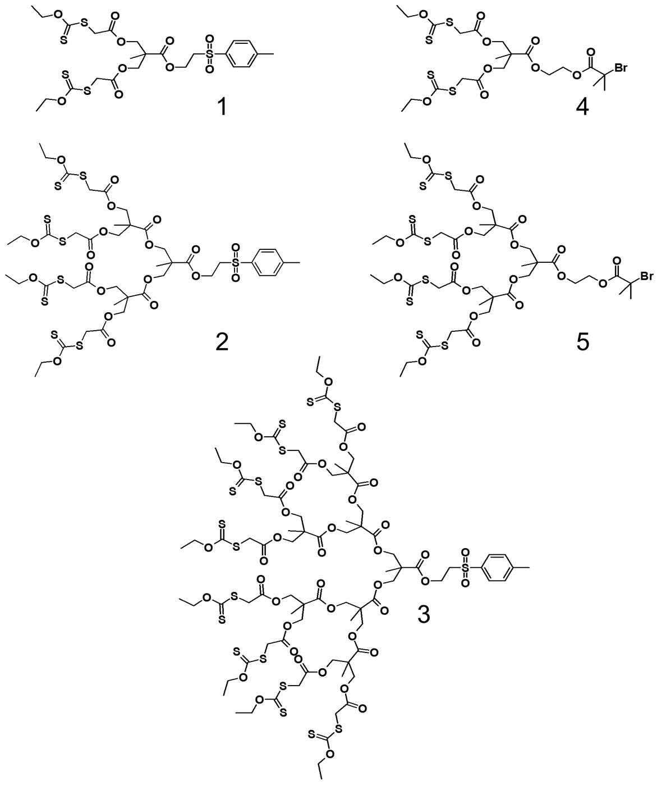
Figure 2. Structures of xanthate-functional dendrons (1, 2 and 3) and xanthate-functional dendron atom transfer radical polymerisation initiators (4 and 5) used during this study
A) Sequential functionalisation – model dendrons 1-3:
The sequential deprotection/functionalisation strategy requires an initial partial deprotection of the available terminal xanthate groups, followed by addition of the first acrylate monomer at a slight molar excess with respect to deprotected thiols; the remaining xanthate groups are subsequently deprotected, followed by addition of a second acrylate (Figure 1; right-hand). To establish potential for this strategy, initial studies monitored the controlled deprotection of the terminal xanthate functional groups of each generation dendron (1-3) via ¹H nuclear magnetic resonance spectroscopy (NMR), by comparison of integrations of the characteristic methylene signal from the terminal ethyl group of the xanthate at approximately 4.60 ppm before and after the addition of n-butylamine.
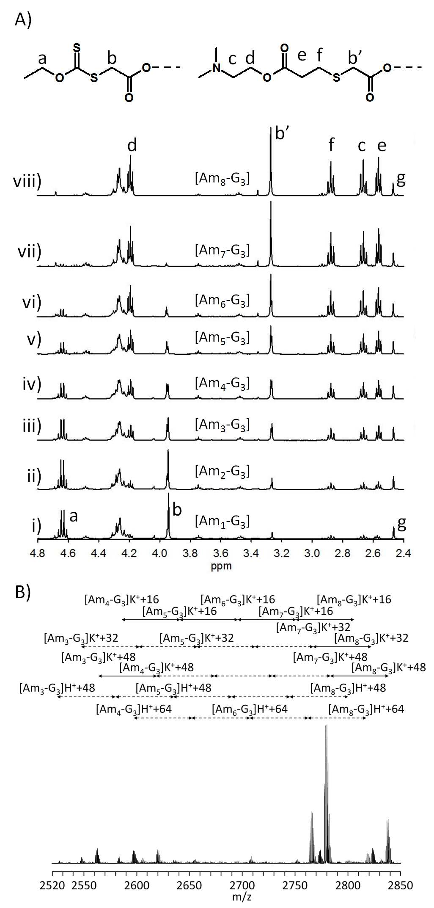
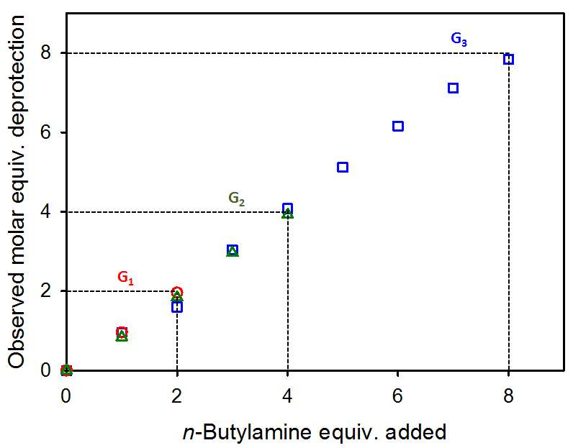
Addition of 1 molar equivalent of n-butylamine per dendron at ambient temperature led to deprotection of 48% of the xanthates within the G₁ dendron, 1, 21% of the xanthates of the G2 dendron, 2, and 12% of the xanthates of the G3 dendron, 3. Within the experimental and expected NMR error,²¹ these figures equate to an average deprotection of 1 xanthate per dendron at each generation. Progressive increases in n-butylamine addition through to 2 molar equivalents for the G₁ dendron, 4 molar equivalents for the G₂ dendron, and 8 molar equivalents for the G₃ dendron led to the linear and controlled average deprotection of xanthate functional groups within each sample, ultimately resulting in complete deprotection of each dendron (Figure 3).
Figure 3. Correlation of the molar addition of n-butylamine to xanthate-functional dendrons of varying generations, and the resultant deprotection of the protected thiol functionality. Deprotection of G1 dendrons (open red circles), G2 dendrons (open green triangles) and G3 dendrons (open blue squares) is shown, yielding a near linear correlation that is independent of dendron generation.
Importantly, the reaction of the xanthates with n-butylamine is statistical and, subsequently, non-uniform; the ¹H NMR-determined correlation shown in Figure 3 represents the averaged value across all dendrons within each sample. Unfortunately, direct analysis of the deprotected products by mass spectroscopic techniques is hampered by the formation of disulphide bonds between the highly thiol-functional structures during sample preparation, as reported earlier.¹⁹ The addition of DMAEA at ambient temperature (1.5 molar equivalents per thiol) to the G₃ dendron 3, after partial and systematic deprotection of one thiol through to eight thiols, allowed the Michael adducts to be formed and facilitated detailed characterisation via ¹H NMR and matrix assisted laser desorption ionisation – time of flight (MALDI-TOF) mass spectrometric analysis (Figure 4). ¹H NMR spectroscopy of the systematically varying G₃ dendron-DMAEA Michael adducts (Figure 4Ai-viii) showed that it was clearly possible to direct an overall molar average functionalisation as required; however, the MALDI-TOF analysis (Figure 4B) also clearly showed that the distribution of structures formed during this process was significantly different to the nominal structures that would be determined by ¹H NMR analysis alone. As described previously, sulphur has over 20 known isotopes of which ³²S, ³³S, ³⁴S and ³⁶S are stable with varying abundance, and sulphur is prone to oxidation during mass spectrometric analysis, making definitive mass spectroscopy difficult;^{19,22} for example, oxidation of thio-ethers will add multiples of 16 Da to the expected mass ion and this may be confused with the difference between sodium and potassium adducts.
Figure 4. Characterisation of the Michael adducts of xanthate-functional G₃ dendrons after controlled, sequential deprotection and reaction with 2-(dimethylamino)ethyl acrylate. A) ¹H NMR analysis of products targeting from 1 to 8 surface amines; B) MALDI-TOF analysis (2-(4'-hydroxybenzeneazo) benzoic acid matrix) of the Michael adduct [Am₆-G₃], targeting the controlled reaction of six 2-(dimethylamino)ethyl acrylate groups whilst retaining two xanthate functionalities. Identifiable peaks are shown as assigned species; double-headed arrows indicate mass differences of 55 Da (dotted arrows indicate missing peaks; solid arrows indicate identified peaks).
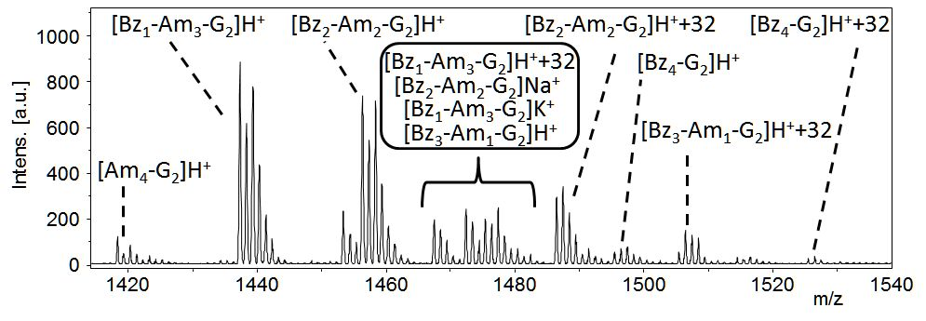
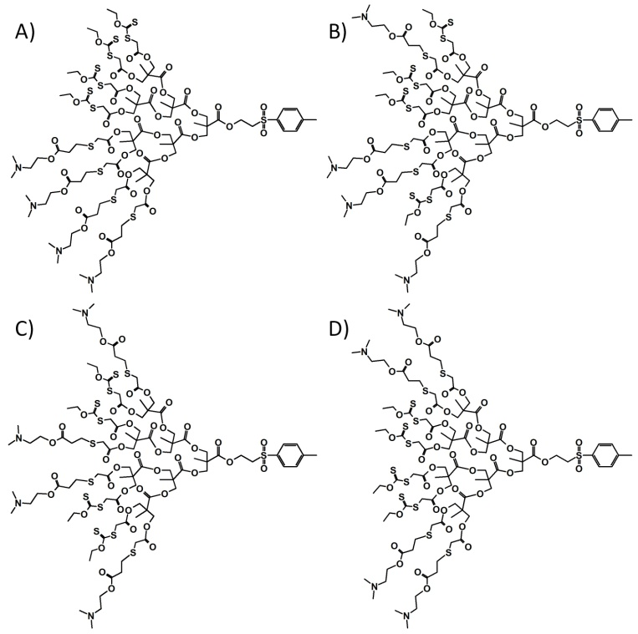
The MALDI-TOF spectrum of the modified G₃ dendron sample with a targeted removal of 6 xanthates and subsequent Michael addition with 6 DMAEA units, nominally [Am₆-G₃] (Figure 4B; ESI Table S1), was tentatively assigned assuming each observed species was either a protonated or potassium adduct; structures ranging from [Am₃-G₃] to [Am₈-G₃] were clearly present. Several repeating series, varying by multiples of 55 Da, corresponding to the mass difference expected from removal of one xanthate and subsequent addition of one DMAEA unit, were also observed. Although complex NMR analysis was not carried out, mimicking many studies reporting successful statistical post-polymerisation modifications, it is highly likely that the individual species identified also represent considerable isomeric variation (Figure 5) with identical masses.

Figure 5. Probable isomeric structures of one structure, namely [Am₄-G₃], formed during the statistical deprotection of four xanthates at the surface a G₃ xanthate-functional dendron, and subsequent Michael addition with four 2-(dimethylamino)ethyl acrylate groups. Many other structures, containing varying degrees of substitution are also expected within the statistical distribution of products obtained.
After establishing the generic nature of the reaction conditions through the synthesis of the 100% benzyl-functionalised G₃ dendron, [Bz₈-G₃], using ¹H NMR analysis (ESI Figures S44-45), a series of sequential reactions were conducted using the model dendrons, 1-3, to target systematic formation of statistically modified dendrons.
When using the G₁ xanthate-functional dendron a simple 1:1 molar ratio of dimethylamino and benzyl functionality was targeted by initially deprotecting half of the available xanthate groups with 1 molar equivalent of n-butylamine at ambient temperature and subsequent addition of 1.5 molar equivalents of DMAEA. The product was purified, analysed by ¹H NMR, and the remaining xanthates were subsequently deprotected and a 1.5 molar excess of BzA per thiol was added. The resulting product was analysed using ¹H NMR and MALDI-TOF after purification, confirming the expected average 50/50 functionalisation (by ¹H NMR; ESI Figure S46) and the presence of targeted compound ([Bz₁-Am₁-G₁], calculated MH⁺ = 770.96 Da); signals were also observed in the mass spectrum corresponding to the symmetrical [Am₂-G₁] (calculated MH⁺ = 751.95 Da; MNa⁺ = 766.95 Da) but signals indicating the formation of [Bz₂-G₁] (calculated MH⁺ = 789.20 Da; MNa⁺ = 804.20 Da) were not observed (ESI Figure S48) suggesting variable ionisation. The oxidised ([Bz₁-Am₁-G₁] products were seen as a series of peaks separated by 16 Da.
The xanthate functional G₂ material, 2, was subjected to an identical sequential methodology to obtain [Am₄-G₂], [Bz₁-Am₃-G₂], [Bz₂-Am₂-G₂], [Bz₃-Am₁-G₂] and [Bz₄-G₂]. Several different outcomes were observed within the MALDI-TOF analysis, despite the excellent correlation between the ¹H NMR analyses (ESI Figure S49) and the expected targeted (average) structures in each case. As an illustrative example, the MALDI-TOF analysis of the targeted mixed functionality dendron [Bz₁-Am₃-G₂] showed considerable complexity, again, highlighting the statistical nature of the initial deprotection/thiol-acrylate Michael addition as species containing no benzyl groups ([Am₄-G₂]) through to dendrons bearing no amine functionality ([Bz₄-G₂]) were all clearly present (Figure 6). It must also be noted that variation of relative peak heights within each isotopic distribution was observed when utilising different matrix materials during analysis indicating differences in ionisation and highlighting the experimental difficulty in fully quantifying the outcomes using this technique.
Figure 6. Expansion of the MALDI-TOF spectrum of the product of the reaction of the G₂ xanthate-functional dendron by a sequential deprotection/Michael addition of 2-(dimethylamino)ethyl acrylate groups and benzyl acrylate targeting the [Bz₁-Am₃-G₂]
When undergoing the same iterative sequential deprotection/thiol-acrylate Michael addition using the G₃ dendron, 3, targeting structures ranging from [Am₈-G₃] to [Bz₈-G₃], the same excellent correlation of ¹H NMR analysis with expected outcomes was seen (ESI Figure S54); three distinct populations were evident within the MALDI-TOF analysis (ESI Figure S56-62) in many cases. As an illustrative example, analysis of the targeted [Bz₄-Am₄-G₃] showed a range of peaks that were readily assigned to chemical species resulting from the statistical nature of the sequential xanthate deprotection and subsequent thiol-acrylate Michael additions (Figure 7A and Table 1 peaks 16-29). Two subsequent clusters of peaks at lower molecular weight were assigned to molecular ions containing either one unreacted thiol functional group (Figure 7A and Table 1 peaks 8-15), or two unreacted thiols (Figure 7A and Table 1 peaks 1-7). The thiols are presumed to be derived from steric crowding and isolation during the sequential deprotection/thiol-acrylate Michael addition strategy.
The observation of species assigned as [Am₆-(SH)₂-G₃] and [Am₇-(SH)₁-G₃], peak 1 and peak 8 respectively, strongly supports thiol isolation as excess BzA within the second reaction stage would be expected to react all exposed thiols. Whilst species attributed to isolated thiols were very noticeable within the series of G₃ dendron sequential functionalisation reactions, unreacted thiols were also observed within several sequential G₂ dendron reactions (ESI Figure S51-53).
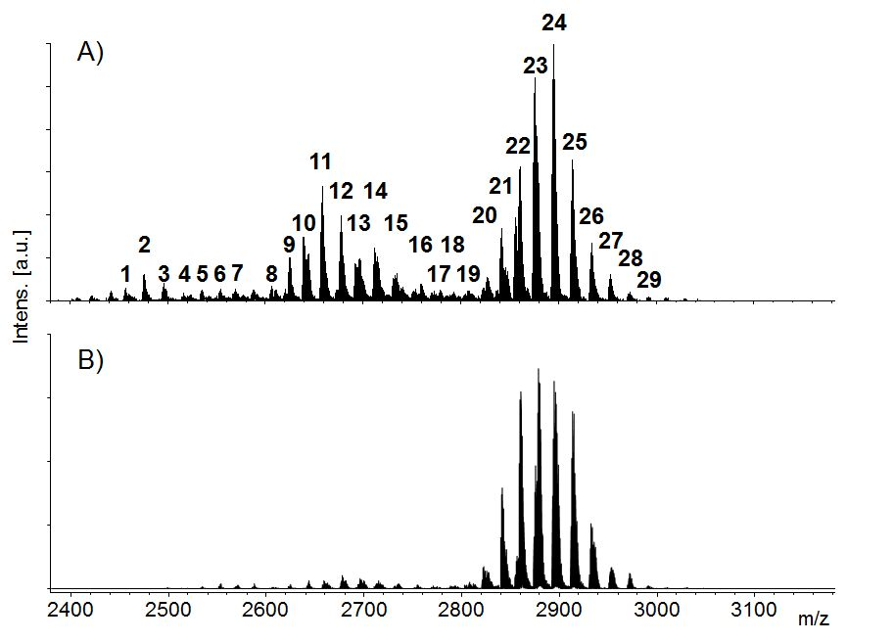

Figure 7. MALDI-TOF analysis of the product of targeting [Bz₄-Am₄-G₃] by A) the sequential deprotection/thiol-acrylate Michael addition strategy, and B) the simultaneous mixed acrylate strategy.

B) Simultaneous functionalisation – model dendrons 1-3:
An alternative strategy to introduce multiple functionalities to the model dendrons is to simply deprotect all thiols and simultaneously react a mixture of acrylates at the desired molar ratio (Figure 1; left-hand). A series of materials were, therefore, targeted using the three protected G₁-G₃ dendrons, 1-3, after full deprotection and reaction with a mixture of BzA and DMAEA to match the materials formed using the sequential strategy. As seen previously, ¹H NMR analysis of the resulting products confirmed that, on average, the targeted molar ratio of BzA and DMAEA had reacted completely; matching the sequential synthesis outcomes (ESI Figures S47, S50 & S55).
MALDI-TOF analysis, conducted under identical analytical conditions used for samples generated from the sequential deprotection/functionalisation strategy, showed a markedly different distribution of species when conducting the simultaneous mixed acrylate functionalisation. Surprisingly, using a mixture of acrylates in a single reaction yielded far fewer isolated thiol structures in all reactions studied and, in some cases, the formation of species with two isolated thiols was almost undetectable. For example, and in comparison to earlier results, MALDI-TOF analysis of [Bz₄-Am₄-G₃] synthesised using the simultaneous functionalisation strategy, exhibited almost the entire peak distribution listed in Table 1 but the relative intensities of the main distribution of ions (Figure 7B and Table 1 peaks 16-29) was significantly higher in comparison to the peaks indicating the presence of isolated thiols (Figure 7B and Table 1 peaks 1-15). In other cases, such as targeting of [Bz₇-Am₁-G₃] and [Bz₆-Am₂-G₃], almost no species containing isolated thiols were observed (ESI Figure S56 & S57 respectively) when using the simultaneous functionalisation strategy.
Table 1. Peaks identified and assigned within the MALDI-TOF spectrum of [Bz₄-Am₄-G₃] synthesised using the sequential deprotection/thiol-acrylate Michael addition strategy – see Figure 7A
Peak | Species  assignment | Theoretical  m/z+1 (Da) | Observed  m/z (Da)
1 | [Am₆-(SH)₂-G₃] | MH⁺ = 2463 | 2462.99
2 | [Bz₁-Am₅-(SH)₂-G₃] | MH⁺ = 2482 | 2481.97
3 | [Bz₂-Am₄-(SH)₂-G₃] | MH⁺ = 2501 | 2500.97
4 | [Bz₃-Am₃-(SH)₂-G₃] | MH⁺ = 2520 | 2519.97
5 | [Bz₄-Am₂-(SH)₂-G₃] | MH⁺ = 2539 | 2539.02
6 | [Bz₅-Am₁-(SH)₂-G₃] | MH⁺ = 2558 | 2558.06
7 | [Bz₆-(SH)₂-G₃] | MH⁺ = 2577 | 2577.05
8 | [Am₇-(SH)₁-G₃] | MH⁺ = 2606 | 2606.14
9 | [Bz₁-Am₆-(SH)₁-G₃] | MH⁺ = 2625 | 2625.12
10 | [Bz₂-Am₅-(SH)₁-G₃] | MH⁺ = 2644 | 2644.11
11 | [Bz₃-Am₄-(SH)₁-G₃] | MH⁺ = 2663 | 2663.12
12 | [Bz₄-Am₃-(SH)₁-G₃] | MH⁺ = 2682 | 2682.14
13 | [Bz₅-Am₂-(SH)₁-G₃] | MH⁺ = 2701 | 2701.14
14 | [Bz₆-Am₁-(SH)₁-G₃] | MH⁺ = 2720 | 2720.15
15 | [Bz₇-(SH)₁-G₃] | MH⁺ = 2739 | 2739.19
16 | [Am₈-G₃] | MH⁺ = 2750 | 2750.21
17 | [Bz₁-Am₇-G₃] | MH⁺ = 2768 | 2768.26
18 | [Bz₂-Am₆-G₃] | MH⁺ = 2787 | 2787.21
19 | [Bz₃-Am₅-G₃] | MH⁺ = 2806 | 2806.20
20 | [Bz₄-Am₄-G₃] | MH⁺ = 2825 | 2825.26
21 | [Bz₅-Am₃-G₃] | MH⁺ = 2844 | 2844.30
22 | [Bz₆-Am₂-G₃] | MH⁺ = 2863 | 2863.29
23 | [Bz₇-Am₁-G₃] | MH⁺ = 2882 | 2882.28
24 | [Bz₈-G₃] | MH⁺ = 2901 | 2901.32
25 | [Bz₈-G₃]H⁺ + 16 | MH⁺ = 2901 | 2917.29
26 | [Bz₈-G₃]K⁺ | MH⁺ = 2901 | 2939.32
27 | [Bz₈-G₃]K⁺ + 16 | MH⁺ = 2901 | 2955.32
28 | [Bz₈-G₃]K⁺ + 32 | MH⁺ = 2901 | 2971.32
29 | [Bz₈-G₃]K⁺ + 48 | MH⁺ = 2901 | 2987.26

Sequential and simultaneous deprotection/functionalisation of xanthate-functional linear-dendritic hybrids and hyp- polydendrons.

Post-polymerisation functionalisation is regularly reported for materials that are conventionally defined using descriptors of averages derived from distributions, such as number average and weight average molecular weights (M_{n} and M_{w} respectively). The detailed analysis of such functionalisation strategies is, therefore, very difficult to achieve without lengthy separation of individual components of complex distributions and subsequent study using multiple techniques. The model studies of G₁-G₃ dendrons presented here, offers new insights into outcomes that would result from post-polymerisation reactions using novel complex polymer architectures bearing dendron subunits – eg Janus-dendrimers, hyperbranched polymers, linear-dendritic hybrids, dendron modified surfaces, dendron-bearing networks, dendronized polymers and hyperbranched polydendrons (hyp-polydendrons).
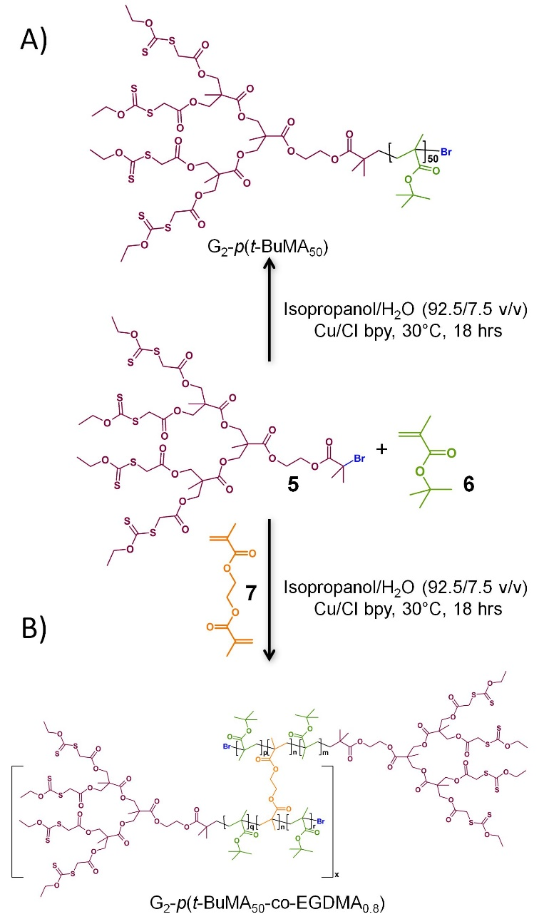
The orthogonal nature of the dendron periphery and focal point protection chemistries, utilised in these studies, allows selective deprotection and introduction of ATRP initiating functional groups at the focal point of the model dendrons. We have previously reported G₁ to G₄ xanthate-functional ATRP initiators for linear-dendritic hybrid synthesis;²⁰ however, this new study aimed to evaluate the potential of the sequential and simultaneous strategies, analysed in detail in our model studies, to controllably introduce mixed functionality to the dendron periphery of both linear-dendritic hybrids and the previously unreported xanthate-functional hyp-polydendrons. The ATRP initiators 4 and 5 were therefore synthesised from 1 and 2 and used to initiate the CuCl/2,2′-bipyridyl catalyst mediated linear polymerisation of t-butyl methacrylate (t-BuMA; 6), or branched copolymerisation of t-BuMA and ethylene glycol dimethacrylate (EGDMA; 7), targeting a number average degree of polymerisation (DP_{n}) of 50 monomer units for the linear-dendritic hybrids and the primary chains of the hyp-polydendrons respectively (Scheme 1).
Scheme 1 Alcoholic atom transfer radical polymerisation of t-butyl methacrylate (6) using the G₂ xanthate initiator (5) to form: A) a linear-dendritic hybrid, or B) a hyperbranched-polydendron when copolymerised with ethylene glycol dimethacrylate (7).
Higher generation dendrons were not employed after the clear indication within the model studies that thiol isolation was most prevalent in the sequential functionalisation of the G₃ dendron 3. Hyp-polydendrons were included within the studies to determine the ability to access the chain-ends of these complex polymer architectures controllably and demonstrate, for the first time, their potential as a platform for post-polymerisation functionalisation.
Hyp-polydendrons are synthesised through the statistical copolymerisation of a mono-functional vinyl monomer and a low concentration of divinyl branching monomer using a dendron initiator ensuring an effective molar brancher/initiator ratio of <1.^{11,23,24} This one-pot polymerisation follows conventional ATRP polymerisation stages, but at high conversion of monomer the pendant vinyl groups, of the incorporated divinyl co-monomer, are consumed leading to inter-chain branching whilst avoiding crosslinking and gelation.^{23,25,26,27} Very high molecular weight soluble polymers are formed and the resulting polymers contain large numbers of conjoined chains, each bearing a dendron on one chain-end.
The linear-dendritic hybrids and hyp-polydendrons synthesised within this study were analysed using triple detection size exclusion chromatography (SEC; Table 2); as the hyp-polydendrons contain multiple conjoined linear-dendritic hybrid chains, the number average number of primary chains within each structure can be readily estimated by simple comparison of the SEC values of the two materials synthesised in the presence and absence of EGDMA; approximately 3-4 in each case. Similarly, the weight average number of primary chains may be estimated and this varied from approximately 55 (G₁ initiator) to 22 (G₂ initiator), equating to a number average xanthate functionality of approximately 8 (G₁ initiator) and 16 (G₂ initiator) or weight average xanthate functionality of between 110 (G₁ initiator) and 88 (G₂ initiator). This clearly establishes the utility of the xanthate-functional dendrons to create highly functional hyp-polydendrons.
Table 2 Triple detection SECª of selected materials made during this study
Polymer | Type^{b} | Monomer Conv. (%) | M_{n}  (g mol⁻¹) | M_{w}  (g mol⁻¹) | Đ
G₁-p(t-BuMA₅₀) | LD | 99+ | 13701 | 16986 | 1.24
G₁-p(t-BuMA₅₀-co-EGDMA_{0.8}) | HP | 99+ | 59626 | 935774 | 15.69
G₂-p(t-BuMA₅₀) | LD | 99+ | 16381 | 19341 | 1.19
[Bz₂-Am₂-G₂]-p(t-BuMA₅₀) | LD | - | 18659 | 21916 | 1.18
G₂-p(t-BuMA₅₀-co-EGDMA_{0.8}) | HP | 99+ | 46460 | 340678 | 7.29
[Bz₂-Am₂-G₂]-p(t-BuMA₅₀-co-EGDMA_{0.8}) | HP | - | 79862 | 590720 | 7.40
ªGPC values (M_{n}, M_{w} and Đ) determined using THF eluent at 1 mL min⁻¹ flow rate. ^{b}LD=linear-dendritic hybrid; HP = hyp-polydendron
A) Sequential thiol-acrylate Michael addition - polymers:
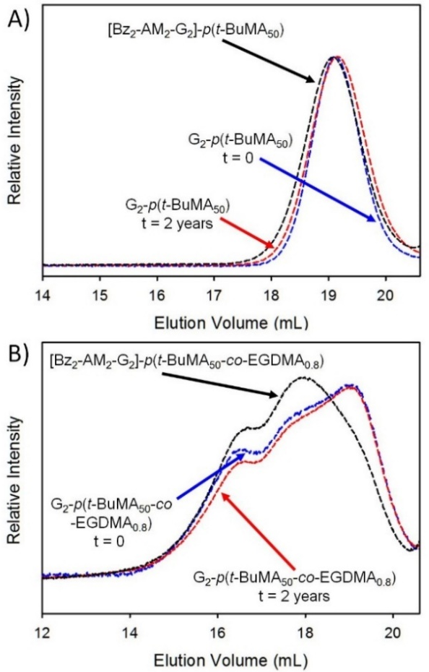
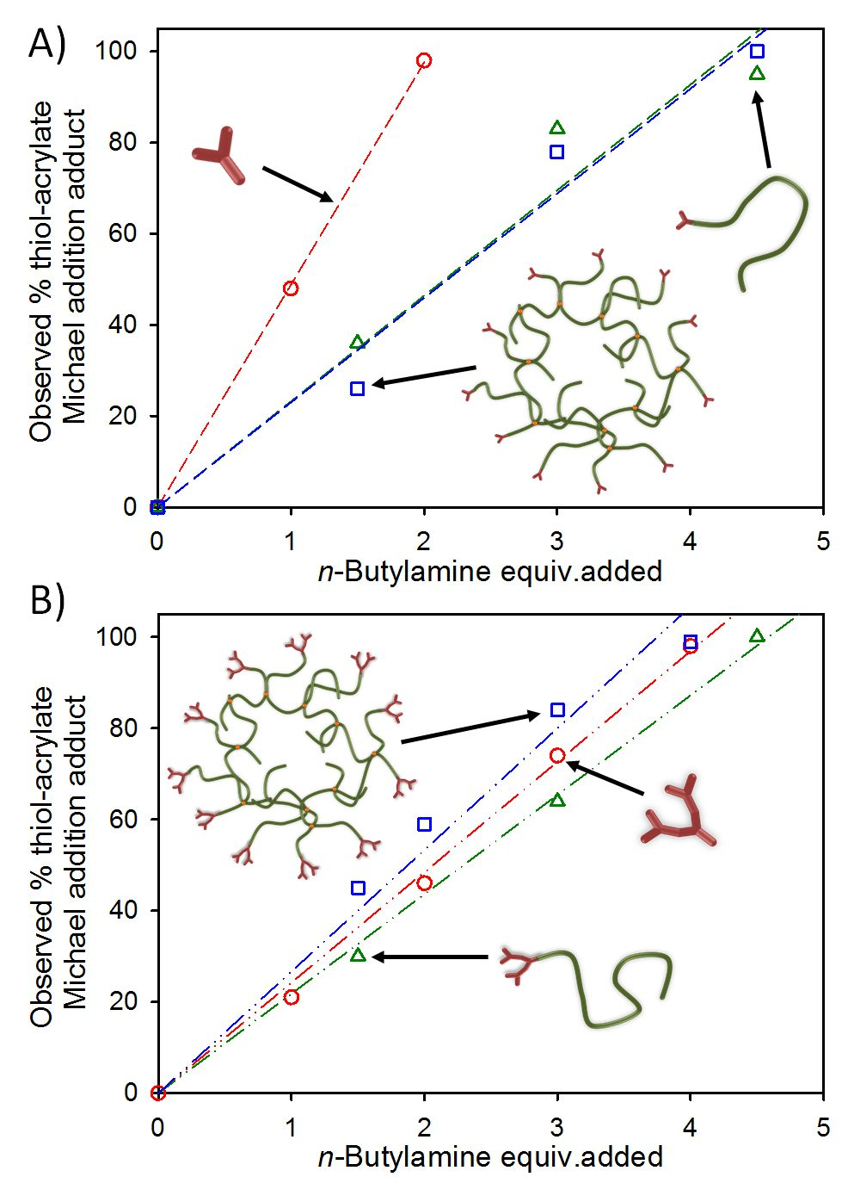
The linear-dendritic hybrids G₁-p(t-BuMA₅₀) and G₂-p(t-BuMA₅₀), and the hyp-polydendrons G₁-p(t-BuMA₅₀-co-EGDMA_{0.8}) and G₂-p(t-BuMA₅₀-co-EGDMA_{0.8}) were each subjected to the same strategy of sequential xanthate-deprotection utilised in the model studies; increasing molar equivalents of n-butylamine were added to yield increasing numbers of thiols. The direct targeting of thiol-functionality was somewhat hindered by the polymer compositions being less well defined than the model dendrons, therefore, a pseudo-calibration curve was generated for each material. The pseudo-calibration curves were formed by: 1) estimation of DP_{n} of each polymer using ¹H NMR end-group analysis; 2) calculation of the average number of xanthates per gram of each sample; 3) Varied addition of n-butylamine; and 4) determination of the average number of xanthates deprotected using ¹H NMR analysis. It was evident from the resultant deprotection curves that the linear-dendritic hybrid and hyp-polydendron derived from the G1-dendron initiator required considerably more n-butylamine than the model dendron 1 to achieve the desired level of deprotection. Within experimental error, the G₂-containing linear-dendritic hybrid and hyp-polydendron closely resembled the behaviour of the model G₂-dendron 2 requiring approximately 1 molar equivalent of n-butylamine per xanthate to liberate the required thiols. To investigate this further, the deprotected materials were treated with BzA and the percentage of Michael adduct was determined by ¹H NMR after purification (Figure 8); 5 equivalents of BzA per thiol were added to ensure full reaction.
Figure 8 Relationship between moles of n-butylamine required for sequential xanthate deprotection and subsequent benzyl acrylate Michael adducts. A) Structures derived from G₁ dendrons, and B) structures derived from G₂ dendrons. Model dendrons (open red circles), linear-dendritic hybrids (open green triangles) and hyp-polydendrons (open blue squares). All data was determined using ¹H NMR spectroscopy and linear regression is shown.
The number of thiol-acrylate Michael adducts formed in each sequential deprotection-functionalisation confirmed the observations seen within the pseudo-calibration curves; a significant molar excess of n-butylamine was required to efficiently deprotect the xanthates within both G₁-dendron initiated polymer samples. In all cases the ability to target the deprotection of a bespoke number of thiols, and a near-linear relationship with subsequent thiol-acrylate Michael addition, was seen (Figure 8). The marked difference between the behaviour of the model G₁-dendron and the polymers derived from the respective G₁-initiator appears to suggest a difficulty in accessing chain-ends for deprotection and subsequent thiol-acrylate Michael addition. The G₂-dendron initiated samples appear, conversely, to be accessible, suggesting that even at this relatively low dendron generation, a different coiling of chains in solution may be present.

B) Simultaneous thiol-acrylate Michael addition - polymers:
Simultaneous statistical functionalisation was investigated using the G₂ dendron initiated linear-dendritic hybrid and hyp-polydendron. The complete deprotection of chain-end xanthate functionality (1.2 molar equivalents n-butylamine/xanthate) and addition of a 1:1 molar ratio of BzA:DMAEA (2 molar equivalents/thiol) resulted in the linear-dendritic hybrid [Bz₂-Am₂-G₂]-p(t-BuMA₅₀) and hyp-polydendron [Bz₂-Am₂-G₂]-p(t-BuMA₅₀-co-EGDMA_{0.8}) as confirmed by ¹H NMR spectroscopy (ESI Figures S65 & S66) and SEC (Figure 9; Table 2).
Figure 9 Triple detection SEC (THF eluent; refractive index detector) analysis of A) linear dendritic hybrid materials and B) hyp-polydendron materials. Molecular weight distributions for xanthate-functional materials as prepared (blue lines), stored for 2 years (red lines) and after full xanthate deprotection and subsequent simultaneous Michael addition reaction with a 1:1 molar ratio of benzyl acrylate and 2-(dimethylamino)ethyl acrylate reaction (black lines) are shown.
¹H NMR analysis confirmed the formation of a statistical 1:1 ratio of Bz and Am functionality within both products whilst SEC analysis of the linear-dendritic hybrid before and after the full deprotection and subsequent thiol-acrylate Michael addition showed a slight shift to lower retention times (Figure 9A) and subsequent increase in the determined values for M_{n} and M_{w} (Table 2). Interestingly, the shape of the molecular weight distributions of the linear-dendritic hybrids, and subsequent Ð values, were nearly identical with no broadening or obvious bimodality. This would suggest an absence of intermolecular coupling after deprotection and exposure of the large number of thiol functional groups. To establish the storage stability of the xanthate-protected G₂-p(t-BuMA₅₀), a sample was stored for approximately 2 years and showed no meaningful change in the molecular weight distribution (Figure 9A). The same simultaneous deprotection/thiol-Michael addition strategy also formed the mixed-functionality hyp-polydendron [Bz₂-Am₂-G₂]-p(t-BuMA₅₀-co-EGDMA_{0.8}) without obvious intermolecular coupling, as confirmed by SEC analysis (Figure 9B); additionally, xanthate-functional hyp-polydendron storage stability was confirmed by analysis of a sample approximately two years after initial synthesis (Figure 9B).
Conclusions
The data presented here summarise the first demonstration of hyp-polydendron synthesis using xanthate-functional polyester dendrons in addition to a rigorous model study of two strategies (sequential and simultaneous) to introduce mixed functionality onto multi-functional masked thiol dendrons. The model studies of dendrons allows a detailed evaluation of the outcomes of each strategy that would not be available through analysis of the linear-dendritic hybrid or hyp-polydendron materials alone due to their inherent distribution of molecular weights; indeed, it is common in many polymer studies to rely on ¹H NMR to confirm successful post-polymerisation reactions. It is intuitive to expect a diversity of outcome from statistical functionalisation approaches; however, the dendron studies shown here provide an insight into the complexity of the diverse structures and isolation of unreacted groups. Interestingly, for a mixed functionalisation approach, the simultaneous and competitive reaction of the two chosen acrylates generally led to fewer isolated thiols in the final products.
Although it is apparent that linear-dendritic hybrid materials, and their more complex analogues hyp-polydendrons, can be successfully manipulated through both functionalisation approaches, it is also clear that neither statistical functionalisation approach would lead to outcomes substantially resembling the nominal chosen product. Rather the statistical introduction of two functional groups will generate a considerable chemical diversity within the final sample and potentially incorrect conclusions drawn from the study of molecular behaviour that is interpreted through an ill-informed view of the composition of the material under investigation.
The implications for partial or mixed-chemistry post-synthesis modification of any material are clear. These are more substantial when attempting to modify the functional groups of dendron-bearing materials. For example, linear-dendritic hybrids bear a single dendron at the end of each chain and subject to partial or mixed-functionalisation would be expected to generate end-groups representing the full spectrum of chemical compositions and very little of the targeted chemistry. In the example studied here, compositions ranging from 100% amine-containing through to 100% benzyl-terminated species would be present, leading to significant impact on the physical behaviour of the product. Although this was not studied here, highly heterogeneous and non-uniform behaviour to environmental conditions of varying pH²⁸ or temperature would be expected, as shown previously for subtle changes in the single functionality at the chain-ends of linear polymers.^{29,30} Through the formation of hyp-polydendrons, however, the distribution of functionalisation outcomes is widely averaged across the large number of conjoined chain-ends, allowing the inclusion of the intended ratio of functional groups to be more closely achieved within individual highly branched molecules (Figure 10) rather than at the single chain-end of linear-dendritic hybrids. Such a result would also be expected for materials such as dendronised polymers, but the distribution of diverse compositions, even in linear-dendritic hybrids and linear polymers, does potentially lead to other implications such as the formation of concentrated areas of specific functional groups which may influence the behaviour of the materials under specific conditions (eg biological interactions).³¹⁻³³ It would be incorrect to assume that localised domains of grouped functionality are not present within statistically modified mixed functionality materials (Figure 10).
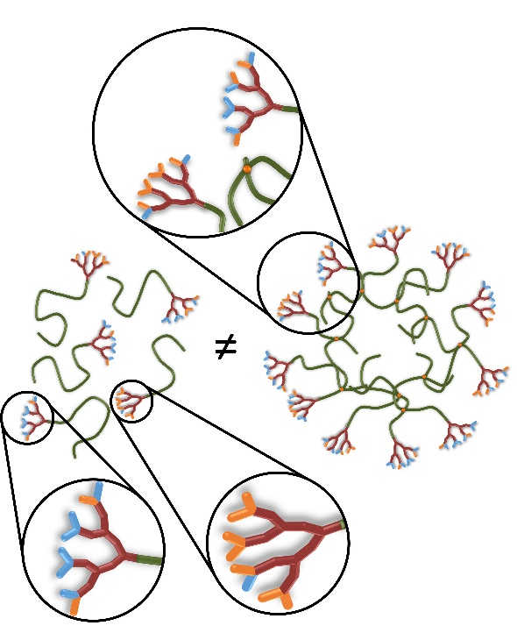
Figure 10 Schematic comparison of the outcome of statistical chain end modification of linear-dendritic hybrids and hyp-polydendrons. The inequality of the outcomes is clearly observed through the heterogeneity of chain-ends within the linear-dendritic hybrids and the averaging of this heterogeneity across the conjoined chains within the hyp-polydendron structure.
The study of the potential applications of hyp-polydendron materials synthesised through the strategies outlined here are ongoing. We believe that the materials and their synthesis strategies provide opportunities for materials chemists to build systematically varying complex architectures which may overcome many of the limitations of analogous macromolecules with more iterative and lengthy syntheses.
Acknowledgements
The authors acknowledge the EPSRC for a Doctoral Training Award for FH and financial support (EP/I038721/1 and EP/L02635X/1). MALDI-TOF mass spectroscopy was conducted at the KTH Royal Institute of Technology, School of Chemical Engineering.
Notes and references
- J. Huskens, Current Opinion in Chemical Biology, 2006, 10, 537–543.
- C. Sieben, C. Kappel, R. Zhu, A. Wozniak, C. Rankl, P. Hinterdorfer, H. Grubmüller and A. Herrmann, PNAS, 2012, 109, 13626–13631.
- N. S. Greenspan, Adv. Cancer Res. 2001, 80, 147-87.
- M. Mammen, S. K. Choi, and G. M. Whitesides, Angew. Chem. Int. Ed., 1998, 37, 2754–2794.
- O. Rolland, C-O. Turrin, A-M. Caminade and J-P. Majoral, New J. Chem., 2009, 33, 1809–1824.
- G. V. Dubacheva, T. Curk, B. M. Mognetti, R. Auzély-Velty, D. Frenkel and R. P. Richter, J. Am. Chem. Soc., 2014, 136, 1722-1725.
- H. Carrstensen, R. H. Müller and B. W. Müller, Clin. Nutr., 1992, 11, 289–297.
- S.-D. Li and L. Huang, Mol. Pharm., 2008, 5, 496–504.
- C. He, Y. Hu, L. Yin, C. Tang and C. Yin, Biomaterials, 2010, 31, 3657–3666.
- C. C. Lee, J. A. MacKay, J. M. J. Fréchet and F. C. Szoka, Nat. Biotech., 2005, 23, 1517–1526.
- F. L. Hatton, L. M. Tatham, L. R. Tidbury, P. Chambon, T. He, A. Owen, S. P. Rannard, Chem. Sci., 2015, 6, 326-334.
- T. Weil, U. M. Wiesler, A. Herrmann, R. Bauer, J. Hofkens, F. C. De Schryver and K. Müllen, J. Am. Chem. Soc., 2001, 123, 8101-8108.
- H. Willcock, A. I. Cooper, D. J. Adams, S. P. Rannard, Chem. Commun., 2009, 21, 3095-3097.
- V. Percec, P. Leowanawat, H-J. Sun, O. Kulikov, C. D. Nusbaum, T. M. Tran, A. Bertin, D. A. Wilson, M. Peterca, S. Zhang, N. P. Kamat, K. Vargo, D. Moock, E. D. Johnston, D. A. Hammer, D. J. Pochan, Y. Chen, Y. M. Chabre, T. C. Shiao, M. Bergeron-Brlek, S. Andre,́ R. Roy, H-J. Gabius and P. A. Heiney, J. Am. Chem. Soc., 2013, 135, 9055−9077.
- S. Nummelin, V. Liljestrçm, E. Saarikoski, J. Ropponen, A. Nykänen, V. Linko, J. Seppälä, J. Hirvonen, O. Ikkala, L. M. Bimbo and M. A. Kostiainen, Chem. Eur. J., 2015, 21, 14433-14439.
- P. V. Rewatkar, H. S. Parekh and M-O. Parat, PloS ONE, 2016, 11, e0147491.
- S. W. Svenningsen, A. Janaszewska, M. Ficker, J. F. Petersen, B. Klajnert-Maculewicz and J. B. Christensen, Bioconjugate Chem., 2016, 27, 1547–1557.
- I. U. Ahad, A. Bartnik, H. Fiedorowicz, J. Kostecki, B. Korczyc, T. Ciach and D. Brabazon, J. Biomed. Mater. Res. A, 2014, 102, 3298–310.
- S. E. R. Auty, O. Andrén, M. Malkoch and S. P. Rannard, Chem. Commun., 2014, 50, 6574–6577.
- S. E. R. Auty, O. C. J. Andrén, F. Y. Hern, M. Malkoch, and S. P. Rannard, Polym. Chem., 2015, 6, 573–582.
- K, McLeod and M. B. Comisarow, J. Magn. Reson., 1969, 84, 490-500.
- Chengdu Yuan Dong Pharmaceutical Co., Ltd., Novel chiral sulfoxide compound and method for preparing esomeprazole by using novel chiral sulfoxide compound, Chinese Pat., CN102603621 A, 2012.
- F. L. Hatton, P. Chambon, T. O. McDonald, A. Owen and S. P. Rannard, Chem. Sci., 2014, 5, 1844-1853.
- F. L. Hatton, P. Chambon, A. C. Savage and S. P. Rannard, Chem. Commun., 2016, 52, 3915-3918.
- R. A. Slater, T. O. McDonald, D. J. Adams, E. R. Draper, J. V. M. Weaver and S. P. Rannard, Soft Matter, 2012, 8, 9816-9827.
- T. He, D. J. Adams, M. F. Butler, A. I. Cooper and S. P. Rannard, J. Am. Chem. Soc., 2009, 131, 1495-1501.
- T. He, D. J. Adams, M. F. Butler, C-T. Yeoh, A. I. Cooper and S. P. Rannard, Angew. Chem. Int. Ed., 2007, 46, 9243-9247.
- H. E. Rogers, P. Chambon, S. E. R. Auty, F. Y. Hern, A. Owen and S. P. Rannard, Soft Matter, 2015, 11, 7005-7015.
- M. Long, D. W. Thornthwaite, S. H. Rogers, F. R. Livens and S. P. Rannard, Polym. Chem., 2012, 3, 154-161.
- S. Jana, S. P. Rannard and A. I. Cooper, Chem. Commun. 2007, 2962-2964.
- S. L. Mangold, R. T. Carpenter and L. L. Kiessling, Org. Lett., 2008, 10, 2997-3000.
- N. R. Bennett, D. B. Zwick, A. H. Courtney and L. L. Kiessling, ACS Chem. Biol., 2015, 10, 1817−1824.
- S. Szunerits, A. Barras, M. Khanal, Q. Pagneux and R. Boukherroub, Molecules, 2015, 20, 14051-14081.

