Location, Location, Location: Exploring macro-market influences and impacts of reshoring on operational decision-making

David Cockayne, University of Huddersfield Business School
Marina Papalexi, University of Huddersfield Business School
Christine Jordan, University of Huddersfield Business School
Introduction
Questions concerning the location of a firm’s operations have often sought to explore the benefits and risks of domestic practice versus outsourcing aspects of production to a location abroad. Comparatively lower production costs, tax incentives, and economies of scale are often cited as the main rationale for this strategic decision. More recently however, the popular press or ‘grey literature’ in western markets (i.e. Europe and North America) has identified a shift in focus at the strategic decision making level for manufacturers with respect to their operational ‘location’. This time the focus of current research into operational location is the concept of ‘reshoring’. Reshoring is concerned with “bringing manufacturing back home…” (Gray, Skowronski, Esenduran, & Johnny Rungtusanatham, 2013) from a current location that is not the origin or ‘home’ of the firm. The term is unconvincing as to whether the manufacturing being brought home occurred in a wholly owned facility in an offshore location, or in the factory of an offshore supplier. For example, a firm may have ‘outsourced’ manufacturing operations to an independent supplier, or they may have set up a factory in a foreign location and shifted production to that site to benefit from, for example, reduced labour costs. For Gray et al., (2013) reshoring is fundamentally concerned with the location of manufacturing activities independent of who is performing them. As such ‘location’ becomes the primary decision determinant as opposed to ownership. Such a development signals an interesting development that has implications for offshored manufacturing in the long-term, and shorter-term planning.
Literature Review
In their ‘typology of the reshoring phenomenon’ Gray et al (2013) identify four possible types of reshoring;(a) in-house reshoring where a firm serves local demand by relocating manufacturing activities to an alternative destination aboard through wholly owned offshore facilities; (b) reshoring for outsourcing, whereby a firm supplies local demand by relocating manufacturing activities being performed in wholly owned offshore facilities back to local suppliers; (c) reshoring for insourcing, in which a firm satisfies demand in its local market by relocating manufacturing activities being performed by offshore suppliers back to wholly owned local facilities; and (d) outsourced reshoring, in which a firm fulfils demand in its local market by relocating manufacturing activities being performed by offshore suppliers back to local suppliers. This framework emphasises the subtle, but significant differences and requisite decision choices of different forms of reshoring. For this reason, researchers have focused on studying each form of reshoring separately. A representative example is that of Rothe et al.’s (2014) paper where they examined short-distance firm relocations which according to them is the most common type of relocation. They found that staff, within the same organisation, experienced this change differently and thus staff should be treated as several objects of change and not just one as a force.
Although the various forms of reshoring have been defined and analysed based on firms’ actions, a number of reports explore relocation as a phenomenon focusing on the reasons that influence organisations ’decisions and the impact of these types of initiatives on firms’ performance. In particular, Christersson and Rothe (2012) created a conceptual framework outlining the impacts of organisational relocation. A list of those impacts was the output of their research; relocation costs, disruption, employee reactions to change, altered lease attributes, and changed environmental footprints included into that list. They also suggested that organisational relocation could affect elements such as: productivity, employee satisfaction, employee turnover, organisational dynamics, ways of working, commuting, accessibility for external stakeholders, and organizational culture and image.
Other scholars have concentrated on exploring the factors supporting or preventing the organisations’ decision to relocate. Knoben (2011) evaluates relocation from a resource-based perspective; he found that not only the distance away from external resources influences the decision behind relocation, but the distance from external resources also influences the success of relocation. In a similar vein, Simula and Torstila (2012) outlined catalysing factors affecting relocation decisions. They categorised them into two different groups: push and pull factors influencing location choice. Specifically, push factors include high taxes and high employment rate, while pull factors which increase the attractiveness of locations when making relocation decisions include central location and low taxes. Rasila and Nenonen (2008) were looking at the perceptions of relocation risks defining five different categories: financial risks, functional risks, corporate culture risks, interest group risks and future risk.
Figure 1 demonstrates a proposed framework, inspired by the fundamental input – transformation – output operations management model, to explain how the phenomenon of reshoring is incorporated within an organisation. From an Operations Management perspective, firms have to orchestrate various forms of operations taking place simultaneously during the production process (Bamford & Forrester, 2010) in order to be able to provide high quality products and services, hence generating or sustaining a completive advantage (Barney, 2012; Buckeley & Ghauri, 2015). In particular, Brown et al. (2013, p.4) highlighted the importance of Operations Management by defined it as ‘a set of activities that enable an organisation (and not just one part of it) to transform a range of basic inputs (materials, energy, customers’ requirements, information, skills, finance, etc) into outputs for the end customer’. As can be seen from Figure 1, reshoring is considered as an intervention that attempts to enhance the transformation process through improving the access to the required resources and, as a result, the distribution system, which enables firms to minimise the associated costs and meet their strategic objectives (Bamford & Forrester, 2010).
The main concern derived from reviewing the existing literature is related to the successful rate of reshoring (Christersson & Rothe, 2012). It is apparent that reshoring causes significant change to organisations. A realistic interpretation of the change process has to consider multiple and varying forces that exert varied influences (Bamford & Forrester, 2003), which are presented in Figure 1. Those external and internal factors influence firms’ decisions to relocate. It is often difficult to predict, control and manage those influences, which means that they might generate unprecedented outcomes (Kotter and Heskett, 1992). In addition, Bamford and Forrester (2003, p. 562) highlighted that ‘the influence of the immediate social context can be markedly different across regional, national and international borders’. The success rate of any initiative is extensively dependent on the organisational context (Michel et al., 2013). Firms, therefore, need to adopt a suitable approach to manage the change process effectively and communicate the reasons and the potential benefits of this type of initiatives. Adopting the most suitable approach minimises the likelihood of the potential risks, as illustrated in Figure 1.

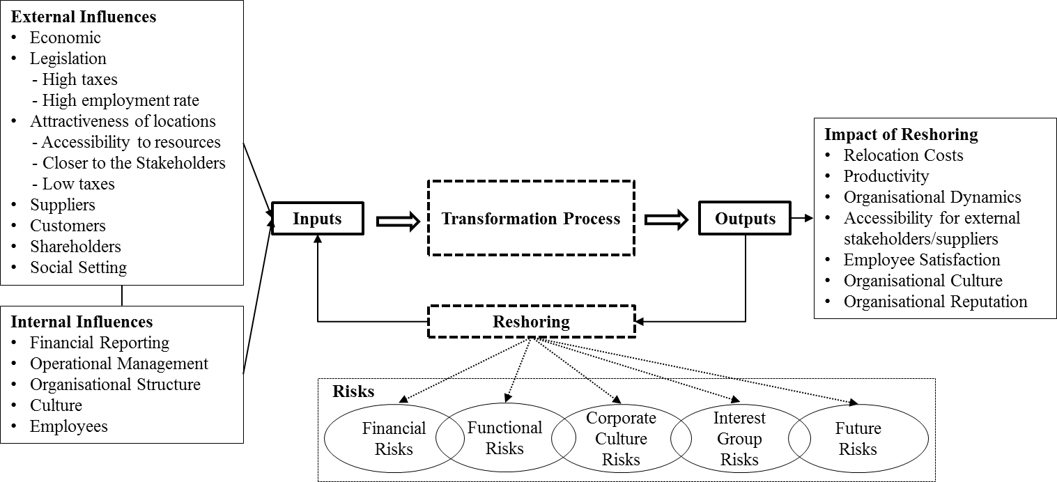

Figure 1: Influences and Impact of Reshoring (Adapted from Bamford & Forrester, 2003)
Based on the literature related to the subject under investigation, it can be concluded that the phenomenon of reshoring is something that has been partially studied, with particular focus on US markets. Further, the current level of press and government interest in the concept would suggest that it is a concept demanding greater organisation consideration. Therefore, understanding fully this initiative by exploring the factors affecting it and the organisations’ expectations is considered essential. As it has been explained in the previous section, scholars have analysed this element approaching it from a different angle. However, there is weak evidence regarding firms’ relocation in a particular geographical area. For this reason, this research aims at exploring the factors affecting organisations’ decisions to relocate in the UK and whether or not this initiative would influence firms’ effectiveness and efficiency. To achieve this, three research questions have been developed:
RQ1: What are the factors affecting organisations’ decision to relocate in the UK?
RQ2: To what extent relocation influences the organisations’ performance?
RQ3: Explore the extent to which location affects choice of, or is determined by, available resources
Methodology
The research adopts an exploratory approach. To investigate the phenomenon of reshoring, an initial analysis of the current reshoring literature has been identified in order to identify the different typology and trends of reshoring.
The choice of a case study to provide the required empirical data for this research is based on the need to develop an in-depth understanding of reshoring, why and how it has played, and has the potential to play, a significant role for a manufacturing company in the UK.
As an instrumental case study (Stake, 2000), a manufacturing company was identified which had some experience of reshoring to the UK which would allow detailed examination into the application of reshoring in a real life example. Although the findings from a single case are not intended to offer any generalisations, the provision of further analysis and insight into reshoring and the factors relating to it will subsequently promote understanding of this important and growing area. The company selected cannot be named for legal purposes, and will be referred to as ‘CTT’ within this paper. Case study information will be sourced from internal sources including in-depth interviews with representatives from the case study company (5 interviews in total). These will be complemented by 2 interviews with external parties connected at the public level with outsourcing and reshoring in the UK. The style of questioning will follow a narrative approach to generate thoughts and discussion around the reshoring concept with broad questions guiding the direction of the interviews. Qualitative data from interviews will enable a deeper understanding of the perceptions, approaches and outcomes of reshoring the business. A thematic analysis of the interviews using inductive methods will categorize the main themes, and an appraisal of the findings in relation to the literature and the research questions.
Bibliography
Bamford, D. & Forrester, P. (2003). Managing planned and emergent change within an operations management environment. International Journal Of Operations & Production Management, 23(5), 546-564. http://dx.doi.org/10.1108/01443570310471857
Bamford, D. & Forrester, P. (2010). Essential guide to operations management. Hoboken, NJ: John Wiley & Sons.
Barney, J. (2012). Purchasing, Supply Chain Management and Sustained Competitive Advantage: The Relevance of Resource-based Theory. Journal of Supply Chain Management, 48(2)3-6.
Brown, S., Bessant, J. & Lamming, R. (2013) Strategic Operations Management. third edition, Routledge
Buckley, P.J. & Ghauri, P.N. (2015). International Business Strategy: Theory and Practice. Routledge, New York
Gray, J. V., Skowronski, K., Esenduran, G., & Johnny Rungtusanatham, M. (2013). The reshoring phenomenon: What supply chain academics ought to know and should do. Journal of Supply Chain Management, 49(2), 27–33. doi:10.1111/jscm.12012
Kotter, J.P. and Heskett, J.L. (1992), Corporate Culture & Performance, The Free Press, New York, NY.
Michel, A., Todnem By, R., & Burnes, B. (2013). The limitations of dispositional resistance in relation to organizational change. Management Decision, 51(4), 761-780. http://dx.doi.org/10.1108/00251741311326554
Stake, R. (2000). Case Studies. In Denzin, N. and Lincoln, Y. (eds), Handbook of Qualitative Research, second edition, Thousand Oaks, CA:Sage.

