Competing notions of search for home: behavioural economics and housing markets

Richard J. Dunning
Urban Studies and Planning, University of Sheffield
r.j.dunning@sheffield.ac.uk

Abstract
The frequent use of the unifying term ‘behavioural economics’ in contemporary economic theories and English housing policies masks divergent accounts of human ability, search processes and housing markets. The resurgence in interest in the behaviours of housing markets brings exchange mechanisms and housing search processes into sharp focus; this paper provides and applies a framework to assess the compatibility of behavioural economics theories of housing search. Assessing the ontological commitments of theories is possible through analysis of their conceptualisations of human ability, the search process and the structure and operation of the market. This assessment reveals a spectrum of diversity; distinctions between ‘old’ and ‘new’ behavioural economics are evident despite there being only limited acknowledgement of this variation. Whilst significant contributions to housing economics have taken place across the spectrum, clear distinctions are needed to prevent policy makers’ inadvertently misapplying incompatible approaches to behavioural economics and to prevent inappropriate synthesis in academic theorization.

Keywords: housing search, conceptual models, behavioural economics, institutional economics, ontology

Introduction
The policy significance of behavioural economics has risen dramatically in England since its explicit introduction under New Labour and then subsequently through the 2010-15 coalition (Jones et al., 2010; Dolan et al., 2012; Leggett, 2014), mirroring similar trends in other countries such as the Netherlands, the USA and Australia (Scanlon and Elsinga, 2014; Smith, 2013). The English resurgence of interest in behavioural economics coincides with policy maker’s increasing interest in housing market processes as well as outcomes to support planning (Maclennan and O’Sullivan, 2012). Yet, application of behavioural economics in English housing policy remains inconsistent. Policies such as the New Homes Bonus use behavioural economic language but display limited understanding of behaviour in the housing market and under-theorize agency in the development process (Dunning et al, 2014). Whilst contestation in the political process frequently leads to partial or mis-applications of behavioural economic theory in policy creation (Whitehead et al, 2011), another reason for its under-use is that such theory is underspecified in relation to housing markets and is therefore difficult to synthesize in housing policy.

Behavioural economics is not a single theory. The ontological assumptions behind self-defined behavioural economic approaches to housing theory are not necessarily shared between those approaches (Watkins and McMaster, 2011). Calls to integrate studies in behavioural economics, or to combine them with neoclassical economics (e.g. Boelhouwer, 2011) may oversimplify the variation between approaches. Any integration needs to examine whether housing theories share compatible ontological perspectives. An example of the variation in behavioural economic ontologies highlights this. Does Scott and Lizieri’s (2012) experimental evidence for anchoring and arbitrary coherence in house price judgement share similar enough assumptions about price formation with Christie, Munro and Smith’s (2008) work on emotions and price inflation, for them to be uncritically assimilated? Only a cursory reading would suggest that they share a similar behavioural economic philosophy.

Adams and Watkins (2014) argue that, in line with the pragmatist philosophy of Haack (2004), different economic approaches are useful in revealing insights into aspects of housing markets and planning. This reinforces Guy and Henneberry’s (2000) call for methodological pluralism and Gibb’s (2009) defence of multiple economic approaches. However, whilst perspectives may be successfully harvested from the panoply of economic approaches (Chang, 2014), a common framework is necessary for their perspectives to be appropriately co-located in policy. The background and ontological commitments of research that seeks to provide clues about housing processes therefore need to be scrutinized before being admitted as corroborating evidence (McMaster and Watkins, 2006).

In order to assimilate or define differences for housing policy, clarity is needed about the compatibility of housing market theories purporting to incorporate insights from behavioural economics. Whilst a complete assessment of the ontological commitments of the range of behavioural housing theories is impracticable, a heuristic approach can simplify and determine the key areas for understanding their ontological hetero- and homogeneity. Narrowing down the focus of the assessment to a single aspect of the expansive housing market economics canon, the housing search process, provides a useful case study of the variation in behavioural approaches. Housing search regularly incorporates three key variables that may be analysed to understand the ontologies underpinning the approach: human ability (analogous to agency), the housing search process (analogous to performance) and the housing market (analogous to structure).

Human ability is normally considered to be a property of individuals, but in this paper the household is used, referring to the unit moving home, which, whilst a simplification, has pedigree in behavioural research (e.g. Ferrari et al., 2011), akin to firm’s or organizations decision-making (Simon, 1972). Before assessing housing search models in detail we must consider an overview of behavioural positions in wider economic theory.

Economic theory of housing search: from neoclassical to behavioural
Behavioural economics is commonly viewed either as an alternative to or variation on neoclassical economics. This section will outline the main tenets of a neoclassical economics view of housing search before providing an overview of the behavioural economics challenges. Neoclassical economic models assume that households can achieve, or approximate, utility maximization in decision-making, where the decisions include remaining in their current premises. At any moment in time a dwelling reflects the optimal relationship between household preferences, housing characteristics, financial constraints and market prices. The search process is therefore only of limited interest to neoclassical economics as outputs explain preferences and markets are assumed to be in equilibrium, or moving towards it.

Whilst economists have regularly demurred from the tenets of homo economicus and neoclassical economics views of the market (including Smith, 1759 and Veblen, 1899) it was not until the latter half of the twentieth century that behavioural economics became recognized as an alternative to rational utility maximization. Herbert Simon was a catalyst in cohering an alternative behavioural approach (Sent, 2004). Simon’s (1978) theory that consumers satisfice rather than maximize was a direct challenge. Satisficing households were no longer assumed to make optimal decisions. Instead they choose acceptable dwellings from the array of opportunities because of limitations on their ability to maximize utility. These limitations may relate to cognitive complexity, problems in acquiring information or the structure of market relations and are summarized by the term “bounded rationality”.

Within a behavioural economics approach the search process becomes of increasing significance, because information is not known a priori but needs to be collected, collated and weighed up, which may result in a suboptimal move. Preferences may shift with new information and are not static, but may revolve around broader aspirations (e.g. for comfort) and may contradict each other (e.g. wanting a larger dwelling that is, at the same time more intimate or homely).

The extent to which the assumptions in behavioural economics are compatible with those in neoclassical economics is, however, disputed. Herbert Simon argued that the flaws in homo economicus create a disjuncture: “I shall assume that the concept of “economic man” (and I might add his brother “administrative man”) is in need of fairly drastic revision” (Simon, 1955, P.99). This view led to Simon being marginalized, and to a resurgent form of behavioural economics with closer links to neoclassical economics assumptions, which largely supplanted Simon’s view in the mainstream (Wilkinson, 2008). The strand of behavioural economics that views households in a similar way to neoclassical economics is most clearly articulated by Camerer and Loewenstein (2004), and is sometimes refereed to as new behavioural economics:
At the core of behavioral economics is the conviction that increasing the realism of the psychological underpinnings of economic analysis will improve economics on its own terms…. This conviction does not imply a wholesale rejection of the neoclassical approach to economics based on utility maximization, equilibrium, and efficiency. (Camerer and Loewenstein, 2004, P.3).
The bifurcation between Simon’s and Loewenstein’s views is clear, with one seeking distance from neoclassical economics and the other proximity to it. Whilst recognising this bifurcation is not ubiquitous, some authors have endorsed its existence. Sent (2004) suggests that the work of David Laibson, George Loewenstein, Colin Camerer and Matthew Rabin, building on the work of Daniel Kahneman and Amos Tversky is symptomatic of the new perspective, whilst old behavioural economists are exemplified by the work of Richard Cyert, James March and evidently Herbert Simon. The distinction between the two views is that old behavioural economics is concerned with describing actual behaviour and providing empirical evidence of the shape of the utility function, whilst new behavioural economics is concerned with finding deviations from the neoclassical model of behaviour that may be used to enhance the predictive power of those models (Sent, 2004). Angner and Loewenstein (2012) also differentiate between old (exemplified in the work of Herbert Simon and George Katona) and new behavioural economics (exemplified in the work of Amos Tversky, Daniel Kahneman and Richard Thaler), which grew out of behavioural decision research and broadly accepts the conception of rationality found in neoclassical economics. Ferrari et al (2011) and Watkins and McMaster (2011) likewise endorse this bifurcation, classifying the groups as new behavioural economics and original/old behavioural economics respectively, drawing attention to the relationship between old behavioural economics and old institutional economics. In doing this they highlight the social relationship between agents and market norms, defending old behavioural economics from the critique that Simon’s work minimised the role of social structures (e.g. by Bourdieu, cited in Swedberg, 2011). The old behavioural economics approach therefore is more closely aligned to cultural economy approaches to housing markets (e.g. Smith et al., 2006, Wallace, 2008, Munro and Smith, 2008) and conceptualises housing decisions as being socially constructed within a wider market context (Leggett, 2014). Jackson and Watkins (2011) argue that new behavioural economics does not offer an alternative to rational choice, whilst old behavioural economics supports ‘procedural’ rationality, in which satisficing behaviour reflects embedded relationships and habits impact upon beliefs and attitudes.
New behavioural economics is currently the dominant form of behavioural economics and insights frequently migrate between neoclassical economics and new behavioural economics. The porous nature of the boundaries between new behavioural and neoclassical economics may be seen in Genesove and Mayer’s (2001) work on loss aversion in seller behaviour in the Boston housing market. It represents an ontologically consistent application of concepts from both neoclassical and new behavioural economics. Indeed the future of housing research is likely to reveal many advances in the synthesis between neoclassical and behavioural approaches through modelling housing markets (Gibb and Price, 2012). However, to understand the diversity within behavioural economics, and to assess the commonality in philosophical presuppositions between behavioural approaches and neoclassical economics the new-old distinction is a helpful micro-taxonomy. It may be used to question whether it is possible to assimilate all branches of behavioural research without raising questions about the fundamental axioms of human ability, choice processes and the market. However, this taxonomy risks masking the nuances of variation between the array of ontological commitments present in behavioural research. Using the analogy of distance from neoclassical economics we can envisage a spectrum of approaches from the neoclassical economics’ tenets of rational utility maximisation to socially embedded and satisficing behaviour. This paints a more complete picture of the similarities and differences between various behavioural economics approaches. Tomer (2007) describes a spectrum of positions covering eight distinct strands of thought within behavioural economics (Harvey Leibenstein, experimental economics, psychological economics, George Katona, George Akerlof, Herbert Simon, evolutionary theory, and behavioural finance). He compares the philosophy of science within each to that of mainstream economics in relation to the following variables: narrowness, rigidity, intolerance, mechanicalness, separateness and individualism.

Tomer’s (2007) six-strand spectrum is unwieldy in practice and is more suitable to analyzing an author’s complete body of work rather than specific papers. A simplified version however can also reveal variation. This heuristic approach identifies three key ontological elements: the household’s decision making ability (agency); the housing search process (process); and the housing market (structure). The three elements are explored further in Figure 1 below. Each element is considered along a spectrum rather than clear categorization which allows for variation in the behavioural emphases between the three elements within a model. It also enables the practitioner to visualize the ontological similarities and differences before deciding if insights from the studies are compatible.

Figure 1. Divergent approaches to human ability; housing search processes; and the housing market across neoclassical, new and old behavioural economics
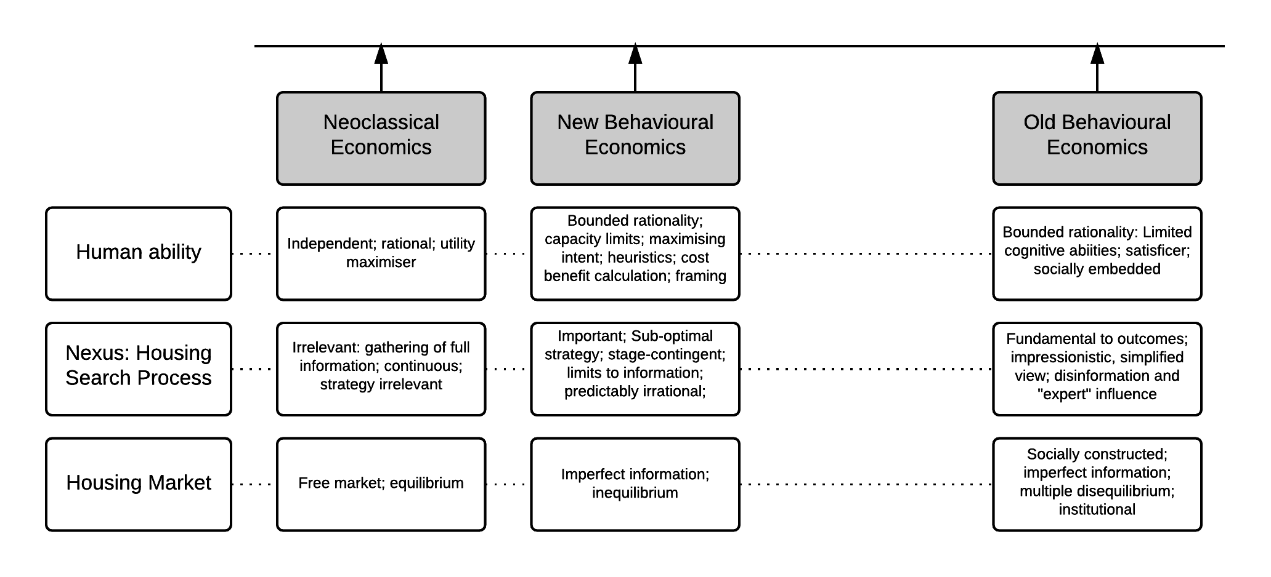
Source: author
Change in housing search models
The analysis is applied to five models of housing search. These models have been selected as examples of the range of perspectives from neoclassical economics (Tu & Goldfinch, 1996) through four variations of behavioural economics models presented chronologically: Speare, Goldstein and Frey (1975); Maclennan (1982); Wong (2002); and Marsh and Gibb (2011).

Tu and Goldfinch, 1996
Tu and Goldfinch’s (1996) work represents a neoclassical model of housing search, but is interesting in this context as it discusses behavioural economics, and explores some of the assumptions of neoclassical economics explicitly. It assumes that the household has incomplete information at the beginning of the search process, but through the search process obtains perfect information and is then able to maximize its utility (or at least satisfice with complete information). This conceptualization of human ability is that home buyers’ are independent, rational utility maximisers: “buying a dwelling is the largest expenditure and probably one of the biggest decisions that a household makes… it is reasonable to assume that each buyer will buy a dwelling only after obtaining full market information.” (Tu and Goldfinch, 1996, PP.519-520) and later:
The decision to buy a dwelling will be made when the buyer has obtained full market information. If this buyer is a rational buyer, he/she will be able to estimate correctly the utility he/she can obtain from each dwelling and the buyer’s choice will be his/ her maximum utility choice dwelling (Tu & Goldfinch, 1996, P.521)
The language of choice is used, however as preferences are assumed to be fixed and full information is obtained this choice amounts to a simple selection process, reflecting the neoclassical approach (Ferrari et al, 2011). The process does not influence the stopping point, or outcome given stable preferences and full information. In essence Tu and Goldfinch (1996) assume that humans have the ability to obtain and process the complete information set and that the institutional structure is such that there is no barrier to obtaining it.
‘Housing search’ is a simple box, the mechanisms of which are not of interest. There is little in the paper about the housing market, or the role of market actors such as estate agents, presenting a mechanistic neoclassical economics understanding of the market rather than a culturally performed and socially constructed understanding (e.g. Smith et al., 2006). This typical neoclassical economics approach relies on a clear ontological commitment to ordered preferences, the ability to retrieve and compute all relevant information, inconsequential processes and the transparency of the housing market.
Figure 2. Tu & Goldfinch’s ontology in relation to key behavioural economics elements
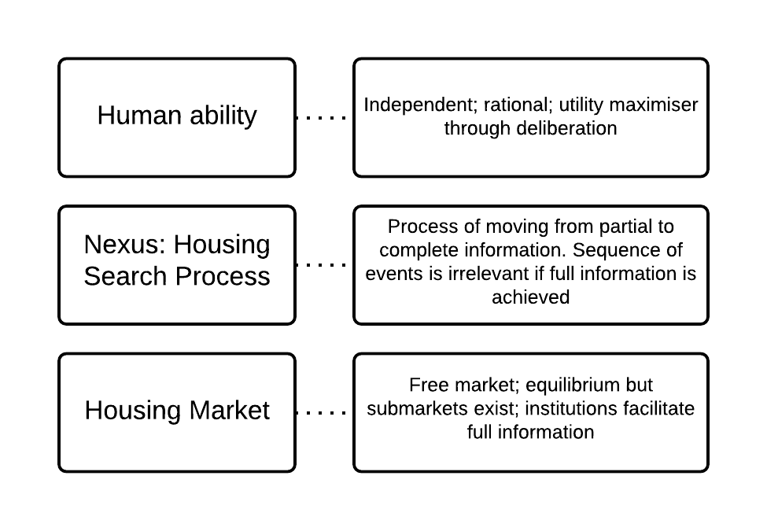
Source: author

Speare, Goldstein and Frey, 1975
As behavioural economics emerged partly as a critique of neoclassical economics with regard to human ability, process and markets, we should expect some variation in these elements in behavioural models of housing search. Speare, Goldstein and Frey (1975) situate their work explicitly in relation to Herbert Simon’s work. One way to combat cognitive limitations is for the household to construct a simplified model of the housing market and of their decision and then act rationally with regards to that model (procedural rationality).

Following Brown and Moore (1970) they separate the housing search process into three detailed stages: determinants of consideration to move; result of the search process; and the decision to move or stay. Citing Simon, their model can be seen to be procedurally rational, in that the household determines a course of action, which may be suboptimal and then acts rationally with regard to it. There is little discussion of the housing search process, suggesting that whilst human ability is viewed as sub-optimal the process itself is not considered to be a function and feature of that bounded rationality.

This model explores satisfaction thresholds, drawing on Wolpert’s behavioral geography work (1965) and rejects utility maximization. This is because households do not search continuously, instead their search is triggered after becoming aware that a threshold of dissatisfaction or of the potential to realize an aspiration has been passed (Mulder, 1996). Speare et al (1975) also assume that households’ awareness of information is constrained and consequently, they reject the full market information outlined by neoclassical economics models.
In contrast to Tu and Goldfinch (1996), Speare et al (1975) argue that actors and institutions influence search processes and outcomes through actors’ descriptions of the housing market and relationships with households. These relationships may have a significant role in guiding the household’s awareness of housing opportunities and neighbourhood characteristics and therefore the decision making process. This approach is not made explicit in the diagrammatic model in Speare et al’s (1975) paper and there is only limited evidence in the text that the housing market will influence outcomes as well as processes.
Fig 3. Speare, Goldstein and Frey’s ontology in relation to key behavioural economics elements
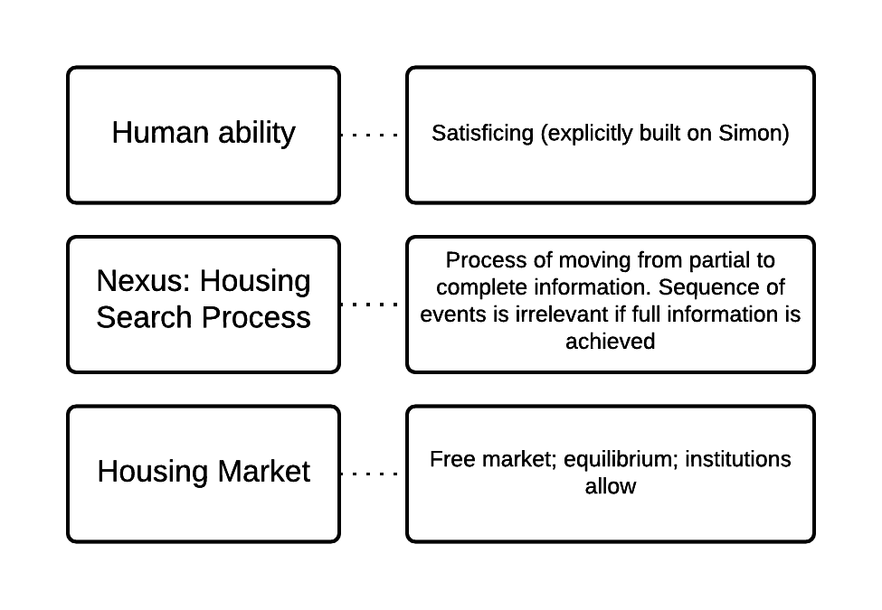
Source: author

Maclennan, 1982
Duncan Maclennan’s book Housing Economics (1982) encouraged an incremental change in the adoption of institutional and behavioural approaches in housing economics. Published in the same year that Clark’s edited book, Modelling Housing Market Search (1982), Maclennan expresses and extends the intent to create a new approach to conceptualizing housing search. Whilst not drawing explicitly on behavioural economics, the implications are clear and led commentators to consider Maclennan’s work to be a behavioural economics approach (Clark, 2011; Needham et al., 2011). The focus on micro economic behaviour and housing search provide signs of variation from neoclassical economics, but not the complete break preferred by Herbert Simon. There is little focus explicitly on human ability and in this regard Maclennan’s work aligns with new behavioural economics. This is confirmed in the model framework characteristics: “the appropriate specification of the structure of the housing choice decision should mean that ‘behavioural’ and ‘neoclassical’ models should no longer be seen as polar alternatives but that they tend to converge as the decision structure is appropriately specified”(Maclennan, 1982, PP.66).

The search process includes extensive and intensive stages. The extensive search stage is related to both the household’s initial preferences and its revised aspirations in an iterative process as the household adjusts tits expectations depending on the types of housing opportunity presented. The intensive housing and finance search stages flow from the extensive search stage as individual dwellings are considered in detail (within defined area and financial parameters). Maclennan acknowledges that distinguishing empirically between the extensive and intensive phases is problematic. The intensive phase feeds directly into the bid formation and offer process.

The model acknowledges that a household may endure a sustained search process, working recursively through the boxes. The manner in which the household is described as doing this, however, implies that moves from one rational step to another. Consider a household viewing a dwelling, engaged in intensive search, but at the same time asking questions about their aspirations and preferences. It may be through the actual experience of viewing a dwelling that a household determines whether it is prepared to trade one housing attribute for another. Therefore, whilst Maclennan’s schematic provides more evidence of the importance of aspects of the housing search process, it does not explicitly extend an explanation of the influence the process itself can have on outcomes.

The behavioural and institutional elements of Maclennan’s model entail a better description of human behavior and the unique characteristics of housing: infrequency of home owners acting in the market (as buyers or sellers); the complex bundle of characteristics comprising a house; the geography of housing; and the difficulty in obtaining appropriate information (Clark, 2011). Maclennan’s (1982) model goes some way to incorporating these concerns. Take for example the gathering of information about opportunities. The household brings aspirations to the extensive search phase, but the housing market institutions also impact on that phase in a recursive relationship. Maclennan argues that housing market context will differ from decision to decision (for example depending on institutional arrangements as well as macro economic conditions) and that in some cases markets will be in disequilibrium.
Fig 4. Maclennan’s ontology in relation to key behavioural economics elements
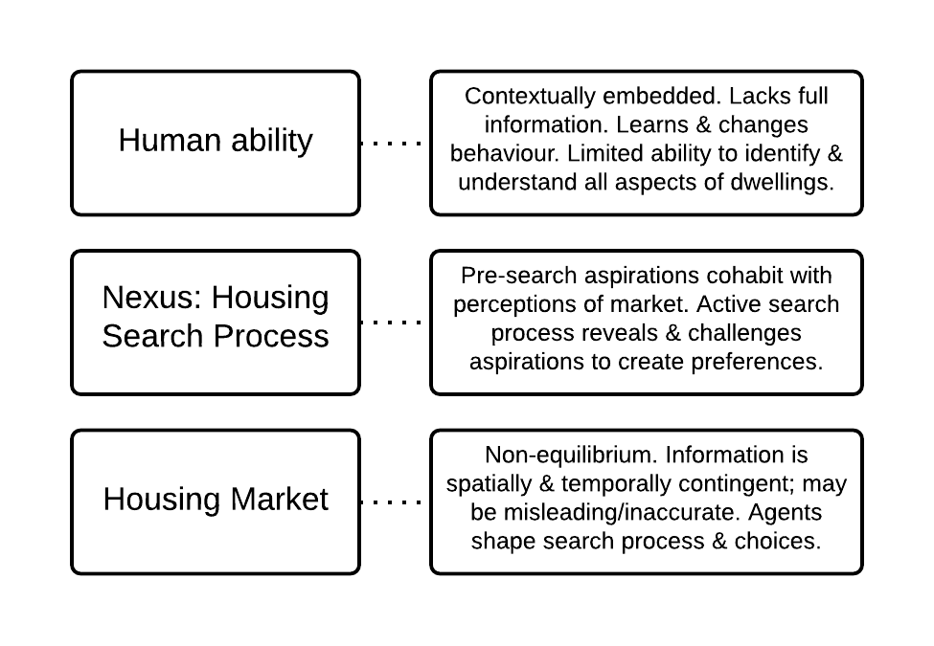
Source: author

Wong, 2002
Wong (2002) develops a more behaviourally rich discussion of human ability than Maclennan, applying Simon’s (1978/1982) concept of satisficing to search:
instead of searching for the best alternative that could be time-consuming or even impossible in view of imperfect information and uncertainty of events, the decision-maker is usually concerned with finding an alternative that satisfies his preferences. This heuristic search for alternatives basically illustrates the essence of “the utility satisficing model” (Wong, 2002, P.221)

Like Speare, Goldstein and Frey (1975) the application of stress threshold levels to the decision to move in Wong’s model is an example of applying a behavioural economics approach to human ability. Households do not continuously appraise their housing. Rather, a search is triggered when a stress threshold level is crossed in their current dwelling. Wong’s model, however, retains perspectives on human ability that conflict with neoclassical economics. The desire to find ‘best value for money’, Wong argues, is more akin to utility maximization than satisficing. Wong applies this mix of satisficing and utility maximization to a two-stage housing search process (the decision to move, then the selection of a new residence). A household creates a shortened list of preferred housing attributes, against which opportunities are evaluated. The stages of the decision require ranking of preferences, evaluating alternatives against set preferences and feedback loops (Wong, 2002). This approach, intended to be procedurally rational, includes the types of decision inherent in the standard economic approach, and similar forms of decision-making (e.g. ranking of housing preferences) but in a form that acknowledges greater computational complexity and is based on less information.

Whilst Wong uses behavioural language, such as heuristics and satisficing, the terms are not applied consistently across to the housing search process. For example, she describes search as a heuristic process but does not define what the shortcut means or what impact it has on the search output. Satisficing is applied to the decision to move and to the selection of attributes to be considered, but not to the search process itself (for example the information sources). In this context the shortcomings of Maclennan’s (1982) work on human ability are partially dealt with but are not applied consistently.

Wong’s (2002) model assumes that the housing market does not impact on the search process. Institutions and agents reveal the range of housing characteristics to choose from, although she recognizes that supply may constrain choice. The decision making process is therefore conceptualized as independent of the housing market.

Whilst all conceptual models are simplifications and abstractions, Wong’s (2002) model takes incompatible elements of both satisficing and neoclassical economics approaches, and therefore lacks an internally consistent explanation of human ability, the search process and the housing market. One example of this is her treatment of the decision to select a new residence or improve a current residence, which is arguably the insertion of a binary option where one does not exist. A household may continue to search for properties whilst enhancing their current dwelling, this may be a utility maximizing rational process in order to increase the price of their existing dwelling, but may also simultaneously represent current and attempted future satisficing.
Fig. 5. Wong’s ontology in relation to key behavioural economics elements
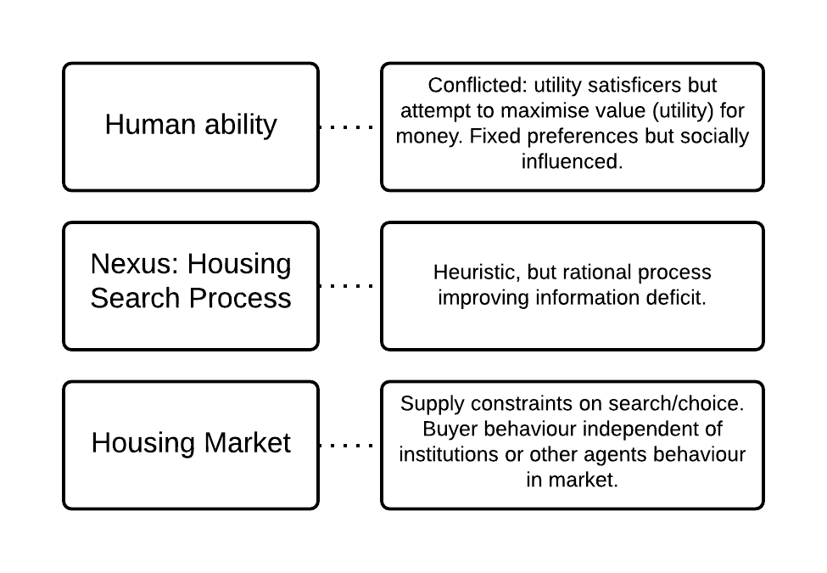
Source: author

Marsh and Gibb, 2011
Marsh and Gibb (2011) argue that the neoclassical economic theory of decision-making under uncertainty does not hold for housing markets. Aligning their model with Maclennan (1982), they argue for the application of all robust behavioural (and institutional) insights about human decision-making to be applied to housing search, rather than singular insights applied to a mainstream approach. Decision-makers’ cognitive power is a scarce resource, and simpler decision-making rules are necessary for most decisions including those relating to the selection of search strategy, area orientation, establishing vacancies, visiting vacancies, evaluating in detail, and forming and placing a bid. The components are not-necessarily sequential, and decision-making occurs throughout these components meaning that someone may enter a housing search process and leave without working through the whole, or may repeat components.

Marsh and Gibb (2011) frame institutional considerations by highlighting the significance of market conditions on the selection of a search strategy. They suggest that in a buyers’ market housing search may be less intense than in a sellers’ market, as the full range of vacancies may be viewed prior to making a decision. In a sellers’ market the searcher is less likely to be able to view all of the vacancies before they are purchased, hence time constraints lead to more intense and selective search behaviour. As the cost of search (intensity) increases the household is more likely to follow suboptimal rules of behaviour in their search. This links clearly to Herbert Simon’s view of dynamic aspiration levels in housing search:
The aspiration level, which defines a satisfactory alternative, may change from point to point in the sequence of trials. A vague principal would be that as the individual, in his exploration of alternatives, finds it easy to discover satisfactory alternatives, his aspiration level rises; as he finds it difficult to discover satisfactory alternatives his aspiration level falls. (Simon, 1955, P.111)

Like previous models, whilst extolling the likelihood of rules of behaviour Marsh and Gibb (2011) do not indicate what these rules might be, or how these rules or habits are learnt or changed. A more institutionally rich discussion of how behaviour is constructed and performed in the housing market should cover the role of intermediaries and the media in influencing expectations of search length and intensity. A more behaviourally rich approach may also consider how rules are adapted and consider intensity as a flexible concept throughout the search process. An old behavioural economics approach questions whether households rationally select search strategies (information sources, intensity etc), suggesting that households pursue norms of behavior and engagement and adapt the search strategy as it proves more or less fruitful. In Simon’s (1972) Theories of Bounded Rationality, a chess game is considered analogous to strategizing and the competing rational and bounded rational approaches are discussed. Simon defines the strategy problem as “one of finding a set of accurate evaluations for the alternative moves immediately before the player” (Simon, 1972, P.165). Rejecting the rational approach that is able to compute all of the possible permutations of moves on the chessboard, Simon suggests that a more realistic approach in chess is to select a move (i.e. the next stage that satisfices the aspirations of the player rather than a complete strategy). This approach suggests that in housing search far from selecting an over-arching search strategy (where the amount and quality of housing opportunities is unknown), households are more likely to select individual heuristic events of housing search (e.g. looking in an estate agents window), and routinely undertake new search events as they re-analyse (with partial, but potentially increasing knowledge) opportunities, aspirations and constraints in the housing market. A bounded rationality approach therefore may be more akin to a trial-and-error approach than rational strategic decision-making.

Area orientation is a fully institutionalized concept in Marsh and Gibb’s (2011) account, with social signals and culturally referenced aspirations the norm amongst homebuyers. These socio-cultural aspects will have an influence on the areas and tenures considered by a household, and may prevent switching between areas and tenures regardless of financial optimization. Marsh and Gibb (2011) combine discussion of personally visiting vacancies and evaluating dwellings in detail. Their approach is a retort to Tu and Goldfinch’s (1996) model and to the possibility of a buyer being able correctly to predict the utility they will obtain from purchasing a house:
evaluating a dwelling as a potential home involves constructing a scenario regarding what life – in all its diverse aspects – will be like in a particular location. It may also involve trying to make an assessment of the likely saleability of the property at some indistinct point in the future. Importantly, it is upon the basis of these scenarios that choices are made: where future prospects are inaccurately perceived choice may appear, from some “objective” viewpoint or with hindsight, perverse and the decision maker may miss the global, or even local, optimum (Marsh and Gibb, 2011, PP.224-225)

Marsh and Gibb include in the idea of satisficing the complexity of imagining utility. The experience of living in a home can only be projected by a household. Whilst the accuracy of these projections is likely to be enhanced by personally visiting the properties, households can only rely on lived experience outwith the opportunity, on partial information and on speculation. Where information is difficult to obtain, or where information masks the likely lived experience of the household, projections may be less realistic. These perceptions again may be less realistic in the case of long-distance movers who have not experienced living in the locality. This is contrasted to a classical concept of rationality, which suggests that the household need not know the definitive experience, but must know the definitive range of experiences (pay-offs). A behavioural economics reply questions not whether the household can accurately predict the definitive experience level, but whether they can predict the precise range of experiences that will occur. Marsh and Gibb’s model is further towards the old behavioural end of the spectrum than previous models, though it does retain some new behavioural hangovers from neoclassical economics. More detail could also be added to the role of institutions in the housing market, which would mark a further distinction between the model and the individualism of new behavioural economics approaches (Clapham, 2011).
Fig 6. Marsh & Gibb’s ontology in relation to key behavioural economics elements
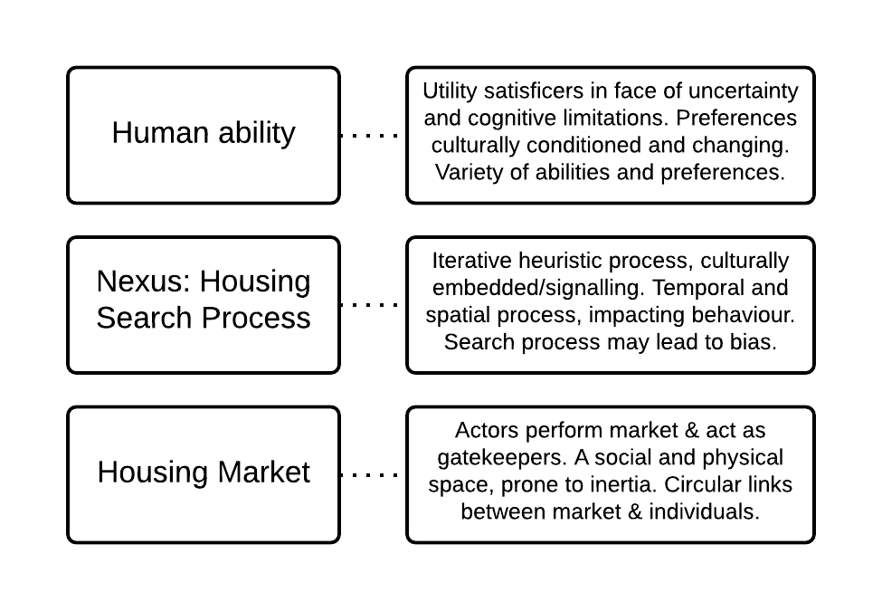
Source: author

Other conceptual models
In addition to the five conceptual models outlined, many other models have made significant contributions to the development of housing search conceptualizations from across the spectrum. Two papers are considered briefly to highlight these contributions. Levy and Lee (2004) dissect the household decision making unit by considering the role of individual family members across the search process. Using a five-stage approach to the decision-making process (problem recognition, product specification, search, evaluation of alternatives and final choice) they conceptualize family members in different roles, for example the men specifying location requirements and women the physical requirements. This reflects culturally embedded norms of behavior, wherein roles differ across groups in society. The issue here is not the precise roles, rather their work reveals that not only are aspirations and preferences culturally formed, but the decision making process internally is itself culturally formed.

Rae’s (2014) model of housing search directly addresses the nexus of growth in online search and behavioural conceptualisations by constructing a new model to support empirical work on online search behavior, the effects of which are currently under researched (Dunning and Grayson, 2014). In Simon’s (1972) essay on bounded rationality one of the limits on rationality is the amount of information available to an actor. Simon considers both incomplete choice sets and incomplete consequence sets. With the rise of Internet based multiple listing services it is conceivable that in some markets the website hosts the complete choice set. In this instance, incomplete information about consequences may pose a larger challenge to economic man than alternatives. Rae’s model suggests that, in this context, housing search should not now be viewed as a single intensity process, and that there is a distinction between the ability of a household to undertake housing search virtually and physically to view properties and to deal with estate agents. The concepts of time and intensity have frequently played little part in housing search conceptualisations, and are to date under theorized and have little empirical support.

Discussion
The growing acceptance of heterodox economics accounts, and in particular those with behavioural antecedents, has enabled greater variety in the philosophical perspectives underpinning housing search theory and in practice in housing policy. This paper explores the variation between behavioural economics models of housing search across three key elements: human ability; the search process; and, the housing market. These variations can be seen clearly when located on a spectrum from neoclassical economics to old behavioural economics (see Figure 7). In this light it is evident that there is an array of behavioural perspectives, which vary considerably and are not all mutually compatible. Whilst the heterogeneity in behavioural models has been evidenced, the interpretation of philosophical presuppositions represented here is partial and not all aspects of the models presented require uniformity of commitment. Further analysis exploring the philosophical positions in these papers could shift them to the left or right of the spectrum.
Figure. 7. A perspective on the theoretical position of search models presented in this paper
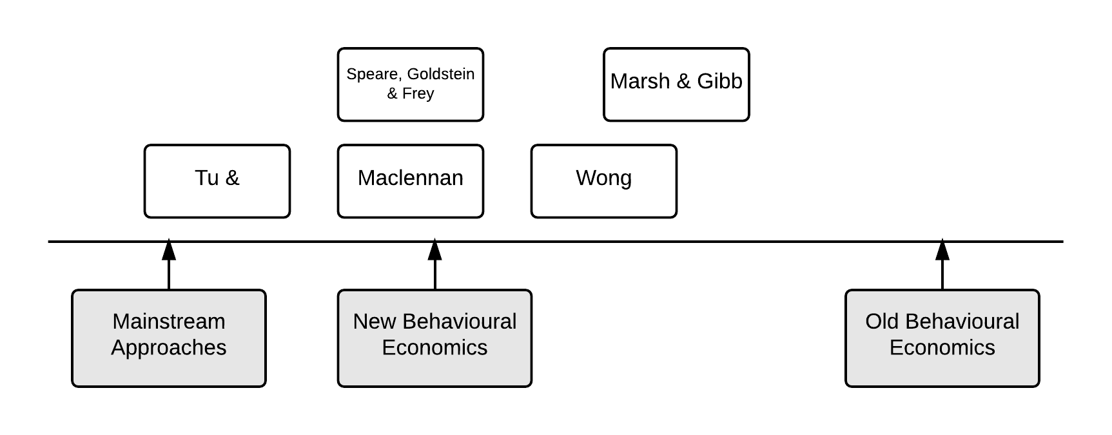
Source: author

Whilst this spectrum might suggest that there has been an incremental approach to adopting behavioural economics, the movement has not been fluid. In line with the variations in philosophical presuppositions between factions of behavioural economics there has been no coherent temporal movement to either a new behavioural perspective or an original/old behavioural perspective. However, it should be recognized that the most prevalent form of behavioural theory in housing economics is closely aligned to new behavioural economics. Few behavioural economics studies explicitly outline their ontological commitments, which hinders comparison and rigorous testing of their ability to be synthesized.

Given this lack of uniformity and clarity in approaches, the potential for policy makers to absorb incompatible insights into policy is evidenced here through two examples. Whilst both new and old behavioural economics use the term ‘bounded rationality’, their views of human ability in some cases lead to inconsistent approaches. The new behavioural economics human acts with limited knowledge to maximize their utility, perhaps through the use of a cost benefit calculation, albeit with computational limits or heuristics. Whereas, the old behavioural economics human is a satisficer whose situation reflects a socially and culturally embedded notion of housing that is ‘good enough’. This difference produces different views of the level and capacity of financial incentives to adjust a household’s housing consumption. Take the Voluntary Right to Buy policy as an example; it is designed to encourage social tenants to become home owners through a financial incentive. In order to have a large-scale impact, in new behavioural economics an appropriate incentive for tenants is the minimum amount to adjust the cost benefit analysis in favour of ownership (taking into account mortgage capacity, policy awareness and framing effects). An old view argues that the amount required will need to be above the minimum cost-benefit amount, in order to overcome households’ inherent satisficing behaviour, otherwise households may not take up the scheme despite missing the optimal utility from an objective point of view.

Second, housing search evidently involves the process of gathering of information. Making price paid data freely available from the Land Registry in England has increased the perspicuity of price information significantly. From both new and old behavioural perspectives this information is likely to have an impact upon search behaviour and outcomes, however the extent of this impact upon the efficiency of the market varies. New behavioural economics points out that a range of systematic heuristics (e.g. anchoring and loss aversion) will continue to impinge upon the search process even with greater availability of information. Old behavioural economics suggests that socially constructed local market structures (including the influence of local ‘experts’ such as estate agents), emotionally shaped cognitive limitations and impressionistic understandings will be a greater limit on the impact that open information may have than a new behavioural approach. These types of discrepancies evidence clear differences in the housing search process. A satisficer who is heavily influenced by social and cultural market institutions will not experience the same search process as an optimizer with cognitive limitations and pose limitations therefore to their ability to be assimilated in housing policy.

Utilising the heuristic approach outlined in this paper will make the ontological variation in behavioural housing studies more transparent. This transparency should also support greater academic rigour in housing search theory as the internal consistency of conceptions of human ability, the search process and markets are interrogated. A re-defined empirical programme addressing aspects only weakly specified currently (e.g. area orientation, changes in information sources and trust relations as well as variations in search behavior between household types) would provide evidence for the potential tractability of either a new or old approach. When this theoretical and empirical heavy lifting has been undertaken we will be in a better place to support the creation and critique of housing policy.
Behavioural economics remains a potentially fruitful avenue for research in housing and useful insights have come from all positions on the spectrum presented. However, clarity and openness is needed from all behavioural economists about the form of their theoretical underpinnings if insights are to be combined. Criticism of behavioural economics must similarly recognize the variation between behavioural stances and specify with precision both their critiques and the type of behavioural economics that the critique addresses.

References
Adams, D. & Watkins, C. (2014) The Value of Planning, RTPI Research report No.5
Angner, E. & Loewenstein, G. (2012) Behavioral Economics, in (Eds) Gabbay, D., Thagard, P., Woods, J. & Maki, U., (2012) Philosophy of Economics, North Holland, Great Britain
Boelhouwer, P. (2011) Neo-classical Economic Theory on Housing Markets and Behavioural Sciences: Ally or Opponent? Housing, Theory and Society, 28, 3, PP.276-280
Brown, L.A. & Moore, E.G. (1970) The Intra-Urban Migration Process: A Perspective, Geografiska Annaler Series B, 52, PP.1-13
Camerer, C.F. & Loewenstein, G. (2004) Behavioral Economics: Past, Present, Future, in Camerer, C., Loewenstein, G. & Rabin, M. (eds) Advances in Behavioral Economics, Princeton University Press, USA
Chang, H-J (2014) Economics: The user’s guide, Pelican, England
Clapham, D. (2011) “I Wouldn’t Start From Here”: Some Reflections on the Analysis of Housing Markets, Housing, Theory & Society, 28, 3, PP.288-291
Clark, W.A.V. (1982) Modelling Housing Market Search, Palgrave Macmillan, London
Clark, W.A.V. (2011) Prices, Expectation and the Changing Housing Market: A Commentary and Discussion, Housing, Theory and Society, 28, 3, PP.262-275
Christie, H., Munro, M. & Smith, S. (2008) The emotional economy of housing, Environment and Planning A, 40, PP. 2296-2312
Dolan, P., Hallsworth, M., Halpern, D., King, D., Metcalfe, R. & Vlaev, I. (2012) Changing Behaviour: The mindspace way, Journal of Economic Psychology, 33, PP.265-277
Dunning, R., & Grayson, A. (2014). Homebuyers and the representation of spatial markets by information providers, International Journal of Housing Markets and Analysis, 7, 3. PP.292-306
Dunning, R., Inch, A., Payne, S., Watkins, C., While, A.,Young, Hickman, H., Bramley, G., McIntoh, S., Watkins, D. & Valler, D. (2014) The Impact of the New Homes Bonus on Attitudes and Behaviour, Working Paper presented to DCLG, April 2014, accessed http://eprints.whiterose.ac.uk/81581/1/White%20Rose%20Working%20Paper.pdf on 17th September 2015
Ferrari, E., Henneberry, J., Leahy Laughlin, D., Tait, M., Watkins, C. & McMaster, R. (2011) Behavioural change approach to the housing sector, Department for Communities and Local Government, UK
Genesove, D. & Mayer, C. (2001) Loss aversion and seller behavior: Evidence from the hosing market, The Quarterly Journal of Economics, November 2001
Gibb, K. (2009) Housing studies and the role of economic theory: an (applied) disciplinary perspective, Housing, Theory and Society, 26, 1, PP.26-40
Gibb, K. & Price, G. (2012) Future directions in housing economics: introduction to a special issue of the Journal of Property Research, Journal of Property Research, 29, 4, PP.271-279
Guy, S. & Henneberry, J. (2000) Understanding urban development processes: integrating the economic and the social in property research, Urban Studies, 37, 13, PP.2399-2416
Haack, S. (2004) Pragmatism, old and new, Contemporary Pragmatism, 1, PP.3-41
Jackson, C. & Watkins, C. (2011) Planning Policy and Retail Property Investment in the UK, Urban Studies, 48, 11, PP. 2321-2338
Jones, R. Pykett, J. & Whitehead, M. (2010) Governing temptation: Changing behaviour in an age of libertarian paternalism, Progress in Human Geography, 35, 4, PP.483-501
Leggett, W. (2014) The politics of behaviour change: nudge, neoliberalism and the state, Policy & Politics, 42, 1, PP.3-19
Levy, D. and Lee, C K-C. (2004) The influence of family members on housing purchase decisions, Journal of Property Investment & Finance, 22, 4, PP.320-338
Maclennan, D. (1982) Housing Economics, Longman Group, Singapore
Maclennan, D. & O’Sullivan, G. (2012) Housing markets, signals and search, Journal of Property Research, 29, 4, PP.324-340
Marsh, A. & Gibb, K. (2011) Uncertainty, Expectations and Behavioural Aspects of Housing Market Choices, Housing, Theory and Society, 28, 3, PP. 215-235
McMaster, R. & Watkins, C. (2006) Economics and underdetermination: a case study of urban land and housing economics, Cambridge Journal of Economics, 30, PP. 901-922
Munro, M. & Smith, S. (2008) Calculated Affection? Charting the Complex Economy of Home Purchase, Housing Studies, 23, 2, PP.349-367
Mulder, C. (1996) Housing Choice: Assumptions and Approaches, Netherlands Journal of Housing and the Built Environment, 11, 3, PP.209-232
Needham, B., Segeren, A. & Buitelaar, E. (2011) Institutions in Theories of Land Markets: Illustrated by the Dutch Market for Agricultural Land, Urban Studies, 48, 1, PP.161-176
Rae, A. (2014) Online Housing Search and the Geography of Submarkets, Housing Studies, 30, 3, PP.453-472
Scanlon, K., & Elsinga, M. (2014) Policy changes affecting housing and mortgage markets: how governments in the UK and the Netherlands responded to the GFC, Journal of Housing and the Built Environment, 29, 2, PP.335-360
Scott, P. J., & Lizieri, C. (2012). Consumer house price judgements: new evidence of anchoring and arbitrary coherence, Journal of Property Research, 29, 1, PP.49-68.
Sent, E-M. (2004) Behavioral Economics: How Psychology Made Its (Limited) Way Back Into Economics, History of Political Economy, 36, 4, PP.735-760
Simon, H. A. (1955) A Behavioral Model of Housing Choice, The Quarterly Journal of Economics, 69, 1, PP.99-118
Simon, H.A. (1972) Theories of Bounded Rationality, in Decision and Organization: A volume in honor of Jacob Marschak, Ed’s McGuire, C.B. & Radner, R., North-Holland Publishers, Amsterdam
Simon, H. A. (1978). Rationality as process and as product of thought, The American economic review, 68, 2, PP.1-16
Smith, A. (1759), The Theory of Moral Sentiments, Prometheus, New York
Smith, S. (2013) Crisis and innovation in the housing economy: A tale of three markets, chp. in Financial Innovation: Too much or too little? Eds. Michael Haliassos, MIT Press, London
Smith, S.J. Munro, M. & Christie, H. (2006) Performing (Housing) Markets, Urban Studies, 43, 1, 81-98
Speare, A., Goldstein, S. & Frey, W. (1975) Residential Mobility, Migration and Metropolitan Change, Ballinger Publishing Company, USA
Swedberg, R. (2011) The Economic Sociologies of Pierre Bourdieu, Cultural Sociology, 5, 1, PP.67-82
Tomer, J.F. (2007) What is behavioral economics? The Journal of Socio-Economics, 36, 3, PP.463-479
Tu, Y. & Goldfinch, J. (1996) A Two-stage Housing Choice Forecasting Model, Urban Studies, V. 33, No. 3, PP.517-537
Veblen, T. (1899) Theory of the Leisure Class: An Economic Study of Institutions, Macmillan, New York
Wallace, A. (2008) Understanding and Performing York’s Housing, Housing Studies, 23, 2, PP.253-270
Watkins, C. & McMaster, R. (2011) The Behavioural Turn in Housing Economics: Reflections on the Theoretical and Operational Challenges, Housing, Theory & Society, 28, 3, PP. 281-287
Whitehead, M., Jones, R. & Pykett, J. (2011) Governing irrationality, or a more than rational government? Reflections on the rescientisation of decision making in British Public Policy, Environment and Planning A, 43, PP.2819-2837
Wolpert, J. (1965) Behavioral aspects of the decision to migrate, Papers in Regional Science, 15, 1, PP.159-169
Wong, G. (2002) A conceptual model of the household’s housing decision-making process: The economic perspective, RURDS, 14, 3, P.217-234
Wilkinson, N. (2008) An Introduction to Behavioral Economics, Palgrave Macmillan, GB

There is a caveat to this claim. This view does not consider time, and the delays between a dwelling becoming available and marketed online. In slow markets this may be of little concern, but it is feasible that in hot markets the dwelling may be transacted before the details have been submitted online. This may be more likely in the rental market than in the freehold market, where time may be of greater significance.

