Electrical and optical properties of a gradient microplasma for microfluidic chips

Paul M. Bryant,*¹ Pascal Wettstein,² Sameer A. Al-Bataineh,² Robert D. Short,^{2,3} James W. Bradley,¹ Suet P. Low,² Luke A. Parkinson,⁴ and Endre J. Szili*²

¹Department of Electrical Engineering and Electronics, University of Liverpool, Liverpool L69 3GJ (UK)
²Future Industries Institute, University of South Australia, Adelaide, SA 5095 (Australia)
³Materials Science Institute and Department of Chemistry, The University of Lancaster, City of Lancaster LA1 4YW, United Kingdom
⁴School of Computer Science, Engineering and Mathematics, Flinders University, Adelaide, SA 5042 (Australia)

Corresponding authors: P.M.Bryant@liverpool.ac.uk and endre.szili@unisa.edu.au

Abstract
We report on how the electrical and optical properties of a spatially varying microplasma might influence the gradient surface modification of an adsorbed protein layer inside a microfluidic chip. Previously, microfluidic chips fabricated with a central microchannel, surounded by two graded electrodes, were shown to generate microplasmas of spatially varying intensities. These could be used to remove / modify adsorbed layers of protein from the microchannel walls in a gradient fashion where the protein removal rate decreases along the length of the microchannel as the plasma intensity diminishes. In this study, microfluidic chips were used without an adsorbed protein layer. Electrical characterisation of the gradient microplasma reveals that the discharge filament distribution and intensity evolves from a broad to bi-modal distribution towards a stable single peak after 65 minutes of operation at a helium (He) flow rate of 5.3 ml / min. Optical emission spectroscopy reveals that this is due to the gradual purging of air with He from the microchannel and gas supply system. The temporal evolution of selected He and nitrogen (N₂) emission lines suggest that excited and metastable states of He and N₂ can play a major role in the removal / modification of protein during the discharge period. In-between discharge events, the N₂(A) metastables can also induce bond breaking and surface modification. However, the role of He in the modification of protein inside the microchannel is only relevant if the process gas (He) is flushed through the microchannel. This depends on the gas delivery system design, including the microfluidic chip, and operation. The purge, or contamination, of air can be monitored by observing the evolution and shape of the filament distribution without use of optical methods. The purge time of the feed gas (prior to plasma treatment) is an important factor that needs consideration in the use of small scale microplasma sources for surface processing or protein modification.

Introduction
The application of low temperature microplasma technology is rapidly advancing in many areas including materials processing,¹⁻⁴ chemical patterning,⁵⁻⁹ photonics,¹⁰ nanomaterial synthesis,¹¹⁻¹⁴ chemical / analyte sensing,¹⁵⁻¹⁷ biotechnology (e.g. cell transfection)^{3, 18-20} and plasma medicine.²¹⁻²⁴ Microplasma sources, broadly defined as electrically driven µm to mm atmospheric pressure gas discharges, can be operated over a wide range of power, frequency and pressure regimes depending on the configuration of the microplasma device.²⁵ Because microplasma sources are amenable for the miniaturisation of technologies they have also found use as excitation sources in lab-on-a-chip devices for in situ chemical modification and patterning of microchannel walls, arraying of biomolecules and for analytical chemistry.^{5, 9, 26-30}

Lab-on-a-chip technology has progressed remarkably within the past 15 years from the preserve of small groups of researchers using “home-built” type of devices to complex, commercially available products for industrial and clinical applications.³¹⁻³⁵ The strong interest in developing microfluidic technology has arisen from the industrial, environmental and societal requirements for “greener” technologies and more accessible and lower cost healthcare. This can be accomplished through miniaturisation of technology that affords higher efficiency, lower fabrication and running costs and a higher level of convenience in handling and operation.

We are interested in the use of microplasma in lab-on-a-chip technology for two reasons. The first is to develop a microplasma (chemical) patterning approach to functionalise the internal walls of bonded microfluidic chips. This approach allows us to add a chemical and biological functionality to the microfluidic chip in situ, which can be used to tailor the microfluidic chip for specific applications in biotechnology (e.g. sensors, cell-screening) and chemical intensive processes such as solvent extraction. The second is to develop biomimetic models based on a lab-on-a-chip design to study the interaction of plasma with biological systems in order to understand how plasma can be used to influence biological processes in a controllable fashion. Because the potential benefits of plasma in healthcare are significant as shown through many promising applications including the stimulation of wound healing,²³ wound decontamination,^{36, 37} dentistry³⁸ and cancer therapy,³⁹ we believe that more fundamental studies of plasma with biomimetic systems is necessary in order to develop safe and effective plasma medical technologies.

In order to effectively pursue the application of microplasma in lab-on-a-chip and in medicine then we must also develop our understanding of the plasma source. However, the characterisation of the microplasma inside the microchannel is challenging; arising from the small scale of the microchannel (50 µm), confined environment and the non-planar geometry. Previously, we demonstrated the efficacy of using gradient microplasmas to modify and generate protein gradients inside microfluidic chips.⁴⁰ In that previous study, we adsorbed a homogeneous coating of bovine serum albumin (BSA) to the microchannel walls. The microcchannel was then exposed to a helium (He) plasma of gradient emission intensity. It was found that a higher amount of BSA was removed at the end with the smallest electrode separation. Here, the plasma emission was highest. As the electrode separation increased and the plasma emission decreased, a lower amount of BSA was gradually removed along the microchannel in a gradient fashion. In this paper, we aim to understand the plasma species and mechanisms responsible for BSA removal. We believe that this new information is necessary to achieve reliable and reproducible operation of microplasma sources inside confined capillary spaces of lab-on-chip devices, to deliver enhanced process control for surface modification procedures and for understanding plasma interactions with biomolecules.

Experimental
Microfluidic chip fabrication
Microfluidic chips, consisting of a PDMS half with patterned microchannels and a flat glass half, were fabricated using PDMS (Sylgard 184, Dow Corning, USA) and microscope slides. A 50 μm SU8 negative photoresist was spin-coated (Suess Delta 80, 3000 rpm) onto Si wafers (50 mm dia., [100], Si-Mat, Germany), baked (4 min at 65 °C and 20 min at 95 °C), exposed (EVG620 Mask Aligner, 250 mJ cm⁻²) and post-exposure baked (1 min at 65 °C and 4 min at 90 °C). After the microchannel structures were developed, they were hard baked (ramping profile 100 °C - 200 °C - 100 °C) and silanized at 80 °C under vacuum (~ 10⁻² Torr, 20 min) using hexamethyldisilane (HMDS). PDMS was cured on the master for 2 h at 65 °C. The gas and gallium inlets were created using a biopsy punch (1.5 mm, Kai Medical, Germany) after removal of the PDMS structure.

The microscope slides were rinsed with acetone and isopropanol, dried under nitrogen (N₂), plasma cleaned (oxygen, 5 min, Harrick Plasma Cleaner) and chemically bonded to the PDMS structure. The PDMS surface was activated by oxygen plasma treatment (15 s, Harrick Plasma Cleaner) before the two halves were compressed up to 30 min in ambient atmosphere. Alongside the 50 μm wide main microchannel with length of 18 mm, two electrode guides were included in the photomask (JD Photo-Tools, UK). These guides were graded, i.e. the electrode – main microchannel distance is 50 μm at one end of the main microchannel and 150 μm at the other end. The width of the electrode guides is 100 μm and the depth of the microchannel is determined by the thickness of the photoresist layer (50 μm). The injection of the gallium electrodes is described elsewhere.²⁶ Briefly, gallium is heated to 50 °C, drawn into ethylene vinyl acetate microbore tubing (Cole Parmer) with a 1 ml syringe and injected into the guide. The electrodes were solidified by adding a seed crystal to a droplet of gallium protruding from the inlet. In this paper BSA protein was not adsorbed onto the microchannel walls. Figure 1a shows the arrangement of the graded electrodes and microchannel and figure 1b shows the gradient in emission intensity of the microplasma along the microchannel as the electrode separation increases. In a proof-of-principle demonstration, we adsorbed a homogeneous coating of fluorescein conjugated BSA to the microchannel walls. The microchannel was then exposed to the plasma of gradient emission intensity. The plasma removed / modified BSA along the microchannel. A higher amount of BSA was removed at the higher intensity plasma intensity end and gradually a lower amount of BSA was removed along the microchannel as the plasma emission reduced in intensity. This was visualized inside the microchannel by fluorescence microscopy of the fluorescent BSA protein (figure 1c).

Microplasma operation and electrical measurements
The experimental set-up is shown in figure 2. A signal generator (Farnell ESG.1) was connected to an audio amplifier (HQ power VPA2350MB) and a custom made step-up transformer (Express Transformers, UK) to generate sinusoidal voltages at 10 kHz and 8 kV_{pk-pk}. The electrical connection to the microfluidic chip was made by using unshielded (stripped BNC cable) in order to minimize current loses which can be significant at these high voltages. He gas (BOC 99.996 % purity) was passed through copper gas tubing (initially filled with air) into an Omega FL3800 series rotameter with a glass float (FLT-45G). The gas flow was fixed at the lowest measureable He flow rate of 5.3 ml / min. A gas-tight custom-made adaptor allowed connection to the micro-bore tubing (Cole Parmer), which was push-fitted into the microfluidic chip. The experiment was housed in a dark box to minimize stray light. The driven electrode voltage was measured by a Tektronix P6015A voltage probe. The discharge current was obtained from a voltage probe (Tektronix P6139A) connected across a 75 Ω resistor between the opposing electrode and ground. Electrical signals were then displayed on a Tektronix DPO3034 oscilloscope.

Optical emission spectroscopy (OES) and optical imaging
The microfluidic chip was mounted onto a vertically adjustable holder which was fixed onto a carriage and optical rail. A 600 μm optical fibre (Ocean Optics P600-1-SR) was placed in a separate holder and vertically adjusted until the fibre head was aligned close to the microchannel (glass side). The fibre assembly was mounted onto a moveable rail carriage that allowed for micrometer controlled movement of the optical fibre along the microchannel. The fibre was coupled to an Ocean optics (USB4000-UV-VIS) spectrometer (full width at half maximum, FWHM, resolution of 1.5 – 2.3 nm). Time averaged optical emission data was acquired with 20 s exposure (Boxcar average over 10 data points) after background subtraction of stray room light. A video camera (JVC TK-S350) was positioned, on a rail carriage, in-front of the microfluidic chip (PDMS side) to image the discharge and was used to align the fibre to the microchannel. In both the electrical and optical experiments the air inside the gas supply system was not purged before acquiring measurements. The discharge was ignited, and measurements were acquired, a few minutes after opening the valve for He to flow to ensure a steady flow rate.

Results
Electrical properties
He gas was allowed to flow at a fixed rate of approximately 5.3 ml / min, with the electrical and optical measurements taken regularly at 10 min intervals. Discharge parameters (8 kV_{pk-pk} at 10 kHz) were kept constant throughout the experiment. After ignition, the discharge current showed distinctive filamentary behaviour (see ESI, figure S1), similar to those observed in a larger dielectric barrier discharge (DBD)⁴¹ and in a similar microfluidic DBD plasma.⁴² Due to the random temporal occurance of the filaments, the captured screen images were found to be inadequate in determining the variation of filament amplitude and the voltage range over which the filaments occurred. By using the oscilloscope in envelope mode it was possible to capture all measured filaments over a longer interval of time. This allowed the filament distribution over the entire voltage period to be more easily observed. Figure 3 shows the filament envelope from just after ignition (2 min) and at 24 and 84 min. The discharge ignited twice per period with the regions of no discharge defined by bands of constant current amplitude due to accumulated noise. Filaments of both positive and negative amplitudes were observed over a wide range of voltages. In both discharges, the larger amplitude filaments are associated with the same polarity as the electrode voltage (i.e. positive current during positive half period). The filaments that occured in the negative half-period of the voltage waveform are larger than those in the positive half-period. This suggests that during the negative half cycle the discharge is more intense with higher electron and radical densities. The discharge envelope evolved from a single broad peak (2 min), slowly increasing in amplitude and duration, to a bi-modal distribution (24 min). This is characterised by a narrow intense peak and a less intense broader peak. At later times, the filament distribution decreased in amplitude to a single narrower peak appearing after 55 min (Figure 3, 84 min).

The ignition of each discharge shifted to earlier times (Figure 3) with changes in the threshold voltage at which the discharge appears. Charge accumulation on the microchannel walls, during each succesive discharge event, is time dependant and manifests as a memory voltage. The applied voltage is then augmented by the memory voltage so that small applied voltages can still lead to discharge ignition.⁴¹ The onset voltage in the negative half period increased from 0.2 kV (at 2 min) to 1.8 kV (at 84 min). Also shown is the displacement current (1.1 mA_{pk-pk}, averaged over 128 samples), which is leading the voltage waveform by approximately 90º due to the capacitive nature (< 1 pF) of the microfluidic chip and capacitive coupling to nearby grounded metal wires and surfaces.

The temporal behaviour of the peak filament current (the first and largest narrow peak after each ignition) and the discharge duration is shown in figure 4. Both the peak filament current and discharge duration show similar trends. The peak filament current, after reaching a maximum value around 5.3 mA (at 14 min) decreases to a minimum value, around 1.3 mA between 45 and 55 min, before increasing to a plateau after 65 min. The increase in the peak filament current, due to more intense filaments, is indicative of a rise in the electron density. After reaching a maximum value, the peak filament current (electron density) decreases to a minimum value before increasing and reaching a steady value at around 65 min. The discharge duration reaches a maximum time of 35 ms before decreasing to a steady value of around 7 ms at later times. The discharge duration and electron density (proportional to the intensity of the filament current) are important factors that determine how much BSA protein is removed from the microchannel walls. It has often been observed experimentally¹ that longer treatment times (discharge duration) enhances the surface modification. Higher electron densities, resulting in higher excited, metastable and ion densities, increases the rate of surface modification.¹

Optical emission characterisation
A typical optical emission spectrum acquired at 84 min is shown in figure 5. The optical fibre was positioned at the end with the smallest electrode seperation of 50 μm. All line intensities are normalised (relative intensity units) to the most intense N₂ 337.13 nm line acquired less than 1 min after ignition. Lines were analysed by identifying persistant lines from all available data to mitigate the effects of random noise. Lines were assigned to particular transistions if the wavelength discrepancy, Δ = ⏐λ_{observed} - λ_{assigned}⏐, was less than the spectral resolution of the spectrometer (FWHM of 1.5 nm). In cases where Δ > 1.5 nm the discrepancy is stated. Clear emission lines from the second positive system (SPS) of N₂ (C³Π_{u} – B³Π_{g} transition) rotational states are observed between 268 – 546 nm.⁴³ Most of the SPS lines overlap with those from He. Lines were then assigned if they share the same temporal behaviour as unambiguous lines (see figure 5). The upper C³Π_{u} state (N₂ SPS) has a threshold energy, E_{threshold}, of 11 eV above the ground state.⁴¹ At atmospheric pressure, during each micro-discharge filament, this high level state is likely to be populated by multi-step in-elastic electron collisions. Emission around 390 and 426 nm correspond to emission from the first negative system (FNS) of N₂⁺ (B²Σ_{u}⁺ - X²Σ_{g}⁺) at 388.43, 391.44 (Δ = 1.74) and 427.81 (Δ = 1.87) nm.⁴³ In general, ion lines are unlikely to contribute significantly to the observed peak intensities due to the low fractional ionisation at atmospheric pressure. However, observations in DBDs with flowing He and air mixtures demonstrate that the transition at 391.44 nm can be as strong as the He lines.⁴¹

Additional peaks atributed to various He lines are observed between 388 – 728 nm.⁴⁴ Two He emission lines (706.57 and 706.52 nm) occur around 706.5 nm which, due to the spectrometer’s resolution, are unresolvable. The He emission at 706.5 nm is caused by a transition from the 3s ³S₁ to the 2p ³P_{0,1,2} state.⁴¹ The upper 3s ³S₁ state can be populated via electron collisions, during the micro-discharge filament, from the ground state (E_{threshold} = 22.72 eV) or from the metastable states (2s ³S₁ E_{threshold} = 2.9 eV and 2s ¹S₀ E_{threshold} = 2.12 eV).⁴⁴ The 3s ³S₁ state can also be populated by either associative ionization:

He*(n ≥ 3) + He He₂⁺ + e (1)

or by three-body collisions involving He ions and metastables:

He⁺ + 2He He₂⁺ + He; He^{m} + 2He He₂* + He (2)

combined with dissociative recombinaton:

He₂⁺ + e He₂* He*(n = 3) + He (3)

followed by:

He*(n = 3) He*(n = 2) + hv (≈ 706.5 nm)

The strong He emission at 706.5 nm and the above reaction scheme indicates a high abundance of He₂⁺, He⁺ and highly excited He atoms (n > 3, E > 22.72 eV) in the filamentary discharges.^{41, 45} These species decay on a timescale of 100s of ns during the filament afterglow.⁴¹ Electrons with energies between 2.12 eV and 19.82 eV, to excite from metastable and ground states, must also be present during the discharge filament.

Figure 6 shows the time evolution of selected prominent lines from both N₂ (314, 337.13, 357.69 and 380.94 nm) and He (667.8 and 706.5 nm). The 313.6 nm and 315.93 nm N₂ lines are unresolvable and are desinated as 314 nm. Both the 314 nm and 380.94 nm N₂ lines have almost the same relative intensity and are shown as a single line. Residual air is present in the gas supply system and microchannel prior to introducing He. It is reasonable to assume that the N₂ concentration is decreasing over time as the air is flushed out in the microchannel. Despite this, all of the N₂ lines increase in intensity up to 33 min. This behaviour could then be due to an increasing electron density and is consistant with increases in the peak filament current, the intensities of the He lines (667.8 and 706.5 nm) and the discharge duration (Figure 3). Collisions between He metastables are also known to produce electrons⁴⁶ in addition to associative and multi-step ionization. At approximately 33 min after ignition, the line intensities reach maximum values (between 33 and 43 min). This time period corresponds to the bi-modal filament envelope (Figure 3). After 43 min, the N₂ SPS line intensities decrease and coincide with the reduction in the peak filament current and reduced discharge duration. The associated drop in electron density and diminishing N₂ concentration in the microchannel results in the decreasing SPS line intensities. Stability is reached in both the peak filament current and discharge duration after 64 min when the N₂ lines have decreased to values comparable to the He lines (Figure 5).

Also shown are the 390 and 427 nm emission lines, which show different temporal behaviour. The 390 nm emission reaches a maximum intensity at around 53 min and then slowly decreases. The maximum is reached after the maxima for the N₂ lines between 33 and 43 min. The observed peak around 390 nm involves contributions from He (388.87 nm), N₂ (389.46 nm) and N₂⁺ (391.44 nm). Although it is difficult to determine the relative contributions to the measured peak it is likely that the observed behaviour is a result of the interplay between the steadily increasing He concentration and the variation in both N₂ and N₂⁺ emissions. The 427 nm emission also increases steadily, reaching a maximum at the same time as the 390 nm line, before decreasing at a slower rate. The 427 nm emission, which has contributions from N₂ (426.97 nm) and N₂⁺ (427.81 nm), is likely to have a significant contribution from N₂⁺. The presence of N₂⁺ is verified by the observed weak emission at around 485 and 626.76 nm in figure 5. These emissions correspond to the transitions B²Σ_{u}⁺ - X²Σ_{g}⁺ (485.0 and 485.7 nm) of the FNS and A ²Π_{u}⁺ - X ²Σ_{g}⁺ (626.76 nm) of the Meinel system.⁴³ The FNS transitions at around 390, 427 and 485 nm can be caused by the very fast Penning ionization of He metastables:^{41, 45}

He^{m} + N₂ N₂⁺(B ²Σ_{u}⁺) + He + e (4)

and also by the charge transfer reaction:⁴¹

He₂⁺ + N₂ N₂⁺(B ²Σ_{u}⁺) + 2He (5)

The He metastable, He^{m} (E_{threshold} = 19.82 eV), can be populated by direct electronic transitions from ground state, cascade transitions from higher level states and by reaction (3). The molecular ion He₂⁺ can be produced from reactions (1) and (2) as well as by Penning ionization with He^{m}.⁴⁶ The Penning reaction rate (4) is so high that the effective lifetime of the He metastables and the N₂⁺ ions are comparable to the lifetime of the micro-discharge filament.⁴⁵ The main loss mechanisms for N₂⁺ (B ²Σ_{u}⁺) is radiative decay to the X ²Σ_{g}⁺ state and quenching with ground state N₂ via the reaction:

N₂⁺ (B ²Σ_{u}⁺) + N₂ products + N₂ (6)

with rate constant k = 3.7 × 10⁻¹⁰ cm³ s⁻¹.⁴⁵ The decay time is around 0.1 ns so that the effective lifetime for these ions is also limited to the lifetime of the discharge filament (10 – 100 ns). In addition to the reaction scheme (4) and (5), N₂⁺(B ²Σ_{u}⁺) can also be produced from the ground states of N₂ (E_{threshold} = 18.7 eV) and N₂⁺ (E_{threshold} = 3.17 eV) by electron collisions.⁴¹

In reactions (4) and (5) the reaction product N₂⁺ is dependant on the abundance of He^{m}, He₂⁺ and N₂. The continual increase in the 706.5 and 667.8 nm emission intensities (see figure 6) indicates that the He species (He₂⁺, He, He*, He⁺ and He^{m}) also steadily increase. The FNS lines (390 and 427 nm) follow the increase of the He lines (706.5 and 667.8 nm) even after 33 min where the peak filament current and SPS lines are decreasing. The loss of N₂ molecules (reaction 6) must occur at a slower rate than the combined production rate of He^{m} and He₂⁺ (reactions 4 and 5). Eventually, after the intensity maxima has been reached, the loss rate of N₂ dominates over the production rate of He^{m} and H₂⁺ and the N₂⁺ densities and emissions start to decrease. Similar flow related effects were observed in a larger DBD reactor in flowing He in ambient air.⁴¹

In the same experiment the CCD camera was used to acquire pictures of the discharge through the PDMS side. The time evolution of the total light emission is shown in figure 7 with pictures taken at different times after discharge ignition. Up to about 40 minutes after ignition the discharge emission is mostly confined to the region with the smallest electrode separation. In figures 4 and 6 this corresponds to both the prominent N₂ emission lines and discharge duration increasing in magnitude to maximum values. After 40 minutes of operation the discharge starts to expand downstream into regions of increasing electrode separation. In figures 4 and 6 this corresponds to the gradual increase of the He lines, the decrease of the prominent N₂ emission lines and the discharge duration.

The variation of the most prominent emission lines along the microchannel is shown in figure 8. The spectrums were acquired over a duration of 40 min from the ignition of the discharge starting from the most intense end of the microchannel. The optical fibre was moved along the microchannel in approximately 2.6 mm steps with distance measured from the electrode edge at the smallest electrode separation (i.e. upstream). Intense emission is observed around 0.4 mm which corresponds to the brightest glow of the discharge (as confirmed by comparing the fibre position with the image obtained by the video camera). These lines originate from the N₂ C³Π_{u} – B³Π_{g} second positive system (SPS) with no He detected in this experiment. As the fibre is moved downstream, with the electrode seperation gradually increasing, all of the line intensities rapidly decrease to less than 0.16 (relative intensity) at a distance of 3 mm. These lines then gradually decrease until the last measurement position near to the end of the microchannel at 16 mm. At 18.8 mm, outside the region of the electrodes, no lines are detected.

Discussion
We conducted an electrical and optical study of the microplasma to provide an insight into the nature of the plasma environment and possible mechanisms that may be involved in the plasma modification of biomolecules to generate gradients of proteins inside confined microchannels. The removal or modification of protein can occur during the discharge period (with durations 6 – 34 µs) consisting of many transient filamentary discharges (10 – 100 ns duration). During each microdischarge filament, collisions by energetic ions (e.g. N₂⁺) accelerated in strong electric fields (caused by surface charges) and absorption of VUV photons can cause bond-breaking within the protein. In addition, excited N₂ neutrals, metastables and radical species such as O₃, OH and NO_{x} are well known reactants which can cause surface modification or functionlisation. The optical emission spectrum of the discharge up to around 40 min (see figure 5) is dominated by N₂ emission lines. The absence of OH (200 – 315 nm with intense peaks around 310 nm) or NO_{x} lines (190 – 300 nm) in the spectrum could be due to the attenuation of glass. It is well known that glass typically allows transmission of light for wavelengths above 300 nm with the transmission dropping rapidly below 300 nm. The atomic oxygen line at 777 nm, which is usually an intense emission line indicative of the presence of oxygen, is not observed. This does not mean that these reactive species are not present. However, their relative abundance in laboratory air is expected to be small (e.g. O₂ ≈ 20 %) compared to that of N₂ (≈ 78 %) and may not be detectable by the spectrometer. Filaments occur randomly both in time and space⁴⁵ so that the filament intensity, distribution along the microchannel and overall discharge duration per cycle will determine the rate of protein modification. For the experimental conditions used in this study, the intensity of the N₂ (C³Π_{u} – B³Π_{g}) SPS bands decrease rapidly to within 3 mm from the electrode edge (see figure. 8). This means that the length of the main discharge is less than 3 mm. The observed intense emission in this region indicate that the filament density, and by inference protein removal rate, is highest here. Downstream, with increasing electrode seperation, the observed fainter emission suggests that the filament density (and current) is signifiacntly lower than in the main discharge region. Consequently, the rate of protein modification is expected to be significantly lower in the tenuous discharge region. With increasing electrode gradient, and weaker electric fields, the filament density is expected to decrease further leading to less protein modification along the microchannel.⁴⁰

The period in-between discharges (with duration of 10 – 20 µs) can also result in protein modification. In a recent paper, laser induced fluorescence spectroscopy was used to determine the N₂(A³Σ_{u}⁺) metastable density in a single micro-discharge filament, in a DBD reactor with pure N₂ at 0.5 Bar.⁴⁷ It was found that the metastable density reached a maximum value with densities around 5 × 10¹³ cm⁻³, several µs after extinction of the microdischarge. In a computational DBD model values of the order of 10¹² cm⁻³ were also reported.⁴⁵ After the extinction of a filamentary discharge, collisional de-excitation from the higher level C³Π_{u} and B³Π_{g} states can populate the N₂(A³Σ_{u}⁺) metastable state. The energy level of this state is around 6 eV above ground level and is more than enough to break chemical bonds of protein such as C-H, C-C and amide (peptide) bonds with dissociation energies typically reported below 5 eV.^{2, 48} Given the close proximity of the channal walls, surface-to-volume ratio: S / V = 8 × 10⁴ m⁻¹, this will occur if the characteristic diffusion time, τ_{D}, is significantly less than the residance time, τ_{r}, in the microchannel due to gas flow. The characteristic diffusion time is given by τ_{D} ≈ a² / D, with the diffusion coeffcient D ≈ 10⁻¹ cm² s⁻¹ (N₂, 1 Bar, 300 °K) and the characteristic distance (a = 25 µm) from microchannel axis to wall. This gives τ_{D} to be around 63 µs. The residance time can be estimated from τ_{r} = L a² / F_{v} with L the microchannel length (L = 18 mm) and F_{v} is the volumetic flow rate. Taking the majority of the species to be N₂ the effective N₂ flow rate is 2 ml / min. This gives the residence time to be around 338 µs. This allows for sufficient time for the metastable density to build up. The dominant loss mechanisms for these metastables is via collisions with ground state N₂ neutrals N₂(X) (rate constant, k_{X} = 3 × 10⁻¹⁶ cm³ s⁻¹) and via the pooling reaction:

N₂ (A³Σ_{u}⁺) + N₂ (A³Σ_{u}⁺) N₂ (C³Π_{u}, B³Π_{g}) + N₂ (X ¹Σ_{g}⁺)

with a rate constant k_{A} ≈ 1.5 – 4 × 10⁻¹⁰ cm³ s⁻¹.⁴⁷ Assuming a N₂(X) density of 2.4 × 10¹⁹ cm⁻³ (1 Bar, 300 °K) then the characteristic decay time, τ = (n k)⁻¹, is around τ_{X} = 139 µs for collisions with ground state neutrals. This is comparable to the corresponding decay time of τ_{A} = 50 - 133 µs for the pooling reaction above (with n_{A} = 5 × 10¹³ cm⁻³).. The total decay times for both loss mechanisms is τ_{T} = (τ_{A}⁻¹ + τ_{X}⁻¹)⁻¹ = 36.8 - 68 µs. This is comparable to the diffusion time of 63 µs. The metastable density in the microchannel is likely to be lower than that in a larger DBD. This would mean a longer decay time for the pooling reaction increasing the overall decay time. Note that these decay times are longer than the period in-between successive discharges. Consequently, the metastable density reaches a steady value over many cycles. Other quenching processes such as collisions with O₂(X)⁴⁹ can be neglected due to the low abundance of O₂ in air and the lower rate constant of k_{O} = 2.5 × 10⁻¹² cm³ s⁻¹. This strongly suggests that N₂ metastables can contribute significantly to the breaking of the protein chemical bonds.

It is also useful to consider the role of He in protein surface modification and removal at later times, i.e. after 33 min of He flow, when the He emission appears in the observable spectrum. The lowest level above ground state is around 20 eV and corresponds to the 2s metastable states. Excited and metastable He atoms, upon collision with the protein-coated walls, can induce bond breaking leading to protein modification and eventual removal. However, due to the very fast Penning reaction (4) the decay time is around 0.6 ns (k_{m} = 7.1 × 10⁻¹¹ cm³ s⁻¹)⁴⁵ limiting the metastable lifetime to the discharge duration. The bond-breaking and modification of protein due to excited and metastable He atoms, as well as N₂, is likely to occur only during the discharge period. In-between these discharge events the N₂(A) metastables can induce bond breaking and surface modification. All of these processes, after inducing bond breaking, can lead to the eventual removal of the protein from the microchannel walls, chemical modification of the protein, changes in the protein’s secondary structure and protein fragmentation.^{9, 50-52}

It was also found that the time allowed for the He to flush the residual air out of the microchannel and gas supply system prior to igniting the discharge is important. Under our experimental conditions, and for flushing times under 60 min, bond-breaking of protein (if present) would be dominated by N₂ ions and excited species. After 60 min, He ions and excited species start to contribute with decreasing contribution from N₂. This causes changes in the discharge electrical characteristics (e.g. filament distribution) as measured from the discharge current. This is due to the longer time required to flush N₂ out of the gas supply system and microchannel by He, at relatively low flow rates (of 5.3 ml / min for He). The actual purge time of air will depend on the volumetric flow rate and the internal volume of the gas supply system. The volumetric flow rate is determined by the pressure difference between the gas supply and the outlet port of the microfluidic chip (nominally atmospheric pressure) and the overall conductance of the gas supply system (with varying lengths and diameters). The overall conductance is expected to be determined largely by the microchannel itself. Given the volumetric flow rate, F_{v}, an estimate of the purge time can be obtained if the internal volume of the gas system is known. The volumetric flow rate for air, equivalent to He flowing at 5.3 ml / min, is around 2 ml / min. The internal volume, vol, of the gas supply system, largely taken up by the copper pipes, was estimated to be around 40 ml. This gives a characteristic purge time, τ_{p} = vol / F_{v}, of around 20 min. This is less than the measured results with N₂ significantly reduced but still observable in the optical emission spectrum at 84 min. Note that the spectrometer was not calibrated for absolute intensity so there is a wavelength dependant attenuation factor which makes comparison of intensities qualitative. Sources of leaks into the microchannel should also be considered. The He gas flows through a tube which is push-fitted into the microchannel of the PDMS microfluidic chip. Atmospheric gases can then diffuse through the gap between the tube and PDMS. Another source is from the PDMS material which typically has a high permeability coefficient. Air present in the material can diffuse into the microchannel. The higher pressure He inside the microchannel will slowly permeate through the PDMS gradually flushing out the air. By observing the evolution of the electrical characteristics the removal or contamination of air from inside the microchannel can be monitored without use of an optical spectrometer or estimating the purge time.

Comparison of the plasma intensity profile along the microchannel in our previous work⁴⁰ (Figure 3 a, d = 150 μm) with this study (Figure 8) shows a significant difference. In our previous work, the total light intensity (normalised to the intensity at the narrow end of the microchannel) decreases steadily along the microchannel reaching a value of around 0.15 (relative intensity). In Figure 8 the light intensity (normalised to the 337.13 nm N₂ emission line at the start of the experiment and narrow end of the microchannel) decreases rapidly to around 0.2 (relative intensity) within 3 mm of the narrow electrode gap. In our previous work, the internal volume of the gas supply system from the mass flow controller to the microfluidic microchannel was 0.785 ml. The gas line from the gas bottle to the mass flow controller (MFC) was purged of air at 5 L / min for about 1 minute before connection to the microchannel. The gas line between the MFC and the microchannel outlet was then flushed for a further 15 minutes at 2.5 ml / min before igniting the discharge. Assuming that the gas in the line between the gas bottle and the MFC is He and the gas line between the MFC and the microchannel outlet is air then the characteristic purge time, τ_{p}, at a flow rate of 2.5 ml / min is 0.3 min. Furthermore, it was observed that the length of the emission region inside the microchannel increased along the microchannel towards the wider electrode end (Figure 7) after about 40 minutes. This expansion of the discharge glow along the microchannel is consistent with the gradual purging of air with He in the microchannel. It can be concluded that the gradual decrease of light emission along the microchannel, observed in our previous work,⁴⁰ is from a He discharge. The rapid decrease of the light emission along the microchannel in this work is from a discharge with an air – He mixture.

Conclusions
In our previous paper we demonstrated that microfluidic chips, fabricated with microchannels adjacent to pairs of graded electrodes, can be used to generate microplasmas with gradient emission intensities, which is dependent on the slope of the electrodes.⁴⁰ Microplasmas with graded emission intensities were used to produce micro-scale surface protein gradients in bonded microchannels. In this paper, we have demonstrated that the purge time of air from the microchannel is an important factor that can influence the removal rate of protein that was adsorbed onto microchannel walls prior to microplasma treatment. The resulting flow effect, with gradually increasing amounts of the process gas e.g. He, causes the discharge filament distribution, discharge duration, peak filament intensity and discharge length to slowly evolve over time towards a steady state. This can be monitored by observing the filament distribution or the discharge length within the microchannel without the need for optical emission spectroscopy. We argue that the removal and / or modification of protein (from bond-breaking) occurs during the filamentary discharges and, with sufficient amount of metastable N₂, in the period between sucessive microdischarges. During the filament discharge period, breaking of the chemical bonds in the protein can occur from collisions by highly excited neutrals, metastables, energetic ions (accelerated in strong electric fields) of both He and N₂, and absorption of VUV photons. In the period between filamentary discharges, bond breaking can result from collisions with N₂ metastables that have diffused to the wall. Although not limited to these applications, this technology finds immediate use in bioassays requiring surface-bound biomolecule or adhesive gradients. Controlling the plasma generation of excited He, N₂ and N₂(A) metastables reactive species, by electrically pulsing the plasma and adjusting the discharge on and off times, may be an important methodology in tailoring surface treatments for specific applications in the future. The discharge length can also be tailored by use of gas mixtures to control the spatial extent of BSA removal in the microchannel. Finally, our results also have implications for the use of microplasmas in medicine where the influence of purge of time could signifcantly affect the resultant medical outcome; such as in the tartgetted treatment of tumours, wound debridement and in the use of microplasmas in therapeutic endoscopy.

Acknowledgements
The microfluidic devices were fabricated at the South Australian node of the Australian National Fabrication Facility. We would like to thank them for the facilities and technical assistance. Part of this work was supported by the ANFF-SA start-up award. We thank Dr Craig Priest for his technical help with the microfluidic chip design and for proof reading the manuscript.

References
¹E. J. Szili, S. A. Al-Bataineh, P. M. Bryant, R. D. Short, J. W. Bradley, D. A. Steele, Plasma Process. Polym. 8, 38 (2011).
²P. M. Bryant, E. J. Szili, T. Whittle, S.-J. Park, J. G. Eden, S. Al-Bataineh, D. A. Steele, R. D. Short, J. W. Bradley, Surf. Coat. Technol. 204, 2279 (2010).
³S. Yonson, S. Coulombe, V. Léveillé, R. L. Leask, J. Phys. D: Appl. Phys. 39, 3508 (2006).
⁴H. M. L. Tan, H. Fukuda, T. Akagi, T. Ichiki, Thin Solid Films 515, 5172 (2007).
⁵C.-P. Klages, A. Hinze, K. Lachmann, C. Berger, J. Borris, M. Eichler, M. von Hausen, A. Zänker, M. Thomas, Plasma Process. Polym. 4, 208 (2007).
⁶S. Kreitz, C. Penache, M. Thomas, C. P. Klages, Surf. Coat. Technol. 200, 676 (2005).
⁷A. Hinze, C.-P. Klages, A. Zänker, M. Thomas, T. Wirth, W. E. S. Unger, Plasma Process. Polym. 5, 460 (2008).
⁸A. Möbius, D. Elbick, E.-R. Weidlich, K. Feldmann, F. Schüßler, J. Borris, M. Thomas, A. Zänker, C.-P. Klages, Electrochim. Acta 54, 2473 (2009).
⁹E. J. Szili, S. A. Al-Bataineh, P. Ruschitzka, G. Desmet, C. Priest, H. J. Griesser, N. H. Voelcker, F. J. Harding, D. A. Steele, R. D. Short, RSC Adv. 2, 12007 (2012).
¹⁰R. M. Sankaran, D. Holunga, R. C. Flagan, K. P. Giapis, Nano Lett. 5, 537 (2005).
¹¹D. Mariotti, R. M. Sankaran, J. Phys. D: Appl. Phys. 43, 323001 (2010).
¹²W.-H. Chiang, R. Mohan Sankaran, Nat. Mater. 8, 882 (2009).
¹³J. Fang, I. Aharonovich, I. Levchenko, K. Ostrikov, P. G. Spizzirri, S. Rubanov, S. Prawer, Crys. Growth Des. 12, 2917 (2012).
¹⁴H. Shirai, T. Kobayashi, Y. Hasegawa, Appl. Phys. Lett. 87, (2005).
¹⁵P. Siebert, G. Petzold, A. Hellenbart, J. Muller, Appl. Phys. A: Mater. Sci. Process. 67, 155 (1998).
¹⁶J. M. Symonds, A. S. Galhena, F. M. Fernández, T. M. Orlando, Anal. Chem. 82, 621 (2009).
¹⁷R. Foest, M. Schmidt, K. Becker, Int. J. Mass Spectrom. 248, 87 (2006).
¹⁸M. Leduc, D. Guay, R. L. Leask, S. Coulombe, New J. Phys. 11, 115021 (2009).
¹⁹Y. Ogawa, N. Morikawa, A. Ohkubo-Suzuki, S. Miyoshi, H. Arakawa, Y. Kita, S. Nishimura, Biotechnol. Bioeng. 92, 865 (2005).
²⁰Y. Sakai, V. Khajoee, Y. Ogawa, K. Kusuhara, Y. Katayama, T. Hara, J. Biotechnol. 121, 299 (2006).
²¹G. Fridman, G. Friedman, A. Gutsol, A. B. Shekhter, V. N. Vasilets, A. Fridman, Plasma Process. Polym. 5, 503 (2008).
²²M. G. Kong, G. Kroesen, G. Morfill, T. Nosenko, T. Shimizu, J. v. Dijk, J. L. Zimmermann, New J. Phys. 11, 115012 (2009).
²³G. Lloyd, G. Friedman, S. Jafri, G. Schultz, A. Fridman, K. Harding, Plasma Process. Polym. 7, 194 (2010).
²⁴G. E. Morfill, M. G. Kong, J. L. Zimmermann, New J. Phys. 11, 115011 (2009).
²⁵F. Iza, G. J. Kim, S. M. Lee, J. K. Lee, J. L. Walsh, Y. T. Zhang, M. G. Kong, Plasma Process. Polym. 5, 322 (2008).
²⁶C. Priest, P. J. Gruner, E. J. Szili, S. A. Al-Bataineh, J. W. Bradley, J. Ralston, D. A. Steele, R. D. Short, Lab Chip 11, 541 (2011).
²⁷J. K. Evju, P. B. Howell, L. E. Locascio, M. J. Tarlov, J. J. Hickman, Appl. Phys. Lett. 84, 1668 (2004).
²⁸C.-P. Klages, C. Berger, M. Eichler, M. Thomas, Contrib. Plasma Phys. 47, 49 (2007).
²⁹S. Thorslund, F. Nikolajeff, J. Micromech. Microeng. 17, N16 (2007).
³⁰D. Luo, Y. Duan, TrAC Trends Anal. Chem. 39, 254 (2012).
³¹H. Craighead, Nature 442, 387 (2006).
³²A. J. deMello, Nature 442, 394 (2006).
³³J. El-Ali, P. K. Sorger, K. F. Jensen, Nature 442, 403 (2006).
³⁴J. Tian, H. Gong, N. Sheng, X. Zhou, E. Gulari, X. Gao, G. Church, Nature 432, 1050 (2004).
³⁵G. M. Whitesides, Nature 442, 368 (2006).
³⁶G. Isbary, J. Heinlin, T. Shimizu, J. L. Zimmermann, G. Morfill, H. U. Schmidt, R. Monetti, B. Steffes, W. Bunk, Y. Li, T. Klaempfl, S. Karrer, M. Landthaler, W. Stolz, Br. J. Dermatol. 167, 404 (2012).
³⁷G. Isbary, G. Morfill, H. U. Schmidt, M. Georgi, K. Ramrath, J. Heinlin, S. Karrer, M. Landthaler, T. Shimizu, B. Steffes, W. Bunk, R. Monetti, J. L. Zimmermann, R. Pompl, W. Stolz, Br. J. Dermatol. 163, 78 (2010).
³⁸H. W. Lee, G. J. Kim, J. M. Kim, J. K. Park, J. K. Lee, G. C. Kim, J. Endod. 35, 587 (2009).
³⁹J. Y. Kim, Y. Wei, J. Li, P. Foy, T. Hawkins, J. Ballato, S.-O. Kim, Small 7, 2291 (2011).
⁴⁰P. Wettstein, C. Priest, S. A. Al-Bataineh, R. D. Short, P. M. Bryant, J. W. Bradley, S. P. Low, L. Parkinson, E. J. Szili, Biomicrofluidics 9, 014124 (2015).
⁴¹G. Nersisyan, W. G. Graham, Plasma Sources Sci. Technol. 13, 582 (2004).
⁴²O. T. Olabanji, J. W. Bradley, Surf. Coat. Technol. 205, S516 (2011).
⁴³A. Lofthus, P. H. Krupenie, J. Phys. Chem. Ref. Data 6, 113 (1977).
⁴⁴ W. C. Martin, J. Res. Nat. Bur. Stand. Sect. A 64, 19 (1960); W. C. Martin, J. Phys. Chem. Ref. Data. 2, No. 2, 257 (1973).
⁴⁵N. K. Bibinov, A. A. Fateev, K. Wiesemann, J. Phys. D: Appl. Phys. 34, 1819 (2001).
⁴⁶J. M. Pouvesle, A. Bouchoule, J. Stevefelt, J. Chem. Phys. 77, 817 (1982).
⁴⁷S. Nemschokmichal, J. Meichsner, Plasma Sources Sci. Technol. 22, 015006 (2013).
⁴⁸E. Alizadeh, D. Gschliesser, P. Bartl, M. Hager, A. Edtbauer, V. Vizcaino, A. Mauracher, M. Probst, T. D. Märk, S. Ptasińska, N. J. Mason, S. Denifl, P. Scheier, J. Chem. Phys. 134, 054305 (2011).
⁴⁹G. Cartry, L. Magne, G. Cernogora, J. Phys. D: Appl. Phys. 32, 1894 (1999).
⁵⁰R. Jijie, V. Pohoata, I. Topala, Appl. Phys. Lett. 101, 144103 (2012).
⁵¹H. Shintani, Pharmaceutica Analytica Acta 3, 177 (2012).
⁵²G. Desmet, A. Michelmore, E. J. Szili, S.-J. Park, J. G. Eden, R. D. Short, S. A. Al-Bataineh, RSC Adv. (2013).

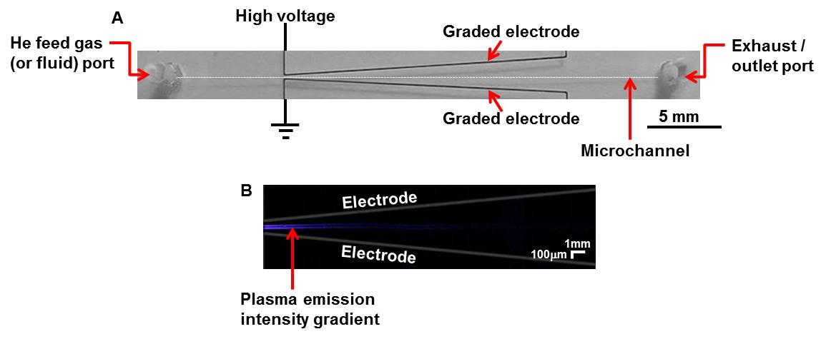

Figure 1. Design of the microfluidic chip to generate microplasma with gradient of emission intensity. (A) A section of a microfluidic chip designed with a microchannel in-between two graded electrodes is shown in the photograph at the top. (B) Plasma generation with an emission intensity gradient.

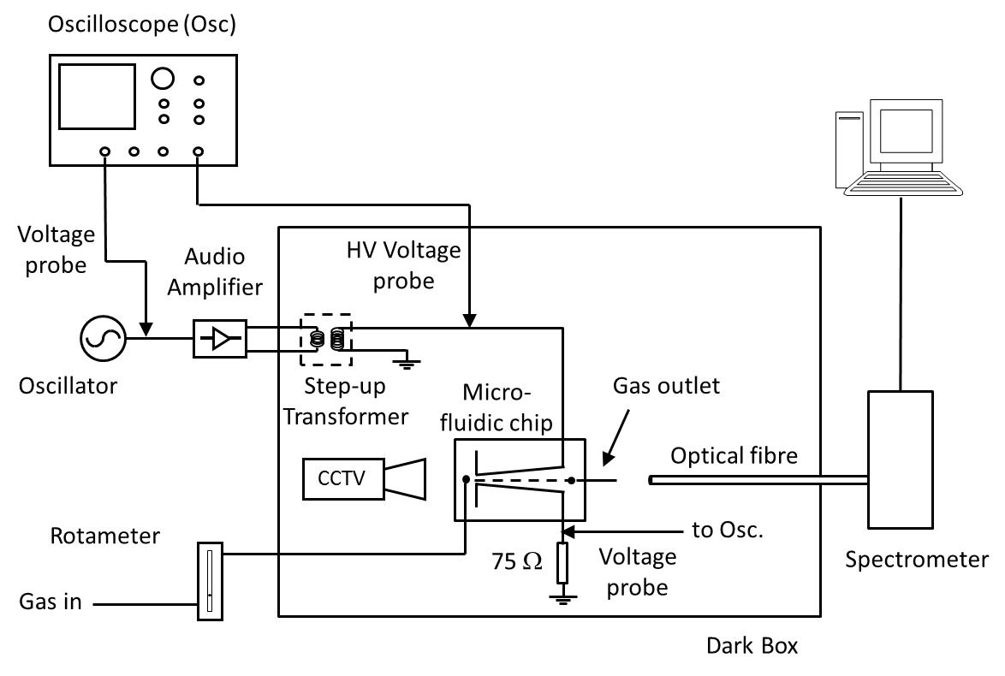
Figure 2. Schematic of the experimental set-up. The microfluidic chip was mounted in a fixed position. The optical fibre, mounted in a movable holder, can be moved along the microchannel. Experiments were performed in a dark box to minimise interference from room light.

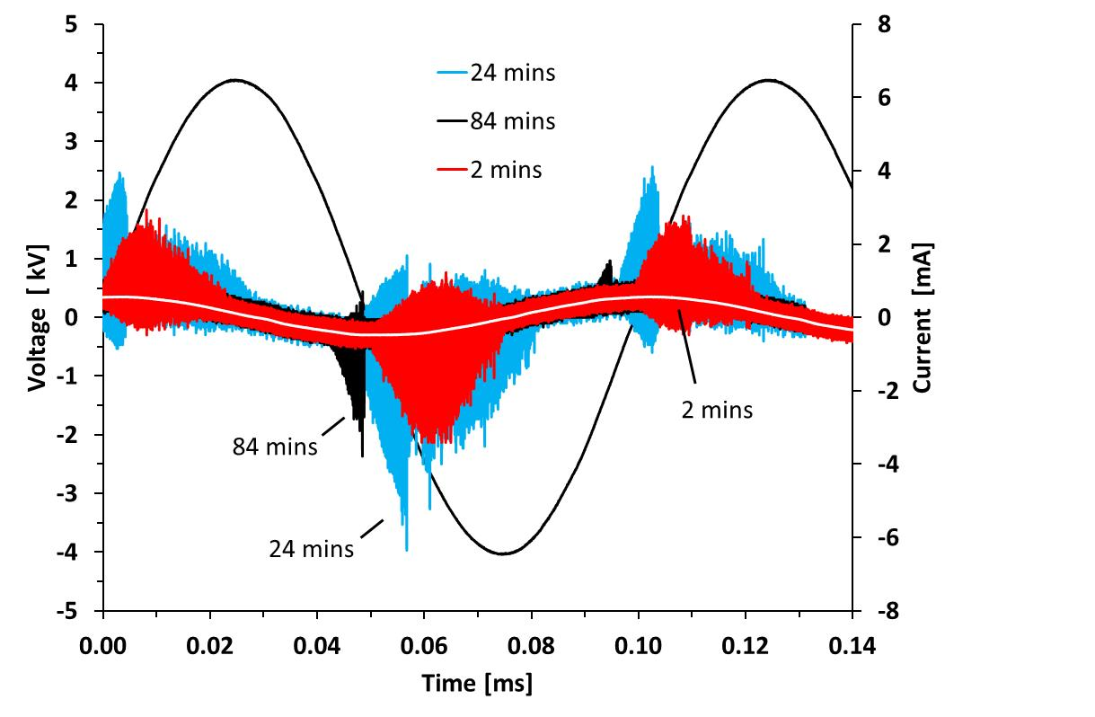
Figure 3. Filament envelope waveforms (colour filled) at different times after discharge ignition. The averaged electrode voltage (black) and displacement current (white) waveforms are also shown. This shows a filamentary discharge igniting twice per period. The discharge characteristics are slowly changing over time because of flow effects.

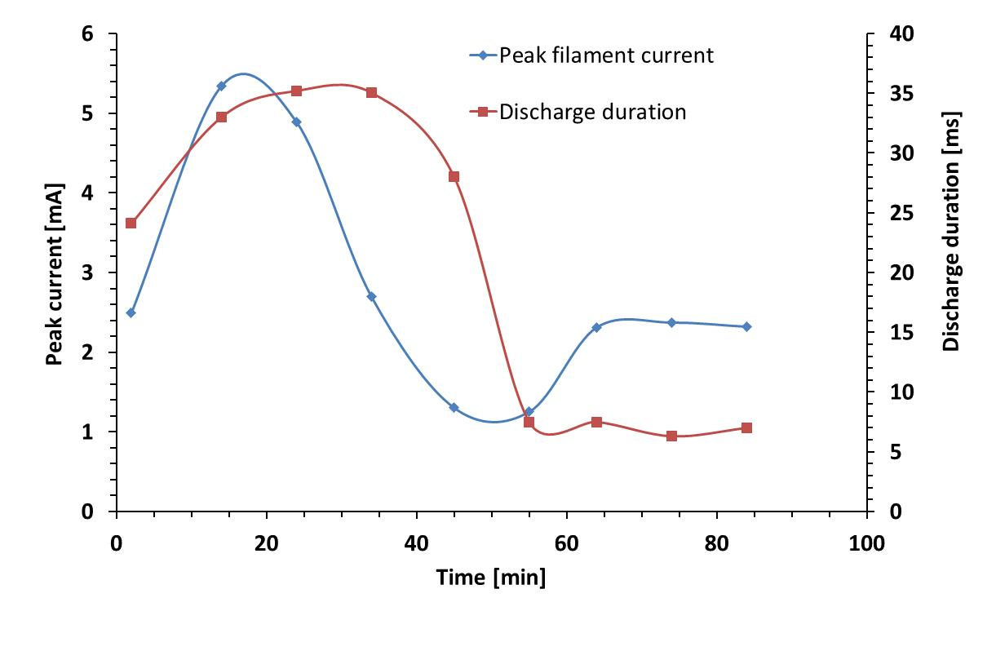
Figure 4. Peak filament envelope current and discharge duration at different times after ignition. The discharge characteristics are slowly changing over time because of flow effects and stabilise after 65 min.

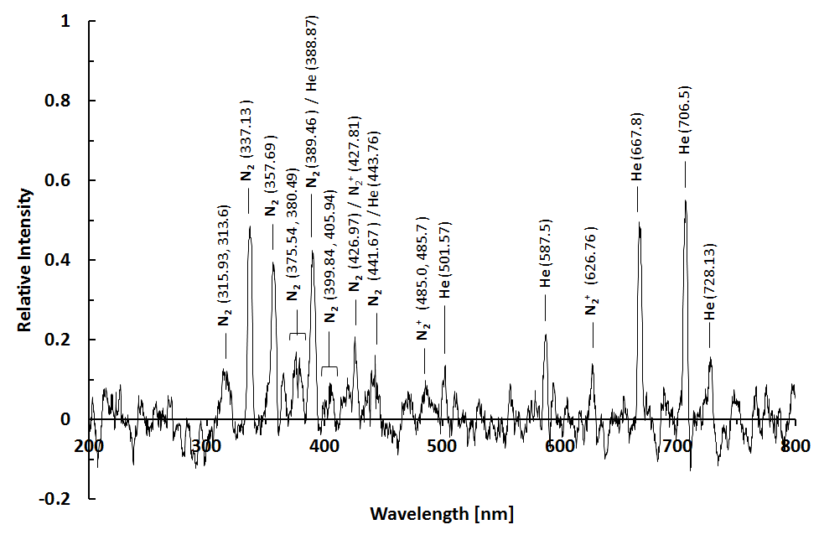
Figure 5. Optical emission spectrum of the discharge acquired 84 min after ignition. Assigned emission lines are indicated. Relative intensity is normalised to the 337.13 nm line (N₂, with 2379.76 counts) less than 1 min after ignition. This shows a mixture of air (N₂) and He is present in the microchannel. These species can contribute to the removal and / or modification of proteins.

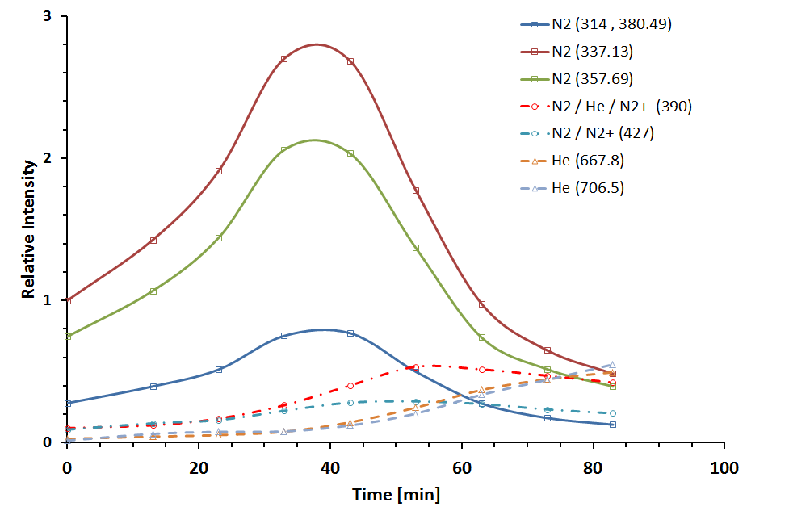
Figure 6. Time evolution of prominent selected lines after microplasma ignition. Solid lines (square symbols) are emission from neutral N₂ and dashed lines (triangle symbols) are from neutral He. Dash - dot lines (circle symbols) contain several species. Relative intensity is normalised to the 337.13 nm N₂ line, with 2379.76 counts, less than 1 min after ignition. At early times (up to 30 min) the spectrum is dominated by highly excited N₂ neutrals. At later times, due to the flushing of N₂ by He flow, the N₂ lines start to decrease and the He lines increase. This shows that the species responsible for the removal and / or modification of proteins depends on the time after ignition.

Optical fibre
16 mins
23 mins
33 mins
43 mins
63 mins
73 mins
83 mins
microchannel
#l
Gas inlet
Graded
electrodes

Figure 7. Time evolution of micro discharge in the microchannel. Gas flow is left to right. Discharge appears at the narrowest electrode gap (gas inlet side) and increases in intensity with time. After 43 minutes the discharge starts to extend down the microchannel in the direction of gas flow.

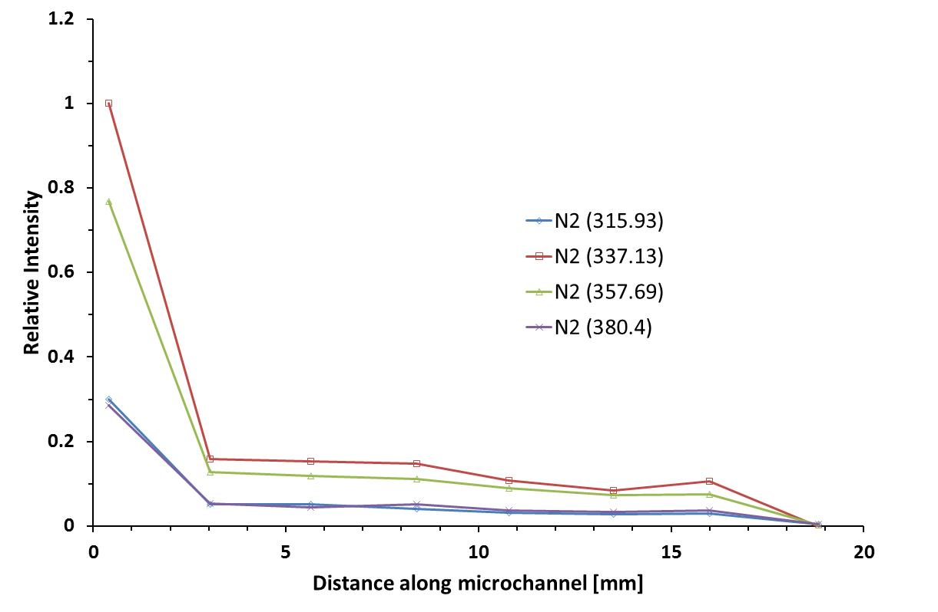
Figure 8. Variation of emission intensity (normalised to the 337.13 nm N₂ emission line, with 6662.99 counts) of the most intense lines along the length of the reaction microchannel. The position where the electrode separation is smallest (i.e. at 50 μm) corresponds to 0 mm. This shows that the density of plasma species, and the ability to remove and / or modify proteins, decreases along the along the microchannel.

