A novel approach to study in situ enamel erosion and abrasion lesions.
Ablal MAª, Milosevic Aª, Preston AJª, Higham SM^{b}
a) Department of Restorative Dentistry, Liverpool University Dental Hospital, UK
b) Department of Health Services Research/School of Dentistry, Institute of Psychology, Health and Society, University of Liverpool, UK.

Abstract
Objectives: This study investigated previous hypotheses that the tongue can abrade acid softened/eroded enamel surfaces.
Methods: Twelve upper removable appliances each retaining 2 anterior and 2 posterior human enamel specimens were constructed. Each specimen was exposed to acid on both surfaces, but only one surface was allowed contact with the tongue. Therefore, 96 surfaces were assessed. Appliances were worn from 9.30 to 17.00 Monday to Friday for 22 days. Acid eroded lesions were created by immersing the specimens for 5 min in 50 ml orange juice three times daily. Enamel loss was measured using Quantitative light- induced fluorescence (QLF) and Non- contact profilometry (NCLP) and the differences (D) between tongue (D_{t}) and palate facing (D_{P}) surfaces determined.
Results: %∆F_{D(t-p)} from the two anterior specimens were greater than from those placed posteriorly with mean values of 15.9% (± 9.1) and 14.4% (± 8.4), 5.6% (± 8.7) and 4.5% (± 6.6) respectively. Similarly, NCLP data showed anterior specimens had greater differences for mean step height (MSH) between tongue- facing and the palate- facing (control) surfaces than posterior specimens. MSH_{D(t-p)} values were 59.4 µm (± 30.3) for anterior tongue facing surfaces and 55.5 µm (± 29.4) for posterior palate facing surfaces. For the posterior specimens MSH was 48.1µm (± 26.1) and 51.7 µm (± 30.4) respectively (p < 0.05).
Conclusion: The greater enamel surface loss of the anterior specimens demonstrates that abrasion by the tongue on acid softened/eroded enamel in situ is likely.

Introduction
Dental erosion is the irreversible loss of dental hard tissues by acids without bacterial involvement.¹ As a result, the enamel surface will be characterised by partial demineralisation (softening) followed by a complete loss of the outermost enamel layer. If not allowed to re - mineralise, the remaining softened enamel is susceptible to be removed by mechanical forces such as toothbrushing.²⁻⁵
Friction from oral soft tissues, particularly the tongue, has also been reported as responsible for tissue loss from pre - eroded surfaces.⁶⁻⁸
The interaction between erosion and abrasion, in many in vitro and in situ models, has been studied separately; eroded lesions are first created on enamel surfaces which are then subjected to abrasion. Such models are applicable when wear has been caused by brushing of teeth after the consumption of acidic food or beverages. However, it is possible for erosion and abrasion to occur simultaneously, for instance, during the consumption of acidic food or drinks.
Despite the growing research interest in the effect of pressure from the tongue on previously eroded enamel surfaces, related studies are still scarce with only one tongue simulation study⁸ and one, in vitro, tongue licking study.⁷ Greater wear occurred after erosion with attrition or tongue rubbing followed by remineralisation in artificial saliva in vitro than in the other regimens which included simulated tooth brush abrasion, tongue rubbing and attrition without the erosion in citric acid⁸. Another in vitro study also found greater tooth substance loss on enamel and dentine specimens eroded for 10 minutes and then licked by the tongue for one minute although ultrasonication had a significant synergistic effect.⁷ Both studies were carried out in vitro using relatively harsh regimens.
Prevalence of enamel erosion on different enamel surfaces in healthy individuals has been investigated previously.⁹⁻¹² Despite wide agreement that palatal surfaces are more susceptible to erosion, ^{10,11} some studies showed that labial enamel was mostly affected⁹ while others could not find differences between the two surfaces.¹²

The aim of this study was to investigate the effect of tongue abrasion, in vivo, on pre-eroded enamel specimens using a novel in situ appliance and to compare that effect on different tooth surfaces (labial vs. palatal). It was hypothesised that: (1) enamel specimens previously exposed to acid erosion in vitro followed by tongue abrasion would show more wear than if eroded only and (2) that there would be no difference in susceptibility to erosion/ abrasion between labial and palatal enamel surfaces.

Keywords: Enamel erosion, Tongue abrasion, QLF, Profilometry.

Materials and methods
The protocol was approved by the North-West 2 Research Ethics Committee – Liverpool Central, UK (reference number: 09/ H1005/ 69).Twelve medically and dentally healthy volunteers of both genders, aged between 20-60 years were recruited from the staff of Liverpool University Dental Hospital. Subjects were given verbal and written information concerning the study and provided written consent to participate. All subjects had their un-stimulated and stimulated salivary flow rates and their corresponding pH measured.

In order to be eligible for inclusion in the study, subjects were required to be / have: (i) aged between 20 - 60 years, (ii) non - smokers with good general and oral health, (iii) a full upper dentition, (iv) a good salivary function with 0.3 ml / min and 1.0 ml / min flow rates for un- stimulated and stimulated saliva.

Saliva collection

Using the spitting method, un-stimulated saliva was collected by asking subjects to spit into a pre- weighed container over a period of 5 min. They were then asked to chew on a piece of paraffin gum and at the same time spit into a separate container over a period of 5 min. Flow rates were calculated and recorded in ml/ min.

Sample preparation

The crowns of twelve human upper central incisors were gently abraded and pumiced using 1200 - grit sandpaper (Water Sandpaper, 151 Products Limited, Manchester, UK) to remove extrinsic stains and other residues and to obtain a homogenous surface. Each crown was sectioned in a labio- palatal direction (n= 12 labial, 12 palatal specimens) using water - cooled diamond wire (Well type 2400, Walter EBNER, Le Locle, Switzerland). The labial and palatal surfaces were further sectioned mesio- distally to produce 2 specimens from each surface (n = 24 labial, 24 palatal specimens).
The incisal and cervical thirds of each specimen were discarded and the remaining surface was reshaped. Therefore, each incisor was sectioned both labio- palatally and mesio-distally to give four 4 x 4 x 1.5 mm specimens per tooth (Figure 1). The dimensions of all specimens were standardized using Vernier calliper then they were all checked under a USB microscopic light (VehoTM, Discovery, UK) to ensure dentine removal.

Specimen allocation and insertion
A total of 24 labial and 24 palatal enamel specimens were randomly allocated to a 12 upper removable appliances. This was performed in such a way that 2 labial and 2 palatal enamel specimens were randomly allocated to their corresponding sites on each appliance (n = 4) so that one labial and one palatal enamel specimen were positioned in the anterior and another 2 in the posterior region (Figure 2).
Figure 1 shows the surface and position of each enamel specimen on the appliance. Each appliance had 4 specimens but each specimen was subjected to either an erosion only regimen (palate- facing side) or an erosion and abrasion regimen (tongue- facing side). Therefore, a total of 96 surfaces were assessed.

Design of the removable appliance

Twelve upper removable acrylic base plates, each had 2 retention clasps on both maxillary first and second premolars were constructed (Fig. 1). Four 1.0 x 0.7 cm slots; 2 opposite the central incisors and 2 next to the first molar teeth were cut through each base plate to accommodate 4 jigs of the same size. On one side of each slot, a hinge joint made of [- shaped 0.5 mm orthodontic wire was embedded in the acrylic resin into which an acrylic jig holding 1 enamel specimen was attached. In order to easily identify and quickly assign each specimen to its corresponding slot on the appliance, each acrylic jig had a groove on the side representing the number of each specimen e.g. specimen 1 had one groove; specimen 2 had two grooves, etc. The hinge type joint facilitated the removal and reinsertion of each specimen in its corresponding slot on each appliance.
During manufacture of the acrylic base plates a single layer of wax was placed in the slots against the palate to standardise the gap and in effect countersink the palate facing surfaces of each enamel specimen. Specimen surfaces facing the palatal mucosa were thus slightly recessed, by approx. 1 mm inside the appliance, to avoid any possible friction and thus abrasion by the opposing palatal mucosa. The surfaces were, however, still accessible to the erosive challenge allowing each specimen to act as its own control (Figure 3). Each appliance then had 4 enamel specimens; 2 from labial and 2 from palatal enamel.

Sterilisation
The 12 upper removable appliances with the jigs inserted were sterilised by exposing them to Gamma irradiation using a cobalt - 60 source with particle energy of 0.315 MeV and irradiation cycle of 3.4 Gy/ min at a source - to - specimen distance of 100 cm and field size of 15 x 15 cm for 2 days making a total overall dose of approximately 25 kGy.¹³

In situ study

On each day of the study, volunteers were asked to wear the intra- oral appliance and its retained enamel specimens between 09.30 and 1700 h except for 1 h over lunch- time and two 30 min coffee breaks. When not in place inside the mouth, appliances were taken from the volunteers, jigs containing the specimens detached and immersed, for 5 min, in 50 ml of orange juice (Tesco value from concentrate, Tesco, UK) before each re- insertion. The mean pH of the orange juice was 3.85. The Adams cribs and collets around the teeth ensured seating in the same position after each re-insertion.
The first 90 min intraoral insertion of the appliances, however, was performed without exposure to the erosive challenge to allow the formation of a salivary pellicle layer, mimicking the natural situation found inside the mouth.
Volunteers were not allowed to consume food products nor beverages or practice any oral hygiene measure while wearing the appliance. Overnight and at weekends, the appliances and their specimens were stored in humid containers at room temperature until next use.

Erosion/ erosion and abrasion lesion measurement
Quantitative light - induced fluorescence images (QLF, version 2.00c, Inspektor Research Systems BV, Amsterdam, Netherlands) were taken and analysed using an external reference composite jig to which the fluorescing intensity of tooth surfaces could be referenced¹⁴ (Figure 6). QLF measurements at 5% threshold were used. Non-contact light profilometry scans (NCLP, Proscan 2000, Scantron, Taunton, UK) were performed by marking three fixed points on each acrylic jig and using each as a reference (Figure 9).
QLF images and NCLP scans were taken for the entire tongue- facing and palatal- facing surfaces of each specimen, at baseline and at the end of each week throughout the 4-week study period. Measurements were made, however, on the centre of each specimen. Data reported were ∆F (% fluorescence loss of enamel lesion created compared to sound enamel). NCLP mean step height was systematically measured across four mid - points on the sides of each specimen to give four measures of step height (loss of depth). A mean value for the step height for each specimen was then calculated.

Statistical analysis

Means were calculated for saliva pH and flow rate. The data obtained were statistically analysed using SPSS V20 (SPSS Inc., Chicago, USA). Changes within each specimen were recorded from both labial (erosion and abrasion) and palatal (erosion only) surfaces at baseline and at the end of each week. As each specimen acted as its own control, the analysis of QLF and NCLP data was performed on the mean differences between the two different lesions rather than on absolute values. Those differences, for all measurements, were calculated by subtracting the mean fluorescence loss and mean step height values on the tongue- facing surfaces from those on the palate- facing surfaces. A one - way ANOVA and paired t-test were used for comparisons between mean differences throughout the study period. A p- value < 0.05 was considered statistically significant.

Results
All twelve volunteers completed the study. The average age of the participants (9 females and 3 males) was 28.67 ± 9.5 years.

Salivary flow rates
All subjects had normal salivary flow rates, the mean values of which ranged from 0.6 ± 0.2 ml / min and 1.8 ± 0.6 ml / min for the un- stimulated and paraffin gum stimulated saliva, respectively. Their respective mean pH values were 7.1 ± 0.4 and 7.4 ± 0.5.

QLF data
Differences between mean fluorescence loss (%∆F) between tongue- facing (erosion/ abrasion) and palate- facing erosion (only) surfaces (%∆F_{D (t-p)}) were statistically significant at the end of the 4- week period (p < 0.05). By the end of week 1, %∆F_{D (t-p)} for specimens 1L, 2P, 3L, and 4P were 2.4% (± 2.3), 5.8% (± 1.2), 4.3% (± 1.8) and 2.2% (± 1.7), respectively. However and at the end of week 4, the same specimens had %∆F_{D (t-p)} of 5.6% (± 8.7), 15.9% (± 9.1), 14.4% (± 8.4) and 4.5% (± 6.6), respectively. The %∆F_{D (t-p)} between the two posterior specimens (1L & 4P) was not statistically significant throughout the study period (p > 0.05). (Figure 4)

Surfaces from labial and palatal enamel sections showed no significant difference in %∆F at the end of the study period (p > 0.05). At the end of the first week labial surfaces had %∆F values of 19.3% (± 5.3) and palatal had 19.1% (± 5.2) and at the end of week 4, %∆F values were 32.6% (± 6.4) and 34.3% (± 6.8) respectively (Figure 5).

NCLP data
Differences between the mean step height (MSH) on the tongue- facing (erosion/ abrasion) and palate- facing (erosion only) surfaces (MSH_{D(t-p)}) were also statistically significant at the end of the 4- week study period (p < 0.05). At the end of the first week, MSH_{D(t-p)} for specimens 1L, 2P, 3L, and 4P were (-) 30.0 µm (± 20.9), 40.7 µm (± 21.4), 37.0 µm (± 22.3), (-) 33.4 µm (± 19.5). Those differences increased by the end of week 4 reaching values of (-) 48.1 µm (± 31.1), 59.4 µm (± 30.3), 55.5 µm (± 29.4), (-) 51.7 µm (± 30.4), respectively. Positive values indicate increased MSH_{D(t-p)} on the tongue-facing surfaces while negative values indicate increased MSH_{D(t-p)} on the palate- facing surfaces (Figure 7). Comparison of labial and palatal enamel sections, however, showed no significant difference in MSH at the end of the study period (p > 0.05).
The MSH for labial and for palatal surfaces was 167.2 µm (± 52.0) and 157.9 µm (± 42.4) at the end of the first week and 306 µm (± 94.0) and 308.8 µm (± 124.9), respectively by the end of the fourth week (Figure 8).

Discussion
This in situ study aimed to investigate the effect of tongue abrasion on pre- eroded human enamel specimens using a novel intra-oral appliance. Furthermore, the influence of different intra-oral sites (anterior or posterior) and different enamel structure (labial or palatal) was also assessed by this method. To standardise the conditions and reduce the experimental variations under which demineralisation occurs, erosion lesions in the current study were created extra-orally.
The development of dental plaque on the specimens was not discouraged as any attempt to remove the accumulated biofilm carried the risk of disturbing the eroded surface. A common technique used to prevent plaque growth is by soaking appliances with the specimens in antiseptic agents like chlorhexidine.^{15,16} This is not, however, without risk as the mouth rinse is known to produce extrinsic discolouration of teeth as a result of a chemical interaction. That discolouration could potentially interfere with QLF imaging and NCLP scanning.¹⁷
Specimens used in this study, particularly the two anterior ones, were closely examined for the presence of dental plaque on the tongue-facing enamel surfaces and were found devoid of any accumulation. Therefore, this finding supported previous observations that tongue rubbing reduced the thickness of salivary pellicle on the palatal surface of upper anterior teeth^{18,19} and that salivary pellicle formed on palate – facing surfaces over a period of 88 h did not provide protection against acid erosion.

A thin layer of plaque formed, however, on the palate- facing surfaces and tended to increase in thickness around the sides where specimens were embedded in the acrylic material (Figure 10). This could have affected analysis, with increased data variability, so those areas were avoided during image and scan analysis.
Similar to previous observations no influence from salivary characteristics on dental erosion was observed.²⁰ This could be a result of creating erosion lesions extraorally where the benefits from salivary protection (flow rate, volume in the mouth, buffer capacity, and clearance) particularly at time of exposure to the erosive challenge, did not exist. This effect from the in vitro exposure was more profound than it would be under clinical conditions as a result of the thinning, flattening and polishing of specimens that created enamel surfaces with extreme vulnerability to dissolution.²¹ Moreover, since salivary flow was normal it is assumed that a normal pellicle formed on the specimen surfaces. Thus in clinical situations, the wear of enamel could be less, but the pattern of demineralisation should be similar. Also, because of the increased thickness of the appliance to accommodate the specimens, the two anterior specimens in particular (specimens 2P and 3L) in particular were in a continuous and a closer contact to the tongue than in normal situations. This in turn could have resulted in a limited access of saliva and hence, a reduction in its protective effect.

QLF works by quantifying mean fluorescence loss associated with demineralised enamel.²² Demineralised enamel is more porous than sound enamel. The pores become filled with liquid from the surrounding aqueous environment, decreasing the path of light in dental enamel. As a result, demineralised lesions exhibit greater light scattering properties than sound enamel (Figure 6) resulting in decreased light absorption per unit of volume and therefore, they produce greater fluorescence loss.²³⁻²⁵

Over the 4- week study period, anterior specimens 2P and 3L showed an increase in the difference of %∆F between tongue- facing and palate- facing surfaces denoting that the two surfaces underwent different processes. The relative fluorescence loss on the tongue- facing surfaces had a lower %∆F value when compared with the palate- facing surfaces.
There was a greater difference of %∆F in the anterior enamel specimens compared to the posterior specimens irrespective of whether the enamel was originally labial or palatal (Figure 4). Furthermore, a steady increase in the difference of %∆F is seen over the 4 week study period. The greater loss in fluorescence anteriorly reflects greater mineral loss from the anterior specimens which increased over the 4 week period as more enamel volume was lost.

On the other hand, specimen 1L (posterior right) had a greater decrease in %∆F when compared with specimen 4P (posterior left). In the current study, all controllable variables were taken into consideration,²⁶ therefore, this difference in the %∆F between the two specimens exposed to the same environment could only be related to behavioural factors known to influence development of tooth surface loss.²⁷ Prior to commencing the study, subjects were instructed as how to best insert and remove their appliances without the risk of physically disturbing the specimens. However, there is a possibility that subjects adopted a more convenient way for insertion and removal and applied mechanical rubbing force from fingers, on the side where specimen 1L was located, resembling tongue abrasion. A noteworthy observation is that all subjects participated in this study were right - handed justifying why specimen 1L (posterior right), in particular, was affected.

NCLP software calculates lesion depth by subtracting the average height of the treated surface from the average height of the reference points on the untreated surfaces. The two anterior specimens (2P and 3L) showed greater MSH on the tongue- facing than on the palate-facing surfaces reaching a maximum of 60µm after 4 weeks compared to 50 µm on the palate facing surface (Figure 7). The positive values of the difference between the two surfaces indicated an increased MSH on the tongue- facing surface while negative values were indicative of a greater tooth surface loss activity on the palate- facing surface. As participants were instructed not to consume food or brush teeth while wearing their appliances, these results indicated a significant abrasive effect by the tongue on the two anterior specimens (2P and 3L) irrespective of the origin of the section being labial or palatal enamel.
The two posterior enamel specimens (1L, 4P), however, had less MSH on tongue-facing enamel surfaces than on the anterior specimens (2P and 3L) (Figure 7). This confirmed previous findings that tongue pressure is greater on palatal anterior surfaces as compared to posterior surfaces.^{28–30} NCLP results also indicated that specimen 1L (posterior right) had a slightly increased MSH on the tongue- facing surface when compared with specimen 4P (posterior left). This could partly be due to light lateral tongue pressure on eroded enamel surfaces. In addition, behavioural factors mentioned earlier are believed to have had a role.
Palatal enamel has been reported to be more susceptible to acid erosion than labial enamel.^{10,11} This could be the result of the location of the labial surfaces, being in intimate contact with the minor salivary glands of the lips. In addition, the contact of palatal surfaces with food and with their antagonists makes them more prone to show wear. In this study, we believe that subjecting palatal and labial enamel surfaces to intermittent and repeated exposure to orange juice have resulted in constant lesion depth.³¹ Exposure to tongue abrasion then led those softened layers being removed at a constant rate which could explain similar surface loss on both labial and palatal surfaces. Therefore, our results supported previous findings that labial and palatal specimens had no variation in their susceptibility to dental erosion.¹²

Conclusion
This in situ study shows that the tongue is capable of removing previously softened enamel surfaces. Cyclic and short acid exposure periods resulted in surface demineralisation that was rubbed away by the tongue. Anatomical position within the arch (anterior versus posterior) has a greater influence on susceptibility to the tooth wear process than enamel structure (labial versus palatal).

References
1- Imfeld T. Dental erosion. Definition, classification and links. Eur J Oral Sci 1996; 104 (2 (Pt 2)): 151-5.

2- Davis WB, Winter PJ. The effect of abrasion on enamel and dentine and exposure to dietary acid. Br Dent J 1980; 148(11-12): 253-6.

3- Attin T, Knöfel S, Buchalla W, Tütüncü R. In situ evaluation of different remineralization periods to decrease brushing abrasion of demineralized enamel. Caries Res 2001; 35(3): 216-22.

4- Eisenburger M, Shellis RP, Addy M. Comparative study of wear of enamel induced by alternating and simultaneous combinations of abrasion and erosion in vitro. Caries Res 2003; 37(6): 450-5.

5- Hooper SM, West NX, Pickles MJ, Joiner A, Newcombe RG, Addy M. Investigation of erosion and abrasion on enamel and dentine: a model in situ using toothpastes of different abrasivity. J Clin Periodontol 2003; 30(9): 802-8.

6- Amaechi BT, Higham SM, Edgar WM. Influence of abrasion in clinical manifestation of human dental erosion. J Oral Rehabil 2003; 30(4):407-13.

7- Gregg T, Mace S, West NX, Addy M. A study in vitro of the abrasive effect of the tongue on enamel and dentine softened by acid erosion. Caries Res 2004; 38(6): 557-60.

8- Vieira A, Overweg E, Ruben JL, Huysmans MC. Toothbrush abrasion, simulated tongue friction and attrition of eroded bovine enamel in vitro. J Dent 2006; 34(5): 336-42.

9- Lussi A, Schaffner M, Hotz P, Suter P. Dental erosion in a population of Swiss adults. Community Dent Oral Epidemiol. 1991; 19(5):286-90.

10- Järvinen V, Rytömaa I, Meurman JH. Location of dental erosion in a referred population. Caries Res. 1992; 26(5):391-6.

11- Tucker K, Adams M, Shaw L, Smith AJ. Human enamel as a substrate for in vitro acid dissolution studies: influence of tooth surface and morphology. Caries Res. 1998; 32(2):135-40

12-Van Eygen I, Vannet BV, Wehrbein H. Influence of a soft drink with low pH on enamel surfaces: an in vitro study. Am J Orthod Dentofacial Orthop. 2005; 128(3):372-7.

13- Amaechi BT, Higham SM, Edgar WM. Efficacy of sterilisation methods and their effect on enamel demineralisation. Caries Res 1998; 32(6):441-6.

14- Adeyemi AA, Jarad FD, de Josselin de Jong E, Pender N, Higham SM. The evaluation of a novel method comparing quantitative light-induced fluorescence (QLF) with spectrophotometry to assess staining and bleaching of teeth. Clin Oral Investig 2010; 14(1):19-25.

15- Ganss C, Klimek J, Brune V, Schürmann A. Effects of two fluoridation measures on erosion progression in human enamel and dentine in situ. Caries Res 2004; 38(6): 561-6.

16- Hooper SM, Newcombe RG, Faller R, Eversole S, Addy M, West NX. The protective effects of toothpaste against erosion by orange juice: studies in situ and in vitro. J Dent 2007; 35(6):476-81.

17- Sulieman M. An overview of tooth discoloration: extrinsic, intrinsic and internalized stains. Dent Update 2005; 32(8):463-71.

18- Milosevic A, Dawson LJ. Salivary factors in vomiting bulimics with and without pathological tooth wear. Caries Res 1996; 30(5):361-6.

19- Amaechi BT, Higham SM, Edgar WM, Milosevic A. Thickness of acquired salivary pellicle as a determinant of the sites of dental erosion. J Dent Res 1999; 78(12):1821-8.

20- Correr GM, Alonso RC, Correa MA, Campos EA, Baratto-Filho F, Puppin-Rontani RM. Influence of diet and salivary characteristics on the prevalence of dental erosion among 12-year-old schoolchildren. J Dent Child 2009; 76(3): 181-7.

21- Meurman JH, Frank RM. Scanning electron microscopic study of the effect of salivary pellicle on enamel erosion. Caries Res 1991; 25(1): 1-6.

22- Pretty IA. Caries detection and diagnosis: novel technologies. J Dent 2006; 34(10):727-739.
23 - van der Veen MH, de Josselin de Jong E. Application of quantitative light-induced fluorescence for assessing early caries lesions. In: Assessment of oral health, diagnostic techniques and validation criteria. Whitford GM (Ed). Monogr Oral Sci 2000; 17:144-62.

24- Pretty IA, Edgar WM, Higham SM. Detection of in vitro demineralization of primary teeth using quantitative light-induced fluorescence (QLF). Int J Paediatr Dent 2002; 12(3):158-67.
25- Stookey GK. Quantitative light fluorescence: a technology for early monitoring of the caries process. Dent Clin North Am 2005;49(4): 753-70.

26- Dawes C, Watanabe S, Biglow-Lecomte P, Dibdin GH. Estimation of the velocity of the salivary film at some different locations in the mouth. J Dent Res 1989; 68(11): 1479-82.

27- Moss SJ. Dental erosion. Int Dent J 1998; 48(6): 529-39.

28- Kydd WL, Akamine JS, Mendel RA, Kraus BS. Tongue and lip forces exerted during deglutition in subjects with and without an anterior open bite. J Dent Res 1963; 42: 858-66.

29- Carlsson GE, Johansson A, Lundqvist S. Occlusal wear. A follow-up study of 18 subjects with extensively worn dentitions. Acta Odontol Scand. 1985; 43(2):83-90.

30- Youmans SR, Stierwalt JA. Measures of tongue function related to normal swallowing. Dysphagia 2006; 21(2): 102-11.

31- Creanor S, Creanor S, Alharthy N. A comparison of in vitro erosion-like mineral loss between continuous and intermittent acidic exposure with and without human saliva. Arch Oral Biol 2011; 56(7):703-8.

Figures:

Figure 1. Schematic representation illustrating crown sectioning method.

Figure 1. Schematic representation illustrating crown sectioning method.

Figure 2. Upper removable appliance with all surfaces of the specimens exposed to abrasion from the tongue. L = labial cut, P= palatal cut.

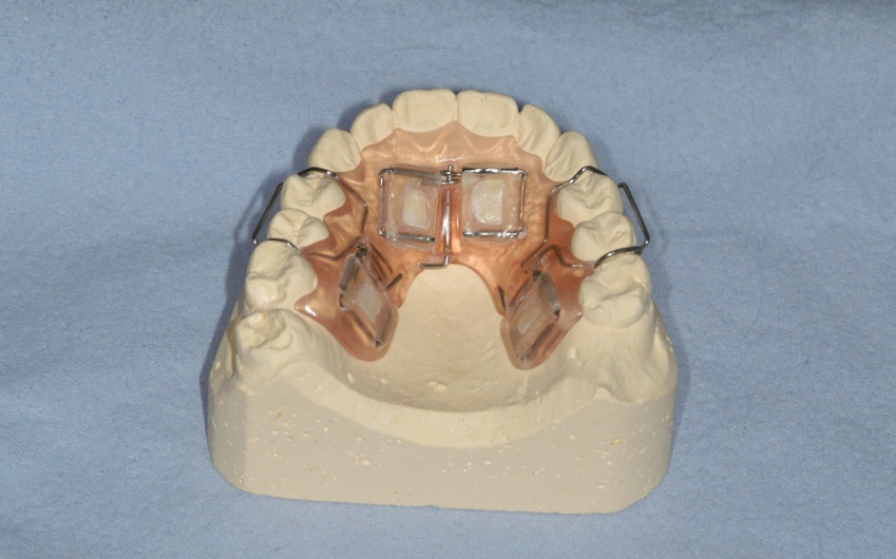

Specimen 2P
Specimen 3L
Specimen 1L
Specimen 4P

Figure 3. A palatal view of a removable appliance showing surfaces facing the palatal mucosa and not subjected to abrasive tongue forces but only to the in vitro acid erosion from Orange Juice. (red arrow).

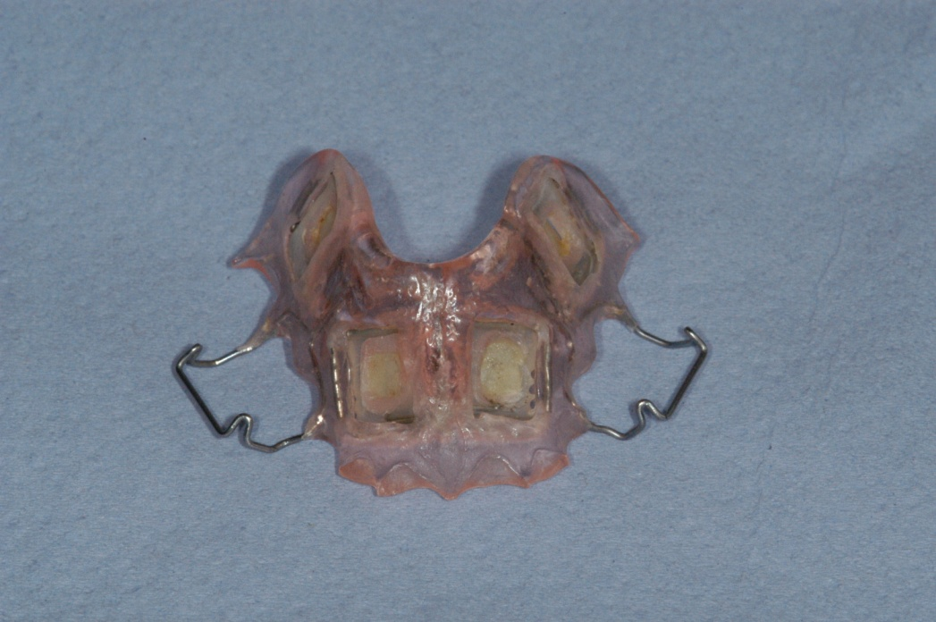

Figure 4. Differences of the mean fluorescence loss for the 48 specimens/ 96 surfaces of specimens during the 4 week study period. Note: differences were calculated by subtracting %∆F of the tongue- facing surface from that of the palate- facing surface. Specimen position in the appliance is shown whilst its section from the tooth is denoted as either L for labial or P for palatal.

Figure 5. %∆F for the labial and palatal sections during the 4-week study period. No significant statistical difference between labial and palatal surfaces was found at the end of each week of the study (p > 0.05).

Figure 6. An example of a tongue- facing surface QLF final image analysis, for one of the anterior specimens, at the end of each week of the study period. QLF demonstrates severity of enamel surface loss in false colour. Red fluorescence in the middle of (a) and (b) images denotes mean fluorescence loss at 25% threshold. As tongue abrasion continued, %∆F increases reaching 45% threshold level (yellow) by the end of week 4.

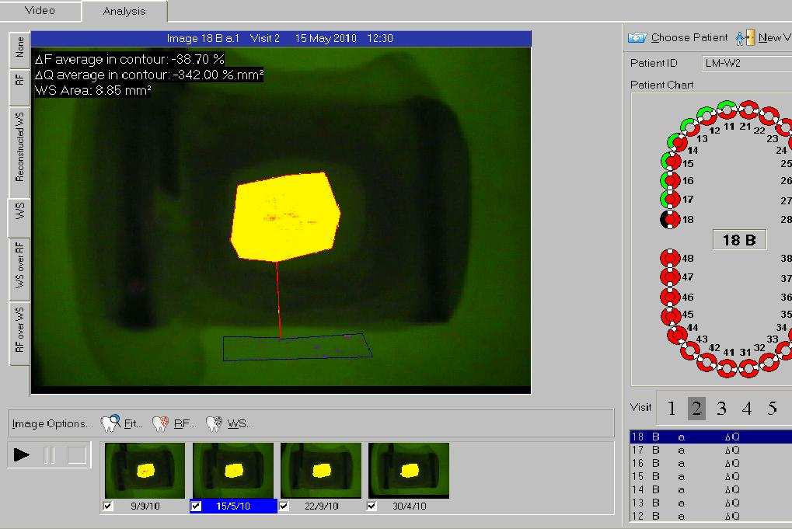
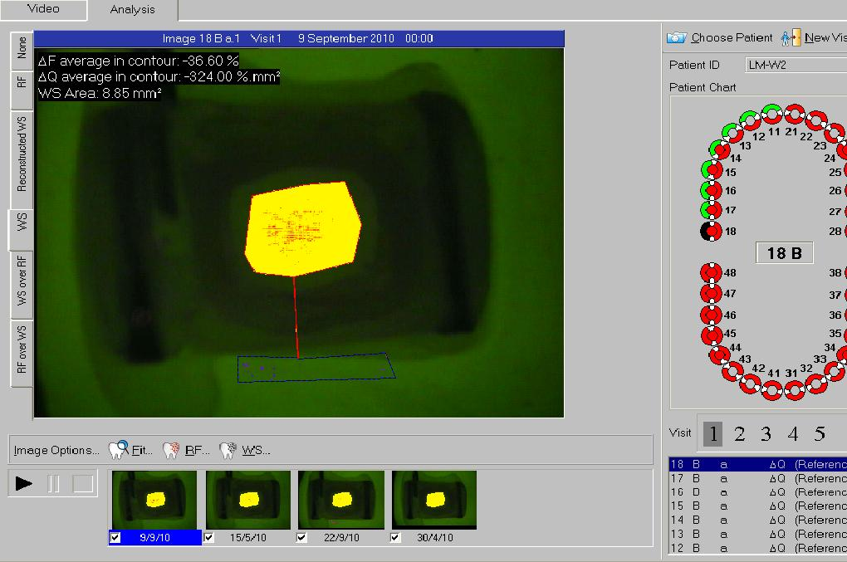
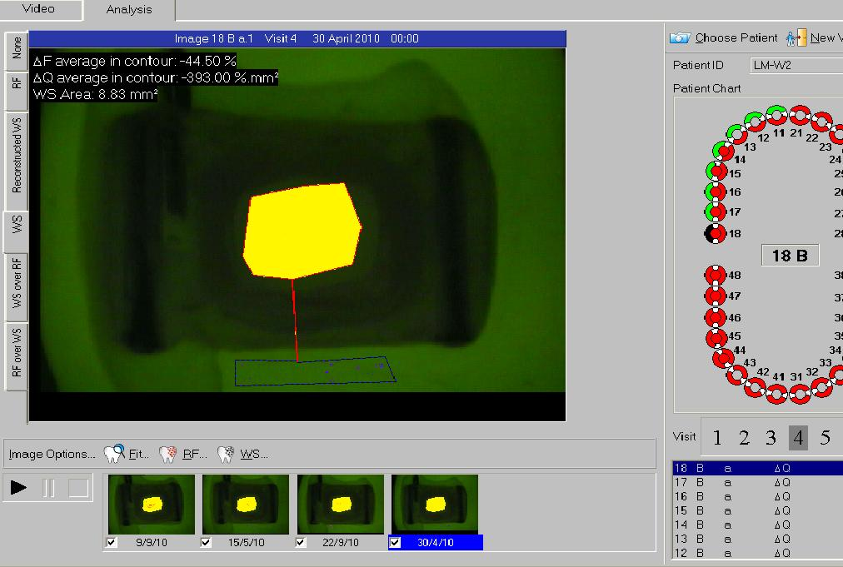
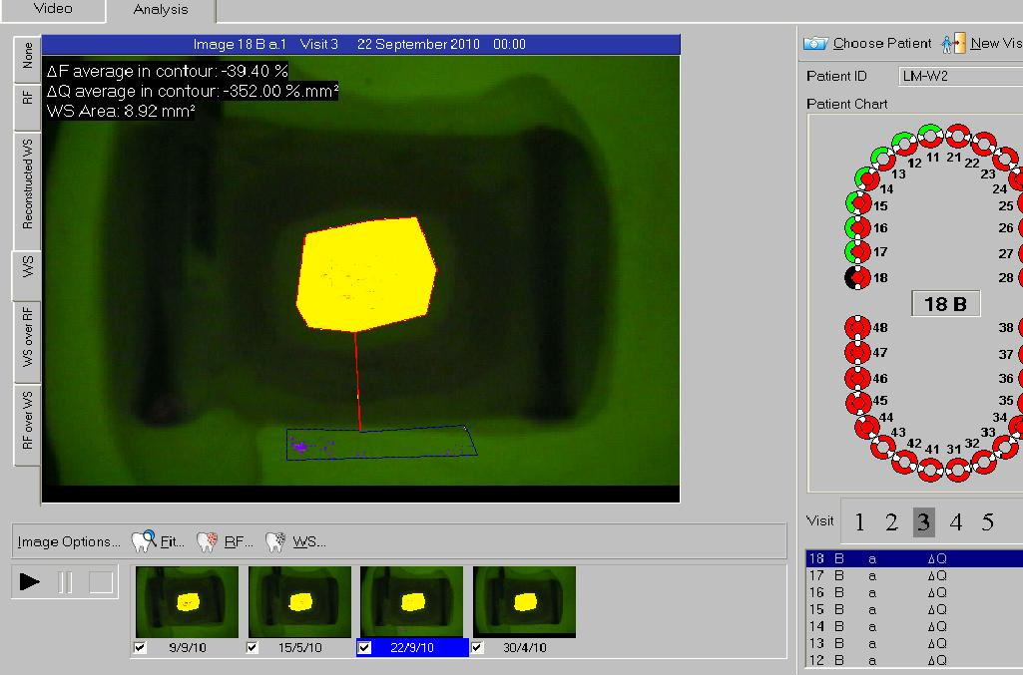
d
c
b
a

Figure 7. Comparison of the differences in the MSH (MSH_{D(t-p)}) for the 48 specimens/ 96 surfaces during the 4 week study period. Note: positive values indicate increased D_{MSH} on the tongue- facing surfaces; negative values indicate increased D_{MSH} on the palate- facing surfaces. Specimen position in the appliance is shown whilst its section from the tooth is denoted as either L for labial or P for palatal.

Figure 8. Mean step height for the surfaces from labial and palatal sections irrespective of which tissue they faced (n = 96 surfaces) over the 4 weeks period. There was no significant statistical difference between labial and palatal specimens at the end of each week of the study period (p > 0.05).

Figure 9. Examples of profilometry scans of the tongue- facing surface (top) and palate- facing surface (bottom) of a specimen showing the changes in the step height from baseline (left) to week 4 (right). Note: the three markings on each image were carved on each acrylic jig to standardize specimen orientation after each cycle.

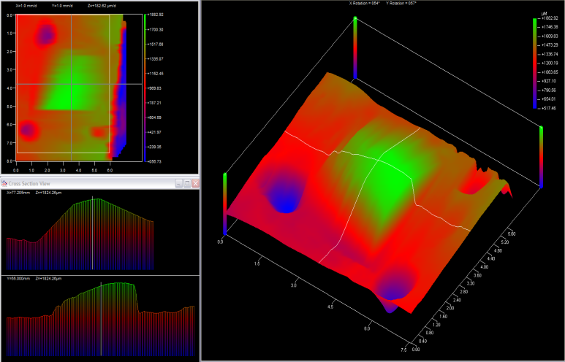
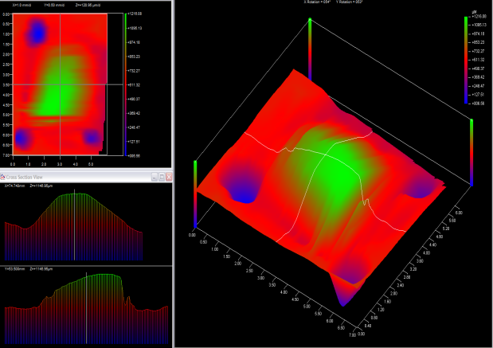
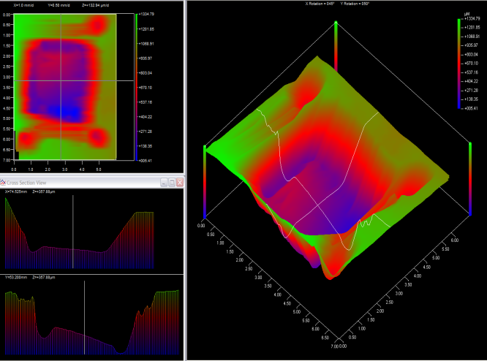
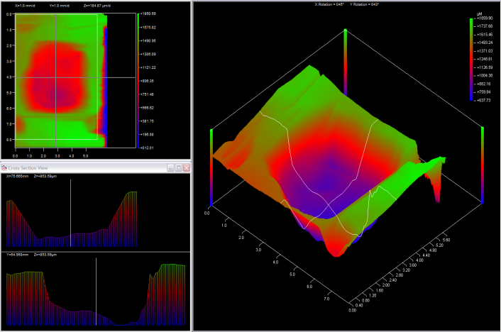

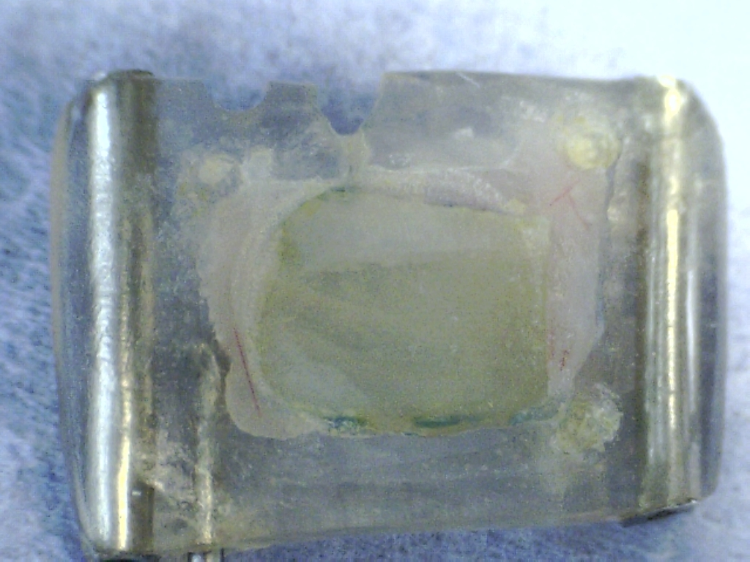
Figure 10. A microscopic light image showing the palate- facing surface (control) of a specimen with plaque accumulation on corners (arrows).

