Rebecca Mateer
Paul Scott, Mark White, & Ieuan Owen
University of Liverpool, UK.
A CFD Study of the Aerodynamics of a Ship’s Bulky Enclosed Mast

ABSTRACT
Many modern warships have enclosed main masts that are bulky and very different to the lattice or pole masts of earlier ships. While the newer masts are carefully designed to reduce radar cross section, and provide a weather tight enclosure for sensors and systems, they also significantly affect the air flow over the ship. This paper reports some results from a CFD study of the air flow over a generic ship representative of a modern frigate with an enclosed mast. Specific attention has been paid to the unsteady velocities at locations around the mast where a ship’s anemometer might typically be placed. The flow is seen to be highly disturbed and both the wind strength and angle are significantly different to those of the free stream, hence making a true wind over deck measurement difficult. In the context of helicopter launch and recovery this makes it difficult to specify the helicopter’s operational limits which can restrict operational capability. The study has also quantified the temperature field due to the ship’s exhaust gas, and shows how vortex shedding from the mast mixes the exhaust gas with the airwake, so quenching the hot gases and reducing temperatures over the flight deck.

INTRODUCTION
Many designs of modern warships have masts that are more solid and bulky than the traditional lattice or tripod masts. Figure 1, for example, shows the mast structures for a US Arleigh-Burke class destroyer and a UK Daring class Type 45 destroyer. The images of the two ships are approximately scaled and it can be seen how the mast of the American ship has a taller and more open structure. The British Type 45 is an enclosed mast which contains a variety of equipment and systems in a watertight enclosure. In this case the outer surface of the mast is constructed from steel, but an enclosed mast could also be made from composite materials which allow antennae to be contained within the mast and to operate effectively as they can ‘see’ through the composite material. A further evolution of the enclosed mast concept is the integrated mast in which many of the antennae and sensors are not so much contained within the mast, but are themselves part of the outer surface of the mast. An example of a ship that operates with an integrated mast is the Dutch Holland class offshore patrol vessel which carries a Thales integrated mast. The geometry of the enclosed masts also lend them to reduced radar cross section, particularly for the integrated mast which does not have external sensors and equipment, such as those seen on the Type 45 in Fig. 1.

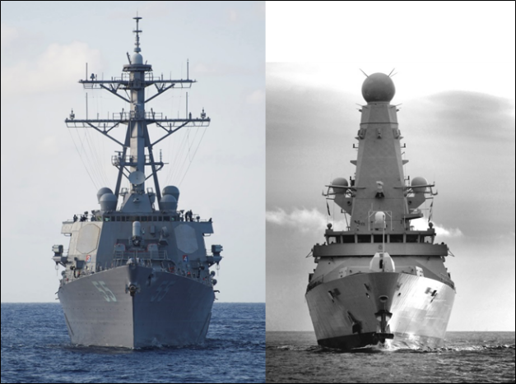
Figure 1: Mast profiles of a US Arleigh-Burke class (left) and a UK Daring class destroyer (right)

A review of integrated masts and their implications for ship design is given by Savage & Kimber [1]. There are structural design issues related to the need to align the base of the mast with the under-deck structure and bulkheads, and the additional strength required to withstand the whipping and slamming loads. The increased weight and higher centre of gravity of the mast also has an influence on ship stability. Savage & Kimber also recognise that the bulkier non-aerodynamic profile of the integrated mast has implications for ship airwake and ship engine exhaust gas dispersion, their concern over the latter being related to the heating of surfaces and electronic components.
The purpose of this paper is to consider the aerodynamics of the flow around an enclosed mast with a particular emphasis on how this may affect the positioning of the ship’s anemometers, how it affects the engine exhaust gas dispersion, and the implications of both of these for the operation of the ship’s helicopter. The study has been carried out using unsteady Computational Fluid Dynamics (CFD). The accuracy of the wind velocity measurements recorded by the ship’s anemometers is important because they are used to define the Ship-Helicopter Operating Limits (SHOL) at the outset of the ship’s service, and the Wind-Over-Deck conditions for every sortie thereafter; unreliable anemometers lead directly to unnecessarily restricted SHOLs. As for exhaust gases from the ship’s engines, if the temperature of the airflow in which the helicopter has to operate is increased, this can adversely affect the helicopter’s performance through reduced rotor lift and reduced engine power.

CFD METHODOLOGY

Generic Frigate Model and Meshing
Figure 2 shows the generic ship model that has been created for this study and which has many of the characteristics of a modern frigate, such as a large bulky main mast similar to that seen on the Type 45, a large rectangular funnel with a main gas turbine (GT) exhaust amidships immediately behind the mast, and four Diesel generator (DG) exhausts – two placed amidships adjacent to the GT and two situated on a starboard rear funnel, above the hangar and immediately in front of the flight deck. The superstructure also has sloping smooth sides to minimise radar cross section reduction.
To illustrate the aerodynamic issues for this ship should its anemometers be mounted off the main mast (as they are on the Type 45), the velocities of the air flow at typical port and starboard positions have been studied in detail. The positions are half-way up the mast and at port and starboard locations equivalent to being at the end of 6m long yardarms attached to the front corners of the mast and angled 60° forward. The positions will be indicated on the relevant figures later in the paper (yardarms can be seen on the mast in Fig. 2, but these are not at mast half-height).
For the exhausts, both the GT and DG’s uptakes are cylindrical and have exit planes flush to their funnel top surfaces. The GT exhaust has a diameter of 2.8m whilst the DG exhausts have diameters of 0.5m. The length of the generic frigate is 150m with a beam of 20m.
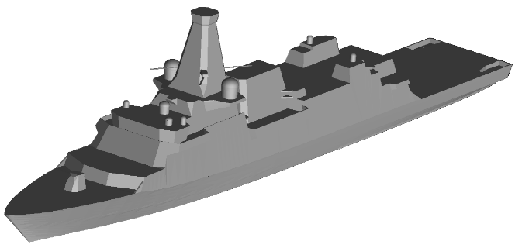
Figure 2: Generic Frigate Model
The CFD analysis was carried out using the commercial code Ansys Fluent. The ship CAD model was imported into the Ansys ICEM mesh generation software for an initial ‘clean-up’ process to remove any unnecessary clutter and to ensure that the geometry was ‘sealed’ ready for meshing. The removal of clutter was based upon recommendations by Forrest & Owen [2] where objects less than 0.3m in diameter can be neglected as they have little effect on the airwake but will increase cell count and therefore computational time.
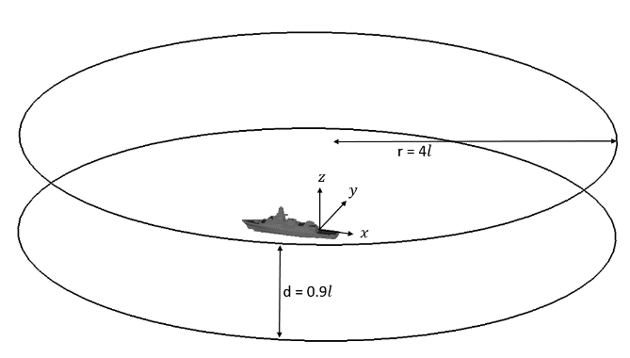
Figure 3: Computational domain
The prepared ship geometry was enclosed in a large cylindrical domain, Fig. 3, of radius, r = 4$l$ and depth, d = 0.9$l$, where $l$=ship’s length; this ensures that the boundaries are far enough away from the ship model to negate any blockage effects during the simulation. Using a cylindrical domain allows multiple Wind-Over-Deck (WOD) simulations to be run through 360° from a single mesh by altering the $x$ and $y$ velocity components of the oncoming flow. In this instance, the ship was placed in the domain for the positive $x$-direction to run through the longitudinal axis from bow to stern and positive $y$-direction to run through the lateral axis toward starboard.
Detached Eddy Simulation (DES) was used for turbulence modelling and an unstructured meshing technique was used which suits the turbulence modelling due to the isotropic nature of the tetrahedra away from the walls [2]. An Octree volume mesh was first used to produce a good quality triangular surface mesh from which a Delaunay volume mesh was grown, as seen in Fig. 4. A general rule of minimum cell size = 0.05 x hangar height was adhered to and prism layers were included in order to resolve the viscous boundary layer on the ship and representative ‘sea-surface’. Mesh growth normal to the geometry walls was controlled using a tetra growth ratio of 1.2 to retain a smooth transition between the prism and tetrahedra cells. The refined region over the flight deck is for future work on the effect of the ship airwake on helicopter flight simulation. The total cell count of the domain is approximately 10.5 million cells.
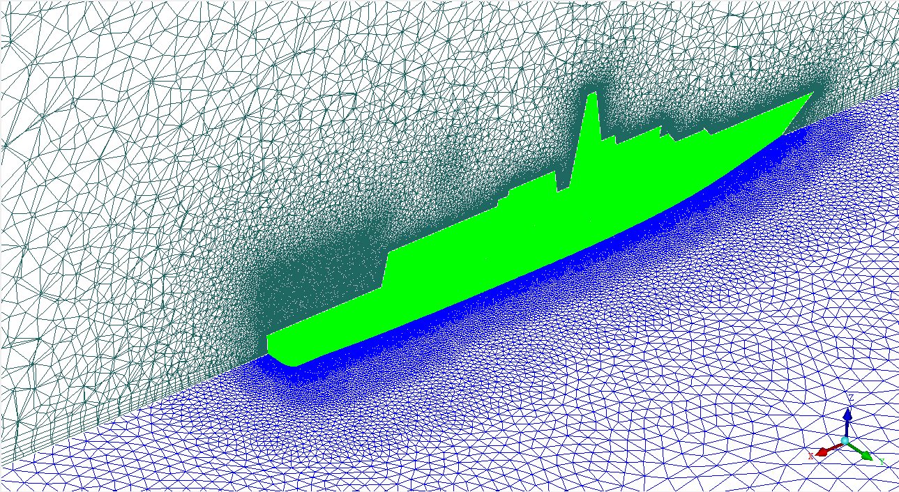
Figure 4: CFD Mesh

Boundary Conditions
Ansys Fluent requires all of the geometry surfaces to have specified boundary conditions. In the case of the cylindrical domain, the upper surface was set as a symmetry condition where there is no flux across the boundary while specifying a zero shear condition. The outer circumference of the domain was set to a ‘pressure far field’ which allows the freestream conditions to be modelled at infinity. The freestream Mach number must also be specified along with the x, y and z components of the freestream flow velocity for the pressure far field boundary condition.
The ship’s surfaces were set as a series of walls with a zero slip condition to allow boundary layers to develop. The sea-surface plane was set as a wall but with a zero shear stress condition to allow the atmospheric boundary layer profile specified at the inlet to propagate through the domain unchanged.
The atmospheric boundary layer (ABL) profile was included to increase the accuracy of the CFD simulations as there can be a significant velocity change between the sea surface and the ship’s anemometer height. The following power law was used to model the ABL:
$V=V_{ref}{\left(\frac{z}{z_{ref}}\right)}^{α}$ (1)
Where, $V_{ref}$, is the velocity at reference height, $z_{ref}$, and, $α$, is a constant dependent on the surface roughness. The following values were used: $V_{ref}$ = 50 knots, $z_{ref}$ = 200m, $α$ = 0.13 (as recommended in [2]). At the ship’s anemometer height, approximately 27 metres above sea level, this equates to an approximate 20 m/s freestream velocity (~38.5 kts).
For the CFD simulations inclusive of exhaust gas effects, the energy equation within Ansys Fluent was activated, as well as the solution of additional transport equations to account for the buoyancy of the plume. The exhaust efflux has both momentum and buoyancy, however in the near field where this study is concerned the exhaust gases are ejected at high speed (~ 100 m/s) into highly disturbed air therefore the plume is momentum dominated and not buoyancy dominated [3].
The boundaries of both the GT and DG exhausts were specified as mass flow inlets in order to model the exhaust efflux. The GT boundary condition was set with a mass flow rate of 106 kg/s and temperature of 445°C while the DG boundary conditions were set with mass flow rates of 5.6 kg/s and temperatures of 430°C. These values were chosen to be representative of typical engines used in frigates that do not have waste heat recovery systems. In this instance, the exhaust gas species were not modelled with the gas being defined as air for simplicity. The ambient temperature was set to 38°C, which represents a demanding condition for helicopter launch and recovery and is representative of what might be encountered, for example, in the Arabian Gulf.

Computational Modelling
Second-order discretisation was used in time and space, and a blended upwind central-differencing scheme was used for the convective terms. Pressure-velocity coupling was resolved through use of the Pressure-Implicit with Splitting of Operators (PISO) scheme. As DES is a time-accurate CFD method, and having been originally developed to resolve the flow separation from large bluff-bodies at high Reynolds numbers, it is an appropriate model to simulate the flow around the superstructure of a ship. DES was originally a modification to the Spalart-Allmaras turbulence model [4] such that the distance to the wall, $d$, is replaced as shown in equation (2):
$\tilde{d}=min⁡(d,C_{DES }∆)$ (2)
In the unmodified Spalart-Allmaras model the length scale $d$ is used to drive the turbulent viscosity. By linking the length scale to the local grid spacing ($∆$), the new modified length scale ($\tilde{d}$) means that turbulent viscosity production is limited away from the walls, allowing the DES model to fully resolve the medium to large scale turbulence. The constant ($C_{DES }$) has the default value of 0.65 which was retained for this study.
To produce the unsteady CFD solutions, the fluid dynamic equations in the whole domain were first solved iteratively 1000 times to converge onto a steady-state solution. The steady-state flow field was then used as the initial conditions for calculating the unsteady flow field by activating the unsteady solver in DES mode with the simulation carried out at 100Hz. An initial 1500 time steps were computed to allow the transition from steady to unsteady to develop fully; this data was then discarded and a further 3000 time steps were computed to create 30 seconds of unsteady airwake data. Solutions were obtained using 128 processors and a typical run time per wind angle was three days.
The computational methodology outlined above is based on that reported by Forrest & Owen [2], who included validation against experimental ship airwake data from wind tunnel testing and at-sea measurements taken over the deck of a frigate. The CFD was seen to represent well the velocity field and captured the main structures within the flow.

MAST AERODYNAMICS
As can be seen in Fig. 2, the main mast is a tapered structure that has a square cross section with chamfered corners. It has a width at its base of 9m, a height of 14.8m and a width at the top of 3.2m; the surface slope is 11°. The mast clearly does not have an aerodynamic geometry and as such it will have a large and unsteady wake as can be seen in Figs. 5 to 7. For a bluff body with a square cross section and a uniform cross-flow the wake will shed a Von-Karman vortex sheet at a regular frequency described by the Strouhal number St:
$St=\frac{f D}{V}$ (3)
Where f is the shedding frequency, D is the characteristic diameter, and V is the incident velocity.
For a square cylinder the values of St at high Reynolds number is 0.13 [5]. However the mast does not have a constant or a square cross section. Tamura & Miyagi [6] showed that the Strouhal number (St) can increase to about 0.17 for a square cylinder with chamfered corners, and that for incident angles between 0 and 30° the value of St reduced to 0.14. The effect of the mast taper will also alter the vortex shedding frequency because, as it narrows, Eq.3 shows that the frequency can be expected to increase. This fact is sometimes used to reduce the wind loading on tall buildings since in a tapered building the change in the natural frequency of shedding up the height of the building prevents coherent vortex shedding and reduces the likelihood of resonant unsteady wind loads. Kim & Kanda [7] have shown that for a tall building with a taper on the side of about 3° the value of St decreases from 0.13 to 0.09 at increased height up the structure, and that the spectrum of the unsteady loads on the building become weaker and broader.
It is clear from the discussion above that the wake being shed from the ship’s mast will be affected by its geometry and it will be further affected by the fact that the approaching air flow is not orthogonal to the mast, neither is it uniform and it is also unsteady. Figure 5 shows the ship’s airwake in a headwind as longitudinal mean velocity contours together with the position of the ship’s anemometer in the ABL (indicated by the red arrow). The air flow approaching the mast is rising as it flows over the forward superstructure, and Fig. 6 shows the general turbulence intensity on the centreline plane of the ship created by the flow separating from the non-aerodynamic mast and other geometric features. Figure 7 shows both velocity vectors and contours of general turbulence intensity in a Green 45 WOD at 20 m/s with a plan view of the velocity field in a horizontal plane at 50% mast height. The wake is clearly visible and within the intensely turbulent regions is the unsteady vortex shedding from the edge of the mast. The vectors on the plot are scaled according to velocity magnitude and show clearly the abrupt change in velocity across the shear layer as well as the flow recirculation occurring in the lee of the mast structure. Also shown in Fig. 7 are the locations where anemometers might be placed, as discussed earlier.
Through examining a Fast Fourier Transform (FFT) of the lateral velocity at the starboard anemometer location when it is positioned directly in the lee of the mast wake (Red 150 WOD), it can be seen in Fig. 8 that there is no single dominant vortex shedding frequency. Returning to the previous discussion about the range of shedding frequencies that can be expected from a modified square cylinder, if the ideal St value of 0.13 is adopted then at this location a shedding frequency of 0.43 Hz is obtained, which is in the middle of the spread of dominant frequencies shown in Fig. 8, indicating that the vortex shedding is highly irregular, but within a range that can be expected for a mast of this size and shape.

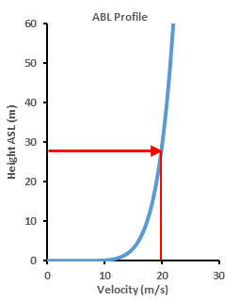 | 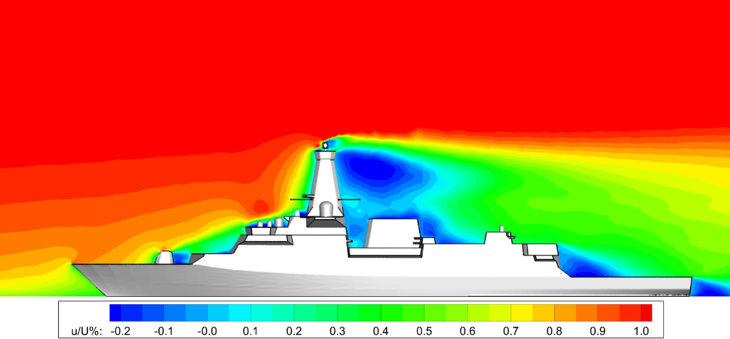
(a) | (b)
Figure 5: Atmospheric Boundary Layer profile (a) with reference to a longitudinal view of the ship’s airwake showing contours of normalised longitudinal mean velocity (b)

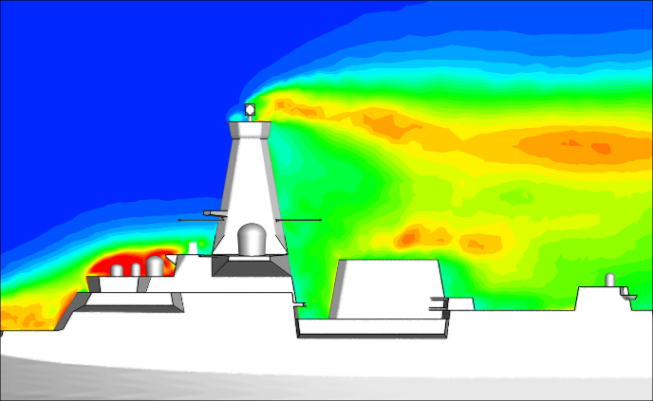
Figure 6: Contours of turbulence intensity in the longitudinal vertical plane in a 20 m/s headwind
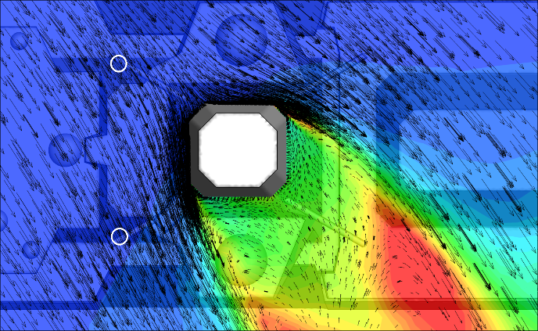
Figure 7: Contours of turbulence intensity with vectors of mean velocity magnitude in the horizontal plane for a 20 m/s Green 45 WOD

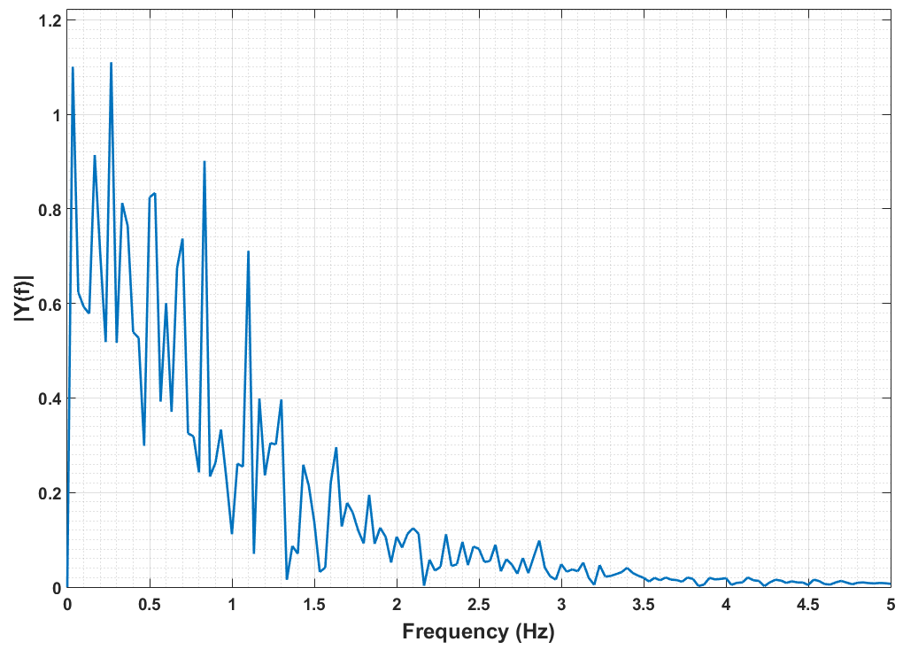
Figure 8: FFT of the lateral velocities at the starboard anemometer in a Red 150 WOD – representative of the anemometer being in the centre of the wake of the mast
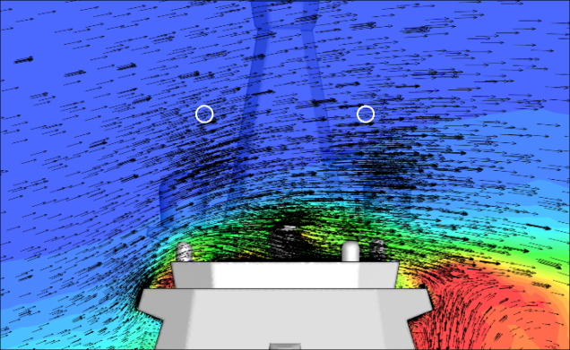
Figure 9: Contours of turbulence intensity with vectors of mean velocity magnitude in transverse vertical plane ahead of the mast in a 20 m/s Green 45 WOD
A ship’s anemometers usually only take account of the horizontal components of velocity, although modern ultrasonic anemometers are capable of measuring all three components. The vector sum of the two horizontal components yields both the wind strength and direction with the vertical component being seen as less useful, although it is a measure of the local flow distortion. Figure 10 shows the vertical velocity component, w, calculated for the two assumed anemometer locations, and for a 20 m/s wind for all directions; for an undisturbed wind the vertical velocity would be zero, as indicated by the blue line in Fig. 10. It can be seen that there are vertical (upward) velocities of up to 6 m/s, and on average about 3 m/s; the exception is the tailwind where the air flow is coming from the stern and after the main mast the air flows downwards towards the bow. The magnitude of the vertical component should be seen against the oncoming wind speed of 20 m/s, so this is another indication of the distorted air flow in which the anemometers would have to operate.

Figure 10: Variation in mean vertical flow velocity for different wind angles
Figures 11 & 12 show the computed air velocity and direction, respectively, for a 20 m/s oncoming wind, for all wind angles. In Fig. 11 the undisturbed wind speed at approximate anemometer height is 20 m/s, as marked on the graph (blue line). The red and green curves represent the port and starboard positions where the velocities are recorded and they can be seen to be very nearly mirror images of each other, reflecting the relatively symmetrical geometry of the ship and of the assumed anemometer positions. Errors in the velocity readings can be seen in the context of UK military defence standards, DEFSTAN 08-133 Part 2 [8], which require an error in velocity readings no greater than 10% of the true wind speed and an error in angular deviation no greater than 5°. As can be seen in Fig. 11, the computed wind speed at the assumed anemometer positions deviate by more than 2 m/s for the majority of wind angles. Between approximately 105° and 195° for the port position, and 165° and 255° for the starboard position, the respective anemometers are in the lee of the mast and would be significantly in error and inoperable for those wind directions.
Referring now to Fig. 12, the true wind direction is indicated by the blue straight line, and again it can be seen that when the anemometer positions are immersed in the mast wake the direction of the flow in the horizontal plane is significantly in error.

Figure 11: Variation in mean anemometer flow velocity in the horizontal plane (true wind 20 m/s)

Figure 12: Variation in mean anemometer flow angle in the horizontal plane compared to true wind angle
Finally, on the anemometer positions, Fig. 13 shows the turbulent RMS values in u, v, w in the x, y, z (longitudinal, transverse, vertical) directions respectively. The wind angles that are problematic in Figs, 11 & 12 are also those that have significant unsteadiness, again due to the unsteady and irregular vortex shedding.
It is not unusual for a ship’s two main (port & starboard) anemometers to have useable and non-useable wind angles. It is also possible that anemometers which have repeatable errors in wind strength and direction can be calibrated during at-sea trials (or possibly against wind tunnel or CFD data). However, for the bulky mast considered in this study it can be seen that the wind directions where one or both of the anemometers provide accurate readings is limited, and that the significant range of wind angles when the flow is unsteady and irregular makes anemometer calibration more difficult.
The data presented above has been for a potential anemometer position that is half way up the mast. Looking at the disturbed flow near the base of the mast in Fig. 9 shows that if the anemometers can be placed higher up the mast, where its cross-section is smaller and the flow distortion from the superstructure is less, then the better it is for the anemometer.
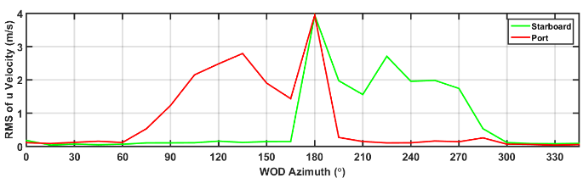
(a)
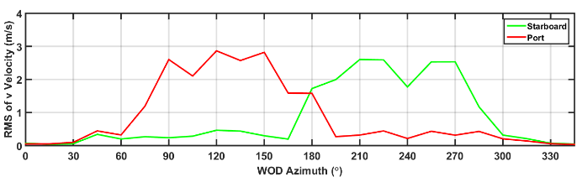
(b)
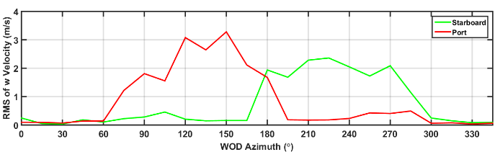
(c)
Figure 13: RMS of $u (a)$, $v (b)$, $w (c)$ components of velocity about the mean velocity

EFFECT OF MAST WAKE ON EXHAUST GAS DISPERSION
The large bulky shape of the main mast structure and the relative positioning of the GT exhaust, amidships and directly in the lee of the mast in acute WOD conditions can cause the exhaust gases to be entrained into the mast wake. The unsteadiness of the ship airwake as a result of the vortex shedding from the mast promotes the mixing of the exhaust efflux with the airwake and will enhance its dilution and dispersion.
Figure 14 shows air temperature in a vertical plane through the centre of the GT exhaust for a headwind condition; in this case the wind speed is lower at 14 m/s (~27 kts). As mentioned earlier, the ambient temperature is 38°C. It can be seen how the recirculation zone in the lee of the mast causes the exhaust gases to be entrained into the wake. Adjacent to the mast, air temperatures can reach 26°C above ambient (64°C), shown by the green region against the rear surface of the mast, which may affect sensitive equipment and systems at that location. Figure 15 shows a plan view of the mean velocity vectors and mean temperatures in a horizontal plane at half-mast height; again the entrainment of the hot exhaust gases into the mast wake can be seen with temperatures of the air surrounding the mast in that plane of approximately 20° above ambient. In Fig. 16, which shows mean velocity vectors and air temperatures in a transverse vertical plane through the centre of the flight deck, it can be seen that the hot exhaust has been cooled to about 15°C above ambient. The core of the GT exhaust is high above the deck and is unlikely therefore to interact with the helicopter under normal launch & recovery operations. Also visible in Fig. 16 is an area of raised temperature at around 6°C above ambient at about hangar height which is due to the rear Diesel exhaust.
It is known that elevated air temperatures will reduce the thrust of the main rotor, and the power output of the helicopter engine(s). While these adverse effects are not large, they are sufficient for users of offshore oil/gas platforms to issue guidelines to their helicopter operators that ambient air temperature rises greater than 2°C require some form of action [9]. Somewhat surprisingly there is no similar recommendation for naval operations, a topic that was discussed at some length by Scott et al [10]. Data presented in Fig. 17 shows unsteady temperatures at 200% and 250% hangar height above the landing spot (16m and 20m above the deck respectively). There is an irregular periodicity in the temperature fluctuations that are consistent with the frequencies of the shedding from the mast. In this instance where the WOD condition is a headwind, the higher temperatures in the core of the GT exhaust plume are higher than the standard hover position of a helicopter and therefore may not be of great concern to launch and recovery operations. Acute angle WOD conditions, such as Green/Red 30, do present potential issues as the core of the GT exhaust plume is entrained down into the helicopters operational area on the lee side of the ship, as discussed by Scott et al [10].

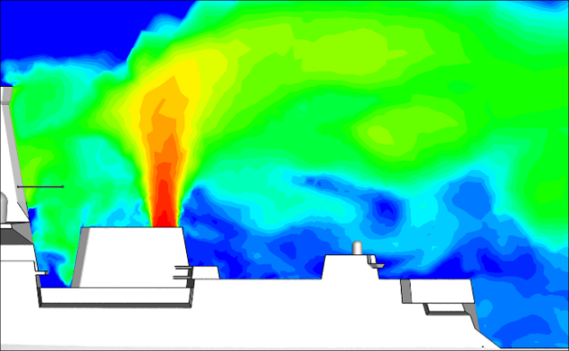
Figure 14: Contours of temperature above ambient along the ship centreline in a 14 m/s headwind (logarithmic scale)

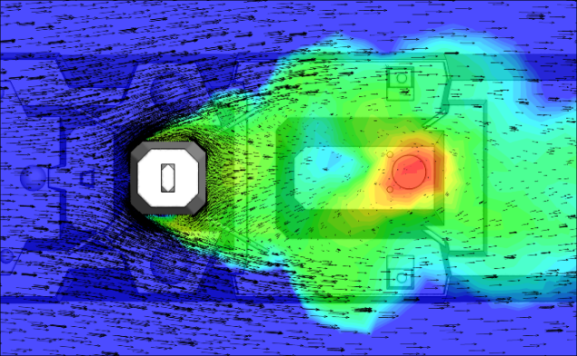
Figure 15: Contours of mean temperature above ambient with vectors of velocity magnitude at 50% mast height in a 14 m/s headwind (logarithmic scale)

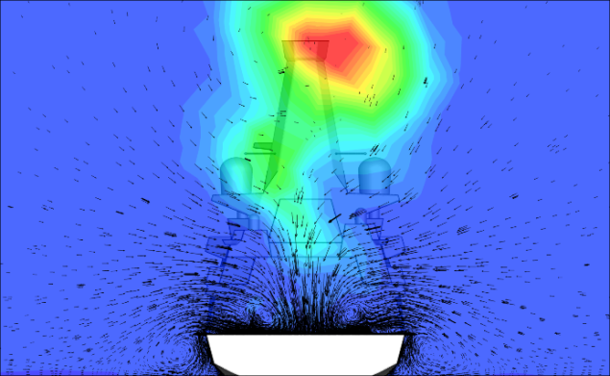
Figure 16: Contours of mean temperature above ambient with vectors of velocity magnitude across the centre of the flight deck in a 14 m/s headwind

Figure 17: Temperatures above ambient over the landing spot on the flight deck according to hangar height (HH) in a 14 m/s headwind

CONCLUSIONS
The air flow over and around a generic frigate with a bulky enclosed mast has been investigated using unsteady CFD.
The bluff geometry of the mast significantly distorts the air flow and leads to a large and unsteady wake in the lee of the mast.
Mounting the ship’s anemometers on the main mast, as is traditional, means that the anemometers could well be in serious error in both speed and direction for a considerable range of wind directions. Furthermore, the unsteady and irregular nature of the mast wake will make it difficult to obtain repeatable readings from the anemometer, which means that corrective calibration would also be problematic. Unsteady anemometers will lead to unnecessarily restricted SHOLs.
The large and unsteady wake from the mast will also interact with the ship’s engine exhaust gases. In the case of the generic ship considered in this paper, with a gas turbine exhaust directly behind the main mast, the interaction of the hot exhaust with the unsteady wake appears to be beneficial in that the hot exhaust gases are significantly cooled by the time the pass over the helicopter landing deck. Notwithstanding the cooling of the ship’s exhaust, there is still a significant uncertainty over what are acceptable air temperatures for safe helicopter operations.

REFERENCES

[1] | C. Savage and A. Kimber, “When is a mast a mast? The impact of integrated masts on platform design and classification,” in RINA Warship 2010: Advanced Technlogies in Naval Design and Construction, London, 2010.
[2] | J. Forrest and I. Owen, “An investigation of ship airwakes using Detached-Eddy Simulation,” Computers and Fluids, vol. 39, no. 4, pp. 656-673, 2010.
[3] | S. Ergin and E. Dobrucali, “Numerical Modelling of Exhaust Smoke Dispersion for a Generic Frigate and Comparison with Experiments,” Journal of Marine Science and Application, vol. 13, pp. 206-211, 2014.
[4] | P. R. Spalart, W. H. Jou, M. Strelets and S. R. Allarmas, “Comments on the feasibility of LES for wings and on a hybrid RANS/LES Approach,” in 1st AFOSR International Conference on DNS/LES, Ruston, LA, 1997.
[5] | C. Norberg, “Flow around regular cylinders: pressure forces and wake frequencies,” Journal of Wind Engineering and Industrial Aerodynamics, pp. 187-196, 1993.
[6] | T. Tamura and T. Miyagi, “The effect of turbulence on aerodynamic forces on a square cylinder with various corner shapes,” Journal of Wind Engineering and Industrial Aerodynamics, pp. 135-145, 1999.
[7] | Y. C. Kim and J. Kanda, “Wind pressures on tapered and set back tall buildings,” Journal of Fluids and Structures, vol. 39, pp. 306-321, 2013.
[8] | Ministry of Defence, “Requirements and Guidance for the Aviation Arrangements in Surface Ships: Part 2 - Guidance for the Design and Construction of Aviation Requirements,” UK, 2008.
[9] | Civil Aviation Authority, “CAP 437: Standards for Offshore Helicopter Landing Areas,” CAA, London, 2013.
[10] | P. Scott, M. White and I. Owen, “Unsteady CFD Modelling of Ship Engine Exhausts and Over-Deck Air Temperatures and the Implications for Helicopter Operations,” in American Helicopter Society 71st Annual Forum and Technology Display, Virginia Beach, Virginia, USA, 2015.

ACKNOWLEDGEMENTS
The authors are grateful to BAE Systems and to Ansys Inc for their continued support of the ongoing research at the University of Liverpool.

AUTHOR BIOGRAPHIES
Rebecca Mateer is a PhD Student at the University of Liverpool. She received her BEng (Hons) in Aerospace Engineering with Pilot Studies from Liverpool in 2014. Rebecca was awarded the prize for best Individual Project from the Association of Aerospace Universities at their Annual Student Conference in 2014.
Paul Scott is a PhD student at the University of Liverpool; his research is into the effect of ship superstructure aerodynamics on helicopter operations. Paul received his MEng degree in Aerospace Engineering from Liverpool in 2012.
Mark White is a Senior Lecturer at the University of Liverpool. He has over 25 years of research experience including the last 15 years in the area of real-time piloted simulation. He received his bachelors and doctoral degrees from the University of Liverpool.
Ieuan Owen is emeritus professor of Mechanical Engineering and currently visiting professor at the University of Liverpool. He has some 40 years of experience in industrial fluid mechanics and has been working on ship superstructure aerodynamics and their effect on aircraft operations for the past fifteen years. He received his bachelor and doctoral degrees from the University of Wales, Cardiff.

