Incorporating digital tools with ceramic crafting: Design and fabrication of Light defusing screen Shells
Asterios Agkathidis, Rosa Urbano Guttierez
asterios.agkathidis@liv.ac.uk, Rosa.Urbano-Gutierrez@liverpool.ac.uk University of Liverpool

Editor’s Note: This space reserved for the Editor to give such information as date of receipt of manuscript, date of receipt of revisions (if any), and date of acceptance of paper. In addition, a statement about possible written discussion is appended.

DOI: Digital Object Identifier to be provided by Editor when assigned upon publication

ABSTRACT
This paper investigates the possibilities which arise by incorporating digital tools into the design and fabrication of ceramic building components. In particular, we show how traditional ceramic crafting fabrication methods could be enriched by using parametric, performative and generative design techniques alongside digital fabrication technologies. Considering the growing importance of ceramic components in architectural construction due to their economic and environmentally friendly properties, this paper highlights the findings of design-led research explorations, demonstrating potential innovative solutions and failures arising through a digitalised ‘file to factory’ design approach.

Keywords: Design digital fabrication, parametric design, performative design, ceramic fabrication

1. INTRODUCTION
Ceramics are among the oldest building materials and can be traced in a range of structures across every part of the world. Ceramic components such as bricks and tiles have been used continuously as structural, cladding or decorating elements from ancient times up to the present in almost every building type and geographic location. Among the most unique feature of clay is its plasticity; in its humid condition, it can be formed into almost any shape. Traditionally, slab forming, extrusion or slip casting are among the most typical ceramic crafting techniques used.
For at least twenty years now, computational design and fabrication tools have been increasingly applied in the design of building components. Parametrisation of design solutions (e.g. through the use of modelling software such as Rhinoceros and Grasshopper software) has initiated innovation in almost every construction or fabrication sector. Digital technologies such as 3D printing, CNC milling and CNC cutting are becoming applicable in all types of building materials or composites [1], including ceramics.
However, despite their wide use in construction, ceramic components have remained largely unchanged for decades: they are geometrically simple, remain planar and are commonly applied in standardised, rectangular formats. One can barely find components with innovative forms; complex geometries double-curved solutions or performative optimisation embedded in their design process. The largest part of ceramic building component production is still based on Cartesian geometries and two-dimensional forming principles, focusing mostly on innovations in colour and glassing, rather than embedded performative or geometrical variation.
The aim of this paper is to explore potential innovation in the design and fabrication of ceramic building components by combining traditional craftsmanship with emerging computational technologies within a design-led research framework.
In particular, our aim was to investigate a ‘file to factory’ design and fabrication path based on the synergy of laser cutting, CNC milling and 3D printing technologies with slab forming, extruding and slip casting techniques, in order to develop innovative ceramic solutions. We thus expected to demonstrate that parametric design can be enriched with environmentally friendly properties, such as daylight defusion, shading and solar gain prevention, and that digital fabrication techniques can be used to produce formers, moulds and prototypes, which could be combined with one of the ceramic crafting techniques mentioned.
2. Literature review
Looking at the current professional architectural press, ceramic innovation is rarely found. Realised, experimental projects, such as ‘Vila Nurbs’, by Geli [2], ‘the Spanish Pavilion’ by Foreign Office Architects [3] or the ‘Urban Guerrilla’ installation by GGlab [4] (where double-curved ceramic tiles were designed and fabricated out of clay slabs produced on CNC milled formers) remain an exception.
There are however various research groups focusing on incorporating digital tools into ceramic design and fabrication. Their main focus is mostly on 3D printing technology and robotic fabrication applications; the 3D printed bricks by Building Bytes [5], the ‘PolyBrick’ by Sabin, Miller, Cassab and Lucia [6], and the Contour Crafting robots used by Roche [7] are among the most promising precedents mentioned. In addition, Gramatio and Koehler’s robotic brick walls assembly research [8] initiates an entire glossary of formal freedom in brickwork.
Celanto and Horrow are also investigating ceramics and 3D printing, focusing on the microstructure of ceramic skin [9], while Martin Bechtold’s work with ceramic systems and digital fabrication [10] is among the most thorough, advanced research in the field. In his ceramic shading system prototype, Bechtold has been the first to integrate environmental design strategies (such as radiance) and robotic fabrication workflow. This project was very influential in terms of our research [11], alongside Bechtold’s work on industrialised ceramic robotic fabrication flow [12].
The fusion of traditional ceramic crafting techniques with digital design and fabrication remains however still largely unexplored. It appears that a potential synergy between emerging computational technologies and ceramic crafting [13] (such as slip casting, slab forming and extrusion forming) has not been sufficiently explored, in contrast to their use in other industries in other industries. In timber construction for instance, the synergy between crafting and digital technology enabled innovative solutions for craft-like timber joints as demonstrated by Weinand and Hudert in the ‘Timberfabric’ project [14], reviving haptic qualities in architecture long lost through industrial automation.
The concrete shading screens as presented in Erwin Hauer’s book Continua [15] demonstrate such qualities. Being highly sculptural, Hauer’s pre-computational, concrete shading modules were an important source of inspiration for this research project. However, as they have been produced using a top-down approach, they remain standardised, form-driven solutions, without incorporating any performative qualities, such as structural efficiency or lighting optimisation. Describing his ‘Design 3’ screen project, Hauer admits:
“The structure as it relates to physical gravity and construction was a secondary consideration in the design process and it turned out to be a considerable tour-de-force. They did not say it could not be done, only that there were no procedures in the books to calculate its physical requirements.” [15].
By incorporating digital design and fabrication techniques with traditional ceramic crafting methods, formal complexity made possible by the use of clay could be combined with performance. As a continuation of the ‘Responsive Façade’ research project [16] by Dutt and Das, where 3D printing was combined with slip casting techniques in order to develop façade components, and as no similar documented approaches were found, we decided to extend this research to other ceramic production methods and assess their potential in a bottom-up design process.
3. RESEARCH QUESTIONS AND METHODS
3.1. Research questions
This paper investigates the following main research questions:
- How can we embed parametric design tools in the design process of ceramic building components?
- How can we incorporate CNC milling, CNC cutting and 3D printing technologies into ceramic crafting fabrication techniques, such as slip casting, extruding and slab forming?
- How can digital optimisation techniques pre-inform the design of ceramic building components in a bottom-up design process?
- How can conventional ceramic design and fabrication processes benefit by the incorporation of digital technologies? Can the use of new technologies encourage the development of innovative ceramic solutions?
3.2. Research method

To answer the research questions, we decided to apply, assess and evaluate three different file to factory methods in three design explorations, where digital tools were combined with ceramic fabrication techniques as follows:

- Digital modelling using Rhinoceros - optimisation using Ecotect digital fabrication using CNC milling and laser cutting - ceramic fabrication using slab forming - firing the outcome.
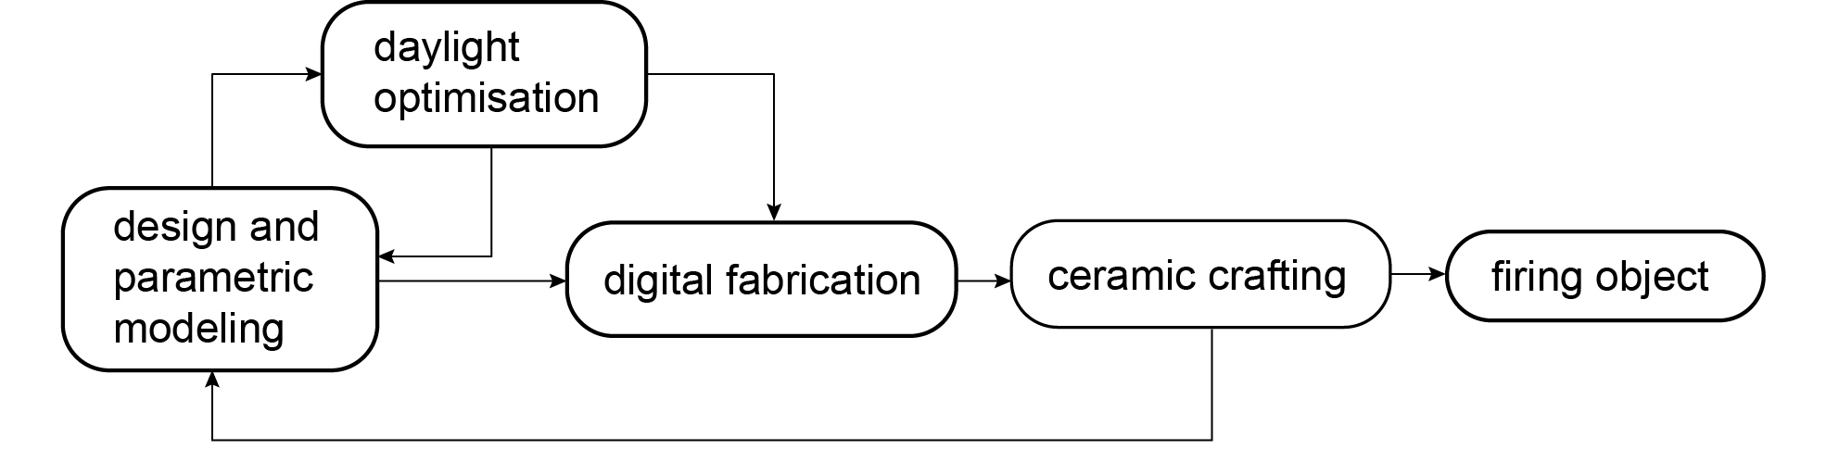
- Digital modelling with Rhinoceros and Grasshopper - optimisation with the Grasshopper plug-in Geco and Ecotect -
Figure 01: ‘File to factory’ fabrication diagram

digital fabrication using CNC milling and laser ceramic fabrication using extrusion and extrusion forming - firing the outcome.
- Digital modelling with Rhinoceros and Grasshopper - optimisation with the Grasshopper plug-in Geco and Ecotect - digital fabrication using 3D printing - ceramic fabrication using slip casting - firing the outcome.
All three methods are based on a generic scheme (figure 1) which should enable a feedback loop, thus allowing potential malfunctioning aspects of the process to be improved before firing the final artefact. Rhinoceros 5, Grasshopper and Ecotect software packages were chosen due to their high popularity among most architectural practices. To assess the different design and fabrication pathways, we proceeded to develop a suitable design brief focusing on designing, optimising and fabricating light defusing, ceramic screen components, to be applied as a suspended ceiling for a generic gallery space, covered by a glassed roof and without windows on the surrounding walls.

Light defusing devices are commonly used in museum or galley spaces in order to ensure constant, defused daylight flow within the space. Products available today are mostly louvre components made out of metal or plastic materials. There are no ceramic light defusing screen products currently on the market, making this a potential area for ceramic innovation. Each of the three file to factory production methods aimed to invent a non-existing ceramic product, which should itself explore non-typical geometries informed by environmental performance.

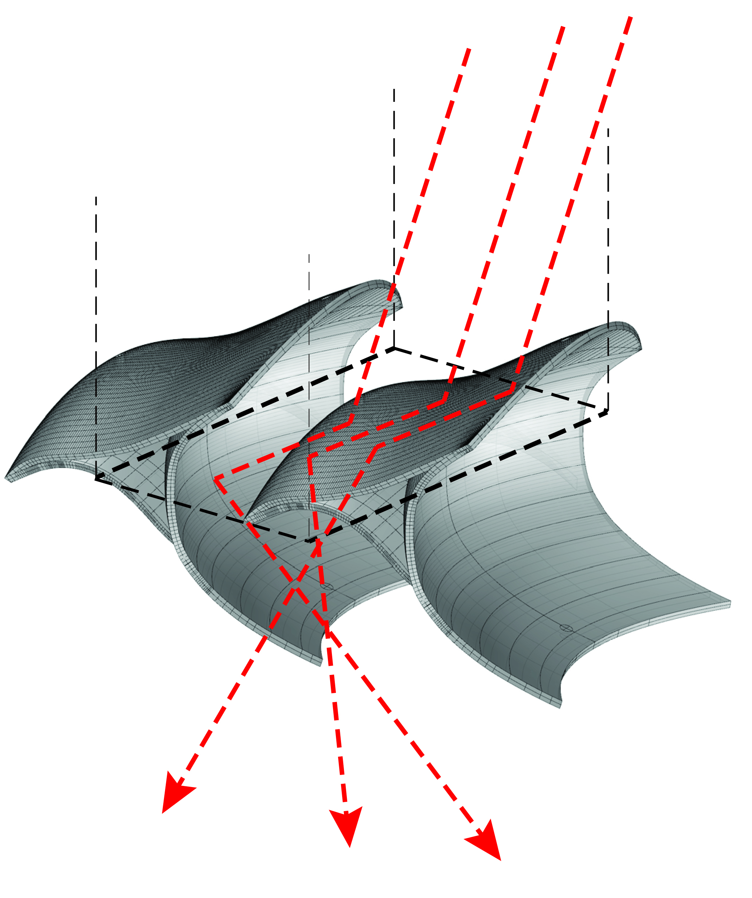
Each scheme had to follow a set of constraints and was determined by the size of the available kilns, budget, and the material properties of the clay type. We decided to use white porcelain in all three explorations to ensure that variable material properties would not influence the fabrication process.

After applying the three different design and fabrication methods, the entire process was analysed and evaluated in terms of feasibility, and possible conflicts between the various production techniques or the material properties, in order to draw a set of conclusions. The aim was to re-inform and improve similar processes in the future.

Success or failure of this triple merge was assessed on the basis of the feasibility of the entire file to factory ‘path’ as well as of the quality and innovation degree of the final product. Could such a production flow promote successful innovative solutions and encourage the development of new ceramic products which do not currently exist?

Available facilities consisted of the School’s digital fabrication laboratories, as well as the ceramic fabrication workshops of Liverpool-Hope University. Our available equipment included a Zprint 3D printer, a three-axis CNC router, a laser cutter, ceramic slab-forming tables, clay extruders and several kilns.

In the following chapter, we present three design explorations, one for each file to factory approach assessed.

4. CERAMIC FABRICATION DESIGN EXPLORATIONS AND RESULTS

4.1. Double curved louvres

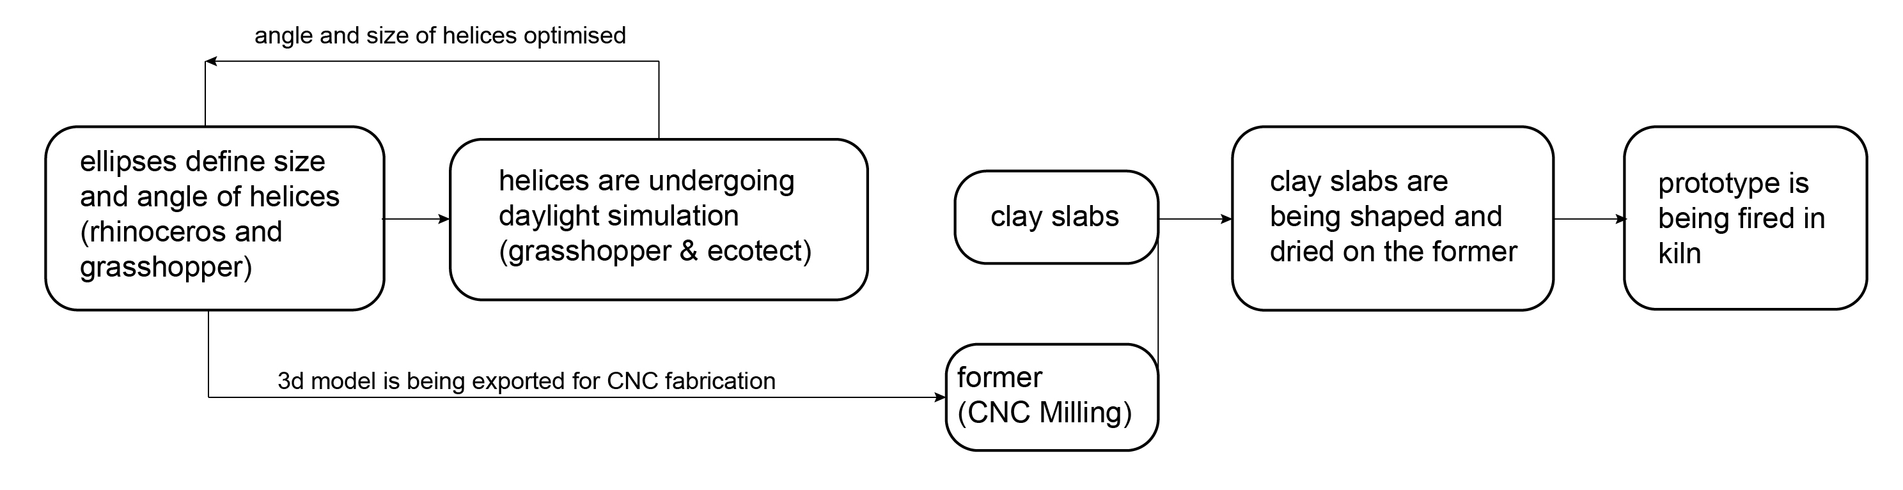
The first design exploration investigated the combination of parametric design, daylight simulation, laser cutting and CNC milling with slab forming fabrication techniques (figure 02).
Figure 02: file to factory fabrication diagram using slabs and CNC milling

clay slabs shaped and dried
helices undergo
daylight simulation
Figure 3: Double curved louvre unit and array with suspension mechanism (black) and ray of light (red).

The first screen shell component was conceived as a ceramic louvre system made of double-curved shells, which would disrupt direct transmission of light from ceiling to floor. Its curved surfaces dilute the rays of light, causing light defusion.

Each component was designed to be suspended from the ceiling in an array with an overlap (figure 3), forming a homogeneous surface. The suspension mechanism consists of a metal rod slipping like a giant skewer through the hollow, triangular tube formed between the three joined clay slabs. The rods can be fixed on several points on the ceiling structure. The module was modelled in Rhinoceros 5, 3D modelling software, as a parametric NURB entity, out
prototype fired

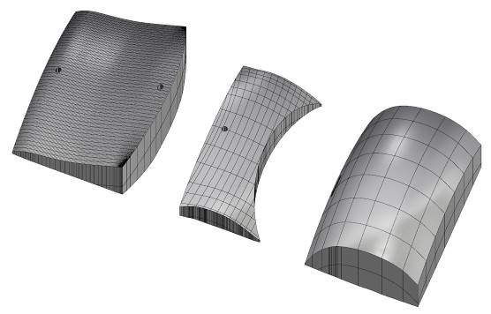
of three double curved shells. In order to simulate the structure’s daylight defusion performance in Ecotect, all Nurb-elements had to be converted into polygons before being exported. Our feedback loop allowed us to optimise the angles of the slabs and module overlap before producing and firing the object. All slab formers had to be modelled as surface extrusion solids and converted into polygons (STL files) before being milled by the CNC router (figure 4)

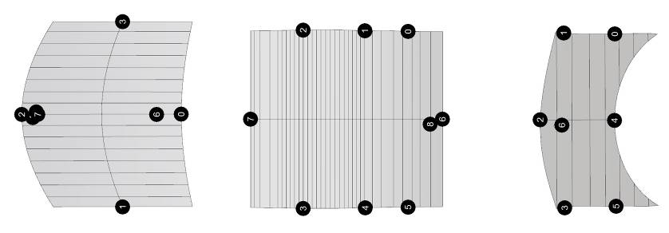
Figure 4: Styrofoam formers 3D models for CNC production

Figure 5: 2D slab components

Each three-dimensional shell had to be unrolled into a planar 2D outline (figure 5); these flattened outlines were used as cut-out stencils for the clay slabs. When the three formers had been finalised, each slab was adjusted on them and formed. The three shells were then joined together to form the final component (figure 6). This proved to be a somewhat complicated process, related to the material properties of the wet porcelain which resulted in differing degrees of elasticity and formability according to the slab’s thickness. When the component was formed, it was left to dry before firing (figure 7).

4.2. Layered helix

The second design exploration examined parametric/performative tools in combination with clay extrusion and CNC milling fabrication techniques. Clay extruders operate as a large press which pushes the clay mass through a chosen stencil. It is ideal for the production of longitudinal, tube-like elements (figure 8).

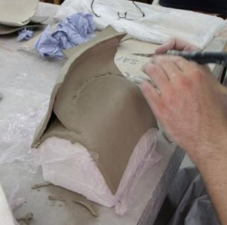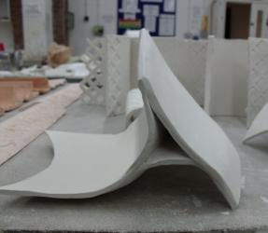
Figure 6: Forming the component out of clay slabs Figure 7: Finalised ceramic component
As a consequence, the design component was conceived as a set of multi-layered helix louvres (forming an extruded and twisted elliptical tube) which disturb and dilute the direct light transmission from ceiling to floor. It was developed as a parametric model using Rhinoceros 5 and Grasshopper software. Its geometry is based on an array of ellipses, which formed a twisted, three-dimensional helix louvre. Each ellipse can rotate parametrically around its axis allowing different degrees of curvature, and thus different degrees of light defusion, to occur (figure 9). The parametric script applied defines each ellipse at four points, allowing each to have a different radius. In contrast to Bechtold’s simulation technique using radiance software [11], the digital louvres were simulated using the Geco-Ecotect component, which allowed real time optimisation within the Rhino-Grasshopper software environment, while Ecotect was used as a simulation engine.

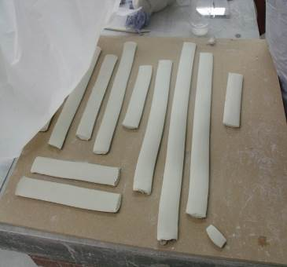
Figure 8: Unformed clay extrusions
Lighting simulation parameters (such as lighting calculation type, simulation precision and sky luminance) could be altered directly in Grasshopper within the ‘Lighting Calculations’ Geco plug-in
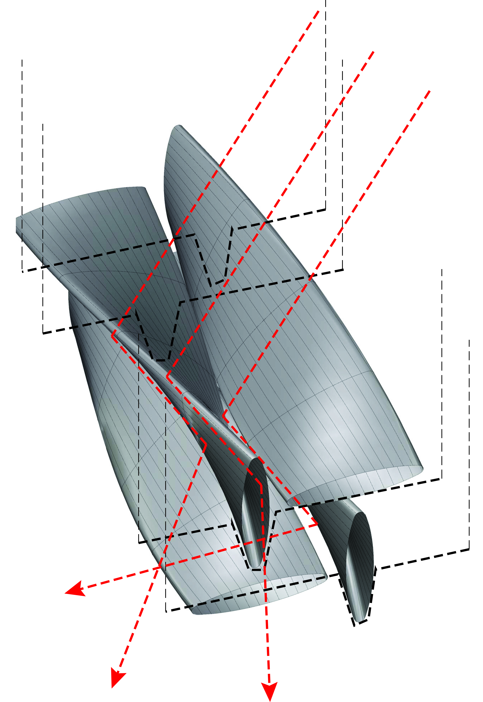
component, allowing direct optimisation of size,
Figure 9: Layered helices component with suspension mechanism (black) and ray of light pathway (red).

overlap and angle of helices. In addition, the optimised component was inverted into a negative 3D model and could thus act as former, once it had been fabricated out of an STL file.

To enable its fabrication, an elliptic stencil profile had to be cut and placed into the extruder, forming the clay tubes (figure 8); these were then placed on the formers and left to dry (figure 10) and subsequently fired. The four helices would later be assembled on a metallic framework, which would also enable their suspension from the ceiling (figure 9).

4.3. Distorted cone

The third design exploration assesses parametric/performative design tools in combination with 3D printing and slip casting fabrication techniques. The component was conceived as a distorted cone, which would re-direct light transmission according to the angle of distortion and the size of the upper side profile. Its complex shape could not be fabricated using any of the other previous methods. It was developed as a parametric point grid system by assigning each cone to a box defined by four points in a Rhinoceros-Grasshopper environment (figure 12).

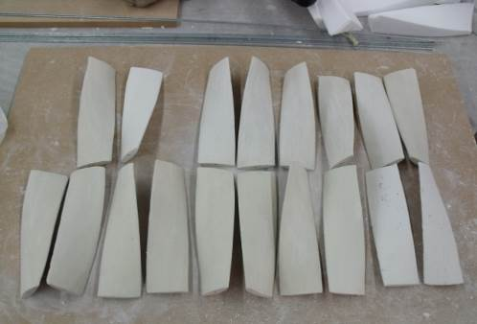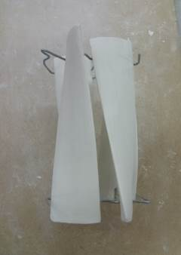
Figure 10: Formed and dried helix

Each cone was designed as a Nurb surface composed of offset-distorted profiles. Grid size, density, component height and distortion. as well as the Nurb’s tectonics (e.g. soft edge, hard edge) could be parametrically modified and tested in terms of their daylight defusion performance. The digital cones were simulated using the Geco-Ecotect parametric script as described above, allowing for the various angles, height and size of each component to be optimised.
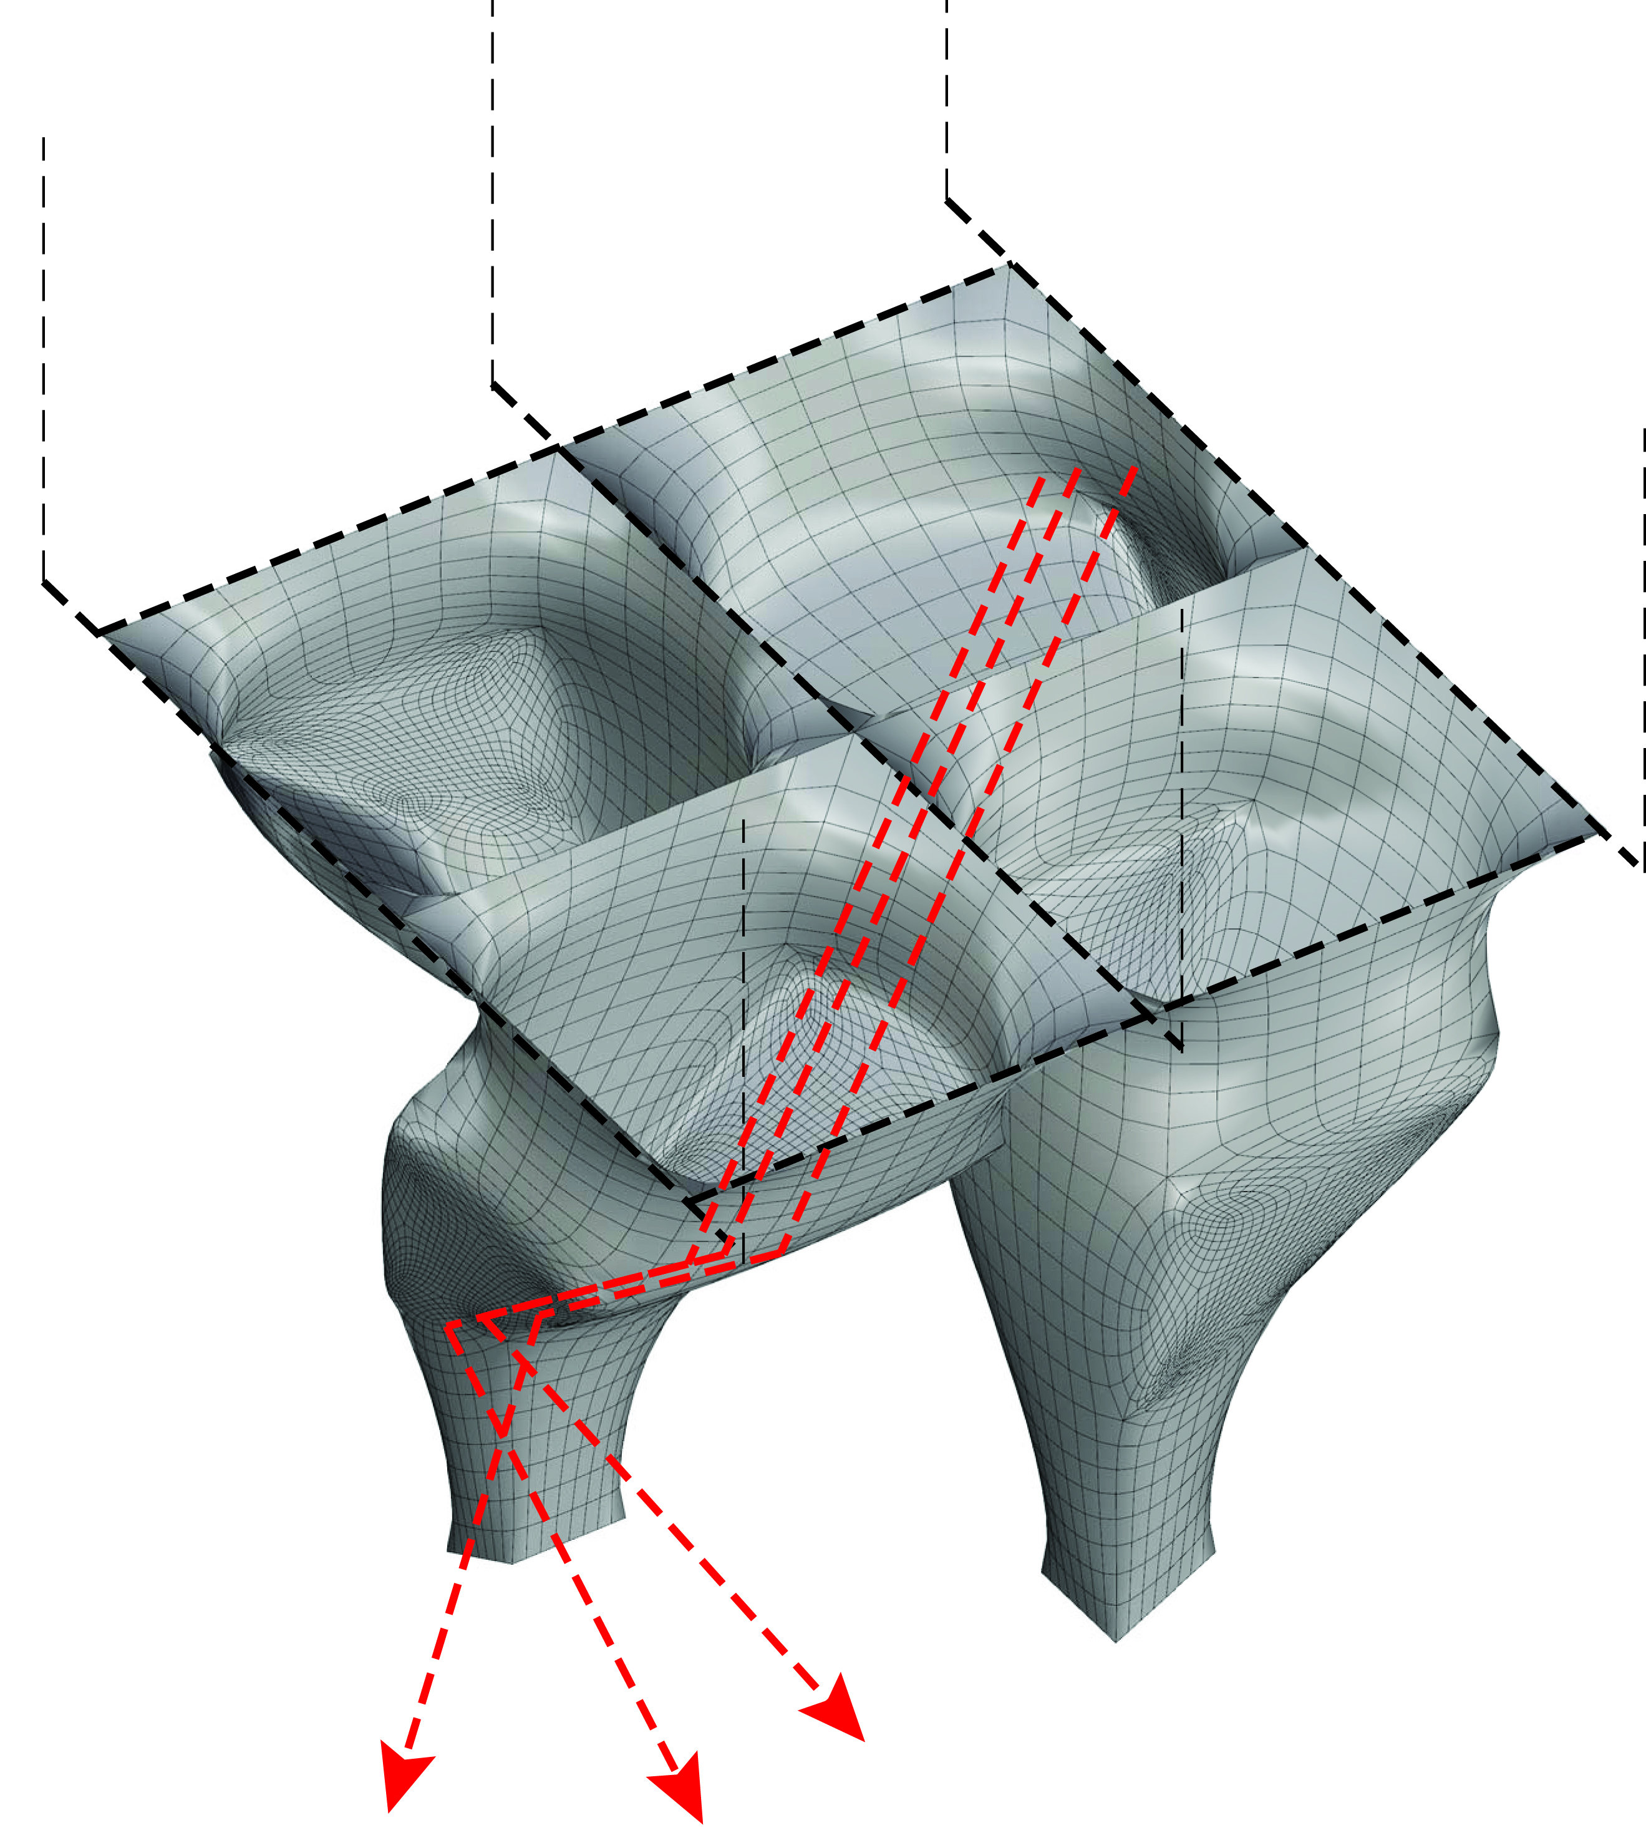
Figure 11: Parametric distorted cone units, suspension mechanism (black) and ray of light pathway (red).

When the required light defusing performance had been achieved, the 3D model was exported for 3D printing as an STL file. As soon as it was printed, the model was then used as a prototype to produce a negative plaster-made mould to be used for the remaining slip casting process, applying a technique similar to the one described in the Digital Fabric research project by Vollen and Clifford [17]. In this case however, the mould was cast directly out of the 3D ‘Z-printed’ prototype. It was cast in two pieces and thus could be opened easily in order to safely remove the final prototype. Ceramic slip was then cast into the dried-out plaster mould and poured out 10-15 minutes later, enabling the creation of a thin ceramic slip layer (figure 12). After drying out, the finalised object was removed and the mould could be used again. Finally, every component was fired in the kiln. Assembly and suspension of all components was achieved through the use of a metallic lattice frame, where each ceramic element can be placed in an array (figure 13).

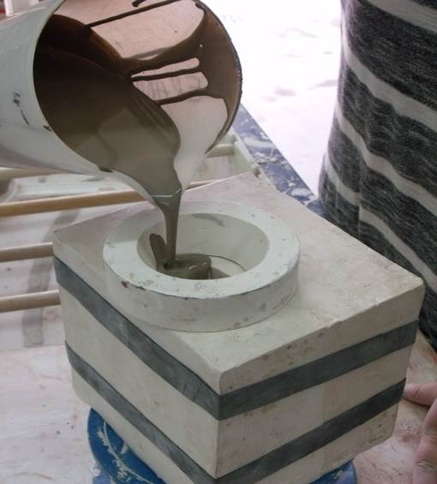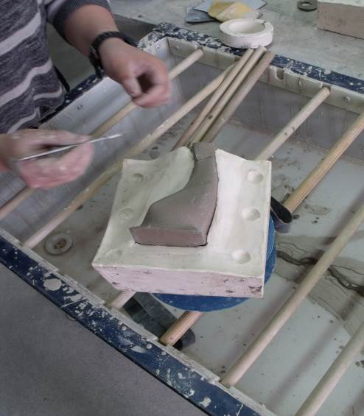
Figure 12: Slip casting the cones out of clay slip

4. DISCUSSION AND CONCLUSION

Keeping in mind that our exploration was aimed at assessing the file to factory process applied (figure 1) and not the actual products (which were obviously influenced by design decisions as well), one can claim that it proved to be a functioning path in all of its three variations. Combining digital tools with ceramic crafting techniques revealed its huge potential.

Fusion of slab forming/extruding and CNC milling as well as slip casting and 3D printing techniques enabled innovative design solutions, by merging formal expression enriched with performative properties. Similar to timber structure fabrication, hybridisation of digital technology and crafting enriches the final artefact with qualities hard to combine: hand-made plasticity and aesthetics with precision and performative behaviour.

Innovative solutions did emerge, and all three artefact prototypes met the pre-set criteria of performance (daylight diffusion), materiality (ceramic) and non-standard form. In this sense, all three explorations accomplished their aim. Even though manual crafting was largely involved in all three cases, one could incorporate these techniques in a fully automatised fabrication process, as described by Andreati, Castillo, Jyoti, King, Bechtold [11].

In addition, looking into the detailed file to factory flow, further findings worthy of discussion emerged. While 3D printing as applied by Bechtold [10] or Sabin, Miller, Cassab, and Lucia [6] entirely replaces craftsmanship and all of its aesthetic qualities (forming the product as it does by adding contour on top of contour), the method used in our third exploration, incorporating 3D printing and slip casting, offers a useful alternative. The extraordinary elegance of the thin clay slip is a property which has not yet been achieved in a 3D printing, additive process.

Looking into the relationship between design, materiality and the firing process, no discrepancies occurred. The use of porcelain, one of the most formable and resistant clay types, prevented unexpected surprises. To avoid dimension and size inaccuracies between the digital and the finalised fired product, all initial ceramic units had to be modelled 3 mm larger than required, as the fired object shrinks during the firing process. Exploration using different types of clay was not conducted during this process.

On the other hand, a number of findings demonstrate the limitations of all three methods applied. By examining technical, process-based characteristics, findings from all three explorations vary.

Starting with the first fabrication bath, we can observe that it is best suited for relatively simple, single shell components. Our unit’s design was too complex to be fabricated efficiently using slab forming. The curved clay slabs lost their elasticity and assembling them into one component proved difficult. During the drying process, cracks occurred in many of the joints of the overstretched shells and they had to be remodelled. The final product was less precise than the others and its sharp shaped surfaces could not be reproduced accurately. However, this is a valid fabrication method for simpler, single slab components made out of just one shell and not requiring assembly. The double curved louvre unit would have been fabricated more easily by using a 3D printed prototype in combination with the slip casting technique.

The small parametrisation degree of the initial 3D model used made the feedback loop from the lighting simulation slower, demanding more time to re-inform and optimise it. The component's complexity made lighting simulation very slow and time consuming, delaying the entire fabrication process even further.

The second exploration, focusing on a combination of CNC-produced formers and ceramic clay extruded tubes, proved to be an adequate fabrication method. The tubular extrusions could be produced quickly and formed easily, and their drying process was completed without crack occurrence. Producing the formers was inexpensive and they could be reused, allowing a high degree of production efficiency, consistent quality and high precision output. A combination of variable formers and standardised extrusions, and mass customised components, proved to be a viable path.

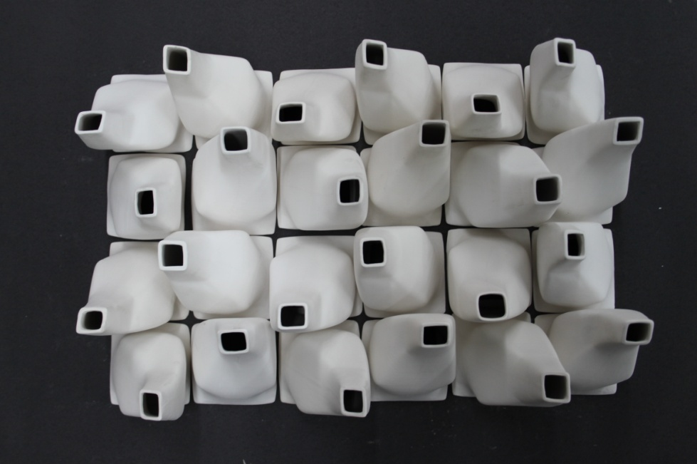
Figure 13: Finalised array of cones after firing

Simulating the digital helices directly from a Rhinoceros-Grasshopper environment and not by importing it into the Ecotect software enabled a faster feedback loop, a sufficient optimisation process between form and performance. However, simulating larger areas consisting of component clusters slowed the process down. In addition, parametrisation files became overcomplicated and hard to use.

Finally, the third design exploration’s file to factory process proved to be the most suitable for complex forms, allowing an almost perfect reproduction of the initial 3D object without having to compromise on geometrical complexity. Furthermore, once the slip cast replica is removed from the mould, it can be re-used an infinite number of times, making the artefact’s modular customisation easy. Mould casting is however a time-consuming process, making it less suitable for mass customisation. In addition, considering the higher cost of the 3D-printed prototype, it is by far the most expensive fabrication technique of all the three applied.

Looking at the bigger picture, including all three different production methods, the huge potential provided by incorporating digital design and fabrication techniques into the conventional ceramic fabrication process becomes clear. Parametrisation and simulation software supported the combination of formal expression and performative behaviour. In addition, clay and its property of high plasticity used in a digitalised, performative file to factory process supports innovative form generation.

Design techniques similar to those presented in this paper are being applied to some extent in the product design industry, but barely find their way into architectural building components, such as tiles, louvres, bricks and shading devices. By understanding more of clay’s material properties, and its relationship to the firing and the various glassing coating processes, further and additional fields of potential innovation arise.

5. ACNKOWLEDGMENTS

Special thanks to Chris Champion and David Machell, who worked on the first exploration, Robert Novelli and Deborah Wood who worked on the second exploration and Nojam Adami for producing the third exploration. Our acknowledgments to Amanda Wanner, Nuno Ferreira, Jade Crompton, John Clare, Stephen Barkey and Jason Stewart, who tutored at the workshop as well as to Stuart Carroll, the fabrication lab master of LSA. Acknowledgment goes also to the ceramic laboratory of Liverpool-Hope University, ASCER and the ‘Tile of Spain’ research funds, which funded this research project.

REFERENCES
- Kolarevic, B., Digital Production, Kolarevic B, Architecture in the Digital Age: Design and Manufacturing, Taylor & Francis, 2003, London, pp 46-48
- Ruiz-Geil, E., Cloud 9, Actar-Birkhäuser, 2013, Barcelona
- Brownell, B., Material Strategies: Innovative Applications in Architecture, Princeton, 2011 Architectural Press, Princeton
- Fores, P., Urban Guerrilla, Salazar J, Sakamoto T, Rhythms, Cycles, Performances, Ceramics in Architecture, ASCER-Actar, Barcelona, 2010, pp 108-111
- Peters, B., Das Haus aus dem Drucker: Building Bites, Detail 06/2013, Solid forms of Construction, 2013, Eltville, p 720
- Sabin, J., Miller, M., Cassab, N., Lucia, A., Polybric: Varigated Additive Ceramic Component Manufacturing (ACCM), 3D Printing, Volume1, Mary Ann Liebert Publishers, 2014, New York, pp78-84
- Leach, N., Carlson, A., Khoshnevis, B., Thangavelu, M., Robotic Construction by Contour Crafting: The Case of Lunar Construction, International Journal of Architectural Computing, issue 03, volume 10, 2012, pp 423-438, DOI: 10.1260/1478-0771.10.3.423
- Bonwetsch, T., Kobel, D., Gramazio, F., Kohler, M., The Informed Wall: applying additive digital fabrication techniques on architecture, Synthetic Landscapes, ACADIA 2006, pp 489-495
- Celento, D., Harrow, D., CeramiSkin, Biophilic Topological Potentials for Microscopic and Macroscopic Data in Ceramic Cladding, First International Conference on Critical Digital: What matters? 2008, Cambridge (USA), pp 65-76.
- Bechtold. M., Kane, A., King, N., Ceramic Material Systems: In architecture and Interior Design, Birkhäuser, 2015, Basel, DOI: 10.1515/9783038210245
- Bechtold, M., King, J., Kane, A., Kiemasz, J., Reinhart, C., Integrated Environmental Design and Robotic Fabrication Workflow for Ceramic Shading Systems, ISARC 2011, Seoul, pp 70-75
- Andreati, S., Castillo, J., Jyoti, A., King, N., Bechtold, M., Flowing matter: Robotic fabrication of complex ceramic systems, ISARC 2012, Einthoven
- Turner, A., Throwing & Handbuilding: Forming Techniques (Ceramic Arts Handbook), Amer Ceramic Society, 2007, Westerville
- Weinand, Y., Hudert, M., Timberfabric, Applying textile principles on Building Scale, Structures and Architecture, AD, Taylor & Francis, 2001, London
- Hauer, E., Continua- Architectural Screens and Walls, Princeton Architectural Press, 2007, Princeton
- Dutt, F., Das, S., Computational design of Bio Inspired Responsive Architectural Façade System, International Journal, of Architectural Computing, issue 04, volume 10, 2013, pp 613-633, DOI: 10.1260/1478-0771.10.4.613
- Vollen, J., Clifford, D., Winn, K., Gindlesparger, M., Digital Fabric: Generating Ceramic Catenary Network, Lilley, B., Beesley, P., Expanding Bodies: Arts, Cities, Environment: Proceedings of the ACADIA 2007 Conference, 2007, Halifax, pp48-55

