Tracing the past: a digital analysis of Wells cathedral choir aisle vaults

Nicholas Webb, Alexandrina Buchanan

School of Architecture, University of Liverpool
Department of History, University of Liverpool

Abstract
Architectural historians have identified Wells cathedral as a key monument in the transition between high and late Gothic, a move in part characterised by the rejection of simple quadripartite or tierceron rib vaults for more complex vaults. Here we will show how digital methods are used to reopen questions of design and construction first posed in 1841 by pioneer architectural historian Robert Willis. Digital laser scanning documents vaults accurately, thereby establishing their geometries to a high degree of certainty and, at Wells, highlighting differences between the choir aisle bays which have previously been treated as a single design. Significantly, we will show how digital techniques can be used to investigate these differences further, using point cloud data as a starting point for analysis rather than an end point. Thus we will demonstrate how modern technologies have the potential to reignite historic debates and transform scholarly enquiries.

Keywords
3D digital modelling
Laser scanning
Wells cathedral
Medieval vaults
Digital analysis
Robert Willis

Highlights
- Point cloud models can be used to identify differences requiring more detailed analysis.
- Tracing of mesh models allows us to establish the geometry of the vault ribs.
- Digital reconstructions enable us to reverse-engineer the design and construction process of a sample bay.
- The validity of Robert Willis’s hypotheses is confirmed and his research augmented.

1. Introduction
This article discusses how 3D digital documentation and analysis techniques are used to investigate the design and construction of the medieval choir aisle vaults at Wells cathedral in the south-west of England (figure 1). In his 1841 lecture ‘On the construction of the vaults of the middle ages’ Willis posed several questions concerning medieval vaults that he was unable to answer at the time, as obtaining detailed measurements through manually surveying numerous vaults, unreachable without scaffolding, was logistically unfeasible (Willis, 1842). Our primary aim is therefore to demonstrate that recent advances in digital surveying techniques, most notably laser scanning which is now known to offer a robust and realistic method of adequately surveying heritage assets, can provide us with a base model as a tool for detailed analysis beyond the digital survey data itself. This has the potential to challenge simplifying assumptions based on traditional approaches in the study of medieval architecture that can lead to sweeping narratives (Bork and McGehee, 2011) and to open new questions about design and construction processes and knowledge transfer between sites (Talaverano et al, 2012, López-Mozo et al, 2015).
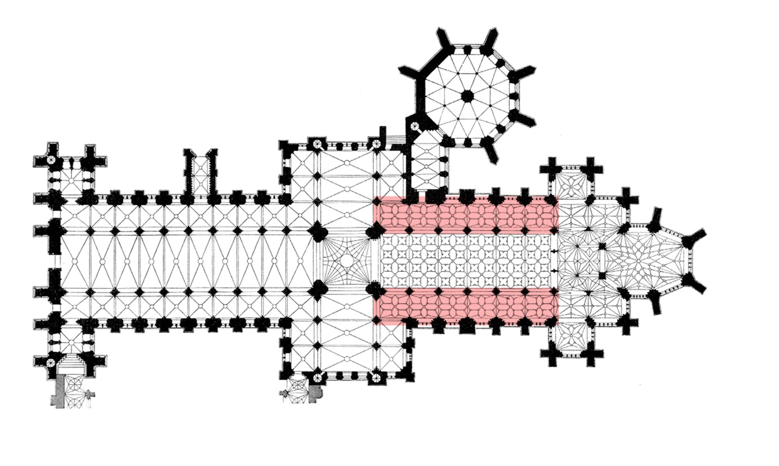
Figure 1. Georg Dehio plan of Wells Cathedral modified to highlight the north and south choir aisles.

Previous historiography has demonstrated the significance of the Wells cathedral choir aisles but has treated them as a single repeated design (Wilson, 1990 and 2011; Crossley, 2003; Monckton, 2006) although subtle variations between bays have been identified by eye (Monckton, 2006, fn. 72, citing Buchanan). For example, the plastered infill panels forming hexagons running along the apexes of the north aisle appear to be flatter than those of the south aisle, which appear to have a more defined curvature. Figure 2 attempts to show this, however, it is difficult to perceive by eye, hence the requirement for contemporary digital tools for a more objective and thorough analysis. These observations therefore make Wells an ideal case study as they reveals the variety of design and construction processes coexisting at this key moment in architectural history, whilst still offering an apparent level of consistency throughout. Wells also presents an opportunity in relation to Willis’s hypotheses, which have been used to frame this paper. The aim of the present research is to create a digital version of an existing building as accurately and efficiently as possible and subsequently enabling a detailed analysis of the vault geometry, as opposed to producing a digital model primarily for documentation and visualisation purposes. Nevertheless, the surveyed digital models will also stand as heritage assets for future use and analysis.
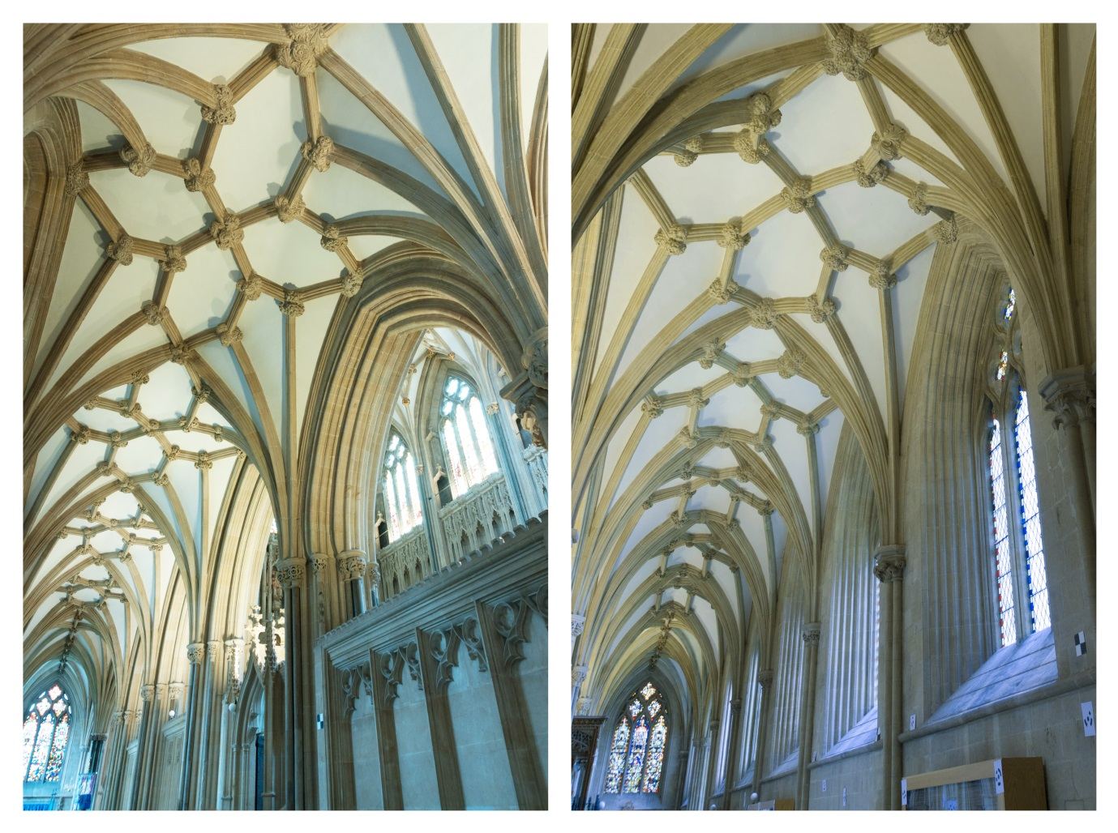
Figure 2. North choir aisle vaults (left) and south choir aisle vaults (right). Image: JR Peterson.

2. Context
2.1 Willis’s call to the RIBA
Professor Robert Willis (1800-1875), engineer and pioneer architectural historian, called on members of the newly founded Royal Institute of British Architects to survey medieval vaults in order to gather evidence to test his ideas about their design and construction (Willis, 1842). He presented four hypotheses which have underpinned the current research: (1) that medieval vaults did not use Classical stereometrical principles, where the full 3D geometry of a design is worked out prior to construction, but instead that medieval vault ribs are defined first using projections and then the intervening surfaces are filled in with a lightweight panel. This means that the geometry of the ribs is the defining factor in the vault’s design; (2) that the tas-de-charge (or springer block - the lowest course of stone in a vault, where the ribs begin to diverge) offers particular design challenges which he suggested were met by ignoring geometrical accuracy in favour of constructional contingency; (3) that rib curvatures can be based on single or multiple arcs, and are dependent upon three points (impost, apex and centre). Which of these factors was variable, and how they were determined, he attributed to workshop practice, requiring further research, and (4) that the projection of lierne vaults (those involving ribs which neither spring from the tas-de-charge nor define a longitudinal or transverse ridge) required the pre-existence of a 2D plan.

2.2 Wells cathedral
The significance of architecture in south-west England for the development of late Gothic, first identified in the 1950s, has been confirmed by recent scholarship (Pevsner, 1953; Bock, 1961 and 1962; Wilson, 1990; Crossley, 2003; Wilson, 2011). In both 3D form and rib configurations, the Wells vaults anticipate the ‘net vaults’ designed by Peter Parler at Prague Cathedral, thus establishing the principles of their design and construction provides vital data for investigating international influence and the possible transfer of technical ideas (Talaverano et al, 2012; López-Mozo et al, 2015).

In addition, the data produced by this research has both complicated existing interpretations of the construction at Wells (Colchester and Harvey 1974; Draper 1981; Ayers 2004) and offered the potential for solutions. The present research focuses on the eastern arm, which began to be extended and remodelled sometime after 1300, whilst retaining some elements of the existing choir, including the two westernmost arcade piers on each side and the aisle walls, which were remodelled, with the insertion of new windows. These existing bays provided the width and length for the new choir aisle bays and heights for the new piers which corresponded to those of the older work. There have been suggestions that the remodelling of the south aisle wall pre-dated work further east, i.e. probably dating from before 1320 (Draper, 1981, pp.22-3) but there is no necessity for the western bays of either aisle to have been vaulted at this time. The Lady Chapel was described as ‘newly built’ in 1326 and the two projecting chapels just to the east of the aisle bays under discussion are documented in relation to chantries (foundations for commemorating the dead) in 1328 (Ayers, 2004, vol 1, p.139). Demolition of the wall behind the former high altar had taken place before 1333 and the glazing of the great east window has royal heraldry without fleurs-de-lys, suggesting a date prior to 1339 when this element was added by Edward III (Colchester and Harvey, 1974, p.208). Assuming the usual pattern of east-west construction and with a need for both choir aisles to have been vaulted before the erection of the upper vaults, itself probably predating glazing of the east window, the eastern bays of the aisles must have been built and the vaults added in around 1330.

Although there is a ‘window’ of less than a decade for the construction of the vaults under discussion, questions remain about their sequence of construction and the identity of their designer. As will be shown, our research has suggested the aisle vaulting involved at least four separate campaigns taking place either simultaneously or sequentially. It is generally assumed that the handover between the two named masons associated with Wells, Thomas of Witney and William Joy, occurred between the retrochoir and the choir, with Witney responsible for the former and Joy responsible for the latter (Harvey, 1984; Morris, 1991; Wilson, 1990). The nature of their responsibility and the extent of their involvement is, however, undocumented and the nature of the differences between the designs identified by our research raises new questions about the relationship between design and construction, and about construction processes and site management, which will be discussed in a future article.

2.3 Precedents and parallels
Willis identified the problem for testing his hypotheses as a lack of data, particularly since obtaining the necessary results required the long and laborious process of raising scaffolding to enable a detailed survey to be recorded by hand. Although we have yet to obtain the comparative material he sought, we have demonstrated that laser scanning makes surveying far quicker, therefore the logistics of documenting a cathedral interior digitally, compared to traditional methods, is much more viable. In addition to the speed of data collection, laser scanning produces highly accurate digital models, enabling significant analysis opportunities for researchers. Andrew Tallon’s surveys of French gothic architecture demonstrate the accuracy of digitally captured data and the potential results they can provide, such as revealing the non-alignment of piers in the crypt of the abbey church of Saint-Denis (Tallon, 2014). He also highlights how previous data, such as 2D drawings, can be misleading in their accuracy in terms of the reliability of the original survey and also because of potential degradation of the drawings themselves. Such problems are eradicated using digital techniques, for example with point cloud data the use of section cuts are a standard method of analysis: scan points along a specified plane are extracted from a model and represented in two dimensions and therefore visualised in the same way as traditional architectural plans and sections. This, however, is more reliable than traditional techniques due to the accuracy of the digital survey data (Brumana et al, 2013, Datta, 2015). Similarly, orthorectified images, where the point clouds are presented as a parallel projection instead of using perspective, can be produced to assist with analysis as can be seen in Giannattasio et al’s (2013) analysis of the San Francesco Convent in Cagliari and Tsingas’ (2012) modelling of the Acropolis of Athens. Our research explores other uses for these methods of converting 3D data on to a 2D plane, and also investigates how the 3D digital models produced can be analysed directly, particularly in terms of their underlying geometry and what this means in relation to vault design and construction. Capone et al (2015) therefore forms a key parallel study using similar techniques to study gothic vaults, however their research first hypothesises how a vault was built and then uses the digital survey for clarification; whereas our study digitally surveys the vaults first and uses this as a starting point for our hypotheses via a process of reverse engineering.

3. Process
3.1 Laser scanning
Laser scanning was chosen as the most appropriate method based on an analysis of ‘what we have to survey and why’, as discussed by Capone et al (2015) in their study of French gothic cathedrals. For our research we required an accurate record of the vaults at two distinct scales. The first of these was to document the vault rib curvatures to understand their geometries, which was achieved by tracing along rib intrados lines using either a point cloud model or mesh model. This typically involved tracing ribs over four metres long, with standard deviations between the radii of established vault rib sets ranging from 80mm to 175mm, which were deemed acceptable based on the large lengths of ribs. These deviations are mainly based on potential inaccuracies in the construction process and settlement of the ribs, as well as potential issues with the accuracy of our own tracing methodology. The second scale of investigation required precise details of moulding profiles to be recorded to study potential tas-de-charge stone distortions. To study such distortions required a much higher accuracy level, as a distortion may be significant based on differences in stone mouldings as little as 3.5mm. We also wanted to ensure that we had a detailed record of the vaults for any additional investigations that we may come back to in the future, such as a study of the boss stones. Based on our surveying methods, which captured the vaults from the cathedral floor, both laser scanning and photogrammetry techniques provided an accurate record of the built structure at a large scale. However, when investigating precise details our photogrammetry method was not reliable enough because we could not accurately record the individual stones, or voussoirs, based on the distance from the cathedral floor (Webb et al 2016). Therefore laser scanning remained the primary survey method to capture the vaults for both scales of investigation, with photogrammetry employed as a secondary data set demonstrating conformity between the two techniques at a large scale. A Faro Focus 3D X330 laser scanner enabled the creation of a detailed point cloud with one scan of 20264 x 5121 points taken in each bay. This resolution was high enough to capture tas-de-charge stones sufficiently, as well as easily documenting adequate detail for rib curvatures. As the focus of the research is to investigate the vaults forming the ceilings of the choir aisles, we set the scanner to only survey above its horizontal line of sight, therefore capturing all detail above and ignoring the floor below. Not scanning the floor also helped logistically as the cathedral was open to the public and therefore people could walk freely around and underneath the scanner, which was positioned on a tripod above head height (figure 3).

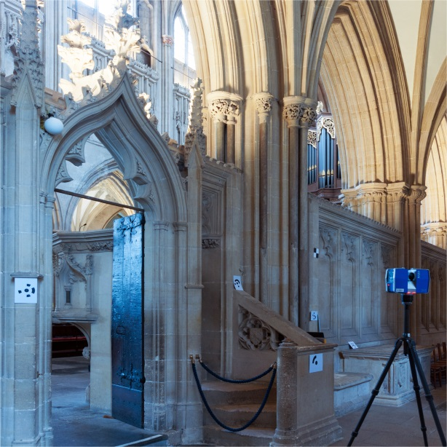
Figure 3. The Faro Focus 3D scanner is positioned on a tripod above head height to limit disruption to the running of the cathedral.

A single scan per bay enabled us to capture almost all detail of the vaults above, based on their curvatures. Overlap with adjacent bays also ensured details of ribs and bosses in the immediate context were thoroughly documented. In Scene, Faro’s proprietary software, scans were aligned to each other using sphere targets, with the north and south choir aisles dealt with separately to reduce overall file sizes. The registration process produced good results with a mean target tension in Faro Scene of 0.0034 recorded in the north aisle and 0.0027 in the south aisle, where the closer the result to zero, the better the registration result. The overlapping scans produced detailed point cloud models (figure 4), which were exported as individual bays with a homogenised point density giving, for example, a file size of 1.66GB for bay N1. This was deemed too large to work with for our later analysis process based on the computing power available to us, therefore we investigated subsampling the points to one every six in each row and column, reducing the file size in N1 to 102MB. This level of detail was sufficient to trace rib curvatures, however, we later decided to use mesh models rather than the point clouds for rib curvature tracings. For the detailed investigations of tas-de-charge stones which required higher accuracies, we only needed to export a small portion of the point clouds (a slice of approximately 0.75 x 0.35 metres) therefore also producing manageable file sizes.
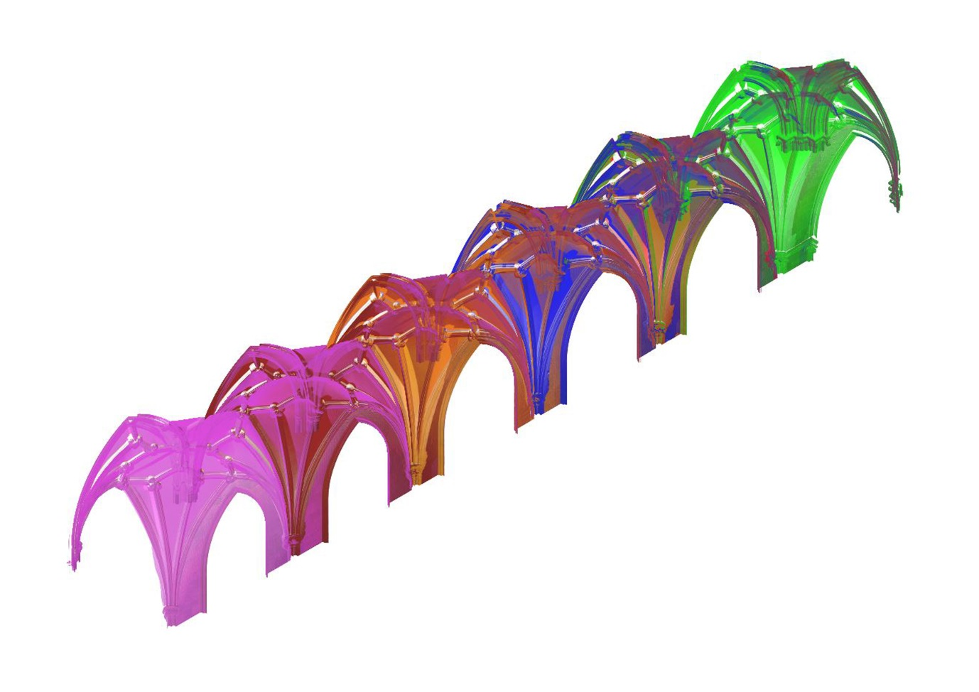
Figure 4. Point cloud model of the north choir aisle, with different colours indicating the scans taken and their overlap.

3.2 Hurdles during the process
Although wholly satisfactory for surveying the vault surfaces, the laser scanning process still had to be carefully planned, particularly as some areas in a scene could be blocked from the laser’s line of sight causing voids in the resulting point cloud model, generally referred to as ‘shadow’ (Guidi et al, 2014). Recording the full 3D geometry of the ribs was straightforward by scanning from several stations on the cathedral floor as discussed in section 3.1, however small areas of shadow were found immediately above the upper surface of the column abaci at their intersection with the ribs (figure 5). For the purpose of this project, two decisions were possible: firstly a raised platform such as a small basket crane could have been employed to position the laser scanner above the upper surface of the abaci, ensuring that all details were captured. Alternatively, a simpler approach was to rely solely on scans taken below the upper surface of the abaci from the cathedral floor and accept that this resulted in small areas of shadow directly beyond it (figure 5). This latter approach was taken, as the area of shadow produced was insignificant in terms of our lines of enquiry.
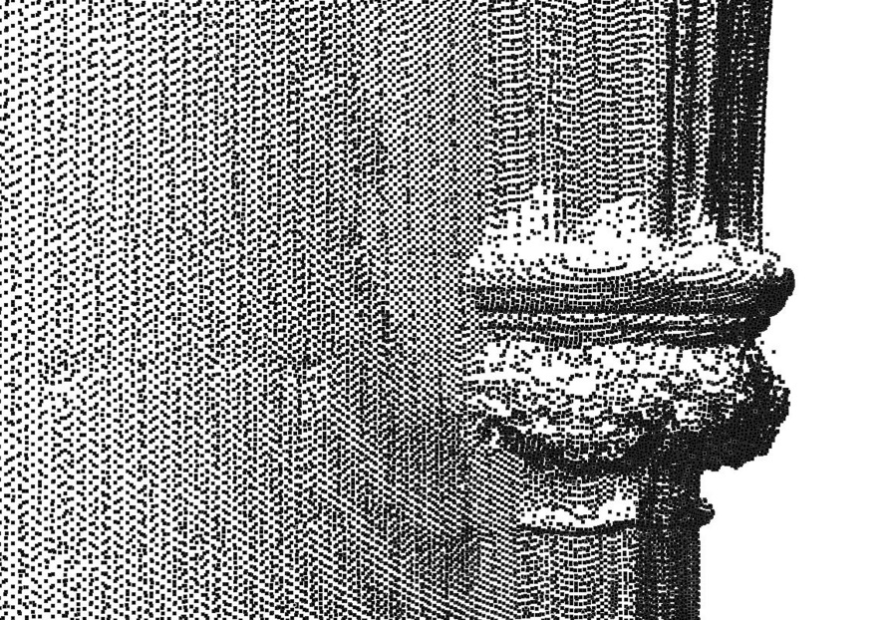
Figure 5. Point cloud model with a homogenised density showing an area of shadow above the upper surface of an abacus in bay N5.

As already discussed, accuracy in the digital representations was a requirement for our research goals at different scales. The point cloud models were very precise other than the issue of outlying and erroneous points, a common occurrence in scans often referred to as ‘noise’. However, a more visually readable model format was sometimes required for better interpretation of the data, particularly in terms of tracing the vault rib curvatures, which is discussed in the next section, as well as for future dissemination purposes. In first attempting to trace the vault ribs using the point cloud models, it became clear that this was a laborious process as the required points along the intrados lines were difficult to locate amongst the other thousands of points. A solution to this was to create sections of points or orthophotos along the required lines, as discussed by Andrews et al (2013), however, the process of setting up these views in each vault bay proved equally laborious based on the numerous planes required. Each of the 12 bays required the tracing of 36 vault ribs, therefore the choir aisles would have required 432 processes in total. We therefore decided to convert the point cloud models to 3D mesh models. The idea here was that the intrados lines would be easier to locate visually on the mesh models and also prevented the need for additional processes based on the large number of tracings required. Mesh models can be created from single scan point clouds within Faro Scene, which proved adequate for our research, as we were investigating the vaults bay by bay. However, as the mesh was produced from a single scan, rather than a combined scan, there were some areas of ‘shadow’ in the models. Yet these were insignificant to our investigation, with the main purpose for using mesh models being to trace along intrados lines, which were never in areas of shadow on the scans as they are located on the outermost edge of each vault rib. Ultimately we found that a combination of mesh and point cloud models were required for the different aspects of the project, checking back and forth between the two types depending on the lines of enquiry pursued. Additionally, the original scan data in Faro Scene itself was valuable, particularly at producing orthorectified images and checking measurements. Once all the data was processed, we could begin to investigate the vaults.

4. Findings
4.1 Orthorectified images
One of the first findings used the ‘orthophoto’ tool in Faro Scene and relates to Willis’s observation of the interplay between 2D and 3D geometry. Creating an orthographic projection, where perspective is removed from the representation of the point cloud data, enabled subtle differences between the different bays to be revealed in section (figure 6). This was particularly relevant compared with studying the space by eye, where the differences are much less noticeable.
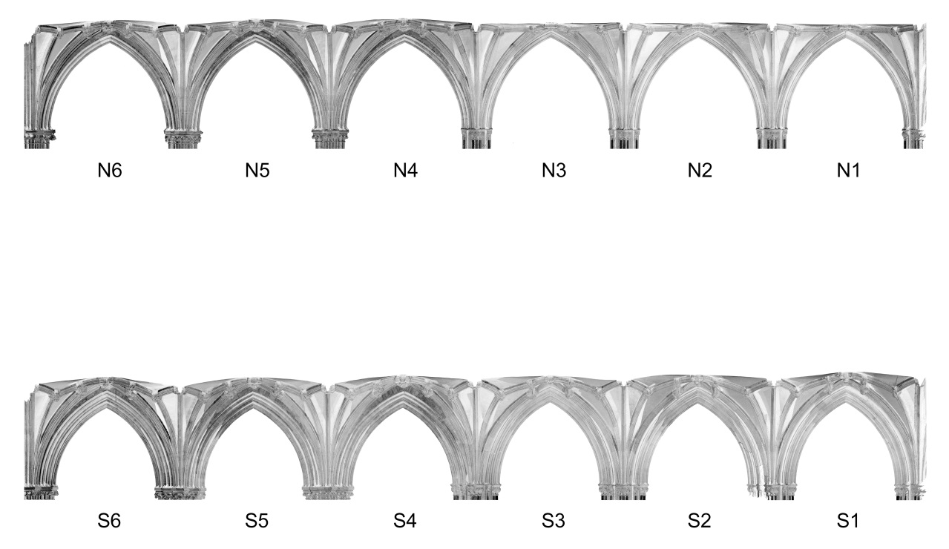
Figure 6. Orthographic sectional projections of the north and south choir aisles revealing initial differences in apex profiles.

The bays have been labelled beginning at the east end (N1 and S1) through to the west end (N6 and S6). Viewed longitudinally, the north aisle bays N1 to N3 have a very flat notional ridge line, whereas N4 to N6 have a slight upward arc. In the south aisle, bays S1 to S3 also have a slight upward arc, which becomes more pronounced in bays S4 to S6. Orthorectified images of each bay’s plan revealed distinct differences in bays S4 to S6 compared with all remaining bays; with a wider ‘lozenge’ shape across the width of the bays. Subtle differences were also found at the crossings of the notionally diagonal lierne ribs in the centre of each bay, for example bays S4 to S6 have a wider vertically opposite angle whereas in bays N1 to N3 these are very close to right angles. These differences can be seen on the traced plans in figure 8 which are discussed in the following section. A previously drawn plan of bays N4 to N6 overlaid with the orthophoto of the same space also demonstrates the differences between digital and traditional surveying results, with ‘lozenges’ drawn much wider across the bay, akin to S4 to S6, in the hand drawn and surveyed version of N4 to N6 (figure 7).
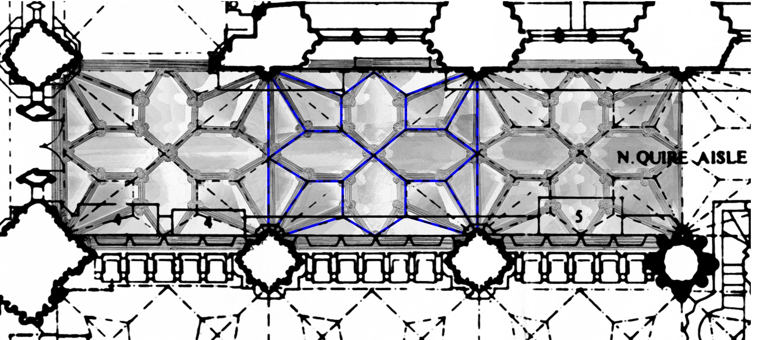
Figure 7. Orthorectified plan of bays N4 to N6 overlaid with a previously hand drawn version, with hand drawn vault ribs for N5 highlighted in blue. (Reproduced by kind permission of the Dean and Chapter of Wells Cathedral.)

All of these observations suggest the existence of four separate campaigns in the choir aisles but that the basic similarity of the bays within each campaign meant that, where appropriate, we could analyse a selected sample of four bays rather than looking at all twelve. N2, N5, S2 and S5 were selected as they sit in the middle of each set, therefore not having the possible complication of adjacency to a bay with a different design such as the retrochoir. For example, S2 has the same design principles as S1 and S3, but S3 joins to S4 which has different principles (figure 8), and S1 is the end bay and therefore bridges to the design of the retrochoir. Although studying the orthorectified images enables us to observe these subtle differences, they do not provide us with exact measurements such as radii, angles and distances. The following section describes how we went beyond the point cloud data to ascertain this information.

4.2 Tracing the vault ribs
Once the point cloud and mesh models were created as discussed in section 3.2, a three-dimensional tracing of each rib’s curvature was produced. Willis’s recognition that the ribs of a single vault could each have different radii has been confirmed by numerous studies (e.g. Nussbaum and Lepsky, 1999, p. 180; Wendland, 2012a, vol. 1. p. 352; Wendland et al, 2014, p. 462) but there has been less research into ribs of multiple curvature, which have been identified by eye at the contemporary cathedral of Exeter (Harvey, 1972, pp. 128 and 135 and Wilson, 1979, p. 263), nor into the position of the centres. In order to establish whether or not single or multiple curvatures are present at Wells, the intrados (innermost edge) of each rib’s profile was traced using the ‘control point curve’ tool in Rhinoceros 5. The intrados probably marked the point at which the rib rested on the wooden centering constructed prior to the vault’s physical construction (Fitchen, 1961, pp. 159-165), suggesting its significance both in terms of design and erection, making it ideal for comparative analysis purposes. The ‘control point curve’ tool was used rather than an arc tool as this would assume that each rib was made of a single arc, and potentially lead to inaccuracies in the results. The key was to ensure that the tracing provided was as realistic as possible and to be open to the prospect that the rib curvatures may have been made of more than one arc.

In the first instance, tracing the vaults to create a wireframe model clarified the assumptions about the different bay sets made when studying the orthorectified images (see section 4.1). As a development of this, comparing in Rhinoceros 5 the 3D perspective view with the 2D orthographically projected views (top, front and right) enabled the curvature of each rib to be analysed in detail; again we found that the 2D views created a more readable format to ascertain their geometric principles. When working solely in 2D, we found that exporting to Microstation PowerDraft V8i provided clearer reading for manipulation and testing. Studying the rib curvatures revealed that every rib constructed was based on a single arc, however, they had different radii and different centre points; either above, below or on the impost line. It became apparent that several radii were used consistently throughout the vaults, and patterns began to emerge in terms of their use (figure 8). This is a significant finding as it supports our observations, initially perceived by eye and also using the orthorectified images, that the design of each bay set is not the same, as stated previously. Once these differences were revealed, we could begin to postulate how the vaults were designed and constructed by digitally reconstructing the selected sample of bays, and overlaying them with the digital survey models for accuracy.
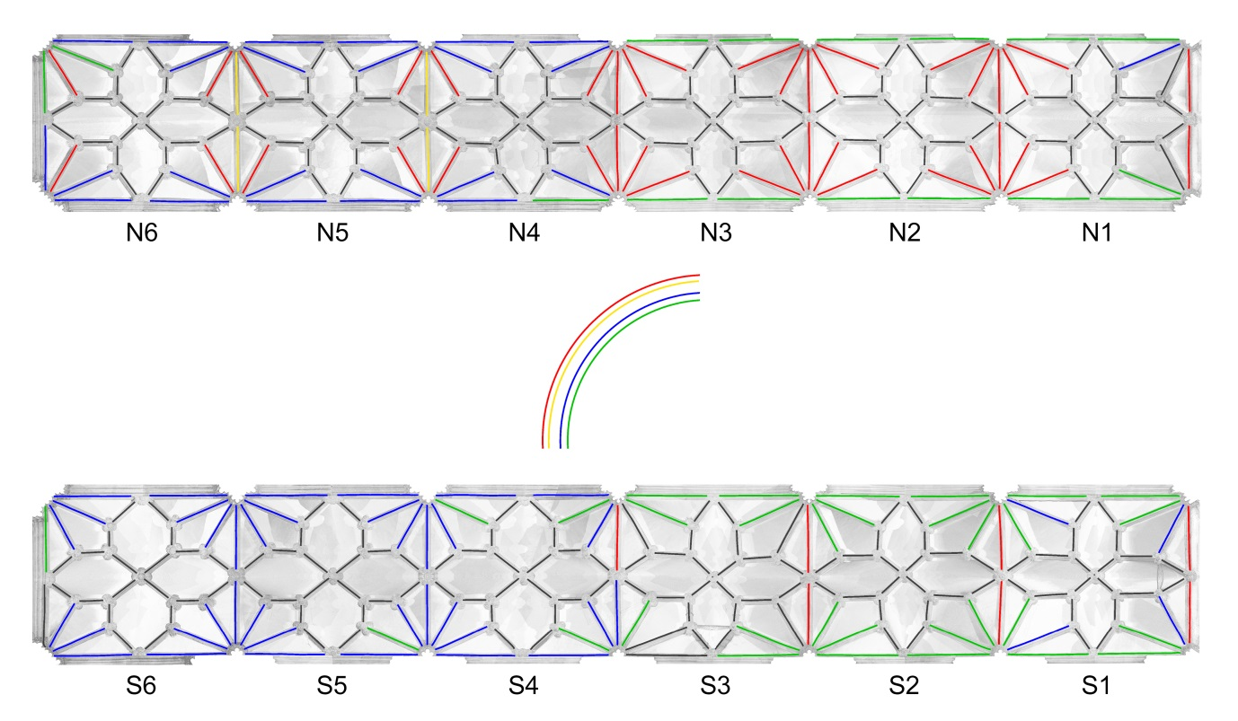
Figure 8. Orthorectified plan of the north and south aisles from the point cloud model overlaid with the traced arcs. The coloured lines indicate the significant radii discovered.

4.3 Process investigation for bay N5
Although the investigation of the selected sample of bays was very productive in terms of findings, the focus of this article is on the application of digital techniques therefore we will only discuss them briefly using bay N5 as an example of the richness of the data set established. Willis had suggested a method by which complex lierne vaults could be projected from a 2D plan, which must therefore have preceded their erection. It became apparent in experimenting with the digital data that at least some elements of the plan needed to be decided by the medieval designer in order to establish the full 3D form of the vaults (Buchanan and Webb, forthcoming 2017). The plan of the bay was therefore investigated retrospectively to try to ascertain the geometrical processes the medieval masons might have used to produce it, followed by a reconstruction of the bay design and construction process in 3D. In terms of fixed points, we already knew that the size of the rectangular bay was established, as well as the height to the upper surface of the abaci; ready for construction of the vaults to take place (see section 2.2). Precedent also suggested that a tracing floor would have been used to mark out the basic geometry of the vault (Harvey, 1968; Bucher, 1972; Holton, 2006; Pacey, 2007; Taín-Guzmán et al., 2012; Calvo-López et al., 2013; Adamson, 2014) from which templates were traced to cut the individual stones (Shelby, 1971). Although two tracing floors survive at Wells, the better surviving example seems to relate to the cloister vaults (Pacey, 2007) and the other, in the Chapter House, appears to have too few incisions for detailed geometrical analysis (ex inf. Jerry Sampson). No medieval sketchbooks or small-scale drawings survive in relation to English vaults; therefore the only data for analysis derives from the vaults themselves.

Figure 9 suggests a geometrical process followed to create a floor plan for N5. The 2D process shows how existing points are used, such as the bay corners, midpoints and diagonals as well as a circle reliant on these points. Figure 9 also suggests the additional 3D process that the masons could then use to project points and arcs upwards and downwards to design and construct the vaults. The process hypothesised does not necessarily need to be sequential; however, the designer needs to have an awareness of the 3D geometry required.
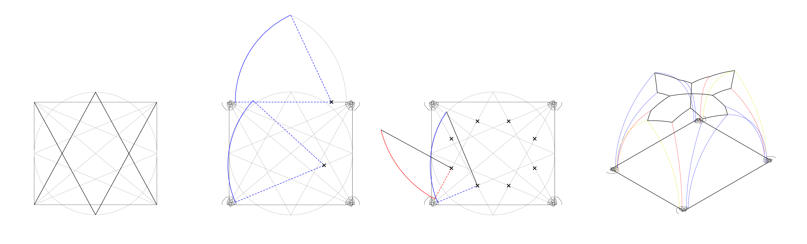
Figure 9. Hypothesised design and construction process for bay N5. (The video file version can be found as part of the online journal).

The methodology used here is particularly important to wider research investigating the design and construction of medieval vaults, as subtle differences in the plan become more noticeable based on the accuracy of the digital survey data. Although the design of all the twelve bays is conceptually similar, and each of the three bays in each campaign seem to have been projected from the same plan, the differences between the four sets are sufficient to have required four different geometrical processes. For example, if we take the average width between transverse liernes in each bay set drawn in plan (figure 10), bays N1-N3 are 1.22 metres wide (a), bays N4-6 1.34 metres wide (b), bays S1-S3 1.24 metres wide (c) and bays S4-S6 1.71 metres wide (d). Here we are dealing with differences between transverse liernes of as much as 0.49 metres on what was previously thought to be vaults of the same design. This finding adds considerable complexity to any attempt to establish classifications of vault geometry and draw conclusions about morphological developments. As a counter example, Palacios’s study of Spanish ribbed vaults, hypothesised that tiercerons (a type of additional ribs which, unlike liernes, spring from the capital, are created in plan by drawing a circle with a radius from the bay centre point to the bay corner, and directionally establishing the tiercerons by drawing a line from the bay corner to the opposite mid-point of the circle created (Palacios, 2003). However information on how the ribbed vaults in question were surveyed is unknown and, as we will show based on the accuracy provided using laser scanning for this project, subtle differences in plan can have a significant impact on the 3D design. Therefore, without the accuracy of digital surveying, subtle differences can be missed and conclusions about design processes and relationships may be less accurate. Our research thus demonstrates the need for transparency about data collection and processing methods, without which significant doubt now needs to be thrown on any conclusions. Conversely, it should be noted that because the level of accuracy the digital methodology provides is very high, the precision of the medieval construction could also be questioned. For example, in analysing the vaults digitally we often found ourselves comparing measurements across different bays (figure 10) and attempting to establish whether or not deviations formed a difference in the design and construction process or were simply a margin for error based on the medieval construction. Such issues will need to be further investigated using case studies across different sites to establish more definite rules.
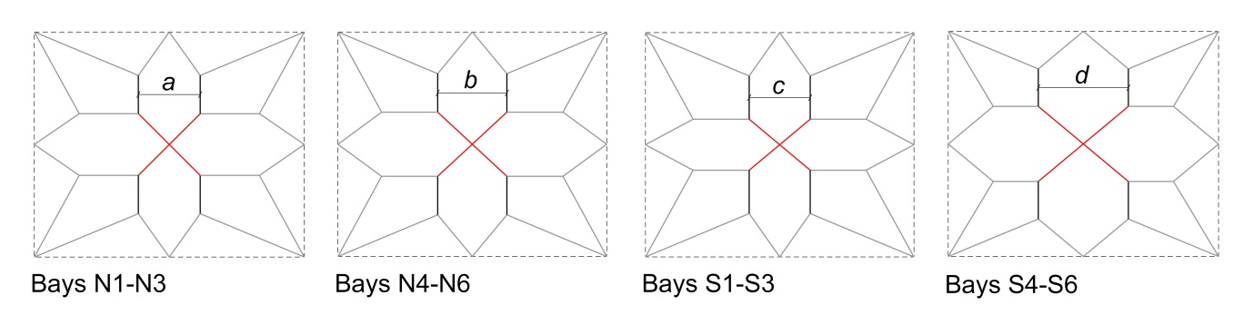
Figure 10: Hypothesised bay set plans highlighting the average width measurements between transverse liernes (a – d) and the differing central saltires in red.

Using such information we were able both to confirm the applicability of Willis’s method and to propose reconstructions for the entire bay design and construction process for each of the selected sample bays and consequently analyse the differences as well as similarities between each the 3D forms of bay set (Buchanan and Webb, forthcoming 2017). The 3D process for N5 is also demonstrated in figure 9.

4.4 3D reconstructions
The final part of the analysis process was to create 3D reconstructions of the selected sample bays, in this case N5. The aim here was to test how the proposed design and construction process (see section 4.3) compared to the original scan data. This sequence of starting with known information such as the mesh model and working backwards to create a 3D representation is referred to as hindcasting (Knight et al., 2001), reverse geometrical engineering (Wendland, 2012b) or reverse modelling (Datta, 2015). In order to show rigour in our research the 3D model contains four layers for comparison; the mesh created from the scan data, the wireframe based on lines traced along the intrados on the mesh, the hypothesised intrados wireframe lines of the design and construction process and finally a 3D reconstruction of bay N5 based on the hypothetical process represented in figure 9. The 3D reconstruction of N5 removes details in carvings on the bosses and column capitals and instead models them as simplified geometry. This is because the focus of the current research is on the geometry of the vaults and therefore sculptural elements outside of this do not require such detailed modelling. As the animation in figure 11 demonstrates, the model conforms closely to the raw data but is sufficiently different that any conclusions drawn from the former need to be tested against the latter. Again, our intention in presenting the model in this way is to show transparency and accountability in the analysis process, with the hypothesised wireframe intrados lines (blue) and 3D reconstruction being easily compared against the wireframe traced intrados lines (red) and original mesh model.
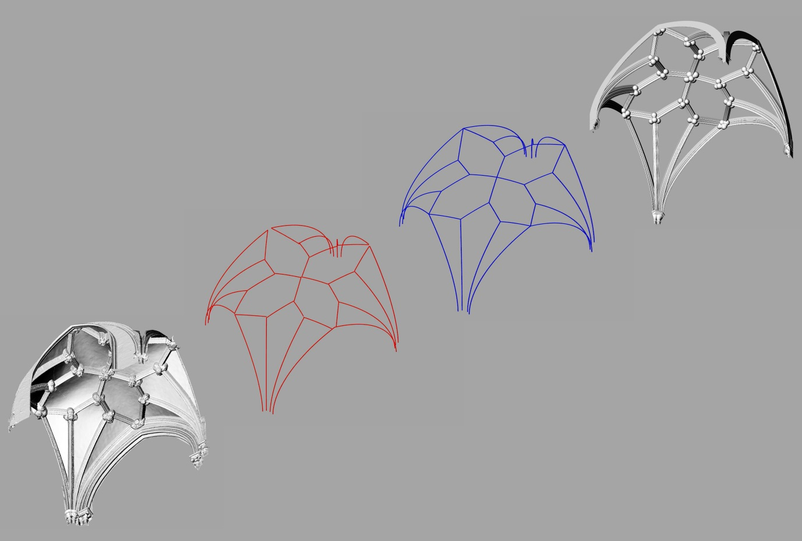
Figure 11. The animation demonstrates the different phases of the documentation and analysis process; original mesh model, wireframe traced intrados lines from original mesh model (red), hypothesised wireframe intrados lines (blue) and 3D reconstruction. (The video file version can be found as part of the online journal).
4.5 Tas-de-charge distortion
In his essay Willis discusses his observations of distortions to the tas-de-charge (figure 12). Willis notes that each voussoir, or individually cut stone making up the ribs, is normally cut radially to the rib’s arc, however, in some cases the tas-de-charge stone is cut horizontally instead. From inscribed lines found on stones from a vault from the demolished north west tower of Canterbury cathedral (not the central tower, as suggested by Pérez-de-los-Ríos and Rabasa, 2014), he suggested that the moulding profile was placed horizontally at this point rather than radially, which would result in a distortion of the rib’s profile if the moulding profile is not adjusted.

The use of digital techniques makes it possible to test quickly and accurately whether or not the tas-de-charge distortion occurred elsewhere, in this case at Wells. This builds on the total station theodolite method used by Pérez-de-los-Ríos and Rabasa (2014) by firstly studying the orthorectified images of the point cloud models which made clear whether or not horizontally cut tas-de-charge voussoirs were evident, and if identified, we could then export a full resolution sectional point cloud model cut across the tas-de-charge mortar joint for analysis. It should be reiterated here that establishing whether stones were cut horizontally or radially by eye is very difficult as the differences are subtle and the tas-de-charge complex, therefore the use of orthorectified images was crucial. Additionally, taking measurements by hand would be very slow and prone to errors.
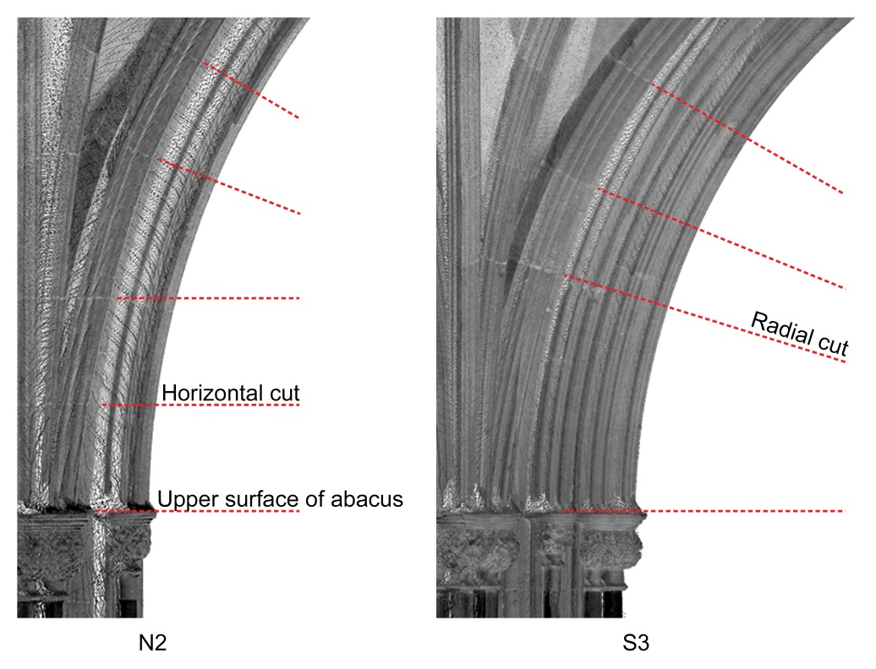
Figure 12. A comparison of orthorectified images highlighting stones cut horizontally in bay N2 (left) and stones cut radially in bay S3 (right).

Based on the orthorectified images (figure 12) we could see that in some cases the tas-de-charge were cut horizontally and in others they were not. Further research will seek to establish any patterns to this distinction. Once a horizontal cut was identified, a sectional point cloud was then exported from Faro Scene. The profile of the cut was traced in Rhinoceros 5, and compared to the standard moulding profile used across all ribs, which had already been traced (red lines in figure 13). The profile was sufficiently similar to confirm Willis’s theory that the tracing occurred horizontally and consequently distorted the rib profile, especially when compared with an adjusted profile of the rib had it been cut radially (blue lines in figure 13). This was tested several times in different bays, but will require studies at additional sites to investigate the introduction and frequency of use of this method.
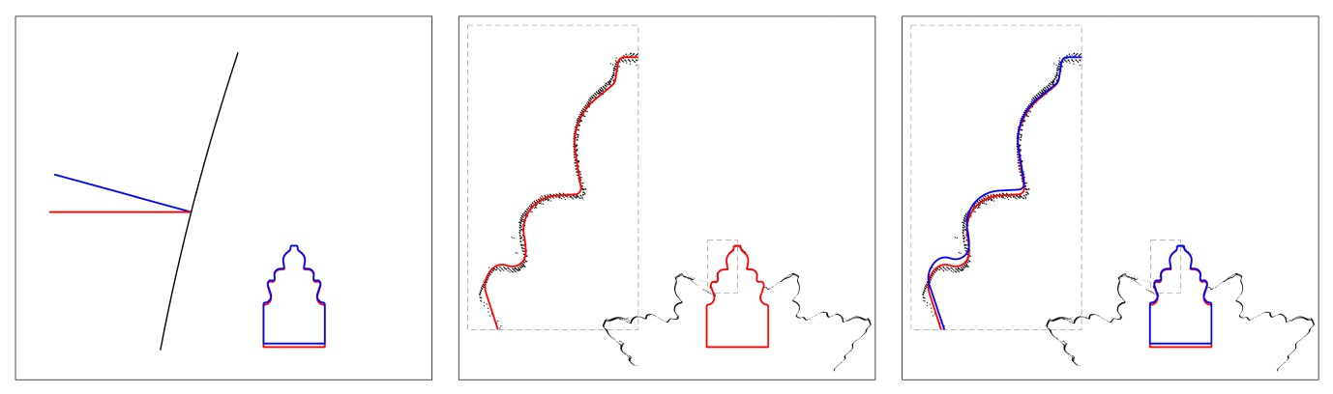
Figure 13. The moulding profiles of a standard horizontal cut in red and radial cut in blue are compared (left). When the standard moulding profile is overlaid with a point cloud of a tas-de-charge in N5 cut through the horizontal mortar joint they align (centre). Overlaying the radial cut emphasises the distortion (right).

5 Reflections and future plans
The project has shown how digital surveying and modelling techniques can be the starting point for a rigorous investigation of the underlying geometry of a historic building, in this case medieval vaults. It enabled us to better understand the possible design and construction processes of the choir aisle vaults at Wells through a process of trial and error using a number of digital modelling techniques such as point cloud, mesh, wireframe and solid models. The project was also revealing in relation to Willis’s article as we were able to support many of his theories, such as distortions to the tas-de-charge and demonstrating how the 2D geometry of the floor plan is used in conjunction with projections to create the full 3D form of the vaults.

Future research will take several directions: firstly we will investigate further medieval vaults to establish similarities and differences across many sites in relation to Willis’s theories to the chronological development and geographical distribution of different vault designs and constructional techniques, and to the possible careers of Witney and Joy. A proposed outcome of this will be to better define tolerances to establish margins of error, for example using standard deviation diagrams described by Lo Buglio et al (2015) as a starting point, then analysing in more detail the extent of changes in design and construction processes compared to these potential deviations. We also intend to create a digital archive of point cloud models for researchers to use. Secondly, and most importantly to the application of digital techniques, we will explore the use of parametric software such as Grasshopper to experiment with the analysis of vault design and construction as a rule-based process, which is clearly evident in the findings presented here. To assist with this, as well as the process of capturing vault rib curvatures generally, we will investigate the use of edge detection technology such as that developed by Ni et al (2016). We will also consider building information modelling software as a method of documenting the geometry of the vaults in a clearer manner. Finally, the focus of this article is on the potential analysis opportunities that digital surveying tools enable us to initiate; we will also explore further opportunities to enhance the appearance of the models providing photorealism by combining mesh models with orthophotos (Kosta and Kremen, 2013), enabling us to disseminate our findings more widely, such as on display at Wells cathedral itself.

Acknowledgements
We would like to thank the Paul Mellon Centre for Studies in British Art for providing a research support grant to survey the vaults at Wells. We are also very grateful to JR Peterson for his technical assistance during the process. Finally, thank you to Wells cathedral, particularly Jez Fry (Clerk of Works) and Jerry Sampson (Cathedral Archaeologist) for allowing us to scan the interior.

References
Adamson, R.H., 2014. Stonemasons' Drawings on Building Fabric: Diversity, Form and Function. Archaeological Journal, volume 171 number 1, pp.258-288.

Andrews, D.P., Bedford, J., and Bryan, P.G., 2013. A Comparison of Laser Scanning and Structure from Motion as Applied to the Great Barn at Harmondsworth, UK, International Archives of the Photogrammetry, Remote Sensing and Spatial Information Sciences, volume XL-5/W2, pp. 31-36.

Ayers, T., 2004. The Medieval Stained Glass of Wells Cathedral, volume 1. Corpus vitrearum medii aevi: Great Britain, volume 4. Oxford University Press, Oxford.

Bock, H., 1961. Der Beginn spargotischer Architektur in Prag (Peter Parler) und die Beziehungen zu England. Wallraf-Richartz Jahrbuch 23, pp.191-210.

Bock, H., 1962. Der Decorated Stil. Carl Winter, Universitatsverlag, Heidelberg.

Bork, R., McGehee, A., 2011. Introduction, in: Bork, R., et al. (Eds.), New Approaches to Medieval Architecture. Ashgate Publishing Limited, Surrey, pp. 1-7.

Brumana, R., et al., 2013. HBIM for Documentation, Dissemination and Management of Built Heritage. The Case Study of St. Maria in Scaria d’Intelvi. International Journal of Heritage in the Digital Era volume 2 number 3.

Buchanan, A., and Webb, N., 2017 – forthcoming. Creativity in Three Dimensions: An Investigation of the Presbytery Aisles of Wells Cathedral, British Art Studies.

Bucher, F., 1972. Medieval Architectural Design Methods, 800-1560. Gesta volume 11 number 2, pp. 37-51.

Calvo-López, José, et al., 2013. The Tracing for the Sail Vault at the Murcia Cathedral Vestry: Surveying a 16th-Century Full-Scale Working Drawing. International Journal of Architectural Heritage volume 7 number 3, pp. 275-302.

Capone, M., Campi, M., and Catuogno, R., 2015. Gothic Churches in Paris; St Gervais et St Protais Image Matching 3D Reconstruction to Understand the Vaults System Geometry. International Archives of the Photogrammetry, Remote Sensing and Spatial Information Sciences, volume XL-5/W4, pp. 423-430.

Colchester, L. S., Harvey, J. H., 1974. Wells Cathedral. Unwin Hyman, London.

Crossley, P., 2003. Peter Parler and England: A Problem Revisited. Wallraf-Richartz Jahrbuch volume 64, pp. 53-82.

Datta, S., 2015. Accuracy and ambiguity: Geometric reconstruction of a seventh century stone temple in Hanchey, Cambodia. The Next City: 16th International Conference CAAD Futures 2015, pp. 190-202.

Draper, 1981. The Sequence and Dating of the Decorated Work at Wells, in Medieval Art and Architecture at Wells and Glastonbury. The British Archaeological Association Conference Transactions 4 for the year 1978. Maney, Leeds, pp. 18-29.

Evans, R., 1995. The Projective Cast: Architecture and its Three Geometries. MIT Press, Cambridge Massachusetts.

Fitchen, J., 1961. The Construction of Gothic Cathedrals: A Study of Medieval Vault Erection. Clarendon Press, Oxford.

Giannattasio, C., et al., 2014. The Medieval San Francesco Convent in Cagliari: From the Architectural, Materical and Historical-Stratigraphical Analysis to the Information System. International Journal of Heritage in the Digital Era volume 3 number 2.

Guidi, G., et al., 2014. 3D survey and virtual reconstruction of archaeological sites. Digital Applications in Archaeology and Cultural Heritage 1 pp. 55-69.

Harvey, J. H., 1968. The Tracing Floor in York Minster. 40th Report of the Friends of York Minster for 1968. Friends of York Minster, York.

Harvey, J. H., 1972. The Medieval Architect. Wayland, London.

Harvey, J. H., 1984. English Medieval Architects. A Biographical Dictionary down to 1550. 2nd edn. Alan Sutton, Gloucester.

Holton, A., 2006. The working space of the medieval master mason: the tracing houses of York Minster and Wells Cathedral, in Proceedings of the Second International Congress of Construction History, volume 2, pp. 1579-1597.

Knight, M., et al., 2001, Digital Hindcasting - Critical Analysis through Virtual Reconstruction. 19th eCAADe Conference Proceedings, pp. 529-533.

Kosta, B., and Kremen, T., 2013. The Combination of Laser Scanning and Structure from Motion Technology for Creation of Accurate Exterior and Interior Orthophotos of St. Nicholas Baroque Church. International Archives of the Photogrammetry, Remote Sensing and Spatial Information Sciences, volume XL-5/W1, pp. 133-138.

Lo Buglio, D., Lardinois, V., and De Luca, L., 2015. What Do Thirty-One Columns Say about a “Theoretical” Thirty-Second? In ACM Journal on Computing and Cultural Heritage, volume 8, number 1.

López-Mozo, A., Senent-Domínguez, R., Alonso-Rodríguez, M. Á., Calvo-López, J., and Natividad-Vivó, P., 2015, Asymmetrical Vaults in Late European Gothic: Basel and Bebenhausen as case studies, in Proceedings of the Fifth International Congress of Construction History, volume 2, pp. 497-504.

Monckton, L., 2006. Experimental Architecture? Vaulting and West Country Cloisters in the Late Middle Ages. Journal of the British Archaeological Association, volume 159 number 1, pp. 249-283.

Morris, R. K., 1991. Thomas of Witney at Exeter, Winchester and Wells, in Kelly, F. (Ed.), Medieval Art and Architecture at Exeter Cathedral. British Archaeological Association Conference Transactions 9 for the year 1985. Maney, Leeds, pp. 57-84.

Ni, H., Lin, X., Ning, X., and Zhang, J., 2016. Edge Detection and Feature Line Tracing in 3D-Point Clouds by Analysing Geometric Properties of Neighbourhoods. In, Remote Sens, 8, 710.

Nussbaum, N. and Lepsky, S., 1999. Das gotische Gewölbe. Eine Geschichte seiner Form und Konstruktion. Wissenschaftliche Buchgesellschaft, Darmstadt.

Pacey, A., 2007. Medieval Architectural Drawing: English Craftsmen’s Methods and Their Later Persistence. Tempus, Stroud.

Palacios Gonzalo, J. C., 2003. Spanish ribbed vaults in the 15th and 16th centuries. Proceedings of the First International Congress on Construction History, pp. 1547- 1558.

Pérez-de-los-Ríos, C. and Rabasa-Díaz, E., 2014. Stretched templates in Gothic tas-de-charge construction. In Proceedings of the First Conference of the Construction History Society. Cambridge, pp. 333-342.

Pevsner, N., 1953. Bristol-Troyes-Gloucester: The Character of the Early Fourteenth Century in Architecture, Architectural Review, 113:674, pp.89-98.

Ruther, H., Palumbo, G., 2012. 3D Laser Scanning for Site Monitoring and Conservation in Lalibela World Heritage Site, Ethiopia. International Journal of Heritage in the Digital Era volume 1 number 2.

Shelby, L. R., 1971. Mediaeval masons' templates. The Journal of the Society of Architectural Historians, volume 30 number 2, pp.140-154.

Taín-Guzmán, M., Alonso-Rodríguez, M.Á., Calvo-López, J. and Natividad-Vivó, P., 2012. Stonecutters’ literature and construction practice in Early Modern Gothic: the tracings for a rib vault at the Cathedral of Tui in Galicia. Construction History volume 27, pp.1-22.

Talaverano, R. M., Pérez de los Ríos, C. and Domínguez, R.S., 2012. Late German Gothic Methods of Vault Design and Their Relationships with Spanish Ribbed Vaults. Proceedings of the Fourth International Congress on Construction History. Available at http://oa.upm.es/15746/1/MartinTALAVERANO_2012_Comunicacion_Late_German_Gothic_Methods_4ICCH.pdf

Tallon, A., 2014. Divining Proportions in the Information Age. Architectural Histories, 2(1): 15, pp. 1-14.

Tsingas, V., 2012. Acropolis of Athens: Recording, Modeling and Visualising a Major Archaeological Site. International Journal of Heritage in the Digital Era volume 1 number 2.

Webb, N., Buchanan, A., and Peterson, J.R., 2016. Modelling Medieval Vaults: Comparing Digital Surveying Techniques to Enhance our Understanding of Gothic Architecture. In Proceedings of the 34th eCAADe Conference - Volume 2, pp. 493-502.

Wendland, D. 2012a. Arches and Spirals – The Geometrical Concept of the Curvilinear Rib Vault in the Albrechtsburg at Meissen and Some Considerations on the Construction of Late Gothic Vaults with Double-Curved Ribs. In Carvais, R. et al. (Eds.), Nuts & Bolts of Construction History: Culture, Technology and Society volume 1, Picard, Paris, pp. 351-357.

Wendland, D., 2012b. Research on “cell vaults”: analytic and experimental studies on the technology of late-gothic vault construction. Wiadomości Konserwatorskie, pp.127-132.

Wendland, D., Aranda Alonso, M. and Kobe, A., 2014. The Vault with Curvilinear Ribs in the ‘Hall of Arms’ in the Albrechtsburg Meissen: Studies on the Concept, Design and Construction of a Complex Late Gothic Rib Vault. Proceedings of the First Conference of the Construction History Society, pp. 459-468.

Willis, R., 1842. On the Construction of the Vaults of the Middle Ages. Transactions of the Royal Institute of British Architects, London, volume 1 number 2, pp. 1-69.

Wilson, C. (1979). The Origins of the Perpendicular Style and its Development to circa 1360. Unpublished PhD thesis, Courtauld Institute of Art, University of London, 1979.

Wilson, C. (1990). The Gothic Cathedral. Thames and Hudson, London.

Wilson, C. (2011). Why did Peter Parler come to England?, in Opacic, Z. and Timmerman, A. (Eds), Architecture, Liturgy and Identity. Liber Amicorum Paul Crossley, Brepols Studies in Medieval Art. Brepols, Turnhout: Brepols, pp. 89-109.

