Functional characterisation of three novel candidate biomarkers and therapeutic targets for prostate cancer

Thesis submitted in accordance with the requirements of the
University of Liverpool
for the Degree of Doctor in Philosophy

by
Yu Zhang

March 2010

To xxx

ABSTRACT

Anterior gradient-2 (AGR2), S100A4, and osteopontin (OPN) play important roles in malignant progression of breast cancer. Their possible involvement in prostate cancer had not been full explored previously. The aim of this study was to investigate the expression status of these genes and their diagnostic and prognostic significance in prostate cancer. The possibility of using these candidate genes as targets to suppress tumourigenicity of prostate cancer cells was also investigated.

Comparing with the normal and benign cells, expression of AGR2, S100A4 and OPN were greatly increased in malignant prostate cancer cell lines as observed in breast cancer. Immunohistochemical staining of an archival set of more than 100 prostate tissue samples showed that the levels of all these 3 proteins were significantly higher in carcinoma tissues than those expressed in normal and benign tissues. Kaplain Mire Survival analysis of immunohistochemically stained samples showed that high expression of AGR2 and OPN but not S100A4 was significantly correlated with the poor patients’ survival time. Thus, all these three molecules were over-expressed in prostate carcinomas and AGR2 and OPN may be useful prognostic markers to predict patient’s outcomes.

To futher study the roles of S100A4 and OPN in malignant progression, RNAinterference was employed to stably establish S100A4-suppressed and OPN-suppressed clones. When compared with the control, suppression of either OPN or S100A4 signifcantly inhibited cell proliferation, invasiveness, and anchorage-independent growth. Similar results were obtained from in-vivo experiments. S100A4-suppressed and OPN-suppressed cells produced significant reductions in sizes of subcutaneous tumours after inoculation into nude mice. When the levels of OPN and S100A4 were analysed respectively in the tumors produced by both types of transfectants, it was found that it was the suppression of OPN rather than S100A4 that was significantly associated with the reduction in tumor sizes. Hence S100A4 may promote malignant progression of prostate cancer through modulating OPN and thus OPN is a down-stream mediator of S100A4. This result suggested that OPN may be a more effective target for tumour suppression than S100A4 in prostate cancer.

Acknowledgements
Table of Contents
ABstract…………………………………………………………………..II
Acknowledements…………………………………………………...III
Table of contents…………………………………………………….IV
List of Figures………………………………………………………..XIII
LiST of TAbles…………………………………………………………XVI
ABBreviations……………………………………………………….XVII

CHapter one: General introduction…………………….….1
  - Overview of prostate cancer………………………………………..2
    - Overview of cancers………………………………………………..2
    - Incidence of prostate cancer………………………………………..3
      - General statistics…………………………………………………...3
      - By age……………………………………………………………...4
      - By regions……………………………………………………….…5
      - Trends…………………………………………………………..….6
    - Mortality of prostate cancer…………………………………..……8
    - Risk factors of prostate cancer………………………………….….9
      - Age………………………………………………………………...10
      - Family history………………………………………………..……10
      - Ethnicity………………………………………………………..….11
    - Pathology of prostate cancer…………………………………..…..11
      - Anatomy of the prostate………………………………………..….11
      - BPH……………………………………………………………..…13
      - PIN………………………………………………………………...13
      - Grading the prostate cancer…………………………………….…14
  - Biomarkers for prostate cancer………………………………….…17
    - Molecular pathology of prostate cancer…………………………..17
    - Current prognostic biomarkers for prostate cancer………………..17
      - PSA…………………………………………………………………...18
      - Other potential biomarkers……………………………………………19
    - Some candidate genes to test in our study…………………………….19
  - AGR2…………………………………………………………………..20
    - AGR2………………………………………………………………….20
    - Role of AGR2 in breast cancer………………………………………..21
    - AGR2 in prostate cancer………………………………………………22
  - S100A4………………………………………………………………...22
    - S100 protein family……………………………………………………22
    - S100A4………………………………………………………………...24
    - Human S100A4 gene structure………………………………………...25
    - S100A4 function……………………………………………………….26
      - Intracellular roles and targets………………………………………….26
      - Extracellular roles and targets………………………………………....28
    - Effects of S100A4 in cancers………………………………………….28
      - Cell motility……………………………………………………………29
      - Cell invasiveness………………………………………………………30
      - Cell-cell adhesion……………………………………………………...30
      - Proliferation&apoptosis………………………………………………..30
      - Angiogenesis…………………………………………………………...31
    - S100A4 in prostate cancer……………………………………………..32
    - S100A4 and biomarkers………………………………………………..34
  - OPN……………………………………………………………………..35
    - SIBLING family……………………………………………………….35
    - OPN………………………………………………………………..…..36
    - OPN structure………………………………………………………….37
    - OPN functions…………………………………………………………39
      - Apoptosis………………………………………………………………39
      - Invasion & metastasis………………………………………………….40
      - Tumor cell migration………………………………………….……….41
      - Inflammatory and immune response…………………………….....42
      - Neovascularization and angiogenesis……………………………….44
        - OPN and potent angiogenesis factor VEGF……………………..…44
        - OPN and FGF-2………………………………………………..…...45
        - OPN and COX-2……………………………………………………45
        - OPN and NF-κB…………………………………………………....45
    - OPN in prostate cancer…………………………………………..…46
    - OPN and biomarker…………………………………………….…..48

CHAPTER TWO: MATERIAL AND METHODS……………..…………50
  - Materials…………………………………………….…………...51
  - Methods……………………………………………………….…51
    - Cell culture………………………………………………………..51
      - The cell lines……………………………………………..………..51
      - Routine culture of cells…………………………………….……..52
      - Cell counts………………………………………………….…......52
      - Freezing cells /cryopreservation…………………………….….…52
      - Thawing cells/reanimation………………………………………...53
    - Culture of Transfected Cells…………………………………..…...53
    - Analysing protein expression in cell lines…………………………54
      - Preparation of cellular extracts…………………………………….54
        - Using 1×SLB method…………………………………………..….54
        - Using Cellytic M Cell Lysis Reagent with Bradford assay………..55
          - Using Cellytic M cell Lysis Reagent…………………………….…55
          - Bradford assay……………………………………………………...55
          - Equalization of protein samples for loading…………………….…56
      - SDS-PAGE…………………………………………………….…...56
      - Transfer of proteins from SDS gel to nitrocellulose membrane…...56
      - Coomassie blue and PONCEAU S staining…………………….….57
      - Immunoblotting for detection of protein expression……………….57
      - Immunoblotting for detection of β-actin expression…………….….58
    - Protein expression in tissues………………………………………...59
      - Human tissue samples…………………………………………….…59
      - Sectioning of tissues……………………………………………..…..60
        - Preparation of APES coated slides………………………………..…60
        - Sectioning of tissues with Microtome…………………………….....60
      - Immunohistochemistry…………………………………………..…..60
    - RNA interference………………………………………………….....62
      - RNAi………………………………………………………………….62
      - Three different ways of RNAi……………………………………..…63
      - RNAi of Vector-based approach……………………………………..64
        - Designing siRNA silencing Construct………………………………..65
        - Cloning hairpin siRNA into vector…………………………………...68
          - Annealing sense and antisense oligos…………………………………68
          - Preparation of competent cells…………………………………..…….68
          - Ligation of silencing inserts into pSilencer plasmid……………...…..69
          - Transformation………………………………………………………..70
          - Mini and midi preparation of plasmid DNA………………………….70
            - Miniprep DNA extraction………………………………………...71
            - Midiprep DNA extraction………………………………………...71
          - Double digestion of DNA products…………………………………..72
          - Agarose gel electrophoresis…………………………………………..73
          - Sequencing analysis…………………………………………………..73
        - Transient and stable transfection……………………………………...73
        - Selection………………………………………………………………74
        - Ring cloning of transfected cells……………………………………..74
    - In vitro assays…………………………………………………………75
      - Soft Agar Assay………………………………………………………75
      - Proliferation Assay……………………………………………….......76
        - Standard curve preparation…………………………………………...76
        - Proliferation assay………………………………………………….….77
        - Determination of cell numbers by MTT……………………………....77
      - Invasion assay……………………………………………………..…..78
      - Motility assay………………………………………………………....79
    - In vivo assay…………………………………………………………...80
      - Mice and cell lines…………………………………………………..…80
      - Inoculation of mice………………………………………………….…81
      - Processing of tumor and tissue from mice……………………………..82
      - Detection of OPN and S100A4 protein in mice tissues…………….….82
      - Extraction of protein from the tissue and Western Blot analysis……...82
      - Primary tumor cell culture……………………………………………..83
    - Statistic analysis…………………………………………………….….83
      - Student’s t test………………………………………………………….84
      - Survival analysis……………………………………………………….84
        - Kaplan Meier curve………………………………………………….…84
        - Log Rank……………………………………………………………….84
      - Chi-square……………………………………………………………...84
      - Two-sided Fisher’s exact test…………………………………………..85
      - Mann-Whitney U……………………………………………………….85

CHAPTER THREE: Result 1 - Anterior gradient-2 (AGR2)…………………86
  - AGR2 expression in prostate cell lines………………………………...87
  - AGR2 expression in prostate tissues…………………………………...87
  - Correlation with patient survival……………………………………….88
    - AGR2 expression and patient survival…………………………………89
    - Combined Gleason Scores (GS) and patient survival………………….89
    - Prostate-Specific Antigen (PSA) and patient survival…………………89
    - Androgen receptor (AR) and patient survival………………………….90
  - Correlation between differently selected variables expressed in prostate cancer…………………………………………………………………………..90
    - AGR2 expression and Combined Gleason Scores (GS) ……………….90
    - AGR2 expression and Prostate-Specific Antigen (PSA) level………...91
    - AGR2 expression and Androgen receptor (AR) index………………...91
    - Prostate-Specific Antigen (PSA) and Combined Gleason Scores (GS) ……………………………………………………………………………...91
  - Discussion……………………………………………………………...92

CHAPTER FOUR: Result 2 - S100A4…………………………………..……...102
  - S100A4 expression in prostate cell lines………………………………103
  - S100A4 expression in prostate tissues………………………………...103
  - Correlation with patient survival………………………………………105
    - S100A4 expression and patient survival………………………………105
    - Combined Gleason Scores (GS) and patient survival…………………105
    - Prostate-Specific Antigen (PSA) and patient survival…………………106
    - Androgen receptor (AR) and patient survival………………………....106
  - Correlation between differently selected variables…………………….106
    - S100A4 expression and Combined Gleason Scores (GS)……….…….106
    - S100A4 expression and Prostate-Specific Antigen (PSA) level…….…107
    - S100A4 expression and Androgen receptor (AR) index……………....107
    - Prostate-Specific Antigen (PSA) and Combined Gleason Scores (GS).108
  - RNA interference stably decreased S100A4 expression……………....108
    - Selection of efficient siRNA for S100A4 suppression………………...108
    - Establishment of S100A4 stably suppressed clones…………………...109
  - Effect of suppression of S100A4 on tumor cells in vitro……………....110
    - Suppression of S100A4 significantly inhibited anchorage-independent growth of cancer cells……………………………………………………...110
    - Suppression of S100A4 had no effect on cellular proliferation……….110
    - Suppression of S100A4 significantly inhibited the invasiveness of the cancer cells………………………………………………………………...111
    - Suppression of S100A4 had no effect on cellular motility…………….111
  - Discussion……………………………………………………………..112

CHAPTER FIVE: Result 3 – Osteopontin (OPN)………………………….…..130
5.1 OPN expression in prostate cell lines…………………………………..131
5.2 OPN expression in prostate tissues……………………………………..131
5.3 Correlations with patient survival……………………………………..133
    - OPN expression and patient survival………………………………..…133
    - Combined Gleason Scores (GS) and patient survival………………….133
    - Prostate-Specific Antigen (PSA) and patient survival………………….134
    - Androgen receptor (AR) and patient survival……………………………134
  - Correlation between differently selected variables…………………….135
    - OPN expression and Combined Gleason Scores (GS)…………………135
    - OPN expression and Prostate-Specific Antigen (PSA) level…………..136
    - OPN expression and Androgen receptor (AR) index…………………..136
    - Prostate-Specific Antigen (PSA) and Combined Gleason Scores (GS).137
  - RNA interference stably decreased OPN expression…………………..137
    - Selection of efficient siRNA for OPN suppression…………………….137
    - Establishment of OPN stably suppressed clones……………………….138
  - Effect of suppression of OPN on tumor cells in vitro………………….139
    - Suppression of OPN significantly inhibited anchorage-independent growth of cancer cells………………………………………………………………139
    - Suppression of OPN had no effect on cellular proliferation…………...139
    - Suppression of OPN significantly inhibited the invasiveness of the cancer cells…………………………………………………………………………140
    - Suppression of OPN significantly inhibited the motility of cancer cells…………………………………………………………………………140
  - Cross suppression of OPN and S100A4in SDC and OPC clones……..140
  - Discussion…………………………………………………….………..141

CHAPTER SIX: Result 4 - OPN suppression in DU145 malignant cell line…164
  - Establishment of OPN-suppressed-DU145 (ODC) clones…………..165
  - Effect of suppression of OPN on DU145 cells in vitro…………...…165
    - Suppression of OPN significantly inhibited anchorage-independent growth of DU145 cells………………………..…………………………............166
    - Suppression of OPN had no effect on cellular proliferation…………166
    - Suppression of OPN significantly inhibited the invasiveness of DU145 cells……………………………………………………………………....166
    - Suppression of OPN had no effect on cellular motility……………...167
  - Discussion……………………………………………………………167
.
CHAPTER SEVEN: Result 5 - Effect of suppression of OPN and S100A4 in tumorgenecity in vivo………………………………………………………..…..174
  - Tumor volume……………………………………………………..….175
  - S100A4 and OPN expression in tumor tissues by Western blot…..…176
  - S100A4 and OPN expression in tumor tissues by Immunohistochemistry…………………………………………………...177
  - Correlations between the average volumes of tumors and protein expression levels from tumors…………………………………………….178
    - Correlation between the average volumes of tumors and OPN levels expressed in tumors……………………………………………………….178
    - Correlation between the average volumes of tumors and S100A4 levels expressed in tumors………………………………………………..……...178
    - Correlation between OPN expression level and S100A4 expression levels in tumors……………………………………………………………….....178
  - Discussion…………………………………………………………….179

CHAPTER EIGHT: General discussion and conclusions…..191
  - Expression of AGR2, S100A4 and OPN in prostate cancer cells and tissues. ……………………………………………………………………….193
  - AGR2 and OPN were associated with the patients survival…………194
  - Both OPN and S100A4 suppressed tumor cells in vitro…………..…195
  - OPN, not S100A4 suppressed the tumorgenecity in vivo……………197
References……………………………………………………………….…200

Appendix A: Reagents………………………….………………………………230
Appendix B: Buffers……………………………………………………………235
B1: Tissue culture………………………………………………………………235
B2: SDS-PAGE…………………………………………………………………235
B3: Protein expression………………………………………………………….237
B4: Immunohistochemistry……………………………………………………..238
B5: Transformation……………………………………………………………..239
B6: In vitro assay……………………………………………………………….241
Appendix C: Equipments………………………………………………………242

List of figures

Figure 1.1 Incidence of the major cancers, 2007, England
Figure 1.2 The 10 most common cancers in males, UK, 2006
Figure 1.3 Numbers of new cases and age specific incidence rates, prostate cancer, UK 2006
Figure 1.4 Age-standardised incidence and mortality rates for prostate cancer by world regions, 2002 estimates
Figure 1.5 Age standardised (European) incidence rates, prostate cancer, UK, 1993-2006
Figure 1.6 Age standardised (European) incidence and mortality rates, prostate
Figure 1.7 Number of deaths and age-specific mortality rates, prostate cancer, UK, 2007
Figure 1.8 Schematic of prostate gland depicts zonal anatomy.
Figure 1.9 Schematic diagram of modified Gleason grading system
Figure 1.11 Structure of S100A4
Figure 1.12 Possible effects of S100A4 in tumors on gene up-regulation and/or protein overexpression
Figure 1.13 Secondary structure of OPN protein
Figure 1.14 Structure of Osteopontin protein
Figure 2.1 RNAi process
Figure 2.2 Three ways to trigger the RNAi pathway
Figure 2.3 pSilencerTM 4.1-CMV neo vector
Figure 2.4 Vector-based approach flow chart
Figure 3.1 Measurement of levels of AGR2 expression in benign and malignant prostate cell lines
Figure 3.2 Detection of AGR2 expression in normal, benign and malignant prostate tissues by immunohistochemical staining
Figure 3.3 Kaplan-Meier survival curves of prostate cancer patients
Figure 3.4 Box plot analysis of correlation between differently selected variables expressed in prostate cancer
Figure 4.1 Measurement of the levels of S100A4 expression in different prostate cell lines
Figure 4.2 Detection of S100A4 expression in different prostate tissues by immunohistochemical staining
Figure 4.3 Kaplan-Meier survival curves of prostate cancer patients
Figure 4.4 Box plot analysis of correlation between differently selected variables expressed in prostate cancer
Figure 4.5.1 Measurement of the levels of S100A4 expression after suppressing with different siRNAs separately and in differently combined manners in DU145 cell line
Figure 4.5.2 Measurement of the levels of S100A4 expression in stable transfected cell lines
Figure 4.6.1 The impact of S100A4 silencing on in vitro DU145 cell anchorage-independent growth
Figure 4.6.2 The impact of S100A4 silencing on in vitro DU145 cell proliferation
Figure 4.6.3 The impact of S100A4 silencing on in vitro DU145 cell invasiveness
Figure 4.6.4 The impact of S100A4 silencing on in vitro DU145 cell motility
Figure 5.1 Measurement of the levels of OPN expression in different prostate cell lines
Figure 5.2 Detection of OPN expression in different prostate tissues by immunohistochemical staining
Figure 5.3 Kaplan-Meier survival curves of prostate cancer patients
Figure 5.4 Box plot analysis of correlation between differently selected variables expressed in prostate cancer
Figure 5.5.1 Measurement of the levels of OPN expression after suppressing with different siRNAs separately and in differently combined manners in PC3 cell line
Figure 5.5.2 Measurement of the levels of OPN expression in stable transfected cell lines
Figure 5.6.1 The impact of OPN silencing on in vitro PC3 cell anchorage-independent growth
Figure 5.6.2 The impact of OPN silencing on in vitro PC3 cell proliferation
Figure 5.6.3 The impact of OPN silencing on in vitro PC3 cell invasiveness
Figure 5.6.4 The impact of OPN silencing on in vitro PC3 cell motility
Figure 5.7 Cross detection of OPN and S100A4 expression in cell lines and suppressed clones
Figure 6.1 Measurement of the levels of OPN expression in stable transfected cell lines
Figure 6.2.1 The impact of OPN silencing on in vitro DU145 cell anchorage-independent growth
Figure 6.2.2 The impact of OPN silencing on in vitro DU145 cell proliferation
Figure 6.2.3 The impact of OPN silencing on in vitro DU145 cell invasiveness
Figure 6.2.4 The impact of OPN silencing on in vitro DU145 cell motility.
Figure 7.1 Tumors produced by different cells in nude mice
Figure 7.2 Measurement of levels of OPN and S100A4 expression in tumours developed in different groups of animals
Figure 7.3 Detection of OPN and S100A4 expression in tumor tissues from different groups of animals by immunohistochemical staining
Figure 7.4

List of Tables

Table 1.1 2005 ISUP modified Gleason system
Table 1.3 Studies using plasma OPN as a prognostic biomarker
Table 2.1 Origins of the human prostate cell lines
Table 2.2 Primary and secondary antibodies used in Western blot
Table 2.3 Antibodies used in IHC
Table 2.4 S100A4 and OPN target sequences and their siRNA silencing constructs.
Table 3.1 AGR2 expression in different prostate tissues
Table 4.1 S100A4 expression in different prostate tissues
Table 5.1 OPN expression in different prostate tissues
Table 7.1 Expression of OPN and S100A4 and average tumor volume

ABBREVIATIONS
AGR2 Anterior gradient-2
APES (3-Aminopropyl)triethoxy-silane
AR Androgen receptor
BRCA Breast cancer
bcl-2 B-cell leukemia/lymphoma 2
BLAST Basic Local Alignment Search Tool
BPH Benign, nodular, paraurethral hyperplasia
BSA Bovine serum albumin
BSA/TBS Bovine Serum Albumin in TBS
BSP Bone sialoprotein
cDNA Complementary DNA
COX-2 Cyclooxygenase-2
CRUK Cancer Research UK
CZ The central zone (of the prostate)
DCs Dendritic cells
DMSO Dimethyl Sulfoxide
DMP1 Dentin matrix protein 1
DNA Deoxyribonucleic acid
DSPP Dentin sialophosphoprotein
ECL Electrochemiluminescence
ECM Extracellular matrix
EDTA Ethylenediaminetetraacetic acid
EGF Epidermal growth factor
EGFR EGF receptor
EPCA-2 Early prostate cancer antigen 2
ER Estrogen receptor
ErbB2 Erythroblastic leukemia viral oncogene homolog 2
ETA-1 Early T-lymphocyte activation
FCS Fetal calf serum
FGF-2 Fibroblast growth factor-2
FM Freezing Medium
FSP1 Fibroblast-specific protein
G418 Geniticin
H&E Haematoxylin and eosin
HAG-2 Human homologue of the Xenopus laevis cement gland gene XAG-2
HGF Hepatocyte growth factor
HLA-DR Human leucocyte antigen-DR
hnRNP Heterologous nuclear ribonuclear protein
HRP Horse radish peroxidase
HUVEC Human umbilical vein endothelial cells ()
IHC Immunohistochemistry
IKK I kappa B kinase
IL Interleukin
ILK Integrin-linked kinase
IMS Methylated Spirits
iNOS Inductible Nitric Oxide Synthase
IPA Isopropanol
ISUP International Society of Urological Pathology
I kappa B alpha Inhibitor of nuclear factor Kappa B
LB Luria-Bertani broth
LMA Low melting temperature agarose
MAPK Mitogen-Activated Protein Kinase
MAE Murine aortic endothelial
MDCK Madin-Darby canine kidney
MEC Mammary epithelial cell
MEPE Matrix extracellular phosphoglycoprotein
MMP Matrix metalloproteinase
MT Membrane type
NCI National Cancer Institute

NCBI National Center for Biotechnology Information
NCRI National Cancer Research Institute
NF-κB Nuclear factor-κB
NO Nitric oxide
NK Natural killer cells
NHPE Normal human prostate epithelial cells
NGF Nerve growth factor
OPN Osteopontin
OPC OPN-suppressed-PC3 clone
ODC OPN-suppressed-DU145 clone
PAGE Polyacrylamide gel electrophoretic system
PBS Phosphate buffered saline
PCR Polymerase Chain Reaction
PI3k Phosphatidylinositol 3-kinase
PIN Prostatic intraepithelial neoplasia
PKC Protein kinase C
PMA Phorbol12-myristate 13-acetate
PSA Prostate-specific antigen
PZ The peripheral zone (of the prostate)
RA Retinoic acid
RISC RNA induced silencing complex
RM Routine medium
RNA Ribonucleic acid
RNAi RNA interference
RPMI Roswell Park Memorial Institute Medium
RSM Routine Selective Medium
SD Standard deviation
SDC S100A4-suppressed-DU145 clone
SE Standard error
SFM Serum-free Medium
SIBLING Small integrin-binding ligand N-linked glycoprotein
siRNA Short interfering RNA
SLB Sample loading buffer
SOB Super optimal broth
SOC SOB medium plus glucose
Spp1 Secreted phosphoprotein I
SV40 Simian virus 40
TBS Tris Buffered Saline
T/E Trypsin/EDTA solution
TGFβ Transforming growth factor β
Th1 T helper 1
TIMP-1 Tissue inhibitor of metalloproteinase 1
TRAMP Transgenic adenocarcinoma of the mouse prostate
TSG Tumour suppressor genes
TURP Transurethral resection of the prostate
TZ The transition zone (of the prostate)
UKCCCR United Kingdom Coordinating Committee on Cancer Research
uPA urokinase plasminogen activator
VACURG Veteran Administration Cooperative Urological research Group
VEGF Vascular endothelial growth factor
VMR Mouse adenocarcinoma cell line
WHO World Health Organisation
XAG-2 Xenopus laevis AGR protein
ng Nanogram
µg Microgram µl Microlitre
mg Milligram ml Millilitre
g Gram
rpm Round per minute

CHAPTER ONE:
GENERAL INTRODUCTION

CHAPTER ONE: GENERAL INTRODUCTION

  - Overview of prostate cancer

    - Overview of cancers

In the UK, one in three people develop cancer during their lives. The total number is increasing every year.
In 2007, 245,300 new case of malignant cancer (excluding non-melanoma skin cancer) were reported in England: 123,100 cases in males and 122,200 in females. Breast, lung, colorectal and prostate cancers accounted for more than half of the total number of cases. Especially, breast cancer accounted for 31 percent of cases among women and prostate cancer for 25 percent among men. (Fig 1.1)

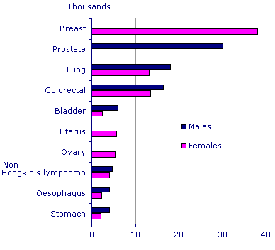
Figure 1.1: Incidence of the major cancers, 2007, England
http://www.statistics.gov.uk/CCI/nugget.asp?ID=915
Source: Office for National Statistics (ONS)
The data show that the age-standardised incidence of cancer increased by around 21 percent in males and 45 percent in females between 1971 and 2007. (www.statistics.gov.uk)

    - Incidence of prostate cancer

      - General statistics

The trend of male cancer incidence in the UK has changed in the past number of years. Prostate cancer, accounting for 24% of total cancer cases, exceeds that of lung cancer at 15%, to become the most common cancer in UK males (Fig 1.2). In the UK, over 35,000 prostate cancer cases were diagnosed in 2006. While 35,500 cases of prostate cancer were reported, 22,300 cases of lung cancer were reported as second. Bowel cancer also accounts for 14%. The three most common cancers in men: prostate, lung and bowel, account for over half (53%) of the cancer incidence reported in men in the UK. (CRUK, 2006)
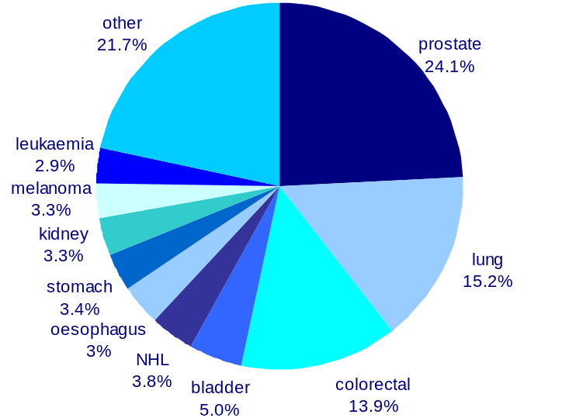
Figure 1.2: The 10 most common cancers in males, UK, 2006
All male cancers (exc NMSC): 147,223
http://info.cancerresearchuk.org/cancerstats/incidence/males/
Source: CRUK
In 2006, the fact that 35,515 new cases of prostate cancer were diagnosed in the UK means that one man every 15 minutes or 97 men everyday are diagnosed with prostate cancer. The lifetime risk of being diagnosed with prostate cancer for a man living in the UK is 1 in 10.

      - By age

Prostate cancer incidence increases steeply with age. In accordance with the general trend of cancer incidence within the UK population, prostate cancer incidence rate is 144 per 100,000 for men aged 55-59; it rises to 500 by age 65-69, and rises further to 789 by 85+ (Fig 1.3).
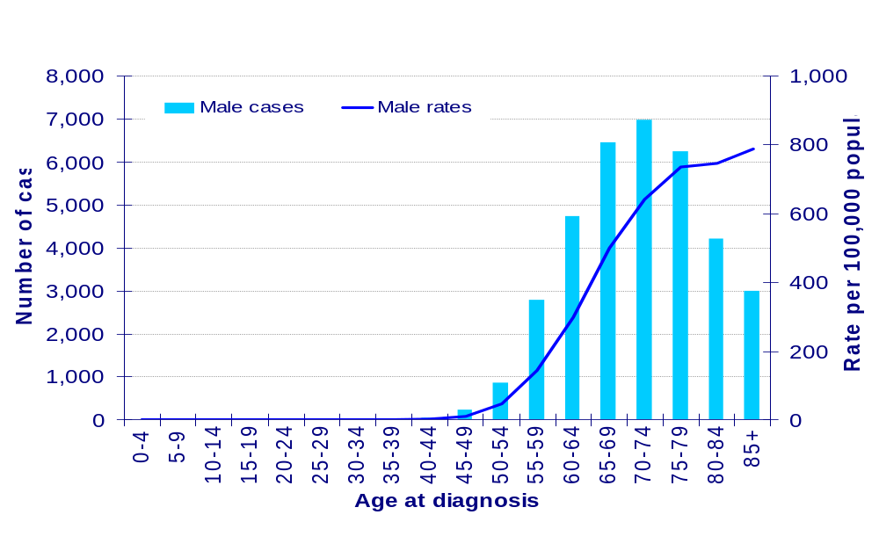
Figure 1.3: numbers of new cases and age specific incidence rates, prostate cancer, UK 2006
http://info.cancerresearchuk.org/cancerstats/types/prostate/riskfactors/#age
Source: CRUK

      - By regions

World wide, more than 670,000 men were diagnosed with prostate cancer in 2002, accounting for 1/9 of all new cancers in males. Unlike in the UK prostate cancer is the most common male cancer; it is the second most common in men after lung cancer worldwide. Three-quarters of all new cases are in the developed world with the highest rates occurring in North America and the lowest rates in Asian countries. (Fig 1.4)
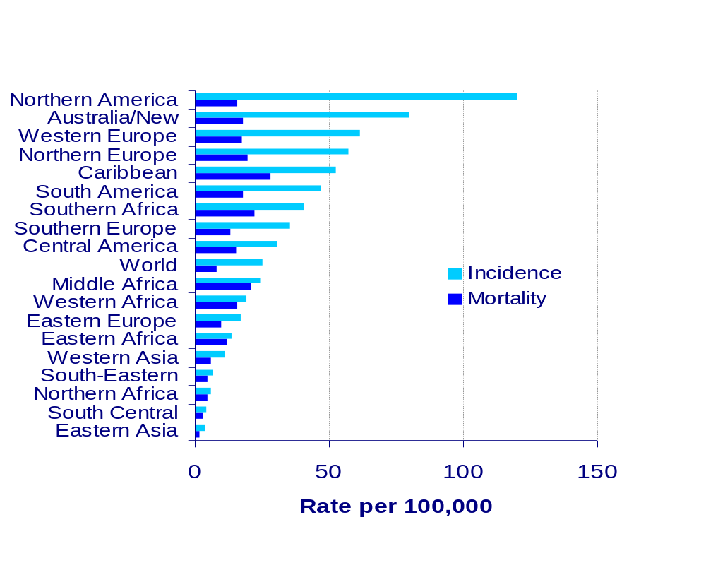
Figure 1.4: age-standardised incidence and mortality rates for prostate cancer by world regions, 2002 estimates
http://info.cancerresearchuk.org/cancerstats/types/prostate/incidence/
Source: CRUK
The extreme high rate in the USA (142.4 per 100,000, 2005) is probably due to the frequent use of PSA testing. And within the USA significant differences are observed between racial groups. The rate for black Americans is more than 50% higher than that for white Americans while rate for Asian Americans is 40% lower than that for white Americans. (CRUK, 2005)

      - Trends

During the last ten years in the UK, European age-standardised rate for prostate cancer has increased by a third from 71 per 100,000 in 1997 to 97 per 100,000 in 2006 while the number of the cases diagnosed rose from 23,741 in 1997 to 35,515 in 2006, an increase of 50%. (Fig 1.5)
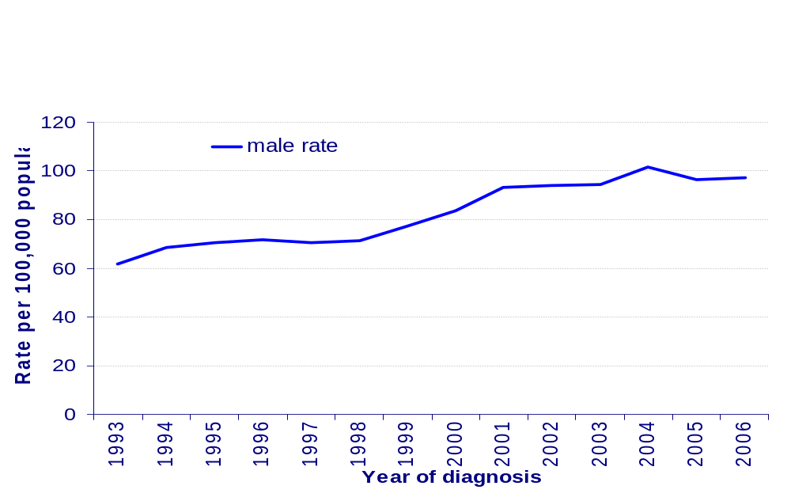
Figure 1.5: Age standardised (European) incidence rates, prostate cancer, UK, 1993-2006
http://info.cancerresearchuk.org/cancerstats/types/prostate/incidence/
Source: CRUK
Time trends for a longer period (1975-2006) are shown in Fig 1.6 for Great Britain. During the late 1970s and 1980s rate rose consistently, and an acceleration of the trend in the early 1990s was followed by a brief levelling off in the mid-1990s. Another rising trend is seen in the late 1990s.
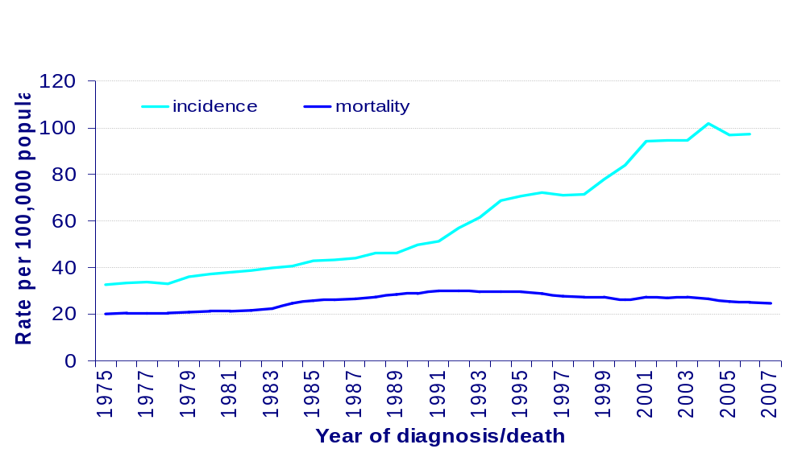
Figure 1.6: Age standardised (European) incidence and mortality rates, prostate cancer, males, Great Britain, 1975-2007
http://info.cancerresearchuk.org/cancerstats/types/prostate/incidence/
Source: CRUK

    - Mortality of prostate cancer

Though there has been a huge rise in prostate cancer incidence over the past years this has not been reflected in mortality rates.
In 2006, there were 10,038 deaths in the UK from prostate cancer which accounts for around 12 % of male death from cancer and is the second most common cause of caner death in men after lung cancer.
In older men aged 85+, prostate cancer overtakes lung cancer to become the most common cause of cancer deaths. (Fig1.7)
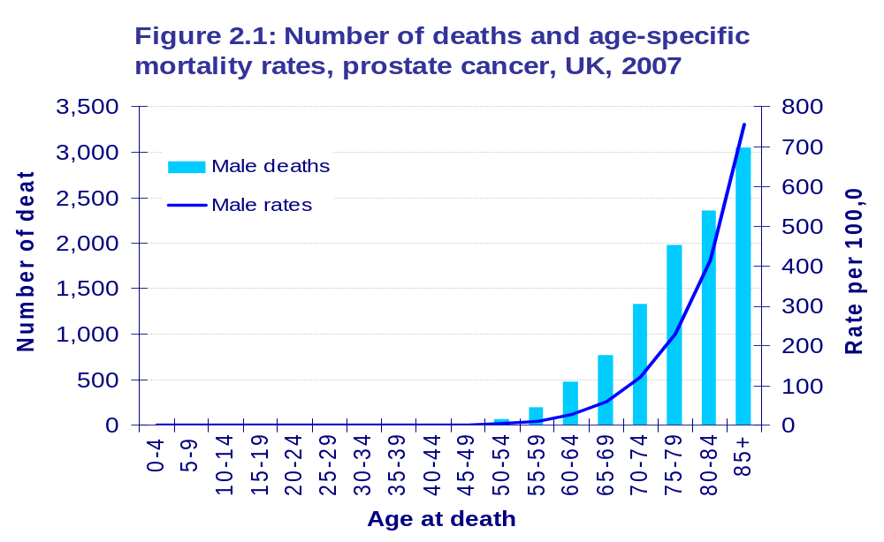
Figure 1.7: number of deaths and age-specific mortality rates, prostate cancer, UK, 2007
http://info.cancerresearchuk.org/cancerstats/types/prostate/mortality/
Source: CRUK
Worldwide, although North America ranks first in terms of incidence, it is 8th for mortality with the highest rates being recorded in the Caribbean. (Fig 1.4)
In results by PSA is not only higher prostate cancer incidence but also a much higher proportion of early stage cases being diagnosed which naturally leads to higher survival rates and lower mortality rates relative to the incidence.
Overall in Great Britain, prostate cancer mortality was fairly stable during the 1970s but began to increase in the early 1980s. (Fig 1.6)

    - Risk factors of prostate cancer

Though the risk factors for prostate cancer include age, family history, ethnicity, diet, alcohol and smoking, body weight and physical activity, medications, medical procedures and infections, endogenous hormones and diabetes mellitus, there is insufficient evidence on which to base a prevention strategy. The established risk factors are age, family history and ethnicity ¹. (CRUK, 2005)

      - Age

The strongest known risk factor for prostate cancer is age, with very low risk in men under 50 and rising risk with increasing age (Fig 1.3). The older the men; the higher the risk. Approximately 80% of men by age 80 were diagnosed to have cancer cells in their prostate². Some of this increase may partly be due to the increasing use of transurethral resection of the prostate (TURP) during 1980’s and PSA testing during the 1990’s³.

      - Family history

As with all cancers, a positive family history is a known risk factor. Risk increases two to three fold for men with a first-degree relative diagnosed with prostate cancer. If the relative is less than 60 years old at diagnosis or more than one relative is affected (at any age), the individual’s risk is four times the average. If these factors combine so that when more than one relative is affected by early-onset prostate cancer, the risk is increased seven-fold^{4, 5}.
Interestingly, a strong family history of breast cancer may also affect a man’s risk of prostate cancer, particularly if the family members were diagnosed under the age of 60., Gremlin mutations in the breast cancer susceptibility genes, especially, BRCA1 and BRCA2, can predispose men to prostate cancer⁶.
Recently, several genetic variants that each slightly increase prostate cancer risk have been identified which may contribute to a significant proportion of all prostate cancer cases. Genetic profiling is being used to inform prostate screening and treatment^{7, 8}.

      - Ethnicity

Variation in incidence rates around the world and within countries suggests that risk is affected by ethnicity.
In the UK, data shows that black Caribbean and black African men have the highest risk of being diagnosed or dying from prostate cancer which was approximately two to three times than white men^{9, 10}. Meanwhile, Asian men have a lower risk than the national average⁹. (CRUK, 2005)
Worldwide, the highest rate was also recorded in Caribbean and African American men who have much higher rates than white Americans and Europeans, the lowest incidence is seen in Far East and Asian men¹¹.
However, migrant studies suggest that environmental factors are also involved as the rates for migrants from low to high risk countries increase. Nevertheless, cancer data indicates that ethnic factors are the more important determinants rather than environmental factors. For example, South Asian men living in the UK have a higher risk of prostate cancer than men living in South Asia¹².

    - Pathology of prostate cancer

      - Anatomy of the prostate

The prostate is a pear-shaped exocrine glandular organ enveloped by fibro-muscular connective tissue, composed of an inner layer of smooth muscle, and an outer fibrous condensation¹³.
It produces secretions which nourish sperm and is an accessory gland of the male reproductive system adding to the bulk of the seminal fluid like seminal vesicles and bulbourethral glands.
A healthy prostate measures 4 cm transversely at the base (width), 3cm vertically (length) and 2 cm anteroposteriorly (thickness). Its average weight is 8 mgs.¹⁴
It is comprised of three distinct zones ¹⁵ as shown in Fig 1.8:
The peripheral zone (PZ): 70% of volume, the commonest site for PIN and adenocarcinoma.
The central zone (CZ): 25% of volume.
The transition zone (TZ): 5% of volume, primary site for BPH and the rare large dust carcinoma.
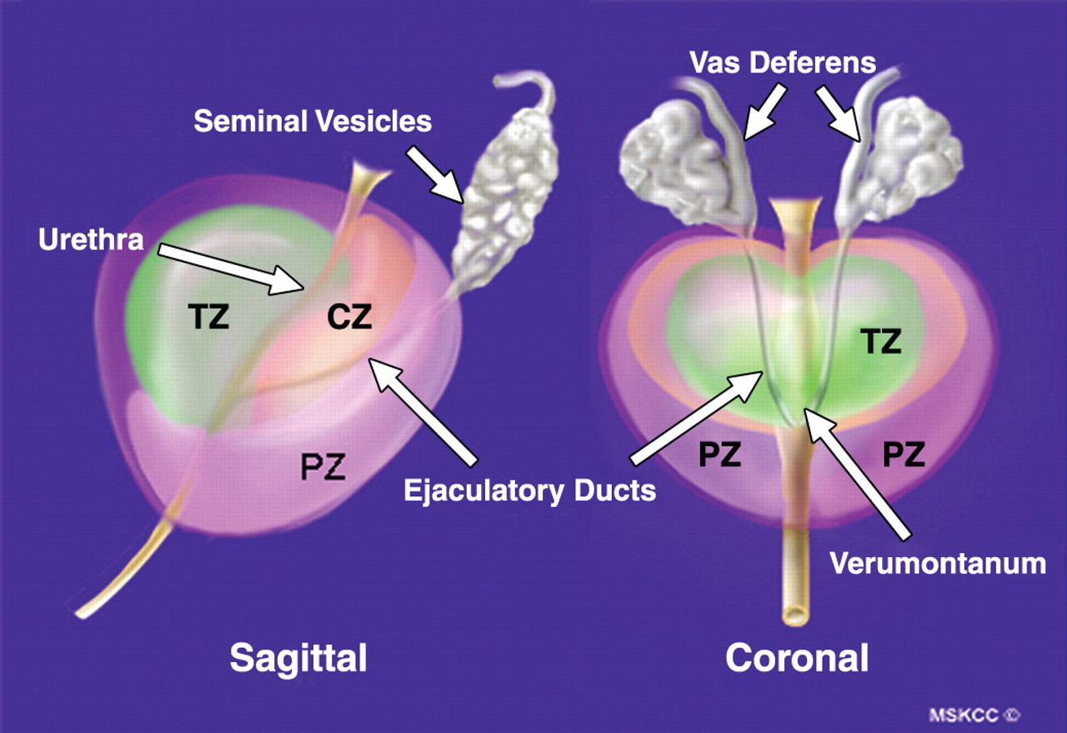
Figure 1.8: Schematic of prostate gland depicts zonal anatomy.¹⁶
(Permitted by American Journal of Roentgenology)
      - BPH

Benign, nodular, paraurethral hyperplasia of the prostate (BPH) is one of the most common disease of elderly men and the most frequent benign condition identified in the prostate. It is the result of proliferation of the mesenchymal-stromal and the glandular epithelial components of the prostate. BPH is not a malignant lesion or a precursor of prostate cancer¹⁷.
Normally, BPH appears not to result in the formation of prostatic malignancy since 70%-80% of prostate carcinoma develops in the PZ. Only 20% of all carcinomas are found in the TZ and are usually highly differentiated incidental carcinomas.¹⁵
Though there are some similarities between prostate cancer and BPH such as androgenic stimulation requirement, age-prevalence increase and most prostate cancer patients already had BPH¹⁷.
Recent studies showed androgens and estrogens both play a role in the development of BPH^{18, 19}.

      - PIN

The precursor of prostatic adenocarcinoma has been studied and focused on the prostatic intraepithelial neoplasia (PIN) recently. PIN is considered proliferation of the luminal epithelium with pre-existing acini and ducts and is cytologically atypical and demonstrates features such as nuclear and nucleolar enlargement. It co-exists with cancer in more than 85% of cases but retains an intact or fragmented basal cell layer, unlike cancer, which lacks a basal cell layer.¹⁵
PIN was divided into two grades, low-grade PIN and high-grade PIN, according to their features of cellular crowding, nuclear enlargement, and chromatin pattern and nucleolar appearance¹⁵.
PIN has a high predictive value as a marker for adenocarcinoma, particularly the high-grade PIN. If this lesion is identified, close surveillance and follow-up biopsy are indicated^{15, 20, 21}.
Thus, current recommendations from the World Health Organization are only reporting high-grade PIN.

      - Grading the prostate cancer

Histological grading methods are very important to assess diagnosis and prognosis in prostate cancer. Many grading systems¹⁵ have been proposed in which the Gleason grading system of prostate carcinoma is the predominant and the most commonly used one around the world.
In 1966 DF Gleason developed his unique grading system for prostatic carcinomas based solely on the architectural pattern of tumor in a study of 270 patients from the Minneapolis veterans Administration Hospital²². The Gleason grading system was then expanded to 1032 men by Gleason and the Veteran Administration Cooperative Urological research Group (VACURG) by 1974²³. A modified Gleason grading system was introduced in 2005, at the ISUP (International Society of Urological Pathology) consensus conference held in San Antonio²⁴. Gleason grading is now both the world wide grading system for prostatic carcinomas and grading system of the WHO tumour classification of prostatic carcinomas.
In the Gleason grading system, the histological patterns were categorized at low magnification according to the extent of glandular differentiation and the pattern of growth of the tumors within the prostatic stroma. The glandular patterns were identified from well-differentiated (grade1) to anaplastic (grade 5) according to the characteristic morphological appearances shown in Table1.1 and Fig 1.9²⁴.
Table 1.1: 2005 ISUP modified Gleason system
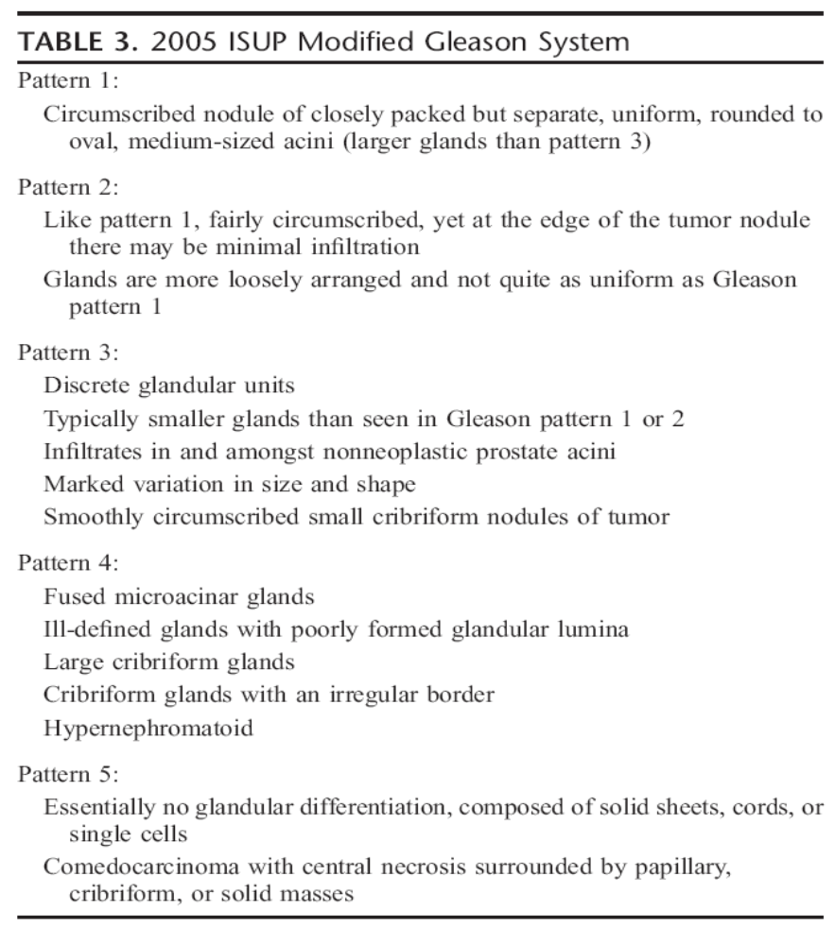

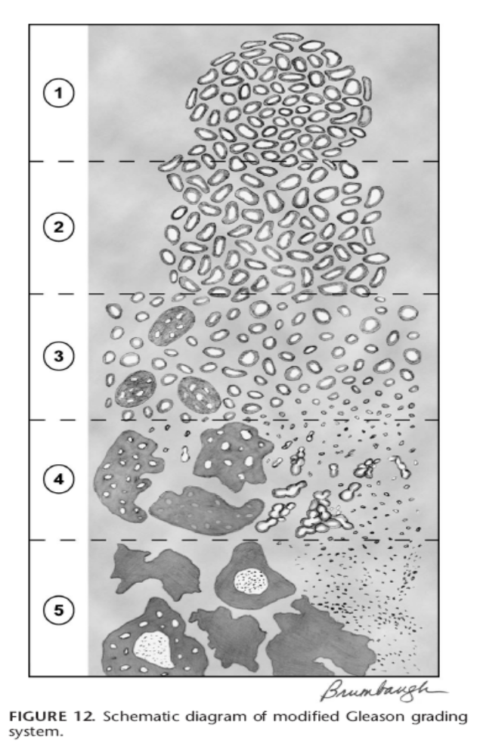
Figure 1.9: Schematic diagram of modified Gleason grading system²⁴
Another innovative aspect of this system was, rather than assigning the worst grade as the grade of the carcinoma, the grade was defined as the sum of the two most common grade patterns and reported as Gleason score²⁵.
For example, the lowest possible Gleason score is 2 (1+1), where both the primary and secondary patterns have a Gleason grade of 1 while the highest possible Gleason score is 10 (5+5), when the primary and secondary patterns both have the most disordered Gleason grades of 5.
The Gleason grading system has been simplified by compressing the scores into ‘grade lumping’ as three groups: well differentiated (Gleason score 2-5), moderately differentiated (6-7) and poorly differentiated (8-10). Combined Gleason scores were commonly used as the prognostic indicators for prostatic carcinomas and correlated with all of the important pathologic parameters and clinical outcomes, such as patient survival time, prostate-specific antigen (PSA), androgen-receptor (AR) and multiple prognostic index¹⁵. Recent studies also showed that with the modified Gleason system, grade, stage, tumor extent and serum PSA have good correlations and characterize the difference between low and high grade malignancy of prostate carcinoma²⁶.

  - Biomarkers for prostate cancer

    - Molecular pathology of prostate cancer

The molecular pathology of prostate cancer is complex as many genes are involved in its pathogenesis. A number of somatic mutations and chromosomal abnormalities have been identified in prostate cancer, including overexpression of oncogenes, such as bcl-2 and underexpression of tumor suppressor genes, such as GSTP1, and changes in the expression of growth factors and their receptors²⁷.

    - Current prognostic biomarkers for prostate cancer

In many disease states, the use of biomarkers is a standard method of determining both the presence and the risk of the future development of disease. For several years, PSA levels have been the standard measure for the diagnosis of prostate cancer. It was also suggested to be used as the prognostic biomarker of the prostate cancer. ²⁸

      - PSA

Prostate-specific antigen (PSA) is a 33-kD glycoprotein that is currently the most important tumor marker for adenocarcinoma.
PSA was identified and characterized from 1966 to 1978²⁹. The 6-kb PSA gene is located on chromosome 19 and codes for a single-chain 33-kD glycoprotein³⁰.
PSA is an enzyme that belongs to the kallikrein family of serine protease and also known as human kallikrein 3. Its physiologic function is to liquefy seminal coagulum by cleaving the protein semenogelin into small peptides thus increasing sperm motility¹⁵. PSA was initially thought to express specifically in the prostate, especially to benign and malignant prostatic luminal epithelial cells. However, so far, it has been found expressing in several tissues and disease from periurenthral glands to breast carcinoma¹⁵.
PSA is normally secreted from prostatic epithelial cells. PSA levels may be elevated in men with prostate cancer because PSA production is increased and because tissue barriers between the prostate gland lumen and the capillary are disrupted, releasing more PSA into the serum³¹.
The traditional cut off point for an abnormal PSA level in the major screening studies has been 4.0 ng/ml³².At this level, the sensitivity of PSA has been estimated to be about 70 to 80 percent, while the specificity is about 60 to 70 percent estimated³³.
Though PSA is commonly used as the biomarker for prognosis of prostate cancer worldwide, controversies were shown from the study. It was demonstrated that the overall positively predictive value for a PSA level > 4.0 ng/ml is 30 percent which means slightly less than one in three men with an elevated PSA will have prostate cancer³⁴. Meanwhile, some men with PSA levels < 4.0 ng/ml were found to have prostate cancer³⁵. Many observations indicate that there is no clear point between ‘normal’ and ‘abnormal’ PSA levels. A recent study was looking at the correlation between PSA level and prostate cancer during five-year intervals at a hospital, and the result showed while serum PSA was correlated with prostate stage, grade and size from 1983 to 1988, it was only correlated with prostate weight from 1998 to 2003³⁶. Thus, further concerns should be raised about the utility of PSA as a prognostic marker for prostate cancer and more molecules should be tested and considered for the prognosis of prostate cancer.

      - Other potential biomarkers

A number of potential biomarkers have been identified and their predictive value to determine the risk of future prostate cancer studied. Transforming growth factor –β1, interleukin-6, PCA3, BRCA and EPCA-2 have been reported and show some predictive value for prostate cancer, but none of them can replace PSA²⁸. Thus, PSA will remain as the most important and effective biomarker for prostate cancer until a more reliable molecular biomarker is identified.

    - Some candidate genes to test in my study

In our study, three genes, AGR2, S100A4, OPN, were chosen to test their effectiveness and potential as a prognostic biomarker and therapeutic targets for prostate cancer. They were considered and selected as the candidate genes because:
- All have shown a possible role as prognostic indicators with therapeutic potential in breast cancer which is a hormone responsible cancer, the same as the prostate cancer.
- AGR2 has previous been investigated without regards to prostate cancer. However the others, like OPN, have been investigated less and produced conflicting results, due to ineffective methods or small sample numbers.
- All of these have similarities in structure and function according to the literature.

  - AGR2

    - AGR2

Anterior gradient-2 (AGR2), a secret protein, is the human orthologue of the secreted Xenopus laevis AGR protein XAG-2³⁷. Its molecular weight is 20kDa^{38, 39}. The human AGR2 gene is located on chromosome 7p21.3, a location supported by the sequence of the human genome assembly (NCBI build 35), earlier radiation hybrid mapping and fluorescence in situ hybridization⁴⁰.
AGR2 was also known as HAG-2⁴¹ and Gob-4⁴². HAG-2 is the human homologue of the Xenopus laevis cement gland gene XAG-2 which was renamed from DEME-2⁴³. It was found co-expressed with estrogen receptor in breast cell line⁴¹. Gob-4 was expressed in goblet cells in the intestine. Its deduced amino acid sequence was reported as similar to XAG-2 and it was suggested that Gob may be involved in the secretary mechanism⁴².
AGR2 was first identified by screening for differentially expressed genes in the neural development in Xenopus laevis³⁷. It played a patterning role in the development of frog embryos by inducing the formation of the forebrain and the mucus-secreting cement gland³⁷. In humans, AGR2 was originally cloned as a gene differentially expressed between ER-positive MCF7 and ER negative MDA-MB-231 breast cancer cell lines and the cooperation of AGR2 and ER was observed in a panel of cancer cell lines⁴¹. As well as breast cancer, AGR2 expression was observed in a variety of other cancers, such as esophagus⁴⁴, pancreas^{45, 46}, and prostate^{38, 47}.

Fig1.10 AGR2 structure!
    - Role of AGR2 in breast cancer

A number of studies have investigated the role of AGR2 in breast cancer since it was originally observed in breast cancer cell lines. The metastasis-inducing property of AGR2 was first demonstrated by screening of mRNA and protein expression in ER-positive and ER-negative carcinoma. AGR2 was expressed at a higher level in the human breast cancer cell line MCF-7 than in the benign cell line Hama 123. More importantly, transfection of AGR2 cDNA into a benign rat mammary cell line, Rama 37, induced metastasis in vivo, which suggested AGR2 may contribute to the malignant progression of ER-positive breast cancer.⁴⁸ Subsequent investigation showed that expression of AGR-2 was significantly associated with poor outcome in patients with ER-positive breast cancer, which indicated AGR2 could be used as a prognostic marker for ER-positive breast cancer³⁹.

    - AGR2 in prostate cancer

Unlike its role in breast cancer, the role of AGR2 in prostatic malignancy is not fully understood.
AGR2 was highly induced by androgen in an androgen receptor (AR)-dependent manner and the expression of AGR2 markedly increased at both mRNA and protein levels in prostate cancer cells compared with their benign counterparts, indicating that AGR2 might be involved in the malignant progression of prostate cancer⁴⁷.
However, the prognostic value of the increased AGR2 in prostate cancer is not clear, and thus it is not known whether the increased AGR2 can be used as a new target for therapeutic suppression of prostate caner.

  - S100A4

    - S100 protein family

Calcium-binding proteins which act as intracellular calcium receptor molecules and couple changes in intracellular calcium levels to alternations in cell function can be divided into three groups⁴⁹, according to structural properties:
- the calmodulin-S100-tropolin C superfamily, which contain high affinity EF-hand type calcium-binding domains and has approximately 200 family members
- those containing a henolysin-like-calcium-binding domain
- the annexin family, which bind phospholipids in a calcium-dependent manner
Human S100 proteins comprise over 20 known members that are distributed tissue specifically and each coded by a separate gene^{50, 51}.
The first two members were identified by Moore in 1965 when a subcellular fraction from bovine brain was isolated. This was thought to contain nervous-system specific proteins. The fraction was called S100 because the constituents were soluble in 100% saturated ammonium sulfphate at neutral pH^{49, 52}. S100A1 and S100B were isolated and characterized from this fraction^{53, 54}. Based on amino acid homology and similar structural properties, several additional proteins have been catalogued to this S100 family^{49, 51, 55}.
The S100 proteins are small, acidic proteins of 10-12 kD and have two distinct EF-hands^{55, 56}.
It is well demonstrated that S100 proteins have been implicated in intracellular and extracellular regulatory activities. Intracellular functional roles of S100 proteins include inhibition of protein phosphorylation, regulation of enzyme activity, regulation of cell growth and differentiation, regulation of calcium homeostasis, regulation of cytoskeleton and regulation of transcriptional factors. The extracellular functions of some S100 proteins are as leukocyte chemoattractants, macrophage activators and modulators of cell proliferation. ^{55, 57}
There has been growing interest in the role of S100 protein family in cancers and several members of S100 family have been shown to play an important roles in tumorgenecity and metastasis, such as S100A2⁵⁸, S100A4⁵⁹, S100A5⁶⁰, S100A6⁶¹, S100A8, S100A9 and S10011^{62, 63}.
In summary, the S100 protein family is a group of calcium binding proteins with size 10-12kD and two distinct EF-hand calcium-binding domains and amino-acid homology whose role have been implicated with both intracellular and extracellular functions and they are also associated with the tumorgenecity and metastasis in many cancers.

    - S100A4

As with most of the S100 family members, S100A4 is a symmetric homodimer stabilized by noncovalent interactions between two helices from each subunit(helices 1,4,1’,4’) that form an X-type four-helix bundle (Fig 1.11).Each S100A4 subunit has two EF-hand calcium-binding domains: a pseudo-EF-hand or S100-hand and a typical EF-hand^{64, 65},which are brought into close proximity by a small two-stranded antiparallel β-sheet.⁶⁶ In S100A4, the pseudo-EF-hand is formed by helices 1 and 2. The orientation of helices 3 and 4 in the S100A4 typical EF-hand is similar to S100A6^{65, 67}. In S100A4, there is a C-terminal loop following helix 4 that is long and basic, which is particularly unique compared to other S100 proteins⁶⁵. The main difference between the S100 family proteins is the linker connecting the EF-hands and in the long C-end. Binding of calcium ions by the pseudo-EF-hand induces small conformational alterations in the S100 molecule structure, where as those by the canonical EF-hand result in turning helix 3 relative helix 4, making the hydrophobic amino acid residues of helices 3 and 4, as well as those of the long C-terminal region, more accessible^{68, 69}. This calcium-dependent conformational change is necessary for S100A4 to interact with its protein targets and generate a biological effect and the target binding significantly enhances the calcium binding affinity of S100A4^{64, 65, 67, 70-72}. This provides a mechanism for the formation of a high affinity complex in vivo that occurs only when calcium, S100A4, and one of its target proteins are present⁶⁵.
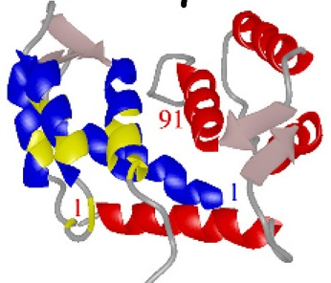
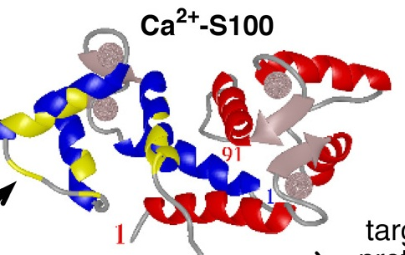
A4
Ca²⁺
Figure 1.11: Structure of S100A4
S100A4 , a small 11-kD protein^{73, 74}, was first identified by Jackson-Grusby and coworkers and called 18A2. It was cloned from quiescent fibroblasts following serum stimulation⁷⁵. S100A4 is expressed in the S phase of the cell cycle^{49, 75}.
It was then identified independently in different laboratories: pEL98, an mRNA induced in transformed murine cells, established from the BALB/C-3T3⁷⁶; 42A, an NGF-induced mRNA in rat pheochromocytoma cells, established from PC12 cells after nerve growth factor stimulation⁷⁷; p9Ka, an induced protein product in differentiated mammary epithelial stem cells⁷⁸; mts1, an overexpressed gene product in metastatic tumor cell subclones, the mouse homologue of the rat p9Ka gene⁷³; calvasculin, a protein that interacts with a potent vasorelaxant in bovine aorta⁷⁹; calcyclin, a protein similar to the EAT protein, purified from mouse stomach ⁸⁰; CAPL, an protein selectively expressed in cell lines that have been induced to grow or differentiate, purified from bovine neural retina⁸¹; FSP1, a filament-associated, calcium-binding protein, detected by in situ hybridization as a postgastrulation event⁸².

    - Human S100A4 gene structure

Of 25 currently known human genes of the S100 family, 21 (S100A1-S100A18, trichohylin, filaggrin, and repetin) are located in a cluster in chromosome locus 1q21. Sequencing of the human S100A4 gene showed that it consists of three introns and four exons, the former two of which do not code for an amino acid sequence⁶⁹.
There are two variants of the human S100A4 as a result of alternative splicing within the 5’-UTR ⁸³. The two splice variants display different expression profiles in human tissues and tumor cell lines⁸⁴.
The S100A4 promoter contains an ErbB2 response element⁸⁵, and the transcription of the S100A4 gene is controlled by both positive and negative regulatory elements located within the first intron, which bind several transcription factors⁸⁶⁻⁸⁸. In addition, hypermethylation of the S100A4 gene is associated with transcriptional silencing^{65, 89}.

    - S100A4 function

S100A4 exerts both intracellular and extracellular effects and is involved in a number of cellular events.

      - Intracellular roles and targets

It has been demonstrated that, using the yeast two-hybrid system, S100A4 could not only exist as a homodimer (S100A4/S100A4) but also form a heterodimer with S100A1 (S100A4/S100A1), another member of S100 family^{90, 91}.
Since S100A4 has not been associated with any enzymatic activity, the interaction with the other target proteins is likely to be more critical for S100A4 activity. S100A4 interacts with the tumor suppressor p53⁹², nonmuscle myosin II⁹³ and liprin β^{74, 94}.
S100A4 binds to the extreme end of the C terminus of p53 and inhibits the phosphorylation of the tumor suppressor in vitro by protein kinase C (PKC)⁹². It has been shown that the p53 target gene (p21/WAF, bax, thrombospondin-1 and mdm-2) transcriptions were modulated differently upon S100A4 induction. For example, bax was up-regulated by S100A4, mdm-2 was down-regulated initially and then up-regulated while p21 and thrombopondin-1 were inhibited by S100A4⁹². These seemingly opposite effects of S100A4 expression on p53-regulated genes are not due to the interactions of S100A4 with p53 but likely to be a consequence of direct interactions with other targets such as cytoskeletal proteins⁶⁵.
S100A4 regulates the monomeric, unassembled state in an isoform-specific manner by binding to the A isoform of the nonmuscle myosin-II (myosin IIA) and then modulate the filament assembly through the stabilization of myosin-II assemblies. S100A4 binds to residues 1909-1924 of the myosin IIA heavy chain, which is near the C-terminal tip of the α-helical coiled-coil.⁹⁵ Though S100A4 binding site overlap the site of protein kinase C (PKC) at the platelet myosin heavy chain at Ser-1917⁹⁶, recent studies have shown that PKC phosphorylation had no effect on S100A4 binding while the protein kinase CK2 decreased the affinity of S100A4⁹⁷. CK2 phosphorylation of the myosin-IIA heavy chain protects against S100A4-induced filament disassembly⁹⁷. All data suggest S100A4 regulates cell shape and motility through the modulation of myosin-IIA function⁶⁵.
S100A4 binds Liprin β1 at the C terminus of Liprin β1 between amino acid residues 938-1005. The S100A4-binding region contains two putative phosphorylation sites by protein kinase C and protein kinase CK2. S100A4-liprin β1 phosphorylation by both kinases in vitro.⁹⁴

      - Extracellular roles and targets

S100A4 was secreted by fibroblasts in culture and tumor cells can stimulate S100A4 secretion from them⁹⁸. Furthermore, in vivo, S100A4 was observed accumulating in the blood of aging animals⁹⁹.
It was demonstrated that S100A4 protein added to the extracellular space strongly stimulates proteolytic activity of VMR (mouse adenocarcinoma cell line) cells and this activity was associated with matrix metalloproteinases, particularly, with matrix metalloproteinase-13 (MMP-13)⁹⁸.
In osteosarcoma cells, the mRNA levels of MMP2, membrane type (MT) 1-MMP, and TIMP-1 were significantly reduced when S100A4 mRNA expression was inhibited¹⁰⁰. In Madin-Darby canine kidney (MDCK) epithelial cells, the coordinated action of MT1-MMP and S100A4 contributes to the invasion of the malignant carcinoma cells¹⁰¹.
Recent studies have shown that extracellular S100A4 interacts with annexin II, an endothelial plasminogen co-receptor by binding to the N-terminal region. This interaction accelerated plasminogen activation by tissue plasminogen activator on the endothelial cell surface to generate plasmin, which is known to activate pro-MMPs.^{65, 102}
In summary, extracellular S100A4 can promote metastasis by inducing remodeling of the extracellular matrix thus facilitating angiogenesis and tumor invasion.

    - Effects of S100A4 in cancers

S100A4 expression is observed in metastatic cancers. Immunohistochemical staining shows S100A4 to be expressed significantly in human breast, pancreatic, prostate, gallbladder, esophagel, gastic, lung, and thyroid carcinomas¹⁰³⁻¹¹⁰. In these cancers, S100A4 expression was found at elevated levels compared with normal tissue, suggesting that enhanced S100A4 expression contributes to the manifestation of a metastatic phenotype⁶⁵.
It has been shown that both intracellular and extracellular S100A4 contributes to the metastasis-promoting function of protein. Possible mechanisms are summarized below in Fig 1.12¹¹¹.
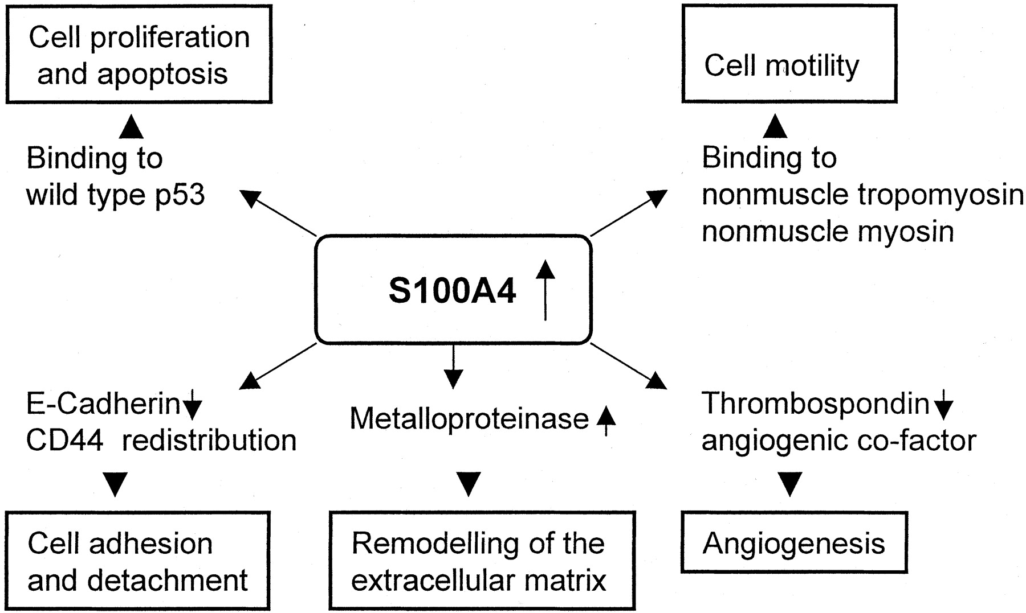
Figure 1.12: Possible effects of S100A4 in tumors on gene up-regulation and/or protein overexpression¹¹²

      - Cell motility

The role of S100A4 in cell motility was suggested by initial studies performed with human promyelocytic leukemia HL-60 cells¹¹³ and a mouse mammary adenocarcinoma cell line¹¹⁴. S100A4 was shown to interact with cytoskeletal components including the heavy chain of nonmuscle myosin⁹³, nonmuscle thopomyosin¹¹³ and F-actin¹¹⁵.

      - Cell invasiveness

Interaction of S100A4 with the heavy chain of nonmuscle myosin results in inhibition of PKC and CK2 dependent phosphorylation of nonmuscle myosin^{96, 116}. This interaction increases myosin solubility and therefore suppresses its assembly and may directly destabilize myosin filaments¹¹⁷. Similarly, S100A4 binding to nonmuscle tropomyosin is also thought to be responsible for the disassembly of actin filaments¹¹³. These data suggest S100A4 can modulate the invasiveness of tumor cells.

      - Cell-cell adhesion

Cooperation of S100A4 and E-cadherin (a transmembrane glycoprotein that mediates calcium dependent cell-cell adhesion) has been studied in mouse tumor cells and humans^{109, 118}. The inverse correlation of E-cadherin and S100A4 expression was monitored in both cases, suggesting the invasiveness of tumours expressing S100A4 may be induced by the abrogation of E-cadherin expression¹¹⁸. Recent studies have also shown that S100A4 contributes to cell adhesion via binding to liprinβ1, thus modulating LAR (transmembrane phosphotyrosine phosphatise)-dependent signalling directly involved in cell adhesion⁹⁴.

      - Proliferation&apoptosis

An association between S100A4 and cell proliferation has been studied after initial cloning experiments that isolated the S100A4 gene from growth-stimulated cells^{112, 119}. Recent studies have shown that S100A4 expression was associated with an increased amount of p53¹²⁰. It also suggested that a complex of S100A4 with p53 and the sequestration of p53 may result in stimulation of cells to enter the S phase by abrogating the control functions of p53 at the G1-S checkpoint^{112, 120, 121}.
The regulation of tumor cell populations is a result of an increase in cell numbers by proliferation and balanced by cell loss by apoptosis. Recently it has been reported that S100A4 activates the apoptotic pathway. It might conceivably influence apoptosis by activating more than one signaling system¹²².
Bax is a target of p53 and it can be argued that sequestration of p53 by S100A4 could be resulting in the down regulation of bax¹²³. The overexpression of S100A4 has been shown to lead to the modulation of bax gene⁹². Hyperthermia has been shown to inhibit cell proliferation and induce apoptosis. The induction of apoptosis and inhibition of cell proliferation were accompanied by down regulation of S100A4 in parallel with compatible alternations in the pro-apoptotic bax and anti-apoptotic bcl-2 genes¹²⁴. The interference RNA-mediated down regulation of S100A4 enhanced expression of BNIP3, a pro-apoptotic member of Bcl-2 family¹²⁵. Phorbol12-myristate 13-acetate (PMA) was shown up regulate BNIP3 expression together with increased apoptosis while S100A4 was found down regulated¹²⁶. Retinoic acid (RA) arrests tumor growth and reverses expression of the neoplastic phenotype which has been attributed to its ability to induce differentiation or apoptosis^{122, 127, 128}.

      - Angiogenesis

Another important hallmark of invasive tumour growth and cancer metastasis is angiogenesis. S100A4 has been found to exert its role in angiogenesis particularly by modulating expression of thrombospondin 1 and matrix metalloproteinases (MMPs).
Thrombospondin 1 belongs to the class of extracellular matrix glycoproteins with antiangiogenic effects that can express the progression of tumours¹²⁹. In addition, it was demonstrated that the S100A4 oligomer was capable of stimulating angiogenesis by promoting the chemotactic motility of endothelial cells in vitro, and of inducing corneal neovascularisation in vivo^{74, 98}.
An association between S100A4 and MMPs has previously been described.
Extracellular S00A4 was shown to strongly stimulate proteolytic activity in endothelial and tumour cells, particularly by upregulating MMP13. It was also shown that in a highly metastatic osteosarcoma cell line transfected with a specific ribozyme against the S100A4 gene transcript, the downregulation of S100A4 expression resulted in a reduction of the mRNA levels of MMP2, MMP14 and the endogenous tissue inhibitor TIMP-1¹⁰⁰. Recent studies show that the suppression of S100A4 significantly reduced expression and proteolytic activity of MMP9¹³⁰.

    - S100A4 in prostate cancer
S100A4 was first studied in the Dunning R3327 rat prostate cancer model in 1997. The expression of the mRNA and corresponding protein product of S100A4 in 6 different metastatic cell lines of this prostate cancer model was assessed by Western and Northern blotting. There is a direct association between the elevated expression of S100A4 mRNA and protein levels and the increased metastatic capability of individual prostatic cancer cell lines.¹³¹
In 2003, S100A4 was studied in the progression of human prostate adenocarcinoma as well as S100A2. The protein level of S100A4 was significantly higher in all carcinoma cells compared to the normal human prostate epithelial cells NHPE and virally transformed prostate epithelial cells P3-HPV-7. The mRNA and protein level of S100A4 was also significantly higher in high-grade cancer specimens compared to BPH, prostatitis, and low-grade cancer. In cancer tissues, the high level of S100A4 observed was correlated with increasing tumour grade using immunohistochemistry. For the first time, the data provided evidence that loss of increased expression of S100A4 may be indicative of cancer progression in human prostate adenocarcinoma.¹⁰⁵
Additional studies were carried out to assess the expression of S100A4 during autochthonous prostate cancer progression in the transgenic adenocarcinoma of the mouse prostate (TRAMP) model. It has shown that an increase in the expression of S100A4 at mRNA and protein level in dorsolateral prostate, but not in nontransgenic mice occurred with the progression of age and prostate cancer growth in TRAMP mice. Furthermore, GTP feeding of TRAMP mice resulted in marked inhibition of prostate cancer expression, which was associated with reduction of S100A4 and restoration of E-Cadherin. Thus, S100A4 was suggested as a promising biomarker for prostate cancer.¹³²
The siRNA-mediated suppression of the S100A4 gene was observed to significantly reduce the proliferative and invasive capability of the highly invasive prostate cancer cells PC3. Both MMP-9 and TIMP-1 were found highly responsive to S100A4 gene suppression. It was demonstrated that the S100A4 gene controls the invasive potential of human prostate cancer cells through regulation of MMP-9 and thus contributing to metastasis of prostate cancer cells. S100A4 was suggested to be used as not only a biomarker for prostate cancer progression but also a novel therapeutic or chemopreventive target for treatment.¹³⁰
However, in contrast to all these data, it was also reported that S100A4 protein was not expressed in benign or malignant prostatic epithelium nor in LNCaP and DU145 cell lines thus suggesting the mechanism underlying the absent S100A4 expression in prostatic epithelium and cell lines may involve methylation¹³³. The difference in the staining pattern from before¹⁰⁵ was not due to the differences in the surgical method used for the removal of prostatic tissue, tissue fixation, or the immunohistochemical procedure. The absence of S100A4 protein in cell lines was also not likely to be due to insufficient protein loading since the Western blotting data were in agreement with their immunohistochemical data.
Clearly, further studies are required to clarify the expression status and the possible role of S100A4 in human prostate cancer.

    - S100A4 and biomarkers

S100A4 is a candidate molecular marker for metastatic potential with high prognostic significance.
S100A4 was first suggested as a prognostic marker in two studies of patients with early stages of breast cancer. Western blotting was used to assess the prognostic significance of S100A4 in primary tumors from a group of 349 patients treated between 1976 and 1982 for stage I and stage II breast cancer. The median survival of the S100A4-negative group was >228 months compared to 47 months for the S100A4-positive group.¹³⁴
The comparison of S100A4 with other prognostic markers was performed over 14-20 years of immunocytochemically detected S100A4 and other tumor variables in primary tumors from 349 patients with operable breast cancer. Results of this study has shown that in this set of patients, the tumour variable mostly tightly correlated with patient death was S100A4.¹³⁵
In analogous studies performed on breast cancer, the prognostic significance of protein S100A4 expression has recently been evaluated in a series of cancers. An increase in S100A4 protein expression has been correlated with poor prognosis for patients with colorectal¹³⁶, gallbladder¹³⁷, bladder¹³⁸, esophagel¹³⁹, non-small-cell lung¹⁰⁹, gastric¹⁴⁰, medulloblastoma¹⁴¹, pancreatic¹⁴² and hepatocellular¹⁴³ cancer. ⁵⁹.
Taken together, the data collected thus indicate that, protein 100A4 may indeed represent an important prognostic marker. Larger studies with longer follow-up are clearly needed to further clarify the prognostic significance of this protein.¹¹²

  - OPN

    - SIBLING family

Osteopontin (OPN) belongs to the small integrin-binding ligand N-linked glycoprotein (SIBLING) family.
Other members of the SIBLING family are: bone sialoprotein (BSP), dentin matrix protein 1 (DMP1), dentin sialophosphoprotein (DSPP) and matrix extracellular phosphoglycoprotein (MEPE)^{144, 145}.
Members of this family were characterized in bones and teeth¹⁴⁶. Chromosomal localization and gene-structure studies suggested that all these SIBLING proteins belong to the same genetic family¹⁴⁶.
Three members of the SIBLING family can specifically bind and activate three different MMPs. Activation includes both making the proMMPs enzymatically active and the reaction of the TIMP inhibited MMPs. Using fluorescence binding and affinity purification studies, it has been demonstrated that BSP, DMP1 and OPN activate pro-matrix metalloproteinases (MMP)-2, MMP-9 and MMP-3, respectively, and subsequently bind to the catalytically active MMPs by the abundant serum protein, complement Factor H, thereby, reactivating the inhibition of MMPs.¹⁴⁷
Members of the SIBLING family have the capacity to bind and modulate the activity of matrix metalloproteinases (MMPs), and in analyses of nine distinct cancers (breast, colon, stomach, ovarian, lung, rectum, thyroid, kidney and uterus), the elevated expression of SIBLING members were correlated with paired MMP expression¹⁴⁸. Furthermore, histological studies showed BSP and OPN were highly expressed in several cancer cells and associated with the tumor grade¹⁴⁹. All these studies suggest SIBLINGs as potential markers of early disease progression in a number of different cell types. So far, the role of OPN in the malignant progression of cancer has been more clearly defined than other SIBLINGs.

    - OPN
OPN was first discovered by Senger in 1979 as a phosphoprotein secreted by transformed, malignant epithelial cells¹⁵⁰ and rediscovered 10 years¹⁵¹ later, by molecular cloning, as a transformation-associated phosphoprotein whose level of expression correlated with tumorgenecity.
OPN was also identified as secreted phosphoprotein I (Spp1), 2ar, uropontin, early T-lymphocyte activation(ETA-1) factor and bone sialoprotein I from the independent investigation from different cell models^{152, 153}.
OPN was expressed in multiple species, such as humans and rodents^{154, 155} and found in various tissues and cell types including bone, dentin, cementum, hypertrophic cartilage, kidney, brain, activated macrophages, lymphocytes, vascular smooth muscle cells and specialised mammary epithelial cells¹⁵⁶⁻¹⁵⁸. Although the secreted protein is present in mineralised connective tissues, it can also be diluted in biological fluids, including blood, milk (lactopontin), urine (uropontin) and seminal fluids¹⁵⁹⁻¹⁶².

    - OPN structure
The comparison of mammalian OPN cDNA from human, mouse, rat, pig, bovine, and chicken samples reveals a high degree of sequence homology at the NH2 and COOH-terminal regions and the 50 amino acid segment^{152, 155}. The single copy OPN gene maps to chromosome 4q13 in humans¹⁶³ and the human genes consist of seven exons extending approximately 8 kb¹⁶⁴. At least three OPN cDNA have been identified because of alternative RNA splicing of the human OPN genes: OPNa (945bp) encoding the full length protein; OPNb (903bp) lacks a 14 amino acid sequence and OPNc (864bp) lacks an additional 27 amino acid sequence¹⁶⁵.
Human OPN contains ~314 amino acid residues^{163, 165} although spice variants have been described. The molecular weight of OPN varies between 41 to 75kD¹⁶⁶⁻¹⁷⁰ which could be explained by substantial post-translational modification, including phosphorylation and N-linked glycosylation¹⁷¹.
OPN protein is acidic, hydrophilic and highly negatively charged with features of a secreted protein¹⁶⁵. The predicted secondary structure of OPN consists of eight α-helices and six β-sheet segments¹⁵⁵ (Fig 1.13). Phosporylation of OPN occurs to a variable extend at up to 28 sites distributed throughout the molecule. It contains ~30 monosaccharides, including 10 sialic acids and carbohydrates present as one N-glycosyl and 5-6 O-glycosyl side chain¹⁷².
OPN is rich in aspartate, glutamate and serine residues and contains several interesting structural domains (Fig 1.14): NH₂ and COOH-termianl regions, the thrombin cleavage site(RSK) and the Glycine-Arginine-Glycine-Aspartate-Serine(GRGDS) and so on.¹⁵²
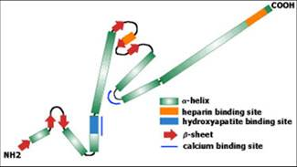
Figure 1.13: Secondary structure of OPN protein
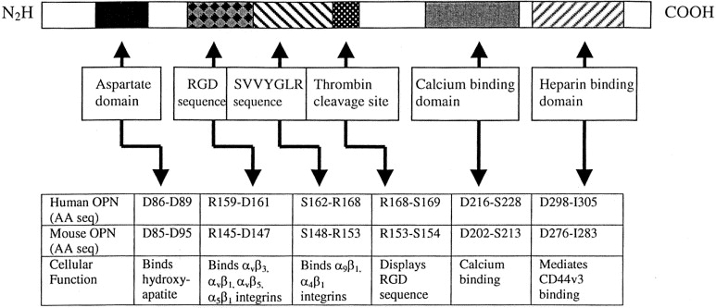
Figure 1.14: Structure of Osteopontin protein¹⁵²
The GRGDS sequence in exon 6 of human OPN contains a functional Arginine-Glycine-Asparate (RGD) binding domain. The RGD domain is present in many ECM proteins and ligates cell-surface α_{ν} β_{3,} α_{ν}β_{1,} α_{ν}β_{5,} and α₅β₁ integrins^{152, 165}. A hydroxyapatite binding sequence is represented by a run of several aspartate residues. There is a calcium binding domain and two heparin binding domains which may regulate interaction with RGD domain. A thrombin cleavage site resides six amino acids away from the RGD domain. It has been documented that thrombin cleaves OPN efficiently at this protease-hypersensitive site which generates two fragments of approximately equivalent 30kD size on SDS-PAGE and displays the integrin and CD44 binding domains^{173, 174}. Thrombin cleavage and phosphorylation of the N-terminal fragment are required for the efficient engagement of the integrin receptor by OPN which improve cell attachment and migration in comparison to uncleaved OPN^{175, 176}. Thrombin cleavage of human OPN uncovers the Serine-Valine-Valine-Tyrosine-Glycine-Leucine-Arginine(SVVYGLR) adhesion sequence and the SVVYGLR ligates the α₉β₁ integrin¹⁷⁷.

    - OPN functions

      - Apoptosis

It has been demonstrated that in interleukin(IL)-3-treated cells, OPN inhibited apoptosis predominantly through activation of the phosphatidylinositol 3-kinase/Akt pathway¹⁷⁸. Stimulation of PI3-kinase activity by OPN binding was shown to regulate activation of osteoclasts¹⁷⁹. It was also shown that soluble OPN inhibits apoptosis of adherent human umbilical vein endothelial cells (HUVEC) which grow in an environment without growth factor and cytokines. OPN was also found to inhibit DNA fragmentation and stimulate the expression of the anti-apoptotic protein Bcl-xl in these cells, which suggested that OPN facilitate the survival of stressed endothelial cells by suppressing integrin-mediated death.¹⁸⁰
A study on fibroblast survival found OPN protected cardiac fibroblasts from cell death and OPN-deficient cardiac fibroblasts undergo increased H(2)O(2)-induced cell death via caspase-3-independent pathway¹⁸¹. OPN was shown to confer a survival advantage in tumor cells, together with bone sialoprotein (BSP). The initial binding to alpha(v)beta(3) (α_{v}β3) integrin or CD44 on the cell surface promotes the sequestration of Factor H to cell surface, thus inhibiting the complement-mediated cell death¹⁸².
This data clearly indicate the function of OPN for inhibition of apoptosis in the promotion of neoplastic transformation¹⁸³ and the anti-apoptotic effects of OPN on endothelial cells are also well documented through NF-κB¹⁴⁵.

      - Invasion & metastasis

Cell migration and extracellular matrix invasion (ECM) are major steps in cancer cell metastasis. Matrix metalloproteinases (MMPs) degrade the extracellular matrix (ECM) and function in tumor invasion and metastasis.
It has been shown that OPN activates pro-MMP-2 via an NF-kappa-B mediated pathway during ECM invasion¹⁸⁴. OPN-induced invasion and migration of human mammary epithelial cells requires urokinase plasminogen activator (uPA)¹⁸⁵. The uPA system was found at high levels and uPA consistently predicts poor patient outcome in many cancers¹⁸⁶, such as human breast carcinoma and its bone metastasis¹⁸⁷.
OPN was also reported to induce phosphorylation and degradation of the inhibitor of nuclear factor Kappa B (I kappa B alpha) by activating I kappa B kinase (IKK), thus inducing the NK kappa b activity. Furthermore, by blocking the IKK/I kappa B alpha signaling pathways, curcumin potently suppressed OPN-induced cell migration, tumor growth, and NF kappa B-mediated pro-MMP-2 activation¹⁸⁸.
It was also shown that OPN induction of NF kappa B activity and uPA secretion was PI3’-kinase/Akt/iKK mediated¹⁸⁹.
It has been reported in prostate cancer that OPN regulates tumor growth by regulating cyclooxygenase-2 (COX-2). One study demonstrated that induction of COX-2 upregulates prostaglandin E(2) production and activates matrix metalloproteinase-2 (MMP-2) in response to the stimulation of OPN through the protein kinase C alpha/nuclear factor-inducing kinase/nuclear factor-kappa B-dependent signaling pathway¹⁹⁰. Meanwhile, in B16F10 cells, another matrix metalloproteinase, MMP-9, was reported to be activated by OPN through MAPK/IKKalpha/beta-dependent NIK/NFκB mediated pathway, thus regulating invasiveness¹⁹¹. Recent studies showed that OPN regulated MMP-2 and uPA activity via integrin-linked kinase (ILK) and AP-1 signaling pathway during tumor cell invasion¹⁹². The thrombin-cleaved OPN COOH-terminal fragment has been reported to bind with cyclophilin C or rotamase to the cell surface glycoprotein CD147, thus activating Akt1/2 and MMP-2, and enhancing the invasiveness of tumor cells¹⁹³.
All these studies indicate OPN activates MMP through several overlapping pathways¹⁴⁵.

      - Tumor cell migration

OPN-induced mammary epithelial cell (MEC) migration was shown to be integrin-dependent and associated with the increase of HGF receptor (Met) mRNA and protein expression and the Met kinase activity suggested OPN-regulated cell migration was hepatocyte growth factor (HGF)-dependent¹⁹⁴.
Later studies by the same research group showed OPN-induced migration of MEC was not only HGF-dependent but also epidermal growth factor (EGF) dependent. It was also associated with an increase of EGF receptor (EGFR) mRNA expression and EGFR tysosine kinase activity. ¹⁹⁵
Thus, OPN-induced MEC migration includes at least two growth factor/receptor pathways.
It was also reported that OPN-induced cell migration was ERK/MAPK dependent in B16 cells¹⁹⁶.

      - Inflammatory and immune response

OPN is involved in the inflammation and immune response¹⁹⁷. OPN secreted by activated T cells was expressed in a variety of inflammatory cells including T cells, dendritic cells(DCs), macrophages and NK cells¹⁹⁷⁻¹⁹⁹. It induced immune cells, particularly macrophages migrating to sites of inflammation¹⁹⁷. Dendritic cells (DCs) were consistently identified as central for T-cell-mediated immunity induction. OPN was found to play a promoting role in the migration of human DCs, activation myeloid-type DCs, augmenting the HLA-DR and adhesion molecules expression, thus promoting maturation of DC towards a T helper 1 (Th1)-promoting phenotype²⁰⁰. OPN was identified as a key cytokine for efficient type-1 immune responses as it was shown that OPN-integrin interaction induced IL-12 secretion while OPN-CD44 interaction suppressed macrophage IL-10 production²⁰¹.
Two strains of transgenic mice were designed and generated to analyze the role of OPN in immune responses and the results confirmed that OPN plays a vital role in the proliferation and differentiation of B1 cells, enhancing the generation of immunoglobulins²⁰².
Recent studies showed that OPN is also involved in the TLR9 dependent OPN-IFN-alpha pathway in cross-presentation in vitro and anti-herpes simplex virus 1 IFN-alpha response in vivo²⁰³.
Nitric oxide (NO) was believed to control blood flow, regulate salt and water balance, play a defending role against tumour cells and infectious microorganisms²⁰⁴. OPN was shown to serve as a defence against NO-mediated host cell cytotoxicity, augmenting the metastatic phenotype^{204, 205}.
Later work demonstrated that OPN inhibited the NO production by macrophage-like RAW264.7 cells and inhibited cytolytic activity of the activated macrophages toward NO-sensitive p815 mastocytoma cells, which suggested the tumour-cell-derived OPN protected the tumour cells from macrophage-mediated destruction²⁰⁶. Interestingly, OPN was also reported to protect tumour cells by interacting with factor H thus enabling cell evasion from complement-mediated cell lysis and opsonisation¹⁸².
However, LPS-induced NO synthesis resulted in feedback inhibition and it was evident that LPS-induced NO synthesis feedback depended on OPN status, thus down regulating iNOS expression²⁰⁷. The heterologous nuclear ribonuclear protein (hnRNP A/B) was identified as a critical NO-dependent trans-regulator of OPN expression in murine macrophages in this model system²⁰⁸.
Regulation of NO by OPN was associated with tumour metastasis and several recent studies have shown that it is modulated by tumour-host interactions. RNAi-mediated inhibition of OPN synthesis in CT26 cells resulted in an induction of macrophage iNOS expression, in the co-cultured CT26-RAW cells, which correlated with the inhibition of CT26 proliferation via increased apoptosis, indication that OPN may enhance tumour survival by inhibiting NO production in the local microenvironment²⁰⁹.

      - Neovascularization and angiogenesis

Angiogenesis, the formation of new blood vessels from the existing ones, is essential for tumor growth and metastasis¹⁵⁶.

        - OPN and potent angiogenesis factor VEGF

OPN was reported to be involved in the cooperative mechanisms for VPF/VEGF regulation of EC migration during angiogenesis, with the α_{ν}β₃ and thrombin cleavage of OPN together²¹⁰.
The roles of vascular endothelial growth factor (VEGF) and OPN in angiogenesis was studied and it was apparent that OPN induced endothelial cell migration and upregulated endothelial cell migration was induced by VEGF²¹¹. To clarify the cooperative role of VEGF and OPN in angiogenesis, 87 cases of stage I non-small cell lung cancer were detected by immunohistochemistry and it was found that microvessel counts was significantly higher in VEGF and OPN positive tumours. Furthermore, VEGF- and OPN- positive stage I lung adenocarcinoma was significantly related to poor patient survival time compared to others, which indicated that the cooperation of OPN is very important in VEGF-mediated tumour angiogenesis.²¹²
This evidence suggests an involvement of OPN in angiogenesis by upregulating endothelial cell migration in cooperation with VEGF. A further study in murine neuroblastoma cells showed that OPN really regulated the tumor angiogenesis but the OPN-induced neovacularization was independent of VEGF expression²¹³.

        - OPN and FGF-2

Angiogenic fibroblast growth factor-2 (FGF-2) upregulated OPN in the serum-deprived murine aortic endothelial (MAE) cells which suggested OPN-mediated recruitment of proangiogenic monocytes may represent a mechanism of amplification of FGF-2-induced neovascularization during tumor growth²¹⁴.

        - OPN and COX-2

Recently, OPN was reported as regulating the expression of COX-2 in prostate tumor growth. The activation of protein kinase C α/nuclear factor-inducing kinase/nuclear factor-κB-dependent signalling cascades stimulated by OPN induced COX-2 expression which in turn regulated several events including angiogenesis. The suppression of OPN-induced COX-2 expression or blocking of the EP2 receptor significantly inhibited cell motility, tumour growth and angiogenesis. Moreover, the OPN-induced mice PC-3 xenograft exhibited increased neovascularisation which was also supported by the human clinical prostate cancer specimen analysis. This data suggested OPN may act as a potential angiogenic factor in prostate cancer and blocking the action of OPN is a promising therapeutic approach to inhibit prostate tumour progression and angiogenesis.¹⁹⁰

        - OPN and NF-κB

Since OPN was identified as an angiogenic factor by promoting neovascularisation through integrin-mediated endothelial cell migration, prevention of endothelial cell apoptosis and vascular lumen formation^{145, 215}, and integrin-mediated endothelial cell survival was mediated by (via) NF-kB p65 and p50 activity, it was demonstrated that OPN and α_{ν}β₃ ligation rapidly increased NF-kB activity and OPN-induced NF-kB activation was dependent on the small GTP-binding protein Ras and the tyrosine kinase Src²¹⁶.

    - OPN in prostate cancer

Prostate cancer is one of the most life-threatening diseases for men worldwide.
OPN was found to contribute to prostate cancer progression²¹⁷. Messenger RNA blot analysis, immunohistochemistry and Western blot were performed to measure expression of OPN mRNA and protein respectively, in prostate cell lines and it has shown that antibodies against OPN inhibited the anchorage independent growth in prostate cancer cells (LNCaP and C4-2), which suggested OPN may act as a mediator of prostate cancer growth and progression²¹⁷.
Immunohistochemical staining was also examined in prostate tissues from 34 patients with primary prostate cancer and results showed enhanced OPN expressed in metastatic clinical specimens²¹⁸.
Enhanced OPN expression was also observed in the serum and plasma of patients with prostate cancer. Interestingly, from studies on clinical specimens and plasma OPN, it was reported that OPN expression showed a negative correlation with patient survival from the study on clinical specimens²¹⁸.
Anti-α_{ν}β₃ integrin antibody (LM609) was used to block the ability of OPN to trigger a Ca²⁺ transient in PC-3 cells which suggested that OPN was involved in progression of metastatic prostate cancer²¹⁹.
In addition, OPN was reported to induce the chemotaxis and chemoinvasion of PC-3 cells²²⁰.
A study of 2003, measure the level of OPN and BSP expression by immunohistochemistry on 12 breast cases and 9 prostate cases. Though it was limited by the small number of samples, it still showed that the divergent pattern of OPN/BSP expression could be a determinant to characterize bone metastasis of both malignancies.²²¹
OPN expression was also analysed in different prostate cell lines, such as LNCaP²²² and PC3²²³.
TRAnsgenis Mouse Prostate adenocarcinoma (TRAMP) mice was also studied on OPN expression in prostate cancer and by TRAMP testing, dietary genistein was shown to delay the malignant progression by inhibiting OPN expression²²⁴.
OPN was also investigated in comparison to other bone markers in prostate cancer patients and it was found that OPN, alone or in combination with bone metastasis, served as prognosticator for survival time in prostate cancer patients²²⁵.
OPN was associated with CD44 and MMP9 in migration of prostate cancer cells²²³. A similar result was obtained from the study in 2008 and the OPN/integrin α_{ν}β₃ signaling pathway was involved in the migration and invasion of PC3 cells via regulating the formation and function of invadopodia²²⁶.
Recently work has focused on the role of OPN-mediated MMP activation in prostate cancer progression. OPN was found to be significantly correlated to MMP9 and both were associated significantly with the enhanced ‘cell proliferation’ ‘genes constituting the phosphoinostide-3-kinase predictor’ ‘proliferation signature’ and ‘tumor metastasis’ gene sets. Similar results were also observed in patients. This computational and experimental data proved the OPN pathway plays a vital key role in prostate cancer progression²²⁷.

    - OPN and biomarker

OPN has been considered as one of the most promising biomarkers for various cancers. The correlation of elevated OPN expression, tumour malignancy and patient survival time has been studied in a variety of cancers.
A significant increase was observed in OPN plasma concentration in patients with metastatic disease compared with normal sera^{149, 228}. Histological analysis of tumour specimens showed that increased OPN expression was associated with tumour progression in cancers of breast²²⁹, stomach²³⁰, lung^{212, 231}, prostate²¹⁷, liver²³² and colon²³³.
Many studies have focused on OPN expression in breast cancer. In 1998, a series of 154, lymph node negative breast cancer patients were analyzed and demonstrated that elevated OPN expression was associated with poorer clinical outcome²²⁹. In 2002, it was shown that OPN-negative specimens correlated with a median survival of >228 months while OPN-positive specimens correlated with a median survival of 68 months from 333 patients with operable stage I and II breast cancer thus enforcing the prognostic significance of OPN inhuman breast cancer²³⁴.
Intense investigations have been performed on the practical application of plasma OPN biomarkers in clinical medicine. The plasma expression of OPN was examined in both patients with advanced disease and no disease or local/regional disease. These data demonstrated that elevated OPN levels could be sensitive and specific in predicting disease progression in various cancers as shown in Table 1.3¹⁴⁵.
Table 1.3 Studies using plasma OPN as a prognostic biomarker
Authors | Journal | Publication year | Cancer type | Number of patients with disease | Number and type of control patients | OPN levels (disease vs control; ng/ml)
Singhal et al. | Clinical Cancer Research | 1997 | Breast | 70 | 35 | 142 vs 47
Bramwell et al. | Clinical Cancer Research | 2006 | Breast | 157 | n/a | 177
Reiniger et al. | American Journal of Opthamology | 2006 | Uveal melanoma | 8 | 8, healthy | 170.72 vs 46.78
Wu et al. | Gut | 2007 | Gastric cancer | 132 | 93, healthy | 166.5 vs 55.6
Le et al. | Clinical Cancer Research | 2003 | Head and neck squamous cell cancer | 54 | 15, healthy | 447 vs 318
Kim et al. | American Journal of Gastroenterology | 2006 | Hepatocellular carcinoma | 62 | 60, healthy | 954 vs 155
Koopman et al. | Cancer Epimediology, Biomarkers & Prevention | 2004 | Pancreatic adenocarcinoma | 50 | 22, healthy | 482 vs 204
Ramankulov et al. | Journal of Cancer Research and Clinical Oncology | 2007 | Renal cell carcinoma | 80 | 52, healthy | 115 vs. 28.9 ug/l
Chang et al. | Lung Cancer | 2007 | Non-small cell lung cancer | 47, Stage IV | 32, stage 1 | 1,58.2 vs 86.2
Ramankulov et al. | The Prostate | 2007 | Prostate cancer | 28, Stage IV | 29, healthy | 1,723 vs 625 ug/l
Shimada et al. | Oncology | 2004 | Esophageal squamous cell cancer | 103 | n/a | >450 vs <450

Furthermore, elevated plasma OPN levels were found to be significantly associated with lower survival rates²³⁵. In the study on non-small cell lung cancer, stage was defined as the only independent factor influencing circulating levels of OPN²³⁶. In similar analyses on breast cancer, it was shown that measuring OPN levels over the course of breast metastasis enhanced the prognostic value, with an increase in OPN level > 250ng/ml being the strongest prognostic indicator for overall survival²³⁷.
These findings suggested that OPN may act as a biomarker and may have prognostic value during tumor progression.

CHAPTER TWO:
MATERIAL AND METHODS

CHAPTER TWO: MATERIAL AND METHODS

  - Materials

Reagents are identified in Appendix A. Buffers are located in Appendix B. Equipment lists can be found in Appendix C.

  - Methods

    - Cell culture

      - The cell lines

The cell lines used were all single-cell-cloned and their derivation and characterization is summarized in Table 2.1.
Table 2.1 Origins of the human prostate cell lines
Cell lines | Origin | Identity | Reference
PNT2 | Human prostate epithelium | Benign | ²³⁸
LNCaP | Left supraclavicular lymph node metastasis. | androgen-sensitive,  adherent epithelial | ²³⁹
DU145 | Brain metastasis. | Epithelial | ²⁴⁰
PC3 | Bone metastasis | Malignant, neoplastic cells of epithelial origin | ²⁴¹
PC3M | Selected from PC3 | Highly malignant,  Epithelial | ²⁴²

      - Routine culture of cells

All human prostate cells were grown in monolayer culture in RM (routine medium) in T125/T75 tissue culture flasks and maintained in a humidified incubator (model TC2323 CO₂ incubator, Borolabs) at 37℃ with 5% (v/v) CO₂. Growth medium was changed every 3-4 days.
Cells were passaged when ≥80% confluent, and subcultured at 1:10 fold. Medium was removed and the cells were washed with PBS. 2.5% Trypsin (w/v) in versene (T/E) was added, at 3ml/T75 flask or 5ml/T125 flask, to cover the cells and the cells were incubated at 37℃ for 2-5 min until the majority of cells were rounded or detached from the substratum. Equal volume of RM was then added to the cells to inactivate the T/E. Cells were transferred to a 25ml universal for centrifugation at 900 rpm for 3 min. The cell pellets were resuspended in a small volume of RM and aliquots were placed into flasks containing a suitable volume of RM.

      - Cell counts

Cell numbers were determined using a haemacytometer (Scientific Laboratory Supplies LTD). A cell suspension, obtained by Methods 2.1.1.2, was added to the haemacytometer. The mean of four squares was considered as ‘n’ and the number of cells in 1ml of suspension was ‘n’✕10⁴.

      - Freezing cells /cryopreservation

Cells were ready for freezing when they were approximately 70% confluent. Cells were detached (Method 2.2.1.2) and resuspended in PBS, and quantified (Methods 2.2.1.3). The cell suspension was centrifuged at 900rpm for 3 min, and the supernatant was discarded. The cell pellet was resuspended in an appropriate volume of FM (freezing medium) containing 10% DMSO to produce a final cell density of 1-1.5×10⁶ cells/ml and aliquot into1ml ampunts in cryotubes (Nunc). The cryotubes were placed in a Cryobox (Nalgene, UK) filled with isopropanol (IPA) and stored at -80℃ overnight before being transferred to liquid nitrogen. The Cryobox and the FM containing DMSO ensured a slow cooling rate of the cells at -1℃ per min which avoids formation of ice crystals in cells during freezing procedure.

      - Thawing cells/reanimation

Frozen cells were removed from liquid nitrogen and thawed quickly in a 37℃ water bath. The cells were transferred to a 25ml universal tube and resuspended in 10ml RM. The cell suspension was then centrifuged at 900rpm for 3 min and the supernatant was discarded. This is to remove all traces of the cryprotectanct DMSO which is toxic to cells when it is above 4℃. The pellet was resuspended in RM and the cell suspension was then transferred to a T75 tissue culture flask and RM was added to give a final suitable volume. Cells were maintained in the humidified incubator with 5% CO₂ at 37℃.

    - Culture of Transfected Cells

After transfection and selection, transfected cells were grown and maintained in the RSM (routine selective medium) in which G418 was added. All the culture methods (passaging, counting, freezing and thawing) were the same as non-transfected cells (Methods 2.1.1) but using RSM instead of RM.

    - Analysing protein expression in cell lines

Expression of protein was analyzed by Western blotting.
Western blotting is commonly performed using an anionic detergent (SDS). Dissociated proteins (individual polypeptide subunits) were loaded in a polyacrylamide gel electrophoretic system (PAGE) and were separated according to the size and charge ratio. The separated proteins were then transferred to the nitrocellulose membrane and probed using the specific antibodies.

      - Preparation of cellular extracts

Two methods were used for protein preparation, a simple lysis in 1×Sample Loading Buffer (1×SLB) and a quantified lysis using Cellytic M Cell Lysis Reagent followed by Bradford assay.

        - Using 1×SLB method

Cells were grown in 9cm dishes and treated as required. Medium was removed and the cells were washed twice with PBS and drained in a sterile situation to get rid of extra PBS. One millilitre boiled(≥95℃) 1×SLB was added to the cell monolayer and the dish was placed on a hot plate (Ori-Block 08-3, Techne) for 3 min. Cells were scraped from the dish using a rubber scraper and transferred to an 1.5ml microfuge tube before being passed through a 16 gauge needle for about 10 times. The protein-containing supernatant was then collected by centrifugation at 4℃ for 10 min. Protein lysates were stored at -80℃. The protein samples would be boiled for 10min, chilled on ice for 2 min and spun down before loading into the SDS gel.

        - Using Cellytic M Cell Lysis Reagent with Bradford assay

          - Using Cellytic M cell Lysis Reagent

Medium was removed and cells were washed and drained as described in Methods 2.2.3.1.1. One milllitre of Cellytic M reagent was added to cover the cell monolayer and the cells were incubated for 15 min on a shaker. Cells were collected using a cell scraper and the lysed cells were centrifuged at 13,000rpm for 20 min at 4℃, to pellet the cellular debris. The protein-containing supernatant was collected and could be stored at -80℃.

          - Bradford assay

The concentration of protein extracted using the method in 2.2.3.1.2.1 was measured using Bio-Rad protein assay (Dye reagent). A standard curve of concentration from 0.03125μg/μl to 1μg/μl BSA in PBS 50μl aliquots was prepared. Protein samples were also diluted for analysis, using appropriate volume of sample diluted to 50μl using PBS. One ml diluted Dye reagent was added to each sample, as well as to the BSA/PBS buffer and PBS blanks, and incubated for 15 min before measuring the absorbance at 595 nm (Multiskan).

          - Equalization of protein samples for loading

Protein samples were quantified before loading using methods descried above. Distilled water was added to samples to make sure an equal amount of total protein in all protein samples. After equalization, 5× sample loading buffer was added and the protein samples were boiled for 10 min, chilled on ice for 2 min and spin down before loading into the SDS gel.

      - SDS-PAGE

SDS-PAGE was carried out according to the published method²⁴³. SDS-PAGE was performed using 4% stacking gel and 9%, 12% or 15% resolving gels respectively, depending on the molecular size of the target protein, using a Bio-Rad mini protein gel system (Bio-rad) in 500 ml of 1× running buffer. The protein samples were electrophoresed at 120V for 15 min to reach the resolving gel and at 200V for 30-45 min according to the position of the dye front. The appropriate protein marker (Lonza) was used to estimate protein sizes.

      - Transfer of proteins from SDS gel to nitrocellulose membrane

Separated proteins were transferred from the polyacrylamide gel to a nitrocellulose membrane (Hybond-ECL, GE Healthcare) using the Trans-Blot electrophoric transfer system (Flowgen).
Six sheets of Whatman 3MM filter paper and the nitrocellulose membrane were cut according to the gel size and soaked in the 1×transfer buffer. After the SDS-gel electrophoresis, the SDS-gel was also soaked in the chilled 1×transfer buffer for 15 min. A filter paper/gel/membrane sandwich was then assembled in a cassette and the bubbles were squeezed out. The cassette was then placed into a tank containing chilled 1×transfer buffer. The transfer was undertaken at 100V for 2h at 4℃.

      - Coomassie blue and PONCEAU S staining

After transfer, the gel was stained with coomassie blue for an hour and washed with distilled water shaking slowly overnight, then dried using a vacuum gel-drier (Flowgen) at 70℃ for 3 h.
After transfer, the membrane was stained with 10% PONCEAU S solution for 3 min and washed with TBST for 10 min to visualize the protein bands.
Efficiency of the transfer can be assessed through both staining methods.

      - Immunoblotting for detection of protein expression

The membrane was incubated with 5 ml of 5% Protoblock for 1 h to prevent non-specific binding of the primary antibody. It was incubated with the primary antibody in an appropriate concentration (Table 2.2) at 4℃ overnight. The membrane was then washed 6 times for 5 min with 0.05% TBST and incubated with secondary antibody at appropriate concentration (Table 2.2) for 2 h at the room temperature. Blots were washed 6×5 min with 0.05% TBST again before ECL Advance (GE Healthcare) was performed at 1:1 mixture of reagents I and II. The membrane was incubated with ECL mixture for 1 min at room temperature. After gently discarding the surplus ECL detection reagent, the membrane was sealed in Saran wrap and exposed to the film (GE Healthcare) for a serial required times. The films were developed and fixed in the dark room.

      - Immunoblotting for detection of β-actin expression

Consistently-expressed β-actin antibody was performed to normalise any loading variation.
After target protein expression detection by ECL, the membrane was washed in 0.1% TBST, agitated overnight. Then the membrane was incubated in 5 ml of 5% Protoblock for 30 min before incubation with the β-actin antibody in a 1:5000 dilution for 30 min. This was followed by three washes with 0.1% TBST for 10 min each and then the secondary antibody was added and incubated for 30 min at room temperature in a 1:1000 dilution. Blots were washed 3×10 min with 0.1% TBST again and bound β-actin probes were visualised using the ECL detection system.
Several different antibodies were used to identify AGR2, S100A4, OPN and β-actin (Table 2.2). All antibodies were diluted in 5% Protoblock.
Table 2.2 Primary and secondary antibodies used in Western blot
Target protein | Primary Antibodies | Secondary antibodies
AGR2 | the affinity-purified, in-house rabbit polyclonal anti-human AGR2 1:500 | Polyclonal Swine Anti-Rabbit Immunoglobulins/HRP (Dako) 1:1000
S100A4 | Polyclonal Rabbit Anti-Human S100A4 (DakoCytomation) 1:500 | Polyclonal Swine Anti-Rabbit Immunoglobulins/HRP (DakoCytomation) 1:1000
OPN | MPIIIB10 ascites (OPN)  (Developmental Studies Hybridoma Bank) 1:200 | Polyclonal Rabbit Anti-Mouse Immunoglobulins/HRP (Dako) 1:1000
β-Actin | Monoclonal Anti-β-Actin (Sigma)  1:5000 | Polyclonal Rabbit Anti-Mouse Immunoglobulins/HRP (Dako) 1:1000

    - Protein expression in tissues
      - Human tissue samples
Human prostate tissues were an archival set with full treatment history held within Molecular Pathology Laboratory, Department of Pathology, University of Liverpool, UK.
Tissues were taken from 65 prostate adenocarcinoma patients with a mean age of 73 years and from 34 benign prostate hyperplastic (BPH) patients with a mean age of 67.5 years through trans-urethral resection of the prostate in the Royal Liverpool University Hospital during the 5-year period of 1995-2000. Seven normal prostate tissues were taken from road traffic accident victims (mean age 48 years) who did not have a history of any prostatic diseases.
The study was performed in accordance with the Medical Research Council guidelines and was approved by Liverpool Local Science Ethics Committee (project reference number: Ke: 02/019).

      - Sectioning of tissues

        - Preparation of APES((3-Aminopropyl)triethoxy-silane) coated slides

Glass slides were placed in a large metal racks and washed in 1% acid/alcohol solution for 30 minutes. The slides were then rinsed in running tap water for 15 minutes and dried in an incubator at 70℃ overnight. After cooling, the slides were placed in acetone for 10 minutes and transferred to 2% APES in acetone for 10 minutes. Following several washes with distilled water, the slides were dried overnight.

        - Sectioning of tissues with Microtome

The microtome (Microm) was cleaned with Para gard (Microm) and a new disposable blade fitted to the machine and the water bath was heated to 58℃.The paraffin-embedded tissue blocks were cooled on ice. Tissue sections were cut at 4μm thickness and placed onto labelled APES slides. Slides were dried overnight at 37℃.

      - Immunohistochemistry

Immunohistochemistry (IHC) is the process of localizing proteins in the cells of a tissue section exploiting the principle of antibodies binding specifically to antigens in biological tissues²⁴⁴.
Immunohistochemical staining is widely used in the diagnosis of abnormal cells such as those found in cancerous tumours. In our study, it was used to identify protein expression in human prostate tissues.
Sections were dewaxed in two washes of xylene (each 3 min 30 sec) and rinsed in Industrial Methylated Spirits (IMS) twice (each 30 sec) before being transferred into fresh H₂O₂ /methanol, in order to block endogenous peroxidase activity for 12 minutes. They were then rinsed in running tap water for 30 sec, and deionised water for 30 sec, the sections were placed in staining racks, and transferred to a pressure cooker filled with EDTA solution (pH7) for 3 min for AGR2 and S100A4 staining or without any pretreatment for OPN. Then all slides were racked into Sequenzer (Immunocytochemistry Staining Trays (Shandon UK)) and washed with Tris Buffered Saline (TBS) for 4 min. Then 100ul 5% BSA/TBS was applied to each section and then incubated with the primary antibody at an appropriate dilution for 1 hour and washed with TBS for 3 times (each 4 min). Bound antibodies were detected with 100μl of Labelled Polymer for each section for 30 minutes and washed in TBS for three times (each 4 min).To visualize the reaction, the samples were stained with DAB for 10 min, washed with distilled water for 4 min, briefly counterstained with Heamatoxylin solution for 2 min, rinsed in 0.5% Acid/alcohol, washed with water and briefly rinsed in Scott’s Tap water until the blue colour appeared on the slides. Sections were dehydrated through four rinses of IMS and cleaned in 3 washes of xylene and mounted in DPX (Bios, Lancashire, UK).
All tissue sections were examined independently under the microscope by two qualified pathologist and classified by Gleason Grade.
Several different antibodies were used in IHC to identify AGR2, S100A4, and OPN in tissues shown as Table 2.3.
Table 2.3 Antibodies used in IHC
Target protein | Primary Antibodies | dilution
AGR2 | the affinity-purified, in-house rabbit polyclonal anti-human AGR2 | 1:500
S100A4 | Polyclonal Rabbit Anti-Human S100A4 (DakoCytomation) | 1:500
OPN | MPIIIB10 ascites (OPN)  (Developmental Studies Hybridoma Bank) | 1:250

    - RNA interference

      - RNAi

RNAi (RNA interference) is a process of mRNA cleavage and degradation that is induced by double stranded RNA in a sequence-specific manner.
dsRNA
siRNA
RISC
Target mRNA
Dicer cleavage
Guide strand assembling
Cleavage
Figure 2.1 RNAi process

      - Three different ways of RNAi
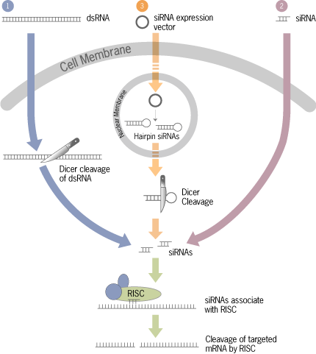
Figure 2.2 Three ways to trigger the RNAi pathway²⁴⁵

      - RNAi of Vector-based approach

The pSilencerTM 4.1-CMV neo vector (Ambion) was chosen to perform the vector-based approach for RNAi. It has three advantages (Fig 2.3): First, it has an ampicillin resistant gene which enables the transformed bacteria to be differentiated from non transformed bacteria in an ampicillin-rich growth environment. Second, it has a neomycin resistance gene to enable antibiotic selection of transfected cells by killing cells that lack this plasmid in a growth medium containing neomycin. Third, it facilitates directional cloning by being linearized with both BamH1 and HindIII restriction enzymes.
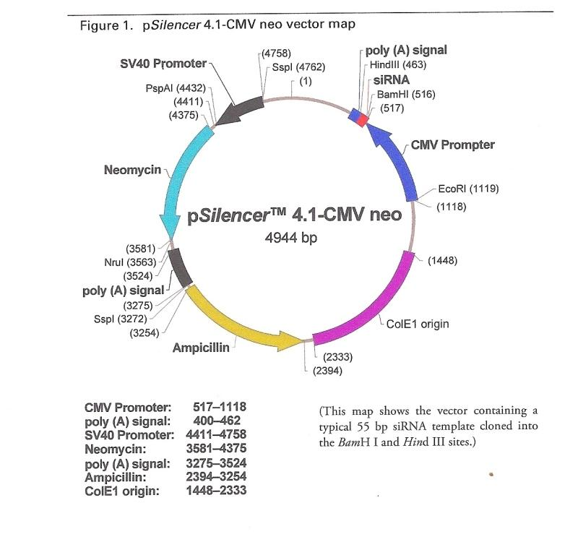

Figure 2.3: pSilencerTM 4.1-CMV neo vector.
(From Ambion pSilencerTM 4.1-CMV neo kit instruction manual)

annealing
sense oligos
antisense oligos
ligation
transformation
E.coli
Mammalian cells
plasmid
selection
transfection

Figure 2.4: Vector-based approach flow chart

        - Designing siRNA silencing Construct

Using Ambion’s siRNA target finders in Design Tool, three target sequences were chosen and confirmed by blast searching to ensure it has high specificity only to these target genes. For S100A4, target sequence numbers 7, 11 and 19 (Table 2.4) were chosen for further investigation. And for OPN, target sequence numbers 1, 18 and 47 (Table 2.4) were chosen for the further investigation. The vector used in the experiment, pSilencerTM 4.1-CMV neo vector, was specified in the design tool. Sense and antisense oligonucleotides of 55 base pairs were designed and ordered from Invitrogen.
Table 2.4: S100A4 and OPN target sequence and their siRNA silencing constructs.
 | Target sequence | Silencing construct (Oligos)
S100A4 | S100A4-7:  5’-AACAAGTCAGAGCTAAAGGAG-3’ | Sense:  5’-GATCC CAAGTCAGAGCTAAAGGAGTTCAAGAGACTCCTTTAGCTCTGACTTGTT A-3’
S100A4 | S100A4-7:  5’-AACAAGTCAGAGCTAAAGGAG-3’ | Antisense:  5’-AGCTT AACAAGTCAGAGCTAAAGGAGTCTCTTGAACTCCTTTAGCTCTGACTTG G-3’
S100A4 | S100A4-11:  5’-AAGGACAGATGAAGCTGCTTT-3’ | Sense:  5’-GATCC GGACAGATGAAGCTGCTTTCTCAAGAGAAAAGCAGCTTCATCTGTCCTT A-3’
S100A4 | S100A4-11:  5’-AAGGACAGATGAAGCTGCTTT-3’ | Antisense:  5’-AGCTT AAGGACAGATGAAGCTGCTTTTCTCTTGAGAAAGCAGCTTCATCTGTCC G-3’
S100A4 | S100A4-19:  5’-AATTCTTTGAAGGCTTCCCAG-3’ | Sense:  5’-GATCC TTCTTTGAAGGCTTCCCAGTTCAAGAGACTGGGAAGCCTTCAAAGAATT A-3’
S100A4 | S100A4-19:  5’-AATTCTTTGAAGGCTTCCCAG-3’ | Antisence:  5’-AGCTT AATTCTTTGAAGGCTTCCCAGTCTCTTGAACTGGGAAGCCTTCAAAGAA G-3’
OPN | OPN-1:  5’-AAATTCTGGGAGGGCTTGGTT-3’ | Sense:  5’-GATCC  ATTCTGGGAGGGCTTGGTTTTCAAGAGAAACCAAGCCCTCCCAGAATTT A-3’  (AUUCUGGGAGGGCUUGGUUUU)
OPN | OPN-1:  5’-AAATTCTGGGAGGGCTTGGTT-3’ | Antisense:  5’-AGCTT  AAATTCTGGGAGGGCTTGGTTTCTCTTGAAAACCAAGCCCTCCCAGAAT G-3’  (AACCAAGCCCUCCCAGAAUUU)
OPN | OPN-18:  5’-AAGTCCAACGAAAGCCATGAC-3’ | Sense:  (GUCCAACGAAAGCCAUGACUU)
OPN | OPN-18:  5’-AAGTCCAACGAAAGCCATGAC-3’ | Antisense:  (GUCAUGGCUUUCGUUGGACUU)
OPN | OPN-47:  5’-AAGATATGCTGGTTGTAGACC-3’ | Sense:  (GAUAUGCUGGUUGUAGACCUU)
OPN | OPN-47:  5’-AAGATATGCTGGTTGTAGACC-3’ | Antisense:  (GGUCUACAACCAGCAUAUCUU)

        - Cloning hairpin siRNA into vector

          - Annealing sense and antisense oligos

Oligos were dissolved and diluted to 1μg/μl in TE buffer. For every construct, 2μl sense oligo was mixed with 2μl antisense oligo in 46μl 1×DNA annealing solution. The mixture was heated at 90℃ for 3 min, cooled at 37℃ and incubated for 1 hr at 37℃. Annealed inserts were stored at -20℃.

          - Preparation of competent cells

Competent DH5α E.Coli bacteria cells were prepared from stocks for cloning experiments. The DH5α glycerol stocks were streaked onto LB-agar plates and incubated at 37℃ overnight. After 24 hours, a single colony was picked into an individual flask containing 10ml LB medium and incubated overnight at 37℃ with shaking at 225rpm. After overnight incubation, 1ml of culture was added into 100ml of SOB medium containing 1ml Mg²⁺ salts and incubated at 37℃ with shaking at 225 rpm. After 90 min, the OD was checked at 550nm using SOB as a blank and then checked at regular intervals. When the OD reached 0.4, the culture was divided equally into 8 universals and chilled on ice for 10 min. The cells were pelleted by centrifugation at 2500 rpm for 10 min at 4℃ and the supernatant was discarded. Pellets were resuspended in 66 ml of cold RF1 buffer (RF1 calcium chloride/glycerol buffer) followed by chilling on ice for 10 min and centrifugation for a further 10 min at 2500 rpm at 4℃. The supernatant was discarded and pellets resuspended in a total of 16ml RF2 buffer (RF2 calcium chloride/glycerol buffer) and pooled. The cell mixture was then divided into 1 ml aliquots in cryovials, flash frozen in liquid nitrogen and stored in -80℃.

          - Ligation of silencing inserts into pSilencer plasmid

The pSilencerTM 4.1-CMV plasmids were supplied linearlized and ligation-ready. The silencing inserts obtained from the 2 annealled RNAi oligos (Methods 2.2.5.3.2.1) were diluted to a final concentration of 8ng/μl with nuclease-free water. Four 10μl ligation reactions (three with the annealed siRNA inserts, one with the annealing solution as negative control) were set up as follows:
Reaction 1 | Reaction 2 | Reaction 3 | Negative control reaction
1µl diluted annealed siRNA insert 1 | 1µl diluted annealed siRNA insert 2 | 1µl diluted annealed s4iRNA insert 3 | 1µl 1×DNA annealing solution
1μl pSilencerTM 4.1-CMV neo vector
1μl T4 DNA ligase
1μl 10 × T4 DNA Ligase Buffer
6μl nuclease-free water

Ligation reactions were incubated at 16℃ overnight.

          - Transformation

Three microlitres of each ligated plasmid was added to 200μl of competent DH5α cells and incubated on ice for 30 min. A falcon tube containing only DH5α competent cells was used as a negative control. All reactions were transferred into 42℃ water bath for exact 90 sec, and placed on ice for 2 min. Eight hundred microlitre of freshly made SOC medium was preheated to 42℃ and added to each reaction then incubated at 37 ℃ for an hour with shaking at 225 rpm. The transformation reaction was then plated onto LB-amp agar plates each containing 100μg/ml ampicillin and incubated overnight at 37℃. Following incubation, colonies were picked and grown in10ml LB amp medium each at 37℃ with shaking at 225 rpm overnight. Plasmids were then extracted using the Qiagen Plasmid mini-preparation kit (see below). Plasmid midi-preparation could also be performed when transferring 1ml of the overnight 10ml culture into 100ml LB-amp medium and grow for another 4 hours at 37℃ with shaking at 225 rpm. To ensure the optimal plasmid extraction, cell growth should be stopped when OD₅₅₀ reached 1-1.3.

          - Mini and midi preparation of plasmid DNA

Plasmid DNA extraction was conducted using a Qiagen plasmid preparation kits. Preparation of up to 20μg of plasmid was performed using the Qiagen plasmid Mini Kit while preparation of 20μg to 100μg was made using the Qiagen Plasmid Midi Kit.

            - Miniprep DNA extraction

Five millimitres of overnight culture was pelleted by centrifugation at 6000g for 15 min at 4℃ and the supernatant was discarded. The pellets were collected and transferred to a 1.5 ml microfuge tube and resuspended in 250μl of Buffer P1. Buffer P2 (250μl) was then added and mixed by gently inverting 4-6 times. The mixture was incubated at room temperature for 5 min. Chilled Buffer N3 (350μl) was added and mixed immediately and thoroughly by inverting 4-6 times. At this point the solution becomes cloudy in colour. This was then centrifuged at 13,000rpm for 10 min and the supernatant containing plasmid DNA was applied to a miniprep column Qiagen-tip 20. It was centrifuged at maximum speed for 1 min and the flow through was discarded. The column was washed by adding 750µl Buffer PE and centrifuged for 1 min again. The flow-through was also discarded and the column was centrifuged again for an additional 1 min to remove residual wash buffer. The column was put in a clean 1.5ml microfuge tube and 50µl Buffer EB was added and allowed to stand for 1 min. DNA was eluted by centrifuging for 1min at 13,000rpm.

            - Midiprep DNA extraction
Approximately 100-200mls of bacterial cell culture was harvested by centrifugation at 6000g for 15 min at 4℃ and the pellet resuspended in 4ml of Buffer P1 followed by 4ml Buffer P2, mixed by inverting 4-6 times and incubated at room temperature for 5 min. After incubation, 4ml of chilled Buffer P3 was added, mixed immediately by inverting 4-6 times and incubated on ice for 15 min before centrifugation at maximum speed for 30 min at 4 ℃. Meanwhile, the midiprep column Qiagen-tip 100 was equilibrated by applying 4ml Buffer QBT and allowed to flow through under gravity. The supernatant containing DNA from the previous centrifugation was applied to the equilibrated column and allowed to enter the resin by gravity flow. The column was then washed twice with 10 ml Buffer QC. The DNA was eluted from the resin with 5 ml of Buffer QF and precipitated with 3.5 ml isopropanol. The mixture was then centrifuged at maximum speed for 30 min at 4℃ and the pellet resuspended in 2ml of 70% ethanol and centrifuged at maximum speed for a further 10 min. The supernatant was decanted carefully so as not to disrupt the pellet which was then air-dried for 5-10 min. The DNA was dissolved in 50μl TE buffer (pH8.0). Extracted DNA was stored at -20 ℃.

          - Double digestion of DNA products

The plasmid DNA was double digested by BamHI and HindIII to confirm the presence of the siRNA inserts. The reaction mixture was prepared as follow: 2μg of plasmid DNA, 0.9μl BamHI, 0.9μl HindIII, 2μl10×Buffer 2, 2μl 10×BSA and made up 20μl with distilled water. The mixture was incubated at 37℃ for one hour to allow digestion. Four microlitres of 6× DNA loading buffer was added and the enzyme was inactivated by heating at 65℃ for 10 min. The reaction was examined following agarose gel electrophoresis (see section 2.2.5.3.2.7) to confirm the complete digestion.

          - Agarose gel electrophoresis

A 0.8% agarose was prepared by dissolving 0.8 g of agarose in 100ml of 0.5×TBE buffer using heat and then cooling to 50 ℃. Ten microlitres of a 5mg/ml ethidium bromide (EB) was added for visualisation and the gel was poured and allowed to set. DNA samples were prepared as above and loaded onto the gel with DNA molecular weight marker and the plasmid DNA without digestion was loaded as a control. The gel was run at 80V for an hour in 0.5×TBE buffer and was visualised under UV light and subjected to densitometry for quantification.

          - Sequencing analysis

The sequence analysis was conducted by using the internal pSilencer 4.1-CMV neo sequence primer to sequence the cloning site of the plasmid. Plasmid DNAs were sent for sequencing to Cogenics Lark Inc. The results were analysed using BIOEDIT sequence visualisation software.

        - Transient and stable transfection

Ambion’s siPORT XP-1 transfection agent was used to perform both the transient transfection and the stable transfection.
Cells were plated at 2×10⁵/dish in the RM approximately 24 hours before the transfection, to reach the confluency of 30-60%. For each dish: 2μl of siPORT XP-1 reagent was diluted into Opti-MEM I medium (Gibco) to a final volume of 100μl. After thorough mixing, the diluted reagent was incubated at room temperature for 15 min. Then, 1μg DNA construct was added into the diluted reagent and mixed by gently flicking the tube. The siPORT XP-1/DNA complex was incubated at room temperature for 15 min. After adjusting the volume of RM for cells, the siPORT XP-1/DNA complex was overlaid dropwise onto the cells. The dishes were gently rocked back and forth to evenly distribute the complexes. Dishes were incubated for 24, 48, 72 hours respectively in the normal cell culture conditions. Scrambled RNA insert was also transfected in a separate reaction as negative control. Protein was exacted from the cells harvested in different time points and the target gene activity was assessed as described in Methods 2.2.3. The most efficient DNA was selected for stable transfection in the most appropriate incubation time.

        - Selection

After the most appropriate incubation time, RSM containing 0.1% G418 was used to replace the RM. RSM was changed every three days for both parental and transfectant cells. Geneticin (G418 sulphate) is a selective antibiotic which blocks polypeptide synthesis by inhibiting protein elongation; resistance is conferred by the presence of a resistant gene in the transfection vector. Thus unsuccessfully transfected cells were killed by G418; and the successfully transfected cells were survived in the RSM.

        - Ring cloning of transfected cells

The transfected cells were distributed into several bigger dishes at a low density so that each cell can grow and form an individual colony.
After colonies were formed, ring cloning was performed to obtain several separate colonies. For this, the tops of 1ml pipette tips were cut to gain the ‘rings’ and using silicone grease to isolate colonies. Eighty microlitres of T/E was added to the isolated colonies and incubated for 2 min until the cells were detached or rounded. The detached cells were then transferred into the prepared wells containing larger amount of RSM. Since the T/E used was a small volume and also at a dilute concentration, there was no need to precipitate the cells using centrifugations. The medium was changed the next day and the colonies were grown in the RSM in the normal cell culture condition.

    - In vitro assays

      - Soft Agar Assay

Growth of cells in soft agar is one of the hall mark characteristics of cellular transformation and uncontrolled cell growth. The more malignant a tumour cell, the greater the ability to form colonies of cells. Soft agar assay was performed to test the tumorgenecity or the ability for cells to form tumours in vitro. In this experiment, parental cells and the siRNA transfectant cells were cultured in soft agar to determine their ability to form colonies.
Two percent low melting point agarose (LMA) gel was prepared and incubated in a water bath at 37 ºC and the RM and RSM were warmed in water bath at 37 ºC as well. Mixture I (MI) was made from 2% LMA mixed with equal amount of RM for parental cells while Mixture II (MII) was made from 2% LMA mixed with equal amount of RSM for control Scrambled RNAi cells and transfectant cells. MI and MII were plated at 1ml per well in a 6-well plate and the whole plate was placed at 4℃ for about 15 min to solidify the basement gel layer. Parental cells, scrambled RNA control and S100A4/OPN-knocking down transfectant cells harvested and adjusted with MI or MII to 3×10³ cells/ml, were plated on top of the preset basement gel layer, and placed at 4 ℃ for 10 minutes for solidification. Once the top layer of gel was set, the 6-well plates were incubated at 37℃ in a humidified atmosphere of 5% CO2 in an incubator. After 8 weeks incubation, all soft agar gels were stained with 2% MTT for 4 hours. Plates were scanned and the colonies formed were counted using the Gel Count (Oxford Optronix, UK).

      - Proliferation Assay

The increased proliferation ability of cells is also hallmark characteristic in cancer malignancy. Malignant cells grow in a more aggressive way. The proliferation assay was carried out to check the growth ability of cells.

        - Standard curve preparation

All cells were harvested when cultured to 80% confluent. Cells were counted using a haemocytometer and adjusted to 2×10⁵ cells/ml. A standard curve was prepared in a serial dilution: cells of 2×10⁵ cells/ml were set as D1. The final serial dilution was: D1 (2×10⁵ cells/ml); D2 (1×10⁵ cells/ml); D3 (5×10⁴ cells/ml); D4 (2.5×10⁴ cells/ml); D5 (1.25×10⁴ cells/ml); D6 (6.25×10³ cells/ml); D7 (3.125×10³ cells/ml). Two hundred microlitres of each cell line from D1-D7 was loaded to 96-well plate which produced cell numbers of each 200μl: d1 40000 cells; d2 20000 cells; d3 10000 cells; d4 5000 cells; d5 2500 cells; d6 1250 cells; d7 625 cells. Each cell line’s standard curve was set as duplicate and the plate was incubated at 37 ℃ and 5% CO2 overnight.

        - Proliferation assay

Each cell line was harvested and counted with a haemocytometer, and adjusted to a density of 1×10⁴ cells/ml. Two hundred microlitres of each cell line was plated in triplicate in a 96-well plate to make 2×10³ cells/well. The proliferation assay was run for 6 days, so 6×96-well plates were seeded to enable measurements on each experimental day. All plates were incubated at 37℃ and 5% CO₂.

        - Determination of cell numbers by MTT

MTT (3-(4, 5-Dimethylthiazol-2-yl)-2, 5-diphenyltetrazolium bromide, a tetrazole) is a chemical which can enter into the mitochondrion of the cell. It is converted by oxidative enzymes into a soluble blue dye known as formazan which forms blue crystals in the cell cytoplasm. Addition of DMSO causes the Formazan crystal to dissolve and the depth of the blue solution obtained is directly proportional to the number of cells present. Optical density of the dye will be measured at 595nm. A standard curve can be established by plotting OD against cell density. The experimental cell density would then be determined through the standard curve.
Fifty microlitres MTT solution (5mg/ml) was added to each well of cells, and the plates were incubated at 37 ℃ for 4 hours. After incubation with MTT for 4 hours, 200μl medium was removed from each well. DMSO was then loaded to cells at 200μl per well and incubated for 10 minutes. An empty well in the plate was added with 200μl DMSO to act as a Blank. The optical density of each well was then measured at 595nm using the Multiskan MS plate reader (Labsystems, Finland). A standard curve of the optical absorbance against known cell numbers was constructed. Optical absorbance values obtained for the proliferation assays were converted into cell numbers per well by regression analysis.

      - Invasion assay

Invasiveness is a very important feature, distinguishing benign from malignant lesions. Tumour cells, when establishing colonies at secondary sites, must move through tissue boundaries that normal cells do not cross. Invasiveness and motility are indicative of tumor malignancy.
An invasion assay was performed to test the invasiveness of cells as follow:
Cells were passaged 48 hours prior to setting up the plate (60% confluent). Serum-free media (SFI and SFII) with 0.01% BSA were prepared and sterilized. Geneticin was added in SFII for transfectant cells. Cells were incubated in SFI/SFII at 37 ºC for 24 hours prior to setting up the plates. Matrigel (BD Biosciences) solution was defrosted and prepared in a 1:25 dilution. Inserts (Scientific Laboratory Supplies Ltd) were placed in a 24-well plate. One hundred microlitres of matrigel was loaded to each insert. Plates were then incubated at 37℃ for two hours to solidify the Matrigel in the chamber. Cells were harvested and adjusted with SFI or SFII to 8×10⁵ cells/ml. Then 2×10⁵ cells in 250μl medium were loaded to every upper compartment of chamber while RM (within the 10 %( v/v) FBS) was placed 1ml per well to the lower compartment. Meanwhile, negative controls for each cell line was set up with SFI and SFII loaded 1ml per well in the lower compartment of chamber. All cell lines were set as triplicate and the assay run for 24 hours in the incubator at 37 ºC. After 24 hours incubation, inserts were taken out and gently washed in PBS for three times followed by wiping the upper side of filter with a cotton bud to remove any non-invading cells. Invaded cells on the lower side of the filter were fixed and stained by Crystal Violet (CV) for 10mins. After several washes with water, cells were left at 37 ºC overnight to dry. The number of the stained cells on the lower side of the chamber was then observed and counted using the microscope (Leitz, labovert, Luton, UK) at ×125 magnification (graticule required). The photomicrographs were taken at 100× magnification using an Olympus digital camera (Olympus C-3030 zoom).

      - Motility assay

Cells, medium, experimental condition and analysis were similar to those of the invasion assay except no Matrigel were needed. Serum-free medium (SFI and SFII) with 0.01% BSA were prepared and sterilized. Geneticin was added in SFII for transfectant cells. Cells were incubated in SFI or SFII at 37℃ for 24 hours prior to setting up the plates. Inserts (Scientific Laboratory Supplies Ltd) were placed in a 24-well plate. Cells were harvested and adjusted with SFI or SFII to 4×10⁵ cells/ml. Then 1×10⁵ cells in 250μl medium were loaded to every upper compartment of chamber while the RM (within the 10 %( v/v) FBS) was placed 1ml per well to the lower compartment. Negative controls for each cell line were also included with SFI / SFII loaded 1ml per well in the lower compartment of chamber. All cell lines were examined in triplicate and the assay allowed running for 24 hours in the incubator at 37 ℃. After 24 hours incubation, inserts were taken out and gently washed in PBS for three times followed by wiping the upper side of filter with a cotton bud to remove any immotile cells. Motile cells on the lower side of the filter were fixed and stained by CV for 10mins. After washing excess water was removed by gently tapping and the cells left at 37℃ overnight to dry. The number of the stained cells on the lower side of the chamber was then observed and counted using the microscope (Leitz, Labovert, Luton, UK) at 125×magnification (graticule required). The photomicrographs were taken at 100×magnification using an Olympus digital camera (Olympus C-3030 zoom).

    - In vivo assay

This assay was performed to investigate the effect of silencing S100A4 or OPN in tumorgenecity in vivo.

      - Mice and cell lines

All animal work was conducted according to UKCCCR guidelines under Home Office project licence PPL40/2270 to Prof Y Ke and the personal licence (PIL40/8714) to Y Zhang.
Six to eight week-old male Balb/c nude mice were purchased from Charles River Laboratories. Their body weights were measured on arrival and ranged from 18-20g. The mice were divided into five groups (eight per group) and maintained in a single room equipped to the required environment in the University Biomedical Service building.
The following five cell lines were tested in the five groups of mice at the same time:
Group 1: control cells
Group 2: OPN-moderately-suppressed transfectant ODC4
Group 3: OPN-highly-suppressed transfectant ODC10
Group 4: S100A4-highly-suppressed transfectant SDC2
Group 5: S100A4-moderately-suppressed transfectant SDC11

      - Inoculation of mice

After a week of quarantine, each mouse was inoculated with a single subcutaneous injection of cells.
On the day of the inoculation, all cells (control cells, ODC10, ODC4, SDC2, and SDC11) were harvested and counted. Cells were washed with PBS twice to remove serum and then resuspended in PBS at a concentration of 2×10⁷ cells/ml. An equal volume of thawed Matrigel was added to the cells and mixed well. The cell suspensions were kept on ice to prevent gelling. Each mouse was given a subcutaneous injection on the right shoulder region of 200ul suspension containing 2×10⁶ cells for each cell line. Tumours appeared approximtely a week after inoculation. Body weight and the tumor size were measured twice a week using a calliper. Tumor volume was calculated by the formula 0.5236× (length) ×(width) × (height) ²⁴⁶. The animals were followed for 4 weeks, or until the tumours reached 17mm in one dimension, when the mice were sacrificed. At autopsy, dissections were performed to remove primary tumor tissue (where available), lungs, liver, kidneys and pancreas and these were placed in 10% formalin tissue fixation. At autopsy, primary tumours were divided to three pieces, one was fixed in 10% formalin, and one was snap frozen to the liquid nitrogen for protein and RNA testing. Another piece was kept in PBS and used for primary culture.

      - Processing of tumor and tissue from mice

The primary tumor tissue and other body tissues from sacrificed mice were fixed in 10% formalin for at least 24 hours. The fixed tissues were trimmed and placed within embedding cassettes and processed on a Shandon processor. The tissues were then washed for 1 hour in 70% ethanol, 1 hour in 90% ethanol, 4×1 hour in absolute ethanol, 3×1 hour in xylene and 2×1.5 hour in paraffin wax 60ºC and then, the processed tissues were embedded in paraffin wax and cooled on ice. Paraffin embedded tissues were cut into 4μm sections as described in Methods 2.2.4.2.2 and stained for the detection of OPN and S100A4 as described in Methods 2.2.4.3.

      - Detection of OPN and S100A4 protein in mice tissues

Detection of OPN and S100A4 was performed on tumor and other tissue sections using the same methodology as described in Methods 2.2.4.3. Primary anti-OPN and anti-S100A4 antibodies were used at a dilution of 1:250 and 1:500 respectively.

      - Extraction of protein from the tissue and Western Blot analysis

The snap frozen tumor tissues were defrost on ice for 1 hour and tissues were cut into small pieces and put in the microfuge tubes filled with 500µl Cellytic-M. The tissues in each tube were sonicated at 4×10 sec in 100% power (Bandelin, Berlin). During this procedure, samples were kept on ice to avoid damaging protein with high temperature. After sonication, samples were centrifuged at the max speed for 30 min and the supernatant containing the protein was transferred to a new microfuge tube and proteinase inhibitor was added to each protein at 10μl/ml. The pellets of the tissues were kept in the -80℃. Western blotting was performed to test the OPN and S100A4 protein expression as described in Methods 2.2 3.

      - Primary tumor cell culture

Parts of the tumor tissues from mice were incubated in PBS at 37 ºC for 1 hour and cut into small pieces using a sterile scalpel blade. The tumor tissues were collected in PBS and centrifuged at 900rpm for 4 min to collect the pellets. The supernatants were discarded and 5-10ml T/E was added to the pellets for 6 min at 37 ºC. The supernatants were removed carefully and 10 ml fresh RM were added to the pellets and gently but thoroughly mixed. The mixture was plated onto 9cm dishes and maintained in the normal culture condition. To remove tissue debris extracted from the tumor tissues, the RM was changed after 24 hours while the tumor tissues were kept on the surfaces carefully. RM was changed again after 48 hours. Microscopic examination showed the medium was much clearer and there was evidence of cell growth on the dishes. When the cells started to make colonies after 3 days, the tumor tissues were removed from the dishes carefully using pipette.

    - Statistic analysis

Statistical analyses were performed using the SPSS package, version 13.0 (SPSS Inc., Chicago, IL, USA).

      - Student’s t test

In this study, the student’s t test was used to compare differences observed within the experimental groups and control groups. Data from the proliferation assay, invasion and motility assay, and soft agar assay were all assessed using student’s t test. In vivo experiments, tumor incidence and tumor volume were also compared statistically using Student’s t test. And for all calculations, a value of P<0.05 was used to define the statistical significance.

      - Survival analysis

        - Kaplan Meier curve

To evaluate the correlation between patients’ survival and AGR2 expression/S100A4 expression/OPN expression, PSA level, AR expression, Gleason scores in prostate carcinoma, Kaplan-Meier method was used.

        - Log Rank

Log rank was used to assess the differences of survival probability between different patients groups as described immunohistochemically.

      - Chi-square

Chi-Square was used to compare the difference shown in the immunohistochemical staining between the normal, BPH and carcinoma samples and also the carcinoma samples with different GS, GS<5, GS6-7, GS8-10 samples. For all calculations, a value of p<0.05 was used to define the statistical significance.

      - Two-sided Fisher’s exact test

Two-sided Fisher’s exact test is the simple and more accurate way to examine the significance of the association between the two kinds of classification. It is used when the sample sizes are small while Chi-square is used with the large samples. Here it was used to assess the association between the AGR2 expression and the nature of the prostate tissues (normal, benign and malignant). A value of p<0.05 was used to define the statistical significance.

      - Mann-Whitney U

Box plot and Mann-Whitney U test were used to assess the correlation between AGR2 and PSA level, AGR2 and AR, PSA levels and Gleason scores.

CHAPTER THREE:
Result 1- Anterior gradient-2 (AGR2)

CHAPTER THREE: Result 1- Anterior gradient-2 (AGR2)

  - AGR2 expression in prostate cell lines

Western blot analysis detected a single AGR2 band with a size of 20kD in the benign PNT2 cell line and in highly malignant cell lines, PC3 and PC3M (Fig 3.1A). The detailed quantitative measurements of relative AGR2 levels expressed in different cell lines were shown in Fig 3.1B. When the level of AGR2 expressed in the PNT2 cells was set at 1.0, the relative levels of AGR2 in the malignant cell lines PC3 and PC3M were 5.29±0.14 and 3.81±0.23, respectively. No AGR2 protein was detected in the weakly malignant cell line LNCaP and highly malignant DU145.

  - AGR2 expression in prostate tissues

Examples of immunohistochemical stains of different prostate tissues with rabbit polyclonal anti-human AGR2 antibody were shown in Fig 3.2. In normal prostate gland as shown in Fig 3.2A, AGR2 staining was localized predominantly to the cytoplasm of luminal cells of prostate glands, whereas in the prostate carcinomas (Fig 3.2C-E), both cytoplasmic and nuclear stains were observed. It showed the negative or weakly staining in normal prostate (Fig 3.2A) and BPH (Fig 3.2B). As represented in Fig 3.2C-E, it stained from moderately to strongly with the increasing malignancy of the carcinoma tissues. And in Fig 3.2F, a strongly stain was observed in a malignant carcinoma (large arrow) while it was negative in the adjacent benign areas (small arrow) within the same tissue sample. When the antibody was neutralized with the recombinant AGR2 protein, the stain was completely blocked (Fig 3.2G and H), indicating the specificity of the antibody for AGR2.
Amongst seven normal prostate tissues, one (14.3%) was unstained, five (71.4%) stained weakly and one (14.3%) stained moderately positive. Amongst 34 BPH cases, 12 (35.3%) were unstained, 18 (52.9%) stained weakly positive and four (11.8%) stained moderately positive (Table 3.1). The difference of AGR2 stains between normal and BPH cases was not statistically significant (Chi-square test, p=1.19). Amongst 65 carcinoma cases, three (4.6%) were unstained, 14 (21.5%) stained weakly positive, 19 (29.2%) stained moderately positive, and 29 (44.9%) stained strongly positive (Table3.1). The staining in carcinoma cases for AGR2 was significantly higher than those observed in normal (Chi-square test, p<0.02) and BPH (Chi-square test, p<0.0001) cases. These 65 carcinoma cases were divided into three categories according to the malignancy which was represented by Combined Gleason Scores: GS≤5, GS6-7, and GS8-10 (Table 3.1).
Table 3.1 AGR2 expression in different prostate tissues
Tissues | AGR2 expression |  |  |  | No. of cases
Tissues | Negative  (-)  No. (%) | Weak  (+)  No. (%) | Moderate  (++)  No. (%) | Strong  (+++)  No. (%) | No. of cases
Normal | 1(14.3%) | 5(71.4%) | 1(14.3%) | 0 | 7
BPH | 12(35.3%) | 18(52.9%) | 4(11.8%) | 0 | 34
Carcinoma (total) | 3(4.6%) | 14(21.5%) | 19(29.2%) | 29(44.9%) | 65
GS≤5 | 0 | 13(86.6%) | 2(13.3%) | 0 | 15
GS 6-7 | 2(7.7%) | 0 | 15(57.6%) | 9(34.6%) | 26
GS 8-10 | 1(4.1%) | 1(4.1%) | 2(8.3%) | 20(83.3%) | 24

  - Correlation with patient survival

    - AGR2 expression and patient survival

The relationship between the strength of AGR2 staining and the patient-survival time was shown in Fig 3.3A. For patients with strongly positive AGR2 stains, the median survival time was 36.3 months, which was significantly shorter than 75 months and 80 months for patients with moderately (log rank test, p=0.03) and weakly (log rank test, p=0.006) positive AGR2 stains, respectively. Overall survival time was significantly (log rank test, p=0.007) reduced with increased AGR2 stains. The difference in median survival time between moderately and weakly positive AGR2 staining groups was not significant (log rank test, p=0.25).

    - Combined Gleason Scores (GS) and patient survival

To assess the relationship between the GS and patient survival, 65 carcinoma cases were divided into the weakly malignant group with GS of ≤5, the moderately malignant group with GS of 6-7 and the highly malignant group with GS of 8-10. The median survival time of patients with weakly, moderately and highly malignant carcinomas was 80, 48 and 24 months, respectively (Fig 3.3B). The reduced survival time was significantly (log rank test, p=0.002) associated with the increased degree of malignancy.

    - Prostate-Specific Antigen (PSA) and patient survival

The correlation between PSA level and patient-survival time was shown in Fig 3.3C. The median survival time for patients with low (<4ng/ml) and borderline (4-10ng/ml) PSA level was 60.9 months compared with 48.3 months in patients with high (>10ng/ml) PSA levels. Although survival time has been reduced in patients with high PSA level, the association of the patient PSA level with the length of the survival time was not significant (log rank test, p=0.108).

    - Androgen receptor (AR) and patient survival

The correlation between AR and survival time was shown in Fig 3.3D. The median survival time for patients with low (index<4) and high (index≥4) AR levels was 60.6 and 48 months, respectively. The time of patient survival and the level of AR were not significantly (log rank test, p=0.485) associated.

  - Correlation between differently selected variables expressed in prostate cancer

    - AGR2 expression and Combined Gleason Scores (GS)

Amongst 15 GS≤5 carcinomas, 13 (86.6%) stained weakly positive and two (13.3%) stained moderately positive. Amongst 26 GS6-7 carcinomas, two (7.7%) were unstained, 15 (57.6%) stained moderately positive and nine (34.6%) stained strongly positive. Amongst 24 GS 8-10 carcinomas, one (4.1%) was unstained, one (4.1%) stained weakly positive, two (8.3%) stained moderately positive and 20 (83.3%) stained strongly positive (Table 3.1). The strengthened AGR2 staining was significantly (Chi-square test, p<0.0001) associated with the increased GS of the carcinomas.

    - AGR2 expression and Prostate-Specific Antigen (PSA) level

The correlation between levels of PSA and AGR2 expression was shown in Fig 3.4A. For patients with weak, moderate and strong AGR2 stains, the median PSA level was 6.85, 6.20 and 10.3ng/ml, respectively. Box plot analysis showed that the level of PSA in the patients with strong AGR2 staining was significantly higher than that of patients with moderate (Mann-Whitney U test, p=0.015) and weak (Mann-Whitney U test, p=0.007) staining. However, the difference in patient PSA levels between moderate and weak AGR2 stained groups was not significant (Mann-Whitney U test, p=0.095).

    - AGR2 expression and Androgen receptor (AR) index

The correlation of AR index with AGR2 expression was shown in Fig 3.4B. For patients with weak AGR2 stains, the median AR index was 1. For patients with moderate and strong AGR2 stains, the median AR indexes were 4. Box plot analysis showed that the difference in patient AR indexes either between strong and moderate AGR2 stained groups (Mann-Whitney U test, p=0.600), or between strong and weakly stained groups (Mann-Whitney U test, p=0.286), was not significant.

    - Prostate-Specific Antigen (PSA) and Combined Gleason Scores (GS)

The correlation of PSA levels and GS was shown in Fig 3.4C. For patients with GS≤5, GS6-7 and GS 8-10 carcinomas, the median PSA levels were 6.2, 7.05 and 27.40ng/ml, respectively. Box plot analysis showed that the PSA level was significantly higher in patients with GS 8-10 carcinomas than those with GS≤5 (Mann-Whitney U test, p=0.001) and GS 6-7 carcinomas (Mann-Whitney U test, p=0.02). However, the difference in patient PSA levels between the GS 6-7 and GS≤5 carcinoma groups was not significant (Mann-Whitney U test, p=0.308).

  - Discussion

The aim of this chapter was to establish whether or not AGR2 could be the prognostic biomarker for prostate cancer. The work represented the expression status of AGR2 in prostate cancer cells and tissues. The positive outcomes were associated with the patient data, especially the patient survival time.
AGR2 was originally found in human breast cancer. Using suppression subtractive hybridization, it was found that 29 genes expressed in Estrogen receptor (ER)-positive breast carcinomas might contribute to its less aggressive phenotype when compared to ER-negative tumor. The ER expression in 8 breast carcinoma cell lines was correlated with the expression of one of the 29 genes, DEME2²⁴⁷. After screening an ER-positive breast cancer cell cDNA library with the DEME2 probe and searching EST database, AGR2, human homologue of the Xenopus laevis cement gland anterior gradient (XAG-2) protein was discovered⁴¹. It was found that XAG-2 was a direct inducer of anterior neural fate of Xenopus ectoderm and its overexpression did not result in activation of cephalic hedgehog nor in induction of noggin expression³⁷. The deduced 175-amino acid soluble AGR2 protein, which is 91% and 47% identical to mouse and frog homologues, respectively, contains a signal peptide. Northern blot analysis detected AGR2 transcripts of 0.9- kb in lung cancer cells and 1.6-kb in ER-positive breast cancer cells; whereas a weaker expression was detected in pancreas. RNA dot blot analysis detected a strong AGR2 expression in trachea, lung, stomach, colon, prostate, and small intestine⁴¹. By immunohistochemistry and real-time quantitative PCR analyses, it was found that AGR2 mRNA and protein exhibited similar increase in breast cancer tissues and expression of AGR2 was correlated with expression of estrogen receptor²⁴⁸. In a recent study, it was found that there was a significantly progressive reduction in patient survival time with increasing AGR2 staining solely in ER-positive cases³⁹. Further analysis suggested that AGR2 was a prognostic marker in breast cancer for the subgroups of nodal negative stage I tumors²⁴⁹. Recently, preliminary investigations were performed on the possible role of AGR2 in other diseases, such as inflammatory bowel disease²⁵⁰ and prostate cancer^{47, 251}. Although it was reported that overexpression of AGR2 was detected in prostate cell lines and carcinomas; its actual role in malignant progression was not clear. Its prognostic significance in patient survival has not been previously investigated.
We first examined the AGR2 expression status in five commonly used prostate cell lines (Fig 3.1). We found that two of the four (50%) malignant cell lines expressed 3.8 to 5.3 times more AGR2 than the benign PNT2 cells, whereas another two malignant cell lines did not express AGR2. This result showed that the elevated expression of AGR2 is associated with increased malignant characteristics in 50% of the cell lines examined, indicating that it is possible that the increased AGR2 expression plays a promoting role in the development and metastasis of prostate cancer cases.^{252, 253}
The immunohistochemical analyses (Table 3.1) showed no significant (Chi-square test, p=1.19) difference in AGR2 staining strength between normal (Chi-square test, p<0.02) and BPH (Chi-square test, p<0.0001) cases. However, significant increase in AGR2 level was observed in carcinomas compared to normal and BPH cases. Furthermore, AGR2 staining was significantly stronger (Chi-square test, p<0.0001) in moderately malignant tissues than that in weakly malignant tissues. Similarly, highly malignant carcinomas exhibited significantly stronger AGR2 stains than weakly (Chi-square, p<0.0001) and moderately (Chi-square, p<0.01) malignant carcinomas. These results suggest that, increased AGR2 expression was significantly associated with increased malignant changes as reflected by the increased GS. Thus increased AGR2 expression may be an indicator for the malignant progression of prostate cancer.
The overall increment of AGR2 expression was significantly (log Rank test, p=0.007) associated with the reduced time of patient survival. The survival time of the patients with strong AGR2 staining was significantly shorter than that of the patients with moderate and weak AGR2 staining (Fig 3.3A). This result showed that the overall increased AGR2 expression was significantly associated with the poor prognosis in terms of patient survival. Further assessment showed that the patient survival time (Fig 3.3B) was significantly (log Rank test, p=0.002) correlated in a reciprocal manner to the degree of malignancy classified by GS. These results suggested that like GS of the carcinomas, the AGR2 staining strength was also a very useful parameter in predicting patient outcome.
PSA is currently the most widely used marker for prostate cancer^{254, 255}. In this study, although the survival time was reduced with increased PSA level (Fig 3.3C), the increased PSA level was not significantly (log Rank test, p=0.108) associated with the reduced patient survival time. Thus, in this group of patients studied, PSA level was not a reliable prognostic marker. AR was believed to play an important role in regulation of the malignant progression of prostate cancer^{256, 257}, but the result (Fig 3.3D) in this study showed there was no significant (log Rank test, p=0.485) association between AR index and the time of patient survival.
When the correlations between AGR2 expression and PSA level (Fig 3.4A) and between AGR2 and AR index (Fig 3.4B) were assessed, the level of PSA in the patients with strong AGR2 staining was significantly higher than that of the patients with moderate staining (Mann-Whitney U test, p=0.007) and weak staining (Mann-Whitney U test, p=0.015), but the difference in patient PSA levels between moderate and weak AGR2 stains was not significant (Mann-Whitney U test, p=0.095), suggesting that the level of AGR2 expression was partially associated with the level of PSA. In contrast, the difference in patient AR indexes was neither significant between strong and moderate AGR2 stained cases (Mann-Whitney U test, p=0.600), nor between strong and weakly stained cases (Mann-Whitney U test, p=0.286). These results suggest that the expression of AGR2 was not related to that of AR in the cases of prostate cancer studied in this work, although AGR2 was closely related to Estrogen Receptors (ER) in breast cancer⁴⁸. More study is required to find out why AGR2 acts in such a different manner in breast and prostate cancers.
The assessment (Fig 4.4C) showed that PSA level was significantly higher in patients with highly malignant carcinomas than those with weakly (Mann-Whitney U Test, p=0.001) and moderately (Mann-Whitney U Test, p=0.02) malignant carcinomas, whereas the difference between the moderately and weakly malignant carcinoma cases was not significant (Mann-Whitney U Test, p=0.308). This result showed that although PSA is not suitable to be a prognostic marker, it can partially reflect the degree of malignancy of the carcinomas in these groups of patients.
In conclusion, AGR2 was expressed in higher levels in some malignant prostate cell lines and tissues compared with the normal and BPH cases. The increased AGR2 expression was significantly associated with the increased malignancy of the carcinoma and the reduced survival time of patients. Therefore, the increased expression of AGR2 may be a valuable prognostic marker to predict the outcome of patients with prostate cancer.
New achievement has been made on AGR2 from two directions of study. In breast cancer, positive staining of AGR2 was significantly associated with that of metastasis-inducing proteins OPN, S100P and S100A4²⁵⁸. Though the induction of the four metastasis-inducing proteins culminates in a coordinated manner in the primary carcinomas, they all appear as significant independent prognostic indicators in this study. Some deeper, mechanical study on AGR2 has been carried on in pancreatic cancer²⁵⁹ and esophageal carcinoma²⁶⁰. RNAi was used to reduce AGR2 expression for the assessment of its function and significant reduction was observed in invasiveness in vitro after AGR2 silencing and the same in the incidence and volume of metastasis in vivo which suggested that the inhibition of AGR2-regulated pathways could be of clinical benefit in pancreatic cancer treatment²⁵⁹.

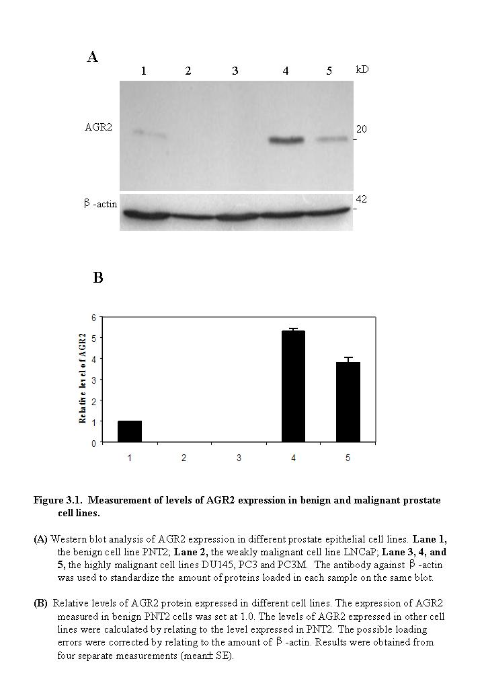
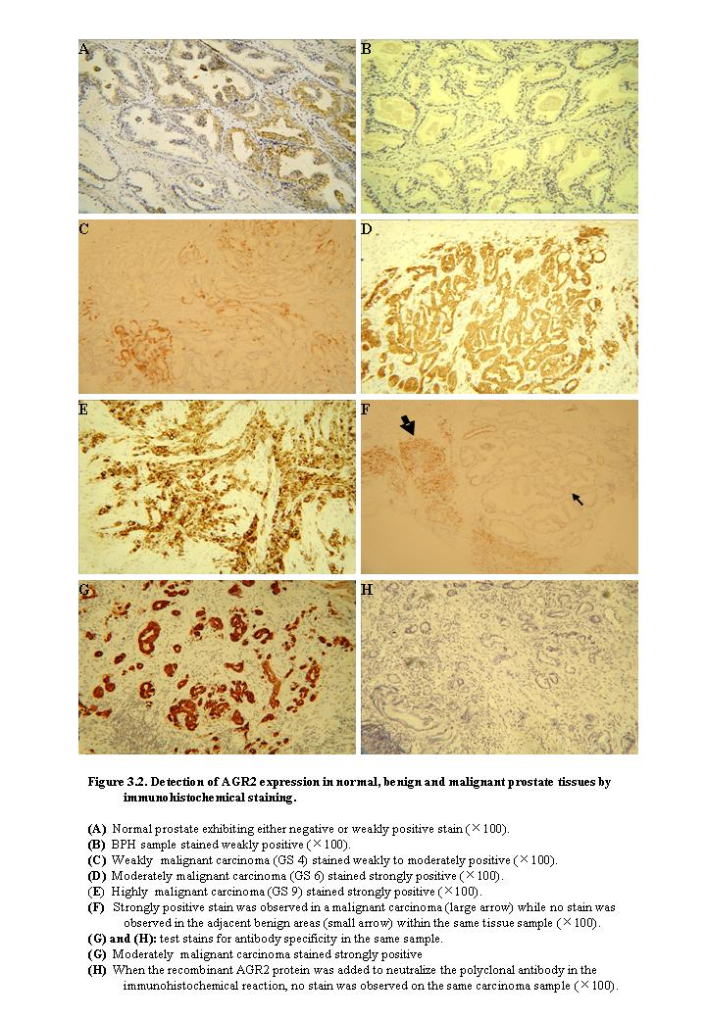

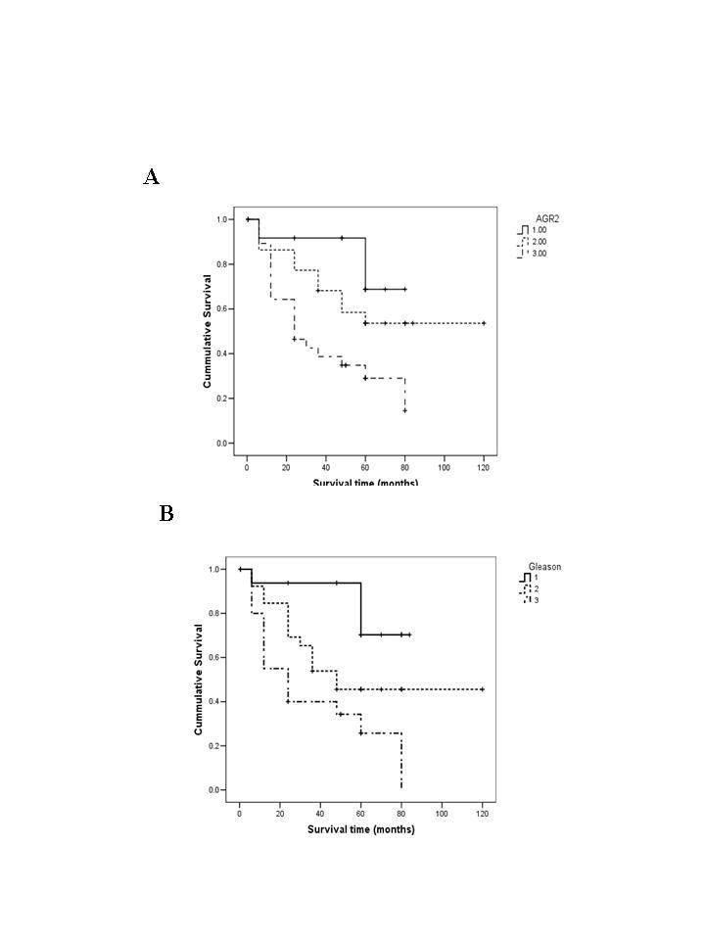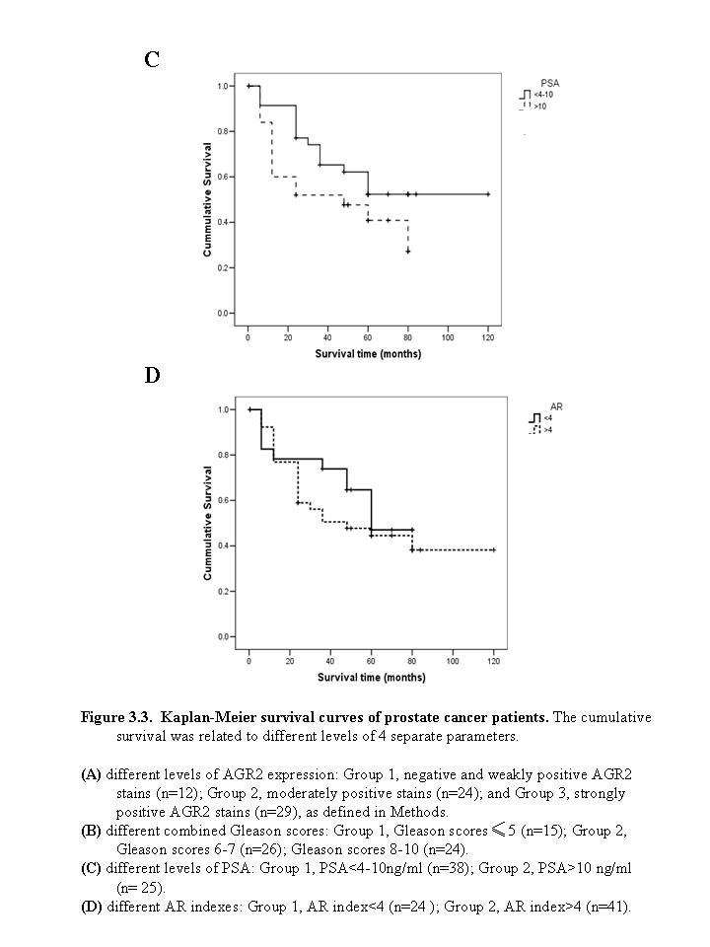

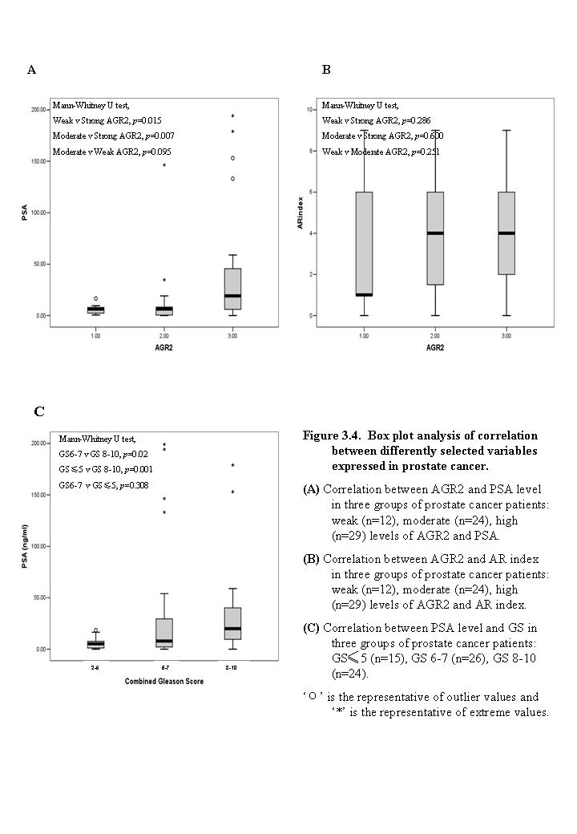

CHAPTER FOUR:
Result 2 - S100A4

CHAPTER FOUR: Result 2 - S100A4

  - S100A4 expression in prostate cell lines

A strong S100A4 protein band at 10kD was detected by Western blot in highly malignant cell line DU145 and a weaker band on the same position was detected in the highly malignant cell lines PC3 and PC3M while no band was detected in the benign cell line PNT2 and the weakly malignant cell line LNCaP, as shown in Fig 4.1A. The detailed quantitative measurements of relative S100A4 levels expressed in different cell lines were shown in Fig 4.1B. When the level of S100A4 expressed in the PC3M cells was set at 1.0, the relative levels of S100A4 in DU145 and PC3 were 23.2±0.2 and 2.7±0.1, respectively.

  - S100A4 expression in prostate tissues

The representative samples of immunohistochemical stains of different prostate tissues with the polyclonal anti-human S100A4 antibody were shown in Fig 4.2. No staining was observed in the normal prostate tissues as shown in Fig 4.2A. In benign prostate tissues, S100A4 staining was localized in stroma, not in glandular cells (Fig 4.2B). Weakly positive staining (Fig 4.2C)and strongly positive staining (Fig 4.2F) was shown in both stroma and glandular cells in weakly malignant tissues and highly malignant tissues respectively while some of the moderately malignant tissues were stained strongly positive (Fig 4.2D) and some were unstained (Fig 4.2E). The stain was completely blocked when the antibody was neutralized with the recombinant S100A4 protein (Fig 4.2G and H), indicating the specificity of the antibody for S100A4.
The results of immunohistochemical staining were summarized in Table 4.1.
Amongst 7 normal prostate tissues, 6 (86%) was unstained, 1 (14%) stained in stroma. Amongst 34 BPH cases, 30 (88%) were unstained, 4 (12%) stained in stroma (Table 4.1). The difference of S100A4 stains between normal and BPH cases was not statistically significant (two-sided Fisher’s exact test, p>1). Amongst 110 carcinoma cases, 44 (41%) were unstained, 66 (59%) stained (Table4.1). Expression of S100A4 in carcinoma cases was significantly higher than that in benign (two-sided Fisher’s exact test, p<0.0001) and normal (two-sided Fisher’s exact test, p<0.05).
Table 4.1 S100A4 expression in different prostate tissues
Tissues | Stain Intensities (Stroma) |  | No. of cases
Tissues | Negative  (-)  No. (%) | Positive  (+)  No. (%) | No. of cases
Normal | 6 (85.7%) | 1 (14.3%) | 7
BPH | 30 (88.2%) | 4 (11.8%) | 34
Carcinoma  (total) | 44 (40%) | 66 (60%) | 110
GS≤5 | 13 (61.9%) | 8 (38.1%) | 21
GS6-7 | 20 (43.5%) | 26 (56.5%) | 46
GS8-10 | 11 (25.6%) | 32 (74.4%) | 43

  - Correlation with patient survival

    - S100A4 expression and patient survival

The relationship between the intensity of S100A4 staining and the patient-survival time was shown in Fig 4.3A. For the patients with positive S100A4 stains, the median survival time was 48 months. For the patients with negative S100A4 stains, the median survival time was 60 months. Although there is some difference between the median survival time, statistic analysis showed that the survival time was not significantly (log rank test, p=0.77) reduced with increased S100A4 stains.

    - Combined Gleason Scores (GS) and patient survival

To assess the relationship between the GS and patient survival, 110 carcinoma cases were divided into the weakly malignant group with GS of <6, the moderately malignant group with GS of 6-7 and the highly malignant group with GS of 8-10. The median survival time of patients with weakly, moderately and highly malignant carcinomas was 85, 60 and 24 months, respectively (Fig 4.3B). The reduced survival time was significantly (log rank test, p<0.001) associated with the increased degree of malignancy.

    - Prostate-Specific Antigen (PSA) and patient survival

The correlation between PSA level and patient-survival time was shown in Fig 4.3C. The median survival time for patients with low (<4ng/ml) and borderline (4-10ng/ml) PSA level was 72 months compared with 48 months in patients with high (>10ng/ml) PSA levels. The association of the patient PSA level with the length of the survival time was significant (log rank test, p<0.05).

    - Androgen receptor (AR) and patient survival

The correlation between AR and survival time was shown in Fig 4.3D. The median survival time for patients with low (index<4) and high (index≥4) AR levels was 61.4 and 61.9 months, respectively. The time of patient survival and the level of AR were not significantly (log rank test, p=0.151) associated.

  - Correlation between differently selected variables

    - S100A4 expression and Combined Gleason Scores (GS)

Amongst 21 GS≤5 carcinomas, 13 (61.9%) stained negative and 8 (38.1%) stained positive. Amongst 46 GS6-7 carcinomas, 20 (43.5%) were unstained, 26 (56.5%) stained positive. Amongst 43 GS 8-10 carcinomas, 11 (25.6%) was unstained, 32 (74.4%) stained positive (Table 3.1). The intensity of S100A4 staining was significantly (Chi-square test, p<0.02) associated with the increased GS of the carcinomas.

    - S100A4 expression and Prostate-Specific Antigen (PSA) level

The correlation between levels of PSA and S100A4 expression was shown in Fig 4.4A. For patients with negative and positiveS100A4 stains, the median PSA level was 20.0 and 37.1ng/ml, respectively. Though there was 17.1ng/ml difference between the median, box plot analysis showed that the level of PSA in the patients with positive S100A4 staining was not significantly (Mann-Whitney U test, p=0.614) higher than that of patients with negative staining.

    - S100A4 expression and Androgen receptor (AR) index

The correlation of AR index with S100A4 expression was shown in Fig 4.4B. For patients with negative S100A4 stains, the median AR index was 3.9. For patients with positive S100A4 stains, the median AR indexes were 3.5. Box plot analysis showed that the difference in patient AR indexes between negative and positive S100A4 stained groups was not significant (Mann-Whitney U test, p=0.597).

    - Prostate-Specific Antigen (PSA) and Combined Gleason Scores (GS)

The correlation of PSA levels and GS was shown in Fig 4.4C. For patients with GS≤5, GS6-7 and GS 8-10 carcinomas, the median PSA levels were 15.9, 24.9 and 39.0ng/ml, respectively. Box plot analysis showed that the PSA level was significantly higher in patients with GS 8-10 carcinomas than those with GS≤5 (Mann-Whitney U test, p=0.024) and GS 6-7 carcinomas (Mann-Whitney U test, p=0.027). However, the difference in patient PSA levels between the GS 6-7 and GS≤5 carcinoma groups was not significant (Mann-Whitney U test, p=0.911).

  - RNA interference stably decreased S100A4 expression

DU145 prostate cells are highly malignant and expressing high level of S100A4 as shown in Fig 4.1. RNAi was used to suppress S100A4 in DU145 cells specifically.

    - Selection of efficient siRNA for S100A4 suppression

Three 21-nt sequences within the S100A4 cDNA for RNAi were selected and used to make double-stranded 21-nt siRNA constructs encoding sense and antisense siRNA. These three siRNAs were transient transfected to the DU145 cell line both separately and in differently combined manners as described in Methods. After 72 hours, the transient transfectants were subjected to Western blot analysis for their S100A4 expression level. SiRNA11 exhibited the highest efficiency in suppressing S100A4 expression. It reduced the S100A4 expression by nearly 5 fold from the level detected in parental DU145 cells (Fig 4.5.1). Thus, siRNA11 was identified as the best siRNA used for further study.

    - Establishment of S100A4 stably suppressed clones

The plasmid express siRNA11 against S100A4-cDNA target was designed and constructed as described in Methods. Sense and antisense siRNA sequences were arranged sequentially to facilitate the formation of hairpin siRNA upon transcription. DU145 cells were transfected with purified pSilencerTM 4.1-CMV neo vector containing either the siRNA11 insert or the scrambled siRNA control insert. pSilencerTM 4.1-CMV neo vector contains a neomycin resistance gene. The selection medium (RSM) containing 1mg/ml neomycin G418 was applied 24 hrs after transfection. Three months after the initial transfection, several clones in which the S100A4 expression was suppressed were established. They were named S100A4-suppressed-DU145-clone (SDC) 1, SDC2, SDC3…etc, respectively. Western blot was performed to detect their S100A4 expression as shown in Fig 4.5.2. Result showed that the level of S100A4 in clone SDC11 and SDC2 had been moderately and highly suppressed by 4 and 28 folds, respectively, compared with sR-control transfectant. Thus, S100A4-moderately-suppressed clone SDC11 and S100A4-highly-suppressed clone SDC2 were chosen to do the further investigation.

  - Effect of suppression of S100A4 on tumor cells in vitro

    - Suppression of S100A4 significantly inhibited anchorage-independent growth of cancer cells

The soft agar colony-formation assay was performed to investigate the effect of S100A4 suppression on anchorage-independent growth of DU145 cells. As shown in Fig 4.6.1, no significant differences (student’s t test, p=0.82) were observed between the number of colonies formed by the parental DU145 cells and the scrambled-RNA transferctant (sR-control). Numbers of colonies produced in soft agar by S100A4-highly-suppressed cells SDC2 (student’s t test, p<0.0001) and S100A4-moderately-suppressed cells SDC11 (student’s t test, p<0.001) significantly reduced by 11.4 and 3.5 folds, respectively, in comparison with sR-control.

    - Suppression of S100A4 had no effect on cellular proliferation

Cell proliferation assay was performed in 120 h to measure the growth rate for SDC clones. The density of the cultured cells was determined by extrapolating from the standard curve and cell numbers were obtained by MTT assays as described in Methods. Cell proliferation rates of SDC2 (student’s t test, p=0.984) and SDC11 (student’s t test, p=0.359) did not show any significant difference from the sR-control cells.

    - Suppression of S100A4 significantly inhibited the invasiveness of the cancer cells

The invasiveness of SDC clones were assessed using Matrigel coated transwell invasion chambers as described in Methods. The parental DU145 cells and the sR were used as controls. While no significant (student’s t test, p=0.47) difference between parental DU145 cells and sR-control cells was observed, the invasiveness of SDC2 (student’s t test, p<0.0001) and SDC11 (student’s t test, p<0.003) was reduced by 4.9 and 1.6 fold respectively, in comparison with sR-control (Fig 4.6.3B). Fig 4.6.3A represented the proportion of cells invaded into Matrigel in DU145, sR-control, SDC2 and SDC11.

    - Suppression of S100A4 had no effect on cellular motility

The motility of SDC clones were assessed across transwell polycarbonate membranes as described in Methods. The parental DU145 cells and the sR were used as controls. No significant (student’s t test, p=0.48) difference was observed between parental DU145 cells and sR-control cells. The motility of SDC2 (student’s t test, p=0.300) and SDC11 (student’s t test, p=0.137) was not significantly different in comparison with the sR-control (Fig 4.6.4B). Fig 4.6.4A represented the proportion of motile cells in DU145, sR, SDC2 and SDC11.

  - Discussion

The aim of this chapter was to establish whether or not S100A4 could be the prognostic biomarker for prostate cancer and if it plays a role in the malignancy of prostate cancer. Expression of S100A4 in prostate cell line and tissues were investigated in this work and the expression status of this protein was correlated with the patient survival data. The expression of S100A4 was knocked down in the malignant prostate cancer cell line and the role of S100A4 in the malignancy was assessed in vitro.
S100A4 was first identified in 1987 by Jackson-Grusby⁷⁵. An mRNA was characterized after serum stimulation of quiescent mouse fibroblasts and this mRNA, designated 18A2 was found encoding a predicted polypeptide of 101 amino acids with homology to known calcium binding proteins⁷⁵. S100A4 mRNA expression level was found to be related to the metastatic phenotype in several tumor cells⁷³. The role of S100A4 in metastasis was then studied in a variety of cancers^{115, 261, 262}, mouse models²⁶³ ²⁶⁴ and even related to tumor suppressor p53¹²³. After these extensive investigations, S100A4 was widely accepted as a metastasis-inducing protein.
In contrast to the rapid progress of the study on the role of S100A4 in metastasis, its role in prognosis of cancer was not studied until 2000. Studies on patients with19 years follow-up survival data in stage I and II breast cancer suggested that the length of median survival time between S100A4-negative group (>228 months) and S100A4-positive group (47 months)¹³⁴ was significantly different. The result of another study of 10- year follow-up survival data in early stage also supported that S100A4 could be a valuable marker of prognosis for breast cancer²⁶⁵. However, the controversial results were presented in 2002 by Pedersen. 66 breast carcinoma samples of I-IV stages on a were with 79 months follow-up time were studied and the S100A4 immunoreactivity was not associated with overall survival, although high expression of S100A4 did relate to the histological grade III and had a inverse correlation with the expression of estrogen receptor¹⁰³. This contrast result may be explained by the small sample volume and the short follow-up time and other technique conditions. Thus, the prognosis of S100A4 in breast cancer is still widely accepted. The prognostic significance of S100A4 has recently been evaluated in a series of cancers, a worse prognosis for patients was correlated with the increase S100A4 expression in colorectal¹³⁶, gallbladder¹⁰⁶, bladder¹³⁸, esophagel¹⁰⁷, non-small-cell lung¹⁰⁹, gastric¹⁴⁰, medulloblastoma⁸⁵, pancreatic¹⁴² and hepatocellular¹⁴³ cancers.
S100A4 was first studied in the Dunning R3327 rat prostate cancer model in 1997. Western blot and Northern blot were applied to analyze S100A4 at both protein and mRNA levels in different metastatic prostate cancer cell lines and the association between elevated expression of S100A4 and increased metastatic capability was revealed.¹³¹ Association between the increased S100A4 expression with the increased prostate cancer progression was first discovered by using RT-PCR, Western blot and immunohistochemistry techniques on normal, BPH and carcinoma samples.¹⁰⁵ S100A4 expression was detected in transgenic adenocarcinoma of the mouse prostate (TRAMP) model during autochthonous prostate cancer progression. Inhibition of prostate cancer expression by feeding GTP on TRAMP mice was associated with reduction of S100A4 and restoration of E-Cadherin.¹³²
In this study, the expression status of S100A4 was first examined in the five commonly used prostate cell lines (Fig 4.1). All highly malignant cell lines, DU145, PC3 and PC3M were found expressed S100A4 whereas it was expressed in neither of the benign cell line PNT2 nor the weakly malignant cell line LNCaP. Amongst three highly malignant cell lines, highest level of S100A4 expression was found in DU145 which was 23.2 fold than that of PC3M and PC3 expressed S100A4 at 2.7 fold compared to that of PC3M. Thus, in prostate cell lines, the high expression of S100A4 appeared to be closely linked to the high malignant potential of the cells. Increased S100A4 may involve in the malignancy progression of cancer cells in prostate.
The immunohistochemical staining of S100A4 may be divided into two parts: stains in glandular cells and stains in stroma (Fig 4.2). In normal tissues, no stain was observed in glandular cells or stroma. In BPH, only stroma was stained; in carcinomas, both stroma and glandular cells were stained but in different intensities. The immunohistochemical analyses (Table 4.1) showed no significant (two-sided Fisher’s exact test, p>1) difference in S100A4 stain intensities between normal and BPH cases. However, significant increase in S100A4 expression was observed in carcinomas compared to normal (two-sided Fisher’s exact test, p<0.05) and BPH (two-sided Fisher’s exact test, p<0.0001) cases. Furthermore, S100A4 staining was significantly stronger (two-sided Fisher’s exact test, p<0.01) in highly malignant tissues (GS8-10) than that in weakly malignant tissues (GS<6). This result suggested that increased S100A4 expression may be an indicator for the malignant progression of prostate cancer.
Although the median survival time for patients with positive (48 months) S100A4 stains was 12 months shorter than those stained negatively (60 months) (Fig 4.3A), this difference was not statistically significant (log rank test, p=0.77). This result suggested the S100A4 stain intensity increment may not be used to accurately predict the patient outcome. However, the reduced patient survival time (Fig 4.3B) was shown to be significantly (log rank test, p<0.001) associated with the increased GS which measured the degree of malignancy in prostate cancer. This result as reported consistently by our group that GS of the carcinomas was a useful prognostic parameter for outcomes of patients³⁸.
In present work, as shown in Fig 4.3C, the increased PSA level was not significantly (log Rank test, p<0.05) associated with the reduced patient survival time. However, it showed there was no significant (log Rank test, p=0.151) association between AR index and the time of patient survival (Fig 4.3D).
The level of PSA in patients with positive S100A4 stains was not significantly (Mann-Whitney U test, p=0.614) higher than that of patients with negative stains, although there was difference of 17.1ng/ml between the median PSA level of these two groups. This result suggested that the increased level of S100A4 expression was not significantly associated with the increased level of PSA. Similarly, the difference in patient AR indexes was not significant (Mann-Whitney U test, p=0.597) between positive and negative S100A4 stained cases, indicating that the expression of S100A4 was not related to the AR index in the cases of prostate cancer studied in this work. This result is in contrast to that with the ER in breast cancer, which was closely related to S100A4⁴⁸.
The assessment (Fig 4.4C) showed that PSA level was significantly higher in patients with highly malignant carcinomas than those with weakly (Mann-Whitney U Test, p=0.024) and moderately (Mann-Whitney U Test, p=0.027) malignant carcinomas, whereas the difference between the moderately and weakly malignant carcinoma cases was not significant (Mann-Whitney U Test, p=0.911). This result was similar to that obtained from the AGR2. Both of studies showed that although PSA was consistent to be a prognostic marker, it partially reflected the degree of malignancy of the carcinomas in these groups of patients.
From these results, S100A4 was expressed in higher levels in highly malignant prostate cell lines and tissues compared with the normal and BPH cases. Although the increased S100A4 expression was significantly associated with the increased malignancy of the carcinoma, it was not significantly associated with the reduced survival time of patients. Therefore, the increased expression of S100A4 may be used as a valuable biomarker to differential malignant phenotype but not suitable to be used as a prognostic marker to predict the outcome of patients with prostate cancer.
To further address the question of whether S100A4 can be used as a therapeutic target for prostate cancer, we employed the RNA interference (RNAi) method in an attempt to deplete the expression of S100A4 in cultured prostate cells. RNAi is the most commonly used technique to suppress gene expression in a variety of cancers. In human periodontal ligament (PDL) cells, inhibition of S100A4 by siRNA resulted in increased expression of osteoblastic markers such as OPN and osteocalcin and the osteoblast-specific transcription factors, Runx2/Cbfa1 and Osterix²⁶⁶.The specific knockdown of S100A4 by siRNA suppressed cell growth, induced G2 arrest and eventual apoptosis and decreased cell migration in pancreatic cancer. The additional microarray analyses showed the knockdown of S100A4 induced expression of the tumour suppressor genes PRDM2 and VASH1 ²⁶¹. S100A4 expression was downregulated by RNAi in HEC-1A cells in endometrial cancer which resulted in significant reduction of migration and invasion. TGF-β1-mediated endometrial cancer cell motility was inhibited by S100A4 siRNA suggested S100A4 was upregulated by the TGF-β1 signalling pathway ²⁶⁷.
In this study, the plasmid-based RNAi suppressed S100A4 expression in DU145 prostate cancer cells were performed in both transient and stable manners. The best suppressing sequence was identified using the transient manner (Fig 4.5.1) and several clones were established by using the stable and long-term manner (Fig 4.5.2). Most of them were confirmed a decrease in S100A4 protein expression over three months (Fig 4.5.2). SDC11 and SDC2 which had the reduction of 4 and 28 fold were selected to do the further assessment.
In this study, suppression of S100A4 were associated with a 11.4 and 3.5 fold decrease in anchorage-independent growth (Fig 4.6.1) and 4.9 and 1.6 fold decrease in invasiveness (Fig 4.6.2) in vitro, respectively, in the S100A4-highly-suppressed cells SDC2 and S100A4-moderately-suppresseed cells SDC11. Importantly, it was demonstrated that these phenotypic differences are independent of cellular proliferation as the rate of growth is conserved between sR-control and SDC2 and SDC11 (Fig 4.6.3). This suppression of S100A4 expression seemed not to be associated with the cellular motility (Fig 4.6.4). Stable S100A4 knockdown clones were generated by siRNA in HEC-1A cells, it also caused significant decreases in cell migration and invasion and no significant effect were observed on cell proliferation in vitro in endometrial cancer²⁶⁷.
It has been proposed that S100A4 promoted the cell invasiveness through the cooperation of molecules MMP-9, TIMP-1.^{100, 130}
In this work although high expression of S100A4 was not significantly associated with poor prognosis, the suppression of S100A4 did reduce the anchorage-independent growth and invasiveness of the prostate cancer cells. To investigate the biological significance of S100A4 by elevated expression level in DU145 cells and to study whether S100A4 can be used as a therapeutic target for tumor suppression, further assessment of effect of the reduced expression of S100A4 on the ability of forming tumours of cancer cells in vivo was necessary.

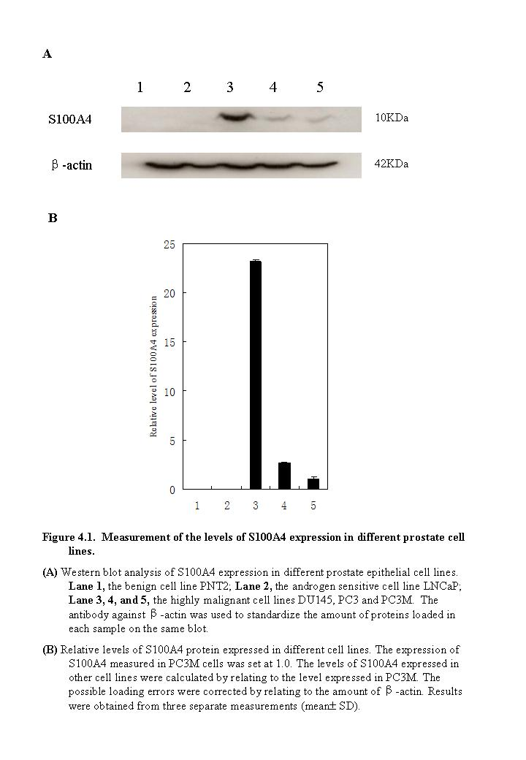
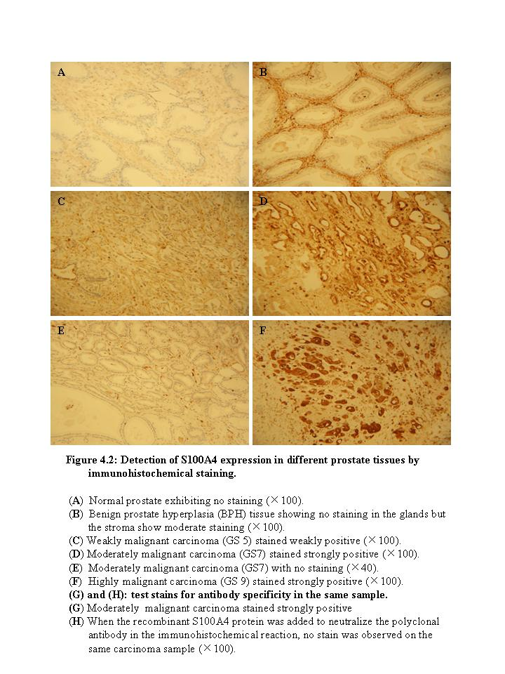
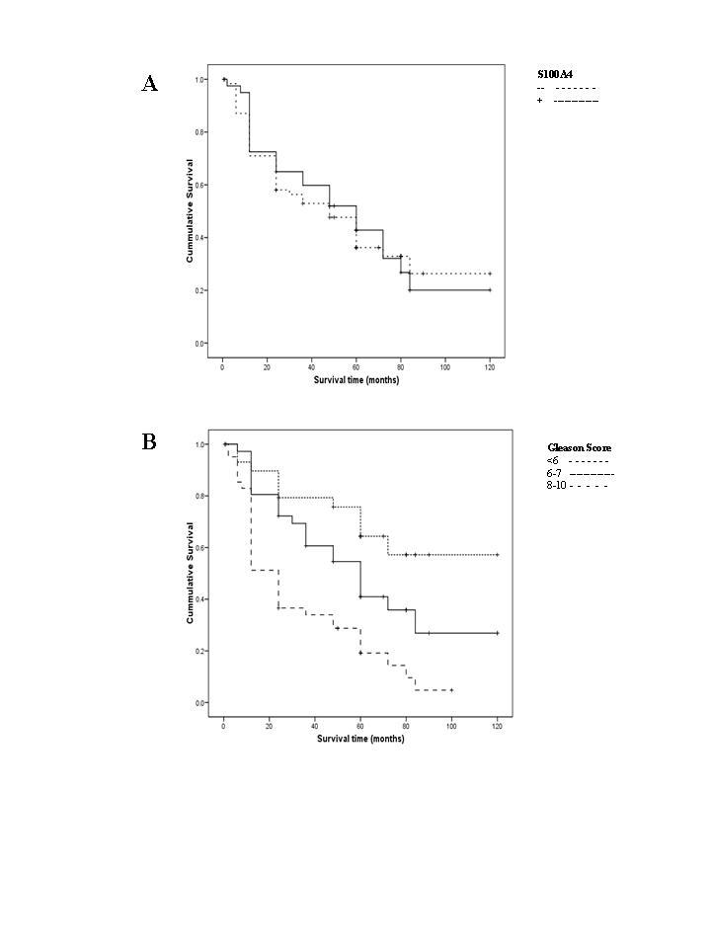
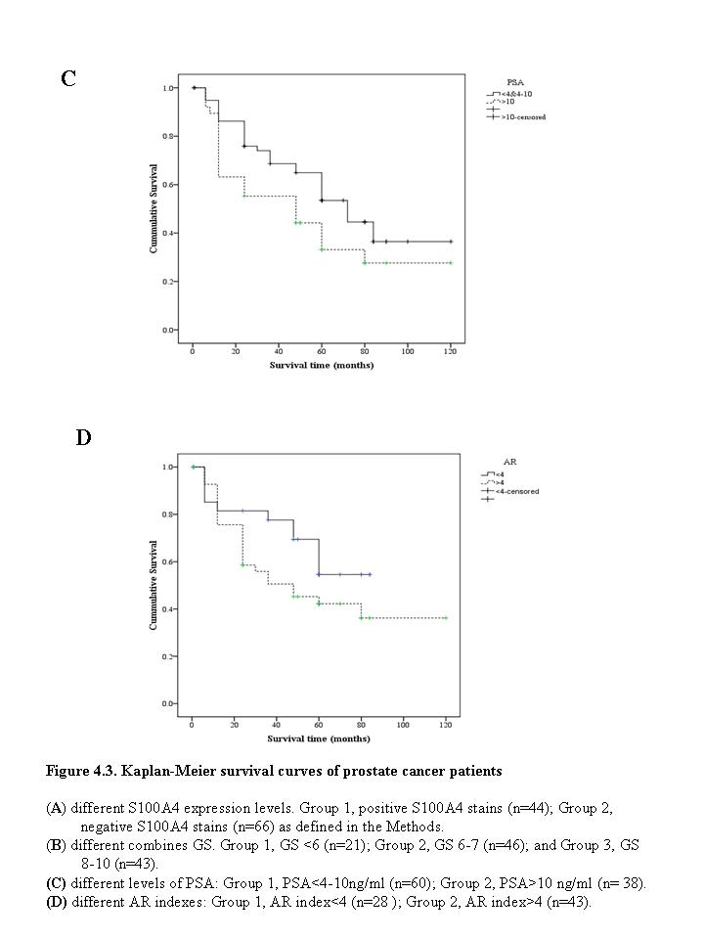
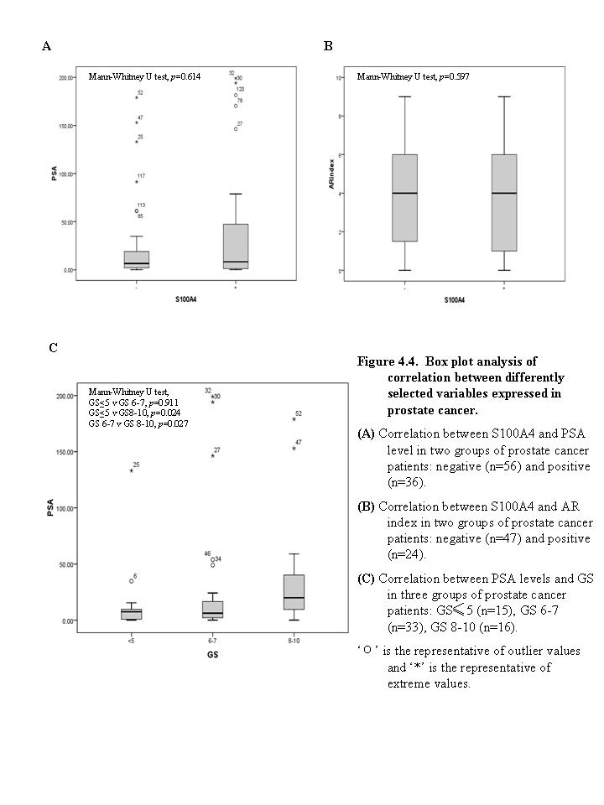
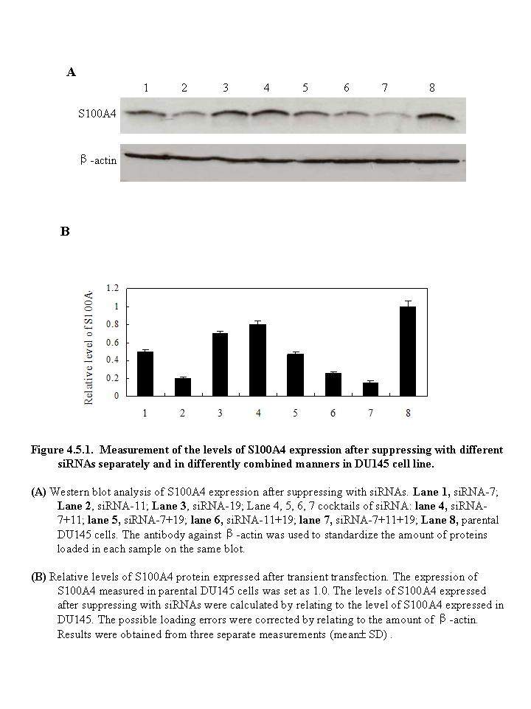

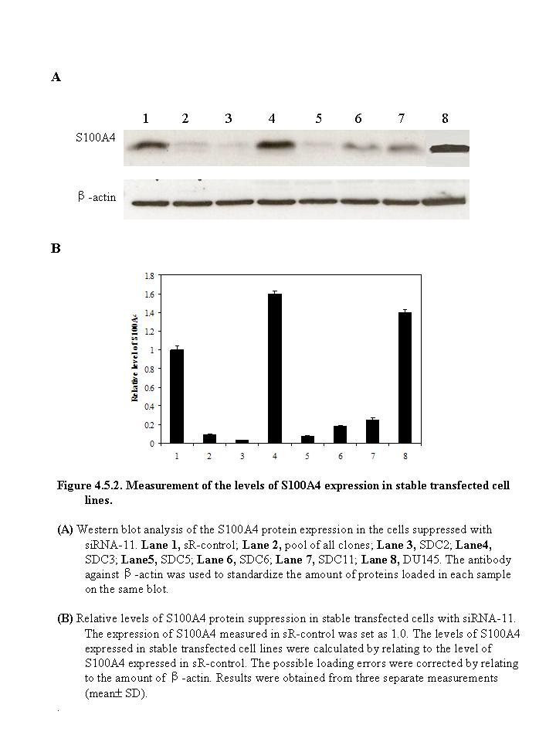
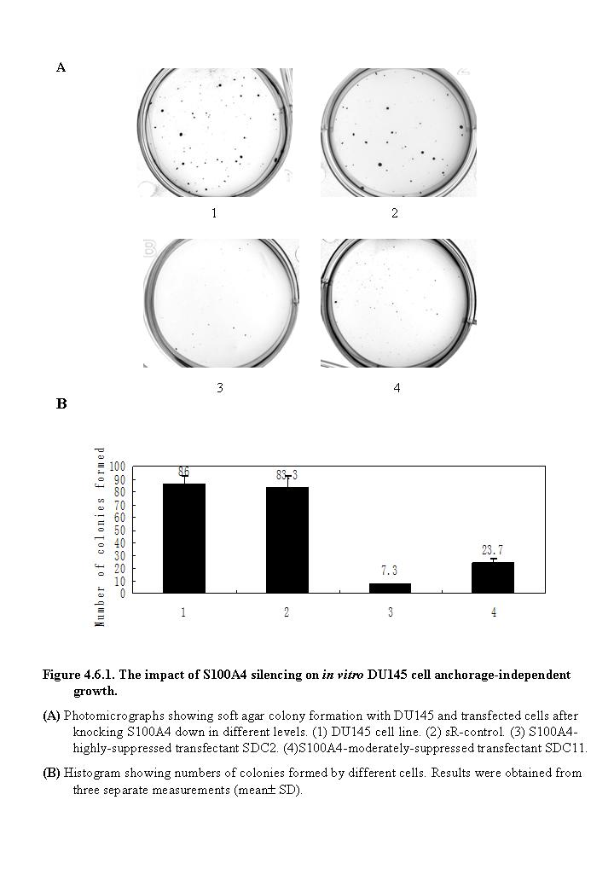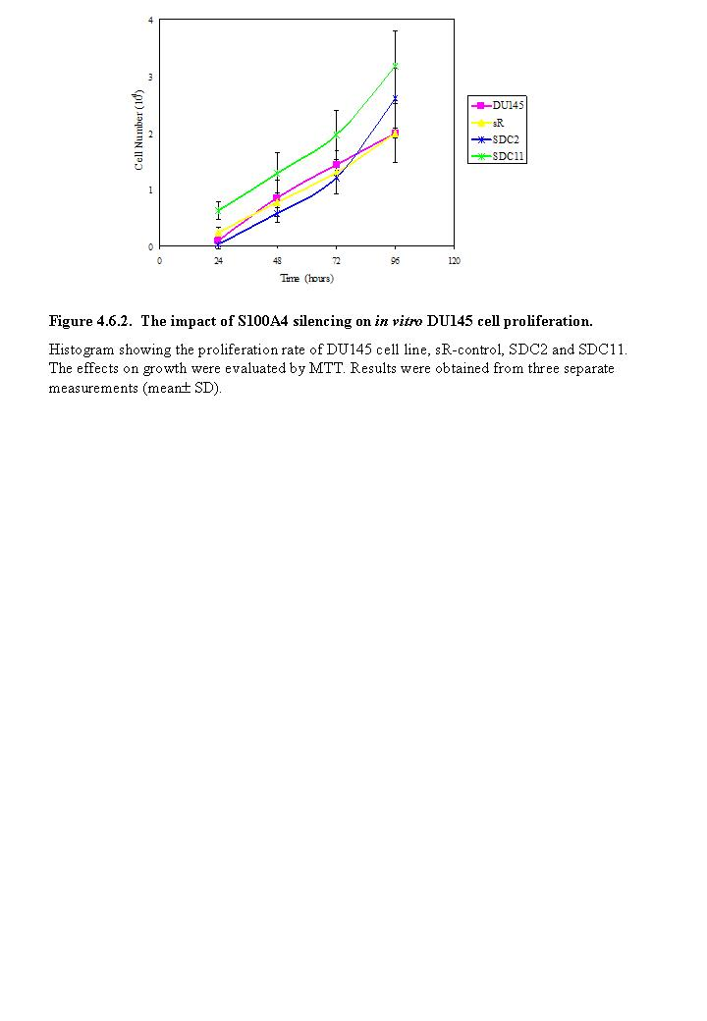

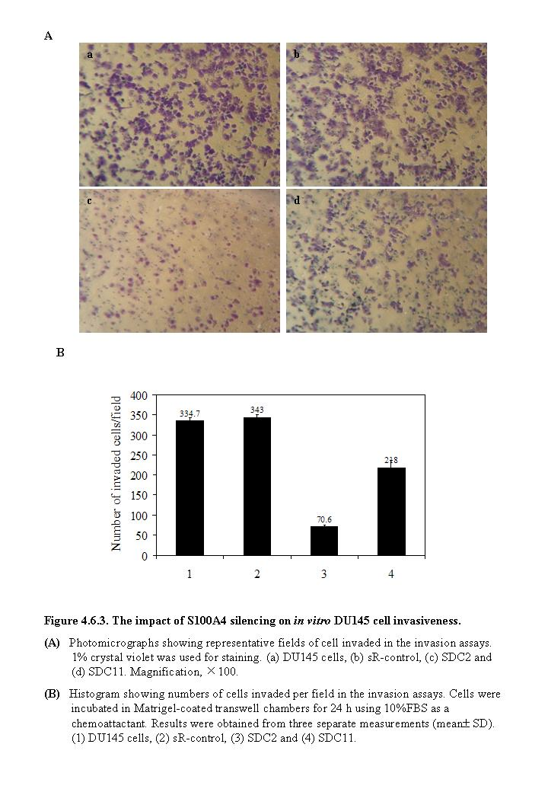
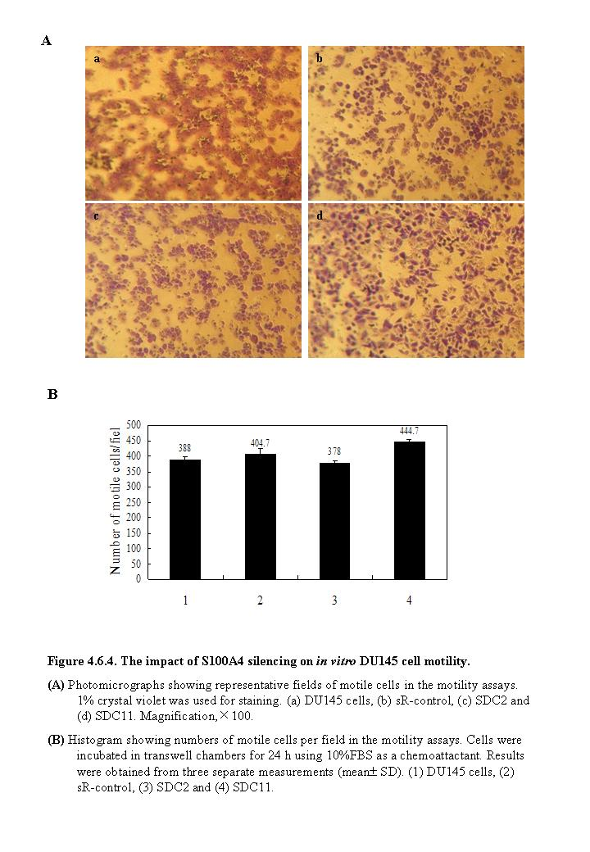

CHAPTER FIVE:
Result 3 – Osteopontin (OPN)

CHAPTER FIVE: Result 3 – Osteopontin (OPN)

5.1. OPN expression in prostate cell lines

A single OPN band with a size of 64kD was detected by Western blot in all cell lines examined (Fig 5.1A) and the detailed quantitative measurements of relative OPN levels expressed in different cell lines were shown in Fig 5.1B. When the level of OPN expressed in the PNT2 cells was set at 1.0, the relative levels of OPN expressed in weakly malignant cell line LNCaP, highly malignant cell lines DU145 and PC3 were 1.5±0.3, 2.9±0.5 and 4.4±0.6, respectively.

  - OPN expression in prostate tissues

The immunohistochemical staining of the different prostate tissues with the OPN-specific monoclonal antibody (MAb) was performed, as shown in Fig 5.2. The stain was located in the cytoplasm of the epithelial cells of the prostatic glands in most of the tissues. In some normal (Fig 5.2A) and BPH (Fig 5.2B) tissues, weak staining was observed in basal cells whereas in carcinoma tissues (Fig5.2 C-E), it was not seen since basal cells were absent. As represent in Fig 3.2F, a strongly stain was observed in a malignant carcinoma (large arrow) while it was negative in the adjacent benign areas (small arrow) within the same tissue sample. When the OPN-specific MAb was neutralized with the recombinant OPN protein, staining was blocked completely (Fig 5.2G and H). The results were summarized in Table 5.1. Amongst 116 cases studied, 3 (30%) of the 10 normal cases were unstained and the other 7 (70%) exhibited a weakly positive stain. Amongst 36 BPH samples, 32 (89%) stained weakly positive and 4 (11%) were unstained. The difference of OPN stains between normal and BPH cases was not statistically significant (two-sided Fisher’s exact test, p=0.16). Amongst 70 carcinomas samples, 31 (44%) stained strongly positive and 20 (29%) stained moderately positive while 19 (27%) stained weakly positive and no samples were unstained. The intensity of the staining in carcinomas is significantly stronger than that in normal (Chi-square test, p<0.001) and in BPH (Chi-square test, p< 0.001) tissues.
Table 5.1 OPN expression in different prostate tissues
Tissues | Stain Intensities |  |  |  | No. of cases
Tissues | Negative  (-)  No. (%) | Weak  (+)  No. (%) | Moderate  (++)  No. (%) | Strong  (+++)  No. (%) | No. of cases
Normal | 3 (30%) | 7 (70%) | 0 | 0 | 10
BPH | 4 (11%) | 32 (89%) | 0 | 0 | 36
Carcinoma  (Total) | 0 | 19 (27%) | 20 (29%) | 31 (44%) | 70
GS<5 | 0 | 17 (85%) | 2 (10%) | 1 (5%) | 20
GS5-7 | 0 | 4 (13%) | 14 (47%) | 12 (40%) | 30
GS8-10 | 0 | 0 | 2 (10%) | 18 (90%) | 20

  - Correlations with patient survival

    - OPN expression and patient survival

The relationship between the intensity of OPN staining and the patient-survival time are shown in Fig 5.3A. The 70 carcinomas were divided into weakly positive (+), moderately positive (++) and strongly positive (+++) groups (Table 5.1), according to their OPN staining intensities. The mean expected survival time for patients with weakly positive OPN stains was 61.6 months. The mean survival time for patients with moderately positive OPN stains and strongly positive OPN stains were reduced to 48.56 and 38.47 months, respectively. The survival of patients in moderately OPN positive cases was shorter than that in the weakly OPN positive cases, but the difference was not significant (log rank test, p=0.26). The survival of the patients in the strong OPN positive cases was significantly shorter than that in weakly OPN positive cases (log rank test, p=0.008) but the difference in survival between the strong and the moderate OPN positive cases was not significant (log rank test, p=0.19).

    - Combined Gleason Scores (GS) and patient survival

To assess the relationship between the combined GS and patient survival, 70 carcinoma cases were divided into the weakly malignant group with GS of <5, the moderately malignant group with GS of 5-7 and the highly malignant group with GS of 8-10. The mean survival time of patients with weakly, moderately and highly malignant carcinomas was 66.2, 48.24 and 31.42 months, respectively (Fig 5.3B). The reduced survival time was significantly (log rank test, p=0.001) associated with the increased degree of malignancy. There was a highly significant difference between patients of highly malignant group and those of weakly malignant group in the length of the survival time (log rank test, p=0.003). The difference in survival time between the highly malignant cases and moderately cases was significant (log rank test, p=0.02), but difference between the weakly malignant cases and the moderately malignant cases was not significant (log rank test, p=0.09).

    - Prostate-Specific Antigen (PSA) and patient survival

The correlation between PSA level and patient-survival time was shown in Fig 5.3C. The median survival time for patients with low (<4ng/ml) and borderline (4-10ng/ml) PSA level was 48 months and it was also 48 months in patients with high (>10ng/ml) PSA levels. Although survival time has been reduced in patients with high PSA level, the association of the patient PSA level with the length of the survival time was not significant (log rank test, p=0.903).

    - Androgen receptor (AR) and patient survival

The correlation between AR and survival time was shown in Fig 5.3D. Although the median survival time for patients with low (index<4) and high (index≥4) AR levels was 60 and 24 months, respectively, the time of patient survival and the level of AR were not significantly (log rank test, p=0.152) associated.

  - Correlation between differently selected variables

    - OPN expression and Combined Gleason Scores (GS)

Amongst 20 GS<5 carcinomas, 17(85%) stained weakly positive and 2 (10%) stained moderately positive and 1 (5%) stained strongly positive. Amongst 30 GS5-7 carcinomas, 4 (13%) stained weakly positive, 14 (47%) stained moderately positive and 12 (40%) stained strongly positive. Amongst 20 GS 8-10 carcinomas, none was unstained or stained weakly positive, 2 (10%) stained moderately positive and 18 (90%) stained strongly positive (Table 5.1). The intensity of the stains in moderately positive malignant cases is significantly stronger than that observed in the weakly malignant cases (Chi-square test, p<0.001). The intensity of the stains in the highly malignant case is significantly stronger than those observed in both the weakly malignant group (Chi-square test, p<0.001) and the moderately malignant group (Chi-square test, p<0.01).

    - OPN expression and Prostate-Specific Antigen (PSA) level

The correlation between levels of PSA and OPN expression was shown in Fig 5.4A. For patients with weak, moderate and strong OPN stains, the median PSA level was 5.2, 12.5 and 9.2ng/ml, respectively. Box plot analysis showed that the level of PSA in the patients with moderate OPN staining was significantly (Mann-Whitney U test, p=0.019) higher than that of patients with weak staining. However, the difference in patient PSA levels between moderate and strong OPN stained groups (Mann-Whitney U test, p=0.224) and between weak and strong OPN stained groups (Mann-Whitney U test, p=0.259) were not significant.

    - OPN expression and Androgen receptor (AR) index

The correlation of AR index with OPN expression was shown in Fig 5.4B. For patients with weak OPN stains, the median AR index was 2. For patients with moderate and strong OPN stains, the median AR indexes were 4. Box plot analysis showed that the difference in patient AR indexes either between strong and moderate OPN stained groups (Mann-Whitney U test, p=0.368), or between weak and moderate stained groups (Mann-Whitney U test, p=0.055), was not significant. The difference in patient indexes between weak and strong OPN stained groups was significant (Mann-Whitney U test, p=0.011).

    - Prostate-Specific Antigen (PSA) and Combined Gleason Scores (GS)

The correlation of PSA levels and GS was shown in Fig 5.4C. For patients with GS≤5, GS6-7 and GS 8-10 carcinomas, the median PSA levels were 7.5, 6.2 and 20ng/ml, respectively. Box plot analysis showed that the PSA level was significantly higher in patients with GS 8-10 carcinomas than those with GS≤5 (Mann-Whitney U test, p=0.024) and GS 6-7 carcinomas (Mann-Whitney U test, p=0.027). However, the difference in patient PSA levels between the GS 6-7 and GS≤5 carcinoma groups was not significant (Mann-Whitney U test, p=0.911).

  - RNA interference stably decreased OPN expression

PC3 prostate cells are highly malignant and expressing high levels of OPN as shown in Fig 5.1. RNAi was used to suppress OPN in PC3 cells specifically.

    - Selection of efficient siRNA for OPN suppression

Three 21-nt sequences within the OPN cDNA for RNAi were selected and used to make double-stranded 21-nt siRNA constructs encoding sense and antisense siRNA. These three siRNAs were transient transfected to the PC3 cell line both separately and in different combined manners as described in Methods. After 72 hours, the transient transfectants were subjected to Western blot analysis for their OPN expression level. SiRNA 1 exhibited the highest efficiency in suppressing OPN expression. It reduced the OPN expression by nearly 5 fold from the level detected in the parental PC3 cells (Fig 5.5.1). Thus, siRNA1 was identified as the most efficient OPN suppressor.

    - Establishment of OPN stably suppressed clones

The plasmid express siRNA1 against OPN-cDNA target was designed and constructed as described in Methods. Sense and antisense siRNA sequences were arranged sequentially to facilitate the formation of hairpin siRNA upon transcription. PC3 cells were transfected with purified pSilencerTM 4.1-CMV neo vector containing either the siRNA1 insert or the scrambled siRNA control insert. pSilencerTM 4.1-CMV neo vector contains a neomycin resistance gene. The selection medium (RSM) containing 1mg/ml neomycin G418 was applied 24 hrs after transfection. Three months after the initial transfection, several clones in which the OPN expression was suppressed were established. They were named OPN-suppressed-PC3 clone (OPC) 1, OPC2, OPC3…etc, respectively. Western blot was performed to detect their OPN expression as shown in Fig 5.5.2. Result showed that the level of OPN in clone OPC7 and OPC2 had been moderately and highly suppressed by 3.8 and 29 folds, respectively, compared with sR-control transfectant. Thus, OPN-moderately-suppressed clone OPC7 and OPN-highly-suppressed clone OPC2 were chosen for further investigation.

  - Effect of suppression of OPN on tumor cells in vitro

    - Suppression of OPN significantly inhibited anchorage-independent growth of cancer cells

The soft agar colony-formation assay was performed to investigate the effect of OPN suppression on anchorage-independent growth of PC3 cells. As shown in Fig 5.6.1, no significant differences (student’s t test, p=0.49) were observed between the number of colonies formed by the parental PC3 cells and the scrambled-RNA transfectant (sR-control). Numbers of colonies produced in soft agar by OPN-highly-suppressed cells OPC2 (student’s t-test, p<0.002) and OPN-moderately-suppressed cells OPC7 (student’s t-test, p<0.003) were significantly reduced by 44 and 8 folds, respectively, in comparison with sR-control.

    - Suppression of OPN had no effect on cellular proliferation

Cell proliferation assay was performed in 6 days (144 h) to measure the growth rate for OPC clones. The density of cultured cells was determined by extrapolating from the standard curve and cell numbers were obtained by MTT assays as described in Methods. Cell proliferation rates of OPC2 (student’s t-test, p=0.8) and OPC7 (student’s t-test, p=0.19) did not show any significant difference from sR-control (Fig 5.6.2).

    - Suppression of OPN significantly inhibited the invasiveness of the cancer cells

The invasiveness of OPC clones were assessed using Matrigel coated transwell invasion chambers as described in Methods. While no significant (student’s t test, p=0.93) difference between parental PC3 cells and sR-control cells was observed, the invasiveness of OPC2 (student’s t-test, p<0.003) and OPC7 (student’s t-test, p<0.004) were reduced by 29 and 16 folds respectively, in comparison with sR-control (Fig 5.6.3B). The proportions of invaded cells into matrigel from PC3, sR-control, OPC2 and OPC7 were shown in Fig 5.6.3A.

    - Suppression of OPN significantly inhibited the motility of cancer cells

The motility of OPC clones were assessed across transwell polycarbonate membranes as described in Methods. The parental PC3 cells and the sR were used as controls. Although the motility of PC3 cells and sR-control cells were significantly (student’s t test, p<0.01) different, the motility of OPC2 (student’s t-test, p<0.001) and OPC7 (student’s t-test, p<0.001) were reduced by 3.9 and 4 fold respectively, in comparison with sR-control (Fig 5.6.4B). The proportions of motile cells in PC3, sR-control, OPC2 and OPC7 were shown in Fig 5.6.4A.

  - Cross suppression of OPN and S100A4 in SDC and OPC clones

Both S100A4-suppressed SDC clones and OPN-suppressed OPC clones exhibited reduced anchorage-independent growth and invasiveness. To investigate the effect of reduced S100A4 level on OPN expression or effect of reduced OPN level on S100A4 expression, both S100A4 and OPN expression in SDC, OPC, DU145 and PC3 cells were detected with Western blot. OPN levels in S100A4-highly-suppressed SDC2 and S100A4-moderately-suppressed SDC11 were reduced by nearly 100 and 3 folds, respectively, in comparison to that in scrambled RNA transfectant (sR-DU145) (Fig 5.7A). However, in comparison to the S100A4 expression level in the scrambled RNA transfected control (sR-PC3), OPN-highly-suppressed OPC2 demonstrated 5 fold reduction while OPN-moderately-suppressed OPC7 showed the complete suppression in S100A4 expression (Fig 5.7B). When either S100A4 or OPN level in sR-DU145 was set as 1, OPN expression level was reduced with the decreased S100A4 expression in SDC clones. When either S100A4 or OPN expression level was set as 1in sR-PC3 and reverse trend was found in the OPC clones, in which S100A4 level decrease with the increment of OPN expression.

  - Discussion

The aim of the work described in this chapter was to establish whether or not OPN could be the prognostic biomarker for prostate cancer and if it plays a role in the malignant progression of prostate cancer.
Some part of this work had been performed by this laboratory previously²⁶⁸, and was expanded in this study.
Expression of OPN in prostate cell lines and tissues were investigated in this work and the expression status of this protein was correlated with the patient survival data. The expression of OPN was knocked down in the malignant prostate cancer cell line PC3 and the role of OPN in the malignancy was assessed in vitro.
OPN was first described in 1979 by Senger as a phosphoprotien secreted by transformed, malignant epithelial cells¹⁵⁰. It is a secreted glycoprotein that is rich in aspirate and sialic acid residues and contains several functional domains¹⁵⁵. OPN expression was first correlated with tumorgenecity by molecular cloning in 1989¹⁵¹. OPN was then found expressed and secreted by a variety of cancers. It functions in cell adhesion, chemotaxis, macrophage-directed interleukin-10 suppression, stress-dependent angiogenesis, prevention of apoptosis and anchorage-independent growth of tumour cells by regulating cell-matrix interactions and cellular signalling through binding with integrin and CD 44 receptors.¹⁵²
Elevated OPN expression was also associated with the prognosis in cancers of the breast, stomach, lung, liver and colon¹⁴⁵. OPN levels in tumors from 154 patients with lymph node negative (LNN) breast cancer who were followed for a median of 7 years were examined and the elevated OPN expression was associated with the poor clinical outcome²²⁹. A group of 333 patients with operable stage I and stage II breast cancer with 19 years of follow-up were studied and OPN-negative group had a median survival of >228 months while the OPN-positive group had a median survival of only 68 months²³⁴. Furthermore, serial osteopontin plasma levels in women with metastatic breast cancer were measured throughout the course of their disease. It enhanced the prognostic value with an increase OPN expression of >250 ng/mL having the most prognostic value for poor survival.²³⁷
In contrast to the well-studied role of OPN in breast cancer, the role of OPN in prostate cancer was not well studied. They were even controversial among different studies on the biological function of OPN^{149, 217, 218}.
OPN was found contributing to prostate cancer progression by performing mRNA blot analysis and immunohistochemistry in human prostate cancer specimens and western blot analysis in prostate cell lines and it was successfully proved that OPN stimulated anchorage-independent growth of the prostate cancer cell lines LNCaP and C4-2 in vitro. It suggested OPN may act as a mediator of prostate cancer growth and progression.²¹⁷ Prostate tissues from 34 patients with primary prostate cancer were assessed using immunohistochemistry and it also showed that enhanced OPN expressed in metastatic clinical samples.²¹⁸ However, in that same study, it reported that OPN expression was not correlated with patients’ survival²¹⁸ which was in contrast with another study ²²⁵. TRAMP mice model was also set on the study of OPN in prostate cancer and it demonstrated that dietary genistein delay the malignancy progression by inhibiting OPN expression in prostate cancer²²⁴.
Although OPN was expressed in all 4 cell lines examined in our study (Fig 5.1), the level of OPN in the weakly malignant cell line LNCaP was 1.5-fold higher than that detected in the benign PNT-2 cells. A further increase of 2.9- and 4.4-fold, respectively, was found in the highly malignant cell lines DU145 and PC3. Western blot also detected nearly a 6-fold of increment of OPN expression in the highly malignant tissues when compared with those expressed in the normal and BPH samples²⁶⁸ (data was not shown). Thus, in the prostate cell lines and tissues examined the expression of OPN protein appears to be closely linked to the malignant potential of the cells. OPN may, therefore, be involved in malignant transformation and hence play an important role in pathogenesis of prostate cancer.
The immunohistochemical examination (Table 5.1) showed that there was no significant difference (Fisher's exact test, p = 0.16) in OPN staining intensities between the normal and the BPH samples. However, the level of OPN staining in carcinoma tissues was significantly stronger than those observed in both normal (Chi-square test, p < 0.001) and BPH (Chi-square test, p < 0.001) tissues. This result suggests that the increase in OPN expression in prostate tissue is related to prostate cancer only, and not to benign prostatic conditions, indicating that the elevated OPN expression may be an important factor enabling malignant transformation of the prostate cells. Further study (Table 5.1) on the correlation of the staining intensities and the degree of malignancy of the carcinoma tissues showed that the OPN intensity in moderately malignant prostate tissues were significantly (Chi-square test, p < 0.001) higher than that observed in the weakly malignant tissues. The OPN stain intensity observed in highly malignant prostate tissues (GS8-10) was significantly higher than those observed in both the weakly (GS<5) (Chi-square test, p < 0.001) and moderately (GS5-7)(Chi-square test, p < 0.01) malignant tissues. These results suggest that the elevated OPN expression is closely associated with increased GS of the carcinomas, indicating the increase in OPN expression may play an important role in malignant progression of prostate cancer. The fact that the increase in OPN staining intensity from weakly to moderately malignant samples is larger than that from moderately to highly malignant tissues, maybe due to a threshold value for OPN, which promotes the malignant progression of prostate cancer, and once this threshold value is surpassed, any further increase of GS is accompanied by a reduced increment of OPN expression.
When the relationship between the OPN staining intensity and the patient survival (Fig 5.3A) was assessed, a general inverse trend between a reduction in patient survival and increasing OPN staining intensity was observed (Log rank test, p = 0.03). Thus, the level of immunostaining for OPN may be used as a tool in the diagnosis and prognosis of prostatic biopsies. When similar assessment was made to examine the relationship between the GS and patient survival, it was found (Fig 5.3B) that the combined GS is significantly related to the mean survival of the patients (Log rank test, p = 0.001).
In present work, although the survival time was reduced with increased PSA level (Fig 5.3C), the increased PSA level was not significantly (log Rank test, p=0.903) associated with the reduced patient survival time. Thus, in this group of patients studied, PSA level was not a reliable prognostic marker. It also showed there was no significant (log Rank test, p=0.152) association between AR index and the time of patient survival (Fig 5.3D).
When the correlations between OPN expression and PSA level (Fig 5.4A) and between OPN and AR index (Fig 5.4B) were assessed, the level of PSA in the patients with moderate OPN staining was significantly higher than that of the patients with weak staining (Mann-Whitney U test, p=0.017) while the difference in patient PSA levels between strong OPN stains and weak (Mann-Whitney U test, p=0.26) and moderate (Mann-Whitney U test, p=0.224) stains were not significant. Similarly, the difference in patient AR indexes was neither significant between strong and moderate OPN stained cases (Mann-Whitney U test, p=0.368), nor between moderately and weakly stained cases (Mann-Whitney U test, p=0.06) while it was significant between weakly and strongly stained cases (Mann-Whitney U test, p=0.011). These results suggest that the expression of OPN was neither related to that of PSA nor to that of AR index in the cases of prostate cancer studied in this work, although OPN was reported dependent on Estrogen Receptors (ER) ER alpha for its expression in breast cancer²⁶⁹. More study is required to find out why OPN acts in such a different manner in breast and prostate cancers.
In this set of cases studied, the assessment (Fig 5.4C) showed that PSA level was significantly higher in patients with highly malignant carcinomas than those with weakly (Mann-Whitney U Test, p=0.024) and moderately (Mann-Whitney U Test, p=0.027) malignant carcinomas, whereas the difference between the moderately and weakly malignant carcinoma cases was not significant (Mann-Whitney U Test, p=0.911). Similar to the results showed in AGR2 and S100A4 studies, it also showed that although PSA is not suitable to be a prognostic marker, it can partially reflect the degree of malignancy of the carcinomas in these groups of patients.
These results demonstrated that both Gleason score and the OPN staining intensities of the carcinomas were significantly associated with patient survival while neither of the PSA and AR was associated with patient survival. Thus, both OPN stain and GS can be used as prognostic factors for prostate cancer patients.
Our study on OPN in prostate cancer has proved that the expression of OPN in the carcinoma tissues was significantly increasing comparing to the normal and BPH samples and it was associated with the Gleason Score of the carcinoma which indicated OPN was involved in the malignant transformation of prostate epithelial cells. Meanwhile, from these 116 cases examined in our study, the elevated expression of OPN was associated significantly with the reduced survival time of patients, which suggested OPN was an important determinant for patient survival and could be served as molecular marker for prostate cancer progression.
To further address the question of whether OPN can be used as a therapeutic target for prostate cancer, we employed the RNA interference (RNAi) method in an attempt to deplete the expression of OPN in cultured prostate cells. RNAi is the most commonly used technique to suppress gene expression in a variety of cancers. OPN knockdown in murine lung cancer 3LL cells resulted in the decrease of MPE accumulation in mice and markedly decreased Vascular endothelial growth factor (VEGF) concentration in Malignant pleural effusion (MPE) which suggested that OPN is positively involved in the formation of MPE of lung cancer presumably by promoting VEGF secretion from vascular endothelial cells or mesothelial cells²⁷⁰. In the human gastric cancer cells, down-regulation of OPN inhibited anchorage-independent growth, migration and invasion through the reduction of MMP-2 and uPA expression, inhibition of NF-kappaB DNA binding activity, and down-regulation of Akt phosphorylation²⁷¹. The specific knockdown of OPN by siRNA in breast cancer suppressed the expressions of oncogenic molecules such as uPA, MMP-2 and -9 resulting in inhibition of in vitro cell motility and reduced the pristine-induced tumour growth and angiogenesis in vivo²⁷².
In this study, the plasmid-based RNAi suppressed OPN expression in PC3 prostate cancer cells were performed in both transient and stable manners. The best suppressing sequence was identified using the transient transfection (Fig 5.5.1) and several clones were established by using the stable transfection (Fig 5.5.2). Most of these clones expressed reduced OPN level over three months (Fig 5.5.2). OPC2 which exhibited a 29 fold reduction were selected to study the effect of the suppression. To avoid the clonal variation, another clone OPC7 which had the moderate suppression by 3.8 fold was also used to detect the effect of the suppression.
In this study, suppression of OPN were associated with a 44 and 8 fold decrease in anchorage-independent growth (Fig 5.6.1) and 29 and 16 fold decrease in invasiveness (Fig 5.6.3) in vitro, respectively, in the OPN-highly-suppressed cells OPC2 and OPN-moderately-suppressed cells OPC7. Importantly, it was demonstrated that these phenotypic differences are independent of cellular proliferation as the rate of growth is conserved between sR-control and OPC2 and OPC7 (Fig 5.6.2). Unlike the S100A4 suppression in DU145 cells, OPN-suppressed-PC3 clones OPC2 and OPC7 had a significant reduction by 3.9 and 4 folds on cellular motility, respectively, in comparison with sR-control (Fig 5.6.4).
These results were supported by several other studies on the suppression of OPN in other cancers. The suppression of OPN expression by siRNA also exhibited the inhibition of the anchorage-independent growth, invasiveness and motility in the gastric BGC-823 cells²⁷¹. In human endometrial endothelial cells (HEEC) and human endometrial cancer Ishikawa (ISK) cells, OPN expression was knocked down by siRNA resulting in the reduced cell migrationand decreased invasiveness of both HEECs and ISK cells while no effect on the proliferative activity²⁷³. Cell motility and invasiveness were decreased only in OPN-suppressed clones in colon cancer while the proliferation was similar amongst the cell lines²⁷⁴.
It has been proposed that OPN promotes anchorage-independent growth, cell motility and invasiceness via the pathways involving the cooperation of molecules, like MMP-9, NF-kappa-B, pro-MMP-2, COX-2 etc. ^{144, 184, 189, 190}
Both of S100A4-suppressed SDC clones and OPN-suppressed OPC clones showed their suppression in the anchorage-independent growth and invasiveness. In the final part of the study described in this chapter, possible relationship between S100A4 and OPN were explored using Western blot to test the S100A4 and OPN expression in SDC, OPC, sR cells. While in S100A4-suppressed clones, OPN expression level decreased with the S100A4 expression decrease, the reverse trend happened in the OPN-suppressed clones where S100A4 expression level decrease with the OPN expression level increase. This result indicated that S100A4 may be upstream mediator of OPN and it plays an important role in carcinogenesis through mediating of modulate OPN in prostate cancer.
In this work not only high expression of OPN was significantly associated with poor prognosis, but also the suppression of OPN did reduce the anchorage-independent growth and invasiveness and cellular motility of the prostate cancer cells. To investigate the biological significance of elevated expression level of OPN in prostate cancer cells and to study whether OPN can be used as a therapeutic target for tumor suppression, further assessment of effect of the reduced expression of OPN on the ability of forming tumours of cancer cells in vivo was necessary.

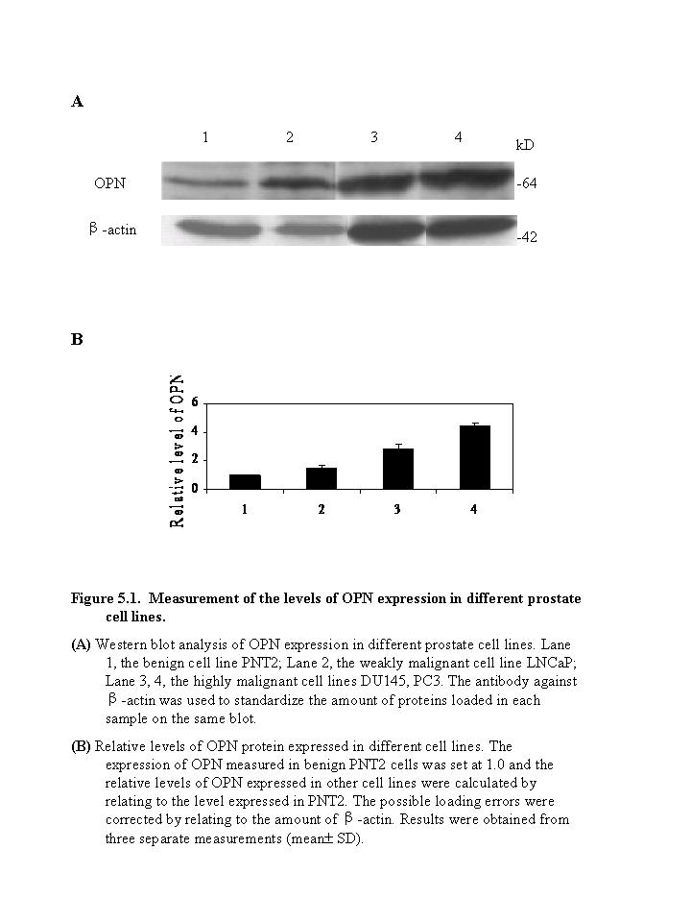

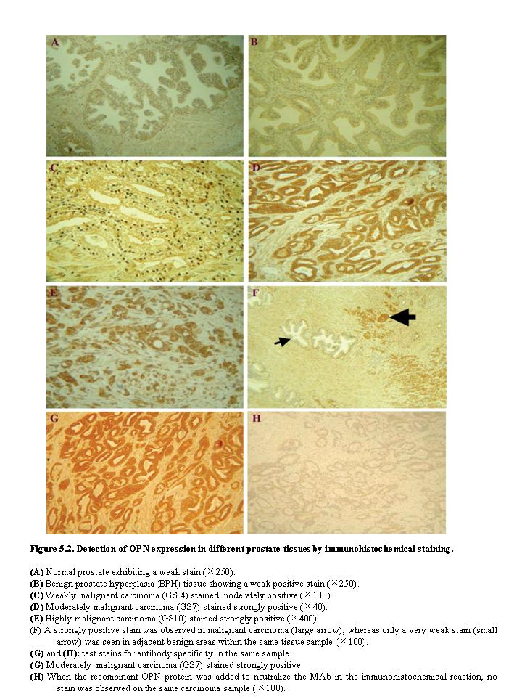

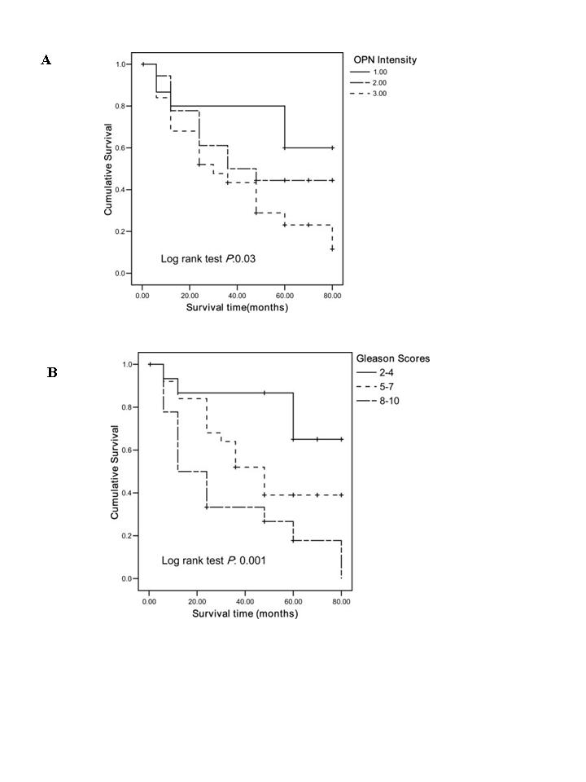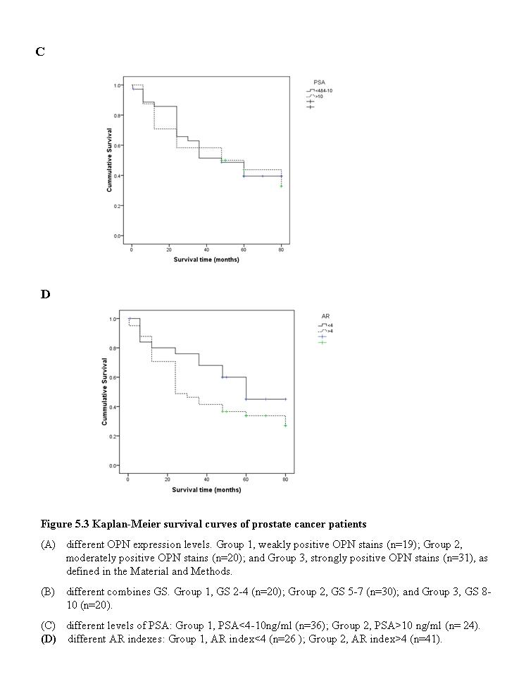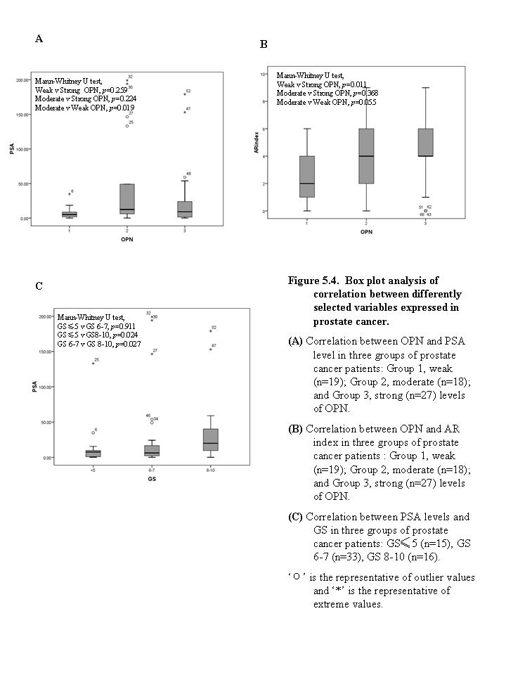

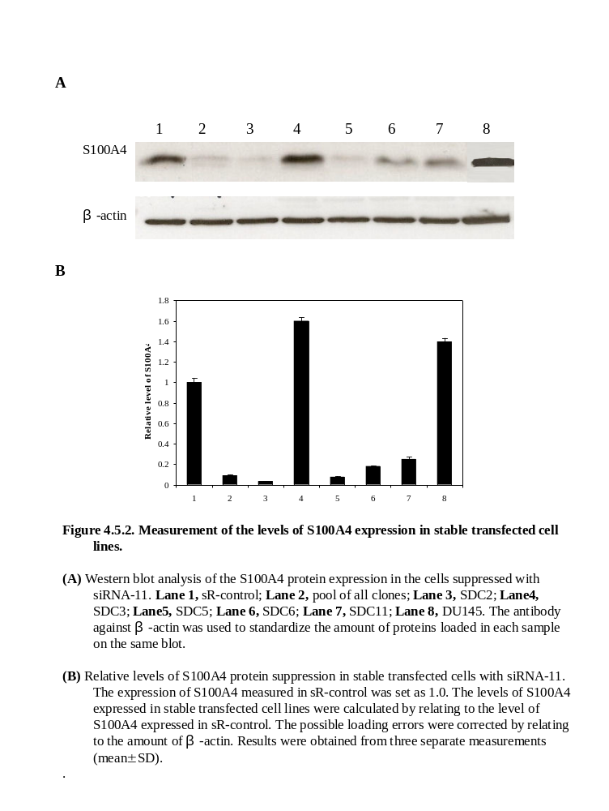
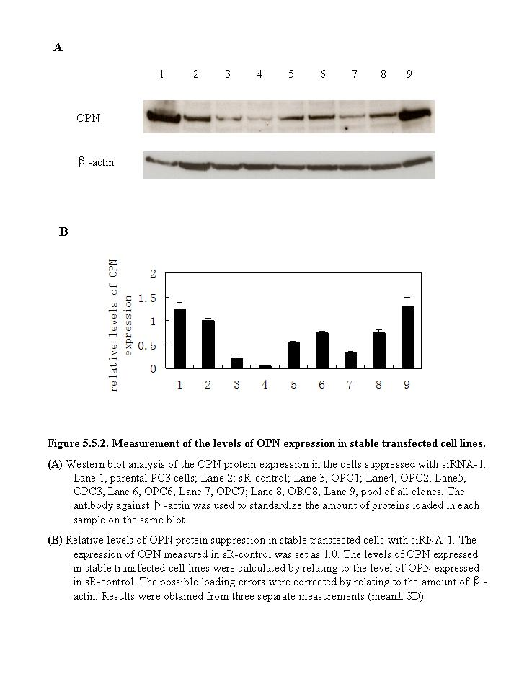

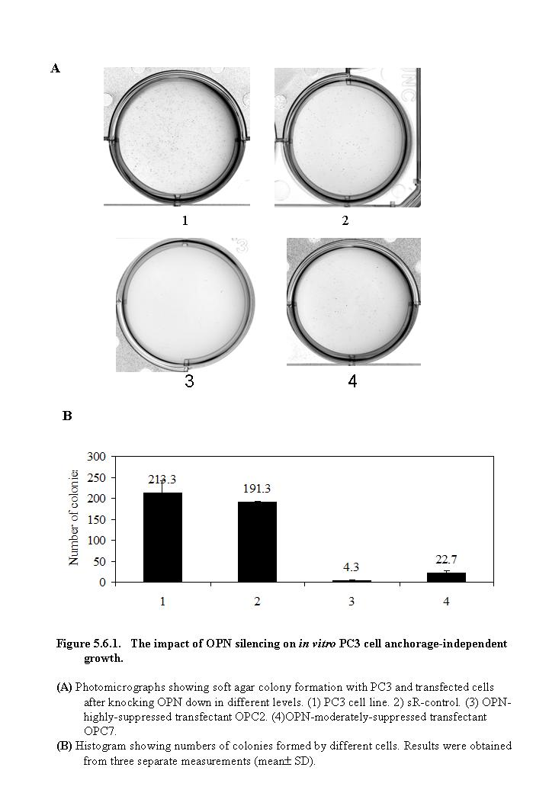

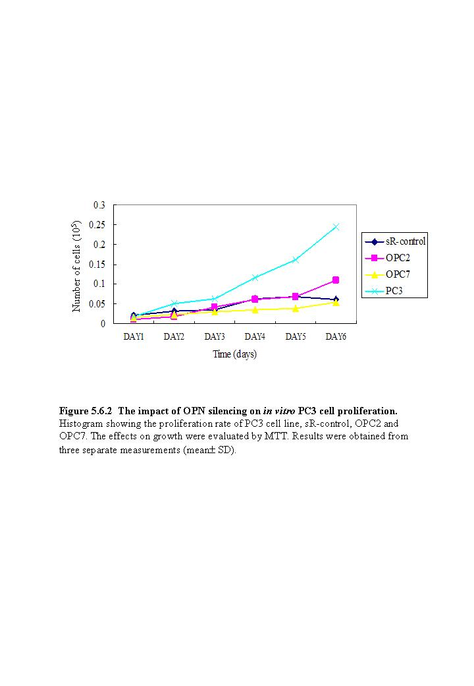
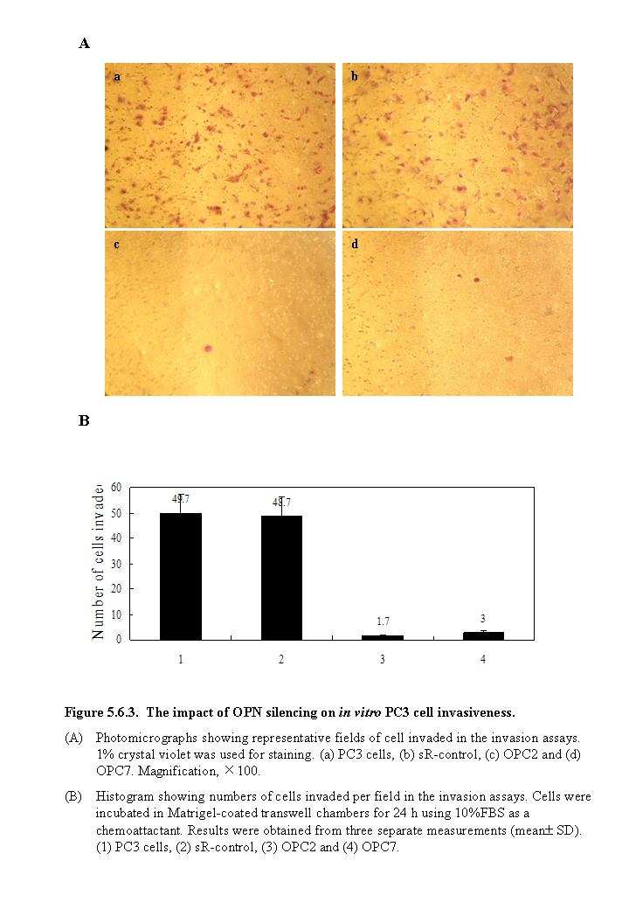

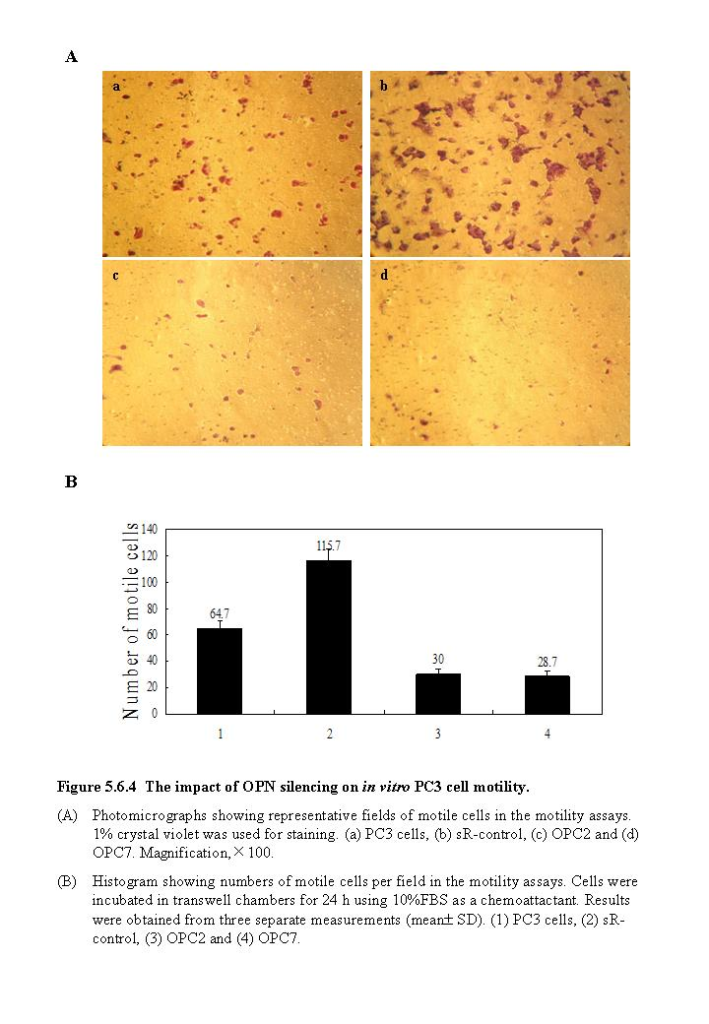

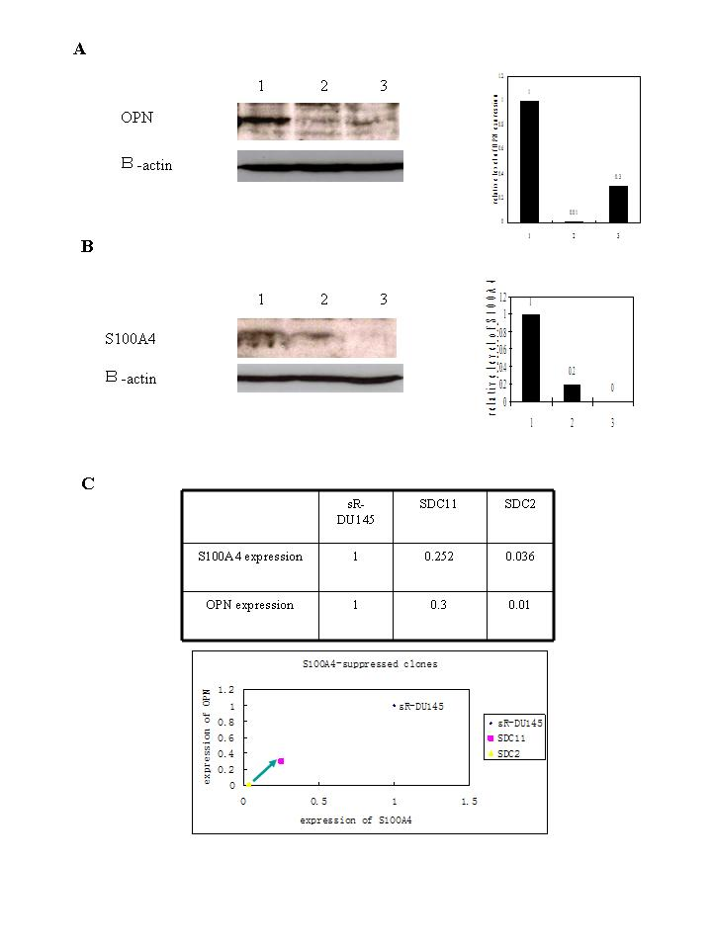
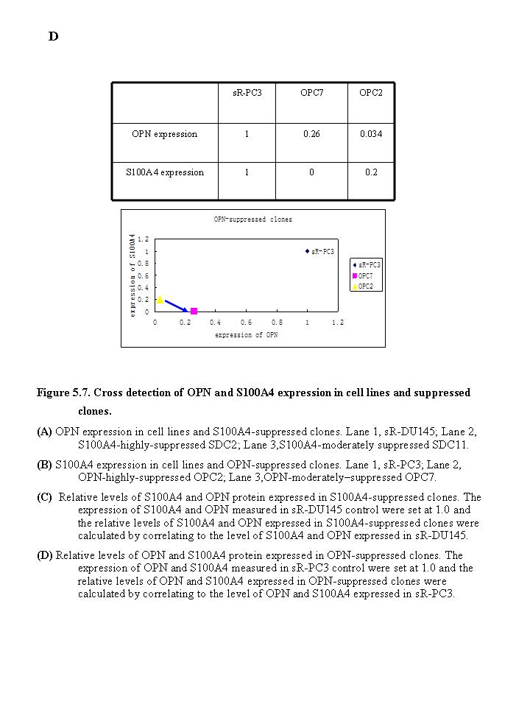

CHAPTER SIX:
Result 4- OPN suppression in DU145 malignant cell line

CHAPTER SIX: Result 4- OPN suppression in DU145 malignant cell line

Result 5.7 suggested that OPN can be the downstream mediator for S100A4. To avoid further arguments on the study of exploring the relationship between these two genes, S100A4 and OPN were suppressed in the same malignant prostate cell line DU145 in which both S100A4 and OPN expressed at a high level. S100A4 suppression in DU145 was shown in Chapter Four. OPN suppression in DU145 malignant cell line were shown as below.

  - Establishment of OPN-suppressed-DU145 (ODC) clones

The plasmid express siRNA1 against OPN-cDNA target used in Chapter 5 was stably transfected into DU145 cells as described in Methods. Three months after the initial transfection, several clones in which the OPN expression was suppressed were established. They were named OPN-suppressed-DU145 clone (ODC) 1, ODC2, ODC3…etc, respectively. Western blot was performed to detect their OPN expression as described in Fig 6.1. Result showed that the level of OPN in clone ODC10 was almost completely suppressed and it was suppressed moderately by 8 folds in ODC4, compared to sR-control transfectant. Thus, OPN-moderately-suppressed clone ODC4 and OPN-highly-suppressed clone ODC10 were chosen for further investigation.

  - Effect of suppression of OPN on DU145 cells in vitro.

    - Suppression of OPN significantly inhibited anchorage-independent growth of DU145 cells

The soft agar colony-formation assay was performed to investigate the effect of OPN expression on anchorage-independent growth of DU145 cells. As shown in Fig 6.2.1, no significant differences (student’s t test, p=0.14) were observed between the number of colonies formed by the parental DU145 cells and the scrambled-RNA transfectant (sR-control). Numbers of colonies produced in soft agar by OPN-highly-suppressed cells ODC10 (student’s t test, p<0.0001) and OPN-moderately-suppressed cells ODC4 (student’s t test, p<0.001) were significantly reduced by 13.6 and 2.6 folds, respectively, in comparison with sR-control.

    - Suppression of OPN had no effect on cellular proliferation

Cell proliferation assays were performed in 144 h to measure the growth rate for SDC clones. The density of cultured cells was determined by extrapolating from the standard curve and cell numbers were obtained by MTT assays as described in Methods. No significant difference was observed either between sR-control with ODC4 (student’s t test, p=0.77) or sR-control with ODC10 (student’s t test, p=0.4).

    - Suppression of OPN significantly inhibited the invasiveness of DU145 cells

The invasiveness of ODC clones were assessed using Matrigel-coated transwell invasion chambers as described in Methods. While no significant (student’s t test, p=0.75) difference between parental DU145 cells and sR-control cells was observed, the invasiveness of ODC4 (student’s t test, p<0.0001) and ODC10 (student’s t test, p<0.003) were reduced by 14 and 8.5 folds respectively, in comparison with sR-control (Fig 6.2.3B). The proportions of invaded cells into Matrigel from DU145, sR-control, ODC4 and ODC10 were shown in Fig 6.2.3A.

    - Suppression of OPN had no effect on cellular motility

The motility of ODC clones were assessed across transwell polycarbonate membranes as described in Methods. No significant (student’s t test, p=0.62) difference was observed between parental DU145 cells and sR-control cells. The motility of ODC4 (student’s t test, p=0.300) and ODC10 (student’s t test, p=0.137) was not significantly different in comparison with sR-control (Fig 6.2.4B). The proportions of motile cells in DU145, sR, ODC4 and ODC10 were shown in Fig 6.2.4A.

  - Discussion

In this study, the plasmid-based RNAi suppressed OPN expression in DU145 prostate cancer cells were performed. Several clones were established after three months (Fig 6.1). Most of them were confirmed a decrease in OPN protein expression (Fig 6.1). OPN-highly-suppressed clone ODC10 and OPN-moderately-suppressed clone ODC4 were selected for further assessment.
Suppression of OPN were associated with a 13.6 and 2.6 fold decrease in anchorage-independent growth (Fig 6.2.1) and 14 and 8.5 fold decrease in invasiveness (Fig 6.2.3) in vitro, respectively, in the OPN-highly-suppressed cells ODC10 and OPN-moderately-suppressed cells ODC4. It was also demonstrated that these phenotypic differences are independent of cellular proliferation as the rate of growth is conserved between sR-control and ODC10 and ODC4 (Fig 6.2.2). Similarly to the result obtained from the SDC clones, but contrast to that from the OPC clones, neither ODC4 (student’s t test, p=0.300) nor ODC10 (student’s t test, p=0.137) showed any significantly difference on cellular motility, in comparison with sR-control (Fig 6.2.4B).
In this work the suppression of OPN in DU145 did reduce the anchorage-independent growth and invasiveness of the prostate cancer cells, like that observed in S100A4. Further assessment of effect of the reduced expression of OPN on the ability of forming tumours of cancer cells in vivo would be the final test to investigate whether S100A4 or OPN can be used as a therapeutic target.

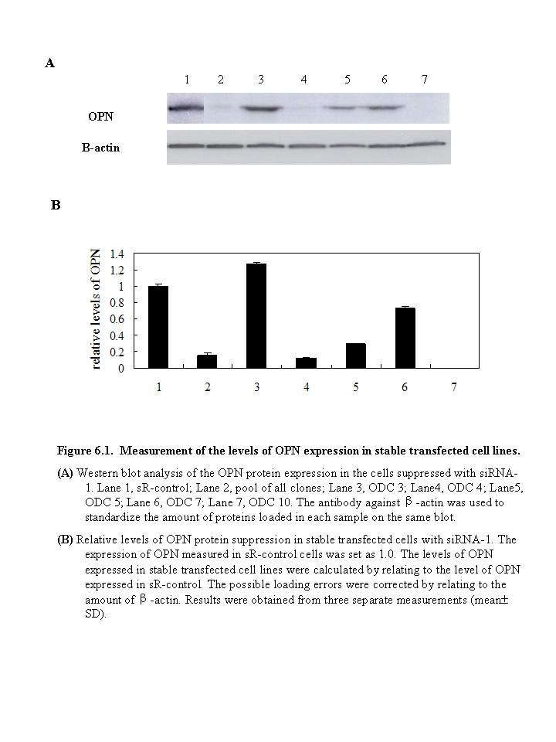
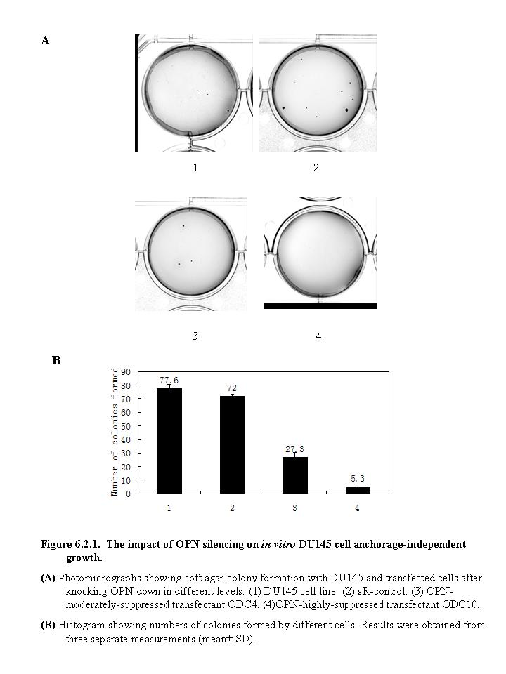

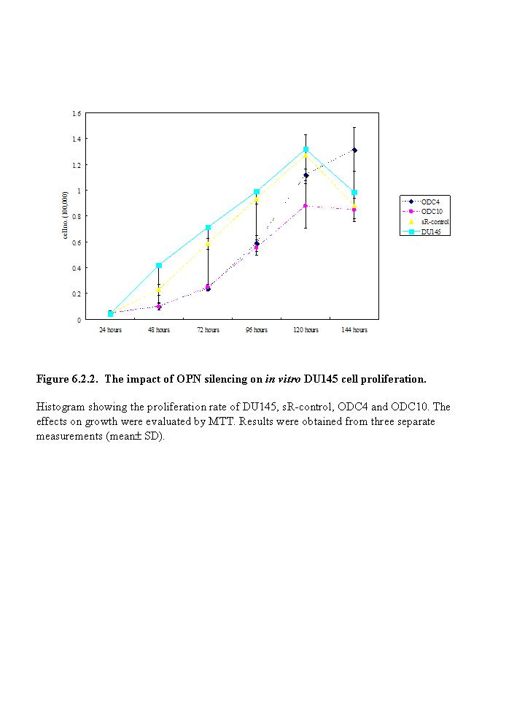

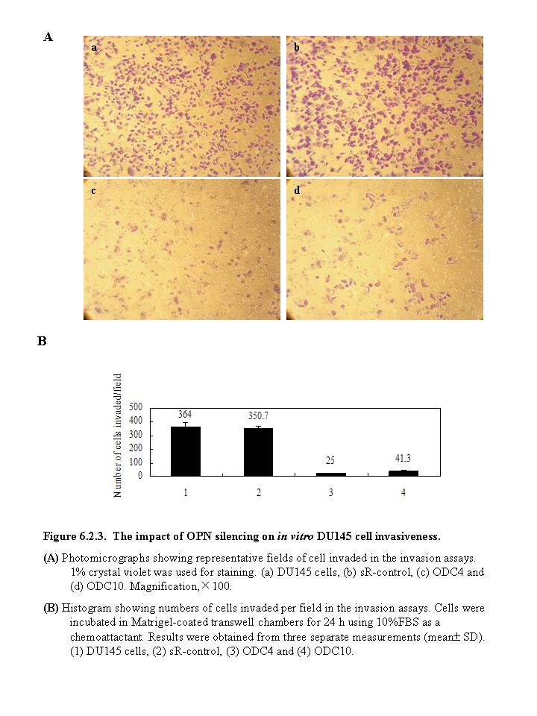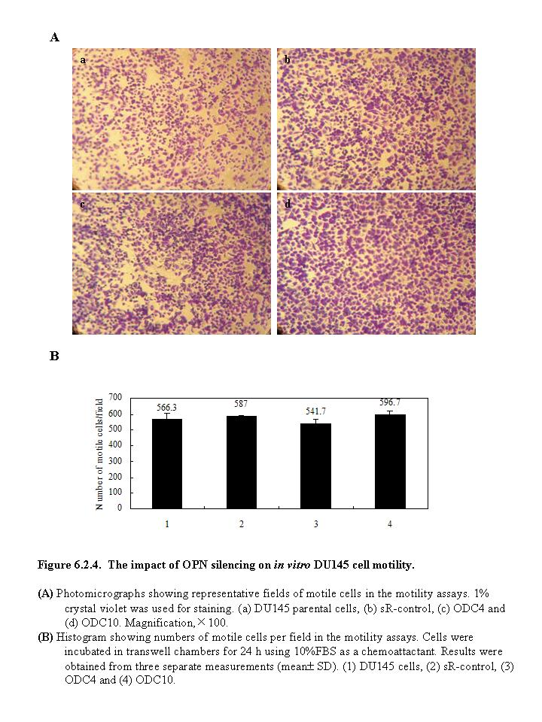

CHAPTER SEVEN:
Result 5- Effect of suppression of OPN and S100A4 in tumorgenecity in vivo

CHAPTER SEVEN: Result 5- Effect of suppression of OPN and S100A4 in tumorgenecity in vivo

To assess the effect of the suppression of OPN and S100A4 in tumorgenecity in vivo, sR-control cells, OPN-moderately-suppressed ODC4 cells, OPN-highly-suppressed ODC10 cells, S100A4-moderately-suppressed SDC11 cells and S100A4-highly-suppressed SDC2 cells were inoculated respectively into 5 groups (8 each) of male balb/c nude mice. Cells were subcutaneously injected into the shoulder area at a density of 2×10⁶ cells (in 200μl PBS) per mouse, as described in Methods.

  - Tumor volume

The control, ODC and SDC cells produced tumors in all nude mice (100% tumor incidence). Tumors appeared in six days in all experimental mice after the inoculation. The volume of the five groups did not exhibit any difference until Day 13 from which the tumor of control group and SDC2 group started to grow faster than the other groups. Tumors from OPN-suppressed groups, ODC4 and ODC10, remarkably grew in a slower rate than those from the control group. Tumors produced by OPN-moderately-suppressed ODC4 grew slower that those in OPN-highly-suppressed ODC10 group. Tumors produced by S100A4-moderately-suppressed SDC11 group grew in the lowest rate during the post-inoculation days amongst all these groups although S100A4-highly-suppressed SDC2 group did not produce any reduction to the sR-control.
On the 23rd day of the post-inoculation days, the average volume of tumors produced by the control cells was 347.9±38.8mm³. The average volume of tumors produced by the group inoculated by ODC4 and ODC10 were 102.2±26.5 mm³ and 204.9±53.6 mm³ respectively. The average volume of tumors in ODC4 group and ODC10 group was significantly reduced by 3.4 (student’s t test, p<0.001) and 1.7 (student’s t test, p<0.01) folds, respectively, in comparison with those in the control group (Fig 7.1B). The average volume of tumors produced by the group inoculated by SDC11 was 62.8±12.5 mm³, significantly reduced by 5.6 (student’s t test, p<0.0001) fold in comparison with the control group. However, the average volume of tumors produced from SDC2 group was 330.8±80mm³, not significantly (student’s t test, p=0.84) different from the control group. Moreover, between two OPN-suppressed groups, the tumors produced by OPN-highly-suppressed ODC10 cells were significantly (student’s t test, p<0.05) larger at nearly 2 times than those produced by OPN-moderately-suppressed ODC4 cells. Between two S100A4-suppressed groups, tumors produced by S100A4-highly-suppressed SDC2 cells was significantly (student’s t test, p<0.003) larger at nearly 5.3 times than those produced by the S100A4-moderately-suppressed SDC11 cells. Fig 7.1C showed the representative tumors taken from each group of mice.

  - S100A4 and OPN expression in tumor tissues by Western blot

Protein was extracted from the tumors produced by control, ODC and SDC cells as described in Methods. Western blot was used to detect the expression level of OPN and S100A4. All data were summarized and the quantitative measurements of relative average OPN and S100A4 expressed in the tumors from different groups of animals were shown in Fig 7.2. When the average level of OPN and S100A4 were both set at 1, the relative levels of OPN expressed in ODC4, ODC10, SDC2 and SDC11 were 0.4±0.12, 0.53±0.09, 0.95±0.38 and 0.16±0.05, respectively. Expression of OPN in the groups of animals inoculated with ODC4, ODC10 and SDC11 were reduced by 2.5, 1.9 and 6.3 fold, respectively, in comparison with that in control group. Expression of OPN was not significantly (student’s t test, p=0.91) reduced in SDC2 group compared to that in control group. The relative level of S100A4 expressed in ODC4, ODC10, SDC2 and SDC11 groups were 0.49±0.14, 0.4±0.04, 0.33±0.09 and 0.58±0.07, reduced by 2, 2.5, 3 and 1.7 fold, in comparison with that in control group.

  - S100A4 and OPN expression in tumor tissues by Immunohistochemistry

Examples of Immunohistochemical stains of tumor tissues with OPN and S100A4 antibodies were shown in Fig 7.3. When stained with OPN antibody, strongly stains were observed in control group (Fig7.3A) and samples stained moderately positive in ODC4 and ODC10 groups. In SDC2 group, it stained strongly positive and in SDC11 group, only weakly positive stains were observed (Fig 7.3A).When stained with S100A4 antibody, it stained strongly positive in control group (Fig 7.3B) and it stained moderately positive and weakly positive in ODC4 group and ODC10 group respectively. Weakly positive stains were observed in SDC2 group while moderately positive stains were shown in SDC11 group (Fig 7.3B).

  - Correlations between the average volumes of tumor and protein expression levels from tumor

    - Correlation between the average volumes of tumor and OPN levels expressed in tumor

The correlation of the average volumes of tumors and OPN expression levels was shown in Fig 7.4.1. It showed the average tumor volumes were significantly associated with the levels of OPN expressed in each group of animals.

    - Correlation between the average volumes of tumors and S100A4 levels expressed in tumors

The correlation of the average volumes of tumors and S100A4 expression levels was shown in Fig 7.4.2. It showed the average tumor volumes were not significantly associated with the levels of S100A4 expressed in each group of animals.

    - Correlation between OPN expression level and S100A4 expression levels in tumors

The correlation of the OPN expression and S100A4 expression levels was shown in Fig 7.4.3. It showed generally, the increment of OPN expression was correlated with the decreased S100A4 expression in tumor.

  - Discussion

The aim of this chapter was to investigate the effect of the reduced OPN or S100A4 on the tumorgenecity of prostate cancer cells in vivo and hence to assess whether OPN or S100A4 can be used as a therapeutic target for prostate cancer.
Animal groups inoculated by OPN-moderately-suppressed ODC4, OPN-highly-suppressed ODC10 and S100A4-moderately-suppressed SDC11 cells produced suppressions in tumor growth of ~3, ~2 and ~5 folds respectively, compared to the group inoculated by the control cells (Fig 7.1A). However, the animal group inoculated by S100A4-highly-suppressed SDC2 did not show any difference in tumor growth from that in control group.
Tumor volumes were measured at the end of experiment as shown in Fig 7.1B. In comparison with the control group, the average volume of tumors from the groups inoculated with OPN-moderately-suppressed ODC4 and OPN-highly-suppressed ODC10 were significantly (student’s t test, p<0.001 and p<0.01) reduced by 3.4 and 1.7 fold, respectively. The average volume of tumors from the group inoculated with S100A4-modertely-suppressed SDC11 was significantly (student’s t test, p<0.0001) reduced by 5.6 fold, compared with the control group, but that inoculated with S100A4-highly-suppressed SDC2 did not have any reduction (student’s t test, p=0.84).
Further analysis showed between the groups injected with ODC4 and ODC10, the tumors produced in the group injected with OPN-highly-suppressed ODC10 were significantly (student’s t test, p<0.05) 2 times larger than those produced in OPN-moderately-suppressed ODC4 group. Tumors produced in the group by S100A4-highly-suppressed SDC2 cells were significantly (student’s t test, p<0.003) larger, at 5.3 times, than those produced in the S100A4-moderately-suppressed SDC11 group, between two animal groups injected with SDC2 and SDC11.
Before injection, the level of OPN in OPN-highly-suppressed ODC10 cells was almost completely suppressed and it was suppressed moderately by 8 folds in OPN-moderately-suppressed ODC4 cells, compared to sR-control cells (Result 6.1). The level of S100A4 in S100A4-modertely-suppressed SDC11 cells and S100A4-highly-suppressed SDC2 cells were suppressed by 4 and 28 folds, respectively, compared with sR-control cells (Result 4.5.1). Generally, no relationship can be observed between the level of OPN suppression in ODC4 and ODC10 cells before the injection and the reduction of tumor volume in vivo. Similarly, the levels of S100A4 expression in SDC2 cells and SDC11 cells before the injection were not associated with the tumor volume in vivo.
RNA interference was born in 1998, when it was demonstrated that small strands of RNA stuck together in pairs, like the strands that make up DNA, could turn off specific genes in roundworms²⁷⁵. This finding was honored by Nobel Prize in Physiology or Medicine in 2006²⁷⁶. It was widely used to suppress the expression of specific genes in a variety of studies²⁷⁷⁻²⁷⁹on different subjects, like virology, oncogenes, cancer therapy etc. However, the exact mechanism was not fully understood. Controversial results were reported by several labs²⁸⁰⁻²⁸². It was recently names as ‘RNAa’, briefly for RNA activation, and these kinds of siRNA were identified leading to the activation of E-cadherin, p21, and VEGF in human cells²⁸³. Although siRNA was enormously successful as a laboratory tool, it is not sufficiently stable in vivo.
Although OPN expression and S100A4 expression were suppressed respectively in ODC and SDC cells by siRNA and the effect of the suppression were observed in vitro in this study, the quantitative suppression of OPN and S100A4 by siRNA can change after the injection in vivo.
In order to clarify the levels of OPN and S100A4 expression in vivo and the possible association with tumor volume, all tumor samples were subjected to Western blot and immunohistochemistry analysis to examine the OPN and S100A4 expression in these tumor tissues.
Results showed that in vivo, the level of OPN in the group inoculated by OPN-moderately-suppressed ODC4 cells was suppressed by 2.5 fold and it was suppressed by 1.9 fold in the group inoculated by OPN-highly-suppressed ODC10 cells, compared to that in the control group (Fig 7.2). In the group inoculated by S100A4-modertely-suppressed SDC11 cells, OPN levels were also reduced by 6.3 fold, compared to that in the control group. OPN level in the S100A4-highly-suppressed SDC2 group was not suppressed significantly, compared to that in the control group.
In vivo, the level of S100A4 in the groups inoculated by ODC4, ODC10, SDC2 and SDC11 cells were significantly inhibited by 2, 2.5, 3 and 1.7 folds, compared to the control group.
To compare the possible change of the suppression of OPN and S100A4 from in vitro to in vivo, the expression levels of OPN and S100A4 before injection and after injection were summarized in Table 7.1.
Table 7.1 Expression of OPN and S100A4 and average tumor volume
 | Level of OPN expression before injection | Level of S100A4 expression before injection | Level of OPN expression  in vivo | Level of S100A4 expression  in vivo | Average Tumor volume (mm3)
control | 1 | 1 | 1 | 1 | 347.9 (100%)
ODC4 | 0.12 | -------- | 0.4 | 0.49 | 102.2 (30%)
ODC10 | 0 | -------- | 0.53 | 0.4 | 204.9 (58%)
SDC2 | -------- | 0.04 | 0.95 | 0.33 | 330.8 (95%)
SDC11 | -------- | 0.25 | 0.16 | 0.58 | 62.8 (18%)

Level of OPN expression in ODC4 cells before injection produced a suppression of 8 fold and exhibited a suppression of 2.5 fold in vivo, compare to that in the control. Level of OPN expression in ODC10 cells was suppressed completely before injection but only exhibited a suppression of 1.9 fold compared to that in control. As shown in Table 7.1, the group inoculated with OPN-highly-suppressed-moderately ODC10 cells expressed higher level of OPN, 1.3 times, than that with OPN-moderately-suppressed- ODC10 cells in vivo. The average tumor volume of the ODC10 group was 2 times larger that that of ODC4 group.
Level of S100A4 expressed in SDC2 cells before injection produced a tremendous suppression of 25 fold and show a suppression of 3 fold in vivo, compare to that in the control. Level of S100A4 expression in SDC11 cells was suppressed 4 fold before injection and exhibited a suppression of 1.7 fold compared to that in control. Although the group inoculated with S100A4-highly-suppressed SDC2 cells still expressed lower expression of S100A4, by 1.8 fold, in comparison with S100A4-moderately-suppressed SDC11 cells in vivo, the difference was not as significant as it was between the S100A4 expression in SDC2 and SDC11 cells before injection. (Table 7.1)
From above, it was suggested that RNAi was not stable in vivo in this study although generally groups of animals injected with OPN-suppressed cells did exhibit a suppression of OPN and those injected with S100A4-suppressed cells did show a suppression of S100A4 in vivo.
Immunohistochemistry analysis result shown in Fig 7.3 also supported the result obtained from Western blot analysis (Fig 7.2) for the levels of OPN and S100A4 expressed in tumors of different groups.
When associating the levels of OPN and S100A4 expression in tumors with the average tumor volumes, interesting correlations were discovered. The suppression of OPN in tumors produced by ODC and SDC cells was significantly correlated to the average tumor volume in each group, indicating that tumor growth and tumor volume were inhibited by suppression of OPN expression and related to the concentration of OPN expressed in tumors (Fig 7.4.1). However, the suppression of S100A4 in tumors produced by cell lines was not associated with the average tumor volume in each group of animals (Fig 7.4.2), suggesting OPN but not S100A4 was the determinate for the tumorgenecity in vivo.
From the In vitro assays (Result 5.7), it was suggested that S100A4 may be an upstream mediator of OPN which mediating through OPN. However, in vivo, Fig 7.4.3 showed increment of OPN expression was correlated with the decrease of S100A4 expression, which indicating S100A4 may be one of the upstream mediators which can only mediate the tumorgenecity through OPN in vivo.
These results showed that the tumor growth and tumor volume were inhibited by suppression of OPN expression and related to the concentration of OPN expressed in tumors. It suggested that OPN, not S100A4, can be used as a therapeutic target for prostate cancer.

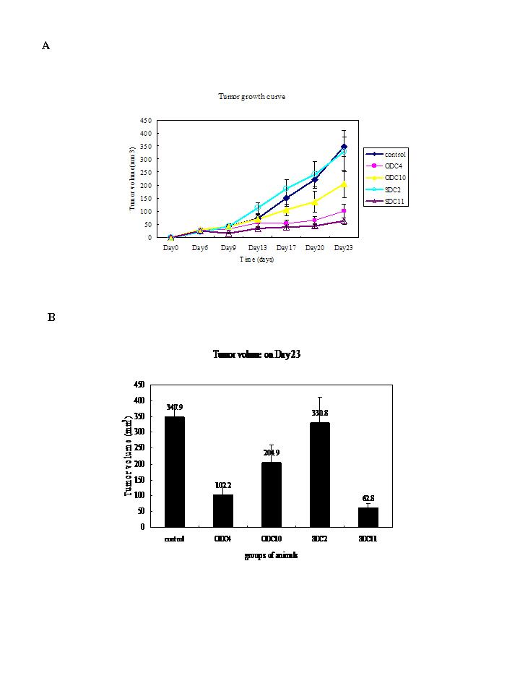
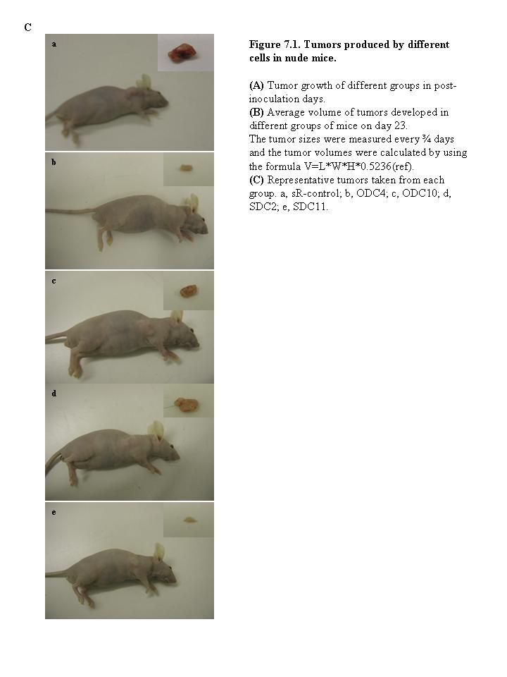
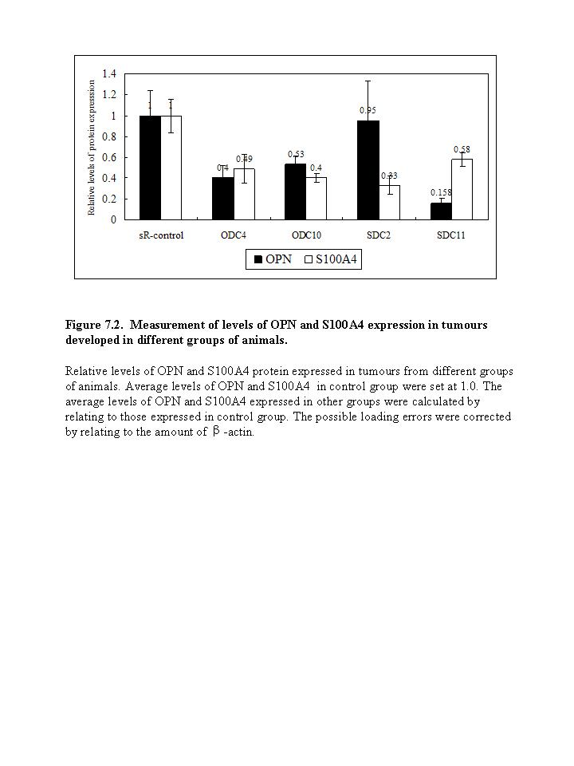
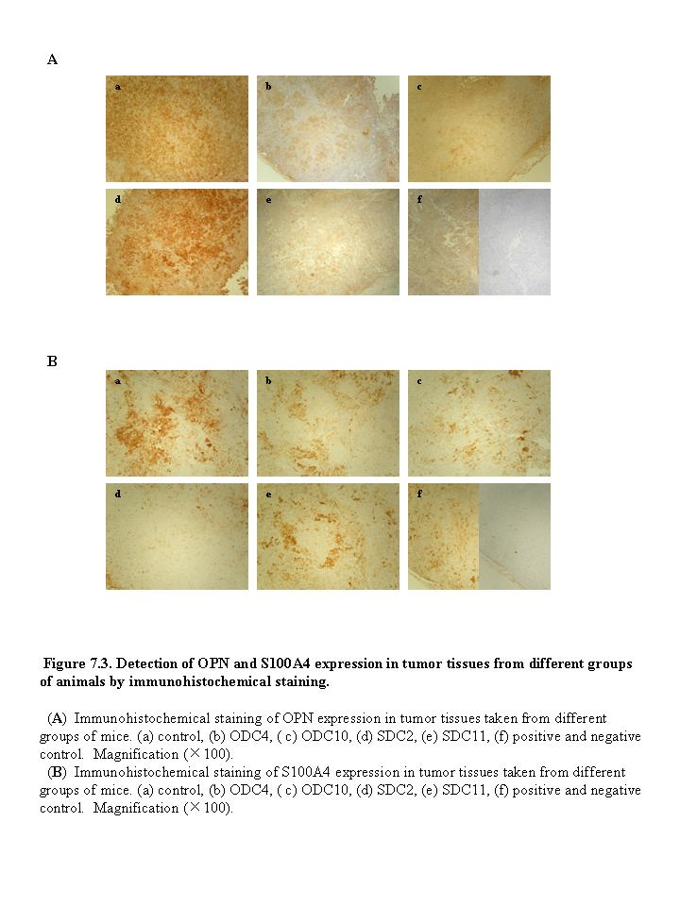
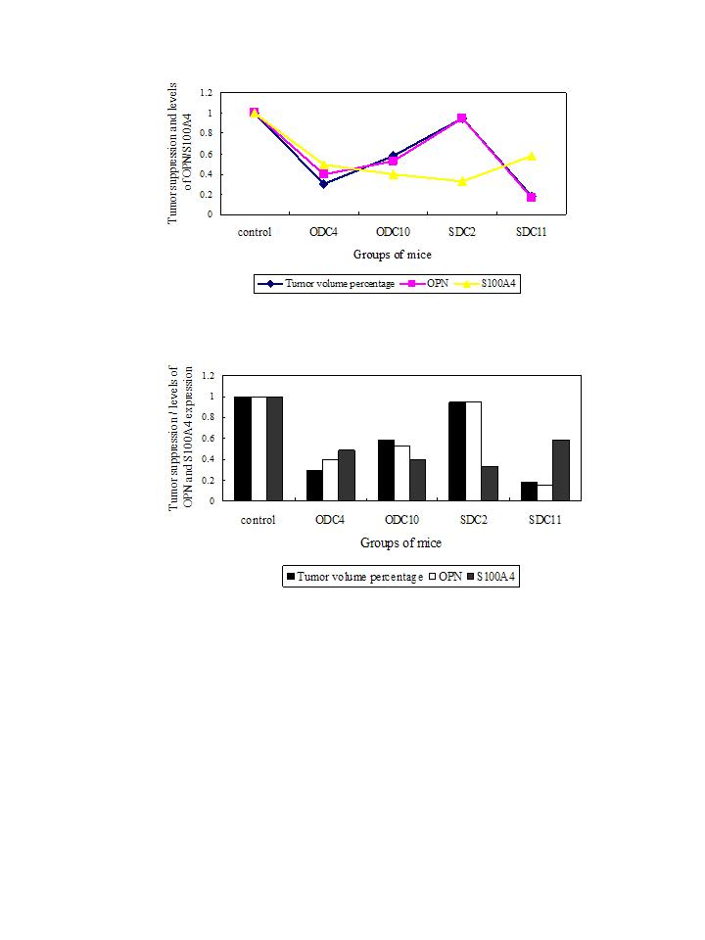
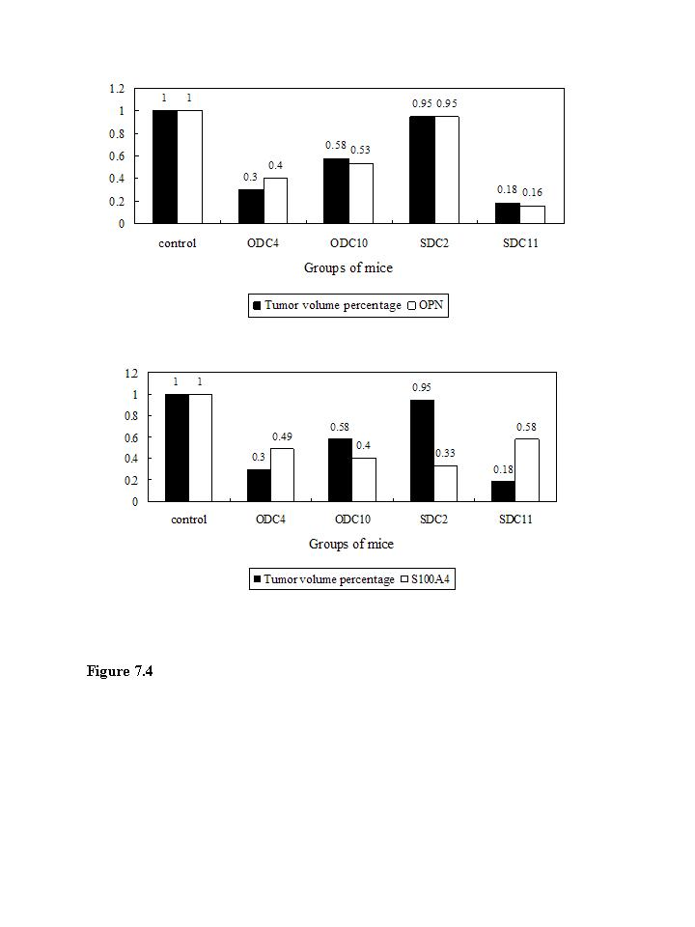

Chapter EIGHT:
General discussion and conclusions

Chapter EIGHT: General discussion and conclusions

Prostate cancer, accounting for 24% of total cancer cases and caused 10,038 deaths, becomes the most common cancer in UK males in 2006.
The molecular pathology of prostate cancer is complex. Great effort has been made to find out those genes promoting or suppressing malignant progression of prostate cancer and many new genes have been identified. In contrast to rapid development in identification of new oncogenes and tumor suppressor genes, progress in searching for new prognostic markers and therapeutic targets from cancer-related genes has been relatively slow.
The overall aim of this thesis was to examine the possibility of using three candidate genes as prognostic markers and the potential therapeutic targets in prostate cancer. The identification of the prognostic and therapeutic significance of these genes can be of clinical importance. To achieve this aim, the work focused on two areas: firstly, assessment of the prognostic significance of these genes; secondly, investigation of the therapeutic potential of these genes.
AGR2, S100A4 and OPN were selected as the candidate genes because they were highly and universally expressed in a variety of cancers. In addition, they have shown their possible role of the prognosis and therapy potential in the breast cancer which is also the hormone responsible cancer like the prostate cancer. Expressions of these three genes have been observed in a variety of cancers. Their elevated expressions were reported in breast cancer. AGR2 was expressed at a higher level in the human breast cancer cell line MCF-7 than in the benign cell line Hama 123⁴⁸. S100A4 protein expression appeared widely expressed in early and advanced breast cancer stages compared with normal breast when applying Immunohistochemistry to malignant and normal breast tissue cores from 216 patients²⁸⁴. Study on the primary tumors of 154 patients with lymph node negative (LNN) breast cancer examined by immunohistochemical analysis and in situ hybridization revealed the overexpression of OPN protein and mRNA²²⁹. Furthermore, these three genes have some similarities in the structure and mechanism and some possible relationships have been suggested between them in playing the role in prostate cancer. Little was investigated on AGR2 in prostate cancer. Controversial results were shown in studies on S100A4 and OPN due to the poor sample size and inefficient methodology. It is of great importance for prostate prognosis and treatment to characterize these molecules for their roles in prostate cancer.

  - Expression of AGR2, S100A4 and OPN in prostate cancer cells and tissues.

Status of AGR2, S100A4 and OPN expression were examined in several commonly used prostate cell lines using western blot analysis. Increased expressions of all these three proteins were found in the highly malignant cells, indicating they may be involved in the malignancy progression of prostate cancers. The immunohistochemistry analyses was applied to the prostate tissue samples of patients and significant increase in the levels of AGR2 ,S100A4 and OPN expression was observed in carcinomas compared to normal and BPH cases, suggesting that AGR2, S100A4 and OPN can be an indicator for the malignant progression of prostate cancer.

  - AGR2 and OPN were associated with the patients survival

Overall increased AGR2 and OPN expression was significantly associated with the poor prognosis in terms of patient survival, respectively, indicating level of immunostaining of AGR2 and OPN may be used as a tool in the diagnosis and prognosis of prostatic biopsies. Although the median survival time for patients with positive S100A4 stains was 12 months shorter than those stained negatively this difference was not statistically significant suggesting the S100A4 stain intensity increment may not be used to accurately predict the patient outcome.
Reliable prognostic biomarkers are always of clinical importance. Studies on prognostic biomarkers for prostate cancer have identified several potential molecules for their predictive value. However, none of them can replace PSA. PSA is still used as a standard tool in practical diagnosis for prostate cancer. In recent years, more and more controversies in PSA use were revealed, especially focus on the cutpoint of PSA levels between ‘normal’ and ‘abnormal’ which was usually 4.0ng/ml^{34, 35}. Recently, it was evident that when data on the PSA level and prostate cancer were analyzed during five-year intervals at a hospital, PSA levels were only associated with prostate weight from 1998 to 2003 while serum PSA was correlated with prostate stage, grade and size from 1983 to 1988³⁶. Obviously, more reliable and consistent biomarker should be valued and considered.
This study suggested that AGR2 and OPN may be potential prognostic biomarkers for prostate cancer in this study.

  - Both OPN and S100A4 suppressed tumor cells in vitro

RNAi was used to suppress S100A4 expression in DU145 prostate cancer cells and OPN expression in PC3 cells. Long-term S100A4-suppressed-DU145 (SDC) clones and OPN-suppressed-PC3 (OPC) clones were established. SDC2 and SDC11 were chosen to investigate the effect of suppression of S100A4 as representative S100A4-highly-suppressed and S100A4-moderately-suppressed clones to avoid colonel variation. OPC2 and OPC7 were selected in the same purpose. Soft-agar assays, proliferation assays, invasion and motility assays were performed to examine the effect of the suppression to the anchorage-independent growth, proliferation, invasiveness and motility of cancer cells. The results showed that although high expression of S100A4 was not significantly associated with poor prognosis, the suppression of S100A4 did reduce the anchorage-independent growth and invasiveness of the prostate cancer cells. High expression of OPN was not only significantly associated with poor prognosis, but the suppression of OPN also did reduce the anchorage-independent growth, invasiveness and cellular motility of the prostate cancer cells. Since both of S100A4-suppressed SDC clones and OPN-suppressed OPC clones showed their suppression in the anchorage-independent growth and invasiveness, relationship between S100A4 and OPN were explored using Western blot. Result indicated that S100A4 may be upstream mediator of OPN and it plays an important role in carcinogenesis through mediating of modulate OPN in prostate cancer.
To detect the effect of the suppression of S100A4 and OPN more accurately, OPN-suppressed-DU145 clones were also established. In vitro assays were carried on the OPN-highly-suppressed clone ODC10 and OPN-moderately-suppressed clone ODC4. It was demonstrated that the suppression of OPN in DU145 did reduce the anchorage-independent growth and invasiveness of the prostate cancer cells, like that observed in S100A4.
RNAi is a successful lab tool in suppressing gene expression since it was discovered in 1998²⁷⁵. It has been used to test the hypotheses of gene function, functional screening and target identification, target validation and therapeutics²⁴⁵. siRNA, short interference RNA, was originally identified in the RNA interference pathway but the endogeous siRNAs have been identified in plants, fungi and animals. It was adopted in this study to silence the S100A4/OPN expression in prostate cancer cells. Result showed that RNAi did silencing the protein expression in cancer cells.
Anchorage-independent growth, proliferation, invasiveness and motility, these are four important capabilities for cancer cells during the tumor development, especially invasiveness. The capability for invasion and metastasis enables cancer cells to escape the primary tumor mass and colonize new terrain in the body where nutrients and space are not limiting at least initially²⁸⁵. It was suggested S100A4 modulate the invasiveness of tumor cells through inhibiting of PKC and CK2 dependent phosphorylation of nonmuscle myosin^{96, 116} and thus increasing the myosin solubility, suppressing its assembly and directly destabilizing myosin filaments¹¹⁷. Compared to S100A4, the pathway OPN involved in invasiveness is much more complicated. Several studies showed that OPN activated pro-MMP-2 via an NF-kappa-B mediated pathway during ECM invasion^{184, 188}. It was also shown that OPN induction on NF kappa B activity and uPA secretion was PI3’-kinase/Akt/iKK mediated¹⁸⁹. MMP-9, was reported to be activated by OPN through MAPK/IKKalpha/beta-dependent NIK/NFκB mediated pathway, thus regulating the invasiveness¹⁹¹.Thus, OPN activated MMP through several overlapping pathways¹⁴⁵.

  - OPN, not S100A4 suppressed the tumorgenecity in vivo

Assessment of effect of the reduced expression of S100A4 and OPN on the ability of forming tumours of cancer cells in vivo were performed to investigate whether S100A4 or OPN can be used as a therapeutic target. OPN, not S100A4, was found playing a determinate role on the tumor growth and tumor volume in this study. It was revealed that the tumor growth and tumor volume were inhibited by suppression of OPN expression and related to the concentration of OPN expressed in vivo, suggesting that OPN can be used as a therapeutic target for prostate cancer.
OPN contributed to prostate cancer progression^{217, 218} and associated with the clinical data, especially patient survival²²⁵. Recently, most mechanism studies were focused on the role of OPN-mediated MMP activation in prostate cancer progression^{223, 227}. It suggested that the OPN pathway play a vital key role in prostate cancer progression.
Not only in prostate cancer cells, OPN is expressed and secreted by various other cells, and has a role in cell adhesion, chemotaxis, prevention of apoptosis, invasion, migration and anchorage-independent growth of tumor cells in a variety of cancers²⁸⁶. Since OPN acts an oncogenic molecule in cancers, it was suggested that silencing the OPN message by RNAi may be useful approach for treatment of cancer¹⁶².

The work presented in this thesis has established several important findings:
Firstly, the overexpression of AGR2, S100A4, OPN in malignant cancer cells and tissues suggested all of them were involved in the malignancy of prostate cancer.
Secondly, elevated AGR2 or OPN expression were associated with the poor patient survival, suggesting AGR2 and OPN can be used as a prognostic biomarker for prostate cancer.
Thirdly, suppression of S100A4 or OPN can inhibited the anchorage-independent growth and invasiveness in prostate cancer cells in vitro.
Fourthly, in vivo, suppression of OPN expression inhibited tumor growth and tumor volume and the concentration of OPN expressed in tumor were associated with the average tumor volume, suggesting that OPN can be used as a therapeutic target for prostate cancer.
Finally, S100A4 effect tumorgenecity through modulating OPN expression, suggesting that S100A4 was an upstream mediator for OPN.

references

1. Giovannucci E LY, Platz EA, Stampfer MJ, Willett WC. Risk factors for prostate cancer incidence and progression in the health professionals follow-up study. Int J Cancer 2007; 121 (7):1571-1578.
2. Sakr WA GD, Haas GP, Heilbrun LK, Pontes JE, Crissman JD. Age and racial distribution of prostatic intraepithelial neoplasia. Eur Urol 1996; 30 (2):138-144.
3. Merrill RM PA, Feuer EJ. Changing trends in U.S. prostate cancer incidence rates. J Natl Cancer Inst 1996; 88 (22):1683-1685.
4. Carter BS BT, Steinberg GD, Childs B, Walsh PC. Mendelian inheritance of familial prostate cancer. Proc Natl Acad Sci U S A 1992; 89 (8):3367-3371.
5. Johns LE HR. A systematic review and meta-analysis of familial prostate cancer risk. BJU Int 2003; 91 (9):789-794.
6. Eeles RA PT. Chemoprevention options for BRCA1 and BRCA2 mutation carriers. J Clin Oncol 2000; 18 ((21 suppl)):93s-99s.
7. Eeles RA K-JZ, Giles GG, Olama AA, Guy M, Jugurnauth SK, Mulholland S, Leongamornlert DA, Edwards SM, Morrison J, Field HI, Southey MC, Severi G, Donovan JL, Hamdy FC, Dearnaley DP, Muir KR, Smith C, Bagnato M, Ardern-Jones AT, Hall AL, O'Brien LT, Gehr-Swain BN, Wilkinson RA, Cox A, Lewis S, Brown PM, Jhavar SG, Tymrakiewicz M, Lophatananon A, Bryant SL; UK Genetic Prostate Cancer Study Collaborators; British Association of Urological Surgeons' Section of Oncology; UK ProtecT Study Collaborators, Horwich A, Huddart RA, Khoo VS, Parker CC, Woodhouse CJ, Thompson A, Christmas T, Ogden C, Fisher C, Jamieson C, Cooper CS, English DR, Hopper JL, Neal DE, Easton DF. Multiple newly identified loci associated with prostate cancer susceptibility. Nat Genet 2008; 40 (3):316-321.
8. Thomas G JK, Yeager M, Kraft P, Wacholder S, Orr N, Yu K, Chatterjee N, Welch R, Hutchinson A, Crenshaw A, Cancel-Tassin G, Staats BJ, Wang Z, Gonzalez-Bosquet J, Fang J, Deng X, Berndt SI, Calle EE, Feigelson HS, Thun MJ, Rodriguez C, Albanes D, Virtamo J, Weinstein S, Schumacher FR, Giovannucci E, Willett WC, Cussenot O, Valeri A, Andriole GL, Crawford ED, Tucker M, Gerhard DS, Fraumeni JF Jr, Hoover R, Hayes RB, Hunter DJ, Chanock SJ. Multiple loci identified in a genome-wide association study of prostate cancer. Nat Genet 2008; 40 (3):310-315.
9. Jack RH DE, Møller H. Testis and prostate cancer incidence in ethnic groups in South East England. Int J Androl 2007; 30 (4):215-220.
10. Ben-Shlomo Y ES, Ibrahim F, Patel B, Anson K, Chinegwundoh F, Corbishley C, Dorling D, Thomas B, Gillatt D, Kirby R, Muir G, Nargund V, Popert R, Metcalfe C, Persad R; PROCESS study group. The risk of prostate cancer amongst black men in the United Kingdom: the PROCESS cohort study. Eur Urol 2008; 53 (1):99-105.
11. Parkin DM BF, Devesa SS. Cancer burden in the year 2000. The global picture. Eur J Cancer 2001; 37 (Suppl 8):S4-66.
12. Winter H CK, Cummins C, Maric R, Silcocks P, Varghese C. Cancer incidence in the south Asian population of England (1990-92). Br J Cancer 1999; 79 (3-4):645-654.
13. JE. M. Origin and development of carcinoma in the prostate. Cancer 1969; 23 (1):24-34.
14. Ahmed N. prostate cancer. 1995.
15. Bostwick FCaD. Pathology of the prostate. 1998.
16. Curran S AO, Agildere AM, Zhang J, Hricak H, Rademaker J. Endorectal MRI of prostatic and periprostatic cystic lesions and their mimics. AJR Am J Roentgenol 2007; 188 (5):1373-1379.
17. L. S. Distinguishing prostate cancer from BPH. Trends Endocrinol Metab 2001; 12 (4):146.
18. RS K. Textbook of benign prostatic hyperplasia. 2005.
19. WE. F. Estrogen in the etiopathogenesis of BPH. Prostate 1999; 41 (4):263-274.
20. DG. B. Prostatic intraepithelial neoplasia is a risk factor for cancer. Semin Urol Oncol 1999; 17 (4):187-198.
21. Bostwick DG QJ, Frankel K. The incidence of high grade prostatic intraepithelial neoplasia in needle biopsies. J Urol 1995; 154 (5):1791-1794.
22. DF G. Classification of prostatic carcinomas. Cancer Chemother Rep 1966; 50 (3):125-128.
23. Gleason DF MG. Prediction of prognosis for prostatic adenocarcinoma by combined histological grading and clinical staging. J Urol 1974; 111 (1):58-64.
24. Epstein JI AWJ, Amin MB, Egevad LL; ISUP Grading Committee. The 2005 International Society of Urological Pathology (ISUP) Consensus Conference on Gleason Grading of Prostatic Carcinoma. Am J Surg Pathol 2005; 29 (9):1228-1242.
25. DF. G. Histologic grading of prostate cancer: a perspective. Hum Pathol 1992; 23 (3):273-279.
26. Helpap B EL. Modified gleason grading. An updated review. Histol Histopathol 2009; 24 (5):661-666.
27. Hughes C MA, Martin C, Sheils O, O'Leary J. Molecular pathology of prostate cancer. J Clin Pathol 2005; 58 (7):673-684.
28. Fleshner NE LN. Risk of developing prostate cancer in the future: overview of prognostic biomarkers. Urology 2009; 73 (5 suppl):S21-27.
29. DA. A. Prostate-specific antigen: biochemistry, analytical methods, and clinical application. Clin Chem 1993; 39 (2):181-195.
30. Schaller J AK, Tsuda R, Hara M, Marti T, Rickli EE. Isolation, characterization and amino-acid sequence of gamma-seminoprotein, a glycoprotein from human seminal plasma. Eur J Biochem 1987; 170 (1-2):111-120.
31. Freedland S. Measurement of prostate specific antigen wwwuptodatecom 2009.
32. Brawer MK CM, Beatie J, Buchner DM, Vessella RL, Lange PH. Screening for prostatic carcinoma with prostate specific antigen. J Urol 1992; 147 (3 Pt 2):841-845.
33. MK. B. Prostate-specific antigen: current status. CA Cancer J Clin 1999; 49 (5):264-281.
34. Catalona WJ RJ, Ahmann FR, Hudson MA, Scardino PT, Flanigan RC, deKernion JB, Ratliff TL, Kavoussi LR, Dalkin BL, et al. Comparison of digital rectal examination and serum prostate specific antigen in the early detection of prostate cancer: results of a multicenter clinical trial of 6,630 men. J Urol 1994; 151 (5):1308-1309.
35. Babaian RJ JD, Naccarato W, Ayala A, Bhadkamkar VA, Fritsche HA HA Jr. The incidence of prostate cancer in a screening population with a serum prostate specific antigen between 2.5 and 4.0 ng/ml: relation to biopsy strategy. J Urol 2001; 165 (3):757-760.
36. Stamey TA CM, McNeal JE, Nolley R, Hemenez M, Downs J. The prostate specific antigen era in the United States is over for prostate cancer: what happened in the last 20 years? J Urol 2004; 172 (4 Pt 1):1297-1301.
37. Aberger F WG, Grunz H, Richter K. Anterior specification of embryonic ectoderm: the role of the Xenopus cement gland-specific gene XAG-2. Mech Dev 1998; 72 (1-2):115-130.
38. Zhang Y FS, Liu D, Barraclough R, Foster CS, Rudland PS, Ke Y. Increased expression of anterior gradient-2 is significantly associated with poor survival of prostate cancer patients. Prostate Cancer Prostatic Dis 2007; 10 (3):293-300.
39. Innes HE LD, Barraclough R, Davies MP, O'Neill PA, Platt-Higgins A, de Silva Rudland S, Sibson DR, Rudland PS. Significance of the metastasis-inducing protein AGR2 for outcome in hormonally treated breast cancer patients. Br J Cancer 2006; 94 (7):1057-1065.
40. Petek E WC, Egger H, Kroisel PM, Wagner K. Localization of the human anterior gradient-2 gene (AGR2) to chromosome band 7p21.3 by radiation hybrid mapping and fluorescencein situ hybridisation. Cytogenet Cell Genet 2000; 89 (3-4):141-142.
41. Thompson DA WR. hAG-2, the human homologue of the Xenopus laevis cement gland gene XAG-2, is coexpressed with estrogen receptor in breast cancer cell lines. Biochem Biophys Res Commun 1998; 251 (1):111-116.
42. Komiya T TY, Hirohashi S. Cloning of the gene gob-4, which is expressed in intestinal goblet cells in mice. Biochim Biophys Acta 1999; 1444 (3):434-438.
43. Sive HL HK, Weintraub H. Progressive determination during formation of the anteroposterior axis in Xenopus laevis. Cell 1989; 58 (1):171-180.
44. Hao Y TG, Sahbaie P, Young HS, Omary MB, Lowe AW. Gene expression profiling reveals stromal genes expressed in common between Barrett's esophagus and adenocarcinoma. Gastroenterology 2006; 131 (3):925-933.
45. Iacobuzio-Donahue CA MA, Olsen M, Lowe AW, van Heek NT, Rosty C, Walter K, Sato N, Parker A, Ashfaq R, Jaffee E, Ryu B, Jones J, Eshleman JR, Yeo CJ, Cameron JL, Kern SE, Hruban RH, Brown PO, Goggins M. Exploration of global gene expression patterns in pancreatic adenocarcinoma using cDNA microarrays. Am J Pathol 2003; 162 (4):1151-1162.
46. Lowe AW OM, Hao Y, Lee SP, Taek Lee K, Chen X, van de Rijn M, Brown PO. Gene expression patterns in pancreatic tumors, cells and tissues. PLoS ONE 2007; 2 (3):e323.
47. Zhang JS GA, Cheville JC, Smith DI, Young CY. AGR2, an androgen-inducible secretory protein overexpressed in prostate cancer. Genes Chromosomes Cancer 2005; 43 (3):249-259.
48. Liu D RP, Sibson DR, Platt-Higgins A, Barraclough R. Human homologue of cement gland protein, a novel metastasis inducer associated with breast carcinomas. Cancer Res 2005; 65 (9):3796-3805.
49. Zimmer DB CE, Landar A, Song W. The S100 protein family: history, function, and expression. Brain Res Bull 1995; 37 (4):417-429.
50. Marenholz I HC, Fritz G. S100 proteins in mouse and man: from evolution to function and pathology (including an update of the nomenclature). Biochem Biophys Res Commun 2004; 322 (4):1111-1122.
51. CW H. The multifunctional S100 protein family. Methods Mol Biol 2002; 172:69-80.
52. BW. M. A soluble protein characteristic of the nervous system. Biochem Biophys Res Commun 1965; 19 (6):739-744.
53. Hidaka H ET, Kawamoto S, Yamada E, Umekawa H, Tanabe K, Hara K. Purification and characterization of adipose tissue S-100b protein. J Biol Chem 1983; 258 (4):2705-2709.
54. Isobe T OT. The amino-acid sequence of the alpha subunit in bovine brain S-100a protein. Eur J Biochem 1981; 116 (1):79-86.
55. Salama I MP, Mihaimeed F, Jones JL. A review of the S100 proteins in cancer. Eur J Surg Oncol 2008; 34 (4):357-364.
56. Zimmer DB WSP, Weber DJ. Molecular mechanisms of S100-target protein interactions. Microsc Res Tech 2003; 60 (6):552-559.
57. R. D. Intracellular and extracellular roles of S100 proteins. Microsc Res Tech 2003; 60 (6):540-551.
58. Rehman I CS, Catto JW, Leiblich A, Mukherjee A, Azzouzi AR, Leung HY, Hamdy FC. Promoter hyper-methylation of calcium binding proteins S100A6 and S100A2 in human prostate cancer. Prostate 2005; 65 (4):322-330.
59. Helfman DM KE, Lukanidin E, Grigorian M. The metastasis associated protein S100A4: role in tumour progression and metastasis. Br J Cancer 2005; 92 (11):1955-1958.
60. Hancq S SI, Brotchi J, De Witte O, Gabius HJ, Heizmann CW, Kiss R, Decaestecker C. S100A5: a marker of recurrence in WHO grade I meningiomas. Neuropathol Appl Neurobiol 2004; 30 (2):178-187.
61. Rehman I CS, Azzouzi AR, Catto JW, Deloulme JC, Larre S, Champigneuille J, Fromont G, Cussenot O, Hamdy FC. S100A6 (Calcyclin) is a prostate basal cell marker absent in prostate cancer and its precursors. Br J Cancer 2004; 91 (4):739-744.
62. Cross SS HF, Deloulme JC, Rehman I. Expression of S100 proteins in normal human tissues and common cancers using tissue microarrays: S100A6, S100A8, S100A9 and S100A11 are all overexpressed in common cancers. Histopathology 2005; 46 (3).
63. Rehman I AA, Cross SS, Deloulme JC, Catto JW, Wylde N, Larre S, Champigneuille J, Hamdy FC. Dysregulated expression of S100A11 (calgizzarin) in prostate cancer and precursor lesions. Hum Pathol 2004; 35 (11):1385-1391.
64. Dukhanina EA DA, Lomonosov MY, Lukanidin EM, Georgiev GP. Spectral studies on the calcium-binding properties of Mts1 protein and its interaction with target protein. FEBS Lett 1997; 410 (2-3):403-406.
65. Garrett SC VK, Weber DJ, Bresnick AR. S100A4, a mediator of metastasis. J Biol Chem 2006; 281 (2):677-680.
66. Vallely KM RR, Ellis KC, Varlamova O, Bresnick AR, Weber DJ. Solution structure of human Mts1 (S100A4) as determined by NMR spectroscopy. Biochemistry 2002; 41 (42):12670-12680.
67. Mäler L PB, Chazin WJ. High resolution solution structure of apo calcyclin and structural variations in the S100 family of calcium-binding proteins. J Biomol NMR 1999; 13 (3):233-247.
68. Tarabykina S SD, Herzyk P, Hill TJ, Tame JR, Kriajevska M, Lafitte D, Derrick PJ, Dodson GG, Maitland NJ, Lukanidin EM, Bronstein IB. The dimerization interface of the metastasis-associated protein S100A4 (Mts1): in vivo and in vitro studies. J Biol Chem 2001; 276 (26):24212-24222.
69. Koshelev IuA GG, Kibardin AV. Functions of protein MTS1 (S100A4) in normal and tumor cells. Genetika 2008; 44 (2):149-162.
70. Bhattacharya S LE, Heizmann CW, Hemmings B, Chazin WJ. Structure of the Ca2+/S100B/NDR kinase peptide complex: insights into S100 target specificity and activation of the kinase. Biochemistry 2003; 42 (49):14416-14426.
71. Smith SP SG. A change-in-hand mechanism for S100 signalling. Biochem Cell Biol 1998; 76 (2-3):324-333.
72. Inman KG YR, Rustandi RR, Miller KE, Baldisseri DM, Weber DJ. Solution NMR structure of S100B bound to the high-affinity target peptide TRTK-12. J Mol Biol 2002; 324 (5):1003-1014.
73. Ebralidze A TE, Grigorian M, Afanasyeva A, Senin V, Revazova E, Lukanidin E. Isolation and characterization of a gene specifically expressed in different metastatic cells and whose deduced gene product has a high degree of homology to a Ca2+-binding protein family. Genes Dev 1989; 3 (7):1086-1093.
74. Oslejsková L GM, Gay S, Neidhart M, Senolt L. The metastasis associated protein S100A4: a potential novel link to inflammation and consequent aggressive behaviour of rheumatoid arthritis synovial fibroblasts. Ann Rheum Dis 2008; 67 (11):1499-1504.
75. Jackson-Grusby LL SJ, Linzer DI. A growth-related mRNA in cultured mouse cells encodes a placental calcium binding protein. Nucleic Acids Res 1987; 15 (16):6677-6690.
76. Goto K EH, Fujiyoshi T. Cloning of the sequences expressed abundantly in established cell lines: identification of a cDNA clone highly homologous to S-100, a calcium binding protein. J Biochem 1988; 103 (1):48-53.
77. Masiakowski P SE. Nerve growth factor induces the genes for two proteins related to a family of calcium-binding proteins in PC12 cells. Proc Natl Acad Sci U S A 1988; 85 (4):1277-1281.
78. Barraclough R SJ, Dube SK, Rudland PS. Molecular cloning and sequence of the gene for p9Ka. A cultured myoepithelial cell protein with strong homology to S-100, a calcium-binding protein. J Mol Biol 1987; 198 (1):13-20.
79. Watanabe Y KR, Ishikawa T, Hidaka H. Isolation and characterization of a calcium-binding protein derived from mRNA termed p9Ka, pEL-98, 18A2, or 42A by the newly synthesized vasorelaxant W-66 affinity chromatography. Arch Biochem Biophys 1992; 292 (2):563-569.
80. Kuźnicki J FA, Heimann P, Kaczmarek L, Kamińska B. Tissue specific distribution of calcyclin--10.5 kDa Ca2+-binding protein. FEBS Lett 1989; 254 (1-2):141-144.
81. Polans AS PK, Asson-Batres MA, Ohguro H, Witkowska D, Haley TL, Baizer L, Crabb JW. Purification and primary structure of Capl, an S-100-related calcium-binding protein isolated from bovine retina. J Biol Chem 1994; 269 (8):6233-6240.
82. Strutz F OH, Lo CW, Danoff T, Carone RL, Tomaszewski JE, Neilson EG. Identification and characterization of a fibroblast marker: FSP1. J Cell Biol 1995; 130 (2):393-405.
83. Ambartsumian N TS, Grigorian M, Tulchinsky E, Hulgaard E, Georgiev G, Lukanidin E. Characterization of two splice variants of metastasis-associated human mts1 gene. Gene 1995; 159 (1):125-130.
84. Lukanidin EM GG. Metastasis-related mts1 gene. Curr Top Microbiol Immunol 1996; 213:171-195.
85. Hernan R FR, Calabrese C, Frank AJ, Maclean KH, Allard D, Barraclough R, Gilbertson RJ. ERBB2 up-regulates S100A4 and several other prometastatic genes in medulloblastoma. Cancer Res 2003; 63 (140-8).
86. Cohn MA HI, Wu LC, Guldberg P, Lukanidin EM, Tulchinsky EM. Characterization of Sp1, AP-1, CBF and KRC binding sites and minisatellite DNA as functional elements of the metastasis-associated mts1/S100A4 gene intronic enhancer. Nucleic Acids Res 2001; 29 (16):3335-3346.
87. Tulchinsky E PE, Georgiev G, Lukanidin E. A kappaB-related binding site is an integral part of the mts1 gene composite enhancer element located in the first intron of the gene. J Biol Chem 1997; 272 (8):4828-4835.
88. Tulchinsky E KD, Ford HL, Reshetnyak E, Lukanidin E, Zain S. Characterization of a positive regulatory element in the mts1 gene. Oncogene 1993; 8 (1):79-86.
89. Chen D RP, Chen HL, Barraclough R. Differential reactivity of the rat S100A4(p9Ka) gene to sodium bisulfite is associated with differential levels of the S100A4 (p9Ka) mRNA in rat mammary epithelial cells. J Biol Chem 1999; 274 (4):2483-2491.
90. Wang G RP, White MR, Barraclough R. Interaction in vivo and in vitro of the metastasis-inducing S100 protein, S100A4 (p9Ka) with S100A1. J Biol Chem 2000; 275 (15):11141-11146.
91. Tarabykina S KM, Scott DJ, Hill TJ, Lafitte D, Derrick PJ, Dodson GG, Lukanidin E, Bronstein I. Heterocomplex formation between metastasis-related protein S100A4 (Mts1) and S100A1 as revealed by the yeast two-hybrid system. FEBS Lett 2000; 475 (3):187-191.
92. Grigorian M AS, Tulchinsky E, Kriajevska M, Carlberg C, Kruse C, Cohn M, Ambartsumian N, Christensen A, Selivanova G, Lukanidin E. Tumor suppressor p53 protein is a new target for the metastasis-associated Mts1/S100A4 protein: functional consequences of their interaction. J Biol Chem 2001; 276 (25):22699-22708.
93. Kriajevska MV CM, Grigorian MS, Ambartsumian NS, Georgiev GP, Lukanidin EM. Non-muscle myosin heavy chain as a possible target for protein encoded by metastasis-related mts-1 gene. J Biol Chem 1994; 269 (31):19679-19682.
94. Kriajevska M F-LM, Moertz E, Vorm O, Tulchinsky E, Grigorian M, Ambartsumian N, Lukanidin E. Liprin beta 1, a member of the family of LAR transmembrane tyrosine phosphatase-interacting proteins, is a new target for the metastasis-associated protein S100A4 (Mts1). J Biol Chem 2002; 277 (7):5229-5235.
95. Li ZH SA, Varlamova O, Bresnick AR. Mts1 regulates the assembly of nonmuscle myosin-IIA. Biochemistry 2003; 42 (48):14258-14266.
96. Kriajevska M TS, Bronstein I, Maitland N, Lomonosov M, Hansen K, Georgiev G, Lukanidin E. Metastasis-associated Mts1 (S100A4) protein modulates protein kinase C phosphorylation of the heavy chain of nonmuscle myosin. J Biol Chem 1998; 273 (16):9852-9856.
97. Dulyaninova NG MV, Almo SC, Bresnick AR. Regulation of myosin-IIA assembly and Mts1 binding by heavy chain phosphorylation. Biochemistry 2005; 44 (18):6867-6876.
98. Schmidt-Hansen B KJ, Grum-Schwensen B, Christensen A, Andresen S, Kruse C, Hansen T, Ambartsumian N, Lukanidin E, Grigorian M. Functional significance of metastasis-inducing S100A4(Mts1) in tumor-stroma interplay. J Biol Chem 2004; 279 (23):24498-24504.
99. Ambartsumian N KJ, Grigorian M, Christensen C, Kriajevska M, Tulchinsky E, Georgiev G, Berezin V, Bock E, Rygaard J, Cao R, Cao Y, Lukanidin E. The metastasis-associated Mts1(S100A4) protein could act as an angiogenic factor. Oncogene 2001; 20 (34):4685-4695.
100. Bjørnland K WJ, Odegaard OT, Hovig E, Loennechen T, Aasen AO, Fodstad O, Maelandsmo GM. S100A4 involvement in metastasis: deregulation of matrix metalloproteinases and tissue inhibitors of matrix metalloproteinases in osteosarcoma cells transfected with an anti-S100A4 ribozyme. Cancer Res 1999; 59 (18):4702-4708.
101. Miyamori H HK, Kim KR, Sato H. Expression of metastasis-associated mts1 gene is co-induced with membrane type-1 matrix metalloproteinase (MT1-MMP) during oncogenic transformation and tubular formation of Madin Darby canine kidney (MDCK) epithelial cells. Clin Exp Metastasis 2000; 18 (1):51-56.
102. Semov A MM, Onichtchenko A, Abulrob A, Ball M, Ekiel I, Pietrzynski G, Stanimirovic D, Alakhov V. Metastasis-associated protein S100A4 induces angiogenesis through interaction with Annexin II and accelerated plasmin formation. J Biol Chem 2005; 280 (21):20833-20841.
103. Pedersen KB NJ, Fodstad Ø, Maelandsmo GM. Expression of S100A4, E-cadherin, alpha- and beta-catenin in breast cancer biopsies. Br J Cancer 2002; 87 (11):1281-1286.
104. Rosty C UT, Argani P, Jansen M, Yeo CJ, Cameron JL, Hruban RH, Goggins M. Overexpression of S100A4 in pancreatic ductal adenocarcinomas is associated with poor differentiation and DNA hypomethylation. Am J Pathol 2002; 160 (1):45-50.
105. Gupta S HT, MacLennan GT, Fu P, Patel J, Mukhtar H. Differential expression of S100A2 and S100A4 during progression of human prostate adenocarcinoma. J Clin Oncol 2003; 21 (1):106-112.
106. Nakamura T AT, Murao S, Kamigaki T, Maeda S, Ku Y, Kuroda Y. Prognostic significance of S100A4 expression in gallbladder cancer. Int J Oncol 2002; 20 (5):937-941.
107. Ninomiya I OT, Fushida S, Endo Y, Hashimoto T, Yagi M, Fujimura T, Nishimura G, Tani T, Shimizu K, Yonemura Y, Heizmann CW, Schäfer BW, Sasaki T, Miwa K. Increased expression of S100A4 and its prognostic significance in esophageal squamous cell carcinoma. Int J Oncol 2001; 18 (4):715-720.
108. Yonemura Y EY, Kimura K, Fushida S, Bandou E, Taniguchi K, Kinoshita K, Ninomiya I, Sugiyama K, Heizmann CW, Schafer BW, Sasaki T. Inverse expression of S100A4 and E-cadherin is associated with metastatic potential in gastric cancer. Clin Cancer Res 2000; 6 (11):4234-4242.
109. Kimura K EY, Yonemura Y, Heizmann CW, Schafer BW, Watanabe Y, Sasaki T. Clinical significance of S100A4 and E-cadherin-related adhesion molecules in non-small cell lung cancer. Int J Oncol 2000; 16 (6):1125-1131.
110. Ito Y YH, Tomoda C, Uruno T, Miya A, Kobayashi K, Matsuzuka F, Kakudo K, Kuma K, Miyauchi A. S100A4 expression is an early event of papillary carcinoma of the thyroid. Oncology 2004; 67 (5-6):397-402.
111. L. M. Protein S100A4: too long overlooked by pathologists? Am J Pathol 2002; 160 (1):7-13.
112. L M. Protein S100A4: too long overlooked by pathologists? Am J Pathol 2002; 160 (1):7-13.
113. Takenaga K NY, Sakiyama S. Expression of a calcium binding protein pEL98 (mts1) during differentiation of human promyelocytic leukemia HL-60 cells. Biochem Biophys Res Commun 1994; 202 (1):94-101.
114. Ford HL SM, Chakravarty R, Aluiddin V, Zain SB. Expression of Mts1, a metastasis-associated gene, increases motility but not invasion of a nonmetastatic mouse mammary adenocarcinoma cell line. Oncogene 1995; 11 (10):2067-2075.
115. Davies BR DM, Gibbs FE, Barraclough R, Rudland PS. Induction of the metastatic phenotype by transfection of a benign rat mammary epithelial cell line with the gene for p9Ka, a rat calcium-binding protein, but not with the oncogene EJ-ras-1. Oncogene 1993; 8 (4):999-1008.
116. Kriajevska M BI, Scott DJ, Tarabykina S, Fischer-Larsen M, Issinger O, Lukanidin E. Metastasis-associated protein Mts1 (S100A4) inhibits CK2-mediated phosphorylation and self-assembly of the heavy chain of nonmuscle myosin. Biochim Biophys Acta 2000; 1498 (2-3):252-263.
117. Ford HL SD, Kachar B, Sellers JR, Zain SB. Effect of Mts1 on the structure and activity of nonmuscle myosin II. Biochemistry 1997; 36 (51):16321-16327.
118. Keirsebilck A BS, Bruyneel E, Vermassen P, Lukanidin E, Mareel M, van Roy F. E-cadherin and metastasin (mts-1/S100A4) expression levels are inversely regulated in two tumor cell families. Cancer Res 1998; 58 (20):4587-4591.
119. Linzer DI ND. Growth-related changes in specific mRNAs of cultured mouse cells. Proc Natl Acad Sci U S A 1983; 80 (14):4271-4275.
120. Parker C LM, Piura B, Sherbet GV. Metastasis-associated mts1 gene expression correlates with increased p53 detection in the B16 murine melanoma. DNA Cell Biol 1994; 13 (4):343-351.
121. Sherbet GV LM. S100A4 (MTS1) calcium binding protein in cancer growth, invasion and metastasis. Anticancer Res 1998; 18 (4A):2415-2421.
122. GV. S. Metastasis promoter S100A4 is a potentially valuable molecular target for cancer therapy. Cancer Lett 2008.
123. EL Naaman C G-SB, Mansouri A, Grigorian M, Santoni-Rugiu E, Hansen T, Kriajevska M, Schafer BW, Heizmann CW, Lukanidin E, Ambartsumian N. Cancer predisposition in mice deficient for the metastasis-associated Mts1(S100A4) gene. Oncogene 2004; 23 (20):3670-3680.
124. Basile A BD, Sherbet GV, Comi P, Cajone F. Hyperthermia inhibits cell proliferation and induces apoptosis: relative signaling status of P53, S100A4, and Notch in heat sensitive and resistant cell lines.
. J Cell Biochem 2008; 103 (1):212-220.
125. Mahon PC BP, Bhakta V, Chelala C, Caulee K, Harada T, Lemoine NR. S100A4 contributes to the suppression of BNIP3 expression, chemoresistance, and inhibition of apoptosis in pancreatic cancer. Cancer Res 2007; 67 (14):6786-6795.
126. Matsumoto T MS, Kito K, Kihana T, Matsuura S, Ueda N. Modulation of S-100 genes response to growth conditions in human epithelial tumor cells. Pathol Int 1997; 47 (6):339-346.
127. Lakard S LE, Michel G, Lakard B, Morrand-Villeneuve N, Versaux-Botteri C. In vitro induction of differentiation by retinoic acid in an immortalized olfactory neuronal cell line. Acta Histochem 2007; 109 (2):111-121.
128. Fields AL SD, Soprano KJ. Retinoids in biological control and cancer. J Cell Biochem 2007; 102 (4):886-898.
129. DD. R. Regulation of tumor growth and metastasis by thrombospondin-1. FASEB J 1996; 10 (10):1183-1191.
130. Saleem M KM, Johnson JJ, Adhami VM, Elcheva I, Khan N, Bin Hafeez B, Bhat KM, Sarfaraz S, Reagan-Shaw S, Spiegelman VS, Setaluri V, Muk. S100A4 accelerates tumorigenesis and invasion of human prostate cancer through the transcriptional regulation of matrix metalloproteinase 9. Proc Natl Acad Sci U S A 2006; 103 (40):14825-14830.
131. Ke Y JC, Barraclough R, Smith P, Davies MP, Foster CS. Elevated expression of calcium-binding protein p9Ka is associated with increasing malignant characteristics of rat prostate carcinoma cells. Int J Cancer 1997; 71 (5):832-837.
132. Saleem M AV, Ahmad N, Gupta S, Mukhtar H. Prognostic significance of metastasis-associated protein S100A4 (Mts1) in prostate cancer progression and chemoprevention regimens in an autochthonous mouse model. Clin Cancer Res 2005; 11 (1):147-153.
133. Rehman I GA, Cross SS, Leiblich A, Catto JW, Phillips JT, Hamdy FC. DNA methylation and immunohistochemical analysis of the S100A4 calcium binding protein in human prostate cancer. Prostate 2007; 67 (4):341-347.
134. Rudland PS P-HA, Renshaw C, West CR, Winstanley JH, Robertson L, Barraclough R. Prognostic significance of the metastasis-inducing protein S100A4 (p9Ka) in human breast cancer. Cancer Res 2000; 60 (6):1595-1603.
135. Platt-Higgins AM RC, West CR, Winstanley JH, De Silva Rudland S, Barraclough R, Rudland PS. Comparison of the metastasis-inducing protein S100A4 (p9ka) with other prognostic markers in human breast cancer. Int J Cancer 2000; 89 (2):198-208.
136. Takenaga K NH, Wada K, Suzuki M, Matsuzaki O, Matsuura A, Endo H. Increased expression of S100A4, a metastasis-associated gene, in human colorectal adenocarcinomas. Clin Cancer Res 1997; 3 (12 pt 1):2309-2316.
137. Nakamura T AT, Murao S, Kamigaki T, Maeda S, Ku Y, Kuroda Y. Prognostic significance of S100A4 expression in gallbladder cancer. Int J Oncol 2002; 20 (5):937-941.
138. Matsumoto K IA, Satoh T, Ishii J, Iwabuchi K, Iwamura M, Egawa S, Baba S. Expression of S100A2 and S100A4 predicts for disease progression and patient survival in bladder cancer. Urology 2007; 70 (3):602-607.
139. Ninomiya I OT, Fushida S, Endo Y, Hashimoto T, Yagi M, Fujimura T, Nishimura G, Tani T, Shimizu K, Yonemura Y, Heizmann CW, Schäfer BW, Sasaki T, Miwa K. Increased expression of S100A4 and its prognostic significance in esophageal squamous cell carcinoma. Int J Oncol 2001; 18 (4):715-720.
140. Cho YG NS, Kim TY, Kim YS, Kim CJ, Park JY, Lee JH, Kim HS, Lee JW, Park CH, Song YH, Lee SH, Yoo NJ, Lee JY, Park WS. Overexpression of S100A4 is closely related to the aggressiveness of gastric cancer. APMIS 2003; 111 (5):539-545.
141. Hernan R FR, Calabrese C, Frank AJ, Maclean KH, Allard D, Barraclough R, Gilbertson RJ. ERBB2 up-regulates S100A4 and several other prometastatic genes in medulloblastoma. Cancer Res 2003; 63 (1):140-148.
142. Missiaglia E BE, Terris B, Wang YH, Costello E, Neoptolemos JP, Crnogorac-Jurcevic T, Lemoine NR. Analysis of gene expression in cancer cell lines identifies candidate markers for pancreatic tumorigenesis and metastasis. Int J Cancer 2004; 112 (1):100-112.
143. Cui JF LY, Pan BS, Song HY, Zhang Y, Sun RX, Chen J, Feng JT, Tang ZY, Yu YL, Shen HL, Yang PY. Differential proteomic analysis of human hepatocellular carcinoma cell line metastasis-associated proteins. J Cancer Res Clin Oncol 2004; 130 (10):615-622.
144. Rangaswami H BA, Kundu GC. Osteopontin: role in cell signaling and cancer progression. Trends Cell Biol 2006; 16 (2):79-87.
145. Wai PY KP. Osteopontin: regulation in tumor metastasis. Cancer Metastasis Rev 2008; 27 (1):103-118.
146. Fisher LW FN. Six genes expressed in bones and teeth encode the current members of the SIBLING family of proteins. Connect Tissue Res 2003; 44 (1):33-40.
147. Fedarko NS JA, Karadag A, Fisher LW. Three small integrin binding ligand N-linked glycoproteins (SIBLINGs) bind and activate specific matrix metalloproteinases. FASEB J 2004; 18 (6):734-736.
148. Fisher LW JA, Tayback M, Fedarko NS. Small integrin binding ligand N-linked glycoprotein gene family expression in different cancers. Clin Cancer Res 2004; 10 (24):8501-8511.
149. Fedarko NS JA, Karadag A, Van Eman MR, Fisher LW. Elevated serum bone sialoprotein and osteopontin in colon, breast, prostate, and lung cancer. Clin Cancer Res 2001; 7 (12):4060-4066.
150. Senger DR WD, Hynes RO. Transformed mammalian cells secrete specific proteins and phosphoproteins. Cell 1979; 16 (4):885-893.
151. Craig AM SJ, Denhardt DT. Osteopontin, a transformation-associated cell adhesion phosphoprotein, is induced by 12-O-tetradecanoylphorbol 13-acetate in mouse epidermis. J Biol Chem 1989; 264 (16):9682-9689.
152. Wai PY KP. The role of Osteopontin in tumor metastasis. J Surg Res 2004; 121 (2):228-241.
153. Tuck AB CA. The role of osteopontin in breast cancer: clinical and experimental studies. J Mammary Gland Biol Neoplasia 2001; 6 (4):419-429.
154. Craig AM DD. The murine gene encoding secreted phosphoprotein 1 (osteopontin): promoter structure, activity, and induction in vivo by estrogen and progesterone. Gene 1991; 100:163-171.
155. Denhardt DT GX. Osteopontin: a protein with diverse functions. FASEB J 1993; 7 (15):1475-1482.
156. Chakraborty G JS, Behera R, Ahmed M, Sharma P, Kumar V, Kundu GC. The multifaceted roles of osteopontin in cell signaling, tumor progression and angiogenesis. Curr Mol Med 2006; 6 (8):819-830.
157. Sodek J GB, McKee MD. Osteopontin. Crit Rev Oral Biol Med 2000; 11 (3):279-303.
158. Higashibata Y ST, Kawahata H, Fujihara S, Moriyama K, Okada A, Yasui T, Kohri K, Kitamura Y, Nomura S. Identification of promoter regions involved in cell- and developmental stage-specific osteopontin expression in bone, kidney, placenta, and mammary gland: an analysis of transgenic mice. J Bone Miner Res 2004; 19 (1):78-88.
159. Senger DR PC, Gracey CF, Papadopoulos A, Tenen DG. Secreted phosphoproteins associated with neoplastic transformation: close homology with plasma proteins cleaved during blood coagulation. Cancer Res 1988; 48 (20):5770-5774.
160. Senger DR PC, Papadopoulos A, Tenen DG. Purification of a human milk protein closely similar to tumor-secreted phosphoproteins and osteopontin. Biochim Biophys Acta 1989; 996 (1-2):43-48.
161. Bautista DS DJ, Chambers AF, Harris JF. Low-molecular-weight variants of osteopontin generated by serine proteinases in urine of patients with kidney stones. J Cell Biochem 1996; 61 (3):402-409.
162. Jain S CG, Bulbule A, Kaur R, Kundu GC. Osteopontin: an emerging therapeutic target for anticancer therapy. Expert Opin Ther Targets 2007; 11 (1):81-89.
163. Young MF KJ, Termine JD, Wewer UM, Wang MG, McBride OW, Fisher LW. cDNA cloning, mRNA distribution and heterogeneity, chromosomal location, and RFLP analysis of human osteopontin (OPN). Genomics 1990; 7 (4):491-502.
164. Hijiya N SM, Matsuura K, Higuchi Y, Akizuki S, Yamamoto S. Cloning and characterization of the human osteopontin gene and its promoter. Biochem J 1994; 303 (1):255-262.
165. O'Regan A BJ. Osteopontin: a key cytokine in cell-mediated and granulomatous inflammation. Int J Exp Pathol 2000; 81 (6):373-390.
166. Smith JH DD. Molecular cloning of a tumor promoter-inducible mRNA found in JB6 mouse epidermal cells: induction is stable at high, but not at low, cell densities. J Cell Biochem 1987; 34 (1):13-22.
167. Patarca R FG, Singh RP, Wei FY, Durfee T, Blattner F, Regnier DC, Kozak CA, Mock BA, Morse HC 3rd, et al. Structural and functional studies of the early T lymphocyte activation 1 (Eta-1) gene. Definition of a novel T cell-dependent response associated with genetic resistance to bacterial infection. J Exp Med 1989; 170 (1):145-161.
168. Franzén A HD. Isolation and characterization of two sialoproteins present only in bone calcified matrix. Biochem J 1985; 232 (3):715-724.
169. Oldberg A FA, Heinegård D. Cloning and sequence analysis of rat bone sialoprotein (osteopontin) cDNA reveals an Arg-Gly-Asp cell-binding sequence. Proc Natl Acad Sci U S A 1986; 83 (23):8819-8823.
170. Senger DR AB, Smith BD, Perruzzi CA, Dvorak HF. A secreted phosphoprotein marker for neoplastic transformation of both epithelial and fibroblastic cells. Nature 1983; 302 (5910):714-715.
171. Singh K DM, Mukherjee BB. Physiological properties and differential glycosylation of phosphorylated and nonphosphorylated forms of osteopontin secreted by normal rat kidney cells. J Biol Chem 1990; 265 (30):18696-18701.
172. Prince CW OT, Butler WT, Tomana M, Bhown AS, Bhown M, Schrohenloher RE. Isolation, characterization, and biosynthesis of a phosphorylated glycoprotein from rat bone. J Biol Chem 1987; 262 (6):2900-2907.
173. Senger DR PC. Cell migration promoted by a potent GRGDS-containing thrombin-cleavage fragment of osteopontin. Biochim Biophys Acta 1996; 1314 (1-2):13-24.
174. Senger DR PC. Secreted phosphoprotein markers for neoplastic transformation of human epithelial and fibroblastic cells. Cancer Res 1985; 45:5818-5823.
175. Helluin O CC, Vilaire G, Mousa S, DeGrado WF, Bennett JS. The activation state of alphavbeta 3 regulates platelet and lymphocyte adhesion to intact and thrombin-cleaved osteopontin. J Biol Chem 2000; 275 (24):18337-18343.
176. Senger DR PC, Papadopoulos-Sergiou A, Van de Water L. Adhesive properties of osteopontin: regulation by a naturally occurring thrombin-cleavage in close proximity to the GRGDS cell-binding domain. Mol Biol Cell 1994; 5 (5):565-574.
177. Smith LL CH, Ling LE, Chen J, Sheppard D, Pytela R, Giachelli CM. Osteopontin N-terminal domain contains a cryptic adhesive sequence recognized by alpha9beta1 integrin. J Biol Chem 1996; 271 (45):28485-28491.
178. Lin YH Y-YH. The osteopontin-CD44 survival signal involves activation of the phosphatidylinositol 3-kinase/Akt signaling pathway. J Biol Chem 2001; 276 (49):46024-46030.
179. Chellaiah M HK. Osteopontin stimulates gelsolin-associated phosphoinositide levels and phosphatidylinositol triphosphate-hydroxyl kinase. Mol Biol Cell 1996; 7 (5):743-753.
180. Khan SA L-CC, Zhang J, Fisher LW, Sørensen ES, Denhardt DT. Soluble osteopontin inhibits apoptosis of adherent endothelial cells deprived of growth factors. J Cell Biochem 2002; 85 (4):728-736.
181. Zohar R ZB, Liu P, Sodek J, McCulloch CA. Increased cell death in osteopontin-deficient cardiac fibroblasts occurs by a caspase-3-independent pathway. Am J Physiol Heart Circ Physiol 2004; 287 (4):H1730-1739.
182. Fedarko NS FB, Robey PG, Young MF, Fisher LW. Factor H binding to bone sialoprotein and osteopontin enables tumor cell evasion of complement-mediated attack. J Biol Chem 2000; 275 (22):16666-16672.
183. Rangaswami H BA, Kundu GC. Osteopontin: role in cell signaling and cancer progression. Trends Cell Biol 2006; 16 (2):79-87.
184. Philip S BA, Kundu GC. Osteopontin stimulates tumor growth and activation of promatrix metalloproteinase-2 through nuclear factor-kappa B-mediated induction of membrane type 1 matrix metalloproteinase in murine melanoma cells. J Biol Chem 2001; 276 (48):44926-44935.
185. Tuck AB HC, Chambers AF. Osteopontin(OPN)-induced increase in human mammary epithelial cell invasiveness is urokinase (uPA)-dependent. Breast Cancer Res Treat 2001; 70 (3):197-204.
186. Andreasen PA KL, Christensen L, Duffy MJ. The urokinase-type plasminogen activator system in cancer metastasis: a review. Int J Cancer 1997; 72 (1):1-22.
187. Fisher JL FC, Zhou H, Harris TL, Henderson MA, Choong PF. Urokinase plasminogen activator system gene expression is increased in human breast carcinoma and its bone metastases--a comparison of normal breast tissue, non-invasive and invasive carcinoma and osseous metastases. Breast Cancer Res Treat 2000; 61 (1):1-12.
188. Philip S KG. Osteopontin induces nuclear factor kappa B-mediated promatrix metalloproteinase-2 activation through I kappa B alpha /IKK signaling pathways, and curcumin (diferulolylmethane) down-regulates these pathways. J Biol Chem 2003; 278 (16):14487-14497.
189. Das R MG, Kundu GC. Osteopontin stimulates cell motility and nuclear factor kappaB-mediated secretion of urokinase type plasminogen activator through phosphatidylinositol 3-kinase/Akt signaling pathways in breast cancer cells. J Biol Chem 2003; 278 (31):28593-28606.
190. Jain S CG, Kundu GC. The crucial role of cyclooxygenase-2 in osteopontin-induced protein kinase C alpha/c-Src/IkappaB kinase alpha/beta-dependent prostate tumor progression and angiogenesis. Cancer Res 2006; 66 (13):6638-6648.
191. Rangaswami H BA, Kundu GC. Nuclear factor-inducing kinase plays a crucial role in osteopontin-induced MAPK/IkappaBalpha kinase-dependent nuclear factor kappaB-mediated promatrix metalloproteinase-9 activation. J Biol Chem 2004; 279 (37):38921-38935.
192. Mi Z GH, Wai PY, Gao C, Kuo PC. Integrin-linked kinase regulates osteopontin-dependent MMP-2 and uPA expression to convey metastatic function in murine mammary epithelial cancer cells. Carcinogenesis 2006; 27 (6):1134-1145.
193. Mi Z OT, Guo H, Gao C, Kuo PC. Thrombin-cleaved COOH(-) terminal osteopontin peptide binds with cyclophilin C to CD147 in murine breast cancer cells. Cancer Res 2007; 67 (9):4088-4097.
194. Tuck AB EB, Hota C, Tremblay E, Chambers AF. Osteopontin-induced, integrin-dependent migration of human mammary epithelial cells involves activation of the hepatocyte growth factor receptor (Met). J Cell Biochem 2000; 78 (3):465-475.
195. Tuck AB HC, Wilson SM, Chambers AF. Osteopontin-induced migration of human mammary epithelial cells involves activation of EGF receptor and multiple signal transduction pathways. Oncogene 2003; 22 (8):1198-1205.
196. Hayashi C RS, Hayata T, Amagasa T, Denhardt D, Ezura Y, Nakashima K, Noda M. Serum osteopontin, an enhancer of tumor metastasis to bone, promotes B16 melanoma cell migration. J Cell Biochem 2007; 101 (4):979-986.
197. Diao H KS, Iwabuchi K, Kimura C, Morimoto J, Ito D, Segawa T, Maeda M, Hamuro J, Nakayama T, Taniguchi M, Yagita H, Van Kaer L, Onóe K, Denhardt D, Rittling S, Uede T. Osteopontin as a mediator of NKT cell function in T cell-mediated liver diseases. Immunity 2004; 21 (4):539-550.
198. Denhardt DT NM. Osteopontin expression and function: role in bone remodeling. J Cell Biochem Suppl 1998; 30-31:92-102.
199. O'Regan AW CG, Lowry JA, Goetschkes M, Mulligan N, Berman JS. Osteopontin is associated with T cells in sarcoid granulomas and has T cell adhesive and cytokine-like properties in vitro. J Immunol 1999; 162 (2):1024-1031.
200. Renkl AC WJ, Ahrens T, Thoma K, Kon S, Uede T, Martin SF, Simon JC, Weiss JM. Osteopontin functionally activates dendritic cells and induces their differentiation toward a Th1-polarizing phenotype. Blood 2005; 106 (3):946-955.
201. Ashkar S WG, Panoutsakopoulou V, Sanchirico ME, Jansson M, Zawaideh S, Rittling SR, Denhardt DT, Glimcher MJ, Cantor H. Eta-1 (osteopontin): an early component of type-1 (cell-mediated) immunity. Science 2000; 287 (5454):860-864.
202. Iizuka J KY, Tada N, Murakami M, Ikeda T, Sato M, Hirokawa K, Okada S, Hatano M, Tokuhisa T, Uede T. Introduction of an osteopontin gene confers the increase in B1 cell population and the production of anti-DNA autoantibodies. Lab Invest 1998; 78 (12):1523-1533.
203. Shinohara ML LL, Bu J, Werneck MB, Kobayashi KS, Glimcher LH, Cantor H. Osteopontin expression is essential for interferon-alpha production by plasmacytoid dendritic cells. Nat Immunol 2006; 7 (5):498-506.
204. Hwang SM LC, Heck DE, Gardner CR, Laskin DL, Laskin JD, Denhardt DT. Osteopontin inhibits induction of nitric oxide synthase gene expression by inflammatory mediators in mouse kidney epithelial cells. J Biol Chem 1994; 269 (1):711-715.
205. Feng B RE, Denhardt DT. Osteopontin (OPN) may facilitate metastasis by protecting cells from macrophage NO-mediated cytotoxicity: evidence from cell lines down-regulated for OPN expression by a targeted ribozyme. Clin Exp Metastasis 1995; 13 (6):453-462.
206. Rollo EE LD, Denhardt DT. Osteopontin inhibits nitric oxide production and cytotoxicity by activated RAW264.7 macrophages. J Leukoc Biol 1996; 60 (3):397-404.
207. Guo H CC, Schroeder RA, Kuo PC. Osteopontin is a negative feedback regulator of nitric oxide synthesis in murine macrophages. J Immunol 2001; 166 (2):1079-1086.
208. Gao C GH, Mi Z, Wai PY, Kuo PC. Transcriptional regulatory functions of heterogeneous nuclear ribonucleoprotein-U and -A/B in endotoxin-mediated macrophage expression of osteopontin. J Immunol 2005; 175 (1):523-530.
209. Wai PY GL, Gao C, Mi Z, Guo H, Kuo PC. Osteopontin inhibits macrophage nitric oxide synthesis to enhance tumor proliferation. Surgery 2006; 140 (2):132-140.
210. Senger DR LS, Claffey KP, Papadopoulos-Sergiou A, Peruzzi CA, Detmar M. Stimulation of endothelial cell migration by vascular permeability factor/vascular endothelial growth factor through cooperative mechanisms involving the alphavbeta3 integrin, osteopontin, and thrombin. Am J Pathol 1996; 149 (1):293-305.
211. Shijubo N UT, Kon S, Nagata M, Abe S. Vascular endothelial growth factor and osteopontin in tumor biology. Crit Rev Oncog 2000; 11 (2):135-146.
212. Shijubo N UT, Kon S, Maeda M, Segawa T, Imada A, Hirasawa M, Abe S. Vascular endothelial growth factor and osteopontin in stage I lung adenocarcinoma. Am J Respir Crit Care Med 1999; 160 (4):1269-1273.
213. Takahashi F AS, Fukumoto H, Tsukiyama S, Ohe Y, Takahashi K, Fukuchi Y, Saijo N, Nishio K. Osteopontin induces angiogenesis of murine neuroblastoma cells in mice. Int J Cancer 2002; 98 (5):707-712.
214. Leali D DEP, Stabile H, Sennino B, Chambers AF, Naldini A, Sozzani S, Nico B, Ribatti D, Presta M. Osteopontin (Eta-1) and fibroblast growth factor-2 cross-talk in angiogenesis. J Immunol 2003; 171 (2):1085-1093.
215. Hirama M TF, Takahashi K, Akutagawa S, Shimizu K, Soma S, Shimanuki Y, Nishio K, Fukuchi Y. Osteopontin overproduced by tumor cells acts as a potent angiogenic factor contributing to tumor growth. Cancer Lett 2003; 198 (1):107-117.
216. Scatena M AM, Chaisson ML, Fausto N, Nicosia RF, Giachelli CM. NF-kappaB mediates alphavbeta3 integrin-induced endothelial cell survival. J Cell Biol 1998; 141 (4):1083-1093.
217. Thalmann GN SR, Devoll RE, Kiefer JA, Markwalder R, Klima I, Farach-Carson CM, Studer UE, Chung LW. Osteopontin: possible role in prostate cancer progression. Clin Cancer Res 1999; 5 (8):2271-2277.
218. Tozawa K YY, Kawai N, Okamura T, Ueda K, Kohri K. Osteopontin expression in prostate cancer and benign prostatic hyperplasia. Urol Int 1999; 62 (3):155-158.
219. Lecrone V LW, Devoll RE, Logothetis C, Farach-Carson MC. Calcium signals in prostate cancer cells: specific activation by bone-matrix proteins. Cell Calcium 2000; 27 (1):35-42.
220. Angelucci A FC, D'Andrea G, Teti A, Bologna M. Osteopontin modulates prostate carcinoma invasive capacity through RGD-dependent upregulation of plasminogen activators. Biol Chem 2002; 383 (1):229-234.
221. Carlinfante G VD, Svensson O, Wendel M, Heinegård D, Andersson G. Differential expression of osteopontin and bone sialoprotein in bone metastasis of breast and prostate carcinoma. Clin Exp Metastasis 2003; 20 (5):437-444.
222. Angelucci A FC, Gravina GL, Muzi P, Bonghi L, Vicentini C, Bologna M. Osteopontin enhances the cell proliferation induced by the epidermal growth factor in human prostate cancer cells. Prostate 2004; 59 (2):157-166.
223. Desai B RM, Chellaiah MA. Mechanisms of osteopontin and CD44 as metastatic principles in prostate cancer cells. Mol Cancer 2007; 6:18.
224. Mentor-Marcel R LC, Eltoum IA, Greenberg NM, Elgavish A. Dietary genistein improves survival and reduces expression of osteopontin in the prostate of transgenic mice with prostatic adenocarcinoma (TRAMP). J Nutr 2005; 135 (5):989-995.
225. Ramankulov A LM, Kristiansen G, Loening SA, Jung K. Plasma osteopontin in comparison with bone markers as indicator of bone metastasis and survival outcome in patients with prostate cancer. Prostate 2007; 67 (3):330-340.
226. Desai B MT, Chellaiah MA. Invadopodia and matrix degradation, a new property of prostate cancer cells during migration and invasion. J Biol Chem 2008; 283 (20):13856-13866.
227. Castellano G MG, Mazzarino MC, Figini M, Marchese F, Gangemi P, Travali S, Stivala F, Canevari S, Libra M. Activation of the osteopontin/matrix metalloproteinase-9 pathway correlates with prostate cancer progression. Clin Cancer Res 2008; 14 (22):7470-7480.
228. Singhal H BD, Tonkin KS, O'Malley FP, Tuck AB, Chambers AF, Harris JF. Elevated plasma osteopontin in metastatic breast cancer associated with increased tumor burden and decreased survival. Clin Cancer Res 1997; 3 (4):605-611.
229. Tuck AB OMF, Singhal H, Harris JF, Tonkin KS, Kerkvliet N, Saad Z, Doig GS, Chambers AF. Osteopontin expression in a group of lymph node negative breast cancer patients. Int J Cancer 1998; 79 (5):502-508.
230. Ue T YH, Kitadai Y, Yamamoto S, Yasui W, Ishikawa T, Tahara E. Co-expression of osteopontin and CD44v9 in gastric cancer. Int J Cancer 1998; 79 (2):127-132.
231. Chambers AF WS, Kerkvliet N, O'Malley FP, Harris JF, Casson AG. Osteopontin expression in lung cancer. Lung Cancer 1996; 15 (3):311-323.
232. Gotoh M SM, Kanetaka K, Chuuma M, Hirohashi S. Overexpression of osteopontin in hepatocellular carcinoma. Pathol Int 2002; 52 (1):19-24.
233. Agrawal D CT, Irby R, Quackenbush J, Chambers AF, Szabo M, Cantor A, Coppola D, Yeatman TJ. Osteopontin identified as lead marker of colon cancer progression, using pooled sample expression profiling. J Natl Cancer Inst 2002; 94 (7):513-521.
234. Rudland PS P-HA, El-Tanani M, De Silva Rudland S, Barraclough R, Winstanley JH, Howitt R, West CR. Prognostic significance of the metastasis-associated protein osteopontin in human breast cancer. Cancer Res 2002; 62 (12):3417-3427.
235. Wu CY WM, Chiang EP, Wu CC, Chen YJ, Chen CJ, Chi NH, Chen GH, Lin JT. Elevated plasma osteopontin associated with gastric cancer development, invasion and survival. Gut 2007; 56 (6):782-789.
236. Chang YS KH, Chang J, Ahn CM, Kim SK, Kim SK. Elevated circulating level of osteopontin is associated with advanced disease state of non-small cell lung cancer. Lung Cancer 2007; 57 (3):373-380.
237. Bramwell VH DG, Tuck AB, Wilson SM, Tonkin KS, Tomiak A, Perera F, Vandenberg TA, Chambers AF. Serial plasma osteopontin levels have prognostic value in metastatic breast cancer. Clin Cancer Res 2006; 12 (11 Pt 1):3337-3343.
238. Cussenot O BP, Berger R, Mowszowicz I, Faille A, Hojman F, Teillac P, Le Duc A, Calvo F. Immortalization of human adult normal prostatic epithelial cells by liposomes containing large T-SV40 gene. J Urol 1991; 146 (3):881-886.
239. Horoszewicz JS LS, Chu TM, Wajsman ZL, Friedman M, Papsidero L, Kim U, Chai LS, Kakati S, Arya SK, Sandberg AA. The LNCaP cell line--a new model for studies on human prostatic carcinoma. Prog Clin Biol Res 1980; 37:115-132.
240. Stone KR MD, Wunderli H, Mickey GH, Paulson DF. Isolation of a human prostate carcinoma cell line (DU 145). Int J Cancer 1978; 21 (3):274-281.
241. Kaighn ME LJ, Narayan KS, Jones LW. Prostate carcinoma: tissue culture cell lines. Natl Cancer Inst Monogr 1978; 49:17-21.
242. Kozlowski JM FI, Campbell D, Xu ZL, Kaighn ME, Hart IR. Metastatic behavior of human tumor cell lines grown in the nude mouse. Cancer Res 1984; 44 (8):3522-3529.
243. J. Sambrook ea. Molecular Cloning--a laboratory manual--second edition. 1989.
244. JA. R-V. Technical aspects of immunohistochemistry. Vet Pathol 2005; 42 (4):405-426.
245. Ambion. siRNA Screening Guide. 2008.
246. Janik P BP, Hartmann NR. The effect of estrone-progesterone treatment on cell proliferation kinetics of hormone-dependent GR mouse mammary tumors. Cancer Res 1975; 35 (12):3698-3704.
247. Kuang WW TD, Hoch RV, Weigel RJ. Differential screening and suppression subtractive hybridization identified genes differentially expressed in an estrogen receptor-positive breast carcinoma cell line. Nucleic Acids Res 1998; 26 (4):1116-1123.
248. Fletcher GC PS, Tyson K, Adam PJ, Schenker M, Loader JA, Daviet L, Legrain P, Parekh R, Harris AL, Terrett JA. hAG-2 and hAG-3, human homologues of genes involved in differentiation, are associated with oestrogen receptor-positive breast tumours and interact with metastasis gene C4.4a and dystroglycan. Br J Cancer 2003; 88 (4):579-585.
249. Fritzsche FR DE, Pahl S, Burkhardt M, Luo J, Mayordomo E, Gansukh T, Dankof A, Knuechel R, Denkert C, Winzer KJ, Dietel M, Kristiansen G. Prognostic relevance of AGR2 expression in breast cancer. Clin Cancer Res 2006; 12 (6):1728-1734.
250. Zheng W RP, Huse K, Sina C, Valentonyte R, Mah N, Zeitlmann L, Grosse J, Ruf N, Nürnberg P, Costello CM, Onnie C, Mathew C, Platzer M, Schreiber S, Hampe J. Evaluation of AGR2 and AGR3 as candidate genes for inflammatory bowel disease. Genes Immun 2006; 7 (1):11-18.
251. Kristiansen G PC, Wissmann C, Kaiser S, Bruemmendorf T, Roepcke S, Dahl E, Hinzmann B, Specht T, Pervan J, Stephan C, Loening S, Dietel M, Rosenthal A. Expression profiling of microdissected matched prostate cancer samples reveals CD166/MEMD and CD24 as new prognostic markers for patient survival. J Pathol 2005; 205 (3):359-376.
252. Adamson J ME, Beesley C, Mei Y, Foster CS, Fujii H, Rudland PS, Smith PH, Ke Y. High-level expression of cutaneous fatty acid-binding protein in prostatic carcinomas and its effect on tumorigenicity. Oncogene 2003; 22 (18):2739-2749.
253. Smith P RN, Shortland AP, Fraser SP, Djamgoz MB, Ke Y, Foster CS. Sodium channel protein expression enhances the invasiveness of rat and human prostate cancer cells. FEBS Lett 1998; 423 (1):19-24.
254. Collette L BT, Schröder FH. Prostate-specific antigen (PSA) alone is not an appropriate surrogate marker of long-term therapeutic benefit in prostate cancer trials. Eur J Cancer 2006; 42 (10):1344-1350.
255. Freedland SJ PA. Prostate-specific antigen: update 2006. Urology 2006; 67 (3):458-460.
256. Stanbrough M LI, Kwan PW, Bubley GJ, Balk SP. Prostatic intraepithelial neoplasia in mice expressing an androgen receptor transgene in prostate epithelium. Proc Natl Acad Sci U S A 2001; 98 (19):10823-10828.
257. Shah RB MR, Chinnaiyan AM, Shen R, Ghosh D, Zhou M, Macvicar GR, Varambally S, Harwood J, Bismar TA, Kim R, Rubin MA, Pienta KJ. Androgen-independent prostate cancer is a heterogeneous group of diseases: lessons from a rapid autopsy program. Cancer Res 2004; 64 (24):9209-9216.
258. Barraclough DL P-HA, de Silva Rudland S, Barraclough R, Winstanley J, West CR, Rudland PS. The metastasis-associated anterior gradient 2 protein is correlated with poor survival of breast cancer patients. Am J Pathol 2009; 175 (5):1848-1857.
259. Ramachandran V AT, Wang H, Logsdon CD. Anterior gradient 2 is expressed and secreted during the development of pancreatic cancer and promotes cancer cell survival. Cancer Res 2008; 68 (19):7811-7818.
260. Wang Z HY, Lowe AW. The adenocarcinoma-associated antigen, AGR2, promotes tumor growth, cell migration, and cellular transformation. Cancer Res 2008; 68 (2):492-497.
261. Tabata T, Tsukamoto N, Fooladi AA et al. RNA interference targeting against S100A4 suppresses cell growth and motility and induces apoptosis in human pancreatic cancer cells. Biochem Biophys Res Commun 2009; 390 (3):475-480.
262. Wang YY, Ye ZY, Zhao ZS, Tao HQ, Chu YQ. High-Level Expression of S100A4 Correlates with Lymph Node Metastasis and Poor Prognosis in Patients with Gastric Cancer. Annals of Surgical Oncology 2010; 17 (1):89-97.
263. Ambartsumian NS GM, Larsen IF, Karlstrøm O, Sidenius N, Rygaard J, Georgiev G, Lukanidin E. Metastasis of mammary carcinomas in GRS/A hybrid mice transgenic for the mts1 gene. Oncogene 1996; 13 (8):1621-1630.
264. Davies MP RP, Robertson L, Parry EW, Jolicoeur P, Barraclough R. Expression of the calcium-binding protein S100A4 (p9Ka) in MMTV-neu transgenic mice induces metastasis of mammary tumours. Oncogene 1996; 13 (8):1631-1637.
265. Lee WY SW, Lin PW, Guo HR, Chang TW, Chen HH. Expression of S100A4 and Met: potential predictors for metastasis and survival in early-stage breast cancer. Oncogene 2004; 66 (6):429-438.
266. Kato C, Kojima T, Komaki M et al. S100A4 inhibition by RNAi up-regulates osteoblast related genes in periodontal ligament cells. Biochem Biophys Res Commun 2005; 326 (1):147-153.
267. Xie R, Schlumbrecht MP, Shipley GL et al. S100A4 mediates endometrial cancer invasion and is a target of TGF-beta1 signaling. Laboratory investigation; a journal of technical methods and pathology 2009; 89 (8):937-947.
268. Forootan SS FC, Aachi VR, Adamson J, Smith PH, Lin K, Ke Y. Prognostic significance of osteopontin expression in human prostate cancer. Int J Cancer 2006; 118 (9):2255-2261.
269. de Silva Rudland S ML, Roshanlall C, Winstanley J, Leinster S, Platt-Higgins A, Carroll J, West C, Barraclough R, Rudland P. Association of S100A4 and osteopontin with specific prognostic factors and survival of patients with minimally invasive breast cancer. Clin Cancer Res 2006; 12 (4):1192-1200.
270. Cui R, Takahashi F, Ohashi R et al. Osteopontin is involved in the formation of malignant pleural effusion in lung cancer. Lung Cancer 2009; 63 (3):368-374.
271. Gong MC, Lu ZM, Fang GE, Bi JW, Xue XC. A small interfering RNA targeting osteopontin as gastric cancer therapeutics. Cancer Letters 2008; 272 (1):148-159.
272. Chakraborty G, Jain S, Patil TV, Kundu GC. Down-regulation of osteopontin attenuates breast tumour progression in vivo. Journal of Cellular and Molecular Medicine 2008; 12 (6A):2305-2318.
273. Du XL, Jiang T, Sheng XG, Gao R, Li QS. Inhibition of osteopontin suppresses in vitro and in vivo angiogenesis in endometrial cancer. Gynecologic Oncology 2009; 115 (3):371-376.
274. Wai PY, Mi ZY, Guo HT et al. Osteopontin silencing by small interfering RNA suppresses in vitro and in vivo CT26 murine colon adenocarcinoma metastasis. Carcinogenesis 2005; 26 (4):741-751.
275. Fire A, Xu S, Montgomery MK et al. Potent and specific genetic interference by double-stranded RNA in Caenorhabditis elegans. Nature 1998; 391 (6669):806-811.
276. Mello CC. Return to the RNAi world: rethinking gene expression and evolution. Cell death and differentiation 2007; 14 (12):2013-2020.
277. Dwivedi M, Misra SP, Misra V, Waikhom RK, Bhatnagar M. Management of chronic hepatitis B virus infection: a promising approach using small interfering RNA (siRNA). The National medical journal of India 2008; 21 (3):123-127.
278. Tong AW, Zhang YA, Nemunaitis J. Small interfering RNA for experimental cancer therapy. Current opinion in molecular therapeutics 2005; 7 (2):114-124.
279. Heidenreich O. Oncogene suppression by small interfering RNAs. Current pharmaceutical biotechnology 2004; 5 (4):349-354.
280. Chen Z, Place RF, Jia ZJ et al. Antitumor effect of dsRNA-induced p21(WAF1/CIP1) gene activation in human bladder cancer cells. Molecular cancer therapeutics 2008; 7 (3):698-703.
281. Li LC, Okino ST, Zhao H et al. Small dsRNAs induce transcriptional activation in human cells. Proceedings of the National Academy of Sciences of the United States of America 2006; 103 (46):17337-17342.
282. Janowski BA, Younger ST, Hardy DB et al. Activating gene expression in mammalian cells with promoter-targeted duplex RNAs. Nature chemical biology 2007; 3 (3):166-173.
283. Huang V, Qin Y, Wang J et al. RNAa is conserved in mammalian cells. PloS one; 5 (1):e8848.
284. Ismail NI, Kaur G, Hashim H, Hassan MS. S100A4 overexpression proves to be independent marker for breast cancer progression. Cancer cell international 2008; 8:12.
285. Hanahan D, Weinberg RA. The hallmarks of cancer. Cell 2000; 100 (1):57-70.
286. Johnston NI, Gunasekharan VK, Ravindranath A et al. Osteopontin as a target for cancer therapy. Front Biosci 2008; 13:4361-4372.

Appendix A: Reagents
(sequenced as brands)

Ambion, Austin, USA
DNA Annealing Solution
Nuclease-free water
pSilencer 4.1-CMV neo
siPORT XP-1 Transfection Agent
siPORT NeoFX Transfection Agent
BD Biosciences, Erembodegem, Belgium
BD Matrigel
BDH, England, UK
Acetone
Absolute ethanol
Bio-Rad Laboratories GmbH, Munchen, Germany
Bio-Rad protein assay (Dye reagent)
Biosera, East Sussex, UK
Foetal bovine serum (FBS)
BIOzym, Germany
Agarose
BWR international, London, UK
Haematoxylin solution
HCl
Hydrogen peroxide
DakoCytomation, Ely, UK
DAB
RAPID
Labelled Polymer
Polyclonal Rabbit Anti-Human S100A4
Polyclonal Swine Anti-Rabbit Immunoglobulins/HRP
Polyclonal Rabbit Anti-Mouse Immunoglobulins/HRP
Developmental Studies Hybridoma Bank (DSHB), Iowa, USA
MPIIIB10 ascites (OPN)
Fisher Scientific, Loughborough, UK
Methanol
Tryptone
Yeast Extract
Flowgen Bioscience, Nottingham, UK
protoFlowGel
Fluka, Switzerland
Isopropanol
FMC Bioproducts, Philadelphia, USA
Low melting temperature agarose (LMA)
GE Healthcare, Buckinghamshire,UK
Amersham ECL Western Blotting Detection Reagent
Amersham Hybond ECL Nitrocellulose Membrane
Amersham Hyperfilm ECL
GENTA Environmental Ltd, Tockwith, UK
IMS
Xylene
Gibco, Invitrogen, Paisley, UK
PBS Tablets
2.5% Trypsin (10X)
Versene (1X)
Fungizone (amphotericin B 250UG/ml)
Opti-MEM I medium
Lonza, Belgium
L-Glutamine (200mM)
Pen-strep (5000U penicillin/ml, 5000U streptomycin/ml)
ProSieve color protein marker
Melford, UK
Tris base ultrapure
Glycine
Sodium Chloride
Microm, Bicester, UK
Para gard
National Diagnostics, Hessle, UK
ProtoBlock
New England Biolabs, Hitchin, UK
10×Buffer for T4 DNA ligase
T4 DNA ligase
BamHI
Hind III
10×NEBuffer 2
100×purified BSA (for restriction enzyme reaction)
PAA, Pasching, Austria
RPMI1640
G418 sulfate
QIAGEN, Crawley, UK
QIAprep Spin Miniprep Kit
QIAGEN Plasmid Midi kit
Promega, Southampton, UK
Ethidium bromide
Roche, England, UK
DNA marker III
DNA marker XIV
Severn Biotech Ltd, UK
Collodial Coomassie blue stain
Sigma, USA
β-mercaptoethanol
Ammonium persulfate (APS)
Ampicillin
APES
Boric acid
BSA (for IHC)
Bromophenol blue
Calcium chloride
Cellytic M Cell Lysis Reagent
D-(+)-Glucose
EDTA
Glycerol
Hydrocortisone
LB Agar
LB Broth
Monoclonal Anti-β-Actin
Magnesium chloride
Magnesium sulphate
MOPS
MTT
Ponceau S solution
Sodium dodecyl sulphate (SDS)
NNN’N’-tetramethylethylenediamine (TEMED)
Testosterone
Sigma-Aldrich, Germany
Dimethyl sulphoxide (DMSO)
Tween 20
GBX developer and replenisher
GBX fixer and replenisher
Potassium acetate
Potassium chloride
Sodium bicarbonate
Sodium hydroxide

* the affinity-purified, in-house rabbit polyclonal anti-human AGR2 antibody was made by Dr Liu D in University of Liverpool⁴⁸

Appendix B: Buffers

B1: Tissue culture

Routine Medium (RM)
RPMI1640 (1X) 500ml
L-Glutamine 20mM
Pen-strep 5ml
FBS 10% (v/v)
*if LNCap, add hormone: 25ul Hydrocortisone and 25ul Testosterone in 5ml PBS

Routine Selective Medium (RSM)
RM with 0.1% G418

Serum-free Medium (SFM)
RPMI1640 (1X) 500ml
L-Glutamine 20mM
Pen-strep 5ml
BSA 0.01%

Freezing Medium (FM)
RM/RSM with 7.5% DMSO

PBS
1 PBS tablet dissolved in 500ml distilled water (Autoclave)

Trypsin/EDTA solution (T/E)
1× versene containing 2.5% (w/v)trypsin

B2: SDS-PAGE

10% (w/v) SDS solution
10g SDS dissolved in 100ml distilled water

1.5M Tris-HCl pH8.8 solution
27.23g Tris base in 150ml distilled water(Adjust PH to 8.8)

0.5M Tris-HCl pH6.8 solution
6g Tris base in 100ml distilled water(Adjust PH to 6.8)

10%(w/v) APS solution
0.1g APS powder in 1ml distilled water (made fresh before use)

SDS-PAGE seperating gel (9%, 12%, 15%) 10ml
9% 12% 15%
Distilled water 4.4ml 3.5ml 2.4ml
ProtoFlowGel 3ml 4ml 5ml
1.5M TRIS pH 8.8 solution 2.5ml 2.5ml 2.5ml
10% SDS solution 100μl 100μl 100μl
10% APS solution 100μl 100μl 100μl
TEMED 5μl 5μl 5μl

SDS-PAGE stacking gel (4%) 10ml
Distilled water 6.1ml
ProtoFlowGel 1.3ml
0.5M TRIS pH 6.8 solution 2.5ml
10% SDS solution 100μl
10% APS solution 100μl
TEMED 10μl

Electrophoresis buffer (Running Buffer)
Tris base 50mM
Glycine 192mM
SDS 0.1% (w/v)

Transferring Buffer (made fresh before use)
Tris base 25mM
Glycine 192mM
Methanol 20% (v/v)

5×SDS-PAGE sample loading buffer(SLB)
1M Tris-HCl PH6.8 1.25ml
40% glycerol 15ml
10%SDS 5ml
β-mercaptoethanol 1.25ml
1% Bromophenol blue 2.5ml

2×SDS-PAGE sample loading buffer(SLB)
0.5M Tris-HCl PH6.8 1.25ml
Glycerol 2.5ml
10%SDS 2ml
β-mercaptoethanol 0.5ml
1% Bromophenol blue 200ml
Distilled water 3.55ml

1×sample loading buffer (SLB)
2×SLB 1ml 900μl
β-mercaptoethanol 100μl
Distilled water 1ml

B3: Protein expression

Protoblock
Reagent A 5g
Reagent B 10ml
Distilled water up to 100ml

TBS buffer (10×)
Tris base 60.55g
Sodium Chloride 87.66g
Distilled water up to 1 litre
(Adjust PH to 7.5)

0.05%TBS-Tween (TBST)
500ul Tween20 in 1litre TBS (1×)

Amersham ECL Western Blotting Detection Reagent
Diluted Developer
110ml GBX developer and replenish add distilled water to 500ml
Diluted Fixer
110ml GBX developer and replenish add distilled water to 500ml

Diluted Dye Reagent
20ml Dye reagent (Bio-Rad protein assay) with 80ml Distilled water (filtered)

B4: Immunohistochemistry

EDTA buffer
EDTA 3.72g
Sodium hydroxide 0.32g
Distilled water up to 1 litre
Adjust PH to 7

TBS
(Refer to B3)

Hydrogen peroxide-methanol solution
Hydrogen peroxide 12ml
Methanol 400ml

1%acid/alcohol
HCl 20ml
IMS 1400ml
Distilled water 600ml

Scott’s Tap Water
Magnesium sulphate 20g
Sodium bicarbonate 3.5g
Distilled water up to 1 litre

2%APES
20ml APES in 1000ml acetone

5% BSA/TBS
1g BSA in 20ml TBS

B5: Transformation

SOB medium
Tryptone 2% (w/v)
Yeast extract 0.5% (w/v)
NaCl 0.585g
KCl 0.1864g
Distilled water up to 1 litre
(Adjust PH to 7.0)

2M Mg²⁺ salts
1M MgCl₂ (20.31g)
1M MgSO₄ (24.65g)
Distilled water up to 100ml
(Sterile by filtration)

RF1 Buffer (1 litre)
KCl 7.456g
MgCl.4H₂O 9.9g
KAc 2.94g
CaCl₂ 1.5g
Glycerol 15% (v/v)
Distilled water up to 1 litre
(Adjust PH to 5.8, Sterilize by filtration)

RF2 Buffer
MOPS 2.10g
KCl 0.745g
CaCl₂.2H₂O 11.0g
Glycerol 15% (v/v)
Distilled water up to 1 litre
(Adjust PH to 6.8, Autoclave)

LB medium
10g LB Broth in 500ml distilled water
(Autoclave)

LB-Agar
17.5g LB Agar in 500ml distilled water
(Autoclave)

LB-Amp agar
100µl/ml Ampicillin in made LB-Agar

LB-Amp medium (made fresh)
100µl/ml Ampicillin in made LB medium

SOC medium (5ml, made fresh)
SOB Medium 4.85ml
2M Mg²⁺ Salt solution 50µl
Glucose 20%

Glycerol stock for bacteria
Glycerol 5 ml
Bacteria culture 3 ml
LB medium 4 ml

2% agarose gel
1g Agarose in 50ml 0.5×TBE

TBE (10x)
Tris base 108g
Boric acid 55g
0.5M EDTA PH8.0 40ml
Distilled water up to 1litre

B6: In vitro assay

MTT solution (5mg/ml)
50mg MTT powder in 10ml PBS

2% LMA
2g LMA in 100ml PBS

Appendix C: Equipments
(sequenced as brands)

BD Falcon, BD Bioscience, Oxford, UK
Cell Scraper
BD Microlance 3, Ireland
Needles
BD Plastics, Sunderland, UK
Syringes
BECTON DIKINSON, USA
Sterile falcon 2059 tube
Bandelin, Berlin
Sonicator
Bibby Sterlin Ltd, Stone, UK
Disaposable plastic pipettes
Bio-RAD, Hemel, UK
Mini-protein 3 cell system
Mini Trans-Blot Electrophoretic Transfer Cell
UV transilluminator
DNA gel electrophoresis rig
BioTec, Brigend, UK
Spectrophotometer
Borolabs, Basingstoke, UK
Model TC2323 CO₂ incubator
Flowgen, Nottingham, UK
Gel-drier
Generier bio-one, UK
25 ml Universal tubes
50 ml PP tubes
Leitz Labovert, Luton, UK
Microscope
Labtech International, Ringmer, UK
NanoDrop spectrophotometer
Labsystem, Finland
Multiskan MS
MICROM, Oxford, UK
Microtome
NOKOR, USA
16 G Admix needles
Nunc, Denmark
Cryotube vials
Tissue culture plates
Tissue culture flasks
Tissue culture petri dishes
Nalgene, UK
Cryobox
OXFORD OPTRONIX, Oxford, UK
GELCOUNT
QIAGEN, Crawley, UK
Qiagen 100 tips
QIA Shredder spin column
Scientific Laboratory Supplies Ltd, Nottingham, UK
BD cell Inserts
haemacytometer
Magnificent stirrer
Swann-Morton, Sheffield, UK
Carbon steel surgical blades 22
Surgipath, UK
Micro slides
Shandon UK, London, UK
Sequenza casstte and special cover plates
Starlab, Milton Keynes, UK
Microtubes
Pipett tips
Techne, England, UK
Hot plate (Ori-Block 08-3,)
Whatman, England, UK
Whatman filter paper

