Designing switchable polarisation and magnetisation at room temperature in an oxide
P. Mandal¹, M.J. Pitcher¹, J. Alaria², H. Niu¹, P. Borisov^{1a}, P. Stamenov³, J.B. Claridge¹*, M.J. Rosseinsky¹*
1 Department of Chemistry, University of Liverpool L69 7ZD, UK
2 Department of Physics, University of Liverpool L69 7ZE, UK
3 CRANN, Trinity College Dublin, College Green, Dublin 2, Republic of Ireland
a Present address: Department of Physics, West Virginia University, Morgantown WV26506, USA
Ferroelectricity and ferromagnetism are the long-range order of atomic-scale electric or magnetic dipoles, where the electrical polarisation or magnetisation direction can be switched by an electric or magnetic field, respectively. The field-driven switching of these order parameters is the basis of ferroelectric random access memory (FRAM) and magnetic random access memory (MRAM)¹. While both are non-volatile, FRAM involves destructive electrical reading and MRAM requires high writing energy². The induction of a magnetic moment by an external electric field or electrical polarization by a magnetic field is known as the magnetoelectric effect, which has been proposed for spintronic devices³ such as magnetoelectric RAM⁴. A magnetoelectric multiferroic material which displays coupled ferroelectricity and ferromagnetism simultaneously would permit low-power and high-density information storage combining fast electrical writing and magnetic reading⁵. It is, however, challenging to synthesise bulk materials with both long-range orders at room temperature in a single crystalline structure. Conventional mechanisms for ferroelectricity involve closed-shell d⁰ or s² cations, whereas ferromagnetic order requires open-shell d^{n} configurations with unpaired electrons⁶, posing difficulties for atomic scale design approaches such as magnetic ion substitution into ferroelectrics^{7,8}. Although BiFeO₃ is both ferroelectric and magnetically ordered, its cycloidal magnetic structure⁹ precludes bulk magnetisation and linear magnetoelectric coupling¹⁰. Glassy magnetisation without long-range magnetic order¹¹ has been combined with switchable polarisation in the PZT-PFT solid solution of ferroelectric and spin-glass end members¹². Co-operative octahedral tilting¹³ affords room temperature polar ferromagnets, but the electrical polarisation has not been switchable. Here we combine ferroelectricity and ferromagnetism above room temperature in a bulk perovskite oxide by control over multiple length scales. This is achieved by constructing a percolating network of magnetic ions with strong superexchange interactions within a structural scaffold of polar lattice symmetries at a morphotropic phase boundary¹⁴ that both enhances polarisation switching and permits canting of the ordered magnetic moments.
Several approaches to room temperature multiferroicity have been explored. Composite multiferroics, which are multiphase mixtures of magnetic and ferroelectric materials, have displayed the largest magnetoelectric effects, originating from stress-mediated coupling¹⁵. The indirect nature of the cross-coupling between the polar and magnetic phases hinders complete switching of the ferroic properties through magnetoelectric coupling. The single phase oxide BiFeO₃ is antiferromagnetically ordered with competing exchange interactions producing a 62 nm long-period cycloidal structure⁹. Two approaches have been used to disrupt this cycloid. Solid solution of the non-polar weak ferromagnetic LnFeO₃ (Ln = Sm, Dy, La) ferrites into BiFeO₃ induces a finite magnetisation at room temperature^{16,17} in a fully ordered magnetic network. The inherent trade-off between the soft magnetic properties of the orthoferrite and the ferroelectric properties of BiFeO₃ leads to intermediate compositions where the long-range crystallographic symmetry (polar versus non-polar)¹⁸, the magnetic ground state and the switchability¹⁹ are the subject of discussion. Strained and nanostructured BiFeO₃ films show remanent magnetisation²⁰, and electrical control of the staggered magnetisation in BiFeO₃ can switch the magnetisation of a coupled ferromagnetic material in a thin film device structure²¹.
In BiFeO₃ the ferroelectric polarisation is aligned along the [111]_{p} direction of the primitive cubic ABO₃ perovskite subcell. The morphotropic phase boundary (MPB) between two non-cubic, polar crystallographic symmetries of the ABO₃ perovskite with distinct polarisation directions is a route to large, switchable polarisation via polarisation rotation or reorientation¹⁴. The structure at the MPB is a single perovskite network with a complex domain microstructure²², where the Bragg scattering can be modelled in single or multiple phase approximations²³. We have recently produced a new MPB in a solid solution between rhombohedral (R, space group R3c, Fig. 1a) [111]_{p} and orthorhombic (O, space group Pna2₁ Fig. 1b) [001]_{p} polarisation directions in the Bi³⁺-based perovskites (1-x)BiTi_{(1-y)/2}Fe_{y}Mg_{(1-y)/2}O₃ – (x)CaTiO₃: the MPB occurs for 0.075 ≤ x < 0.175, y = 0.25 (Fig. 1c)²⁴. This affords large switchable polarisations in bulk materials, e.g., P = 49 μC.cm⁻² for x = 0.15, y = 0.25. These materials were designed to have high d⁰ Ti⁴⁺ and Mg²⁺ cation content on the octahedral B site to minimise dielectric loss and aid ferroelectric switching by sustaining the required electric field. As the MPB structure is based on a continuous ABO₃ network, there is a coherent magnetic B site sublattice connected by B-O-B superexchange pathways. The low Fe content of 21.25% at x = 0.15, y = 0.25 is below the percolation threshold for the primitive cubic lattice (Fig. 1e): as magnetic order in insulators arises from nearest neighbour superexchange, such a material cannot display long-range magnetic order and none is observed (demonstrated by the monotonic temperature dependence of the FC and ZFC magnetisations and the linear M(H) isotherm at 100 K, Extended Data Fig. 1).
We therefore explored increasing the Fe content ((1-x) × y) on the B site to generate long-range magnetic order within an MPB system that displays switchable polarisation (Fig 1d, f). A series of compositions in the range x = 0.15, 0.60 ≤ y ≤ 0.90 were prepared and the perovskite phase purity was confirmed by X-ray powder diffraction (Extended Data Fig. 2). The compositions x = 0.15, y = 0.60 and y = 0.80 were selected for detailed property studies. Pawley refinements on these compositions show that a model with both R and O phases, and a single-phase monoclinic model in a √2a_{p} × 2a_{p} × √2a_{p} unit cell (space group Pa, which is a polar sub-group of both R3c and Pna2₁; refined lattice parameters shown in Extended Data Table 1), both produce superior fits to that obtained by a purely rhombohedral model (Extended Data Fig. 3 and Extended Data Table 1) showing that these compositions exist in the MPB region towards the rhombohedral limit, and hence that they are long-range ordered polar non-cubic materials.
The x = 0.15, y = 0.60 material has 51% Fe present on the B site, above the percolation threshold for magnetic long-range order, and has low dielectric loss despite the enhanced d-electron content (Extended Data Fig. 4a). It retains the polarisation switching characteristics of the MPB and is a ferroelectric at room temperature with a maximum polarization (P_{max}) of 47.1 μC.cm⁻² (Fig. 2a). Positive up negative down (PUND) measurements confirm the intrinsic nature of the measured polarisation, with a remanent polarization of 41.5 μC.cm⁻². The 300 K Mössbauer spectrum, which probes all the iron nuclei in the sample, is a sharp paramagnetic doublet (Figure 2b), showing that the material is not magnetically ordered at room temperature. The good single paramagnetic component fit (B_{hf} = 0) to the data excludes any magnetically ordered impurity phases with concentration higher than 2 wt%. The isomer shift of δ = 0.22(3) mm.s⁻¹ corresponds to Fe³⁺ in a homogeneous distorted octahedral environment. The loop observed in the M(H) isotherm at 300 K, which has a small coercive field, is therefore associated with trace amounts of Fe-rich ferrimagnetic impurities (e.g., Fe₃O₄ or MgFe₂O₄ spinels) in amounts below diffraction detection limits (Extended Data Fig. 5) and does not correspond to long-range order of the perovskite. Magnetic ordering in the perovskite at lower temperature was identified by dc SQUID zero-field cooled (ZFC) and field cooled (FC) magnetisation, and thermal remanent magnetisation (TRM) measurements (Fig. 2c). The large divergence between the ZFC and FC data indicates the onset of weak ferromagnetism at the Néel temperature, T_{N} = 205 K, consistent with the Brillouin-like drop in the TRM. No other sign of magnetic ordering at lower temperature is observed (Extended Data 6a), suggesting that the MPB perovskite behaves as a single phase magnetic material, supported by the sharpness of the Mössbauer spectrum. The M(H) isotherm at 10 K (Fig. 2d) can be decomposed into two components, a soft magnetic phase which is associated with a trace amount (≈ 0.6 wt%, consistent with the 300 K measurement shown in Extended Data Fig. 5c) of the Fe-rich spinel ferrite impurity, and a harder phase with an open hysteresis loop and a linear high field contribution, which are characteristic features of a weak ferromagnet (Extended Data Fig. 5a). This phase is attributed to the perovskite compound with an extracted coercive field of 376 mT and saturation magnetisation of 0.013 µ_{B} per Fe, confirming that the material is a weak ferromagnet, where the magnetisation arises from ferromagnetic canting of a predominantly antiferromagnetic magnetic structure. The structural symmetries present at this MPB all permit canting to occur within the G-type antiferromagnetic arrangement generally found for perovskite ferrites²⁵ (Fig. 1d).
To confirm whether the two order parameters P and M are coupled, magnetoelectric measurements were performed on a disc poled both electrically and magnetically. The y = 0.60 material displays linear magnetoelectric (ME) coupling (measured as the slope of the induced ac magnetization (M_{ac}) versus the applied ac electric field amplitude (E_{ac})) only below the long-range ordering temperature of 205 K (Fig. 2e and Fig. 2f). At 10 K, the material shows a pronounced ME susceptibility α (=μ₀M_{ac}/E_{ac}) of -1.1 ps.m⁻¹ (Extended Data Fig. 7), which changes sign on warming to T_{N}²⁶. The residual 300 K magnetoelectric coupling is an order of magnitude smaller than that in the magnetically ordered state (Fig. 2f compares data below T_{N} at 150 K and above T_{N} at 300 K) and can be associated with composite effects^{8,15} involving the magnetic minority phases not integrated into the complex MPB microstructure of the ABO₃ perovskite network.
The 51% Fe content at x = 0.15, y = 0.60 is sufficient to percolate and give long-range magnetic order, but the mean exchange field is too weak for room temperature magnetisation, as the effective number of nearest neighbours for superexchange is too low. The x = 0.15, y = 0.80 composition gives 68% B site occupancy by Fe³⁺. Mössbauer spectroscopy demonstrates that this increased coverage does produce bulk magnetic order at 300 K (Fig. 3b), in contrast to x = 0.15, y = 0.60, as there are no paramagnetic contributions to the spectrum (Extended Data Table 2). ZFC/FC magnetisation and TRM measurements (Fig. 3c) show that T_{N} increases to 370 K. The majority (98.6(2)%) components 1 and 2 arise from the magnetically ordered MPB perovskite. Component 1 corresponds to Fe³⁺ in a slightly distorted octahedral environment (isomer shift δ = 0.29(5) mm.s⁻¹, electric quadrupole moment Q = 0.033(7) mm.s⁻¹). The broader local field distribution and reduced hyperfine field in component 2 reflect the different local magnetic environments in a percolating system²⁷. The minority components (1.3(2) %) arise from spinel-derived Fe³⁺ (δ = 0.3 mm.s⁻¹). There is no signature of further magnetic ordering at lower temperature in the TRM plot (Extended Data 6b). The 300 K (i.e., below T_{N}) M(H) isotherms for this composition are similar to those observed for x = 0.15, y = 0.60 in the magnetically ordered state at 10 K: there are two components, a soft phase attributed to the high Fe content impurity (≈ 0.7 wt%), and a harder phase assigned to the perovskite with a coercive field (367 mT) and remanent magnetisation (0.008 μ_{B} per Fe) consistent with bulk weak ferromagnetic behaviour (Fig. 3d and Extended Fig. 6b). The x = 0.15, y = 0.80 material is a ferroelectric at room temperature with a switchable maximum polarisation (P_{max}) of 49.9 μC.cm⁻² (Fig. 3a): a ferroelectric polarisation is still measurable at 473 K (Extended Data Fig. 8). The remanent polarization obtained from PUND measurement is 43.7 μC.cm⁻² (Fig. 3a and Extended Data Fig. 4c). PUND and leakage current measurements confirm the intrinsic origin of the polarization, consistent with the 300 K dc resistivity of 2.1 × 10¹² Ω.cm (Extended Data Fig. 4). The switching of the intrinsic perovskite weak ferromagnetic magnetisation at the bulk coercive field thus coexists with the switching of the ferroelectric polarisation at room temperature.
The long range ordered P and M in x = 0.15, y = 0.80 afford bulk ME coupling at room temperature with a linear ME susceptibility (α) of 0.26 ps.m⁻¹ (Fig. 3f). Variable temperature measurements (Fig. 3e) show that α is -1.11 ps.m⁻¹ at 10 K, with a change of sign similar to that found for x = 0.15, y = 0.60 on heating. The linear ME susceptibility tends to zero at the bulk T_{N} (Fig. 3e), demonstrating that it arises from interaction between the coexisting magnetic and electric long-range orders. The x = 0.15, y = 0.80 material with 68% Fe³⁺ B site occupancy (and thus a percolating network of Fe-O-Fe superexchange paths to give long-range magnetic order) is a room temperature magnetoelectric ferromagnetic ferroelectric. The introduction of high temperature long-range magnetic order into MPB systems is a diversifiable strategy for the generation of tuneable multiferroic materials.

References
1. Zhu, J.-G. Magnetoresistive random access memory: the path to competitiveness and scalability. Proc. IEEE 96, 1786-1798 (2008).
2. Bibes, M. Nanoferronics is a winning combination. Nature Mater. 11, 354-357 (2012).
3. Weisheit, M. et al. Electric field-induced modification of magnetism in thin-film ferromagnets. Science 315, 349-351 (2007).
4. Chen, X., Hochstrat, A., Borisov, P. & Kleemann, W. Magnetoelectric exchange bias systems in spintronics. Appl. Phys. Lett. 89, 202508 (2006).
5. Scott, J. F. Data storage: Multiferroic memories. Nature Mater. 6, 256-257 (2007).
6. Hill, N. A. Why are there so few magnetic ferroelectrics? J. Phys. Chem. B 104, 6694-6709 (2000).
7. Smolenskiĭ, G. A. & Chupis, I. E. Ferroelectromagnets. Sov. Phys. Usp. 25, 475 (1982).
8. Fiebig, M. Revival of the magnetoelectric effect. J. Phys. D: Appl. Phys. 38, R123 (2005).
9. Sosnowska, I., Neumaier, T. P. & Steichele, E. Spiral magnetic ordering in bismuth ferrite. J. Phys. C: Solid State Phys. 15, 4835 - 4846 (1982).
10. Popov, Y. F. et al. Linear magnetoelectric effect and phase transitions in bismuth ferrite, BiFeO₃. JETP Letters 57, 69 (1993).
11. Chillal, S. et al. Magnetic short- and long-range order in PbFe_{0.5}Ta_{0.5}O₃. Phys. Rev. B 89, 174418 (2014).
12. Evans, D. M. et al. Magnetic switching of ferroelectric domains at room temperature in multiferroic PZTFT. Nature Commun. 4, 1534 (2013).
13. Pitcher, M. J. et al. Tilt engineering of spontaneous polarization and magnetization above 300 K in a bulk layered perovskite. Science 347, 420-424 (2015).
14. Damjanovic, D. A morphotropic phase boundary system based on polarization rotation and polarization extension. Appl. Phys. Lett. 97, 062906 (2010).
15. Nan, C.-W., Bichurin, M. I., Dong, S., Viehland, D. & Srinivasan, G. Multiferroic magnetoelectric composites: Historical perspective, status, and future directions. J. Appl. Phys. 103, 031101 (2008).
16. Yuan, G. L. & Or, S. W. Multiferroicity in polarized single-phase Bi_{0.875}Sm_{0.125}FeO₃ ceramics. J. Appl. Phys. 100, 024109 (2006).
17. Zhang, S. et al. Observation of room temperature saturated ferroelectric polarization in Dy substituted BiFeO₃ ceramics. J. Appl. Phys. 111, 074105 (2012).
18. Arnold, D. Composition-driven structural phase transitions in rare-earth-doped BiFeO₃ ceramics: a review. IEEE Trans. Ultrason. Ferroelect. Freq. Control 62, 62-82 (2015).
19. Khomchenko, V. A. et al. Structural, ferroelectric and magnetic properties of Bi_{0.85}Sm_{0.15}FeO₃ perovskite. Cryst. Res. Technol. 46, 238-242 (2011).
20. Heron, J. T. et al. Electric-field-induced magnetization reversal in a ferromagnet-multiferroic heterostructure. Phys. Rev. Lett. 107, 217202 (2011).
21. Heron, J. T. et al. Deterministic switching of ferromagnetism at room temperature using an electric field. Nature 516, 370-373 (2014).
22. Zhang, N. et al. The missing boundary in the phase diagram of PbZr_{1−x}Ti_{x}O₃. Nature Commun. 5, 5231 (2014).
23. Noheda, B. & Cox, D. E. Bridging phases at the morphotropic boundaries of lead oxide solid solutions. Phase Trans. 79, 5-20 (2006).
24. Mandal, P. et al. Morphotropic phase boundary in the Pb-Free (1 − x)BiTi_{3/8}Fe_{2/8}Mg_{3/8}O₃–xCaTiO₃ system: tetragonal polarization and enhanced electromechanical properties. Adv. Mater. 27, 2883-2889 (2015).
25. White, R. L. Review of recent work on the magnetic and spectroscopic properties of the rare‐earth orthoferrites. J. Appl. Phys. 40, 1061-1069 (1969).
26. Shtrikman, S. & Treves, D. Observation of the magnetoelectric effect in Cr₂O₃ powders. Phys. Rev. 130, 986-988 (1963).
27. Filoti, G., Kuncser, V., Rosenberg, M., Schinzer, C. & Kemmler-Sack, S. Variable rate spin freezing and long range antiferromagnetic order in Bi₂FeRhO₆. J. Alloys Compd. 256, 86-91 (1997).
28. Borisov, P., Hochstrat, A., Shvartsman, V. V. & Kleemann, W. Superconducting quantum interference device setup for magnetoelectric measurements. Rev. Sci. Instrum. 78, 106105 (2007).
29. Schmid, H. Some symmetry aspects of ferroics and single phase multiferroics. J. Phys. Cond. Matter 20, 434201 (2008).

Acknowledgements This work was supported by EPSRC under EP/H000925/1. MJR is a Royal Society Research Professor.
Author Contributions
MJR and JBC developed the concept. PM carried out materials synthesis, characterisation and physical property measurements and analysis, HN performed physical property measurements, MJP and JBC performed structural analysis, JA analysed magnetic and magnetoelectric data, PB built the ME measurement equipment, PS performed and analysed Mössbauer experiments. PM and MJR wrote the first draft, all authors contributed to the development of the manuscript and to discussion as the project developed.

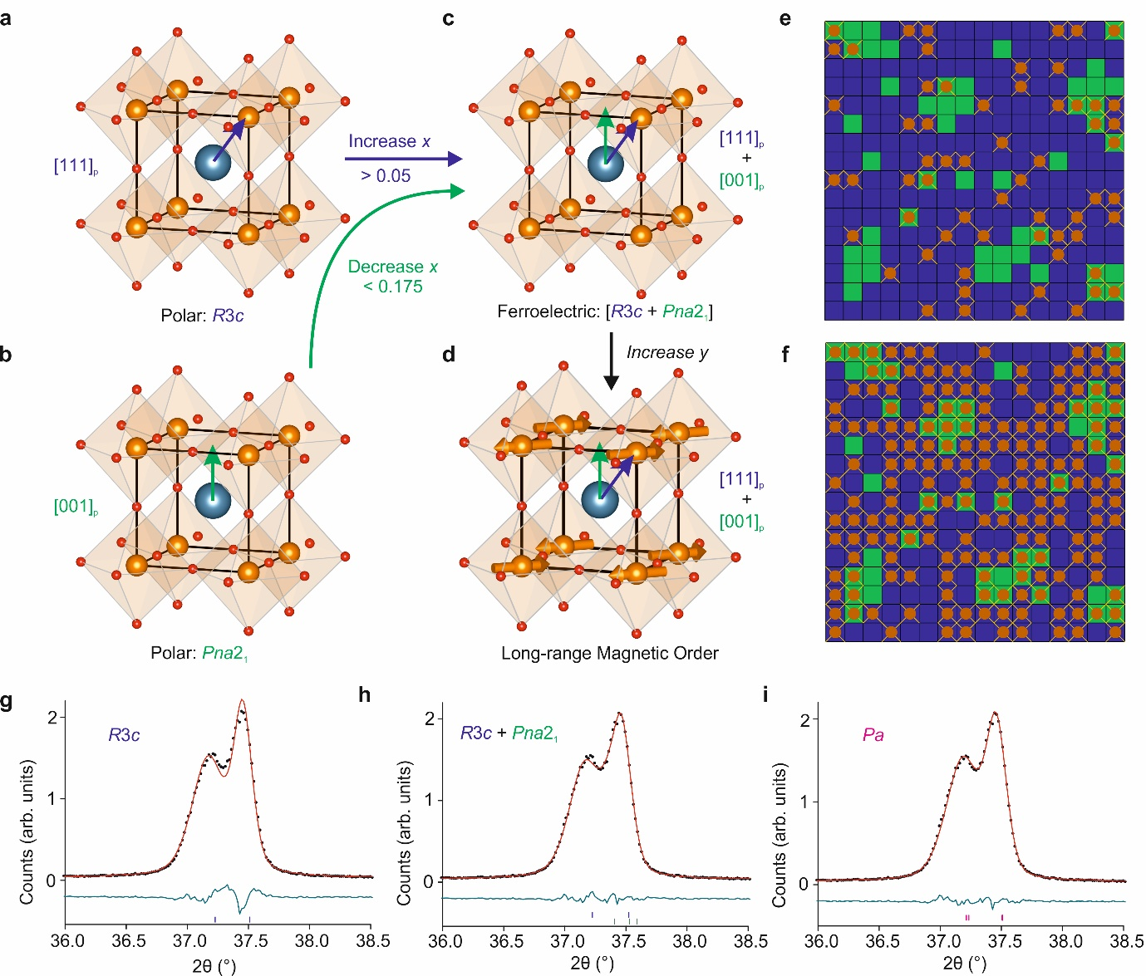
Figure 1: Crystal structure, magnetic percolation and the morphotropic phase boundary (MPB) in (1-x)BiTi_{(1-y)/2}Fe_{y}Mg_{(1-y)/2}O₃ – (x)CaTiO₃ where 0 ≤ x ≤ 0.35 and 0.25 ≤ y ≤ 0.90 (a) Schematic diagram of the purely rhombohedral (R3c) structure where x ≤ 0.05, y = 0.25, represented in the cubic perovskite sub-cell with polar displacement of Bi along the [111]_{p} axis, (b) the purely orthorhombic (Pna2₁) structure where 0.175 ≤ x ≤ 0.35, y = 0.25 with polar displacement of Bi along the [001]_{p} axis, (c) the ferroelectric MPB observed for 0.075 ≤ x < 0.175, y = 0.25, shown with superimposed polar displacements of Bi along [111]_{p} and [001]_{p} axes, (d) Long-range magnetic order at 300 K for x = 0.15, y = 0.80, with a proposed magnetic structure (orange arrows) based on a G-type antiferromagnetic arrangement and spins oriented perpendicular to the [111]_{p} polarisation direction. (e) Schematic diagram of the MPB microstructure and nearest-neighbour magnetic exchange pathways for x = 0.15, y = 0.25 and (f) for x = 0.15, y = 0.80. Each square represents a perovskite unit cell (rhombohedral in purple and orthorhombic in green), brown dots are distributed randomly to represent unit cells containing Fe, and the associated brown lines represent magnetic exchange pathways. A percolating exchange pathway spanning the sample is absent in (e) but present in (f). (g - i) Pawley fits to PXRD data from composition x = 0.15, y = 0.80 modelled using a single R3c unit cell, superimposed R3c and Pna2₁ unit cells, and a single monoclinic Pa unit cell respectively (see Extended Data Figure 3 for full patterns).
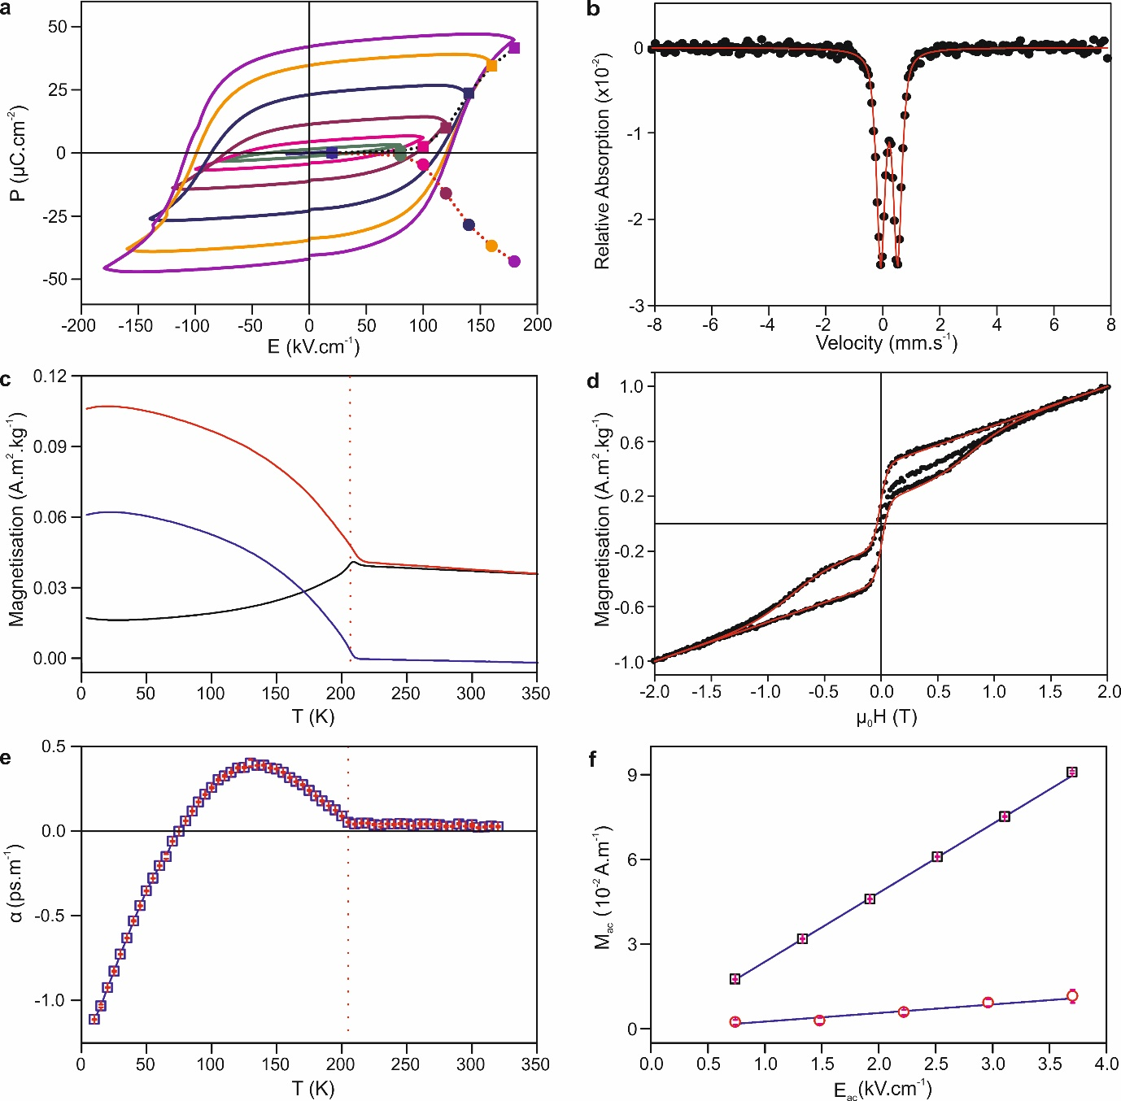
Figure 2: Ferroelectric, magnetic and magnetoelectric properties of x = 0.15, y = 0.60 (a) Polarisation versus applied electric field at 300 K showing ferroelectric switching, measured at 10 Hz. Filled squares and circles represent the remanent polarizations from PUND measurements (b) Mössbauer spectrum measured at 300 K, with no applied magnetic field (black circles) and a single component paramagnetic fit (red line). (c) dc magnetisation measurement of TRM and ZFC/FC magnetisation. The red dotted line indicates T = T_{N}. The FC and ZFC data only converge at the highest temperature, as the divergence above the Néel temperature arises from an impurity phase with an ordering temperature above the highest measured T. (d) Isothermal magnetisation M(H) at 10 K (black squares) and the sum of the perovskite and spinel impurity phase contributions (red line). (e) Temperature dependence of the linear magnetoelectric susceptibility. The red dotted line indicates T = T_{N}; error bars in red are standard errors from 10 repeated measurements. (f) Induced ac magnetization versus applied ac electric field amplitude at 150 K (black square) and 300 K (red circle). The blue line is a linear fit to the data; error bars in red are standard errors from 10 repeated measurements.

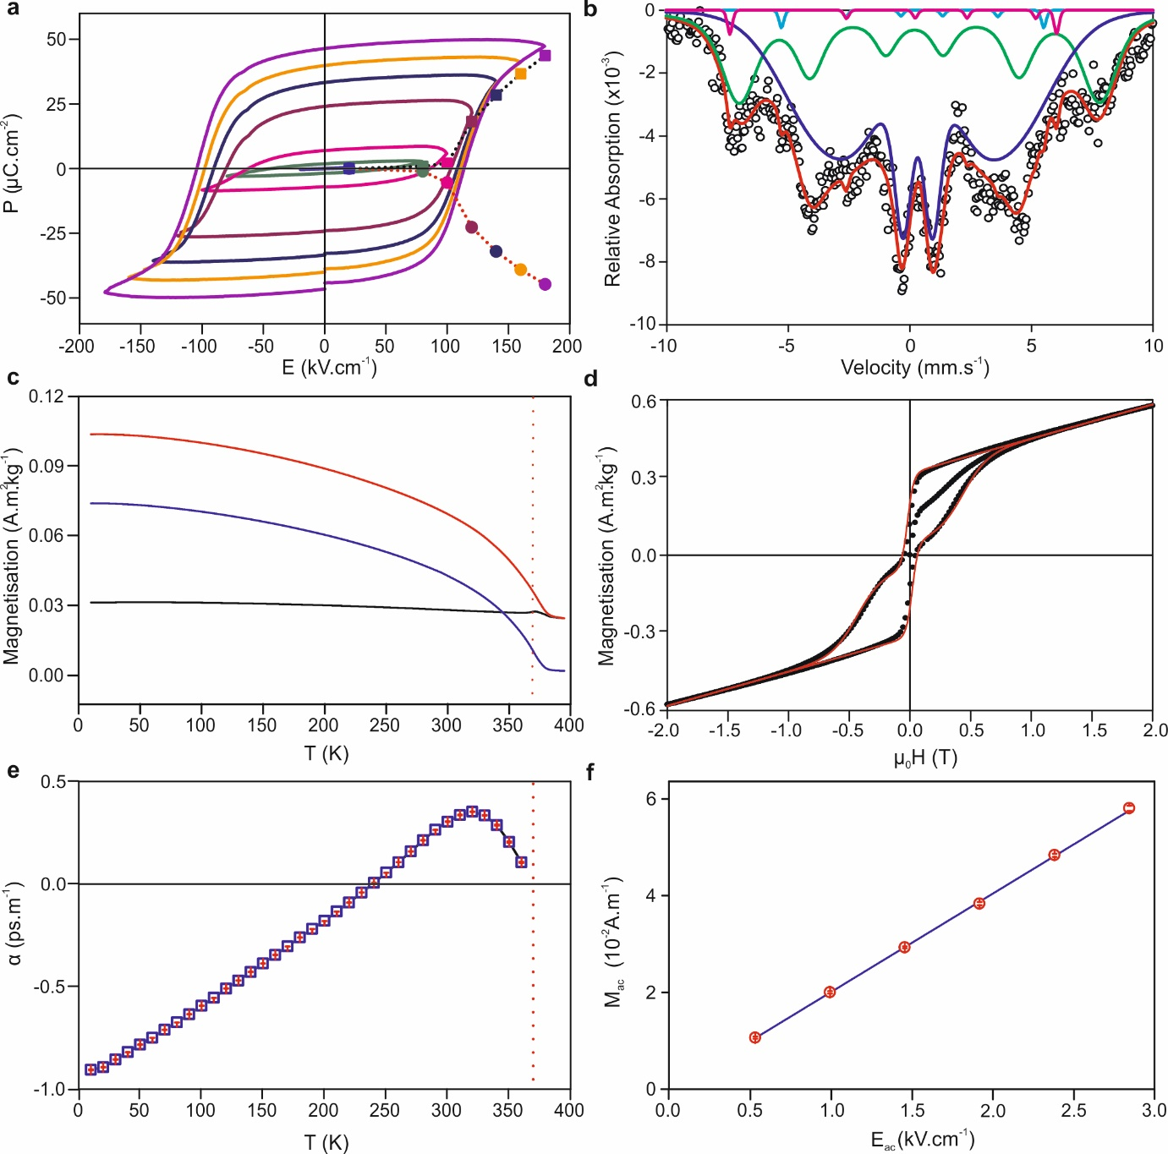
Figure 3: Ferroelectric, magnetic and magnetoelectric properties of x = 0.15, y = 0.80 (a) Polarisation versus applied electric field at 300 K showing ferroelectric switching, measured at 10 Hz. Filled squares and circles represent the remanent polarizations from PUND measurements. (b) Mössbauer spectrum measured at 300 K, with no applied magnetic field (black circle) and the multicomponent fit (red line). Individual components (Extended Data Table 2) are described in the text. (c) dc magnetisation measurement of TRM and ZFC/FC magnetisation. The red dotted line denotes T = T_{N} (d) Isothermal magnetisation M(H) at 300 K (black squares) and sum of the perovskite and minority phase spinel contributions (red line). (e) Temperature dependence of the linear ME susceptibility. The red dotted line denotes T = T_{N}; error bars in red are standard errors from 10 repeated measurements. (f) Induced ac magnetization versus applied ac electric field amplitude at 300 K (red circle). The blue line is a linear fit to the data; error bars in red are standard errors from 10 repeated measurements.
METHODS
Sample preparation. Powder samples of (1-x)BiTi_{(1-y)/2}Fe_{y}Mg_{(1-y)/2}O₃ – (x)CaTiO₃, in the compositional range x = 0.15, y = 0.60-0.90, were synthesised by a conventional solid-state reaction. The binary oxides Bi₂O₃, CaCO₃, Fe₂O₃, TiO₂ (pre-dried at 473 K) and MgCO₃·Mg(OH)₂·xH₂O (x~3, used as received) were weighed in stoichiometric amounts and ball milled in ethanol for 20 hours. The mixtures obtained after evaporating ethanol were pelletised and calcined at 1208 K for 12 hours in a platinum-lined alumina crucible. These pellets were then re-ground thoroughly and re-pelletised, and subjected to a second calcination at 1213 K for 12 hours in platinum-lined alumina crucibles. The resulting powders were found to contain only the target phase with no minority phases visible by PXRD. Dense pellets (> 95 % of crystallographic density) suitable for property measurements were produced from these powders by the following protocol: first, 2 wt% polyvinyl butyral binder and 0.2 wt% MnO₂ were added to the samples, and this mixture was ball-milled for 20 hours. The resulting mixture was then pelletised (8 mm diameter) with a uniaxial press, followed by pressing at ~ 2 x 10⁸ Pa in a cold isostatic press. These pellets were loaded into a Pt-lined alumina boat. A programmable tube furnace was used to heat the reaction under flowing oxygen to 943 K for 1 hour, followed by 1228 K for 3 hours, followed by 1173 K for 12 hours before cooling to room temperature at 5 K.min⁻¹. The resulting pellets were found to contain no minority phases by PXRD. Their densities were measured using an Archimedes balance.
Powder X-ray Diffraction (PXRD). All data were collected using a PANalytical X’Pert Pro diffractometer in Bragg-Brentano geometry with a monochromated Co K_{α1} source (λ = 1.78896 Å) and position-sensitive X’Celerator detector. Each sample was contained in a back-filled sample holder and rotated during the measurement. A programmable divergence slit was used to provide a constant illuminated area throughout the angular range. Data were collected in the angular range 5 ≤ 2θ ≤ 130° in steps of 0.0167°. Pawley refinements were carried out using the software package Topas Academic (version 5). For each PXRD pattern, background was modelled using a Chebyschev polynomial function with 12 refined parameters. Lattice parameters, a sample height correction, peak profile functions and model-independent peak intensities were refined. Peak profiles were modelled with a modified Thompson-Cox-Hastings pseudo-Voigt function. When fitting data to a single phase (R3c or Pa cells), a Stephens anisotropic strain broadening function was refined. In two-phase (R3c + Pna2₁) refinements this function was refined only for the rhombohedral (R3c) phase.
Electrical measurements. For electric poling, gold was sputtered on both sides of thin discs (130 – 160 µm thickness with 10 µm tolerance). For P(E) and PUND measurements, silver conductive paint (RS components) was applied on both sides of thin discs and cured at 393 K for 10 minutes. The edges were bevelled by approximately 0.2 mm to avoid electrical breakdown. The area of the electrode was measured under an optical microscope equipped with a camera and measurement software. The disc was loaded in a PVDF sample holder. Silicone oil was used as dielectric medium to avoid air breakdown. P(E) measurements were conducted using a Radiant ferroelectric tester system and an aixACCT piezoelectric evaluation system (aixPES). PUND measurements were carried out using the Radiant ferroelectric tester system with a square pulse of delay of 500 ms and pulse width of 5 ms (x = 0.15, y = 0.60) and 8 ms (x = 0.15, y = 0.80). The remanent polarization is calculated as dP/2 = (P* - P^)/2 where P* contains both remanent and non-remanent polarization, whereas P^ contains only the non-remanent polarization.
Leakage current measurements. Leakage current was measured in an aixPES instrument using a triangular waveform in steps of 25 V and step duration of 2 s. A switching prepolarization pulse was applied before actual measurements.
Resistivity measurements. Resistivity was measured using the two probe method in an MPMS XL-7 SQUID magnetometer (Quantum Design, USA). The pellet was loaded in a modified SQUID dc probe and connected to a Keithley 6430 sub-femptoamp remote sourcemeter.
Impedance measurements. Impedance and phase angles were measured using an Agilent LCR meter E4980 by applying an ac voltage of 0.5 V in the frequency range 20 Hz – 2 MHz.
Magnetic measurements. Magnetic measurements were carried out using MPMS XL-7 and MPMS3 systems (Quantum Design, USA). For this, powder or pellet samples were loaded into a polycarbonate capsule and fixed into a straight drinking plastic straw and then loaded into a SQUID dc probe. The isothermal magnetisation data were decomposed using the general function:
Where m_{i} is a generic function describing a single magnetic component taking the form:
Where a represent the saturation magnetisation, b the coercive field, c a parameter describing the squareness of the loop, and d a linear term including paramagnetic, diamagnetic and antiferromagnetic contributions for the individual magnetic component. Above the magnetic ordering temperature of the perovskite phase only one component was used to describe the isothermal magnetisation assigned to a high Fe content impurity. Below the perovskite magnetic ordering temperature two components were used.
Mössbauer spectroscopy. Absorption mode Mössbauer spectroscopy measurements were performed at room temperature, using an electromagnetic Doppler drive system, a ⁵⁷Co(Rh) gamma source, of actual activity of ~20 mCi and Xe-gas Reuter-Stokes proportional counter, and Canberra amplification, discrimination and scaling electronics. Samples were diluted with sucrose (icing sugar) for measurements at an approximate ratio of 0.2, in order to prevent excessive line-shape distortion and non-resonant absorption, due to the high bismuth content of the samples. Custom modelling and non-linear least squares error minimisation routines were used for the extraction of the spectroscopic parameters. Isomer shifts are reported with respect to the source.
Magnetoelectric measurements. Details of the magnetoelectric measurements set-up²⁸ and protocol²⁸ are described elsewhere. In this experiment, a sinusoidal electric field E = E_{ac} cos ωt (ω = 2 π f where f is frequency, E_{ac} is the electric field amplitude) is applied across the disc and the first harmonic of the complex ac magnetic moment, m(t) = (m’ – i.m’’)cosωt is measured. The measurements were performed in the absence of any dc magnetic and electric fields. In this scenario, the real part of the electrically induced magnetic moment²⁸ is
where V is the sample volume. This moment involves only the linear ME (α) effect, whereas the higher order effects are zero. To demonstrate the linear ME effect on x = 0.15, y = 0.60 and x = 0.15, y = 0.80, the electric field amplitude E_{ac} was varied and the induced moment was recorded. Linear ME susceptibility (α) was calculated from a plot of volume ac magnetization amplitude M_{ac} (= m′/V) vs E_{ac} following the relation²⁹:$\left|α\right|=μ_{0}.\frac{∆M}{∆E_{0}}$
.
All measurements were performed at f = 1 Hz with 20 blocks to average and 10 scans per measurement. The sensitivity of the experimental set-up used here is m’ = V×M_{ac} > 5×10⁻¹² A.m⁻². Prior to ME measurements, discs were poled externally using the aixPES instrument at a field of 100 kV.cm⁻¹ for 15 minutes from 343 K to room temperature. Discs were then loaded into a modified dc SQUID probe at 300 K and subjected to a magnetic field of 2 T for 30 minutes. After removal of electric and magnetic fields, electrodes were short circuited for 15 minutes before conducting ME measurements at 300 K. For ME measurements at 10 and 150 K (for x = 0.15, y = 0.60), the sample was cooled down to the measurement temperature in the presence of an electric field (3.5 kV.cm⁻¹) and a magnetic field (2 T) and the protocol for 300 K measurement was followed. For the temperature dependence of α, an electric field (3.5 kV.cm⁻¹ for y = 0.60 and 2.7 kV.cm⁻¹ for y = 0.80 respectively) and a magnetic field of 2 T were applied at 300 K followed by cooling to 10 K at a rate of 1 K.min⁻¹, and the data was collected at 1 Hz. The temperature was stabilized for 5 minutes at each step prior to measurement. The room temperature bulk d.c. resistivity of x = 0.15, y = 0.60 is 3.3 × 10¹² Ω.cm, and that of x = 0.15, y = 0.80 is 2.1 × 10¹² Ω.cm. The leakage currents observed for y = 0.60 and y = 0.80 are 0.35 nA (320 K) and 11.4 nA (360 K) respectively at the maximum measurement fields. These values are too low to cause any artifacts in the ME measurements. The upper limit of temperature in this measurement set-up is 360 K.

Extended Data Table 1: Refined lattice parameters and agreement factors from Pawley fits to PXRD data
Refined lattice parameters (a, b, c, γ) and agreement factors (R_{wp} and χ²) from Pawley fits to PXRD data fitted in three different candidate space groups for compositions x = 0.15, y = 0.60 and x = 0.15, y = 0.80. The lattice parameters obtained by fitting to a √2a_{p} x 2a_{p} x √2a_{p} unit cell in space group Pa.
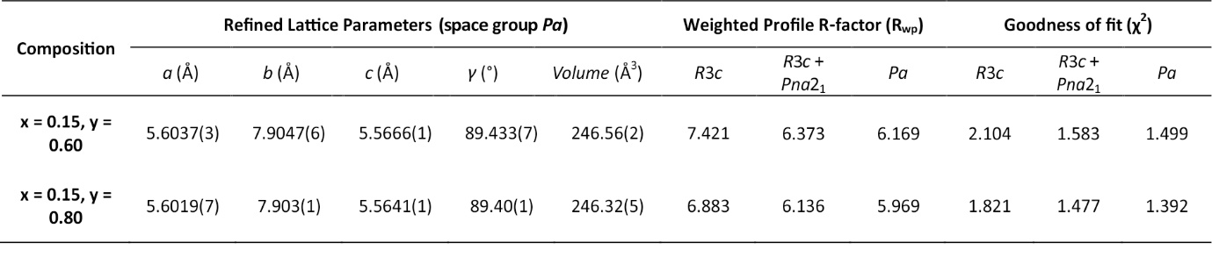

Extended Data Table 2: Spectroscopic parameters from Mössbauer data fitting of x = 0.15, y = 0.80 at 300 K
The area, isomer shift (δ), electric quadrupole moment (Q) and hyperfine field (B_{hf}) for different components as extracted from multicomponent fit are shown with errors in parenthesis.
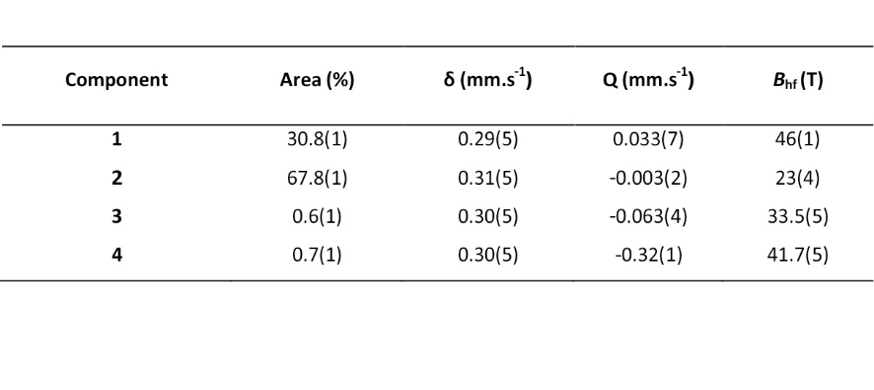

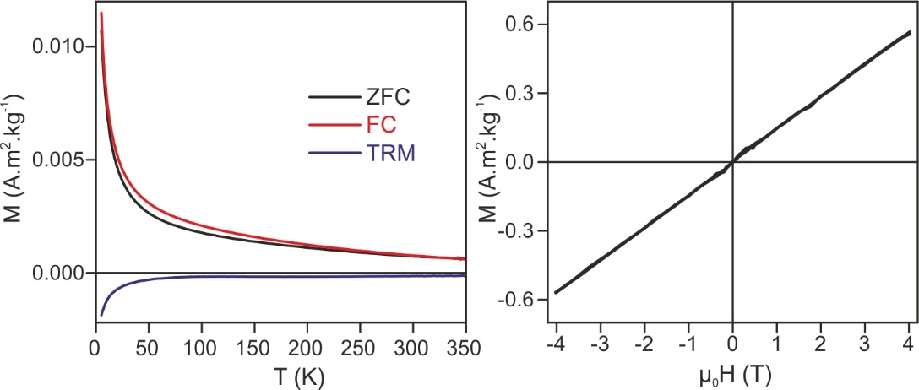
Extended Data Figure 1: Magnetic properties of composition x = 0.15, y = 0.25 (a) magnetisation versus temperature, cooled in zero applied field (black line), cooled in 1 mT applied field (red line) and thermal remanent magnetisation in zero applied field (blue line). (b) magnetisation versus field strength at 100 K.

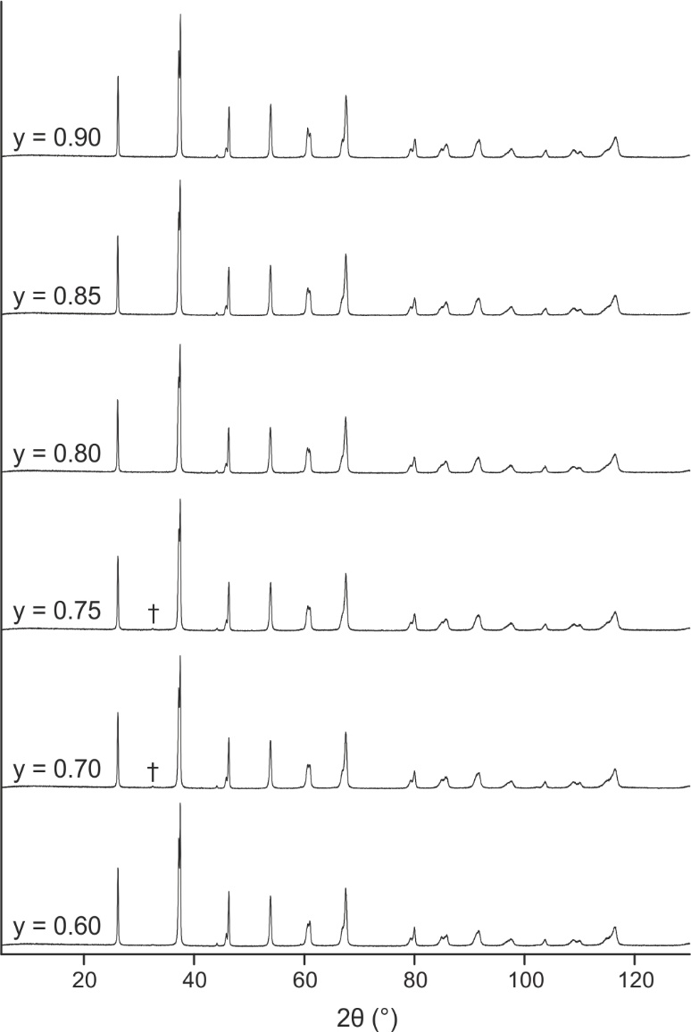
Extended Data Figure 2: PXRD patterns obtained from six compositions of the series (1-x)BiTi_{(1-y)/2}Fe_{y}Mg_{(1-y)/2}O₃ – (x)CaTiO₃ where x = 0.15, y = 0.60-0.90. The weak reflection marked with the † symbol, which is visible in the y = 0.70 and 0.75 patterns, corresponds to the most intense reflection of sillenite (Bi₂₅FeO₄₀). All other peaks are indexed to the target perovskite phase using either rhombohedral, rhombohedral + orthorhombic, or monoclinic cells as discussed in the text.

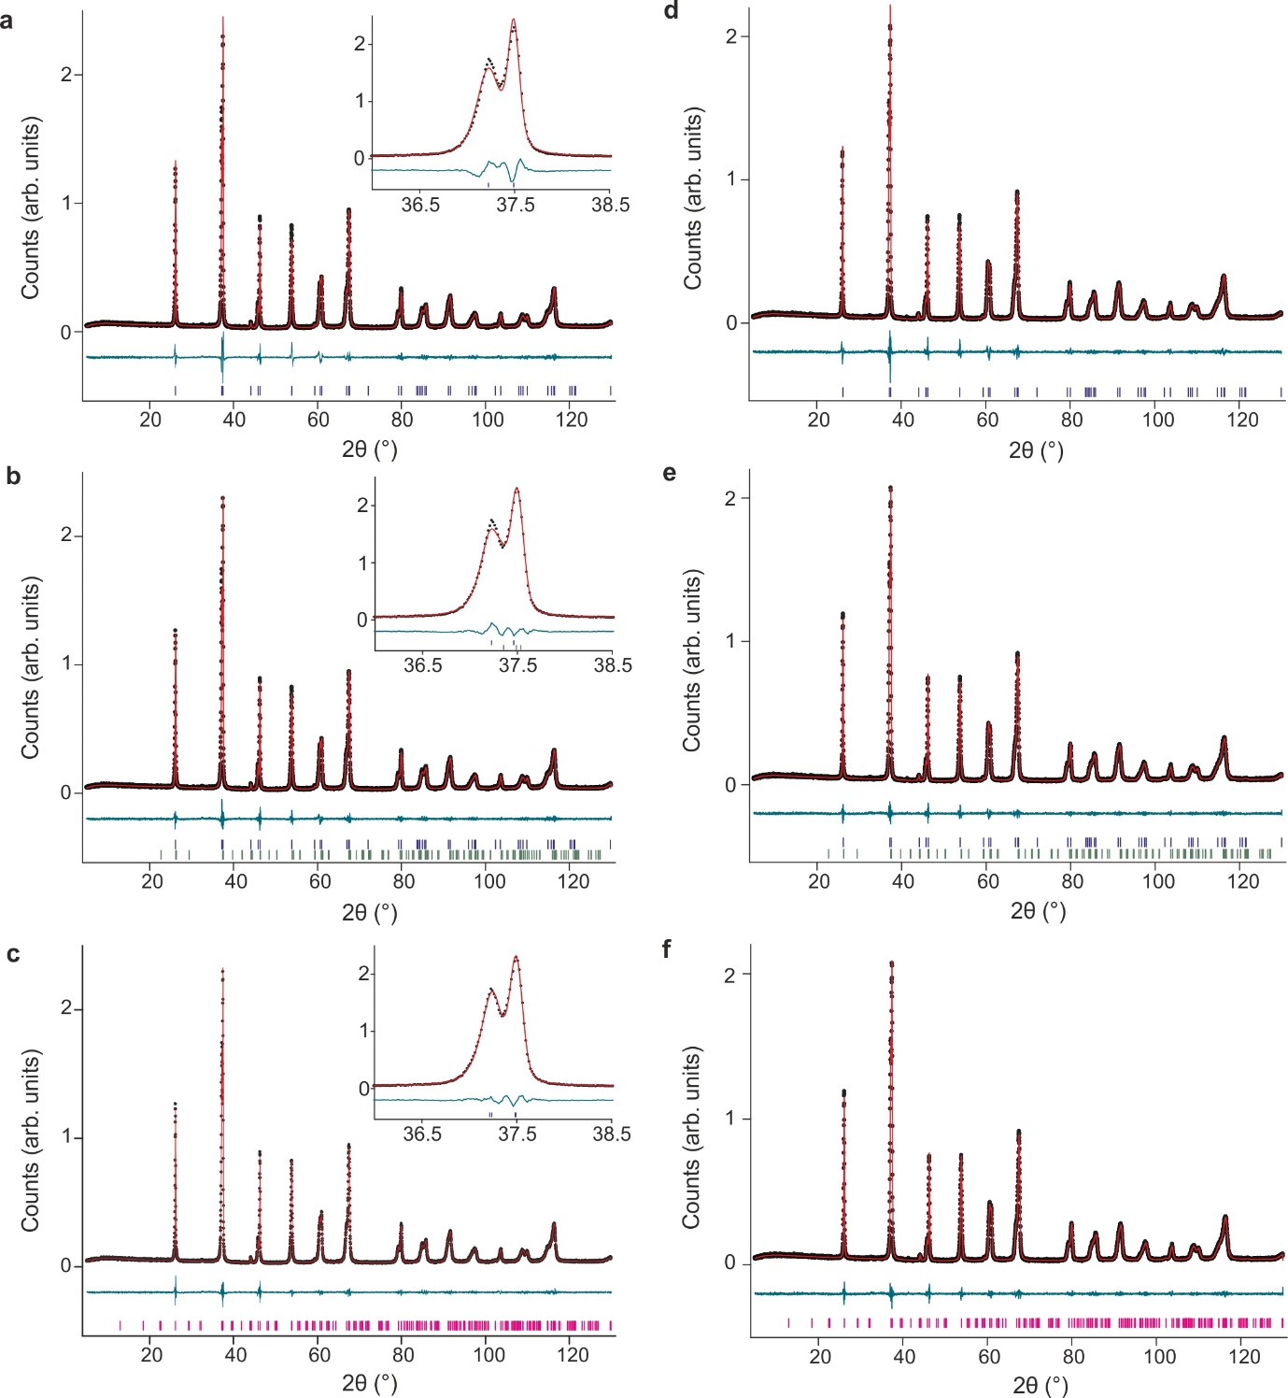
Extended Data Figure 3: Pawley fits to PXRD patterns collected from the composition (a) x = 0.15, y = 0.60 modelled as a single rhombohedral phase in space group R3c, (b) x = 0.15, y = 0.60 modelled as a combination of rhombohedral (R3c) and orthorhombic (Pna2₁) phases, (c) x = 0.15, y = 0.60 modelled as a single monoclinic phase in space group Pa. (d) x = 0.15, y = 0.80 modelled as a single rhombohedral phase in space group R3c, which is a sub-group of R3c and Pna2₁ (e) x = 0.15, y = 0.80 modelled as a combination of rhombohedral (R3c) and orthorhombic (Pna2₁) phases, (f) x = 0.15, y = 0.80 modelled as a single monoclinic phase in space group Pa. Black circles = y_{obs}; red line = y_{calc}; teal line = [y_{obs} – y_{calc}]; blue markers = hkl (R3c) reflections; green markers = hkl (Pna2₁) reflections; magenta markers = hkl (Pa) reflections.

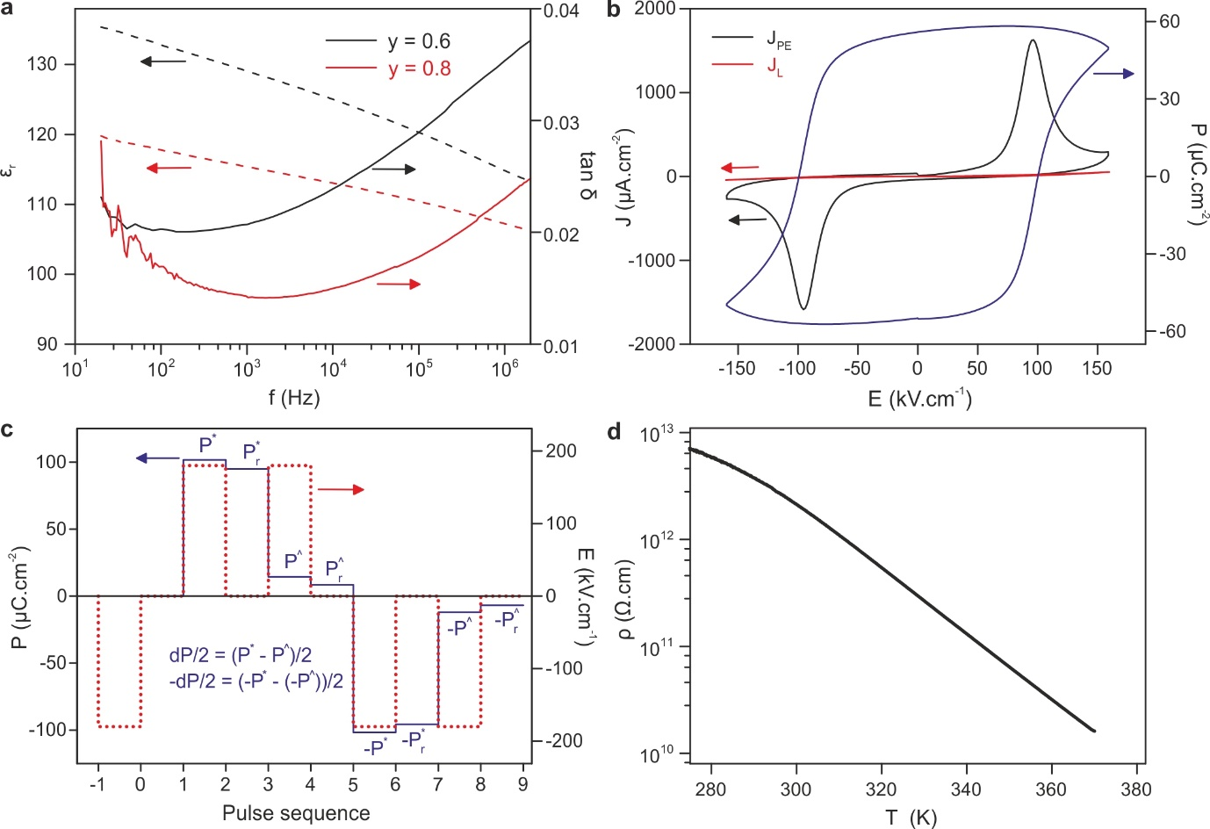
Extended Data Figure 4: Dielectric, polarisation and leakage characteristics. (a) Frequency dependence of dielectric permittivity (left axis) and loss (right axis) at 300 K for x = 0.15, y = 0.60 (black) and 0.80 (red). (b) A typical P(E) loop (right axis, blue line) shown with the corresponding current density (left axis, black line) and the leakage current density (left axis, red line) on x = 0.15, y = 0.80. (c) The polarization (blue line) and voltage profile (red dotted line) from PUND measurement on x = 0.15, y = 0.80. (d) d.c. resistivity of x = 0.15, y = 0.80 against temperature showing highly insulating behaviour.

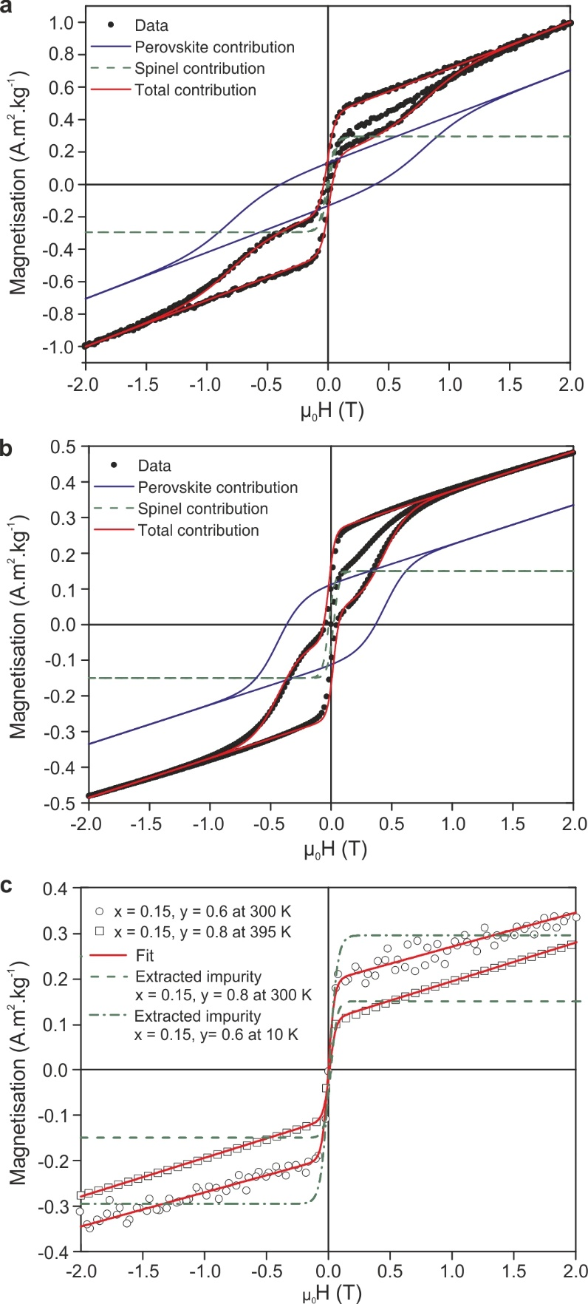
Extended Data Figure 5: Isothermal magnetisation (M(H)) for (a) x = 0.15, y = 0.60 at 10 K (T < T_{N}) and (b) x = 0.15, y = 0.80 at 300 K (T < T_{N}). The experimental data are represented as black circles. Red lines show the sum of the perovskite phase (blue line) and spinel impurity phase (green dots) contributions. (c) isothermal magnetisation (M(H)) for x = 0.15, y = 0.60 at 300 K (T > T_{N}) and x = 0.15, y = 0.80 at 395 K (T > T_{N}); the experimental data are represented as open circles (y = 0.60) or squares (y = 0.80), green dashed lines show extracted spinel impurity contributions and red lines show fits to the data.

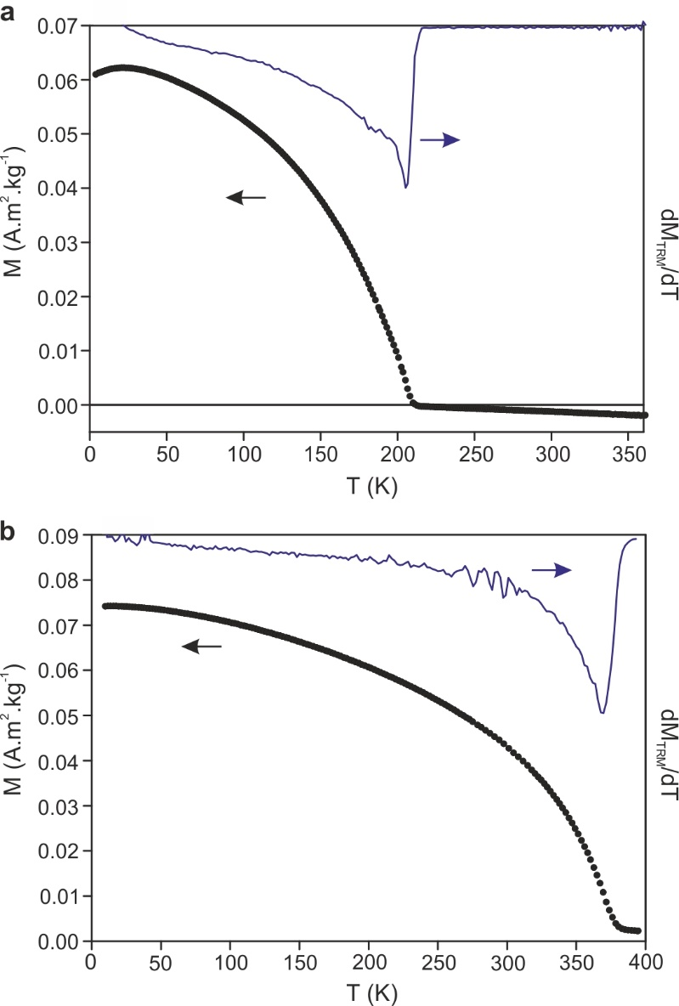
Extended Data Figure 6: Thermal remanent magnetisation (TRM, left axis) and derivative of TRM (dM_{TRM}/dT, right axis) for (a) x = 0.15, y = 0.60 and (b) x = 0.15, y = 0.80.

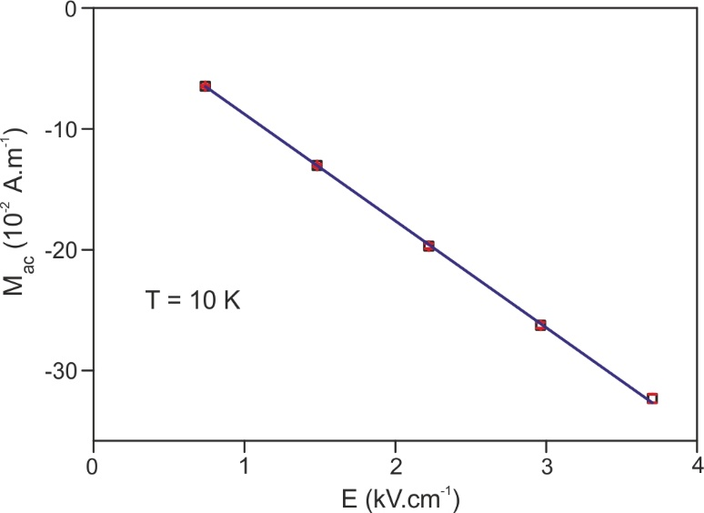
Extended Data Figure 7: Linear magnetoelectric effect of x = 0.15, y = 0.60 at 10 K. Error bars in red are standard errors from 10 repeated measurements.

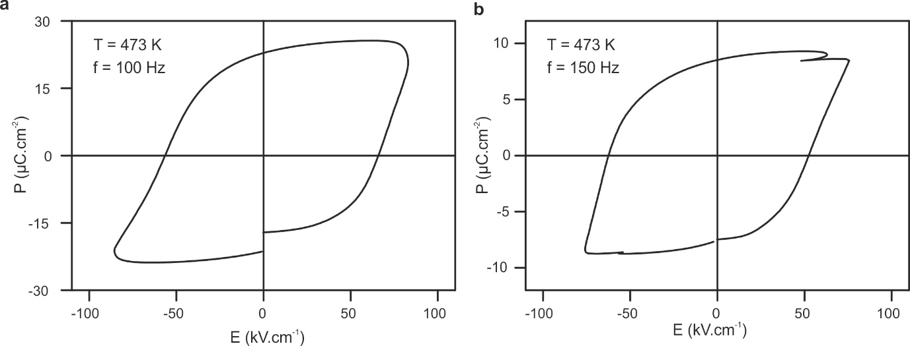
Extended Data Figure 8: P(E) measurement from (a) x = 0.15, y = 0.60 and (b) x = 0.15, y = 0.80 at 473 K.

