Table 1. Biosecurity hazards and their identification by catchers (n=53), including comparison of responses for those with and without (self-reported) biosecurity training. The number in each cell is the percent of respondents that correctly identified each hazard.
Hazards |  |  | Hazard identification (%)
 |  |  | Overall  n=53 | With  Training  n=42 | No  Training  n=11 | PR Test†  p value
Description | Short  name | Still from film
The catching crew wear clothes from another farm | clothes | 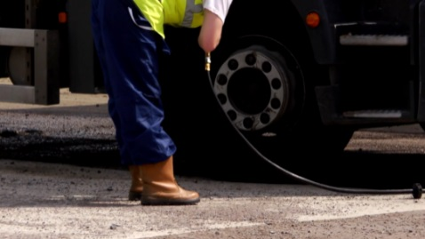 | 70 | 76 | 45 | 0.048*
The catching forklift is not sanitised before going onto farm | Forklift | 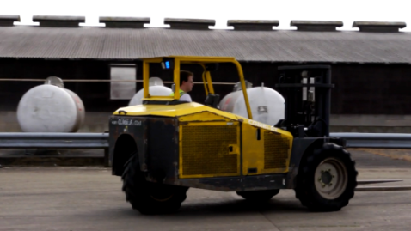 | 75 | 83 | 45 | 0.009**
Dirty clothing and boots are put on from the back of the catching van | Dirty  clothes | 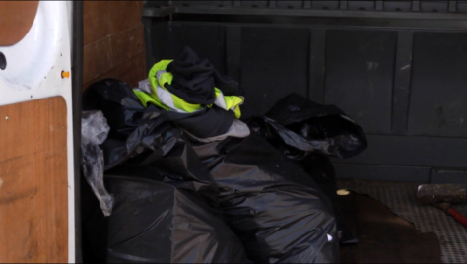 | 72 | 71 | 73 | 0.932
Boots are not dipped on entry to the shed⁺⁺ | Dip | 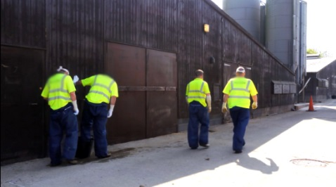 | 96 | 100 | 82 | 0.005**
The modules/ transport crates are dirty | Crates | 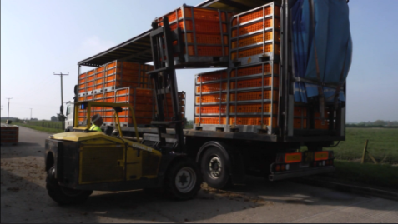 | 87 | 93 | 64 | 0.011*
The forklift is not sanitised before entering another shed | Between  sheds | 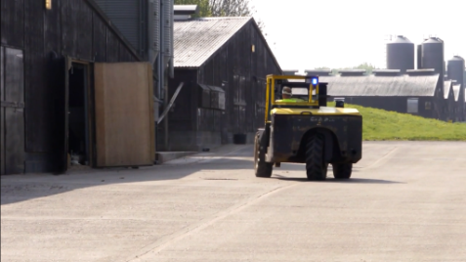 | 77 | 83 | 54 | 0.042*
The catching crew sit in their van for their break | Break | 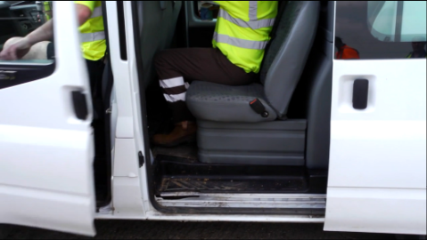 | 93 | 95 | 82 | 0.134
† PR Test = Test of proportions between those with and without (self-reported) biosecurity training*<0.05; **<0.01
⁺⁺The boot dip was not situated at the entry to the shed as required for biosecurity. The hazard showed individuals not using this boot dip.

