Macrocell corrosion formation in concrete patch repairs – A laboratory study
C. A Eldho^{1, a*}, O. Nanayakkara ^{2, b}, J. Xia^{3, c} and S. W Jones^{4, d}
¹PhD student, School of Engineering, University of Liverpool, Liverpool, UK
² Lecturer, Xi’an Jiaotong – Liverpool University, Suzhou, China
³ Lecturer, Xi’an Jiaotong – Liverpool University, Suzhou, China
⁴ Senior Lecturer, School of Engineering, University of Liverpool, Liverpool, UK
ªeldho@liverpool.ac.uk ^{b} Ominda.Nanayakkara@xjtlu.edu.cn ^{c} jun.xia@xjtlu.edu.cn
^{d} Stephen.Jones@liverpool.ac.uk
Keywords: Concrete durability, Patch repair, Macrocell corrosion
Abstract
Corrosion of reinforcement steel bars is a major threat to the durability of concrete structures exposed to chloride contaminated environment. Patch repairing is widely practiced in affected structures to avoid further damage due to corrosion. Macrocell formation within the patch repair is identified as one main reason for the failure of patch repairs. In the present study, a group of patch repairing materials is tested for their potential to form macrocell corrosion after repaired in a chloride contaminated environment. The influence of parameters such as level of chloride contamination, type of repair materials and the area of steel bar receiving repair are presented based on macrocell current measurements. The selected repair materials for study were cement based, GGBS based and polymer based in its composition. It is found that the severity of macrocell depends on the driving potential existing between the repair and substrate concrete. The quality of substrate concrete and repair material influences the macrocell formation. The surface area of the steel bar that receives the repair also affects the macrocell current. The study will be used for the evaluation of repair materials for macrocell corrosion formation potential before their field application in a chloride contaminated environment.
Introduction
Steel bars in concrete are naturally protected by an oxide layer in the presence of an alkaline environment. In the presence of chlorides, this passive film is broken down and corrosion sites develop on the steel surface. The corrosion process involves oxidation of iron at the anode by leaving the electrons and at cathode reduction reaction combining water, oxygen and electrons to form hydroxyl ions. Rust is formed at the anode and the steel bar is protected at the cathode [1]. Macrocell type of corrosion is predominant in chloride contaminated concrete. The distance between anode and cathode will be large and the area of anode is small in comparison to the cathode in such type of corrosion [2]. Patch repairing involves the removal of loose chloride contaminated concrete, cleaning of the steel bar and filling the cavity with a repair material. Repair materials restore the alkaline environment and passivity to the steel bar. The repairs may fail to prevent the further corrosion due to various reasons; the compatibility issues between substrate concrete and repair material could be one reason for such failures. Immature failure of reinforced concrete members requires patch repairing and if it fails, there is a huge associated economic loss.
The durability of patch repairs depends on compatibility of the repair material with the substrate concrete in terms of chemical, electrochemical, mechanical and dimensional properties. Electrochemical compatibility of the repair materials should be checked for the respective exposure conditions to ensure the success of a repair [3]. It is suggested to remove the entire chloride contaminated concrete before patch repairing to avoid such macrocells. The electrical resistance of the concrete plays an important role in deciding the magnitude of current flow. There are two possibilities of macrocell formation in concrete patch repairs. One is due to the potential difference between the steel bars in chloride contaminated concrete and chloride free concrete. It acts as a driving potential for the macrocell corrosion current flow. Steel bar in the chloride free patch repair receives passivation and the steel in the substrate concrete tends to corrode in this case. The other possibility arises when patching is performed with a dense repair material having low permeability. The absence of availability of oxygen in the patch shifts the potential to a more negative value and then the oxygen rich substrate concrete promotes cathodic reactions [4]. Hence steel bars in the repair material tend to corrode. Different factors such as electrical resistivity, cathode to anode surface ratio affects the magnitude of the macrocell current [5]. Also microcell corrosion can also coexist with the macrocell corrosion in patch repairs. The individual contribution of microcell and macrocell corrosion towards the total corrosion is continuing as a topic of research among researchers [6]–[8].
The potential of steel in repair materials to form macrocell corrosion when applied in chloride contaminated concrete can be used as criteria for the selection of repair materials. A methodology was proposed for the selection of repair materials to be used for the repair of carbonation induced corrosion based on this. It suggests the selection of repair materials based on its potential to form a macrocell corrosion cell when attached to the substrate concrete [9]. Evaluation of the material properties of repair materials alone will not be sufficient to predict the success of a repair after its field application. Hence, a performance based approach should be implemented to evaluate the success of concrete repairs. In the present work, patch repairs are executed in concrete with different chloride contaminations and the macrocell corrosion formation is studied. This gives insight to the macrocell formation in patch repairs and enables us to select the repair materials based on the substrate concrete quality. Three different repair materials are examined for three different levels of chloride contamination. The influence of the area ratio between the steel in the repair material and chloride contaminated concrete is also examined. The macrocell current flow is monitored along with the half-cell potential measurement.
Materials and Methods
Grade 42.5N cement is used as per the Chinese standards. River sand having a fineness modulus of 3.5 is used in the mix. Crushed aggregates with specific gravity 2.65 are used. The maximum aggregate size is limited to 10 mm for making the concrete. Details of the mix are given in Table. 1
Selection of patch repair materials
The repair materials selected are representatives of commonly used patch repair materials in the field. These include cement based repair materials and polymer modified materials. Details are given in the Table 1. Portland cement based repair mortars were produced in the laboratory and polymer modified repair materials were obtained from the manufacturer.

Table 1. Mix details of substrate concrete and repair material
Name | Mix Details
A | OPC mortar  W/C -0.5  Cement content – 500 kg/m³
B | OPC mortar with 30% GGBS replacement  W/C -0.5  Binder content – 500 kg/m³  GGBS – 30% by weight of Binder
C | Polymer modified  Repair material  SikaMonotop NFG -412
S1 | Substrate concrete  W/C ratio – 0.53  Cement content – 387 kg/ m³  Cl- content – 1%
S2 | Substrate concrete  W/C ratio – 0.53  Cement content – 387 kg/ m³  Cl- content – 2.5%
S3 | Substrate concrete  W/C ratio – 0.53  Cement content – 387 kg/ m³  Cl- content – 5%

Preparation of steel bar
Plain steel bar of 8 mm diameter is used. Electrical wire was connected to the one end of the steel bar before inserting it in the concrete. Both the ends of the steel bars were insulated with epoxy coating to avoid preferential corrosion at the ends.
Mixing and curing
Repair materials A, B and C were made using the laboratory mortar mixer. Potable water is used for the mixing. To determine the macrocell corrosion formation potential, 150 mm cube moulds were used. The casting was done in two steps; repair material was placed in the moulds followed by the substrate concrete. Specimens were allowed to harden in the mould for one day. After demoulding, the specimens were covered under wet polythene sheets for curing. At the end of 28 days curing, epoxy coating was applied on all faces of the specimen except two, which are marked as 1 and 2 in Fig. 2. In total eighteen specimens were cast. The specimens were kept exposed in the laboratory environment, where the average temperature and relative humidity were 25⁰C and 60% respectively during the testing period. The area of steel inside the substrate concrete was varied in such a way to provide an anodic : cathodic ratio of 1 and 0.5. The details of substrate concrete and repair material are shown in Table 2.

Measurement techniques
Macrocell current is measured using a zero resistance ammeter (ZRA). Half-cell potential is measured against a CuSO₄ reference electrode with the help of a voltmeter according to ASTM C 876 - 91[10].
Table 2. Details of the specimens
Name of specimen | Repair material | Chloride content in substrate concrete (Cl⁻) | Steel area ratio between repair and substrate
A1 | A | 5% | 1
A2 | A | 1% | 1
A3 | A | 5% | 0.5
A4 | A | 1% | 0.5
A5 | A | 2.5% | 1
A6 | A | 2.5% | 0.5
B1 | B | 5% | 1
B2 | B | 1% | 1
B3 | B | 5% | 0.5
B4 | B | 1% | 0.5
B5 | B | 2.5% | 1
B6 | B | 2.5% | 0.5
C1 | C | 5% | 1
C2 | C | 1% | 1
C3 | C | 5% | 0.5
C4 | C | 1% | 0.5
C5 | C | 2.5% | 1
C6 | C | 2.5% | 0.5

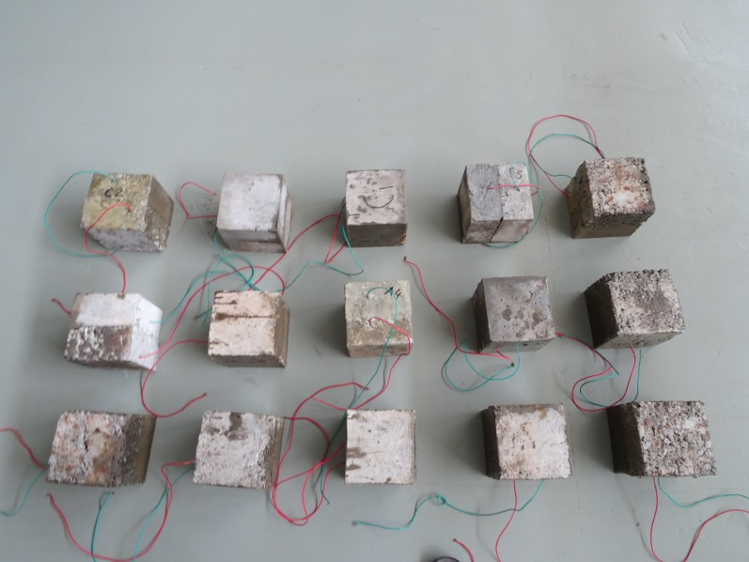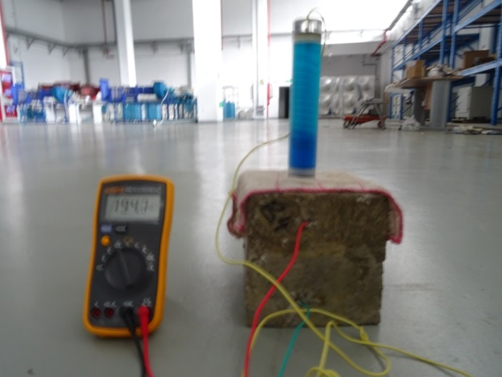

Fig. 1 Prepared specimens at the laboratory and Half-cell potential measurement
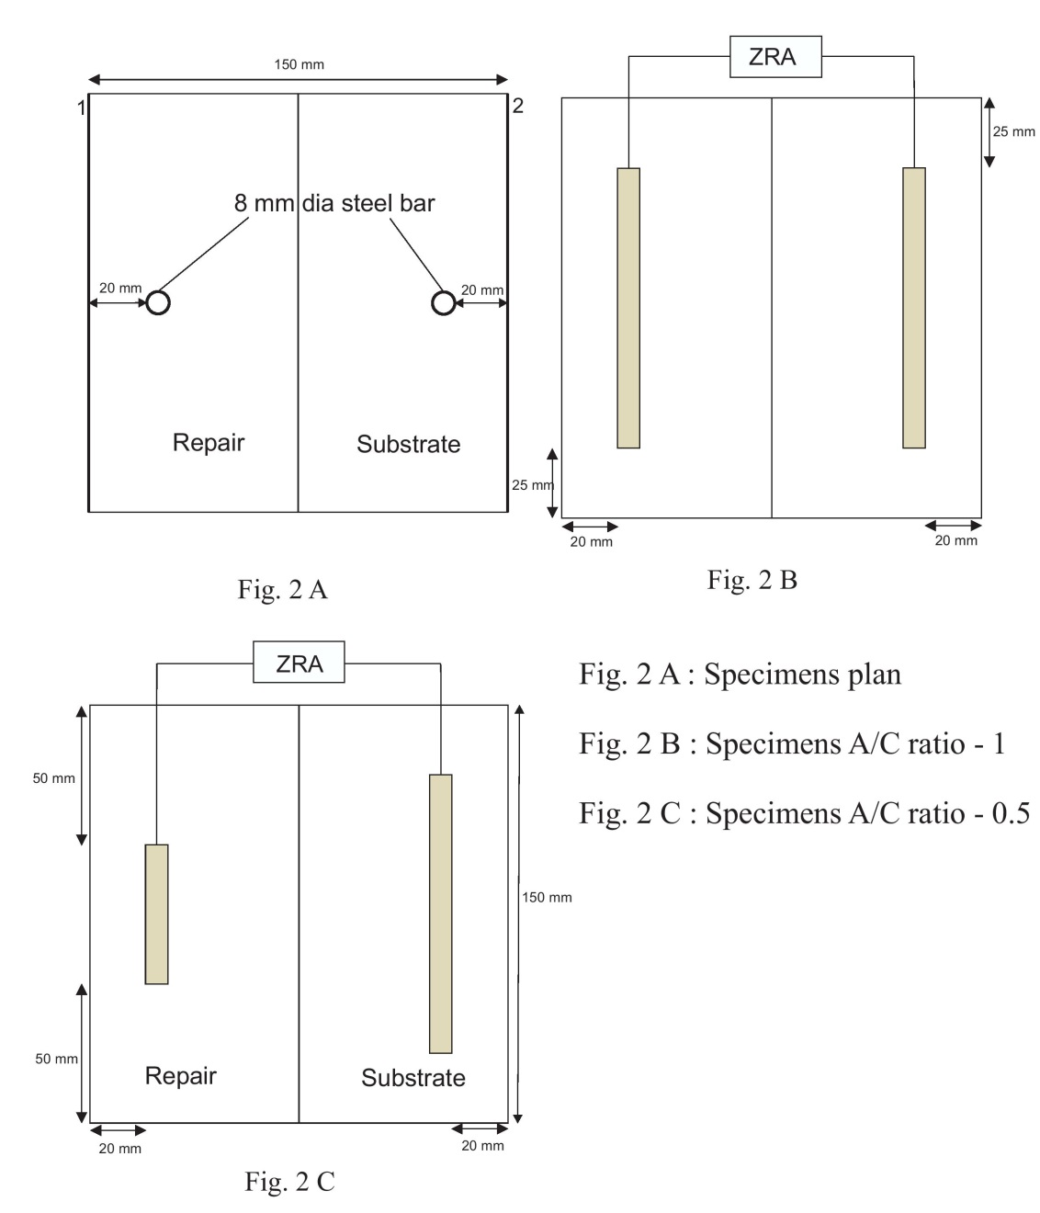
Fig. 2 Details of the specimen used
Results & discussions
- Mechanism of macrocell corrosion formation.
Macrocell corrosion formation arises when an anode and cathode are separated by a distance. It is the predominant corrosion mechanism in chloride contaminated concrete. The steel bar in the substrate concrete continues to be in an active sate or environment ??? when the repair is performed in chloride contaminated concrete. This is evident from its half-cell potential value. The repair material provides a passive environment to the steel bar and a more positive half- cell potential value is shown.
Anodic reaction is at the active steel in the substrate concrete,
Fe Fe²⁺ + 2e⁻ | (1)
Cathodic reaction is at the passive steel in repair material,
2H₂O +O₂+4e⁻ 4OH⁻ | (2)
Furthermore the OH⁻ reacts with Fe²⁺ to form Fe(OH)_{2,} this further reacts with oxygen to form a series of oxide compounds. They appear as rust in the steel surface.
 | Fe²⁺ + 2 OH⁻ Fe (OH)₂ | (3)

Fig. 3 Driving potential as observed in A6 specimen
The half-cell potential values of the steel in the substrate concrete and repair material are represented as E_{mi, c} and E_{mi, a} , respectively, when the steel bars are disconnected in Fig 3. The steel bars are polarised to new potential values E_{ma, c} and E_{ma, a} when they are connected. The difference between E_{ma, c} and E_{ma, a} acts as the driving potential which is responsible for the generation of the macrocell current. The driving potential existing between the repair material and the substrate concrete is responsible for the macrocell corrosion current.
Fig. 4 Relationship between the driving potential and macrocell current in different repair materials
The magnitude of macrocell current is not dependent on the driving potential alone. As seen in Fig 4, the relationship between the driving potential and magnitude of macrocell current is not always directly proportional. As mentioned in equations (1) and (2), the corrosion current is influenced by the rate of anodic and cathodic reactions. At the anode, chloride contamination is sufficient to break down the passive layer and to initiate the corrosion. At the cathode, the availability of oxygen, water and the electrical resistivity of the repair material and concrete control the overall charge transfer. Hence, large potential difference between the anodic and cathodic sites does not necessarily create a macrocell corrosion site.
- Factors that influence the macrocell current magnitude
The influence of factors such as quality of substrate concrete, type of repair material and the area ratio between anode and cathode are compared as shown in the Fig 5 A-C.
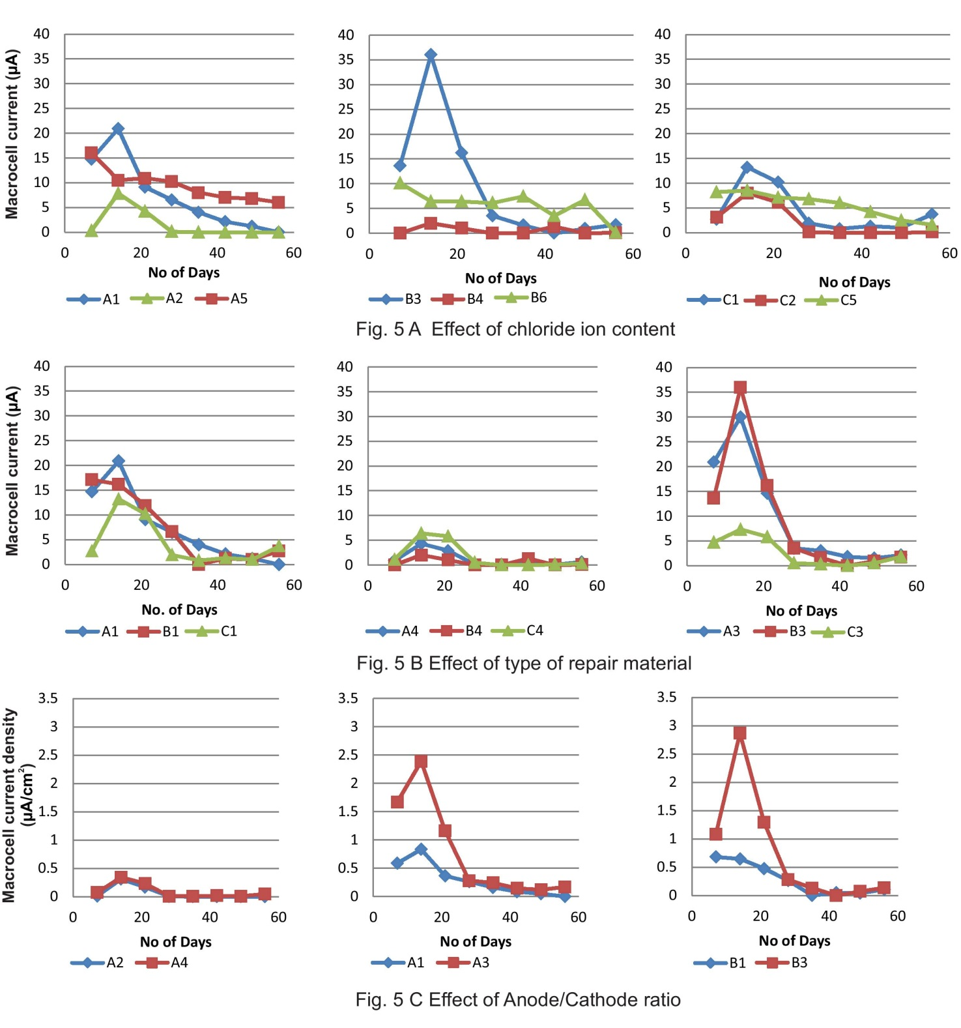
Fig. 5 Factors influencing the magnitude of macrocell current
The key findings of the study are explained in the following points,
- Macrocell activity decreases with the passage of time. It is predominantly in the initial days after the patch repair. Macrocell activity is evident in all the repair materials but the intensity varied depending on the substrate quality and type of repair material.
- The magnitude of macrocell current depends on the driving potential generated due to the electrochemical differences. In repair materials like polymer modified repair material and GGBS based repair materials measurement of half-cell potential alone would give misleading information about the presence of macrocell corrosion.
- The decreasing trend of macrocell current values could be due to the following reasons,
  - The increase in the resistivity of both the concrete and repair material with the passage of time due to the development of concrete microstructure.
  - Drying of the prepared specimens.
  - Chloride binding in concrete progresses with time and the reduced availability of free chlorides to initiate the corrosion reduces.
- OPC based repair materials showed high tendencies to form macrocell compared to others.
Conclusions
Macrocell formation in concrete patch repairs was identified when different quality of substrate concrete is repaired with different types of repair material. The magnitude of the macrocell current was not significant when the chloride contamination is 1% in the substrate. Macrocell corrosion becomes significant once the chloride content exceeds this. There is no direct relationship between driving potential and macrocell current magnitude when repair materials like polymer modified mortar are used for patch repair. A comprehensive evaluation of the repair materials is necessary to ensure their suitability in patch repair applications.
References
[1] M. Raupach, “Chloride-induced macrocell corrosion of steel in concrete - Theoretical background and practical consequences,” Constr. Build. Mater., vol. 10, no. 5 SPEC. ISS., pp. 329–338, 1996.
[2] B. Elsener, “Macrocell corrosion of steel in concrete – implications for corrosion monitoring,” Cem. Concr. Compos., vol. 24, no. 1, pp. 65–72, Feb. 2002.
[3] D. R. Morgan, “Compatibility of concrete repair materials and systems,” Constr. Build. Mater., vol. 10, no. I, pp. 57–67, 1996.
[4] P. Gu, J. J. Beaudoin, P. J. Tumidajski, and N. P. Mailvaganam, “Electrochemical incompatibility of patches in reinforced concrete,” Concr. Int., vol. 19, pp. 68–72, 1997.
[5] J. Warkus and M. Raupach, “Numerical modelling of macrocells occurring during corrosion of steel in concrete,” Mater. Corros., vol. 59, no. 2, pp. 122–130, 2008.
[6] S. Qian, J. Zhang, and D. Qu, “Theoretical and experimental study of microcell and macrocell corrosion in patch repairs of concrete structures,” Cem. Concr. Compos., vol. 28, no. 8, pp. 685–695, Sep. 2006.
[7] Y. Ji, W. Zhao, M. Zhou, H. Ma, and P. Zeng, “Corrosion current distribution of macrocell and microcell of steel bar in concrete exposed to chloride environments,” Constr. Build. Mater., vol. 47, pp. 104–110, Oct. 2013.
[8] C. M. Hansson, a. Poursaee, and a. Laurent, “Macrocell and microcell corrosion of steel in ordinary Portland cement and high performance concretes,” Cem. Concr. Res., vol. 36, no. 11, pp. 2098–2102, 2006.
[9] J. L. S. Ribeiro, Z. Panossian, and S. M. S. Selmo, “Proposed criterion to assess the electrochemical behavior of carbon steel reinforcements under corrosion in carbonated concrete structures after patch repairs,” Constr. Build. Mater., vol. 40, pp. 40–49, 2013.
[10] A. S. for Testing and Materials, “ASTM C 876-91: Standard Test Method for Half-Cell Potentials of Uncoated Reinforcing Steel in Concrete,” 1991.

