A case of vanishing skull: Gorham’s disease
Sizheng Zhao^{1,2}, David Richardson³, Madhu Mahindrakar¹, Jagdish Nair¹
1. Rheumatology Department, Aintree University Hospital, Liverpool, UK
2. Institute of Ageing and Chronic Disease, University of Liverpool, Liverpool, UK
3. Department of Oral and Maxillofacial Surgery, Aintree University Hospital, Liverpool, UK

Correspondence to: Dr Jagdish Nair, Clinical Sciences Centre, University Hospital Aintree, Lower Lane, Liverpool, L9 7AL, UK.
Tel: +44 (0)151-529-5889; Fax: +44 (0)151-529-5888
E-mail: jagdish.nair@aintree.nhs.uk

A case of vanishing skull: Gorham’s disease
Gorham’s disease (GD) is a rare form of lymphangiomatosis associated with profound osteolysis. Outcome depends on the site affected. Small limb lesions can cause fractures, while spinal involvement or chylothorax associated with rib lesions can be life-threatening. There is no consensus regarding treatment. Surgical resection and/or radiotherapy are most commonly used but often unsuccessfully [1].
We report the case of an otherwise healthy female who presented at the age of 40 with a small, painless skull indentation. Over the following six years, the indentation evolved into an 11 by 11cm cranial vault defect. There were no other abnormal findings on examination. Investigations were negative for malignancy, infection, biochemical or immunological abnormalities. CT demonstrated a defect in the occipital region (figure 1) but no abnormalities elsewhere in the skeletal system. A skull and dural biopsy confirmed GD.
Radiotherapy proved ineffective. Monthly intravenous zoledronic acid 5mg infusion was therefore commenced, with weekly subcutaneous pegylated interferon alfa-2b 35mcg. Clinical and radiological follow-up over three years demonstrated suppression of the osteolytic process with stabilisation of the calvarial defect.
Lymphangiomatoses are non-malignant processes involving abnormal lymphatic proliferation. In GD, an increased number of osteoclasts are often present, which is thought to be promoted by elevated levels of IL6 [2]. While interferon and bisphosphonate can provide effective therapy, cases with poor response may benefit from trials of anti-cytokine therapy or other biological modulators in research settings which will fall into the remit of rheumatologists.
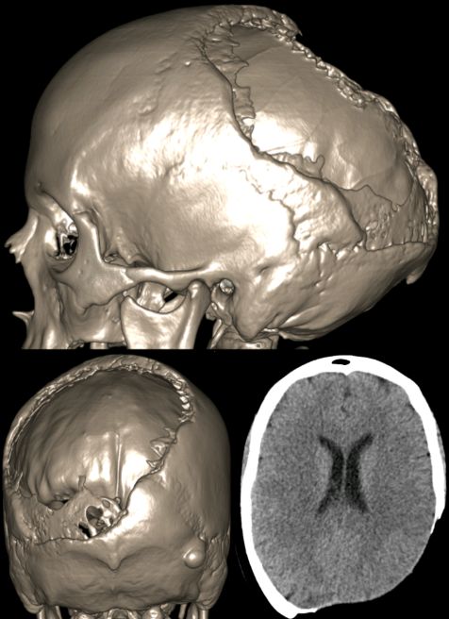

References
1. Kuriyama DK, McElligott SC, Glaser DW, Thompson KS. Treatment of Gorham-Stout disease with zoledronic acid and interferon-alpha: a case report and literature review. J Pediatr Hematol Oncol 2010;32:579-84.
2. Dellinger MT, Garg N, Olsen BR. Viewpoints on vessels and vanishing bones in Gorham-Stout disease. Bone 2014;63:47-52.

