An inverted gapped-target sputter magnetron for the deposition of thin ferromagnetic films
Phitsanu Poolcharuansin^{1*}, Paveena Laokul¹, Nitisak Pasaja¹, Artit Chingsungnoen¹, Mati Horprathum², Pongpan Chindaudom² and James W Bradley³

¹ Department of Physics, Mahasarakham University, Maha Sarakham, 44150, Thailand
² Optical Thin-Film Laboratory, National Electronics and Computer Technology Center, Pathumthani, 12120, Thailand
³ Department of Electrical Engineering and Electronics, University of Liverpool, Brownlow Hill, Liverpool, L69 3GJ, UK

Corresponding author: Phitsanu Poolcharuansin
Email: phitsanu.p@msu.ac.th
Contact details: Department of Physics, Faculty of Science, Mahasarakham University, Maha Sarakham,
44150, Thailand
Abstract
An inverted gapped-target magnetron sputtering device has been developed for deposition of ferromagnetic thin films under energetic conditions. The main feature of this technique is that the discharge is driven by a positive voltage relative to a grounded target situated away from the magnetic field. As a result, it is possible to efficiently sputter ferromagnetic materials and have a source of energetic plasma ions available in the ion-assisted deposition process at the substrate. Electrical probe measurements have shown that the density and the most likely energy of the ions arriving to the grounded substrate is approximately 10¹⁶ m⁻³ and 200 eV, respectively. In the sputtering of nickel films, no cracking of the film surfaces was observed, without substrate heating or biasing. The energetic ions available with this inverted configuration are thought to be the main contributor to the observed enhancement in overall film qualities.

Keywords: ferromagnetic thin films; magnetron sputtering; magnetic properties
Introduction
Magnetron sputtering is a magnetically enhanced sputtering process in which mutually perpendicular magnetic and electric fields confine the plasma, so increasing the probability of gas ionization and therefore the plasma density and sputter rates [1]. However, since the magnetic field is created by permanent magnets behind the sputtered target, the use of ferromagnetic targets can be problematic. They significantly lower the confining field for electrons in the plasma leading to a narrowing of the racetrack width, a lowering the target current and raising the target voltage. Therefore, for the deposition of ferromagnetic thin films such a. Ni, Co and Fe, strong magnets and thin targets may be required. Otherwise, the magnetron needs to be modified to increase the magnetic field present above the target surface, for example, by the use of an opposed target magnetron [2].
To address these issues, in the present study we have developed and tested a different magnetron configuration for the deposition of ferromagnetic thin films based on the gapped-target configuration [3,4] with inverted electrical polarities to the usual magnetron case. In the inverted magnetron configuration, referred here to as IMS, a positive DC power supply is employed to apply a positive voltage to the anode of the magnetron while the vacuum chamber and the gapped-ferromagnetic target are electrically grounded. With this configuration, we could generate both sputtered particles of the ferromagnetic material but also an energetic ion beam which bombards to substrate during film growth. Here, we correlate the microstructure of the deposited films to the process parameters, and systematically investigate how the ion beam parameters, (i.e. energy, density and bombarding flux) influence the crystallography, surface morphology, and magnetic properties of the ferromagnetic films.
The inverted gapped-target sputtering magnetron
A diagram of the cross-section of the inverted gapped-target magnetron used in this work is shown schematically in Fig. 1. The magnetron consists of an anode covered by a gapped cathode. The anode is composed of an inner and an outer magnet holder and a magnetic yoke. A number of permanent magnet rods (NdFeB) are embedded in the holders forming the annular transverse magnetic field lines. The space between the magnet holders is referred to as the anode cavity, allowing the discharge to be operated with a voltage of a few hundreds of volts. The argon gas is introduced to the anode cavity through the pinholes located at the magnetic yoke. The cathode consists of a gapped target, a grounded shield and a water-cooled target holder. A center nickel plate and a concentric nickel ring were employed as the target with an annular gap with a width of about 3 mm and a radius of 17 mm measured at the gap center. Despite the magnets being located in the anode, a sufficient magnetic field strength for electron confinement at the target gap can be achieved. The concentric nickel ring is firmly fitted on a grounded shield cylinder, while the center nickel plate is screwed at the end of a water-cooled target holder which is held in a ceramic tube. Since the magnetron is designed for the inverted configuration, the cathode as well as the vessel wall is grounded while the anode is connected to a positive voltage DC power supply.

Experimental setup
A diagram of the experimental setup is shown in Fig. 2. The experiments were conducted in a cylindrical vacuum chamber of 250 mm internal diameter and 300 mm in height. A diffusion pump backed-up by a rotary pump was used to establish a base pressure of 5×10⁻⁴ Pa. For a given butter-fly valve position, the process pressure (p) in a range of < 13 Pa can be directly controlled by the flow rate of argon gas (< 50 sccm). The process pressure was measured using a capacitance gauge (CMX45, Brooks Instrument) while the argon flow rate was controlled using a mass flow controller (4850, Brooks Instrument). A positive voltage power supply (Pinnacle plus 5kW, Advanced Energy) was employed to drive the inverted magnetron. The power supply was operated in a DC mode and regulated by the output power. The voltage (V_{d}), current (I_{d}) and power (P_{d}) of the discharge were read directly from the front panel of the power supply.
The same DC power supply but with negative output voltage was also used to drive an in-house conventional unbalanced sputtering magnetron. Plasma diagnostics and thin film characterization were carried out in both magnetron systems, i.e. the inverted and the conventional magnetrons, as a comparison.
In order to measure the relevant plasma parameters in the magnetron discharges, a cylindrical Langmuir probe and a retarding field ion energy analyzer were employed. During the diagnostic study the substrate (located 6 cm from the magnetron target) was removed and directly replaced by the probes, as shown in Fig. 2. In this way, the probes sampled conditions relevant to the deposition. A cylindrical Langmuir probe with a diameter of 0.2 mm and an exposed length of 12 mm was used to estimate the local ion density. The details of the probe design and analysis procedure can be found elsewhere [5]. Using orbital motion limited theory [5], the probe current in the ion saturation region of the probe characteristic can be expressed as
$$I_{p}≈\frac{\sqrt{2}}{π}eA_{p}n_{i}\sqrt{\frac{e\left(V_{s}-V_{p}\right)}{M_{i}}}, (1)$$
where I_{p} is probe current in the ion saturation region of the probe characteristic , e the elementary charge, A_{p} the exposed area of the probe tip, n_{i} the ion density, V_{s} the plasma potential, V_{p} the probe potential and M_{i} the ion mass. The local ion density can be estimated from the slope of the linear portion in I_{p}²-V_{p} plotting.
To determine the energies of the ion arriving at the substrate, an in-house ion energy analyzer was used based on a gridded probe configuration. The analyzer consists of three electrodes namely an outer grid, an inner grid and an ion collector. The outer grid is electrically grounded while the inner grid is biased to a negative potential for electron suppression. The adjustable positive voltage at the collector generates the retarding field for ion energy discrimination. Ions with kinetic energy larger than the potential energy with respect to ground can eventually reach the collector. The ion current as a function of the discriminating voltage establishes the I-V characteristic. The corresponding energy distribution function (IEDF) for assuming singly charged ions can be obtained using the first derivative of the I-V curve, i.e. |dI_{p}/dV_{p}|.
Nickel films were deposited on the glass slides located at ∼ 6 cm from the magnetron with a fixed discharge power of ∼ 80 W and with the process pressures of 2, 4,
and 6 Pa. As shown in Fig.2 a glass slide were held on the moveable and rotatable substrate holder. The holder was made from aluminum and was grooved for which the holder surface is flush with the surface of the glass slide. Pieces of Kapton tape with a thickness of 0.065 mm were used to hold the glass slide on the holder. By adjusting the deposition time, the film thickness can be controlled to ∼ 300 nm ± 50 nm. The crystal structure of the films was investigated using a D8 ADVACNE (Bruker) with Cu-kα with λ = 1.5418 Å configured for grazing incidence X-ray diffraction (GIXRD). Out-of-plane magnetization of the films was carried out using a vibrating sample magnetometer (VersaLab, Quantum Design). In addition, SEM images were obtained to evaluate the surface morphology of the films.
Electrical probe diagnostics and thin film deposition as described above were additionally performed in the conventional magnetron sputtering discharge. The conventional magnetron was equipped with a 2” nickel target (∼1.6 mm in thickness) and operated at a fixed power of 80 W and at a pressure of 4 Pa.

Results
Discharge characteristics
The side view and the front view images during the inverted discharge with a power of 80 W and with a pressure of 2 Pa are shown in Fig. 3. Plasma emission is intense around the annular gap region where the transverse component of magnetic field is sufficiently high for the electron confinement. Since the anode is located inside the magnetron, it is reasonable to expect that the magnetically confined plasma is mainly generated right underneath the target gap. As we can see from the side view image in Fig. 3a, however, the plasma could penetrate through the gap and diffuse to the outside. The penetration is mainly due to the fact that the plasma Debye length λ_{D} is much less than the length of the target gap (∼3 mm). This fact is supported by the observation and the estimation. As seen in Fig. 3b, we can observe a thin layer of plasma sheath (a region of low plasma emission with a length of a few λ_{D}) with the thickness of less than 0.2 mm adjacent to the edge of the target pieces. Additionally, the Debye length in a DC magnetron discharge is approximately less than 0.2 mm (calculated from the typical parameters of T_{e} ∼ 3 eV and n_{e} ∼ 10¹⁶ m⁻³, where T_{e} and n_{e} are the electron temperature and density).
Based on the discussion above, we postulate that the sputtering of the ferromagnetic target due to the magnetically confined plasma is most likely to take place in the vicinity of target gap both inside and outside of the magnetron. Sputtered particles may get deposited on the surface of the anode cavity or on the substrate surface located outside the magnetron.
The voltage-current characteristic of the inverted magnetron discharge at different pressures (p) is shown in Fig. 4. Note that, the positive DC voltage (V_{d}) is applied to the anode located inside the magnetron (see Fig. 1) while the gapped target and the vessel well are grounded. The V-I curve for a given pressure p indicates that the inverted discharge is classified as a voltage-independent mode in which V_{p} is almost constant during the increasing of the discharge current (I_{d}). In a classical DC glow discharge, the regime at which V_{d} remains constant is referred to as a “normal glow regime”. The increase of I_{d} in the normal regime is mainly due to expanding of the effective discharge area over the cathode surface. In the case of the inverted configuration, it is possible that the discharge could initially cover the target surface inside the magnetron and then continuously expand to the opposite side through the target gap.
The significant increase of discharge voltage with decreasing pressure is also observed. For example, V_{d} increases from ∼ 246 at p = 6 Pa to ∼ 294 at p = 2 Pa. This is due to the face that in order to sustain the same I_{d}, the discharge at a lower p needs a higher V_{d} for electron production to compensate the reduction of gas density in the vicinity of the target gap.

Probe diagnostics
To investigate the plasma generated from the inverted gapped-target magnetron, a cylindrical Langmuir probe was used to estimate ion density (n_{i}) and floating voltage (V_{f}). In addition, a retarding field energy analyzer was also employed to obtain the most probable energy (ε_{m}) of the ions at the substrate position.
Fig. 5 shows I-V probe characteristics in the inverted magnetron sputtering (IMS) at P_{d} = 80 W and at p = 2, 4 and 6 Pa compared to that in conventional magnetron sputtering (MS) at P_{d} = 80 W and at p = 4 Pa. It is obvious that I-V probe characteristic in these two sputtering techniques is significantly different. In the conventional discharge, we can observe both the positive portion of the probe current where electron flux to the probe Γ_{e} is larger than the ion flux Γ_{i} , and the negative portion where Γ_{i} > Γ_{e}. In the inverted discharge, however, Γ_{i} to the probe is always higher than Γ_{e} for the given range of V_{b}.
According to a typical I-V probe characteristic, the negative portion of the probe current corresponds to the ion saturation region where the current drawn to probe is mainly due to the ions arriving to the probe. The orbital motion limit (OML) theory [5] predicts that probe current I_{p} in the ion saturation region is a function of probe voltage V_{p} as expressed in equation (1). The ion density n_{i}, therefore, can be estimated from the slope of the plot of I_{p}² versus V_{p}. It is found that n_{i} both in the IMS and MS discharges is of the order of 10¹⁶ m⁻³ for the given process conditions. The estimated n_{i} agrees well with that found in other magnetron discharges operated in the same range of discharge power [6,7].
Due to the limitation of the Langmuir probe acquisition system employed in this work, other plasma parameters typically analyzed from the positive portion of the probe current including floating potential V_{f}, plasma potential V_{s} and electron temperature T_{e}, cannot be obtained in the inverted discharge. However, the extrapolation of the I-V probe characteristics to the higher probe voltage indicates that V_{f} and also V_{s} must be larger than +120 V based on the traditional probe analysis. In addition, since we can approximately determine ion energy from V_{s}; therefore, the ion energy of greater than 120 eV could be expected in the inverted discharge.
The corresponding energy distribution function (IEDF), i.e. dI_{p}/dV_{p}, of the ions in IMS discharge is shown in Fig. 6. Note that the IEDFs are plotted against probe voltage V_{p} corresponding to the energy in the range between 150 eV and 300 eV for singly charged ions. As expected, the most probable ion energy ε_{m} inferred from the peak position of IEDF is in the range of a few hundreds of eV, e.g. ε_{m} ∼ 220 eV at p = 2 Pa. In other words, most of the ions generated in the inverted discharge arrive to a grounded substrate at the energy of about 200 eV which is much larger than that (∼ 1 eV) in our conventional DC magnetron discharge and that typically found in other magnetrons [8,9].
The high plasma potential V_{s} is considered to be responsible for the energetic ions present in the inverted discharge since ions can be accelerated through the plasma sheath, forming in the front of a ground surface, with the most probable energy ε_{m} of singly charged ions of the order of eV_{s}. We postulate that the high positive voltage V_{d} applied to the inverted magnetron is the main contribution elevating the plasma potential V_{s} up to a few hundred volts. Even though we did not measure the plasma potential in this work, V_{s} in the inverted discharge should be a value of between V_{f} and V_{d}, e.g. 120V < V_{s} < 300 V. A large plasma potential of about 378 V has been observed in an asymmetric bi-polar magnetron discharge, however, during the off-time phase when discharge voltage reverses to the positive value of 290V [10].
The most probable ion energy ε_{m} in the inverted discharge tends to shift toward a lower energy when operating at the higher pressure. This could attribute to the decrease of discharge voltage at the higher pressure as shown in Fig. 4. In addition, the increase in gas density gives rise to a higher collision frequency between the energetic ions and the residual gas. The depletion of the energetic ions as the pressure is increased has typically been found in a conventional DC [8] and RF discharges [11].
It is also observed from Fig. 6 that the IEDF consists of not only a single high energy peak but also a flat low energy tail. This feature has been observed in RF discharges operating at pressures higher than 1.3 Pa [12]. Gahan etal [12] have pointed out that a low energy tail in the IEDF is mainly due to the collision between ions and neutrals in the plasma sheath, particularly when operating at a high pressure. Since the inverted magnetron discharge can be operated at the minimum pressure of about 2 Pa, we can therefore see the low energy tail in the IEDF for the given range of process pressure.
The plasma parameters investigated for the given discharge conditions are summarized in Table 1. The characterizations of nickel films deposited with similar conditions to the probe measurements are described in the next section.
Thin film characterizations
Surface morphologies of the nickel films prepared by the inverted magnetron sputtering and the conventional magnetron sputtering for the given process conditions were investigated by SEM and the results are shown in Fig. 7. It can be seen that the nickel films prepared by IMS shows fine grains and high density surfaces without pores (see Fig. 7a, 7b and 7c). In contrast, the surface prepared by the conventional magnetron has many micro-cracks apparent (see Fig. 7d).
The crack feature has been found in other works using a conventional DC magnetron sputtering device [13]. It was clearly shown in [13] that crack-free structure can be achieved when either the temperature is above 570°C or a potential of up to -90 V is applied to the substrate during the deposition. Using the inverted magnetron, however, both substrates heating and biasing are not required to deposit the crack-free nickel films on glass slides. This may be attributed to the energetic ions available in the inverted discharge with the energy of ∼ 200 eV enhancing the surface mobility of the nickel adatoms during the film growth and, in turn, improving surface morphology.
The XRD analysis was performed in order to study the crystal structure and the crystallite size of nickel films as shown in Fig. 8. The diffraction patterns of those films prepared by IMS and the conventional MS are characterized as polycrystalline with fcc cubic structure corresponding to JCPD card no.04-0850. No secondary phases as NiO and Ni₂O₃ were detected. In the samples prepared by the inverted configuration, the intensities of diffraction peaks increase with increasing pressure. This indicates that the crystallinity of the films is enhanced at the higher pressures. From X-ray line broadening, the average crystalline sizes (D_{c}) of the films are calculated by Scherer’s formula [14], D_{c} = 0.89λ / βcosθ, where is the wavelength of X-ray radiation, is the diffraction angle, and is the full width at half maximum (FWHM) of the (111) plane. The average crystalline sizes D_{c} are 8.3, 10.1 and 12.5 nm for the sample prepared by IMS at the pressure of 2, 4 and 6 Pa, respectively, as compared to D_{c} = 9.2 nm for the film prepared by the conventional magnetron at 4 Pa. Lattice constants (a) evaluated by using the diffraction peaks corresponding to the (111), (200) and (220) planes are listed in Table 2. These values are close to a = 0.3523 nm reported in the standard data JCPD card. From the results, one can conclude that both the crystallite size and the lattice parameter of the nickel film tend to increase with increasing pressure. This implies that the operating pressure significantly affects the microstructure of the prepared films.
Room temperature magnetic behavior of the nickel films were investigated by VSM technique. The out-of-plane M-H curves under the external magnetic field of ± 2 kOe applied perpendicular to the film surface are shown in Fig. 9. The variation of saturation magnetization (M_{s}), remanent magnetization (M_{r}) and coercive field (H_{c}) of the nickel films are summarized in Table 2. The obtained M_{s} for all conditions are in the range of about 100-400 emu/cm³ which is less than the M_{s} of single crystalline nickel (∼ 500 emu/cm³) [15]. The lower M_{s} of the films observed in this work is contributed to the forming of smaller crystallite size [16].
According to the M-H hysteresis curves for the films prepared using the IMS technique, there is a narrow hysteresis loop, corresponding to soft ferromagnetism for the given process pressure, however, with different M_{s}, M_{r} and H_{c} values. The obtained values of the magnetic properties tend to increase with increasing crystallite size. For example, the nickel film prepared at 2 Pa shows a smallest crystalline size of a = 8.3 nm resulting in the lowest H_{c} of 8.54 Oe. The variations in M_{s} and H_{c} values can be explained on the basis of magnetic domain structure, critical diameter and anisotropy in the crystal. In nanocrystalline materials with particle size less than the critical point, where a crystallite spontaneously break up into a number of domains in order to reduce the large magnetization energy that it would have if it was a single domain [17]. Therefore, the larger particle size results in the higher M_{s}. In this work, the crystal sizes obtained from the samples prepared by IMS are in the range of 8.3-12.5 nm. These values are less than that of the single domain size of nickel, 21.2 nm, reported by He et al [18]. It is reasonable to conclude that with larger particles, the magnetization proceeds by reversible spin rotation at high applied magnetic field resulting in the increase of H_{c}.
We also observed the variation of the M_{r} and M_{r}/M_{s} with the process pressure. The results reveal that with increasing pressure, corresponding to the enhancement of crystallite size (see Table 2), the M_{r} and M_{r}/M_{s} obviously increase, especially in the sample prepared at 6 Pa.

Discussions
In this section, we further discuss the important aspects including the limitation of the IMS system, the Langmuir probe characteristics in the IMS discharge, and the potential at the surface of electrically insulating glass substrates using the IMS technique, as follows.
It is well known that the power delivered to the magnetron is mainly dissipated as heat at the target. During the conventional magnetron sputtering, the temperature of the uncooled target can rise up over 1000 K [19, 20]. This is unexceptional for the inverted magnetron sputtering. As seen in Fig. 1, only the center plate of nickel target (6) is water cooled via the target holder (7). The contact area between the target and the holder could limit the efficiency of the target cooling. As a result, it could lead to the lowering of magnetic field strength in the target gap. If the target temperature is close to the curie temperature of ∼ 628 K [21], the discharge is eventually extinguished due to the inefficiency of electron confinement in the target gap. In addition, gas heating in the anode cavity (4) may induce the anode heating and damage to magnets, although the permanent magnets embed in the anode are not in direct contact to the target. Therefore, the high efficiency of the cooling both at the cathode and the anode is required for a long running (over several hours) as well as for a high power operation (over several hundred watts).
As we can see in Fig. 3(b) that plasma in the target gap gives rise to the cathode sheath adjacent to the target surface. This suggests that electric field in the cathode sheath should be parallel to magnetic field in the gap as sketched in Fig. 10. The secondary electrons emitted from the target surface could be confined in the gap due to the cyclotron motion [22] and pendulum effect [23]. As a result, plasma density and sputtering process near the target gap could be considerably enhanced. Although the detail of discharge mechanism is out of the scope in the present work, it is speculated that the inverted gapped-target magnetron probably works as similar to a magnetically enhanced hollow cathode discharge [23] with a transverse magnetic configuration [22, 24, 25]. Monte Carlo model [24] and Langmuir probe measurements [22, 25] have indicated that the ionization rate as well as plasma density can be significantly enhanced in the hollow cathode discharge with the transverse magnetic field. Mathematical models as well as plasma diagnostics is required in future works to understand the inverted gapped-target magnetron discharge in more detail.
In the conventional magnetron discharge, we can see all regions of the Langmuir probe characteristics, namely: the ion saturation, the electron retarding and the electron saturation, as shown in Fig. 5. In addition, the plasma potential estimated from the inflection point of the probe characteristics is found to be a few volts. In the IMS discharge, the Langmuir probe characteristics is unusual, i.e. only the ion saturation region has been found for the given range of the probe voltage. The probe characteristic may be shifted to a high voltage. It is probably because the power electrode (the anode) in the IMS is driven by a positive voltage of up to 300 V. As a result, the potential profile in the IMS discharge may be elevated to above ground by a factor related to the positive discharge voltage. Consequently, the floating and plasma potential of higher than +120 V can be expected in the IMS. Large plasma potential can be observed in other type of discharges [10, 26]. For example, in a pulsed bi-polar dc magnetron discharge, Bradley et al [10] have reported that a plasma potential of up to +378 V can be measured during the reverse phase at which the magnetron was driven by a positive voltage of +290V.
The RFA measurements, as shown in Fig. 6, have indicated that the most likely energy of the ions arriving to a grounded substrate is approximately 200 eV. However, the substrates used in the recent work were electrically insulating glass slides. An important question may be raised that how the bombardment of the energetic ions available in IMS can influence on the surface morphology of the nickel films deposited on the electrically insulating substrates. To address this point, we need to estimate the potential at the top most surface of the substrate (with respected to ground) during the deposition.
A thin gold layer with the area of 5×30 mm² was deposited on a glass slide used as a tasting substrate. The glass slide was held on the grounded substrate holder using two piece of Kapton tape as shown in Fig. 11. The isolated thin gold layer employed as an electrical probe was connected to a digital voltmeter via a shield wire. This setup allows us to track the potential with respected to ground at the surface of the glass substrate during the deposition. The coating condition was IMS_2pa as described in Table 1.
The probe potential plotted against the deposition time is shown in Fig. 12. At the beginning, the potential is as high as +225 V. However, when the deposition time is longer than 2 minutes, the measured potential decreases monotonically toward ground, e.g. the probe potential is less than +2 V within 7 minutes after starting the deposition process. It can be expected that the glass surface is initially floated from the holder. The measured probe potential at the initial state is approximately close to the floating potential. This agrees well with the Langmuir probe measurements (see Fig. 5) pointing that the floating potential in the IMS discharge should be larger than +120 V.
After a certain deposition time, the measured probe potential evolves toward ground. This is mainly due to the conducting path of the metallic nickel film, e.g. forming over the Kapton surface. Since the deposition time for all IMS samples, used for thin film characterization, was about 30 minutes, we confident that the surface potential of the coated glass substrates is close to ground.
It could be accepted that the most plasma ions arrive to a substrate surface with an additional kinetic energy (E_{i}) gained in the sheath [27], i.e. E_{i} = QeV_{s} where Q is the average ion charge state which is normally equal to 1 for DC magnetron sputtering discharges [28], e is an elementary charge and V_{s} is the potential drop in the sheath which is the difference between the plasma potential and the potential of the substrate surface.
During the early phase of the deposition when the potential of the substrate surface is considerably high and may be close to the plasma potential, the substrate should undergo the low-energy ion bombardment. However, in the later phase when the potential of the substrate surface is close to ground, the top most surface of the nickel films should experience the bombardment of the energetic ions with the most probable energy of up to ∼ 200 V as suggested by the RFA measurements. As a result, the crack-free structure can be attained only in IMS as shown by the SEM images in Fig. 7.

Conclusions
An inverted gapped-target magnetron sputter source has been developed for the deposition of ferromagnetic films. The system driven by a single positive voltage power supply allows the effective sputtering of ferromagnetic materials and provides a beam of energetic ions available to aid in thin film growth. Langmuir probe and ion energy measurements have confirmed that plasma ions with a density of ∼ 10¹⁶ m⁻³ and the most likely energies of approximately 200 eV can be produced at the substrate. The origin of the energetic ions is attributed to the high plasma potentials which accelerate ions toward the grounded substrate. As a result, crack-free, fine grain and dense nickel films can be achieved without the use of substrate heating or voltage biasing technique. The magnetic properties of the nickel films can be adjusted by the process pressure, which regulates the ion energy. In particular, a very low coercive field of less than 10 Oe can be achieved using the inverted magnetron at a pressure of 2 Pa.
Acknowledgments
This work is financially supported by the Thailand Research Fund (TRF) under grant number TRG5880101. Dr. Poramate Chunpeng is gratefully acknowledged for his skillful technical assistance. We are also grateful to Dr. T J Petty for helpful discussions. The authors would like to thank Nanotechnology Center (NANOTEC), NSTDA, Ministry of Science and Technology, Thailand, through its program of Center of Excellence Network and the Integrated Nanotechnology Research Center, Khon Kaen University for technical support in VSM measurements.

References
[1] Abolmasov SN. Plasma Sources Sci Technol 2012;21:035006.
[2] Moiseev T. Cameron DC. Surf Coat Technol 2005;200:644.
[3] Window B. Sharples F. J Vac Sci Technol A 1985;3:10.
[4] Window B. J Appl Phys 1988;63:1080.
[5] Chen FF. Plasma Sources Sci Technol 2009;18:035012.
[6] Seo S –H, In J –H, Chang H –Y. Plasma Sources Sci Technol 2006;15:256.
[7] Bradley JW, Willett DM, and Gonzalvo YA. J Vac Sci Technol A 1999;17:333.
[8] Kadlec S, Quaeyhaegens C, Knuyt G, Stals LM. Surf Coat Technol 1977;89:177.
[9] Richter F, Welzel T, Kleinhempel R, Dunger T, Knoth T, Dimer M, Milde F. Surf Coat Technol 2009;204: 845.
[10] Bradley JW, Karkari SK and Vetushka A. Plasma Sources Sci Technol 2004;13:189.
[11] Hayden C, Gahan D, Hopkins MB. Plasma Sources Sci Technol 2009;18:025018.
[12] Gahan D, Dolinaj B and Hopkins MB. Rev Sci Instrum 2008;79:033502.
[13] Priyadarshini BG, Aich S, Chakraborty M, J Mater Sci 2011;46:2860.
[14] Suryanarayana C, Norton MG. X-ray diffraction a practical approach. New York: Plenum Press; 1998.
[15] Barmak K and Coffey K. Metallic films for electronic, optical and magnetic applications. Woodhead Publishing Limited; 2014.
[16] Kodama RH, J Magn Magn Mater 1999;200:359.
[17] Laokul P, Arthan S, Maensiri S, Swatsitang E. J Supercond Nov Magn 2015;28: 2483.
[18] He X, Zhong W, Au CT, Du Y. Nanoscale Res Lett 2013;8:446.
[19] Mercs D , Perry F, Billard A. Surf Coat Technol 2006;20:2276.
[20] Tesař J, Martan J, Rezek J. Surf Coat Technol 2011;206:1155.
[21] Coey J. Magnetism and Magnetic Materials. New York: Cambridge University Press; 2009 [chapter 1].
[22] Ohtsu Y, Yanagise T. Plasma Sources Sci Technol 2015;24:034005.
[23] Muhl S, Pérez A. Thin Solid Films 2015;579:174
[24] Lai J –J, Chen Q –M, Qiu J –L. J Phys D Appl Phys 2000;33:1785.
[25] Ohtsu Y, Eguchi J, Yahatav Y. Vacuum 2014;101:46.
[26] Edelberg EA, Perry A, Benjamin N, Aydil ES. Rev Sci Instrum 1999;70:2689.
[27] Wu H, and Anders A. J Phys D Appl Phys 2010;43: 065206.
[28] Li Z, Miyake S, Mori M. Jpn J Appl Phys 2003;42: 7086.

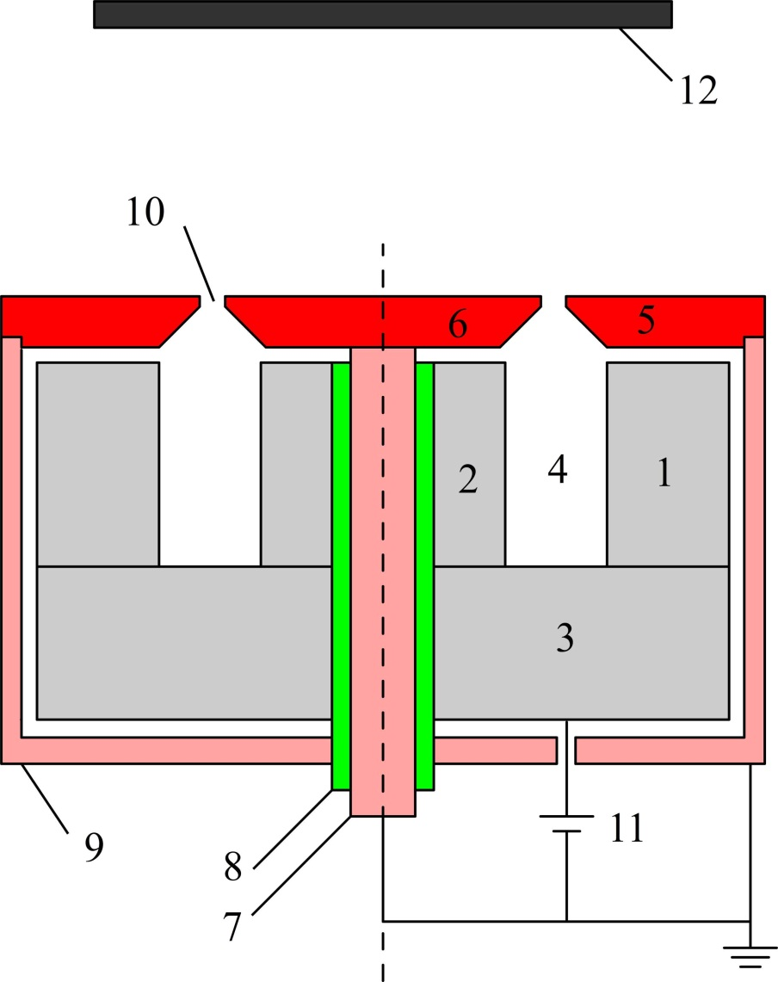
Fig. 1 Cross-section diagram of the inverted gapped-target magnetron source consisting of the following parts: (1) outer and (2) inner magnet holders, (3) magnetic yoke, (4) anode cavity, (5) concentric ring of nickel target, (6) center plate of nickel target, (7) target holder, (8) ceramic tube, (9) grounded shield, (10) circular target gap, (11) positive voltage power supply and (12) substrate holder.
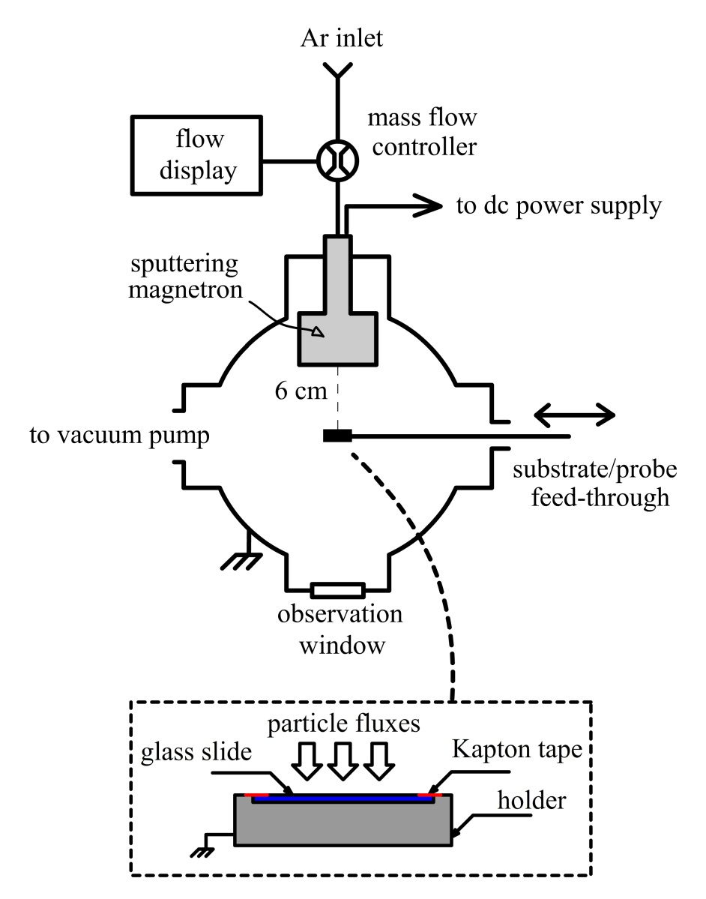
Fig. 2 Experimental arrangement for probe diagnostics and ferromagnetic thin film deposition using the inverted gapped-target magnetron.

(b)
(a)
Fig. 3 (a) The side view and (b) the front view image of the inverted gapped-target magnetron discharge operated at the Ar pressure of 2 Pa and at a discharge power of about 80 W (took at 1/10s shutter speed and f/13 aperture size and ISO100).

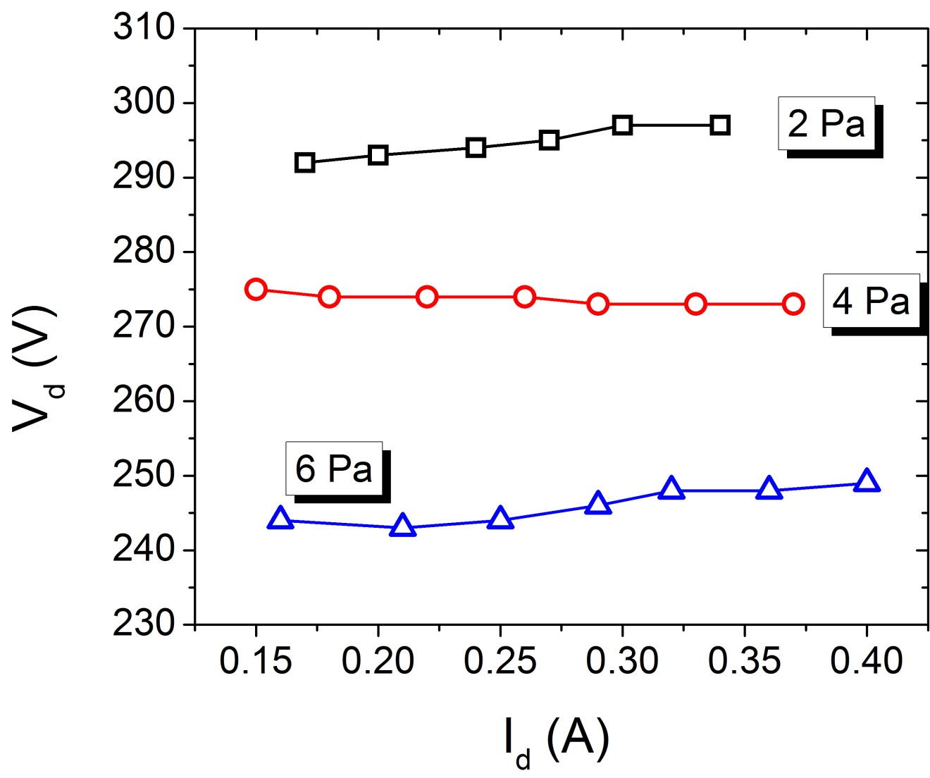
Fig. 4 The V-I characteristics of the inverted magnetron discharge for pressures of 2, 4 and 6 Pa. Note that the discharge voltage V_{d} is measured at the anode with respected to the grounded cathode, i.e. the nickel target and the vessel wall.
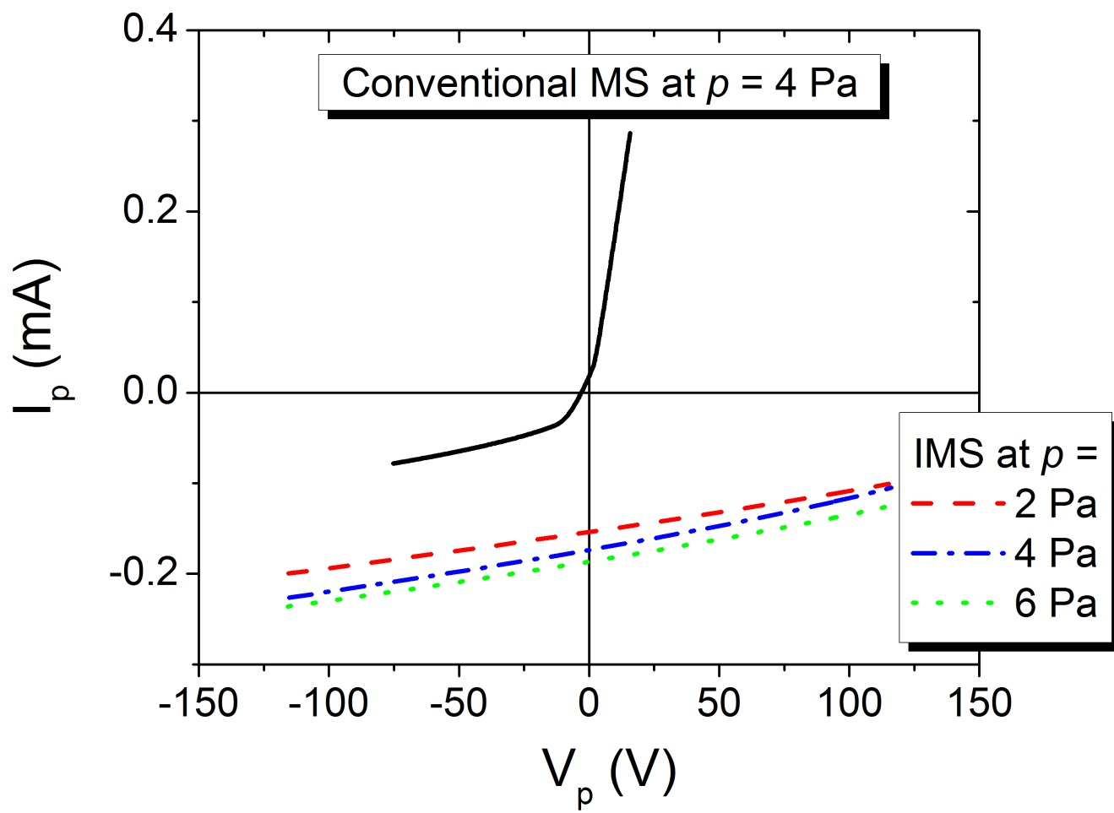
Fig. 5 I-V Langmuir probe characteristics measured at the substrate position (6 cm from the magnetron target) in the inverted magnetron sputtering (IMS) at P_{d} = 80 W and at p = 2, 4 and 6 Pa compared to that in a conventional magnetron sputtering at P_{d} = 80 W and at p = 4 Pa.

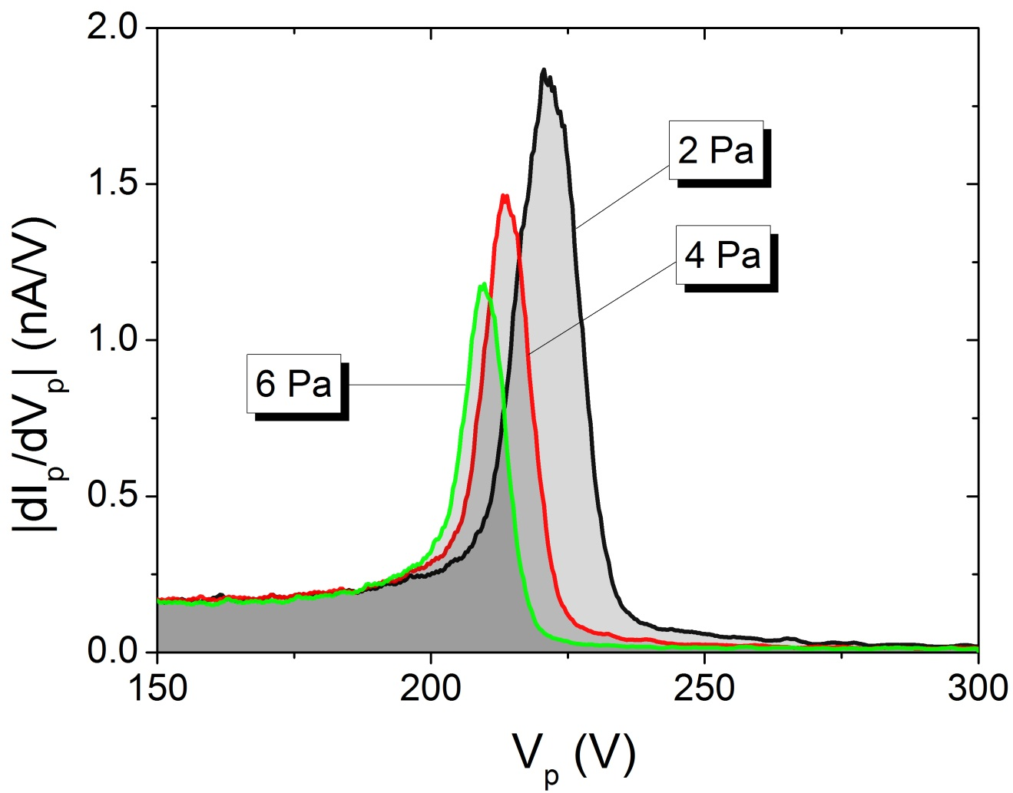
Fig. 6 The corresponding ion energy distribution function |dI_{p}/dV_{p}| plotted against discriminating voltage V_{p} of the RFA in the inverted discharges with different pressures.

(a)
(b)
(c)
(d)

Fig. 7 SEM images surface morphology of Nickel films prepared by the inverted magnetron at the pressure of (a) 2 Pa , (b) 4 Pa, (c) 6 Pa as compared to (d) the film prepared by the conventional magnetron at p = 4 Pa.

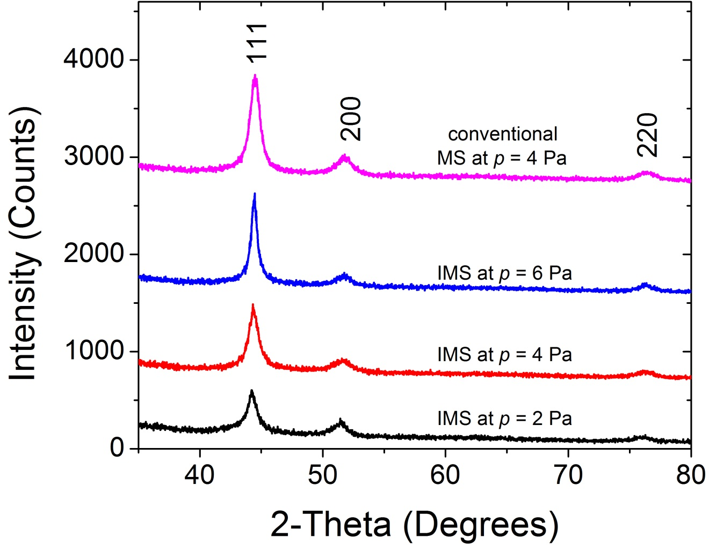
Fig. 8 XRD patterns of Ni films prepared by the inverted magnetron and the conventional magnetron for a number of pressures.

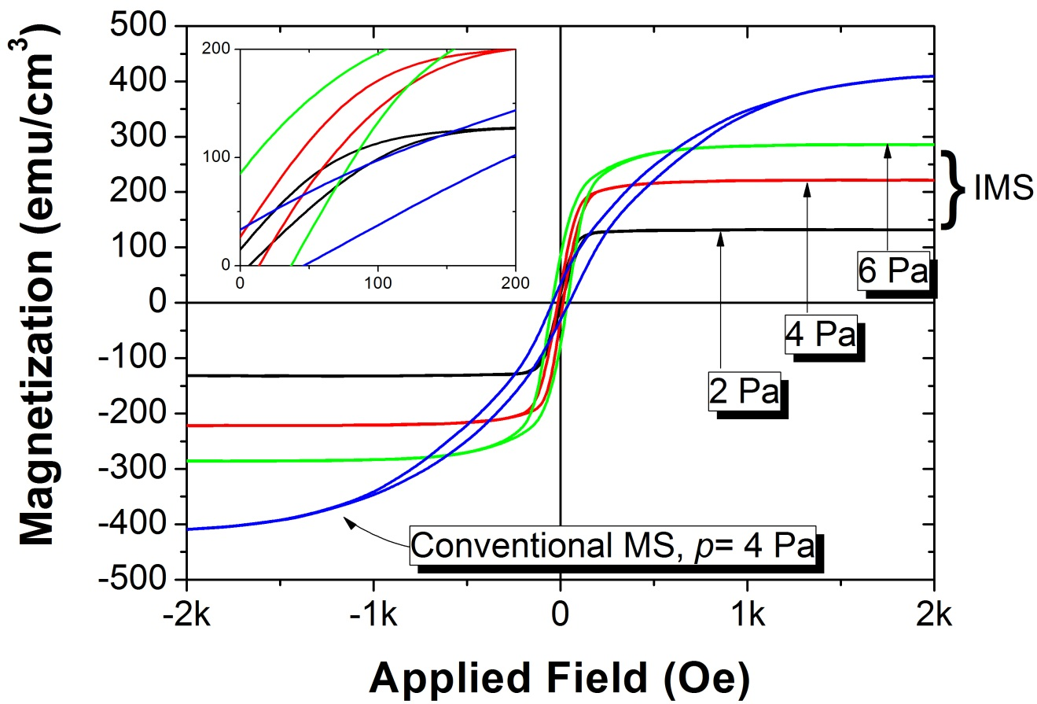
Fig. 9 Room temperature M-H hysteresis loops of nickel films prepared by IMS as compared to the conventional MS technique. The insert shows the hysteresis loops in more detail.

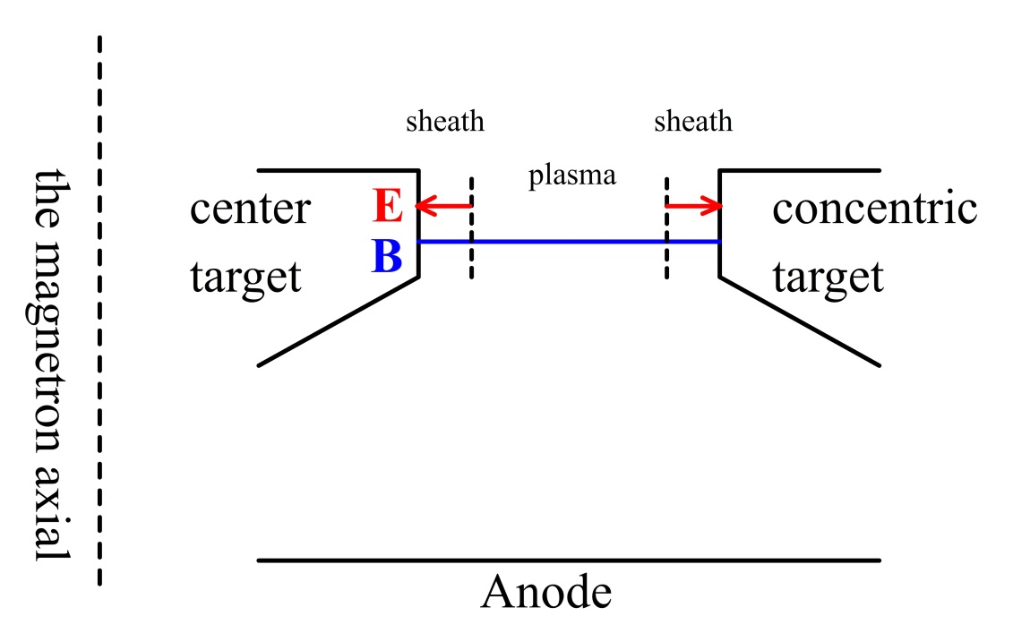
Fig. 10 Sketch of electric filed and magnetic field in the target gap to discuss the discharge mechanism in the IMS.
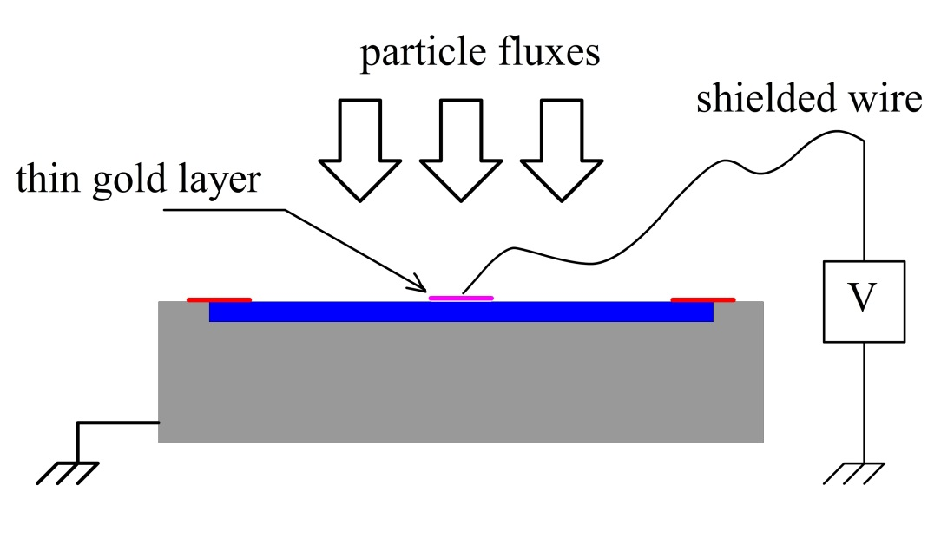
Fig. 11 The arrangement for testing the surface potential of an insulated glass slide during the IMS deposition.

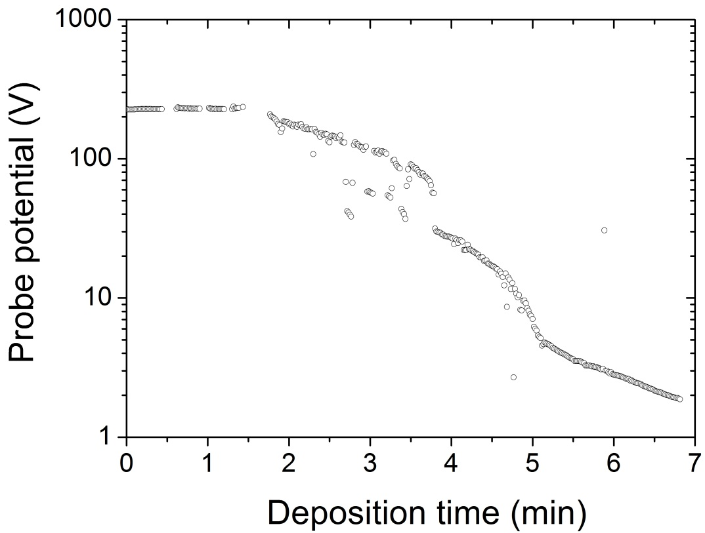
Fig. 12 The probe potential on the surface of the glass slide during nickel films deposition using the IMS discharge.

Table 1. A summary of discharge and plasma parameters for the given process conditions.
Coating | V_{d} | P_{d} | p | n_{i} | ε_{m}
Technique | (V) | (W) | (Pa) | (m⁻³) | (eV)
IMS_2pa | +295 | 80 | 2 | 0.6×10¹⁶ | 221
IMS_4pa | +273 | 80 | 4 | 0.7×10¹⁶ | 213
IMS_6pa | +247 | 80 | 6 | 0.7×10¹⁶ | 209
MS_4pa | -369 | 80 | 4 | 0.5×10¹⁶ | 1

Table 2. Crystalline size and magnetic parameters for nickel films obtained at the given process conditions
Coating | R | T | D_{c} | a | M_{s} | M_{r} | H_{c} | M_{r}/M_{s}
Technique | (nm/min) | (nm) | (nm) | (nm) | (emu/cm³) | (emu/cm³) | (Oe)
IMS_2pa | 9.8 | 290 | 8.3 | 0.35297 ± 5.82 x 10⁻⁴ | 131.82 | 12.79 | 8.54 | 0.1
IMS_4pa | 9.4 | 280 | 10.1 | 0.35297 ± 4.64 x 10⁻⁴ | 222.1 | 28.72 | 13.58 | 0.13
IMS_6pa | 8.3 | 250 | 12.5 | 0.35332 ± 1.92 x 10⁻⁴ | 285.9 | 80.88 | 40.85 | 0.28
MS_4pa | 22.6 | 340 | 9.2 | 0.35308 ± 1.10 x 10⁻⁴ | 415.39 | 32.28 | 44.62 | 0.08

