Characterisation of a micro-plasma for Ambient Mass Spectrometry Imaging
Andrew Bowfield,*^{a,b} Josephine Bunch,^{b} Tara L. Salter,^{b} Rory T. Steven,^{b} Ian S. Gilmore,^{b} Dave A. Barrett,^{c} Morgan R. Alexander,^{c} Kirsty McKayª and James W. Bradleyª
Received (in XXX, XXX) Xth XXXXXXXXX 20XX, Accepted Xth XXXXXXXXX 20XX
DOI: 10.1039/b000000x
Results are presented on the characterisation and optimisation of a non-thermal atmospheric pressure micro-plasma ion source used for ambient mass spectrometry imaging. The geometry of the experiment is optimised to produce the most intense and stable ion signals. Signal stabilities (relative standard deviation) of 2.3 – 6.5% are achieved for total ion current measurements from chromatograms. Parameters are utilised to achieve MS imaging by raster scanning of PTFE/glass samples with a spatial resolution of 147 ± 31 μm. A systematic study of resolution as a function of acquisition parameters was also undertaken to underpin future technique development. Mass spectra are obtained from PTFE/glass sample edges in negative ion mode and used to construct images to calculate the spatial resolution. Images are constructed using the intensity variation of the dominant ion observed in the PTFE spectrum. Mass spectra originating from the polymer are dominated by three series of ions in a m/z spectral window from 200 – 500 Da. These ions are each separated by 50 Da and have the chemical formula [C₂F+[CF₂]_{n}]⁻, [CF+[CF₂]_{n}+O]⁻ and [CF+[CF₂]_{n}+O₃]⁻. The mechanism for the generation of these ions appears to be a polymer chain scission followed by ionisation by atmospheric ion adduction. Positive and negative ion mode mass spectra of personal care products, amino acids and pharmaceuticals, dominated by the proton abstracted/protonated molecular ion, highlight the potential areas of application for such a device. Further to this end a mass spectral image of cardamom seeds, constructed using the variation in intensity of possible fragments of the 1,8-cineole molecule, is included to reveal the potential application to the imaging of foods and other biological materials.

Introduction
The increasing importance of ambient ionisation mass spectrometry (ambient MS)^{1,2} as a tool for surface analysis and spectral imaging is unsurprising when one considers the number of successful applications in many areas of such a powerful technique. Recent studies have revealed applications including pharmaceuticals,^{3,4} polymers,^{4,5} micronutrients,⁶ drugs of abuse,⁷ agrochemicals in food stuffs⁸ and personal care products.⁹ While desorption electrospray ionization (DESI) was the first of these techniques,¹⁰ there are now a vast number of differing ion sources utilised in the field. Within this growing domain, plasma-based desorption and ionisation techniques¹¹ have developed as one of the leading variants.
Direct analysis in real time (DART),¹² established in 2005 and now commercially available, is currently the most common plasma-mediated ambient ion source. However, dielectric barrier discharge ionization (DBD)¹³ and low temperature plasma (LTP)¹⁴ (an annular version of DBD) are increasingly being utilised for ambient MS. These have the benefit of being inexpensive and easy to construct with the potential for rapid and on-site analysis when coupled to mobile mass spectrometers.^{15,16} Many other plasma sources have also been designed and tested successfully when combined with ambient MS.^{2,4,11}
The plasma afterglow is allowed to directly interact with the sample when using LTP, in common with plasma assisted desorption ionisation (PADI).¹⁷ Mechanisms proposed to explain the complex plasma chemistry apparent in each ambient ionisation source include direct electron impact ionization, metastable Penning ionization and ion-molecule interactions.¹⁷ Elucidation of such mechanisms has been aided by optical emission spectroscopy, especially for LTP,¹⁸⁻²¹ and molecular beam mass spectrometry.²² Most ambient plasma-based techniques employ helium as the discharge gas³⁻⁹ since the metastable ions produced by the breakdown processes contain a large amount of internal energy (He*, ³S₁, 19.8 eV) which can directly ionise analytes through Penning ionisation. Also, the ionised He dimer, He₂⁺, has been identified as the dominant positive ion in this scenario and acts as an energy carrier into the plasma afterglow where charge is transferred to atmospheric nitrogen. This leads to the formation of N₂⁺, which is key in the creation of water clusters and hence proton transfer to the surface. While logic would suggest that different excitation processes in the various plasma devices may alter the dominance of primary mechanisms through which desorption/ionisation occur, a previous study²³ compared DART to both DBD and RF glow discharges and concluded that desorption/ionisation processes appeared to be indistinguishable between the three sources in the specific case of the ambient MS analysis of acetaminophen.
The device used in the current study is based upon the DBD/LTP construction due to the inherent non-thermal nature of plasma generation. These devices generate a highly nonequilibrium plasma through the formation of ‘plasma bullets’. These ‘bullets’ are regions constituted of ions and vacuum ultra violet (VUV) photons²⁴⁻²⁶ ejected from the capillary when the applied voltage crosses a certain threshold in both the negative and positive regions of the voltage waveform. Initiation of the bullets is localised between the driven and ground electrode within the capillary volume and they are formed and ejected with a FWHM in the µs region.²⁶ This behaviour is displayed in Fig. S1 in the Supporting Information (SI) by the spikes in the current trace of the IV graph. The discrete packets act as the major vehicle for energy delivery to the surface and as such effectively create a non-continuous plasma, limiting the temperature within the capillary to approximately 60°C. While higher gas temperatures result in more efficient analyte desorption,^{8,23} the investigations herein avoid the use of such mechanisms in order to localise the incident plasma.
Investigations employing ambient plasma ion sources have primarily focused on applicability to a wide range of surfaces and molecules. Such efforts would be aided by a reduction in desorption footprint and associated improvement in spatial resolution to open up the field of ambient MS imaging analysis to such devices. Of the ambient techniques, currently DESI is the most widely used to obtain such images with a spatial resolution of 35 μm recently being achieved.²⁷ However, LTP²⁸⁻³¹ and PADI have the potential to operate in an imaging mode with improvements in design. At present, the best reported spatial resolution for plasma-mediated ambient MS is approximately 200 µm using LTP,³¹ where the device was used exclusively for sample removal. Although this is behind the resolutions routinely achieved in matrix-assisted laser desorption ionization (MALDI)^{32,33} or secondary ion mass spectrometry (SIMS),³⁴ those techniques require either complex sample preparation in the case of MALDI or vacuum conditions when referring to the latter. Studies using laser ablation sources combined with plasmas have also produced images with spatial resolutions between 1 – 20 µm.^{35,36} The advantages of using this alternative LTP over the techniques mentioned above are; the lack of complex or time consuming sample preparations/procedures; the absence of solvents means there is no source of analyte de-localisation as in DESI; mass spectra are dominated by the proton abstracted/protonated molecular ion;^{4,37} the ability to be used with analytes of any surface in the absence of thermal damage;⁸ both positive and negative ion modes can be used; the control of fragmentation processes;¹⁴ its inexpensive design, construction, power consumption and implementation coupled to its low source flow rates also result in a hugely important application of on-site analysis with a truly mobile ion source. These advantages must be balanced against a lower maximum spatial resolution, however, this technique provides complimentary and orthogonal information to that obtainable by the other techniques in a much quicker time-scale and at substantially lower cost (in comparison to expensive to maintain vacuum and laser instruments.)
In this study, the authors develop a strategy of characterisation and optimisation of crucial operating parameters to understand their impact on the spatial resolution of a non-thermal micro-plasma device. Not only do these investigations aid in establishing the desired conditions in which mass spectrometry imaging (MSI) can be achieved with the best spatial resolution, they also provide the basis for future technique development through a systematic experimental approach.

Experimental
Samples
Polytetrafluoroethylene (PTFE) was analysed in bulk form as thread-seal tape (RS, Corby, UK) which was wrapped around a standard glass microscope slide to present a uniform and flat surface to the ion source and replaced following each experiment to ensure no repeat sampling. Previous investigations^{4,5} have revealed the sensitivity of this polymer to plasma ion sources, hence it was chosen to probe the spatial resolution of the micro-plasma as a model system. 5 µL of 10 mM pure components of personal care products (pcps) (liquids – triethanolamine, linalool, propylene carbonate) (Alfa Aesar, Heysham, UK) were deposited onto glass microscope slides and MS analysis conducted while wet. 5 µg crystalline solids including amino acids (valine, leucine, phenylalanine), Fmoc (fluorenylmethyloxycarbonylchloride-pentafluoro-L-phenylalanine), caffeine (Sigma, Poole, UK), the phospholipid dipalmitoylphosphatidylcholine (DPPC) (Avanti Polar Lipids, Alabaster, AL, USA) and over the counter generic drug compounds ibuprofen and paracetamol, were also placed on glass slides for MS analysis.

Micro-plasma
The device is similar to the LTP,¹⁴ however the driven and earthed electrodes are reversed in this configuration.³⁸ A full description and optical image of the micro-plasma in operation can be found in the SI (Fig. S2) while a schematic is also included in Fig. 1. The main operating parameters were; a driving frequency of 14.25 kHz resulting in ac voltages 9.8 kV p-p applied to a sharpened copper electrode, 1.0 mm diameter; the electrode was placed coaxially within tapered borosilicate glass capillaries 112.5 mm long, 3.0 mm outer diameter and 1.6 mm inner diameter; the tapered end of the capillaries is 25 mm long with variable diameters in the range 20 – 56 µm (D_{c}); the sharpened tip of the electrode is placed 35 mm from the end of the capillaries; aluminium tape, 10 mm in width, is wrapped around the capillaries 45 mm from the end and is electrically grounded; helium gas, 99.996% pure (BOC, Guildford, UK), flows between the driven electrode and capillaries and out through the tapered end and is controlled via a rotameter (Omega engineering, Manchester, UK), in the range 5 – 65 ml/min.

Mass Spectrometer
A Thermo Scientific LTQ-Orbitrap Velos mass spectrometer (LTQ linear ion trap, nominal mass resolution) was used for all MS studies, unless otherwise stated. Negative ion mode MS was employed for all studies of PTFE as desorption/ionisation is not observed from this substrate in positive ion mode. Preliminary studies of PTFE established that the spectrometer needed to be programmed with a set ion trap injection time of 600 ms with automatic gain control turned off and 5 co-added micro-scans per spectrum. Total ion current (TIC) intensities were generated by summing ion signal intensity over the range m/z 200 – 500. The standard ion transfer tube was replaced with an extended version 127 mm in length (internal diameter of 0.5 mm), but with the final 18 mm bent at an angle of 15 degrees towards the 2-axis stage. This tube is referred to as the ‘sniffer’, as shown in Fig. S2, and the temperature was set to 225°C while held at a voltage of 0 V. All samples were placed on a 2-axis stage (Prosolia, IN, USA) 0.5 mm below the sniffer. The effect of the position of the device on the observed negative ion intensity from PTFE was investigated by recording TIC as a function of four parameters: the diameter of the capillaries at the nozzle exit (D_{c}), sniffer/capillary separation (r, 1 – 11 mm), the vertical distance separating the surface and capillary (z, 1 – 2 mm) and source flow rate. The optimal parameter values deduced from these studies were then used to conduct MSI of PTFE/glass samples.
Volatiles/non-volatiles – Both positive and negative ion modes were used for studies involving pcps, amino acids and pharmaceuticals. Negative ion mode MS was used to study Fmoc and negative ion tandem MS of DPPC (collision induced dissociation energy of 25.00 eV) was used to aid phospholipid identification.
Positive/negative ambient ions – The time-averaged spectra were obtained on a Hiden Analytical HPR-60 MBMS with the exit of a 56 µm diameter capillary placed 4 mm from the entrance orifice of the MS and aligned with the centre of the sampling orifice (100 µm diameter) along the discharge axis and parallel to the axis of the instrument. The sampling time of the detector was set at 1s and a source flow rate of 0.25 ml/min was used. This MS was used as it can detect ions < 50 Da and this is where a large number of such atmospheric ions reside.

Mass Spectrometry Imaging (MSI)
PTFE – All images of PTFE were produced by compiling the raw data (.raw, Thermo Scientific Xcaliber) into an image (Firefly, Prosolia) which was then read into BioMAP (v.3.7.5.5, Novartis). The image contained herein consists of a two dimensional 75 x 7 pixel grid (pixel size 40 μm x 40 μm) where each row took 3.96 min to record with each pixel acquisition time taking 3.17 s. The x-y stage moved at a rate of 12.62 μm/s.
Cardamom – The dried seeds were purchased whole from a local supermarket and were cut in half through the sagittal plane using a scalpel. Two halves of different seeds were chosen so as to be non-symmetrical. The seeds were then placed, with their interiors facing upwards, on sticky tape which was wrapped around a glass microscope slide and secured in the 2-axis stage. This stage was then lowered to 2.5 mm below the sniffer to ensure the seeds could pass freely beneath the sniffer. The thickness of the seeds was approximately 2 mm and the plasma device was placed 1 mm above the surface of the seeds at r = 1.5 mm as this produced the most intense spectrum from the seed surface not dominated by ambient ions. The separation between the plasma device and the surface of the seeds was not constant across the recorded image due to the uneven nature of the surfaces themselves.
Intense ion signals (10⁴) were detected in preliminary studies of cardamom seeds, likely originating from volatile organic compounds (VOCs). The MS was programmed to collect 3 co-added microscans per spectrum and 200 ms injection time which allowed a scan time of 0.72 s per pixel with each row taking 0.90 min to acquire due to the abundance of aromatic molecules. The x-y stage moved at a rate of 277.78 μm/s and the MSI consists of a 75 x 50 pixel grid.

Comparison of Line Profiles
Line profiles are generated by calculating the average ion intensity of the m/z 297 ion in each column of pixels along the x-axis and normalising to the maximum ion intensity. This method reduces the two-dimensional pixelated image into a single line of 75 averaged pixels from which the spatial resolution can be calculated.^{39,40} Spatial resolutions are calculated by measuring the 16-84% interval of the line profile of the intensity variation of the ion across the step edge between the PTFE sample and the glass slide. This measurement provides the value of 2σ of the Gaussian broadening observed at the edges of the ‘top hat’ function⁴¹ and then this value is multiplied by $\sqrt{2ln2}$ to provide the FWHM and therefore the spatial resolution of the device. It is important to emphasise that this is a theoretical spatial resolution defined, as it is, by the broadening of the line profile generated at the step-edge between the PTFE tape and the glass slide. This process neatly captures and defines variations in spatial resolution as a function of the operating parameters.

Results and Discussion
Optimisation of Plasma MS
The micro-plasma device, shown in Figs. 1 and S2, was orientated normal to the surface for imaging to ensure the activated plasma plume profile presented to the substrate was symmetrical.
Fig. 2a displays the variation in negative TIC and intensity of the ion located at m/z 297 from PTFE for 56 – 20 µm diameter capillaries. An intermittent and unstable ion signal was observed for capillaries with diameters less than 20 µm and consequently these results are excluded from the data shown here. Decreases in both TIC and peak intensity of several orders of magnitude are clearly observed as the capillary diameter is reduced. The error bars display +/- 1 standard deviation of three measurements from samples which were replaced following each plasma exposure. The relative standard deviation (RSD) of TIC for the 56 µm diameter capillary is the largest of the set at 6.5%, whereas those for the three others vary between 2 – 4%. Such stability is a significant improvement on that reported previously when using PADI (7%)⁵ or LTP (16%)^{7,8} and is of vital importance in mass spectrometry imaging. It is likely that reducing the diameter of the capillaries reduces the rate and number of plasma/air interactions around the main stream of ions and photons and hence decreases the sampling area of the surface. This limits the effect of turbulence induced treatment of the surface and increases signal stability²⁵ (reduces RSD) until a threshold is reached where further reducing the diameter of the capillary leads to a loss of signal due to the limits of detection of the sniffer and the amount of surface material desorbed. Evidence for this is found in the fact that the largest diameter capillary produced the most fluctuating signal. The data presented here leads the authors to conclude that this intensity balance occurs when using capillaries with diameters less than 20 µm for non-volatile samples and helium as the discharge gas.
TIC is presented as a function of gas flow and sniffer/capillary separation, r, in Figs. 2b and 2c as r is increased from 1 mm to 11 mm for (b) 56 µm and (c) 20 µm diameter capillaries at z = 1 mm. The surface/capillary separation, z, was kept at a constant 1 mm throughout optimisation studies (investigated in section 3) in order to limit gas diffusion considerations and its impact on desorption footprint. There are again large decreases in TIC observed with both capillaries as the source flow rate is reduced and r is increased. The most intense TIC is observed at r = 2 mm for both capillaries. This is due to the fact that at r = 1 mm, there is direct sampling of the plasma afterglow by the sniffer which reduces plasma volume at the PTFE surface for both capillaries (subsequent data recorded at r = 1.5 mm saw a restoration of the signal to the approximate level previously observed at r = 2 mm). A comparison of Figs. 2b and 2c shows that the intensity distribution is much more confined and centred at r = 2 mm and 65 ml/min when using the 20 µm diameter capillary. This difference highlights that the smaller capillary is more sensitive to variations in gas flow than the larger capillary. Indeed, gas flows below 20 ml/min produced no detectable signal.
An important consideration of such plasma devices is the surface area/volume ratio of the capillary compared to the plasma as the inside surface of the glass capillary acts as an ion ‘sink’. If it is assumed that the plasma inhabits the whole cavity volume of the tapered end of the capillary and that it is only the surface area of this interior cylinder which acts as the sink, then calculations show that the surface area increases by 180% relative to the volume of plasma as one reduces the capillary diameter to 20 µm from 56 µm. Of course, the plasma is struck in the larger diameter chamber and it is likely that some ions are entrapped by the main stream of activated species generated at the needle tip and therefore do not migrate outwards towards the capillary walls.
The lack of a persistent ion signal from the PTFE surface when using capillaries with diameters less than 20 µm can be explained by the lower number of ions produced per unit time by capillaries of this size. It is entirely plausible that desorption/ionisation is occurring, but it is simply below the detectable limit of this sniffer due to lower ion throughput. Alternatively, it is also possible that the life time of the plasma bullets outside the capillary may be decreased significantly when coupling small diameter capillaries to low gas flow.⁴² If collisions between atmospheric molecules and the He gas increase resulting in greater gas diffusion with these smaller capillaries, desorption/ionisation may be prevented. If one conjectures that the plasma bullets have a radial cross section containing ionic species and VUV photons in the inner core surrounded by an envelope of activated gas species,²⁴⁻²⁶ the increased interaction of this envelope with the walls of the narrower capillaries reduces the concentration of such species surrounding the plasma bullet. Since this envelope also decays with distance, lower concentrations may result in fewer plasma interactions upon the analyte per unit time when using narrower capillaries, even at high source flow rate. The threshold beyond which the reduction in capillary diameter restricts the number of activated species per volume per unit time to reach the surface and induce desorption/ionisation at a level which the MS sniffer can detect appears to be 20 µm. It is also interesting to note that negative ion signals are still observed as r is increased beyond 10 mm. This suggests that the ions are long lived and it is diffusion with ambient air which reduces ion intensity, although added turbulence induced desorption/ionisation from higher source flow rates also clearly contribute to the persistent ion signal.
Excluding data points for a source flow rate of 5 ml/min and maximum source-interface gap of r = 11 mm, RSD using the 56 µm diameter capillary decreased to 7.6% from 14.8%. Calculations for the 20 µm capillary result in a RSD of 6.5% excluding data points at 20 ml/min and r = 11 mm as compared to 16.3% RSD when included. These results again confirm the sensitivity of the lower diameter capillary to source flow rate as RSD decreases relatively more than that of the larger capillary when the signal recorded using lower rates of gas flowing through the capillary are excluded from the calculation.
The ambient ions produced by plasma/air mixing agree with the conclusions of optical spectroscopy studies¹⁸⁻²¹ that the helium discharge gas is crucial to the mechanisms underpinning creation and propagation of the plasma afterglow. The dominance of the N₂⁺ ion when the mass spectrometer was operated in positive ion mode (Fig. S3a, (SI)), and an excess of oxygen, ozone and water clusters when operated in negative ion mode (Fig. S3b, (SI)) are clearly visible.

MSI and Spatial Resolution Calculations
The negative ion MSI of a PTFE step-edge, shown in Fig. 3a, was recorded using the 43 μm diameter capillary with a flow of 65 ml/min at z = 1 mm, r = 1.5 mm. A capillary of this dimension was utilised for publication purposes to ensure a clear representation of the typical images produced using this set-up. The image is 3.0 x 0.28 mm in size as defined by the blue lines. It was constructed using the variation in intensity of the ion at m/z 297 and which belongs to the series with the formula [CF+[CF₂]_{n}+O]⁻ where n = 4 ( ). Also included in Fig. 3a are typical negative ion mass spectra of the polymer (top) and also from the glass slide (bottom). The three major series of ions observed from PTFE are labelled using the same icons as previously⁵ and correspond to ions belonging to the series [C₂F+[CF₂]_{n}]⁻ (n = 4, 5, …9) () and [CF+[CF₂]_{n}+O₃]⁻ (n = 3, 4, …8) () as well as that noted above. The ‘background spectrum’ is sufficiently different to that produced from the PTFE to result in a clear image defining the step edge and there is also a marked reduction in signal from 10³ for those ions released from PTFE to single units when on the glass slide. The spatial resolution of the MS image in Fig. 3a is calculated to be 399 μm using the process as defined in the experimental section under the heading of ‘Comparison of Line Profiles’.
Fig. 3b charts the direct comparison of two line profiles generated from images produced using a 22 μm diameter capillary where x is the distance across the 3 mm mass spectral image. The position of the device changes from z = 1 mm, r = 1.5 mm (dashed line) to z = 2 mm, r = 4 mm (solid line) and is included to allow a direct comparison of the effect on the spatial resolution of the position of the device. The spatial resolution of the dashed line is 145 μm and increases to 497 μm when the device is moved further away from both the sniffer and the polymer. It is also noticeable that the ‘quality’ of the line profile is significantly lower when the device is positioned further away from the sniffer, probably due to a more fluctuating signal.

Effect of Operating Parameters on Spatial Resolution
It is important to measure the effect of the major operating parameters (r, z, D_{c} and source flow rate) on the spatial resolution in order that optimisation studies fully consider parameter space. Such studies allow operating parameters to achieve the best resolution to be stated with confidence (for this experimental system). Fig. 4a shows how spatial resolution varies as a function of gas flow for 43 and 20 µm diameter capillaries. The data presented in Fig. 4a is in good agreement with Fig. 2 as it confirms the increased sensitivity of the narrower capillaries to gas flow. The sniffer/capillary separation clearly has the biggest impact on spatial resolution, as displayed in Fig. 4b, and is likely due to the greater diffusion of the desorbed PTFE ions due to the longer sampling time and larger distances over which they have travelled. However, it is also significant that the highest spatial resolution is achieved with the smallest values of z, r and D_{c} across both charts.
Fig. 4c shows the variation in the spatial resolution achieved for each different capillary. The spatial resolution has been improved to 147 ± 31 µm by reducing the diameter of the capillary to 20 µm. As the spatial resolution achieved with a 56 µm diameter capillary is 512 ± 68 µm, this constitutes an improvement of 71% in resolution coupled to a 64% reduction in diameter. The error bars show the RSD of the spatial resolution achieved with each capillary positioned at r = 1.5 mm and z = 1 mm. This position has been selected as the optimal position for the device after consideration of the data displayed in the previous figures. A resolution of 147 µm is a modest improvement to the current best spatial resolution achieved with plasma ion sources³¹ (200 µm) but this is also coupled to a significant improvement in signal stability. Both of these factors are crucial in the field of complex mass spectrometry imaging.
The limiting factor in terms of improving spatial resolution beyond 147 µm appears to be the lack of a stable ion signal when using capillaries with diameters below 20 µm and sampling non-volatiles on different substrates, possibly due to low volumetric gas flow. Studies are continuing with the current device to obtain images of a similar resolution to those reported earlier when using DESI.²⁷

MSI of Cardamom Seeds
Fig. 5a shows a 15 x 10 mm optical image of two different halves of freshly cut cardamom seeds (Amomum subulatum) along with MS images of the same seeds obtained using a 26 μm capillary. An inspection of Fig. 4c suggests the spatial resolution of the device at r = 1.5 mm, z = 1 mm for a 26 μm capillary to be approximately 180 μm and therefore 200 μm x 200 μm pixels were chosen. However, the spatial resolution obtainable with such irregularly shaped specimens (in all three spatial dimensions) is unlikely to be the same as that observed when using planar substrates. Such pixel size should aid in efforts to avoid the unpredictable distortions in the plasma producing image artefacts from the non-flat surface.
Fig. 5b is a positive ion MSI of the seeds displayed in Fig. 5a. A typical positive ion mass spectrum of the seeds is displayed in the Supporting Information (Fig. S4). Fig. 5b is constructed using the same software packages as outlined earlier and uses the variation in intensity of the positive ion located at m/z 81. This image clearly depicts the cardamom seeds as shown in Fig. 5a and also shows an apparent distribution of this ion, with two circular areas coloured in red, common to both seeds. It is clear however that the spatial resolution of the device is significantly lower than that achieved with planar substrates. GC-MS studies of the essential oil of cardamom seeds report that 1,8-cineole, M = 154.1357, constitutes anything from 43 – 89% of the dried capsules.⁴³⁻⁴⁵ The positive ion located at m/z 81 could therefore be the protonated cyclohexane fragment of 1,8-cineole [M+H-3(CH₃)-COH]⁺. Unfortunately MS/MS was not conducted on the ion fragments in order to substantiate an unambiguous identification. A further MSI constructed using the positive ion located at m/z 95 can also be seen in Fig. S5. Again, one possible assignment of this ion is to a different fragment of 1,8-cineole [M+H-C(CH₃)(CH₃)-H₂O]⁺, where VOCs, aromatic molecules which readily interact with the plasma/air mixture, result in higher levels of fragmentation but this cannot be confirmed without further data.
It is likely that the irregular, non-symmetrical and uneven substrates presented to the plasma plume create fluid dynamic distortions both at the centre of the seed and at the edges. Of course, this will impact on image quality and the intensity profiles produced in a complex fashion. However, a full analysis of plasma interactions at the surface and edges of the seed is beyond the scope of this investigation.

AMS of Volatile/Non-volatile Compounds
In order to establish that this device produces similar typical mass spectra observed previously with the LTP,³⁷ i.e. dominated by the proton abstracted/protonated molecular ion with little fragmentation making identification relatively simple, positive (Fig. S6) and negative (Fig. S7) ion MS of volatile pcps and less/non-volatile amino acids, caffeine and paracetamol and ibuprofen are included in the Supporting Information. The negative ion mass spectra of the volatile pcps clearly displayed series of ions with additional oxygen components (Fig. S7a) which originate from plasma/air interactions (Fig. S3b). Fig. S7f of PC(16:0/16:0) DPPC is the first negative ion tandem MS of an intact lipid using a plasma ion source that the authors are aware of.^{46,47} The dominant peak at m/z 795 corresponds to the ion [M+NO₃]⁻. The excited gas and air mixture produces adduct formation and addition to the subject molecule which allows for definitive identification of the lipid in the absence of solvent based adduction. Such behaviour has been reported previously.¹⁶ This is a potentially important result in the field of bioanalysis and increases the impact of the studies contained herein. This feature also occurs for investigations of PTFE and Fmoc.

Conclusions
This study used a model sample of PTFE wrapped around glass microscope slides to study the effects of principal parameters on the spectral intensity and spatial resolution of ambient MS images. Recommended values of these parameters are 1 mm ≤ z ≤ 2 mm, 1.5 mm ≤ r ≤ 2 mm, D_{c} = 20 µm and source flow rate ≥ 45 ml/min for this experimental system. It is clear the major factors affecting signal and spatial resolution are the diameter of and the gas flow through the capillary. The spatial resolution achieved with this micro-plasma is in the realm of other ambient mass spectrometry imaging techniques and could be improved with further modifications to the system.
The RSD of signal intensities is found to be approximately 2 – 7% and which originate from the plasma source rather than the mass spectrometer. This is significantly better than that reported previously with both PADI and conventional LTP itself.
These studies were also able to observe and detect non-volatiles even at non-thermal operating temperatures, thereby limiting damage to sensitive surfaces. These investigations provide evidence of significant advantages of the micro-plasma device. These can be summarised as the absence of sample preparation, inexpensive construction, improved signal stability, detection and simple identification of a range of both volatile and non-volatile compounds and the ability to image real-world foodstuffs. Such strengths offer the potential ability to conduct MS imaging of more complicated samples in a rapid and efficient manner.

Acknowledgements
The authors would like to thank The Engineering and Physical Sciences Research Council (EPSRC) and the Chemical and Biological Programme of the National Measurement System of the UK Department of Business, Innovation and Skills for financially supporting this work. The authors thank Dr. Melissa K. Passarelli for discussions on mass spectrometry analysis and Mr. Alan Roby for constructing the plasma device.

References
(a) Department of Electrical Engineering and Electronics, University of Liverpool, L69 3GJ, UK. Tel: +44 (0) 151 794 4593; E-mail: a.bowfield@liv.ac.uk
(b) National Physical Laboratory, Teddington, Middlesex, TW11 0LW, UK
(c) Centre for Analytical Bioscience and Laboratory of Biophysics and Surface Analysis School of Pharmacy, University of Nottingham, NG7 2RD, UK

(1) M. E. Monge, G. A. Harris, P. Dwivedi and F. M. Fernández, Chem. Rev. 2013, 113, 2269.
(2) G. A. Harris, A. S. Galhena and F. M. Fernández, Anal. Chem. 2011, 83, 4508.
(3) J. P. Williams, V. J. Patel, R. Holland and J. H. Scrivens, Rapid Comm. Mass Spec. 2006, 20, 1447.
(4) A. Bowfield, D. A. Barrett, M. R. Alexander, C. A. Ortori, F. M. Rutten, T. L. Salter, I. S. Gilmore and J. W. Bradley, Rev. Sci. Instrum. 2012, 83, 063503.
(5) T. L. Salter, I. S. Gilmore, A. Bowfield, O. T. Olabanji and J. W. Bradley, Anal. Chem. 2013, 85, 1675.
(6) M. J. Stein, E. Lo, D. G. Castner and B. D. Ratner, Anal. Chem. 2012, 84, 1572.
(7) A. U. Jackson, J. F. García-Reyes, J. D. Harper, J. S. Wiley, A. Molina-Diaz, Z. Ouyang and R. G. Cooks, Analyst 2010, 135, 927.
(8) J. S. Wiley, J. F. García-Reyes, J. D. Harper, N. A. Charipar, Z. Ouyang and R. G. Cooks, Analyst 2010, 135, 971.
(9) T. L. Salter, F. M. Green, N. Faruqui and I. S. Gilmore, Analyst 2011, 136, 3274.
(10) Z. Takats, J. M. Wiseman, B. Gologan and R. G. Cooks, Science 2004, 306, 471.
(11) X. Ding and Y. Duan, Mass Spectrom. Rev. 2013, DOI: 10.1002/mas.21415.
(12) R. B. Cody, J. A. Laramee and H. D. Durst, Anal. Chem. 2005, 77, 2297.
(13) N. Na, M. X. Zhao, S. C. Zhang, C. D. Yang and X. R. Zhang, J. Am. Soc. Mass Spectrom. 2007, 18, 1859.
(14) J. D. Harper, N. A. Charipar, C. C. Mulligan, X. R. Zhang, R. G. Cooks and Z. Ouyang, Anal. Chem. 2008, 80, 9097.
(15) S. Soparawalla, F. K. Tadjimukhamedov, J. S. Wiley, Z. Ouyang and R. G. Cooks, Analyst 2011, 136, 4392.
(16) J. S. Wiley, J. T. Shelley and R. G. Cooks, Anal. Chem. 2013, 85, 6545.
(17) L. V. Ratcliffe, F. J. M. Rutten, D. A. Barrett, T. Whitmore, D. Seymour, C. Greenwood, Y. Aranda-Gonzalvo, S. Robinson and M. McCoustra, Anal. Chem. 2007, 79, 6094.
(18) G. C. Y. Chan, J. T. Shelley, A. U. Jackson, J. S. Wiley, C. Engelhard, R. G. Cooks and G. M. Hieftje, J. Anal. At. Spectrom. 2011, 26, 1434.
(19) G. C. Y. Chan, J. T. Shelley, J. S. Wiley, C. Engelhard, A. U. Jackson, R. G. Cooks and G. M. Hieftje, Anal. Chem. 2011, 83, 3675.
(20) M. S. Heywood, N. Taylor and P. B. Farnsworth, Anal. Chem. 2011, 83, 6493.
(21) J. T. Shelley, G. C. Y. Chan and G. M. Hieftje, J. Am. Soc. Mass Spectrom. 2012, 23, 407.
(22) K. McKay, T. L. Salter, A. Bowfield, J. L. Walsh, I. S. Gilmore and J. W. Bradley, J. Am. Soc. Mass Spectrom. (Accepted).
(23) J. Kratzer, Z. Mester and R. E. Sturgeon, Spectrochim. Acta Pt. B 2011, 66, 594.
(24) M. Teschke, J. Kedzierski, E. G. Finantu-Dinu, D. Korzec and J. Engemann, IEEE Trans. Plasma Sci. 2005, 33, 310.
(25) J.-S. Oh, O. T. Olabanji, C. Hale, R. Mariani, K. Kontis and J. W. Bradley, J. Phys. D: Appl. Phys. 2011, 44, 155206.
(26) J.-S. Oh, Y. Aranda-Gonzalvo and J. W. Bradley, J. Phys. D: Appl. Phys. 2011, 44 365202.
(27) D. I. Campbell, C. R. Ferreira, L. S. Eberlin and R. G. Cooks, Anal. Bioanal. Chem. 2012, 404, 389.
(28) Y. Liu, X. Ma, Z. Lin, M. He, G. Han, C. Yang, Z. Xing, S. Zhang and X. Zhang, Angew. Chem. Int. Ed. 2010, 49, 4435.
(29) S. Martínez-Jarquín and R. Winkler, Rapid Comm. Mass Spec. 2013, 27, 629.
(30) D. I. Campbell, J. K. Dalgleish, I. Cotte-Rodriguez, S. Maen and R. G. Cooks, Rapid Comm. Mass Spec. 2013, 27, 1828.
(31) Z. Xing, J. Wang, G. Han, B. Kuermaiti, S. Zhang and X. Zhang, Anal. Chem. 2010, 82, 5872.
(32) A. Römpp and B. Spengler, Histochem. Cell Biol. 2013, 139, 759.
(33) A. Zavalin, E. M. Todd, P. D. Rawhouser, J. Yang, J. L. Norris and R. M. Caprioli, J. Mass Spectrom. 2012, 47, 1473.
(34) F. Kollmer, W. Paul, M. Krehl and E. Niehuis, Surf. Interface Anal. 2013, 45, 312.
(35) J. T. Shelley, S. J. Ray and G. M. Hieftje, Anal. Chem. 2008, 80, 8308.
(36) H. A. O. Wang, D. Grolimund, C. Giesen, C. N. Borca, J. R. H. Shaw-Stewart, B. Bodenmiller and D. Günther, Anal. Chem. 2013, 85, 10107.
(37) Y. Liu, Z. Lin, S. Zhang, C. Yang and X. Zhang, Anal. Bioanal. Chem. 2009, 395, 591.
(38) H. Ayan, E. D. Yildirim, D. D. Pappas and W. Sun, Appl. Phys. Lett. 2011, 99, 111502.
(39) M. C. Chambers, B. Maclean, R. Burke, D. Amodei, D. L. Ruderman, et al. Nat. Biotechnol. 2012, 30, 918.
(40) A. M. Race, I. B. Styles and J. Bunch, J. Proteom. 2012, 75, 5111.
(41) M. P. Seah, Surf. Interface Anal. 2002, 33, 950.
(42) R. Kakei, A. Ogino, F. Iwata and M. Nagatsu, Thin Solid Films 2010, 518, 3457.
(43) A. K. Bhandari, V. K. Bisht, J. S. Negi and M. Baunthiya, J. Med. Plants Res. 2013, 7, 1957.
(44) R. Joshi, P. Sharma, V. Sharma, R. Prasad, R. K. Sud and A. Gulati, J. Sci. Food Agric. 2013, 93, 1303.
(45) I. P. S. Kapoor, B. Singh, G. Singh, V. Isidorov and L. Szczepaniak, Int. J. Ess. Oil. Ther. 2008, 2, 29.
(46) J. I. Zhang, A. B. Costa, W. A. Tao and R. G. Cooks, Analyst 2011, 136, 3091.
(47) J. I. Zhang, W. A. Tao and R. G. Cooks, Anal. Chem. 2011, 83, 4738.

Figures

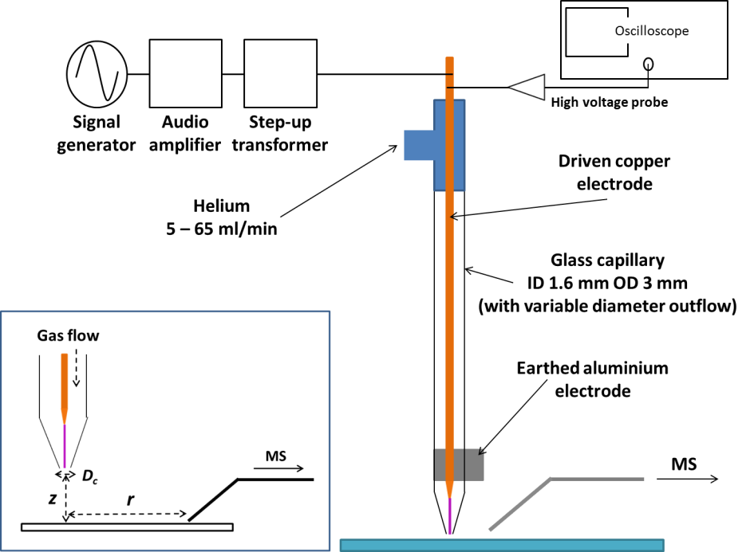

Fig. 1 Schematic of the plasma device with labelled components. The inset also shows the different parameters varied in this study.

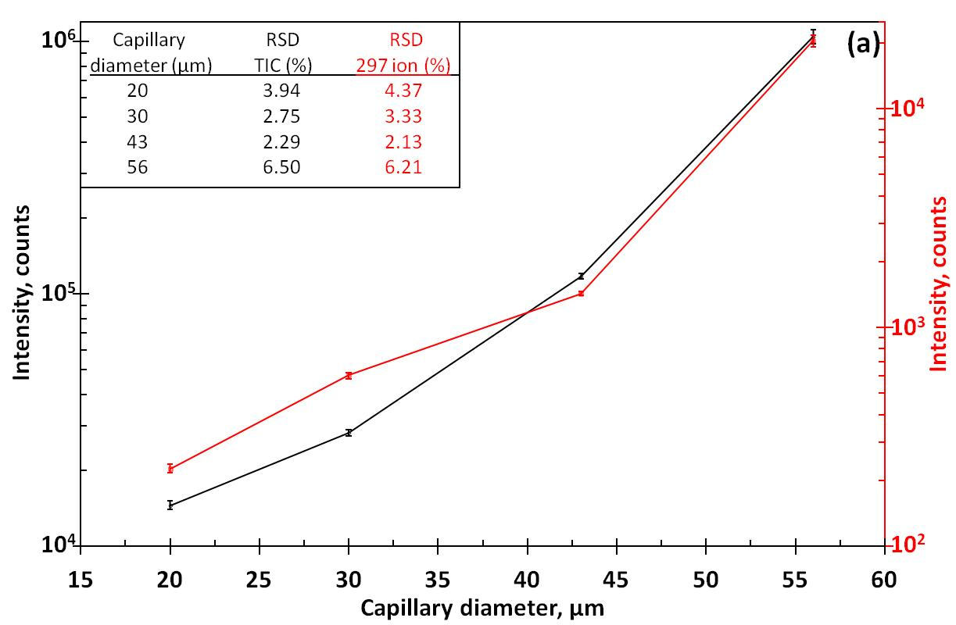

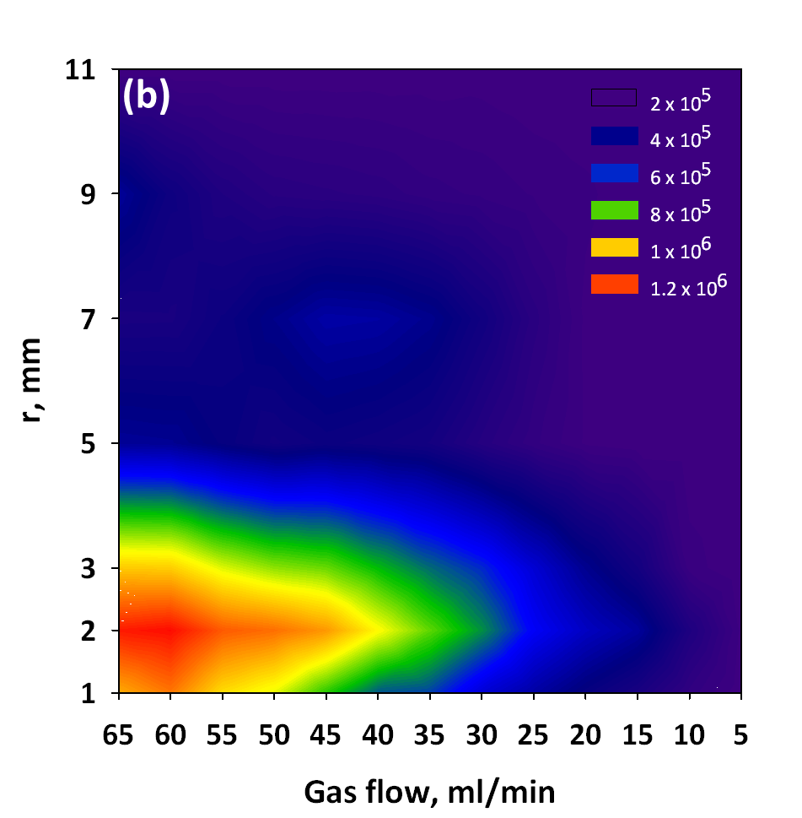

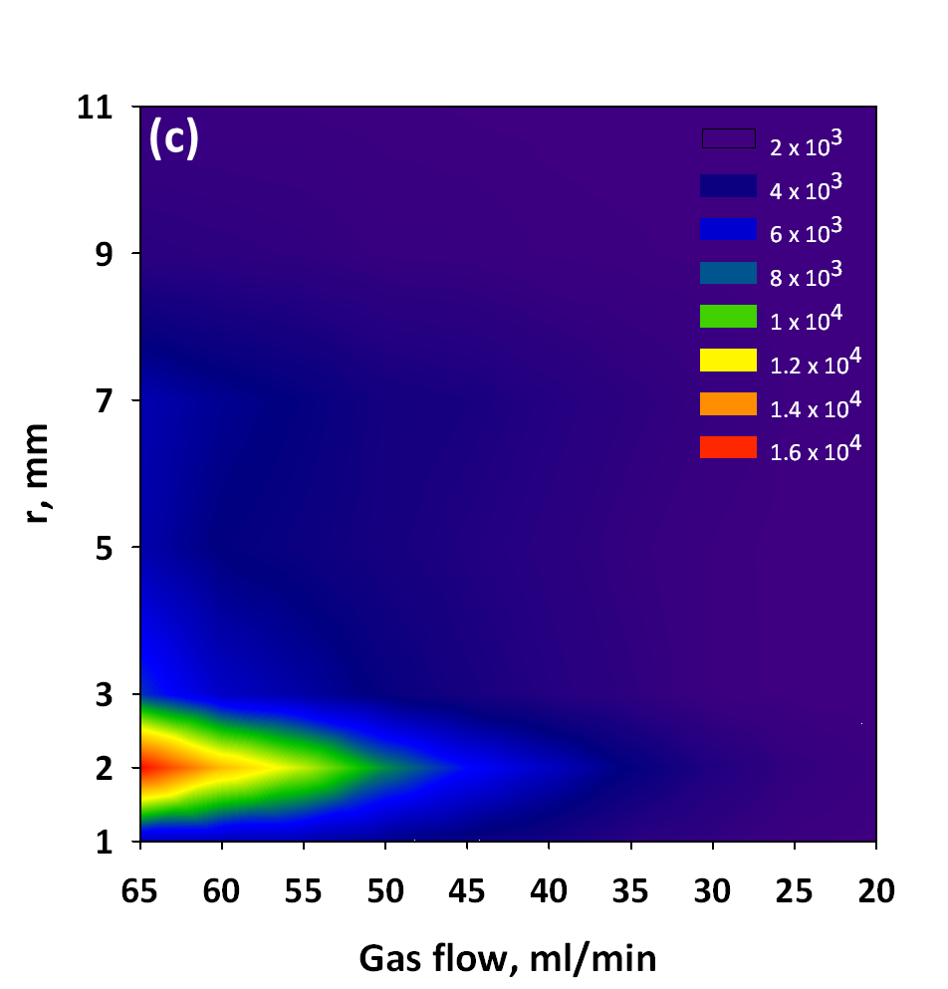

Fig. 2 (a) Variation of average TIC (left hand axis, black line) and peak intensity of the m/z 297 ion from PTFE (right hand axis, red line) as a function of capillary diameter at 65 ml/min. A Log scale is used on both axes for visualisation purposes. The inset displays the relative standard deviation in signal (%) for each capillary for both the TIC and m/z 297 ion. 2D contour maps to show the average TIC as a function of gas flow for each value of r for (b) 56 µm and (c) 20 µm diameter capillaries at z = 1 mm. The different colours represent intensity intervals (counts) as described by the legend on the top right of each graph.

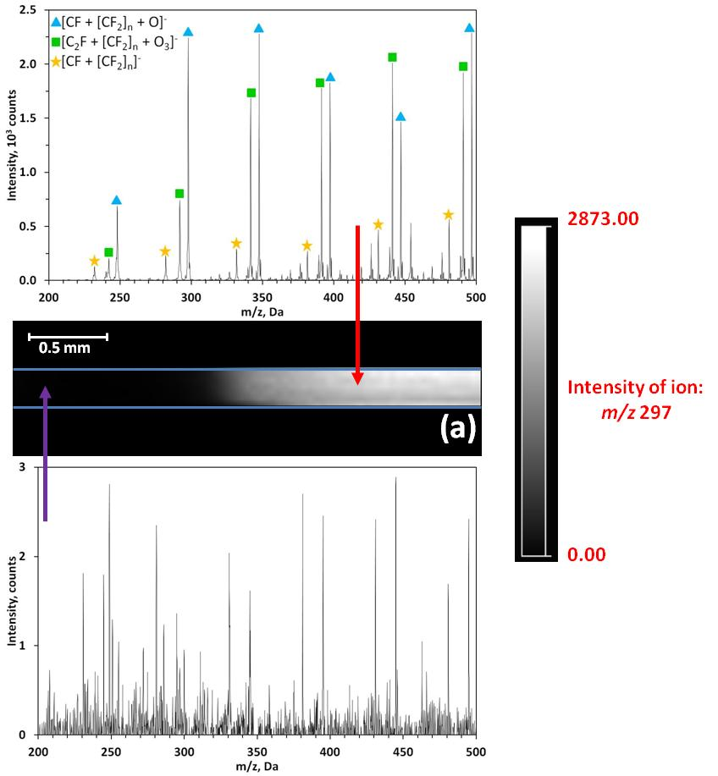

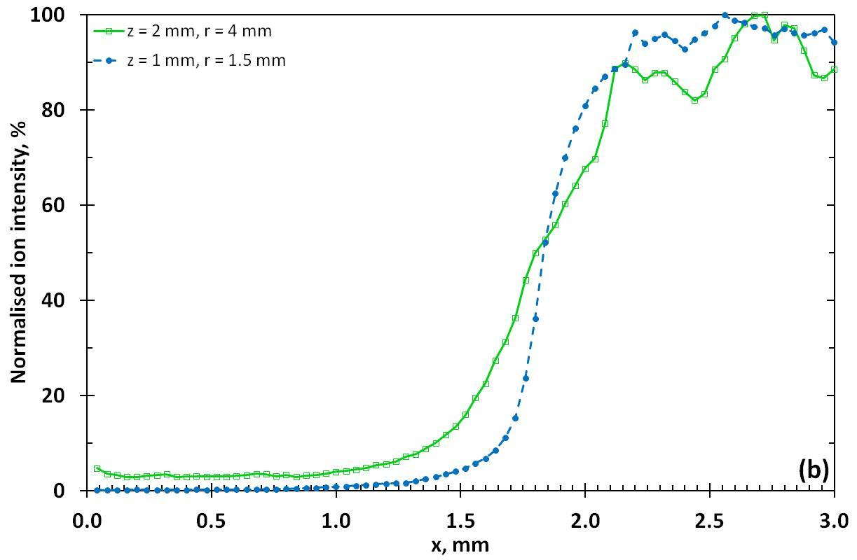

Fig. 3 (a) MSI of a PTFE step edge using a 43 µm diameter capillary at 65 ml/min, including negative ion mass spectra originating from the glass slide (bottom) and the PTFE (top). The absence of ions from PTFE on the left hand side of the MSI help to produce a clear step-edge. The scale bar on the right shows the intensity variation of the ion at m/z 297. (b) Line profiles of the intensity variation of the m/z 297 PTFE ion, normalised to the maximum intensity, across a PTFE step edge for a 22 µm diameter capillary at 65 ml/min with z = 1 mm, r = 1.5 mm (dashed line) and z = 2 mm, r = 4 mm (solid line). Individual data points for each of the 75 averaged pixels are included on both profiles.

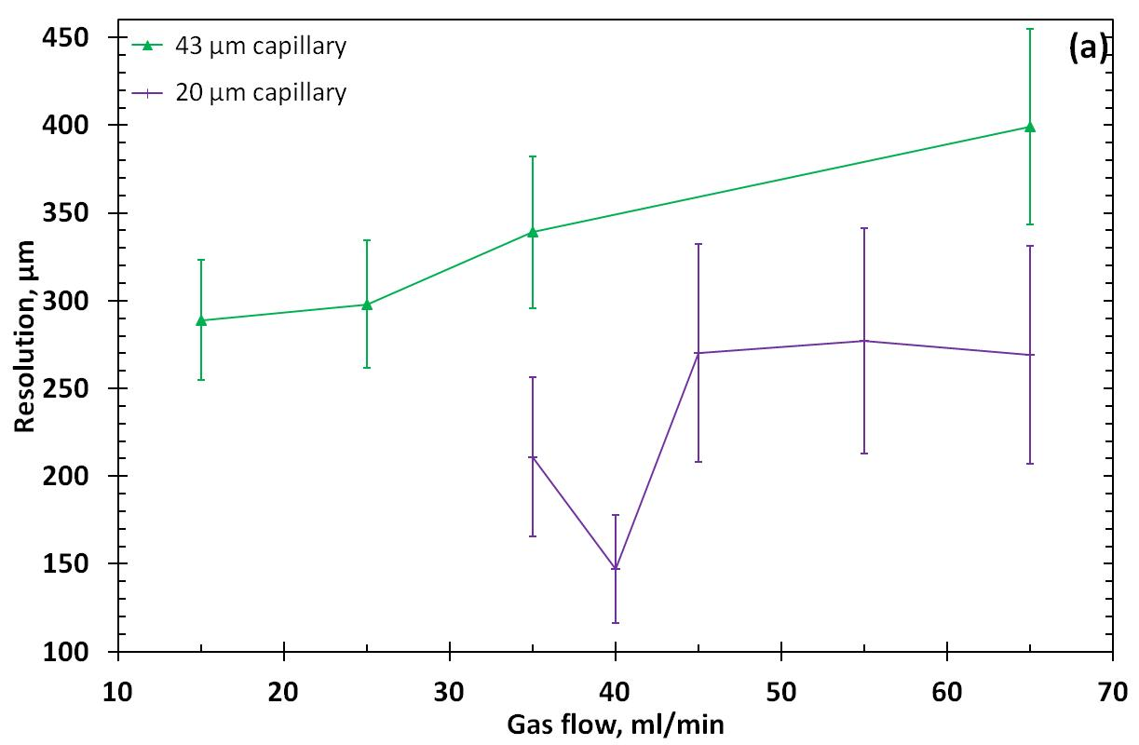

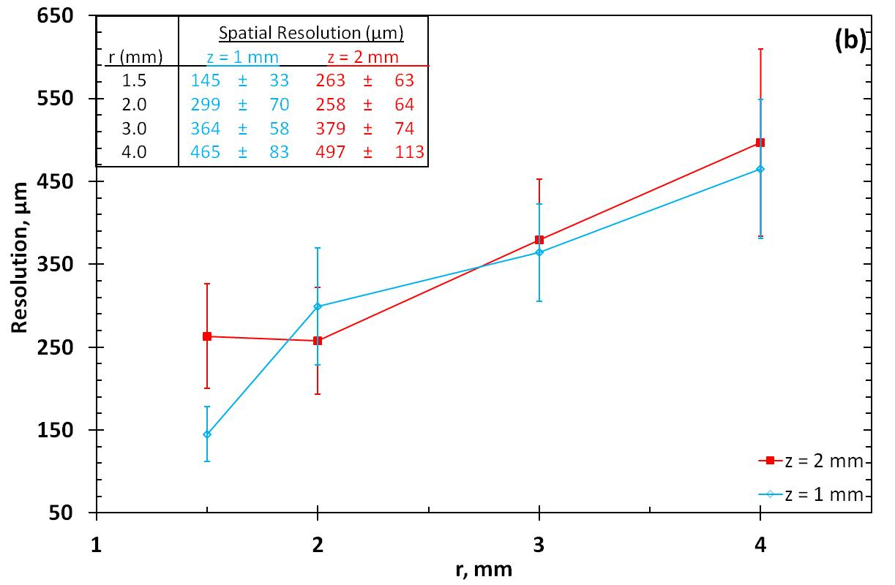

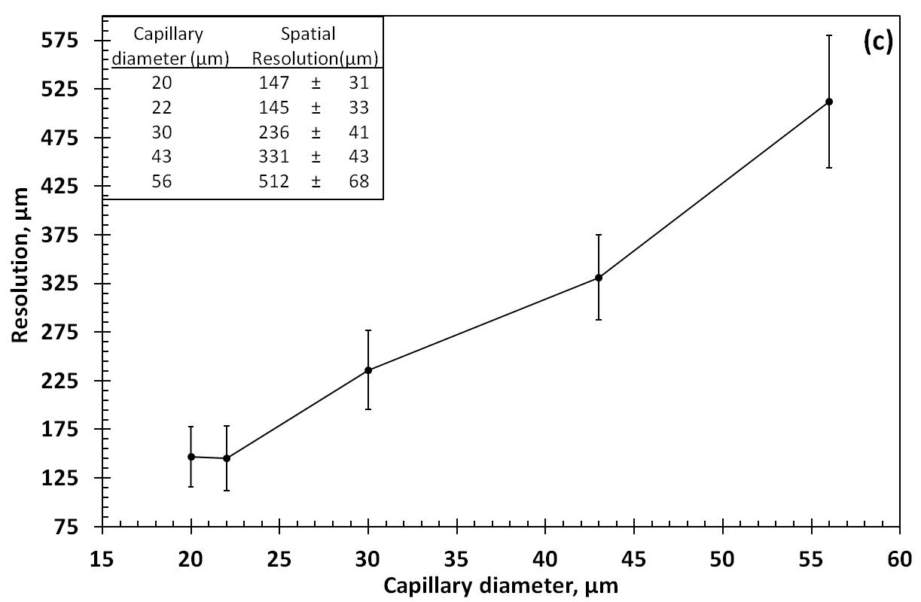

Fig. 4 Variation of spatial resolution as a function of (a) gas flow for two different diameter capillaries at r = 2 mm and z = 1.5 mm, and (b) r and z for a 20 µm diameter capillary at 65 ml/min. (c) Plot of the spatial resolution achieved with each capillary.

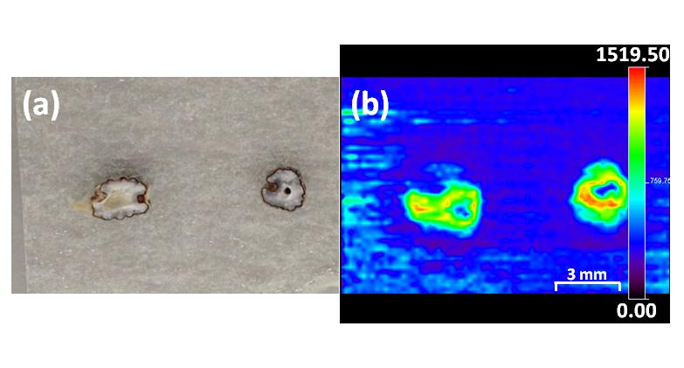

Fig. 5 (a) An optical image of two halves of different cardamom seeds. (b) Positive ion MS images of the seeds shown in (a) using the variation in intensity of the ion at m/z 81, displayed by the scale bars on the right hand side of (b).

