Figure 1 A-F Meta-analyses of associations between genetic variants of TMPT, COMT and ACYP2 and ototoxicity

A Meta-analysis of association between TPMT (rs12201199) and ototoxicity (CTCAE grade 0 vs 2-4)
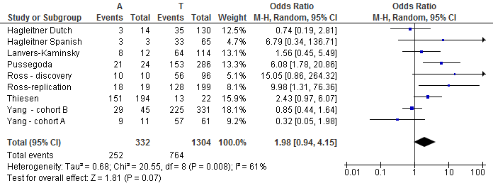
B Meta-analysis of association between TPMT (rs1142345) and ototoxicity (CTCAE grade 0 vs grade 2-4)
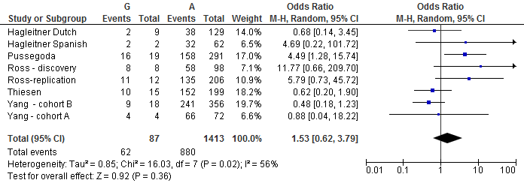
C Meta-analysis of association between TPMT (rs1800460) and ototoxicity (CTCAE grade 0 vs grade 2-4)
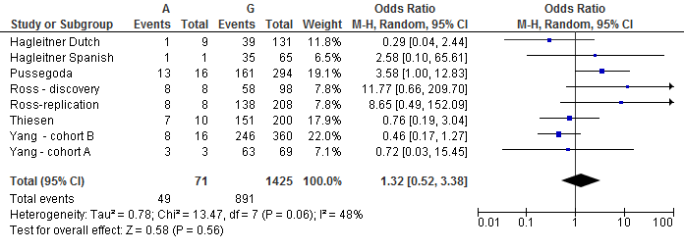

D Meta-analysis of association between COMT (rs4646316) and ototoxicity (CTCAE grade 0 vs grade 2-4)
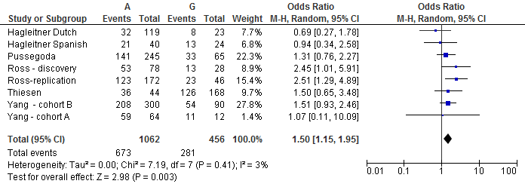
E Meta-analysis of association between COMT (rs9332377) and ototoxicity (CTCAE grade 0 vs grade 2-4)
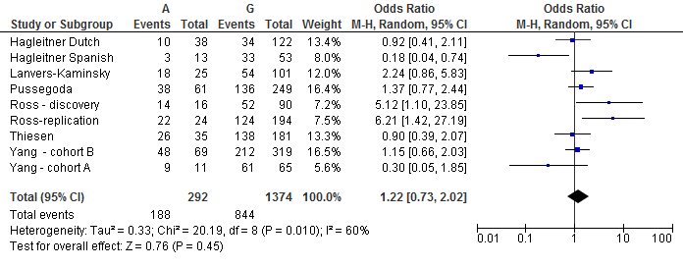
F Meta-analysis of association between AYCP2 (rs1872328) and ototoxicity (Chang grade 0 vs grade >0)
