Experimental band alignment of Ta₂O₅/GaN for MIS-HEMT applications

K. Sawangsri¹, P. Das², S.N. Supardan¹, I.Z. Mitrovic^{1,*}, S. Hall¹, R. Mahapatra², A.K.Chakraborty³, R. Treharne⁴, J. Gibbon⁴, V.R. Dhanak⁴, K. Durose⁴, P.R. Chalker⁵
¹Department of Electrical Engineering and Electronics, University of Liverpool, Liverpool L69 3GJ, UK
²Dept. of Electronics and Communication Engineering, National Institute of Technology Durgapur, Durgapur 713209, India
³Department of Physics, National Institute of Technology Durgapur, Durgapur 713209, India
⁴Dept. of Physics and Stephenson Institute for Renewable Energy, University of Liverpool, Liverpool L69 7ZF, UK
⁵Department of Engineering, University of Liverpool, Liverpool L69 3GH, UK
*Contact details of corresponding author:
E-mail: ivona@liverpool.ac.uk
Tel. +44 (0) 151 794 4516; Fax: +44 (0) 151 794 4540

The band alignment of Ta₂O₅/GaN has been measured experimentally. The HCl cleaning has been found to be effective in removing oxygen from the GaN surface and was used prior to deposition of the Ta₂O₅ films by radio frequency magnetron sputtering. Variable angle spectroscopic ellipsometry was performed to measure the thickness, optical constants and band gap of GaN and Ta₂O₅/GaN samples. The valence band offset of Ta₂O₅/GaN was measured by X-ray photoelectron spectroscopy using Kraut’s method, and found to be 0.70 ± 0.25 eV. The results provide experimental evidence of an earlier theoretical study of higher effective barrier for holes than for electrons in the Ta₂O₅/GaN material system.

Keywords: GaN, Ta₂O₅, band alignment
1. Introduction
Gallium nitride Metal Insulator Semiconductor High Electron Mobility Transistors (MIS-HEMTs) have been used extensively for high frequency, high power and low noise applications [1,2]. GaN has favorable properties such as wide band gap (3.4 eV), high electron saturation velocity (3×10⁷ cm/s) and high critical breakdown electric field (4.2 MV/cm⁻¹) [2]. Moreover, it has a thermal conductivity of up to 350 W/mK, much higher than that of silicon. A layer of GaO_{x} can be formed on the GaN surface by reaction with oxygen even at room temperature. Surface-related defect states associated with the GaO_{x} layer result in large leakage current and severe current collapse at high frequency, inhibiting device performance. The insertion of a dielectric layer, such as SiO₂, SiN_{x}, AlN, Al₂O₃, for surface passivation has been reported to mitigate somewhat the issues above [1,3]. Recently, ZrO₂ has been shown to be a promising gate dielectric for GaN-based MIS-HEMTs with devices exhibiting maximum transconductance (g_{m}) of 138 mS/mm and a low density of interface states (< 4 × 10¹¹ cm⁻²eV⁻¹) [4] due to favorable band alignment to GaN [5]. The inclusion of a Ta₂O₅ layer has been found to result in good interface quality with GaN and its high dielectric constant (~25) [6], leads to improved transconductance. An increase of the 2DEG (two dimensional electron gas) carrier concentration of AlGaN/GaN structures passivated with a thin Ta₂O₅ film (2–4 nm) has been reported [3]. A larger g_{m} of 315 mS/mm and higher current density of 1.37 A/mm has been reported for devices incorporating Ta₂O₅ compared to HfO₂ based HEMTs, with comparable gate leakage currents [7]. So far only a theoretical value of the conduction band offset (CBO) has been reported for Ta₂O₅/GaN using the method of charge neutrality levels [8].
This paper reports on the experimentally derived band alignment of the Ta₂O₅/GaN material system using X-ray Photoelectron Spectroscopy (XPS) and Variable Angle Spectroscopic Ellipsometry (VASE). Different wet chemical cleaning procedures for the GaN surface were investigated prior to oxide deposition. The Ta₂O₅ thin films (up to 10 nm) were deposited by RF (radio frequency) magnetron sputtering. This work provides evidence that HCl cleaning is effective in removing oxygen from the GaN surface, and demonstrates that there is a much higher effective barrier for holes (~ 0.7 eV) than for electrons in Ta₂O₅/GaN stacks.

2. Experimental
2.1 Sample preparation and cleaning procedure
The Ta₂O₅ films were deposited by RF magnetron sputtering on a wafer of 2 µm GaN (0001) film grown on Si (111) substrate by metal organic chemical vapor deposition. Prior to Ta₂O₅ deposition, surface cleaning of GaN was carried out to minimize C and O contaminants [9,10]. Both, acetone [11] and methanol [12] have been reported for GaN surface cleaning. Trichloroethylene (TCE) has also been used to remove grease [12,13]. Diale et al. have reported (NH₄)₂S as the best etchant compared to HCl and KOH in aqueous solution [13]. In this paper, the cleaning of GaN started with a rinse in acetone with ultrasonic agitation for 10 minutes followed by methanol for further 10 minutes. Then the samples were dipped in 3 different etchants separately: 30% NH₄OH, 20% (NH₄)₂S, and 37% HCl solution followed by a rinse in deionized water. Ta₂O₅ films were then sputter-coated onto HCl pre-treated GaN by non-reactive RF magnetron sputtering at room temperature with argon pressure of 5 mTorr and a sputtering power of 100 W. The target was 3-inch Ta₂O₅ with purity of 99.99%; the sample-to-target distance was 11 cm. The sputtering was done with durations of 3 and 15 minutes for the interfacial (nominal 3 nm) and bulk (nominal 10 nm) Ta₂O₅/GaN samples respectively, using AJA International apparatus. The average surface roughness of the GaN and Ta₂O₅ samples was found to be 0.99 nm and 0.42 nm (± 0.1 nm) respectively over 10 μm × 10 μm area by Veeco di Innova atomic force microscope, operated in contact mode. The thickness of 10 nm for the bulk Ta₂O₅ sample is well above the inelastic mean free path (up to 2 nm, [14]) of the photoelectrons at the kinetic energies used in the XPS experiment, to ensure bulk-like response, that is, all detected photoelectrons originate from the Ta₂O₅ layer.

2.2 XPS and VASE
The XPS was performed in a standard ultra-high vacuum (UHV) system consisting of a PSP Vacuum Technology dual anode (Mg/Al) X-ray source and a hemispherical electron energy analyser equipped with five channeltrons. The spectrometer was calibrated so that the Ag 3d_{5/2} photoelectron line had a binding energy (BE) of 368.35 eV with a full width at half maximum (FWHM) of 0.8 eV. The survey scans were recorded in the 0-1250 eV energy range to determine the elements present in the samples and to check for surface contamination. Then the individual core level (CL) regions, such as Ga 2p, O 1s, N 1s, C 1s, Cl 2p, Ta 4f, Ga 3d and valence photoelectron lines were recorded. During the XPS measurements, the X-ray beam exposure was across the whole sample [15,16] so as to diminish the effect of differential charging when evaluating the valence band offset (VBO). The individual core level scans were performed for a duration of at least an hour until the point that they attained constant binding energies and the samples could be considered as charge saturated. The electron BEs were then corrected by setting the Ga 2p CL peak in the spectra to 1117.7 eV for all samples. Note that C 1s correction at 284.6 eV is widely used [17], however for the spectra measured in this work, the former peak is found to be broad and of low intensity leading to erroneous calibration. A Shirley-type background [18] is used during the fitting of all spectra. The CL positions are defined as the FWHM by fitting a Lorentzian–Gaussian curve to the measured peaks, which introduces typically an error of ± 0.08 eV to the determination of VBO. The error bar (± 0.25 eV) defined in this paper is due to valence band maximum (VBM) estimation through the linear interpolation method [19]. Room temperature VASE measurements were performed using a J.A. Woollam M2000 ellipsometer in the energy range 0.7 – 5.1 eV at three incident angles 65°, 70° and 75° to maximize the accuracy in extracting thickness, optical properties and band gap of the GaN and Ta₂O₅ layers.
Figure 1(a) shows XPS background subtracted O 1s CL for GaN surface treated using the three different etchants: NH₄OH, (NH₄)₂S and HCl. It is evident that the HCl treatment shows the lowest oxygen contamination. There is an indication of Cl on the surface for HCl treated GaN as can be seen from Fig. 1(b). From the de-convoluted Cl 2p peak, the Cl 2p_{3/2} component is at 199 eV. It is known that Cl 2p_{3/2} for metallic chloride is in the range of BEs of 198.5-199 eV, while that of organic chlorine is at the BE of 200 eV and above [14]. Hence, it can be deduced that the chlorine present in this sample is in the form of gallium chloride likely to be due to Ga-rich surface [20].

3. Results and discussion
3.1 Thickness and band gap assessment
The VASE fitting for the GaN substrate was done first in the transparent region (240-340 nm) using the Cauchy model,
(1)
where n is the index of refraction, λ is wavelength, and A, B and C are Cauchy parameters initially set to the values from Ref. 21. Then these parameters are varied with the thickness of the GaN film to fit the experimental data. The VASE fitting for the full wavelength range (240-1700 nm) was completed using a parametric model [22]; the thickness of the GaN layer was found to be 2008 ± 2 nm, in close agreement with the nominal value of 2 μm. The VASE experimental and fitted Ψ and ∆ angles for three incident angles (60˚, 65˚, and 70˚) for the GaN substrate are shown in Fig. 2. The modelling of interfacial and bulk Ta₂O₅/GaN samples was done using the Tauc-Lorentz oscillator model for a Ta₂O₅ layer on top of the GaN layer and fitted to extract the thickness and the band gap. Figure 3 shows Ψ and ∆ experimental and fitted ellipsometric angles for bulk Ta₂O₅/GaN sample in the transparent region. The mean squared error (MSE) between the experimental and theoretical (fitted) curves was in all cases below 5, consistent with a good quality fit of the data. The thickness of the interfacial and bulk Ta₂O₅ was found to be 2.8 ± 0.2 nm and 10.6 ± 0.2 nm respectively, consistent with the nominal values. The resulting dielectric function spectra, ε₁ and ε₂, for GaN and Ta₂O₅, are shown in Figs. 4(a) and 4(b) respectively. The band gap obtained from ε₂ spectra using linear extrapolation of the leading edge to the baseline is 3.34 ± 0.15 eV for GaN (Fig. 4(a)) and 4.40 ± 0.15 eV (Fig. 4(b)) for Ta₂O₅. The obtained values are in close agreement with the literature; for GaN 3.2 eV [8], 3.4 eV [21,23], 3.43 eV [24]; for Ta₂O₅ 4.4 eV [25,26].

3.2 Estimation of VBO and derivation of a band diagram for Ta₂O₅/GaN
The valence band offset was calculated using Kraut’s method [27]:
VBO = δ_{SUB} − δ_{OXIDE} + δ_{INT} (2)
where δ_{SUB} refers to the BE difference of Ga 3d CL and VBM for GaN substrate (Fig. 5(a)), δ_{OXIDE} of Ta 4f CL and VBM for Ta₂O₅ bulk sample (Fig. 5(b)), and δ_{INT} of Ga 3d and Ta 4f CLs for interfacial Ta₂O₅ sample (Fig. 5(c)). It can be seen from Fig. 5(a) that the Ga 3d peak for GaN substrate is de-convoluted into seven components, related to Ga – N, Ga – O and Ga – Ga bonds (each with spin-orbit splitting sub-peaks) and N 2s in the lower BE side of the main peak (~ 16.7 eV). For the Kraut’s method, the Ga–N component was used at 19.94 eV, and fitted with the spin-orbit splitting of 0.45 eV and the peak intensity ratio (Ga 3d_{3/2} : Ga 3d_{5/2}) of 0.67. In the case of the bulk Ta₂O₅ sample shown in Fig. 5(b), Ta 4f CL is fitted with two pairs of sub-peaks referring to Ta – O bonds with spin-orbit splitting belonging to the main (stoichiometric) oxide and sub-oxide. The spin-orbit splitting for the dominant Ta 4f oxide component, centered at 25.89 eV, was 1.91 eV with the intensity ratio (Ta 4f_{5/2} : Ta 4f_{7/2}) of 0.75. The VBM was determined by linearly extrapolating the Fermi edge to the base line in the valence band spectra and found to be 2.22 eV for GaN and 2.42 eV for bulk Ta₂O₅ as depicted in the insets of Figs. 5(a)-(b). Hence, the calculated values of δ_{SUB} and δ_{OXIDE} are 17.72 eV and 23.47 eV, respectively. The δ_{SUB} value obtained in this work is in close agreement with those obtained from electronic-state studies of bulk GaN sample found to be in the range 17.7 – 17.8 eV [28]. It is worth mentioning that calculations of both δ_{SUB} and δ_{OXIDE} from the measured XPS CL peaks are independent of band bending (BB) at the interface. The amount of BB, as predicted from Poisson’s equation, is caused by the spatially varying electrostatic potential and is dependent on the distance from the surface [29]. Using the same spin-orbit splitting and intensity ratios deconvolution for Ga 3d and Ta 4f CLs for interfacial Ta₂O₅ sample shown in Fig. 5(c), δ_{INT} is found to be 6.45 eV. Comparing the Ga 3d CL of the GaN substrate (19.94 eV, see Fig. 5(a)) and the same peak from GaN with Ta₂O₅ on top (19.89 eV, Fig. 5(c)), a 0.05 eV energy shift towards lower BEs is observed. The latter is a signature of a small upward BB [30], likely to be due to spontaneous polarization in GaN that can lead to a negative bound polarization charge at the GaN surface and ionized donors to compensate these defects [31]. The angle-resolved XPS Ga 3d and Ta 4f CL spectra taken from interfacial Ta₂O₅/GaN sample at three grazing angles 30°, 50° and 70° (see Appendix) confirm the CL variation of < 0.05 eV and substantiate a negligible band bending at the interface [5,32-33]. The value of VBO from the above data and using Eq. (2) is calculated to be 0.70 ± 0.25 eV, which with the band gap extracted by VASE gives CBO = 0.36 ± 0.25 eV.
The derivation of the energy band diagram using XPS for Ta₂O₅/GaN in this work is illustrated schematically in Fig. 6. The obtained VBO value of 0.7 eV from this work compares to the theoretically predicted value of 1.1 eV [8]. It is worth mentioning that the value of band gap for GaN used in Ref. [8] is 3.2 eV; assuming a more widely cited value of 3.4 eV [2,9,21,23-24] for GaN band gap and the theoretically calculated CBO value of 0.1 eV [8] would imply a VBO of ~0.9 eV, this being consistent with the value obtained in this work within the experimental error of the XPS method. It is evident from the results that both CB and VB offsets of Ta₂O₅ on GaN are smaller than 1 eV. A possible approach to utilize Ta₂O₅ advantages of higher k and good interface properties in GaN-based MIS-HEMTs could be to mix it with other oxides with larger band gap such as Al₂O₃. It has been shown recently that the complementary characteristics of Ta₂O₅ and Al₂O₃ could be combined by fabricating (Ta₂O₅)_{x}(Al₂O₃)_{1-x} as a gate dielectric to achieve both a high-k and a sufficient CBO to the GaN HEMT for low leakage currents [34].

4. Conclusion
The band alignment of Ta₂O₅ prepared by RF sputtering on ex-situ HCl treated GaN surface has been experimentally derived in this paper. The HCl treatment is compared to NH₄OH and (NH₄)₂S cleaning procedures and shows the lowest oxygen contaminant level on the GaN surface. The VBO of Ta₂O₅/GaN was found to be 0.70 ± 0.25 eV from the XPS and Kraut’s method, while the CBO was derived using the band gaps of GaN (3.34 eV) and Ta₂O₅ (4.4 eV) and found to be 0.36 ± 0.25 eV. The results have importance for developing and designing future GaN based MIS-HEMTs.
Acknowledgements. The work was done under Global Challenge Research Fund (GCRF) ‘Digital in India’ project no. EP/P510981/1 funded by the EPSRC, UK.

References
[1] Z. Yatabe, J.T. Asubar, T. Hashizume, J. Phys. D: Appl. Phys. 49 (2016) 393001.
[2] A.M. Ozbek, B.J. Baliga, IEEE Electron Device Lett. 32(10) (2011) 1361.
[3] W. Wang, J. Derluyn, M. Germain, M. Leys, S. Degroote, D. Schreurs, G. Borghs, Jpn. J. Appl. Phys. 45(8) (2006) L224.
[4] G. Ye, H. Wang, S. Arulkumaran, G.I. Ng, R. Hofstetter, Y. Li, M.J. Anand, K.S. Ang, Y.K.T. Maung, S.C. Foo, Appl. Phys. Lett. 103 (2013) 142109.
[5] G. Ye, H. Wang, S. Arulkumaran, G.I. Ng, Y. Li, Z.H. Liu, K.S. Ang, Appl. Phys. Lett. 105 (2014) 022106.
[6] H. Shinriki, T. Kisu, S-I. Kimura, Y. Nishioka, Y. Kawamoto, K. Mukai, IEEE Transaction on Electron Devices 37 (1990) 1939.
[7] D. Deen, D.F. Storm, R. Bass, D.J. Meyer, D.S. Katzer, S.C. Binari, J.W. Lacis, T. Gougousi, Appl. Phys. Lett. 98 (2011) 023506.
[8] J. Robertson, B. Falabretti, J. Appl. Phys. 100 (2006) 014111.
[9] R.D. Long, P.C. McIntyre, Materials 5 (2012) 1297.
[10] L.C. Grabow, J.J. Uhlrich, T.F. Kuech, M. Mavrikakis, Surface Science 603 (2009) 387.
[11] T.G. Maffeis, M. C. Simmonds, S. A. Clark, F. Peiro, P. Haines, P. J. Parbrook, J. Appl. Phys. 92 (2002) 3179.
[12] K. Tracy, W.J. Mecouch, R.F. Davis, R.J. Nemanich, J. Appl. Phys. 94 (2003) 3163.
[13] M. Diale, F.D. Auret, N.G. van der Berg, R.Q. Odendaal, W.D. Roos, Applied Surface Science 246 (2005) 279289.
[14] Handbook of X-ray photoelectron spectroscopy, Eds. J. Chastain and R.C. King, Jr., Physical Electronics Inc. 1992 (ISBN: 0-9648124-1-X).
[15] E. Bersch, M. Di, S. Consiglio, R.D. Clark, G. J. Leusink, A.C. Diebold, J. Appl. Phys. 107 (2010) 043702.
[16] M. Perego, G. Seguini, J. Appl. Phys. 110 (2011) 053711.
[17] J.C. Vickerman, Surface analysis, (Wiley) 1998.
[18] D.A. Shirley, Phys. Rev. B 5 (1972) 4709.
[19] S.A. Chambers, T. Droubay, T.C. Kaspar, M. Gutowski, J. Vac. Sci. Techn. B 22 (2004) 2205.
[20] Y. Koyama, T. Hashizume, H. Hasegawa, Solid State Electronics 43 (1999) 1483.
[21] T.J. Kim, J.S. Byun, Y.D. Kim, J. Korean Phys. Soc. 53 (2008) 1575.
[22] B. Johs, C.M. Herzinger, J.H. Dinan, A. Cornfeld, J.D. Benson, Thin Solid Films 137 (1998) 313.
[23] J. Wagner, H. Obloh, M. Kunzer, M. Maier, K. Köhler, B. Johs, J. Appl. Phys. 89 (2001) 2779.
[24] S. Logothetidis, J. Petalas, Phys. Rev. B 50(24) (1994) 18017.
[25] N. Alimardani, S.W. King, B.L. French, C. Tan, B.P. Lampert, J.F. Conley Jr, J. Appl. Phys. 116 (2014) 024508.
[26] K. Kukli, J. Aarik, A. Aidla, O. Kohan, T. Uustare, W. Sammelselg, Thin Solid Films 260 (1995) 135.
[27] E.A. Kraut, R.W. Grant, J.R. Waldrop, S.P. Kowalczyk, Phys. Rev. Lett. 44 (1980) 1620.
[28] T.E. Cook Jr., C.C. Fulton, W.J. Mecouch, R.F. Davis, G. Lucovsky, R.J. Nemanich, J. Appl. Phys. 94 (2003) 7155.
[29] X. Xu, X. Liu, Y. Guo, J. Wang, H. Song, S. Yang, H. Wei, Q. Zhu, Z Wang, J. Appl. Phys. 107 (2010) 104510.
[30] M. Perego, G. Scarel, M. Fanciuli, I.L. Fedushkin, A.A. Skatova, Appl. Phys. Lett. 90 (2007) 162115.
[31] B. Eller, J. Yang, R. Nemanich, J. Electron. Mater. 43 (2014) 4560.
[32] S. Siol, J.C. Hellmann, S.D. Tilley, M. Graetzel, J. Morasch, J. Deuermeier, W. Jaegermann, A. Klein, ACS Appl. Mater. Interfaces 8 (2016) 21824.
[33] K. Zhang, M. Liao, M. Sumiya, Y. Koide, L. Sang, J. Appl. Phys. 120 (2016) 185305.
[34] T. Partida-Manzanera, J.W. Roberts, T.N. Bhat, Z. Zhang, H.R. Tan, S.B. Dolmanan, N. Sedghi, S. Tripathy, R.J. Potter, J. Appl. Phys. 119 (2016) 025303.

Figure captions
Fig.1: (a) O 1s XPS background subtracted core level peaks of GaN(0001) surface after different cleaning treatments. The spectrum of as-received GaN is added for reference. (b) Cl 2p XPS core level spectrum of the GaN surface after HCl treatment. The sub-peaks refer to spin-orbit splitting of Cl 2p_{3/2} and Cl 2p_{1/2}. The envelope denotes the fitted curve to experimental data.

Fig.2: VASE data for the GaN sample (circle) and the best multiple-layer model fit (full line) in the wavelength range of 240–1700 nm: ∆ for incident angles (a) 60˚, (b) 65˚, (c) 70˚, and (d) Ψ for three incident angles (60-75˚).

Fig.3: VASE data for the bulk Ta₂O₅/GaN sample (circle) and the best model fit (full line) in the transparent wavelength region (240-340 nm): (a) ∆ and (b) Ψ for three incident angles (60-75˚). The thickness of Ta₂O₅ is estimated to be 10.6 ± 0.2 eV.

Fig.4: Photon energy dependence of parametric dielectric function, ε₁ and ε₂, for: (a) as-received GaN substrate, and (b) 10 nm (nominal) Ta₂O₅/GaN.

Fig.5: The XPS spectra of: (a) Ga 3d CL for GaN substrate; (b) Ta 4f CL for bulk Ta₂O₅/GaN sample; (c) Ga 3d and Ta 4f CLs for interfacial Ta₂O₅/GaN sample showing the difference between the CLs. The insets in (a)-(b) show the VBM estimation from valence band leading edge linear fitting. The envelope refers to the fitted curve to experimental data.

Fig.6: Band diagrams of experimentally derived band alignment for the Ta₂O₅/GaN interface: (left) Kraut’s method for VBO measurement, and (right) CBO derived using band gap energies measured by VASE.
Figures

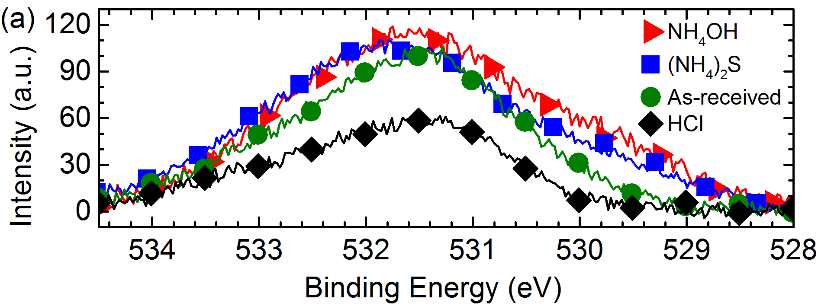
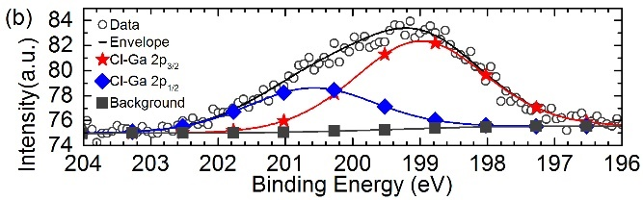

Fig. 1:

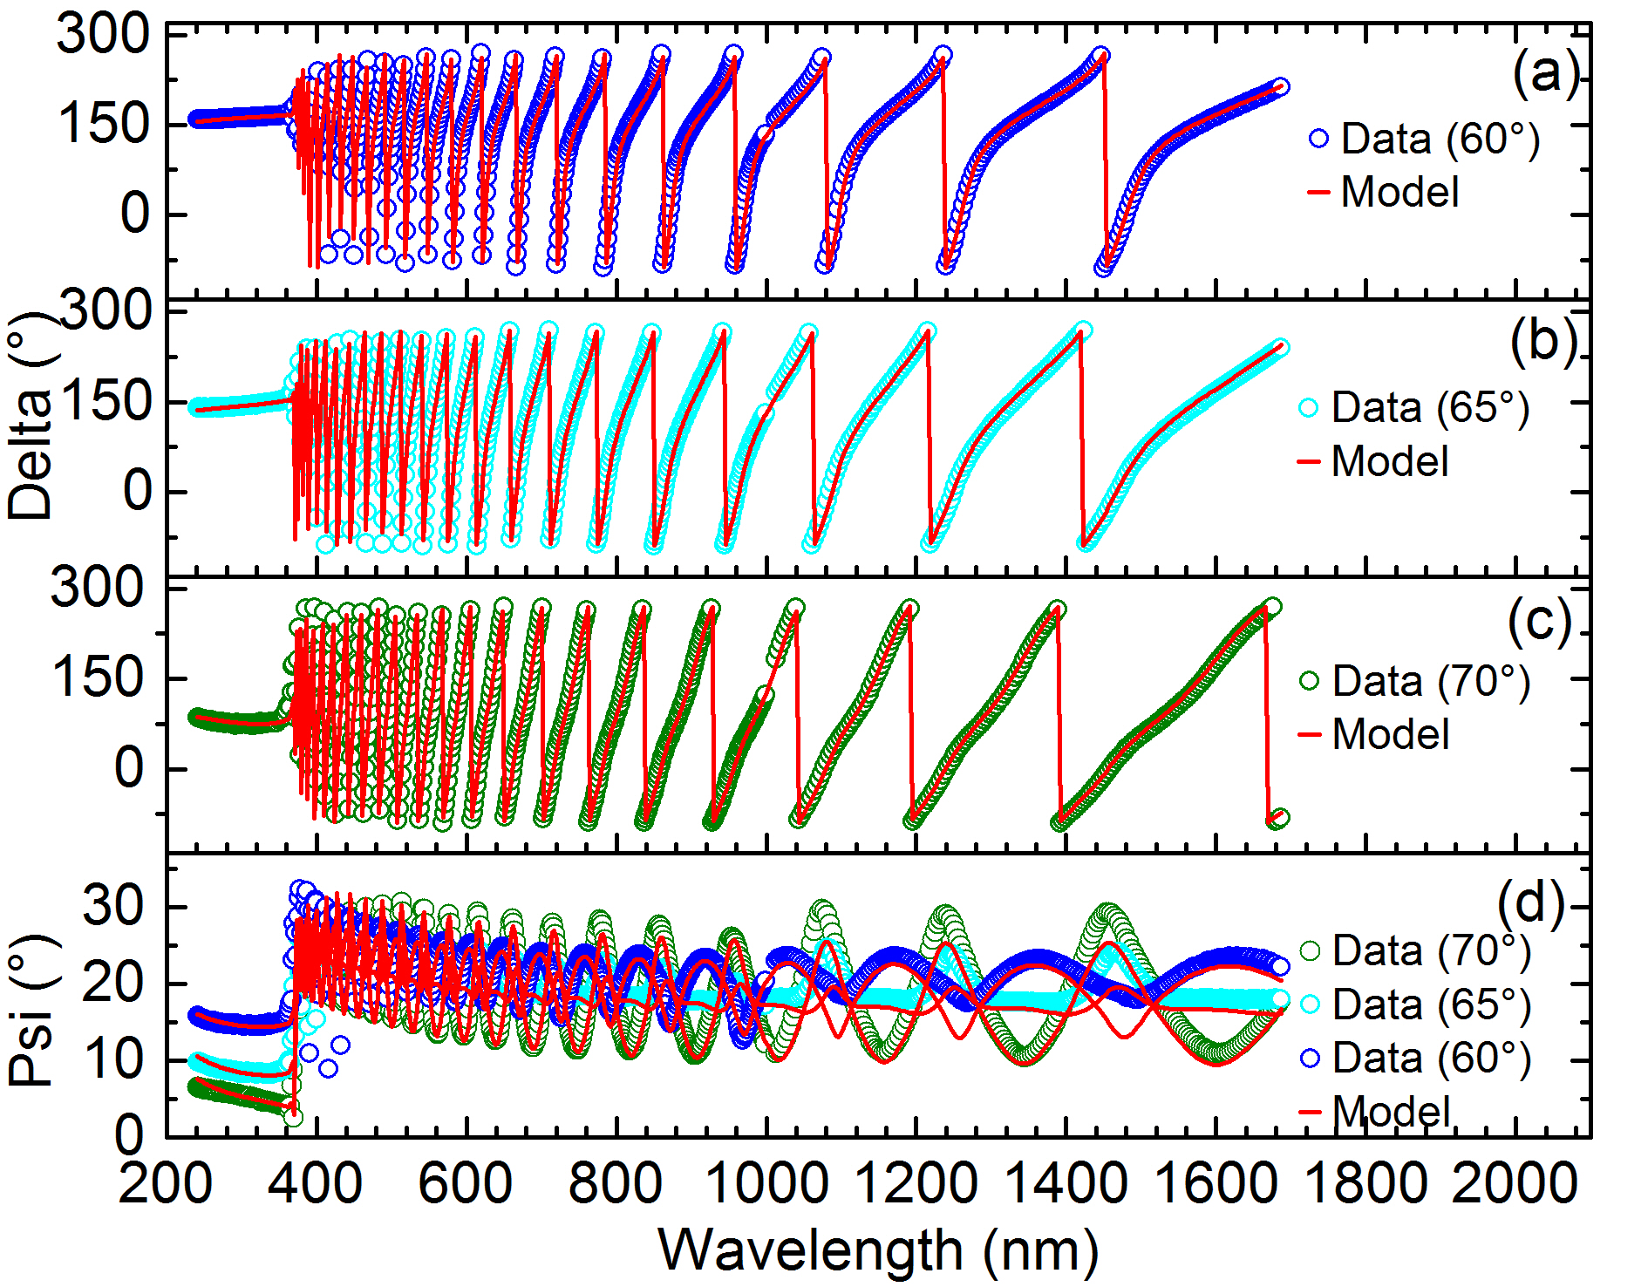

Fig. 2:

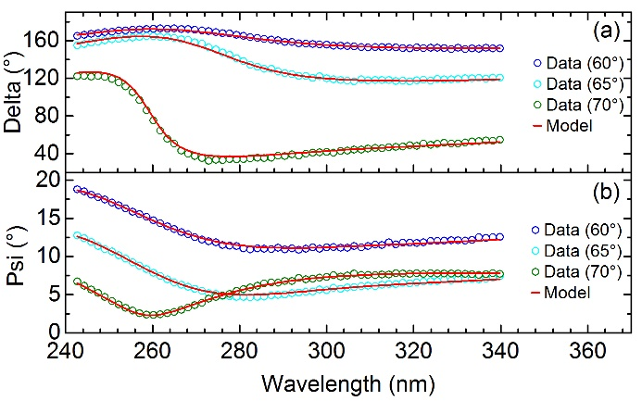

Fig. 3:

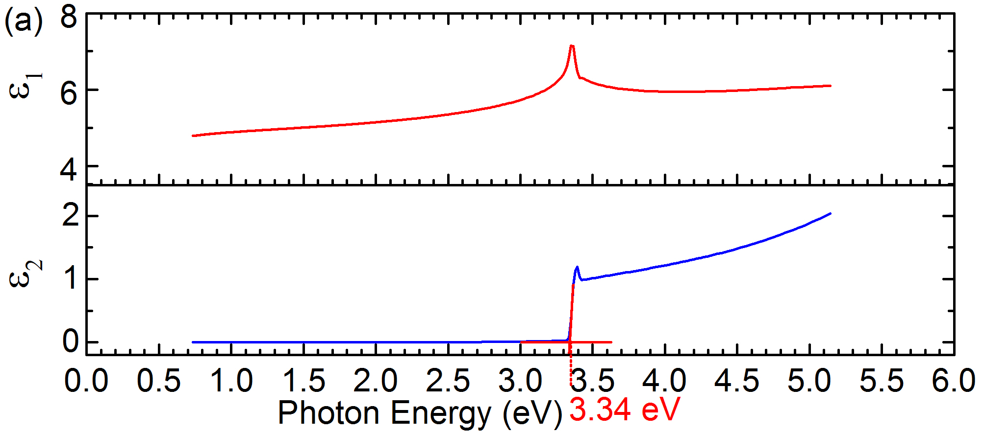
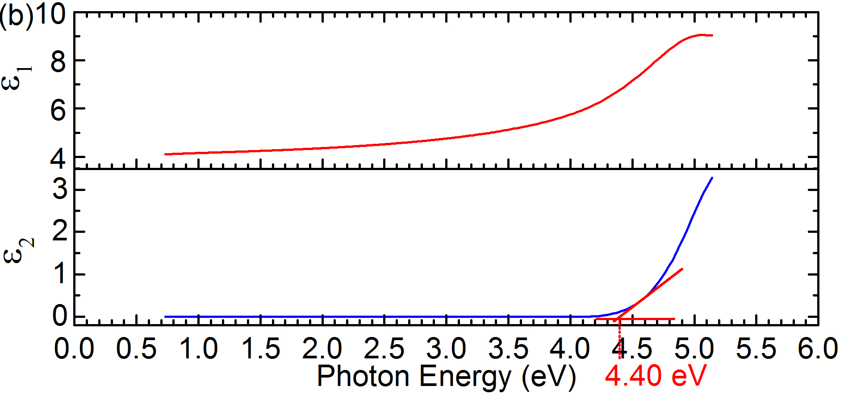

Fig.4:

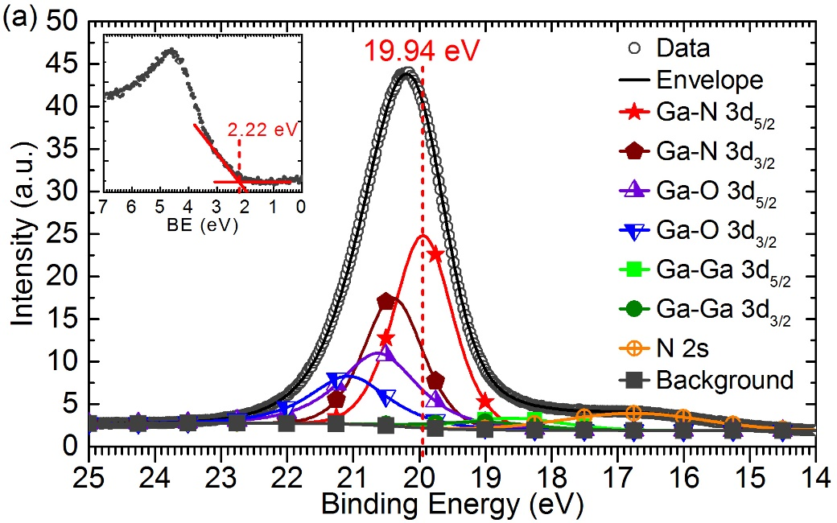
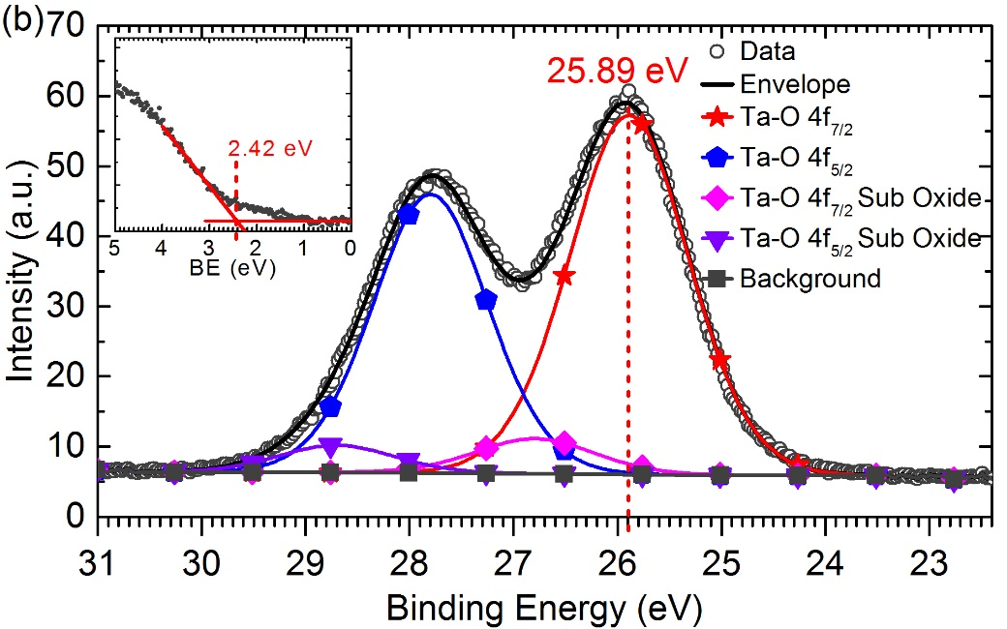
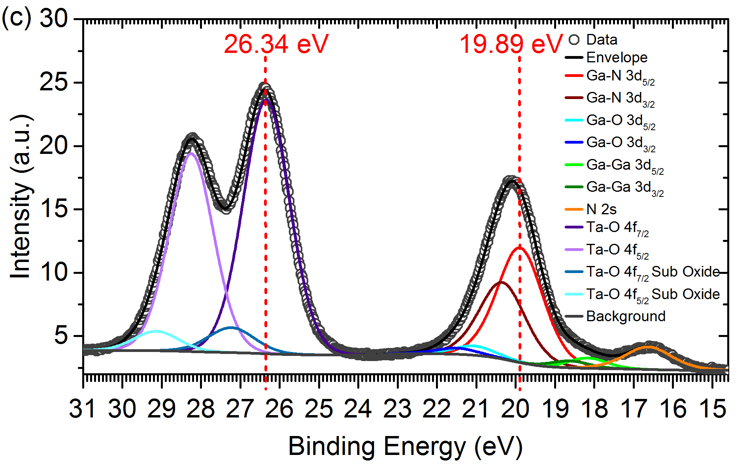
Fig.5:

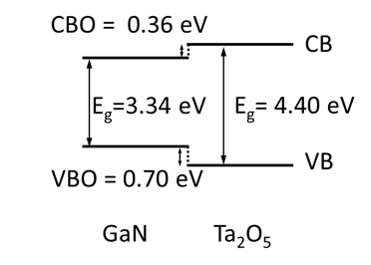
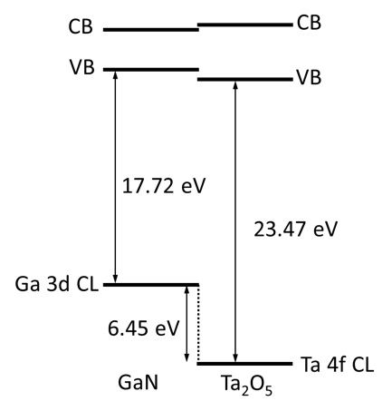

Fig. 6:

Appendix
Fig. A1. Dependence of measured binding energies on take-off angles for Ga 3d_{5/2} XPS CL from 3 nm (nominal) Ta₂O₅/GaN sample. The BE variation is 19.68 ± 0.04 eV.
Fig. A2. Dependence of measured binding energies on take-off angles for Ta 4f_{7/2} XPS CL from 3 nm (nominal) Ta₂O₅/GaN sample. The BE variation is 26.10 ± 0.03 eV.

Table A1. A summary of Ga 3d_{5/2} and Ta 4f_{7/2} XPS CL BEs vs take-off angle for 3 nm (nominal) Ta₂O₅/GaN sample.

Take-off angle (°) | Ga-N 3d_{5/2}  Binding Energy (eV) | Ta-O 4f_{7/2}  Binding Energy (eV)
30 | 19.70 | 26.13
50 | 19.69 | 26.10
70 | 19.64 | 26.08

Fig. A3. Ta 4f_{7/2} XPS CL measured from 10 nm (nominal) Ta₂O₅/GaN sample and from reference Ta₂O₅ sample (oxidised Ta foil). The results indicate bulk-like property of the 10 nm Ta₂O₅ film.

Note. The results shown in Figures A1-A3 are measured by monochromated XPS instrument. Since these XPS measurements are done on a different instrument, the absolute values of the binding energies of CLs may differ from the ones given in Figure 5.

