Augmentation of Transient Stability Margin Based on Rapid Assessment of Rate of Change of Kinetic Energy
Ahmed A. Al-Taeeª, Majid A. Al-Taee^{b}, and Waleed Al-Nuaimy^{b,*}
ª Department of Electronics and Communications Engineering, Al-Nahrain University, Baghdad, Iraq
^{b} Department of Electrical Engineering and Electronics, The University of Liverpool, Liverpool L69 3GJ, UK

Abstract
A fast-load injection through a resistive dynamic brake with appropriate power dissipation capacity can absorb the excess transient energy caused by a large and sudden disturbance and thus improve the transient stability margin of a power system. However, fast assessment of the transient stability and the effective insertion/removal instants of the brake are longstanding challenges. This paper proposes a new criterion based on the rate of change of kinetic energy to rapidly evaluate system transient stability and identify conditions of effective insertion/removal instants of a dynamic brake. Unlike reported studies where the superiority of this criterion was only demonstrated through off-line simulation, both the theoretical modeling and practical implementation of this criterion is presented here using the one machine infinite bus system. A microprocessor controller based on a single-variable measurement, i.e. generator deviation speed, is proposed and implemented to control the dynamic brake during the disturbance periods. The observed behavior of the power system under sudden disturbances and the effect of timely insertion/removal of the dynamic brake on the transient stability of the power system under study are presented and evaluated. The proposed method has been successfully validated, demonstrating its suitability for practical and rapid assessment of transient stability.
Keywords—Dynamic brake; power system; rate of change of kinetic energy; online control; transient stability
_________________________________________
* Corresponding author; e-mail: wax@liv.ac.uk, Tel: +44 (0) 151 794 4512

Introduction
The increased dependence of modern society on electric energy has led to the need for effective methods of assessing and improving power system reliability when subjected to large and sudden disturbances. In order to achieve this, power system designers, planners, and scientists have directed their effort towards achieving the maximum possible system reliability at an affordable cost [1]. Various events can cause interconnected electric power system to move from a normal operating state into a transient emergency state [2]- [4]. Depending upon the nature and order of magnitude of the disturbance, stability studies are broadly classified into steady state, dynamic and transient stability. The transient stability, which is of particular interest in this paper, is associated with the operation of synchronous machines in parallel, and becomes important with long distance heavy power transmissions.
Unlike the step-by-step methods that are explicitly based on solving the system of differential equations, direct methods determine the transient stability based on the energy balance in the system. Among these are the classical equal-area method that is widely accepted in transient stability studies of one machine infinite bus and two-machine power systems [5]. However, as the systems became larger, and the complexity of the systems grew, this method became far too simplistic for use in multi-machine applications and one important drawback of the equal area approach is that where the critical clearing angle may be calculated the critical clearing time remains unknown [6]. Therefore, it is not applicable for online application and instantaneous actions to maintain stability [7].
Fast online stability assessment has been of interest to many researchers. Most of the methods reported in the literature focus on the stability criterion based on the system dynamic response that can decide the transient stability without the need for results obtained from the time-domain simulation. These methods include energy function analysis [8], phase-plane trajectories [9], [10], time-domain equal-area criterion [7], [11] and Lyapunov’s method [12]. However, in multi-machine power systems, the generator groups must be identified before the online stability assessment.
Recently, a method for the online transient instability detection that is based on a concept called adjoint power system was reported in [13]. This method virtualizes the original system and represents all generators as a unit mass ball rolling on a concave is claimed to be sufficiently rapid and the identification of the coherent generator groups is not a requirement. However, validation of this method was only based on computer simulation. In [14], a real-time assessment method of power system transient stability using rate of change of kinetic energy (RACKE) criterion was reported. Effectiveness of this method in transient stability assessment has also been previously investigated in [15] – [18], using computer simulation. When compared to other equivalent direct methods, RACKE requires less computation time since it does not need to evaluate the equilibrium point.
This paper continues the works of [14], [15] by presenting new theoretical modeling and experimental verification for the RACKE criterion to enable rapid assessment and control of the power system transient stability. The proposed criterion does not impose limitations on the system modeling and network structure, and equally applicable for power systems incorporating a single or group of machines. More importantly, it allows for rapid transient stability assessment using a single-variable measurement, i.e., deviation speed of the generator under disturbance. A power system of one machine connected to the infinite bus is used in this study. A microprocessor controller, which is capable of timely inserting and removing a dynamic brake, is designed and utilized to clear the disturbance and thus improving the transient stability margin of the power system.
The remainder of this paper is organized as follows. Section II provides a mathematical model for the proposed RACKE criterion, and selection of the dynamic brake size and its insertion/removal strategy. Section III describes the power system under study and hardware aspects of the proposed controller. Design aspects of the proposed controller software are described in Section IV. The obtained simulation and experimental results are presented and discussed in Section V. Finally; the work is concluded in Section VI.

Mathematical Modeling
This section presents the mathematical modeling of RACKE, the selection of dynamic brake size and optimum time of brake insertion and removal for a single machine connected to the infinite bus.

RACKE criterion
Any difference that takes place between the input mechanical power ($P_{m})$to a generator and the electrical power ($P_{e})$ it delivers must cause acceleration or deceleration of the machine, according to what is known as the swing equation, under the following assumptions; (i) constant voltage behind the transient reactance, (ii) no damping, (iii) constant mechanical power input, and (iv) losses neglected. The dynamic equation of a single machine connected to an infinite bus can be modeled in this form [18]:
$M\frac{d^{2}δ}{{dt}^{2}}= P_{a}=P_{m}- P_{e}$ (1)
where $P_{a}$ is the accelerating power that represents the difference between inputs and outputs power that cause system to accelerate. The kinetic energy of the rotating masses of a turbine generator can be written as
$W_{K}= \frac{1}{2} Iω^{2}$ (2)
where I is the moment of inertia (pu.s) and ω is the angular velocity (rad/s). At steady state, the kinetic energy ($W_{ko}$) is given by
$W_{ko}= \frac{1}{2} Iω_{s}^{2}≜H$ (3)
where H is the inertia constant. Rearranging (3) yields
$I=2H/ω_{s}^{2}$ (4)
By analogy to the definition of momentum as M'=mv, i.e., mass times velocity, the angular momentum (M) is be given by
$M=Iω$ (5)
The angular momentum M is not strictly constant because ω varies somewhat during the swing that follows a disturbance. However, the change in speed at steady state is considered small compared to the synchronous speed ω_{s}. Hence, M can be approximated by
$M=Iω_{s}$ (6)
Now, RACKE is given by the derivative of (2), as follows:
$RACKE= \frac{{dW}_{K}}{dt} = \frac{1}{2} I\left(2ω \frac{dω}{dt}\right)≜P_{K}$ (7)
where P_{K} is the amount of kinetic power transmitted by the generator rotor during a disturbance for a single machine connected to an infinite bus [14]. Simplifying (7) yields
$RACKE=Iω \frac{dω}{dt}$ (8)
Rearranging (6) for I and substituting in (8) yields
$RACKE=M\left(\frac{ω}{ω_{s}}\right)\frac{dω}{dt}$ (9)
At any instant of time, the instantaneous value of RACKE (IRACKE) can be obtained from
$IRACKE(t)=M\left(\frac{ω_{(t)}}{ω_{s}}\right)\frac{dω}{dt}$ (10)
where $ω_{(t)}$is the instantaneous angular velocity of the rotor.
Since solving the swing equation that corresponds to the value of M, at synchronous speed may introduce only a negligible error, M can be assumed constant in (10). As a result, RACKE is solely dependent on the measurement of the deviation speed. This simplifies practical implementation of RACKE criterion and significantly reduces the associated computation time.

Selection of brake size
A resistive dynamic brake with appropriate power dissipation capacity for short time periods is an effective means of improving the stability of a power system under large and sudden disturbances [19]. It acts as a fast load injection to absorb the excess transient energy caused by a disturbance. During the transient period, the brake is shunted between the terminals of the disturbed generator and earth to dissipate the excess energy gained by the generator [17]. As $ω= dδ/dt$, the dynamic equation (1) can be rewritten, after inclusion of the dynamic brake, as follows:
$M\frac{dω}{dt}= {P_{a}= P}_{m}-(P_{e}+ P_{r_{b}})$ (11)
where $P_{r_{b}}$ is the power absorbed by the braking resistor. It is clear from (11) that dynamic braking increases the transient stability limit. Appropriate selection of the dynamic brake resistor provides efficient dissipation of energy.
The maximum power transfer theorem is used to find the best brake size that gives maximum power transfer which helps in increasing the stability margin of the system. Therefore, any system is reduced to its equivalent Thevenin impedance, looking at the system from the point where the brake is to be placed. The brake value ($R_{b}$) that gives maximum power transfer is therefore, obtained from [20]:
$R_{b}= \frac{R_{th}^{2}+ X_{th}^{2}}{R_{th}}$ (12)
where R_{b} is the value of the barking resistance that helps improving stability margin of the system.

Brake insertion/removal strategy
As the RACKE method is used to decide system stability, the RACKE criterion is also used to decide the time of insertion and removal of the brake. According to the theoretical studies [2], [16] – [18] and experimental findings [14], [15], the optimum moment of break insertion is achieved at the moment when RACKE just exceeds its maximum negative value. This instant represents the critical clearing time (t_{cc}) at which the break should be inserted. This time of insertion is found to be effective, since there will be no need to insert the brake if the disturbance is cleared before the critical clearing time, i.e., the system is able to remain stable without the brake.
Removal of the brake also depends on the rate of change of kinetic energy of the machine, and its disturbance angular velocity. Fig.1 shows RACKE against time for stable operation. The brake should be inserted at point Bi₁ and removed when RACKE passes through zero, point Br₁ in the figure. At this point (Br₁) the disturbance angular velocity is zero and changes sign from positive to negative, i.e., it starts to decrease. If the brake had been removed before this point, then the instantaneous angular velocity would still be greater than the normal synchronous speed, and the main purpose of brake is to decrease this abnormal velocity up to a synchronous speed, at which the disturbance angular velocity is zero. If the brake had been left after this point, the angular velocity would have been decreased to a value which may have lead to poor damping of oscillations. Thus, the brake is most effective when removed at this point [17]. In mathematical from, the most effective brake removal conditions are given by
$RACKE=0, ω_{d}=0_{+}^{-}↑$ (13)
where 0$∓↑$means that the variable is zero changing sign from positive to negative, and $ω_{d}$ is the angular velocity during disturbance period. After the last switching of the resistor, it becomes necessary to decide system stability, and this is done by comparing the positive area under curve A₁, representing stored energy in the machine rotor during acceleration, and the negative area under curve A₂, representing the energy given by the machine rotor to the system during deceleration. If these two areas are equal, then the system is stable otherwise the system is unstable. In this case, the system should be brought into the stable trajectory through multiple insertions of the brake.
A single insertion of the brake may not be enough to maintain the stability of a system due to long fault duration. In such cases, subsequent brake insertion(s) become necessary to maintain the system stability through damping out the amplitude of oscillations. As reported in [6], the optimum instant for reinsertion of the braking resistor is when RACKE equals zero and the disturbance angular velocity passes through zero, changing sign from negative to positive, i.e, at point Bi₂ in Fig.1. At this point, the machine starts gaining excess energy. In mathematical from, the most effective brake insertion conditions are given by
$RACKE=0, ω_{d}=0_{-}^{+}↑$ (14)
where 0$±↑$means that the variable is changing sign from negative to positive. Reinsertion of the brake at this point would limit the increase in the disturbance in angular velocity of the machine. In this case, the brake should be removed at point Br₂, which is a similar condition to that of the single insertion, given in (13). Using the single machine connected to infinite bus model given in (1), the optimum brake insertion/removal conditions can be proved mathematically as detailed below.
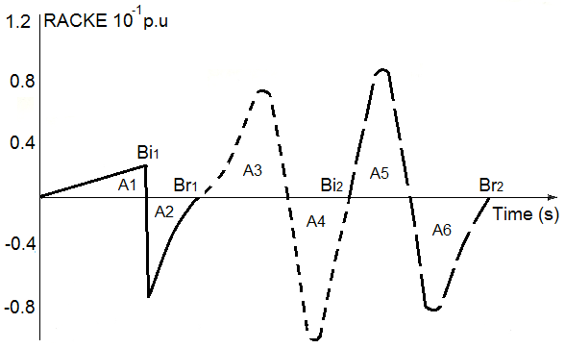
Fig. 1. RACKE versus time, with brake for a stable case
As the power output of a single machine connected to the infinite bus at any instant of time is given by [1]:
$P_{e}= E_{1} E_{2} Y_{12} \sin{δ}$ (15)
where E₁ is the voltage behind the transient reactance of the machine, E₂ is the voltage of the infinite bus, and Y₁₂ is the admittance between the internal node of the machine and the infinite bus. Replacing E₁ E₂ Y₁₂ by $P_{max}$ (i.e. the maximum power fed by the machine to the infinite bus) in (15), yields
$P_{e}= P_{max}\sin{δ}$ (16)
Applying a three-phase disturbance at the generator terminals causes the power output (P_{e}) to be zero during the period of the disturbance. Thus, (1) becomes
$M\frac{d^{2}δ}{{dt}^{2}}= P_{m}$ (17)
Integrating (17) for $δ$ as a function of time yields
$\frac{dδ}{dt}= \left(\frac{P_{m}}{M}\right)t$ (18)
and
$δ\left(t\right)= δ_{0}+ \left(\frac{P_{m}}{2M}\right)t^{2}$ (19)
At the clearing time, when t = t_{c} then $δ(t_{c})$ will be
$δ\left(t_{c}\right)= δ_{0}+ \left(\frac{P_{m}}{2M}\right)t_{c}^{2}$ (20)

Substituting (16) in (1) and rearranging for $\frac{d^{2}δ}{{dt}^{2}}$ gives
$\frac{d^{2}δ}{{dt}^{2}}= \frac{1}{M}[P_{m}- P_{max} sin δ]$ (21)
Now, as $ω= dδ/dt$, the value of RACKE in (9), can be rewritten as
$RACKE= \frac{M}{ω_{s}}\frac{dδ}{dt}\frac{d^{2}δ}{{dt}^{2}}$ (22)
The instantaneous value of RACKE (IRACKE) can therefore be obtained by substituting (18) and (21) in (22) that gives
$IRACKE\left(t\right)=\frac{1}{ω_{s}}\frac{dδ_{(t)}}{dt}\left[P_{m}- P_{max}\sin{δ\left(t\right)}\right]$ (23)
As $P_{m}$is defined for the post-fault state, the value of IRACKE in (23) varies depending on the instantaneous value of$δ$. It will be negative as long as the electro-magnetic power $P_{max}\sin{δ\left(t\right)}$ is greater than the input mechanical power$P_{m}$.
Also at the critical clearing time, when t = t_{cc}, substituting (18) in (23) yields
${\left.IRACKE(t)\right|}_{t=t_{cc}}= {\left.\frac{P_{m}^{2}}{{Mω}_{s}}t-\frac{P_{m }P_{max}}{{Mω}_{s}} t\sin{δ\left(t\right)}\right|}_{t=t_{cc}}$ (24)
${\left.\frac{dIRACKE(t)}{dt}\right|}_{t=t_{cc}}= {\left.\frac{P_{m}^{2}}{{Mω}_{s}}-\frac{P_{m }P_{max}}{{Mω}_{s}} \sin{δ\left(t\right)}\right|}_{t=t_{cc}}- {\left.\frac{P_{m }P_{max}}{{Mω}_{s}}t \frac{dδ\left(t\right)}{dt} cos{δ\left(t\right)}\right|}_{t=t_{cc}}$ (25)
At critical fault clearance, $δ\left(t_{cc}\right)≅{90}^{o}$ [16] and $P_{m}≅{Pe ≅P}_{max} \sin{δ\left(t_{c}\right) }$[14], however the system continues its acceleration as long as the angular velocity is greater than the synchronous speed. Thus the value of dRACKE/dt $≅$ 0.

Power System Under Study
In order to examine the above conclusions and results of the RACKE method practically, a laboratory power system simulator (PSS) is used in this study as shown in Fig. 2. The resistive dynamic brake is connected at the sending end of the transmission line that is represented by an autotransformer. Parameters of the synchronous machine were measured experimentally and compared with that of a specially designed micromachine and of a typical large machine. Per unit values of these machine parameters are given in Table 1. It can be noticed that the parameters values of the machine used in this study are close to that of the large machine (Northfleet), with high armature and field resistance values. The higher resistance of the present machine will cause the transient to die out rapidly.
A digital controller based on the Intel 8086 microprocessor and its associated digital hardware circuitry is also designed and implemented to perform various tasks, including; data acquisition, computation, and dynamic brake control when the system is subjected to sudden disturbances.

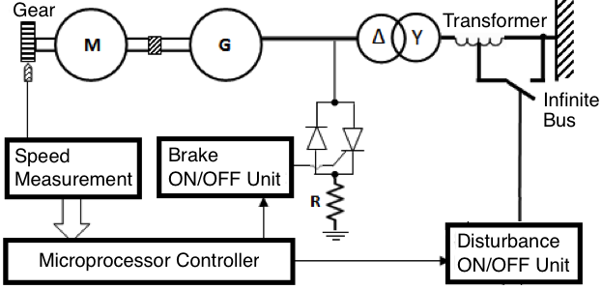
Fig. 2. Power system scheme
Table 1. Per unit value of different machine parameters [14]
Parameter | Micromachine | Northfleet | Present Machine
Base Voltage | 220 V | 13.8KV | 380 V
Power Factor | 0.8 | 0.8 | 0.8
Base OHM | 16.13 | 1.27 | 413
Base VA | 3k | 150M | 350
X_{d}(p.u.) | 2.159 | 1.85 | 1.07
X_{d'} (p.u.) | 0.223 | 0.245 | 0.118
X_{d"} (p.u.) | 0.16 | 0.17 | 0.08

Brake insertion/removal unit
A resistive braking bank with thyristor control is connected at the sending end of the transmission link, as illustrated in Fig. 2. Control of the power supplied to the braking resistors is achieved by switching the current ON and OFF, using three thyristors (a thyristor per phase). The thyristor can be used to switch power to the brake in two firing modes; the ON/OFF firing mode and the phase-angle firing mode. In the ON/OFF mode, the thyristor is energized well into half cycle. This triggers the thyristor and causes a large sudden change to happen in the load current. In the phase angle mode, allowing the thyristor to conduct for only a specified period of the AC supply cycle controls the power. Dynamic braking requires the combination of both mentioned modes in order to control the braking power as well as the braking instants. Three diodes that act as freewheeling diodes are used to provide return paths for the current.

Disturbance simulation unit
Opening and re-closing the transmission line is considered adequate to simulate a disturbance in the power system under study. This is achieved by changing the value of the series reactance of the autotransformer from low to high. Such a simulation is considered equivalent to the loss of part of the transmission circuit between the generator and the infinite bus. An electromechanical switch is used to initiate the application of a sudden disturbance through a hardware interrupt to the microprocessor controller, as shown in Fig. 3. The controller will then decide the disturbance period based on a pre-programmed setting.

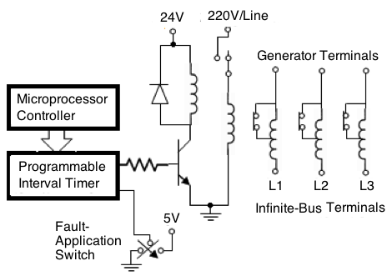
Fig. 3. Disturbance simulation unit

Speed measurement unit
As shown earlier in (10), RACKE method is solely dependent on the measurement of the deviation speed of the generator. A fast and precise speed measurement is therefore a key requirement in this study. A principle of the speed measurement unit adopted in this study was first reported in [14]. It consists of a magnetic pick-up sensor that is fixed close to a toothed wheel mounted on the shaft of the generator, as shown in Fig. 4(a). When the shaft rotates, the wheel’s tooth cut the magnetic field of the probe and generates a signal on the output of the magnetic sensor. The generated signal is then converted to a square waveform using appropriate zero-crossing detector and signal conditioning logic circuit, as illustrated.
Speed measurement can be explained with the aid of the timing diagram of Fig. 4(b), as follows. The generated stream of square pulses is fed to a programmable interval timer (PIT) that comprises three 8-bit counters. This timer is periodically triggered by the microcomputer to count the required tacho-pulses (m) and clock pulses (N), using counters 1 and 0, respectively. At the end of each sampling period (T_{s}), Counter-2 generates a pulse that terminates the counting process and interrupts the microprocessor to read the content of Counter-1 (i.e. the number of tacho pulses during the sampling period) and Counter-0 (i.e. the number of clock pulses during a time interval (∆T). Mathematically, the following relations can be derived [14]:
$n= f_{c }. ∆T$ (26)
$N =f_{c}. T_{S}– n =f_{c} (T_{S} - ∆T)$ (27)
where $f_{c }$ is the clock frequency in Hz, and $n$ is the number of clock pulses during the interval $∆T$
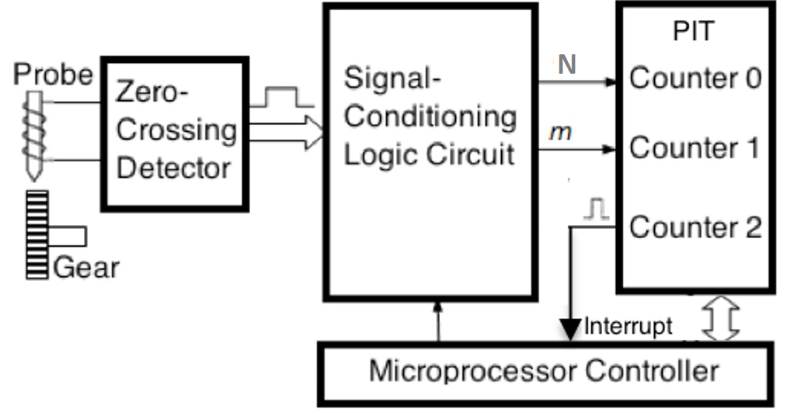
(a) Hardware circuit
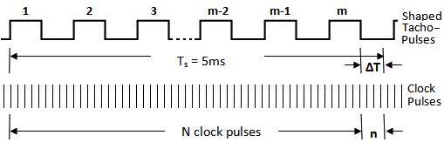
(b) Timing diagram
Fig. 4. Speed measurement unit

$T_{S}-∆T =\frac{N}{f_{c}}= \frac{ 60 × m }{Speed \left(rpm\right)× P}$ (28)
where P is the number of tacho-pulses generated in each revolution. Rearranging (28) yields
$Speed \left(rpm\right)= \frac{60 x f_{c}}{P} × \frac{m}{N}=K × \frac{m}{N}$ (29)
where K is a constant dependent on the number gear-tooth and the clock frequency. In the current implementation, the measurement accuracy is found to be around 0.013%, however, better accuracy can be obtained using a programmable interval timer with higher resolution.

Controller Software
Software implementation is required to make the hardware part performs its tasks successfully. To control the system during the transient condition, it is required to implement fast programs to satisfy the online control requirements of the brake insertion and removal. The developed controller software is designed to perform the following functions:
- Collection of the generator speed.
- When a disturbance exists, the controller (i) calculates RACKE, and (ii) controls the dynamic brake.
- Recording the data during the transient condition to monitor the events that occur during this short time frame.
The controller software that is developed using assembly- language can be described briefly as follows.

Main program
The main program is dedicated to performing software and hardware initialization tasks such as specifying the content of the PIT and default values of the program counter, stack pointer, interrupt vector addresses, and memory buffers. It also executes some background tasks such as prioritizing system response to user commands and hardware interrupts.

Interrupt service routine
The interrupt service routine (ISR) is called at each sampling period. It performs three main tasks: (i) collection and processing of the measured speed values, (ii) computation of RACKE areas under RACKE curve, and (iii) brake control. These tasks that are executed by calling three corresponding subroutines that are described briefly as follows:
1) Speed measurement subroutine: Once the ISR starts, it calls a subroutine that collects the contents of PIT counters 0 and 1 as described earlier in Section III-C. The speed value is then calculated using (27) and (29), and stored in a memory buffer for further use. The subroutine then returns to the main line of the ISR which in turn compares the current speed value with the previously collected one to assess whether a deviation from the synchronous speed exists (i.e. a disturbance exists) or not. If not, the ISR terminates and returns control to the main program. Otherwise, it proceeds to the RACKE subroutine.
2) RACKE subroutine: When a speed deviation exists, this subroutine is called to perform the following tasks in a sequential order; (i) compute RACKE, using new speed value in (10), (ii) evaluates areas under RACKE curve A1 and A2 (Fig. 1), simply by multiplying the computed RACKE value by the sampling period, and (iii) compare the critical clearing time (t_{cc}) with the instantaneous instants of time (Ti). If Ti > t_{cc}, and the disturbance remains in the system, the ISR proceeds to the brake control subroutine. Otherwise, the ISR terminates and returns to the background tasks of the main program.
3) Brake control subroutine: The transient stability is assessed by comparing the areas A1 and A2; if A2 ≥ A1, (with an allowable tolerance up to 3%), the system is considered stable. Otherwise the system is unstable and the brake must be inserted and removed according the conditions described in section 2.3 in order to clear the disturbance and return the system to its stable state.

Results and Discussion

Simulation results
Effectiveness of the proposed RACKE method is initially assessed by computer simulation that is carried out as follows:
- The initial conditions are estimated using an existing load-flow program.
- The data obtained from the load-flow program is then used as an input to the developed transient stability package. A step-by-step simulation, which demonstrates the relationship between generator-rotor angle and different disturbance clearing times, is shown in Fig. 5. In case 1, the rotor angle increases to a maximum, then decreases and oscillates with decreasing amplitude until it reaches a steady state. This case is considered transient stable. In case 2, the rotor angle continues to increase steadily until synchronism is lost. This case is considered transient unstable. Simulation results of RACKE versus time demonstrate that the critical clearing time (t_{cc}) is found to be around 230ms, when the RACKE is maximum negative, as shown in Fig. 6.
- Off-line calculation of rotor speed for disturbance clearing times of 220 ms (stable case) and 360 ms (unstable case) are shown in Fig. 7.
- Calculation of best brake size is found based on the generator rating, and according to (12), the braking resistor is found to be 0.13pu.

Experimental results
To study the behavior of RACKE practically, two experiments with different disturbance clearing times are considered. These clearing times were chosen carefully to demonstrate RACKE when the system is critically stable (t_{c} = 230 ms) and unstable (t_{c} = 250 ms). For each test, the values of RACKE and the generator speed are recorded during and after disturbance clearance.

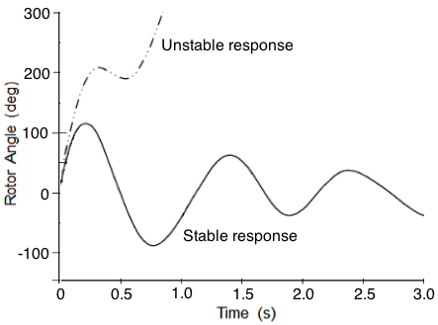 | 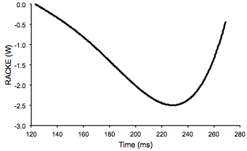
Fig. 5. Rotor angle versus different disturbance clearing times | Fig. 6. RACKE against time for the PSS
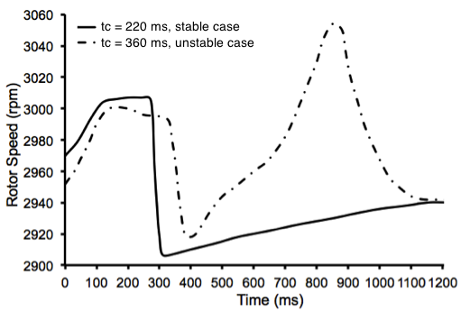
Fig. 7. Rotor speed for different disturbance clearing times
Fig. 8 shows a critically stable case, the part of the curve above the zero level represents kinetic energy gained by the machine during the disturbance period, while the part below the axis represents kinetic energy given up by the machine to the system. One can see that, for this case, the amount of kinetic energy given up is, in general, equal to the amount of energy gained with a certain tolerance. i.e., A₁ = A₂. Thus the oscillation is decreasing and will finally be damped to zero after a certain period due to damping forces inherent to synchronous machine operation.
Fig. 9 demonstrates RACKE behavior for the unstable case. At the instant of disturbance clearance, it can be noticed that RACKE is less negative than that of the critically stable case. The generator is therefore giving up its kinetic energy, taking longer time to change from the lower part to upper part in the first swing. When the curve reaches the zero line, the generator gains too much kinetic energy (i.e. A₁ > A₂.) that makes it move faster and its excess energy will therefore increase further. Table 2 shows a comparison for the areas under RACKE curve for critically stable and unstable cases.
It can be shown practically that RACKE at disturbance clearing time has a maximum negative value if it corresponds to the critical clearing time. As the kinetic energy increases, its rate of change with respect to time will increase negatively. The rate of change of kinetic energy with respect to time is increasing with the increase of disturbance clearance time up to the critical clearing time. However, its value at the instant following disturbance clearance is negative as long as the electromagnetic power P_{e} is greater than the input power P_{m}.
Table 2. Calculated Positive and Negative Areas of RACKE
Disturbance-clearing time (ms) | A₁ (J) | A₂ (J)
230 | 76.5 | 74.4
250 | 85.5 | 64.7

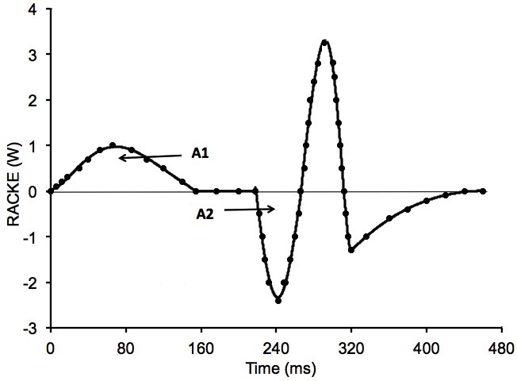 | 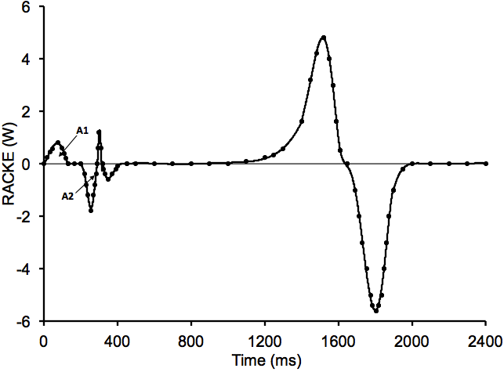
Fig. 8. RACKE versus time, t_{c} = 230 ms, stable case | Fig. 9. RACKE versus time, t_{c} = 250ms, unstable case
In Fig. 10 RACKE is calculated practically for a range of disturbance-clearing times, then the critical value is found from this curve. When the clearing time is at or close to the critical time, RACKE will have a negative maximum value, as illustrated. The RACKE value can therefore form an online stability index, where there is a practical requirement to find the limiting value of disturbance clearing time that maintains system stability. Fig. 11 shows a relationship of rotor speed versus time for different disturbance-clearing times. It can be noticed that the critical clearing time obtained in this experimental test matches well with that obtained by simulation (Fig. 7).
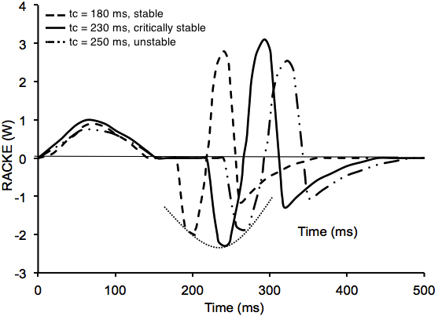 | 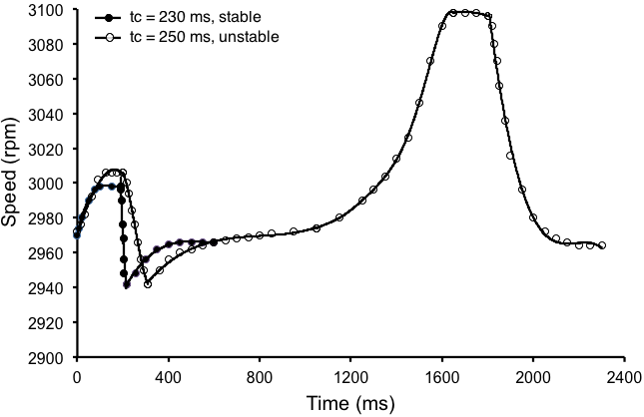
Fig. 10. RACKE versus time for different disturbance clearing times | Fig. 11. Rotor speed versus different disturbance clearing times

A new relationship between the summation of RACKE and the speed is shown in Fig. 12. From Fig. 12(a), It can be noticed that originally the generator is operating at the synchronous speed and the input mechanical power is equal to the output electrical power, represented by Point a on the curve. When the disturbance occurs, the electrical power output is suddenly reduced while the input mechanical power is unaltered. The difference in power must be accounted for by an increase in stored kinetic energy in the rotor masses. This can be accomplished only by an increase in speed, which results from the accelerating power. When the disturbance is cleared at Point b, the electrical power output abruptly increases and exceeds the input mechanical power. The accelerating power therefore becomes negative and the generator starts to give up kinetic energy gained during transient condition. At Point c the rotor speed is again the synchronous speed. The accelerating power at c is still negative (retarding), and so cannot remain at synchronous speed but must continue to slow down, until it reaches Point d at which the rotor speed is less than synchronous speed. From d to e the mechanical power is higher than the electrical power. The rotor speed therefore increases again until it reaches synchronism at e. In the absence of damping, the rotor would continue to oscillate in the sequence b-c-d-e, until it dies out at Point e.
In Fig. 12 (a), the distance a-b is the amount of kinetic energy gained by the generator during transient condition, while b-c, represents the amount of kinetic energy delivered by the generator to the system. The distance a-c represents the difference between these two areas. Therefore every point on this curve represents the instantaneous values of kinetic energy in the generator. It can also be observed that if the amount of energy gained by the generator during transient condition a-b is less than the capability of the generator to maintain this energy during normal condition c-d, then the system is stable. Otherwise from Fig. 12 (b), if the energy gained by the generator during transient state a-b is greater than the capability of the generator to maintain this energy during the normal condition c-d then the system is unstable. Therefore, from this relationship the brake should be inserted at Point b to absorb the energy gained during transient state, and removed at Point c. In Fig.12 (c), it can be noticed clearly how the instant and timely brake insertion/removal will die the system oscillation and maintain system stability.
 | 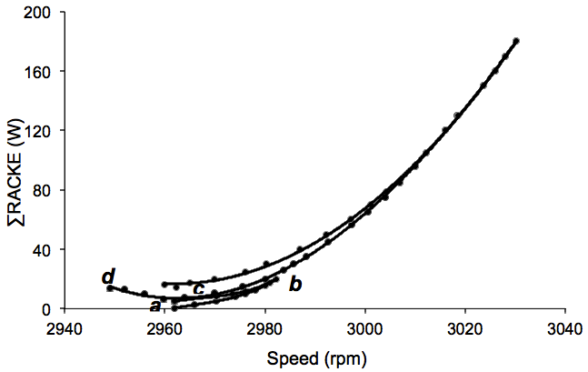
(a) Stable case | (b) Unstable case
(c) Stable case with brake
Fig. 12. Summation of RACKE against speed

Conclusions
A fast method for transient stability assessment based on the rate of change of kinetic energy (RACKE) criterion was proposed in this paper. The effectiveness of the proposed method on the transient stability was tested on a one-machine infinite bus system. Unlike previous studies, which were mostly based on off-line computer simulation, this study was presented practical implementation of the RACKE criterion. An experimental setup based on a single-variable measurement, i.e., deviation speed, was designed and implemented successfully to decide system stability, and to clear the effect of sudden disturbance on the system stability through an effective insertion/removal strategy of a dynamic brake. The obtained simulation results and experimental verification demonstrate clearly the effectiveness of the proposed method and provide an intuitive measure of the influence of optimum insertion/removal instants of the dynamic brake on the transient stability of the power system under study. It is therefore expected to be widely accepted for online assessment of transient stability since it is sufficiently rapid and does not rely on system model/parameters, and equally applicable for power systems incorporating a single or group of machines. More importantly, it is a cost-effective method since its practical implementation is only based on a single-variable measurement. Future efforts will be devoted to the implementation of the proposed method on multi-machine power systems that is not yet investigated experimentally. However, computer simulation reported in [18] showed that RACKE criterion is also applicable to multi-machine power systems. In this case, the machine (or a group of machines) with the largest faulted acceleration/deceleration is considered critical and its behavior will depend on the properties of the machines in the group as well as the rate at which the energy conversion takes place. It is therefore very pertinent to use this rate of change of kinetic energy as a criterion for online stability assessment.

References
[1] M. J. Basler, "Understanding Power-System Stability," Industry Applications, IEEE Transactions, 2008, vol. 44, ( 2), pp. 463 - 474.
[2] R. Zhang, Y. Xu, Z. Y. Dong, K. P. Wong, “Post-disturbance transient stability assessment of power systems by a self-adaptive intelligent system,” IET Gener. Transm. Distrib., 2015, vol. 9, (3), pp. 296–305.
[3] K. A. Sattar and M. A. Al-Taee, “Inter-area oscillations damping using pole assignment controller with selected variables technique,” Int. J. of modelling and simulation, 2006, vol. 26, (3), pp. 276-285.
[4] K. A. Sattar and M. A. Al-Taee MA, Small-Signal Stability Assessment of Iraqi National Grid, Int. J. of Modelling and Simulation, 2008, vol. 28, (1), pp. 1-8.
[5] F. J. AL-Azzawi and F. F. Baldawi, "A comparative study of fast assessment methods used for multimachine power system transient stability," Conf. Proc. 9th Power System Computation, Portugal, Augast, 1987, pp. 633-638.
[6] F. J. Al-Azzawi, "Use of improved machine models in the direct evaluation of transient stability of synchronous machines," Proc. of the 1st INTER-ARAB Conf. on Electrical System, Algeria, Oct. 1986.
[7] S. Paudyal, G. Ramakrishna, and M. S. Sachdev, “Application of equal area criterion conditions in the time domain for out-of-step protection,” IEEE Trans. Power Deliv., 2010, 25, (2), pp. 600–609.
[8] K. R. Padiyar and S. Krishna, “Online detection of loss of synchronism using energy function criterion,” IEEE Trans. Power Deliv., 2006, 21 (1), pp. 46–55.

[9] S. Kai, S. T. Lee and Z. Pei, “An adaptive power system equivalent for real-time estimation of stability margin using phase-plane trajectories,” IEEE Trans. Power Syst., 2011, 26, (2), pp. 915–923.
[10] S. Kai and S. T. Lee,, “Power system security pattern recognition based on phase space visualization,” Proc. IEEE Int. Conf. Electric Utility Deregulation and Restructuring and Power Technologies, Nanjing, China, April 2008, pp. 964–969.
[11] L. Mariotto, H. Pinheiro, G. Cardoso, et al.: ‘Power systems transient stability indices: an algorithm based on equivalent clusters of coherent generators,” IEE Gener. Transm. Distrib., 2010, 4, (11), pp. 1223–1235.
[12] M. A. Al-Taee, “Real-time stability index for open loop controlled synchronous permanent magnet motor drive,” Proc. 41st Int. Universities Power Engineering Conference, UPEC2006, Newcastle-UK, 6–8 September 2006, pp. 719-723.
[13] S. Zhao, H. Jia, D. Fang, Y. Jiang, X. Kong, “Criterion to evaluate power system online transient stability based on adjoint system energy function,” IET Gener, Transm. Dislrib., vol. 9(1), 08 January 2015, pp. 104 – 112.
[14] M. A. Al-Taee, F. J. Al-Azzawi, A. A. Al-Taee, and T. Al-Jumaily, "Real-time assessment of power system transient stability using rate of change of kinetic energy method," IEE Gener, Transm. Dislrib., vol. 148, no. 6, pp. 505-510, Nov. 2001.
[15] F. J. Al-Azawi, M.A. Al-Taee, and A.A. Al-Taee, "online transient stability enhancement of power systems using rate of change of kinetic energy strategy," Proc. 3rd Int. Conf. on Computational Aspects and their Applications in Electrical Engineering (CATAEE 99), IEE-Jordan, Amman-Jordan, 19-20 Oct., 1999, pp. 8-12.
[16] F. J. Al-Azzawi, F. F. Al Baldawi, and C. L. Narayana, "Fast methods for direct assessment of power system transient stability," IEEE Proc., vol. 135, no. 6, pp. 469-473, 1988.
[17] F. J. Al-Azzawi and F. Omar, "Dynamic brake switching times in multimachine power systems during emergency," Proc. 8th University Power Engineering Conf. (UPEC’89), Belfast, pp. 101-106, Sep. 1989.
[18] F. J. AL-Azzawi and F. F. AL-Baldaw, "Multimachine Transient Stability Analysis Methods For Direct On-Line Studies," King Su 'ud Univ. in Collaboration With IEEE Region 8, pp. 345-348, 1987.
[19] R. Patel, T. S. Bhatti and D. P. Kothari, “Improvement of power system transient stability by coordinated operation of fast valving and braking resistor,” IEE Gner, Transm. Dislrib, 2003, vol. 150, (3), pp. 311-316.
[20] L. Shinji, I. Shunji, S. Goro and F. Goro "Experimental Study on Improvement of Transient Stability with Braking Resistor," Electronics & Communications in Japan., 2008, vol. 91, (8), pp. 11-19.

