First draft submitted: 31 May 2017; Accepted for publication: 7 June 2017; Published online: XXX

Advances in Nanomedicine Drug Delivery Applications for HIV Therapy

Paul CURLEY¹, Neill J LIPTROTT¹⁺² and Andrew OWEN¹⁺²

¹ Department of Molecular and Clinical Pharmacology, Institute of Translational Medicine, University of Liverpool, Liverpool, UK

² European Nanomedicine Characterisation Laboratory, Department of Molecular and Clinical Pharmacology, Institute of Translational Medicine, University of Liverpool, Liverpool, UK

Author for correspondence and reprints: Prof A Owen, Molecular and Clinical Pharmacology, Institute of Translational Medicine, University of Liverpool, UK
Tel: +44 (0) 151 794 8211
Fax: + 44 (0) 151 794 5656
E-mail: aowen@liverpool.ac.uk

Word Count: 1492 (excluding references and subheadings)

References: 25

Figures: 1

Key words: Nanomedicine, HIV, Long Acting Antiretroviral, Biocompatibility

Andrew Owen is a co-inventor of patents relating to the application of nanotechnology to HIV drug delivery and are co-founder of a University of Liverpool start-up company, Tandem Nano Ltd. Andrew Owen has also received funding from Merck, Janssen, ViiV Healthcare, AstraZeneca, and Pfizer. The authors have no other relevant affiliations or financial involvement with any organization or entity with a financial interest in or financial conflict with the subject matter or materials discussed in the manuscript apart from those disclosed.
No writing assistance was utilized in the production of this manuscript.

Despite significant advances in the treatment of human immunodeficiency virus (HIV), there remain challenges. HIV is a chronic disease and patient adherence to treatment is critical over a lifetime. Poor therapy adherence increases the likelihood of virological failure and emergence of resistant strains of HIV [1]. Poor aqueous drug solubility is a major limitation, negatively impacting oral bioavailability for many antiretroviral drugs [2]. Complete eradication resulting in cure has long been a focus of research efforts, but the existence of cellular and anatomical regions where the virus can continue to replicate in sub-therapeutic drug concentrations creates sanctuary sites [3], which reseed the blood when therapy is withdrawn [4]. The application of nanomedicine to current and future HIV therapeutic agents may offer bespoke solutions to the issues faced by traditionally formulated drugs. The purpose of this review is to highlight recent advances in the application of nanotechnology to drug delivery as summarised in figure 1.

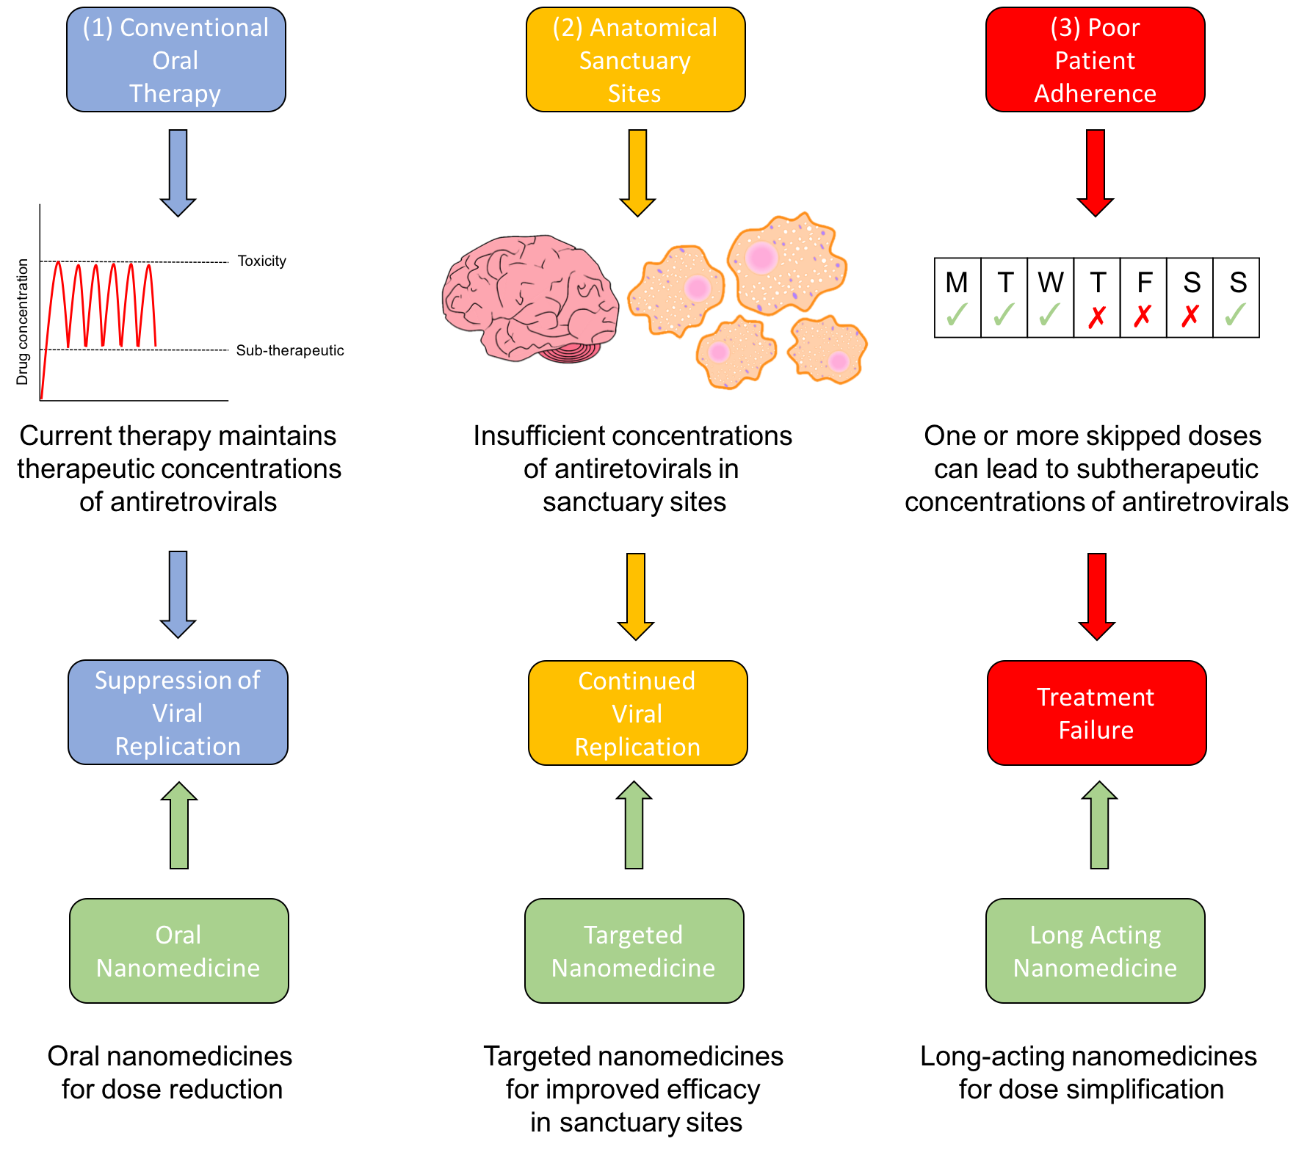
Figure 1 shows some of the limitations of current antiretroviral therapy and opportunities to address these limitations via nanomedicine. (1) conventional oral nanomedicine is effective at achieving therapeutic concentrations of antiretrovirals and maintaining suppression of viral replication. However, application of oral nanomedicine offers potential benefits such as dose reduction, reduced toxicity and improved bioavailability. (2) Sub-therapeutic concentrations of antiretrovirals in sanctuary sites allow continued viral replication in key anatomical and cellular regions despite viral suppression in the plasma. Targeted nanomedicines offer the opportunity to deliver therapeutic concentrations of antiretrovirals to sanctuary sites. (3) Poor patient adherence may produce sub-therapeutic concentrations of antiretrovirals which may lead to viral rebound. Application of long acting nanomedicines may mitigate the risks effects of poor patient compliance.

Oral Nanomedicines
A number of nanomedicine strategies are being explored for oral delivery of antiretroviral drugs and have been reviewed previously [5]. Amongst the current strategies to improve bioavailability of poorly water-soluble drugs are solid drug nanoparticle (SDN) formulations. SDNs of efavirenz were recently generated using a single-step emulsion-templated freeze-drying technique. [6]. In vitro - in vivo pharmacokinetic extrapolation predicted that the SDN formulations could achieve similar pharmacokinetics to the standard Sustiva© formulation with a 50% lower dose. These simulations were validated in vivo, with pharmacokinetics in rats demonstrating a higher C_{max} C_{min} and AUC compared to a conventional preclinical formulation [6].

Currently, the ritonavir-boosted lopinavir (Kaletra©) paediatric formulation consists of an oral solution of 42% ethanol and 15% propylene glycol [7], which is clearly undesirable. This has spurred efforts to develop other formats (such as “sprinkles”) that despite some success have proven challenging due to issues such as taste-masking. Recently, lopinavir SDN formulations (alone and in combination with ritonavir) were produced with potential for an ethanol-free paediatric liquid formulation. In vivo pharmacokinetics demonstrated similar plasma concentrations to a conventional lopinavir preclinical formulation, without the need for an organic solvent [7].

Unlike many nanomedicine strategies, the SDN technologies described above are translatable to industrial scale through spray-dry manufacture and utilise already licensed drugs in combination with FDA CDER-listed excipients. Thus, they potentially provide low-cost solutions to free up manufacturing capacity, while reducing doses required for effective therapy [7]. Importantly however, other advanced strategies involving lipid- or polymer-based nanocarrier systems have also shown preclinical success in augmenting oral delivery [8-10]. It should be noted that many of these strategies involve carrier materials (or excipients) that are in themselves novel, which may present hurdles to translation, necessitating additional safety assessments.

Long-Acting Injectable (LAI) nanomedicines
Problems with low adherence are currently being addressed by development of long-acting injectable (LAI) formulations [2]. The non-nucleoside reverse transcriptase inhibitor Rilpivirine has been available for oral administration since 2011. Recently, rilpivirine has been nanoformulated to produce a LAI. When administered subcutaneously (SC) or intramuscularly (IM), rilpivirine concentrations were detectable for up to 2 months in rats and 6 months in dogs [11]. This was followed up by successful assessment in 51 healthy volunteers where rilpivirine plasma concentrations remained above 10 ng/mL for up to 26 weeks with no grade 3 or 4 adverse events [12].

HIV therapy is most successful when a combination of drugs are administered. Cabotegravir (an integrase inhibitor) is currently being developed for application for both oral and LAI applications [13]. In a recent study in 56 healthy volunteers, cabotegravir LAI (administered either IM or SC injection) sustained exposure for up to 24 weeks. Similar to rilpivirine LAI, cabotegravir was well tolerated with no grade 2 to 4 injection site reactions reported [14].
The rilpivirine and cabotegravir LAI formulations are showing great promise for treatment and pre-exposure prophylaxis for HIV. Notwithstanding, current paradigms for HIV treatment necessitate the combination of therapeutic agents. Accordingly, Janssen and ViiV Healthcare have partnered to evaluate the utility of cabotegravir and rilpivirine co-adminsitration as a combination LAI therapy. Recent data from the LATTE II study have been extremely encouraging in support of this combination as a maintenance therapy [15], with this strategy advancing via separate IM depots for each drug, rather than a combination product.

Recently, a combination (tenofovir and lopinavir/ritonavir) lipid-stabilised nanosuspension was administered subcutaneously to macaques. Encouragingly, tenofovir plasma and peripheral blood mononuclear cell (PBMC) concentrations were detectable over 2 weeks. PBMC exposure of total tenofovir and tenofovir-diphosphate were markedly higher in comparison to conventional oral tenofovir disoproxil fumarate or tenofovir alafenamide [16].

Targeted Nanomedicines
As mentioned previously, a significant barrier to HIV eradication is the presence of sanctuary sites. For example, the central nervous system represents an anatomical sanctuary site for many drugs. To target delivery to the brain, magnetic azidothymidine 5’-triphosphate liposomal nanoformulations have been developed. In an in vitro model of the blood brain barrier the transcellular apparent permeability was increased (when a magnetic field was applied) vs free drug [17].
Macrophages also represent an important target in HIV. Through targeting of the mannose receptor, nanocarrier systems have been proposed that may be suitable for HIV therapy. By optimising the number of mannose units, polyethylene glycol chain- and spacer-length, mannosylated polyethylene glycol-conjugate nanocarriers were generated. In vitro uptake by J774.E murine macrophage-like cells was confirmed using confocal microscopy, and the optimal configuration was identified as (i) small PEG polymer carrier, (ii) two mannose units per nanocarrier (iii) 56Å distance between mannose units [18].

These data support further research into strategies to increase delivery to the CNS, lymph or cellular reservoirs. However, the complexity of these systems complicates compatibility with patient-acceptable routes of administration (often requiring repeated intravenous delivery) and cost-effective routes to scalable manufacture. Translation clearly also demands thorough investigation of the potential safety concerns arising from the altered distribution, and in some cases the additional complexity introduced by the need for additional non-invasive equipment and medical care. Many of these issues are exacerbated by the need to develop systems for implementation in low- and middle-income countries, where the overwhelming burden of disease resides.

Safety
It is becoming increasingly apparent that some nanoparticle platform technologies have a propensity for interaction with the immune system. Therefore, for complex multi-component nanocarrier systems a thorough analysis of potential interactions is required in addition to a robust understanding of the implication for altered distribution. Conventional drug formulations are often too small to interact with the immune system whereas nanoparticles are in the size range, and have physical characteristics, that may be recognised by immune cells with associated implications for safety [19]. As such the assessment of biocompatibility of nanoformulations is an increasingly important area of research [20].

The safety and biocompatibility testing of nanoparticles represents a significant challenge, driven in part by the huge diversity of materials. Particles range in size (1-1000nm), functionality, charge and composition [21]. This diversity means that existing immunological assays are sometimes inadequate to account for nanoparticle characteristics [22]. For example, some nanoparticles possess catalytic properties which interfere with assays meaning careful scrutiny is needed to ensure validity of in vitro toxicity tests [19].

Many nanomedicines aim to alter the pharmacokinetics or distribution. Thus, there is a need to better understand the exposure-response relationship, particularly for nanomedicines that interact with the immune system. In the case of HIV infection, greater accumulation within macrophages may have a therapeutic benefit as a sanctuary site for the virus. However, increasing exposure to macrophages may exacerbate the impact on cell function, thereby necessitating careful understanding of what is required pharmacologically as well as in terms of safety.

Discussion and Future Perspectives
The application of nanomedicine to HIV presents many exciting opportunities. It is well known that during the development of a new therapeutic many candidates will fail to reach the clinic. Frequently reported reasons for failure in phase I and II trials are toxicity, inadequate efficacy and poor pharmacokinetics [23]. Even when medicines transition to commercial applications, careful post-licensing optimisation is often required. Nanotechnology offers the opportunity to develop strategies to address the limitations of current, future and even failed therapeutics. Importantly, a major driver for nanomedicine development has been the improvement of safety by reducing doses or improving distribution to diseased cells.

Despite increasing interest in nanomedicines, there are still significant gaps in knowledge of the underlying mechanisms. For example, a greater understanding of drug release following LAI injection is needed [2]. Recent work on similar SDN formulations of paliperidone palmitate have demonstrated the importance of granuloma and phagocytosis by infiltrating macrophages [24]. Further support for the role of macrophages has been demonstrated in rodents, where nanoparticle-mediated activation of autophagy led to 50-fold increases in the plasma concentration of the viral integrase inhibitor dolutegravir [25]. Such information on nano-specific DMPK will be central to bringing forward the optimised next generation of LAI medicines.

In summary, a better understanding of the mechanisms underpinning nanoparticle behaviour will enable rational design of nanomedicines with greater efficacy and improved safety, so that the preclinical promises can be realised for patients across the different nanotechnologies being explored.

References
1. Rosenbloom DI, Hill AL, Rabi SA, Siliciano RF, Nowak MA. Antiretroviral dynamics determines HIV evolution and predicts therapy outcome. Nat. Med. 18(9), 1378-1385 (2012).
2. Owen A, Rannard S. Strengths, weaknesses, opportunities and challenges for long acting injectable therapies: Insights for applications in HIV therapy. Advanced drug delivery reviews 103 144-156 (2016).
3. Poveda E, Tabernilla A. New Insights into HIV-1 Persistence in Sanctuary Sites During Antiretroviral Therapy. AIDS Rev. 18(1), 55 (2016).
4. Cory TJ, Schacker TW, Stevenson M, Fletcher CV. Overcoming pharmacologic sanctuaries. Curr. Opin. HIV AIDS 8(3), 190-195 (2013).
5. Tatham LM, Rannard SP, Owen A. Nanoformulation strategies for the enhanced oral bioavailability of antiretroviral therapeutics. Ther. Deliv. 6(4), 469-490 (2015).
6. Mcdonald TO, Giardiello M, Martin P et al. Antiretroviral solid drug nanoparticles with enhanced oral bioavailability: production, characterization, and in vitro-in vivo correlation. Advanced healthcare materials 3(3), 400-411 (2014).
7. Giardiello M, Liptrott NJ, Mcdonald TO et al. Accelerated oral nanomedicine discovery from miniaturized screening to clinical production exemplified by paediatric HIV nanotherapies. Nat. Commun. 7 13184 (2016).
8. Tshweu L, Katata L, Kalombo L et al. Enhanced oral bioavailability of the antiretroviral efavirenz encapsulated in poly(epsilon-caprolactone) nanoparticles by a spray-drying method. Nanomedicine (London, England) 9(12), 1821-1833 (2014).
9. Skanji R, Andrieux K, Lalanne M et al. A new nanomedicine based on didanosine glycerolipidic prodrug enhances the long term accumulation of drug in a HIV sanctuary. Int. J. Pharm. 414(1-2), 285-297 (2011).
10. Hatton FL, Tatham LM, Tidbury LR et al. Hyperbranched polydendrons: a new nanomaterials platform with tuneable permeation through model gut epithelium. Chemical Science 6(1), 326-334 (2015).
11. Van 'T Klooster G, Hoeben E, Borghys H et al. Pharmacokinetics and disposition of rilpivirine (TMC278) nanosuspension as a long-acting injectable antiretroviral formulation. Antimicrob. Agents Chemother. 54(5), 2042-2050 (2010).
12. R Verloes GVK, L Baert, F Van Velsen, M-P Bouche, K Spittaels, J Leempoels, P Williams, G Kraus, P Wigerinck. TMC278 long acting - a parenteral nanosuspension formulation that provides sustained clinically relevant plasma concentrations in HIV-negative volunteers
Presented at: 17th International AIDS Conference
Mexico City. Mexico City 2008.
13. Spreen WR, Margolis DA, Pottage JC, Jr. Long-acting injectable antiretrovirals for HIV treatment and prevention. Curr. Opin. HIV AIDS 8(6), 565-571 (2013).
14. W. Spreen SLF, S. Chen, E. Gould, D. Wilfret, D. Subich, T. Taishi, Z. Hong. Pharmacokinetics, safety and tolerability of the HIV integrase inhibitor S/GSK1265744 long acting parenteral nanosus- pension following single dose administration to healthy adults [Abstract no. TUPE040]. Presented at: 19th International AIDS Conference. Washington, DC 2012.
15. Margolis DA, González-García J, Stellbrink H-J et al. Cabotegravir+Rilpivirine as Long-Acting Maintenance Therapy: LATTE-2 Week 32 Results. Presented at: Conference on Retroviruses and Opportunistic Infections (CROI) Boston, Massachusetts, USA 2016.
16. Kraft JC, Mcconnachie LA, Koehn J et al. Long-acting combination anti-HIV drug suspension enhances and sustains higher drug levels in lymph node cells than in blood cells and plasma. AIDS 31(6), 765-770 (2017).
17. Saiyed ZM, Gandhi NH, Nair MP. Magnetic nanoformulation of azidothymidine 5'-triphosphate for targeted delivery across the blood-brain barrier. International journal of nanomedicine 5 157-166 (2010).
18. Chen P, Zhang X, Jia L, Prud'homme RK, Szekely Z, Sinko PJ. Optimal structural design of mannosylated nanocarriers for macrophage targeting. J. Control. Release 194 341-349 (2014).
19. Mcneil SE. Nanoparticle therapeutics: a personal perspective. Wiley interdisciplinary reviews. Nanomedicine and nanobiotechnology 1(3), 264-271 (2009).
20. Rosslein M, Liptrott NJ, Owen A, Boisseau P, Wick P, Herrmann IK. Sound understanding of environmental, health and safety, clinical, and market aspects is imperative to clinical translation of nanomedicines. Nanotoxicology 11(2), 147-149 (2017).
21. Grossman JH, Crist RM, Clogston JD. Early Development Challenges for Drug Products Containing Nanomaterials. The AAPS journal 19(1), 92-102 (2017).
22. David CA, Owen A, Liptrott NJ. Determining the relationship between nanoparticle characteristics and immunotoxicity: key challenges and approaches. Nanomedicine (London, England) 11(11), 1447-1464 (2016).
23. Waring MJ, Arrowsmith J, Leach AR et al. An analysis of the attrition of drug candidates from four major pharmaceutical companies. Nat. Rev. Drug Discov. 14(7), 475-486 (2015).
24. Darville N, Van Heerden M, Marien D et al. The effect of macrophage and angiogenesis inhibition on the drug release and absorption from an intramuscular sustained-release paliperidone palmitate suspension. J. Control. Release 230 95-108 (2016).
25. Gnanadhas DP, Dash PK, Sillman B et al. Autophagy facilitates macrophage depots of sustained-release nanoformulated antiretroviral drugs. J. Clin. Invest. 127(3), 857-873 (2017).

