Implementation of clinical guidelines in Brazil: Should academic detailing be used?

Juliana de Oliveira Costa¹, Celline Cardoso Almeida-Brasil¹, *Brian Godman^{2,3}, Michael Adam Fischer^{4,5}, Jonathan Dartnell⁶, Aine Heaney⁶, Carolina Greco Bernardes dos Santos¹, Francisco de Assis Acúrcio¹, Juliana Álvares¹, Augusto Afonso Guerra Júnior¹

¹SUS Collaborating Centre – Health Technology Assessment & Excellence in Health, Department of Social Pharmacy, College of Pharmacy, Federal University of Minas Gerais, Rua Antônio Carlos, 6627 – Pampulha, Belo Horizonte, Brazil
²Strathclyde Institute of Pharmacy and Biomedical Sciences, Strathclyde University, 161 Cathedral St, Glasgow G4 0RE, Glasgow, UK
³Division of Clinical Pharmacology, Karolinska University Hospital Huddinge, Karolinska Institutet, Stockholm, Sweden
⁴National Resource Center for Academic Detailing, Division of Pharmacoepidemiology and Pharmacoeconomics, Department of Medicine, 419 Boylston Street Floor 6, Brigham and Women’s Hospital, Boston, MA, USA.
⁵Harvard Medical School, Boston, MA, USA
NPS MedicineWise, Level 7, 418A Elizabeth St, Surry Hills, NSW 2010, Australia
(Accepted for publication in the Journal of Pharmaceutical Health Services Research. Please keep CONFIDENTIAL)
*Author for correspondence – Brian Godman, Department of Laboratory Medicine, Division of Clinical Pharmacology, Karolinska Institutet, Karolinska University Hospital Huddinge, SE-141 86, Stockholm, Sweden. Tel: 00468 585 81068. Email: Brian.Godman@ki.se

ABSTRACT
Objective: The Brazilian National Health System provides high cost medicines through the Specialized Component of Pharmaceutical Assistance in accordance with adherence to agreed Clinical Guidelines. However, physician compliance to these Guidelines, as well as the barriers and facilitators related to them and the influence on the subsequent quality of care provided is unknown. Consequently, the objectives of this paper are to undertake a review of international experiences and scientific publications of a strategy to disseminate and communicate guidelines to physicians through Academic Detailing. Subsequently use the findings to develop and conduct a pilot Academic Detailing Program in Brazil targeting specialists who prescribe medicines for patients with Alzheimer’s disease, which are part of the Specialized Component of Pharmaceutical Assistance. Methods: Review international experiences and scientific publications relating to academic detailing based on a thorough review of available literature including publications known to the co-authors. Develop and monitor physician acceptance of academic detailing for patients with Alzheimer’s Disease and the impact on future prescribing. Key findings: Based on the lessons learnt from the international experience and review, coupled with the initial experiences in Brazil, we conclude that conducting academic detailing to enhance the implementation and dissemination of clinical protocols and therapeutic guidelines in Brazil is worthwhile. We will be closely monitoring the outcome of the pilot academic detailing programme as a basis for developing future programmes to further improve the quality of prescribing in Brazil. Conclusion: Findings from the experiences are encouraging. This will be further explored to provide a basis for this approach in the future.

Keywords: Health Policy; Guideline Adherence; Academic Detailing; Brazil

INTRODUCTION
- The Brazilian Healthcare System, Clinical Protocols and Therapeutic Guidelines (CPTG)
Pharmaceutical assistance in Brazil is considered a right of the citizen and it’s provided by the Brazilian National Health System (SUS)(1) according to the three groups of medicines in which pharmaceutical assistance is organized.
The Specialized Component of Pharmaceutical Assistance (CEAF) includes "high cost" medicines for the treatment of specific diseases that affect a limited number of patients (2). Access to medicines in CEAF depends on compliance with the Clinical Protocols and Therapeutic Guidelines (CPTGs) published by the Ministry of Health; otherwise 100% patient co-payment for the medicines (2,3). Requests for access is checked by each State Department of Health or those contracted to them such as the SUS Collaborating Centre – Health Technology Assessment & Excellence at the College of Pharmacy, Federal University of Minas Gerais. Refusals due to a lack of compliance with the guidelines mean a long wait for both physicians and patients until the correct forms are returned, checked and approved, which is not in the best interest of any key group.
However, translating scientific evidence of CPTGs into daily practice is complex. Clinical guidelines can improve health care delivery, but there are a number of challenges in guideline adoption and implementation (4-6). These challenges are heightened if there is mistrust in the guidelines produced. This can be addressed by rigorous approaches, including robust conflict of interest regulations (7, 8). In addition, physicians can have guideline overload. This was seen in France with the RMO (références médicales opposables) guidelines for ambulatory care physicians where 243 had been developed by the authorities by the time this initiative was abandoned (9). A more measured approach was seen in Austria where only one guideline is produced per year involving all key stakeholder groups, with good acceptance and impact (10).
Another challenge for CPTG implementation are potential counter-balancing activities by pharmaceutical companies, with companies spending up to one third of their income on promotional and other marketing expenses. In 2012, this represented $24 billion in marketing costs to health care professionals in the US (11-13). A recent meta-analysis of studies of physicians exposed to information from pharmaceutical companies found this exposure was associated with a higher prescribing frequency, higher costs, and/or lower prescribing quality with no improvement in prescribing (13). Such concerns have resulted in countries introducing measures to limit pharmaceutical company marketing activities. These include fines and other measures for abuse (14-16). Alongside this, measures to enhance the rational use of medicines, including Academic Detailing.
Academic detailing has been described as a relatively strong strategy to disseminate guidelines (17), addressing concerns with current prescribing practices including the inappropriate use of medicines. Its method combines the interactive marketing approach used by pharmaceutical company sales forces with evidence-based, unbiased information, from academic sources. As a result, academic detailing aims to close the gap between the best available evidence and prescribing in routine clinical practice to improve clinical decision making and enhance the quality and cost-effectiveness of care.,(18)
Accordingly, this study aimed to evaluate the scientific evidence coupled with international experiences to support a proposal for academic detailing in Brazil, targeting guidelines-based dissemination under the Specialized Component of Pharmaceutical Assistance. The first guidelines are those for Alzheimers’ Disease.
- Concepts and terminology surrounding academic detailing
Academic detailing, or educational outreach visits, corresponds to the visit of a trained person (health professional or not) to health professionals in their own settings (hospital, nursing home, office) (19) conducted on a one-on-one basis.
Visits are traditionally delivered to general practitioners; however, they can be directed to specialists, nurses, or pharmacists. The aim is to provide information with the intent of changing health professionals’ behavior. The visits can have a range of goals. These include: development and dissemination of CPTGs; changing prescribing patterns including utilisation; changing resource patterns, e.g. increased screening for cancer or increased use of lower cost generics; and improving the management of targeted health conditions (19, 20).
To achieve its objectives, academic detailing is commonly delivered in one or more visits and is often combined with other strategies, as part of a multi-faceted intervention (19). These other strategies can include for instance mailed information, reminders, audits and feedback (Table 1).

Table 1: Types of intervention
Intervention | Description
Audit and feedback | Any summary of clinical performance of health care over a specified period of time, with or without recommendations for clinical action
Conferences and training | Participation of health care providers in conferences, lectures, workshops or traineeships outside their practice settings
Educational materials | Published or printed recommendations for clinical care, including clinical practice guidelines, audiovisual materials and electronic publications, delivered personally or through mass mailings
Educational outreach visits | Use of a trained person who meets with providers in their practice settings to provide information with the intent of changing the provider’s practice  Includes Academic Detailing
Local opinion leader | Use of providers explicitly nominated by their colleagues to be educationally influential
Other | Other professional intervention categories of the EPOC editorial team, such as patient mediated interventions, local consensus processes, mass medias
Adapted from the Cochrane Effective Practice and Organization of Care Group (Available from: http://epoc.cochrane.org/epoc-taxonomy)

In general, the process to develop an academic detailing program follows the recommendation of Soumerai and Avorn (1990) (18). It includes: (i) identifying the gap/topic to be addressed. This can be done by conducting interviews to investigate baseline knowledge and motivations for current prescribing patterns. Alternatively via telephone enquiries with physicians, expert advisory groups with key informants, literature reviews, or analysis of drug utilisation data; (ii) planning the activities. This includes selecting which groups of clinicians or other healthcare professionals should be visited, e.g. family practitioners, internists, nurse practitioners, or physician assistants. This typically involves local opinion leaders when developing programs; (iii) developing key messages and printed materials. This includes defining educational and behavioral objectives, establishing credibility through a respected organizational identity, referencing authoritative and unbiased sources of information, and using concise graphic educational materials; (iv) hiring the detailers and training them. Typically academic detailers are pharmacists (or other clinicians) who are comfortable with evidence-based-medicine and are trained in the principles of social marketing; (v) visiting the health care provider. This consists of stimulating active physician participation in educational interactions, highlighting and repeating the essential messages, and providing positive reinforcement of improved practices in follow-up visits; and (vi) evaluating the results of the visit. Physicians and the academic detailers evaluate the visit and its content.
- Scientific evidence of strategies for clinical guideline dissemination
As mentioned, the dissemination and implementation of CPTGs is a complex undertaking, and involves not just professionals and patients, but a range of people who need to be influenced such as legislative and administrative personnel, with each one of them requiring different information and activity (21). The target audience for the dissemination of the evidence will depend on the problem at hand. Considering SUS, the provision of medicines depends on CPTG compliance by law. Consequently, the dissemination of the evidence is mainly directed to prescribers and patients affected by the law. However, the approaches developed should consider social, political, and economic environments (22).
The rationale for academic detailing is that the availability of CPTGs in isolation is typically not enough to promote a voluntary change in physician practice patterns (22), and that multiple approaches are needed to influence future physician prescribing. Interactive techniques have proven to be effective in changing physician care and patient outcomes, whilst just disseminating CPTGs alone has been among the least effective interventions, despite being the most common practice identified in 26 systematic reviews (22). Other authors have also documented that multiple policies, including dissemination and follow-up of guidelines, are needed to change prescribing behavior (5, 23-25).
Consequently, there was a perceived need to instigate academic detailing in Brazil alongside dissemination of CPTGs. The objective being to enhance physician adherence to the guidelines to improve future care as well as potentially reduce patient co-payments, especially if prescriptions are denied due to physician non-adherence to the guidelines. We found only one study conducted in Brazil, showing that academic detailing in a hospital setting is a good strategy. Our challenge is to show that this strategy also works in ambulatory care.
In view of this, the objectives of this paper are to undertake a review of international experiences and scientific publications of a strategy to disseminate and communicate guidelines to physicians via academic detailing. Secondly, use the findings to develop a pilot Academic Detailing Program in Brazil targeting specialists who prescribe medicines of the Specialized Component of Pharmaceutical Assistance for patients with Alzheimer’s disease.
Alzheimer's disease was chosen for this pilot as it is the leading cause of irreversible dementia, accounting for approximately 60% of cases(26), and affects 2.03/million inhabitants in Latin America (27). Alzheimer’s disease was responsible for 1.23% (1.08-1.38).disability adjusted life years in Brazil in 2013, with an annual increase of 3%. Its treatment is under the CPTG, with a high level of requests (38%) being initially denied in Minas Gerais because prescribers were wrongly completing the forms, leading to potential harm to patients.
METHODS
To review international experiences and scientific publications relating to academic detailing among countries actively conducting such programmes, including Australia, USA and Canada. This was based on a thorough review of available literature including publications known to the co-authors, some of whom have considerable experience with developing and conducting academic detailing programmes. Following completion, use the findings to develop a structured approach to academic detailing based on the CPTG for Alzheimer’s Disease in Brazil.
Subsequently implement the pilot programme and monitor physician acceptance of academic detailing and its impact on future prescribing. To help with this, develop and conduct a satisfaction survey by telephone. The survey included questions about the acceptability, relevance and the quality of the academic detailing received. The results to be evaluated in terms of the feasibility, effectiveness and satisfaction with academic detailing. The feasibility will consider the costs incurred with undertaking the planning and conducting the field visits. The effectiveness of the academic detailing programme will be determined by analysing the rate of returned requests prior to (3 months earlier) and after (3 months later) the programme among the control and intervention groups, matched to reduce bias. Finally, the satisfaction survey will be analyzed qualitatively and quantitatively to assess the satisfaction and perceptions of the physicians and facilitators. The combined results will be used to determine whether academic detailing is a worthwhile option to reduce the rate of denied applications to CEAF medicines in Brazil.
RESULTS
- Literature review
The systematic review of the effects of guideline implementation strategies identified 22 relevant studies involving educational outreach as part of multifaceted interventions compared to no-intervention (20). The most common combination was educational outreach plus materials (34%), followed by educational outreach plus materials and meetings (17%). The authors of the published papers concluded that multiple educational outreach visits improved clinical performance compared to no intervention by an average of 6-7%, but considered these results modest. The results from ten studies (11 comparisons) showed that educational outreach was more effective than educational materials as well as audit and feedback with an overall modest impact (20).
Recently systematic reviews of guideline dissemination have been published, with a variety of results and control groups. A systematic review aiming to increase influenza vaccination rates among those of 60 years or above in the community included one trial with 27,580 participants. The authors found that written feedback was more effective than educational outreach plus feedback (OR: 0.77, 95%CI: 0.72; 0.81). This same review also included another trial (1,400 participants) that did not find any difference between educational reminders, academic detailing and peer comparisons to other physicians compared to mailed educational materials [OR: 1.13 (0.80; 1.58)] (28). Another systematic review, evaluating strategies targeting Specialist Mental Health Care services, included five studies with only one evaluating academic detailing.This review concluded that academic detailing was not effective in reducing antipsychotic co-prescribing in schizophrenia outpatients (29).
On the other hand, Kahn and colleagues (30) analyzed 54 studies and observed that education, alerts and multifaceted interventions were associated with statistically significant increases in the prescribing of appropriate thromboprophylaxis in hospitalized medical and surgical patients. In addition, multifaceted interventions were associated with statistically significant increases in the prescription of any prophylaxis.
In Brazil, Silva and colleagues(31) conducted a randomized controlled clinical trial to evaluate the usefulness of academic detailing with increasing pre-natal Group B Streptococcus screening in a hospital, in accordance to a Clinical Guideline. They found that the physicians who received academic detailing had a higher proportion of women screened compared to physicians receiving direct mailing or physicians who did not receive any intervention.

- International experiences with academic detailing
There are reports of academic detailing initiatives worldwide. However, only a few countries have large-scale experiences in developing and maintaining permanent academic Programs. A summary of the experiences with academic detailing and the structure of the programs of Australia, United States and Canada are shown in Table 2. These findings helped formulate the structure of the pilot programme in Brazil (below).
Academic detailing combined with other interventions, including regular prescribing feedback and financial incentives, have also enhanced physician adherence to a limited list of pharmaceuticals in Stockholm, Sweden – the ‘Wise List’ (7, 32).
Table 2: Selected Experiences with Academic Detailing worldwide
 | NPS MedicineWise | National Resource Center for Academic Detailing (NaRCAD) | Canadian Academic Detailing Collaboration
Context | Implemented by NPS MedicineWise, an independent not-for-profit organization. Programs funded by the Australian Government Department of Health.  Spend on medicines:  Department of Health spend on drugs: AU$9.15 billion on 209.8 million prescriptions dispensed in year ending 30 June 2014 (34) | Through the Agency for Healthcare Research and Quality (AHRQ) Funded by the U.S Government Department of Health and Human Services | In partnership with the Dalhousie Office of Continuing Medical Education  Funded by the Nova Scotia Department of Health  Spend on medicines:  Canada spent $23.3 billion on 499.6 million prescriptions dispensed in 2010 (35)
Experience with AD | Between January 1999 and December 2013, NPS have delivered over 140,000 educational visits to GPs and GP registrars.  At any time between 60-150 trained professional detailers.  Offer three programs each year focused on the quality of use of medicines and medical tests, with typically 50% of GPs participating | More than 130 professionals trained since 2010  Conducted 8 sessions of training in the principles and techniques of Academic Detailing and a large number of outreach presentations | The five programs together have:  - Task force of 10.2 Full Time Equivalent Academic Detailers  - Each program delivers two to five topics per year  - Average of 1,000 doctors reached per topic
Therapeutic areas delivered (in successive years) | Asthma; Dyslipidemia; Type 2 diabetes  Hypertension; Osteoporosis; Antibiotics;  Depression; Hormone replacement; Menopause; NSAID therapies; Heart failure; Antipsychotics;  Dementia; Pain; Anticoagulants; Stroke  COPD | Diabetes care; HIV screening; HIV prevention; safer use of prescription pain medication; increased vaccination for pregnant women; improved developmental screening in children; tobacco cessation; reduction of opioid overdoses; safer use of medications in nursing homes; cancer screening and many others | Atrial fibrillation; Statin update; Aggressive statin therapy; Hormonal contraception; Dyslipidemia; Pneumonia; Fluoroquinolones; Anti-infective guidelines; Parkinson`s treatment; Restless legs syndrome; Opioids in chronic non-malignant pain; Spironolactone in heart failure; Oral vitamin k; Transdermal fentanyl; Pitfalls in drug therapy; Clopidogrel in acute coronary syndrome; Smoking cessation counselling
Participation in the programs | Free and voluntary  Physicians earn credits for Continuing Medical Education. | - | Free and voluntary  Physicians earn credits for Continuing Medical Education.
Topics selection | Selected after broad formative research with: Expert advisory groups, key informant interviews, literature research, drug use data, surveys; drug adverse events and phone line inquiries | - | Based on physician surveys, practice gaps, current topics in the news, suggestions from groups who identify practice gaps, assessment of need, available educational and financial resources

Training | Three-day workshop: structure of the educational visit; building trust and credibility; barriers to communication; exploring values and believes; barriers and enablers, closure; using educational aids; handling challenging responses; putting all together; taking it back to workplace. Participants are filmed conducting an educational visit with a GP. | Two-day workshop: theory of Academic Detailing, principles of social marketing, evaluating clinical evidence, deconstructing an Academic Detailing call including engaging clinicians and gaining commitment to behavioural change, small group-practice, case-studies, evaluation of recorded detailing sessions with practice clinicians. | Training includes upskilling workshop and extensive self-study; qualitative and quantitative evaluation for each topic.
Interventions | Multi-faceted interventions: Academic Detailing, audit and feedback, strategic use of opinion leaders, interactive case studies, patient mediated strategies and educational materials | Multi-faceted interventions: Academic Detailing and printed materials, combined with audit and feedback or electronic interventions, depending on the context and the clinical problem being addressed | Multi-faceted interventions: Academic Detailing, guidelines, local physician opinion leader, printed materials, prescribing feedback reports
Visit | Mainly conducted by pharmacists targeting mainly GPs. One-to-one visits are expected to take up to 30 minutes. Facilitated peer group discussions up to 1 hour. | One-on-one visits with clinicians in their practice site | Face-to-face visits or via Web conferencing sessions in one-on-one or small groups;  Duration of visits range from 10 to 30 minutes for individuals and 30 to 60 in group sessions
After visiting | Physicians complete an evaluation form and the educational facilitators complete a visit review  All material for the facilitators are available through the NPS website specific area | - | Material of visits, questions and answers on trials are available online. Also publishes newsletters in the Canadian Family Physician journal
AD: Academic Detailer; GP: General Practitioner

Australia. A pillar of Australia’s National Medicines Policy is that there should be mechanisms to ensure rational and responsible use of medicines. In 1998, NPS MedicineWise, an independent, not-for-profit organization, was established to provide a nationally coordinated approach to design, develop, implement and evaluate national programs to improve the quality use of medicines, and more recently medical tests, in support of this policy (33).
Each year, NPS MedicineWise delivers at least three national educational programs focused on carefully selected therapeutic issues, with more than 50% of Australia’s general medical practitioners (primary care physicians) participating. Systematic evaluation has been critical to its success and, since inception, the investment in these programs has consistently achieved demonstrable improvements in the use of medicines and medical tests. Moreover, the programs have resulted in improved health outcomes and savings in government expenditure, far in excess of the cost of the programs (34).
United States. Because the healthcare system in the US is decentralized, there is no organization that provides co-ordinated academic detailing services. However, there are many individual initiatives of varying sizes and scales. The National Resource Center for Academic Detailing (NaRCAD) is an initiative supported by the Agency for Healthcare Research and Quality (AHRQ) in the US Department of Health and Human Services. NaRCAD provides training, materials, and consultative support to health care organizations who conduct academic detailing programs in multiple US States as well as several programs in other countries (Personal Communication Michael Fischer).

Multiple other public and private organizations run academic detailing programmes in the United States, ranging from pediatric screening for developmental problems to the safe use of medications in the elderly, e.g. the Alosa Foundation, the Kaiser Permanente system, the Veterans Affairs healthcare system.

Canada. The Canadian Academic Detailing Collaboration was founded in 2003 initially with five programs. This collaboration works in partnership with the Canadian Agency for Drugs and Technologies in Health - CADTH, which develops the information to be disseminated by the detailers (35,36).The programmes were developed by a pharmacist alone or in a group containing also a specialist physician, urban and rural family physicians.
- Brazilian Academic Detailing Pilot Programme

Based on the experiences with academic detailing among NPS MedicineWise in Australia, NaRCAD in the US, and experiences in Canada, coupled with the findings from the comprehensive literature search, an academic detailing pilot programme has been initiated in Minas Gerais, Brazil, by the not-for-profit SUS Collaborating Centre for Technology Assessment and Health Excellence (CCATES), with an institutional partnership with the Ministry of Health in Brazil. It includes nine steps to improve future prescribing (3):
Step 1: Identifying the subject. A cross-sectional analysis of a random sample of 165 requests for Alzheimer`s treatment between Oct 2012 and May 2013 from Minas Gerais state showed a 38% rate of non-approval. This was mainly due to incongruence or wrong application of the cognitive tests (30%) as well as the presence of not eligible conditions including advanced disease (12%) or untreated depression (7%). These results suggested non-observance of the CPTG inclusion criteria and lack of knowledge in how to perform cognitive tests among physicians. For this reason, Alzheimer’s disease was chosen for the pilot study (37).
Step 2: Defining the purpose of the Academic Detailing. The purpose of the pilot was to disseminate, in Minas Gerais, the CPTG for Alzheimer’s disease developed by the Ministry and by the State of Health of Minas Gerais. As a result, improve physician familiarity with the guidelines to improve care and reduce future denials.
Step 3: Providing the team and planning. One expert in the field, two research coordinators, two pharmacists and four academics were responsible for planning the academic detailing visits, including the outsourced services, educational materials, hiring and training of facilitators. The team determined the number of visits required to solve/minimize the identified problem. The calculation of sample size was based on the prevalence of returned requests for Alzheimer’s Disease treatment found in previous research and subsequently considering a difference of 20% in the outcome between control and intervention groups, in addition to a 12% possible drop-out rate. The estimated sample was 114 participants, 57 for each group. For each participant in the intervention group, it was envisaged a minimum of two and a maximum of three visits were needed to improve future prescribing according to the CPTG.
Step 4: Developing and acquiring support materials. Handouts with key messages to physicians and folders for patients and caregivers were developed. These educational materials were simple, objective and attractive, with the physician’s handout consisted of three volumes. We also provided the Ministry of Health’s book of CPTGs, a flash drive containing all the material needed to request drugs at the CEAF, and a book documenting how to perform multidimensional assessments of the elderly (Figure 1). In each visit, at least one material was delivered.
Figure1 – Materials provided for the Academic Detailing Programme in Brazil

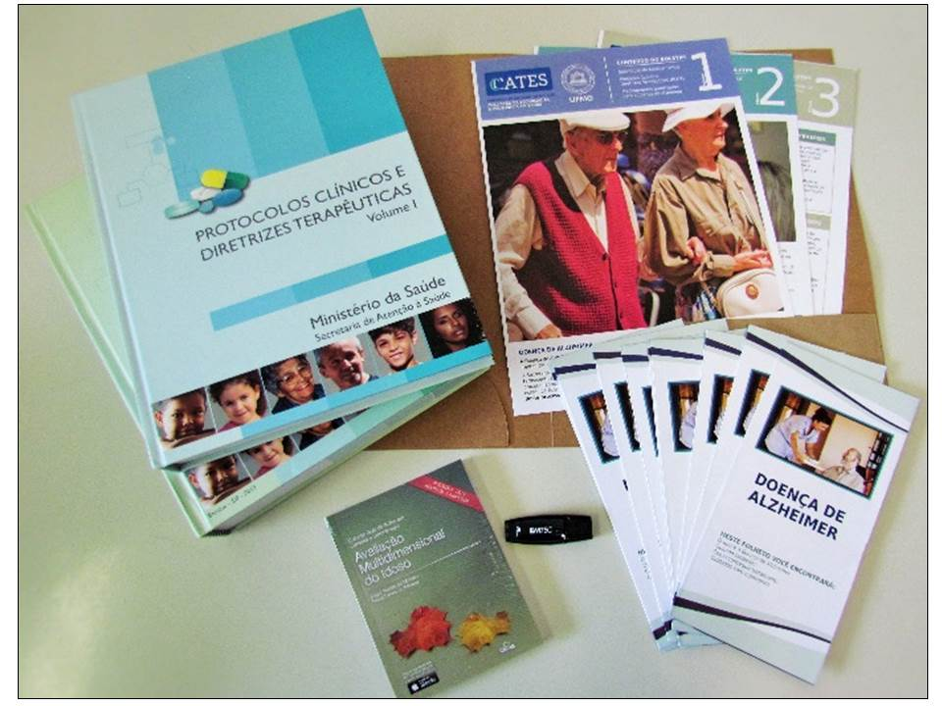
Step 5: Selecting participants. The sample was randomly selected from a database of all physicians that requested on at least three occasions medicines for the treatment of Alzheimer’s disease through the CEAF during the year prior to the study. The prescribers included psychiatrists, neurologists, geriatricians and general practitioners.
Step 6: Recruiting and training facilitators (academic detailers). Eight pharmacists with experiences in SUS and in evidence-based medicine concepts were recruited and trained as follows: (i) studying the topic in their own time; (ii) learning the principles and techniques of academic detailing; (iii) learning the clinical content of the detailing materials; and (iv) simulating the visit. In total, the training took an average of 12 hours. At the end of the training, each facilitator received a name card, a badge, the support materials and a list of prescribers to be visited. This contained details of their specialty, working address and telephone number.
Step 7: Conducting the educational outreach visits. Before the visit, the facilitators checked the prescriber address and availability. Once the academic detailier was at the prescriber’s office, he/she presented him/herself to the assistant and waited until the prescriber was able to receive him/her. Each academic detailer took a notebook with a standardized form to collect data from the visit and a space to write any observations. 37 (65%) physicians were visited. The duration of the visits depended on the receptivity and availability of the prescriber. All detailers carried out at least two visits for each prescriber. It took two months for all academic detailers to visit all prescribers.
Step 8: Conducting a satisfaction survey. All prescribers provided a personal telephone number so the team could subsequently conduct a satisfaction survey about the visit. A different team to that of the academic detailers was responsible for conducting the telephone survey so prescribers could be comfortable in informing their perception regarding the acceptability, relevance and the quality of the academic detailing received. The questionnaire used is shown in Figure 2.
Figure 2 – Questionnaire used to follow-up each visit
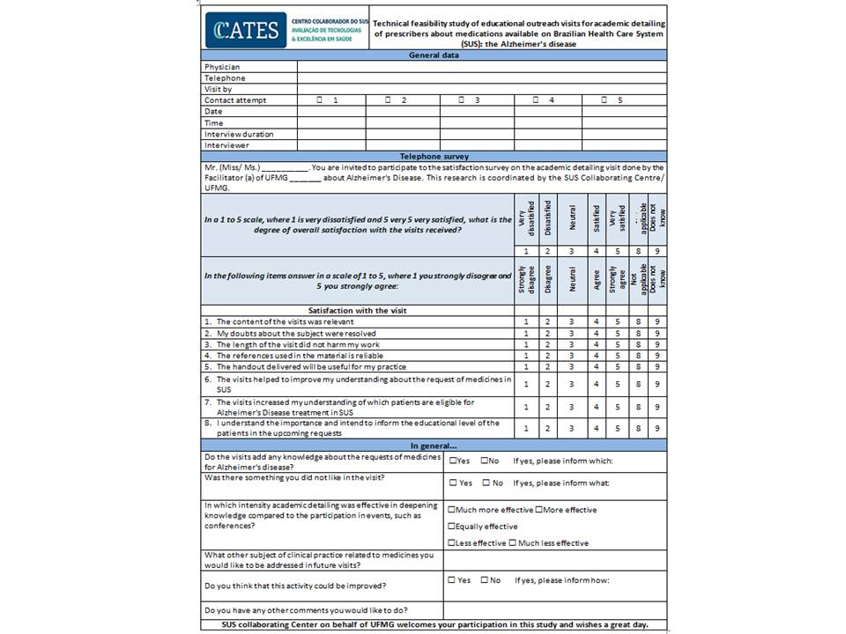
Step 9: Evaluating the results. As mentioned, the results are currently being evaluated in terms of satisfaction, feasibility and efficacy in line with other studies undertaken to assess the influence and impact of academic detailing (38). To date, the satisfaction survey has been conducted with 29 physicians. 86.2% reported the maximum level of overall satisfaction with the visit. Similar results were obtained for the relevance of the content of the visits (93.1%), resolution of the doubts (72.4%), length of each visit (89.6%), bibliography reliability (96.5%), usefulness of the materials to their clinical practice (82.8%), improvement in the understanding of the SUS requests of drugs (75.9%) and a better understanding of the inclusion criteria for Alzheimer´s treatments to be reimbursed (55.2%). Recognition of the importance to inform the education level of patients after the visit was of 82.7%.
DISCUSSION
We can find in the literature many strategies aiming to translate the growing body of knowledge into regular practice by prescribers, including evidence-based guidelines, continuing medical education conferences, academic detailing, opinion leaders giving advice, audit and feedback, pay-for-performance, and computer-based reminder systems. These strategies help to close gaps in knowledge due to lack of information independent from commercial influence, limited efforts by physicians to actively implement evidence-based information, limited comprehensibility of the guidelines especially if physicians are expected to know and follow multiple guidelines, as well as potentially biased activities from pharmaceutical companies (12, 13,16, 39,40).
The development of treatment guidelines, based on explicit assessments of the evidence base, has been a strategy of the Ministry of Health to improve the care provided to Brazilian citizens. However, there are still challenges regarding their implementation and the extent of their compliance.
Studies have reported reasons why prescribers do not follow guideline recommendations. These can be related to the information presented or its usefulness, e.g. doubts about scientific grounds for the key recommendations and the applicability of trial data to particular patients, or overly complex algorithm for diagnosis/treatment. They can also be related to the prescriber, e.g. resistance to a proactive preventive approach and efforts to motivate patients to change their lifestyles as well as specific biases and attitudes of general practitioners. Barriers can also relate to the preferences of patients or be related to organizational difficulties, e.g. the absence of a computerized system, effect of time pressures and financial considerations making the subject a low priority, and the absence of an educational mentor (38,41).
Detecting obstacles to the CPTG implementation is essential in order to develop methods and solutions, and can be done through a “diagnostic analysis” of the target group before initiating the implementation of the guideline (38). Most accepted guidelines are the ones “owned and operated” by the profession itself, i.e., when the target group participates in the construction, dissemination and implementation (38). Other strategies include disseminating the guideline in pertinent scientific journals or in professional networks (38) and the use of software that facilitates diagnosis of a disease and promotes easy access to protocols and criteria, thereby increasing the response to the guideline among prescribers (41). Academic detailing, audit and feedback activities can be used to identify the need for a review of current guidelines and to improve/adapt them to local realities (29).
A considerable body of evidence indicates that academic detailing can change healthcare practitioner behaviors. However, the overall evidence is heterogeneous in terms of study designs, populations studied, target actions and implementation strategies (20). It is reasonable to conclude that academic detailing is one of the approaches with better results, especially when used as part of a multifaceted intervention.
As seen, initial feedback is positive and we expect this to continue. However, we need to wait until all the findings have been analysed, including all the costs involved coupled with the outcomes, before we can make more definitive statements. As soon as these are evaluated, we will publish the findings and make all the materials used available online to other researchers, prescribers and the public in general. We acknowledge that our study is confined to one locality in Brazil. However, we believe the robustness of our approach, including building on International experiences, should mean that our results can translate into other disease areas and other localities in Brazil.
The main difference among the ongoing Brazilian academic detailing pilot programme and international experiences is that we are targeting specialists, not general practitioners. In addition, in Australia and Canada, when a physician participates in educational outreach visits they earn credits for their Continuing Medical Education (CME), so although incentivized, they participate voluntarily. In Brazil, there is no obligation of CME; consequently, the prescriber’s perception about the need of the visit is restricted to the usefulness of the information and materials received to their clinical practice. However, increased knowledge should result in less rejections for authorizing treatments under the CEAF scheme, which should benefit all key stakeholder groups.
CONCLUSION
The successful experience internationally coupled with our comprehensive approach suggests that academic detailing could represent an effective intervention. Consequently, we believe this strategy is worthwhile as a proposal aiming to improve patients’ access to appropriate medicines in CEAF through the implementation and dissemination of Clinical Protocols and Therapeutic Guidelines in Brazil. We look forward to demonstrating this in practice, building on early positive feedback. As a result, we believe we need to further develop academic detailing in Brazil to improve the quality of care of patients using trained pharmacists.

Acknowledgments
To SUS Collaborating Centre for Technology Assessment and Excellence in Health and Secretariat of State of Health of Minas Gerais members for the availability of data and team involvement.

Financing and conflicts of interest

This study was funded by the Department of Management and Incorporation of Health Technologies of the Ministry of Health of Brazil, through the Pan American Health Organization (BR / LOA / 1400015) and the Institutional Program of Newly Doctors Research Grants of the Federal University of Minas Gerais (01/2013).

The write-up was in part supported by a Newton Advanced Fellowship awarded to Professor Augusto Afonso Guerra Junior by the Academy of Medical Sciences, through the UK Government's Newton Fund programme.

The authors have no other conflicts of interest to declare.

REFERENCES
1. Brasil. Lei nº 8.080, de 19 de setembro de 1990: Dispõe sobre as condições para a promoção, proteção e recuperação da saúde, a organização eo funcionamento dos serviços correspondentes e dá outras providências. Diário Oficial da união. 1990;128(182).
2. Portaria no 221 de 01 de abril de 2002. Aprova a Diretrizes Clínicas e Protocolos Terapêuticos de Medicamentos Excepcionais e de Alto Custo no SUS. Transplantes Renais. , (2002).
3. Godman B, Acurcio F, Guerra Junior AA, Alvarez-Madrazo S, Faridah Aryani MY. Initiatives among authorities to improve the quality and efficiency of prescribing and the implication s. J Pharma Care Health Sys. 2014;1(3):1-15.
4. Francke AL, Smit MC, de Veer AJ, Mistiaen P. Factors influencing the implementation of clinical guidelines for health care professionals: a systematic meta-review. BMC medical informatics and decision making. 2008;8:38.
5. Grol R, Grimshaw J. From best evidence to best practice: effective implementation of change in patients' care. Lancet. 2003;362(9391):1225-30.
6. Holloway KA. Combating inappropriate use of medicines. Expert review of clinical pharmacology. 2011;4(3):335-48.
7. Bjorkhem-Bergman L, Andersen-Karlsson E, Laing R, Diogene E, Melien O, Jirlow M, et al. Interface management of pharmacotherapy. Joint hospital and primary care drug recommendations. European journal of clinical pharmacology. 2013;69 Suppl 1:73-8.
8. Neuman J, Korenstein D, Ross JS, Keyhani S. Prevalence of financial conflicts of interest among panel members producing clinical practice guidelines in Canada and United States: cross sectional study. BMJ (Clinical research ed). 2011;343:d5621.
9. Sermet C, Andrieu V, Godman B, Van Ganse E, Haycox A, Reynier JP. Ongoing pharmaceutical reforms in France: implications for key stakeholder groups. Applied health economics and health policy. 2010;8(1):7-24.
10. Godman B, Bucsics A, Burkhardt T, Haycox A, Seyfried H, Wieninger P. Insight into recent reforms and initiatives in Austria: implications for key stakeholders. Expert review of pharmacoeconomics & outcomes research. 2008;8(4):357-71.
11. The Pew Charitable Trusts. Persuading the Prescribers: Pharmaceutical Industry Marketing and its Influence on Physicians and Patients http://www.pewtrusts.org/en/research-and-analysis/fact-sheets/2013/11/11/persuading-the-prescribers-pharmaceutical-industry-marketing-and-its-influence-on-physicians-and-patients: 2013
12. Civaner M. Sale strategies of pharmaceutical companies in a "pharmerging" country: the problems will not improve if the gaps remain. Health policy. 2012;106(3):225-32.
13. Spurling GK, Mansfield PR, Montgomery BD, Lexchin J, Doust J, Othman N, et al. Information from pharmaceutical companies and the quality, quantity, and cost of physicians' prescribing: a systematic review. PLoS medicine. 2010;7(10):e1000352.
14. Brkicic LS, Godman B, Voncina L, Sovic S, Relja M. Initiatives to improve prescribing efficiency for drugs to treat Parkinson's disease in Croatia: influence and future directions. Expert review of pharmacoeconomics & outcomes research. 2012;12(3):373-84.
15. Roehr B. Drug companies will have to report all payments to US doctors from March 2014. BMJ. 2013;346:f826.
16. Yu SY, Yang BM, Kim JH. New anti-rebate legislation in South Korea. Applied health economics and health policy. 2013;11(4):311-8.
17. Davis DA, Taylor-Vaisey A. Translating guidelines into practice. A systematic review of theoretic concepts, practical experience and research evidence in the adoption of clinical practice guidelines. CMAJ. 1997;157(4):408-16.
18. Soumerai SB, Avorn J. Principles of educational outreach ('academic detailing') to improve clinical decision making. JAMA. 1990;263(4):549-56.
19. O'Brien MA, Rogers S, Jamtvedt G, Oxman AD, Odgaard-Jensen J, Kristoffersen DT, et al. Educational outreach visits: effects on professional practice and health care outcomes. Cochrane Database Syst Rev. 2007(4):CD000409.
20. Grimshaw JM, Thomas RE, MacLennan G, Fraser C, Ramsay CR, Vale L, et al. Effectiveness and efficiency of guideline dissemination and implementation strategies. Health Technol Assess. 2004;8(6):iii-iv, 1-72.
21. Lomas J. Beyond the sound of one hand clapping: a discussion document on improving health research dissemination and uptake. Sydney: NSW Health Department. Research and Development Centre. 1997.
22. Bloom BS. Effects of continuing medical education on improving physician clinical care and patient health: a review of systematic reviews. Int J Technol Assess Health Care. 2005;21(3):380-5.
23. Barton S. Using clinical evidence. BMJ. 2001;322(7285):503-4.
24. Godman B, Shrank W, Andersen M, Berg C, Bishop I, Burkhardt T, et al. Comparing policies to enhance prescribing efficiency in Europe through increasing generic utilization: changes seen and global implications. Expert review of pharmacoeconomics & outcomes research. 2010;10(6):707-22.
25. Moon J, Godman B, Petzold M, Alvarez-Madrazo S, Bennett K, Bishop I, Bucsics A, Hesse U, Martin A, Simoens S, Zara C, Malmstrom RE. Different initiatives across Europe to enhance losartan utilisation post generics: impact and implications Frontiers in pharmacology. 2014;5(Article 219):1-10.
26. Petersen R. Guia da Clínica Mayo sobre mal de Alzheimer. Rio de Janeiro: Anima. 2006.
27. Brookmeyer R, Johnson E, Ziegler-Graham K, Arrighi HM. Forecasting the global burden of Alzheimer’s disease. Alzheimer's & Dementia. 2007;3(3):186-91.
28. Thomas RE, Lorenzetti DL. Interventions to increase influenza vaccination rates of those 60 years and older in the community. Cochrane Database Syst Rev. 2014;7:CD005188.
29. Barbui C, Girlanda F, Ay E, Cipriani A, Becker T, Koesters M. Implementation of treatment guidelines for specialist mental health care. Cochrane Database Syst Rev. 2014;1:CD009780.
30. Kahn SR, Morrison DR, Cohen JM, Emed J, Tagalakis V, Roussin A, et al. Interventions for implementation of thromboprophylaxis in hospitalized medical and surgical patients at risk for venous thromboembolism. Cochrane Database Syst Rev. 2013;7:CD008201.
31. Silva JM, Stein AT, Schünemann HJ, Bordin R, Kuchenbecker R, de Lourdes Drachler M. Academic detailing and adherence to guidelines for Group B streptococci prenatal screening: a randomized controlled trial. BMC Pregnancy Childbirth. 2013;13:68.
32. Gustafsson LL, Wettermark B, Godman B, Andersen-Karlsson E, Bergman U, Hasselstrom J, et al. The 'wise list'- a comprehensive concept to select, communicate and achieve adherence to recommendations of essential drugs in ambulatory care in Stockholm. Basic & clinical pharmacology & toxicology. 2011;108(4):224-33.
33. Weekes LM, Mackson JM, Fitzgerald M, Phillips SR. National Prescribing Service: creating an implementation arm for national medicines policy. Br J Clin Pharmacol. 2005;59(1):112-6.
34. Dartnell J, Heaney A, Kaye K, Zuo Y. NPS MedicineWise: a national approach to
improving the quality of use of medicines. J Bras Econ Saúde. 2015;7((Suppl.1)):3-5.
35. Jin M, Naumann T, Regier L, Bugden S, Allen M, Salach L, et al. A brief overview of academic detailing in Canada: Another role for pharmacists. Can Pharm J (Ott). 2012;145(3):142-6.e2.
36. Maclure M, Allen M, Bacovsky R, Bugden S, Lopatka H, MacNair K, et al. Show me the evidence: best practices for using educational visits to promote evidence-based prescribing. Victoria, BC: Canadian Academic Detailing Collaboration and Drug Policy Futures. 2006.
37. Almeida-Brasil CC, Costa JdO, Guerra Júnior AA, Acurcio FdA, Moraes EN, Álvares J. Compliance with clinical protocol and therapeutic guidelines on prescribing acetylcholinesterase inhibitors for treatment of Alzheimer’s disease in Minas Gerais, Brazil. J Bras Econ Saúde; 2015. p. 16.
38. Grol R. Successes and failures in the implementation of evidence-based guidelines for clinical practice. Med Care. 2001;39(8 Suppl 2):II46-54.
39. Davis C, Abraham J. Is there a cure for corporate crime in the drug industry? Bmj. 2013;346:f755.
40. Abraham J. Pharmaceuticalization of Society in Context: Theoretical, Empirical and Health Dimensions. Sociology 2010;44:603-22.
41. Cranney M, Warren E, Barton S, Gardner K, Walley T. Why do GPs not implement evidence-based guidelines? A descriptive study. Family Practice. 2001;18(4):359-63.

National Resource Center for Academic Detailing (NaRCAD). About Academic Detailing. [cited 2015 Jan 22]. Available from: http://www.narcad.org/about/aboutad/
Institute for Health Metrics and Evaluation. Global Burden of Disease.http://vizhub.healthdata.org/gbd-compare/

