17q21 gene variance and the risk of exacerbations in asthmatic children treated with inhaled corticosteroids: a meta-analysis in the PiCA consortium

Farzan N ^{1,2}, Vijverberg SJ^{1,2}, Burchard EG³, Canino G⁴, Celedón JC⁵, Cloutier MM⁶, Forno E⁵, Hawcutt DB^{7,8}, Kabesch M^{9,10}, Karimi L¹¹, Melén E^{12,13}, Mukhopadhyay S^{14,15}, Nilsson S^{12,13}, Palmer CN¹⁵, Pino-Yanes M^{16,17}, Pirmohamed M¹⁸, Potočnik U^{19,20}, Raaijmakers JA¹, Repnik K^{19,20}, Schieck M^{9,10}, Smyth RL²¹, Soares P¹⁴, Tantisira KG^{22,23}, Turner S²⁴, Verhamme KM¹¹, Maitland-van der Zee AH^{1,2}
¹Division of Pharmacoepidemiology and Clinical Pharmacology, Faculty of Science, Utrecht University, Utrecht, Netherlands, ² Department of Respiratory Medicine, Academic Medical Center (AMC). University of Amsterdam, Amsterdam, the Netherlands, ³Departments of Medicine, Bioengineering and Therapeutic Sciences University of California, San Francisco, USA, ⁴Behavioral Sciences institute, University of Puerto Rico, Medical Sciences Campus, San Juan, Puerto Rico, ⁵Division of Pulmonary Medicine, Allergy, and Immunology, Children’s Hospital of Pittsburgh of the University of Pittsburgh Medical Center, University of Pittsburgh, Pittsburgh, Pennsylvania, ⁶University of Connecticut Health Center, Asthma Center, Connecticut Children's Medical Center, Connecticut, United States of America, ⁷Department of Women's and Children's Health, University of Liverpool, Liverpool, UK, ⁸Alder Hey Children's Hospital, Liverpool, UK, ⁹Dept. of Pediatric Pneumology and Allergy, University Children's Hospital Regensburg (KUNO), Regensburg, Germany, ¹⁰Dept. of Pediatric Pneumology, Allergy and Neonatology, Hannover Medical School, Hannover, Germany. Member of the German Lung Research Center (DZL),¹¹Dept. of Medical Informatics, Erasmus University Medical Center, Rotterdam, the Netherlands. ¹²Institute of Environmental Medicine, Karolinska Institutet, Stockholm, Sweden, ¹³Centre of Occupational and Environmental Medicine, Stockholm County Council, Stockholm, Sweden, ¹⁴Academic Department of Paediatrics, Brighton and Sussex Medical School, Royal Alexandra Children's Hospital, Brighton, United Kingdom, ¹⁵Population Pharmacogenetics Group, Biomedical Research Institute, Ninewells Hospital and Medical School, University of Dundee, Dundee, United Kingdom, ¹⁶CIBER de Enfermedades Respiratorias, Instituto de Salud Carlos III, Madrid, Spain, ¹⁷Research Unit, Hospital Universitario N.S. de Candelaria, Santa Cruz de Tenerife, Spain, ¹⁸Department of Molecular and Clinical Pharmacology, Institute of Translational Medicine, University of Liverpool, Liverpool, United Kingdom, ¹⁹Centre for Human Molecular Genetics and Pharmacogenomics, Faculty of Medicine, University of Maribor, Maribor, Slovenia, ²⁰Faculty for Chemistry and Chemical Engineering, University of Maribor, Maribor, Slovenia, ²¹Institute of Child Health, University College London, London, United Kingdom, ²²The Channing Division of Network Medicine, Dept. of Medicine, Brigham and Women’s hospital and Harvard Medical School, Boston, United States of America, ²³Division of Pulmonary and Critical Care Medicine, Brigham and Women's Hospital and Harvard Medical School, Boston, MA, United States of America, ²⁴Child Health, University of Aberdeen, Aberdeen, United Kingdom.

Abstract
Background:17q21 gene variants are the strongest known genetic determinants for early onset childhood asthma, but have also been associated with uncontrolled asthma despite asthma treatment.
Aim: To assess the association between a variant in the 17q21 locus (rs7216389) and asthma exacerbations despite the use of inhaled corticosteroids (ICS) in asthmatic children and young adults.
Methods: We meta-analyzed the association between the 17q21 locus (rs7216389) and exacerbations in 4,156 children and young adults with reported ICS use in twelve studies participating in the global Pharmacogenomics of Childhood Asthma (PiCA) consortium. The following studies were included: BAMSE (n=122, Sweden), BREATHE (n=806, Scotland, UK), CAMP (n=172, USA), eSTATE (n=102, the Netherlands), GALA II (n=745, USA), HPR (n=123, USA), MAGICS (n=155, Germany), PACMAN (n= 530, the Netherlands), PAGES (n=354, Scotland, UK), PASS (n=390, UK), SAGE II (n=468, USA) and SLOVENIA (n=199, Slovenia). Two outcome measures were studied: hospitalization/emergency room (ER) visits (available in 12 studies, n= 4,156 patients) and oral corticosteroid (OCS) use (available in 9 studies, n=3,512 patients) in the last 6 or 12 months of the study or first year of the trial. Meta-analyses with random effects were performed using an additive genetic model adjusted for age, gender and British Thoracic Society (BTS) treatment steps.
Results: The variant in the 17q21 locus was statistically significantly associated with an increased risk of OCS use (OR per increase in variant allele= 1.19, 95%CI: 1.02-1.39, p=0.03) (fig 1). The SNP was not statistically significantly associated hospitalization / ER visits, even though the summary effect estimate pointed in the same direction (OR per increase in variant allele= 1.17, 95%CI: 0.96- 1.42).
Conclusion: The findings suggest that variation in the 17q21 locus contributes to a higher risk of exacerbations despite the use of ICS in children and young adults.

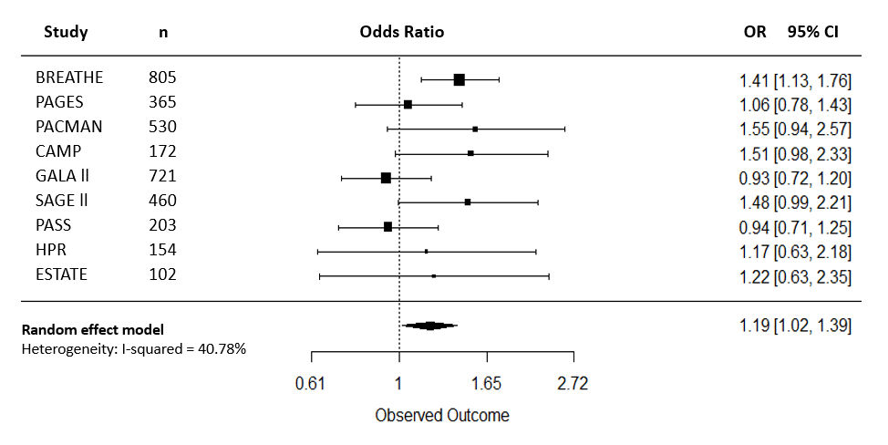
Figure 1. Forest Plot of rs7216389 for OCS use in all studies. Odds Ratios (OR) and corresponding 95% Confidence Intervals (95% CI) for individuals with rs7216389, controlling for age, sex and BTS treatment step.

