Measures to enhance ARB prescribing efficiency in Belgium following generic losartan: impact and implications for the future

**Steven Simoensª, Kristien De Bruyn^{b}, Jamilette Miranda^{c}, Marion Bennie^{de}, Rickard E Malmström^{f}; Brian Godman^{ghi}
ªDepartment of Pharmaceutical and Pharmacological Sciences, KU Leuven, Herestraat 49, O & N 2, 3000 Leuven, Belgium. Email: steven.simoens@pharm.kuleuven.be
^{b}Centre for Statistics, Belgian Pharmaceutical Society, Brussels, Belgium. Email: kristien.debruyn@apb.be
^{c}Department of Healthcare Development, Public Healthcare Services Committee Administration, Stockholm County Council, Stockholm, Sweden. Email: jamilette.miranda-tellez@sll.se
^{d}Strathclyde Institute for Pharmacy and Biomedical Sciences, University of Strathclyde, Glasgow, United Kingdom. Email: marion.bennie@strath.ac.uk
^{e}Information Services Division, NHS National Services Scotland, Edinburgh, United Kingdom, EH12 9EB. Email: m.bennie@nhs.net
^{f}Department of Medicine, Clinical Pharmacology Unit, Karolinska Institutet, Karolinska University Hospital Solna, SE-17176, Stockholm, Sweden. Email: Rickard.Malmstrom@ki.se
^{g}Department of Laboratory Medicine, Division of Clinical Pharmacology, Karolinska Institutet, Karolinska University Hospital Huddinge, Stockholm, SE-141 86 Sweden. Tel number: 00468 585 81068; Fax: 0468 585 810 70. Email: Brian.Godman@ki.se
^{h}Institute for Pharmacological Research ‘Mario Negri’, Via Giuseppe La Masa 19, 20156 Milan, Italy. Telephone +3902 39014314, Fax +39 02 3546277 Email: godman@marionegri.it
^{i}Prescribing Research Group, University of Liverpool Management School, Chatham Street, Liverpool, UK

*Corresponding author

Key words: Pharmaceuticals, Belgium, ARBs, losartan, generics, drug utilisation, reforms

(Acceptance in the Journal of Pharmaceutical Health Services Research – Please keep CONFIDENTIAL)
Abstract

Objective:
Compare the utilisation of losartan before and after the availability of generics in Belgium and its inclusion in the reference price system, which changed its reimbursement status. Determine the impact of reforms on expenditure/ DDD for losartan and overall reimbursed expenditure for the ARBs.
Methods:
Interrupted time series analysis of monthly reimbursed prescriptions for all patients in Belgium covered by the social health insurance system prescribed an ARB alone or in combination between January 2007 and August 2011, i.e. 42 months before generic losartan was included in the reference price system (July 2010) to 13 months after.
Results:
Significant increase in losartan utilisation following its change in reimbursement status whilst all other ARBs still required prior approval for reimbursement. Losartan utilisation increased from 18% of all single ARBs on an MAT DDD basis just before the inclusion of losartan in the reference price system to 24% on a MAT basis 12 months after this. During this period, total ARB utilisation increased by 1%. Consequently, representing both new and switched patients. Reimbursed expenditure for losartan decreased 40% 12 months after its inclusion in the reference price system despite a 22% increase in utilisation. Total ARB expenditure reduced by 15% during this period.
Conclusion:
The reforms including altering the prescribing regulations for losartan significantly enhanced its utilisation, reduced its expenditure/ DDD as well as reduced overall ARB expenditure in Belgium. No further measures are suggested for Belgium with more ARBs losing or about to lose their patents. There has been no change in the utilisation patterns of losartan in countries following generic availability where no specific demand-side measures. These findings confirm that multiple measures are needed to change physician prescribing patterns.

Introduction

Scrutiny over pharmaceutical expenditure has increased in recent years in Europe. This has been driven by well known factors including ageing populations, rising patient expectations, and the continued launch of new premium priced products [1-5]. As a result, pharmaceutical expenditure is now the largest or equal to the largest cost component in ambulatory care [1-4]. European countries have typically instigated multiple measures to curb growth rates, or even reduce pharmaceutical expenditure, to maintain the European ideals of comprehensive and equitable healthcare [1-17]. Policies for existing drugs incorporate both supply- and demand-side measures. Supply-side measures include initiatives to lower the cost of generics [1-3, 6-13, 15]. Demand-side measures include reforms and initiatives to enhance the utilisation of generics versus originators as well as patented products in a class or related classes. Measures include prescribing guidance, benchmarking of prescribing habits, compulsory International Non-Proprietary Name (INN) prescribing, physician prescribing targets, financial incentives, generic substitution and prescribing restrictions [1-3,6-17]. However, their number and intensity varies appreciably among European countries leading to considerable differences in overall prescribing efficiency [5,6,8,13-16].

Belgium is no exception. The principal supply side measure to lower the cost of generics and originators once multiple sources are available is the reference price system [10-12,18.19]. Under this system, patients have to pay an additional co-payment to cover any additional cost for their preferred product over and above the reference price for the molecule if this occurs. In addition, generic drugs have to lower their prices at least to the level of the reference price to be reimbursed (16% reduction versus pre-patent loss prices until 2002, 20% until 2003, 26% until 2005, and currently 31%). Consequently, the system in Belgium is currently an internal reference pricing system based on the molecule. Typically the manufacturers of originators lower their prices to the reference price to compete by avoiding any additional co-payment for the patient. This especially as the price reductions are modest compared to other European countries and generic substitution is currently not allowed in Belgium when originators are prescribed [20]. As a result, there tends to be higher prices for generics in Belgium than other European countries, a concentration of prices for generics and originators around the reference price, as well as an appreciable proportion of originators still being dispensed even after multiple sourced products are available [11,19-22].

Details of current demand-side policies in Belgium have already been described [10,18]. They have principally been targeted at physicians. They include their participation in local quality meetings, provision of guidelines, encouragement of INN prescribing, as well as monitoring of their prescribing of low cost medicines against agreed targets [10-12,18,23]. Low-cost medicines are defined as generics prescribed by INN or originator medicines whose prices have dropped to the current reference price for the molecule [10,18]. Initiatives also include prescribing restrictions, which mirrors the situation in other European countries [5,6,8,14,24]. There are few incentives for pharmacists to dispense generic medicines [22].

The prescribing of angiotensin receptor blockers (ARBs) has been a target for health authority and health insurance company activities across Europe as both ACEIs and ARBs appear equally effective in treating patients with hypertension and heart failure [8,14,25-29]. However, there are considerable price differences once generic ACEIs become available. In addition, a dry cough with ACEIs only occurs in a minority of patients [8,30,31], although greater in patients with heart failure with higher doses. Authority activities include prescribing guidance, benchmarking, prescribing targets for ACEIs, financial incentives and prescribing restrictions limiting ARB prescribing to patients intolerant to ACEIs [2,8,14,17,26,31,32]. Care is not compromised with a recent ecological study showing similar reductions in blood pressure among patients with hypertension prescribed formulary drugs including generic ACEIs versus non-formulary drugs including patented ARBs [33]. In Belgium, expenditure on single ARBs in February 2010, i.e. just before generic losartan, was €10.24m, 57% of total expenditure on single renin-angiotensin inhibitor drugs.

Recently, generic losartan became available across Europe. All ARBs are seen as equally effective in lowering blood pressure [34,35]. Consequently, the National Institute for Health and Clinical Excellence (NICE) in the UK recently stated that patients with hypertension can be started on either an ACEI or a low cost ARB [36]. Alongside this, there have been no head to head trials showing any difference in effectiveness between the various ARBs when treating heart failure [34]. In addition, higher doses of losartan were not associated with increased mortality versus candersartan in patients with heart failure, although this is different for lower doses [37]. Patients in the UK have also been successfully switched between ARBs without compromising care [34,38]. Greater care though may be needed when switching patients with heart failure between different ARBs [39,40].

In Belgium, generic losartan entered the market in March 2010 and was included in the reference price system in July 2010. Following its inclusion in the reference price system, the status of losartan changed from a ‘chapter IV’ medicine to a ‘chapter I’ medicine. A chapter IV medicine can only be prescribed subject to prior approval from the advising physician of the patient’s health insurance fund. Otherwise a 100% patient co-payment applies. A chapter I medicine can be prescribed without restrictions. This loosening of prescription conditions for losartan followed an agreement between the National Institute for Health and Disability Insurance and the originator company, with the originator company dropping its price to the level of the reference price in return for a switch from chapter IV to chapter I. Generic versions of losartan were priced at or below the reference price and were also subsequently included in chapter I. The other ARBs remained in chapter IV.

We would expect to see a significant increase in the utilisation of losartan, and a corresponding decrease in the utilisation of the other ARBs, following the removal of the prescribing restrictions for losartan. This would be the mirror image of the influence of prescribing restrictions on subsequent utilisation patterns that have been seen with renin-angiotensin inhibitor drugs in other European countries and other classes [5,6,8,14,25,26]. Consequently, the principal objective of this paper is to compare the utilisation of losartan before and after its inclusion in the reference price system to see if this expectation is realised. Secondly, examine the impact of the various reforms on expenditure/ DDD for losartan following its inclusion in the reference pricing system and overall reimbursed expenditure for the ARBs. Thirdly, suggest additional reforms if needed that could further enhance ARB prescribing efficiency in Belgium with all ARBs seen as essentially similar.

Methodology

We used an interrupted time series design to analyze monthly reimbursed prescriptions for all patients in Belgium covered by the social health insurance system prescribed at least one ARB alone or in combination (C09CA01 to 09, C09DA01 to 05, C09DX01 to 03) [41] between January 2007 and August 2011, i.e. 42 months before losartan was included in the reference price system in July 2010 to 13 months after its availability. The data source was Pharmanet, a database of reimbursed medicines prescribed by general practitioners in Belgium. This database is maintained by the National Institute for Health and Disability Insurance and covers the whole Belgian population.

We are confident that we can undertake this type of analysis as the reimbursement of the first generic losartans, their inclusion in the reference price scheme, and the shifting of the classification of losartan from Chapter IV to Chapter I took place concurrently for all versions of losartan.

Utilisation was measured in terms of Defined Daily Dose, with DDDs defined as ‘the average maintenance dose of a drug when used in its major indication in adults’, with this measure recognised as the international standard to assess utilisation patterns within and between countries [42]. 2011 DDDs were used in line with international guidance [42-44]. The WHO methodology used to calculate the DDDs for the combination products. This was based on the principle of counting the combination as one dose [42].

Serial autocorrelations of losartan prescription items were assessed with an ARIMA model using a Box-Jenkins-Tiao strategy [45]. Items dispensed were plotted over time in months. The graphs were visually inspected to assess the trends or the nonstationarity of the data. Alongside this, a segmented regression analysis of the interrupted time series was used to assess the effect of the lifting of prescribing restrictions for losartan and its inclusion in the reference price system from July 2010. Common segmented regression models were used to fit a least-squares regression line to each segment of the independent variable (time t) assuming a linear relationship between time and the outcome within each segment. The effect of the intervention (reimbursed items for losartan) was assessed with using the model: Y_{t} = β₀ + β₁ (time_{t = 0, 1, 2, …, 24}) + β₂ (intervention 1t) + β₃ (time after intervention 1 t) + β₄ β₂ (intervention 2 t) + β₅ ₍time after intervention 2 t)+ e_{t}, where Y_{t} was losartan’s DDDs per month t, time is a continuous variable indicating time (in months) at time t from the start until the end of the observation period, intervention is an indicator variable for time t occurring before (t = 0 month) or after (t = 1 month) the inclusion of losartan in the reference price system, and e_{t} is the error term at time t [46]. The time after the intervention (months) is a continuous variable that counts the number of months after the intervention at time t, coded time 0 before the intervention (July 2010) and after the cap. The Durbin-Watson statistic was calculated to test for a serial autocorrelation of the error terms in the regression models [47]. The statistical package IBM SPSS Statistics version 19.0 was used for all analyses. A P value of <0.05 was considered significant [48].

Reimbursed expenditure for the single ARBs was measured on a monthly basis during the study period. It was also measured on a MAT basis for the 12 months before the availability of generic losartan, and its inclusion in the reference price system, to the end of the study period. Reimbursed expenditure per DDD was computed for losartan over time to assess the extent of price reductions following the inclusion of losartan in the reference price scheme.

One of the co-authors (BBG) undertook a narrative review of ongoing supply- and demand-side measures based on published studies coupled with the knowledge of the co-authors. This approach has been successfully used in previous publications [5-9,13-15].

Results

There was a significant increase in the utilisation of losartan following the change in its reimbursement status (Chapter IV to Chapter I) after the availability of generic losartan and the decreased price of the originator (Figures 1 and 2, Table 1). There was also a corresponding decrease in the utilisation of other ARBs.

Figure 1 – Monthly utilisation of losartan versus other single ARBs (DDD basis) January 2007 to August 2011

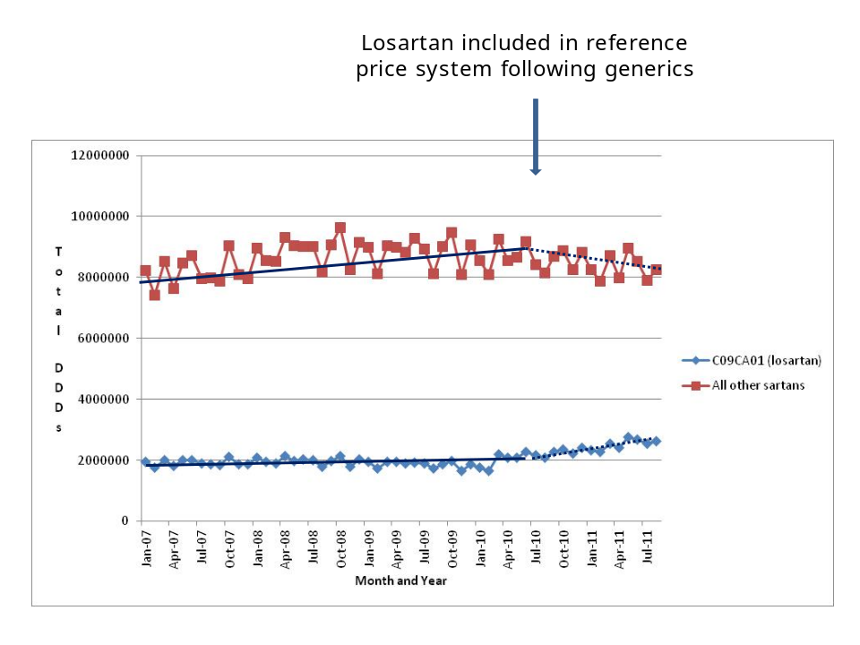
Table 1 - Parameter estimates, standard errors and P-values from the segmented regression model predicting the extent of losartan DDDs before and after losartan included in the reference price system (Coeficientª variable is losartan items dispensed)
Coefficientsª
Model |  | Unstandardized Coefficients |  | Standardized Coefficients | t | Sig. | 95.0% Confidence Interval for B
 |  | B | Std. Error | Beta | t | Sig. | Lower Bound | Upper Bound
1 | (Constant) | 1924149.718 | 42198.942 |  | 45.597 | .000 | 1839471.346 | 2008828.091
1 | Time | 465.335 | 1709.753 | .029 | .272 | .787 | -2965.537 | 3896.206
1 | Reimbursement | 149908.624 | 86060.060 | .253 | 1.742 | .087 | -22783.521 | 322600.770
1 | Time after reimbursement | 41301.926 | 9067.027 | .616 | 4.555 | .000 | 23107.605 | 59496.247
a. Dependent Variable: Losartan items dispensed

Figure 2 – Change in utilization patterns for losartan (DDDs) over time before and after inclusion in the reference price systm

Before and after change in losartan DDDs dispensed
Losartan utilisation increased from 18% of all single ARBs on an MAT DDD basis just before losartan was included in the reference price system to 24% on a MAT basis 12 months after this. During this period, there was a 3% reduction in the utilisation of other ARBs on a DDD basis, with total ARB utilisation increasing by 1%.

Utilisation of ARB combinations steadily increased from 27% of all ARB utilisation on a DDD basis in January 2007 to 36% in mid 2010. After this, utilisation patterns stabilised. Utilisation of losartan fixed dose combinations (FDCs) as a % of total ARB combinations declined from 24% in January 2007 to 17% in July 2009, with utilisation patterns stabilising after this even after the availability of generic losartan.

There was an immediate reduction in reimbursed expenditure for both losartan and the other ARBs combined following the inclusion of losartan in the reference price scheme in July 2010 (Figure 3). The reduction in expenditure for the other ARBs mirrored their reduced utilisation (Figure 1).

Figure 3 – Reimbursed total expenditure for losartan and other single ARBs (Euros) January 2007 to August 2011
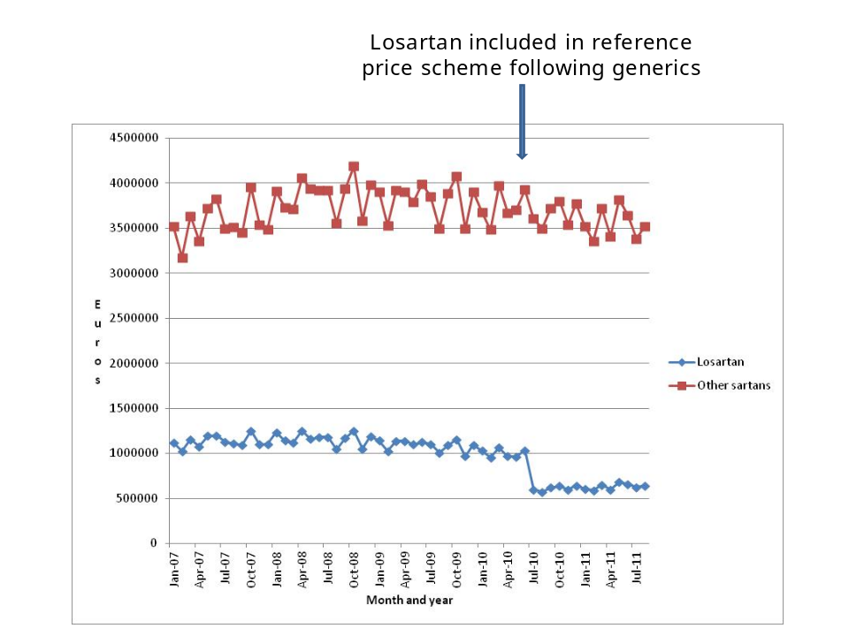

There was a 40% reduction in reimbursed expenditure for losartan on a MAT basis 12 months after the introduction of generic losartan and its inclusion in the reference pricing system (Table 2). This was despite a 22% increase in its utilisation during this period (Figure 1). As a result, reimbursed expenditure for the ARBs decreased by 12% on a MAT basis 12 months after the inclusion of losartan in the reference price system versus total expenditure prior to this (Table 2). The contribution of losartan decreased from 22% of total ARB expenditure just prior to generic losartan availability to 15% one year later (Table 2).

Table 2 – MAT reimbursed expenditure for losartan and other ARBs before and after generic losartan and its inclusion in the reference price scheme (Euros)

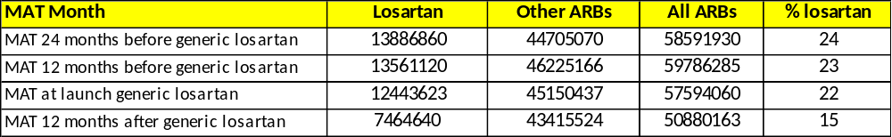

The reduction in reimbursed expenditure for losartan (Table 2) following its inclusion in the reference pricing system was helped by a 46% reduction in expenditure/ DDD for losartan by the end of the study period. Expenditure/ DDD was €0.244 compared with a pre-patent loss price of €0.454/ DDD in June 2010. This was assisted by the manufacturer of originator losartan decreasing its price as part of the agreement from moving from Chapter IV to Chapter I status.

Reimbursed expenditure/ 1000 inhabitants/ year for total ARB utilisation increased from €5314 in 2007 to €5473 in 2009, i.e. full year before the availability of generic losartan. Reimbursed expenditure/ 1000 inhabitants/ year subsequently fell to €4646 in the first 12 months following the inclusion of losartan in the reference price scheme, i.e. a 15% reduction.

Discussion

As envisaged, there was a significant increase in the utilisation of losartan following its change in reimbursement status versus other ARBs, and a corresponding reduction in the utilisation of the other ARBs. It is expected this increasing use of generic ARBs will continue given the current trend lines (Figures 1 and 2, Table 1). It is believed this increase in utilisation of losartan includes both new patients as well as patients switched from other ARBs to losartan to decrease patient co-payments (currently 25%). This is because the number of losartan DDDs increased by over 8.6million per year scaling up the last 4 months, which equates to greater than 24,000 patients, and the number of DDDs for the other ARBs combined decreased by nearly 3.5million. This equates to a fall of approximately 10,000 patients or more. Consequently, also potentially including patients initiated on losartan rather than and ACEI. However, it is difficult to confirm these hypotheses and patient numbers without access to specific patient data.
This change in the utilisation pattern for losartan following its change in reimbursement status mirrored the findings in Austria [49-51]. In Austria, prescribing restrictions were removed for losartan but not the other patented ARBs following the availability of generic losartan [49-51]. Multiple demand-side measures introduced in one English region also appreciably increased the utilisation of losartan versus other ARBs following the availability of generic losartan [50,51]. Prior to this, there had been no change the utilisation pattern for losartan following the availability of generic losartan when no active measures [50]. Similarly, no changes in the losartan utilisation following generic availability were observed in other countries and regions that had not introduced any specific demand-side measures to enhance the prescribing of losartan [50]. This included Scotland and Catalonia in Spain [50]. These findings confirm previous studies that multiple measures are needed to influence physician prescribing habits [5-9, 52,53]. Consequently, authorities cannot rely on the transfer of learnings from one class to another to change physician behaviour even when the classes are closely related such as ACEIs and ARBs. As a result, no Hawthorne effect [54-56]. The Hawthorne effect in studies relates to the confounding that occurs if experimenters fail to realise how the consequences of a given subject’s performance in one area may affect activities in another area [57]

As a result of the ongoing measures, there was an appreciable increase in ARB prescribing efficiency in Belgium following the availability of generic losartan and its inclusion in the reference pricing system. This is because all ARBs are seen as equally effective for hypertension and heart failure [34,35]. This is demonstrated by a 1% increase in the utilisation of ARBs one year after the availability of generic losartan (Table 2) but a 12% reduction in expenditure. This decrease in expenditure was helped by a 46% reduction in expenditure/ DDD for losartan by the end of the study period compared with originator pre-patent loss prices.

Reimbursed expenditure/ DDD for losartan fell in line with expectations, with a greater reduction in expenditure/ DDD for the generics with the necessity for these to be priced lower than the originator (31% lower) for reimbursement and utilisation. There are though greater reductions in the price of generic losartan and other generics versus pre-patent loss prices in countries that appreciably encourage the utilisation of generics alongside potentially reference pricing [24,25,49,51,58-62]. In Austria, the third generic has to be 60% below pre-patent loss prices to be reimbursed with market forces after that to encourage further price reductions [24,25,49,51]. However, patients to do not have to cover the additional costs themselves for a more expensive molecule than the current lowest priced branded generic [2,24,25]. Substantial price reductions for generics are seen in the Netherlands with its preference pricing policies, including additional co-payments for more expensive molecules, and other demand-side measures [51,58]. Low prices for generics are also seen in Sweden with compulsory generic substitution along with other demand-side measures including additional co-payments for a more expensive molecule than the generic [7,51,59]. Low prices for generics are also seen in the UK with its high INN prescribing rates and transparency in the pricing of generics [8,51,59,60]. In view of this, reference pricing on its own is not always sufficient to obtain low prices of generics. Other measures are also needed. Recent research has also shown that countries with small populations such as Lithuania and the Republic of Srpska can obtain low prices for generics through multiple measures [51,61,62]. Consequently, population size is not a barrier to obtaining low prices for generics.

There was appreciable utilisation of ARB FDCs in Belgium. This may reflect the fact that drugs for hypertension can be prescribed alone or combined to achieve the desired therapeutic effect, and increasingly combining therapies may be seen as preferable to increasing doses of single agents alone [63-65]. However, there is still ongoing controversy surrounding whether there is improved compliance in practice with FDCs compared with combining single agents. In addition, FDCs negate the ability of physicians to further titrate single agents and have different choices for diuretics if needed [66-69]. As a result, the utilisation of FDCs can be as low as 2% of total utilisation of renin-angiotensin inhibitor drugs (DDD basis) in some countries, e.g. Scotland [8]. Consequently, further research is needed to ascertain the rationale behind the high use of FDCs in Belgium and whether this leads to improved health gain in practice.

There appears to be no need for any additional demand-side measures to further enhance the prescribing of multiple sourced ARBs in Belgium as a number of ARBs have recently lost their patents, e.g. valsartan in April 2012, or about to lose their patent. As a result, further decreasing the costs of ARBs in Belgium under the reference pricing system.

Conclusion

The change in the reimbursement status for losartan (Chapter IV to Chapter I) led to its significantly increased use compared with other ARBs. This coupled with the pricing policies for generics and originators enhanced ARB prescribing efficiency in Belgium, with all ARBs seen as essentially similar. The Belgian experience provides an example to other health authorities and health insurance agencies as they assess potential additional reforms that could be introduced in their countries if needed to further enhance prescribing efficiency. ARB prescribing efficiency is likely to be further increased in Belgium as more ARBs lose their patents. Finally, the reduction in expenditure/ DDD for losartan mirrored expectations given the current pricing policy for generics in Belgium.

Financial & competing interests disclosure

The work was in part supported by grants from the Karolinska Institutet.

The authors would like to thank André De Swaef for extracting the data from Pharmanet. The authors have no other relevant affiliations or financial involvement with any organization or entity with a financial interest in or financial conflict with the subject matter or materials discussed in the manuscript apart from those discussed.

No writing assistance was utilized in the production of this manuscript.

References

1. Sermet C et al. Ongoing pharmaceutical reforms in France; implications for key stakeholder groups. Applied Health Economics and Health Policy 2010;8:7-24

2. Godman B et al. Insight into recent reforms and initiatives in Austria; implications for key stakeholders. Expert Rev Pharmacoeconomcis Outcomes Research 2008; 8:357-371

3. Wettermark B et al. Recent national and regional drug reforms in Sweden – implications for pharmaceutical companies in Europe. Pharmacoeconomics 2008; 26: 537-50

4. Garattini S et al. Enhancing the rational use of new medicines across European healthcare systems – A Position Paper. Eur Jn Clinical Pharmacology 2008; 64:1137–8

5. Godman B et al. Comparing policies to enhance prescribing efficiency in Europe through increasing generic utilisation: changes seen and global implications. Expert Rev. Pharmacoeconomics Outcomes Res 2010; 10: 707–22

6. Godman B et al. Policies to enhance prescribing efficiency in Europe: findings and future implications. Frontiers Pharmacol. 2011; 1 (141): 1-16 doi: 10.3389/fphar.2010.00141

7. Godman B et al. Multifaceted national and regional drug reforms and initiatives in ambulatory care in Sweden; global relevance. Expert Rev Pharmacoeconomcis Outcomes Research 2009; 9:65-83

8. Vončina L et al. Influence of demand side measures to enhance renin-angiotensin prescribing efficiency in Europe; implications for the future. Expert Rev Pharmacoeconomics and Outcomes Res 2011; 11: 469-79

9. Bennie M et al. Multiple initiatives continue to enhance the prescribing efficiency for the proton pump inhibitors and statins in Scotland. Expert Review Pharmacoeconomics and Outcomes Research 2012; 12: 125-130

10. Dylst P et al. Where a cheap medicine is not the same as a generic medicine: the Belgian case. JPHSR 2011; 2:185-99

11. Dylst P et al. The impact of reference pricing systems in Europe: a literature reviews and case studies. Expert Rev Pharmacoeconomics and Outcomes Research 2011; 11:729-737

12. Simoens S. A review of generic medicine pricing in Europe. GaBI 2012; 1:8-12

13. Godman B et al. Use of generics – a critical cost containment measure for all healthcare professionals in Europe? Pharmaceuticals 2010; 3:2470-94 doi 10.3390/ph/3082470 ISSN 1424-8247

14. Godman B et al Prescribing restrictions - a necessary strategy among some European countries to enhance future prescribing efficiency? Reviews in Health Care 2012; 3: 5-16

15. Godman B et al. Payers endorse generics to enhance prescribing efficiency; impact and future implications, a case history approach. GABI 2012; 1(2): 21-35

16. Wettermark B et al. Soft regulations in pharmaceutical policymaking - an overview of current approaches and their consequences. Appl. Health Econ Health Policy 2009; 7: 137-47

17. Gustafsson LL et al. The “Wise List”- A comprehensive concept to select, communicate and achieve adherence to recommendations of essential drugs in ambulatory care in Stockholm. Basic & Clinical Pharmacology & Toxicology 2011; 108:224-233

18. Vrijens F et al. Patient socieoeconomic determinants for the choice of the cheapest molecule within a cluster: evidence from Belgian prescription data. Eur J Health Econ. 2012 Jun;13(3):315-25. Epub 2011 Dec 3.

19. Simoens S et al. Pharmaceutical policy regarding generic drugs in Belgium. PharmacoEconomics 2005; 23:755-66.

20. Brekke K, Holmå T. Prices of Pharmaceuticals: A Comparison of Prescription Drug Prices in Sweden with Nine European Countries. SNF REPORT NO. 01/12 Bergen, Norway

21. Simoens S. International comparison of generic prices. Current Medical Research and Opinion. 2007; 23: 2647-54

22. Dylst P, Vulto A, Simoens S. How can pharmacist remuneration systems in Europe contribute to generic medicine dispensing? Pharmacy Practice 2012; 10: 3-8

23. Reglementering van de werking van de LOK [Eng. Regulation of the 'local quality meeting']. 2010; Available from: http://www.riziv.fgov.be/care/nl/doctors/accreditation/peer-review/reglement.htm.

24. Godman B et al. Impact of recent reforms in Austria on utilisation and expenditure of PPIs and lipid lowering drugs; implications for the future. Expert Rev Pharmacoeconomics Outcomes Research 2009; 9:475-484

25. Godman B et al. Initiatives to enhance renin-angiotensin prescribing efficiency in Austria; impact and implications for other countries. Expert Rev Pharmacoeconomics and Outcomes Research 2010;10:199-207

26. Wettermark B et al. Initial effects of a reimbursement restriction to improve the cost-effectiveness of antihypertensive treatment. Health Policy 2010; 94: 221-29

27. Dickstein K et al on behalf of the task force for the Diagnosis and Treatment of acute and chronic heart failure 2008 of the European Society of Cardiology. ESC guidelines for the diagnosis and treatment of acute and chronic heart failure 2008. Eur Heart Jn 2008; 29;2388-2442

28. Gradman A, Papademetriou V. Combined renin-angiotensin-aldosterone system inhibition in patients with chronic heart failure secondary to left ventricular systolic dysfunction. Am Heart Jn 2009; 157: S17-23

29. Mielniczuk L, Stevenson L. Angiotensin-converting enzyme inhibitors and angiotensin II type 1 receptor blockers in the management of congestive heart failure patients: what have we learnt from recent clinical trials. Curr Opin Cardiol 2005; 20:250-5

30. Fletcher A et al. Coughing with angiotensin converting enzyme inhibitors; how much of a problem? J Hypertens 1994; 12: S43-S47

31. NHS. PCT prescribing report (November 2009). Prescribing of angiotensin-converting-enzyme (ACE) inhibitors and angiotensin-II receptor antagonists (AIIRAs) – Prescribing guidance and discussion points. Available via URL: http://www.nhsbsa.nhs.uk/Documents/PPDPCTReports/pctreport_20092.pdf [Accessed 2 April 2012]

32. Office of Fair Trading. Current price inefficiencies and potential benefits of value-based pricing. February 2007. Available via URL: http://www.oft.gov.uk/shared_oft/reports/comp_policy/oft885m.pdf [Accessed 3 April 2012]

33. Norman C e al. Potential savings without compromising the quality of care. Int J Clin Pract 2009: 63:1320–26

34. Moon J et al. Getting better value from the NHS drug budget. BMJ 2011; 342: 30-32

35. Heran BS et al. Blood pressure lowering efficacy of angiotensin receptor blockers for primary hypertension. Cochrane Database Syst Rev 2008(4):CD003822

36. NICE updates its guidance on the management of hypertension. MeReC 10 October 2011. Available via URL: http://www.npc.nhs.uk/rapidreview/?p=4470 [Accessed 3 April 2012]

37. Svanström H et al. Association of treatment with losartan vs. candersartan and mortality among patients with heart failure. JAMA 2012; 307:1506-12

38. Usher-Smith J et al. Evaluation of the clinical outcomes of switching patients from atorvastatin to simvastatin and losartan to candesartan in a primary care setting: 2 years on. Int J Clin Pract 2008; 62: 480-4

39. MeReC. Key Therapeutic Targets; Medicines Management Options for Local Implementation. July 2011. Available via URL: http://www.npc.nhs.uk/qipp/resources/qipp_key_therapeutic_topics_july11_version3.1.v2.pdf [Accessed 3 April 2012]

40. MeReC. February 2012. Key Therapeutic Targets; Medicines Management Options for Local Implementation . Available via URL: http://www.npc.nhs.uk/qipp/resources/Key_therapeutic_topics_Medicines_Management_for_local%20implementation_feb%202012_final.pdf [Accessed 3 April 2012]

41. WHO Collaborating Centre for Drug Statistics Methodology. ATC / DDD index 2011. WHO, Oslo; 2010. Available from: http://www.whocc.no/atc_ddd_index/. [Accessed 5 June 2012]

42. World Health Organization (WHO). Introduction to Drug Utilisation Research. WHO International Working Group for Drug Statistics Methodology, WHO Collaborating Centre for Drug Statistics Methodology, WHO Collaborating Centre for Drug Utilization Research and Clinical Pharmacological Services. ISBN 92 4 156234 X (NLM classification: WB 330) Available via URL: http://www.who.int/medicines/areas/quality_safety/safety_efficacy/Drug%20utilization%20research.pdf [Accessed 5 June 2012].

43. Rønning M et al. Different versions of the anatomical therapeutic chemical classification system and the defined daily dose--are drug utilisation data comparable? Eur J Clin Pharmacol 2000; 56: 723-7

44. Vlahovic-Palcevski V et al. Coping with changes in Defined Daily Dose in longitudinal drug consumption databases. Pharm World Sci 2010; 32:125-9

45. McDowall D et al. Interrupted time series analysis. In: Sage University Papers Series on Quantitative Applications in the Social Sciences 1980 ps 7–021. Thousand Oakes, CA: Sage Publications Inc.

46. Ross-Degnan D et al. Examining product risk in context. Market withdrawal of zomepirac as a case study. Journal of the American Medical Association 1993; 270, 1937–1942.

47. Durbin J, Watson GS. Testing for serial correlation in least square regression. Biometrika 1951; 37, 409–428.

48. Brennan P, Croft P. Interpreting the results of observational research: chance is not such a fine thing. BMJ 1994; 309: 727–730.

49. Buscics A et al. Influence of lifting prescribing restrictions for losartan on subsequent sartan utilisation patterns in Austria; implications for other countries. In Press Expert Review of Pharmacoeconomics and Outcomes Research

50. Godman B, Bennett K, Bennie M, Burkhardt et al. Variable approaches to enhancing the prescribing of losartan once generics available; influence and future direction. Pharmacoepidemiology and Drug Safety; 2012; 21 (Suppl 3): 295

51. Godman B, Bennie M, Baumgärtel C, Sović Brkičić L et al. Essential to increase the use of generics in Europe to maintain comprehensive healthcare? Farmeconomia: Health Economics and Therapeutic Pathways 2012; 13 (Suppl 3):5-20

52. Bero LA, Grilli R, Grimshaw JM et al. Closing the gap between research and practice: an overview of systematic reviews of interventions to promote the implementation of research findings. BMJ 1988; 317:465-8

53. Barton S. Using clinical evidence. BMJ 2001; 322:503-4

54. Holden J. Hawthorne effects and research into clinical practice. Jn Evaluation Clin Practice 2001; 7; 65-70

55. Konstantinou G. Pragmatic trials: how to adjust for the ‘Hawthorne effect’? Thorax 2011;-:1. doi:10.1136/thoraxjnl-2011-200657

56. Verstappen WHJM, Weijden T van der, ter Riet G, Grimshaw J, Winkens R, Grol R. Block design allowed for control of the Hawthorne effect in a randomized controlled trial of test ordering. Journal of Clinical Epidemiology 2004, 57:1119-1123

57. Parsons, H. M. "What happened at Hawthorne?: New evidence suggests the Hawthorne effect resulted from operant reinforcement contingencies". Science 1974; 183 (4128): 922–932.

58. van Woerkom M, Piepenbrink JF, Godman et al. Ongoing measures to enhance the efficiency of prescribing of PPIs and statins in the Netherlands; influence and future implications. Journal of Comparative Effectiveness Research 2012; 1: 527-38

59. Godman B, Abuelkhair M, Vitry A, Abdu S et al. Payers endorse generics to enhance prescribing efficiency; impact and future implications, a case history approach. GABI 2012; 1(2): 21-35

60. McGinn D, Godman B, Lonsdale J, Way R, Wettermark B, Haycox A. Initiatives to enhance the quality and efficiency of statin and PPI prescribing in the UK; impact and implications. Expert Rev Pharmacoeconomics and Outcomes Res 2010; 10: 73-85

61. Garuoliene K, Godman B, Gulbinovič J, Wettermark B, Haycox A. European countries with small populations can obtain low prices for drugs: Lithuania as a case history. Expert Rev. Pharmacoeconomics Outcomes Res 2011; 11: 343-9

62. Markovic-Pekovic V, Ranko Škrbić R, Godman B, Gustafsson LL. Ongoing initiatives in the Republic of Srpska to enhance prescribing efficiency: influence and future directions. Expert Review of Pharmacoecono Outcomes Res 2012; 5: 661-71

63. Mancia G et al. Reappraisal of European guidelines on hypertension management: a European Society of Hypertension Task Force document. J Hypertens 2009; 27:2121-2158

64. Combinatie- of monotherapie voor de behandeling van hypertensive. Minerva 2010; 9(8): 86-87. Available via URL: http://www.minerva-ebm.be/nl/article.asp?id=1950 [Accessed 3 July 2012)

65. Wald DS et al. Combination therapy versus monotherapy in reducing blood pressure: meta-analysis on 11 000 participants from 42 trials. Am J Med 2009;122:290-300

66. Bangalore S et al. Fixed-dose combinations improve medication compliance: a meta analysis. Am J Med 2007; 120:713-719

67. Coma A t al. Policies to enhance the efficiency of prescribing in the Spanish Catalan Region: impact and future direction. Exp Review of Pharmacoeconomics and Outcomes Research 2009; 9: 569-81

68. Regional Drugs and Therapeutic Centre (NHS). Fixed-dose combinations (Part 2) -Use in specific medical conditions. October 2008. Available via URL: http://www.nyrdtc.nhs.uk/docs/dud/DU_62_Fixed-Dose_Combinations_(2).pdf [accessed 23 June 2012]

69. ACCF/AHA 2011 Expert Consensus Document on Hypertension in the Elderly - A Report of the American College of Cardiology Foundation Task Force on Clinical Expert Consensus Documents.
Developed in Collaboration With the American Academy of Neurology, American Geriatrics Society,
American Society for Preventive Cardiology, American Society of Hypertension, American Society of Nephrology, Association of Black Cardiologists, and European Society of Hypertension. Available via URL: http://content.onlinejacc.org/cgi/content/full/57/20/2037 [Accessed 20 May 2012]

