Original Research Article

Changes in the utilisation of venlafaxine after the introduction of generics in Sweden

Brian Godman BSc PhD^{1,2,3}*, Marie Persson MSc Pharm⁴, Jamilette Miranda MD PhD⁵, Peter Skiöld MSc⁶, Björn Wettermark MScPharm PhD1^{,7}, Corrado Barbui MD PhD⁸, Lars L Gustafsson MD PhD¹

²Strathclyde Institute of Pharmacy and Biomedical Sciences, Strathclyde University, Glasgow, UK; ³Liverpool Health Economics Centre, University of Liverpooll, Chatham Street, Liverpool, UK. ¹Department of Laboratory Medicine, Division of Clinical Pharmacology, Karolinska Institutet, Karolinska University Hospital Huddinge, SE-141 86, Stockholm, Sweden. Email: Brian.Godman@ki.se and lars-l.gustafsson@ki.se. Telephone: 0046 8 585 81068. Fax: 0046 8 585 81070
⁴Drug Management Department, Stockholm County Council, Stockholm, Sweden. Email: marie.e.persson@sll.se
⁵Department of Healthcare Development, Public Healthcare Services Committee Administration, Stockholm County Council, Stockholm, Sweden. Email: jamilette.miranda-tellez@sll.se
⁶Dental and Pharmaceuticals Benefits Agency (TLV), PO Box 22520, Flemingatan 7, SE-104, Stockholm, Sweden. Email: peter.skiold@tlv.se
⁷Centre for Pharmacoepidemilogy, Karolinska Institutet, Karolinska University Hospital Solna, SE-17176, Stockholm, Sweden. Email: Bjorn.Wettermark@ki.se
⁸WHO Collaborating Centre for Research and Training in Mental Health and Service Evaluation, Department of Public Health and Community Medicine, Section of Psychiatry, University of Verona, Policlinico G.B. Rossi, Piazzale L.A. Scuro 10, 37134 Verona, Italy. Email: corrado.barbui@univr.it

*Author for correspondence

Running title: Generic venlafaxine in Sweden

(Accepted for publication in Applied Health Economics and Health Policy. Please keep CONFIDENTIAL)

Abstract

Background: There has been an appreciable increase in the prescribing efficiency of the proton pump inhibitors, statins and renin-angiotensin inhibitor drugs in Sweden in recent years. This has been achieved through multiple reforms encouraging the prescribing of generics at low prices versus patented drugs in the class or related class. Generic venlafaxine is also an opportunity to save costs given the prevalence of depression. However, depression is more complex to treat with physicians reluctant to change prescriptions if patients are responding to a particular antidepressant. Objectives: Assess (a) changes in the utilisation pattern of venlafaxine versus other newer anti-depressants before and after the availability of generic venlafaxine and before and after the initiation of prescribing restrictions for duloxetine limiting its prescribing to refractory patients, (b) utilisation of generic versus originator venlafaxine after its availability, (c) price reductions for generic venlafaxine and the subsequent influence on total expenditure on newer antidepressants over time. Lastly, suggest additional reforms if pertinent to further enhance the prescribing of generic antidepressants. Methodology: Interrupted time series analysing the changes in monthly reimbursed prescriptions using Defined Daily Doses (DDDs) of patients dispensed at least one newer antidepressant from January 2007 to August 2011. DDDs defined as the average maintenance dose of a drug when used in its major indication in adults. This included 19 months after the availability of generic venlafaxine and before initiation of prescribing restrictions for duloxetine to 13 months after prescribing restrictions. Total expenditure and also expenditure/ DDD for venlafaxine measured over time. Results: No appreciable change in the utilisation pattern for venlafaxine after generic availability with no appreciable demand side activities by the regions (counties) to encourage its use. The utilisation of venlafaxine significantly increased after prescribing restrictions for duloxetine. Principally generic venlafaxine was dispensed once available, reaching 99.6% of total venlafaxine (DDD basis) by August 2011. There was an appreciable fall in expenditure for newer antidepressants in Sweden after generic venlafaxine despite increased utilisation, helped by a 90% reduction in expenditure/ DDD for venlafaxine by the end of the study versus pre-patent loss prices. Conclusion: Multiple demand side measures are needed to change physician prescribing habits. Authorities should not rely on a spill over between classes to effect change. Limited influence of prescribing restrictions on the subsequent utilisation of duloxetine reflects the complexity of the disease area. This is exacerbated by heterogeneous indications for duloxetine.

Key points for decision makers

- Authorities cannot rely on a spill over effect between classes to effect changes in physician prescribing habits
- Prescribing restrictions can appreciably influence physician prescribing behaviour even with antidepressants.
- It is likely their influence will be less than seen with prescribing restrictions for the statins and angiotensin receptor blockers with a greater need to tailor of treatment and limited opportunities for therapeutic switching on cost grounds if patients are responding to a particular antidepressant
- Multiple measures led to low prices for generic venlafaxine in Sweden helping to conserve resources

Key words: demand side measures, drug utilisation study, generics, venlafaxine, Sweden

1 Introduction

Pharmaceutical expenditure continues to grow among OECD countries, averaging 50% in real terms between 2000 and 2009^{[1-10]}. As a result, pharmaceutical expenditure is now typically the largest or equalling the largest cost component in ambulatory care^{[1-9,11-15]}. This increase in expenditure will continue unless addressed, driven by well know factors including changing demographics, the continued launch of new premium priced drugs, rising patient expectations and stricter clinical management targets^{[2,5,6-9,11,13,15,16]}.

This has resulted in health authorities and health insurance companies across Europe implementing multiple reforms to slow down, or even reverse this growth, to maintain the European ideals of equitable and comprehensive healthcare^{[1-9,11-15,17-26]}. Sweden is no exception with both national and regional authorities introducing multiple supply- and demand-side measures to enhance prescribing efficiency for both new and established drugs^{[4-9,14,22,27-32]}. Demand-side measures are typically instigated at a regional (County Council) level in Sweden with budgets, including drug budgets, devolved to the Counties^{[4,5,27,28,30]}. The national reimbursement agency (TLV - Pharmaceuticals Benefits Agency - Tandvårds- och läkemedelsförmånsverket) is responsible for reimbursement decisions for new drugs based on their perceived value versus current standards along with the perceived priority of the disease area and level of unmet need^{[4,5,33,34]}. TLV can also instigate prescribing restrictions for both new and established drugs if wished based on their value against current standards^{[4,5,29,32].} However, it is the Counties that introduce the majority of demand-side measures to help them stay within agreed budgets.

Supply-side measures include those to obtain low prices for generics. These include compulsory generic substitution, apart from a minority of situations^{4,5,31]}. TLV has also recently introduced regular monthly auctions for generics^{[14,22]}. Under this system, the manufacturer with the lowest price for a particular generic wins the auction for the molecule. However, the chosen manufacturer must be able to supply the whole market for the entire month. This typically translates into approximately 70% of the total volumes during the month when accounting for an allowed wash out period for pharmacies to de-stock the previous winner of the auction , and almost 80% when crossed prescriptions are excluded)^{[14,22]}. Crossed prescriptions include situations where substitution does not occur for medical reasons. These could include previous tolerance problems with the excipients in the generics compared with the originator or patients having handling problems with different packaging than the originator. In addition, pharmacists currently not stocking the cheapest generic. However, under the regulations this is technically not allowed as a reason for a ‘cross over’, especially with an agreed wash out period.

This is achieved by all pharmacies obligated to offer patients the cheapest molecule (branded generic) currently on the market (ATC Level 5) when there are substitutable generic medicines available^{[14,22]} although as stated, a wash our period is allowed. Physician and patient trust is built into the system with the Medicine Product Agency (MPA) adjudicating beforehand whether a particular molecule is substitutable^{[4,5,31]}. This is reflected by appreciable acceptance of generic substitution by physicians, with few patients requesting the originator once generics are available^{[4,5,31]}.

Examples of demand-side activities instigated nationally and regionally in Sweden to enhance prescribing efficiency for existing drugs include^{[4-9,14,22,27-32,34]}:
- Educational activities such as prescribing guidance contained within the Stockholm County Council the ‘Wise List’ of recommended drugs in ambulatory care. They also include guidelines, routine benchmarking of prescribing habits against colleagues and against agreed guidance, academic detailing and electronic prescribing support systems prompting for instance generic proton pump inhibitors (PPIs), statins and Angiotensin Converting Enzyme Inhibitors (ACEIs) where applicable
- Financial incentive schemes including devolving budgets to physician practices together with guidance on prescribing and penalties for over-budget situations, as well as financial incentives for achieving prescribing targets. In addition, giving hospital clinics financial responsibility for their prescribing costs. Prescribing targets included % of generics vs. patented PPIs and statins, and % ACEIs versus all angiotensin receptor blockers (ARBs) by volume
- Restricting the prescribing of patented statins and angiotensin receptor blockers (ARBs) to second line after generic statins and ACEIs respectively. In addition, compulsory generic substitution

The various initiatives resulted in reimbursed expenditure for PPIs decreasing by 49% between 2001 and 2007 in Sweden despite utilisation increasing by 53% during this period, reimbursed expenditure for statins decreasing by 39% during the same period despite a 3.2 fold increase in their utilisation, and reimbursed expenditure on renin-angiotensin inhibitor drugs similar in 2007 to 2001 despite a nearly doubling of utilisation during this period^{[6,8,9,14,22]}. In view of this, reimbursed expenditure/ 1000 patients/ year for both the PPIs and statins in Sweden in 2007 was approximately 10% of that seen in Ireland with only limited demand-side measures^{[8,9,14,22]}. However, the population in Ireland had greater co-morbidities than seen with the overall population in Sweden^{[8,9,22]}.

Drugs for the management of depression and general anxiety disorders are another high volume prescribing area in ambulatory care^{[3]}. Newer antidepressants, including the dual acting antidepressants venlafaxine and mirtazapine, have also lost their patents during the past decade in Sweden. Venlafaxine and mirtazapine are typically prescribed second line after the Selective Serotonin Re-uptake Inhibitors (SSRIs) with their increased effectiveness over the SSRIs^{[3,35-38]}. However among the newer antidepressants, venlafaxine and mirtazapine are seen as significantly more effective than duloxetine or reboxetine^{[38,39]}. There are also concerns with the antidepressant activity of agomelatine in addition to its effect with increasing liver function parameters^{[40]}.

From December 2008, both generic immediate release (IR) and extended release (ER) formulations of venlafaxine became available in Sweden. ER venlafaxine was launched to reduce possible side-effects associated with immediate release venlafaxine^{[35-37]}. Consequently in theory, there should be an opportunity for the Counties (regions) in Sweden to further conserve resources with the availability of generic venlafaxine alongside generic SSRIs. This as a result of ongoing measures nationally and regionally to lower the prices of generics in Sweden as well as encourage the prescribing of multiple sourced products ahead of patented products in a class or related class^{[4-9,14,22,28,30,31]}. The prescribing of venlafaxine versus other newer antidepressants should be further enhanced with the introduction of prescribing restrictions for duloxetine in July 2010^{[41]}. These restrictions limited the prescribing of duloxetine to patients suffering from depression or general anxiety disorders who have been prescribed at least two other antidepressants and have not reached their treatment goals^{[41]}.

However unlike the PPIs, statins and renin-angiotensin inhibitor drugs, the newer antidepressants should not be considered as a single class as there are differences between them in terms of their effectiveness, side-effects and mechanisms of action^{[38-40]}. A similar situation is seen with the atypical antipsychotic drugs as well as add-on therapies to manage patients with Parkinson’s Disease^{[15,42,43]}. These conditions are seen as more complex to treat than acid-related stomach disorders, hypertension or hypercholesterolemia. In view of this, it is acknowledged that ideally patients should not have their treatment changed on economic grounds if they are responding to a particular antidepressant. This is unlike the situation with treatments for hypertension or hypercholesterolemia where therapeutic substitution has occurred to save costs^{[11,22,44,45]}. In addition, there is a greater need to tailor treatment with antidepressants to improve outcomes. Having said this, there is no reason why physicians should not prescribe a multiple sourced anti-depressant first line when choices are available and appropriate, building on the recent prescribing restrictions for duloxetine in Sweden^{[41]}. This builds on ongoing measures within the regions (Counties) to encourage physicians to preferentially prescribe well established drugs first line, which are typically available as generics and include generic newer anti-depressants^{[4-9,14,22,28,30]}.

2 Objective

Assess (a) the changes in the utilisation of venlafaxine versus other newer anti-depressants before and after the availability of generic venlafaxine formulations as well as before and after the introduction of the prescribing restrictions for duloxetine, (b) changes in the utilisation of generic versus originator venlafaxine once multiple sources became available, (c) price reductions for generic venlafaxine over time and the subsequent influence on total expenditure on newer antidepressants. Finally, suggest potential additional reforms that could be introduced if needed in Sweden nationally or regionally to further enhance the prescribing of generic antidepressants when multiple drug choices are available and appropriate.

3 Methodology

We used an interrupted time series design to analyse the changes in aggregated monthly reimbursed prescriptions of all patients in Sweden contained in the national Swedish Pharmacy Register dispensed at least one newer antidepressant. This included mirtazapine (N06AX11), venlafaxine (N06AX16), reboxetine (N06AX18), duloxetine (N06AX21) and agomelatine (N06AX22)^{[46]}, from January 2007 to August 2011, i.e. 23 months before the availability of generic venlafaxine to 32 months after generic venlafaxine. Desvenlafaxine (N06AX23) was never launched in Sweden. In addition, from December 2008 to July 2010 and July 2010 to August 2011, i.e. 19 months after the availability of generic venlafaxine and before the prescribing restrictions for duloxetine to 13 months after the prescribing restrictions were introduced for duloxetine. We did not include buproprion in our analysis of aggregated data across Sweden since this has been available to treat depression in the US for over 20 years; however, only recently marketed in Sweden for depression following its initial launch for smoking cessation. We also did not include desvenlafaxine (N06AX23) as this was never launched in Sweden.

The Swedish Pharmacy Register covers all patients in Sweden, and is regularly audited to ensure the robustness of the data. Drug utilisation data including aggregated data is readily available to the Counties in Sweden. However more sophisticated analyses, including patient diagnosis and drug sequencing data, requires special approval.

Dispensed items, including the number of tablets and their strengths, were automatically converted to defined daily doses (DDDs) in the register, with DDDs defined as ‘the average maintenance dose of a drug when used in its major indication in adults’^{[47]}. DDDs were used in this study as DDDs are recognised as the international standard to assess utilisation patterns within and between countries^{[46,47]}. 2011 DDDs were used in line with international guidance^{[47-49]}.

The demand-side measures instigated after the availability of generic venlafaxine, but before the prescribing restrictions for duloxetine, as well as after the implementation of prescribing restrictions for duloxetine, were collated under the 4Es; namely Education, Engineering, Economics and Enforcement^{[50]}. These include (building on the initiatives discussed in the background)^{[5-9,27-32,50]}:
- Education, i.e. programmes that influence prescribing such as the distribution of printed guidelines and guidance as well as academic detailing
- Engineering, i.e. organizational or managerial intervention, including prescribing and quality targets
- Economics, i.e. financial incentives and interventions, including devolved budgets to physicians combined with financial incentives, additional co-payments for a more expensive drug than the current reimbursed drug (molecule) and financial incentives for physicians for achieving agreed prescribing targets
- Enforcement, i.e. regulations including those enforced by law such as compulsory generic substitution and prescribing restrictions

A narrative review of the various measures instigated among the counties (regions) in Sweden was undertaken by two of the co-authors (BBG and MP).

Serial autocorrelations of aggregated venlafaxine DDDs was assessed in the interrupted time series design using an ARIMA model and a Box-Jenkins-Tiao strategy^{[51]}. Any demand-side measures instigated by the counties were in direct response to the availability of generic venlafaxine as well as after the introduction of prescribing restrictions for duloxetine. DDDs were plotted over time in months. The graphs were visually inspected to assess the trends or the nonstationarity of the data.

Alongside this, a segmented regression analysis of the interrupted time series was used to assess the effects of the reimbursement of generic venlafaxine and any demand-side measures instigated both after the availability of generic venlafaxine as well as after the instigation of prescribing restrictions for duloxetine. Common segmented regression models were used to fit a least-squares regression line to each segment of the independent variable (time t), assuming a linear relationship between time and the outcome within each segment. The effect of the interventions (generic venlafaxine initially and after the prescribing restrictions for duloxetine) were assessed using the model: Y_{t} = β₀ + β₁ (time_{t = 0, 1, 2, …,69}) + β₂ (intervention 1t) + β₃ (time after intervention 1 t) + β₄ (intervention 2 t) + β₅ ₍time after intervention 2 t)+ e_{t}, where Y_{t} was venlafaxine DDDs per month t, time is a continuous variable indicating time (in months) at time t from the start until the end of the two observation periods, intervention is an indicator variable for time t occurring before (t = 0 month) or after (t = 1 month) the reimbursement of generic venlafaxine and after prescribing restrictions for duloxetine, and e_{t} is the error term at time t^{[52]}.. The Durbin-Watson statistic was calculated to test for a serial autocorrelation of the error terms in the regression models^{[53]}. The statistical package IBM SPSS Statistics version 19.0 was used for all analyses. A P value of <0.05 was considered significant^{[54]}.

Total expenditure was calculated each year for venlafaxine and the other antidepressants using expenditure figures for the year. No adjustments were subsequently made for inflation as we wanted to measure the extent of expenditure changes over time, including generic venlafaxine versus pre-patent loss prices, without the influence of inflation. This is in line with previous publications^{[6-9,11-15,18-20]}. In addition, calculate the changes in the prices of originator venlafaxine and generic venlafaxine after generic venlafaxine was reimbursed. Prices were expressed in terms of expenditure/ DDD for the various venlafaxine preparations in Swedish Kroner (SEK). We chose to measure total expenditure rather than reimbursed expenditure as we wanted to assess the extent to which the originator company would reduce its prices to limit patient co-payments once generic venlafaxine became available. In addition, calculate the changes in the prices of originator venlafaxine and generic venlafaxine after generic venlafaxine was reimbursed. We also chose SEK rather than Euros as we wanted to ascertain the level of price reductions without any influence of currency fluctuation rates, especially given the current financial situation with the Euro.

Finally, there was a separate analysis of expenditure on newer patented antidepressants in Stockholm County Council from January 2008 to September 2012. This was undertaken to look more closely at changes in expenditure of the still patented antidepressants in the biggest county in Sweden (just over one fifth of the total population). The objective being to better ascertain, and plan, the need for any additional further demand-side measures on a regional basis if required to further enhance the preferential prescribing of multiple sourced antidepressants. This analysis included escitalopram in recognition of its high expenditure within Stockholm County Council. It also included bupropion with the availability of more recent data than used in the principal study. Again, the Swedish Pharmacy Register was used to derive the figures for Stockholm County Council.

4 Results

There were limited activities among the counties (regions) in Sweden to enhance the prescribing of generic venlafaxine versus patented newer antidepressants when it first became available. Demand-side activities typically just included educational activities, e.g. Stockholm County advocating SSRIs first line for the treatment of depression, with venlafaxine and mirtazapine recommended as second line treatment^{[28]}. There were also limited additional demand-side measures among the counties following the implementation of the prescribing restrictions for duloxetine in July 2010. This mainly centred on an analysis of the subsequent prescribing of duloxetine and the other new anti-depressants, with the counties typically just reminding physicians of the prescribing restrictions (Education) where concerns.

There was a 28% increase in the utilisation of newer anti-depressants on an accumulated 6 monthly basis during the study period (Table 1).

Table 1 – Accumulated 6 monthly utilisation of different anti-depressants in DDD millions from January 2007 to August 2011 in Sweden

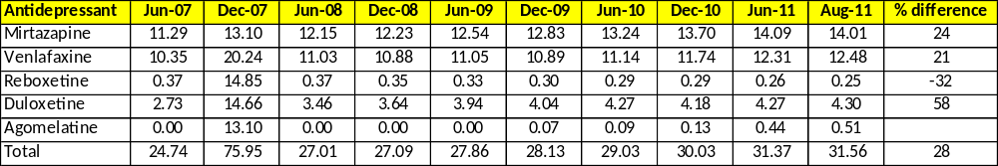
NB % difference refers to % increase in August 2011 vs. June 2007. DDD = Defined Daily Dose

This growth in utilisation of new anti-depressants over time (Table 1) was driven by the growing utilisation of all antidepressants with the exception of reboxetine (Figure 1, Table 1).

Figure 1 – Monthly utilisation of newer anti-depressants from January 2007 to August 2011 in Sweden

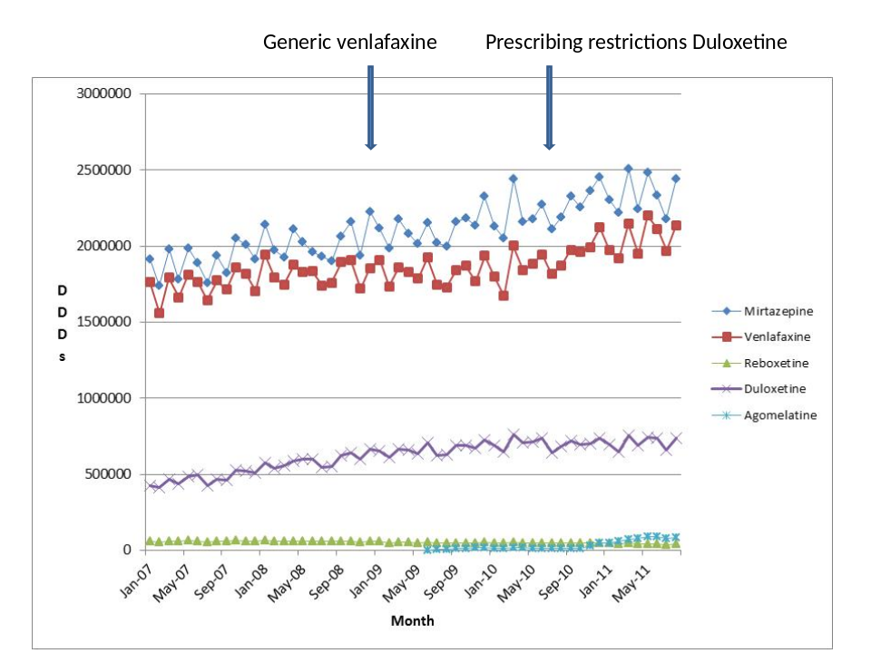
NB: DDDs = Defined Daily Doses

The utilisation of venlafaxine grew significantly after the introduction of the prescribing restrictions for duloxetine (July 2010), which restricted its prescribing to patients suffering from depression or general anxiety disorders who had been prescribed at least two other antidepressants and have not reached their treatment goals, but not after the introduction of generic venlafaxine (December 2008) (Table 2, Figure 2).

Table 2 - Parameter estimates, standard errors and P-values from the segmented regression model predicting the extent of venlafaxine DDDs before and after generic venlafaxine reimbursed and before and after prescribing restrictions for duloxetine (Coefficient variable is venlafaxine DDDs)

Coefficientsª
Model | Unstandardised Coefficients |  | Standardised coefficients | t | Sig | 95% Confidence interval for B
Model | B | Std. Error | Beta | t | Sig | Lower Bound | Upper Bound
Generic venlafaxine | -35461.6 | 53904.0 | -0.133 | -0.658 | -0.514 | -143731.0 | 72807.8
Time after reimbursement of generic venlafaxine | -3068.8 | 4513.8 | -0.261 | -0.68 | -0.50 | -12135.1 | 5997.5
Restriction for duloxetine | 15768.9 | 61759.7 | 0.52 | 0.255 | 0.80 | -108279.1 | 139817.0
Time after restrictions for duloxetine | 14465.6 | 6759.3 | 0.423 | 2.14 | 0.037 | 888.99 | 28042.23

a. Dependent Variable: Venlafaxine items dispensed. Significance (Sig.) <0.05 (only after duloxetine restricted)

Figure 2 – Change in utilization patterns for venlafaxine (DDDs dispensed) over time before and after generic venlafaxine was reimbursed in Sweden and before and after prescribing restrictions for duloxetine
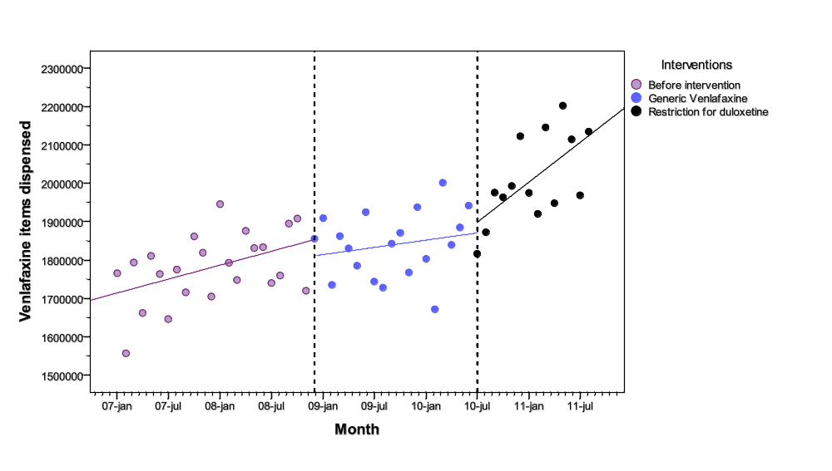
NB. DDDs = Defined Daily Doses

Venlafaxine was principally generic venlafaxine after its availability with limited utilisation of originator venlafaxine by the end of the study period. Utilisation of generic venlafaxine was 99.6% of total venlafaxine (DDD basis) in August 2011 aided by the originator no longer reimbursed (from 1 July 2009).

There was an immediate fall in total expenditure for the newer antidepressants after the availability of generic venlafaxine (Figure 3). Expenditure on the newer antidepressants subsequently stabilised from January 2009 onwards helped by the introduction of prescribing restrictions for duloxetine in July 2010. This was despite the utilisation of the newer antidepressants increasing by 13% from January 2009 until the end of the study (accumulated 3 monthly basis - Figure 1). Overall, 3 monthly expenditure on the newer anti-depressants in August 2011 was 55% below expenditure prior to the availability of generic venlafaxine in January 2009 (Figure 3).

Figure 3 – Total expenditure on newer anti-depressants in Sweden January 2007 to August 2011 (SEK)

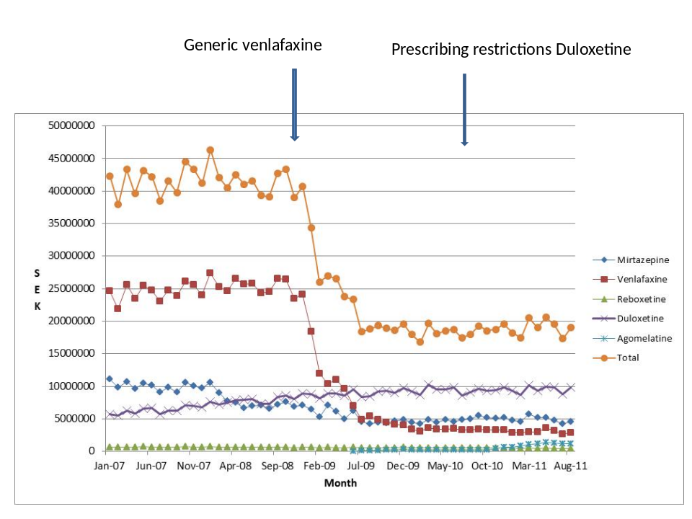

The immediate fall in expenditure for the newer antidepressants was facilitated by the reduction in expenditure/ DDD for venlafaxine once multiple sourced products became available. Expenditure/ DDD for venlafaxine was SEK 1.36 in August 2011, 90% below pre-patent loss expenditure. This was helped by expenditure/ DDD for generic venlafaxine 91% below pre-patent loss prices in August 2011. There was no change in expenditure/ DDD for originator venlafaxine following the availability of generic venlafaxine.

Within Stockholm County Council, there was increasing expenditure on escitalopram, agomelatine and bupropion alongside stable but high expenditure on duloxetine from January 2008 to September 2012 (Figure 4). Expenditure on agomelatine appreciably increased following its inclusion in the reimbursement list from 29th of October 2010.

Figure 4 – Expenditure on patented anti-depressants in Stockholm County Council from January 2008 to September 2012

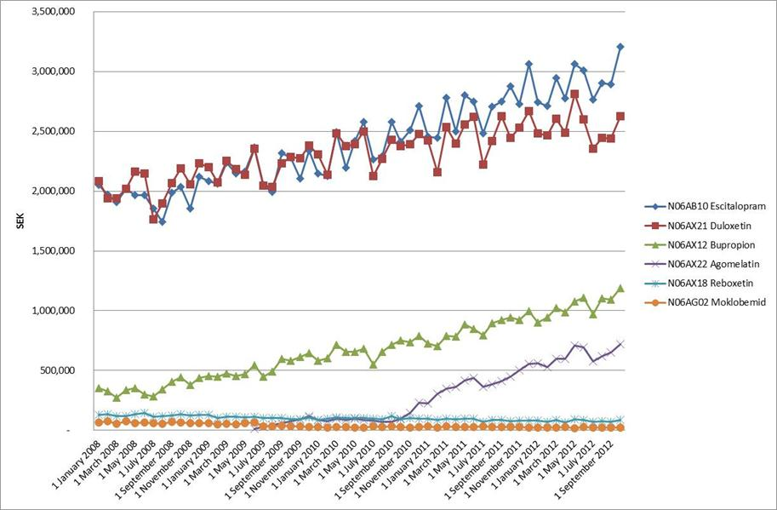

5 Discussion

We believe the lack of change in the utilisation of venlafaxine after the availability of generic venlafaxine (Figures 1 and 2, Table 2), but before the prescribing restrictions were introduced for duloxetine, demonstrates that specific demand-side measures are needed to enhance physician prescribing of multiple sourced antidepressants when several choices are available and suitable. This mirrored the situation in Austria where there were no specific measures from the authorities to preferentially encourage the prescribing of generic venlafaxine. Similarly, no change in its utilisation versus other newer antidepressants following generic availability^{[42,55]}. These findings also mirror the situation seen with atypical antipsychotic drugs among European countries following generic availability. Again, there were no specific measures to encourage the prescribing of multiple sourced antipsychotics first line where suitable and no change in the utilisation patterns of multiple sourced atypical antipsychotic drugs after the availability of generics^{[42,43,56]}.

Consequently, authorities cannot rely on a spill over effect between classes^{[51-54]} to effect changes in physician prescribing habits. This is exacerbated in this situation by the greater complexity in treating patients with depression compared with acid-related stomach disorders, hypercholesterolemia or hypertension. In addition, newer antidepressants cannot be seen as a single class in view of their differences in effectiveness, mechanism of action and side-effect rates^{[38-40]}, as well as inter-patient variability in responses. As a result, there is limited opportunity for therapeutic switching on cost grounds especially if patients are responding to a particular antidepressant. As mentioned, this is unlike the situation with statins and renin-angiotensin inhibitor drugs ^{[11,22,44,45]}.

The utilisation patterns for venlafaxine changed in Sweden following the initiation of prescribing restrictions for duloxetine. After this, there was a significant increase in its utilisation (Figure 2, Table 2). However, there was a more limited influence on the subsequent utilisation of duloxetine (Figure 1). This may be because patients responding to duloxetine continued on duloxetine, and duloxetine was also prescribed in refractory cases. However, we will need access to specific patient data before we can make any definitive statements. This contrasts with the appreciable reduction in the utilisation of patented statins in Austria and Finland following prescribing restrictions, or with the utilisation of ARBs versus ACEIs in Croatia following restrictions to limit ARB prescribing^{[6,11,19,21]}. In all these situations, there was aggressive follow-up of prescribing restrictions by the authorities. This included a prior authorisation scheme in Austria and monitoring of prescriptions in the pharmacy in Finland^{[11,19]}. Without approval by the Chief Medical Office of the patient’s Social Insurance Fund in Austria, or formal authorisation by the Health Insurance Fund in Finland, patients were liable to 100% co-payment^{[11, 19]}. Physician prescribing habits were also closely monitored in Croatia with financial penalties for suspected abuse^{[6,15]}. However, it is recognised that prescribing restrictions are more difficult to apply in patients with mental health problems^{[57,58]} given the need to tailor treatments to the individual to maximise outcomes. This is exacerbated in this situation by the heterogeneous nature of the prescribing indications for duloxetine. Consequently, we believe the significant impact of the prescribing restrictions for duloxetine on the subsequent utilisation of venlafaxine represents a good result. This especially as there was limited impact on subsequent utilisation of generic statins in Sweden with the recent introduction of prescribing restrictions for patented statins in Sweden^{[30]}. However, this may be confounded by a timing issue, with the prescribing restrictions for the statins introduced some six years after aggressive activities by the counties in Sweden to enhance the utilisation of generic versus patented statins^{[5,7-9,14,28]}.

The next stage of the research will involve using patient registers to look more closely at the sequencing of antidepressant prescribing among the various counties in Sweden following the instigation of prescribing restrictions for duloxetine, along with regional demand-side measures. This will exclude patients with diabetes to remove neuropathic pain as a potential indication for the prescribing duloxetine, i.e. no concomitant prescribing of ATC (Anatomical Chemical Therapeutic) A10 drugs^{[46]}. The objective being to ascertain the extent of adherence to the prescribing restrictions in practice among the various counties (regions). Alongside this, the potential rationale if possible and pertinent as to why these were not followed. Subsequently, use the findings to guide future reforms and initiatives among the counties. Further analyses will subsequently look more closely at the continued prescribing of duloxetine to see if this helps explain why there was no observed reduction in its prescribing following the prescribing restrictions.

Future activities in Stockholm County Council will continue to centre on educational activities for duloxetine alongside potential educational activities for agomelatine (Figure 4), especially as there is limited expenditure generally on agomelatine in Sweden (Figure 4) in view of concerns with its effectiveness and safety^{[40]}. There will be less of a focus on escitalopram with generics expected in 2014.

The reduction in expenditure/ DDD for venlafaxine over time is in line with expectations. This mirrors the findings for other high volume generics such as citalopram, omeprazole, losartan, ramipril, sertraline and simvastatin^{[5,14,22,45]}.

The high utilisation of generic versus originator venlafaxine over time is also in line with expectations given the considerable differential in expenditure/ DDD between the two, which would appreciably increase patient co-payment levels^{[5,22,23]} especially once originator venlafaxine was removed from the reimbursement list. The high utilisation of generic venlafaxine (IR and ER) would also suggest no patient problems in practice. This mirrors the findings in Austria^{[42]}. However, specific research will be needed before we can make any definitive statements.

We are aware of several limitations with the study. These include the fact that we have only used aggregated utilisation data in the absence of patient registry data. We also acknowledged that we have not broken down demand-side measures and utilisation data to a County level. We have also not looked specifically at potential compliance issues with patients potentially being dispensed a different branded generic on each occasion. These will be the subject of future research activities.

Never-the-less, we believe these findings and the implications will be of interest to other health authorities and health insurance agencies as they seek ways to further enhance the prescribing of generic drugs where appropriate in more complex disease areas than acid-related stomach disorders, hypercholesterolemia or hypertension.

6 Conclusion

Depression is a complex disease to treat with physicians having limited desire to change prescriptions especially when patients are stable on a particular antidepressant. As a result, specific and tailored measures are needed to encourage the prescribing of generic antidepressants when multiple choices are available and appropriate. Authorities cannot rely on a spill over effect between classes to encourage the prescribing of generic antidepressants first line. Specific measures in this case included prescribing restrictions for duloxetine. The prescribing restrictions helped to significantly increase the utilisation of venlafaxine, which was almost exclusively generic venlafaxine by the end of the study period.

However, expectations of the potential impact of prescribing restrictions on the subsequent utilisation of duloxetine should be tempered by the fact that there is greater tailoring of treatments for depression than for instance treating hypertension with renin-angiotensin inhibitor drugs or hypercholesterolemia with statins. In addition, patients should ideally not be switched between treatments if they are stable on a particular antidepressant. Consequently, prescribing restrictions in this situation are more difficult to enforce especially if no ready access to patient records, exacerbated by the heterogeneous indications for duloxetine. As a result, authorities need to practice care when introducing prescribing restrictions, including potential follow-up, else they may be disappointed in the outcome.

Having said this, the availability of generic venlafaxine helped to appreciably reduce expenditure on newer antidepressants in Sweden overall despite growing utilisation. In addition, there appeared to be no patient problems with generic venlafaxine in practice.

7 Financial disclosure and acknowledgements

BW, MP and JM are employed by Stockholm County Council, Stockholm. The authors have no other conflicts of interest to declare. This work was in part supported by grants from the Karolinska Institutet, Sweden. No writing assistance was provided for this paper.

The authors would like to acknowledge the help of Karl Arnberg (TLV) for his helpful comments especially regarding potential follow-on studies.

7.1 Author contributions

- Brian Godman – Undertook the analysis of utilisation and expenditure data, produced the first draft as well as submission following comments. In addition author guarantor
- Marie Persson – Critiqued the first draft and provided data on expenditure on patented antidepressants in Stockholm County Council
- Jamillete Miranda – Undertook the statistical analysis and critiqued the results
- Peter Skiöld – Provided the rationale behind the study, provided the data on the recent reforms regarding generic prices in Sweden, as well as input on the prescribing restrictions for duloxetine
- Bjorn Wettermark – Provided the rationale behind the study as well as the methodology. In addition, provided the data for Sweden and reviewed the results
- Corrado Barbui – Critiqued early drafts especially with respect to the effectiveness and side-effects of the newer antidepressants
- Lars L Gustafsson – critiqued earlier drafts based on his considerable experience

8 References

- Godman B, Bucsics A, Burkhardt T, Haycox A, Seyfried H, Wieninger P. Insight into recent reforms and initiatives in Austria; implications for key stakeholders. Expert Rev Pharmacoeconomcis Outcomes Research 2008; 8:357-371
- Sermet C, Andrieu V, Godman B, Van Ganse E, Haycox A, Reynier JP. Ongoing pharmaceutical reforms in France; implications for key stakeholder groups. Applied Health Economics and Health Policy 2010;8:7-24
- Coma A, Zara C, Godman B, Augusti A, Diogene E, Wettermark B, Haycox A. Policies to enhance the efficiency of prescribing in the Spanish Catalan Region: impact and future direction. Exp Review of Pharmacoeconomics and Outcomes Research 2009; 9: 569-81
- Wettermark B, Godman B, Andersson K, Gustafsson LL, Haycox A, Bertele’ V. Recent national and regional drug reforms in Sweden – implications for pharmaceutical companies in Europe. Pharmacoeconomics 2008; 26: 537-50
- Godman B, Wettermark B, Hoffman M, Andersson K, Haycox A, Gustafsson LL. Multifaceted national and regional drug reforms and initiatives in ambulatory care in Sweden; global relevance. Expert Rev Pharmacoeconomcis Outcomes Research 2009; 9:65-83
- Vončina L, Strizrep T, Godman B, Bennie M, Bishop I, Campbell S, Vlahovic Palcevski V, Gustafsson LL. Influence of demand side measures to enhance renin-angiotensin prescribing efficiency in Europe; implications for the future. Expert Rev Pharmacoeconomics and Outcomes Res 2011; 11: 469-79
- Godman B, Wettermark B, Bishop I, Burkhardt T, Fürst J et al. European payer initiatives to reduce prescribing costs through use of generics. GABI 2012; 1:22-27
- Godman B, Shrank W, Andersen M, Berg C, Bishop I, Burkhardt T et al. Comparing policies to enhance prescribing efficiency in Europe through increasing generic utilisation: changes seen and global implications. Expert Rev. Pharmacoeconomics Outcomes Res 2010; 10: 707–22
- Godman B, Shrank W, Andersen M, Berg C, Bishop I, Burkhardt T, Garuoliene K et al. Policies to enhance prescribing efficiency in Europe: findings and future implications. Frontiers Pharmacol. 2011; 1 (141): 1-16 doi: 10.3389/fphar.2010.00141
- OECD (2011), "Pharmaceutical expenditure", in OECD, Health at a Glance 2011: OECD Indicators, OECD Publishing. doi: 10.1787/health_glance-2011-63-en Available via URL: http://www.oecd-ilibrary.org/docserver/download/fulltext/8111101ec063.pdf?expires=1343281688&id=id&accname=guest&checksum=4D4F46B30255998AA81601571E18EE8F [Accessed December 2012)
- Godman B, Sakshaug S, Berg C, Wettermark B, Haycox A. Combination of prescribing restrictions and policies to engineer low prices to reduce reimbursement costs. Expert Rev. Pharmacoeconomics Outcomes Res. 2011; 11: 121–9
- Markovic-Pekovic V, Ranko Škrbić R, Godman B, Gustafsson LL. Ongoing initiatives in the Republic of Srpska to enhance prescribing efficiency: influence and future directions. Expert Review of Pharmacoecon Outcomes Res 2012; 5: 661-71
- Garuoliene K, Godman B, Gulbinovič J, Wettermark B, Haycox A. European countries with small populations can obtain low prices for drugs: Lithuania as a case history. Expert Rev. Pharmacoeconomics Outcomes Res 2011; 11: 343-9
- Godman B, Abuelkhair M, Vitry A, Abdu S et al. Payers endorse generics to enhance prescribing efficiency; impact and future implications, a case history approach. GABI 2012; 1(2): 69-93
- Brkičic L, Vončina L, Sovic S, Godman B, Relja M. Initiatives to improve prescribing efficiency for drugs to treat Parkinson’s Disease in Croatia; influence and future directions. Expert Rev Pharmacoeconomics and Outcomes Research 2012; 12:373-84
- Garattini S, Bertele V, Godman B, Haycox A, Wettermark B, Gustafsson LL. Enhancing the rational use of new medicines across European healthcare systems – A Position Paper. Eur Jn Clinical Pharmacology 2008; 64:1137–8
- McGinn D, Godman B, Lonsdale J, Way R, Wettermark B, Haycox A. Initiatives to enhance the quality and efficiency of statin and PPI prescribing in the UK; impact and implications. Expert Rev Pharmacoeconomics and Outcomes Res 2010; 10: 73-85
- Bennie M, Godman B, Bishop I, Campbell S. Multiple initiatives continue to enhance the prescribing efficiency for the proton pump inhibitors and statins in Scotland. Expert Review Pharmacoeconomics and Outcomes Research 2012; 12: 125-130
- Godman B, Burkhardt T, Bucsics A et al. Impact of recent reforms in Austria on utilisation and expenditure of PPIs and lipid lowering drugs; implications for the future. Expert Rev Pharmacoeconomics Outcomes Research 2009; 9:475-484
- Godman B, Schwabe U, Selke G, Wettermark B. Update of recent reforms in Germany to enhance the quality and efficiency of prescribing of proton pump inhibitors and lipid lowering drugs. Pharmacoeconomics 2009; 27: 435-8
- Godman B, Malmstrom RE, Bennie M, Sakshaug S, Burkhardt et al. Prescribing restrictions - a necessary strategy among some European countries to enhance future prescribing efficiency? Reviews in Health Care 2012; 3: 5-16
- Godman B, Bennie M, Baumgärtel C, Sović Brkičić L et al. Essential to increase the use of generics in Europe to maintain comprehensive healthcare? Farmeconomia: Health Economics and Therapeutic Pathways 2012; 13 (Suppl 3):5-20
- Wladysiuk M, Araszkiewicz A, Godman B, Szabert K et al. Patient co-payments do influence atypical antipsychotic choice in Poland; implications once generic atypcials are available. Appl Health Econ Health Policy. 2011; 9: 101-10
- Godman B, Paterson K, Malmstrom R et al. Improving the managed entry of new drugs: sharing experiences across Europe. Expert Review Pharmacoeconomics and Outcomes Res 2012; 12: 439–41
- Fraeyman J, Van Hal G, Godman B, and Beutels Ph. The potential influence of various initiatives to improve prescribing efficiency for proton pump inhibitors (PPIs) and statins in Belgium. The potential influence of various initiatives to improve rational prescribing for proton pump inhibitors and statins in Belgium. Expert Rev Pharmacoecon Outcomes Res. 2013;13: 141-151
- Bucsics A, Godman B, Burkhardt T et al. Influence of lifting prescribing restrictions for losartan on subsequent sartan utilisation patterns in Austria; implications for other countries. Expert Review Pharmacoecon Outcomes Res 2012; 12: 809-19

- Norman C, Zarrinkoub R, Hasselström J, Godman B et al. Potential savings without compromising the quality of care. Int J Clin Pract 2009; 63:1320–26
- Gustafsson LL, Wettermark B, Godman B, Andersén-Karlsson E, Bergman U et al. The “Wise List”- A comprehensive concept to select, communicate and achieve adherence to recommendations of essential drugs in ambulatory care in Stockholm. Basic & Clinical Pharmacology & Toxicology 2011; 108:224-233
- Wettermark B, Godman B, Neovius M, Hedberg N et al. Initial effects of a reimbursement restriction to improve the cost-effectiveness of antihypertensive treatment. Health Policy 2010; 94: 221-29
- Wettermark B, Pehrsson A, Juhasz-Haverinen M, Veg A, Edlert M, Törnwall-Bergendahl G, Almkvist H, Godman B et al. Financial incentives linked to self-assessment of prescribing patterns – a new approach for quality improvement of drug prescribing in primary care. Quality in Primary Care 2009;17:179–89
- Andersson K, Sonesson C, Petzold M, et al. What are the obstacles to generic substitution? An assessment of the behaviour of prescribers, patients and pharmacies during the first year of generic substitution in Sweden. Pharmacoepidemiol Drug Saf. 2005; 14:341-8
- Pettersson B, Hoffmann M, Per Wändell P, Lars-Åke Levin L-A. Utilization and costs of lipid modifying therapies following health technology assessment for the new reimbursement scheme in Sweden. Health Policy 2012; 104: 84-91
- Persson U, Svensson J, Pettersson B. A New Reimbursement System for Innovative Pharmaceuticals Combining Value-Based and Free Market Pricing. Appl Health Econ Health Policy 2012; 10: 217-225
- Godman B, Gustafsson LL. ‘A new reimbursement systems for innovative pharmaceuticals combining value-based and free market pricing’. AHE & P 2013; 11:79–82

- Agüera-Ortiz L, Ramos Garcia I. Effectiveness of venlafaxine extended release and conventional antidepressants in elderly patients with depressive disorder. Actas Esp Psiquiatr. 2006; 34(3):153-61(Article in Spanish with English abstract)
- Yu-Isenberg KS, Fontes CL, Wan GJ et al. Acute and continuation treatment adequacy with venlafaxine extended release compared with fluoxetine. Pharmacotherapy. 2004; 24(1):33-40
- Baldomero EB, Ubago JG, Cercós CL et al. Venlafaxine extended release versus conventional antidepressants in the remission of depressive disorders after previous antidepressant failure: ARGOS study. Depress Anxiety. 2005; 22(2):68-76
- Cipriani A, Furukawa TA, Salanti G, Geddes JR, Higgins JP, Churchill R, Watanabe N, Nakagawa A, Omori IM, McGuire H, Tansella M, Barbui C. Comparative efficacy and acceptability of 12 new-generation antidepressants: a multiple-treatments meta-analysis. Lancet. 2009; 373:746-58
- Parikh S. Antidepressants are not all created equal. Lancet 2009; 373:700-1
- Barbui C, Cipriani A. Agomelatine and the brave old world of narrative-based medicine. Evid Based Mental Health 2012; 15:2-3
- Cymbalta (duloxetine) receives restricted reimbursement. TLV Sweden. Available via URL: TLV decision duloxetine - http://www.tlv.se/Upload/Genomgangen/100615-tlv-interim-decision-cymbalta.pdf [Accessed December 2012]
- Godman B, Buscics A, Burkhardt T et al. Potential to enhance the prescribing of generic drugs in patients with mental health problems in Austria; implications for the future. Frontiers Pharmacol 2012 3:198. doi: 10.3389/fphar.2012.00198
- Bennie M, Bishop I, Godman B, Barbui C et al. Are specific initiatives required to enhance the prescribing of generic atypical antipsychotics in Scotland?; International implications. In Press International Journal of Clinical Practice
- Usher-Smith J, Ramsbottom T, Pearmain H, Kirby M. Evaluation of the clinical outcomes of switching patients from atorvastatin to simvastatin and losartan to candesartan in a primary care setting: 2 years on. Int J Clin Pract 2008; 62,480-4
- Godman B, Wettermark B, Miranda J et al. Influence of multiple initiatives in Sweden to enhance ARB prescribing efficiency following generic losartan; findings and implications for other countries (In Press International Journal of Clinical Practice)

- World Health Organisation (WHO) Guidelines for ATC classification and DDD assignment 2009. Oslo: WHO Collaborating Centre for Drug Statistics Methodology. www.whocc.no [Accessed December 2012]
- World Health Organization (WHO). Introduction to Drug Utilisation Research. WHO International Working Group for Drug Statistics Methodology, WHO Collaborating Centre for Drug Statistics Methodology, WHO Collaborating Centre for Drug Utilization Research and Clinical Pharmacological Services. ISBN 92 4 156234 X (NLM classification: WB 330) Available via URL: http://www.who.int/medicines/areas/quality_safety/safety_efficacy/Drug%20utilization%20research.pdf
- Rønning M, Blix HS, Harbø BT, Strøm H. Different versions of the anatomical therapeutic chemical classification system and the defined daily dose--are drug utilisation data comparable? Eur J Clin Pharmacol 2000; 56, 723-7
- Vlahovic-Palcevski V, Gantumur M, Radosevic N et al. Coping with changes in Defined Daily Dose in longitudinal drug consumption databases. Pharm World Sci 2010; 32:125-9
- Wettermark B, Godman B, Jacobsson B, Haaijer-Ruskamp F. Soft regulations in pharmaceutical policymaking - an overview of current approaches and their consequences. Appl. Health Econ Health Policy 2009; 7: 137-47
- McDowall D et al. Interrupted time series analysis. In: Sage University Papers Series on Quantitative Applications in the Social Sciences 1980 ps 7–021. Thousand Oakes, CA: Sage Publications Inc.
- Ross-Degnan D et al. Examining product risk in context. Market withdrawal of zomepirac as a case study. Journal of the American Medical Association 1993; 270, 1937–1942.
- Durbin J, Watson GS. Testing for serial correlation in least square regression. Biometrika 1951; 37, 409–428
- Brennan P, Croft P. Interpreting the results of observational research: chance is not such a fine thing. BMJ 1994; 309: 727–730.
- Godman B, Schmitzer M, Burkhardt T, Buscics A, Gustafsson LL. Influence of lifting prescribing restrictions for losartan in Austria; implications for other classes. Pharmacoepidemiology and Drug Safety; 2012; 21 (Suppl 3): 295-6
- Godman B, Bennett K, Bennie M, Burkhardt T et al. Are health authorities and health insurance companies taking full advantage of the availability of generic risperidone; implications for the future? Pharmacoepidemiology and Drug Safety; 2012; 21 (Suppl 3): 55-56
- Signorovitch J, Birnbaum H, Ben-Hamadi R et al. Increased olanzapine discontinuation and health care resource utilization following a Medicaid policy change. Journal of ClinicalPsychiatry. 2011; 72(6):787-94
- Soumerai SB, Zhang F, Ross-Degnan D et al. Use of atypical antipsychotic drugs for schizophrenia in Maine Medicaid following a policy change. Health Affairs 2008; 3:w185-w195

