The potential influence of various initiatives to improve rational prescribing for proton pump
inhibitors (PPIs) and statins in Belgium

*Fraeyman J¹, Van Hal G¹, Godman B ^{2,3}, Beutels Ph⁴

¹Epidemiology and Social Medicine, Research group Medical Sociology and Public Health, University of Antwerp, Antwerp, Belgium.
²Institute for Pharmacological Research ‘Mario Negri’, Via Giuseppe La Masa 19, 20156 Milan, Italy
³Department of Laboratory Medicine, Division of Clinical Pharmacology, Karolinska Institutet,
Karolinska University Hospital Huddinge, SE-141 86, Stockholm, Sweden
⁴Centre for Health Economics Research & Modeling Infectious Diseases (CHERMID), Vaccine & Infectious Disease Institute (VAXINFECTIO), University of Antwerp, Antwerp, Belgium.

* Author for correspondence: Fraeyman Jessica, contact details: Tel: + 32 3 265 28 55, Fax: + 32 3 265 28 75, email: jessica.fraeyman@ua.ac.be

(Accepted for publication by Expert Review Pharmacoeconomics and Outcomes Research. Please keep Confidential)

Key words: pharmaceuticals, generics, PPIs, statins, Belgium, reference pricing, demand-side measures; drug utilization studies

Abstract
Background: Proton Pump Inhibitors (PPIs) and statins have been among the top three most prescribed medicines in Belgium for more than a decade. Multiple demand-side measures have been introduced to improve rational prescribing generally as well as for these two classes. Objectives: Firstly, assess the influence of general and specific reforms introduced in Belgium since 1997 on utilization and expenditure of the PPIs and statins. Secondly, suggest additional measures to further improve rational prescribing based on experiences in other European countries. Methods: Retrospective observational study assessing the influence of multiple initiatives in Belgium on utilization and expenditure of the PPIs and statins from 1997 to 2009. Data extracted from the administrative database - Pharmanet. Utilization measured in terms of DDDs and DDDs/ TID (Thousand inhabitants per day). Results: Multiple reforms including co-payments and reference pricing appreciably enhanced rational prescribing for both the PPIs and statins following generic availability. There was an 8-fold increase in PPI utilization between 1997 and 2009 but only 2-fold increase in reimbursed expenditure, helped by decreasing expenditure/ DDD for the PPIs from €1.91 in 1997 to €0.52 in 2009. Similarly, a 20-fold increase in statin utilization between 1997 and 2009 but only a 5-fold increase in reimbursed expenditure, helped again by reimbursed expenditure/ DDD decreasing from €2.05 in 1997 to €0.57 in 2009. Reduced co-payments for larger packs enhanced their prescribing. Conclusion: Multiple reforms influenced utilization patterns and expenditure for the PPIs and statins, as well as the pack sizes dispensed. Additional demand side measures are needed to further enhance rational prescribing, which can build on the experiences in other countries. These can potentially be transferred to other classes.

Introduction

The health care system in Belgium is principally financed through compulsory social security contributions covering the entire population, with contributions dependent on income. Certain groups such as those with low-income and disability also receive privileged insurance status, i.e. lower co-payments. As a result, almost everybody in Belgium enjoys a relatively generous basic health insurance coverage [1, 101]. The National Institute for Health and Disability Insurance (NIHDI) is the federal government institution managing public health insurance in Belgium, with reimbursement of health care consumption organized through seven sickness funds. Every citizen can freely choose between one of the seven sickness funds, with choices often depending on political conviction. Competition between the funds is based on the insurance packages and services they offer, e.g. in relation to childcare, dentistry and homeopathy. Decisions concerning health insurance are made by the NIHDI in close collaboration with key stakeholders including the sickness funds, professional bodies of health care providers and the government.

In 2008, total expenditure on health in Belgium was 10.2% of GDP, with reimbursed expenditure lower at 7.3% [2, 102]. Of this, 16.7% was spent on pharmaceuticals in 2008 and 16.2% in 2009, equating to US$518 PPP (purchasing power parity)/ capita in 2008 [2, 102]. Pharmaceutical expenditure continues to increase, driven by a number of factors including a growing elderly population as well as frequent introductions of new and expensive pharmaceuticals and technologies, mirroring the situation in other European countries [3-6, 102]. Since 1998, the annual growth in health care costs per capita in Belgium has exceeded the OECD average [1, 102].

There is currently no free pricing for pharmaceuticals in Belgium. All pharmaceuticals are subject to regulated pricing by the Ministry of Economic Affairs. In the case of new drugs, the European average price, the relative ‘value’ of the new pharmaceutical product versus existing standards, as well as the requested price are taken into account during the deliberations [7, 101]. The price subsequently set by the Minister of Economic Affairs is the maximum price. Consequently, a new pharmaceutical product can never be marketed at a higher price than this. The actual price finally applied is subject to negotiations following the reimbursement process, overseen by the Commission on Reimbursement of Medicines (CRM). The inception of the CRM provided a formal basis for the application of evidence based medicine criteria, i.e. therapeutic value, clinical effectiveness, safety, cost-effectiveness (only for medicines claimed to have added therapeutic value), and budget-impact, comparable to similar committees in other countries. In Belgium, this Committee has an advisory role only with the final decision concerning reimbursement taken by the Minister of Social Affairs [1, 7, 101].

The total cost for pharmaceuticals consists of a reimbursement fee paid by the national health insurance and a co-payment fee often augmented with a supplement paid for by the patient (and – if applicable – by the patient’s private insurer). The amount of co-payment is dependent on the financial means of the patient and the type of pharmaceutical that is reimbursed. All reimbursed pharmaceuticals are divided into three main categories according to their medical-therapeutic value, with co-payment rates varying by category as well as by the current socio-economic status of the patient (Table 1) [8, 101,103]. The bulk of reimbursed drugs are in Category B, i.e. those medicines for therapeutically important disease areas (Table 1). There is also a maximum reimbursement rate for each category [8, 101] All information on medicines and prices is published on the website www.bcfi.be, which is the national independent drug information center in Belgium [104].

Table 1 – Co-payment rates in Belgium broken down by characteristics [8,101, 103]

Category | Disease area type | Reimbursed rate | Patient co-payment and maximum amount/ prescription
A | Life threatening conditions, e.g. diabetes of cancer | 100% | 0%  Maximum amount – not applicable
B | Therapeutically important disease areas, e.g. drugs for infection and CV diseases | 75% to 85%⁺ | 15%* to 25%  *Maximum amount depending on the package size
C | Typically symptomatic treatments such as PPIs | 50% | 50%  *Maximum amount depending on whether equivalent generic on the same ATC 4 level (drug class)
Cs | Symptomatic treatment including influenza vaccines and anti-histamines | 40% | 60%  No maximum
Cx | Contraceptive medicines | 20% | 80%  No maximum
NB⁺ Refers to preferentially insured people, e.g. widows, orphans, and people receiving disability benefits; ATC: Anatomical Therapeutic Chemical classification

With respect to generics, in January 2002 the Belgian Federal Minister of Social Affairs introduced the reference price system, which set up procedures, terms and conditions for the reimbursement of multiple sourced products with generic alternatives (i.e. same active component – Anatomical Therapeutic Chemical – ATC - Level 5) [1, 8, 105]. In order to qualify for reimbursement once multiple sourced products are available, the price of generics in the reference pricing system are set at a maximum percentage of the originator prices before patent expiration [1, 8]. In addition, regulated price cuts are applied for ‘old pharmaceuticals’, i.e. pharmaceuticals with an active component that have been reimbursed for more than 12, 15 or 17 years. The ex-factory price for these pharmaceuticals is annually reduced by a certain percentage [101]. These old pharmaceuticals are typically originators which have been reimbursed for several years and have one or more generic competitors. Such annual price reductions vary between 2.3 and 14% [101]. In addition in 2007, a public tendering system was instigated to set the price of simvastatin. As a result in January 2008, prices for simvastatin were lowered by on average 40% (Figure 6) [109].

In Belgium generic substitution is not allowed. In addition, typically drug budgets are not devolved down to GPs linked with financial penalties or incentives, which is in contrast to growing practices among European countries including Germany, Sweden and the UK [4, 9-12]. Having said this, when the medicine is prescribed by INN (International Non-proprietary Name), pharmacists are obliged to dispense a pharmaceutical from the group of ‘cheap medicines’ (a group consisting of at least three specialties within a 5% margin above the cheapest equivalent). If no such medicine is available to the pharmacist, they should dispense another specialty. In the latter case, the patient will not be reimbursed, paying the full price. Furthermore as of May 2012, pharmacists are obliged to substitute any prescribed package for antibiotics and antimycotics by its least expensive equivalent package (applying the same procedure as explained above). Clearly, the potential impracticalities of these types of mandatory measures put strains on the various actors involved (pharmacists, physicians, health administration and patients), as well as on the relationships between them. It remains to be seen whether these will be of a passing nature.

During the past two decades, the Belgian government has also implemented several other measures to help contain the growth in pharmaceutical expenditure. These include general measures to promote the prescribing of low-cost medicines, e.g. generic drugs, as well as initiatives to enhance INN prescribing [1, 2, 8, 101, 103]. However, the share of generic drugs in Belgium still remains low at 25.3% of total prescribed medicines in 2009 [13]. This is partly due to the fact that pharmaceutical companies typically lower the prices of their originators to compete with generics under the reference pricing system [2, 8, 14].

The principal objective of this paper is to assess the influence of the multiple demand-side measures on utilization and expenditure for the PPIs and statins in Belgium between 1997 and 2009, with these two medicine groups being the two most prescribed during the past 12 years [13]. A second objective is to suggest additional demand side measures that could potentially be introduced in Belgium if needed to further enhance rational prescribing based on measures successfully introduced in other European countries. Rational prescribing takes into account the cost of the medicines especially when the drugs in a class are seen as essentially similar in all or nearly all patients and contain a mixture of generics, originators and patent protected products [3, 5, 9-12, 15-21]. A recent ecological study showed no difference in lowering lipid levels in patients with hypercholesterolaemia between statins whether patients were prescribed recommended drugs such as generic simvastatin or non-recommended drugs such as patented rosuvastatin [22].

Data and Methods

The Pharmanet database covers pharmaceutical consumption through all ambulatory pharmacies in Belgium, and is managed by the NIHDI. Each month, pharmacists send their data to the Invoice Office of the organisation they are affiliated to (organized per region). Next, the respective Invoice Office passes the data onto the seven sickness funds, which only receive data on the patients affiliated to them. Subsequently, the sickness funds compile all data and encrypt the personal data, rendering the patients unidentifiable. A second encryption is performed by an intermediary organisation, after which the data are transferred to the NIHDI. The NIHDI receives data every quarter.

We conducted a retrospective observational study on ambulatory care utilization and expenditure of all patients prescribed at least one proton pump inhibitor (PPI) (A02BC) and statin (C10AA) [105] from January 1997 to December 2009 using the Pharmanet database. Hospital data was not included as the organization of reimbursement is different for in-patients. In the Pharmanet database, each pharmaceutical product has a unique identification number, the CNK number, with the data including monthly sales volumes in terms of packages, units (e.g. pills, capsules) and defined daily doses (DDDs) per CNK number. The monthly costs per CNK number consist of costs for the NIHDI (reimbursed) and patient co-payment costs. Thus, our cost data includes both reimbursed and total expenditure, with the latter including co-payments. The focus though is on reimbursed data, which represents the perspective of the national health insurance. DDDs are defined as ‘the average maintenance dose of a drug when used in its major indication in adults’ [105, 106]. Utilization was also converted to DDDs/ TID (Thousand inhabitants per day) to enable international comparisons [3-5, 106]. Year 2011 DDDs were used in accordance with international guidelines [3-5, 23, 105, 106] , e.g. simvastatin (30mg) and omeprazole (20mg).

Generic omeprazole was first reimbursed in July 2002 and generic simvastatin in April 2003.

A narrative review of the initiatives and demand-side measures undertaken in Belgium during the study period was undertaken by one of the co-authors (JF). This was based on published data supplemented with web-based publications and internal data sources. Demand side measures were categorized according to the 4Es (education, engineering, economics and enforcement) to compare and contrast the influence of different demand side measures in Belgium with those of other countries
[3, 9, 10, 15, 17, 24-26].

Under this method, Education is defined as ‘programs that influence prescribing through dissemination of material, which can be passive or active’ such as the distribution of printed guidelines. Engineering includes organizational or managerial interventions such as price-volume agreements, quality and prescribing targets. Economics includes all positive or negative financial interventions aimed at patients, physicians or pharmacists, and Enforcement stipulates all regulations mandated by legislation such as prescribing restrictions, compulsory INN prescribing or compulsory generic substitution [9, 10, 15, 17, 24, 27].

No time series analyses were performed in view of the multiple general and specific demand side initiatives that were implemented during the study period, sometimes with varying intensity. No confidence limits were included since the database used covers pharmaceutical consumption among all ambulatory pharmacies in Belgium.

Results

- Demand side measures

- Education

Since 1993, all Belgian physicians are obliged to participate in interprofessional “local quality” meetings at least twice per year. Eligible physicians can earn credits by attending these meetings, with participation in the credit system showing the intention of the physician to provide high quality service through continuous training. Financial incentives have been built into the system to stimulate physicians to participate, e.g. annual lump sums and reductions of co-payment for their patients (see
below) [107].

Annually, all physicians receive individual feedback on their prescribing behavior from NIHDI with the intention of promoting rational prescribing. This includes academic detailing, which has been state funded in Belgium since 1998. This program involves visits to general practitioners where non-commercial (no links with the pharmaceutical industry) educational outreach is performed. The goal is to change professional behavior consistent with rational prescribing [28].

Since the mid 1990’s, the Committee for the Evaluation of medical practice concerning Pharmaceuticals (CEP) of the NIHDI organizes consensus meetings to develop clinical and professional guidelines for quality improvement in clinical care. Guidelines are produced based on extensive literature searches to promote rational prescribing. In 2002, guidelines were written specifically for the efficient use of hypolipidaemic medication (statins and fibrates) [29]. These guidelines gave direction to physicians to make improved choices when prescribing statins or fibrates, e.g. for primary or secondary prevention. In these guidelines, considerable evidence was provided for the use of simvastatin, pravastatin and fluvastatin. This report of 2002 suggested there was enough evidence to support the effectiveness of atorvastatin (in terms of lowering LDL cholesterol and cardiovascular risk reduction). However, the long term use of atorvastatin was insufficiently proven because of the lack of scientific evidence at that time. However, the PROVE-IT study published in 2004 suggested differences between pravastatin and atorvastatin [30], although the IDEAL study published in 2005 failed to show a significant reduction in coronary vascular events for patients prescribed high dose atorvastatin (80mg/ day) versus low dose simvastatin (20mg/ day) [18, 21]. In 2010, the Belgian health care knowledge centre (KCE) published a paper stating that all statins appear equal [103]. Consequently, Belgian health care professionals and their patients have been exposed to mixed messages regarding the effectiveness of different statins over the years.

In 2003, NIHDI published guidelines for the efficient use of PPIs and H² receptor antagonists. No difference was found in terms of effectiveness between the different PPIs. The guideline though gave no suggestions towards prescribing the lowest cost alternative, which left the choice between the different PPIs to the prescribing physician [31-34]. Van Driel et al argued that the consensus guidelines had no meaningful impact on utilization or expenditures [32].
- Engineering

On 1 April 2006, a number of measures were introduced to enhance low cost medicine prescriptions, which were defined as either a generic medicine, an originator medicine of which the price dropped to the reference price level for the molecule, or a prescription in INN [1, 6, 8, 101]. Under this system, physicians are encouraged to prescribe a certain percentage of low cost medicines, with the percentage calculated on the basis of the total number of DDDs of all reimbursed medicines prescribed by the physician during the year. The percentages differ by speciality, ranging from 9% to 30% in 2005 and 4% to 50% in 2011 [2, 8, 101]. The quotas were calculated so that half the physicians within a speciality based on 2004 levels had already reached the quota [8].

In practice, this meant that physicians were provided each year with a profile of their prescribing habits. If pertinent, physicians had two months to justify in writing why they did not reach their designated prescription profile the previous year. If considered justified, e.g. due to the specific profile of their patients, no further action is undertaken. However, if considered unjustified, invalid or insufficient, a more thorough investigation is undertaken and the physician is closely monitored for six months with additional academic detailing [2]. As a result within one year of introduction, the prescription of low cost drugs increased from 17.2% of DDDs (one year before the introduction) to 37.1% [8]. By September 2006, 97% of GPs and 85% of specialists met their quotas, and in 2008 95% of specialists met their quota [8].

However to further enhance rational prescribing, a new measure was introduced stating that at least 80% of new patients must be started on the least costly molecule, e.g. omeprazole and pantoprazole for a PPI or simvastatin or pravastatin for a statin [8].

- Economics

These measures include co-payments for patients (Table 1) as well as financial incentives for physicians attending local quality meetings (above).

The reference price for off-patented drugs was introduced in June 2001 with several modifications since then [8]. Under this system, the reference price for generics was set at 84% of the prices before patent expiration in July 2002, 74% in January 2003, 70% in July 2005, and 69% in 2010 [1, 8, 101]. Market forces should help lower prices after this as there are high patient co-payments especially for products in Category C, i.e. typically symptomatic treatments (Table 1). This is in addition to any extra co-payment patients must make for a particular generic or originator that is above the current reference price for the molecule. In view of this, for the insurer the reimbursed price is the most important one [101] [1, 8, 14].

Having said this, the total co-payment for patients for their medicines (per household per year) is limited by a maximum co-payment level (further abbreviated as MCL). The amount of co-payment is dependent on the financial means of the patient and the type of pharmaceutical that is reimbursed, and varies from 0 to 100% co-payment (Table 1). When accumulated co-payments exceed the MCL in any given year, all additional costs are covered by the sickness funds for the remainder of that year [103]. The MCL is important for patients with a chronic condition and/or on polypharmaceutical treatment, especially for low-income patients [8, 35].

Since December 2000, the price of large packages (containing more than 60 units and at least twice the amount of units of the same drug in the same galenic form and of an equal dosage) was reduced by 20% compared with the price of the smallest reimbursable package [1, 101]. Consequently, encouraging physicians to prescribe larger packages considering the financial benefits for patients, especially for medicines in Categories B and C (Therapeutical important and symptomatic treatments - Table 1).

Since April 2010, pharmacists receive a fixed sum for every INN-prescription within the reimbursement scheme [108].

- Enforcement

Prior to those instigated for antibiotics and antimycotics in May 2012, there was no enforcement in Belgium, e.g. no compulsory INN prescribing, compulsory generic substitution, or restrictions limiting prescribing of patent protected products in a class (Programmes to reduce the prescribing of patent products are part of engineering)

- PPIs

PPI utilization increased just over 8 fold between 1997 and 2009 from 7.81 DDD/ TID to 62.87 in
2009 (Figure 1).

Figure 1 – DDD/ TID of different PPIs between 1997 to 2009

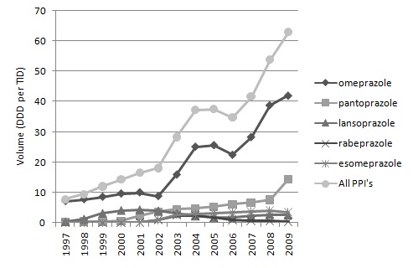

Utilisation of omeprazole appreciably increased after the launch of generics in July 2002, reversing its decline in utilization as a percentage of total PPIs on a DDD basis (Figure 2); subsequently becoming a key driver of growth alongside pantoprazole (Figure 1). As a result, stabilizing at approximately 70% of total PPI utilization (DDD basis) in recent years (Figure 2). Lansoprazole, rabeprazole and esomeprazole had a combined utilization of less than 5% of total PPIs by 2009 (Figure 1). Omeprazole has been nearly all generic omeprazole since 2004, reaching nearly 100% since 2006 (Figure 2).

Figure 2 – Utilisation of omeprazole as a % of total PPIs (DDD basis) as well as % utilization of generic omeprazole as a % in total omeprazole (DDD basis) since launch

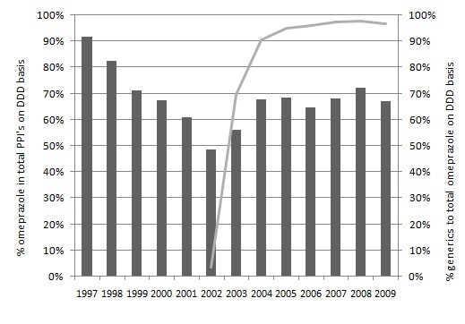
Total public expenditure for the PPIs increased 2-fold between 1997 and 2009, with expenditure stabilizing in recent years. Total reimbursed expenditure for the PPIs in 2009 per 1000 inhabitants per year was €10054, with total expenditure at €14361.

A lower rate of increase in expenditure than utilization was due to decreasing expenditure/ DDD for the PPIs, with reimbursed expenditure decreasing from €1.91 in 1997 to €0.52 per DDD in 2009, and total expenditure/ DDD decreasing from €2.22 in 1997 to €0.68 in 2009. Decreasing expenditure was also helped by the high utilization of generic omeprazole in recent years (Figure 2) coupled with continually lower prices (Figure 3). Reimbursed expenditure/ DDD for generic omeprazole in 2009 was €0.48, equating to a 70% reduction versus prices before patent expiration (Figure 3). From 2005 onwards the reimbursement cost for originator and generic omeprazole converged further to 0.4 euros per DDD in 2009. This led to omeprazole accounting for 40% to 50% of total PPI expenditure in recent years. Note that the maximum reimbursement rate that is shown in table 1 can be exceeded due to a subgroup of patients, whose maximum co-payment level is attained. Therefore figure 3 may show average percentages higher than 50%.

Figure 3: Total and reimbursement cost per DDD for generic versus originator omeprazole between 1997 and 2009
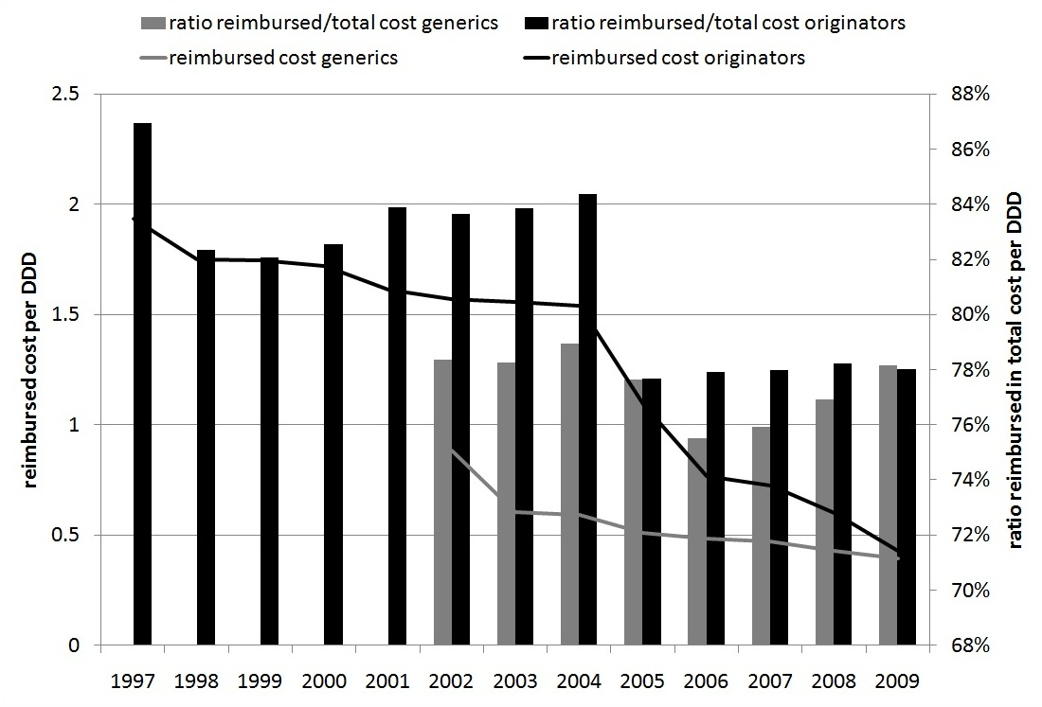

- Statins

There was a 20 fold increase in statin utilization between 1997 and 2009, rising from 5.02 DDD/TID
in 1997 to 97.60 in 2009 (Figure 4). Nominal and relative utilisation of simvastatin grew after generic availability, stabilizing at approximately 40% of total statin utilisation from 2005 onwards. Growth in statin utilization was also driven by increasing use of rosuvastatin, from 3.66 DDD/TID in 2004 to 20.86 in 2009, and to a lesser extent atorvastatin increasing of 1.41 DDD/TID in 1998 to 24.74 in 2009 (Figure 4).

Figure 4 – DDD/ TID for the statins 1997 to 2004

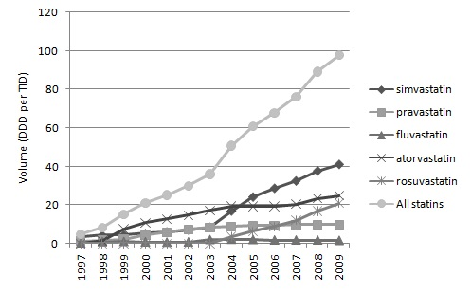

There was increasing use of generic simvastatin as a % of total simvastatin since its availability, rising to 67% of total simvastatin utilisation in 2009 (on DDD basis) (Figure 5).

Figure 5 - % generic simvastatin versus all simvastatin 2003 to 2009 – to be added

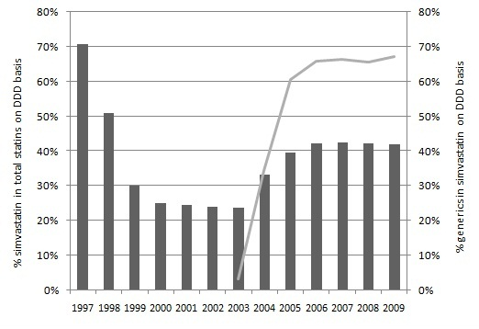

Total public expenditure for the statins increased 5-fold between 1997 and 2009, with expenditure stabilizing between 2004 and 2008 but then increasing again. For the statins, 2009 reimbursed and total expenditures per 1000 inhabitants were €20160 and €23769, respectively. A lower rate of increase in expenditure than utilization was again helped by decreasing reimbursed expenditure/ DDD from €2.05 in 1997 to €0.57 per DDD in 2009; total expenditure/ DDD from €2.48 in 1997 to €0.67 in 2009. Decreasing expenditure/ DDD was also helped by the increasing utilization of simvastatin including generic simvastatin coupled with lower prices. Reimbursed expenditure/ DDD for generic simvastatin in 2009 was €0.26, similar to the originator (Figure 6), equating to an 85% reduction versus prices before patent expiration. Total expenditure/ DDD for simvastatin reduced from €2.59 in 1997 to €0.28 in 2009. Reimbursed expenditure for atorvastatin and rosuvastatin appeared to have stabilised or even increased since the entry of generic simvastatin in 2003 (Figure 6). This led to simvastatin accounting for a decreasing % of reimbursed expenditure in recent years with still considerable utilization of patent protected statins (Figure 4).

Figure 6 – Reimbursed expenditure/ DDD for generic and originator simvastatin as well as atorvastatin and rosuvastatin

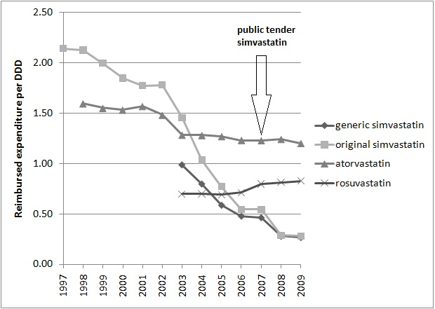

There was an appreciable increase in the utilization of large packages after policy measures were introduced in 2000 equating to a 20% price reduction for larger packages (Figure 7).

Figure 7 – Changes in utilization patterns for larger packages of statins following the policy initiative in 2000

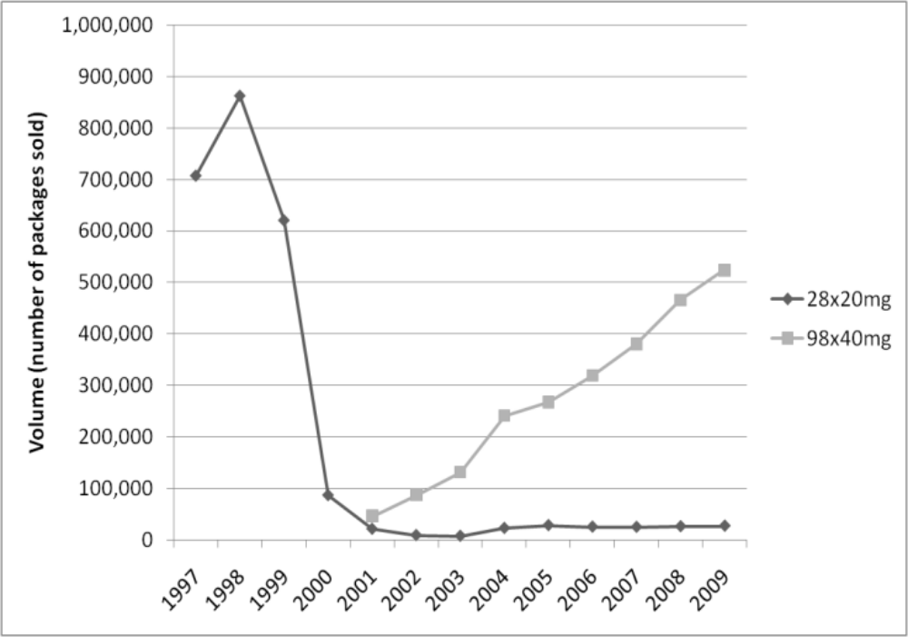

Discussion

Multiple and successive demand side measures introduced in Belgium in recent years appear to have appreciably enhanced rational prescribing for both the PPIs and statins. This compares with countries with less intense demand side measures including France and Ireland where the utilisation of multiple sourced PPIs and statins decreased after their availability, appreciably enhancing their prescribing costs compared for instance with Sweden and the UK [3, 5]. As a result, reimbursed expenditure of €9247/ 1000 inhabitants for the PPIs in Belgium was substantially lower than in France and Ireland in 2007 [3]. Reimbursed expenditure in Belgium for the statins was similar to France when taking into account patient co-payment differences, but still appreciably lower than Ireland [3-5].

More specifically for the PPIs, the multiple demand-side reforms led to the growing utilisation of omeprazole following the availability of generic omeprazole (a supply-side event), coupled with generally limited utilisation of esomeprazole; although growing from a low base (Figures 1 and 2). The low utilisation of esomeprazole mirrors previous findings [2, 8,101], potentially helped by prescribing targets and high patient co-payments (Table 1). The latter is particularly important for low income families [8]. The utilisation patterns seen after the availability of generic omeprazole mirror those seen in Sweden and the UK with their multiple and intensive demand side measures [3-5]. This compares with appreciably increased utilisation of esomeprazole in France and Ireland following generic omeprazole, with their less intensive demand side measures combating industry pressures [3-5].

These results confirm other studies that multiple and intensive demand side measures are needed to favourably influence future prescribing habits [3, 5, 10, 24, 36, 37].

The growth in the utilisation of PPIs during the study period also mirrors other European countries, including nearby countries with a substantially different health care system organization, such as the Netherlands [5, 9, 10, 38]. However, new measures may be needed to limit any further increase in PPI utilisation given growing concerns with their long term use [39-44]. Potential measures could include establishing DDD/ TID targets for GPs, similar to the situation in Stockholm County Council, as well as reviewing doses prescribed and their indications [12].

The increased prescribing of simvastatin following the availability of generic simvastatin, as a result of the multiple initiatives, also mirrors the patterns among other European countries with multiple demand-side measures [3-5]. However, there was also appreciably increased prescribing of atorvastatin and rosuvastatin following the availability of generic simvastatin (Figure 4). The tendency towards persistence utilisation of patented statins (ator- and rosuvastatin) is we believe stimulated through claims of a unique added value versus multiple sourced statins supported by marketing strategies, counterbalancing possible savings in overall expenditure [10, 19, 45]. Having said this, the multiple measures helped combat the commercial activities of patented statin manufacturers and reversed the existing trend of decreasing utilisation of simvastatin as a percentage of overall statin utilisation on a DDD basis (Figure 5). This was made more difficult by the mixed messages from the various studies and guidelines in Belgium although there is a growing consensus of similarity between the statins [19]. In any event, the utilisation patterns after the availability of generic simvastatin was very different to that seen in France and Ireland, where more limited demand side measures are counteracting the pressures from the pharmaceutical companies leading to increasing use of the patented statins following generic simvastatin [3].

Potential additional measures to further increase rational prescribing could include tougher prescribing targets (engineering) for patients already on PPIs and statins, building on the targets for new patients. These subsequently built into the regular feedback and quality meetings (education). Alongside this, greater financial incentives for attending local quality meetings as well as potentially financial incentives for meeting prescribing targets (economics) could be considered. These measures have been successfully applied in other European countries including France (CAPI project), Sweden and the UK [3, 5, 9, 10, 12, 20, 46]. In addition, possibly introducing prescribing restrictions for still patented statins as seen in Austria, Finland and Norway [3, 5, 15, 17]. These would limit the prescribing of patented statins to patients who did not achieve their target lipid levels on generic statins. This measure has been successfully introduced in Austria, with the system administered electronically to reduce administration and the time needed for both the physician and the patient to wait for an answer [22, 24,,T. Burkhardt - Personal Communication]. Although these measures were successful in other countries, it remains to be seen how these would be accepted and perform, given the specifics of the Belgian situation.

The high utilisation of generic versus originator omeprazole once available (Figure 2) mirrors the situation in Sweden, where there is compulsory generic substitution, and the UK with its high voluntary INN prescribing [3, 4, 9, 11, 102]. The utilisation of generic simvastatin versus originator simvastatin once available is not as high (Figure 5). This may be due to similar prices for both the generic and originator simvastatin in recent years (Figure 6), negating any additional co-payment under the reference price scheme [14, 101]. This is unlike the situation with omeprazole where price differences persisted throughout the study until recently (Figure 3), and patients - particularly those in lower socioeconomic groups - appear price sensitive [8]. However, this cannot be confirmed without additional research. In any case, both rates of utilisation are appreciably higher than the current low utilisation generally for generics in Belgium [13], providing direction for the future.

A number of countries have introduced and others may be considering additional measures, such as compulsory INN prescribing or substitution, e.g. Abu Dhabi, Lithuania and Sweden [3, 5, 12, 27, 47]. Although the acceptance and efficiency through which these measures are put into action depend on cultural aspects of every specific country, in the long term it could enhance the continuity of drug dispensing.

For the Belgian situation, the low share of INN prescriptions is remarkable, but causal mechanisms remain difficult to disentangle. It seems a multifaceted and complex phenomenon. Possible underlying causes may be the protection of therapeutic freedom of prescribing physicians, the influence of the pharmaceutical industry, the growing diversity of packages and dosages and frequent complex regulatory changes, which make it hard for physicians and pharmacists to keep up [1]. More specific research will be needed to investigate this.

The reduction in reimbursed expenditure/DDD for omeprazole at 70% of prices before patent expiration in 2009, and simvastatin at 85% in 2009, is very impressive compared with a number of
other European countries [4, 5]. However, there are still opportunities for further price reductions (Table 2 ) [3, 4, 17, 24, 48, 49, BBG Personal Communication], especially given the price differentials between Belgium and Sweden and the UK, as well as the findings in Lithuania demonstrating that even countries with small populations can achieve low prices for generics [27]. The prices of generics were appreciably lower in the UK following the introduction of reforms to increase transparency in the cost of manufacture and any rebates in the system [9, 10], with compulsory substitution in Sweden also helping to lower prices [12], further aided recently by the introduction of monthly auctions for generics [50].

Table 2 – Reimbursed expenditure/ DDD for generic omeprazole, simvastatin (2011 DDDs) in 2007 in Euros unless stated [4, 5, 17, 24, 48, 49, BBG Personal Communication]

NB – AT = Total expenditure

In conclusion, the ongoing multiple demand side reforms have appreciably enhanced rational prescribing for the PPIs and statins in Belgium, which is similar to other European countries also instigating multiple reforms. However, there are opportunities to further enhance rational prescribing for both the PPIs and statins. Possible future measures are discussed, along with potential measures to further reduce the price of generics in Belgium. As a result, additional resources may be released to help fund increased volumes and new expensive drugs without having to raise health insurance premiums.

Financial & competing interests disclosure

JF, GVH and PB acknowledge financial support from the Special Research Fund (Bijzonder Onderzoeksfonds, BOF) of the University of Antwerp, and BG acknowledges financial support from the Karolinska Institute.

PB reports that a research chair in evidence-based vaccinology at the Vaccine & Infectious Disease Institute is currently sponsored by a gift from Pfizer to the University of Antwerp.

The authors have no other relevant affiliations or financial involvement with any organization or entity with a financial interest in or financial conflict with the subject matter or materials discussed in the manuscript apart from those discussed.

No writing assistance was utilized in the production of this manuscript.

Key issues

- The proton pump inhibitors (PPIs) and statins are amongst the three most prescribed drugs in Belgium. There are opportunities for considerable savings as each class contains generics, originators and patented products with the drugs in each class seen as similar in all or nearly all patients
- General and specific initiatives for each class introduced in Belgium in recent years to enhance rational prescribing included a reference pricing system for the molecule, successive price cuts, percentage prescribing rates for low cost medicines, financial incentives for physicians attending local quality meetings and patient co-payments for each disease category. There was also a public tender for simvastatin in 2007 to reduce its costs
- The measures resulted in a 2-fold increase in reimbursed expenditure for the PPIs between 1997 and 2009 despite utilisation increasing 8-fold during this period, due to increasing use of generic omeprazole versus other PPIs, which was 70% below pre-patent loss prices by 2009. Overall, omeprazole, which was nearly 100% generic omeprazole, comprised 70% of total PPI utilisation (DDD basis) in recent years
- Reimbursed expenditure on the statins increased 5-fold during this period despite a 20-fold increase in volumes with simvastatin the principal statin prescribed. Generic simvastatin in 2009 was 85% below pre-patent loss prices helping to conserve resources
- Reduced co-payments for larger packs enhanced their utilisation versus smaller packs
- Multiple reforms favourably influenced utilisation of generic PPIs and statins following their availability helping to conserve resources. Additional demand-side measures are needed to further enhance rational prescribing in Belgium

References

Papers of special note have been highlighted as:
*of interest
** of considerable interest

1. Fraeyman, J., et al., Potential impact of policy regulation and generic competition on sales of cholesterol lowering medication, antidepressants and acid blocking agents in Belgium. Acta Clinica Belgica, 2012. 67(3): p. 160-171.
2. Dylst, P., A. Vulto, and S. Simoens, Where a cheap medicine is not the same as a generic medicine: the Belgian case. JPHSR, 2011. 2: p. 185-189.
** Discusses measures to enhance the prescribing of low cost medicines in Belgium and their influence
3. Godman, B., et al., Comparing policies to enhance prescribing efficiency in Europe through increasing generic utilization: changes seen and global implications. Expert Rev Pharmacoecon Outcomes Res, 2010. 10(6): p. 707-22.
*Reviews ongoing demand-side measures among Western European countries to enhance prescribing efficiency for the PPIs and statins and their influence
4. Godman, B., et al., Use of generics – a critical cost containment measure for all healthcare professionals in Europe? Pharmaceuticals, 2010. 3: p. 2470-94.
5. Godman, B., et al., Policies to enhance prescribing efficiency in europe: findings and future implications. Front Pharmacol, 2010. 1: p. 141.
6. Garattini, S., et al., Enhancing the rational use of new medicines across European health care systems. Eur J Clin Pharmacol, 2008. 64(12): p. 1137-8.
7. Van Wilder, P. and M. Dupont, Introducing evidence-based medicine in reimbursement procedures: does it affect outcomes. Value in Health, 2008. 11: p. 784-7.
8. Vrijens, F., et al., Patient socioeconomic determinants for the choice of the cheapest molecule within a cluster: evidence from Belgian prescription data. Eur J Health Econ, 2012. 13(3): p. 315-25.
9. McGinn, D., et al., Initiatives to enhance the quality and efficiency of statin and PPI prescribing in the UK: impact and implications. Expert Rev Pharmacoecon Outcomes Res, 2010. 10(1): p. 73-85.
10. Bennie, M., et al., Multiple initiatives continue to enhance the prescribing efficieny for the proton pump inhibitors and statins in Scotland. Expert Rev Pharmacoecon Outcomes Res, 2012. 12(1): 125-130
*Reviews the influence of extensive supply- and demand-side measures in Scotland on prescribing efficiency for the PPIs and statins demonstrating considerable savings in practice
11. Godman, B., et al., Update of recent reforms in Germany to enhance the quality and efficiency of prescribing of proton pump inhibitors and lipid-lowering drugs. Pharmacoeconomics, 2009. 27(5): p. 435-8.
12. Godman, B., et al., Multifaceted national and regional drug reforms and initiatives in ambulatory care in Sweden: global relevance. Expert Rev Pharmacoecon Outcomes Res, 2009. 9(1): p. 65-83.
13. Vermeylen, M., G. Verpooten, and H. Beyers, Farmaceutische Kengetallen farmaceutische verstrekkingen ambulante praktijk 2009, Sept 2011, National Institute for Health and Disability Insurance (NIHDI) Brussels. p. 82 p.
14. Dylst, P., A. Vulto, and S. Simoens, The impact of reference-pricing systems in Europe: a literature review and case studies. Expert Rev Pharmacoecon Outcomes Res, 2011. 11(6): p. 729-37.
* Good review of the influence of reference pricing policies in Europe
15. Godman, B., et al., Combination of prescribing restrictions and policies to engineer low prices to reduce reimbursement costs. Expert Rev Pharmacoecon Outcomes Res, 2011. 11(1): p. 121-9.
16. Godman, B., et al., Having your cake and eating it: office of fair trading proposal for funding new drugs to benefit patients and innovative companies. Pharmacoeconomics, 2008. 26(2): p. 91-8.
17. Godman, B., et al., Impact of recent reforms in Austria on utilization and expenditure of PPIs and lipid-lowering drugs: implications for the future. Expert Rev Pharmacoecon Outcomes Res, 2009. 9(5): p. 475-84.
18. Godman, B., Malmstrom, RE., Bennie, M., Sakshaug, S., Burkhardt, T., et al, Prescribing restrictions- a necessary strategy among some European countries to enhance future prescribing efficiency? Reviews in Health care, 2012. 3: p. 5-16.
*Good review article illustrating the influence of different prescribing restrictions and their follow-up in practice
19. Weng, T.C., et al., A systematic review and meta-analysis on the therapeutic equivalence of statins. J Clin Pharm Ther, 2010. 35(2): p. 139-51.
20. Godman, B., K. Paterson, and R.E. Malmstrom, Improving the managed entry of new medicines: sharing experiences across Europe Expert Review Pharmacoeconomics and Outcomes Research: p. [In Press ].
21. Pedersen, T.R., et al., High-dose atorvastatin vs usual-dose simvastatin for secondary prevention after myocardial infarction: the IDEAL study: a randomized controlled trial. JAMA, 2005. 294(19): p. 2437-45.
22. Norman, C., et al., Potential savings without compromising the quality of care. Int J Clin Pract, 2009. 63(9): p. 1320-6.
* Demonstrates in practice that care is not compromised through using older well established drugs (usually generics) versus newer patented drugs; however, considerable differences in costs
23. Vlahovic-Palcevski, V., et al., Coping with changes in the Defined Daily Dose in a longitudinal drug consumption database. Pharm World Sci, 2010. 32(2): p. 125-9.
24. Voncina, L., et al., Influence of demand-side measures to enhance renin-angiotensin prescribing efficiency in Europe: implications for the future. Expert Rev Pharmacoecon Outcomes Res, 2011. 11(4): p. 469-79.
25. Godman, B., et al., European payer initiatives to reduce prescribing costs through use of generics. GABI, 2012. 1: p. 22-27.
26. Wettermark, B., et al., Soft regulations in pharmaceutical policy making: an overview of current approaches and their consequences. Appl Health Econ Health Policy, 2009. 7(3): p. 137-47.
*Original paper describing the 4E approach to influencing physician prescribing habits
27. Garuoliene, K., et al., European countries with small populations can obtain low prices for drugs: Lithuania as a case history. Expert Rev Pharmacoecon Outcomes Res, 2011. 11(3): p. 343-9.
28. Borgermans, L., et al., Impact of academic detailing on primary care physicians. KCE reports 125c, 2010, Belgian Health Care Knowledge Centre (KCE).
29. Vermeylen, M., G. Verpooten, and H. Beyers, The efficient use of hypolipidemic drugs, 2002, Committee for the Evaluation of the medical practice concerning Pharmaceuticals (CEP) of the National Institute for Health and Disability Insurance (NIHDI): Brussels.
30. Topol, E.J., Intensive statin therapy--a sea change in cardiovascular prevention. N Engl J Med, 2004. 350(15): p. 1562-4.
31. Verpooten, G. and H. Beyers, Consensus vergadering 15 mei 2003. Doelmatig gebruik van zuurremmers bij gastro-oesofagale reflux en dyspepsie, in Folia Pharmacotherapeutica2004, RIZIV-INAMI: Brussel. p. 25.
32. Van Driel, M.L., et al., Effects of an evidence report and policies lifting reimbursement restrictions for acid suppressants: analysis of the Belgian national database. Pharmacoepidemiology and Drug Safety, 2008. 17: p. 1113-1122.
33. Van Driel, M.L., et al., Medical evidence and health policy: a marriage of convenience? the case of proton pump inhibitors. Journal of Evaluation in Clinical Practice, 2007. 13: p. 674-680.
34. Vander Stichele, R. and H. Petri, Utilization patterns of subsidized and nonsubsidized reimbursable peptic ulcer medication in Belgium. Pharmacoepidemiology and Drug Safety 1995. 4(4): p. 213-224.
35. Austvoll-Dahlgren, A., et al., Pharmaceutical policies: effects of cap and co-payment on rational drug use (Review). Cochrane database of Systematic Reviews, 2009(3): p. 3-74.
36. Bero, L.A., et al., Closing the gap between research and practice: an overview of systematic reviews of interventions to promote the implementation of research findings. The Cochrane Effective Practice and Organization of Care Review Group. BMJ, 1998. 317(7156): p. 465-8.
** Original paper demonstrating that multiple measures are typically needed to favourably influence physician prescribing habits
37. Barton, S., Using clinical evidence. BMJ, 2001. 322(7285): p. 503-4.
38. van Woerkom, M., et al., Ongoing measures to enhance the efficiency of prescribing of PPIs and statins in the Netherlands; influence and future implications. Journal of Comparative Effectiveness Research, 2012. [accepted for publication].
39. Yang, Y.X., et al., Long-term proton pump inhibitor therapy and risk of hip fracture. JAMA, 2006. 296(24): p. 2947-53.
40. Leonard, J., J.K. Marshall, and P. Moayyedi, Systematic review of the risk of enteric infection in patients taking acid suppression. Am J Gastroenterol, 2007. 102(9): p. 2047-56; quiz 2057.
41. Howell, M.D., et al., Iatrogenic gastric acid suppression and the risk of nosocomial Clostridium difficile infection. Arch Intern Med, 2010. 170(9): p. 784-90.
42. Gulmez, S.E., et al., Use of proton pump inhibitors and the risk of community-acquired pneumonia: a population-based case-control study. Arch Intern Med, 2007. 167(9): p. 950-5.
43. Gray, S.L., et al., Proton pump inhibitor use, hip fracture, and change in bone mineral density in postmenopausal women: results from the Women's Health Initiative. Arch Intern Med, 2010. 170(9): p. 765-71.
44. Editorial, Failing the acid test - benefits of proton pump inhibitors may not justify the risks for many users. Arch Intern Med, 2010. 170: p. 747-8.
45. Dylst, P. and S. Simoens, Generic Medicine pricing policies in Europe: current status and impact. Pharmaceuticals, 2010. 3: p. 471-481.
46. Sermet, C., et al., Ongoing pharmaceutical reforms in France; implications for key stakeholder groups. Applied Health Economics and Health Policy 2010. 8: p. 7-24.
47. Abuelkhair, M., et al., Imperative to consider multiple initiatives to maximize prescribing efficiency from generic availability: case history from Abu Dhabi. Expert Rev Pharmacoecon Outcomes Res, 2012. 12(1): p. 115-24.
48. Godman, B., et al., Enhancing prescribing efficiency through increased utilisation of generics at low price. (E) Hospital, 2011. 13(3): p. 28-31.
49. Coma, A., et al., Policies to enhance the efficiency of prescribing in the Spanish Catalan region: impact and future direction. Expert Rev Pharmacoecon Outcomes Res, 2009. 9(6): p. 569-81.
50. Godman, B., et al., Payers endorse generics to enhance prescribing efficiency; impact and future implications, a case history approach. GABI, 2012. 1(2): p. 21-35.

Web based references

101. DeSwaef, A. and Y. Antonissen. Pharmaceutical Pricing and Reimbursement Information. Belgium. October 2008. Available via URL: http://ppri.oebig.at/Downloads/Results/Belgium_PPRI_2008.pdf [Accessed 2 April 2012]

102. OECD. Pharmaceutical expenditure, % total expenditure on health. Available via URL:
http://www.oecd.org/document/16/0,3746,en_2649_33929_2085200_1_1_1_1,00.html [Accessed 30 April 2012]

103. De Graeve, D., et al., Eigen betalingen in de Belgische gezondheidszorg. De impact van supplementen [Eng. Own payments in Belgian Health care. The impact of supplements], 2006, Federaal Kenniscentrum voor de gezondheidszorg (KCE). p. 240 p. Available from: https://kce.fgov.be/nl/publication/report/eigen-betalingen-in-de-belgische-gezondheidszorg-de-impact-van-supplementen [Accessed 3 September 2012]

104 Belgian Centre for Farmacotherapeutic Information, BCFI [accessed on 29/08/2012]; Available from: http://www.bcfi.be/ggr/index.cfm?ggrWelk=MAIN.
105. WHO Collaborating Centre for Drug Statistics Methodology. ATC/DDD index 2012. Available from: http://www.whocc.no/atc_ddd_index/. [Accessed 20 March 2012]

106. World Health Organization (WHO). Introduction to Drug Utilisation Research. WHO International Working Group for Drug Statistics Methodology, WHO Collaborating Centre for Drug
Statistics Methodology, WHO Collaborating Centre for Drug Utilization Research and Clinical
Pharmacological Services. ISBN 92 4 156234 X (NLM classification: WB 330) Available via URL:
http://www.who.int/medicines/areas/quality_safety/safety_efficacy/Drug%20utilization%20research.pdf [Accessed 30 April 2012]

107 Reglementering van de werking van de LOK [Eng. Regulation of the 'local quality meeting']. 2010. Available from: http://www.riziv.fgov.be/care/nl/doctors/accreditation/peer-review/reglement.htm. [Accessed 30 April 2012]

108. National Institute for Health and Disability Insurance (NIHDI). Remuneration of pharmacists and retailers: revision 1st of April 2010. 2012/04/23]. Available from:
http://www.riziv.fgov.be/drug/nl/pharmacists/modification-20100401/index.htm.

109. Ministerieel besluit tot wijziging van de lijst gevoegd bij het koninklijk besluit van 21 december 2001 tot vaststelling van de procedures, termijnen en voorwaarden inzake de tegemoetkoming van de verplichte verzekering voor geneeskundige verzorging en uitkeringen in de kosten van farmaceutische specialiteiten. (Flemish Government, Belgian State Monitor 30/08/2007, publication: 5/09/2007) [accessed on 04/01/2012]

public tendering system: Manufacturers were publicly invited to offer a price for simvastatin. The government as contractor chose the best bidder and granted him favourable sales conditions.

