Analysis of the Optimum Tilt Angle for a Soiled PV Panel
Ruidong Xu¹, Kai Ni²*, Yihua Hu², Jikai Si³, Huiqing Wen⁴, and Dongshen Yu¹
Affiliation¹: School of Electrical and Power Engineering, China University of Mining and Technology, China (ruidongxu@163.com, dongsiee@163.com)
Affiliation²: Department of Electrical Engineering & Electronics, University of Liverpool, Liverpool, UK (*k.ni@student.liverpool.ac.uk, y.hu35@liverpool.ac.uk)
Affiliation³: School of Electrical Engineering, Henan Polytechnic University, Henan, China (sijikai527@126.com)
Affiliation⁴: Department of Electrical & Electronic Engineering, Xi’an Jiaotong Liverpool University, Jiangsu, China (Huiqing.Wen@xjtlu.edu.cn)
Abstract – A new model of the optimum tilt angle of a soiled photovoltaic (PV) panel is proposed in this paper. The tilt angle is a key factor that influences the output power of PV panel, while dust deposition is an inevitable external element to be considered. In this paper, the solar radiation model is studied by analysing the Hay, Davies, Klucher, Reindl (HDKR) model. The cell temperature of a PV panel is also investigated to evaluate the power output. A fitting formula is derived to express the relationship between the dust deposition density and the tilt angle, and it is integrated in the output model of a fixed-type PV panel. Besides, the effect of dust deposition on the transmittance is analysed. An inverse correlation between the dust deposition density and tilt angle can be obtained, and the optimum tilt angle is calculated to maximize the power output of a soiled PV panel. Simulation is conducted by Matlab to demonstrate the validity of the proposed model of optimum tilt angle with the shielding effect by dust. Furthermore, the relationship between dust deposition and the working temperature of PV panel is investigated by indoor experiments.
Keywords – photovoltaic (PV) panel, optimum tilt angle, dust deposition, shielding effect, working temperature.
I. Introduction
Due to the shortage of fossil fuels and the corresponding degradation of the atmosphere, development of renewable energy resources has attracted extensive attention around the world. As one of the most important renewable energy resources, solar energy has an enormous potential and wide applications since it is clean, free and abundant [1-3]. Solar energy can be directly converted into electric power through PV panels, and the tilt angel of PV panel significantly affects the power output. Therefore, many researches in the past decades focused on the algorithm optimization of tilt angle to maximize PV generation. Generally, the optimal angle varies with several conditions such as the utilization period, geographic latitude, climate, surroundings and other atmospheric factors, i.e. dust and pollution [4-6].
Empirical formulas were employed in early studies to estimate the optimum tilt angles at different sites, which are only related to the local latitudes. In [7] the conclusion was given that the tilt angle can be calculated as (latitude ± 15 °). Later, the authors in [8] conducted a series of experiments and proposed a new formula which is (latitude ± 8 °) to derive the value of the tilt angle. For specific locations, according to coastal radiation data, PV panels should be installed with the tilt angle of 2.8 ° greater than the latitude [9]. However, the accuracy of these statistics is not guaranteed due to limitations of geographical conditions.
Many recent researches attempted to propose more accurate mathematical models of the optimum tilt angle, mainly considering the calculation of the maximum solar radiation incident on inclined panels. In [10], seven irradiance decomposition models for estimating Global Plane Irradiance (GPI) from Global Horizontal Irradiance (GHI) were evaluated for a region in South Africa, along with comparisons among six transposition models. Three meteorological datasets were combined with Perez and Hay-Davies models to compute the irradiance on tilted surfaces in [11], and the cooling effect of wind speed was considered to increase the accuracy of estimating the PV energy output. In [12] the best transposition model was to be found for Singapore’s climatic conditions, and the maximum annual in-plane irradiation was obtained when surfaces were tilted eastward by employing the Perez et al. model.
Although solar radiation is the dominant factor for the output power of PV array, the effects caused by other factors also contribute to the variation in the PV power output [13-18]. Among these factors, dust deposition is a non-ignorable one that shields the panel surface and influences the solar radiation absorption. The shielding effect caused by dust can be considered as transmittance decrease of PV surface glass, and the reduction ratio of transmittance varies with several factors, which are described in Table 1. Since PV arrays are placed in outdoor environments for a long period, the particles such as the raised soiling, atmospheric pollutant and bird dropping that accumulate on the panel surface are inevitable. For the areas that receive intense solar radiation as well as serious dust fall, abundant solar energy resources are wasted. To maximize the efficiency of absorbing solar power for PV arrays, the performance of an electrodynamic screen that removes dust and particles was investigated [19-21]. In addition, researches in adhesion of dust to PV module surfaces were carried out, which offered possible pathways to more effective cleaning methodologies or the development of preventative dust mitigation coatings [22]. However, dust adhered to PV panels cannot be totally removed, and it takes decades for relevant mature technologies to be popularized worldwide. Therefore, currently the influence of dust deposition has to be considered, and the tilt angle should be adjusted in order to increase the power output of PV arrays.
Table 1. Reduction ratio of transmittance versus several factors
Influence factor | Reduction ratio of transmittance
Particle diameter ↑ | lower
PV tilt angle ↑ | lower
Dust deposition density ↑ | higher
Wind speed ↑ | higher
humidity ↑ | higher

Dust concentration and spectral transmittance were investigated in [23], and different tilt angles were applied to find the worst case for transmittance variation. In addition, the conclusion was derived in [24] that a horizontal position should be avoided since dust accumulation is the most serious under this situation. From the researches mentioned above, it can be seen that the tilt angle influences the volume of dust accumulation, and the dust affects the plate-transmittance and solar radiation absorption. However, there is no research that combined the optimum tilt angle model with the calculation of dust deposition density. Apart from the shielding effect, the temperature effect caused by dust deposition is to be investigated. For example, the area covered with dust has lower temperature due to less radiation. However, since the thermal resistance of dust is larger than that of glass, heat dissipation is weakened and the temperature of the shielded area increases. Therefore, it is hard to implement theoretical calculation to discuss the temperature effect.
In this paper, the Hay, Davies, Klucher, Reindl (HDKR) model is analysed for solar radiation, and the cell temperature of a PV panel is investigated under the standard test condition (STC). The mathematical model of optimum tilt angle of PV panel is optimized by combining the correlation between the dust density and tilt angle, and a new model of the optimum tilt angle is proposed for fixed PV arrays. Additionally, a fitting formula is derived to represent the relationship, and the shielding effect of dust on the transmittance is analyzed. Moreover, to investigate the relationship between the dust deposition density and the working temperature of a PV panel, experiments are carried out.
This paper is organized in the following structure: In Section II and III, models of the optimum tilt angle without and with the effect of dust deposition are respectively established. The relationship between the solar radiation and tilt angle is investigated in Section IV by simulation and analysis. In Section V, indoor experiments of temperature effect on PV panel are carried out by considering dust deposits. Finally, conclusions are obtained in Section VI.
II. The Optimum Tilt Angle Model without Dust Factor
A. Calculation of Solar Radiation on the Plane of Array
The solar radiation on an inclined surface is one of the most important parameters for tilted PV panels. Since a meteorological bureau only records the solar radiation on a horizontal surface, the collectible solar radiation on an inclined surface needs to be calculated.
Total solar radiation on a tilted surface H_{T} (W/m²) consists of three components:
1) “Direct radiation H_{T},_{b}”, which is used to describe the solar beam travelling through the atmosphere and straight down to the surface.
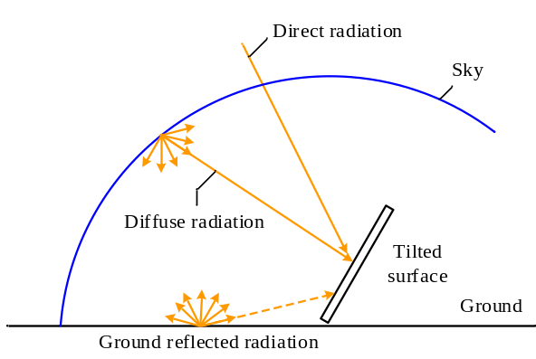
Fig. 1. Three solar radiation components [25]
2) “Diffuse radiation H_{T},_{d}”, which is used to describe the sunlight reaching the surface after being scattered by molecules and particles in the atmosphere.
3) “Ground reflected radiation H_{T},_{refl}”, namely the solar radiation is reflected by the ground and then it reaches the tilted surface.
As can be seen from Fig. 1, direct radiation can reach the panel from only one specific angle, while diffuse radiation can reach the surface from all the angles. Since the horizontal surface is not exposed to reflected radiation, the total radiation on the horizontal surface H recorded by the meteorological bureau is the sum of direct radiation H_{b} and diffuse radiation H_{d}, and the values of H_{b} and H_{d} can also be collected:
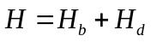 (1)
The total solar radiation on a panel with the tilt angle β can be expressed by using the HDKR model (Hay, Davies, Klucher, Reindl model) [26]:
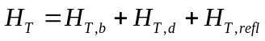 (2)
In particular, the direct radiation on a tilted surface can be calculated as follows:
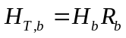 (3)
where R_{b} is the ratio of the direct radiation on an inclined surface to the direct radiation on a horizontal surface, which is defined in [27].
According to the modified Hay-and-Davies diffuse model [25], the diffuse radiation of a tilted surface can be expressed as:
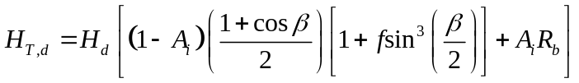 (4)
where A_{i} is the isotropic index, f is the correction coefficient, and both of them can be calculated according to [25].
The ground reflected radiation H_{T,refl} is calculated as:
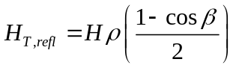 (5)
where ρ is the diffuse reflectance of the ground.
Thus the total solar radiation on a tilted surface can be expressed as [24]:
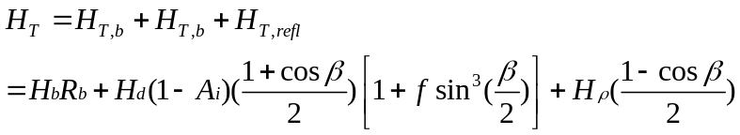 (6)
The HDKR model can be used to calculate the solar radiation, and the daily solar energy density can be derived. After the recommended day of a certain month is selected, the monthly solar energy density can be calculated, and then the annual total solar energy density can be obtained.
B. The PV Output Power Model without Dust Factor
In this paper, the output power model proposed in [28] is referenced. In [28], the standard test condition (STC) is defined under the condition that the solar power density is 1 kW/m², the cell temperature is 25 °C, and no wind is included. The nominal operating cell temperature (NOCT) is defined as the cell temperature with the incident radiation of 0.8 kW/m², the ambient temperature of 20 °C, the average wind speed of 1 m/s, and no load operation.
The simple model used to predict the PV array output power is expressed as:
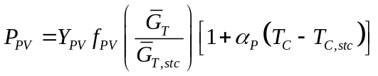 (7)
where Y_{PV} is the rated capacity of the PV array (namely its power output under STC), f_{PV} is the PV derating factor (used to account for the factors such as shading, snow cover, aging, and so forth), is the global radiation striking the PV array, _{T,stc} is the incident radiation under STC (1 kW/m²), α_{P} is the temperature coefficient of power (which indicates how strongly the PV array power output depends on the cell temperature), T_{C} is the PV cell temperature in the current time step, and T_{C,stc} is the PV cell temperature under STC (25 °C).
T_{C} can be calculated as:
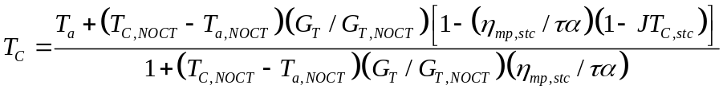 (8)
where T_{a} is the ambient temperature; T_{C,NOCT}, T_{a,NOCT} and G_{T,NOCT} are respectively the nominal operating cell temperature, the ambient temperature (20 °C) and the solar power density (0.8 kW/m²) at NOCT; η_{mp,stc} is the maximum power point efficiency under STC; τ is the solar transmittance of the PV array, and α is the solar absorptance of the PV array. By substituting the equation (8) into (7), the output power of PV array can be calculated, which is related to the solar energy density (affected by the tilt angle), ambient temperature and PV internal parameters.
III. The Optimum Tilt Angle Model with Dust Factor
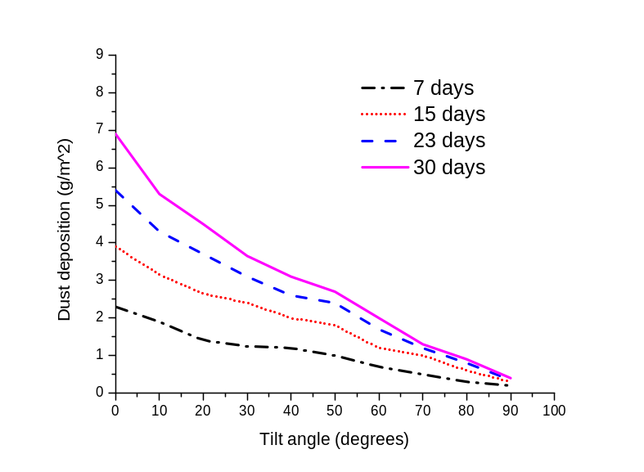
Fig. 2. Relation between tilt angle and dust deposition [29]
A. The fitting formula of dust deposition
(1) Dust deposition density – Tilt Angle
In [29], the dust deposition density ρ_{D} (g/m²) at corresponding tilt angles β (°) of PV panels are measured after 7, 15, 23 and 30 days of exposure, respectively, as shown in Fig. 2. As can be seen in Fig. 2, when the period of exposure is fixed, the dust deposition density ρ_{D} reduces when the tilt angle β rises. If the tilt angle remains at a constant value, the dust deposition density ρ_{D} increases with the addition of exposure days. In Fig. 2, the slopes of the four curves drop with the extension of exposure period, because the amount of dust on surface becomes saturated over time. Moreover, the larger the tilt angle is, the smaller the saturation value is. Thus the dust deposition density on the surface with larger tilt angel saturates earlier, and the increasing speed of dust deposition density slows down as time goes.
Table 2. Deviation between the measured and fitted values
30 days
Tilt angle β (°) | Measured value (g/m²) | Fitted Value (g/m²) | Deviation (%)
10 | 5.3 | 5.072 | 4.31
20 | 4.5 | 4.485 | 0.33
30 | 3.7 | 3.899 | -5.36
40 | 3.2 | 3.312 | -3.50
50 | 2.7 | 2.726 | -0.94
60 | 2 | 2.139 | -6.95
90 | 0.5 | 0.380 | 24.1

23 days
Tilt angle β (°) | Measured value (g/m²) | Fitted Value (g/m²) | Deviation (%)
10 | 4.2 | 4.043 | 3.75
20 | 3.7 | 3.575 | 3.38
30 | 3.2 | 3.108 | 2.89
40 | 2.6 | 2.640 | -1.54
50 | 2.4 | 2.173 | 9.48
60 | 1.7 | 1.705 | -0.29
90 | 0.4 | 0.303 | 24.4

15days
Tilt angle β (°) | Measured value (g/m²) | Fitted Value (g/m²) | Deviation (%)
10 | 3.2 | 2.94 | 8.13
20 | 2.7 | 2.60 | 3.70
30 | 2.4 | 2.26 | 5.83
40 | 2 | 1.92 | 4.00
50 | 1.8 | 1.58 | 12.22
60 | 1.3 | 1.24 | 4.62
90 | 0.3 | 0.22 | 26.67

Since the dust deposition density is affected by local meteorology, pollution levels and wind conditions, the density of dust on a horizontal surface ρ_{D0} (β = 0 °) is regarded as a value that is known in advance for simplicity. Therefore, the data of dust deposition density at β = 0 ° is not included in the fitting formula, and the relationship between β and ρ_{D0} after different exposure days are depicted in Fig. 3.
As can be seen from Fig.3, the relationship between ρ_{D} and β is approximately linear for each case. An unsatisfactory curve for exposure of 7 days is presented since the period is not long enough. Thus only the curves with 30, 23 and 15 days of exposure are utilized to deduce the fitting formula:
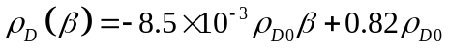 (9)
The deviation between the measured and fitted values is calculated using the fitting formula (9), as presented in Table 2. In the total 21 deviation values between the fitted values and measured values, 17 of them are less than 10%, and 12 are less than 5%. Although the deviation is over 20% when β = 90 ° for all the three situations, the absolute deviation is only around 0.1 g/m². The distribution of dust in the air is not linear owing to the fickle local environmental conditions, which means actually the relationship between the tilt angle and
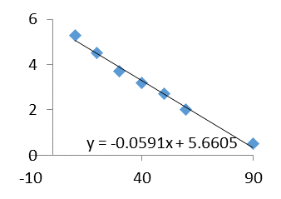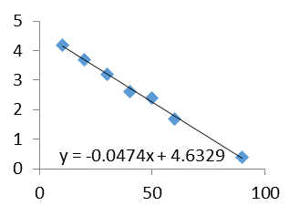
ρ_{D} (g/m²)
β(°)
β(°)
30 days
23 days
ρ_{D} (g/m²)
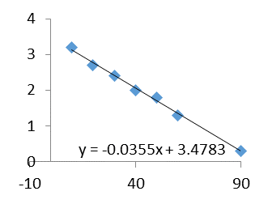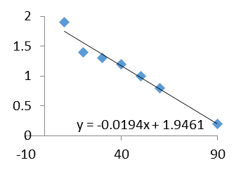
ρ_{D} (g/m²)
β(°)
15 days
ρ_{D} (g/m²)
β(°)
7 days
Fig.3. The relationship between the tilt angle and dust deposition density after different days of exposure
dust deposition density is extremely complex. However, when the value of tilt angle is a commonly used one and the exposing period of PV panel is long enough, a linear approximation is derived as shown in (9). Therefore, nonlinearity in the deviation is presented because the measured values of dust deposition density are nonlinear, especially for large tilt angles. However, extremely large tilt angles like 90 ° is never applied for PV panels in practice, and the deviations for commonly used tilt angles are within an acceptable range. From this point of view, the proposed fitting formula is applicable for expressing the relationship between the dust deposition density and tilt angle.
(2) Dust deposition density – Transmittance
Many studies have depicted the relationship between the dust deposition density and reduction in transmittance by measured data, and the curve trend can be seen in Fig.4. Among these works, respective fitting formulas are derived in [29-31], and the formula in [29] is considered as the best one due to a large amount of measured data, which is expressed as follows:
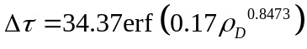 (10)
Reduction in transmittance (%)
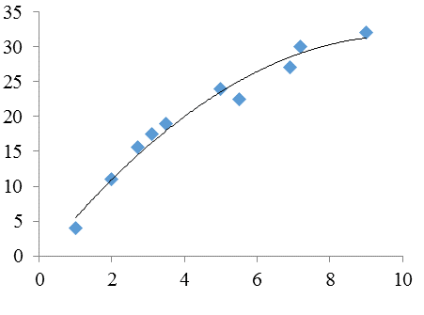
Fig.4. The relationship between dust deposition and the reduction in transmittance
Dust deposition (g/m²)
where ρ_{D} is the monthly dust deposition density, which simplifies the calculation.
The calculation of transmittance is given as:
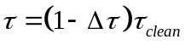 (11)
where τ_{clean} is the transmittance of a clean glass plate, and its values is between 0.98 and 1.
From the equations (9), (10) and (11), the relation between the transmittance τ and the tilt angle β is:
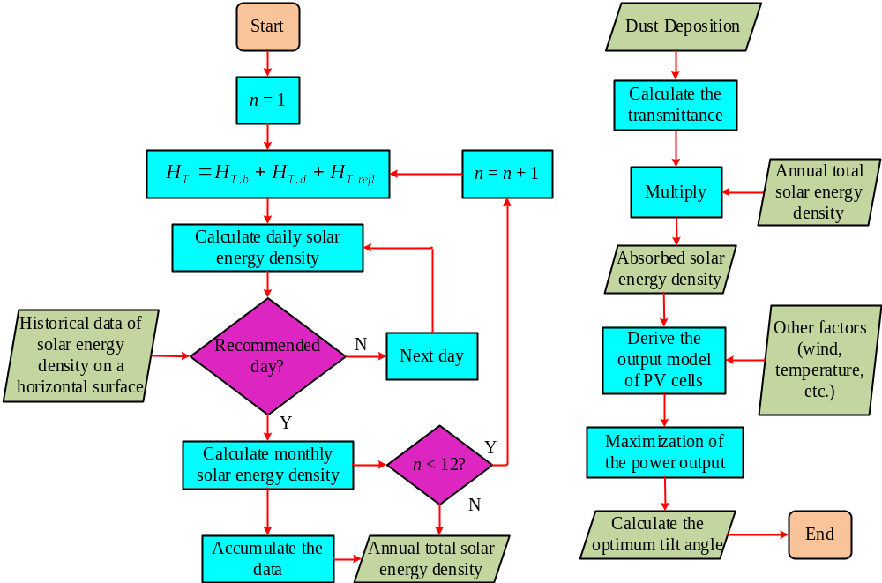
Fig.5 The flow chart of optimum tilt angle calculation
(12)
(3) Transmittance – Solar radiation
The final absorbed solar radiation by PV panel is the product of the received one and transmittance:
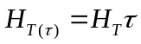 (13)
B. The PV Output Power Model with Dust Factor
Table 4. Monthly and daily solar energy density on the horizontal plane (Hangzhou) (Unit: J/m²)
Month | Monthly total solar energy density | Monthly direct solar energy density | Monthly diffuse solar energy density | Daily average solar energy density | Daily direct solar energy density | Daily diffuse solar energy density
Jan. | 1.865*10⁸ | 6.643*10⁷ | 1.2007*10⁸ | 6.02*10⁶ | 2.14*10⁶ | 3.87*10⁶
Feb. | 2.388*10⁸ | 8.813*10⁷ | 1.5067*10⁸ | 8.53*10⁶ | 3.15*10⁶ | 5.38*10⁶
Mar. | 2.861*10⁸ | 1.0484*10⁸ | 1.8126*10⁸ | 9.23*10⁶ | 3.38*10⁶ | 5.85*10⁶
Apr. | 4.381*10⁸ | 2*10⁸ | 2.381*10⁸ | 1.46*10⁷ | 6.67*10⁶ | 7.94*10⁶
May. | 4.49*10⁸ | 1.3512*10⁸ | 3.1388*10⁸ | 1.448*10⁷ | 4.36*10⁶ | 1.013*10⁷
Jun. | 4.819*10⁸ | 1.9107*10⁸ | 2.9083*10⁸ | 1.606*10⁷ | 6.37*10⁶ | 9.69*10⁶
Jul. | 5.36*10⁸ | 1.9315*10⁸ | 3.4285*10⁸ | 1.729*10⁷ | 6.23*10⁶ | 1.106*10⁷
Aug. | 4.786*10⁸ | 1.8811*10⁸ | 2.9049*10⁸ | 1.544*10⁷ | 6.07*10⁶ | 9.37*10⁶
Sep. | 3.695*10⁸ | 1.3002*10⁸ | 2.3948*10⁸ | 1.232*10⁷ | 4.33*10⁶ | 7.98*10⁶
Oct. | 2.906*10⁸ | 1.0393*10⁸ | 1.8667*10⁸ | 9.37*10⁶ | 3.35*10⁶ | 6.02*10⁶
Nov. | 2.341*10⁸ | 1.0303*10⁸ | 1.3107*10⁸ | 7.80*10⁶ | 3.43*10⁶ | 4.37*10⁶
Dec. | 2.419*10⁸ | 1.0487*10⁸ | 1.3703*10⁸ | 7.80*10⁶ | 3.38*10⁶ | 4.42*10⁶
Annual total solar energy density：4.2311*10⁹ J/m²

Table 3. The sequence of the proposed day in each month i and its corresponding declination angle δ
 | Jan. | Feb. | Mar. | Apr. | May. | Jun. | Jul. | Aug. | Sep. | Oct. | Nov. | Dec.
Day | 17 | 16 | 16 | 15 | 15 | 11 | 17 | 16 | 15 | 15 | 14 | 10
Sequence i | 17 | 45 | 75 | 105 | 135 | 162 | 198 | 228 | 258 | 288 | 318 | 344
Declination Angle δ | -20.9 | -13.0 | -2.4 | 9.4 | 18.8 | 23.1 | 21.2 | 13.5 | 2.2 | -9.6 | -19.9 | -23.0

By substituting the absorbed solar radiation affected by dust (13) into the output power equation (7), a new PV output model is derived by considering the dust factor.
The overall process to obtaining the optimum tilt angle is shown as:
1) Calculate the received solar radiation on an inclined surface H_{T}(β);
2) Calculate the dust deposition density on an inclined surface, and the transmittance of PV panel τ(β) affected by dust;
3) Multiply 1) and 2), the actual absorbed solar radiation H_{T(τ)}(β) is obtained;
4) Calculate the output power of PV panel P_{PV}(β), and when it reaches the maximum value, the corresponding tilt angle β is the optimal one. The overall flow chart is shown in Fig.5.
IV. Simulation by Matlab
A. Parameter setup
Hangzhou, a famous city in China, is taken as the location to provide parameters for the solar radiation model. The latitude of Hangzhou is φ = 30.23 °N, with the surface reflectance ρ set to 0.2, and azimuth is set to south at the beginning of calculation. The sequence of day i and its corresponding declination angle δ are listed in Table 3 [32], and the data of solar energy density provided by the weather bureau on the horizontal plane is shown in Table 4 [33, 34]. Since the solar energy density is proportional to the solar radiation, the relationship between the solar radiation and the tilt angle can be denoted by that between the solar energy density and the tilt angle.
Table 5. Parameters of the PV battery panel (200 W)
Y_{PV} | 200 W | α_{P} | -0.45%
G_{T,NOCT} | 0.8 kW/m² |  | 1 kW/m²
T_{C,NOCT} | 46 °C | T_{C,stc} | 25 °C
T_{α,NOCT} | 25 °C | η_{mp,stc} | 15.4%
τ_{α} | 0.94 | T_{α} | Measured by environmental temperature
f_{PV} | 80%～90% |  | Calculated by the radiation model

Table 6. Environmental temperatures
 | Jan. | Feb. | Mar. | Apr. | May. | Jun. | Jul. | Aug. | Sep. | Oct. | Nov. | Dec.
Temperature(℃) | 4.9 | 7.0 | 10.9 | 16.8 | 21.6 | 24.9 | 28.9 | 28.1 | 24.7 | 19.0 | 13.1 | 7.0

The parameters of YL200P-23b PV panel produced by Yingli Ltd. are used [35], and the rated power is 200 W. The parameters are listed in Table 5. The environmental temperatures are replaced by monthly average temperatures, which are shown in Table 6 [33].
B. Simulation results and analysis
(1) The relationship between the solar radiation and tilt angle
Using the data of solar energy density in Hangzhou, simulation is conducted for the solar radiation model in MATLAB, and the relationship between the solar energy density on an oblique panel W_{S} and the tilt angle β is illustrated in Fig. 6. In this figure the x-axis represents the tilt angle of the oblique panel β (°), and the y-axis denotes the annual total solar energy density W_{S,year} (J/m²).
Annual total solar energy density W_{S,year} [J/m²]
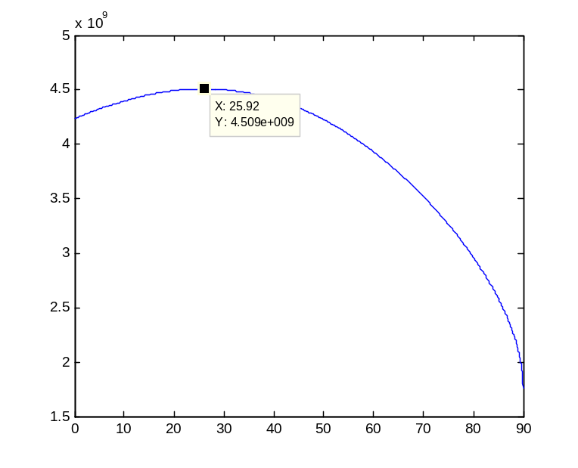
Fig. 6. The relationship between the annual total solar energy density and tilt angle
Tilt angle β [degree]
In Fig. 6 W_{S,year} increases at first and then decreases as the value of β rises, which forms a parabola with the maximum value point at (25.92 °, 4.509*10⁹ J/m²). Therefore, when the tilt angle of the oblique panel is 25.92 °, the maximum annual total solar energy density which is 4.509*10⁹ J/ m² is obtained, which exceeds that derived for the case by using a horizontal panel. According to this result, the fact is proved that with a suitable tilt angle, more solar radiation projects onto the panel.
(2) The relationship between the PV panel output electric energy density and tilt angle
With the model of PV panel solar energy density introduced and the relevant data for 200W Yingli PV panel, the model of electric energy density produced by the PV panel is simulated by MATLAB, which is displayed in Fig. 7. The tilt angle of PV panel β (°) is shown in the x-axis, and the y-axis represents the output electric energy density of PV panel W_{E,year} (J/m²).
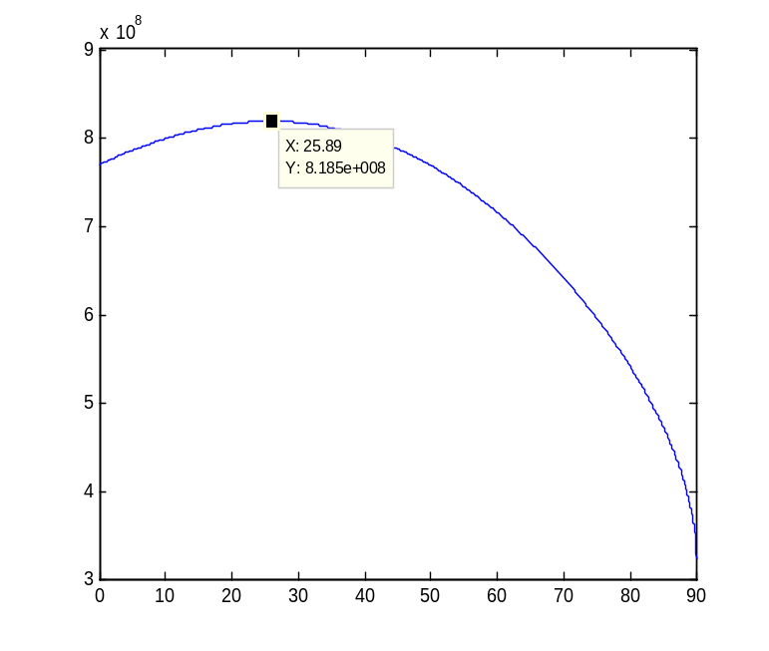
Fig. 7. The relationship between the annual total electric energy density and tilt angle
Tilt angle β [degree]
Similar to the former case, the locus of W_{E,year} is a parabola with the increase of β, with the maximum value point of (25.89 °, 8.19*10⁸ J/m²). It can be seen that with the influence of conversion efficiency of the PV panel and environmental factors, only 18.2% of solar power is converted into electric power output. In addition, when the effect of the working temperature of PV panel is taken into account, the optimum tilt angle slightly decreases, and the degree of decrease is sensitive to the temperature coefficient α_{p} of the output electric energy density. If |α_{p}| increases, the corresponding value of β at the maximum value point decreases.
Annual total electric energy density W_{E,year} [J/m²]
Annual total electric energy density W_{dust} [J/m²]
Transmittance of light τ
Tilt angle β [degree]
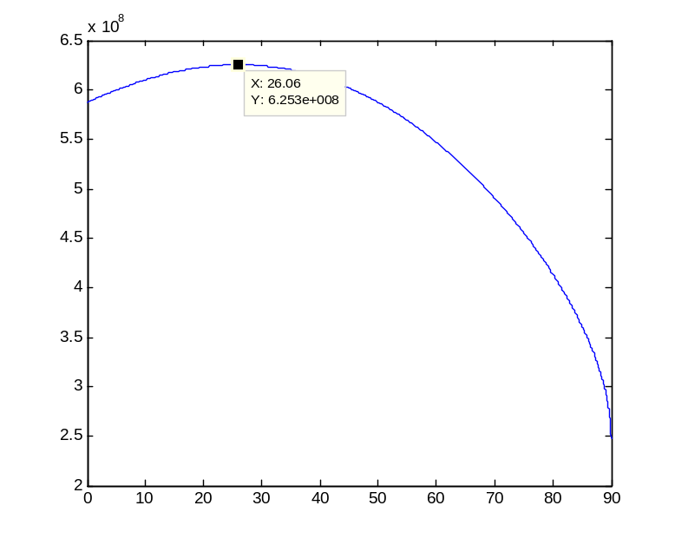
Fig. 9. The relationship between the annual total electric energy density considering dust deposition and tilt angle
Tilt angle β [degree]
Tilt angle β [degree]
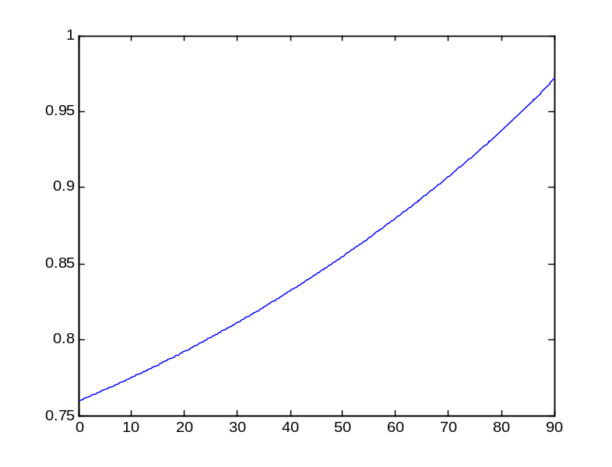
Fig. 8. The relationship between the transmittance of light and tilt angle

(3) The relationship between the output electric energy density and tilt angle considering dust deposition
According to the dust fall quantity in Hangzhou in 2011, which is 6.82 ton/km² (6.82 g/m²), the graph showing the relationship between the transmittance of light τ and tilt angle β is derived in Fig. 8 when the dust deposition density is fixed.
From Fig. 8 it can be seen that the transmittance of light τ increases with the tilt angle β from 0.76 to 0.97, which caters to the analysis results in previous sections.
Multiply the transmittance of light τ with the solar energy density, and then simulate the output electric energy density of PV panel, the relationship between the PV output electric energy density with consideration of dust deposition W_{dust} (J/m²) and tilt angle β (°) is obtained in Fig. 9.
In Fig. 9 W_{dust} first increases with β and then decreases, with the maximum value point at (26.06 °, 6.25*10⁸ J/m²). It is clearly observed that when dust deposition is included, the annual output electric energy density of PV panel falls by 23.7%, which means that dust deposition on the surface of PV panel influences the power output a lot. For comparison, the graphs for the relationships between the annual total electric energy density and tilt angle under both the situations with and without consideration of dust deposition are depicted in Fig. 10. From this figure, the optimum tilt angle increases from 25.89 ° to 26.06 ° after the effect of dust deposition is considered.
Annual total output electric energy density [J/m²]
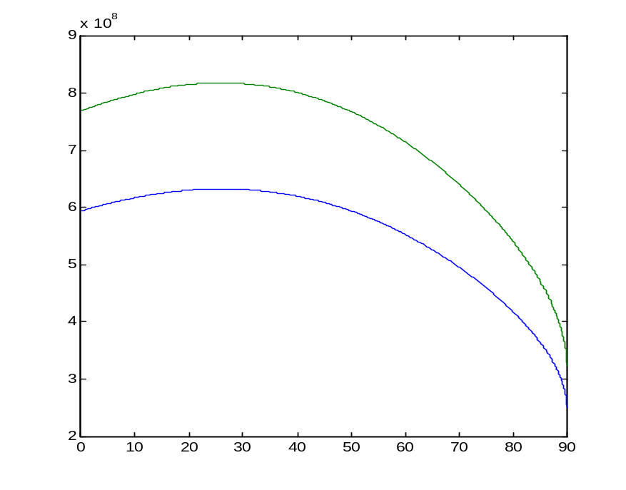
Fig. 10. Annual total output electric energy density under the situations with (lower) and without (upper) dust deposition
Tilt angle β [degree]
With dust deposition
Without dust deposition
With different dust deposition densities, the optimum tilt angles are different. When the dust deposition density is large, its influence on the transmittance of light is relatively obvious, which results in distinct variation in the value of the optimum tilt angle. However, the influence of dust on the transmittance of light tends to moderate with the increase of dust deposition density. Therefore, the locus of the influence of dust deposition density on the optimum tilt angle is a curve with a gradually decreasing slope, which is shown in Fig. 11.
Overall, from the simulation results, the output energy density derived by using the optimized model considering the dust deposition decreases obviously. When the dust deposition density is close to 7g/m², the output value falls by 30%. However, when the optimum tilt angle is calculated by the optimized model, its value increases slightly, while the increasing rate decreases with the increase in dust deposition density.
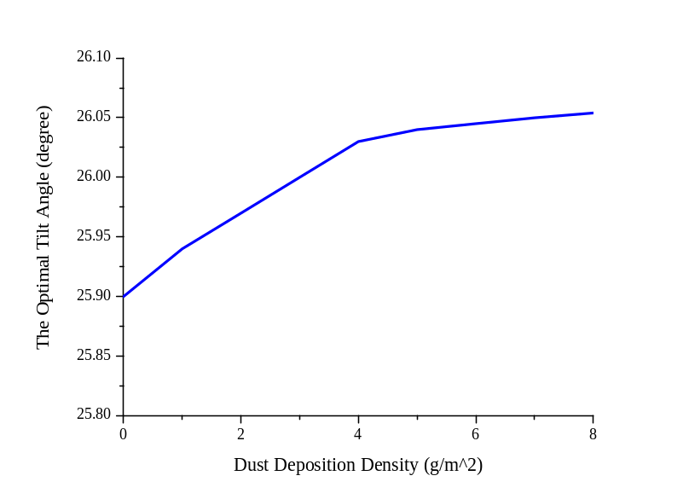
Fig. 11. The optimum tilt angle under different dust deposition density
V. Experiment of Temperature Effect by Dust Deposition
A. Design of Experiment
In order to investigate the effect of dust deposition on the working temperature of PV panel, a long-arc xenon lamp is designed to simulate indoor solar radiation. The PV panel used has the rated power of 2 W and the rated voltage of 6 V. Its length is 135 mm and the width is 110 mm, and it has an area of 148.5 cm². A resistor with the resistance of 20 Ω is connected at the output side of the circuit. An electronic scale with the measuring range of 200 g and accuracy of 0.01 g is used to measure the weight of the PV panel including wires and resistors, and the weight is 57.28 g.
The dust is replaced by water-free soil in the experiment. After the brown water-free soil is sieved and become particles that can float in the air, it is uniformly scattered on the PV panel by a brush which is away from the panel by 30 cm. The PV panel with uniformly covered soil is displayed in Fig. 12, along with the electronic scale. The displayed value on the electronic scale is 57.38 g, meaning that 0.1 g of soil stays on the panel. The speed of increment for the volume of soil deposition decelerates with the increase of time for soil deposition, and the effect on soil deposition volume tends to saturate as the soil density rises. Therefore, to simulate the situation of natural soil deposition, the maximum weight for soil is 0.7 g in the experiment, which means the density is 4.71 g/m².
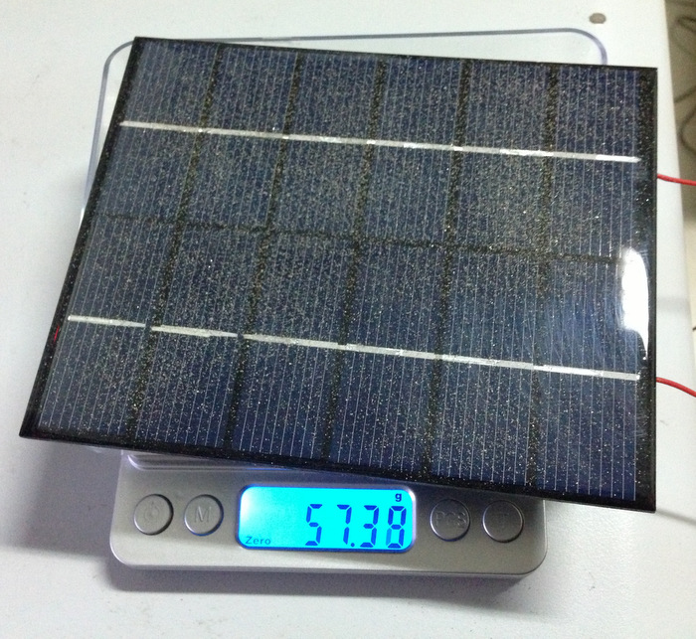
Fig. 12. The PV panel with dust covered on the surface in the experiment
A long-arc xenon lamp rated at 1000 W with adjustable power output is applied to simulate the sun light. The PV panel is put in a white experimental box with white paper paved at the bottom of the box, which is shown in Fig. 13. Because uniform radiation cannot be obtained for the PV panel by using the long-arc xenon lamp, the light reflected from the white surfaces is utilized to make the light illuminance in the experimental box relatively uniform. Different illumination intensities of the long-arc xenon lamp result in different working temperatures for the PV panel, and the temperature of the panel can exceed 100 °C when the illumination intensity is high. In this experiment, in order to avoid the situation that high temperature affects the quality of PV panel, the illumination intensity from the long-arc xenon lamp is kept at a low level and the same value is used all the time.
When a clean PV panel without soil on its surface is put in the experimental box to receive light illuminance, an infrared thermometer is used to measure the temperature of each part of the panel. The results show that the temperatures for different parts are not the same, and the maximum difference is about 3°C, indicating that the temperature on the surface of PV panel is not distributed uniformly. Even if two PV panels with the same type and connected to resistors with the same resistance are used for the experiment, the working temperatures for the same point on the two panels are different. Therefore, it is not convincing to use two PV panels for the control experiment to compare the situations with and without soil attached. In this experiment, only one PV panel is employed for multiple experiments to explore the effect of soil on working temperature. To exclude the effect of non-uniform light illuminance, lines are drawn as borders on the white paper and the PV panel is put in exactly the same place for each experiment.
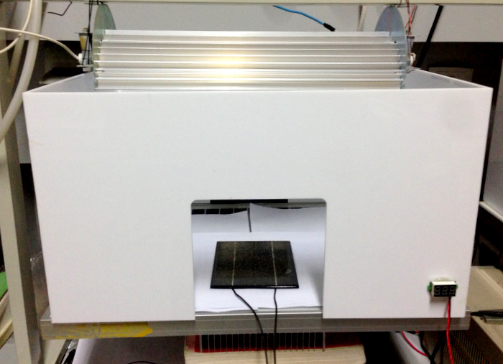
Fig. 13. Experimental box
At the beginning of experiment, the long-arc xenon lamp is used to illuminate the PV panel without soil on its surface for 10 minutes. From the third minute, the temperature at a specific point on the PV panel (set as point A shown in Fig. 14) is measured by the infrared thermometer once every minute, and the output voltage at the end of the last minute is recorded by a multimeter. Then turn off the long-arc xenon lamp, and until the experimental box cools down to 29 °C and the temperature of PV panel falls to 27 °C (the cooling time is around 30 minutes), the next experiment of measuring temperature can be taken. The temperature at point A should be the same for each measurement in each experiment.
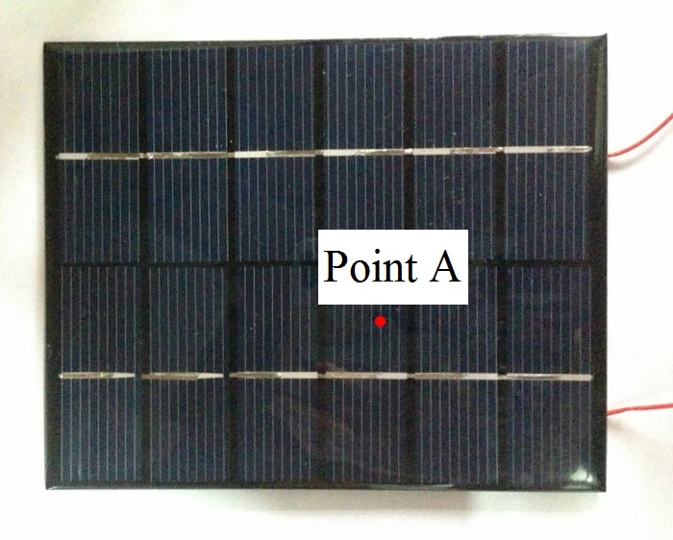
Fig. 14. The position of temperature measurement point A
The aim of measuring the temperature repeatedly by using a soil-free PV panel is to guarantee the same starting point of temperature for the PV panel with soil deposition in the forthcoming experiments. According to the experimental results, the working temperature of PV panel is related to the time of light illuminance, environmental temperature, initial temperature and times of experiments. For example, when the PV panel is idle for a day, the rising speed of working temperature for the first time when it adopts light illuminance is slower than that in the experiments afterwards. Therefore, for the purpose of excluding the environmental effects and ensuring the reliability of experiments, the experiments of measuring temperature are conducted repeatedly with the same illumination time, environmental temperature and initial PV panel temperature until the rising speeds of temperature and the temperatures at point A are the same for all the experiments.
After the experiments above are finished, the experiments for PV panels with soil are carried out, and the temperatures after cooling should be the same as mentioned in the previous experiment procedure. Firstly, the soil is uniformly distributed on the PV panel, and the weight of soil is measured and recorded by an electronic scale. Secondly, put the panel into the experimental box for light illumination, and record the voltage output and the temperature at point A for each minute between the third and tenth minutes. Finally, after the experiment is completed, fetch the PV panel out and clean up the soil. After the panel cools down, the soil with a different weight is put on the panel, and then repeat the experiment. The experimental data is recorded in a table.
B. Experimental results and analysis
In the experiments the light illuminance of the long-arc xenon lamp is fixed at 30 W/m², the room temperature is 25 °C, and the temperature measurement point is always at point A.
The experiments with soil-free PV panel for temperature and voltage measurement are first performed repeatedly. At the beginning of each experiment, the temperature inside the experimental box is always 30 ± 0.5 °C, and the initial temperature of the PV panel surface is 27 ± 0.5 °C. Since the PV panel has worked for over two times before the experiments of temperature and voltage measurement, the first experiment in this paper is conducted at the initial temperature mentioned above, instead of 25 °C. The experimental results are listed in Table 7.
Table 7. Temperature and voltage measurement for the soil-free PV panel
Experiment Times |  | 1 | 2 | 3 | 4 | 5 | 6 | 7
Temperature (℃) | 3 min | 43.6 | 43.4 | 43 | 43 | 43.6 | 43.8 | 43.6
Temperature (℃) | 4 min | 46.4 | 46.4 | 46 | 46.2 | 47 | 47 | 46.8
Temperature (℃) | 5 min | 48.8 | 48.8 | 48.6 | 48.8 | 49.4 | 49.6 | 49.2
Temperature (℃) | 6 min | 50.8 | 50.6 | 50.6 | 50.6 | 51.4 | 51.2 | 51.2
Temperature (℃) | 7 min | 51.8 | 52.2 | 52 | 52.2 | 52.6 | 53.4 | 52.6
Temperature (℃) | 8 min | 52.8 | 53 | 53.6 | 53.6 | 53.4 | 54.6 | 53.6
Temperature (℃) | 9 min | 53.8 | 54 | 54 | 54.4 | 54.6 | 55.4 | 54.4
Temperature (℃) | 10 min | 54.8 | 55.2 | 54.8 | 55.2 | 55.6 | 55.8 | 55.6
Output Voltage (V) |  | / | / | 0.748 | 0.748 | 0.744 | 0.745 | 0.741

From the data in Table 7, the temperatures at each time point are almost equal to each other after multiple experiments, and the working state of PV panel is considered to be stable. The weights of soil distributed on the PV panel are respectively 0.1 g, 0.3 g, 0.5 g and 0.7 g. After the measurements of temperature and output voltage, the statistics are derived in Table 7, and the variations of temperatures with time under different soil deposition densities are illustrated in Fig. 15.
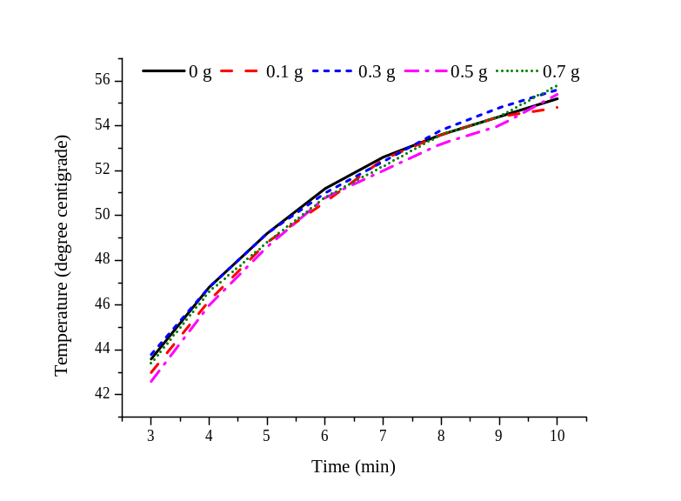
Fig. 15. Working temperature of the PV panel with different weight of soil
According to the results shown in Table 8, the output voltage decreases as the soil deposition density increases which blocks more area of the PV panel surface. Under the soil deposition density of 4.71 g/m², the voltage falls to 63% of the original value, meaning that the soil covered has significant influence on the power output of PV panel. However, there is no obvious trend of temperature variation when different soil deposition densities are applied. At the tenth minute, the increasing speed of temperature gradually reduces, and the working temperature approaches the vertex. In the experiments of this work, the differences in temperatures are not compared when the working temperatures are different by making the PV panel work for a long period of time. Since heat dissipation in the experimental box is not good enough, the temperature of air inside the box affects the temperature on PV panel, which deteriorates the accuracy of experimental results. From Fig. 15, there are no obvious relationships among the five curves. Therefore, soil deposition almost has no effect on the working temperature of PV panel under the conditions of the experiments in this work.
Table 8. Temperature and voltage measurement for the PV panel with soil
Weight of dust (g) |  | 0 | 0.1 | 0.3 | 0.5 | 0.7
Density of dust (g/m²) |  | 0 | 0.67 | 2.02 | 3.37 | 4.71
Temperature (℃) | 3 min | 43.6 | 43.0 | 43.8 | 42.6 | 43.4
Temperature (℃) | 4 min | 46.8 | 46.2 | 46.8 | 46.0 | 46.6
Temperature (℃) | 5 min | 49.2 | 48.8 | 49.2 | 48.6 | 48.8
Temperature (℃) | 6 min | 51.2 | 50.6 | 51.0 | 50.8 | 50.8
Temperature (℃) | 7 min | 52.6 | 52.5 | 52.4 | 52.0 | 52.2
Temperature (℃) | 8 min | 53.6 | 53.6 | 53.8 | 53.2 | 53.6
Temperature (℃) | 9 min | 54.4 | 54.4 | 54.8 | 54.0 | 54.4
Temperature (℃) | 10 min | 55.2 | 54.8 | 55.6 | 55.4 | 55.8
Output Voltage (V) |  | 0.748 | 0.702 | 0.623 | 0.582 | 0.474

VI. Conclusions
In this paper, the factor of dust deposition is included in the original model of the optimum tilt angle of a fixed-type soiled PV panel in order to maximize the output power. A fitting formula which presents a linear relationship between the dust deposition density and tilt angle is derived, and it is proved to be applicable for commonly used values of tilt angle in practice. Then an optimized mathematical model of the optimum tilt angle is proposed for a soiled PV panel. With the increase of the dust density on a PV panel, the optimum tilt angle becomes larger, while the increasing speed of it decelerates since the dust density approaches saturation. Besides, the shielding effect of dust deposition on the reduction in transmittance is investigated mathematically with respect to the tilt angle. Matlab simulation is conducted to verify the optimized model of optimum tilt angle by using the data of solar energy density in Hangzhou. The optimum tilt angle of YL200P-23b PV panel changes from 25.89 ° to 26.06 ° after dust effect is taken into consideration. Furthermore, indoor experiments are carried out to demonstrate that dust deposition hardly has any effect on the working temperature of a PV panel. However, the output voltage decreases by over 60% when the dust deposition density is 4.71 g/m², indicating that the power output of PV panel is seriously cut down.
References
[1] P. G. V. Sampaio, M. O. A. González, “Photovoltaic solar energy: Conceptual framework,” Renewable and Sustainable Energy Reviews, vol. 74, pp.590-601, 2017.
[2] W. Ji, Y. Zhou, Y. Sun, W. Zhang, B. An, J. Wang, “Thermodynamic analysis of a novel hybrid wind-solar-compressed air energy storage system,” Energy Conversion and Management, vol. 142, pp. 176-187, 2017.
[3] H. Chang, Z. Wan, Y. Zheng, X. Chen, S. Shu, Z. Tu, “Energy analysis of a hybrid PEMFC–solar energy residential micro-CCHP system combined with an organic Rankine cycle and vapor compression cycle,” Energy Conversion and Management, vol. 142, pp. 374-384, 2017.
[4] Y. E. Mghouchi, E. Chham, M. S. Krikiz, T. Ajzoul, A. E. Bouardi, “On the prediction of the daily global solar radiation intensity on south-facing plane surfaces inclined at varying angles,” Energy Conversion and Management, vol. 120, pp. 397-411, 2016.
[5] S. Pulipaka, R. Kumar, “Analysis of irradiance losses on a soiled photovoltaic panel using contours,” Energy Conversion and Management, vol. 115, pp. 327-336, 2016.
[6] M. Lv, J. Li, W. Zhu, H. Du, J. Meng, K. Sun, “A theoretical study of rotatable renewable energy system for stratospheric airship,” Energy Conversion and Management, vol. 140, pp. 51-61, 2017.
[7] A. A. Salim, F. S. Huraib, N. N. Eugenio, “PV power-study of system options and optimization,” EC Photovoltaic Solar Conference. 8, pp. 688-692, 1988.
[8] F. Wakim, “Introduction of PV power generation to Kuwait,” Kuwait Institute for Scientific Researchers, Kuwait City, 1981.
[9] M. Mani, R. Pillai, “Impact of dust on solar photovoltaic (PV) performance: Research status, challenges and recommendations,” Renewable and Sustainable Energy Reviews, vol. 14, no. 9, pp. 3124-3131, 2010.
[10] T. Mahachi, A.J. Rix, “Evaluation of irradiance decomposition and transposition models for a region in South Africa investigating the sensitivity of various diffuse radiation models,” IECON Proceedings (Industrial Electronics Conference), art. no. 7793897, pp. 3064-3069, 2016.
[11] M. Malvoni, M.C. Fiore, G. Maggiotto, L. Mancarella, R. Quarta, V. Radice, P.M. Congedo, M.G. De Giorgi, “Improvements in the predictions for the photovoltaic system performance of the Mediterranean regions,” Energy Conversion and Management, 128, pp. 191-202, 2016.
[12] Y.S. Khoo, A. Nobre, R. Malhotra, D.Yang, R. Ruther, T. Reindl, A.G. Aberle, “Optimal orientation and tilt angle for maximizing in-plane solar irradiation for PV applications in Singapore” IEEE Journal of Photovoltaics, 4 (2), art. no. 6683004, pp. 647-653, 2014.
[13] W. Yao, C. Zhang, X. Wang, J. Sheng, Y. Zhu, S. Zhang, “The research of new daily diffuse solar radiation models modified by air quality index (AQI) in the region with heavy fog and haze,” Energy Conversion and Management, vol. 139, pp. 140-150, 2017.
[14] I. A. Ibrahim, T. Khatib, “A novel hybrid model for hourly global solar radiation prediction using random forests technique and firefly algorithm,” Energy Conversion and Management, vol. 138, pp. 413-425, 2017.
[15] Y. Hu, B. Gao, X. Song, G. Tian, K. Li, X. He. “Photovoltaic Fault Detection Using a Parameter Based Model” Solar Energy, Vol. 96, Oct. 2013, 96–102.
[16] Y. Hu, J. Zhang, J. Wu, W. Cao, G. Tian, “Efficiency Improvement of Non-Uniformly-Aged PV Arrays,” IEEE Transactions on Power Electronics., vol. 32, no. 2, pp. 1124-1137, Feb. 2017.
[17] M. J. Adinoyi and S. A.M. Said, “Effect of dust accumulation on the power outputs of solar photovoltaic modules,” Renewable Energy, vol. 60, pp. 633-636, 2013.
[18] S. C.S. Costa, A. S. A.C. Diniz, and L. L. Kazmerski, “Dust and soiling issues and impacts relating to solar energy systems: Literature review update for 2012-2015,” Renewable and Sustainable Energy Reviews, vol. 63, pp. 33-61, 2016.
[19] M. N. Horenstein, M. K. Mazumder, R. C. Sumner, J. Stark, T. Abuhamed, and R. Boxman, “Modeling of Trajectories in an Electrodynamic Screen for Obtaining Maximum Particle Removal Efficiency,” IEEE Transactions on Industry Applications, vol. 49, no. 2, March/April 2013.
[20] M. Mazumder, M. N. Horenstein, J. W. Stark, P. Girouard, R. Sumner, B. Henderson, O. Sadder, I. Hidetaka, A. S. Biris, and R. Sharma, “Characterization of Electrodynamic Screen Performance for Dust Removal from Solar Panels and Solar Hydrogen Generators,” IEEE Transactions on Industry Applications, vol. 49, no. 4, July/August 2013.
[21] A. Sayyah, R. S. Eriksen, M. N. Horenstein, and M. K. Mazumder, “Performance Analysis of Electrodynmaic Screens Based on Residual Particle Size Distribution,” IEEE Journal of Photovoltaics, vol. 7, no. 1, January 2017.
[22] L. L. Kazmerski, A. S. A. C. Diniz, C. B. Maia, M. M. Viana, S. C. Costa, P. P. Brito, C. D. Campos, L. V. M. Neto, S. de M. Hanriot, and L. R. de O. Cruz, “Fundamental Studies of Adhesion of Dust to PV Module Surfaces: Chemical and Physical Relationships at the Microscale,” IEEE Journal of Photovoltaics, vol. 6, no. 3, May 2016.
[23] H. Qasem, T. R. Betts, H. Müllejans, H. AlBusairi and R. Gottschalg, “Dust-induced shading on photovoltaic modules,” Progress in Photovoltaics: Research and Applications, vol. 22, pp. 218-226, 2014.
[24] S. Ghazi, A. Sayigh, K. Ip, “Dust effect on flat surfaces – A review paper,” Renewable and Sustainable Energy Reviews, vol. 33, pp. 742-751, 2014.
[25] JA Duffie, WA Beckman, “Solar engineering of thermal processes,” New York: Wiley; 1982.
[26] D. T. Reindl, W. A. Beckman, J. A. Duffie, “Evaluation of hourly tilted surface radiation models,” Solar Energy, vol. 45, no. 1, pp. 9-17, 1990.
[27] J. E. Hay, J. A. Davies, “Calculation of the solar radiation incident on an inclined surface,” Proceedings First Canadian Solar Radiation Workshop, pp. 59-72, 1980.
[28] T. Maatallah, S. Alimi, S. Ben Nassrallah, “Performance modeling and investigation of fixed, single and dual-axis tracking photovoltaic panel in Monastir city, Tunisia,” Renewable and Sustainable Energy Reviews, vol. 15, no. 8, pp. 4053–4066, 2011.
[29] A. A. Hegazy, “Effect of dust accumulation on solar transmittance through glass covers of plate-type collectors,” Renewable Energy, vol. 22, no. 4, pp. 525-540, 2001.
[30] H. K. Elminir, A. E. Ghitas, R. H. Hamid, et al. “Effect of dust on the transparent cover of solar collectors,” Energy Conversion and Management, vol. 47, no. 18, pp. 3192-3203, 2006.
[31] G. A. Mastekbayeva, S. Kumar, “Effect of dust on the transmittance of low density polyethylene glazing in a tropical climate,” Solar Energy, vol. 68, no. 2, pp. 135-141, 2000.
[32] M. A. Basunia, H. Yoshiob, T. Abec, “Simulation of Solar Radiation Incident on Horizontal and Inclined Surfaces,” TJER, vol. 9, no. 2, pp. 27-35, 2012.
[33] Q. Zhang, H. Yang, “The Standard Meteorological Data Manual for Architecture,” China Building Industry Press, 2012.
[34] Reference Room of China Meteorological Information Center, Department of Architecture Science Technology in Tsinghua University, “Special Meteorological Data Set for Thermal Environment Analysis of Buildings in China,” China Building Industry Press, 2005.
[35] Yingli Solar Panel YGE 48Cell 40mm Series Data Book.

