Aerodynamic noise numerical simulation and noise reduction study on automobile alternator
Chunrong Hua^{1*}, Yadong Zhang², Dawei Dong², Bin Yan¹ and Huajiang Ouyang^{3,4}
¹ School of Mechanical Engineering, Southwest Jiaotong University, Chengdu 610031,China
²State Key Laboratory of Traction Power, Southwest Jiaotong University, Chengdu 610031,China
³School of Engineering, University of Liverpool, Liverpool L69 3GH,UK
⁴The State Key Laboratory of Structural Analysis for Industrial Equipment, Dalian University of Technology, Dalian 116023, China.
(Manuscript Received 000 0, 2009; Revised 000 0, 2009; Accepted 000 0, 2009) -please leave blank
----------------------------------------------------------------------------------------------------------------------------------------------------------------------------------------------------------------------------------------------------------------------------------------------

Abstract

Aerodynamic noise is the predominant component of automobile alternator noise at high speed, which directly affects the noise characteristic and noise control of alternator. Based on Lighthill acoustic theory, the aerodynamic noise of an automobile alternator was simulated with three-dimensional, large eddy simulation (LES) and Ffowcs Williams-Hawkings (FW-H) acoustic model, and the aerodynamic noise reduction research was conducted through optimizing the front fan blade spacing angle of alternator with vector composition method while considering high fan flow and optimal noise frequency components for reduced harmonic rotating noise of alternator. The results show that the sound pressure amplitude of the primary aerodynamic noise components simulated with LES are in good agreement with experimental ones, and the dominant harmonic frequency components of aerodynamic noise are in the 4th, 6th, 8th, 10th, 12th and 18th orders and the A-weighted sound pressure level of one-third octave mainly concentrates in 1120-7000 Hz. The average total noise level of alternator noise is decreased by 2.58 dB, and the mass flow of monitoring surface of fan blade is increased by 1.36 g/s with 5.80 dB decrease in the sound level of the 12th and 18th harmonic orders on average with optimized front fan blade spacing angles, which verifies the effectiveness of the noise reduction method proposed in this paper.

Keywords: Alternator; fan blade; spacing angle; aerodynamic noise; large eddy simulation (LES); noise reduction
----------------------------------------------------------------------------------------------------------------------------------------------------------------------------------------------------------------------------------------------------------------------------------------------

1. Introduction
Automotive NVH (Noise, Vibration and Harshness) research has been developed on from the whole vehicle and assemblies to parts and components with demanding requirements on automobile comfort. As one of the important components on cars, an alternator has a great contribution to automobile noise especially the harmonic noise [1-2]. Alternator noise can be classified into mechanical noise, coupling noise (generated by the interaction between gas and structure), aerodynamic noise and electro-magnetic noise, among which the aerodynamic noise becomes the dominant alternator noise component at 6000 r/min or above [1,3-4]. The aerodynamic noise is generated by periodic pressure fluctuation and vortex generation and shedding, and rupture of fan blade surface. The magnitude of the aerodynamic noise is closely related to the structure of cooling fan, rotating speed and air passage of the alternator. Currently noise control of alternators is not effective because of complex sound source components and difficulties in separation of noise source. Therefore it is of significant importance to study the characteristic and noise reduction of aerodynamic noise of automobile alternators.
At present a great deal of studies have been made on aerodynamic noise of automobile alternators. The Lighthill acoustic analogy theory was used in prediction and reduction of aerodynamic noise [5-7]. In order to investigate the characteristic and mechanism of aerodynamic noise, a large number of experiments were performed on automobile alternators and results indicated that the turbulent pressure generated by high speed rotation of front and rear cooling fan blades was the sound source of aerodynamic noise of alternators [2-4,8,9]. But experimental methods are time-consuming and expensive, and the vortex-induced aerodynamic noise is a result of rotating machine components which is difficult to be recognized in alternator tests, resulting in poor information on the contribution of the aerodynamic noise to the whole noise level of an alternator. Based on the Taguchi method, a low-noise cooling fan of an alternator was developed through optimizing the design factors of fan blade with CFD (Computational Fluid Dynamics) and acoustic software [10], however, the eddy noise was not considered on the aerodynamic noise simulation, and the error between simulated results and experimental ones increased greatly at high speed.
In this paper, the aerodynamic noise of an automobile alternator was simulated with three-dimensional large eddy simulation (LES) method and Ffowcs Williams-Hawkings (FW-H) acoustic model; and the spacing angles of the front fan blade were optimised aiming at reducing the harmonic rotating noise of the alternator while considering high fan flow and optimal noise frequency components; experiments were also carried out to verify the noise reduction performance on aerodynamic noise of an automobile alternator with the method presented in the paper.

2. Aerodynamic noise analysis methods
Genernally CFD can be used to simulate the air flow around the alternator, and Computational AeroAcoustics (CAA) was adopted to calculate the aerodynamic noise [2]. In typical CFD turbulence models, the Subgrid Scale Stress (SGS) model of LES is more universal than the unsteady Reynolds-averaged Navier-Stokes (URANS) model, and a lot of computating time is saved compared to direct numerical simulation (DNS) [10,11]. As URANS with empirical parameters can only capture unsteady mean-flow structures and is unable to provide the detailed unsteady flow information required for noise calculations, whereras LES turbulence model can be used to simulate the dynamic fluid flow characteristics [12], and DNS is considered to be a simple research tool for low Reynolds numbers [11]. Therefore the aerodynamic noise around alternator in this paper was predicted with the LES turbulence model.

2.1 Large eddy simulation
The LES method requires building of a model to approximate the SGS effect for large-scale turbulence[11], and then the Smagorinski-Lilly model was selected, which ensured overall energy conservation by suitably accounting for the energy dissipation capacity and incorporating energy transfer assumptions into the eddy viscosity. The LES model is expressed by
(1)
(2)
(3)

2.2 Ffowcs Williams-Hawkings acoustic analogy
The acoustic analogy method is widely used in CAA, which was first presented by Lighthill [5] and was popularized by Curle [6], Ffowcs Williams and Hawkings [7] obtained the FW-H equation, and the differential equation is given by
(4)
(5)
(6)
FW-H equation indicates that the sound pressure is induced by the transient variable particle force and acceleration, the right-hand side of Eq.(6) represents monopole, dipole and quadrupole sound sources respectively. Neise concluded in his research that the dominant source of fan noise was dipole resulting from the unsteady force fluctuation [13]. As the noise source of alternators is thought to be caused by rotating blades and the air beaten by blades, the aerodynamic noise of the alternator only induced by dipole sound source is studied in this paper.
As the simulated data of sound source with CFD and the acoustic field results with CAA are independent of each other regardless of the influence of the acoustic field on the fluid field in this research, an intermediate file is created to transfer data between CFD and CAA [2,10], then the predicted sound field is obtained by solving the FW-H equation.

3. Computational model and conditions

3.1 The geometry model
Fig.1 shows the internal and external views of an automobile alternator studied in this paper, which consists of front and rear covers, stator, rotor (including front and rear fans, claw poles and field winding etc.) and so on. The cooling system of the alternator consists of front and rear centrifugal fans with 9 blades for the front fan and 10 blades for the rear fan, Fig.2 is the spacing angles of the front fan blade.
Claw pole
Front cover
Front fan
Rear fan
Rear cover
Cover
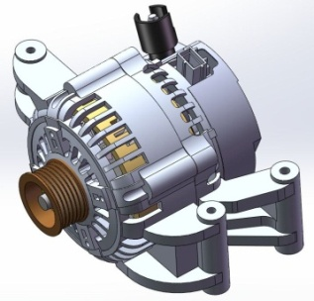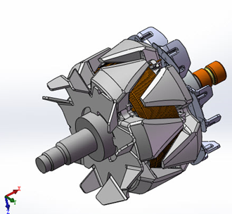

Fig.1. External and internal views of the alternator.
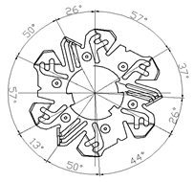
Fig.2. The spacing angles of the front fan blade.

3.2 Computational domain and solution setup
The hydrodynamic calculation method is used to study the aerodynamic noise characteristic and noise reduction proposal, and it is very important to simulate slipping boundary and unsteady flow field accurately in moving mesh. Using a sphere surrounding the alternator as the computational domain in numerical simulation (as shown in Fig.3(a)), the size of which is selected as eight times the size of feature length of the alternator (the longitudinal maximum size of the alternator). The fluid space comprises stationary and rotating parts, and the fluid field of the front and rear cover, stator and rectifier is stationary while that of front and rear fan and claw poles is rotating. The slipping grid technique is used to implement the relative motion between stationary and rotating parts in numerical simulation with five interfaces between them as shown in Fig.3(b), and the five selected interface are labelled Interface1-Interface5.
Interface4
Interface3
Interface2
Interface1
Interface5
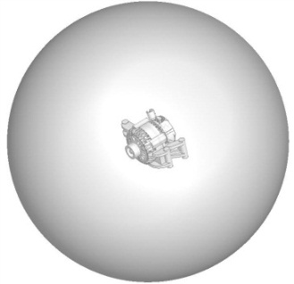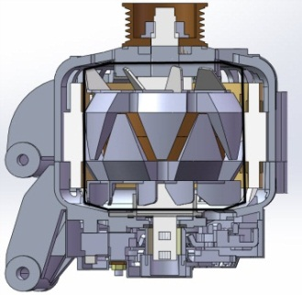

- Computation domain (b) Moving interface
Fig.3. Boundary conditions
The rotating speed of the outlet boundary in the computational domain is selected as 14000 RPM according to the test condition, and the entry initial conditions are as follows: the output relative total pressure is 0 Pa, the relative surface pressure is 0 Pa, and the initial rotational speed is 14000 r/min.
To verify the CFD calculations, the flow field and sound propagation around the automobile alternator model were obtained from a LES using high-order difference schemes and the FW-H acoustic analogy. The commercial CFD program FLUENT was applied to calculate the unsteady aerodynamic noise, and a steady turbulence computation was performed first and its results were used as the initial unsteady values to solve the unsteady flow fields. Table 1 summarizes the main modelling schemes adopted for CFD simulations.

Table 1. Main modelling schemes adopted for CFD simulations
Time-dependency | Steady | Unsteady
Turbulence model | RNG k－ε | LES
Solver | Pressure Based | Pressure Based
Pressure-Velocity Coupling | SIMPLEC | PISO
Pressure Discretization | Standard | PRESTO!
Momentum Discretization | Second Order Upwind | Bounded Central Differencing
Turbulent Kinetic Energy Discretization | QUICK | QUICK
Turbulent Dissipation Rate Discretization | Second Order Upwind | Second Order Upwind
Furthermore the time step, the transient calculation time and computing time of the far field must be considered in numerical simulation. The transient calculation time depends on frequency components of interest and simulation convergence. As the fan speed is 14000 r/min, and the former 20 orders noise are commonly concerned, and the corresponding frequency is 4667 Hz, thus time step is less than 1.07×10⁻⁴ s according to Nyquist theorem. Also the less the time step in unsteady flow field simulation, the better the simulation results, and the time step is eventually determined as 1×10⁻⁵ s considering simulation convergence. The convergence criteria of the absolute residuals were chosen as 10⁻⁵, and the simulations were run with a physical time step size of 2×10⁻⁵ s, which yielded an adequate temporal resolution for the implicit time-marching scheme to ensure the convergence of the simulation at each time step, with a Courant-Friedrichs-Lewy number (CFL, CFL=uΔt/Δx) of less than 1 within the majority of the computational domain and a maximum CFL value of 2 within the entire computational domain.

3.3 Mesh-independent validation
Grid-independent validation was performed with different numbers of tetrahedral meshes combined to form a prism mesh near the alternator surface, with a more highly refined mesh in the claw pole regions of the rotor and the fans to assess the influence of different spatial meshes on the calculation results. With the thickness of the first prism layer defined to satisfy the requirement of the wall function [14], three meshes configurations were considered and the parameters of the three mesh configurations and the corresponding computational results are listed in Table 2. The SPL value of the alternator obtained using the first mesh configuration is only 0.3 dB lower than that obtained with the second mesh and 0.8 dB lower than that obtained with the third mesh. The mass flow rate value for the Interface1 obtained using the first mesh configuration is only 0.96% lower than that obtained with the second mesh and 1.97% lower than that obtained with the third mesh. Thus, it can be concluded that the mesh configuration has a minimal influence on computational results. Thus, all flow-field calculations presented in this paper were performed with the fewest mesh numbers configuration to reduce computation time. The maximum grid size of alternator surface is set to 2.5 mm, while that of the front and rear fan blades is controlled within 0.5 mm and is locally refined due to their structural complexity and high speed rotation. The maximum grid size in the gap is selected as 0.05 mm as the radial clearance between rotor and stator is 1.5 mm. The first set of mesh contains 6 prism layers with a stretching ratio of 1.1 and the thickness of the first layer is 0.1 mm, Fig.4 shows the distribution of spatial meshes.
Table 2. Mesh configurations and computational results
Mesh | Mesh number  (millions) | First layer thickness(mm) | First layer number | Minimum  (mm) | Maximum  (mm) | Stretching  ratio | Mass flow rate (g/s) | SPL  (dB)
1 | 14.14 | 0.1 | 6 | 0.5 | 2.5 | 1.1 | 49.13 | 99.1
2 | 18.26 | 0.1 | 8 | 0.4 | 2.2 | 1.1 | 48.66 | 99.4
3 | 22.74 | 0.1 | 8 | 0.3 | 2.0 | 1.1 | 49.13 | 99.9

0.05mm
2.5mm

Fig.4. Distribution of spatial meshes.

4. Simulation results and test verification

4.1 Flow characteristic of the alternator
Fig.5(a) shows the relative pressure distribution over the surface of the alternator, the pressure in pressure side is higher than that in suction side of front and rear blade, and the pressure in stator and claw poles of the rotor is higher than that of the front and rear blade, and the stator winding are at low pressure area resulted from the small clearance between rotor and stator. It can be seen from the velocity distribution of an axial section of the alternator in Fig.5(b) that there are relatively high air speed in inner claw poles, which can help rotor winding dissipate heat at high speed.

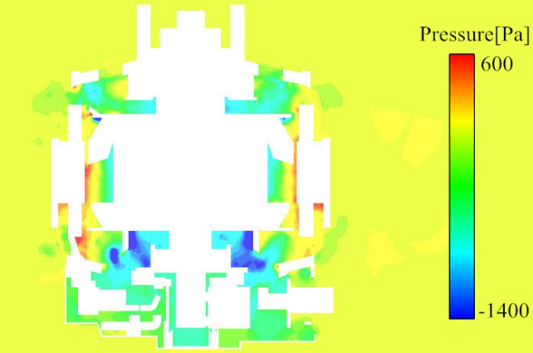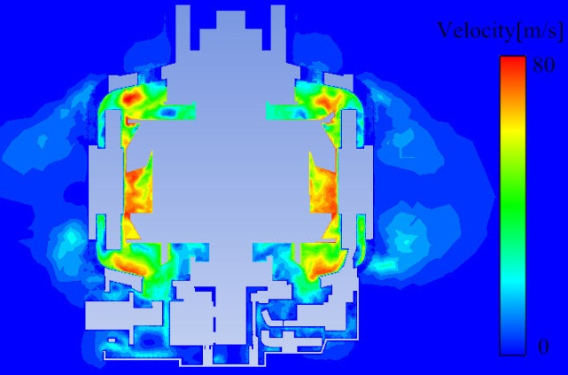

(a) Relative pressure distribution (b) Velocity distribution

Fig.5. Pressure and velocity distribution in an axial cross-section of the alternator.

Fig.6(a) is the relative pressure distribution of a section of front blade, it indicates that there is a quite large pressure difference between the front and rear side of each blade, showing the sound source of the blade surface should be one of the dominant sources of aerodynamic noise of the alternator, and the pressure on leading edge of fan blade pressure side is the highest in addition the pressure in front and rear side of each blade distributes non-uniformly, resulted from the symmetrically distributed front blade. Thereby optimum on spacing angle of front fan blade can reduce the aerodynamic noise of automobile alternator.

Fig.6(b) is the velocity distribution of a section of the front fan blade, it shows that the outlet air speed is interfered by the radial grille and the bracket of the cover, and in the outlet area close to wall surface, air speed is relatively low and the speed of the rear flange of blade is the highest due to the interaction of viscous force between air flow and wall surface. It indicated that optimization on radial grille tilting angle of front cover is also another effective approach to increase fan flow and reduce the aerodynamic noise of alternator, which is not discussed in this paper.

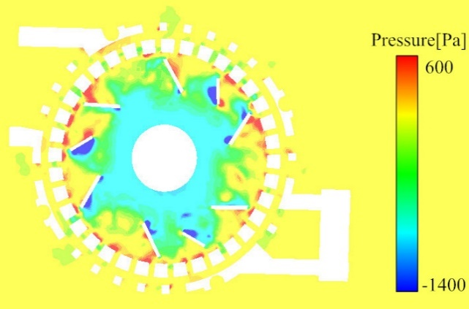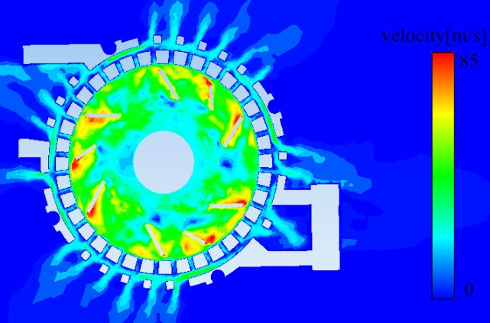
(a) Relative pressure distribution of front blade (b) Velocity distribution of front blade

Fig.6. Pressure and velocity distribution diagram of front-blade.

Fig.7 is the relative velocity vectorgraph of a section of the front blade, it can be seen that the secondary flow of the fan blade is obvious, which is due to the high pressure difference between the front and back blade face is high, resulting in air flow impact and inverse flow is easily formed near the front edge leaf of the blade, and secondary flow is then formed in the neighbourhood of the arc profile of fan blade, and the wake flow phenomenon is formed near the outlet of the blade tail by low surface pressure. The secondary flow not only consumes flow kinetic energy, but also reduces the fan power and increases the aerodynamic noise, moreover the impulse effect caused by secondary flow in the internal flow channel makes the flow unstable. Therefore it is an effective measure to reduce the alternator noise by optimizing the blade structure to reduce the secondary flow of blade.

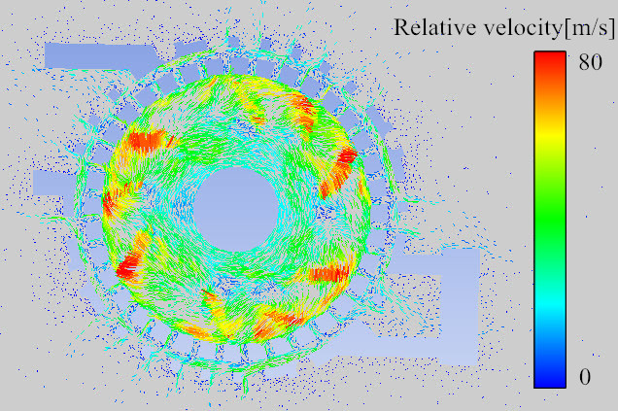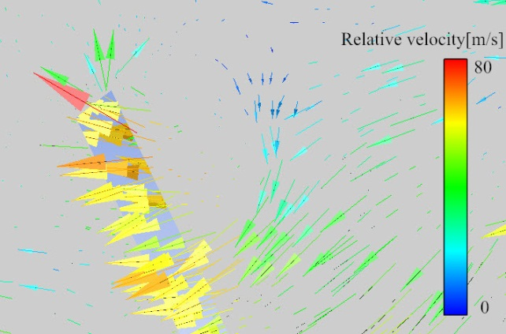

Fig.7. Relative velocity vector in horizontal section of the front fan

The particle tracking diagram of the front and rear fan velocity were obtained by post-processing the numerical results (see Fig. 8), it shows the working process of the cooling fan, the front fan blade takes in the air from the axial grille of the front end housing for cooling of the claw pole, coils, stator winding and other parts, and expels the air from the radial grille of the front end housing for heat radiating; the rear fan blade takes in the air from the axial shield for cooling of the rectifier, the coils of stator winding and other electronic equipment, and vents out the air from the radial grille for heat radiating.
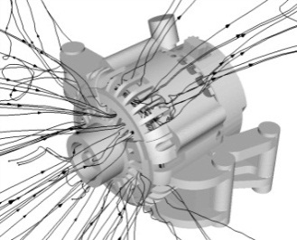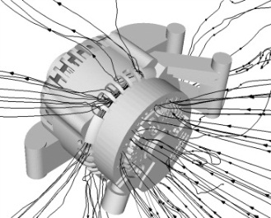

Fig.8. Traces of the front fan and rear fan

4.2. Sound Field Characteristic
The acoustic environment of the lab meets the requirements of GB/T6882-2008, and the alternator noise was tested under no-load condition, the measuring points were selected referring to the ‘the noise test standard of five points methods’ of a car factory [15]. The five points are at a distance of 0.5 m from the alternator centre and the sixth point is 45° on the front lateral direction and 0.2m distance from the alternator axial centre (as shown in Fig.9).

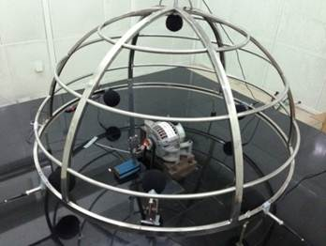

Fig.9. Test bench.

The total noise level at constant speed is obtained from computing the simulated fluctuating pressure values with FW-H method. Table 3 shows that the total noise level of experimental results are close to the computational ones; and the maximum error is 6.97 dB resulted from reflection and refraction of each sound-deadening surface in semi-anechoic room on total noise, the noise level increase induced by the air flow passing through test bed, contribution of environment, electromagnetic and mechanical noise, and the numerical simulation error without considering noise scattering, structure reflection and refraction in sound field.

Table 3. Aerodynamic noise comparison of test and simulation (dB).
Measuring Point | Front Point | Right point | Back Point | Left Point | Upper Point | Front Lateral  45°
Test values | 99.1 | 97.9 | 99.8 | 97.4 | 101.7 | 103.6
Simulation Values | 95.08 | 91.00 | 96.53 | 90.80 | 94.73 | 96.89
Errors | -4.02 | -6.90 | -3.27 | -6.60 | -6.97 | -6.71

The noise spectrum of each harmonic wave can be obtained with Fourier transform and order analysis method. Fig.10 presents the spectra of the radiated noise at the left measuring point indicated in Fig.9. Good agreement between the simulated and experimental spectra is observed in terms of both the tonal frequencies of the noise and the spectral shape. Furthermore, it shows the primary frequency characteristic of alternator noise— the rotating and eddy noise are the predominant components of alternator noise. It also indicates that the amplitudes of the primary harmonics of simulated results correspond fairly well with the experimental values at low frequency, and the 4th, 6th, 8th, 9th, 12th and 18th order harmonics are the dominant orders of the aerodynamic noise for the alternator, with the prediction errors of the 12th and 18th rotational noise being 2.3 dB and 3.3 dB respectively. The simulation results indicate that the LES/FW-H approach is an efficient and high-resolution computational method for aerodynamic noise prediction.
Fig.10. Noise spectrum of left measuring point.
Additionally, as the nine blades of alternator front fan are subdivided into three groups distributed uniformly(see Fig.2), the blades in each group distributes non-uniformly, while the angle of two blades is close to even distribution, such as the angle of blade 1 and 3 is 63°, the angle of blade 3 and 4 is 83°. And then the noise components of the orders multiplied by 6 should be prevalent in total noise level, coinciding with the experimental results. Consequently reducing noise level of main orders above 10000 r/min is feasible for aerodynamic noise control of alternator.

5. Noise reduction improvement simulation
The vector composition method is used to noise reduction research on alternator aerodynamic noise, the idea of which is that the vth harmonic wave of the total sound pressure of the measuring point equals to the superposition of the vth harmonic wave of the sound pressure induced by each blade based on the orthogonality of the harmonic signal [16].The main aerodynamic noise reduction procedures in this paper are to make optimal design on the front fan blade spacing angle, and predict the harmonic order of the larger rotating noise, and then smooth the noise spectrum of alternator to reduce the amplitude of the primary order of aerodynamic noise.

5.1 Mathematical model

5.1.1 Optimal goal
Unequal spacing of circumferential blades is an effective measure to reduce alternator noise [4]. When the circumferential spacing of the blade is changed, the total noise level remains unchanged, while the power distribution of noise becomes more uniform and the spectrum components are more optimal, and then the goal of controlling discrete frequency noise could be achieved. Therefore the goal is to make the sound pressure of the harmonic components requiring control small enough and other harmonic components not to increase too much.
Denote the number of harmonic waves requiring noise reduction as B, and the corresponding harmonic orders as $v_{1}, v_{2},$ …$,v_{B}$, and the number of other controlled harmonic waves as D and the corresponding harmonic orders as $τ_{1},τ_{2}$,…,$τ_{D}$. The optimisation can be cast as

$\left\{\begin{matrix}min\left\{\sum_{k=1}^{B}{a_{k}∆L_{CPv_{k}}}\right\} & \\ ∆L_{CPτ_{j}}<∆L_{0} & j=1,2,⋯,D\end{matrix}\right.$ (7)
where $a_{k}$ is a weighted coefficient corresponding to the kth harmonic wave, and $\sum_{k=1}^{B}{a_{k}=}1; ∆L_{0}$ is the increased upper limit of each controlled harmonic noise level; $∆L_{CPv_{k}}$ and $∆L_{CPτ_{j}}$ are the variation of the relative noise level of the $v_{k}$ and the $τ_{j}$harmonic wave, which is computed by
$∆L_{CPv_{k}}=10∙lg\frac{{\left[\sum_{i=1}^{m}{cos⁡(v_{k}θ_{i}^{'})}\right]}^{2}+{\left[\sum_{i=1}^{m}{sin⁡(v_{k}θ_{i}^{'})}\right]}^{2}}{{\left[\sum_{i=1}^{m}{cos⁡(v_{k}θ_{i})}\right]}^{2}+{\left[\sum_{i=1}^{m}{sin⁡(v_{k}θ_{i})}\right]}^{2}}$ (8)
where $θ_{i}$ and $θ_{i}^{'}$ are the angles between each blade and the reference blade before and after adjustment, and m is the blade number.

5.1.2 Constraint conditions
There are three factors needed to be taken into account in unequally circumferential spacing arrangement of alternator fan blades: the blades still need to meet the dynamic equilibrium requirements in operation after adjusting the circumferential spacing angle; the angle between blades cannot be changed too much or else the aerodynamic characteristics and heat dissipation of alternator would be affected; and the angle between blades cannot be too small considering blade width and processing difficulty.
(1) Constraint of dynamic equilibrium
In general, the constraint condition of dynamic equilibrium can be expressed as
$\left\{\begin{matrix}1+\sum_{i=2}^{m}{cosθ_{i}^{'}}=0 \\ \sum_{i=2}^{m}{sinθ_{i}^{'}}=0\end{matrix}\right.$ (9)
As the fan blades and the casting claw poles of the alternator are coupled rigidly, dynamic equilibrium can be achieved with counterweight regardless of the constraint condition in optimization.
(2) Aerodynamic characteristic constraint condition
Each blade angle is limited in the vicinity of even spacing angle (original spacing angle) to avoid too much variation of aerodynamic characteristics. The air passage between alternator claw poles is the important channel to cool down the rotor winding, the blade spacing angle close to claw pole flange is set in a smaller adjustable value to guarantee the normal ventilation. In addition, the adjacent blade angle cannot be smaller than the circumferential width of blade. Taking into account all these factors, the constraint condition can be expressed as
$\left\{\begin{matrix}θ_{i}-δ_{d}≤θ_{i}^{'}≤θ_{i}+δ_{u} \\ θ_{i+1}^{'}-θ_{i}^{'}>δ_{θ}\end{matrix}\right.$ (10)
where $δ_{d}$ and $δ_{u}$ are the variable lower and upper limits of circumferential blade angles, and $δ_{θ}$ is the lower limit of the angle between adjacent blades.

5.2 Optimum of the front blade spacing angles
The front blade spacing angles optimized with vector synthesis method are given in Table 4 (Plan 1 denotes the spacing angles of the original model).

Table 4. Front blade spacing angles of the two plans (°).
Blade  Plan | 1 | 2 | 3 | 4 | 5 | 6 | 7 | 8 | 9
Plan 1 | 26 | 37 | 57 | 26 | 37 | 57 | 26 | 37 | 57
Plan 2 | 26 | 50 | 57 | 13 | 50 | 44 | 26 | 37 | 57

5.2.1 Flow field characteristics with optimized front blade spacing angles
Fig.11 gives the relative pressure distribution of rotor surface at 14000r/min with no-load and shows the non-uniform pressure distribution on front and rear blades and claw poles surface. It can also be seen that the pressure surface of the front blades in plan 2 is lower than that of plan 1, while the pressure in suction side of the front fan blade is higher than that of plan 1; and the stator winding and the retaining ring of the two plans are in different pressure region.
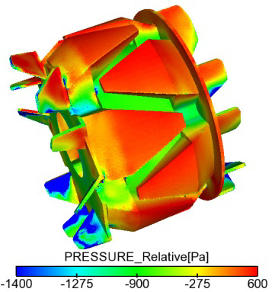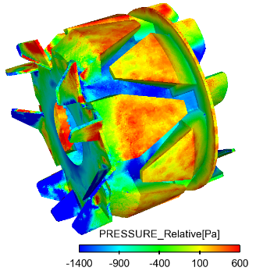
(a) Plan 1 (b) Plan 2
Fig.11. Pressure distribution of the rotor surface.
Consequently, the optimized spacing angles of front blades can cool down the rotor winding with wide pressure distribution of the front blade suction surface and comparatively large flow flux of blade place.

5.2.2 Aerodynamic noise characteristics with optimized front blade spacing angles
Table 5 are the total noise level simulation results with and without optimised the front fan blade spacing angles, it can be seen the total noise levels of the six measuring points on alternator are all decreased with the optimized plan, with the maximum reduction being 3.10 dB.

Table 5. Numerical simulation results (dB).
Measuring Point | Front Point | Right point | Back Point | Left Point | Upper Point | Front Lateral  45°
Plan 1 | 95.08 | 91.00 | 96.53 | 90.80 | 94.73 | 96.89
Plan 2 | 92.09 | 87.90 | 93.92 | 88.85 | 92.48 | 94.07
Difference | 2.99 | 3.10 | 2.61 | 1.95 | 2.25 | 2.82
Fig.12 presents the noise spectrum of the far field point, it indicates that the eddy noise is the dominant aerodynamic noise at high frequency with optimized front blade spacing angles. The 6th, 8th, 10th, 12th and 18th orders are the chief harmonics of the total noise level, and the average decrease of the 12th and 18th order is 5.80 dB with no obvious variation in other harmonic orders. So the contribution of the 12th and 18th harmonic waves to the total noise level mainly comes from front fan blades.
(a) Left point (b) Right point

Fig.12. Noise spectrum of monitoring points.
Fig.13 depicts the one-third octave spectrum of turbulent pressure of the far field points with the front blade spacing angles optimized. It indicates that the primary energy of the far field aerodynamic noise is concentrated in a wider frequency range of 1120 Hz-7000 Hz, the one-third octave of aerodynamic noise increases rapidly with frequency in 224 Hz-1120 Hz, and decreases slowly at frequency above 7000 Hz. The order analysis also shows that the primary contributions of aerodynamic noise are from components under 30 harmonic orders with optimized front fan blade spacing angles.
(a) Left point (b) Right point

Fig.13. One-third octave spectrum of alternator noise at 14000 r/min.
Fig.14 shows that in comparison with the original model, the maximum mass flow in blade monitoring surface is increased by 3.73 g/s, and the average mass flow is increased by 1.36 g/s even though the mass flow in monitoring surfaces 4 and 5 are slightly decreased.
Fig.14. Mass flow rate of blade monitoring surface at 14000 r/min.

6. Conclusions
A numerical model of aerodynamic noise for an automobile alternator was established and verified, and the optimal design of front fan blade spacing angles was presented with vector synthesis method. The aerodynamic noise reduction was studied aiming at reducing harmonic rotating noise while considering high fan flow in this paper. Numerical results show that the amplitude of total noise level and noise level of the cooling fan can be predicted with a combination of large eddy simulation and FW-H equation, with maximum prediction error being 6.97 dB in total noise level, and 2.3 dB and 3.3 dB in the sound level of the 12th and 18th harmonic rotating noise respectively. It also show that with the optimized front fan blade spacing angles, the maximum reduction in total noise level of the alternator is 3.10 dB, the energy of the A-weighted SPL of one-third octave band centre frequencies mainly concentrates in 1120-7000 Hz, with 1.36 g/s increase in mass flow of blade monitoring surfaces and 5.80 dB decrease in the sound level of the 12th and 18th harmonic orders on average.
A revised low-noise design for an automobile alternator was proposed based on the presented numerical analyses, which will be verified in future studies via experiments. Further work will be needed to take into account the acoustic comfort of the car equipped with the alternator.

Acknowledgments
This research is supported by National Natural Science Foundation of China (No.51405399) and is partly supported by the Fundamental Research Funds for the Central Universities (DUT16RC(3)027).

Nomenclature
$ρ$: | air density, $kg/m^{3}$
$μ_{i},μ_{j} :$ | time-averaged velocity in i and j direction,$m/s$
$p$: | air pressure, $P_{a}$
$τ_{ij }$: | subgrid scale stress, $P_{a}$
$T_{ij }$: | the Lightlill tensor,$T_{ij}=ρu_{i}u_{j}+P_{ij}-a_{0}^{2}ρδ_{ij}$, $P_{a}$
$ρ_{0}$: | intial air density, $kg/m^{3}$
$p_{0}$: | intial air pressure, $P_{a}$
$p^{'}$: | sound pressure, $P_{a}$
$c_{0}$: | speed of sound,$340m/s$
$v_{n}$: | velocity of moving body in surface normal  direction, $m/s$
$u_{n}$: | velocity of flow medium in surface normal  direction, $m/s$
$δ\left(f\right)$: | Dirac delta function
$H\left(f\right)$: | Heaviside function

References
[1] J. S. Sang, C. Jintai, D. L. Byung and H. H. Cheol, Case history: Noise source identification of an automobile alternator by rpm dependent noise and vibration spectrum analysis. Noise Control Engineers Journal, 37(1) (1991) 31-36.
[2] Y. D. Zhang, D. W. Dong, B. Yan, and C. R. HUA, Experiment study on aerodynamic noise of an automotive alternator, Noise and Vibration Control, 34(3) (2014) 107-110．
[3] M. Liu, D. W. Dong, B. Yan, Q. S. Chen, X. Tan, and B. Yang, Test and analysis of noise characteristics and noise source of vehicle alternator, Journal of Chongqing University of Technology (Natural Science), 24(6) (2010)13-17．
[4] Y. N. Hui, Study on vehicle alternator noise testing and
noise reduction method. Chengdu: Southwest JiaoTong
University (2011).
[5] M. J. Lighthill, On sound generated aerodynamically: Part1: General theory. Proceedings of the Royal Society of London, Series A, Mathematical and Physical Sciences, 211(1107) (1952) 564-587.
[6] N. Curle, The influence of solid boundaries upon aerodynamic sound. Proceedings of the Royal Society of London, Series A, Mathematical and Physical Sciences, 231(1187) (1955): 505-514.
[7] J. E. Ffowcs Williams, and D. L. Hawkings, Sound generation by turbulence and surfaces in arbitrary motion. Philosophical Transactions for the Royal Society of London, Series A, Mathematical and Physical Sciences, 264(1151) (1969) 321-342.
[8] D. M. Frederick, and G. C. Lauchle, Aerodynamically-induced noise in an automotive alternator, Noise Control Engineering Journal, 43 (2) (1995) 29-37.
[9] T. A. Brungart, G. A. Meyer and G. C. Lauchle, Flow in automotive alternators, Proceedings of the Institution of Mechanical Engineers, Part D: Journal of Automobile Engineering, 210(4) (1996) 283-292.
[10] W. Kim, W. H. Jeon, N. Hur, J. J. Hyun, C. K. Lim and S. H. Lee, Development of a low noise cooling fan for an alternator using numerical and doe methods, International Journal of Automotive Technology, 12(2) (2011) 307-314.
[11] E. Garnier, P. Sagaut, N. Adams, Large eddy simulation for compressible flows, Springer (2009).
[12] G. X. Cai, C. X. Xu, Z. S. Zhang. The progress of turbulent eddy simulation, Aerodynamics Journal, 22(2) (2004) 121-129.
[13] W. Neise, Review of fan noise generation mechanisms
control methods, International Symposium on Fan Noise (1992)45-46.
[14] T. Bose, Aerodynamic Noise: An Introduction for physicists and engineers, Springer Science & Business Media (2012).
[15] Y. D. Zhang, D. W. Dong, B. Yan, J. Y. Zhang, Y. W. Wang, Numerical simulation analysis for aerodynamic noise of a vehicle alternator. Journal of Vibration and Shock, 35(1) (2016) 179-187.
[16] Y. W. Wang , D. W. Dong, X. Xie, B. Yan and Y. H. Sun, Spectral optimization of fan rotation noise based on vector composition method. Key Engineering Materials,584(2014)131-136.

Chunrong Hua received Ph.D. degree from Southwest Jiaotong University (SWJTU), China in 2011, and is currently an associate professor at School of Mechanical Engineering in SWJTU. Dr. Hua’s research interests are vibration and noise control of mechanical equipments, fault diagnosis of ICE (internal combustion engine) and signal processing.

Yadong Zhang is currently a doctoral student at the School of State Key Laboratory of Traction Power of Southwest Jiaotong University in China. His research interests include train aerodynamics and aeroacoustic behaviors.

