Using Performative Knowledge Production to Explore Marketplace Exclusion
Gemma Burgess, Cambridge Centre for Housing and Planning Research, Department of Land Economy, 19 Silver Street, University of Cambridge, Cambridge, CB3 9EP, glb36@cam.ac.uk
Mihaela Kelemen, Keele Management School, Darwin Building, Keele University, Staffordshire, ST5 5BG, m.l.kelemen@keele.ac.uk
Sue Moffat, Director of New Vic Borderlines, New Vic Theatre, Etruria Road, Newcastle-Under-Lyme, Staffordshire, ST5 0JG, SMoffat@newvictheatre.org.uk
Elizabeth Parsons, University of Liverpool Management School, Chatham Building, Liverpool, L69 7ZH, eparsons@liverpool.ac.uk
Using Performative Knowledge Production to Explore Marketplace Exclusion

Introduction
Since the early 1990s marketers have recognised that all marketing activities are by their nature dramatistic (Deighton 1992; Giesler 2008; Pine and Gilmore 1999). Marketing ‘scripts, produces, and directs performances for and with consumers and manages the motives consumers attribute to the decision to perform.’ (Deighton 1992, p. 362). More recently the brand has also taken centre stage with the consumer in the ‘theatre of consumption’ (Dholakia and Firat 2003; McGrath, Sherry & Diamond 2013), a stage on which consumers play out their fantasies but also one in which, using the props of brands and products, consumers work out their own identity through endless comparison with others (Shankar et al. 2009). The theatrical metaphor has been taken to its most extreme in the field of services marketing. Here service employees, the key protagonists, follow a script and consumers are seen as playing an active role in the production of service experience (Grove et al. 2000; Harris et al. 2003; Williams and Anderson 2005).
One might expect dramatic methods would be an obvious first destination for researchers looking to better understand the marketplace. While marketing as a discipline has long been relatively open to a range of what might be called alternative research methods these do not include drama. There has always been a strong emphasis on narrative and story telling as means to capture consumers’ un-reflected upon, taken for granted experiences (Thompson and Arnould, 1998; Autio, 2004; Pace 2008). Projective techniques involving figure drawing and collage creation have also been used to help consumers to quite literally picture their consumption experiences. The visual tradition of consumer research is now well established and photography (Venkatraman and Nelson 2008; Mencarelli and Pulh, 2012) and painting and videography (Pace 2008, Rabikowska 2010, Petr et al. 2015) are accepted research tools in the consumer researcher’s arsenal. Of these techniques documentary film (Belk 2011) has perhaps the closest relation to documentary theatre. Moving into the online world researchers have fruitfully harnessed social media in a series of ‘netnographies’ (Kozinets 2002; Rageh et al. 2013). Finally, poetry is making its way onto the research agenda as a means to represent consumer experience in an alternative frame (Sherry and Schouten 2002). The thread that draws these approaches together is their remit to move beyond traditional textual approaches in representing the contradictory, messy and utterly embodied experiences of consumers. The focus has also been on the way in which consumers themselves play an active part in ‘co-creating’ their consumption experiences (Echeverri and Skålén 2011; Pongsakornrungsilp and Schroeder 2011). However, while both marketing academics and practitioners have recognised that the marketplace is a stage on which the theatre of consumption is played out, and they have also recognised that consumers co-create meaning alongside producers, they have failed to fully embrace the possibilities of a performative approach to undertaking research and knowledge production.
The twin aims of this project were to contribute to understandings of the dynamics of marketplace exclusion and explore the benefits of a performative approach to knowledge production in doing so. The value of the performative approach resides in both modes of representation but also the modes of interpretation that it facilitates. We explore these possibilities drawing on our experiences of using a piece of interactive documentary theatre to explore marketplace exclusion in a relatively deprived UK city. We start by introducing our concept of marketplace exclusion which has been largely neglected in marketing studies to date. We then introduce the concept of performative knowledge production. In the methodology section we discuss the use of documentary theatre and theatre in the round as central strands of performative knowledge production. Importantly here we also highlight the central role of our partnership with the New Vic Theatre who have pioneered both theatre in the round and documentary theatre. In our analysis section we use three vignettes from our documentary drama entitled ‘Because you’re worth it?’ to explore claims to authenticity, viscerality and emotion, and issues of ambiguity in relation to performative knowledge production. We then discuss the advantages of performative knowledge production over more traditional research approaches and some of the challenges in using this methodology. In concluding we highlight theoretical implications of the project and implications for practice and wider society. We also make suggestions for further research.
Marketplace Exclusion
The concept of marketplace exclusion is not a widely used term but one which we think has useful purchase in highlighting the way in which marketplace mechanisms may perpetuate exclusion in society. Reviewing the marketing literature we found a range of associated terminology including marketplace discrimination and injustice (Williams and Henderson, 2012) and consumer vulnerability (Baker, Gentry and Rittenburg, 2005; Hamilton, Dunnett and Piacentini, 2015). These strands have largely emerged from the Transformative Consumer Research school of thought (Mick et al, 2012) which has a mission to improve consumer well-being through research on consumption related problems and opportunities. Scholars working within the Macromarketing (Layton and Grossbart, 2006; Shapiro, Tadajewski and Schultz, 2009) and Critical Marketing (Saren et al. 2007; Tadajewski and Maclaran, 2009) traditions have also sought to examine the macro or more structural implications of marketing practices and processes for consumers and wider society. Below we examine a series of topics which sit within and cut across these strands of thought drawing together insights to refine our conceptualisation of marketplace exclusion. We also look outside the discipline to the existing well used concept of social exclusion for succour.
Only one publication in marketing that we know of has used the terminology ‘marketplace exclusion’ to date. In their paper titled ‘A Critical Spatial Approach to Marketplace Exclusion and Inclusion’ Saatcioglu and Ozanne (2013) explore how spaces might be reimagined and reorganised to afford greater inclusivity. They offer insights into areas such as housing, retailing, spatial segregation, and suburban sprawl. However rather than a focus on the structural implications of marketplace exclusion their focus lies on their critical spatial perspective. Whilst they don’t refer directly to marketplace exclusion they do mention that marketplace inclusion ‘involves access to and fair treatment within the market.’ (2013: 32). This reference to ‘fair treatment’ echoes the viewpoint of those exploring marketplace discrimination and injustice, who see it as:
‘any type of differential treatment of consumers in the marketplace based on membership in an oppressed group that constitutes denial of or degradation in the products and/or services offered to the consumer’ (Williams and Henderson, 2012 p174)
Research on marketplace discrimination has explored how poverty, race, religion, gender, sexuality, and disability have resulted in consumers not receiving ‘equal treatment for equal dollars’ (Williams and Henderson, 2012, p174). For example a range of studies have highlighted that poor consumers routinely pay more, especially for food, as a result of their geographical location (Bell and Burlin, 1993; Chung and Myers, 1999). One key reason for this is the lack of larger supermarkets with lower prices in poorer neighbourhoods, residents are therefore often forced to shop in smaller more expensive neighbourhood stores. Hill’s (2002, 2005, 2015) work in particular highlights the marketplace injustice faced by those living in poverty. His work shows that the behaviours, actions and underlying beliefs of those in poverty often differ very markedly from affluent citizens due to the restrictions they face in their everyday lives. Still those in more affluent contexts have only a very basic understanding of poverty based largely on skewed views from the media. A study which compares materialism between two groups of young people highlights the irony that poor youths may actually rely on the marketplace much more heavily than their more affluent counterparts who live in communities that allow for other ways of increasing self-efficacy and self-esteem (Chaplin, Hill and John, 2014).
Studies have also explored the exclusion of consumers from the marketplace due to race or religion. Recent work has been at pains to highlight the marginalization of Islamic voices (Jafari and Sandikci, 2016) and non-Western voices more generally from debates surrounding the processes and practices of marketing (Jafari and Goulding, 2008). However, forms of marketplace inclusion can be just as problematic and concerns also abound regarding the commodification of religious and cultural forms.
‘The mediation of Islamic knowledge, practices, and identities through increasingly commodified cultural forms and spaces does not merely embody a liberal marketplace. Liaising marketing, good life, cultural, and Islamic may be a dangerous liaison articulating an important discursive function related to the production of profits, ideology, power, and identity, besides giving an active cultural voice to Muslim consumers.’ (Süerdem, 2013)
Finally, the body itself is often the site for discrimination whether along the lines of sexuality (Kates, 1999; Walters and Moore, 2002), body image (Scaraboto and Fischer, 2013) or disability (Kaufmann-Scarborough, 2000; Goodrich and Ramsey, 2012; Pavia and Mason, 2012; Nau, Derbaix and Thevenot, 2016). These studies highlight in some cases the physical exclusion of consumers from the marketplace through poor retail design and failure to interpret policy adequately. But consumers are also excluded symbolically either through a failure to embrace diversity and/or a mis-representation of diversity. This latter form of exclusion functions at the level of identity and often results in stigmatisations of individuals and groups.
Although the above studies are not exhaustive, taken as a whole they begin to exemplify the range of ways in which the marketplace can exclude, misrepresent and discriminate against individuals and groups. However, just as important for an understanding of marketplace exclusion are the mechanics of this process. Recent work has attempted to look ‘Inside Marketing’ (Zwick and Cayla, 2011) to explore in essence the political economy of marketing, in particular the ways in which the consumer is governed through marketing practices and devices. These devices are numerous but ones which have received the most attention are segmentation and profiling, digital marketing and advertising.
Segmentation and profiling have long been targets of concern for researchers. Segmentation in itself can easily lead to stereotyping but these stereotypes are then used for target marketing which can have very divisive and exclusionary results. For example the stereotyping of older consumers as more vulnerable to sales pressure which has resulted in them being targeted with inferior products (Cowart and Darke, 2014). Or racial profiling (also called retail racism) which is commonly used in retail and has resulted in instances of store employees treating customers unfairly based on their race or ethnicity (Gabbidon, 2003; Williams, Harris and Henderson, 2001, 2006). Very recent work has revealed how these segmentation practices have become even more intrusive and divisive in the current digital age (Elmer, 2004; Zwick and Denegri-Knott, 2009; Cluley and Brown, 2014). Cluley and Brown observe:
‘The function of marketing in the new society of control is to identify data points and reconstruct data in clustered segments that define what products people have access to, what advertising offers are made to them and what content they see.’ (2014: 116)

This new society of control is powerful in its effects, Zwick and Denegri-Knott (2009) liken this increasingly sophisticated mode of database marketing to the 21st century factory in which customers are manufactured as commodities. They observe that it not only facilitates a high level of continuous consumer surveillance but that it also literally ‘produces’ consumers through representations. The problem lies however in the issue that these representations have very real effects as they define who does and (more importantly) who does not inform the shaping of future marketing and production activities.
The above devices together form a family of representational practices that attempt to classify, categorise and divide consumers in order to more effectively govern them. One of the most pervasive of these devices is perhaps advertising, so worth considering in more depth. Advertising does not act on its own, rather it is part of a representational system which involves both advertising and consumption – responding to and acting out advertising representations through our consumption activities reinforce them and give them meaning. Equally these actions and meanings are self-reinforcing and serve to perpetuate norms relating to categories such as gender, sexuality, race and disability. In this system only those images and actions that are seen as profitable are promoted resulting in skewed stereotypes which serve to (de)limit both individual, and wider societal, potential and opportunities. As Schroeder and Borgerson comment ‘images provide resources for, and, hence, shape, our understandings of the world, including the identities of its people and places.’(2005: 256). In addition (and just as important) are those images and activities (ways of living and being) that are excluded from the system entirely. In arguing for an ethics of visual representation Schroeder and Borgerson observe that ‘By excluding – to varying degrees – certain representations, possible meanings, interpretations, and understandings are limited in ways that may negatively influence certain individuals, groups, scenarios, and even geographic locations’ (2005: 274). This can be seen very clearly in the marketing of ethnic tourism which involves the promotion of ethnic identities and ways of life in staged heritage and theme parks. Yang (2011) explores the process of commoditization of ethnicity in the Yunnan Ethnic Folk Villages in China. She finds ultimately that ‘Hegemony is perpetuated in representations of minority culture. Through the representation of “otherness,” the powerful are able to construct hegemonic discourse, and reinforce their values and orders’ (2011: 580). In summary our review of the above studies highlights two possible key dimensions of marketplace exclusion associated on the one hand with participation (and barriers to this) and on the other hand representation. Before we attempt a definition of marketplace exclusion based on these dimensions we thought it useful to go to the existing and well-trodden literature on social exclusion for further insight.
While social exclusion is a well-used term, concrete definitions of the concept are hard to come by, this is undoubtedly due to its complexity (Gough and Olofsson, 1999; Levitas, 2006; Levitas et al. 2007). Levitas et al (2007: 9) adopted the following definition based a wide ranging review of sources:
‘Social exclusion is a complex and multi-dimensional process. It involves the lack or denial of resources, rights, goods and services, and the inability to participate in the normal relationships and activities, available to the majority of people in a society, whether in economic, social, cultural or political arenas. It affects both the quality of life of individuals and the equity and cohesion of society as a whole.’
This definition highlights some of the dimensions of social exclusion and its complex relationship with poverty. While it does involve a lack of resources (and thus is about poverty) it also encompasses people’s ability to participate in the normal life of society as well as their resulting quality of life. The Bristol Social Exclusion Matrix was developed to help to offer a larger picture of the range of factors encompassed in social exclusion (Levitas et al. 2007: 10). The matrix includes the three domains of: resources, participation and quality of life, and each of these domains has a series of associated topics. For example associated with participation are: economic participation, social participation, culture, education and skills, and political and civic participation. Our definition of marketplace exclusion, while still in its infancy, relates most closely to the issue of economic participation. This does not only mean workforce participation (i.e. participation in the sphere of production) but also participation in the sphere of consumption. Drawing then on existing understanding of social exclusion and folding into our definition the centrality of participation and representation in the marketplace, our working definition is as follows:
‘Marketplace exclusion involves barriers to participation in the marketplace relationships and activities, available to the majority of people in a society. It affects the ability of individuals and groups to be adequately represented in the marketplace and has implications for quality of life and social cohesion.’
Like social exclusion, marketplace exclusion results from a highly complex intersection of issues. To take an example the below commentary on the UK riots in the summer of 2011 highlights how issues of marketplace participation and representation intersect to reinforce exclusion. Actor and comedian Russell Brand sums up the stark contrast between the everyday lived realities of deprived young people and the media representations they are faced with:
‘No education, a weakened family unit, no money and no way of getting any. JD Sports is probably easier to desecrate if you can’t afford what’s in there and the few poorly paid jobs there are taken. Amidst the bleakness of this social landscape, squinting all the while in the glare of a culture that radiates ultraviolet consumerism and infrared celebrity. That daily, hourly, incessantly enforces the egregious, deceitful message that you are what you wear, what you drive, what you watch and what you watch it on, in livid neon pixels. The only light in their lives comes from these luminous corporate messages.’
We have included this quote here because it was the key inspiration for our project. Our piece of documentary theatre, and the work surrounding its preparation, was concerned with addressing this schism between marketplace media representations and lived realities. We used the approach to explore the experiences of young people living on the margins of the marketplace with the ultimate aim of evaluating some of the policies and local initiatives that might counter these experiences of disaffection and marginalization.

Performative Knowledge Production
In developing our approach to performative knowledge production we draw from literature on both documentary theatre and arts based research. While documentary theatre forms the backbone of our approach, the theatre presentation is one part of a wider research project which includes pre-production research in the form of a seminar series and set of interviews and a post-production discussion workshop. The final performance was entitled ironically, ‘Because you’re worth it?’ mocking L’Oreal’s slogan which encourages individualism, narcissistic consumption and self-gratification through consumption. It raised questions about the barriers to full and fair participation within the marketplace and captured its failure to adequately represent individual consumers and society at large (a link to the performance can be found on https://www.youtube.com/watch?v=eylJqdtE2ZI). Rather than being a standalone presentation of ideas and issues, the theatre production was a vital component of the wider process of embodied and dialogical knowledge production.
Kaptani and Yuval-Davis (2008) argue that theatre provides different kinds of data than other research methods namely data and information that is embodied, dialogical and illustrative (see also Sutherland 2012). They argue that it is a useful tool to study narratives of identity of marginalised groups and “illustrate perceptions and experiences of social positionings and power relations in and outside community groupings” (2008, p. 1). But they go further and make a case that using participatory forms of theatre as a research tool is a form of community action research. Denzin similarly argues that “viewed as struggles and interventions, performances and performance events become transgressive achievements” in which performance is an act of intervention, a method of resistance, a form of criticism and a way of revealing agency (2003, p. 4). Rather than a way to reflect ‘objective’ knowledge or a means to “access the real” (Taylor 2013, p. 378), these authors argue that, like any other type of knowledge, the knowledge generated through theatre is not value free but situated in its political context and embedded within power relations, which it may challenge and subvert. Indeed, Finley argues that the aim of arts-based research is to “create research experiences that are emotionally evocative, captivating, politically and aesthetically powerful, and that, quite literally, move people to protest, to initiate change, to introduce new and provocative ways of living in the world” (2014, p. 532). The goal is just not to describe and adequately understand social reality but to change and improve it (Hamera 2011, p. 318).
This mirrors the shift in qualitative research away from methods and processes where the researcher is positioned as expert, to more participatory methods and the recognition of the importance and validity of other voices. Co-producing knowledge is an interactive and collaborative process of knowledge generation that, in very simple terms, means working together and building relationships between different groups of people to generate knowledge that coherently incorporates the different viewpoints (Pohl et al. 2010). Beebeejaun et al (2014, p. 37), for example, see co-production as “conducting research ‘with’ communities rather than ‘on’ communities.” Co-producing knowledge often uses participatory methodologies that seek to break down the distinction between researcher and researched and recognises people’s capacity to generate knowledge based on their own experiences.

Theatre can be a qualitative research method that is both participatory and performative and presents an alternative way of engaging participants in research (Conrad 2004). As a form of performance ethnography, Hamera posits that this offers the researcher a vocabulary for exploring the expressive elements of culture, a focus on embodiment as a crucial component of cultural analysis and a tool for representing scholarly engagement, and a critical, interventionist commitment to theory as practice (2011, p. 318). Denzin argues that this type of research implies a thoroughgoing reflexivity, obliterating any distinction between the personal and the public, between research and experience (2003). In this process the researcher and the community collectively engage in discovery; the audience is one with the researcher (Finley 2014). It draws on the experiences of participants to collectively create theatre and engage in discussion of ideas through theatrical means (Conrad 2004).
Methodology
In this section we explore the methods we used in the project but first we discuss the importance of our partnership with the New Vic Theatre in particular the theatre’s history of documentary theatre.
Documentary Theatre at the New Vic Theatre
Documentary theatre uses documentary material (such as reports, newspapers, interviews) as direct verbatim source material for the script. The New Vic Theatre who we worked with on this project has developed a strong tradition of documentary theatre which sought to explore new creative relationships with local communities (Elvgren, 1974). The creative ambition of New Vic Borderlines, an outreach department at the New Vic Theatre, builds on the legacy of its founders, Stephen Joseph and Peter Cheeseman, and on a ‘theatre in the round’ architecture, an alternative to the traditional proscenium format which was widely used in ancient Greece and Rome but remained relatively under-explored until the latter part of the 20th century. Having the stage in the centre and the audience arranged on all sides, the theatre in the round format is ideal for high energy productions and audience participation.
Working in the round brought about new ideological and creative possibilities stimulating Cheeseman, for example, to invent verbatim theatre and making possible to create new socially relevant pieces of work in the form of musical documentaries concerned with the real life struggles and stories of the community (Elvgren, 1974). These became the bedrock of the New Vic Theatre’s relationship with documentary drama, a tradition continued through the community led work of the New Vic Borderlines. The experience of theatre in the round is a communal one where actor and audience are in close proximity, affected by each other and aware of each other. The responses to the stories played out are magnified and reflected by each audience member and in turn felt by the people on the stage. The experience is one where each person in the shared space is as important as the other, and as dependant on each other, creating a unique experience.
The link between theatre in the round and documentary theatre is a very tight one at the New Vic. The theatre in the round format enables and amplifies the features of documentary theatre. Documentary theatre is subjective, contested, political and situated within particular contexts and power relations. It enables the expression of multiple points of view but also the integration of the audience. It is not merely a means to express in an alternative way an event and what happened, but a way to explore the discourses that surround it (Claycomb 2003). Referring to productions in the genre of “Theatre of Testimony”, Claycomb argues that these types of productions seek “to give voice to silent voices, or to expose what has been kept hidden” (2003, p.99) and posits that “they also replace that singular, hegemonic voice with a dialogue of voices that presupposes a more democratic conception of power” (Ibid, p. 102).
Establishing resonance with the public’s aspirations and needs is crucial, along with enabling a dialogue to encourage the audience to examine its own problems in light of the story being articulated on stage at any one point in time. According to Turner (1982), documentary theatre has a deep affective effect on audiences by providing the experiential tools by which spectators can think for and of themselves in terms of what is being performed on the stage, thus becoming to some extent spect-actors (Boal 1979).
Documentary theatre is a form of theatre that aims to enact history by offering a powerful way to think about salient and complex issues while revealing the strengths and weaknesses of its sources. The sources tend to be archival and include interviews, records, photographs, films, documents and so on. It is the process of source selection and editing that lends documentary theatre creative and aesthetics focus while at the same time helps it to make claims to factual legitimacy. Documentary theatre “directly intervenes in the creation of history by unsettling the present” (Martin, 2006, p 9). It provides the audiences with a platform for challenging official accounts and constructing alternative public accounts of important events (Paget, 2008). In the context of our paper the event disputed is the 2011 London Riots (https://www.theguardian.com/news/datablog/2011/aug/09/uk-riots-data-figures).
Documentary theatre is not the only research methodology able to elicit such deep responses on difficult issues from an audience. Video-elicitation is also a powerful method for researching sensitive topics (Sayre, 2006). In a study aimed at understanding the purchase power following natural disaster, Sayre has combined story vignettes with video images to construct a talk show in which actors play specific characters that could trigger a deep reaction for the audiences, and serve as a stimulus for in depth interviewing. Documentary theatre is in a nutshell a multi-modal form of research in which people make sense of the world though images, speech, writing and three dimensional forms (such as theatre props, materials and technology). According to Rossolatos (2013) a multi-modal approach provides the researchers with the tool to understand how languages is influenced and influences social and material practices and images. From here, stems its potential for performativity and change.
However using documentary theatre as a research tool is not without its contradictions and challenges. It should be noted that performative research produces a ‘negotiated reality’ which has long been a subject for debate in anthropology and ethnography. The theatre presentation is a complex intersubjective process involving the interactions of a range of subjectivities (Jacobs-Huey, 2002; Srinivas, 1966, 1979). As such the inclusion of verbatim materials from interviews does not and should not make claims to a form of ‘pure’ presentation of lived experience. Performers bring their own experiences and interpretations to their performances, which lead them to perform the concept under study as opposed to merely reproducing the experiences of others.

Research Methods: Creating sources for documentary theatre
The research on which our piece of documentary theatre is based began with a series of five seminars to examine substantive and methodological issues surrounding marketplace exclusion. The seminars and subsequent theatre production were funded by the Economic and Social Research Council under the project title: ‘Marketplace Exclusion: Representations, Resistances and Responses’. The seminars brought together marketing, organisation studies and consumer research scholars on the one hand, and social policy and community cohesion scholars on the other, to identify the ways in which marketplace mechanisms contribute to exclusion as well as policy and community initiative responses to ameliorate this. Each seminar was designed to foster inter-disciplinary discussion as well as viewpoints from practitioners and policy makers and engagement with members from the New Vic Borderlines. There were four or five speakers at each seminar, including a mix of academics and practitioners. A final discussion workshop drew on the issues raised at all of the seminars and central themes were identified as input into research undertaken by New Vic Borderlines which formed the basis for the performance.
The seminars covered topics such as the underrepresentation of certain consumers in marketing theory and practice, media representation of white working class, exclusion from the housing market and digital consumption, as well as resistance practices through community based responses to consumption (https://www.liverpool.ac.uk/management/conferences-and-events/esrc/seminars/). The issues raised through the seminar series were taken directly onto the street, and into the 'market places' of Hanley, Stoke on Trent and Newcastle under Lyme. Questions regarding what people understood to be marketplace exclusion where used to stimulate discussions and opportunities for people to express their own ideas about consumerism, the power of the market, and the way in which people interact with, and respond to the idea of the market. Questions such as which 'tribe' do you think you belong to? Are there places/shops that you would never go into? If Britain was 'the marketplace' what do you think it has to offer? prompted new themes to emerge including people feeling 'pushed out' of various markets such as housing and jobs, and violent desires to belong, own and condemn those who do not conform.
Apart from the general public, the people interviewed were representative of marginalised groups such as NEETS (young people 16-25 who are not in employment education or training), people living in the YMCA, and asylum seekers and refugees. These interviews elicited individual oral testimonies about the lived experiences of marketplace exclusion. Material from the interviews was used to develop the script for the performance, and extracts were also used as voice-overs during the performance. The interviews were also used to recruit participants (actors) for the theatre performance. Five weekly theatre workshops unpacked the above oral testimonies drawing out themes for further elaboration. Participants listened to the interview recordings and selected narratives to be developed into a presentation. The workshops used the principles of cultural animation (Kelemen and Hamilton, 2015) to encourage participation on equal terms and stimulate thinking and acting outside the box. The weekly workshops were followed by a five day theatre residency to bring the work together and devise and rehearse the performance.
The Performance
The cast included four volunteer actors from members of the local community; three theatre/community practitioners from New Vic Borderlines and one professional actor. Present on stage also were the voices of community members through the use of ‘voice-overs’ (extracts from the interviews) during the performance. The performance entitled ‘Because you’re worth it?’ relied on multi-media material (recorded voices, music, poems, costumes, lighting and movement) to create a kaleidoscope of perspectives which ultimately facilitated the emergence of a communal multi-voice about marketplace exclusion. Designed to be challenging and thought provoking, projection was also used in the presentation, including publicly available snatches of video taken during the so called ‘London Riots’. The communal nature of the subject on stage was also realised through the style of acting, with performers shifting from role to role to show what has happened rather than becoming the character to whom it has happened (Claycomb 2003).

The audience was made of academics from the universities involved in the seminar series plus other interested academics form other institutions. Audience members also included local businesses ; the ‘Town Centre Manager’ for Newcastle under Lyme and ex-Chief Executive Officer of the Chamber of Commerce; members of the community who had engaged in interviews and workshops about marketplace exclusion as part of the development of the performance; residents from ‘Brighter Futures’ a large social housing provider from Stoke on Trent; representatives for asylum support services and asylum seekers; young people from the YMCA; foodbank volunteers and users, food-network organisers and two local training providers: ACORN training and PM training.

The performance represented the response from the community on the pressure to consume and participate in the market and the violence of 'smash and grab' revenge consumerism which exploded into being during the 2011 summer riots which took place throughout country.

Performative Knowledge Production in Practice: Three Documentary Theatre Vignettes
In this section we use three separate vignettes from the performance to illustrate important elements of what we have termed performative knowledge production. The vignettes are included because they represent some of the ‘results’ that have emerged from the project; they reflect our findings and analysis in relation to both marketplace exclusion and performative knowledge production. The specific vignettes were chosen to enable discussion around three different themes that emerged in particular in relation to performative knowledge production in the context of marketplace exclusion. These are authenticity, embodied experience and viscerality, and ambiguity. A link to the entire performance can be found on https://www.youtube.com/watch?v=eylJqdtE2ZI.
Performative Knowledge Production and Authenticity
Discussion of Marketplace Exclusion
Richard’s story (see figure 1): “I had a friend called George when I was about 12. He had a Nintendo Gameboy in colour, amazing graphics, you could put it in your pocket, take it to school, go travelling… I had to have it. I thought it would change my life, finish endless hours of boredom. I asked my mother to get it for Christmas and promised I’d do all the chores: learn to iron, feed the dog, even clean the shower. There it was under the tree in all its glory: my brand new Nintendo. I was so excited, I could not wait to see George and play games together. George asked what else I got. He could not comprehend that this was the only Christmas gift I got. I’ll never forget the look on his face. So I had to lie that I got other things. His younger brother got a Nintendo Gameboy as a stocking filler, along with a flashing yo yo, and portable TV”.
Figure 1 about here

This vignette tells the story of a twelve year old who feels excluded by his immediate friends as a result of an act of consumption related to the Christmas celebrations. While Christmas has become the embodiment of consumption and gift giving is central to celebrating it (Belk and Bryce, 1993), individual expectations are growing due to social and peer pressure as well as advertising campaigns that promote the ‘you have to have it all’ attitude to be happy at Christmas. The vignette suggests that even though Richard was very happy to receive a Nintendo Gameboy for Christmas, his joy and personal satisfaction were of a short duration once he compared himself to his friends.
Discussion of Performative Knowledge Production Within this Context
The audience is invited to empathise with Richard’s situation, by first rejoicing with him and then feeling the pain and humiliation he is going through. Richard’s lived experience expressed by words, facial expressions, silences and choreographic movements comes alive on stage. His words are embodied: he smiles, frowns, mumbles and shouts out his joy, gratefulness, frustration, embarrassment and dissatisfaction. At the end of the scene he pauses to reflect on his life and in so doing, he invites the audience to connect with his story on a visceral and emotional level. This connection lends authenticity to what has been witnessed as the audience feels privileged to have access to Richard’s inner feelings and emotions. However, it is important to question the notion of authentic connection that derives from the personal connection of a dramatic production as a way of communicating knowledge. While performative knowledge production makes strong claims to authenticity in terms of accessing real feelings, we need to question to what extent Richard’s performance should be regarded as more authentic and representative of lived experience than other forms of knowledge production. Could it be that the actor who plays Richard is simply telling one of the many available stories using dramaturgical techniques to impress the audience? The performed story originates in the qualitative data that underpins the documentary drama but could be communicated in many different ways and without a performative element attached to it. The Discussion section goes on to question whether we should then regard a performative take on the story as more authentic than the mere narration of the story?
Performative Knowledge Production as an Embodied and Visceral Experience
Discussion of Marketplace Exclusion
Another vignette from the documentary drama presents a performance of the UK riots. The actors wear black and grey tracksuits, hoods partially covering their faces, which are hidden by faceless but grotesque masks, their own human faces replaced with masks of pigs and white blank leering faces (see figure 2). The masks were chosen by the actors and production team. The audience is left to decide how to interpret them, whether as a faceless mob, people who have lost their individual identities, or even as animals not governed by the rules of society. At the beginning of the scene they break into big shops and steal giant TVs and electrical goods, being mesmerised by them, dancing in slow stupor to portray their fascination with the boxes of stolen items which are passed between them reverentially.

They encourage and follow each other, at first the only victims are the gated shop fronts, but then the focus changes and the group becomes more violent, enraged, and destructive. The group, the masked mob, turns from theft to violent destruction. They tear down a fence acting as a barrier between the actors and audience. This is done in silence by the actors, with the soundtrack provided by media clips from the actual riots. The attention of the actors has turned from the stores and goods to the outward world, to the audience. After tearing down the fence they now carry makeshift weapons and begin to act out throwing things at their targets, which here is the audience. The audience is left to imagine that in the riots the target was the shops and then the police. The scene is very physical. Although there is an element of subjectivity in the experience of any event, the authors as audience participants felt this was also an emotionally powerful scene, and felt that this was reflected in the views of other audience members during the discussion.

Figure 2 about here

Discussion of Performative Knowledge Production Within this Context
In the face of a group of masked youths hurling objects, the audience feels unsettled at being the target of such violence, we feel the fear of the victims of the rioters, and even a degree of fear ourselves as we empathise with the performance. We feel the anger of the faceless mob. They become not protestors, but violent thieves. We do not merely gain an understanding of the riots, of the violence, but we feel it. The knowledge is embodied in the brutal performance of the actors on stage, but also in the feelings generated amongst the audience in response. This produces unsettling, visceral knowledge.

But the rioters that appeared in the media at the time as a faceless, homogenous mob, represented by the masked, hooded actors, become personalised as the scene develops. We shift to a jail scene, where when stripped of their masks when imprisoned for their part in the riots, the actors become individuals once more. They talk about the separation from their family, of how they were encouraged by their friends to join in the theft, of being away from their children and of how others were not caught by the police. They sound puzzled at what they did and what happened and in so doing they are re-humanised. The audience is now feeling not fear but empathy, even sympathy for the people caught up and swept away in something unexpected and hard to understand. It is an example of how this type of performative knowledge production is different to knowledge conveyed only through academic writing. Rather than the knowledge we read and interpret individually, this is a collective creation of knowledge that is unsettling, visceral and embodied, something we feel as well as think.

“To use performance as a method of inquiry gives focused attention to the denotative, sensory elements of the event: how it looks, sounds, smells, shifts over time. It requires approaching cultural work –both that of the researcher and of the researched-as imaginative…as co-created within and between communities, as expressive and meaningful” (Hamera 2011, p. 319).

The discussion after the performance is very contested and reflects the different interpretations of these scenes but also the varying political standpoints of audience members. The discussion begins with an impassioned assertion from some members of the audience that the riots were the result of the disenfranchisement of a disaffected urban youth, marginalised and excluded, almost interpreting the mob as silent victims of social inequalities. Other people argue that this was not the case, that the rioters were also people who had no obvious motivations for protest, theft or violence. There is even animosity in the difference of opinion between the audience members.

In the final scene, the actors who were ‘imprisoned’ after the riots stand and hold up cards. On one side is written the offence for which they were arrested. On the other is their profession and the length of their jail sentence (see figure 3). Rather than an unemployed poverty stricken youth, we see a teacher and other professional individuals with jobs. This challenges the perception that the rioters were only those at the bottom of the socio-economic hierarchy. They are not just disempowered youths, socially disadvantaged and excluded economically from the market. Our perception and understanding of the mob is challenged and reinterpreted by the embodiment of the rioters on stage. It shows us the ambiguous place of the riots in considering social and marketplace exclusion. The actors physically disrupt any simple conceptualisation of the riots and social exclusion. Although the actors are often silent throughout these scenes, experiencing this type of embodied knowledge as an audience member is powerful, unsettling and emotive, forcing people to confront and perhaps rethink their preconceived notions. It shows that feeling and knowing cannot be separated but are inextricably linked, and that there can be a tension between what we think we know, and what we feel, and we cannot privilege one at the expense of the other. The theatre space becomes an interaction in an “aesthetic workspace”, where “people may reflexively engage in experiential knowledge formation” (Sutherland 2012). The performance enables the development of “felt, embodied, emotional” (Ibid) knowledge.

Figure 3 about here

Performative Knowledge Production and Ambiguity
Discussion of Marketplace Exclusion
A third vignette from the documentary drama focuses on a young single mother preparing for Christmas. She enters the stage in great excitement carrying a host of shopping bags (see figure 4). Early on in her story we find out that she has four children, three of which have been taken into care. She is very excited about the coming Christmas because ‘they are letting her keep’ her fourth child, a baby girl of four months, so she will ‘be mine for Christmas’. The young Mum then goes on to list the range of presents she has bought for her baby girl. In listing them she cites a series of well-known brands and highlights how numerous and expensive they are.

Figure 4 about here

The story is a good example of the way in which performative knowledge production harnesses ambiguity. Meaning in this context is produced in an interactional manner between actors and audience and is constructed in situ. In creating meaning ambiguity allows for an amount of ‘filling in’ (Eisenberg 1984) by the audience. In the process of interpretation, the audience fill in the meaning of a message in a manner in which is consistent with their own past experiences and beliefs. In its appeals to experience this filling it encourages direct identification with the themes portrayed in the performance, the commodification of Christmas, the replacement of relational bonds with materialism, the use of consumption as compensation for broken relationships and past disappointments.
In the present story of the single mother at Christmastime the audience are entreated directly at several points to fill in meaning through the use of open ended questions. At the start of the story the young mother asks the audience whether they think she has ‘got enough’ presents for her baby daughter. Ironically ‘having enough’ presents is not the issue at stake, rather the reasons why she has felt the need to buy so many things, is at issue. The audience are asked to reflect on her position, and their interpretation of her position as a single mother with three other children in care are central to the meanings they create for the story as a whole.
Discussion of Performative Knowledge Production Within this Context
These direct appeals to the audience to bring their own experience reflect another central tenet of performative knowledge production in that it doesn’t privilege any particular interpretation over any other. Here there is no clear steer as to whether, as the audience, we are supposed to judge the young woman or to feel sympathy for her. Indeed, at various points during the story audience members switch between these positions and the attendant emotions of anger and sadness that they evoke. The script deliberately plays on this switching of emotion, for example, at the end of the story the young mother displays judgemental behaviour herself in relation to another parent, criticising their dress and shouting ‘my kids are worth it, are yours’?
This non privileging of interpretation is an important feature of performative knowledge production that contrasts directly with more traditional modes of academic representation. Traditional textual narratives tend to lead the reader down a relatively narrow linear path of interpretation. In contrast, performative modes harness ambiguity and encourage the audience to ‘fill in’ meaning. This process of filling in can be highly emotive, indeed the emotional context of interpretation is vital to the way in which that interpretation proceeds.
This interactional production of meaning recognises the role that the audience plays in bringing all of their various contexts and experiences to their interpretations. It also underscores the importance of audience make-up in any wider project of creating meaningful social change. The mixed nature of the audience in representing a wide range of social and non-profit groups was important in the further negotiation of meaning after the performance was over. Not least in that they all brought very different contexts, experiences and therefore interpretational framings to the performance. For example, in the post-production discussion there was heated debate about the cause of the riots and, in particular, about whether the performance demonstrated that those who participated in the riots were merely offenders or also victims themselves.

However, questions remain as to the potential of this mode of knowledge production to effect change if interpretations are as various and as many as there are people in the audience. In this sense we argue that there can still be an element of unification in diversity. Eisenberg (1984) calls this ‘unified diversity’ while individual audience members do bring their own interpretation to the performance, this does not negate the series of unifying issues running through the performance.

Discussion
The Challenges and Opportunities of Performative Knowledge Production
This mode of knowledge production presents opportunities, but it also has its challenges. Our research sought to engage in a democratic way with the people excluded from the market but also with other audiences. A series of translation moves took place: we had to translate our research data into a performative format, we then had to reflect on the performance linguistically in order to be able to convey (and eventually publish) our views to an academic audience. The process through which the script was created drew on both the academic seminar discussions and the lived experiences of those who might be regarded as experiencing marketplace exclusion first hand. The theatre director had to translate these sources and make them fit into a documentary drama. Translation continued to take place during the performance. The performance was open to different and multiple interpretations and reinterpretations by both the actors and the audience. At times the meanings seemed ambiguous or multiplying, at other times there was seeming singularity and clarity in the meanings being expressed. The audience discussion that followed the performance showed that the key themes and scenes were interpreted differently and were shaped by the individual experiences of the spect-actors. Performances are clearly more interactive and open ended than traditional forms of academic representation and dissemination, which presents the opportunity for new and multiple voices to be articulated, but challenges traditional academic practice of a single authoritative scholarly voice. Indeed, the bringing together of very different people, using voices, bodies, material props and multi-media to express and enact personal experiences was visceral and unsettling, raising questions and challenging understandings.
A great deal has been lost and gained in each of these translation moves. Issues of voice, representation, ethics and politics make it difficult to unpack each translation move in a structured way. Multiple voices have shaped up the research process and outcomes: the voice of the respondents, of the theatre director, of the people performing the drama (actors and community members), the voice of the spectators and also the voice of the authors. Geertz (1988) talked about a crisis of representation in qualitative research more than 25 years ago and one of the responses has been to ‘give life’ to qualitative data via theatrical means rather than force it into the straight jacket of academic theorising. This seems to suggest that theatrical performances are more pluri-vocal and more able to accommodate and represent the messiness and diversity of existing individual voices when compared to academic papers which tend to assume the privilege of the academic to know what is important and should be written about.
While the performance was very much an embodied form of knowledge production (Langer, 1942), it still poses uncomfortable questions about the authenticity of knowledge and of ‘authentic voice(s)’ present in it. On the one hand, there could be a perceived integrity and authenticity to the voices and performances of the actors (some of whom were indeed excluded from the market). Through their acting, they exposed the audience to reflections on their own lived experiences, giving them a position of authority from which to speak. This could be regarded as subverting the power relations with the middle class academics who are traditionally perceived as the actors who know best. Throughout the performance there was at times an uncomfortable confrontation of the academics’ positions of wealth and education with the lived realities of the social and marketplace exclusion experienced by some of the actors. Sitting through the performance was an embodied experience for the research team. This was research about exclusion and inequality made real, voiced by those that experience it in a public way that forced us as individuals to be conscious of our own privileged positions. However, this confrontation of different life worlds is not resolved through the use of performance.
There is no doubt that this type of documentary theatre gives voice to marginalised individuals and groups, but whether power hierarchies can be subverted or destabilised beyond the moment of the performance is open to question. All knowledge is situated and partial, and it could be argued that whilst the space of the theatre enables a multiplicity of often unheard voices to come to the fore, these voices are no more authentic or imbued with integrity than the voice of others with different positioning in social and economic hierarchies. What the performance does create is a rupture, even if for a short amount of time, in the traditional mode of academic knowledge production and voice of authority.
Performances, according to Finley (2014) often rely on empathetic understandings to encourage the audience to reflexively question the status quo and move to action. They critique dominant cultural assumptions (Denzin 2003) while performative knowledge production creates a dynamic dialogue between the producers and consumers of knowledge by opening up liminal and ephemeral spaces in which multiple parties can engage with a critical discourse and reshape the meanings of market place exclusion.
Finley (2014) also argues that performance facilitates both inquiry and artistic expression while accepting that personal identity and social order are indeterminate, problematic and amenable to change. This ensures that ordinary people, researchers and policy makers can imagine new ways of being in the world and transform these imaginations through performance into active, democratic projects. This is the starting point of any change to be achieved either at individual or collective level. However, what we would question is how and whether those who participated in the performative knowledge production could, or would even want to, engage in further discussions around marketplace exclusion, or participate in any kind of social change in relation to the outcomes of such discussions, beyond the space of the performance.
We faced a number of cognitive and practical challenges in grappling with the performative nature of our research. Cognitive challenges arose due to the fact that we had to learn very quickly not only of the language of the theatre, but also its social and political practices. For example, it is beyond usual academic practice to take an idea developed through a more traditional process such as the initial seminar series discussions, and hand it to a group of young people involved in the theatre and see how they interpret and express it through performance. At this point we ‘lose control’ over our analysis and it becomes re-interpreted in ways over which we do not have control. Yet, our socialization within a home discipline (organization studies, marketing, social policy), and the understandings and comfort this provided, made it difficult at times to make sense of the new world. As Lincoln explained being part of a new world “is an intensely personal process, evolving from not only intellectual but also personal, social, and possibly political transformation” (1990, p. 67). Yet, our immersing into the world of the theatre offered an exceptional frame-breaking experience as our mindsets were forever changed. It almost became impossible to ‘return home,’ and apply our once favored conventions of research and writing. Doing justice to the multiple voices and experiences of market place exclusion became our main goal. Embracing an ethics of care (Held 2005), it became essential that we ‘dared to care’ (Adler and Hansen 2012) and that we put our personal convictions at the heart of our research. What we have learnt is that we may in future structure our research differently, taking a more open stance and enabling a means for multiple voices to be articulated, before a research agenda and methodology is set.
Practical challenges also arose as performative inquiry threatens the traditional conventions of social science research communities. According to McCloskey (1994), researchers gain acclaim, legitimacy, and visibility for their work by following a specific set of established procedures. And if research conventions dictate what counts as legitimate knowledge, our research itself plays a significant role in perpetuating or questioning these conventions. Working within a performative arts-based framework (Bishop 2006, Dezeuze 2010) encouraged us to become more aware of opening up new spaces and conditions of possibility.
We also have a series of insights surrounding the benefits and opportunities of performative knowledge production over more traditional text based forms of research enquiry. Although performative arts-based inquiry is yet to be regarded as legitimate by the marketing field, it has found resonance with a growing cadre of researchers, who are prepared to put to trial their academic credibility in order to engage with the pluralism of voices inherent within qualitative research. According to Barone and Eisner (2006) performative arts-based approaches to representing ethnographic/qualitative data are becoming more popular as a certain ‘performative sensibility’ has been awakened in some qualitative researchers (Denzin 2003).
As we discuss above it is the ethos, the principles and the multitude of media used that enabled our documentary drama to make a significant impact on the audience. The drama allowed the audience to see issues such materialism, greed, selfishness, belonging and exclusion in relation to the marketplace more ‘deeply and differently’ (Sutherland 2012). The documentary drama re-created not only the words of the respondents but also the sounds and sights of the research context which are usually missing in textual representations. Feeling and knowing are seen as equal partners and are held in productive tension throughout the performance. One may know something and yet may feel something quite differently. This allows for a process of continuous reflection and questioning to take place amongst audience members who may find themselves persuaded by the emotions they are experiencing rather than by their previous knowledge about marketplace exclusion.
The methodology adopted in the study goes beyond text (Beebeejaun et al. 2014); it adopts a mixture of linguistic and non-linguistic forms of research and representation to translate personal narratives of marketplace exclusion into a collective grassroots story - a script- which is then performed on stage in front of a mixed audience. In our view the written text has serious limitations for it always has to justify itself to academic peers by relying on narrow writing conventions. Despite claims to pluri-vocality, the academic text is always author centered, while a documentary drama is better placed to capture a wholeness (Elm and Taylor, 2010) which includes a multiplicity of voices. It is for the audience to make up its mind about which voices to embrace in order to decide what constitutes appropriate individual behaviour in the marketplace, who is to blame for people being excluded from the marketplace, what sorts of identities would emerge on the fringes of the market and what value should be placed on them. The audience is drawn into these salient issues not only cognitively but more importantly, sensually and affectively. The format relies on resonance with lived experiences (Taylor, 2008). This engagement allows for personal and political reflection on the structural mechanisms of exclusion and the individual responses and resistances to dominant neo-liberal discourses. In so doing, performances make space not only for a ‘politics of resistance’ but also for a ‘politics of possibilities’ (Denzin 2003).
Performative, qualitative research is the best place to “recover and advance new forms of science and government, precisely because it rests on direct engagement with participants” (Torrance 2014, p. 578). This paper has demonstrated how a plurality of often marginalised voices can be brought to the fore using a form of performative knowledge production such as documentary theatre. This represents a democratic way of sharing different understandings and experiences that can generate knowledge about different types of exclusions. The performance showed that consumption and the marketplace are intrinsic elements of poverty, deprivation and exclusion. Social change is therefore not just about the obvious social indicators of inequality, or the particular urban contexts of cities such as London and Stoke, but also about the market and different forms of consumption. Markets and the processes within them are not neutral. But the performance also shows the ability of the apparently disenfranchised to have a powerful voice, to make their own analysis and commentary on social inequality and the market. Within the safe space of the theatre marginalised individuals regained their individual agency, and the bringing together of actors and spect-actors also created a communal agency that transcended the individual.

Conclusion
To conclude we have drawn out some of the theoretical implications surrounding our conception of marketplace exclusion and the practical implications of our methodology.
Marketplace Exclusion: Shifting the Debate
Returning to our working definition of marketplace exclusion we think that our viewpoint has something to offer future theorising in this area. Importantly we think the concept helps to shift the debate away from a Neoiliberal focus on individual consumer empowerment through the marketplace towards an investigation of the structural conditions of the marketplace which perpetuate their disempowerment in the first place.
‘Marketplace exclusion involves barriers to participation in the marketplace relationships and activities, available to the majority of people in a society. It affects the ability of individuals and groups to be adequately represented in the marketplace and has implications for quality of life and social cohesion.’
This definition, based as it is on both participation and representation turns our attention towards a systemic critique of the marketplace, but perhaps more importantly marketing practices. As such it has the potential to open up a debate about the links between individual discrimination and the more macro level mechanics of marketplace exclusion. Existing debates on social exclusion have helped us to refine our thinking around marketplace exclusion and identify the way in which a range of micro and macro factors might interrelate to result in exclusion, for example the intersection of individual identities with a much wider all-encompassing system of representation. As such understanding the dynamics of exclusion is not a question of either individual or systemic issues.
We have only just begun the work of defining marketplace exclusion. We do think the term will have much future purchase in helping marketers and consumer researchers to develop a holistic view of the complex array of market-focused factors that contribute to exclusion. The concept facilitates a focus both on the causes and mechanisms of exclusion, and its outcomes. We suggest further exploration of the concept in the same way that sociologists have explored social exclusion. A possible next step would be to develop a matrix which identifies the range of factors encompassed by the term and their potential interrelations.
Performative Knowledge Production as Critical Consumer Learning
Further to giving participants a voice performative knowledge production methodology has an impact through critical consumer education (and learning). The traditional model of consumer education argues for increased information for consumers to help them in their purchase decision making. Documentary drama goes beyond this import of information and touches instead on the idea of consumer empowerment. Giving consumers information enables consumers but it doesn’t empower them; empowering consumers instead ‘entails holding the perception that one has the authority to take action – an inner perception of power. Inner power is created by oneself, not given by another.’ (McGregor, 2005: 440) It is in this respect that documentary theatre plays a significant role – not in imparting information – but in providing a safe learning environment in which individuals can feel comfortable enough to explore and reflect on their attitudes, perceptions and values. It is this process that can lead to feelings of personal power (McGregor, 2005). For example, returning to one of the themes of the theatre presentation, which was materialism and greed. The audience are invited to reflect on their own attitudes towards materialism and greed but through the experience of a third party. Discussing a third party scenario is much safer than asking individuals to express personal views and experiences. The post presentation discussion also allowed them to explore possible reasons for greed and materialism including the social and economic context in which people consume (issues such as poverty, social comparison and the promotion of brands as keys to the ‘good life’); also structural factors such as the dominance of a neoliberal world view and the widening gap between the rich and the poor. Performative knowledge production is key then to creating ‘critical spaces’ (Sandlin and St Clair, 2004); in which learners ‘can become conscious of the incredibly oppressive power of materialism and consumerism and that there are alternatives to this lifestyle.’ (McGregor, 2005: 442). As such the theatre represents an ideal critical consumer education environment.
In summary, in a world where we are all so utterly engulfed by consumer culture we need to attempt to change the system rather than just address individual behaviours within the system (Sandlin, 2004; McGregor, 2005). This is where our definition of marketplace exclusion is helpful, while it acknowledges that marketplace exclusion results in individuals’ and groups’ inability to adequately participate and adequately represent themselves in the marketplace, its starting point for critique is the mechanics of the system rather than individual vulnerability or discrimination. We have put forward a model of performative knowledge production in forming a strand of critical consumer education but in achieving sustained impact there are two further steps we need to take. First exploring what the alternatives to materialism and consumerism might look like, examining new possibilities for action and thought. Second helping people to extend their thinking beyond the individual to the common good. This involves encouraging and supporting empowered individual consumers into advocating for others in their communities. Both of these steps are central in linking critique to action (praxis) (Sandlin and St Clair, 2004). Future studies are needed to further explore the translation of individual critique into communal advocacy and thus harness agency and turn it into action that can tackle marketplace and social exclusion in deprived local communities.
Acknowledgements:
The authors would like to acknowledge the reviewers and editor for their in-depth and constructive feedback. We would also like to thank Susan Moffat, Director of New Vic Theatre Borderlines and her team for making this whole project possible. The research was funded by ESRC grant ES/L001101/1 ‘Marketplace Exclusion: Representations, resistances and responses’
References
Adler, N. J., & Hansen, H. (2012). Daring to care scholarship that supports the courage of our convictions. Journal of Management Inquiry, 21(2), 128-139.
Autio, M. (2004). Finnish young people's narrative construction of consumer identity. International Journal of Consumer Studies, 28(4), 388-398.
Bagley, C. (2008). Educational ethnography as performance art: Towards a sensuous feeling and knowing. Qualitative Research, 8(1), 53-72
Baker, S. M., Gentry, J. W., & Rittenburg, T. L. (2005). Building understanding of the domain of consumer vulnerability. Journal of Macromarketing, 25(2), 128-139.
Barone, T., & Eisner, E. (2006). Arts-based research in education. In J. Green, G. Camilli, & P. Elmore (Eds.), Handbook of complementary methods in education research. Mahwah, NJ: Erlbaum.
Beebeejaun, Y., Durose, C., Rees, J., Richardson, J., & Richardson, L. (2014). ‘Beyond text’: Exploring ethos and method in co-producing research with communities. Community Development Journal, 49(1), 37-53.
Belk, R. (2011), Examining markets, marketing, consumers, and society through documentary film, Journal of Macromarketing, 31 (4), 403–409.
Belk, R. & Bryce, W. (1993) Christmas shopping scenes: From modern miracle to postmodern mall, International Journal of Research in Marketing, 10(3), 277-96.
Bell, J and Burlin, B.M. (1993) In Urban Areas: Many of the poor still pay more for food, Journal of Public Policy and Marketing, 12(2), 268-270.
Bishop, C. (2006). The social turn: Collaboration and its discontents. ArtForum, 44(6), 178–183
Boal, A. (1979). Theatre of the oppressed (C.A. Leal McBride & M. Leal McBride, Trans.). New York: Theatre Communications Group.
Boffey, D (2012) Riots panel calls for curb on youth-targeted brand adverts, The Observer, Sunday, 25th March.
Chaplin, L. N., Hill, R. P., & John, D. R. (2014). Poverty and materialism: A look at impoverished versus affluent children. Journal of Public Policy & Marketing, 33(1), 78–92.

Chung, C., & Myers, S. (1999). Do the Poor Pay More for Food? An Analysis of Grocery Store Availability and Food Price Disparities. The Journal of Consumer Affairs, 33(2), 276-296
Claycomb, R. M. (2003). (Ch)oral History: Documentary theatre, the communal subject and progressive politics. Journal of Dramatic Theory and Criticism, (2), 95-122.
Cluley, R. and Brown, S.D. (2014). The dividualised consumer: Sketching the new mask of the consumer. Journal of Marketing Management,1-2, 107-122.
Conrad, D. (2004) Exploring risky youth experiences: Popular theatre as a participatory, performative research method. International Journal of Qualitative Methods 3(1), 12-25.
Cowart, K. O., & Darke, P. (2014). Targeting Miss Daisy: Using age and gender to target unethical sales tactics. Marketing Letters, 25(1), 67-75
Deighton, J., (1992). The consumption of performance. Journal of Consumer Research 19 (3), 362–372.
Denzin, N. K. (2001) ‘The Seventh Moment: Qualitative Inquiry and the Practices of a More Radical Consumer Research.’ Journal of Consumer Research, 28, 324–330.
Denzin, N.K. (2003) Performance ethnography, Sage: London
Dezeuze, A. (2010). The ‘do-it-yourself’ artwork: Participation from Fluxus to new media. Manchester: Manchester University Press.
Dholakia, N., & Firat, A. F. (Eds.). (2003). Consuming people: From political economy to theatres of consumption. London: Routledge.
Echeverri, P., & Skålén, P. (2011). Co-creation and co-destruction: A practice-theory based study of interactive value formation. Marketing Theory, 11(3), 351-373.
Eisenberg, E. M. (1984). Ambiguity as strategy in organizational communication. Communication monographs, 51(3), 227-242.
Elvgren, G.A. (1974) Documentary theatre at Stoke-on-Trent. Educational Theatre Journal, 26,(1), 86-98.
Elm, D.R. & Taylor, S.S., (2010) Representing wholeness: Learning via theatrical productions, Journal of Management Enquiry, 19(2), 127-136
Elmer (2004) Profiling Machines: Mapping the Personal Information Economy, MIT Press: Cambridge, MA.
Finley, S. (2014). An introduction to critical arts-based research demonstrating methodologies and practices of a radical ethical aesthetic. Cultural Studies↔ Critical Methodologies, 1, 2
Gabbidon, S. L. (2003). Racial profiling by store clerks and security personnel in retail establishments: An exploration of “shopping while Black.” Journal of Contemporary Criminal Justice, 19, 345−364.
Geertz, C. (1988). Works and lives: The anthropologist as author. Stanford University Press.
Giesler, M. (2008) Conflict and compromise: Drama in marketplace evolution, Journal of Consumer Research, 34(6), 739-753
Goodrich, K., & Ramsey, R. (2012). Are consumers with disabilities receiving the services they need?. Journal of Retailing and Consumer Services, 19(1), 88-97.
Gough, I & Olofsson, G (1999) Introduction: New thinking on exclusion and integration, in I Gough and G Olofsson, Capitalism and Social Cohesion: Essays on exclusion and integration, Macmillan: London, pp1-12.
Grove, S. J., Fisk, R. P., John, J., Swartz, T., & Iacobucci, D. (2000). Services as theater. Handbook of Services Marketing and Management. Sage Publications, CA, 21-35.
Hamera, J. (2011). Performance ethnography. The SAGE handbook of qualitative research, 317-330
Hamilton, K., Dunnett, S., & Piacentini, M. (Eds.). (2015). Consumer vulnerability: conditions, contexts and characteristics. Routledge: London
Hamilton, L. A., & Kelemen, M. (2015). The role of creative methods in re-defining the Impact Agenda. CASIC Working Paper Series. < http://eprints.keele.ac.uk/1148/1/casic_wp_1.pdf>
Harris, R., Harris, K., & Baron, S. (2003). Theatrical service experiences: Dramatic script development with employees. International Journal of Service Industry Management, 14(2), 184-199.
Held, V. (2005). The ethics of care: Personal, political, and global. Oxford University Press.
Hill, R.P (2015). “Marketing Poverty: How the Poor Transform their Lives.” Consumption, Markets and Culture18 (5):474-478
Hill, R.P, (2005) Do the poor deserve less than surfers? An essay for the special issue on vulnerable consumers, Journal of Macromarketing, 25(2), 215-218.
Hill, R.P (2002) Consumer culture and the culture of poverty: Implications for marketing theory and practice, Marketing Theory, 2 (3) 273-293.
Hu, J., Whittler, T., and Kelly, T. 2013. “Reviewing Immigration Myths: Everyday Consumption Practices of Asians in America.” Consumption, Markets and Culture 16 (2): 169-195.
Kaptani, E. & Yuval-Davis, N. (2008) Participatory theatre as a research methodology: identity, performance and social action among refugees. Sociological Research Online 13(5)2
Kates, S. M. (1999). Making the Ad Perfectly Queer: Marketing “Normality” to the Gay Men's Community?. Journal of Advertising, 28(1), 25-37.
Kaufman–Scarborough, C. (2000). Reasonable access for mobility-disabled persons is more than widening the door. Journal of Retailing, 75(4), 479-508.
Kaufman‐Scarborough, C., & Menzel Baker, S. (2005). Do people with disabilities believe the ADA has served their consumer interests?. Journal of Consumer Affairs, 39(1), 1-26.
Kozinets, R. V. (2002). The field behind the screen: Using netnography for marketing research in online communities. Journal of marketing research, 39(1), 61-72.
Langer, S. K. (1942). Philosophy in a new key. Cambridge, MA: Harvard University Press.

Langley, P. 2014. “Consuming Credit.” Consumption, Markets and Culture 17 (5): 417-428
Layton, R.A. and Grossbart, S. (2006) ‘Macromarketing: Past, Present, and Possible Future’, Journal of Macromarketing, 26(2): 193 – 213.

Levitas, R., Pantazis, C., Fahmy, E., Gordon, D., Lloyd, E., & Patsios, D. (2007). The multi-dimensional analysis of social exclusion. Report Prepared for the Social Exclusion Unit. Bristol: University of Bristol.
Levitas, R. (2006). The concept and measurement of social exclusion. In Pantazis, C., Gordon, D. and Levitas, R. Poverty and Social Exclusion in Britain, Bristol, The Policy Press. Pp123-60
Lincoln, Y.S (1990) The making of a constructivist: A remembrance of transformations past. In E.G Guba (ed.), The Paradigm Dialog. Newbury Park, California: Sage
Martin, C. (2006), Bodies of Evidence, TDR-The Drama Review, 50(3), 8-15
McCloskey, D. N., & McCloskey, D. N. (1994). Knowledge and persuasion in economics. Cambridge University Press.
McGrath, M.A., Sherry, J.F. Jr, & Diamond, N (2013), Discordant retail brand ideology in the House of Barbie, Qualitative Market Research: An International Journal, 16(1), 12-37.
McGregor, S (2005) Sustainable consumer empowerment through critical consumer education: a typology of consumer education approaches, International Journal of Consumer Studies, 29(5), 437–447
Mencarelli, R. & Pulh, M. (2012) Museoparks and re‐enchantment of the museum visits: an approach centred on visual ethnology, Qualitative Market Research: An International Journal, 15(2), 148-164
Mick, D.G., Pettigrew, S., Pechmann, C. & Ozanne, J.L. (eds.) (2012) Transformative consumer research for personal and collective well-being, New York: Taylor and Francis
Mitchell V, Walsh G & Yamin, M (2005), Towards a conceptual model of consumer confusion, Advances in Consumer research, 32,143-150.
Morgan, F.W, Schuler, D.K & Stoltman., J.J (1995) A Framework for Examining the Legal Status of Vulnerable Consumers, Journal of Public Policy & Marketing, 14(2), 267-277.
Nau, J. P., Derbaix, C., & Thevenot, G. (2016). Market offers and the construction of a stigmatised identity: Insights from the case of motor-disabled persons. Recherche et Applications en Marketing (English Edition), 31(4), 47-64.

Pace, S. (2008) "YouTube: an opportunity for consumer narrative analysis?", Qualitative Market Research: An International Journal, Vol. 11 Iss: 2, pp.213 – 22
Paget, D. (2008), New Documentarism on Stage: Documentary Theatre in New Times, ZAA, 56(2), 129-141
Pavia T. M. & Mason M. J. (2012). "Inclusion, exclusion and identity in the consumption of families living with childhood disability." Consumption Markets & Culture 15 (1): 87-115.
Petr, C., Belk, R. & Decrop, A. (2015) Videography in marketing research: mixing art and science, Arts and the Market, 1, 73-102
Pike, A., MacKinnon, D., Coombes, M., Champion, T., Bradley, D., Cumbers, A., Robson, L. & Wymer, C. (2016) Uneven growth: tackling city decline. Joseph Rowntree Foundation, York.
Pine, B. J., & Gilmore, J. H. (1999). The experience economy: work is theatre & every business a stage. Harvard Business Press.
Pohl, C., Rist, S., Zimmermann, A., Fry, P., Gurung, G. S., Schneider, F., & Hadorn, G. H. (2010). Researchers' roles in knowledge co-production: experience from sustainability research in Kenya, Switzerland, Bolivia and Nepal. Science and Public Policy, 37(4), 267-281.
Pongsakornrungsilp, S., & Schroeder, J. E. (2011). Understanding value co-creation in a co-consuming brand community. Marketing Theory, 11(3), 303-324.
Rabikowska, M. (2010) ‘Whose street is it anyway? Visual ethnography and self‐reflection’, Qualitative Market Research: An International Journal, 13(1), 58 – 83.
Rageh, A, Melewar, T.C. & Woodside, A. (2013) ‘Using netnography research method to reveal the underlying dimensions of the customer/tourist experience’, Qualitative Market Research: An International Journal, 16(2), 126 – 149
Rossolatos, G. (2013), Rhetorical Transformations in Multimodal Advertising Texts: from general to Local Degree Zero, Hermes-Journal of Language and Communication in Business, no 50, available at http://download2.hermes.asb.dk/archive/download/Hermes-50-8-rossolatos.pdf
Rouse, L. (2013) A Change of View: Using Visual Methods to Explore Experience in Qualitative Research, JEPS Bulletin, The Official Blog of The Journal of European Psychology Students, <http://blog.efpsa.org/2013/05/15/a-change-of-view-using-visual-methods-to-explore-experience-in-qualitative-research/>
Saatcioglu, B & Ozanne, J, L (2013) A Critical Spatial Approach to Marketplace Exclusion and Inclusion, Journal of Public Policy and Marketing, 32, pp. 32-37.
Sandlin, J.A. (2004) Consumerism, consumption and a critical consumer education for adults. New Directions for Adult and Continuing Education, 102, 25–34
Sandlin, J.A. & St. Claire, R. (eds) (2004) Editors’ notes. New Directions for Adult and Continuing Education, 102, 1–4.
Saren, M., Maclaran, P., Goulding, C., Elliott, R., Shankar, A. and Catterall, M. (2007) Critical Marketing: Defining the field, Elsevier: Oxford
Sayre, S (2006) ‘Using Vide-elicitation to Research Sensitive topics: Understanding the Purchase Power following Natural Disaster’, in Handbook of Qualitative Research Methods in Marketing, Belk, R. (eds), Cheltenham: Edward Elgar Publishing pp.230-243
Scaraboto, D., & Fischer, E. (2013). Frustrated fatshionistas: An institutional theory perspective on consumer quests for greater choice in mainstream markets. Journal of Consumer Research, 39(6), 1234-1257.
Schroeder, J.E. and Borgerson, J.L. (2005) Identity in Marketing Communications: An Ethics of Visual Representation, in Marketing Communication: New approaches technologies and styles, Allan J. Kimmel, ed., pp. 256-277, Oxford University Press,

Shankar, A., Elliott, R & Fitchett, J.A. (2009) Identity, Consumption and Narratives of Socialization, Marketing Theory, 9(1), 75-94
Shapiro, S., Tadajewski, M. and Schultz, C. J. (2009) Macromarketing, SAGE: London

Sherry, J. F., & Schouten, J. W. (2002). A role for poetry in consumer research. Journal of Consumer research, 29(2), 218-234.
Süerdem, A. (2013). Yes my name is Ahmet, but please don’t target me. Islamic marketing: Marketing IslamTM?. Marketing Theory. 13(4): 485-495.
Sutherland, I. (2012). Arts-based methods in leadership development: Affording aesthetic workspaces, reflexivity and memories with momentum. Management Learning, 44(1), 25-43.
Tadajewski, M. and Maclaran, P. (2009) Critical Marketing Studies, SAGE: London

Taylor, L. (2008) Theatrical performance as unfreezing: Ties that Bind at the Academy of Management, Journal of Management Inquiry, 17(4), 398-406
Taylor, L. (2013) Voice, Body and the transmission of the real in documentary theatre. Contemporary Theatre Review, 23(3), 368-379.
Thompson, C. J., & Arnould, E. J. (1998). Narrative analysis of a marketing relationship: The consumer's perspective. Psychology & Marketing, 15(3), 195-214.
Torrance, H (2014) Qualitative research, science and government, in The Sage Handbook of Qualitative Research, Sage: London 569-580.
Turner, V. (1982) From Ritual to Theatre: The Human Seriousness of Play, New York: Performing Arts Journal Publications
Venkatraman, M. & Nelson, T. (2008), ‘‘From Servicescape to Consumptionscape: A Photo-Elicitation Study of Starbucks in the New China,’’ Journal of International Business Studies, 39 (6), 1010-1026.
Walker, D. (2010), Do academics know more or merely different? Public Money and Management, 3/ 4, 204-206
Walters, A. S., & Moore, L. J. (2002). Attention all shoppers, queer customers in aisle two: Investigating lesbian and gay discrimination in the marketplace. Consumption, Markets and Culture, 5(4), 285-303.
Williams, J. D., Harris, A. M., & Henderson, G. R. (2001). Consumer racial profiling: Bigotry goes to market. The New Crisis, 108, 22−24.
Williams, J. D., Harris, A. M., & Henderson, G. R. (2006). Equal treatment for equal dollars in Illinois: Assessing consumer racial profiling and other marketplace discrimination. Law Enforcement Executive Forum Journal, 83−104.
Williams, J.D & Henderson, G.R (2012) ‘Discrimination and Injustice in the Marketplace: They Come in All Sizes, Shapes and Colours’ in David Glen Mick, Simone Pettigrew, Cornelia (Connie) Pechmann, C. and Julie L. Ozanne (eds.) Transformative Consumer Research for Personal and Collective Well-Being, New York: Taylor and Francis, 171-180.
Williams, J. A., & Anderson, H. H. (2005). Engaging customers in service creation: a theater perspective. Journal of Services Marketing, 19(1), 13-23.
Wong, L (2007) Market Culture, the Middle Classes and Islam: Consuming the Market.” Consumption, Markets and Culture 10 (4): 451-480.
Zwick, D., & Cayla, J. (2011). Inside marketing: Practices, ideologies, devices. Oxford University Press.

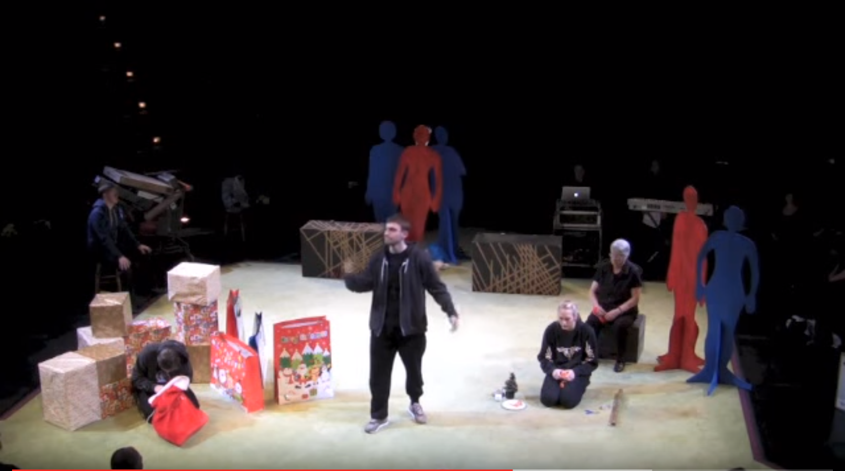
Figure 1
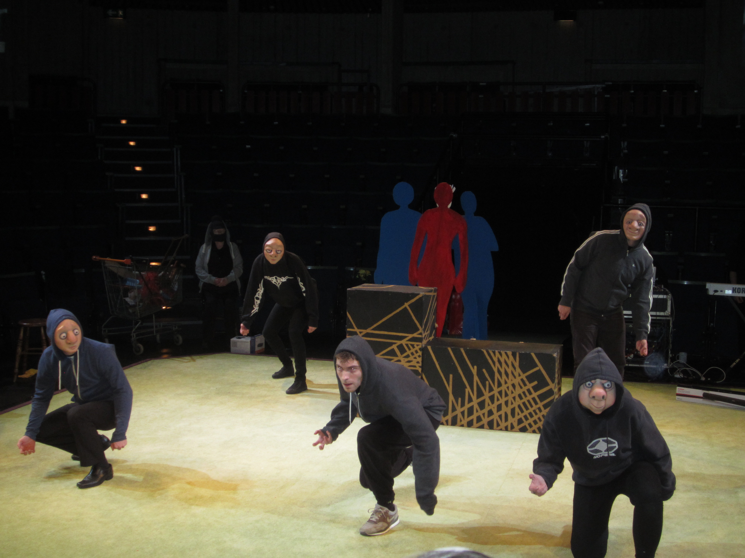

Figure 2
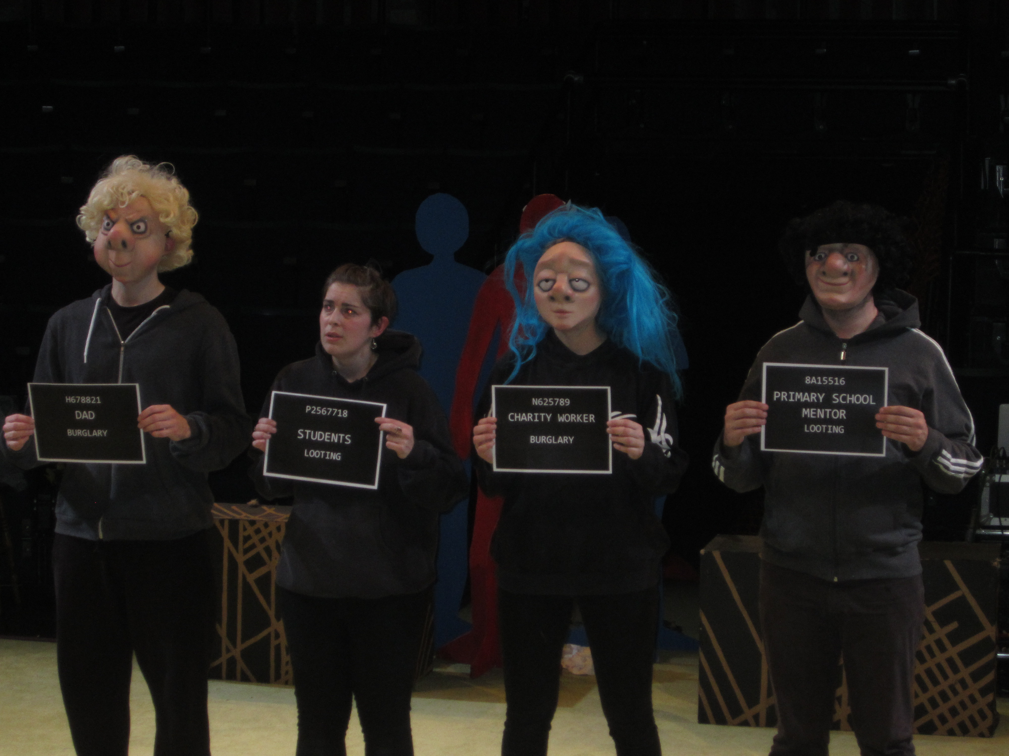

Figure 3
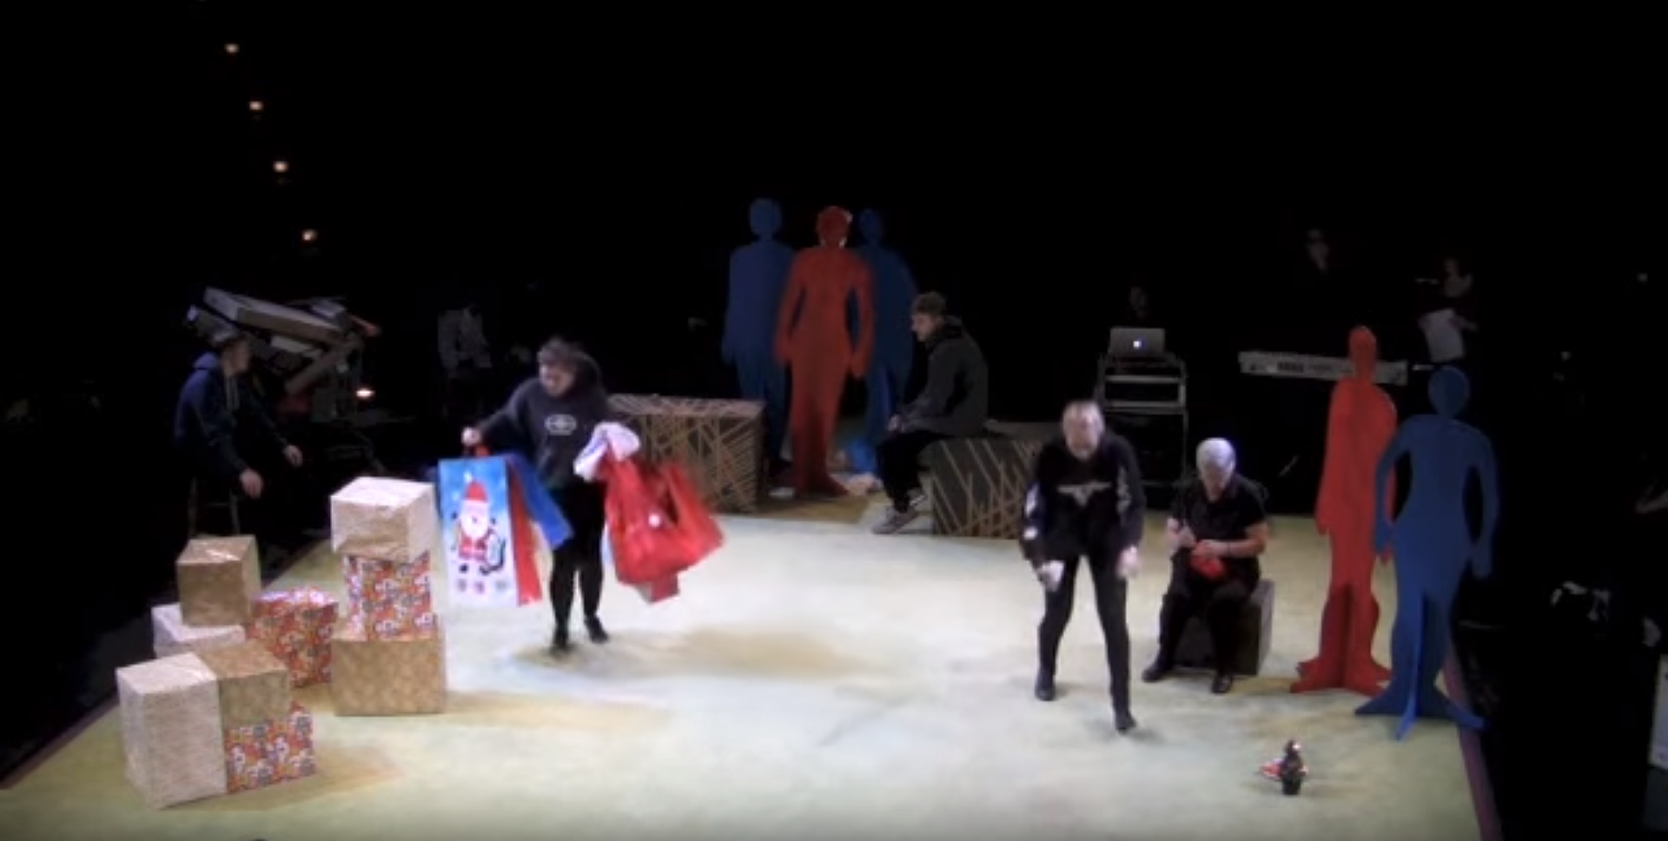
Figure 4

Riots involving thousands of people broke out in London and other major towns and cities across the UK in August 2011. The riots involved looting and arson attacks on shops and resulted in the death of five people. The riots were dubbed the ‘Brand Riots’ in the media (Boffey, 2012) as young people targeted brands in their frustration with economic decline, poor access to jobs and exclusion from consumption opportunities.

