“Creativity in Three Dimensions: An Investigation of the Presbytery Aisles of Wells Cathedral”

Introduction
Recent scholarship has seen a return to the question of medieval creativity. This coincides with wider interest the nature of creativity and its relationship with invention, innovation and entrepreneurship. Whilst the impulse to create can be identified across eras and cultures, it is implicit in such studies that this force may be conceptualised in different ways and operates in various ways in different contexts, which may or may not encourage innovation. The aim of the present essay is to explore the nature of creativity and invention in medieval architecture through forensic analysis of the presbytery aisle vaults of Wells Cathedral. The rationale for the selection of this case study will be discussed below. By using new methods of analysis, based on 3-D scan data, we can investigate in depth the processes by which these vaults were conceived, designed and built, offering insight into the workings of creativity on a single highly significant site.

Architectural Design and Drawing
The intellectual work of architecture lies primarily in the design, where the opportunities for innovation and inventiveness are most readily recognised. Recent study of medieval architecture has been informed by the recognition that drawings both existed in the Middle Ages and must have performed a significant role in the processes associated with both creativity (having new ideas) and invention (creating new things). Such awareness has been based both on surviving drawings and on analysis of architectural derivations which, it is often argued, could only have been transmitted via this medium. This has been a valuable corrective to the earlier assumption that architectural drawing was a Renaissance innovation and has added ammunition to revisionist attacks on the outdated idea that medieval architecture did not involve an ‘architect’. The associated literature is too vast for review here (however the literature cited in footnote 1 provides an introduction) but has had the unintended effect of marginalising discussion of what was distinctive about medieval building practice and what aspects of it might not rely on drawings and/or straightforward geometrical manipulation. That medieval creativity involved choice and the transformation of ‘sources’ in ways which cannot be predicated on a set of learned practices is inherent in discussion of the oeuvre of designers such as Michael of Canterbury and Peter Parler, but what has generally been omitted is recognition that creativity did not end with the production of a set of blueprints upon which construction depended. As our study of Wells reveals, plans must have existed but need to be understood in relation to the whole production process. We suggest that the medieval creative process unfolded over time and innovations could involve the contribution of several parties. The drafting table may have been the main locus for experimentation (defined as the process by which creativity occurs) in respect of designs conceived in 2-D, but its primacy needs to be questioned for the design of essentially 3-D elements such as vaults. Moreover, it needs to be remembered that drawings alone could not produce a building and that architectural creativity could also be expressed through changed working practices.
The dominance of 2-D representations such as drawings as both evidence and explanatory devices in much current interpretation of medieval architecture has been particularly problematic for the study of medieval vaults. Although drawings of vaults do survive, they are fewer in number and of less complexity than the drawings of towers and facades, perhaps suggestive of a different status or function. Many of the vault drawings in the Vienna corpora have been identified as teaching tools rather than design devices. At this point in the discussion, distinctions need to be clarified between the design, the plan and the orthographic projection, which are frequently treated as though they were identical whereas, as our analysis reveals, they should be considered separate entities.
By ‘design’, we refer to the concept informing the appearance and structure of the vault. This could exist in the designer’s imagination prior to its being captured as a representation, or could result from the process of creating a representation. Robert Bork has demonstrated the importance of procedural design conventions in medieval architecture, using existing plans as evidence. However, as many (including Bork) have argued, the existence of design conventions or ‘rules’ did not preclude individual decision-making at each stage of generating the design, which involves the introduction of something external to the plan (such as the imagined final result or preferred design principles) taking the design-as-representation to its next stage. This ‘something’ constitutes the design concept.
All architectural designs are necessarily three-dimensional. However the design concept may be conceived in two, three or even four dimensions. Examples of 2-D design concepts include floor plans and elevations based on modular or geometrical manipulation in two dimensions. In many cases, the 3-D iteration of the design is dependent on decisions made in two dimensions: for example, the three-dimensionality of a pier design is an upwards/downwards projection from a 2-D template (although clearly the designer of the pier would have had the ability to imagine the final 3-D form from experience of previous examples). However it has been argued, for example by Fitchen, that vaults were conceived in three dimensions and, although arguing for design in two dimensions, Willis and others have suggested that designers must have been able to imagine the 3-D form of a vault before its actual construction, even though this cannot be predicted from its orthographic projection. 4-D design involves the possibility of movement around the building informing its planning and forms, as has been argued by Bork for Metz Cathedral and by Neagley for Saint-Maclou, Rouen.
By ‘plan’ we mean one of the tools by which the design could be recorded and communicated: a 2-D representation which is usually understood as taking the form of a drawing or drawings on parchment, paper or the plaster of the tracing house floor. Surviving drawings of medieval vaults demonstrate that the conventions used today, representing the vault ribs as a series of lines as though projected on a horizontal surface, were known in the Middle Ages and, according to our analysis, a series of such plans must have been produced in order to erect the Wells aisle vaults, although none now remains.
2-D drawings often take the form of orthographic projections and in the modern building process they may indeed be generated from 3-D CAD models. Existing plans used in the recording and analysis of medieval cathedrals, however, are often misleading because the vaults are represented as linear schemes which have a visual logic in two dimensions, rather than as projections from their actual form in three dimensions, which would require considerably more measurement than most architectural surveyors have had time to devote to the task. The difference between the supposedly ‘measured’ plan of Wells drawn in two dimensions and the plan derived from orthographic projection from the laser scans is demonstrated in Fig. 1a-c. Previous discussion of the design of the Wells vaults has largely been based on and wholly communicated via such schematic plans. Whilst these can be useful in discussing the genealogy of rib arrangements and the transmission of such designs between sites (which may have involved similarly schematic representations), they are of little value in terms of the detailed analysis of the individual design concept and its realisation in 3-D form. We therefore need to think about the relationship between the design and the finished product without relying solely on 2-D plans. It is here suggested that accurate 3-D models based on laser scans are one tool which helps us to do this. Related analysis has been undertaken for Late Gothic vaults, particularly deriving from the research project “Stonecutting technology in the Mediterranean and Atlantic areas. Survey and analysis of built examples” (BIA2009-14350-C02-02), sponsored by the Ministry of Science and Innovation of the Spanish Government, but not hitherto for their English antecedents.
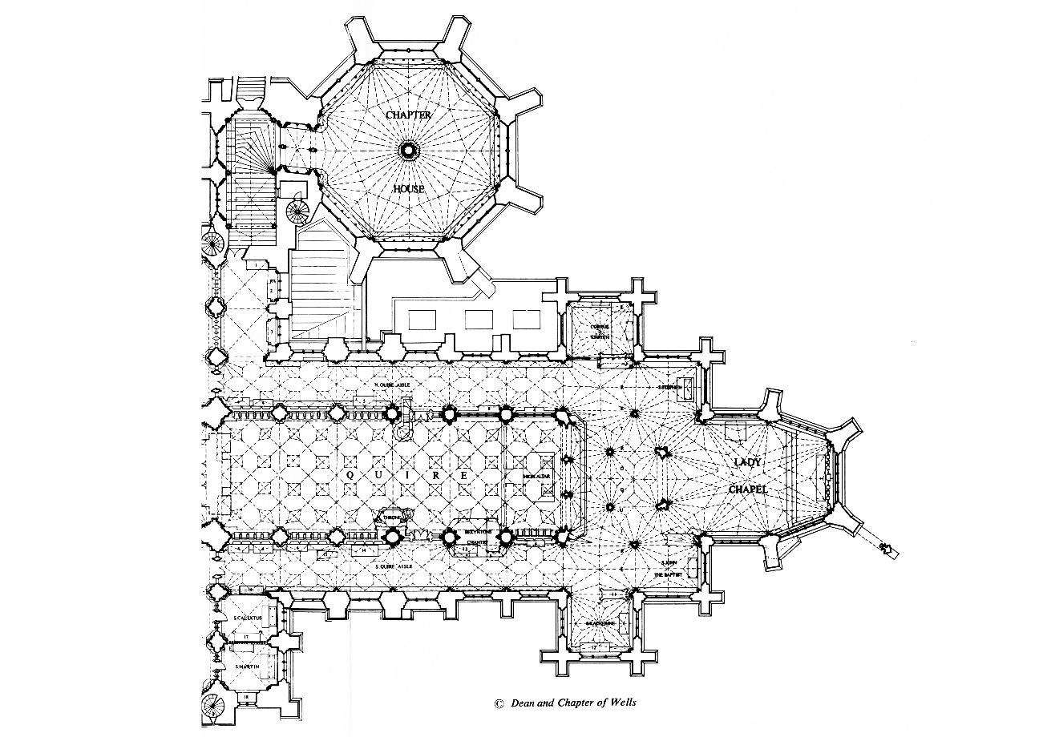
Figure 1a: plan of the East end of Wells Cathedral (Reproduced by kind permission of the Dean and Chapter of Wells Cathedral).

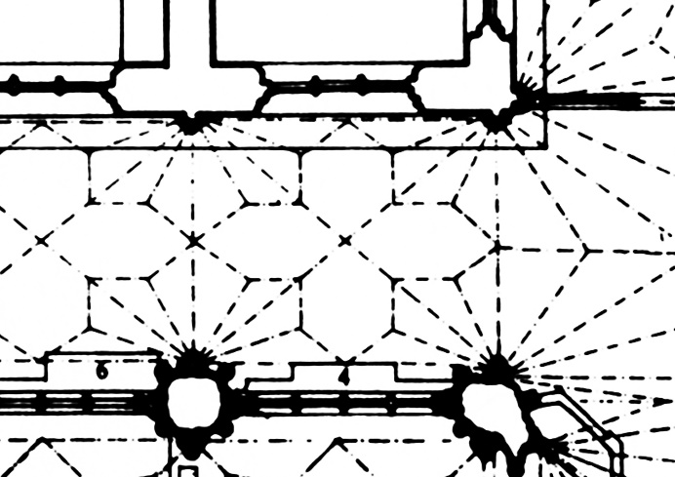
Figure 1b: plan of the presbytery aisle bay N1 (Reproduced by kind permission of the Dean and Chapter of Wells Cathedral).

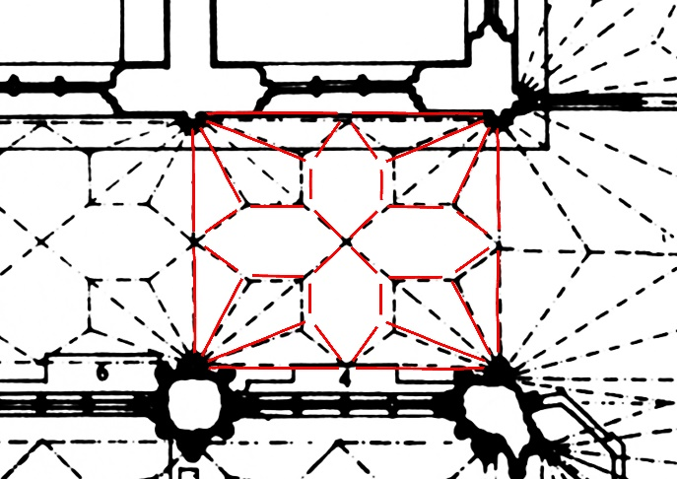
Figure 1c: plan of the choir aisles bay N1 overlaid with digital scan.
Wells Cathedral
The selection of Wells as a case study was based on the difference, clearly visible but not previously analysed, between the forms of the vaults in the north and south aisles of the choir [Fig. 2]. For convenience, the aisles are herein identified as N (north) and S (south), their bays numbered 1-6 from east to west. Although apparently based on the same design concept (to be discussed below), their 3-D form was sufficiently dissimilar to merit investigation. As will be shown, laser scanning revealed further differences within each aisle which, although visible to the eye, are unintelligible without the digital models.
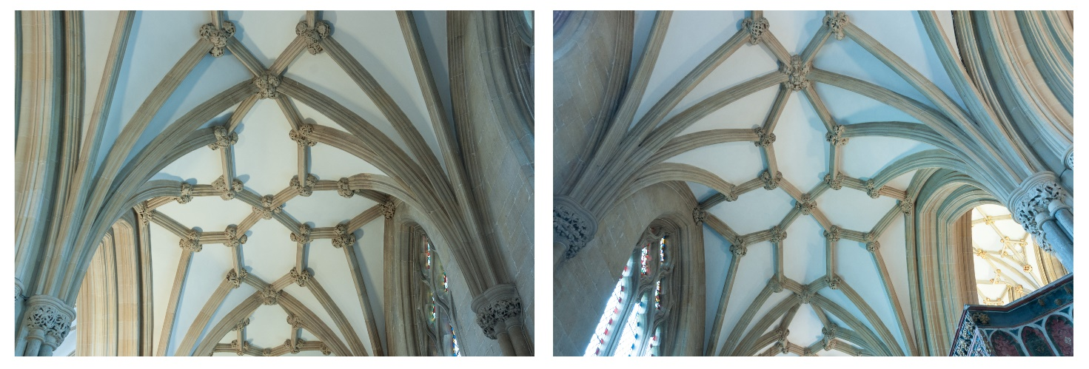
Figure 2: The presbytery aisle vaults from the East looking West in the north aisle (left) and south aisle (right). Image by J R Peterson.

Wells also benefits from a relatively well-documented construction sequence, architects who have been identified by name and a secure position in the literature as having international significance as a ‘prodigy building’, whose design innovations transformed any identifiable prototypes beyond recognition and provided a springboard for late Gothic vaulting forms. Innovations associated with the Wells vaults include the net vault, defined as a vault whose ribs criss-cross a planar surface rather than defining ridges and groins, in this case involving an equally innovative tunnel vault with penetrations, vaulting designs which exclude a main diagonal rib (probably contemporary with their earliest use at Exeter), the use of diagonal ribs extending beyond their original bay and the inclusion of cusping to create a design association between vaults and traceried windows. The aisle vaults, however, have so far played only a limited role in this discussion although the three authors by whom they have been discussed have all highlighted their 3-D form as distinctive.
The aisle vaults belong to a campaign of building whose date of commencement is probably around 1323/4. The scheme involved the building of a Lady Chapel, to a new design and probably further east than its predecessor, and the removal of the liturgical choir into the eastern arm. That early fourteenth-century Wells offered a supportive environment for architectural creativity is suggested by the innovative character of the architecture (contrasting with the predominantly conservative character of the earlier nave). Nevertheless, the new work was also dependent on the twelfth-century design, incorporating three bays of the older presbytery, including the two piers east of the crossing and their arcade arches, probably to support the central crossing tower. All modern accounts propose a division between the Lady Chapel and retrochoir, whose design is attributed to Master Thomas of Witney, and the work of the choir, attributed to William Joy, known to have been involved at Wells by 1329 at the latest. The documentary evidence for dating the various elements of the work need not detain us here, since absolute datings for the aisles are both impossible to provide and irrelevant to the analysis, although most accounts state or imply a date in the early 1330s.
Our analysis suggests that the vaulting of the aisles can be divided into four ‘sets’ of vaults (N1-3, N4-6, S1-3 and S4-6), each of which is different in both horizontal and vertical orthographic projection [see Figs 3 and 4]. Analysis of the sculpture reveals a clear difference in foliage style between the bosses of bays 1-3 and bays 4-6 on both sides, but no significant differences between north and south. This variance introduces the possibility of a chronological distinction between the eastern and western bays; therefore the present article will deal only with bays 1-3 on each side in order not to complicate analysis. The continuity of sculptural style across these bays suggests if not simultaneous construction, then at least chronological continuity. The documented dates suggest that all twelve bays must have been vaulted relatively speedily, probably over the course of no more than a couple of years.
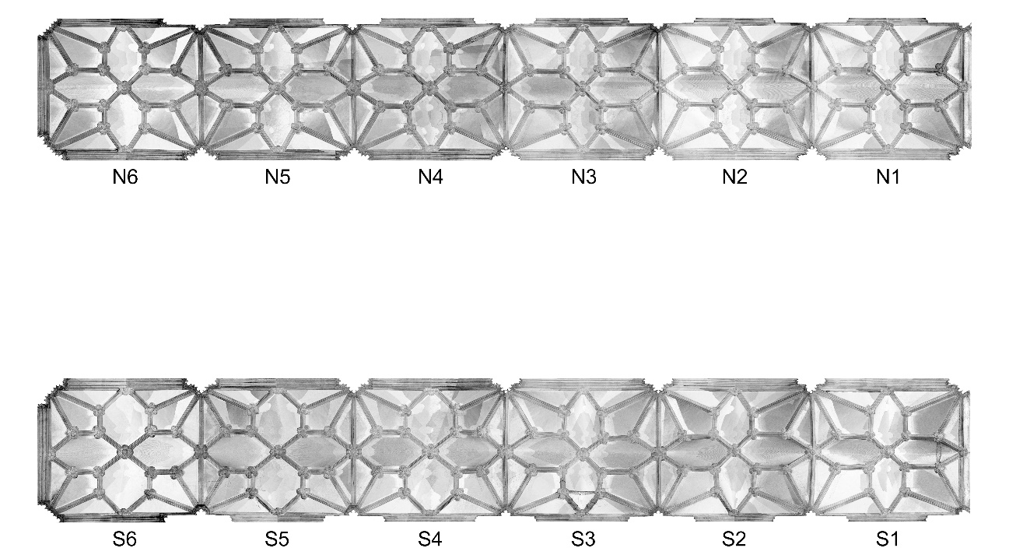
Figure 3: Orthographic image of the digital point cloud data for the north aisle (above) and south aisle (below) in plan.

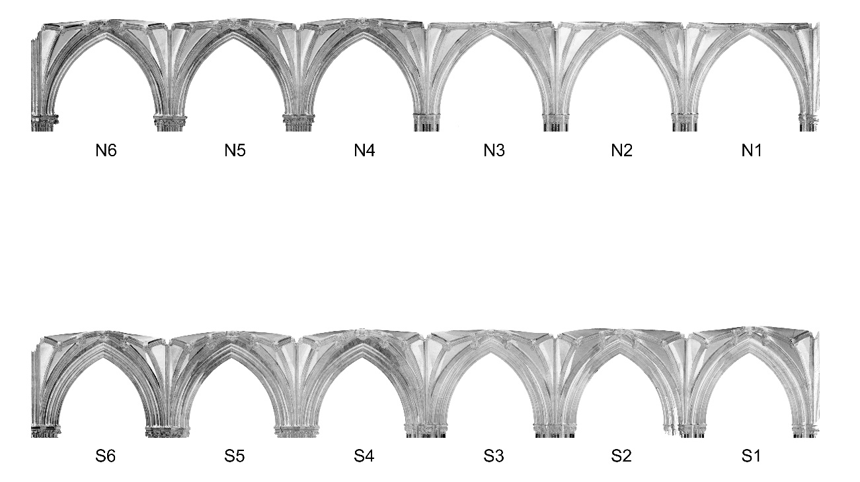
Figure 4: Orthographic image of the digital point cloud data for the north aisle (above) and south aisle (below) in section, both facing north.

Methodology
The data on which our analysis is based derives from a new survey of the eastern arm undertaken by the authors and J.R. Peterson on 24-25 April 2015, using a Faro Focus 3D X330 laser scanner. This produces a highly accurate digital representation of the vaults by recording points on their interior surface every three millimetres. Several scans are required to produce the entire model of the eastern arm: the scanner has to be repositioned to record accurately all of the vaulting detail, as it can only survey the surfaces within a direct sight line of the laser. The scans were subsequently combined using the proprietary software, which recognises common reference points across all scans.
The innermost edge of each rib’s profile was then traced manually point by point, creating an accurate record of the intrados (inner curvature). These points combined established a digital wireframe model of each bay’s geometry in 3 dimensions. The locations of the bosses were left blank, both because the sculpture prevented accurate tracing and because, having experimented with extending the traced lines, it was clear that they did not always meet at a single point. Since this junction does not exist in reality (the role of the bosses being to mask it), we did not want to create models which mixed data derived from the scans with notional points with no basis in reality. Nevertheless, these notional junctions had to be used when measuring the height of the apex of the rib from the impost since the actual bosses vary in depth. These measurements therefore need to be treated with more caution than others and are placed in square brackets in the forthcoming discussion.
From the 3-D models, we created orthographic projections of the traced lines, which are ideal for analysis as they enable a clearer reading of complex 3-D geometry by projecting the traced curves onto a vertical plane (elevation) and onto a horizontal plane (plan) [see Figs 5a-d]. These projections maintain their accuracy based on the original digital models, as they are a direct output of the 3-D data as opposed to projections based on traditional surveying techniques which can result in inaccuracies. We used the tracings to investigate their geometry, identifying the radii of each arc, the location and number of centre points and their position on, above or below the impost line.
Figure 5a: Bay N2 digital mesh model.

Figure 5b: Overlaid with lines traced along intrados of each rib.

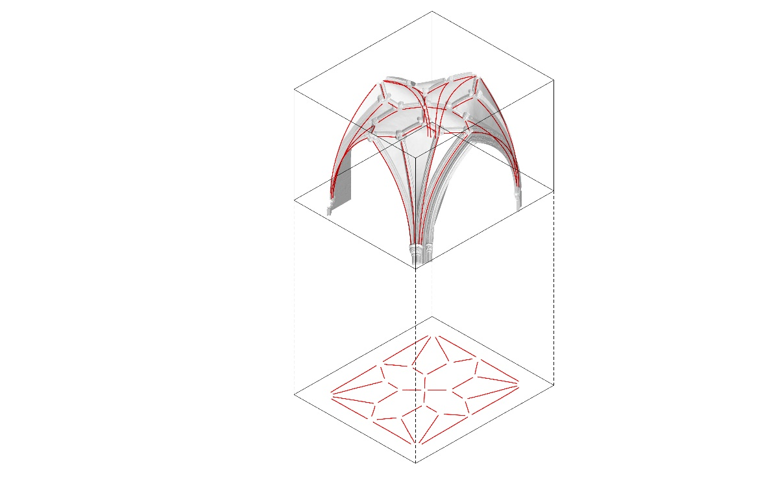
Figure 5c: Orthographic projection extracted in plan.

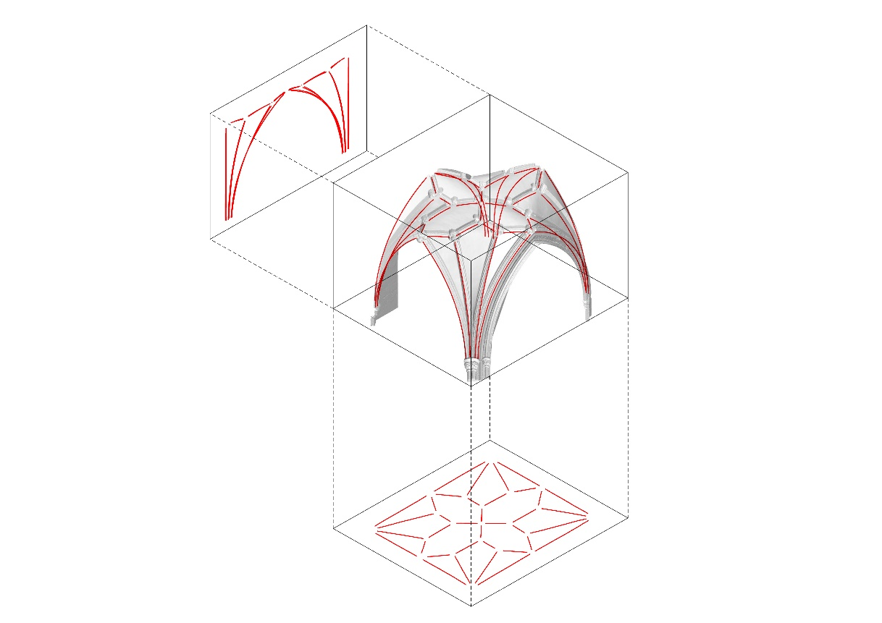
Figure 5d: Orthographic projection extracted in elevation.

Analysis
As explained, our main aim was to interrogate the creative processes involved in designing and constructing the vaults, specifically whether they were conceived in two or three dimensions and whether plans were involved at any stage. The 2-D concept informing the design seems to have involved the elimination of the diagonal rib (also a feature of the earlier vaults of the projecting chapels flanking the retrochoir), the use of hexagonal compartments placed transversely and longitudinally which meet to form a saltire cross at the centre of the bay (perhaps a symbolic reference to St Andrew, patron saint of Wells). Hexagons seem to have been a shape favoured by William Joy, combined with saltire crosses in the east window of the choir, and their use in these vaults can be compared to the lozenges taking the place of ribs along the ridges in the Wells retrochoir and at St Augustine’s, Bristol, another building with which he has been associated.
From our models, it was clear that bays N1-3 and bays S1-3 had very different 3-D geometry [see Figs 6a-c]. In each of the ‘sets’, we looked for the most consistent bay in terms of plan and projection. For N1-3 this was the central of the three bays (N2) and for S1-3 this was the easternmost bay (S1). However, the 3-D form of S1 was found to differ from S2 and S3, with the central boss being considerably higher [see Fig. 6b]. Therefore the 3-D analysis of these bays focuses on S2. In our analysis the north aisle will be treated before the south aisle because the geometry is simpler; this should not be read as suggesting chronological priority.
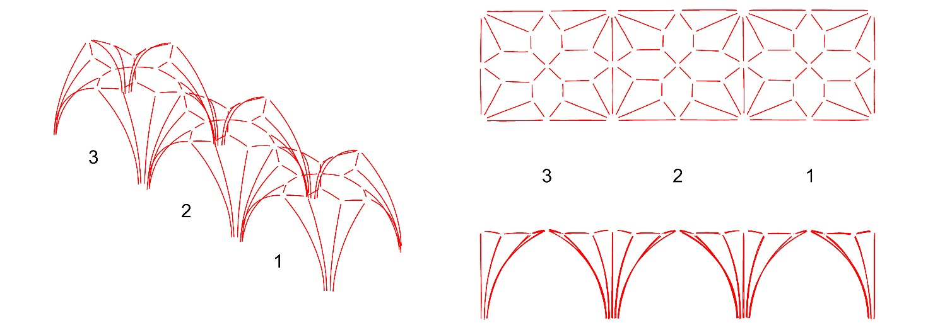
Figure 6a: North bays 1 to 3 in plan, elevation and isometric.

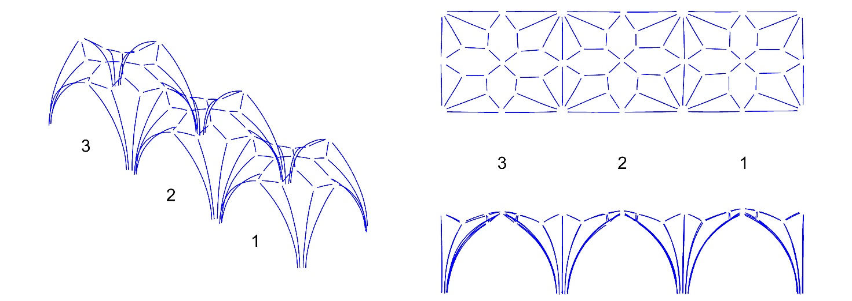
Figure 6b: South bays 1 to 3 in plan, elevation and isometric.

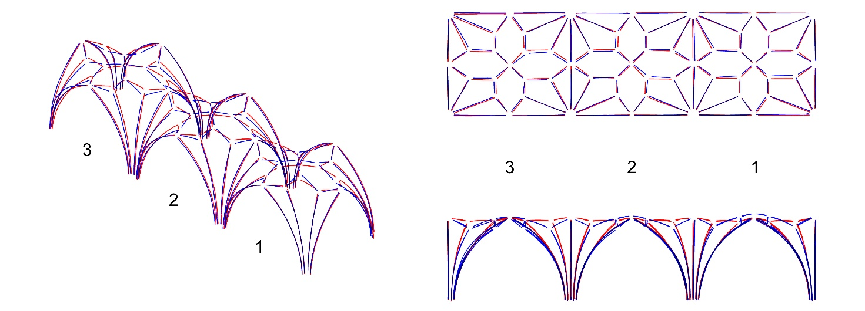
Figure 6c: North and south bays 1 to 3 overlaid in plan, elevation and isometric revealing their differing geometry.
Our initial hypothesis was that the same plan might have been projected using different methods, perhaps with the intention of creating different 3-D forms. According to Bucher, ‘The first conscious decision of the master concerned the basic shape of the vault’. The basic shape, i.e. the 3-D form, of a vault is predicated on five factors: the 2-D plan of the ribs, the heights of their springing point, the points of intersection of the ribs (the apex or highest point, at Wells marked by a boss), the position of the arc’s centre and the arc’s curvature [see Fig. 7a]. Each of these factors could be used as a starting point, which limits the options available for the others. In particular the form of each rib is determined by the location point of the centre, springing and apex [see Figs 7b-f]. Once two of these three factors are fixed, the third automatically follows (unless the arcs have more than one centre). Our models demonstrated that at Wells all the arcs had simple curvatures with a single centre and most were extremely accurately built, as overlaying the actual curvatures with radii of circles revealed little discrepancy between the two. At Wells, bays N1-3 follow what had by that date become the normal practice in tierceron vaults of setting the apex of the transverse and wall ribs and the central boss at the same height. Although the Wells side aisles abandoned ridge ribs, the principle that ridges should be level seems to have informed the 3-D geometry of bays N1-3. Bays S1-3, on the other hand, have a pronouncedly domical shape. Although the transverse, wall and arcade ribs all reach the same height (range of [3.524-3.573]m in S2), the central boss is higher ([3.666]m in S2). The real cause of the domical appearance in S1-3, however, is not the slightly higher central boss but the lower height of the apex of the tiercerons (at least 0.25m lower than in N1-3). This results in a vault virtually in two sections: a lower portion framed by dominant conoids, surmounted by a domical crown. The tierceron heights can be correlated with other measurements (see below) but without further research we cannot say whether this is meaningful. What is clear is that the heights were the result of choices, perhaps intended to achieve a particular effect.
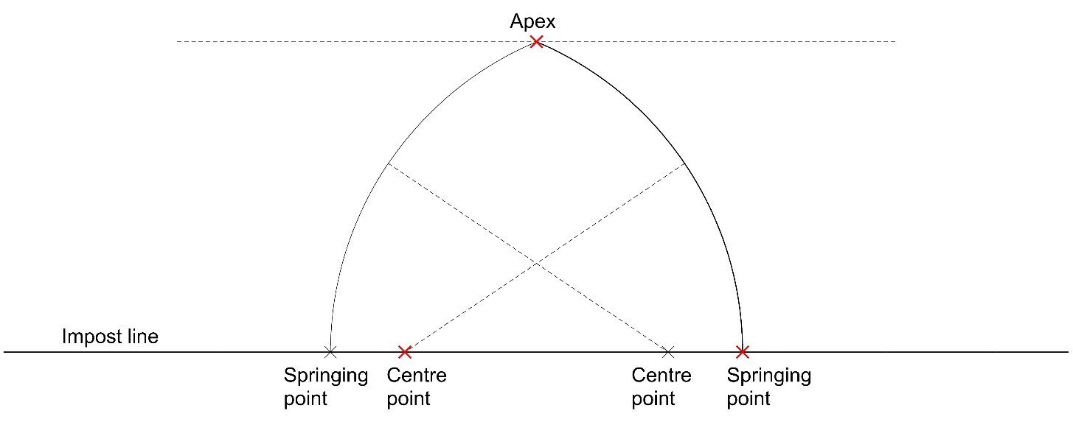
Figure 7a: Two centred arch based on fixed springing point, apex and centre on the impost.

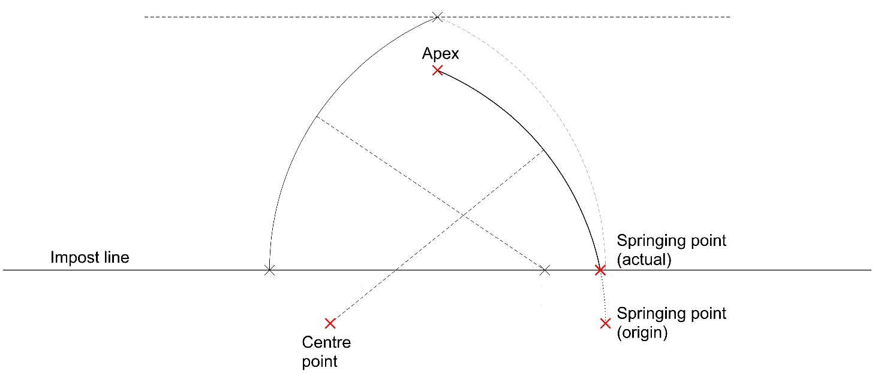
Figure 7b: Left-hand arc as previous; right hand arc showing effect of lowering the centre point.

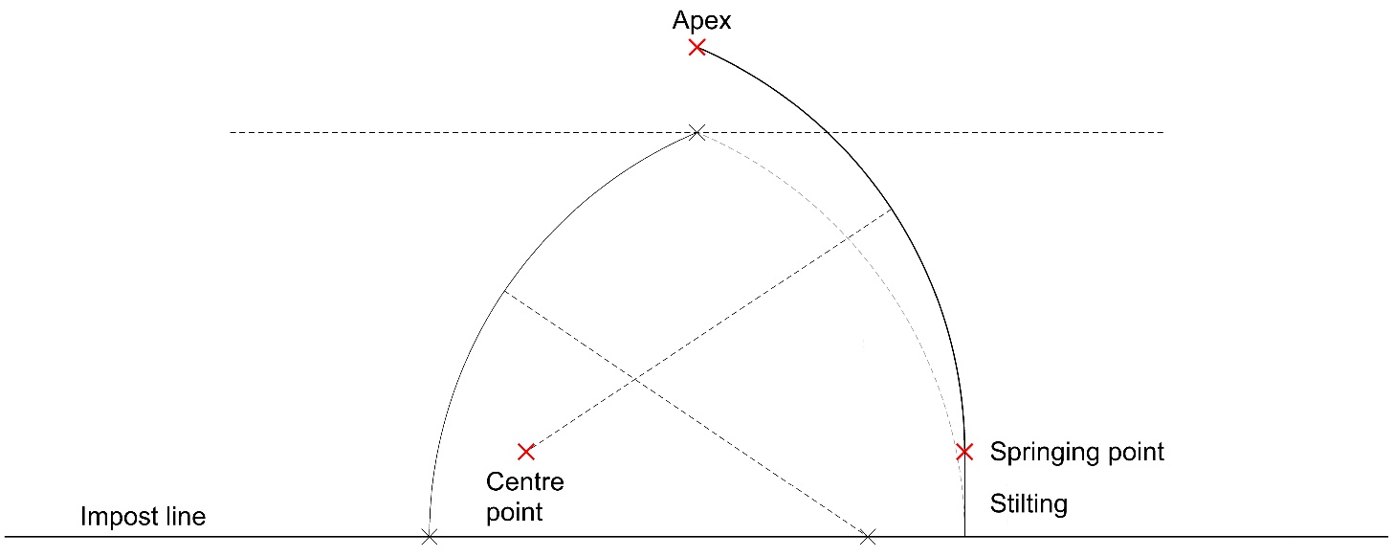
Figure 7c: Left hand arc as previous; right hand arc showing effect of raising the centre point.
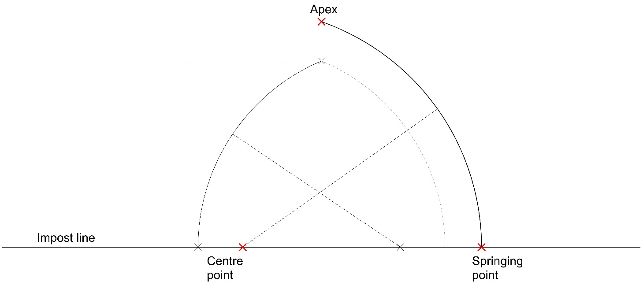
Figure 7d: Left hand arc as previous; right hand arc showing effect of lengthening the radius with same centre point as in 7a.

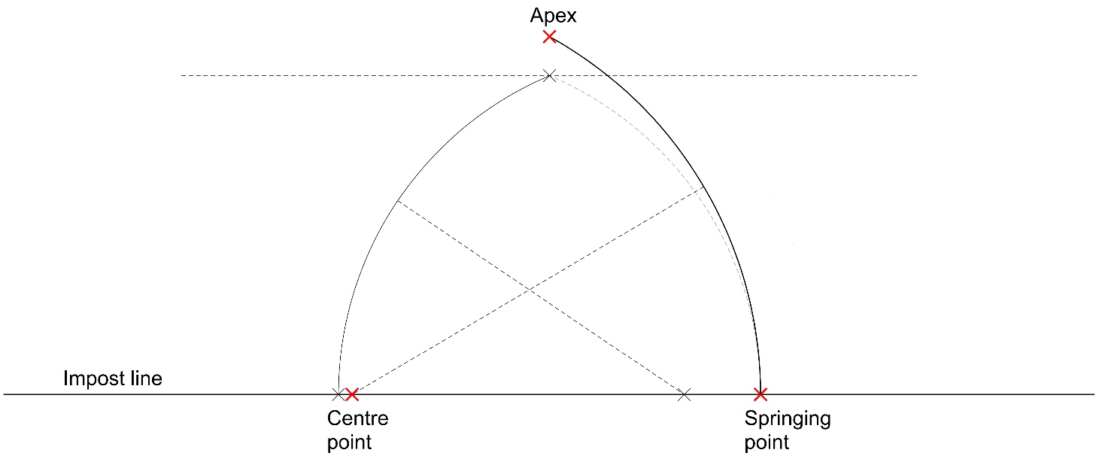
Figure 7e: Left hand arc as previous; right hand arc showing effect of using longer radius with same springing point as in 7a.

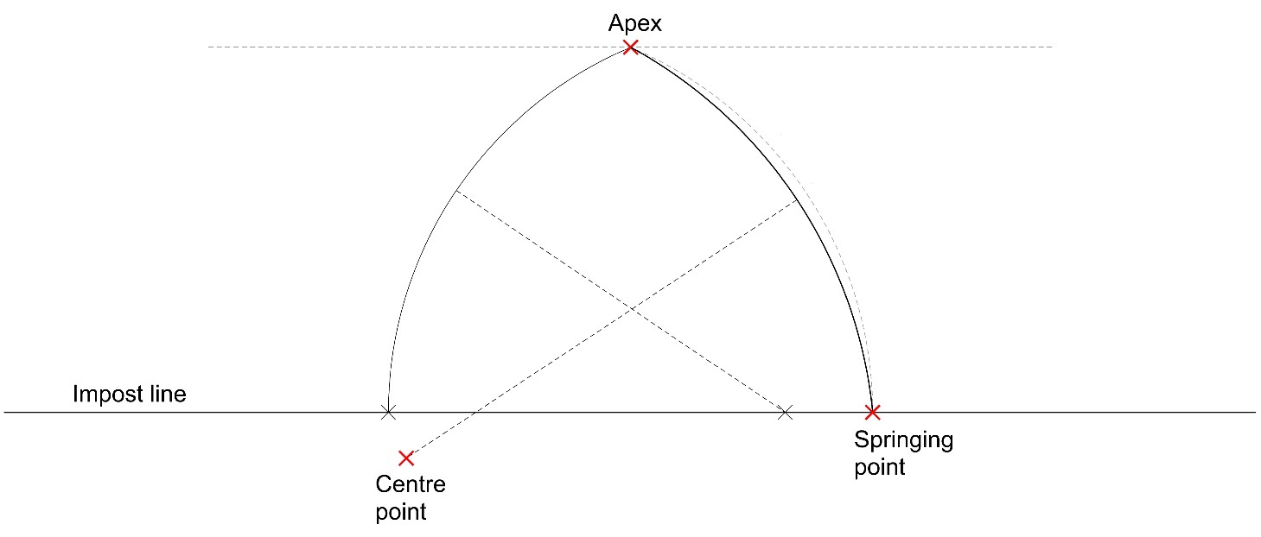
Figure 7f: Left hand arc as before; right hand arc showing effect of using longer radius with same apex as in 7a.

Across all the bays, the height of the apex of the transverse arches was fixed by a decision that it should continue the arch heights from the retrochoir, which are all around [3.560]m from the top of the abacus. The same height was used for the wall and arcade ribs, again maintaining the same heights as in the retrochoir. These have the proportions termed by Villard de Honnecourt an arch of five points [see Fig. 8]. Having opted for level ridges (as in the retrochoir), the height of the central boss in bays N1-3 was therefore fixed from the outset. In bays S1-3, where level ridges were abandoned, only the heights and directions of the bounding ribs were pre-determined. Another fixed point seems to have been consequent upon the decision to place the centre points of the wall and arcade ribs on the base point of the vault (the impost level, at the height of the top of the abacus).
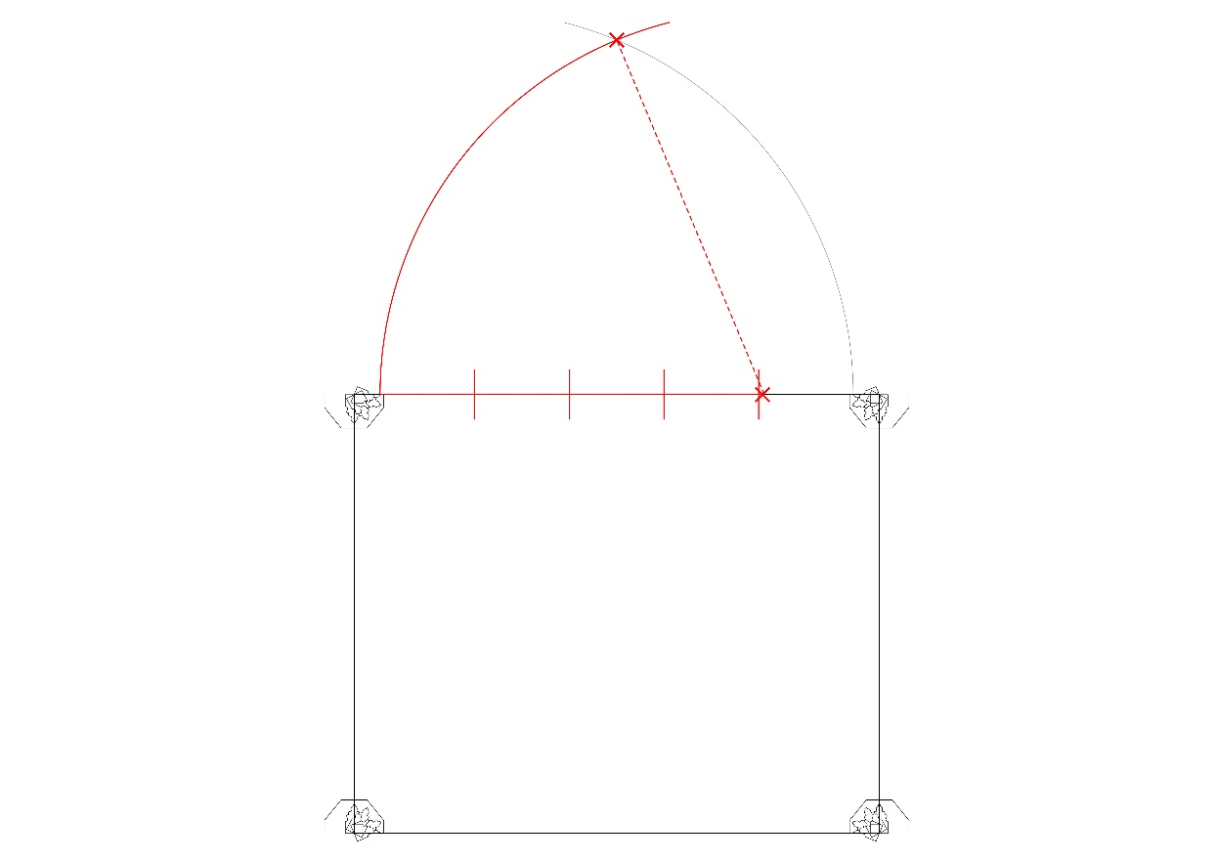
Figure 8: The longitudinal ribs in N1-3 and S1-3 have proportions termed by Villard de Honnecourt as an arch of five points.

The four known elements rule can also be used to locate the position of the centre of a simple 2-D arch where its springing point, apex and radius are known. The impost seems to have been the preferred level of the centre point and was only abandoned when other requirements prevailed; in these cases, the centre point was determined by these other fixed points. As well as preferring to place the centre on the impost line, we identified that potentially variable measurements seem to have been derived from existing dimensions. Thus in bays N1-3 and S1-3, the radius of the transverse arch seems to correlate to the height of the piers from ground to abacus, which is also the length of the bay from edge of abacus to edge of abacus (average 4.620m). Following a simple geometrical process, using circles having the same known radius as the arch [see Figs 9a and 9b], the location of the centre point can be identified, which in this case is both below the impost and outside the area of the plan and thus does not comply with Villard de Honnecourt’s rules. This therefore suggests that the wall ribs were generative elements of the design, as we have posited elsewhere in relation to the tierceron vaults of the retrochoir.
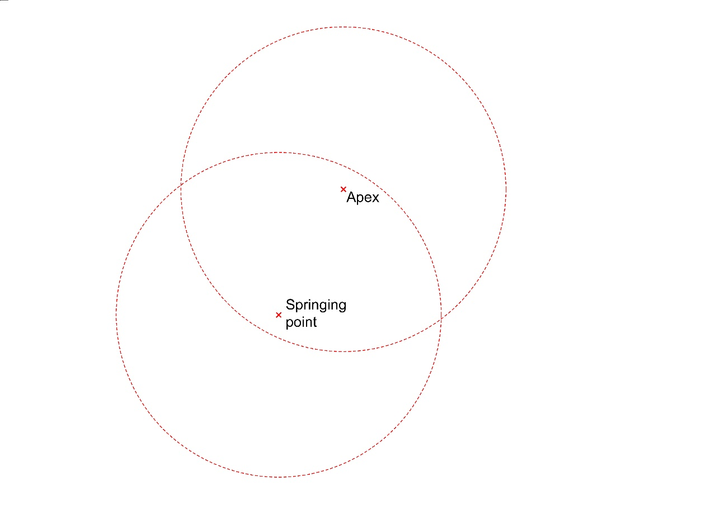
Figure 9a: Rule for finding the centre point of an arc (part 1): draw circles with centres at the springing point and apex using the known radius.
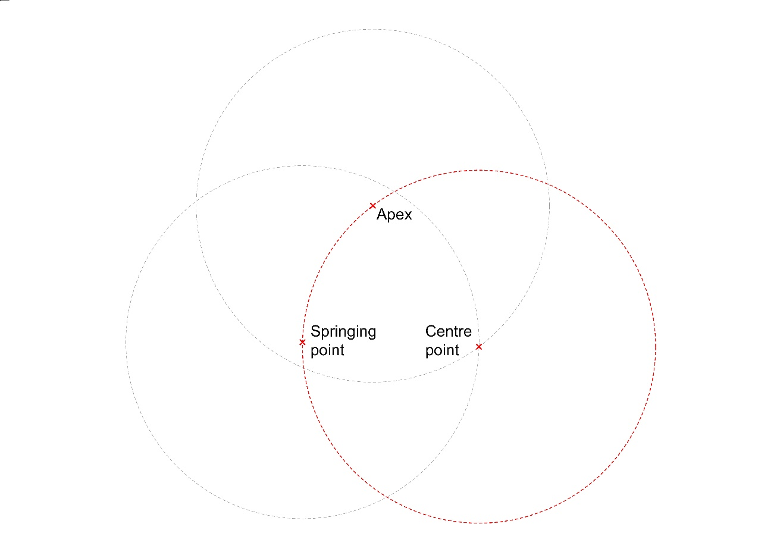
Figure 9b: (part 2): one of the two crossing points of the circles becomes the centre of the desired arc.

The ground plan of the aisle bays, along with the abacus height, was retained from the twelfth-century building. The three eastern bays of the presbytery aisles, although new masonry from the plinth upwards, follow the existing bay plan exactly (within a tolerance of 0.060m). Our analysis suggests that the bay plan must have been drawn out full size on the tracing floor and that geometry and measurements derived from this full-scale representation were fundamental to the design process. This can be demonstrated by creating a digital simulation of the tracing floor plan. The tracing floor must be conceptualised as a base level, corresponding to the impost line at the height of the abacus, from which heights could be projected. Although the tracing floor would have been situated elsewhere, key points derived from it must have been drawn on the platform below the vault on which the centering was erected, in order to inform the construction process.
Having traced out the bay plan on the tracing floor, the basic geometry of the design was formulated. Common to both N1-3 and S1-3 were lines traced from each corner to the opposite mid-point of the shorter side [Figs 10a and 12a]. These determine the direction of spring of the longitudinal tiercerons. These ribs could not be positioned without this guideline, demonstrating that a 2-D representation must have preceded their projection. With springing point and direction known, the radius, the height of apex and centre point of the ribs remain to be settled. Here we start to see differences in process between north and south aisles.
With the exception of the easternmost tiercerons in bay N1, the radius of all the tiercerons in N1-3 is the same as that of the transverse ribs (4.620m) and seems therefore to have derived from these. Because the centre points of the longitudinal tiercerons are not at impost level (so do not represent a predetermined point), the conoid does not have a regular horizontal section and the infill between the ribs has a warped plane.
Besides the springing and the radius, the third fixed point for the tiercerons seems to have been the height of the apex, which is at an average of [3.439]m from the top of the abacus. This measurement, which represents the height of all the tierceron bosses, does not seem to have been an arbitrary one but was the same as the distance from the corner of the bay to its centre (i.e. half the length of a diagonal drawn across the bay). This therefore requires that the diagonal should also have been marked on the tracing floor for the purpose of measurement [Fig. 10b]. For the longitudinal tiercerons, however, the height of the apex represents a level, rather than a position. We therefore conclude that the position of the apex was first located in two dimensions on the tracing floor, then projected upwards. At this stage, the plan had to be conceptualised in three dimensions, even though it could be drawn and measured in two. From these points, the centre point could readily be calculated, as above [Fig. 9a and 9b].
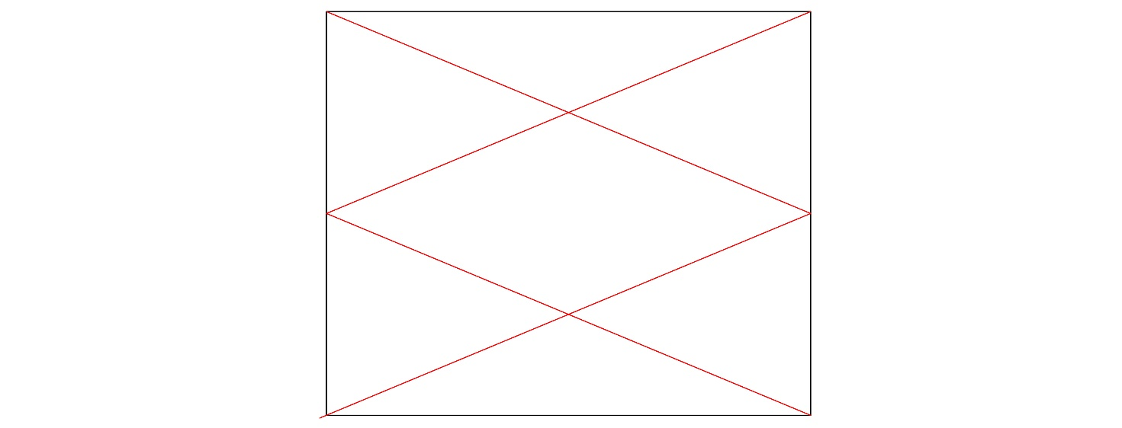
Figure 10a: Hypothetical tracing floor plan of bay N2, showing the direction of the longitudinal tiercerons.

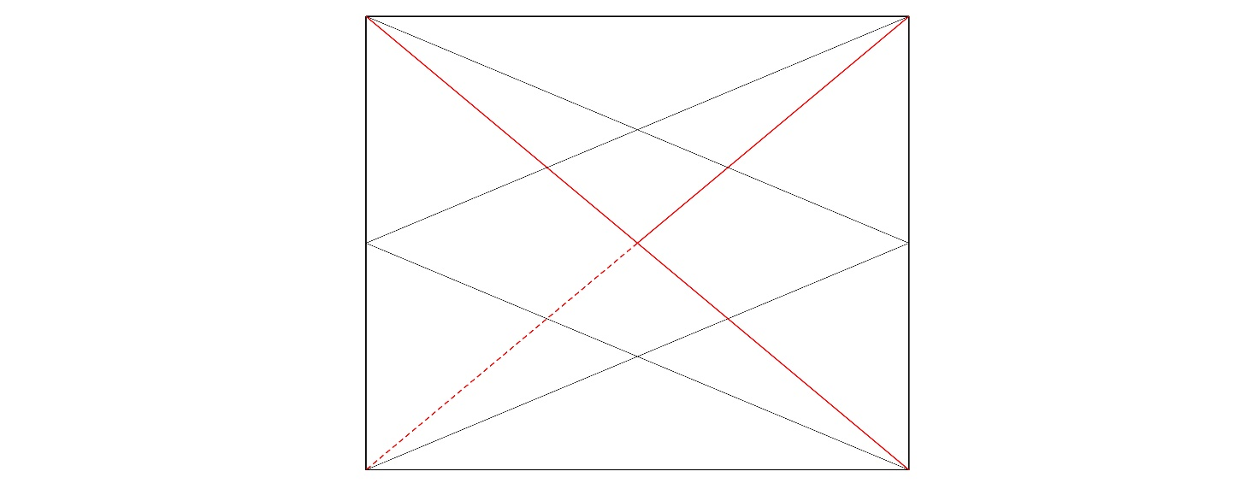
Figure 10b: Hypothetical tracing floor plan of bay N2, showing addition of diagonals and centre of bay to corner dimension.

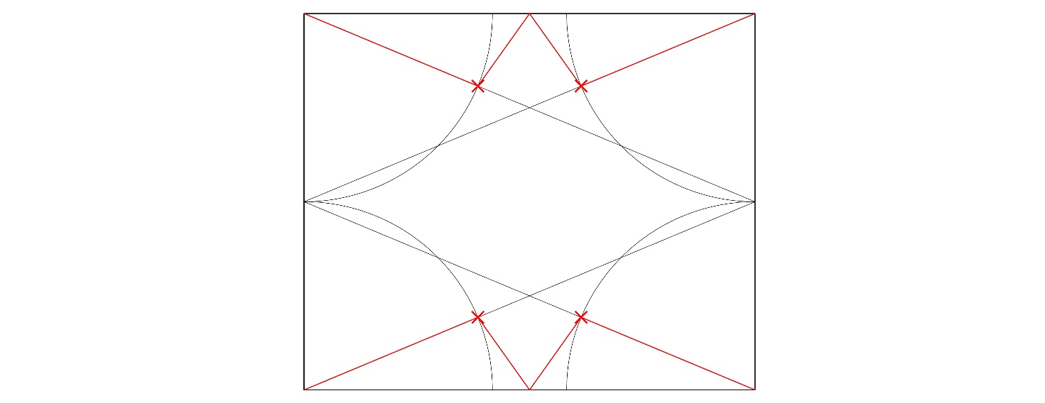
Figure 10c: Hypothetical tracing floor plan of bay N2, showing arcs locating the apex points of the longitudinal tiercerons.

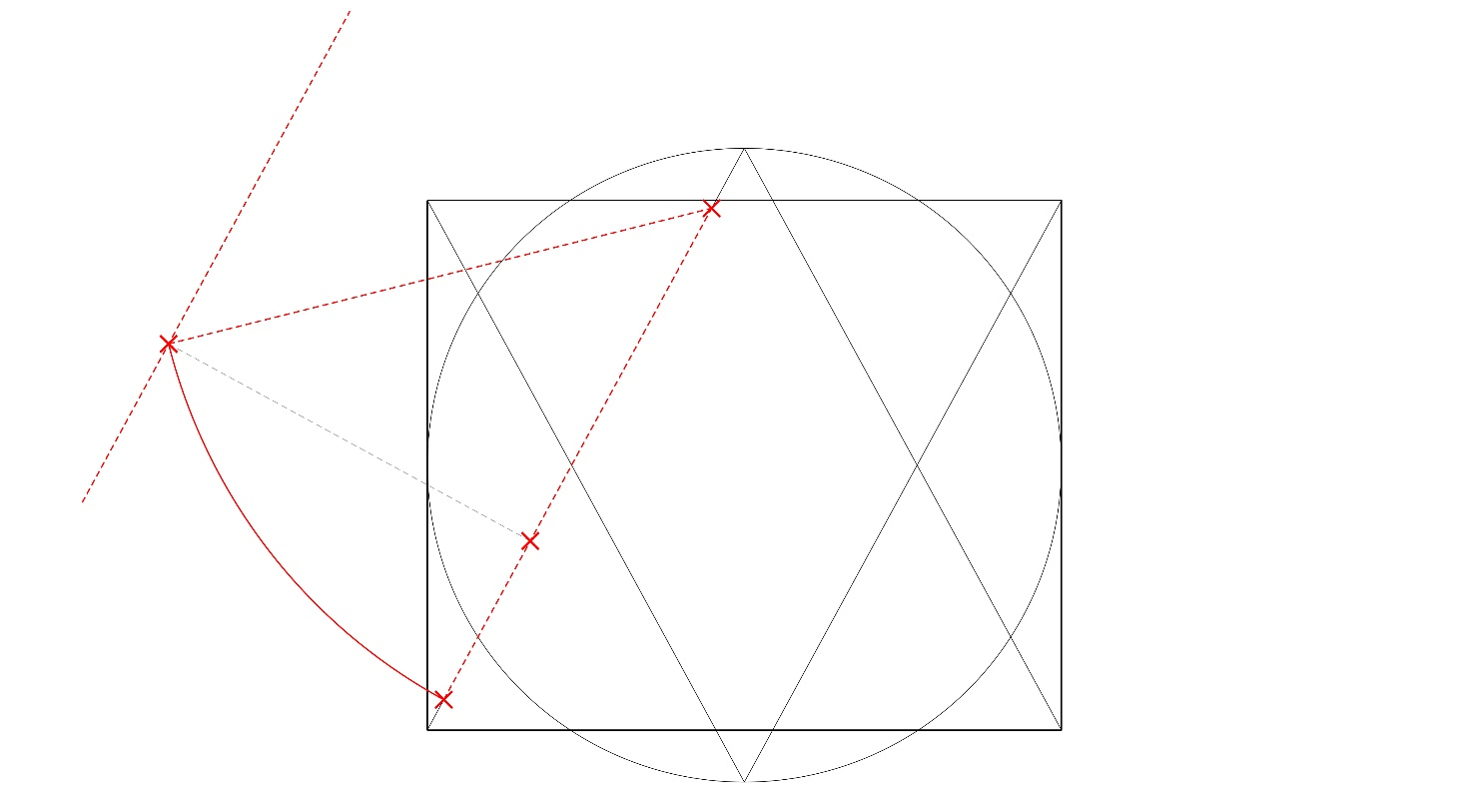
Figure 10d: Hypothetical tracing floor plan of bay N2, showing the direction of the transverse tiercerons and their apex positions based on centre points located on the impost level.

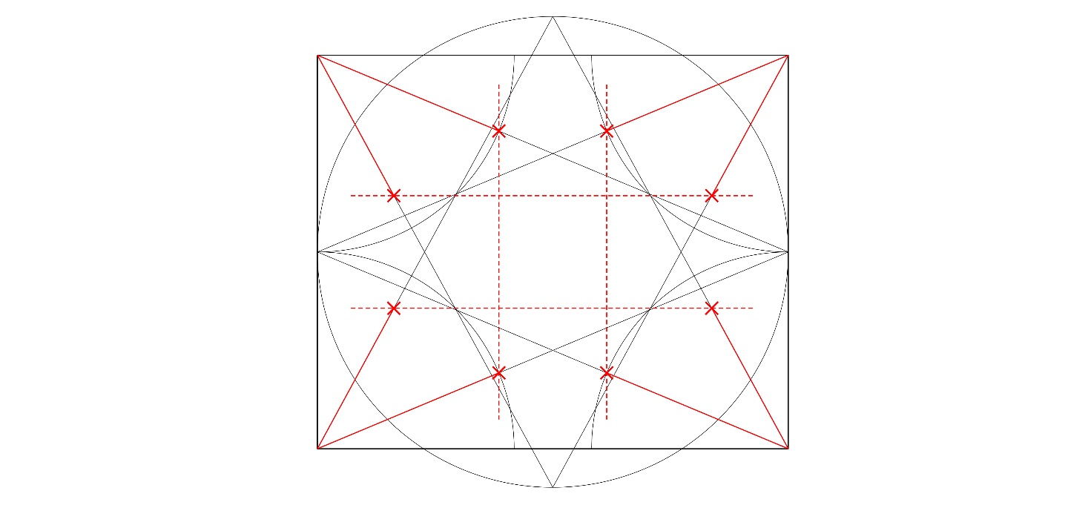
Figure 10e: Hypothetical tracing floor plan of bay N2, showing lines locating the sides of the transverse and longitudinal hexagons.

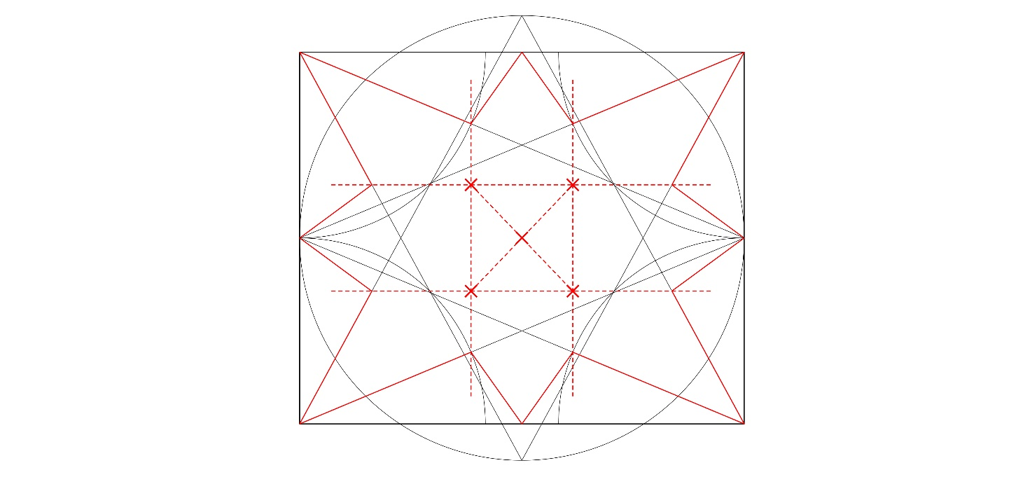
Figure 10f: Hypothetical tracing floor plan of bay N2, showing lines locating the central liernes by connecting the inner lierne apexes.

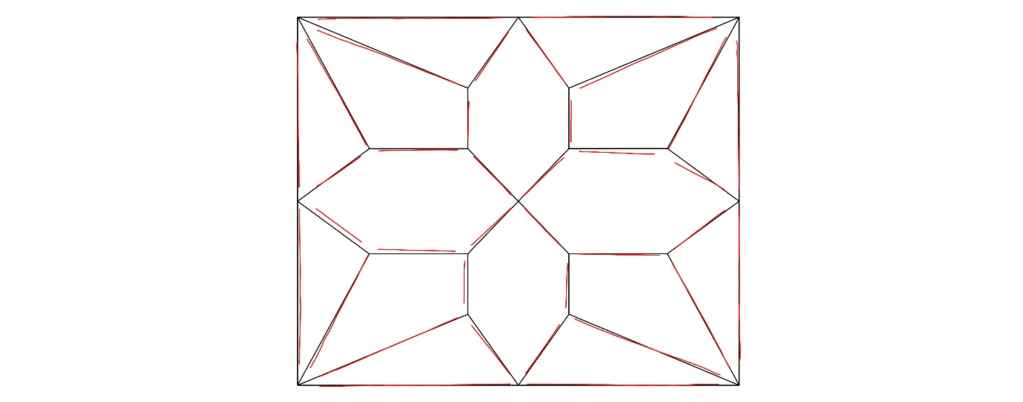
Figure 10g: Hypthetical geometry of bay N2 overlaying actual plan derived from scan data.

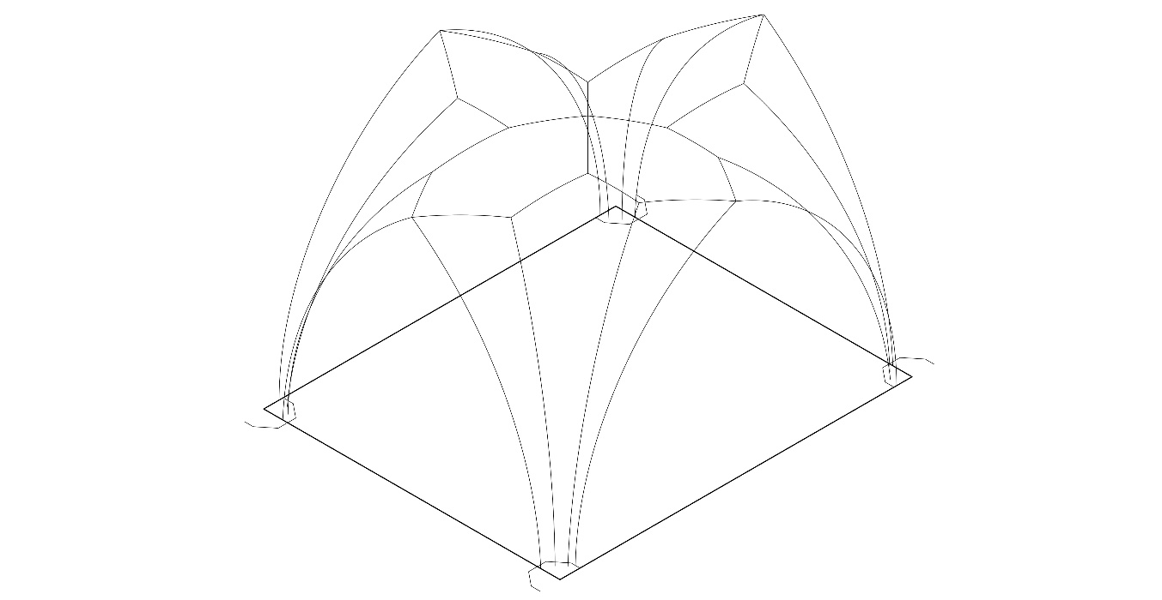
Figure 10h: Hypothetical geometry of bay N2 in three dimensions.

The position of the junction of the liernes and longitudinal tiercerons seems to have been determined in plan by the addition to the plan of four arcs with a radius of half the breadth of the bay and centres in the bay corners. The intersection between these arcs and the already traced lines marks the position on plan of the junction be-tween the longitudinal tiercerons and the liernes springing from the wall and arcade ribs [Fig. 10c].
Initially we thought that the position of the apex of the transverse tiercerons might have resulted from a decision to make the sides of the hexagons formed by the liernes parallel, and to give the transverse hexagons and the longitudinal hexagons the same width. If so, the parallelism and maintenance of the same height for all the lierne bosses could demonstrate the same thought process that opted for level ridges: a desire for horizontality in those ribs parallel with the notional ridges. However, the fact that the centre point of the arcs of the transverse tiercerons was on the impost level, the rib radius was the same as that of the transverse arch and longitudinal tiercerons, and the height of the apex was the same as for the longitudinal tiercerons (all of which can therefore be considered to be fixed points), along with the discovery that the direction of these tiercerons was the same as in the other bay sets, where the liernes are not parallel, suggests that the parallelism may have been coincidental.
The direction of the transverse tiercerons seems to have been determined by a circle drawn with its centre point in the centre of the bay and outer edge at the mid point of the transverse arch in plan. Lines can then be drawn to connect each bay corner, the opposite circle mid point and the opposite bay corner. This layout corresponds exactly to the geometry of the simulated tracing floor plan relating to the tierceron vaults of the retrochoir. Even though the vaults have entirely different configurations of ribs and different dimensions, the basic system of their 2-D geometry is identical [see Fig. 11], potentially throwing doubt on the argument that the differences between the two designs suggest different designers. The transverse tiercerons can be drawn using the known elements of the centre point, rib radius, springing point and apex height [Fig. 10d]. This fixes the position of the apex on the plan by downwards projection from the arc, rather than the apex needing to be positioned by an upwards projection from a known point on the plan. Again, 3-D thinking was therefore fundamental to this stage of the process.
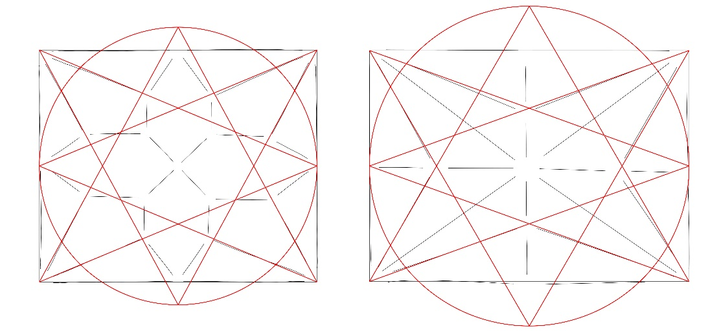
Figure 11: Traced plans of bay N2 of the choir aisle (left) and bay two of the retrochoir south aisle (right) derived from actual scan data, both overlaid with the generative ‘starcut’ diagram and circle.
Joining the outer ring of bosses across the bay creates the central square and inner ring of bosses [Fig. 10e]. The central saltire is created with diagonals across this square [Fig. 10f]. The height of the central boss, as already stated, is [3.560]m from the impost and the inner lierne bosses are at the same height as the outer bosses: [3.400]m. Overlaying the simulated tracing floor on the traced ribs shows the close correspondence between the two [Fig. 10g]. Fig. 10h shows the final simulation in 3-D.
Comparison of bays N1-3 and bays S1-3 demonstrates that our initial hypothesis, that the same plan was projected according to different rules, needed modification. Both used the same basic geometry for the tiercerons, but the liernes were located according to a different process. Making different decisions at certain points resulted in a slightly different plan as well as a different projection. Analysis of bays S1-3, however is complicated by significant differences between the bays. Although all three were apparently based on the same concept, their construction is less precise than any of the other bay sets and no single bay can be taken as normative. The inconsistencies seem both constructional (e.g. use of different radii for equivalent ribs, suggesting that neither the same templates nor the same centering were used across the three bays) and structural (two of the three bays have had to be braced with iron tie beams, evidence of instability either actual or perceived). The scan data provides levels of precision far exceeding the tolerances to which medieval builders were working, they thus document variations which may not in themselves be meaningful but can make it difficult to identify what may have been the original design intentions. Discussion of these bays is therefore more speculative.
In bays S1-3, the direction of the tiercerons was identified following the same processes as in bays N1-3 [see Figs 12a-e]. The tiercerons have a variety of curvatures, except in S2, where all are the same as the wall and arcade ribs. This curvature was used for half the tiercerons in the other two bays but without any obvious pattern. There is no consistency between the levels of their centre points, with few approximating to the abacus level, suggesting that this was not a predetermined point. Where there is consistency across the three bays is in the height of the apex of the transverse tiercerons, at approximately [3.160]m from abacus level. In S2 and S3 this is also the height of the apex of the longitudinal tiercerons, although in S1 they are 0.050m higher, probably because this bay has a higher crown. This suggests that, as in bays N1-3, the height was a fixed point. Similarly to N1-3, the height is determined using the diagonal distance across the bay, this time from the centre of the bay to the edge of the abacus at each corner [Fig. 12b]. Having established these locations on the plan, lines drawn between the points across the bay provide the position of the sides of the transverse hexagons. The intersection between these liernes and the diagonals positions the inner ring of bosses and the central saltire [Fig. 12d]. This gives the diagonals a more significant role than in bays N1-3. The height of the inner ring of bosses is the same as the height of the apex of the transverse arch. Extending the liernes which join the inner bosses in a longitudinal direction to meet the transverse tiercerons creates the sides of the longitudinal hexagons [Fig. 12e]. The central apex forms the highest point in the vault, though it is unclear whether the height of the central saltire [3.666]m is a significant dimension in relation to the other vault measurements. It should be noted that it is almost exactly equal to twelve English feet, although our general assumption is that any measurements used are derived from distances ascertainable directly from the tracing floor rather than requiring a calibrated ruler. The final simulation in 3-D is shown in Fig. 12g.
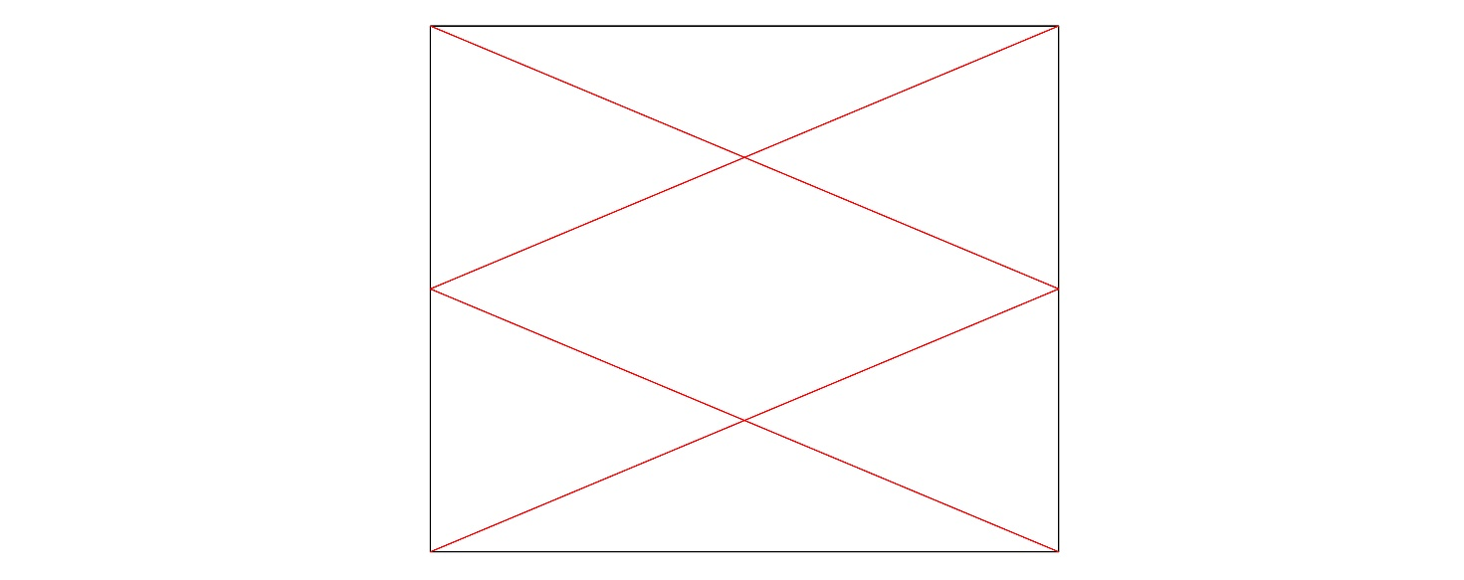
Figure 12a: Hypothetical tracing floor plan of bay S2, showing the direction of the longitudinal tiercerons.

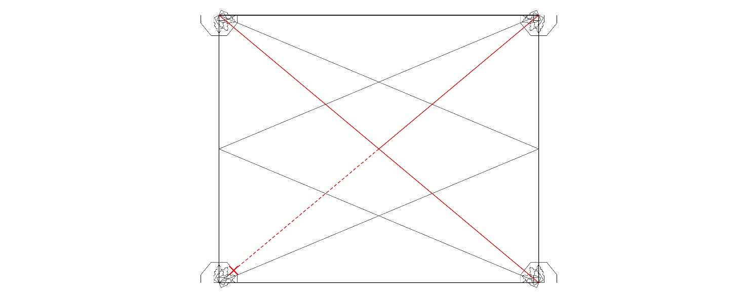
Figure 12b: Hypothetical tracing floor plan of bay S2, showing addition of diagonals and centre of bay to edge of abacus dimension.

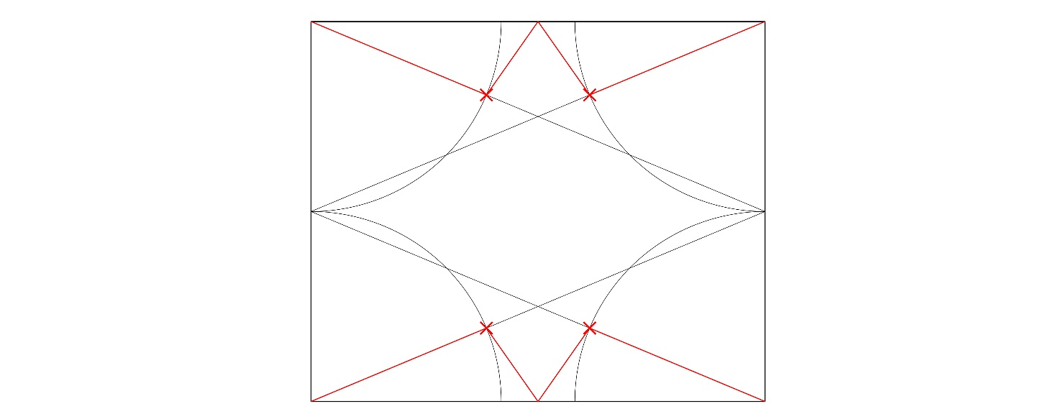
Figure 12c: Hypothetical tracing floor plan of bay S2, showing arcs locating the apex points of the longitudinal tiercerons.

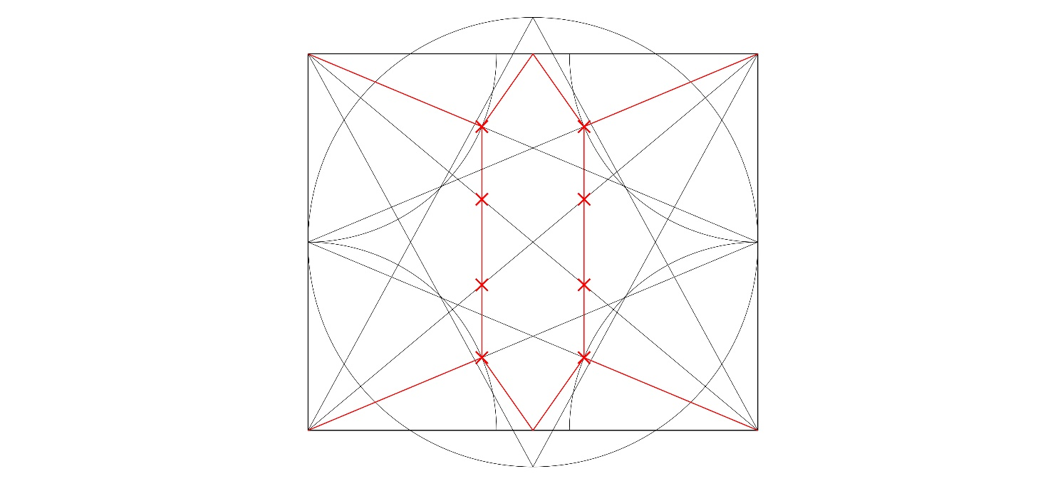
Figure 12d: Hypothetical tracing floor plan of bay S2, joining the longitudinal tierceron apexes across the bay, where the intersection between these liernes and the diagonals positions the inner ring of bosses and the central saltire.

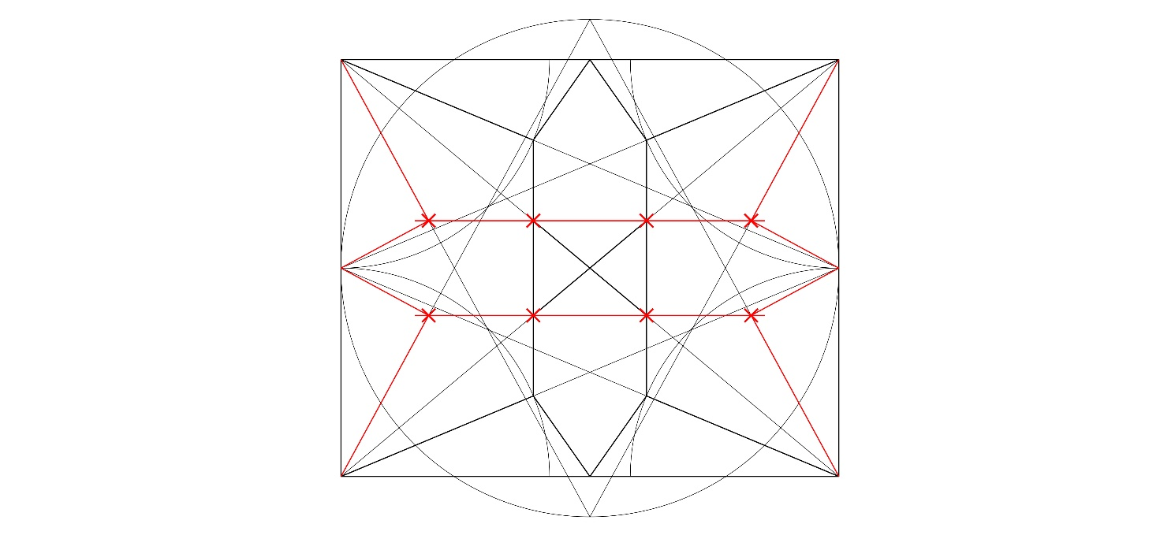
Figure 12e: Hypothetical tracing floor plan of bay S2, showing the extension of inner ring of bosses to meet the transverse tiercerons giving their apex position.

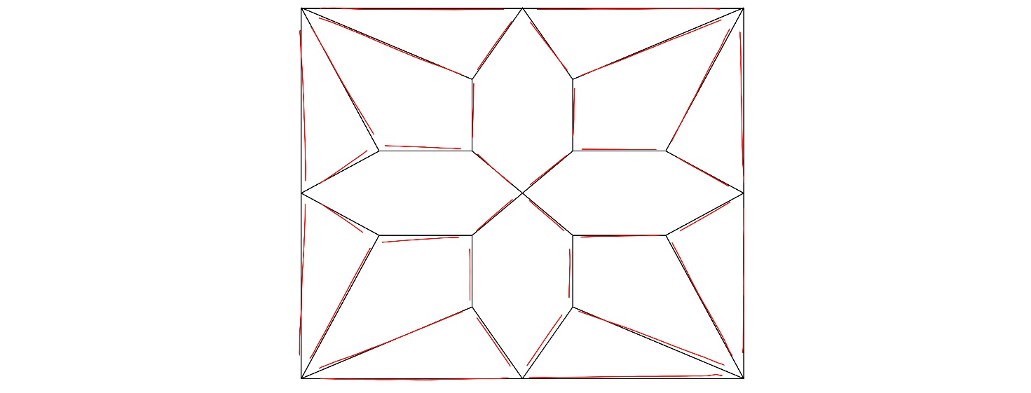
Figure 12f: Hypothetical geometry of bay S2 overlaying actual plan derived from scan data.

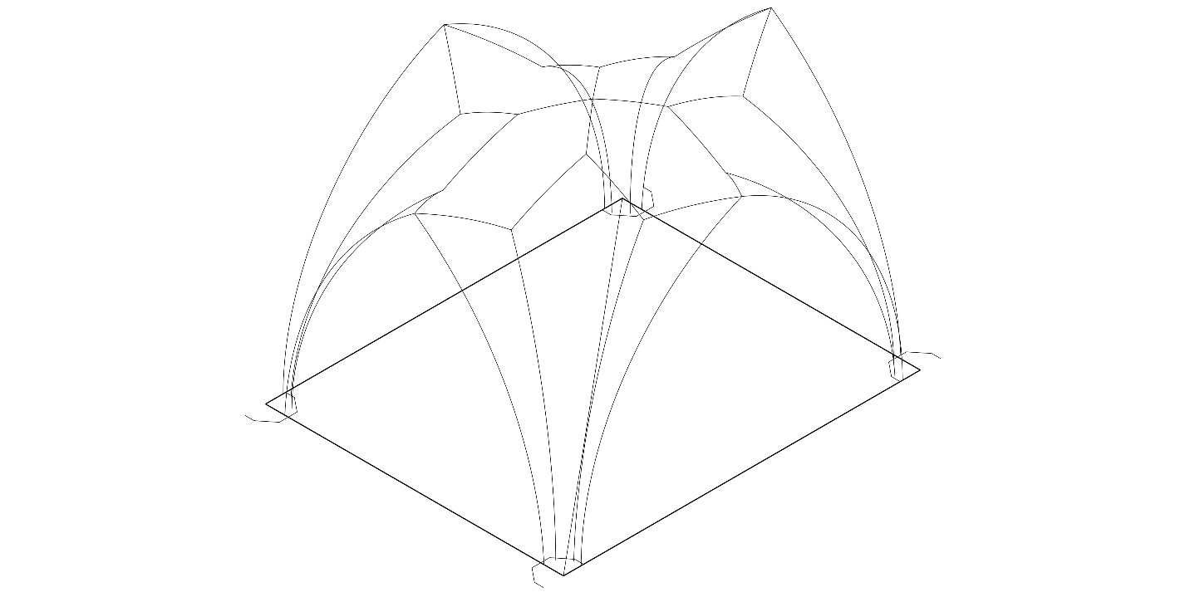
Figure 12g: Hypothetical geometry of bay S2 in three dimensions.

Analysis of both aisles clearly demonstrates that a full-scale plan was essential for defining the 3-D geometries of the vaults, which were dependent on the heights and curvatures of the ribs, which were inter-related. Our analysis seems to suggest also that although the curvatures of the liernes were not standardised, many in bays N1-3 also used the common radius of 3.560m and it may be that all were cut to this curvature but this cannot now be identified because of their short length. Nevertheless, although a full-scale plan was required for projecting the vaults, the plans of the north and south aisles were not identical, nor were some of the basic decisions about projection. The tiercerons of bays S1-3 in the main have the same curvature as the wall and arcade ribs, whereas those in bays N1-3 follow the transverse ribs. More significantly, the length of the tiercerons in both 2- and 3-D was determined by the height of their apex. The liernes which form a cross at the centre of bays S1-3 correspond with the diagonals on the tracing floor, whereas the position of those of bays N1-3 is determined by the junction of the transverse and longitudinal hexagons.

Interpretation of the findings
The results of these different approaches may be variously interpreted. In structural terms, the insertion of bracing suggests that the south aisle vaults were less successful, although we do not know at what date this was added so this may not have been a medieval perception. These bays were the more innovative, offering an early example of what has been termed a ‘net vault’, with the upper part of the crown of the vault forming a regular dome, the central cross of liernes not marking any change of plane. The more conservative design of bays N1-3 nevertheless could be seen to offer aesthetic and constructional as well as structural advantages. By projecting the plan to a series of horizontal levels, liernes which are parallel to the sides of the bay in plan are also parallel in projection and the central saltire closely approaches the diagonals of a square, meeting almost at right angles. There is thus greater consistency between plan and projection and the problems of cutting the bosses in three dimensions are reduced.
Our analysis therefore confirms previous assessment of the creative processes of Gothic design as procedural or generative in nature and reveals how new forms, such as the net vault, could result from a succession of steps not necessarily intended from the outset to achieve this result. The geometrical experimentation involved was largely contingent on measurements derived from the existing structure and the Wells vaults show no interest in ideal forms (except, perhaps in the five point arches). We have so far found no evidence of so-called ‘Platonic’ geometry, nor use of proportional formulae such as the ad quadratum and ad triangulatum principles. Use of the ‘four known elements’ rule evidenced masons’ ‘cunning’ but did not involve anything more than manipulation and measurement using dividers rather than a calibrated ruler and none of the processes used required even the simplest mathematics. The designs and plans are based on practical ingenuity rather than theoretical knowledge. It is also clear that in the bays discussed, the irregularity of the conoids and the variety of rib curvatures involved demonstrate that the vault design methods did not involve a ‘principal arch’ (Prinzipalbogen) whereby all the rib curvatures are derived from a single generative rib, a process associated with Late Gothic and recorded in fifteenth- and sixteenth-century sources.
As we have shown elsewhere, experimentation in the 3-D geometry of vaults predates the fourteenth century and by the 1330s masons would doubtless have been familiar with the 3-D consequences of choosing different rib curvatures or centre points. The power of 3-D visualisation was also required by those responsible for choosing and cutting stones; they had to be able to imagine the finished form within the rough block - a process known in French as ‘derobement’. Although this faculty had become necessary as soon as larger stones started to be used - one thinks for example of the complex and inventive springer blocks found at Salisbury Cathedral, it became particularly vital in cutting the geometrically complex bosses required by lierne vaulting. That the power of anticipation was not complete may be suggested by the need to brace the south aisle vaults, and it is even possible that had speed and cost not been considerations (evidenced in the Chapter records), whichever vaults were deemed less successful might have been demolished and rebuilt. Nevertheless, it is clear that the different geometries of bays S1-3 and N1-3 depended on creative decisions which produced innovations in both two and three dimensions.
The differences between bays S1-3 and N1-3 could be explained either as individual innovation: tinkering with a design concept, or to creativity within the workforce, enabling them to interpret the basic design in different ways with notably different results. The structural advantages of N1-3 suggest the former, whilst differences between south and north aisles in the setting out of the springings seem to suggest the latter [Fig. 13]. Perhaps the creative environment of Wells was stimulated by a site split between different teams. Given that the western bays exhibit further differences in plan and projection methods, it seems impossible to claim that the modifications should be attributed to a change in architect when the records mention only two at most, possibly even working in partnership. If the four designs were based on a single drawing (or set of drawings), this must either have been insufficiently detailed to ensure complete consistency or departures from such a design were sanctioned. A third possibility, the designs were improvised during construction seems impossible given the accuracy and consistency of the geometry and stone-cutting.
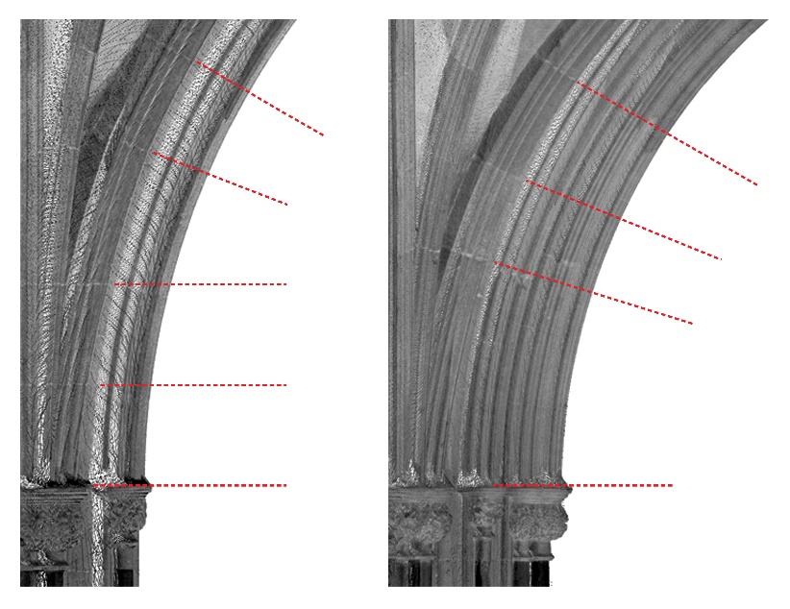
Figure 13: Springing stones cut horizontally in bay N2 (left) and radially to the arc centre point in bay S3 (right).
Conclusion
Analysis of the presbytery aisles of Wells Cathedral therefore suggests that at this site, at this period, the primary moment of innovation was at the design stage, with the introduction of a completely new configuration of ribs, albeit one derived from a pre-existing geometrical formula. This formula involved drawing and the use of basic geometrical manipulation, both associated with the figure of the architect. The designs emerged from the process of creating a plan, involving geometrical manipulation which was sequential, proceeding step by step in a recognisable progression. The production of a plan, however, was not the end of the process. Creative innovation within the building project did not occur at a single point in time and was unlikely to have been the responsibility of a single individual. The accuracy and detail enabled by digital technologies supports forensic analysis which can identify and account for differences and similarities not previously recognised. In this way, creative thinking and visualisation in both two and three dimensions can be found across the timeframe of construction, from conception to projection and even in the cutting of the individual stones, with significant and presumably intentional differences both between individual bays and between bay sets.

Acknowledgements
The authors would like to acknowledge the financial support of the Paul Mellon Centre for Studies in British Art which generously funded the field trip to Wells Cathedral. We would like to thank the Dean and Chapter of Wells for enabling our survey work and in particular the support and help of Jerry Sampson (Cathedral Archaeologist) and Jez Fry (Clerk of Works). Scanning and photography were undertaken along with J. R. Peterson (University of Liverpool).

Bibliography

Ayers, T. The Medieval Stained Glass of Wells Cathedral. Corpus Vitrearum Medii Aevi, Great Britain 4, 2 vols. Oxford: Oxford University Press for the British Academy, 2004.
Binski, P. “Notes on Artistic Invention in Gothic Europe.” Intellectual History Review 24, no. 3 (2014): 287–300.
– – – . “Villard de Honnecourt and Invention.” Nottingham Medieval Studies 56 (2012): 63–79.
Böker, J. J. Architektur der Gotik/ Gothic Architecture: Catalogue of the World-Largest Collection of Gothic Architectural Drawings (bequest Franz Jäger) in the Collection of Prints and Drawings of the Academy of Fine Arts Vienna. Vienna, Salzburg, and Munich: Verlag Anton Pustet, 2005.
Bork, R. “Geometry and Scenography in the Late Gothic Choir of Metz Cathedral.” In Ad Quadratum: The Practical Application of Geometry in Medieval Architecture, ed. N. Y. Yu. Aldershot and Burlington, VT: Ashgate, 2002, 243–67.
– – – . The Geometry of Creation: Architectural Drawing and the Dynamics of Gothic Design. Farnham and Burlington, VT: Ashgate, 2011.
Branner, R. “Villard de Honnecourt, Archimedes, and Chartres.” Journal of the Society of Architectural Historians 19, no. 3 (1960): 91–96.
Buchanan, A. “Linearity versus Three-Dimensionality in English Decorated Vaults.” Unpublished BA diss., University of London, 1990.
Buchanan, A., and N. Webb. “Tracing Tiercerons: An Evaluation of the Significant Properties of Thirteenth and Fourteenth-Century Tierceron Vaults in England.” In Building Histories: The Proceedings of the Fourth Annual Conference of the Construction History Society, ed. James W. P. Campbell et al. Cambridge: Construction History Society, 2017, 145–57.
Bucher, F. Architector: The Lodge Books and Sketchbooks of Medieval Architects. New York: Abaris, 1979.
– – – . “The Dresden Sketch-Book of Vault Projection.” Actes du XXIIieme Congres Internationale d’Histoire de l’Art 1969, 3 vols. Budapest, 1972, 1: 527–37.
Colchester, L. S., and J. H. Harvey. “Wells Cathedral.” Archaeological Journal 131 (1974): 200–14.
Coldstream, N. “The Architect, History and Architectural History.” Transactions of the Royal Historical Society, 6th ser., 13 (2003): 219–26.
Crossley, P. “Peter Parler and England: A Problem Revisited.” Wallraf-Richartz Jahrbuch 64 (2003): 53–82.
Draper, P. “Interpreting the Architecture of Wells Cathedral.” In Artistic Integration in Gothic Buildings, ed. V. C. Raguin, K. Brush, and P. Draper. Toronto, Buffalo, and London: University of Toronto Press, 1995, 114–30.
– – – . “The Sequence and Dating of the Decorated Work at Wells.” In Medieval Art and Architecture at Wells at Glastonbury, British Archaeological Association Conference Transactions 4. London: Routledge, 1981, 18–29.
Fitchen, J. The Construction of Gothic Cathedrals: A Study of Medieval Vault Erection. Oxford: Clarendon Press, 1961.
Hiscock, N. The Symbol at Your Door: Number and Geometry in Religious Architecture of the Greek and Latin Middle Ages(2007). London and New York: Routledge, 2016.
Huerta, S. “Technical Challenges in the Construction of Gothic Vaults: The Gothic Theory of Structural Design.” In Bautechnik des Historismus/ Construction Techniques in the Age of Historicism, ed. U. Hassler and C. Rauhut. Munich: Hirmer, 2012, 163–95.
Knoop, D., and G. P. Jones. “The Rise of the Mason Contractor.” Journal of the Royal Institute of British Architects 43 (1936): 1061–71.
Law, A. N. “Generating Identity through Plan and Architecture: Barcelona Cathedral, Gothic Drawing and the Crown of Aragon.” Unpublished PhD diss., Columbia University, 2007.
Monckton, L. “Experimental Architecture? Vaulting and West Country Cloisters in the Late Middle Ages.” Journal of the British Archaeological Association 159, no. 1 (2006): 249–83.
Morris, R. K. “European Prodigy or Regional Eccentric? The Rebuilding of St Augustine’s Abbey Church, Bristol.” In “Almost the Richest City”: Bristol in the Middle Ages, ed. L. Keen. British Archaeological Association Conference Transactions 19. Leeds: Maney, 1997, 41–56.
– – – . “Thomas of Witney at Exeter, Winchester and Wells.” In Medieval Art and Architecture at Exeter Cathedral, ed. F. Kelly. British Archaeological Association Conference Transactions 11. Leeds: Maney, 1991, 57–84.
Müller, W. “An Application of Generative Aesthetics to German Late Gothic Rib Vaulting.” Leonardo 11, no. 2 (1978): 107–10.
– – – . Grundlagen gotischer Bautechnik: Ars sine scientia nihil est. Munich: Deutscher kunstverlag, 1990.
Murray, S. “Slippages of Meaning and Form.” In The Artful Mind: Cognitive Science and the Riddle of Human Creativity, ed. M. Turner. Oxford: Oxford University Press, 2006, 189–207.
Neagley, L. “Late Gothic Architecture and Vision: Re-presentation, Scenography, and Illusionism.” In Reading Gothic Architecture, ed. M. M. Reeve. Studies in the Visual Cultures of the Middle Ages 1. Turnhout: Brepols, 2008, 37–55.
Nussbaum, N. “Planning and Building without Writing: Questions of Communication in Gothic Masons’ Lodges.” In Architecture, Liturgy and Identity, ed. Opacic and Timmermann, 137–45.
Opacic, Z., and A Timmermann, eds. Architecture, Liturgy and Identity: Liber Amicorum Paul Crossley. Turnhout: Brepols, 2011.
Pacey, A. Medieval Architectural Drawing: English Craftsmen’s Methods and Their Later Persistence. Stroud: Tempus, 2007.
Reeve, M. “The Capital Sculpture of Wells Cathedral: Masons, Patrons and the Margins of English Gothic Architecture.” Journal of the British Archaeological Association 163 (2010): 72–109.
Richens, P., and G. Herdt. “Modelling the Ionic Capital.” In Computation: The New Realm of Architectural Design, ed. Gülen Cagdas and Birgül Colakoglu. 27th eCAADe Conference Proceedings, Istanbul, Turkey (16–19 September 2009): 809–816.
Salzman, L. F. Building in England Down to 1540: A Documentary History. Oxford: Clarendon Press, 1952.
Scholfield, P. H. The Theory of Proportion in Architecture. Cambridge: Cambridge University Press, 1958.
Shelby, L. R., ed. and trans. Gothic Design Techniques: The Fifteenth-Century Design Booklets of Mathes Roriczer and Hanns Schmuttermayer. Carbondale, IL, and Edwardsville, IL; London and Amsterdam: Southern Illinois University Press; Feffer & Simons, 1977.
Talaverano, R. M., C. Pérez de los Ríos, and R. S. Domínguez. “Late German Gothic Methods of Vault Design and Their Relationships with Spanish Ribbed Vaults.” 2012. http://oa.upm.es/15746/1/MartinTALAVERANO_2012_Comunicacion_Late_German_Gothic_Methods_4ICCH.pdf (accessed 10/12/2016).
Tomlow, J. “On Late-Gothic Vault Geometry.” In Creating Shapes in Civil and Naval Architecture: A Cross-Disciplinary Comparison, ed. H. Nowacki and W. Lefèvre. Leiden: Brill, 2009, 240–67.
Turnbull, D. Masons, Tricksters and Cartographers: Comparative Studies in the Sociology of Scientific and Indigenous Knowledge. London and New York: Routledge, 2000, 53–87.
Webb, N., and A. Buchanan. “Tracing the Past: A Digital Analysis of Wells Cathedral Choir Aisle Vaults.” Digital Applications in Archaeology and Heritage 4 (2017): 19–27.
Webb, N., A. Buchanan, and J. R. Peterson. “Modelling Medieval Vaults: Comparing Digital Surveying Techniques to Enhance our Understanding of Gothic Architecture.” In Complexity and Simplicity, ed. Aulikki Herneoja, Toni Österlund, and Piia Markkanen, 34th eCAADe Conference Proceedings, Vol. 2, Oulu, Finland (22–26 August 2016): 493–502.
Weiner, R. P. Creativity and Beyond: Cultures, Values and Change. Albany, NY: State University of New York Press, 2000.
Willis, R. The Album of Wilars de Honecourt. London: J. H. Parker, 1859, 138–43.
– – – . “On the Construction of the Vaults of the Middle Ages.” Transactions of the Royal Institute of British Architects 1, no. 2 (1842): 1–69.
Wilson, C. The Gothic Cathedral. London: Thames and Hudson, 1990.
– – – . “Why did Peter Parler come to England?” In Architecture, Liturgy and Identity, ed. Opacic and Timmermann, 89–109.

P. Binski, “Villard de Honnecourt and Invention,” Nottingham Medieval Studies 56 (2012), 63-79; idem, “Notes on artistic invention in Gothic Europe,” Intellectual History Review 24:3 (2014), 287-300; R. Bork, The Geometry of Creation: Architectural Drawing and the Dynamics of Gothic Design (Farnham and Burlington VT: Ashgate, 2011); S. Murray, “Slippages of Meaning and Form,” in Artful Mind: Cognitive Science and the Riddle of Human Creativity, ed. M. Turner (Oxford: OUP, 2006), 189-207; D. Turnbull, Masons, Tricksters, Cartographers: Comparative Studies in the Sociology of Scientific and Indigenous Knowledge (London and New York: Routledge, 2000), 53-87;
R.P. Weiner, Creativity and Beyond: Cultures, Values and Change (Albany: State University of New York, 2000), 43-51.
For the primacy of the drafting table, see Bork (2011), 422; the drawings he discusses relate primarily to plans and elevations and are those often classified as ‘presentation drawings’.
See A. N. Law, “Generating identity through plan and architecture: Barcelona Cathedral, Gothic drawing and the crown of Aragon” (unpub PhD, Columbia University, 2007), esp. 132 and N. Nussbaum, “Planning and Building without Writing: Questions of Communication in Gothic Masons’ Lodges,” in Architecture, Liturgy and Identity. Liber Amicorum Paul Crossley, ed. Z. Opacic and A. Timmerman, Brepols Studies in Medieval Art (Turnhout: Brepols, 2011), 137-45.
J. J. Boker[umlaut], Architektur der Gotik / Gothic Architecture, Catalogue of the world-largest collection of Gothic Architectural Drawings (bequest Franz Jager[umlaut]) in the Collection of Prints and Drawings of the Academy of Fine Arts Vienna (Vienna, Salzburg and Munich:Verlag Anton Pustet, 2005).
Bork (2011), passim, with general observations on 2, 419, 422, 437-9.
L. R. Shelby, ed. and trans., Gothic Design Techniques: The Fifteenth-Century Design Booklets of Mathes Roriczer and Hanns Schmuttermayer (Carbondale and Edwardsville, London, Amsterdam: Southern Illinois University Press; Feffer & Simons, 1977), 72.
Analysis of 2-D design processes dates back to the nineteenth century, a historiography discussed by Bork (2011), 10-20 and P. H. Scholfield, The Theory of Proportion in Architecture (Cambridge: Cambridge University Press, 1958), 86-90.
J. Fitchen, The Construction of Gothic Cathedrals. A Study of Medieval Vault Erection (Oxford: Clarendon Press, 1961), xi; R. Willis, “On the Construction of the Vaults of the Middle Ages,” Transactions of the Royal Institute of British Architects, 1:2 (1842), 1-69.
R. Bork, “Geometry and Scenography in the Late Gothic Choir of Metz Cathedral,”in N. Y. Yu (ed), Ad Quadratum: The practical application of geometry in medieval architecture, AVISTA Studies in the History of Medieval Technology, Science and Art, 1 (Aldershot and Burlington, VT: Ashgate, 2002), 243-67; L. Neagley, “Late Gothic Architecture and Vision: Re-presentation, Scenography, and Illusionism,” in Reading Gothic Architecture, ed. M. M. Reeve, Studies in the Visual Cultures of the Middle Ages, 1 (Turnhout: Brepols, 2008), 37-55. Monckton has also suggested that the processional function of cloisters may have informed their experimental vault forms: L. Monckton, “Experimental Architecture? Vaulting and West Country Cloisters in the Late Middle Ages,” Journal of the British Archaeological Association 159:1 (2006), 249-283 (278).
The celebrated Wells tracing floor seems to include drawings for the vaults of the cloister: A. Pacey, Medieval Architectural Drawing: English Craftsmen’s Methods and Their Later Persistence (Stroud: Tempus, 2007), 52-3 (which suggests a connection between the earliest incised lines and the work of William Joy, not yet tested in relation to the present data) and 221-223 (for the connection between the tracing floor and cloister vaults). According to Jerry Sampson, cathedral archaeologist at Wells, the Chapter House was also used as a tracing floor. The location of the tracing floor for the aisle vaults is unknown.
P. Crossley, “Peter Parler and England: A Problem Revisited,” Wallraf-Richartz Jahrbuch 64 (2003), 53-82; Monckton (2006); C. Wilson, The Gothic Cathedral (London: Thames and Hudson, 1990), 199-204 and 225-230; idem, “Why did Peter Parler come to England?,” in Opacic and Timmerman (2011), 89-109.
W. Müller, “An Application of Generative Aesthetics to German Late Gothic Rib Vaulting,” Leonardo 11:2 (1978), 107–110 (108) spoke of the need for more accurate measurements.
“La construcción de bóvedas tardogóticas españolas en el contexto europeo. Innovación y transferencia de conocimiento” at http://www.upm.es/observatorio/vi/index.jsp?pageac=actividad.jsp&id_actividad=199963 <accessed 9/12/2016>.
Crossley (2003); Monckton (2006); Wilson (1990) and (2011) and literature cited therein.
Crossley (2003), p.103; Monckton (2006), p.262 and Wilson (1990) p.201.
The chronology is discussed by T. Ayers, The Medieval Stained Glass of Wells Cathedral, CVMA IV, 2 vols (Oxford: Oxford University Press for the British Academy, 2004), vol. 1; L. S. Colchester and J. H. Harvey, “Wells Cathedral,” Archaeological Journal 131 (1974), 200-14, and P. Draper, “The Sequence and Dating of the Decorated Work at Wells,” Art and Architecture at Wells at Glastonbury, British Archaeological Association Conference Transactions IV for 1978 (1981), 18-29.
P. Draper, “Interpreting the Architecture of Wells Cathedral” in Artistic Integration in Gothic Buildings, ed. V. C. Raguin, K. Brush and P. Draper (Toronto, Buffalo, London: University of Toronto Press, 1995), 114-30, but note however M. Reeve, “The Capital Sculpture of Wells Cathedral: Masons, Patrons and the Margins of English Gothic Architecture,” Journal of the British Archaeological Association, 163 (2010), 72-109.
For further details of the process, see N. Webb and A. Buchanan, “Tracing the past: a digital analysis of Wells cathedral choir aisle vaults”, Digital Applications in Archaeology and Heritage, 4 (2017), 19-27.
P. Richens and G. Herdt, “Modelling the Ionic Capital,” Computation: The New Realm of Architectural Design, 27th eCAADe Conference Proceedings, Istanbul, Turkey, 16-19 September 2009, 809-816.
R. K. Morris, “European Prodigy or Regional Eccentric? The rebuilding of St Augustine’s Abbey Church, Bristol,” in “Almost the Richest city”: Bristol in the Middle Ages, ed. L. Keen, British Archaeological Association Conference Transactions, 19 (1997), 41-56.
A hypothesis developed in A. Buchanan, “Linearity versus Three-Dimensionality in English Decorated Vaults” (unpublished BA dissertation, University of London, 1990) and mentioned in Monckton (2006), 282, fn. 72.
F. Bucher, “The Dresden Sketch-book of Vault Projection,” Actes du XXIIieme Congres Internationale d’Histoire de l’Art 1969, 3 vols (Budapest, 1972), vol. 1, 527-37 (530).
A. Buchanan and N. Webb, “Tracing Tiercerons: an evaluation of the significant properties of thirteenth and fourteenth-century tierceron vaults in England”, Building Histories. The Proceedings of the Fourth Annual Conference of the Construction History Society (2017), 145-57
R. Branner, “Villard de Honnecourt, Archimedes, and Chartres,” The Journal of the Society of Architectural Historians 19:3 (1960), 91-96; R. Willis, The Album of Wilars de Honecourt (London: J.H. Parker, 1859), 138-43.
A. Buchanan and N. Webb (2017).
See N. Hiscock, The Symbol at Your Door: Number and Geometry in Religious Architecture of the Greek and Latin Middle Ages, reprint (London and New York: Routledge, 2016), chapters 6 and 7.
For a classification and description of these methods, see W. Müller, Grundlagen gotischer Bautechnik. Ars sine scientia nihil est (Munich: Deutscher kunstverlag, 1990), pp.133-83. The treatises are discussed by Bucher (1972) and idem, Architector: the lodge books and sketchbooks of medieval architects (New York: Abaris, 1979) and R. M. Talaverano, C. Pérez de los Ríos and R. S. Domínguez, “Late German Gothic Methods of Vault Design and Their Relationships with Spanish Ribbed Vaults,” (2012) available at http://oa.upm.es/15746/1/MartinTALAVERANO_2012_Comunicacion_Late_German_Gothic_Methods_4ICCH.pdf, . See also J. Tomlow, “On Late-Gothic Vault Geometry,” in Creating Shapes in Civil and Naval Architecture: A Cross-Disciplinary Comparison, ed. H. Nowacki and W. Lefèvre, History of Science and Medicine Library 11 (Leiden: Brill, 2009), 240-267; S. Huerta, “Technical Challenges in the Construction of Gothic Vaults: The Gothic Theory of Structural Design,” in Bautechnik des Historismus/Construction Techniques in the Age of Historicism ed. U. Hassler and C. Rauhut (Munich: Hirmer, 2012), 163-95.
N. Webb, A. Buchanan and J. R. Peterson, “Modelling Medieval Vaults: Comparing Digital Surveying Techniques to Enhance our Understanding of Gothic Architecture”, Education and research in Computer Aided Architectural Design in Europe, 2 (2016), pp. 493-502; A. Buchanan and N. Webb (2017).
For the involvement of different glaziers’ workshops see Ayers (2004), p. 147; for the possibility of competition between the teams as a spur to creativity, see Reeve (2010), p. 81.
R.K. Morris, “Thomas of Witney at Exeter, Winchester and Wells,” in Medieval Art and Architecture at Exeter Cathedral, ed. F. Kelly, British Archaeological Association Conference Transactions 9 for 1985 (1991), 57-84 (78).

