Article

On a Long Term Strategy for the Success of Nuclear Power

Bruno Merk \*1,2,3, Dzianis Litskevich1,2, Karl R. Whittle1, Mark Bankhead2, Richard Taylor2, Dan Mathers2

1 University of Liverpool, School of Engineering, L69 3GH, United Kingdom

2 National Nuclear Laboratory, Chadwick House, Warrington, WA3 6AE, United Kingdom

3 Helmholtz-Zentrum Dresden – Rossendorf (HZDR), Bautzner Landstraße 400  
01328 Dresden, Germany

**\*** Correspondence: b.merk@liverpool.ac.uk; Tel.: +44  151 794 5370

Academic Editor: name

Received: date; Accepted: date; Published: date

**Abstract:** The current generation of nuclear reactors are evolutionary in design, mostly based on the technology originally designed to power submarines, and dominated by Light Water Reactors. The aims of the GenIV consortium are driven by sustainability, safety and reliability, economics, and proliferation resistance. The aims are extended here to encompass the ultimate and universal vision for strategic development of energy production, the ‘perpetuum mobile’ – at least as close as possible. We propose to rethink nuclear reactor design with the mission to develop an innovative system which uses no fresh resources and produces no fresh waste during operation as well as generates power safe and reliably in economic way. The results of the innovative simulations presented here demonstrate that, from a theoretical perspective, it is feasible to fulfil the mission through the direct reuse of spent nuclear fuel from currently operating reactors as the fuel for a proposed new reactor. The produced waste is less burdensome than current spent nuclear fuel which is used as feed to the system. However, safety, reliability and operational economics will need to be demonstrated to create the basis for the long term success of nuclear reactors as a major carbon free, sustainable, and applied highly reliable energy source.

**Keywords:** Nuclear; Reactor; Spent Fuel; P&T; Innovation Strategy; Molten Salt Reactor

Abbreviations:

MSR: Molten Salt Reactor

MSFR: Molten Salt Fast Reactor

iMAGINE: Visionary Molten Salt Fast Reactor Concept operating on spent nuclear fuel

SNF: Spent Nuclear Fuel

TRU: Transuranium – all elements with an atomic number higher than 92

HM: heavy metal – all elements with an atomic number higher than 90, typically the base to account for fissile materials in the reactor

HEU: Highly enriched Uranium – typically uranium with more than 20% U-235 content

MWth: Megawatt thermal

GWe: Gigawatt electric

GWd/tHM: Gigawattdays per ton of heavy metal – measure for the burnup of nuclear material in a reactor

MWd/tHM: Megawattdays per ton of heavy metal

GenIV: Reactor systems of the 4th generation as defined by the Generation IV International Forum

NEA: Nuclear energy Agency of the OECD

IAEA: International Atomic Energy Agency of the United Nations

Δ͞keff: difference from the critical reactor status, typically measured in pcm (percent mille)

LiF: Lithiumfluoride

SNFF4: Spent Nuclear Fuel Tetrafluoride

UF4: Uranium Tetrafluoride

EVOL: European project for the development of a molten salt fast reactor

BREST: Russian innovative reactor concept with lead coolant

INDE: Integrated Nuclear Digital Environment

R&D: Research and Development

TRL: Technical readiness level

HELIOS: Reactor physics code package of Studsvik Scandpower

AURORA: pre-processor of the HELIOS package

ZENITH: post-processor of the HELIOS package

SERPENT: Reactor physics package based on the Monte Carlo method

ENDF/B VII: Nuclear data library

1. Introduction

Strategic development is the key to the success of industrial innovation in the long term. The final outcome differs very often significantly from the objectives given at begin of the development, since external drivers like political, economic or technical boundary conditions change with time. Already in the 1960s, Everett Rogers described the development of innovation through S-curves and formulated this effect in the theory of diffusion of innovations [[1]](https://osmoticinnovation.wordpress.com/tag/innovation-failure/" \l "_edn1). Rogers’ argues that the application of a technology to a market and the penetration phases from low to high follow an [S-curve](http://en.wikipedia.org/wiki/Diffusion_of_innovations) which is characterized by innovators and early adopters in the first phases and laggards joining the development at the end.

However, Fredmund Malik extended this thinking calling it a “Symphony of S-curves: Seeing the Future Clearly” in his book on strategy development [2] to motivate the people to leave the track of purely evolutionary development when it is indicated by changed boundary conditions. He argues that evolutionary development slows down significantly when the market is saturated. The development speed can only be kept in this phase when a disruption in development appears which creates a new technology entering in to a new phase of rapid development. In this case strategic development enters into a new s-curve. In a first step this concept will be used to derive a deeper understanding of the idea of strategic development of industrial innovations applying an excursion to a day-to-day issue. In a second step the concept is applied to analyze the current development of nuclear reactor systems. The historic boundary conditions are reviewed against the current boundary conditions and the pace of development. The updated boundary conditions will be used to define a reactor system which is as close as possible to the requirements for a wide spread future electric energy production using nuclear power. This is a major request to create the basis for the long term success of nuclear reactors to act as a major contributor for the production of reliable carbon free, sustainable electric energy. Finally, theoretical thinking is complemented with a reactor physical simulation demonstrating the feasibility of the proposed solution from physical point of view.

Excursion: “The lawn mower problem”

The beginning of the lawn mower problem goes back to 1830 when the first lawn mower was developed/invented [3]. This date marks the step from cutting grass by hand to using an automated system. Over the subsequent 200 years diverse optimized solutions have been developed. These developments follow the aim making the work easier, see Figure 1. We have almost approached the end of this curve with the characteristic very low development speed. The most recent development of robot lawn mowers mark the change from the first, black to the second S-curve (red) new, more sophisticated objectives and changed technical as well as legal boundary conditions.

nice and tidy lawn

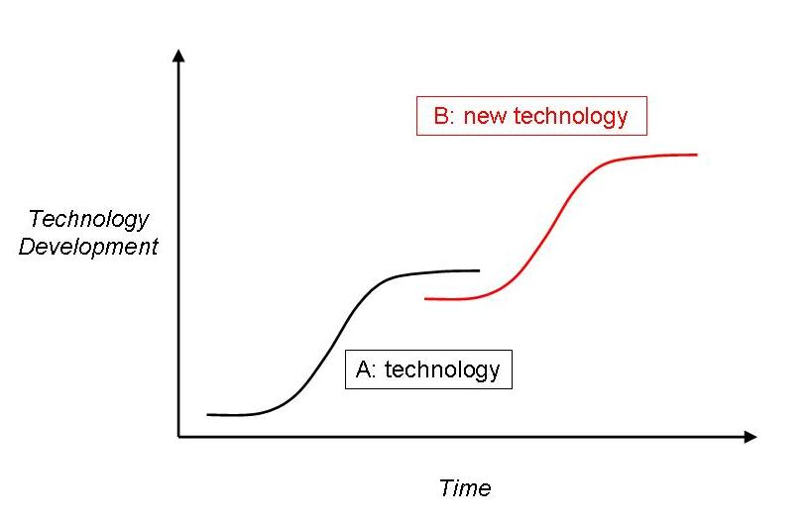

Development with Time

Technological Development

1830

making work  
easier

**Figure 1:** The lawn mower development in S-curves

From strategic development point of view, the objective of the first S-curve ‘make the work easier’ has changed to ‘I want a nice tidy garden lawn, ideally without spending any work and money’. The robot is the first step into the red curve – reducing hand work. However, there could appear other more innovative solutions like genetic manipulated, or even artificial grass. The use of slaves isn’t possible due to changed legal boundary conditions. Ideally, the tidy garden lawn should be achieved without cost for energy, equipment, and work time – this we could call the vision, or ‘dream’ solution. The best solution could come as close as possible but will never fulfil the vision completely.

The development of nuclear reactors has followed an evolutionary track of both the technical solution and the question the technology is trying to address. Thus, we propose to address the future strategic development of nuclear reactors by moving to a new, more advanced s-curve to be able to define a new vision which is addressing the changed boundary conditions. In the following chapters we will develop a long term strategy for the success of nuclear power starting with a very broad and general view on strategic development like in the excursion above. This is started by an analysis of the historic development and the analysis of the historic development objectives followed by applying tools of strategic development, to come up with a new, general vision and a possible mission. This analysis on a higher system level provides a more wide and systematic view than thinking in the level of the development of current project, “to look further into the future and capture a longer period of time which is indispensable for strategy development, a typical cybernetic approach is useful: the change of system levels” [2]. To avoid the critics being dreamers, we have developed one example to prove the most challenging neutron physical feasibility of our proposal of operating a reactor on spent nuclear fuel. This example should not be seen as exclusive, it should motivate the community to develop several systems fulfilling the vision ideally even for different missions arising from different applications for nuclear reactors. What we propose here would be a significant progress compared to all current operational regimes of nuclear reactors. It is the ultimate step to use spent nuclear fuel directly without any prior reprocessing. The feasibility study is followed by a broad discussion of the consequences of our proposal, partly based on the simulation results, partly based on the specific opportunities of the proposed reactor system. We close with a view onto the challenges and the requests to make this proposal successful.

2. Development of Nuclear Reactor Technologies

2.1 Historic Development

The development of nuclear reactors started in war times in 1942, with development of Chicago Pile 1, the world's first nuclear reactor, built by Nobel Prize winner Enrico Fermi [4]. During the first years of development, the purpose of a nuclear reactor was based around three objectives:

1. Demonstration of a continuing chain reaction and its potential application
2. Generation of material for military purposes and/or commercial/medical applications
3. Energy generation from the chain reaction, either as electricity, most desirable, or heat

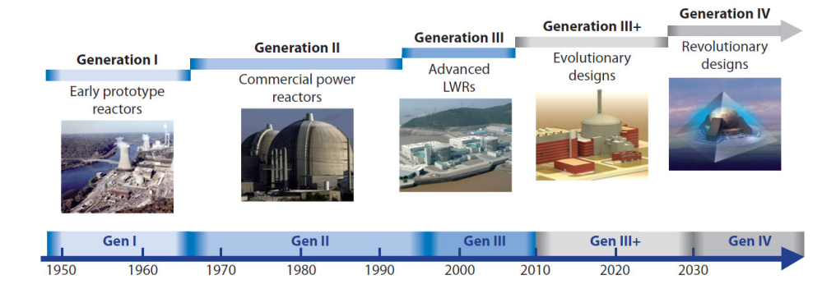

**Figure 2:** Generations of nuclear power: Time ranges correspond to the design and the first deployments of different generations of reactors [5]

The main focus of reactors today is the generation of energy, i.e. objective 3. However, even objective 3 has undergone a partial change given by the request for a solution for the energy trilemma. The request is developing the energy technologies toward the objectives Energy security, Energy equity (accessibility and affordability), Environmental sustainability [6]. The safe use of the chain reaction has been extensively proven and the production of medical isotopes is secured using more specialized technologies. After the following theoretical discussion about the historic and the possible future technological development and the change of the vision, we will describe a highly innovative reactor system which has the potential for a disruptive innovation in nuclear energy production. This will be followed by the demonstration of the neutron physical feasibility of a reactor with significantly improved sustainability indices.

Going back to the begin of the development, “In the course of developing nuclear weapons the Soviet Union and the West had acquired a range of new technologies and scientists realized that the tremendous heat produced in the process could be tapped either for direct use or for generating electricity [7].“ This quote characterizes the origin of nuclear power production, heat and the use of technologies to transform the heat to electricity has been seen as a by-product created when fulfilling objective 2 (producing material for military purposes). Besides this, the early development was driven by the request for a compact long-lasting power source for submarines under Admiral Rickover in his function as Director of the Naval Reactors Branch [8] leading to the first nuclear-powered submarine, the USS Nautilus. The first nuclear reactor for electricity production was EBR-1 a Sodium-Potassium cooled fast reactor in the US, a system which is ideal for the production of plutonium. A major step for the civil nuclear energy development was the "Atoms for Peace" program [9] linked with the name of the US President Eisenhower, the foundation of the IAEA, and the words” The United States knows that peaceful power from atomic energy is no dream of the future. The capability, already proved, is here today” [10] spoken at the 470th Plenary Meeting of the United Nations General Assembly on December 8th, 1953. “When President Eisenhower delivered his Atoms for Peace speech…, it marked a transition toward a broader spectrum of potential applications of this new source of power. This shift led first to nuclear-powered submarines and ultimately to land-based nuclear power plants based on a scaled-up version of the submarine-designed water-cooled reactor”[11]. The first nuclear reactor producing a significant amount of electricity was the Russian AM-1 reactor which was water-cooled and graphite-moderated, once more an ideal configuration for plutonium production. In Russia, it was followed by a lead-bismuth reactor for the navy and a program for the development of sodium cooled fast reactors which offer long cycle times due to breeding of plutonium. In parallel development of the pressurized water reactor (PWR) has been driven by the US navy leading to the USS Nautilus and later to the stationary Shippingport reactor with an initial output of 60 MWe built in 1957 in the search of a robust and easy to operate system. An alternative design based on the use of molten salt as coolant, innovatively designed to power air travel, was built in 1954, which in turn led to the molten salt reactor experiment at Oak Ridge National Laboratory in 1965 [7].

In 1956 the first commercial reactor, the gas-cooled MAGNOX reactor at Calder Hall, started operating [7]. One of the aspects of the MAGNOX design was the output of weapon grade plutonium, which in turn provided a secondary income for the operators, due to the government buying back the formed plutonium. The reprocessing in the UK was developed around this need. “In their early years (1963–72) the UK's civil Magnox reactors produced significant amounts of weapons-grade plutonium… British Nuclear Fuels Ltd … admitted that they called the weapons-grade plutonium "military" irrespective of origin” [11]. The Pu has been given to the United States in exchange for fissile material for UK military requirements [12]. The follow up system, the AGR would have been attractive for high quality Pu production, too. However, due to the already changed demand the reactors have never been operated in an optimized way for plutonium production, but heavily for electricity production.

Comparable design principles like for the MAGNOX system, graphite moderation and natural uranium as fuel, with online refuelling characterize the RBMK reactors “derived from a design principally for plutonium production and was intended and used in Russia for both plutonium and power production.”[13]

However, not only reactor development but also the reprocessing of nuclear material can be followed back to war times. “The roots of nuclear reprocessing also are found in that same realm of war and commercial technology [like the reactor technology]. After Seaborg and coworkers discovered plutonium, it was quickly established as an alternative pathway to nuclear weapons that could be built around nuclear reactors and chemical reprocessing” [11]. Nevertheless, both technologies (reactor and reprocessing) have been developed significantly forward for the civil application. The described first generation of reactors development has continued leading to further generations, mainly of commercial light water power reactors, see Figure 2. The current generation of reactors are the Generation III and III+, once more evolutionary designs. The market for nuclear reactors for energy production is currently almost completely dominated by industrially applied LWRs while the industrial reprocessing is built on the so-called aqueous technology.

Today, the military application is less attractive to most countries. It is even turned around to the demand of proliferation resistance for nuclear systems. It is politically desirable for most of the world’s nations to maintain obligations under strategic nuclear disarmament treaties and focus on the peaceful development of nuclear power supplying safe and sustainable low carbon energy. Following this desire the next generation of nuclear reactors currently under development are following the goals outlined by the Generation IV International Forum (GIF), see Figure 3. More details on the specific reactor systems and the related fuel cycles can be found in [14].

2.2 Strategic Development for the Future

The given GenIV goals build the bridge between the current S-curve and the future one to support a new vision. The current light water reactors are still essentially based on technology used to power nuclear submarines, even if they have undergone an evolution via Generation II to Generation III/III+ reactors. The reactors are to be seen as the current ideal. The GenIV programme is the foreseen next stage of reactor design applying ‘new, innovative’ concepts for nuclear power generation. Such concepts could lead to a reactor that can continually breed, and burn its own fuel, i.e. become a perpetual reactor with significantly lower demand for fresh fuel like current light water reactors. Thus, closed fuel cycle operation is one, but not the only, major development direction to improve sustainability of nuclear reactor operation following the GenIV objectives [15]. Closing the nuclear fuel cycle has already been discussed since decades and the results have been documented in several publication of the NEA [16] and the IAEA [17]. However, the complexity of the challenge in reprocessing and fuel production has to be recognized, see later discussion. Due to the wide operational experience of more than 400 reactor operation years, the sodium cooled fast reactor technology seems to be the one closest to application [18].

*Sustainability*  
• Generate energy sustainably and promote long-term availability of nuclear fuel.  
• Minimise nuclear waste and reduce the long term stewardship burden.

*Safety and reliability*  
• Excel in safety and reliability.  
• Have a very low likelihood and degree of reactor core damage.  
• Eliminate the need for offsite emergency response.

*Economics*  
• Have a life cycle cost advantage over other energy sources.  
• Have a level of financial risk comparable to other energy projects.

*Proliferation resistance and physical protection*  
• Be a very unattractive route for diversion or theft of weapon-usable materials, and provide increased physical protection against acts of terrorism.

* gas-cooled fast reactor (GFR)
* lead-cooled fast reactor (LFR)
* molten salt reactor (MSR)
* sodium-cooled fast reactor (SFR)
* supercritical-water-cooled reactor (SCWR)
* very-high-temperature reactor (VHTR)

**Figure 3:** Generation IV (GenIV) goals (left) and GenIV systems (right) [5]

However, seen from the historic point of view given above, almost all systems are based on the very early developments of nuclear reactors with objectives formed by completely different boundary conditions and requests as we have it today – producing nuclear materials and powering submarines versus wide spread, sustainable, low carbon power production by nuclear reactors. Some important decisions on the way have been made on the historic requests to develop the ideal system for plutonium production. A perfect example is the decision between the molten salt breeder reactor and the sodium cooled fast reactor [19]. A sodium cooled reactor with solid fuel is advantageous for the production of high quality plutonium but will it be advantageous for the wide spread sustainable power production, too?

Applying the future request of wide spread sustainable power production defined by the ‘energy trilemma’, the upcoming next level S-curve should lead to the ultimate, universal vision for energy production (independent of the observed ‘power plant‘ system). This vision is much more broad and advanced than the development goals of the first reactors and even more advanced and broad than the GenIV goals. This ultimate, universal vision can be given with one simple, old phrase – ‘perpetuum mobile’. Fredmund Malik characterizes the function of the vision from the view of strategy development and strategic development point of view in the following way: “A mission is definitely necessary [for the strategy development], and I will get to that shortly. It often follows from a very broad and far-reaching idea which could be called a vision or a dream. That dream, however, has to be transformed into a viable mission: this is the only way to distinguish useful from useless visions.” [2]



Development with Time

Technological Development

1942

Perpetuum mobile

fissile materials and energy

**Figure 4:** The nuclear reactor development in S-curves

It is a clear consensus, amongst physicists and engineers, there is the first law of thermodynamics that prevents a perpetuum mobile from operating – thus it is a dream. However, it provides a clear vision and a far-reaching goal that has to drive research and innovation. The key words for the vision are:

* No resources requested
* No waste produced
* Highly economic, reliable, safe and secure

In the next step of strategic development, the transformation of the very general vision to a viable mission has to be given. The mission derived from the given vision could be, to develop a reactor that can breed and burn its own fuel, for significant period of time and solve the waste problem in addition. This can be seen as a viable mission which brings us as close as possible to the vision which is the essential basis for a successful wide spread application of nuclear reactors. The mission should be fulfilling the requests to form the basis for the successful future of nuclear energy production to become nuclear a worldwide recognized and applied technology as a major reliable, low carbon, and sustainable energy source. In more detail, the vision of the ‘perpetuum mobile’ could be translated to the viable mission following ideal postulates but now lining it to a possible really operable nuclear reactor conception.

Obviously, a reactor can’t be operated without resources but it would be a smart mission to better use already existing resources which are currently characterized as waste. A reactor could be designed which doesn’t require fresh resources, i.e. it can be operated with spent nuclear fuel (SNF) from light water reactors which exists in vast amounts, see below. This kind of reactor design should not produce additional waste, i.e. the waste should closely match the SNF which is used to fuel the reactor, but a significantly increased amount of energy would be produced out of this already existing resource. Ideally, the long term activity of the nuclear waste mainly caused by the transutanium elements could be eliminated, too. Designing this kind of fuel cycle could be seen as an evolution of the first ideas of reusing spent fuel from light water reactors in heavy water moderated reactors [20]. However, the proposed approach is much wider since the re-use of solid fuel in a heavy water reactor has, due to criticality reasons, only the potential to release an increased fraction of the energy compared to a light water reactor.

The design should also make misuse of the plutonium as unattractive as possible, i.e. reduce the likelihood of further nefarious use of plutonium. This could be achieved through many routes, but at least one should be incorporated in the reactor design. The reactor or in a more global view the whole nuclear system has to be designed in a way to be at least as economic as current technologies (nuclear as well as non-nuclear). Additionally, the system has to be highly reliable and secure to operate and remain a safe technology.

The sustainability of long term operation on spent nuclear fuel defined above has to be solved within the core physics of the reactor, as well as the inclusion of a Pu vector preventing any misuse of the Pu. Such a system can only be achieved once the system can provide enough neutrons for a self-sustained operation on the basis of SNF used, directly impacting the choice of the Pu vector.

The following feasibility study is based on a molten salt fast reactor configuration which will need further optimization to realize all the requested goals. One of the key points leading to the decision to investigate molten salt reactor technology is given in the Nuclear Fuel Cycle Evaluation and Screening of the United States [22]. Especially, in the Mass Flow Data Comparison details of the study indicating that MSRs have the potential for the highest (fissile material) utilization which result in the lowest material losses [23]. The potential advantageous safety behavior and the excellent operational flexibility have already been extensively discussed [24, 25, 26] for molten salt fast reactors. The challenges in the implementation of molten salt reactors have already been described in several projects [27, 28]. A detailed list of R&D challenges is given in a final paragraph highlighting the demand of a research program..

3. Results

3.1 Initial Core

The initial core configuration for the simulation is based on the starting configuration with 65% mol LiF, 28.4% mol SNF, and 6.6%mol TRU, translating to 62 tons of SNF with 15 tons of TRU which accumulates to 74 tons of heavy metal (HM), with the blanket filled with pure LiF salt. Such a configuration leads to a start-up core with an averaged Δ͞keff of 0 over the first burnup cycle of 5 GWd/tHM.

3.2 Simulation over Lifetime

For the simulation over longer term variable TRU feeding is used to keep the Δ͞keff in the range of ±400 pcm, Figure 5. In the initial phase, at least until the first tip ~0.75% of the initial loading is fed in every calculation cycle. In the later stage between the two tips the feeding is reduced to ~0.25%. Over the whole TRU feeding period ~3.6 tons of TRU are fed into the system within nearly 20 years. Additionally, a constant amount of SNF is fed into the system to keep the U-238 level almost constant. After reaching a balanced system, the TRU feed is not needed anymore. The system becomes self-sustainable after ~18.5 years, from this point only SNF is fed into the system. Over the evaluated operational period of 60 years 68.3 tons of SNF are fed into the system, accounting for the TRU feed, too, about 69 tons of heavy metal are fed.



Figure 5: Change of the deviation of the averaged effective multiplication factor Δ͞keff over a simulated operational period of 80 years within the iteration band of ±400 pcm

3.3 Isotopic Contents

Throughout the observed period, the atomic number density of U-238 remains almost constant (within 0.6%), with the U-238 content in the core rising slowly during the first ~20 years and reducing over the remainder of the operational period. This small change arises from the TRU feeding which changes the breeding balance slightly. Once there is no TRU feed anymore, slightly more U-238 is consumed by capture reactions leading to the breeding of fresh plutonium.

The atomic number density of the most important fissile isotope Pu-239 increases during the first part of the TRU feeding period, as shown in Figure 6. Once the second stage of reduced TRU feed is reached, the Pu-239 content remains fairly constant, with the Pu-239 content decreasing to an asymptotic value once TRU feeding is stopped. However, the Pu-240 content in the core increases to an asymptotic value almost twice the initial value, whereas the Pu-241 content drops during TRU feeding below the initial amount produced within the LWR, even after this amount has already been reduced to half simulating the long term storage of SNF. Both Pu-242, and Pu-238 content increases during TRU feeding, with both values decreasing during operation.

Isotopic analysis of the Pu compositions at the end of the model operation shows dramatic changes, when compared to the initial TRU feed, see Table 1. The share of LWR fissile Pu isotopes decreases from the already low content of TRU in the high burnup LWR fuel. The primary cause is significant build-up of Pu-240, see Figure 6, with the observed decrease of Pu-241 and 242, which is itself typical for the operation of a nuclear reactor with a fast neutron spectrum, where the accumulation of higher isotopes is strongly reduced compared to LWR with thermal spectrum.



Figure 6: Number density of the different Pu isotope particles in the fuel salt over the observed operational period

Table 1: The plutonium vector appearing in the reactor after long term operation compared to the Pu vector of the TRU used for loading

|  |  |  |
| --- | --- | --- |
|  | Unload | Load |
| Pu-238 | 2.6% | 3.1% |
| Pu-239 | 46.1% | 52.5% |
| Pu-240 | 39.4% | 24.6% |
| Pu-241 | 6.3% | 12.2% |
| Pu-242 | 5.6% | 7.7% |
| Pufiss | 52.4% | 64.7% |

4. Discussion

The results presented here demonstrate that a molten salt reactor with fast neutron spectrum such as that proposed in the EVOL project [21] could be operated using pure spent nuclear fuel (SNF) from light water reactors. However, some plutonium or TRU fissile material would have to be added for the initial start-up, and during transformation phase, see Figure 5. In this period, the fuel composition from the LWR has to be transformed into fuel compatible with fast reactor operation. Once this transition has occurred, solely SNF without adding any further fissile material is sufficient to keep the reactor within the iteration band of keff. The timescale for such transformation requires further optimization based on the core size, the initial material configuration, the feeding strategy, and the quality of the SNF used. The throughput through salt clean-up system has to be increased compared to the EVOL benchmark [41]. In the simulation here the 18 m3 of molten salt is cleaned within two cycles, corresponding to a time ~250 days.

The initial core configuration, as outlined above, 65% mol LiF, ~28.5% mol SNF, and ~6.5% TRU, translates to 62 tons SNF and 15 tons TRU which in turn accumulate to 74 tons of HM while the blanket is filled with pure LiF salt. A comparison with data of the original EVOL benchmark configuration core: 77.5%mol LiF and 22.5%mol HM (~16% Th and ~6.5% TRU), blanket: 77.5%mol LiF and 22.5%mol Th indicates a clear increase of the actinide content. The full EVOL reactor (core and blanket) contains ~62 tons of HM compared to 74 tons of HM in the SNF core.

Over the TRU feeding period ~3.6 tons of TRU are fed into the system, whereas in the evaluated operational period of 60 years 68.3 tons of SNF are fed into the system. Therefore, ~ 69 tons of heavy metal are fed, during 60 years. For quality assurance we will compare this value with a hand calculation since the challenge is not only the simulation of the processes using a reactor physical tool and its validation. It is in addition the linking of all results and transferring as well as evaluating it on the level of the reactor and the long term operation. The applied procedure has already been used and improved over years leading to several publications [24, 25, 26]. However, the most reliable way to confirm a complicated process is a hand calculation based on known values.

(1)

av. consumption: 42.3 kg/TWh for a U/Pu system where no HM leaves [25]

time: 60 years

power: 3000 MW

The calculation leads to 66.7 tons of burnt HM providing a quick cross check of the whole procedure. Several more detailed comparisons of this style have been used to validate the procedure during development. The comparison of both values in conjunction with the change in U-238 content over the lifetime shows a slight increase in the content of major HM isotopes, confirming the quality of the very complicated and innovative simulation result.

A further parameter is to design an innovative nuclear reactor, which suppresses the misuse of plutonium as such the plutonium should be unattractive even if separated. A response to this can be seen in Table 1. In the proposed reactor system plutonium low in Pu-239 but high in Pu-240 is created, coupled with the Pu staying within the reactor until it undergoes fission. This was already highlighted in 1978 by Engel et al, as one of the most attractive features of liquid fuelled reactors. Once the plutonium, or other fissile material, is put into a molten salt reactor system it is not necessary to separate the material, in order to the keep the fission process going [29]. Another important feature of such a system provides no possibility for inserting pure or almost pure fertile material for breeding – all fuel components will be mixed immediately. To create such a possibility would require a significant change in the reactor design, e.g. the core vessel. The short term insertion and irradiation of fresh fertile material, which could lead to the production and separation of plutonium by interested reactor operators or countries is almost impossible.

Reactor operation based on SNF will lead to a significantly reduced fuel cycle (see Figure 7), when compared to current nuclear reactor operation scheme and the planned operational schemes for most of the proposed GenIV systems. No new, fresh resources are required and thus no mining which itself causes significant toxicity, “Clearly, mining is the only contributor with more than 99% of the potential impact both for the eco and the human toxicity”[30]. The reduced fuel cycle requirement and complexity lead to a strong reduction of the environmental impact from nuclear energy, since impact arising from the front end of the fuel cycle will diminish, coupled with the amounts discharged at the back end also being reduced. In the current fuel cycle tremendous amounts of material are moved. For uranium to be inserted into a French 1 GWe LWR, with a U content of 0.1% by weight 120 000 to 150 000 tons material has to move to produce the required 16 to 18 tons of enriched material to operate the reactor for one year. In contrast, in the proposed SNF operated reactor less than one ton of SNF is required to operate a 1GWe reactor for one year.

The arrangement of the molten salt reactor typically has co-location of reactor, salt clean-up (reprocessing), and fuel production without further transport, thus there appears no ‘Plutonium economy’ like the current requirement for a closed fuel cycle which is based on the separation of actinides. No risky handover of Pu at the different stages is required. No separated fresh fertile material appears since all fuel components are immediately. However, we should not forget that the salt clean-up is a system which faces challenges close to the classical reprocessing. This process is a challenge itself, which should be re-thought in the same strictly demand driven way as part of a whole nuclear system analysis. [31]

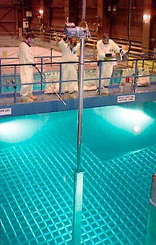  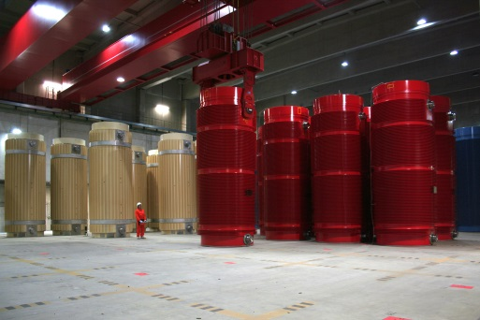

Salt clean-up

dissolving

Figure 7: The reduced fuel cycle like it would be given using MSFR fed with SNF Pictures: left <http://www.wikiwand.com/en/Spent_fuel_pool>, credit DOE License: Public domain, middle: EVOL benchmark configuration, right: Gorleben storage hall, Origin: GNS Gesellschaft für Nuklear-Service mbH

A comparison to classical closed fuel cycle for fast reactors (as proposed for closing the fuel cycle using classical GenIV systems), which would be required to achieve a comparable fuel/uranium usage, is shown in Figure 8. Already components are required as input. Due to the solid nature of such fuel separate steps are required, such as the fuel production, the storage time sufficient to cool the fuel until it can be reprocessed more easily, and the reprocessing. The separation of fissile material opens possibilities for misuse, whereas the solid fuel structure opens the way to insert pure fertile material for a short irradiation to produce weapon grade materials.

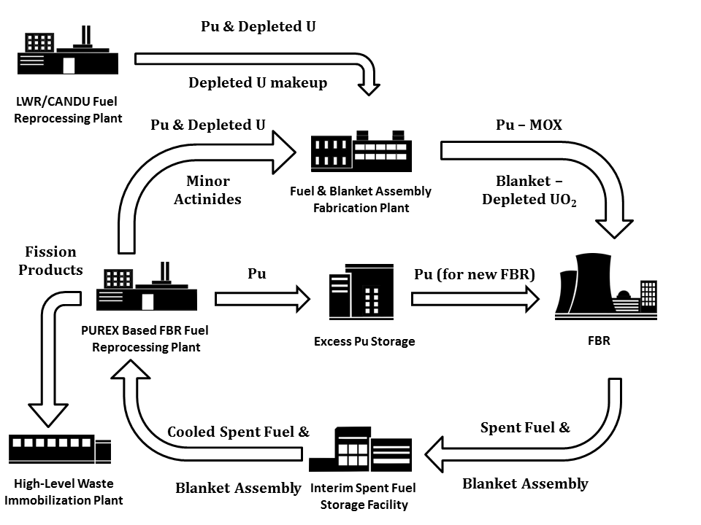

Figure 8: The classical fuel cycle like it would be given using a sodium cooled fast reactor with solid fuel for the incineration of SNF

An almost similar fuel cycle will be required for the more advanced BREST concept of a LFR, such as that under construction in Russia. However, even the significantly more advanced processes, use pyro reprocessing and co-location of the fuel cycle facility like foreseen for this project [32] and suffers from the above described limitations given by the use of solid fuel.

The penultimate design parameter is a nuclear reactor which doesn’t produce additional waste. Operating a reactor on SNF, the waste mass will be almost identical to SNF which is introduced into the reactor. The activity of SNF over time is indicated in Figure 9. However, the mass of waste stays the same, but ~ 20 times more energy is produced, thus the activity of the fission products is expected to be ~20 higher (see Figure 9, red line with spheres). Consequently, besides the energy produced all requirements of waste management driving the development of Partitioning & Transmutation (P&T) would be fulfilled [25, 28] – only fission products would remain in the waste stream while all transuranic isotopes would stay in the reactor, and in turn be burnt. Hence, only the short term activity of the nuclear waste will increase when compared to the original SNF, whilst the long term activity will decrease due to the absence of TRUs in the waste. The real gain occurs however, when the result from a reactor operating on SNF is compared to the production of the same amount of energy with conventional LWRs (black line with halved squares).

However, a strategy for the handling and storage of the separated fission products from the clean-up system has to be developed. In addition to this, a strategy for the capturing and handling of volatile fission products, evaporating from the salt during reactor operation is required. Both challenges are well known in standard molten salt reactor development, with significant work already completed [27, 33, 34]. The molten salt reactor network will work in parallel designing molten salt power reactors.



Figure 9: Activity per ton of SNF over time

The final requirement, i.e. the reactor being both safe and financeable, with limited financial risk in both development and construction, needs to be demonstrated, challenging engineers. The design should be seen as an integrated challenge for many disciplines. It could form the first test bed applying the concept of the Integrated Nuclear Digital Environment (INDE) [35]. However, before starting such development work, and to assure that the system is working in the final design, it is essential to prove the reactor functionality regarding the operability on SNF and confirm this at each important development decision – just the ideal request for the application of INDE.

Not an unlimited energy source!

The amount of fuel unloaded from a LWR per year has changed with time, with the increase in target burnup in LWR fuel. In 1988 the unloading amount was ~27 tonnes per year for a 1 GWe LWR [36], whereas 25 years later the reported unloading mass had decreased to an annual discharge of spent fuel from a 1 GWe LWR of 19 to 20 tons at a typical burn-up of 50 GWd/tHM [37].

Depending on the discharge burnup of the LWR SNF, a MSFR utilizing LWR SNF could operate almost 20 years with SNF from one year of LWR operation. However, the initial loading of the reactor would require ~62 tons of SNF, with the addition of 15 tons of separated Pu, from ~ 1500 tons of SNF (reprocessing 100 tons of SNF gives ~1 ton of Pu) in order to start the machine. However, there is a significant inventory of separated Pu and HEU available worldwide, with the global inventory of highly enriched uranium (HEU) estimated to be 1370 ± 125 tons, and separated plutonium of 504 ± 10 tons, of which ~ 270 tons is available for civilian usage. [38]

Combining all figures, operation of a single reactor requires less than 20 tons of seed material (TRU, Pu, or high enriched uranium depending on the quality of the seed) and ~130 tons of SNF. The amount of SNF for the initial core and 60 years of operation is produced within a LWR in less than 7 years, whilst the seed could possibly be taken from the stockpiles of Pu and HEU, which would then be reduced. Based on initial judgement, the amount of seed material to start up a reactor is slightly higher than for a sodium cooled fast reactor although the operational amount of seed material required is likely to be lower in the iMAGINE concept described here.  It is recognized that further work would be required to understand the number of iMAGINE reactors that could be installed in a given time, fuel/seed requirements, energy output and the implications for storage and disposal of material.

With more than 320 000 tons of spent fuel in storage expected by 2020 [39], and the expectation that ~130 tons are enough for 60 years of operation for a 3 GWth reactor or ~1.4 GWe reactor, there is enough material for ~2500 reactors. If this is coupled with the expected continued use of LWRs there is plenty of energy available.

4.1 Challenges for R&D

In order for such a design to be realized, and more importantly manufactured and operated several multi-disciplinary, integrative scientific and technological challenges have to be solved, which are outlined below:

**Engineering:**

* Optimization of burning used LWR fuel , i.e. demonstration of principles with validation
* Optimization of reactor design, i.e. better than EVOL
  + Fully understanding the fluid dynamics under both normal and accidental conditions
  + Componentry for molten salt system including in service inspection and repair
* Development of materials or engineering solutions capable of operating under such extreme conditions, e.g. high temperature, significant radiation damage, corrosive environment

**Chemistry and Thermodynamics:**

* Optimization of salt purification, i.e. removal of fission products from within the liquid phase
* Design, implementation and capture of volatile fission products, helping to keep the liquid phase pure
* Preparing the fuel – choosing the optimal method for converting used LWR fuel in to a form sufficient for use within the reactor
* Appreciation of the chemical thermodynamics, and limitations in using molten salts with high levels of actinide loading

**Safety:**

* Develop the safety methodology and implementation protocols for such a novel liquid reactor design
* Assurance in safety of such a co-located site, i.e. both reactor and reprocessing

**Others:**

* Economic viability, ensuring the reactor is economically viable and competitive with current technology
* Ensure the public acceptance of such a new technology, without which the reactor is unviable
* Development, verification, and validation of an integrated computer simulation environment incorporating reactor physics, salt chemistry, process engineering, thermodynamics, and material behavior

A detailed look into these challenges makes clear, these are worth a long term (international) research program to be solved. The maturity level of most of the technologies is in technical readiness level (TRL) 1 to 3. However, this could create the basis for a long term success of nuclear reactors as a major carbon free, sustainable, and applied highly reliable energy source.

Besides the above challenges there remain other hurdles to overcome, as a consequence a step by step approach is foreseen gaining operational experience, such that further developments can be made. Starting in a manner similar to the development of previous reactors hopefully with more modelling and simulation as well as digital design. Nevertheless, a small low power experimental machine should be initiated, which would lead on improved implementable designs. Such a machine has to be planned, built, and financed [25]. However, there is experience on other practical challenges available from the EVOL project, there are already proposals made and published on solving the very high neutron fluences on safety related structures [40].

5. Materials and Methods[[1]](#footnote-1)

5.1 Reference Configuration

The calculations are based on the core dimensions and boundary conditions given in the EVOL benchmark definition (see Figure 10), and focus on a reference MSFR of 3000 MWth using a fast neutron spectrum The reactor core is a single cylinder with flowing fuel salt within [41], the dimensions shown in Figure 10. The whole core system is composed of four volumes, an active core, an upper extraction area, a lower injection area, and outside the core where the heat exchanger and pumps are. The active core is surrounded by a blanket ring, and a protection ring, both made from absorbing material, with both components having the function of protecting the pumps and heat exchanger from the high neutron flux arising within the active core.

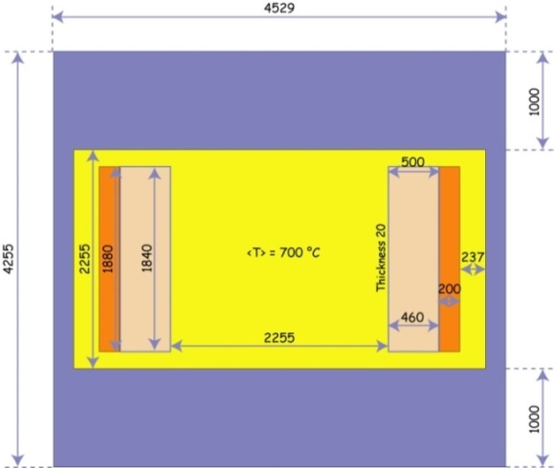

Figure 10: (Right): Simplified scheme of the MSFR system including the core, blanket and heat exchangers (IHX) – (Left): Benchmark definition [41].

The spent nuclear fuel composition, used in this analysis, is based on material and geometry of the “OECD/NEA AND U.S. NRC PWR MOX/UO2 CORE TRANSIENT BENCHMARK” [42]. The uranium oxide fuel assembly, with 4.5% enrichment in U-235, has been calculated to a maximum burnup of 50 GWd/tHM using HELIOS 2.1 to approximate the model material configuration. To simulate storage time leading to Pu-241 decay, the Pu-241 content has been halved and turned to Am-241, equivalent to a postulated storage of 14 years. Besides this change no further adaption for storage has been introduced, which can be considered a conservative assumption from a neutronic point of view. For the initial addition of fissile material for reactor start-up the TRU isotopic vector given in Table 2 is used, and follows the definition of the EVOL benchmark.

**Table 2:** Used transuranium (TRU) isotopic vector – EVOL benchmark data [41]

|  |  |
| --- | --- |
| Np 237 | 6.30% |
| Pu 238 | 2.70% |
| Pu 239 | 45.90% |
| Pu 240 | 21.50% |
| Pu 241 | 10.70% |
| Pu 242 | 6.70% |
| Am 241 | 3.40% |
| Am 243 | 1.90% |
| Cm 244 | 0.80% |
| Cm 245 | 0.10% |

The salt configuration is also based on the EVOL benchmark, and consists of LiF with mainly UF4 (calculated as SNFF4 as approximation). However, in contrast to the EVOL benchmark, the share of SNF has to be determined, to allow for sufficient breeding of fissile material keeping the reactor critical for long term operation without further feeding of fissile material. The blanket region is filled with pure LiF4.The overall fuel salt volume is 18 m3 within the core and 7.7 m3 within the blanket. The salt clean up system has been defined in the EVOL benchmark with a clean-up time of ~450 days for the full amount of 18 m3 fuel salt. This value has to be adapted, thus provides an additional degree of freedom for the optimization of the breeding.

5.2 Modelling and Calculation Tool

For the model evaluations, the HELIOS 2.1 licensing grade code system is used with the internal 177 group library [43]. The HELIOS code is a 2D spectral code with wide unstructured mesh capabilities and a transport solver, based on the collision probability method [44]. The benchmark configuration is transferred to a volume corrected 2D HELIOS model (see Figure 11). The leakage in the third dimension has been fixed based on 3D calculations within the EVOL benchmark exercises, while the leakage in radial direction is directly modelled. Additionally, the model has been adapted to improve the representation of the 16 heat exchanger pipes instead of the smeared treatment in the benchmark configuration.

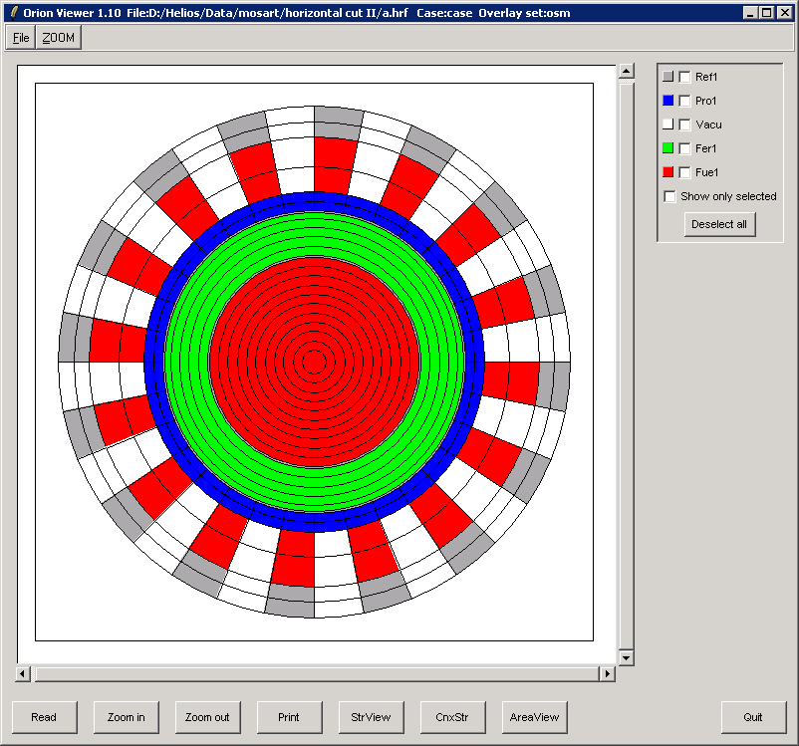

Reflector  
Protector  
Vacuum  
Blanket region  
Fuel region

Figure 11: Volume corrected 2D HELIOS model of the molten salt reactor.

The HELIOS code is an industrial standard software which performs the neutron transport calculation, the burn up calculation, and if requested the cross section. Originally, as HELIOS was written for the simulation of solid fuel assemblies, i.e. as used for the determination of a SNF configuration. The possibility of online refuelling and online salt clean-up is not foreseen. To deal with these special features of molten salt reactors a PYTHON script has been developed, based on the features of the HELIOS package. All information, which is constant during the whole reactor operation, is stored in a so-called expert input, while the changing material configuration is given in the user input, which is written new in every cycle using the PYTHON script. Within each cycle 5 burnup steps are calculated in HELIOS to the target burnup of 5000 MWd/tHM. Both inputs are merged in the pre-processor code AURORA, which creates the updated input for the HELIOS, determining neutron flux distribution and burnup of material. The results are finally evaluated for each cycle in the post-processor ZENITH, where it is decided which isotopes will be fed back into the next user input, created with the help of the PYTHON script (see Figure 12). Theoretically, it is possible to simulate a molten salt reactor precisely by using small time steps in this calculation loop. However, in a real MSR two different time scales for salt clean-up can be observed, due to the different extraction methods for fission products. These are helium bubbling for gaseous and volatile fission products with a comparably short operation cycle (minutes), and online salt clean-up for dissolved fission products with a significantly longer operation cycle. To simulate these different time scales a full removal of gaseous and volatile fission products takes place after each 5000 MWd/tHM cycle, but only a partial removal of dissolved fission products is established at the end of cycle. The lower efficiency in the separation of lanthanides is considered by a 20% lower reduction than for the other dissolved fission products. The throughput of the 18 m3 salt is an optimization parameter, which needs to be determined. However, what is most likely is that throughput through the salt cleanup system will have to be increased when compared to the EVOL benchmark, due to the fission products which are inserted with the SNF.

**only printed  
isotopes**

**re-distribution   
of materials**

**extracted isotopes**

**re-feeding material partial fission product cleaning**

**user input**

**output**

**expert   
input**

**post-processor**

**pre-processor**

**AURORA**

**HELIOS**

**ZENITH**

**SCRIPT**

**restart**

**neutron transport and burnup**

**fuel burnup calculation**

Figure 12: Description of the calculation cycle for the simulation of a MSR.

Due to the characteristics of HELIOS, some approximations have to be accepted, for example, there is no fuel salt movement, thus an undesired burnup distribution arises during the calculation cycle, and the materials are only re-distributed when a new user input is defined via the script. As HELIOS was designed for use with LWR reactors, a LWR spectrum is used for the within group weighting of the 177 group master libraries. However, comparisons to SERPENT on the isotope accumulation during the burnup in a fast reactor configuration using different HELIOS libraries (HELIOS 1 and HELIOS 2) have shown an acceptable agreement for major isotopes [45]. Additionally, different versions of the HELIOS 1 code have been used in the EVOL benchmark calculations for MSFRs [46] and in the benchmark calculations in the ESNII+ project for SFR [47]. In both benchmarks the results were comparable to the other codes, with no major systematic discrepancies observed. A significant improvement has been observed for the use of HELIOS 2 with the cross section libraries based on the most advanced ENDF/B VII library system, and the approximations and use of the HELIOS code package seems to be adequate for the level required for this kind of long term feasibility study. The major uncertainties are predominantly given by the current preliminary design which is far from optimized, with a more detailed design required for the next phase. Such design uncertainties are expected to impact significantly more to the uncertainties than the approximations made within the modelling and the applied code. In general the calculations are performed to demonstrate the feasibility of such operation of a critical reactor on the basis of spent LWR fuel with high burnup.

6. Conclusions

Invention and innovation in nuclear reactor development can be described with the concept of developments in s-curves. The identified key points which should drive invention and innovation are the changed boundary conditions, and the evolvable objectives. These new objectives ideally coincide with the ultimate, universal vision for energy production characterized by minimal use of resources and production of waste, while being economically affordable and safe, secure and reliable in operation.

Following these objectives, a new innovative proposal has been shown, whose operation is based on utilising spent nuclear fuel (SNF) from light water reactors (LWRs) as the main fuel, fulfilling the goals of sustainability in innovative electric energy production. A proof of the feasibility is provided based on a reactor neutronics point of view which provides a solution to the major challenge, establishing a breeding process which generates sufficient fissile material from the inserted SNF. For the initiation of the system a support of fissile material in the initial core and during a transition phase is required. Optimization of the design should be performed defining an ideal initial composition, and the required efficiency of the salt purification system, leading to a further objective of minimising the time required for the transition from a system fed with fissile material and SNF to a pure SNF feed.

The result of such a design would be a system which does neither require new resources nor produce additional waste, providing an option of a sustainable future nuclear system. In addition to providing the desired sustainability, the partitioning & transmutation requirements for such an innovative waste management strategy would be fulfilled in this system as an advantageous side effect. In addition, it provides enhanced resistance against misuse of Pu arising from a high Pu-240 content, with a very limited possibility for short time insertion fertile material, coupled with Pu remaining in the system without further separations. The sustainability of such a system is supported by the significantly reduced environmental impact of the fuel cycle, which is reduced to 3 steps, i.e. dissolving the SNF, reactor operation, storage of fission products. Thus today’s front end of the fuel cycle consisting of mining, conversion, and enrichment would no longer be required, eliminating a major source of toxicity arising from the mining/extraction process.

The use of SNF from LWR as reactor fuel would additionally open a vast energy resource of almost 2500 reactors, each 1.4 GWe operating for 60 years based on the SNF masses postulated for 2020. Thus this design would provide a significant, but not infinite, amount of energy.

The design requirement of such an innovative system would be safe and financeable with limited financial risk in both development and construction, is a challenge which should ideally be tackled by an international consortium following the proposal of the integrated nuclear data environment [35]. The ideal consortium would consist of all countries with an interest in solving their SNF problem. The development of such a sustainable and innovative nuclear reactor is a major challenge across engineering, but with a substantial impact on the future of the worldwide energy production.

**Author Contributions:** BM: designed the work, provided calculations, evaluations, wrote and co-ordinated the manuscript; DL: provided calculations, evaluations and scripts; KRW: supported writing the manuscript and contributed to the discussion; MB: co-designed the work, supported writing the manuscript and contributed to the discussion; RJT: motivated the work, supported writing the manuscript and contributed to the discussion; DM: supported writing the manuscript and contributed to the discussion

**Conflicts of Interest:** “The authors declare no conflict of interest."

References

1. [EM Rogers](http://www.amazon.co.uk/s/ref=dp_byline_sr_book_1?ie=UTF8&text=Everett+M.+Rogers&search-alias=books-uk&field-author=Everett+M.+Rogers&sort=relevancerank): Diffusion of Innovations, 5th Edition Paperback, 11/2003, free press, New York
2. F Malik: Strategy – Navigating the Complexity of the World, Campus Verlag, Frankfurt/New York, 2013
3. A history of the World: The world's first lawnmower, available: <http://www.bbc.co.uk/> ahistoryoftheworld/objects/ NI2ZjBwpTcqYdtpXFnIzUQ, accessed 06/04/2016
4. Achievements: Reactors Designed by Argonne National Laboratory, available: http://www.ne.anl.gov/About/reactors/early-reactors.shtml, accessed 06/04/2016
5. Technology Roadmap Update for Generation IV Nuclear Energy Systems, January 2014,   
   available: <https://www.gen-4.org/gif/upload/docs/application/pdf/2014-03/gif-tru2014.pdf>, accessed 06/04/2016
6. [World Energy Council](http://www.worldenergy.org/): Energy Trilemma Index, available: <https://trilemma.worldenergy.org/>, accessed 05/04/2017
7. Outline History of Nuclear Energy, (Updated March 2014) , available: <http://www.world-nuclear.org/information-library/current-and-future-generation/outline-history-of-nuclear-energy.aspx>, accessed 07/04/2016
8. Hyman G. Rickover, available: <http://www.globalsecurity.org/military/agency/navy/rickover.htm>, accessed 05/04/2017
9. E Roehrlich (2013) 60 Years of "Atoms for Peace", available: https://www.iaea.org/newscenter/news/60-years-atoms-peace, accessed 21/06/2016
10. Mr. Dwight D. Eisenhower (1953) Atoms for Peace Speech, 470th Plenary Meeting of the United Nations General Assembly, available: <https://www.iaea.org/about/history/atoms-for-peace-speech>, accessed 24/05/2017
11. Nash KL, Nilsson M (2015) Introduction to the Reprocessing and Recycling of Spent Nuclear Fuels, in Reprocessing and Recycling of Spent Nuclear Fuel, edited by Robin Taylor, Woodhead Publishing Series in Energy 79, Elsevier, Oxford
12. Barnham KWJ, Hart D, Nelson J, Stevens RA (2000) Did civil reactors supply plutonium for weapons?, Nature **407**, 833-834, doi:10.1038/35038256
13. Barnham KWJ, Hart D, Nelson J, Stevens RA (1985) Production and destination of British civil plutonium, Nature **317**, 213–217
14. RBMK Reactors, available: http://www.world-nuclear.org/information-library/nuclear-fuel-cycle/nuclear-power-reactors/appendices/rbmk-reactors.aspx, accessed 15/06/2016
15. Cerullo N, Lomonaco G (2012) Generation IV reactor designs, operation and fuel cycle. In Nuclear Fuel Cycle Science and Engineering; Crossland, I., Ed.; Woodhead Publishing Limited; Chapter 13; pp. 333–395, [https://doi.org/10.1533/9780857096388.3.333](https://doi.org/10.1533/9780857096388.3.333" \t "doilink)
16. F Carré (2007) The Nuclear Fuel Cycle: key to Generation IV Nuclear Energy Systems’ Sustainability  
    and transition from LWRs, ANS Annual Meeting, available: http://web.mit.edu/nse/pdf/news/2007/07\_ansannualmtg/ANS\_07%20(Carre).pdf, accessed 05/05/2017
17. Trends towards Sustainability in the Nuclear Fuel Cycle, NEA No. 6980, Nuclear Development ISBN 978-92-64-16810-7
18. Assessment of Nuclear Energy Systems Based on a Closed Nuclear Fuel Cycle with Fast Reactors, A REPORT OF THE INTERNATIONAL PROJECT ON INNOVATIVE NUCLEAR REACTORS AND FUEL CYCLES (INPRO) , IAEA-TECDOC-1639, INTERNATIONAL ATOMIC ENERGY AGENCY, VIENNA, 2010
19. Merk B, Stanculescu A, Chellapandi P, Hill R (2015) Progress in reliability of fast reactor operation and new trends to increased inherent safety, Applied Energy **147**, 1 June 2015, Pages 104–116
20. MacPherson HG (1985) The Molten Salt Reactor Adventure. Nucl. Sci. and Eng., **90**, 374-380.

1. [Myung-Seung](https://www.researchgate.net/researcher/2051777049_Yang_Myung-Seung) Y, et al. (2006) The status and prospect of DUPIC fuel technology, [Nuclear Engineering and Technology](https://www.researchgate.net/journal/1738-5733_Nuclear_Engineering_and_Technology) 38(4)
2. Final Report Summary - EVOL (Evaluation and Viability of Liquid Fuel Fast Reactor System), available: <http://cordis.europa.eu/result/rcn/159411_en.html>, accessed 05/05/2017
3. R. Wigeland et al.: Nuclear Fuel Cycle Evaluation and Screening – Final Report, INL/EXT-14-31465, FCRD-FCO-2014-000106, October 8, 201, available: <https://fuelcycleevaluation.inl.gov/Shared%20Documents/ES%20Main%20Report.pdf>, accessed 24/05/2017
4. Kim, T.K.; Taiwo, T.A.; Wigeland, R.A.; Dixon, B.W.; Gehin, J.C.; Todosow, M. Mass Flow Data Comparison for Comprehensive Fuel Cycle Options. In Proceedings of the Actinide and Fission Product Partitioning and Transmutation Thirteenth Information Exchange Meeting, Seoul, Korea, 23–26 September 2014.
5. Merk B, Rohde U, Glivici-Cotruta V, Litskevich D, Scholl S (2014) On the Molten Salt Fast Reactor for Applying an Idealized Transmutation Scenario for the Nuclear Phase Out”, PLoS ONE **9(4):** e92776. doi: 10.1371/journal.pone.0092776 (2014). PMID: 24690768
6. B Merk, D Litskevich (2015) “Transmutation of All German Transuranium under Nuclear Phase Out Conditions – Is This Feasible from Neutronic Point of View?”, PLOS ONE, DOI: 10.1371/journal.pone.0145652
7. B. Merk, D. Litskevich: ”On the Burning of Plutonium Originating from Light Water Reactor Use in a Fast Molten Salt Reactor—A Neutron Physical Study”, Energies 2015, **8**, 12557–12572; doi:10.3390/en81112328
8. Evaluation and Viability of Liquid Fuel Fast Reactor System EVOL, DELIVERABLE D2.1, Design parameters definition for most stable salt flux, rev 3 30/04/2012
9. acatech (Ed.): Partitioning and Transmutation of Nuclear Waste. Opportunities and Risks in  
   Research and Application (acatech POSITION PAPER), Munich 2014.
10. J. R. Engel W. R. Grimes W. A. Rhoades J. F. Dearing: “Molten-Salt Reactors for Efficient Nuclear Fuel Utilization Without Plutonium Separation”, ORNL/TM-6413, August 1978, available: <http://web.ornl.gov/info/reports/1978/3445603227167.pdf>; accessed July 15th, 2015
11. Poinssot et al. (2014) Assessment of the environmental footprint of nuclear energy systems. Comparison between closed and open fuel cycles, Energy **69**, 199-211
12. B. Merk et al. (2016) An Innovative Way of Thinking Nuclear Waste Management – Neutron Physics of a Reactor Directly Operating on SNF, OECD/NEA Actinide and Fission Product Partitioning and Transmutation, 14th Information Exchange Meeting, Hilton San Diego Mission Valley, San Diego, CA, United States, 17-20 October 2016
13. E.O. Adamov, V.A. Pershukov (2016) PROJECT «PRORYV» (Breakthrough), VII International Forum ATOMEXPO, May 30th, Moscow
14. Ingatiev V, et al. (2012) Progress in Development of MOSART Concept with Th Support. ICAPP’12, Chicago, USA June 24-28.

1. <http://samofar.eu/>
2. Patterson EA, Taylor RJ, Bankhead M (2016) A framework for an integrated nuclear digital environment, Progress in Nuclear Energy, **87**:97-103.
3. Charles MADIC (1988) FROM THE REACTOR TO WASTE DISPOSAL : THE BACK-END OF THE NUCLEAR FUEL CYCLE, BIOLOGICAL ASSESSMENT OF OCCUPATIONAL EXPOSURE TO ACTINIDES, Versailles (France) -1988, available: [http://www.iaea.org/inis/collection/ NCLCollectionStore/\_Public/20/005/20005325.pdf?r=1](http://www.iaea.org/inis/collection/%20NCLCollectionStore/_Public/20/005/20005325.pdf?r=1), accessed 18/04/2016
4. H. Feiveson, Z. Mian, MV Rama, F von Hippel, ed. (2011) Spent Fuel from Nuclear Power Reactors – An Overview of a new Study in the International Panel on Fissile Materials, Draft for discussion June 2011, available: <http://fissilematerials.org/library/ipfm-spent-fuel-overview-june-2011.pdf>, accessed 18/04/2016
5. Fissile material stocks, [International Panel on Fissile Materials](http://fissilematerials.org/), , available: http://fissilematerials.org/, accessed 18/04/2016
6. Costing of Spent Nuclear Fuel Storage, IAEA Nuclear Energy Series Technical Reports No. NF-T-3.5, IAEA 2009, available: <https://www.iaea.org/sites/default/files/costingfuel0909.pdf>, accessed 30/08/2016
7. Merk B, Konheiser J (2014) Shielding Studies on an Advanced Molten Salt Fast Reactor Design. Annals of Nuclear Energy **64**, 441–448.
8. MOLTEN SALT FAST REACTOR, EVOL Reference configuration – revised version, 08.10.2011
9. Tomasz Kozlowski and Thomas J. Downar: “OECD/NEA AND U.S. NRC PWR MOX/UO2 CORE TRANSIENT BENCHMARK”, OECD NEA, Final Spec.,2003, http://www.nea.fr/science/wprs/MOX-UOX-transients/benchmark\_documents/specifications/mox\_bench\_spec.pdf
10. HELIOS-2 Methods (Version 2.1), SSP-11/452 Rev 1, December 16, 2011
11. Villarino EA, Stammler RJJ, Ferri A. and Casal JJ (1992) HELIOS: angularly dependent collision probabilities Nuclear Science and Engineering **112**.
12. Rachamin R, Wemple C, Fridman E (2013) Neutronic analysis of SFR core with HELIOS-2, Serpent, and DYN3D codes, ANE,55, <http://dx.doi.org/10.1016/j.anucene.2012.11.030>
13. Brovchenko M (2015) Neutronic Benchmark of the Molten Salt Fast Reactor in the frame of the EVOL and MARS Collaborative Projects, submitted to ANE
14. Mikityuk K (2015)“Core Safety” (ESNII+ WP6,) European Nuclear Gen II, III, IV Days 17-18-19 March 2015, Brussels, Belgium

H:\documents\layout\new template June 2014\figures\CC-BY logo original v1.wmf© 2017 by the authors. Submitted for possible open access publication under the   
terms and conditions of the Creative Commons Attribution (CC BY) license (http://creativecommons.org/licenses/by/4.0/).

1. The raw data of the calculations and the used PYTHON script are available under <http://datacat.liverpool.ac.uk/id/eprint/151> [↑](#footnote-ref-1)